Documentation in Support of Category 4e

Waterbody/Watershed Identification
 | Organization | Florida Department of Environmental Protection
 | Point of Contact | Kevin O’Donnell, 2600 Blairstone Rd Tallahassee, FL 32399  Kevin.ODonnell@dep.state.fl.us, (850) 245-8469  Jessica Mostyn, 2600 Blairstone Rd Tallahassee, FL 32399  Jessica.mostyn@dep.state.fl.us, (850) 245-8441
 | Waterbody(s) | 1570A – Sweetwater Creek (Tidal Segment)  1577A – Pepper Mound Creek  1587A – Woods Creek  1601A – Tampa Bay Channel
 | No. Waterbody / Pollutant Combinations | Based on data from IWR run 56 these waterbodies are impaired for these parameters: WBID 1570A – Dissolved Oxygen (Percent Saturation)  WBID 1577A – Dissolved Oxygen (Percent Saturation), Nutrients (Chlorophyll-a)  WBID 1587A – Dissolved Oxygen (Percent Saturation)  WBID 1601A – Nutrients (Chlorophyll-a)
 | EPA Completed TMDL | EPA has not completed a TMDL for the impaired waterbody segment listed in this document
Description of Baseline Conditions
 | Watershed(s) | Tampa Bay – Group 1  Coastal Old Tampa Bay Tributary – FDEP Southwest District  WBIDs 1570A – Sweetwater Creek (Tidal Segment), 1577A – Pepper Mound Creek, 1587A – Woods Creek and 1601A – Tampa Bay Channel
 | Baseline Data | Group 1 Cycle 4 – IWR Run 56, 2018  (Verification Period: January 1, 2011 through June 30, 2018)  WBID 1570A – Sweetwater Creek (Tidal Segment) – Dissolved Oxygen (Percent Saturation); DOSAT impairment threshold: ≥ 42%. The current exceedance ratio during the verified period is 50/87.  Stations used in the DOSAT assessment:  21FLHILL104  WBID 1577A – Pepper Mound Creek – Dissolved Oxygen (Percent Saturation); DOSAT impairment threshold: ≥ 42%  Stations used in the DOSAT assessment:  21FLHILL502, 21FLTPA2759210823413, 21FLTPA2759080823412  WBID 1577A – Pepper Mound Creek – Nutrients (Chlorophyll-a); Criteria: AGM ≤ 11 µg/L, annual geometric mean chlorophyll-a values exceeded the criteria in 2013, with a value of 13 µg/L and in 2014, with a value of 13 µg/L.  Stations used in the CHLAC assessment:  21FLHILL502, 21FLTPA2759210823413, 21FLTPA2759080823412  WBID 1587A – Woods Creek – Dissolved Oxygen (Percent Saturation); DOSAT impairment threshold: ≥ 42%  Stations used in the DOSAT assessment:  21FLHILL504, 21FLTPA2758470823455, 21FLTPA2759360823459, 21FLTPA2758450823501, 21FLTPA2759070823500  WBID 1601A – Tampa Bay Channel – Nutrients (Chlorophyll-a)  ENRB1 Criterion: AAM ≤ 9.3 µg/L, annual arithmetic mean chlorophyll-a values exceeded the criterion in 2006, with a value of 13.4 µg/L. This parameter was verified impaired in a previous listing cycle for chlorophyll-a and is currently being delisted from the State’s Verified List but will remain on the 303(d) List in category 4e.  Stations used in the CHLAC assessment:  21FLHILL061
 | Map | 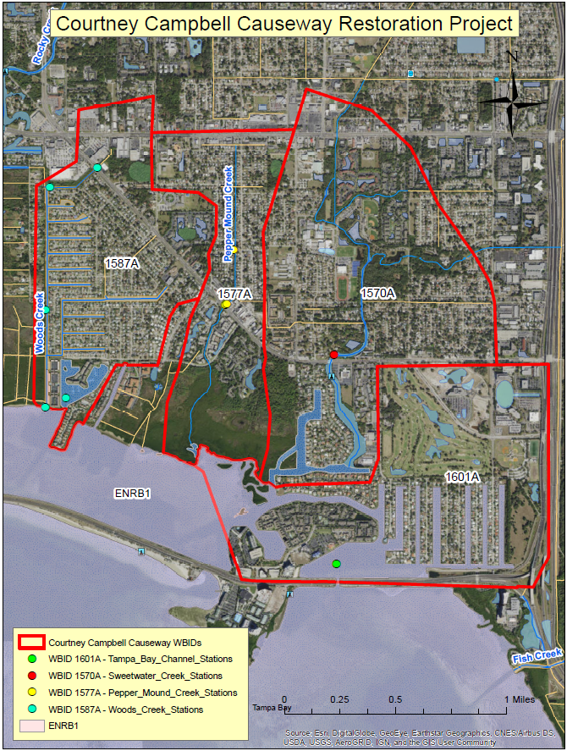

Evidence of Watershed Approach
 | Area of Effort | To improve the water circulation and quality in Old Tampa Bay and restore tidal flows to the northeast portion of the Bay, the Florida Department of Transportation built a new bridge on SR 60 (Courtney Campbell Causeway), west of Ben T. Davis Beach. No elevated bridge with openings previously existed in this section of the causeway. The Courtney Campbell Causeway (CCC) restoration project is located in the Northwestern part of Hillsborough County, in Old Tampa Bay (OTB) along SR 60. The CCC Project consists of construction of a 220-foot opening in the Courtney Campbell Causeway. It has been determined that 81 acres is the most conservative estimate of the area of improvement in Old Tampa Bay that would result from the construction, while the hydrologic modeling predicts measurable improvement in water quality in at least 320 acres.
 | Key Stakeholders Involved and Their Roles | The key stakeholders that have been instrumental in developing and executing this project are listed below.  - Florida Department of Transportation  - City of Tampa Bay  - Hillsborough County  - South West Florida Water Management District  - Atkins Environmental  - ESA – Environmental Science Associates
 | Watershed Plan & Other Supporting Documentation | The area includes the watershed drainage area from Northwestern Hillsborough County within WBID(s) 1570A – Sweetwater Creek (Tidal Segment), 1577A – Pepper Mound Creek, 1587A – Woods Creek and 1601A – Tampa Bay Channel. WBIDs 1570A, 1577A and 1587A are impaired for dissolved oxygen based on the number of exceedances for the sample size. WBIDs 1577A and 1601A are impaired for nutrients (chlorophyll-a) based on the AGMs exceeding the criteria. The objectives outlined by the Florida Department of Transportation (FDOT), Courtney Campbell Causeway project will address these impairments.  In 2002 the Department of Environmental Protection approved a reasonable assurance (RA) plan for the Tampa Bay Estuaries. The area included in the RA plan overlaps the area included in the waterbodies within this document. The Courtney Campbell Causeway restoration project will be included in the 2022 RA plan update as a beneficial project that was implemented over the 2017-2021 RA implementation period. Any dissolved oxygen improvements and nutrient load reductions (or equivalent) associated with this project will be reported to the Tampa Bay Estuary Program by the FDOT and will be included in table 7 of the RA plan update.  The below figure shows an overview of the project area.  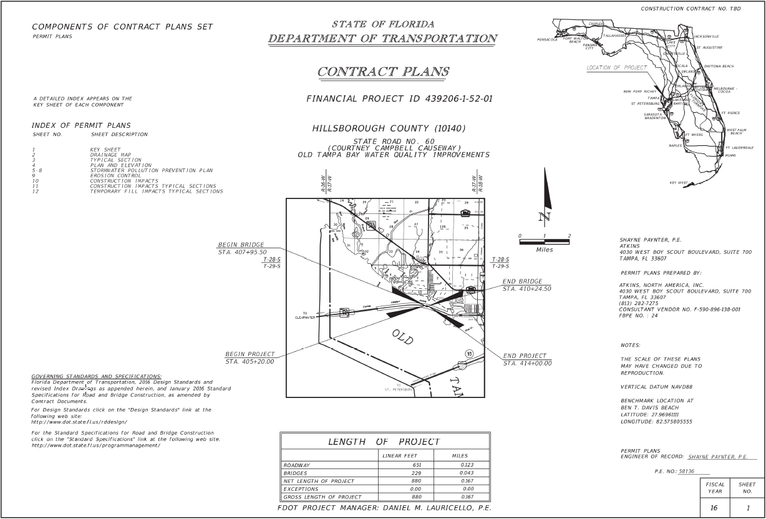  The WBID drainage area corresponds to the key project as follows: Courtney Campbell Causeway bridge construction
 | Point Sources and Indirect Source Monitoring (Sites) | There are several NPDES Facilities that discharge indirectly to the WBIDs included in this document. These facilities are listed in the below table. There are no direct surface water dischargers located within these WBIDs.  Most of the land area within the WBIDs in this document are regulated by two Municipal Separate Storm Sewer System (MS4) permits – NPDES MS4 Permit No. FLS000006, Permittee is Hillsborough County. The most current MS4 permit was issued on July 11, 2016 and expires on July 10, 2021. NPDES MS4 Permit No. FLS000008, Permittee is the City of Tampa Bay. The most current MS4 permit was issued on April 1, 2017 and expires on March 31, 2022.  https://www.tampagov.net/sites/default/files/stormwater/files/COTP3Y5submittal.pdf  A large portion of the area within the WBIDs in this document are regulated by two Municipal Separate Storm Sewer System (MS4) permits:  - Hillsborough County: Permit #FLS000006  - City of Tampa: Permit #FLS000008  Note: Generic Permits for stormwater discharge from large and small construction activities are considered temporary; therefore, are not included in this listing.
  WBID | NPDES Facility ID | NPDES Facility Name
  1570A | FLR10Z174 | The Harbors at Town & Country
  1570A | FLR10W506 | Hillsborough Convenience Store
  1570A | FLR10O320 | Krystal Restaurant
  1570A | FLR10IA84 | Berkeley Preparatory School
  1570A | FLR10HW97 | Berkeley Preparatory School
  1570A | FLR10DJ02 | Chapel in the Pines - Phase 1 Presbytery Office
  1570A | FLR10CZ15 | Korean Presbyterian Church - Parking Lot
  1570A | FLR10CS22 | El Capitan Crossing Townhomes
  1570A | FLR10BY84 | Sweetwater Professional Park
  1577A | FLR20BH77 | Tanglewood Lane Drainage Improvement
  1577A | FLR20AN36 | Webb Rd & Hillsborough Ave-Rd Improvements
  1587A | FLR10JO17 | Memorial ALF
  1587A | FLR10HW02 | Budget Self Storage
  1601A | FLR20AC76 | Independence Park
  1601A | FLR10Q537 | George Rd Widening, Turn Lanes & Signalization
  1601A | FLR10PD93 | Chase Fountain Square
  1601A | FLR10FL46 | Westin Hotel
 | Nonpoint Sources | The Land use breakdown for the WBIDs included in the Courtney Campbell Causeway restoration project area are as follows:  Wastewater Facilities in Area:  There are no wastewater facilities within any of the WBIDs in this document  Solid Waste Facilities in area:  There are no solid waste facilities within any of the WBIDs in this document
  Landuse | WBID 1570A percentages | WBID 1577A percentages | WBID 1587A percentages | WBID 1601A percentages
  Urban and Built-Up | 78.35 | 65.91 | 81.38 | 65.48
  Agriculture | 0.00 | 0.00 | 0.00 | 0.00
  Rangeland | 0.00 | 0.00 | 0.00 | 0.00
  Upland Forest | 5.41 | 1.29 | 0.00 | 0.10
  Water | 5.78 | 1.52 | 11.90 | 23.47
  Wetlands | 8.78 | 28.81 | 5.69 | 2.05
  Barren Land | 0.00 | 0.00 | 0.00 | 0.00
  Transportation, Communication, and Utilities | 1.68 | 2.47 | 1.02 | 8.88
  Special Classifications | 0.00 | 0.00 | 0.00 | 0.00
  Anthropogenic Landuse Component | 80.03 | 63.38 | 82.41 | 74.37
 | Water Quality Criteria | It is expected that the Class II (WBID 1601A) and the Class III water quality standards derived from the Numeric Nutrient Criteria associated with ENRB1 for Nutrients (Chlorophyll-a) will be attained upon implementation of the specified watershed improvement project. It is also expected that the water quality criteria for Dissolved Oxygen (Percent Saturation) will also be attained.
 | Restoration Work | The Courtney Campbell Causeway (CCC) was constructed in the early 1930’s during a time when Old Tampa Bay (OTB) was considered to have good water quality. Aerial photographs show evidence of extensive seagrass meadows in most of OTB in 1948. However, the shallow waters of OTB north of the CCC at its eastern terminus appear to be devoid of seagrass in 1948. These findings indicate that the construction of the CCC changed the environment to the extent that seagrass could not grow in that area, even while adjacent waters supported extensive seagrass meadows.  The below figure illustrates the approximate area of interest within OTB outlined in orange.  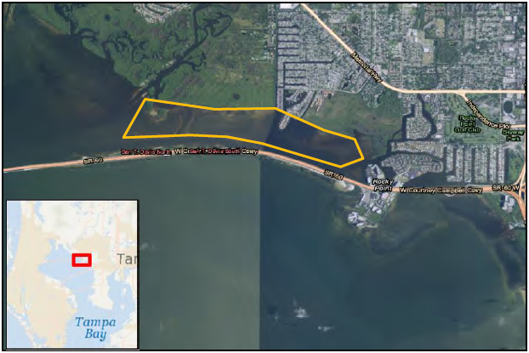  Phase I of this study was initiated to evaluate if the replacement of a portion of the CCC with a conveyance structure such as a bridge would likely bring about an ecological response in OTB similar or greater than that which would be expected to occur by treating stormwater runoff alone. The removal or modifications of causeways such as the CCC has been promoted worldwide as an environmental restoration tool, and ecological responses to causeway removal have benefited water quality over areas in the range of hundreds of acres, based on monitoring system responses to completed projects in the Florida Keys and Tampa Bay. The conclusion was that the modification of the CCC to allow for the restoration of lost historical tidal influences in northeastern OTB is likely to result in an ecological response greater in magnitude than that which could be provided with treating stormwater runoff with traditional treatment systems. Further, the proposed project is consistent with language within FS 373.413(6) and AH Vol II, both of which allow for alternative methods to address water quality issues regionally, as long as the benefit would be equivalent (in this case it would be far greater) than that which would be expected with traditional stormwater treatment systems.  Phase II of the study involves the development and application of a hydrodynamic numerical model to quantitatively evaluate how circulation within the portion of OTB northeast of the CCC is altered and improved by the addition of a conceptual bridge opening and/or modification to the flap gate system east of Rocky Point. Of particular interest is the notion of flushing and residence time, and to what degree potential modifications to the system can increase water exchange with greater OTB, reduce residence time, and, by extension, improve water quality and seagrass suitability. The hydrodynamic model utilized in this effort was the Delft3D model, a widely-used and validated numerical model which incorporates the effects of astronomic tides, wind, waves, and meteorological forces to simulate time-varying hydrodynamics in two or three dimensions. Delft3D supports subgrid flow structures such as culverts and weirs, as well as the nesting of successively more refined modeling domains, allowing for the modeling of large- and small-scale domains at appropriate spatial resolution and optimizing run time. It has the capability to model the dispersion and transport of temperature, salinity, and conservative constituents, which were used as tracers to simulate the movement of water from the area of interest to greater OTB and estimate residence time for the modeled scenarios.  The hydrodynamic model and field review evaluated four representative areas (strata): three to the north of the CCC and one to the southeast (Shown in the figure below). The strata were selected based on available biannual seagrass maps produced by SWFWMD. Stratum A, which is the area on the north side nearest the existing bridge, totals 89 acres; Stratum B, to the east of Stratum A, is 123 acres; Stratum C, located east of Stratum B and furthest from the existing bridge, is 108 acres. Stratum D is on the south side of CCC, therefore representative of areas with no effect from tidal restriction, and totals 94 acres. The model predicts that a 220‐foot opening would result in an 80% reduction in residence time for Stratum A, 82% reduction in residence time for Stratum B, and 50% reduction in residence time for Stratum C. In total, measurable improvement in tidal flushing will occur across an area totaling at least 320 acres.  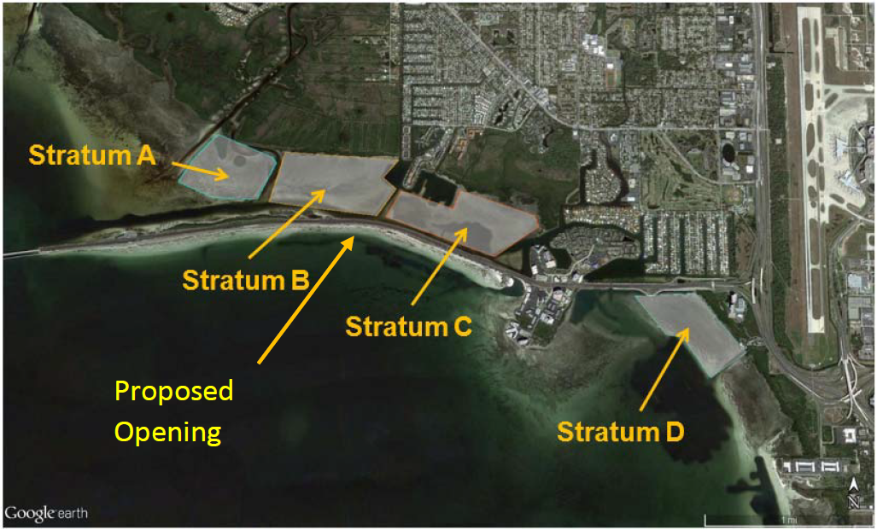  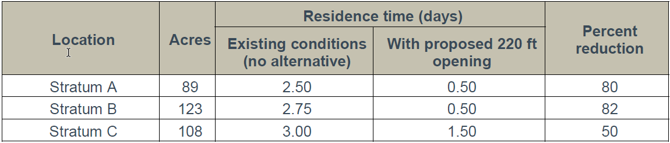  Other positive effects of improved flushing include restoration of conditions favorable for seagrass regrowth in approximately 81‐100 acres (areas with sparse seagrass or with only Ruppia based on data from SWFWMD and in‐water surveys in December 2014 and April 2016 and reduced nitrogen concentrations. 81 acres is therefore the most conservative estimate of the area of improvement in OTB that would result from construction of a 220‐foot opening in CCC, while the model predicts measurable improvement in water quality in at least 320 acres. Strict adherence to regulatory presumptive criteria and traditional stormwater treatment, by contrast, would produce far less benefit to Tampa Bay. The most widely adopted stormwater treatment system in Florida, wet detention ponds, only remove about 30 to 40 percent of incoming nitrogen loads from stormwater, which makes “holding the line” impossible to achieve with their use alone. Further, a recent study conducted for FDOT revealed that the form of nitrogen in roadway runoff is primarily dissolved organic nitrogen (DON), which is not readily assimilated by algae and therefore has less adverse impact on the Tampa Bay ecosystem than dissolved inorganic nitrogen (DIN) (Tomasko et al, 2013). Therefore, construction of large stormwater ponds to treat highway runoff and remove nitrogen in accordance with “standard” presumptive criteria would have minimal beneficial effect to Tampa Bay.

Critical Milestones/Monitoring
 | Anticipated Critical Milestone(s) and Completion Dates: |  | The design portion of this project began in October 2017 and construction began in January of 2018. The northern portion of the new bridge was completed in September 2018. After completion of the northern portion of the bridge, both directions of traffic and the pedestrian trail were shifted to the northern portion of the new bridge. Motorists and trail users will remain in this configuration while the southern portion of the bridge is constructed.  The north and south dam removal was completed on November 15, 2018 to allow full tidal flow through the newly constructed channel. Meanwhile, construction continues on the southern portion of the bridge.  The estimated completion date for the entire project is expected to be in the summer of 2019.
 | Monitoring Component |  | Proposed Monitoring and Assessment Approach:  The proposed monitoring and assessment approach for the CCC modification project would incorporate a number of integrated tasks.  - A detailed Before and After, Control and Impact (BACI) monitoring and assessment program developed and implemented for determining potential impacts of various construction activities. Details of this monitoring and assessment program are included below.  - An assessment of potential nutrient benefits and/or impacts associated with CCC modification activities.  - A proactive public education and outreach program.  Task 1 – Development and implementation of a detailed BACI monitoring and assessment program. Existing reports and data sets will be used to develop a detailed BACI experimental design for detecting changes (if any) in the water quality and natural resources in the areas expected to benefit from modification of the CCC. A BACI approach will be used, as there is a need to differentiate between regional and/or climatic changes in water quality and natural communities, as opposed to changes associated with the causeway removal itself. The basic layout of a BACI experimental design is to collect monitoring data prior to the initiation of any potentially impacting activities, and simultaneously collect the same data set at a nearby site not expected to be impacted by these same activities. The collection of data at both impacted and non-impacted sites allows for the differentiation between changes due to the modification of the CCC. As an example, if baseline water quality and seagrass coverage data provide evidence of an improvement in water quality and expansion of seagrass meadows in the areas influenced by a new hydrologic connection, but no such change in the control sites, then the positive changes are due to the project rather than due to climatic factors or overall improvement in bay-wide conditions. Conversely, if water quality improvements and seagrass expansion occurred at similar rates in both the areas newly influenced by a new hydrologic connection as well as within the control site, then the improvement due the project may be secondary to an overall improvement in water quality in the bay.  For this project, data would be collected prior to, during, and after the modification of the CCC, from the previously used Strata of A, B, C and D (see image below).  Stratum C is the location where it is anticipated that the greatest benefit would occur, in terms of both water quality benefits and seagrass recovery. Benefits would also be expected to occur in Stratum B, particularly on the east side of Stratum B. Stratum A would act as a control for water quality and seagrass coverage in areas north of the CCC. While useful as a control for areas south of the CCC, it is not anticipated that Stratum D would be part of the proposed BACI design for monitoring.  The proposed monitoring program would be structured as outlined below:  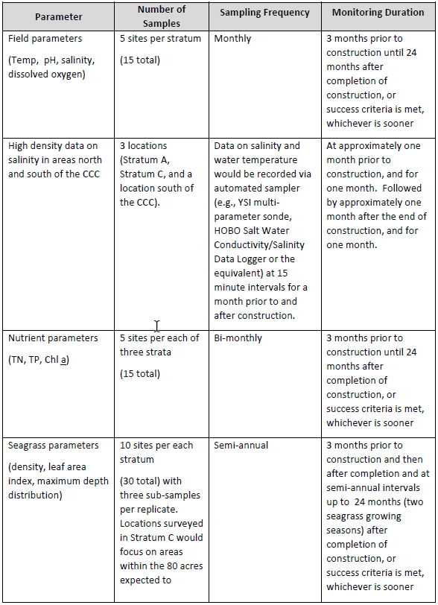  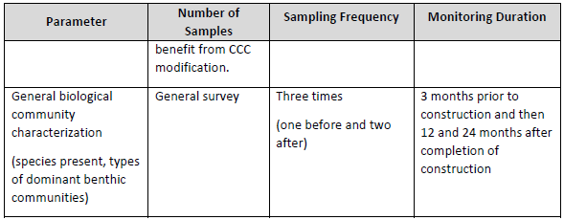  Task 2 – Reporting  2a. Midterm Report. One year after construction completion, summarize and present data trends.  2b. Within a month after receiving the final water quality and seagrass abundance data, the Consultant will prepare a Draft Final Report summarizing the methodology, results and interpretation of results from this above-described BACI assessment. The Consultant will produce a Final Report within 2 weeks of receipt of final comments from FDOT.  Utilizing the most conservative estimate of the area of water quality improvement, at least 81 acres of Old Tampa Bay will benefit from the proposed 220-foot opening in the CCC. This translates into the ecosystem response equivalent to removing 10,568 pounds of nitrogen (FDOT 2015). This reduction in nitrogen is equivalent to the expected performance of more than 100 of the typical stormwater ponds constructed by FDOT. As such, the restoration of historical circulation patterns via a 220-foot wide bridge would be expected to bring about an ecological uplift in this portion of OTB greater than that which would occur with the construction of 100 typical stormwater treatment ponds.  Additional sampling in the adjacent waterbodies outlined in this document will have sampling conducted by the Hillsborough County Environmental Protection Commission. This additional monitoring will be used to help evaluate future water quality progress, as well as supplementing data needs for future assessments.
Other Key Dates
 | Estimated Delisting Date | The WBIDs outlined in this document are in the state’s Group 1 Basin, in the DEP Southwest District. The review and assessment cycle for this basin (cycle 4) is currently ongoing in 2019. These waterbodies will be put in assessment category 4e (Ongoing Restoration Activities) during the cycle 4 assessment. These waterbodies will be reassessed with the potential of delisting from the 303(d) List during the department’s Group 1 cycle 5 assessment scheduled for 2023.

Financial Commitments

 | Estimated Implementation Cost | The total project cost was $16,000,000.  The estimated 20-year operation and maintenance cost is $TBD.
 | Land Acquisition  (if applicable) | Funding Source:  Total……………………………………………………………………...$ NA
 | Design and Construction  (if applicable) | Funding Source:  Total……………………………………………………………………...$16,000,000
References:

Florida Department of Transportation. Old Tampa Bay/Courtney Campbell Causeway Water Quality Improvement Plan.

