# Florida Ecological Risk Assessment Guidance Document

DRAFT

April 11, 2014

**1. Introduction**

*1.1 Purpose and Applicability*

The Florida Ecological Risk Assessment Guidance is intended as a technical guidance for the evaluation of ecological risk. The guidance does not suggest or support an evaluation of ecological risk at all sites; rather it provides technical instruction applicable when an ecological risk assessment is warranted. Although other ecological risk methodologies are available, this guidance has been developed specifically for the State of Florida.

This guidance follows the three-tiered approach outlined in the guide for risk-based corrective action for the protection of ecological resources (Eco-RBCA) (ASTM, 2009). This approach is intended to be consistent with the 8-step process outlined in the US EPA’s Ecological Risk Assessment Guidance for Superfund (1997). Figure 1 shows the approximate relationship between the Eco-RBCA and US EPA processes. Although this guidance is organized into Tiers, the wide variety of needs and goals for ecological habitat in Florida necessitate a flexible approach. Use of this guidance does not necessitate implementation in a step-wise fashion or the inclusion of all steps.

Eco Risk Guidance

Figure 1 – Relationship between the Eco-RBCA and US EPA ERAGS processes

*1.2 Scoping*

The purpose of the scoping section is to determine if an ecological risk assessment is necessary at the site. Assessment of ecological risk is not critical at sites with little or no exposure for ecological receptors. Considerations include:

1. Presence of viable habitat on the site
2. Presence of viable surrounding habitat
3. Current and potential future land use
4. Presence of threatened or endangered species
5. Presence of ecologically sensitive habitat (e.g., wetlands, state preserve, spawning grounds)

**2. Tier I – Screening Level Ecological Risk Assessment**

*2.1 Problem Formulation*

2.1.1 Conceptual Site Model

The purpose of this model is to describe the relationships between contaminated media and ecological receptors. A conceptual site model identifies source, transport, partitioning, contaminated media, and possible exposure routes. It hypothesizes how each of the receptors may be exposed to the chemical hazard. This model allows risk assessors and managers to understand how contaminants are moving among aquatic and terrestrial organisms and through trophic levels at a site. It is also useful for identifying incomplete pathways and eliminating chemicals or media that are not relevant for the site in question. A conceptual site model may be presented as a figure or a chart (Figure 2).

2.1.2 Stressors

Both chemical and non-chemical stressors should be considered. While ecological risk assessment has traditionally focused on chemical hazards, physical and biological stressors are important determinants for the overall health of the ecosystem. These stressors may occur naturally (e.g., parasites, soil high in metals) or be a result of anthropogenic influence (e.g., removal of habitat for construction). Physical stressors such as extremes in pH, dredging, low dissolved oxygen, changes in water level, or fragmented habitat may intensify adverse effects. Biological stressors (e.g., invasive species or changes in predator/prey relationships) can alter species composition and, as a result, change the ecosystem over time. The analysis of non-chemical stressors identifies both the indirect effects of a chemical release on an ecosystem as well as changes due to non-site related activities.

2.1.3 Management Goals

The management goal defines the ecological values that are to be protected at the site. It could be as simple as the protection of one species or as complex as the maintenance of an entire ecosystem. Consequently, it should be defined early in the assessment. Without a clear management goal, sampling and assessment at the site are not focused. If a management goal is chosen later in the risk assessment process,

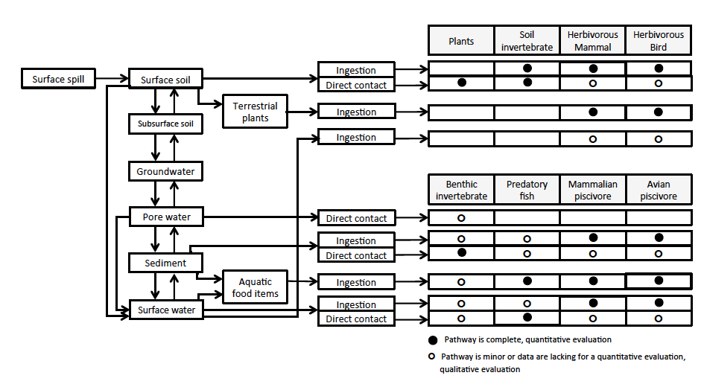

Figure 2 – Example site conceptual model for ecological risk assessment

data gaps may exist (requiring further sampling) or it may be discovered that extraneous data were collected (increasing overall cost).

An assessment endpoint is “an explicit expression of the environmental value that is to be protected” (US EPA, 1997). Assessment endpoints express a value defined by the management goals and cannot usually be measured directly. For example, if a management goal for a wetland contaminated with PCB is “maintenance of the wetland ecosystem”, relevant assessment endpoints may include “protection of piscivorous birds and mammals” or “protection of predatory fish”. Assessment endpoints should be sensitive to the chemical as well as ecologically relevant to the management goal. Although assessment endpoints may not be chosen at this stage, consideration of possible assessment endpoints will help guide sampling.

*2.2 Ecological Screening Levels*

There are several sources of ecological screening levels. Screening levels derived for use in the State of Florida are given preference, followed by Federal and Region 4 screening levels. The following sections list ecological screening level sources for each media of concern, in order of preference.

2.2.1 Soil Screening Levels

* [US EPA Ecological Soil Screening Levels (2003-2008)](http://www.epa.gov/ecotox/ecossl)
* [Supplemental Guidance to RAGS: Region 4 Bulletins, Ecological Risk Assessment (2001)](http://www.epa.gov/region4/superfund/programs/riskassess/ecolbul.html)
* [US EPA Region 5, RCRA Ecological Screening Levels (2003)](http://www.epa.gov/region5/waste/cars/pdfs/ecological-screening-levels-200308.pdf)
* Others

2.2.2 Surface Water Screening Levels

* [FDEP Surface Water Quality Standards, Chapter 62-302, F.A.C. (2010)](https://www.flrules.org/gateway/RuleNo.asp?title=SURFACE%20WATER%20QUALITY%20STANDARDS&ID=62-302.530)
* [FDEP Contaminant Cleanup Target Levels, Chapter 62-777, F.A.C. (2005)](https://www.flrules.org/gateway/ChapterHome.asp?Chapter=62-777)
* [US EPA, National Recommended Water Quality Criteria (current)](http://water.epa.gov/scitech/swguidance/standards/current/index.cfm)
* [Supplemental Guidance to RAGS: Region 4 Bulletins, Ecological Risk Assessment (2001)](http://www.epa.gov/region4/superfund/programs/riskassess/ecolbul.html)

* [US EPA Region 3, Freshwater Screening Benchmarks (2006)](http://www.epa.gov/reg3hwmd/risk/eco/btag/sbv/fw/R3_BTAG_FW_Benchmarks_07-06.pdf)
* Others

2.2.3 Sediment Screening Levels

* [Sediment Quality Assessment Guidelines for Florida Inland Waters (2003) – TECs](http://www.cerc.usgs.gov/pubs/sedtox/sqags_for_florida_inland_waters_01_03.pdf)

* [Sediment Quality Assessment Guidelines for Florida Coastal Waters (1994) - TELs](http://www.dep.state.fl.us/waste/quick_topics/publications/documents/sediment/volume1.pdf)
* [Supplemental Guidance to RAGS: Region 4 Bulletins, Ecological Risk Assessment (2001)](http://www.epa.gov/region4/superfund/programs/riskassess/ecolbul.html)
* [EPA Region III BTAG, Freshwater Sediment Screening Benchmarks (2006)](http://www.epa.gov/reg3hwmd/risk/eco/btag/sbv/fwsed/R3_BTAG_FW_Sediment_Benchmarks_8-06.pdf)
* Others

*2.3* *Screening Level Refinement*

Although assessment endpoints are not usually developed in Tier 1, a screening level assessment may be refined by focusing on species likely to be chosen as assessment endpoints. For example, if the management goal is to maintain the predatory fish population, the screening level assessment could focus on benthic invertebrates and finfish. These species are required as a prey base to maintain higher trophic level populations and have been chosen as assessment endpoints for similar management goals. To refine the assessment, toxicity reference values (TRVs) and conservative exposure factors are used to derive media concentrations protective of different foraging guilds. This is commonly used for the assessment of higher trophic level species where the default screening levels tend to be highly conservative. In the refinement, some exposure parameters may be changed to reflect more realistic parameters for the receptors of concern. These adjustments are usually obtained from the literature and are not site-specific (e.g., area use factor based on home range). Inclusion of site-specific data is addressed under the Tier II assessment. This does not imply that a screening level refinement must exclude site-specific data. It indicates, however, that the inclusion of site-specific data requires additional considerations, which are addressed in the following sections.

Unlike screening levels, there are no generally accepted compilations of TRVs. Individual TRVs must be obtained from ecological toxicity references and databases. Several common sources have been listed below for convenience.

* [US EPA Ecological Soil Screening Levels (2003-2008)](http://www.epa.gov/ecotox/ecossl)
* [US EPA EcoTox Database Release 4.0 (last updated March 2014)](http://www.epa.gov/ecotox)
* [US Army Wildlife Toxicity Reference Values (2001-2009)](http://usaphcapps.amedd.army.mil/erawg/tox/)

**3. Tier II – Baseline Ecological Risk Assessment and Site-specific Exposure Values**

*3.1 Site-specific Species of Concern*

3.1.1 Florida-specific Species

Florida contains a wide variety of unique and endangered species, the most notable of which are reptiles and aquatic mammals. In contrast to other states that do not usually quantify risk for these foraging guilds, Florida encourages their assessment. Representative Florida species include those receptors most likely to have a high dose of contaminant per kg of body weight, such as those with a low body weight and/or small home ranges. Because limited toxicity data exist for reptiles, assessment of these animals is usually qualitative. Examples of receptors of special interest in Florida include:

* Aquatic mammal – Otter
* Piscivorous birds – Little blue heron, Woodstork
* Higher trophic level piscivorous bird – Osprey
* Reptiles – Alligator

3.1.2 Threatened/Endangered Species

The Florida Fish and Wildlife Conservation Commission (FWC) maintains the list of animal species Federally designated as endangered or threatened and State-designated as endangered, threatened, or a species of special concern. The most recent version can be downloaded from <http://myfwc.com/media/1515251/threatened_endangered_species.pdf>. The list of threatened, endangered, or commercially exploited plants is maintained by the Florida Department of Agriculture and Consumer Services (DOACS). It can be obtained from <http://freshfromflorida.s3.amazonaws.com/fl-endangered-plants.pdf>. Ecological TRVs protect species at the population level. For threatened and endangered species, even the loss of one individual can have significant effects on the population. Therefore, each individual is protected. Endpoints used to derive the TRVs (mortality, reproduction, and growth) ensure maintenance of the population, but allow the loss of some individuals. Additionally, toxicity endpoints protective of the individual (e.g., behavior, physiology, pathology) are not considered. Therefore, refined or site-specific screening levels may not be protective of threatened or endangered (T&E) species. If a T&E species is identified on the site (or near the site) and the site has suitable habitat to support foraging, measures should be taken to protect individual animals. Several methods have been utilized to ensure the protection of T&E individuals, including: 1) use of the NOAEL as a not-to-exceed value, 2) application of an intraspecies adjustment factor (between 3 and 10) to account for sensitive individuals in the population, or 3) development of a TRV based on all adverse effects (not just mortality, reproduction, and growth).

*3.2 Background Concentrations*

Background concentrations are defined as “concentrations of chemicals that are not site-related or attributable to releases from the site” (US ACE, 2011). Background concentrations may be natural or anthropogenic, but do not include concentrations resulting from a secondary point sources. Florida-specific guidances for comparison of site concentrations to background are available for soil and groundwater.

* [Guidance for Comparing Background and Site Chemical Concentrations in Soil (2012)](http://www.dep.state.fl.us/waste/quick_topics/publications/wc/Soil_Background_Guidance_Jan12.pdf)
* [Guidance for Comparing Background and Site Chemical Concentrations in Groundwater (2013)](http://www.dep.state.fl.us/waste/quick_topics/publications/wc/GroundwaterBackgroundGuidance2013.pdf)

*3.3 Area Use Factor*

The area use factor is defined as the ratio of the contaminated area to the receptor’s home range. It is the probability that a receptor will be exposed to contamination throughout its home range. Reduction of the area use factor below 1 requires careful consideration. There may not be a direct relationship between the size of the site and the receptor’s home range due to limited foraging habitat both on and off-site. It is also important to consider adjacent impacted properties in the calculation since foraging in contaminated areas will not stop at site boundaries.

Home range varies by season and for nesting. Use of the smaller home ranges (e.g., nesting and fledgling) is necessary to protect the population. Loss of even one age cohort is likely to have long-term population level effects. Therefore, the smallest home range is applicable for population-level protection.

*3.4 Bioavailability*

Bioavailability is the ratio of the amount of chemical absorbed by a receptor to the concentration in the environmental media of concern. Relative bioavailability is the ratio of the amount of chemical absorbed by a test animal from the administered dose to the absorption from the environmental media of concern. Adjustments in bioavailability are not simple and require site-specific testing. Several commonly used methodologies for adjusting bioavailability are discussed below. Bioavailability can also be modified using toxicity testing (see Section 4.3).

3.4.1 AVS/SEM

In anoxic sediment, sulfides are the primary binding material for cationic metals (Cd, Ni, Cu, Pb, Zn) (US EPA, 2007). These sulfide-metal complexes are insoluble and no longer bioavailable to biological organisms. To determine the sulfide binding potential, sediments can be extracted with hydrochloric acid and analyzed for the acid volatile sulfides (AVS) and simultaneously extracted cationic metals (SEM). When the molar concentration of AVS exceeds the sum of the SEM, the metal is bound and not considered to be bioavailable. If the sum of the SEM exceeds the AVS, the metals are present in concentrations greater than the binding capacity of the sulfide and are considered bioavailable.

3.4.2 pH

Bioavailability of metals is a function of whether they exist in the bound or free state. The pH of contaminated media influences the binding of metals in the environment and, therefore, alters bioavailability. The solubility of cationic metals is greatest under acidic conditions and decreases with increasing pH. Conversely, metalloids that exist as anionic species (e.g., arsenic) increase solubility with increasing pH (US EPA, 2007). The Biotic Ligand Model software accounts for changes in metal binding with changes in pH. It uses several water chemistry values to calculate changes in bioavailability due to site-specific conditions (HydroQual, 2007).

3.4.3 Total Organic Carbon

Organic carbon binds to non-polar organic chemicals and some metals (weakly). As organic carbon content increases, bioavailability of these chemicals decreases. Therefore, the total organic carbon (TOC) content of sediment and soil can be utilized to adjust TOC-normalized screening values. Adjusting TOC-normalized screening values to account for site-specific organic carbon content is valid only if the TOC is greater than 0.2%. At TOC concentrations less than 0.2%, organic carbon is no longer the predominant factor in determining partitioning between soil/sediment and water (ITRC, 2011). It is important to note that this adjustment can only be made to TOC-normalized screening values. If the screening value is not normalized, it does not represent any specific carbon content and cannot be adjusted based on site-specific values.

*3.5 Modeling*

Modeling is often used to predict current or future environmental contaminant levels when actual measurements are not available. Many different types of models are available and it is important to utilize a model that provides outputs relevant to the assessment. Additionally, the chosen model should have some level of validation and peer review.

3.5.1 Fate and Transport Modeling

Fate and transport modeling characterizes the effects of chemical, physical, and biological processes on the movement and alteration of chemicals in the environment. Several fate and transport models are available with differing levels of peer review and validation. The US EPA’s [TRIM.FaTE](http://www.epa.gov/ttn/fera/trim_fate.html) model is an example of a fate and transport model with an extensive level of peer review. It estimates environmental fate, transport, and exposure to generate estimated chemical concentrations in media as well as biota.

3.5.2 Bioaccumulation/Food Web Modeling

Food web and bioaccumulation models quantify the transfer of contaminants between media from direct contact and food ingestion. The model estimates exposure by multiplying chemical concentrations in food items and abiotic media by species-specific intake rates. Equations for the estimation of chemical concentrations in media and biota are given below.

Equation 1: Calculation for the contaminant of potential ecological concern (COPEC) concentration in benthic invertebrates (US EPA, 1999):

$$C_{I} = C_{IW}×{BCF}_{WI}$$

where:

CI = COPEC concentration in benthic invertebrate (mg/kg)

CIW = COPEC concentration in interstitial water (mg/L)

BCFWI = Water-to-invertebrate bioconcentration factor (L/kg)

Equation 2: Calculation of a COPEC concentration in interstitial water from soil or sediment (US EPA, 1999):

$$C_{IW} = \frac{C_{S}}{f_{oc}×K_{oc}}$$

where:

CIW = COPEC concentration in interstitial water (mg/L)

CS = COPEC concentration in soil or sediment (mg/kg)

foc = Fraction of organic carbon in soil or sediment (unitless)

Koc = Organic carbon partitioning coefficient (L/kg)

Equation 3: Terrestrial plant concentration due to root uptake (OEPA, 2008; US EPA, 1999):

$$C_{TP} = C_{S}×{BCF}_{TP}×CF for organics: C_{TP} = C_{S}×\left(\frac{{10}^{1.588}}{{K_{ow}}^{0.578}}\right)×CF$$

where:

CTP = COPEC concentration in terrestrial plants (mg/kg)

Cs = COPEC concentration in soil (mg/kg)

BCFTP = Soil to plant bioconcentration factor (unitless)

CF = Dry weight to wet weight conversion factor (0.12)

Kow = Octanol water partitioning coefficient (unitless)

Equation 4: COPEC concentration in fish (US EPA, 1999):

$$C_{F} = {BCF}_{F}×FCM×C_{W}$$

where:

CF = COPEC concentration in fish (mg/kg)

BCFF = Water-to-fish bioconcentration factor (L/kg)

FCM = Food chain multiplier (unitless) (US EPA, 1999, Table 5-2). The food chain multiplier for inorganics and the secondary trophic level (prey fish) is equal to 1

CW = Dissolved COPEC concentration in water (mg/L)

Equation 5: Modeling COPEC dose for herbivorous birds and mammals (adapted from US EPA, 1999):

$${ADD}_{H} = \left[\left(C_{P}×{IR}_{F}×F_{P}\right)+\left(C_{S}×{IR}_{F}×F_{S}\right)+\left(C_{SW}×{IR}_{SW}\right)\right]×AUF/BW$$

where:

ADDH = Average daily dose for herbivores (mg/kg-d)

CP = COPEC concentration in plant matter (mg/kg)

IRF = Food ingestion rate (kg/d)

FP = Fraction of diet comprised of plant matter (unitless)

CS = COPEC concentration in sediment/soil (mg/kg)

FS = Fraction of diet comprised of sediment/soil (unitless)

CSW = COPEC concentration in plant matter (mg/kg)

IRSW = Food ingestion rate (kg/d)

AUF = Area use factor (unitless)

BW = Body weight (kg)

Equation 6: Modeling COPEC dose for omnivorous birds and mammals (adapted from US EPA, 1999):

$${ADD}_{O} = \left[\left(C_{P}×{IR}_{F}×F_{P}\right)+\left(C_{A}×{IR}_{F}×F_{A}\right)+\left(C_{S}×{IR}_{F}×F_{S}\right)+\left(C_{SW}×{IR}_{SW}\right)\right]×AUF/BW$$

where:

ADDO = Average daily dose for omnivores (mg/kg-d)

CP = COPEC concentration in plant matter (mg/kg)

IRF = Food ingestion rate (kg/d)

FP = Fraction of diet comprised of plant matter (unitless)

CA = COPEC concentration in sediment/soil (mg/kg)

FA = Fraction of diet comprised of prey animal (unitless)

CA = COPEC concentration in prey animal (mg/kg)

FS = Fraction of diet comprised of sediment/soil (unitless)

CSW = COPEC concentration in plant matter (mg/kg)

IRSW = Food ingestion rate (kg/d)

AUF = Area use factor (unitless)

BW = Body weight (kg)

Equation 7: Modeling COPEC dose for carnivorous birds and mammals (adapted from US EPA, 1999):

$${ADD}_{C} = \left[\left(C_{A}×{IR}_{F}×F_{A}\right)+\left(C_{S}×{IR}_{F}×F_{S}\right)+\left(C_{SW}×{IR}_{SW}\right)\right]×AUF/BW$$

where:

ADDC = Average daily dose for carnivores (mg/kg-d)

IRF = Food ingestion rate (kg/d)

CA = COPEC concentration in sediment/soil (mg/kg)

FA = Fraction of diet comprised of prey animal (unitless)

CA = COPEC concentration in prey animal (mg/kg)

FS = Fraction of diet comprised of sediment/soil (unitless)

CSW = COPEC concentration in plant matter (mg/kg)

IRSW = Food ingestion rate (kg/d)

AUF = Area use factor (unitless)

BW = Body weight (kg)

*3.6 Bioconcentration and Bioaccumulation*

Bioconcentration describes an increase in chemical concentration in an organism from direct exposure to an environmental media. The bioconcentration factor (BCF) is the ratio of chemical concentration in an organism to the concentration in its environment. Bioaccumulation is the increase in chemical concentration in an organism from both direct exposure and consumption of prey or food items containing the chemical. The bioaccumulation factor (BAF) is identical to the BCF, except that it recognizes the accumulation is from ingestion as well as direct contact.

Field and laboratory bioaccumulation studies are the most common methods for deriving site-specific BAFs. Laboratory studies are usually performed on smaller prey species such as invertebrates or minnows. Tissue samples from bioaccumulation studies provide a direct measure of chemical uptake at the site. These BAFs can also be used in modeling tissue concentrations for higher trophic levels or protected species.

Bioaccumulation studies in Florida follow the methodology outlined in [*A Guidance Manual to Support the Assessment of Contaminated Sediments in Freshwater Ecosystems, Volume III*](http://epa.gov/grtlakes/sediment/Vol3.pdf)(MacDonald and Ingersoll, 2002). Recommended bioaccumulation test methods are published in a memorandum available from the Florida Department of Environmental Protection (<http://www.dep.state.fl.us/waste/quick_topics/publications/documents/ToxicityTestMethodsJune242004.pdf>). These studies are approximately 28 days in length.

**4. Tier III – Highly Specialized or Long-Term Site-Specific Investigations**

*4.1 Developing Toxicity Reference Values*

The US Army Center for Health Promotion and Preventative Medicine (CHPPM) published a standard practice for the development of wildlife toxicity reference values (TRVs) in 2000. This guidance describes an accepted methodology for performing a literature search, identification of relevant studies, and preparation of a toxicity profile. We recommend using this guidance as a reference for the initial phase of TRV development. When all of the relevant toxicity data are compiled, a TRV can be derived. Approaches to the derivation of a TRV are discussed below.

4.1.1 Point of Departure Approach

When dose-response data are available for one or more species, a point of departure (POD) can be used to develop the TRV. Ideally, the POD would be derived using a benchmark dose (BMD) approach. If the dose-response data are not available to derive a BMD or if the data do not adequately fit the models, then the no observable adverse effect level (NOAEL) and lowest observable adverse effect level (LOAEL) can be used to derive TRVs.

In the BMD approach, the dose-response curve is utilized to derive a BMD. The BMD is defined as the dose that represents a 10% response in the population (ED10). The lower 95% confidence limit on the BMD (BMDL) is selected as the TRV. The BMD approach can be used on a single toxicity study (Figure 3) or combined toxicity data from several species (Figure 4). Combining toxicity data should be used when single species data are limited or when a more general TRV is desired (e.g., use of several fish species to represent finfish sensitivity). It is important to note that the more varied the toxicity data are among species, the less likely a combined dose-response cure will estimate a valid BMD since the variability decreases the fit of the model and confidence in the BMD.

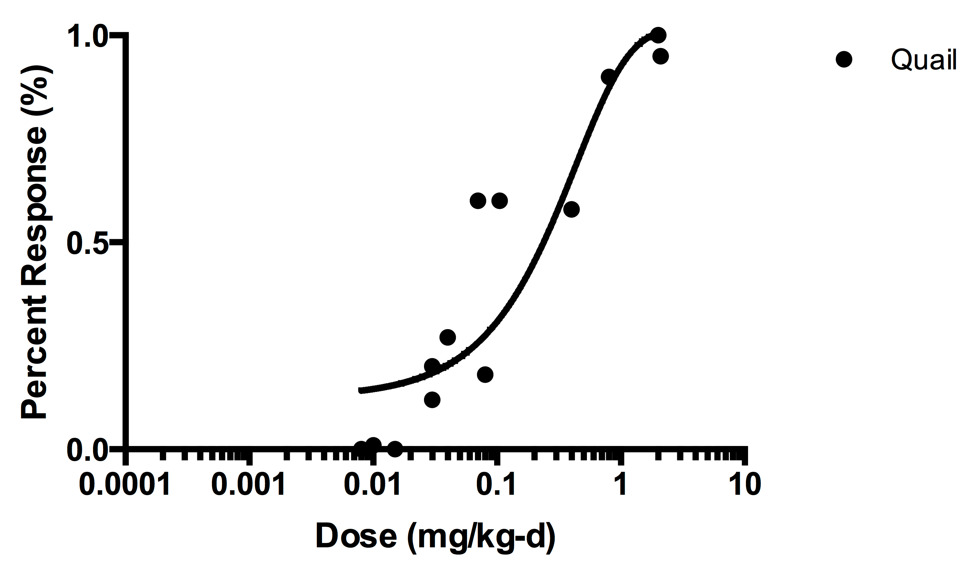

Figure 3 – Single species dose-response curve

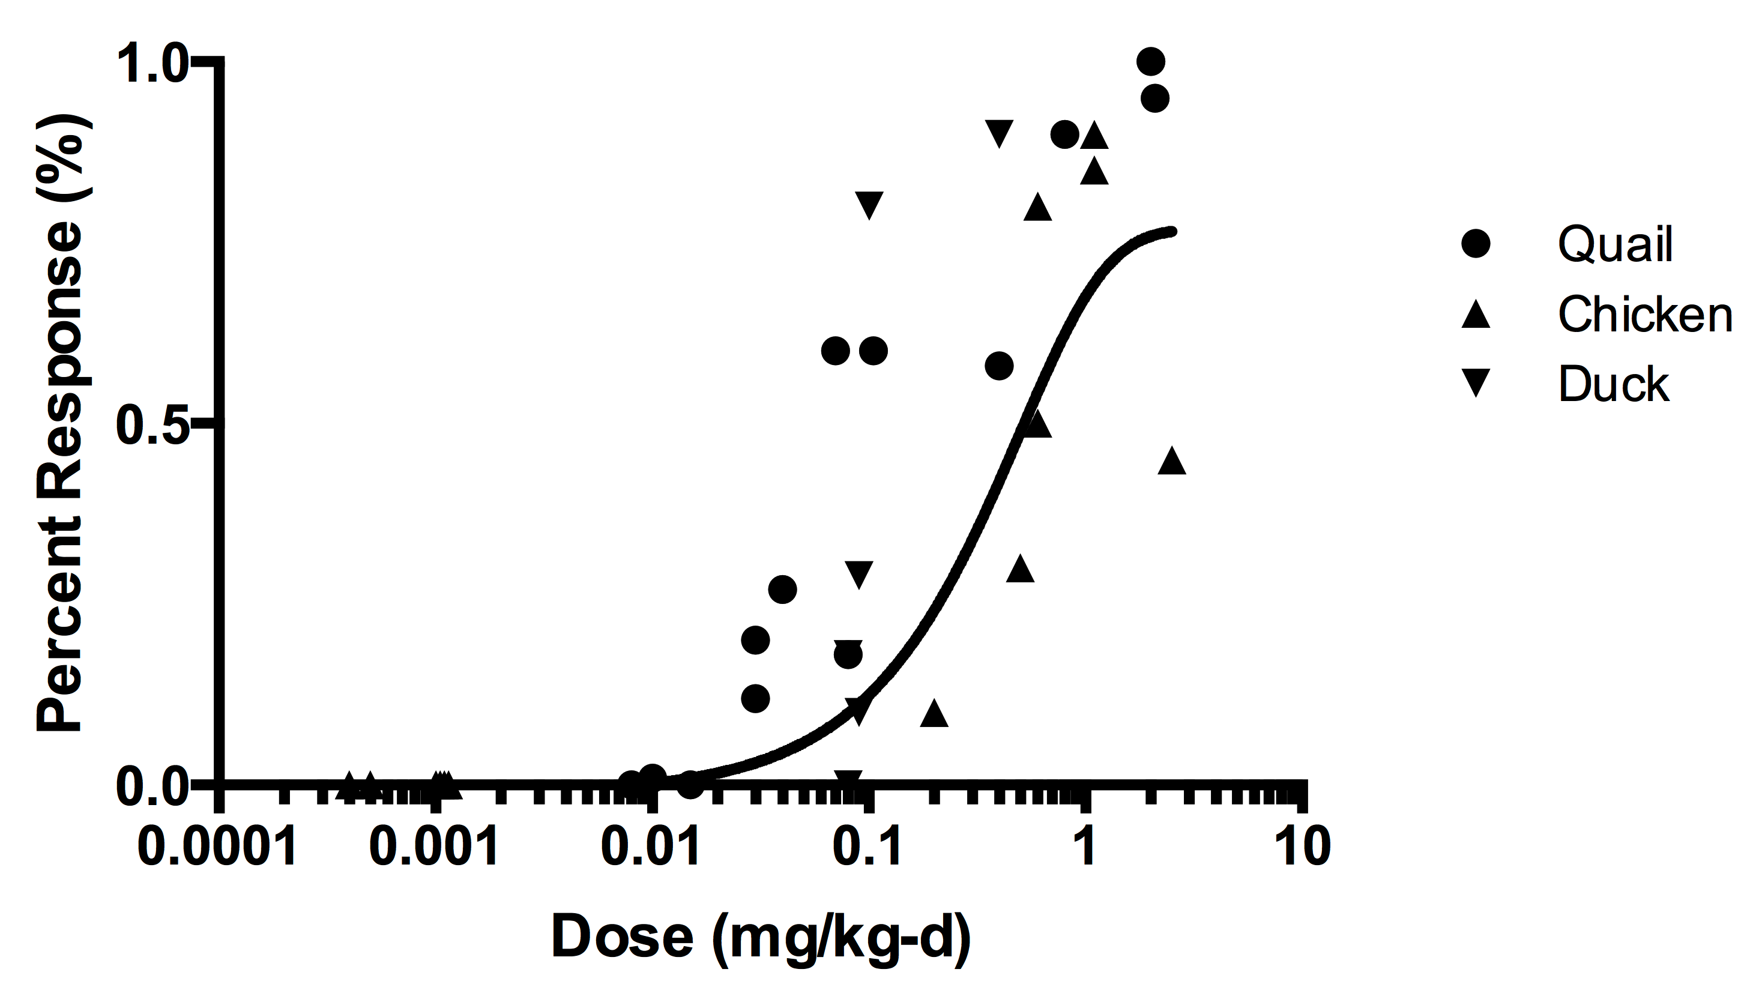

Figure 4 – Multi species dose-response curve

The NOAEL/LOAEL approach is the less preferred approach because it does not utilize the entire dose-response curve and is dependent on the doses chosen for the toxicity study. This approach produces two TRVs – the TRVNOAEL and the TRVLOAEL. The TRVLOAEL is the lowest bounded LOAEL associated with effects on growth, reproduction, and mortality endpoints. The TRVNOAEL is defined as the highest bounded NOAEL lower than the TRVLOAEL for the same population endpoints (CHPPM, 2000). The US EPA utilized the NOAEL/LOAEL approach to derive NOAEL-based TRVs for the ecological soil screening levels.

4.1.2 Species Sensitivity Distributions

Species sensitivity distributions are utilized to derive a TRV protective of communities rather than individual species. The distribution is created by plotting the concentration for a specific endpoint (e.g., EC10, IC25, LC50) for multiple species on a cumulative distribution plot (Figure 5). The distribution helps determine the range of sensitivities for representative species in the ecosystem and results in a TRV protective of the entire community. The 5th percentile concentration on the distribution is selected as the TRV and is considered protective of 95% of the species at the site. Species not represented in the distribution may or may not be protected at this TRV.

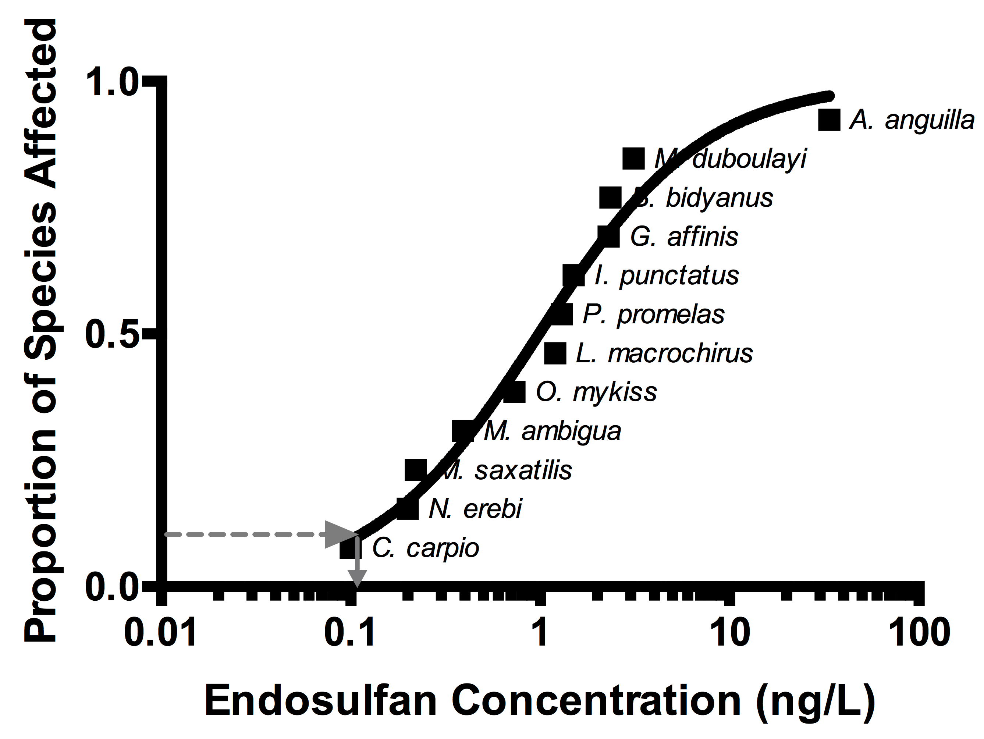

Figure 5 – Freshwater fish species sensitivity distribution for acute exposure to endosulfan (96-hour LD50 values). The 5th percentile of this distribution (the concentration where 5% of the species are affected) is approximately equal to 0.1 ng/L. *data source: CCME, 2010*

4.1.3 Extrapolation of the TRV to Florida-Specific Receptors

Because test species do not usually match the species present at a site, TRVs may need to be extrapolated to protect Florida species. Allometric scaling or the application of uncertainty factors may be used to adjust the TRV. TRVs should not be extrapolated across taxonomic class (e.g., mammals to birds) with the exception of the extrapolation of an avian TRV to reptiles when an endangered species is exposed and reptile toxicity information is nonexistent.

*4.1.3.1 Allometric Scaling*

Allometric scaling accounts for different body weights between the test species and the species of concern. For birds, the scaling factor is not significantly different from 1 and no adjustment is needed. For mammals, it can be calculated based on the following equation:

$${NOAEL}_{F }={NOAEL}_{T}×{\left(\frac{{BW}_{T}}{{BW}_{F}}\right)}^{\frac{1}{4}}$$

where:

NOAELF = NOAEL for a Florida species

NOAELT = NOAEL for a test species

BWF = body weight of a Florida species

BWT = body weight of a test species

*4.1.3.2 Uncertainty Factors*

Uncertainty factors (UFs) can be utilized to account for uncertainty in extrapolation between endpoints and exposure duration. Uncertainty factors relevant to the derivation of ecological TRVs include (CHPPM, 2000; US EPA, 1999):

1. A UF of 10 is applied to extrapolate a LOAEL to a NOAEL.
2. A UF of 10 is applied to extrapolate from a subchronic to chronic exposure duration.
3. A UF of 100 is applied to extrapolate an acute lethal value (e.g., LC50) to a NOAEL.

*4.2 Biological Surveys*

Biological surveys compare communities and populations from a contaminated area to those in a reference area. In order for the variation between the site and reference metrics to be representative of the effects of exposure, the reference properties must be stable and consistent across similar uncontaminated areas (Suter, 2007). Biological surveys help determine if a community or population is impaired from exposure to one or more contaminants. Because they include stressors and exposures that may not be apparent, the cause for a change in community metric is not always clear. If biological survey data show a statistically significant decrease of 20% or more in abundance, production, or diversity, the decrease is considered ecologically significant and will likely result in adverse effects at the population level. If statistically significant effects are noted with less than a 20% decrease in community metrics, the effects are not likely to cause a decline in the population over time. Methodologies for biological community sampling in Florida are described in standard operating procedure [FS 7000](http://publicfiles.dep.state.fl.us/dear/sas/sopdoc/2008sops/fs7000.pdf) (FDEP, 2008)

*4.3 Toxicity Testing*

Site-specific toxicity testing includes both field and laboratory studies and can be performed for any media that represents an exposure concern. In the State of Florida, toxicity testing is primarily used to estimate the toxicity of sediments at sites where bioavailability or the presence of multiple contaminants is of concern. Whole-sediment and pore-water toxicity testing in Florida follows the methodology outlined in [*A Guidance Manual to Support the Assessment of Contaminated Sediments in Freshwater Ecosystems, Volume III*](http://epa.gov/grtlakes/sediment/Vol3.pdf)(MacDonald and Ingersoll, 2002). Recommended toxicity test methods are published in a memorandum available at <http://www.dep.state.fl.us/waste/quick_topics/publications/documents/ToxicityTestMethodsJune242004.pdf> from the Florida Department of Environmental Protection. Toxicity testing for 10-14 days is considered an acute exposure while 28-60 days is considered chronic exposure. Acute exposure principally measures survival. Although growth is sometimes reported, it is not a sensitive endpoint due to the short exposure period. Chronic exposure periods are sensitive indicators of toxicity for growth, emergence, and reproduction endpoints (MacDonald and Ingersoll, 2002).

Florida-specific recommendations on toxicity testing are not available for soil. However, methodologies for soil toxicity testing are summarized in [*Soil Toxicity and Bioassessment Test Methods for Ecological Risk Assessment*](http://oehha.ca.gov/ecotox/pdf/SoilTox120208.pdf) (CalEPA, 2009). Similar to biological surveys, a statistically significant decrease of 20% or more in survival, growth, or reproduction is considered ecologically significant and will likely result in adverse effects at the population level. If statistically significant effects are noted with less than a 20% decrease in toxicity metrics, the effects are not likely to cause a decline in the population over time.

*4.4. Probabilistic Ecological Risk Assessment*

If ecological risk estimates are significantly below or above the level of concern, the improvement in risk characterization created by a probabilistic risk assessment (PRA) are not likely to aid risk managers in decision making. The PRA is most useful when risks are at or near the level of concern. The methodology for performing a PRA in ecological risk assessment is similar to the methodology utilized in human health PRAs and is summarized in RAGS 3A (US EPA, 2001). A probability distribution function (PDF) can be defined for any exposure variable in the equation as long as sufficient data exist to support the distribution. The result of the analysis is a distribution of risk (represented by the hazard quotient) that would be expected in the population of concern.

Another use of ecological PRA is to compare the cumulative distribution of exposure concentrations to the species sensitivity distribution (Figure 6). This provides a quantitative estimate of the percentage of species at the site expected to exceed their TRV at a specified percentile on the exposure distribution (US EPA, 2001). For example, in Figure 6, the 90th percentile concentration at the site is equivalent to the 19th percentile on the species sensitivity distribution. This suggests that, for 90% of the affected area, 19% of the species (or less) will be adversely impacted by the exposure.

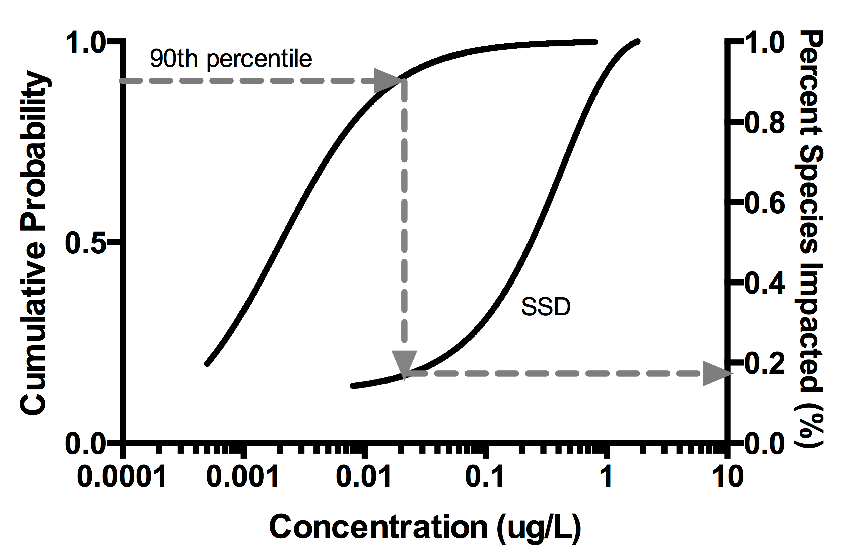

Figure 6 – Use of probabilistic risk assessment to determine the percent of species at risk. In this example, the site-specific 90th percentile chemical concentration in surface water is equivalent to the 19th percentile on the species sensitivity distribution (SSD).

**5. Risk Characterization**

Risk characterization utilizes dose and exposure estimates to evaluate the likelihood and severity of adverse effects from exposure to contaminants. It includes a quantitative and qualitative evaluation of the risk results. To be useful for informing risk management decisions, the risk characterization should directly relate to the assessment endpoint. Common methodologies utilized for the characterization of risk are described below.

*5.1 Hazard quotient & Hazard Index*

The hazard quotient is the ratio of the predicted exposure to an effect level. It is calculated as:

HQNOAEL = Dose/TRVNOAEL

HQLOAEL = Dose/TRVLOAEL

where:

TRVNOAEL = toxicity reference value for the NOAEL (mg/kg-d)

TRVLOAEL = toxicity reference value for the LOAEL (mg/kg-d)

HQNOAEL = hazard quotient for the NOAEL

HQLOAEL = hazard quotient for the LOAEL

Dose = estimated dose in mg/kg-d

If the hazard quotient exceeds 1, then the TRV is exceeded and adverse effects may occur. If the hazard quotient is less than 1, the estimated dose is less than the TRV and adverse effects are not expected.

*5.2 Additivity*

When chemical mixtures are present, additivity is used to estimate the total risk of exposure. There are two types of additivity: dose additivity and response additivity. Dose additivity is used in the calculation of toxic equivalents (TEQs) for chemicals with the same mode of action. Calculation of a hazard index is an example of response additivity. A hazard index is the sum of hazard quotients across all chemicals affecting the same organ system.

*5.2.1 Response Additivity*

The hazard index is calculated as:

${HI}_{i}=\sum{{HQ}_{x}}$

where:

HIi = hazard index for an organ system i

HQx = hazard quotient for exposure to a chemical that affects organ system i

If the hazard index exceeds 1, then the TRV is exceeded and adverse effects may occur. If the hazard index is less than 1, the total estimated dose is less than the TRV and adverse effects are not expected.

*5.2.2 Dose Additivity*

Dose additivity is most commonly utilized when toxic equivalencies are available for congeners of a parent chemical. In ecological risk assessment, dose additivity is utilized to calculate dioxin TEQs. The World Health Organization has adopted toxic equivalency factors (TEFs) for dioxin and dioxin-like PCBs in mammals, birds, and fish (Table 1). The TEFs are multiplied by the concentration of each detected congener to estimate an equivalent concentration of 2,3,7,8-TCDD. The 2,3,7,8-TCDD equivalent concentrations are added, resulting in a total equivalent 2,3,7,8-TCDD concentration (or dose).

*5.3 Weight of Evidence*

The weight of evidence approach relates multiple measurement endpoints to an assessment endpoint to determine if ecological risk is of concern (Simini et al., 2000). Measurement endpoints are considered multiple lines of evidence used to determine the likelihood and ecological significance of the exposure on the assessment endpoint. For the weight of evidence approach, a weight is assigned to each measurement endpoint depending on the severity and relevance of the endpoint. Professional judgment is often used to assign relative weights to each endpoint. Due to the subjectivity inherent in this method, it is preferable to establish criteria for interpreting the results before sampling takes place. This methodology incorporates uncertainty in a qualitative manner by comparing slight versus significant responses and lack of effect in assessment endpoints.

Table 1 – Toxic equivalency factors for dioxin and dioxin-like PCBs

|  |  |  |  |
| --- | --- | --- | --- |
| **Congener** | **Toxic Equivalency Factors** | | |
| **Mammals** | **Birds** | **Fish** |
| **Dioxins** | | | |
| 2,3,7,8-TCDD | 1 | 1 | 1 |
| 1,2,3,7,8-PeCDD | 1 | 1 | 1 |
| 1,2,3,4,7,8-HxCDD | 0.1 | 0.05 | 0.5 |
| 1,2,3,6,7,8-HxCDD | 0.1 | 0.01 | 0.01 |
| 1,2,3,7,8,9-HxCDD | 0.1 | 0.1 | 0.01 |
| 1,2,3,4,6,7,8-HpCDD | 0.01 | <0.001 | 0.001 |
| OCDD | 0.003 | 0.0001 | <0.0001 |
| **Furans** | | | |
| 2,3,7,8-TCDF | 0.1 | 1 | 0.05 |
| 1,2,3,7,8-PeCDF | 0.03 | 0.1 | 0.05 |
| 2,3,4,7,8-PeCDF | 0.3 | 1 | 0.5 |
| 1,2,3,4,7,8-HxCDF | 0.1 | 0.1 | 0.1 |
| 1,2,3,6,7,8-HxCDF | 0.1 | 0.1 | 0.1 |
| 1,2,3,7,8,9-HxCDF | 0.1 | 0.1 | 0.1 |
| 2,3,4,6,7,8-HxCDF | 0.1 | 0.1 | 0.1 |
| 1,2,3,4,6,7,8-HpCDF | 0.01 | 0.01 | 0.01 |
| 1,2,3,4,7,8,9-HpCDF | 0.01 | 0.01 | 0.01 |
| OCDF | 0.0003 | 0.0001 | <0.0001 |
| **Non-*ortho* PCBs** | | | |
| 3,3',4,4'-TCB (77) | 0.0001 | 0.05 | 0.0001 |
| 3,4,4',5-TCB (81) | 0.0003 | 0.1 | 0.0005 |
| 3,3',4,4',5-PeCB (126) | 0.1 | 0.1 | 0.005 |
| 3,3',4,4',5,5'-HxCB (169) | 0.03 | 0.001 | 0.005 |
| **Mono*-ortho* PCBs** | | | |
| 2,3,3',4,4'-PeCB (105) | 0.0003 | 0.0001 | <0.000005 |
| 2,3,4,4',5-PeCB (114) | 0.0003 | 0.0001 | <0.000005 |
| 2,3',4,4'5-PeCB (118) | 0.0003 | 0.00001 | <0.000005 |
| 2',3,4,4',5-PeCB (123) | 0.0003 | 0.00001 | <0.000005 |
| 2,3,3'4,4',5-HxCB (156) | 0.0003 | 0.0001 | <0.000005 |
| 2,3,3'4,4',5'-HxCB (157) | 0.0003 | 0.0001 | <0.000005 |
| 2,3'4,4',5,5'-HxCB (167) | 0.0003 | 0.00001 | <0.000005 |
| 2,3,3'4,4',5,5'-HeCB (189) | 0.0003 | 0.00001 | <0.000005 |

*source: (Van den Berg et al., 2006; Van den Berg et al., 1998)*

Florida utilizes a weight of evidence approach for interpreting sediment quality (MacDonald and Ingersoll, 2002). The sediment quality triad evaluates sediment chemistry, toxicity testing, and benthic assessment results to determine whether impacts to the benthic community are likely. The contingency table for this weight of evidence approach is shown in Table 2. Determining outcomes before sampling ensures that data interpretation is objective and independent of the results.

Table 2 – Contingency table for assessing impacts to aquatic life based on the sediment quality triad

|  |  |  |  |
| --- | --- | --- | --- |
| Sediment Chemistry | Toxicity Test | Benthic Community | Possible Conclusions |
| + | + | + | Impact highly likely |
| - | - | - | Impact highly unlikely |
| + | - | - | Impact unlikely |
| - | + | - | Impacts possible |
| - | - | + | Impacts unlikely |
| + | + | - | Impact likely |
| - | + | + | Impact likely |
| + | - | + | Impact likely |

*source: (MacDonald and Ingersoll, 2002)*

**6. Uncertainty Analysis**

Uncertainty should be addressed and analyzed for all phases of the ecological risk assessment. The uncertainty analysis summarizes the assumptions utilized for the assessment and evaluates the validity of those assumptions. When possible, the uncertainty in the risk estimate should be quantitatively evaluated using alternate risk calculations. Major sources of uncertainty include:

* Conceptual site model – exposure pathways, chemicals or concern, exposed ecological receptors
* Incomplete or missing data – causes parameter uncertainty when estimating chemical concentrations or exposure factors
* Modeling/extrapolation – modeling and extrapolation may not represent site-specific conditions.
* Sampling and laboratory error

**7. References**

ASTM (2009) *Standard Guide for Risk-Based Corrective Action for Protection of Ecological Resources.* West Conshohocken, PA, E2205/E2205M-02 (Reapproved 2009).

California Environmental Protection Agency (CalEPA) (2009) *Soil Toxicity and Bioassessment Test Methods for Ecological Risk Assessment.* Integrated Risk Assessment Branch, Office of Environmental Health Hazard Assessment.

Canadian Council of Ministers of the Environment (CCME) (2010) *Canadian Water Quality Guidelines for the Protection of Aquatic Life: Endosulfan.*

CHPPM (2000) *Standard Practice for Wildlife Toxicity Reference Values.* Environmental Health Risk Assessment Program, Health Effects Research Program, Technical Guide No. 254, Aberdeen Proving Ground, MD.

HydroQual, Inc. (2007) *Biotic Ligand Model, User’s Guide and Reference Manual.* Mahwah, NJ.

ITRC (2011) *Incorporating Bioavailability Considerations into the Evaluation of Contaminated Sediment Sites.* Interstate Technology & Regulatory Council, Contaminated Sediments Team, Washington, DC.

MacDonald, D.D. and Ingersoll, C.G. (2002) *A Guidance Manual to Support the Assessment of Contaminated Sediments in Freshwater Ecosystems, Volume III – Interpretation of the Results of Sediment Quality Investigations.* US Environmental Protection Agency, Great Lakes National Program Office, Chicago, IL, EPA-905-B02-001-C.

Ohio Environmental Protection Agency (OEPA) (2008) *Ecological Risk Assessment Guidance Document.* Division of Environmental Response and Revitalization, Columbus, OH.

Simini, M., Checkai, R.T., and Maly, M.E. (2000) *Tri-Service Remedial Project Manager’s Handbook for Ecological Risk Assessment.*

Suter II, G.W., ed. (2007) *Ecological Risk Assessment.* Second edition, CRC Press, Boca Raton, FL, pg. 347-356.

US ACE (2011) *Tri-Service Position Paper on Background Levels in Risk Assessment.* Environmental and Munitions Center of Expertise, Omaha, NE.

US EPA (1997) *Ecological Risk Assessment Guidance for Superfund*. Solid Waste and Emergency Response, Washington, DC, EPA 540-R-97-006.

US EPA (1999) *Screening Level Ecological Risk Assessment Protocol for Hazardous Waste Combustion Facilities, Volume One.* Office of Solid Waste, Washington, DC, EPA 530-D-99-001A.

US EPA (2001) *Risk Assessment Guidance for Superfund: Volume III – Part A, Process for Conducting Probabilistic Risk Assessment.* Office of Emergency and Remedial Response, Washington, DC, EPA 540-R-02-002.

US EPA (2007) *Framework for Metals Risk Assessment.* Office of the Science Advisor, Risk Assessment Forum, Washington, DC, EPA 120/R-07/001.

Van den Berg, M, Birnbaum, L, Bosveld, ATC, et al. (1998) Toxic equivalency factors (TEFs) for PCBs, PCDDs, PCDFs for humans and wildlife. *Environmental Health Perspectives* **106**(12), 775-792.

Van den Berg, M, Birnbaum, LS, Denison, M, et al. (2006) The 2005 World Health Organization reevaluation of human and mammalian toxic equivalency factors for dioxins and dioxin-like compounds. *Toxicological Sciences* **93**(2), 223-241.