Lake Vegetation Index
2023 Team Proficiency Report

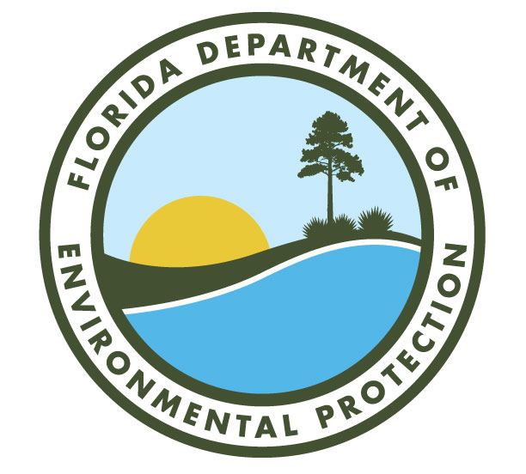

Division of Environmental Assessment and Restoration
Aquatic Ecology and Quality Assurance Section
2023

Executive Summary
Thirty-two teams participated in the 2023 Lake Vegetation Index (LVI) Team Proficiency exercise conducted at Otter Lake (5 teams), Lake Bryant (10 teams), and Lake Annie (17 teams). Thirty teams were within the acceptable score ranges (±12 points of the expert median) within the initial sampling period, and two teams retested outside of the sampling period but within the LVI index period, and were within the acceptable range. Variability in the results was associated with multiple factors: % FLEPPC 1 taxa and % sensitive taxa that diverged from the central tendency, and length of taxa lists/level of effort. The total number of taxa identified was highly variable at Lake Bryant and Lake Annie, but did not always affect comparability of scores. The total number of taxa identified at Otter Lake was less variable than the other lakes, and less variable than previous years’ exercises in the region. A sparse submersed community resulting from tannic conditions contributes to the tight range. Consistency in overall scores was variable among the three lakes. Score ranges were similar between Otter and Bryant, and both were similar to the lakes in their respective regions in the 2021 exercise. Lake Annie had a much larger range in scores than Otter or Bryant but was similar to the range in scores for Lake Rosalie, the south region lake in the 2021 exercise. Dominance selection was fairly consistent at each lake, although the selection of one dominant versus two co-dominants, and the (infrequent) selection of no dominants did contribute to variability. As in previous exercises, the lake in the south region had more variability in scores, as well as more variability in number of total taxa.

Introduction
The Lake Vegetation Index (LVI) is a rapid assessment of lake health based upon the lake’s aquatic and littoral zone plant community. To submit LVI data to the Florida Department of Environmental Protection (DEP), sampling teams must demonstrate proficiency in the LVI method by generating an LVI score that is within the acceptance criteria (± 12 points of median expert score), per DEP Standard Operating Procedure (SOP) LVI 1200. Expert teams used for setting the central tendency for 2023 were those teams that passed the 2021 LVI proficiency demonstration. Three lakes were sampled for LVI proficiency demonstration in 2023: Otter Lake in Wakulla County, Lake Bryant in Marion County, and Lake Annie in Polk County (Figure 1). The sampling time window for all lakes was June 1-June 30, 2023.
To “pass” the proficiency demonstration, the LVI score generated from the data collected by each team (expert or non-expert) was required to be within 12 points (+/-) of the median expert LVI score. Each participating team conducted the LVI at one lake, following the sampling SOP LVI 1100 (effective January 2017, https://floridadep.gov/dear/quality-assurance/content/dep-sops). SOP LVI 1100 also requires that at least one person on an LVI sampling team be proficient in plant identification, by annually taking and passing the DEP test of the most common lake plants for the LVI. Sampling maps were provided by DEP, but the teams followed a random procedure to choose their starting section and subsequent sections, as directed by the SOP. Teams recorded the observed vegetation in each of the four sampling sections. Plants that could not be identified with confidence in the field were collected and later identified in the lab, and when necessary, verified by an expert botanist. Teams then calculated their LVI scores per SOP LVI 2200, either by using the Statewide Biological Database (SBIO) (DEP teams) or the new LVI calculator (V.2 June 2023) provided by DEP https://floridadep.gov/dear/bioassessment/content/bioassessment-training-evaluation-and-quality-assurance).
This report describes the results of the 2023 LVI Proficiency Demonstration, with a comparison of team determinations of the LVI score and component metrics for each lake. Expert and non-expert teams should compare their scores to the expert scores to determine which elements may not be consistent with others’ assessments. Teams should use this exercise as a way to correct any observed methodological deficiencies or deviations from the LVI SOP. Additionally, issues that arise during these exercises may prompt DEP to revise the LVI SOP to enhance clarity and consistency. Demonstration of proficiency by being within the expert range for this exercise provides DEP with assurance that various sampling entities are producing comparable data.
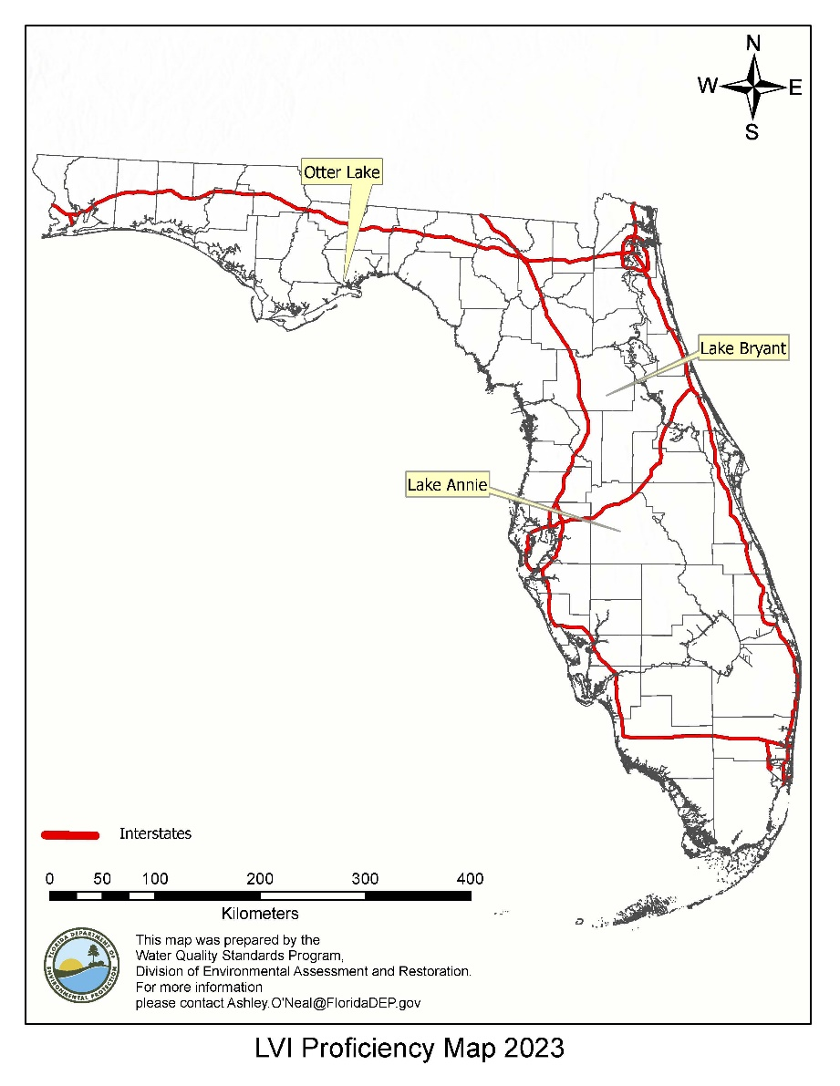
Figure 1. Location of lakes sampled for the LVI Proficiency Demonstration 2023.

Data Analysis
LVI scores were calculated per DEP SOP LVI 2200 and submitted to the DEP Aquatic Ecology and Quality Assurance Section (AEQAS). DEP sampling teams entered the data into SBIO, and AEQAS staff retrieved those data. All non-DEP teams used the Excel LVI calculator (V.2 June 2023) available on the FDEP website and sent completed files to AEQAS. The LVI score is calculated for each lake section for each team. The overall LVI score is the average of the four individual lake section scores. The LVI scores for each section are derived from four metrics: Percent Native Taxa (% Native), Percent Category I Invasive Exotic Taxa from the Florida Invasive Species Council (FISC), previously known as the Florida Exotic Pest Plant Council (FLEPPC) list (% FLEPPC I), Percent Sensitive Taxa (% Sensitive), and the Coefficient of Conservatism (CC) of Dominant/Co-dominant Taxa (CC_Dom_Codom). The median score of the expert teams was calculated for each lake. Per SOP LVI 1200, LVI scores that were within ±12 points of the expert median were considered acceptable. Mean metric data for each team are provided to help teams determine why their scores might have been different from the median; however, in the actual calculation of the LVI, metric scores are not averaged among sections.
Quality control protocols for data entry are in place for the new version of the LVI calculator (v. 2.0, June 2023) and for SBIO-entered samples, so manual checks for region and taxa presence/dominance were not performed prior to data analysis. For all samples, taxa that appear to be data entry errors or inappropriately entered (e.g. upland species) and scores that don’t appear to reflect the taxa lists or dominance choices, are flagged. The online registry and SurveyGizmo notifications are checked to verify that each team has at least one person who has passed the online plant test. If a major QC issue is evident, samples are returned to submitters for review and correction if needed.

Overall Results

Scores
Thirty-two teams conducted LVI assessments for the 2023 LVI Proficiency exercise during the June 1-30, 2023 testing window. Thirty teams successfully scored within ±12 points of the expert median during the initial exercise. All teams that sampled Otter Lake and Lake Bryant were within the passing range for the initial exercise, while two teams that sampled Lake Annie were out of range (one high and one low). The two teams who were out of range at Lake Annie both completed a re-test at Lake Bryant after the testing window and scored within the passing range. All thirty-two teams are thus eligible to submit LVI data to DEP. Table 1 contains summary statistics for all LVI scores. Any errors/inconsistencies with the SOP made by teams during the sampling or analysis phases are described below.
Table 1. Summary statistics of all LVI assessments conducted for the 2023 LVI Proficiency exercise.
Lake | Expert N | Expert Median | Passing Range | Total N | Median (all) | Mean (all) | Standard deviation (all) | Range (all)
Otter Lake | 5 | 66 | 54-78 | 5 | 66 | 68 | 6.8 | 61-78
Lake Bryant | 9 | 67 | 55-79 | 10 | 66 | 67 | 4.1 | 63-77
Lake Annie | 17 | 59 | 47-71 | 17 | 59 | 60 | 6.5 | 45-73

Selection of Dominant/Co-dominant Taxa
The CC score of the dominant taxon or the average CC score of two co-dominant taxa is one of the four LVI metrics. Previous LVI variability exercises have shown that the selection of the dominant or co-dominant taxa is one of the most important decisions made by a team conducting the LVI. The LVI SOP directs samplers to choose two co-dominants rather than a single dominant species if there is not one species that clearly comprises a majority of the areal coverage of plants. The choice of no dominant taxon or co-dominant taxa should be made only when 3 or more taxa are equally abundant or when plants are so sparse that no taxon is abundant.
Among the 34 LVI Proficiency samples (32 initial and 2 re-tests), there were a total of 136 sections assessed. Teams assigned a single dominant for 66 lake sections, two co-dominants for 65 lake sections, and did not assign any dominant for five lake sections. In many lake sections, there was strong consistency among teams in dominance selection, and when one dominant was selected, it appeared to be appropriate. At Otter Lake, for example, Taxodium was selected as a single dominant for ten of the twenty total sections (Table 4). At Lake Bryant, Panicum hemitomon was identified as the single dominant for Section 7, 8, or 9, by six teams (Table 7), and photos indicate it was abundant in many areas of the lake. In many cases, it appears that there was not a single obvious dominant species and the assignment of two co-dominants was the more appropriate choice. At Lake Annie, for example, Fuirena scirpoidea was selected as a co-dominant in 24 of 68 sections, often with Melaleuca quinquenervia or Nymphaea odorata (Table 10). The consistency in dominance /co-dominance selection in 2023 was good overall, and similar to previous years’ exercises.

Taxonomic Verifications
Most LVI samplers agree that taxonomic identification is the most difficult part of the LVI method, and that is why taxonomic verification by outside experts is an important part of the method. Overall, taxa lists were comparable, but additional plant training is needed in some taxonomic areas. Groups for which there were noticeable differences among teams were the genera Persicaria, Ludwigia, Cyperus, and Utricularia, small trees and shrubs with white, bottlebrush-shaped flowers (e.g., Itea virginica, Cliftonia monophylla), and wispy, submersed Eleocharis. In addition, the grass Sacciolepis striata and the macroalga Nitella were missed at Lakes Otter and Annie, respectively, despite evidence of their abundance. Although some variability in taxa observations is likely due to their patchiness throughout the lake and the chances of retrieving taxa with the frotus, the data suggest there were also incorrect identifications, and possibly insufficient sampling effort in some cases. Teams should review the discussions in the lake-specific sections below regarding which plants varied in ID at each lake and review the full taxa lists in Appendix A. It is important that teams collect taxa that require magnification for ID (see LVI Primer section 4.2.3 for that list: LVI Primer) and have an outside expert available for consultation on difficult identifications. The SOP requires either sample collection or photo documentation of the dominant or co-dominant taxa, in order to verify identification.

Determination of Lake Boundary and Taxa Inclusion Decisions
Determining the assessment area for the LVI and deciding which taxa are appropriate to include is an important part of the LVI method. There was notably high variability in the number of taxa identified by teams, especially at Lakes Bryant and Annie. The range in number of total taxa for Otter Lake, Lake Bryant, and Lake Annie was 12, 31, and 34, respectively. This variability can be due to differences in determining the lake boundary, variable access to certain areas of the lake, and variable levels of effort. In lakes that are shallow or have gradual shoreline slopes (e.g., Annie), the shoreline may be more accessible for shallower draft boats. A team with a smaller boat may identify more taxa in the emergent zone (which can be species rich). Alternatively, if the shoreline is not accessible by boat, some teams may make more effort than others to get out of the boat and find additional taxa. Per LVI SOP 1100 section 3.2.4, additional effort to access the shore should generally be limited to the transect within each lake section:
3.2.4. Identify a location within the sampling unit to set up a transect 5 m in width. Choose a location where you will be able to navigate the boat approximately perpendicular to the shoreline. Where possible, choose a location that is species rich and/or contains species which were not identified in section 3.2.3 above. At the shoreline, estimate 5 m for transect width. Orient the transect perpendicular to the shoreline, using the boat as the transect centerline. Record the presence of all aquatic and wetland plant species within the 5 m transect landward to the estimated seasonal high water mark of the lake (as practical, see Section 3.5 of LVI Primer). If practical, get out of the boat and wade to identify plants that are small, hidden or in areas too shallow to reach by boat. Record the presence of new species in the transect (species not already recorded in the “drive-by” portion described in 3.2.3 above)
The high variability among lakes is also notable and may be due to lake size (Otter Lake is approximately 141 acres, while Lake Bryant is 732 acres and Lake Annie is 455 acres), accessibility of shoreline areas, more taxa overall in the two peninsula lakes, and the number of teams that assessed each lake.
The determination of the assessment area is covered in section 3.5 of the LVI Primer. Here are key guidelines for determining the assessment area:
- The assessment area should be to the seasonal high water level, defined as “the elevation to which the groundwater and surface water can be expected to rise in a normal wet season”
- The following hydrologic indicators, used with reasonable scientific judgment, can be used to estimate the seasonal high water level: algal mats, aquatic mosses and liverworts, aquatic plants, rafted debris lines, elevated lichen lines, morphological plant adaptations, and water marks. These indicators are useful in determining if plants are indeed “in the lake.”
- Do not include plants in woods or lawns above the seasonal high water level.
- Plants at the shoreline in saturated soil should be included.
- In the case of sites with extensive fringe wetlands (swamps or marshes), do not include plants in those areas (even though they are within seasonal high water) if they are inaccessible from the boat.

Only aquatic and wetland plant taxa should be included in the LVI assessment. Both SBIO and the new LVI calculator (V. 2.0 June 2023) exclude upland plants from LVI calculations. It is still important to understand the key guidelines:
- Aquatic plants include all floating and submersed taxa (any plant which typically floats on water or requires water for structural support).
- For most emergents and all woody taxa, you must determine the wetland status, and include only taxa which have a wetland status of obligate (OBL), facultative wetland (FACW), or facultative (FAC).
- Do NOT include upland taxa. Pinus elliottii (slash pine) is the exception.
- Vines should be included ONLY if they are rooted in saturated soils, creeping out onto the water, growing intermixed with emergent vegetation, or covering a large portion of shoreline shrubs or trees that are part of the assessment. In addition to using the appropriate lake boundary and including only aquatic and wetland taxa, it is important to maintain consistency among teams in the level of effort. In the “drive-by” portion of the method, “you should not leave the boat or spend effort on difficult to access areas” (LVI SOP 3.2.3). Only during the transect portion of sampling each section should you spend additional effort: “if practical, get out of the boat and wade to identify plants that are small, hidden or in areas too shallow to reach by boat.” (LVI SOP 3.2.4).

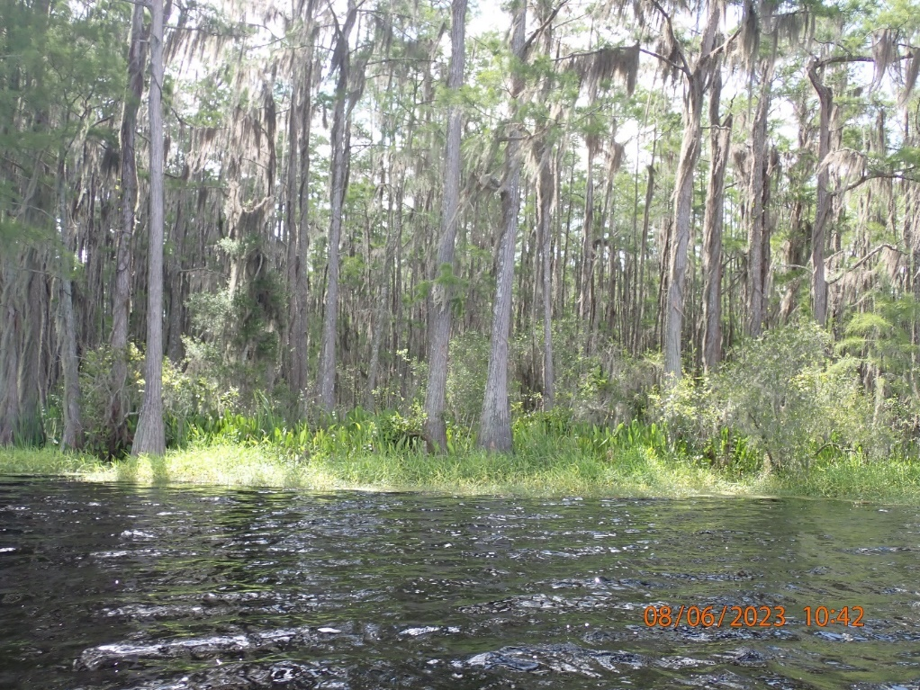
Figure 2. Shoreline of Otter Lake on 6/8/2023 with representative woody and emergent strata (photo: DEP AEQAS).

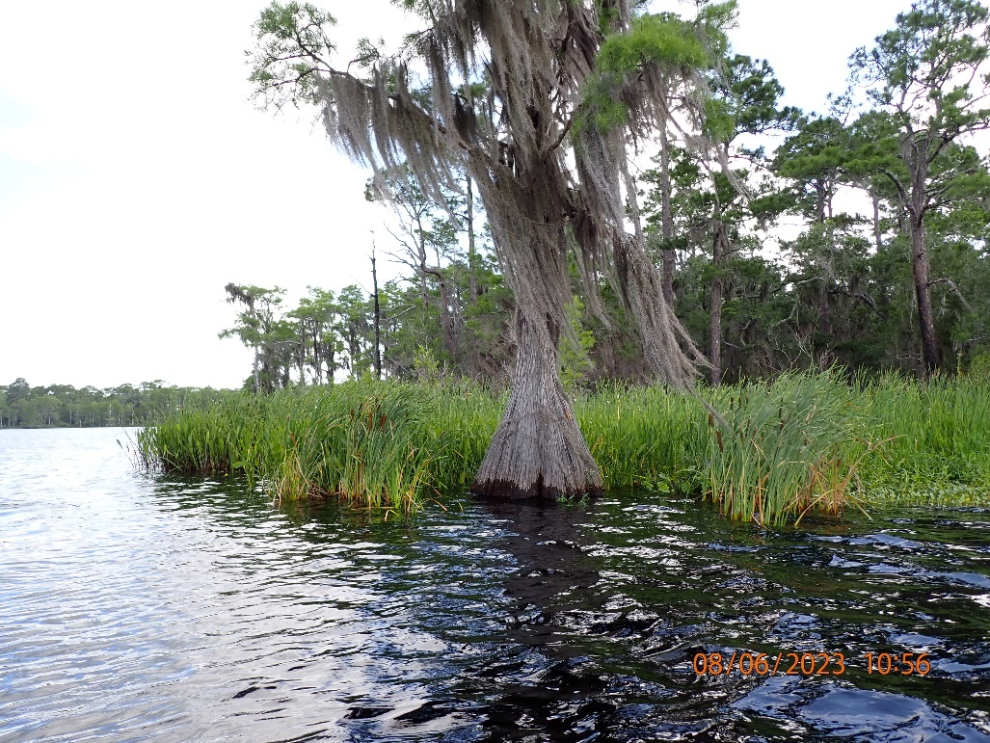
Figure 3. Shoreline near boat launch area at Otter Lake (photo: DEP AEQAS).

Results by Lake

Otter Lake Results
Otter Lake is an approximately 141-acre lake near Panacea, Florida, in the Panacea unit of the St. Marks National Wildlife Refuge. The lake is in the Gulf Coast lowlands lake region and has high color and low alkalinity. The primary land uses surrounding the lake are forested wetlands (Taxodium and Nyssa swamps) and flatwoods. There is one small pocket of low density residential land use on the east side of the lake, north of the boat ramp. The lake is characterized by a shoreline of woody, emergent, and floating taxa with very little submersed vegetation in the lake. The teams who sampled Otter Lake identified between 80% and 94% native taxa in the 4 sections each team sampled. Common shoreline woody taxa were Taxodium, Cephalanthus occidentalis, and Cyrilla racemiflora. Other woody taxa identified included Nyssa sylvatica biflora, Salix caroliniana, and Magnolia virginiana (Figure 2). Common floating taxa included Nuphar and Salvinia minima. Other floating taxa included Landoltia punctata, Lemna, and Nymphaea odorata. Common emergent taxa included Pontederia cordata, Sacciolepis striata, and Sagittaria lancifolia. Additional emergent taxa included Alternanthera philoxeroides, Cladium jamaicense, Echinochloa walteri, Hydrocotyle, Osmunda regalis, Persicaria punctata, and Typha (Figure 3). There were three FISC taxa observed at Otter Lake, Alternanthera philoxeroides (Cat 2), Salvinia minima (Cat 1), and Ludwigia peruviana (Cat 1). Water levels at Otter Lake were normal during the proficiency testing window.
Five teams, all expert from 2021, sampled Otter Lake in 2023 (Table 2) using the sampling map provided by DEP (Figure 4). Team LVI and metric scores and dominant taxa selections are shown in Tables 3 and 4. The median LVI score for Otter Lake teams was 66 and the acceptable range was 54-78. All teams were within the acceptable range. The total number of taxa observed at Otter Lake ranged from 24 to 36 taxa, while the overall average number (± 1 standard deviation) of taxa per section was 18.9 (± 2.1). The average metric values (± 1 standard deviation) per lake section across all teams were as follows: 87.4 (± 1.9) % Native, 5.8 (± 1.2) % FLEPPC Category 1, 12.6 (± 2.9) % Sensitive, and dominant/co-dominant C of C of 6.1 (± 0.6) (Table 3). See Appendix A for team taxa lists.
Table 2. Teams, team abbreviations, team members, expert status, and sampling date for Otter Lake 2023 LVI Proficiency demonstration.
Team | Team Abbreviation |  | Status | Date Sampled | Team Members
DEP-Tallahassee ROC |  | DEP TLH ROC | Expert | 6/20/2023 | Jade Burtchett, Paul Blair
DEP-Northwest ROC |  | DEP NW ROC | Expert | 6/22/2023 | Frank Butera, Christopher Slade, Nathan Mulkey, Lauren McNally, Hannah Henning
City of Tallahassee |  | City of TAL | Expert | 6/20/2023 | Ken Espy, Keith Lawhon
DEP-Watershed Assessment Section |  | DEP WAS | Expert | 6/8/2023 | Curtis Musson, Jennifer Piacente, Gus Fischer
DEP-Aquatic Ecology and Quality Assurance Section |  | DEP AEQAS 1 | Expert | 6/29/2021 | Sarah Noble, Ashley O’Neal, Aaryn Letson, Jackie Krebs

Table 3. Summary results for each team at Otter Lake, including final LVI score, total number of taxa observed, the average of each metric score, and the average number of taxa in the 4 sampling sections. The acceptable LVI score range was 54-78.
Team | Sections Sampled | LVI Score | Total Taxa | Mean # Taxa | Mean % Native | Mean % FLEPPC 1 | Mean % Sens. | Mean CC_  Dom_Codom
DEP NW ROC | 1,4,7,10 | 61 | 36 | 23 | 86.2 | 7.7 | 10.8 | 5.1
DEP AEQAS | 1,4,7,10 | 64 | 27 | 17.3 | 88.1 | 6.0 | 9.7 | 5.8
DEP WAS | 2,5,8,11 | 71 | 27 | 18.3 | 88.9 | 5.5 | 13.4 | 6.5
DEP TLH ROC | 2,5,8,11 | 65 | 24 | 17.5 | 84.2 | 5.8 | 11.2 | 6.3
City of TAL | 3,6,9,12 | 78 | 27 | 18.5 | 89.5 | 4.0 | 18.0 | 7.0

Table 4. Selected dominant or co-dominant taxa per lake section for each team at Otter Lake.
Team | Sections Sampled | Section 1,2,3 Dominants | Section 4,5,6 Dominants | Section 7,8,9 Dominants | Section 10,11,12 Dominants
DEP NWROC | 1,4,7,10 | Pontederia cordata/Sagittaria lancifolia | Pontederia cordata/Sacciolepis striata | Pontederia cordata/Sacciolepis striata | Pontederia cordata/Sacciolepis striata
DEP AEQAS | 1,4,7,10 | Taxodium | Taxodium/Sagittaria lancifolia | Taxodium/Sagittaria lancifolia | Taxodium/Sacciolepis striata
DEP WAS | 2, 5, 8, 11 | Taxodium | Taxodium/Sagittaria lancifolia | Taxodium | Taxodium
DEP TLH ROC | 2,5,8,11 | Taxodium/Sacciolepis striata | Taxodium | Taxodium | Taxodium/Sagittaria lancifolia
City of TAL | 3,6,9,12 | Taxodium | Taxodium | Taxodium | Taxodium

Otter Lake Dominance Selection
Dominance selection was generally very consistent at Otter Lake. Four of five teams selected Taxodium as a dominant or co-dominant taxon in all four sections, and four teams selected Sagittaria lancifolia as a co-dominant in at least one section. Three teams selected Sacciolepis striata as a co-dominant in at least one section (Figure 5). One team selected one dominant (Taxodium) for all four lake sections, and one team selected two co-dominants for all four sections (Pontederia cordata and Sacciolepis striata). The team that selected Taxodium as the single dominant for all sections was a bit of an outlier in scoring (high), although they were within the acceptable range. The remaining three teams selected a mix of co-dominants and dominants for all four sections. There were four taxa total chosen as co-dominants or dominants: Taxodium, Sagittaria lancifolia, Sacciolepis striata, and Pontederia cordata. Of the 20 total sections assessed, Taxodium (CC=7.0) was dominant or co-dominant for 16, Sagittaria lancifolia (CC=3) was co-dominant for five, Sacciolepis striata (CC=5.35) was codominant for five, and Ponteria cordata (CC=5.38) was co-dominant for four. All strata were represented in Otter Lake, although the submersed community was very sparse. The woody stratum was clearly dominated by Taxodium (CC=7); other observed woody taxa were Cephalanthus occidentalis (5 teams, CC=5.0), Cyrilla racemiflora (5 teams, CC=5.0), Salix caroliniana (4 teams, CC=2.95), and Nyssa sylvatica biflora (3 teams, CC=7.0). Commonly observed taxa in the emergent stratum included Sacciolepis striata (4 teams, CC=5.35), Pontederia cordata (5 teams, CC=5.38), Sagittaria lancifolia (5 teams, CC=3), Alternanthera philoxeroides (5 teams, CC=0), and Typha (5 teams, CC=1). Commonly identified floating taxa included Nuphar (5 teams, CC=3.5), Salvinia minima (5 teams, CC=0), Lemna (5 teams, CC=1), and Landoltia punctata (3 teams, CC=0). Submersed taxa were sparse, but included submersed viviparous Eleocharis (3 teams, CC=3), and two species of Utricularia, Utricularia floridana (1 team, CC=6.34) and Utricularia olivacea (1 team, CC=3.33).
The length of taxa lists at Otter Lake ranged from 24 to 36 total taxa. There were seventeen taxa identified by all, or nearly all, teams. Because Otter Lake is highly colored, with a sparse submersed community and a fringing Taxodium swamp, the taxa list length was less variable than at the other two testing lakes.
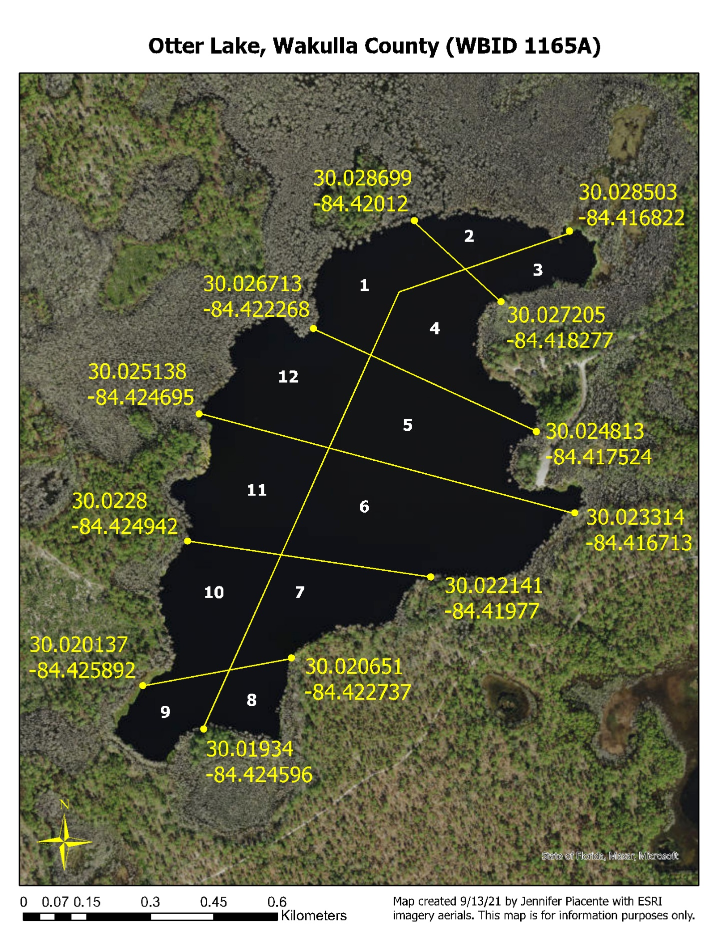
Figure 4. Lake Vegetation Index sampling map of Otter Lake.

Otter Lake Plant ID Discussion
All teams were within the acceptable scoring range, and the range was 17 points. In general, there was good accuracy and consistency in plant identification, but there were a few differences that are important to note. Twelve taxa were identified by all five teams: Alternanthera philoxeroides, Cephalanthus occidentalis, Cyrilla racemiflora, Hydrocotyle, Lemna, Nuphar, Osmunda regalis, Pontederia cordata, Sagittaria lancifolia, Salvinia minima, Taxodium, and Typha. An additional five taxa were identified by four teams: Echinochloa walteri, Mikania scandens, Sacciolepis striata, Salix caroliniana, and Spartina bakeri. A subset of commonly identified taxa at Otter Lake is shown in Figure 6. Other frequently identified taxa were Cladium jamaicense, submersed viviparous Eleocharis, Fuirena scirpoidea, Landoltia punctata, Nyssa sylvatica biflora, and Persicaria punctata. Thirty-one unique taxa each were identified by only one team. The large number of infrequently observed taxa likely is due to several factors, including the presence of small, easily overlooked taxa (Azolla filiculoides, Utricularia olivacea), variable identifications of Persicaria (three teams identified Persicaria punctata [Figure 7], one team identified P. hydropiperoides, and one team identified P. setacea, all in 3 or 4 sections; all three of these Persicaria species are similar looking), and variable identification of shrubs/small trees with white flowers (Leucothoe racemosa, Itea virginica, and Cliftonia monophylla were each identified by one team, in one or two sections). In addition, one team identified Ludwigia peruviana in all four sections. This identification is likely an error because L. peruviana is a large, usually obvious taxon and no other team identified it at Lake Otter. A field key to Persicaria is available here: Persicaria Field Key. Tips for distinguishing the species recorded for Otter Lake are as follows:
- Persicaria punctata—ocreae (sheaths on stems) have bristles; calices (green sepals around white petals) with yellow glandular dots; ~12-30 inches high; leaves lance-shaped, narrow but often wider than 1 cm.
- Persicaria hydropiperoides—ocreae have bristles; calices with NO glandular dots; plant small-medium, delicate-looking, ~12-30 inches high; leaves lance-shaped, narrow and usually not wider than 1 cm; hairs on tube of stipular sheath strongly appressed, stiff, bases attached to tube.
- Persicaria setacea—ocreae have bristles; calices with NO glandular dots; plant more robust generally than P. hydropiperoides; leaves 1.5 cm broad or more; hairs on tube of stipular sheath loose and spreading.

For identifying trees and shrubs around lakes with white, bottle brush-like flowers (e.g., Cliftonia, Cyrilla, Leucothoe, and Itea, Figures 8 and 9) refer to Woody Plants to know for LVI Sampling. The variable identification of the smaller woody taxa at Otter Lake may have been the result of patchy distribution (i.e., all, or nearly all were there, just few individuals unevenly distributed), misidentification because of the lack of flowers or fruits, or the challenge of identifying them from a distance. Otter Lake has an extensive fringing swamp, and it can be difficult to identify smaller trees or shrubs from the boat, when they are among or behind larger Taxodium. Eleocharis was another group that was variably identified at Otter Lake. Three teams identified ‘submersed viviparous Eleocharis,’ one team identified Eleocharis baldwinii, and one team identified Eleocharis. For guidance on the identification of thread-like, submersed Eleocharis, see the Lake Annie Plant ID discussion below.
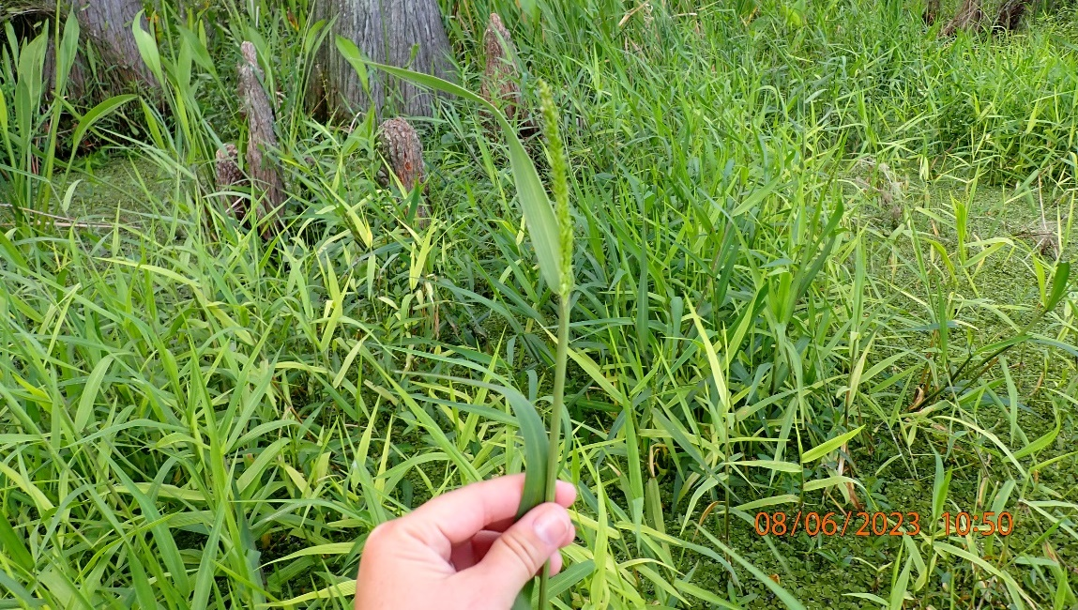
Figure 5. Sacciolepis striata, a frequently selected co-dominant taxon at Otter Lake (photo: DEP AEQAS).

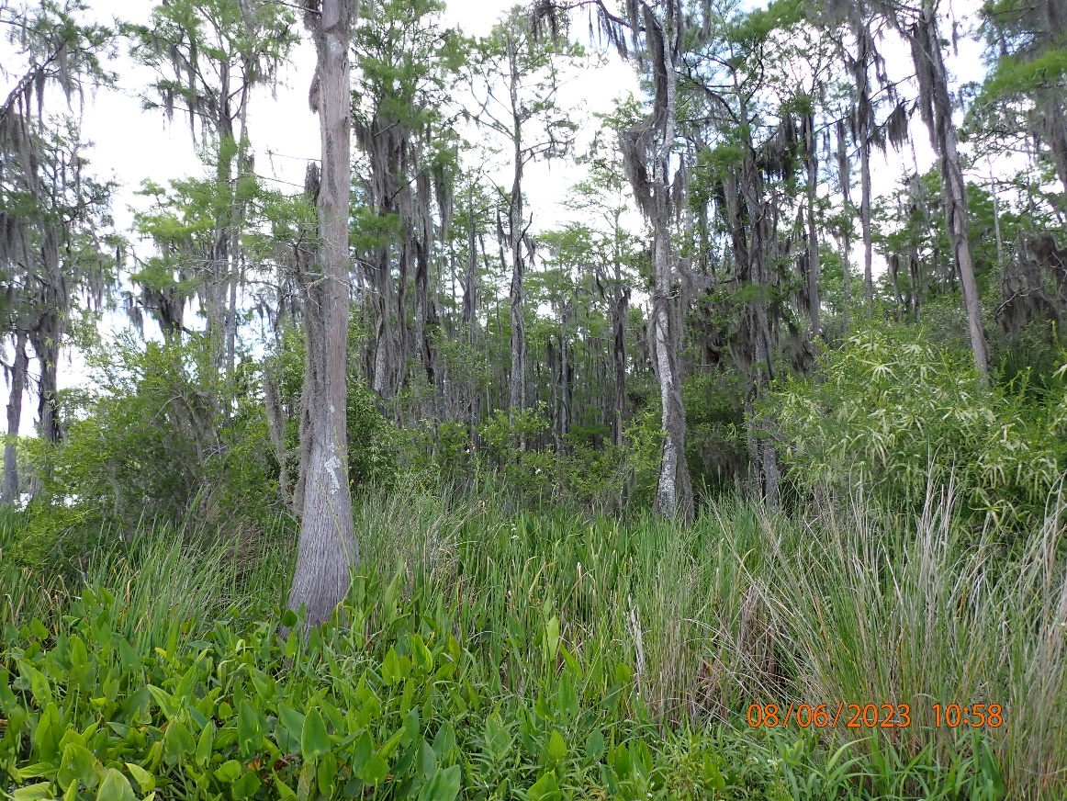
Figure 6. A shoreline view of Otter Lake, showing commonly identified taxa: Taxodium, Cyrilla racemiflora, Spartina bakeri, and Pontederia cordata (photo: DEP AEQAS).

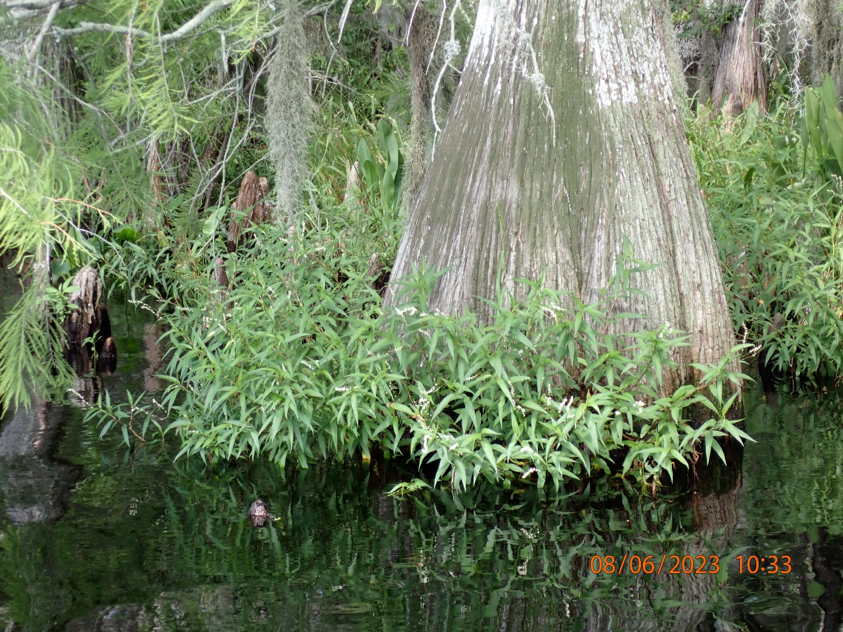
Figure 7. Persicaria punctata growing around the base of Taxodium, at Otter Lake on 6/8/2023 (photo: DEP AEQAS).

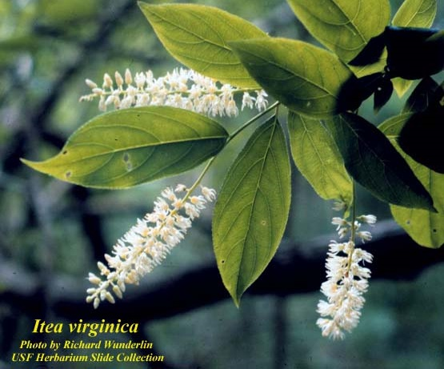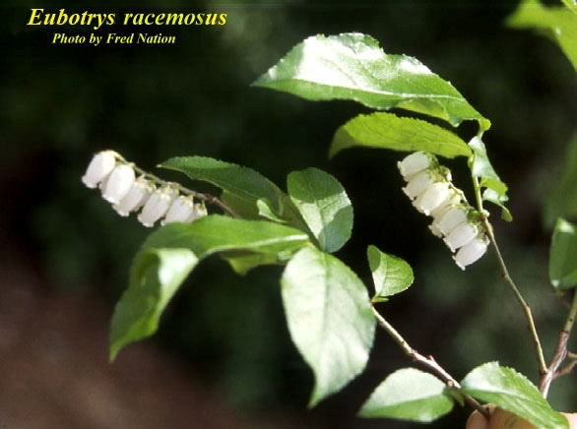
Figure 8. (left) Habit of Itea virginica (photo: Richard Wunderlin, Institute for Systematic Botany website) and (right) Leucothoe racemosa (syn: Eubotrys racemosus) (photo: Fred Nation, Institute for Systematic Botany).

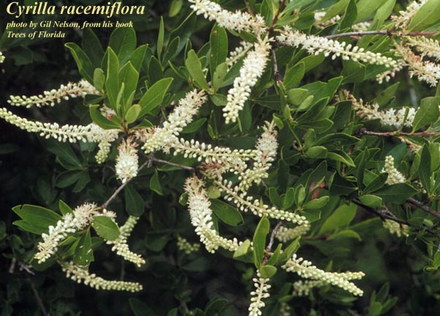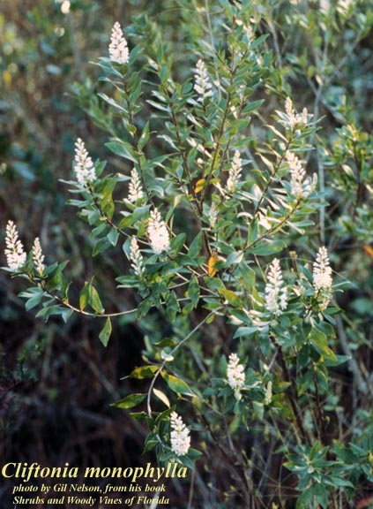
Figure 9. Cyrilla racemiflora (left) and Cliftonia monophylla (right) (photos: Gil Nelson, on Institute for Systematic Botany website).

Lake Bryant Results
Lake Bryant is an approximately 732-acre lake in Marion County, and is a low color, low alkalinity, and low nutrient lake in the Ocala Scrub lake region (Figure 10). The lake is within the Ocala National Forest and is surrounded by hardwood and cypress swamp, scrub, other lakes (Halfmoon, North Lake Bryant), and rural residential development. There is a public boat ramp on the southeast corner of the lake, on a canal that connects to the lake. The plant community at Lake Bryant is characterized by extensive woody, emergent, and floating zones. Submersed taxa are present, but not abundant enough to be selected as dominant or co-dominant. Common shoreline emergents included Cladium jamicense, Typha, Panicum hemitomon, Sagittaria lancifolia, and Pontederia cordata (Figure 11). Common woody taxa were Nyssa biflora, Cephalanthus occidentalis, Myrica cerifiera, Acer rubrum, and Salix caroliniana. The floating community was characterized by Nuphar, and included Nymphaea odorata, Salvinia minima, and Nymphoides aquatica.
Ten teams (nine expert teams) sampled Lake Bryant within the proficiency sampling period, and two teams sampled after the proficiency window but within the LVI index period. The two sampling events outside of the proficiency period were not included in establishing the central tendency. Team LVI and metric scores and dominant/co-selections from Lake Bryant are shown in Tables 6 and 7. The median LVI score for Lake Bryant expert teams was 67, and the acceptable range was 55-79. All teams were within the acceptable range. The overall average number of taxa (± 1 standard deviation) per section was 34.7 (± 5.0). The average metric values (± 1 standard deviation) per lake section across all teams were as follows: 90.5 (± 2.4) % Native, 7.0 (± 1.9) % FLEPPC Category 1, 14.73 (± 1.5) % Sensitive, and dominant/co-dominant C of C of 5.14 (± 0.9) (Table 6). See Appendix A for team taxa lists.
There was considerable variability among teams at Lake Bryant in the total number of plants identified at the lake, ranging from 44-77 taxa. The sample with 44 taxa was an anomaly, with the range being 54-77 and the standard deviation changing from 8.4 to 7.1 without that sample. It does not appear that the team with the fewest taxa missed an entire stratum of taxa (e.g. floating, or woody shoreline plants). Patchiness in the distribution of plants, lake sections with more species, or different levels of effort or expertise in species-rich areas likely were responsible for the differences.
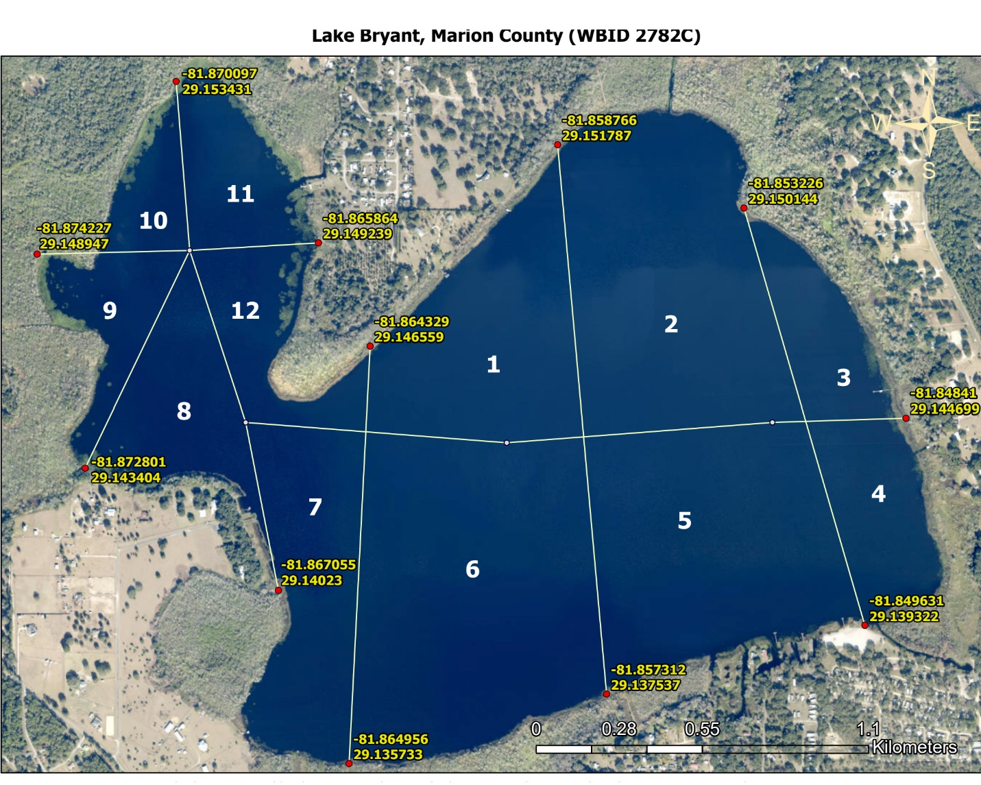
Figure 10. Lake Vegetation Index sampling map of Lake Bryant.

Table 5. Teams, team abbreviations, team members, expert status, and sampling date for Lake Bryant 2023 LVI Proficiency Demonstration.
Team | Team Abbreviation | Status | Date Sampled | Team Members
DEP – Aquatic Ecology and Quality Assurance 2 | DEP AEQAS 2 | Expert | 6/28/2023 | Jessica Patronis, Nia Wellendorf, Joy Jackson
Breedlove Dennis Associates | BDA | Expert | 6/26/2023 | Jake Lyons, Virginia Soumar, Teresa Marker
Noel Cawley | Cawley | Expert | 6/6/2023 | Noel Cawley
DEP – Northeast | DEP NE ROC | Expert | 6/6/2023 | Jeremy Parrish, Katrin Villinger, Katherine Halbert, Niki Barham
Orange County | Orange | Expert | 6/12/2023 | Michael Linger, Taina Torres, Rob Renk, Mike Drennan
Seminole County | Seminole | Expert | 6/27/2023 | Daniel Barber, Thomas Calhoun, Anthony Cintron, Chad Day
St. Johns River Water Management District | SJRWMD | Expert | 6/8/2023 | Dianne Hall, Kimberli Ponzio, Jodi Slater, Jennifer Mitchell, Anabelle Baggs
STANTEC | STANTEC | Expert | 6/8/2023 | Sheri Huelster, Brandon Wanner, Jay Stodghill, Evan Pormen
Water and Air Research | WAR | Non-Expert | 6/28/2023 | Peter NeSmith, Jim Surdick
WSP | WSP | Expert | 6/28/2023 | Shannon McMorrow, Erik Oij, Kevin Chaves
DEP-Central | DEP CEN ROC | Non-Expert | 10/9/2023 | Matt Bearden, Katie March, Victoria Schwartz
DEP-Southwest | DEP SW ROC | Non-Expert | 10/17/2023 | Devin Mathias, Kevin Grace, Ben Paswater

Table 6. Summary results for each team at Lake Bryant, including final LVI score, total number of taxa observed, the average of each metric score, and the average number of taxa in the 4 sampling sections. The acceptable LVI score range was 55-79.
Team | Sections Sampled | LVI score | Total Taxa | Mean # Taxa | Mean % Native | Mean % FLEPPC | Mean % Sensitive | Mean CC dom/codom
AEQAS 2 | 1,4,7,10 | 67 | 59 | 30.5 | 87.5 | 8.5 | 13.5 | 6.3
Cawley | 1,4,7,10 | 70 | 56 | 30.75 | 93.25 | 6.8 | 16.8 | 4.8
DEP NE ROC | 1,4,7,10 | 64 | 44 | 27.8 | 90.2 | 9.1 | 15.8 | 4.3
Orange | 1,4,7,10 | 67 | 60 | 37 | 91.5 | 6.3 | 12.8 | 5.2
Seminole | 1,4,7,10 | 65 | 58 | 31.8 | 87.5 | 10.5 | 15.8 | 5.8
DEP CEN ROC 2* | 1,4,7,10 | 67 | 57 | 34.5 | 89.8 | 7.6 | 13.6 | 5.8
DEP SW ROC 1* | 1,4,7,10 | 66 | 54 | 33.5 | 87.0 | 7.2 | 15.2 | 5.4
BDA | 2,5,8,11 | 65 | 68 | 37.5 | 90.75 | 6.5 | 12.5 | 5.0
STANTEC | 2,5,8,11 | 69 | 66 | 39.3 | 92.5 | 7.0 | 15.8 | 5.1
WAR | 2,5,8,11 | 63 | 77 | 44.5 | 88.8 | 5.8 | 13.5 | 3.9
SJRWMD | 3,6,9,12 | 65 | 59 | 35 | 88.8 | 5.3 | 15.0 | 4.3
WSP | 3,6,9,12 | 77 | 55 | 32.5 | 94.3 | 4.3 | 15.8 | 6.7
*retest sampling conducted in October 2023

Table 7. Selected dominant or co-dominant taxa per lake section for each team at Lake Bryant.
Team | Sections Sampled | Section 1,2,3 Dominants | Section 4,5,6 Dominants | Section 7,8,9 Dominants | Section 10, 11, 12 Dominants
AEQAS 2 | 1,4,7,10 | Cladium jamaicense/Panicum hemitomon | Cladium jamaicense/Panicum hemitomon | Panicum hemitomon | Cladium jamaicense/Nuphar
Cawley | 1,4,7,10 | Cladium jamaicense/Typha | Cladium jamaicense/Panicum hemitomon | Panicum hemitomon/Sagittaria lancifolia | Nuphar
DEP NE ROC | 1,4,7,10 | Typha | Cladium jamaicense/Panicum hemitomon | Panicum hemitomon | Nuphar
Orange | 1,4,7,10 | Cladium jamaicense/Typha | Cladium jamaicense/Panicum hemitomon | Panicum hemitomon | Nuphar
Seminole | 1,4,7,10 | Cladium jamaicense | Panicum hemitomon | Panicum hemitomon | Nuphar
DEP CEN ROC 2* | 1,4,7,10 | Cladium jamaicense/Panicum hemitomon | Cladium jamaicense/Panicum hemitomon | Panicum hemitomon | Nuphar
DEP SW ROC 1* | 1,4,7,10 | Cladium jamaicense/Typha | Cladium jamaicense/Panicum hemitomon | Panicum hemitomon | Nuphar/Pontederia cordata
BDA | 2,5,8,11 | Panicum hemitomon | Panicum hemitomon | No dominants | Nuphar
STANTEC | 2,5,8,11 | Cladium jamaicense/Panicum hemitomon | Panicum hemitomon/Sagittaria lancifolia | Cladium jamaicense/Sagittaria lancifolia | Nuphar
WAR | 2,5,8,11 | Nuphar/Panicum hemitomon | Nuphar | No dominants | Nuphar
SJRWMD | 3,6,9,12 | Nuphar/Panicum hemitomon | Panicum hemitomon | Nuphar | Sagittaria lancifolia/Sagittaria latifolia
WSP | 3,6,9,12 | Panicum hemitomon | Nyssa sylvatica biflora | Nyssa sylvatica biflora | Nyssa sylvatica biflora
*retest sampling conducted in October 2023

Lake Bryant Dominance Selection
There was good consistency in dominance selection among teams at Lake Bryant. There were seven taxa selected as dominant or co-dominant: Panicum hemitomon (CC=5.82), Nuphar sp. (CC=3.5), Cladium jamaicense (CC=8), Typha (CC=1), Sagittaria lancifolia (CC=3), Sagittaria latifolia (CC=3.5), and Nyssa biflora (CC=7). All nine expert teams selected Panicum hemitomon as dominant or co-dominant in at least one section, and it was selected as dominant or co-dominant in 24 sections out of the total 48 sections (including 2 retest samples). Cladium jamaicense was selected as dominant or co-dominant in 15 sections, Nuphar in 14 sections, Typha in 4 sections, Nyssa biflora and Sagittaria lancifolia in 3 sections, and Sagittaria latifolia in 1 section. Ten of twelve total teams selected Nuphar as dominant or co-dominant in their fourth section (10 or 11). It is worth noting that the two teams that did not select Nuphar in their last section sampled the same sections as each other (3, 6, 9, 12), and different from the other ten teams.
Two co-dominant taxa were chosen for 20 of 48 sections, one dominant taxon was chosen for 26 sections, and no dominance was assigned for two sections. The emergent, woody, and floating taxa zones were extensive throughout Lake Bryant (Figure 14). There were several floating species present, but only Nuphar was abundant enough to be chosen as a dominant or co-dominant. There were several submersed Eleocharis and Utricularia species identified, but no submersed taxa were chosen as dominant or co-dominant.

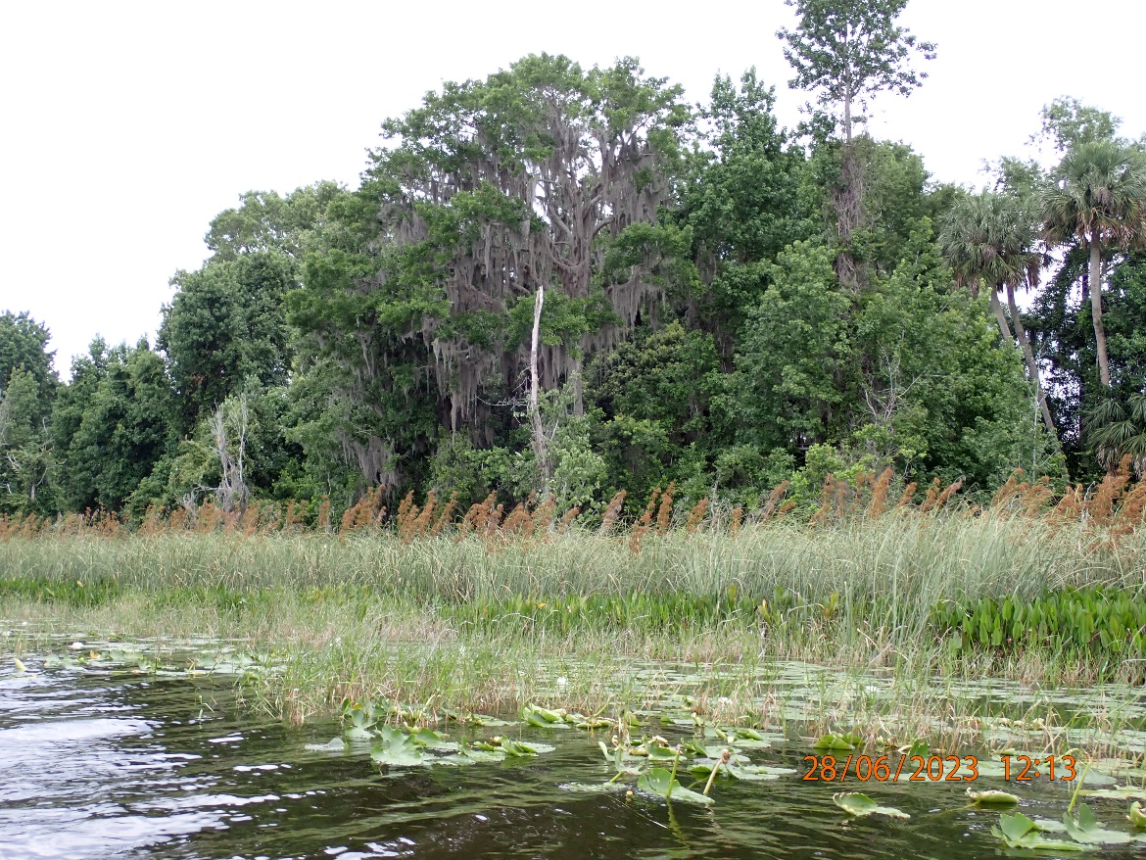
Figure 11. Shoreline photo of Lake Bryant, including Cladium jamaicense, Sagittaria lancifolia, Panicum hemitomon, Paspalidum geminatum, and Nuphar (photo: DEP AEQAS).
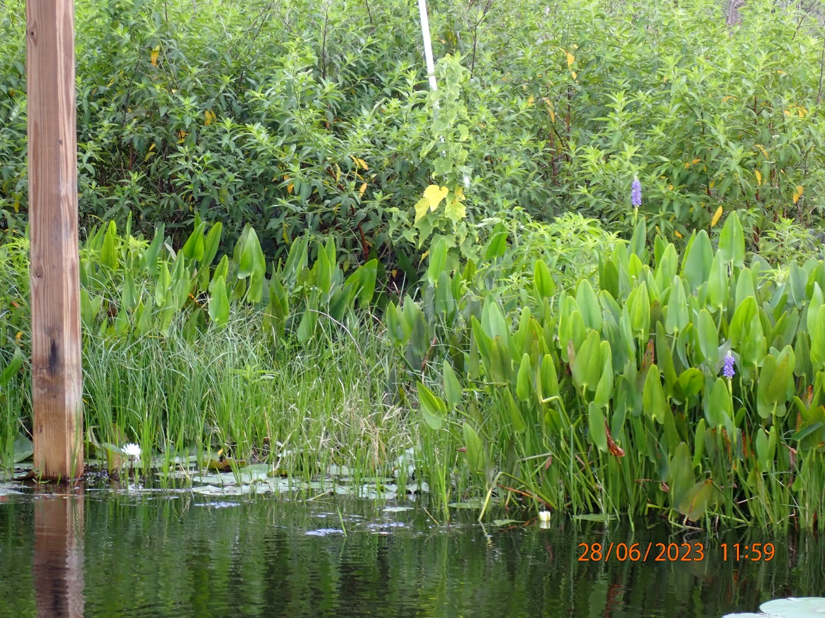
Figure 12. Photo of Lake Bryant, showing a section transect, with Ludwigia peruviana, Pontederia cordata, and Cyperus blepharoleptos (photo: DEP AEQAS).

Lake Bryant Plant Identification Discussion
Plant identification was generally consistent for Lake Bryant. All twelve teams identified the woody taxa Acer rubrum, Cephalanthus occidentalis, Myrica cerifera, Nyssa sylvatica biflora, and Salix caroliniana. Additionally, Ilex cassine, Ludwigia peruviana, Magnolia virginiana, and Taxodium were identified by ten or eleven teams. In the emergent stratum, all twelve teams identified Cladium jamaicense, Panicum hemitomon, Pontederia cordata, Sagittaria lancifolia, and Typha. Additionally, ten or eleven teams identified Eupatorium capillifolium, Panicum repens, Saururus cernuus, Alternanthera philoxeroides, Hydrocotyle, and Osmunda regalis. Nine teams identified Cyperus blepharoleptos, Fuirena scirpoidea, Amaranthus australis, and Colocasia esculenta. There were sixty three (!) species that were identified by only one or two teams, and they were infrequent across sections. Twenty-three sedge taxa, eleven species of Ludwigia and five species of Utricularia were represented. This is a higher than typical count for infrequently occurring taxa, but it is a large lake, and infrequent taxa don’t usually have a significant impact on the variation in LVI scores. The LVI is not intended to be a complete plant inventory, and differences due to patchy distribution and the different sections assessed are expected. The floating plants most commonly identified were Nuphar, Nymphaea odorata and Salvinia minima (all twelve teams), followed by Nymphoides aquatica (ten teams). Six teams identified the floating grass Luziola fluitans, and six teams identified Azolla filiculoides (syn. A. caroliniana). Submersed taxa were common, but less abundant than emergent and floating taxa. Ten teams identified Potamogeton illinoensis, eight identified Cabomba caroliniana, seven identified Utricularia gibba, six identified Hydrilla verticillata and Utricularia foliosa, and five identified submersed viviparous Eleocharis.
A plant group that was variably identified at Lake Bryant was Ludwigia. Eleven teams identified Ludwigia peruviana, which is not surprising because it is a large and easily identified nonnative species, with a shrubby habit, large cone shaped capsule that is almost as broad as long, and 4 showy petals that are larger than most species of Ludwigia. Ludwigia leptocarpa and L. octovalvis were identified by eight and seven teams, respectively. These two taxa are similar in size and habit, with the key differences being 5 (rarely 6, leptocarpa) versus 4 (octovalvis) calyx segments and petals (Figure 13). These taxa often grow together, and most teams who identified one, also identified the other. L. repens was identified by two teams. L. alata, L. arcuata, L. decurrens, L. maritima, L. palustris, and L. sphaerocarpa were each identified by one team, and no team identified more than one of these species. These species are relatively small in stature and patchy in distribution, so it is not unexpected that several were identified. There are, however, morphological similarities between L. repens and L. palustris, and between L. alata and L. sphaerocarpa, so there may be misidentification between these taxa. Aquatic and Wetland Plants of Southeastern United States--Dicotyledons (Godfrey and Wooten, 1981) provides the dichotomous keys, detailed descriptions, and drawings (for most species) needed to be able to differentiate similar-looking Ludwigia taxa. The Flora of North America website (Ludwigia - FNA (floranorthamerica.org) is another great resource for detailed species descriptions, and includes taxa more recently introduced to Florida (i.e., L. grandiflora, L. hexapetala).
Another plant group at Lake Bryant that was variably identified was the genus Utricularia. Utricularia was not abundant at Lake Bryant, and coefficient of conservatism scores among the species are similar, so variable identification of these species likely did not affect the LVI score much at Lake Bryant. It is still important to learn the differences among the species and identify them correctly. There are nine species of Utricularia that commonly occur in Florida lakes, and because their structure is not clearly separated into roots, stems, and leaves, they can be challenging to identify. Their dissected “branches” do take different forms, however, usually allowing for species level identification without flowers. Seven teams identified Utricularia gibba and six teams identified U. foliosa. U. radiata, U. inflata, and U. cornuta were each identified by one team. U. radiata and U. inflata are similar and may have been confused (Figure 14). To separate U. inflata from U. radiata, both of which produce a whorl of floating branchlets that support the flowering stalk, you must look at the lateral branches and determine whether they are symmetrical. They are symmetrical in U. radiata, but unequal in U. inflata (Figure 14). There are also other size and flower characteristics that are different among the two species. For a thorough comparison of the two species, please see: AQUATIC PLANT NOTES_Utricularia_inflata and radiata. U. cornuta is essentially a terrestrial species, with the branches within sandy or sandy-peaty substrate (Godfrey and Wooten, 1981). It can occur in lake margins and on floating islands in lakes, but would not be submersed in water and picked up on a frotus like the aquatic Utricularia species. For help in identifying the nine species of Utricularia common in Florida lakes, please see the Key to Utricularia in Florida Lakes.

It appears that Peltandra may have been misidentified as Sagittaria latifolia by three teams. Eight teams identified Peltandra, and one identified Peltandra virginica. Three teams did not identify Peltandra at all, but did identify Sagittaria latifolia, including one team who called it codominant in one section. These two taxa are easily confused. They have arrow-shaped leaves of similar size. When flowers are not present, the best way to distinguish them is by the leaf venation (Figure 15). Sagittaria latifolia has veins that radiate from a central point where the leaf attaches, giving the appearance of a spider. Peltandra has veins that are pinnate (lateral veins attach to the central vein). When flowers are present, they are easily distinguished. Sagittaria has a 3-petaled white flower with a yellow center, and they are whorled around the stem. Peltandra flowers have a yellow spike (spadix), surrounded by a white bract (spathe).
Paspalidum geminatum was a commonly identified grass at Lake Bryant that was missed by four teams. Eight teams identified it, typically in 3 or 4 sections, and it was verified by sampler photos (Figure 16). Paspalidium has long leaf blades, that are usually folded and appear thin. It has a drooping habit and the seedhead segments are ascending and on one side of the stem.
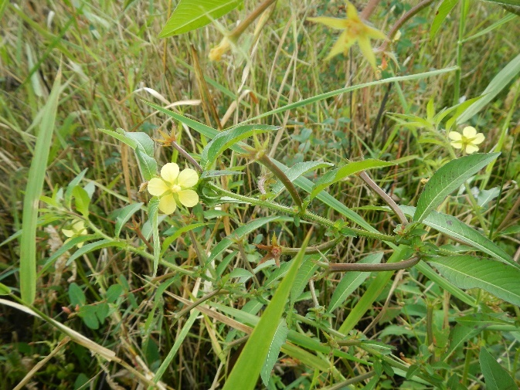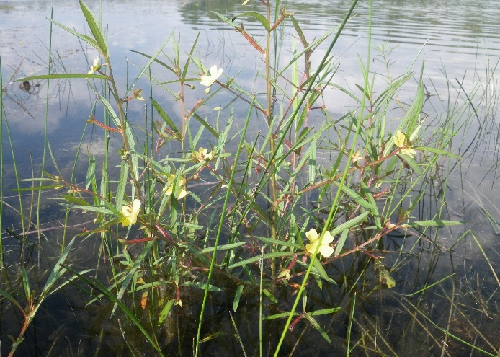
Figure 13. Similar species Ludwigia leptocarpa (left) and Ludwigia octovalvis (right) (both photos: DEP AEQAS).
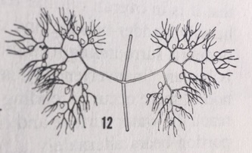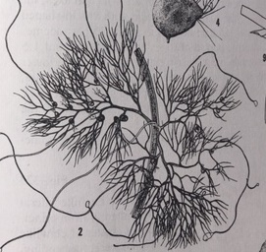
Figure 14. Submersed branching section of Utricularia radiata, showing symmetrical structure (left) and submersed branching section of Utricularia inflata, showing asymmetrical structure (right) (both images: Godfrey and Wooten’s Aquatic and Wetland Plants of Southeastern United States).

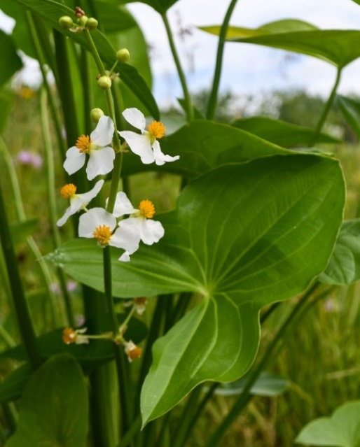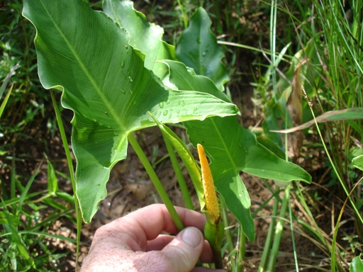
Figure 15. (Left) Sagittaria latifolia, note the radiating veins and whorled three-petaled flowers (photo: Prairie Moon nursery website); (Right) Peltandra virginica showing pinnate venation and yellow spadix (flower) (photo: Kiefer Nursery website)
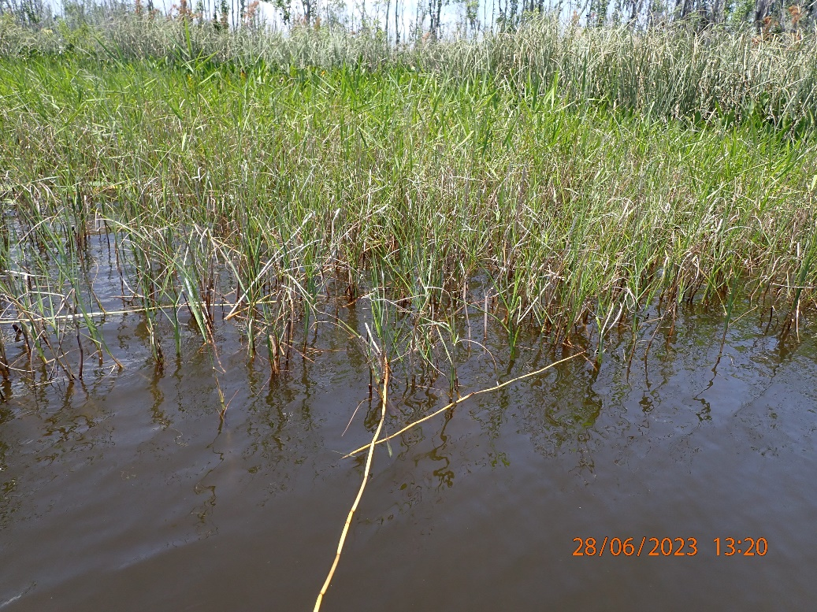
Figure 18. Paspalidium geminatum at Lake Bryant. (photo: DEP AEQAS)

Lake Annie Results
Lake Annie is an approximately 455-acre lake in central Polk County. Lake Annie is in the Northern Lake Wales Ridge lake region, and is clear, with moderate alkalinity and nutrients. Land uses around the lake include low and medium density residential development, freshwater wetlands, tree crops (citrus), and nurseries (Figure 19). Woody, emergent, floating, and submersed strata were all represented, and all of these growth forms were selected as dominants or co-dominants. The shoreline emergent community (Figure 20) included the grasses Panicum hemitomon, Panicum repens, and Paspalidium geminatum. Frequently occurring emergent sedges were Fuirena scirpoidea, Eleocharis cellulosa, and Cladium jamaicense. Other common emergent were Pontederia cordata and Typha. The woody zone was characterized by Acer rubrum, Melaleuca quinquenervia, Ludwigia peruviana, Salix caroliniana, and Cephalanthus occidentalis. Floating species included Nuphar, Nymphaea odorata, and Nelumbo lutea. Frequent submersed taxa were Potamogeton illinoensis, Najas guadalupensis, Nitella, Utricularia gibba, and Utricularia radiata.
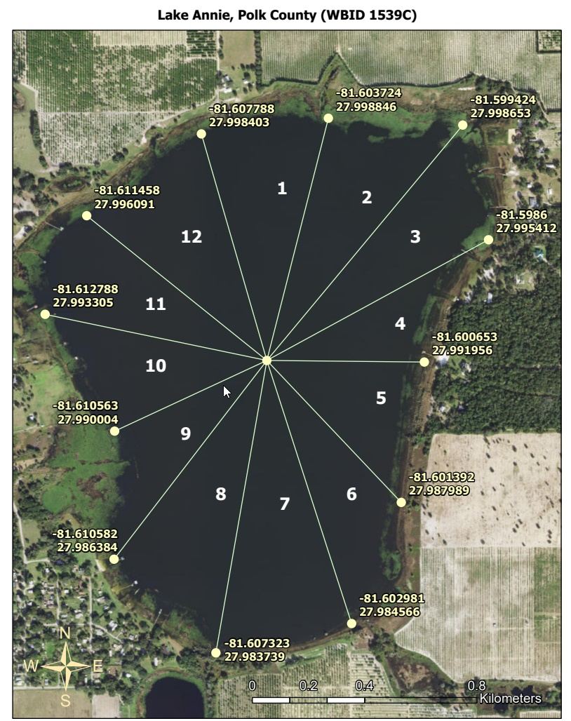
Figure 19. Lake Vegetation Index sampling map of Lake Annie. Created 05/05/2023 by the Water Quality Standards Program. This map is for information purposes only.

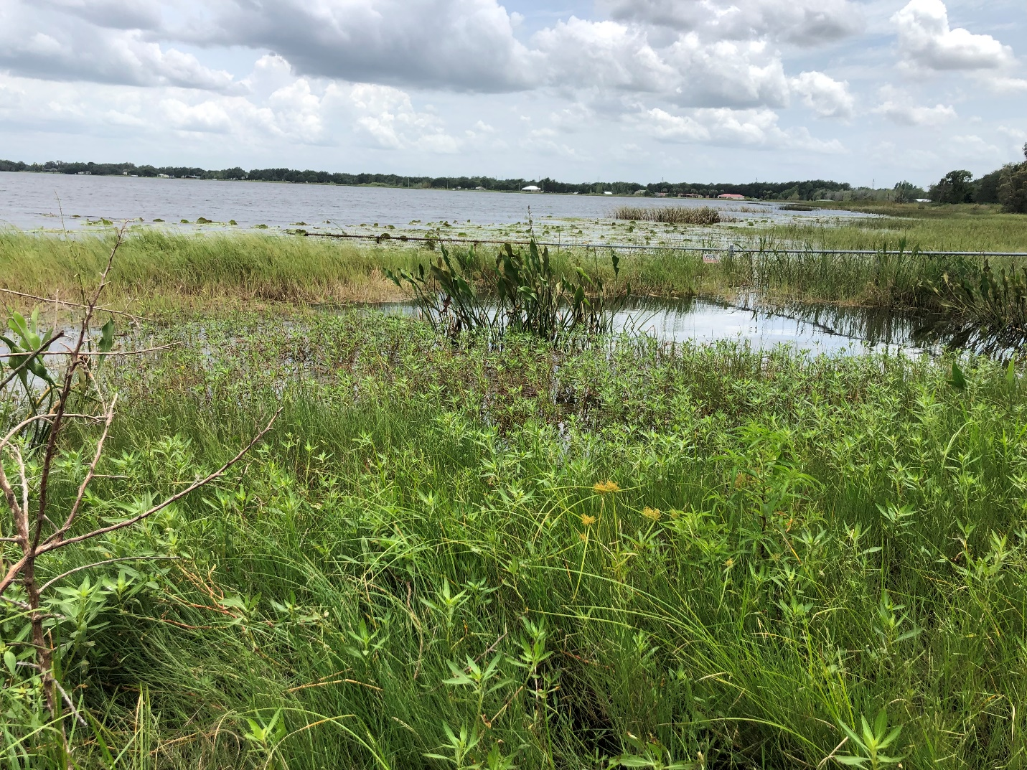
Figure 20. Shoreline of Lake Annie on 6/20/2023, near the boat ramp (photo: DEP AEQAS).
Seventeen teams (all expert) sampled Lake Annie within the sampling period (Table 8). Team LVI and metric scores and dominant selections from Lake Annie are shown in Tables 9 and 10. The median LVI score for Lake Annie teams was 59 and the acceptable range of LVI was 47-71. Fifteen teams were within the acceptable range, 1 team was below the acceptable range by 3 points, and 1 team was above the acceptable range by 1 point. The total number of taxa observed at Lake Annie ranged from 27 to 61 taxa, while the overall average number of taxa per section was 26.7. The average (± 1 standard deviation) metric values per lake section across all teams were as follows: 85.1 (± 2.7) % Native, 11.8 (± 2.2) % FLEPPC Category 1, 7.9 (± 2.6) % Sensitive, and dominant/co-dominant C of C of 4.9 (± 0.6) (Table 9). See Appendix A for team taxa lists.
Table 8. Teams, team abbreviations, team members, expert status, and sampling date for Lake Annie 2023 LVI Proficiency demonstration.
Team | Team Abbreviation | Status | Date Sampled | Team Members
DEP Central ROC 1 | CROC 1 | Expert | 6/6/2023 | Jessie Atchison, Leif Boman, Denver Bourassa, Terry Riordan
DEP Central ROC 2 | CROC 2 | Expert | 6/6/2023 | Matt Bearden, Katie March, Victoria Schwartz, Kaliina Warren
DEP Southwest ROC 1 | SWROC 1 | Expert | 6/14/2023 | Ben Paswater, Kevin Grace, Devin Mathias
DEP Southwest ROC 2 | SWROC 2 | Expert | 6/8/2023 | Megan Maloney, Sarah Meyer, Ken Turman
DEP South ROC | SROC | Expert | 6/15/2023 | Thomas Baker, John Barrington, Monica Jaeger, Nicole Reistad, Gary Snorek
DEP Southeast ROC | SEROC | Expert | 6/6/2023 | Jordan Skaggs, Andrew Luering, Tirzah Chichester, Charlie Hoey
Flatwoods Consulting 1 | FLATWOODS 1 | Expert | 6/20/2023 | Carrie Kelly, Camille Knight, Cole Palmer, Hallie Marshall
Flatwoods Consulting 2 | FLATWOODS 2 | Expert | 6/30/2023 | Michael Grzywacz, Ryan Countess, Matt Gonzalez, James Zweep
Highlands County | HIGHLANDS | Expert | 6/27/2023 | Michael McMillian, Sam Eriksen
City of Lakeland Utilities | LAKE UTIL | Expert | 6/29/2023 | Sarah Malone, Nicole Barber, Molly Klinepeter
City of Lakeland Lakes and Stormwater | LAKE STORM | Expert | 6/13/2023 | Emily McPartlin, Sandra Pope, Jessica Schilling, Cody O’Gorman
City of Orlando | ORLANDO | Expert | 6/28/2023 | Kari Lara-Murabito, Robert Duarte, Lisa Lotti, Bryan Rodriguez, Hannah Yucht, Nicholas Brown
City of Winter Park | WINTER | Expert | 6/22/2023 | Gloria Eby, Joey Cordell
Pinellas County | PINELLAS | Expert | 6/9/2023 | Rob Burnes, Alexandra Rieman, Nicole Maloney, Alex Manos, Christine Joyner
Polk County | POLK | Expert | 6/26/2023 | Chris Bolin, Garrett Tawes
Southwest Florida Water Management District | SWFWMD | Expert | 6/15/2023 | Kym Rouse Holzwart, TJ Venning, Jordan Miller
University of South Florida Water Institute | USF | Expert | 6/12/2023 | David Eilers, Karina Gonthier

Table 9. Summary results for each team at Lake Annie, including final LVI score, total number of taxa observed, the average of each metric score, and the average number of taxa in the 4 sampling sections. The acceptable LVI score range was 47-71.
Team | Sections Sampled | LVI Score | Total Taxa | Mean # Taxa | Mean % Native | Mean % FLEPPC | Mean % Sensitive | Mean CC_Dom_Codom
SWROC 1 | 1,4,7,10 | 73 | 56 | 29.3 | 87.2 | 7.5 | 11.8 | 5.4
SROC | 1,4,7,10 | 57 | 41 | 21.5 | 83.7 | 12.7 | 6.9 | 5.5*
FLATWOODS 1 | 1,4,7,10 | 59 | 49 | 26.8 | 86.0 | 11.0 | 8.3 | 4.1
SEROC | 2,5,8,11 | 57 | 35 | 20.8 | 83.4 | 12.1 | 8.6 | 4.3
CROC 2 | 2,5,8,11 | 56 | 38 | 22.8 | 84.8 | 13.3 | 6.3 | 4.7
FLATWOODS 2 | 2,5,8,11 | 58 | 46 | 23.8 | 87.5 | 10.8 | 4.0 | 5.1*
LAKE UTIL | 2,5,8,11 | 58 | 33 | 17.8 | 82.8 | 15.8 | 9.8 | 5.2
PINELLAS | 2,5,8,11 | 63 | 27 | 17.8 | 84.3 | 14.3 | 11.8 | 5.1
POLK | 2,5,8,11 | 55 | 56 | 35.3 | 80.5 | 10.5 | 6.5 | 4.6
USF | 2,5,8,11 | 63 | 41 | 24.8 | 86.8 | 10.3 | 7.5 | 4.9
HIGHLANDS | 3,6,9,12 | 67 | 61 | 41.8 | 87.0 | 10.5 | 8.8 | 5.6
CROC 1 | 3,6,9,12 | 45 | 46 | 26.3 | 79.1 | 15.9 | 1.6 | 5.4
LAKE STORM | 3,6,9,12 | 59 | 54 | 33.3 | 87.0 | 11.0 | 6.3 | 4.6
ORLANDO | 3,6,9,12 | 65 | 54 | 29.0 | 85.5 | 13.3 | 10.5 | 5.4
WINTER | 3,6,9,12 | 70 | 51 | 34.3 | 90.8 | 8.8 | 7.3 | 5.8
SWROC 2 | 3,6,9,12 | 62 | 34 | 20.3 | 86.7 | 10.6 | 10.1 | 4.0
SWFWMD | 3,6,9,12 | 56 | 43 | 27.8 | 83.2 | 12.3 | 8.5 | 4.0
*mean CC calculated with fewer than 4 CC scores (dominance assigned in fewer than 4 sections)

Table 10. Dominant and co-dominant taxa per lake section for each team at Lake Annie.
Team | Sections Sampled | Section 1,2,3 Dominants | Section 4,5,6 Dominants | Section 7,8,9 Dominants | Section 10,11,12 Dominants
SWROC 1 | 1,4,7,10 | Nymphaea odorata/Paspalidium geminatum | Fuirena scirpoidea/Nymphaea odorata | Fuirena scirpoidea | Fuirena scirpoidea/Pontederia cordata
SROC | 1,4,7,10 | No dominants | Fuirena scirpoidea | Fuirena scirpoidea | No dominants
FLATWOODS 1 | 1,4,7,10 | Cladium jamaicense/Panicum repens | Fuirena scirpoidea/Panicum repens | Eleocharis cellulosa/Fuirena scirpoidea | Utricularia gibba/Panicum repens
SEROC | 2,5,8,11 | Nymphaea odorata | Fuirena scirpoidea/Melaleuca quinquenervia | Fuirena scirpoidea/Potamogeton illinoensis | Fuirena scirpoidea/Typha
CROC 2 | 2,5,8,11 | Nymphaea odorata | Fuirena scirpoidea/Melaleuca quinquenervia | Fuirena scirpoidea | Fuirena scirpoidea
FLATWOODS 2 | 2,5,8,11 | Cladium jamaicense/Nymphaea odorata | Fuirena scirpoidea/Nitella | Nymphaea odorata/Typha | No dominants
LAKE UTIL | 2,5,8,11 | Cladium jamaicense/Nymphaea odorata | Fuirena scirpoidea | Chara | Chara/Fuirena scirpoidea
PINELLAS | 2,5,8,11 | Cladium jamaicense/Nymphaea odorata | Fuirena scirpoidea/Melaleuca quinquenervia | Fuirena scirpoidea | Fuirena scirpoidea
POLK | 2,5,8,11 | Nymphaea odorata/Nitella | Fuirena scirpoidea/Melaleuca quinquenervia | Fuirena scirpoidea/Nitella | Fuirena scirpoidea/Nuphar
USF | 2,5,8,11 | Nitella/Nymphaea odorata | Fuirena scirpoidea/Melaleuca quinquenervia | Fuirena scirpoidea | Fuirena scirpoidea/Nitella
HIGHLANDS | 3,6,9,12 | Nitella | Fuirena scirpoidea | Nymphaea odorata | Fuirena scirpoidea/Nitella
CROC 1 | 3,6,9,12 | Fuirena scirpoidea/Nymphaea odorata | Fuirena scirpoidea | Nymphaea odorata | Fuirena scirpoidea/Nitella
LAKE STORM | 3,6,9,12 | Fuirena scirpoidea/Nymphaea odorata | Fuirena scirpoidea/Panicum repens | Nymphaea odorata | Fuirena scirpoidea/Nymphaea odorata
ORLANDO | 3,6,9,12 | Fuirena scirpoidea | Fuirena scirpoidea | Nymphaea odorata | Fuirena scirpoidea
WINTER | 3,6,9,12 | Najas guadalupensis/Nitella | Nitella | Nitella/Nymphaea odorata | Nitella
SWROC 2 | 3,6,9,12 | Panicum repens | Fuirena scirpoidea | Nymphaea odorata | Fuirena scirpoidea
SWFWMD | 3,6,9,12 | Fuirena scirpoidea/Panicum repens | Fuirena scirpoidea | Nymphaea odorata | Fuirena scirpoidea/Ludwigia peruviana

Lake Annie Dominance Selection
There are several items to note about the decision-making regarding dominance selection among teams at Lake Annie. Lake Annie was a challenging lake for the assignment of dominance because there were multiple abundant emergent, submersed, and woody taxa. Of the 68 total sampling sections, 35 had two co-dominant taxa assigned, 30 had one dominant taxon assigned, and 3 had no dominance assigned. There were 15 unique taxa chosen as dominant or co-dominant. Five were submersed (Nitella, Najas guadalupensis, Potamogeton illinoensis, Chara, Utricularia gibba), five were emergent graminoids (Fuirena scirpoidea, Panicum repens, Paspalidum geminatum, Eleocharis cellulosa, and Cladium jamaicense), two were emergent herbaceous taxa (Pontederia cordata, Typha), two were woody (Melaleuca quinquenervia, Ludwigia peruviana) and one was a floater (Nymphaea odorata). Teams strongly favored Fuirena scirpoidea (41 of 68 sections, 16 of 17 teams) and Nymphaea odorata (19 of 68 sections, 15 of 17 teams) in selection of dominant and co-dominant taxa. Nitella was also frequently chosen as a dominant or co-dominant (11 sections, 6 teams). Less frequently selected were Panicum repens (6 sections, 4 teams), Melaleuca quinquenervia (5 sections, 5 teams), and Cladium jamaicense (4 sections, teams). Typha was selected twice, by two teams, and Chara was selected twice by one team. Paspalidium geminatum, Pontederia cordata, Potamogeton illinoensis, Najas guadalupensis, Ludwigia peruviana, Utricularia gibba, and Eleocharis cellulosa were all selected once, by one team. The results of dominance selection at Lake Annie indicate that there was good agreement on a few taxa, but most taxa selected as co-dominants or dominants were selected by just one or a few teams, for one or two sections.

Lake Annie Plant ID Discussion
Plant identification at Lake Annie was variable. All or all but one team identified the same 15 taxa, including four of the five most frequently assigned dominant taxa. Three teams did not identify the third most commonly assigned dominant taxon, Nitella. Less abundant taxa appear to be patchily distributed and/or variably identified. There was moderate variability in the number of total taxa, ranging from 27 to 61 taxa, with an average of 45 and a standard deviation of + 9.6 taxa. Twelve species of Cyperus were identified on Lake Annie. It is not uncommon to have multiple species of Cyperus present on a lake. Cyperus is a diverse genus and successful lake shoreline plant, and there are more than sixty species native or naturalized in Florida. Twelve species, however, is more than expected at a single lake, and may represent variable identifications rather than the presence of many species growing in patchy distribution. Except for Cyperus blepharoleptos, which forms dense stands and floating mats, most Cyperus form smaller patches and are restricted to the shoreline. Fourteen teams identified Cyperus odoratus, and eleven identified C. blepharoleptos (Figure 21). C. haspan and C. papyrus were each identified by six teams, C. lecontei and C. polystachyos were each identified by four teams, and C. esculentus was identified by two. Six additional Cyperus taxa were identified by only one team each. Many Cyperus are similar in habit, and can be confused, especially without magnification, which is needed to determine the structure of the spikelets and the appearance of the achenes. Cyperus is one of the genera the LVI Primer lists as requiring magnification to identify. Samplers are encouraged to refresh on getting to species level with Cyperus. Sedge and Rush Getting to Genus and Species is a helpful guide.
Teams were also divided on how many and which Eleocharis species were present. Fifteen of sixteen teams identified Eleocharis cellulosa, a robust species with a thick, smooth, somewhat spongy round stem. Most teams identified E. cellulosa in 2 or 3 sections. Eleven teams identified either “submersed viviparous Eleocharis” or Eleocharis vivipara. The identification of “Eleocharis vivipara” is likely a misunderstanding of guidance previously provided:
- Wiry, delicate specimens that have a submersed habit and produce new plantlets at the tips of their stems (vivipary) should be identified for the LVI as “submersed viviparous Eleocharis.” This includes Eleocharis baldwinii, Eleocharis vivipara, and Eleocharis acicularis. These species don’t produce flowers or fruits in their submersed habit.
Eleocharis elongata was identified by 4 teams, in either 3 or 4 sections. E. elongata is a long, wiry species with red rhizomes that can be submersed or emergent. It does NOT form new plantlets at the tips and its stems are much longer than those of submersed viviparous Eleocharis. Eleocharis geniculata and Eleocharis equisetoides were each identified by one team. Although Eleocharis was not a dominant taxon at Lake Annie, and did not have a strong influence on scoring, it is still important to identify these taxa correctly. Here are some identification resources: a newsletter, AQUATIC PLANT NOTES_Eleocharis and a field key, Aquatic Eleocharis Key.
Utricularia identification at Lake Annie was mostly consistent. Utricularia radiata was identified by fourteen of seventeen total teams, and U. gibba was identified by thirteen teams (Figure 22). Utricularia purpurea was identified by 2 teams, and U. resupinata, U. subulata, U. floridana, and U. inflata were each identified by 1 team. U. resupinata is tiny and easily missed, which may be why it was only identified by one team in one section. U. subulata was identified in three sections by one team; as it is not a common Utricularia in lakes, this may be a misidentification.
Nitella was missed by three teams, even though the remaining teams typically identified in most or all sections, and it was a frequently chosen co-dominant taxon. Nitella is a delicate but structurally complex macroalgae. Macroalgae (Nitella and Chara) are included in the LVI. Nitella can be identified by its bright green whorled branchlets (it does not have leaves). It most closely resembles Chara, but unlike Chara it has smooth stems and does not have a musky or garlicky odor. It can be found in small amounts growing on or with other submersed taxa, or can form an extensive submersed monoculture (Figure 23).
Ludwigia identification at Lake Annie was variable, although some identifications were consistent. All 17 teams identified Ludwigia peruviana. Ten teams identified L. octovalvis, and seven teams identified L. leptocarpa (see Figure 15 in the Lake Bryant section for a comparison). These two taxa are somewhat similar (alternate leaves, 8-10 stamens, similar size and habit), with the most obvious difference being four calyx segments (L. octovalvis) versus five-six (L. leptocarpa). They often grow together, and several teams identified both species, so there is not an indication that there were misidentifications. Other Ludwigia identified at Lake Annie included L. repens (5 teams), L. suffruticosa (3 teams), L. arcuata, L. linearis, L. peploides, and Ludwigia (unknown nativity) (all 2 teams each), and L. decurrens (1 team). Several teams identified 3 or more species, suggesting multiple species at the lake. There is an option to use the name “Ludwigia native” when Ludwigia flowers or fruits are absent but it is clear that the specimen is not one of the nonnative taxa (Ludwigia peruviana, or the Ludwigia grandiflora complex). Using “Ludwigia native” allows the plant to be included in the total taxa counts for the % native and % FLEPPC1 metrics, providing more information for the LVI than if it is identified at the genus level as “Ludwigia (unknown nativity).”
Fifteen teams identified Sagittaria lancifolia in all 4 sections, but one team at Lake Annie appears to have called Sagittaria lancifolia, “Sagittaria kurziana.” This was likely just a mix up with the names, or a data entry error (the taxa are one row apart in the vascular plant data entry in SBIO). It is important to QC every sample to catch these types of errors. Egeria densa was identified by one team at Lake Annie, and may have been confused with Hydrilla verticillata.
Overall, consistency was good on the identification of the grass species at Lake Annie. Panicum repens was identified by all seventeen teams, and was abundant, chosen as co-dominant in six sections by four teams. Paspalidium geminatum appeared to be more patchy, identified by seven teams, and chosen by one team as co-dominant in one section. Panicum hemitomon and Sacciolepis striata were identified by thirteen and eleven teams respectively (several teams identified both species), but neither was assigned as dominant or co-dominant. For assistance in identification of the common lake grass species, please see the presentation Field Identification of Common Grasses, here: https://floridadep.gov/dear/bioassessment/content/plant-identification-resources.
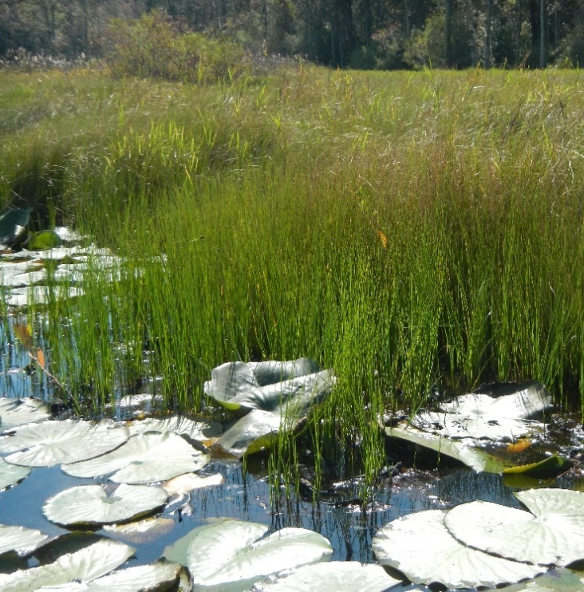
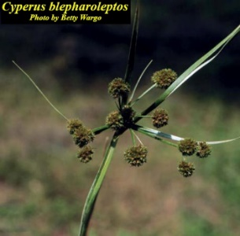
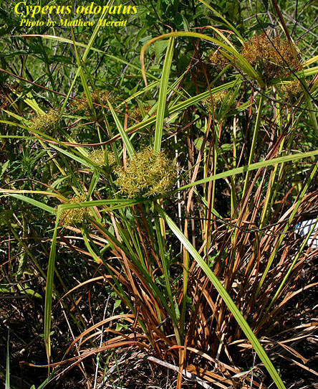
Figure 21. Two species of Cyperus frequently identified at Lake Annie. Cyperus odoratus (left) and Cyperus blepharoleptos (right) (photos: left, Matthew Merit, Institute for Systematic Botany website; right DEP AEQAS, and right inset Betty Wargo, Institute for Systematic Botany website).
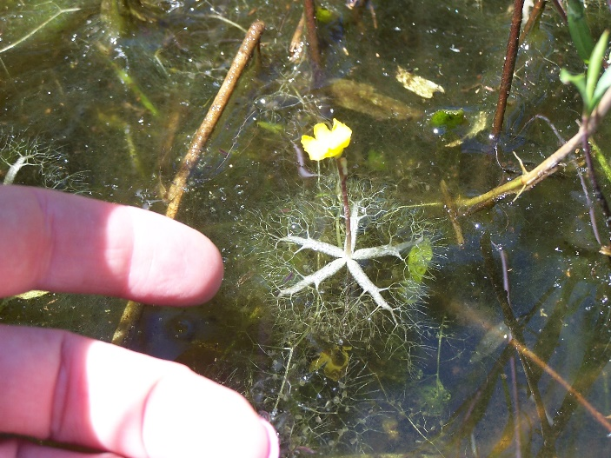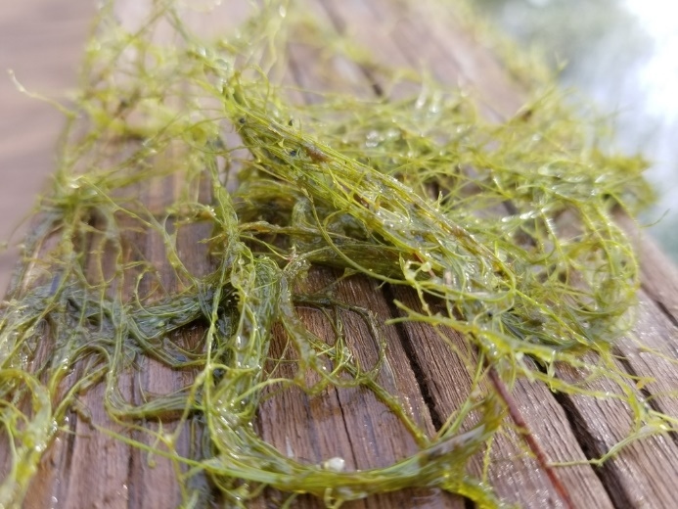
Figure 22. Two species of Utricularia frequently identified at Lake Annie. Utricularia radiata (left) (photo DEP AEQAS) and Utricularia gibba (rught) (photo NC State Extension Plant Toolbox website).
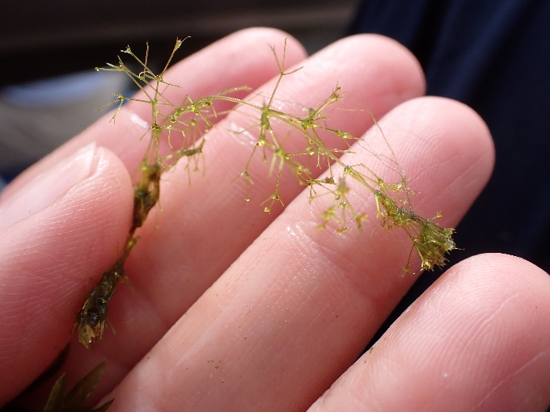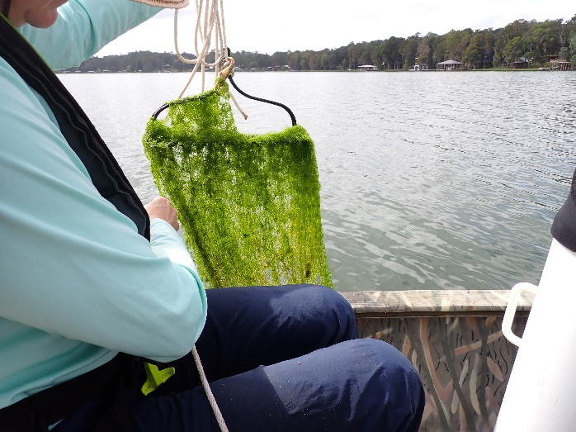
Figure 23. Two views of the macroalga Nitella. (photos: DEP AEQAS).

Conclusions
Results for the 2023 LVI Proficiency exercise indicate that thirty-two of the thirty-four participating teams were within the passing range of scores in the initial exercise. The two teams that were not within the range of passing scores in the initial exercise re-tested successfully. All thirty-four participating teams are therefore currently eligible to submit LVI data to DEP. Variability in dominance selection was good in each of the three testing lakes. No dominance was assigned in five of 136 sections sampled, which was similar to previous exercises. Plant identification challenges were comparable to prior years. There continues to be notable variability in plant identification in a few groups of plants. Continued guidance is needed in several areas of identification of species, including within the genera Eleocharis, Ludwigia, Persicaria, and Utricularia. Recognition and identification of various grass species is generally improved over previous years. Samplers should review the list of taxa in the LVI Primer for which genus level ID is acceptable or recommended. Peltandra, Taxodium, Pluchea, and Nuphar were all taxa that were occasionally identified to species, but should be left at genus level. Samplers should also remember to not include upland taxa in their sample data. SBIO, and the new LVI calculator screen for upland taxa, do not include them in LVI calculations, but it is still important to not include them. As LVI 1100 3.2.3 states, “Record only taxa that are either aquatic or have OBL, FACW, or FAC wetland status (as listed in Chapter 62-340.450, F.A.C.).” If you have a question about a taxon’s wetland status, you can contact AEQAS. Incorrect plant identifications did not result in significant differences in LVI scores for these test lakes, but teams should always strive to attain correct plant identifications for LVI sampling events and remember to obtain secondary/expert verification of dominant/co-dominant plants through photos or specimens. There was also notable variability in the number of taxa included in the assessment, particularly at Lakes Bryant and Annie. Review of the guidance on determination of the lake boundary, and consistency in level of effort is needed.
LVI sampling teams should use this exercise as a method to correct any observed methodological deficiencies or deviations from the LVI SOP. Team member status has been updated on the FDEP searchable Biological Method Proficiency Registry, Biological Method Proficiency Registry - Qlik Sense.
Appendix A – Taxa Lists for Otter Lake, Lake Bryant, and Lake Annie during June 2023 LVI Proficiency Testing

Otter Lake (For each team, the number of lake sections in which team observed taxon is displayed.)

Taxa Observed | City of TAL | DEP WAS | DEP AEQAS | DEP TLH ROC | DEP NW ROC | # sections taxon observed (out of 20 total)
Alternanthera philoxeroides | 4 | 4 | 3 | 4 | 4 | 19
Azolla filiculoides |  | 1 |  |  |  | 1
Baccharis |  |  |  |  | 1 | 1
Carex |  |  | 1 |  |  | 1
Carex glaucescens |  |  |  | 1 | 1 | 2
Centella asiatica | 1 |  |  |  |  | 1
Cephalanthus occidentalis | 4 | 4 | 4 | 4 | 4 | 20
Chara |  |  |  |  | 2 | 2
Cladium jamaicense | 4 | 1 |  | 2 |  | 7
Cliftonia monophylla |  |  |  |  | 1 | 1
Cyrilla racemiflora | 4 | 4 | 4 | 4 | 4 | 20
Decodon verticillatus | 3 |  | 1 |  |  | 4
Echinochloa crusgalli |  |  |  |  | 1 | 1
Echinochloa walteri | 1 | 1 | 2 | 2 |  | 6
Echinodorus cordifolius |  |  |  |  | 4 | 4
Eleocharis |  |  |  | 2 |  | 2
Eleocharis baldwinii | 4 |  |  |  |  | 4
Eleocharis submersed viviparous (species unknown) |  | 2 | 2 |  | 4 | 8
Erechtites hieraciifolius |  |  | 1 |  |  | 1
Eupatorium capillifolium |  |  |  | 1 |  | 1
Fuirena scirpoidea | 1 |  | 1 |  | 1 | 3
Hydrocotyle | 4 | 4 | 3 | 4 | 4 | 19
Hypericum hypericoides |  |  |  |  | 2 | 2
Itea virginica |  |  |  |  | 2 | 2
Landoltia punctata |  | 3 |  | 4 | 4 | 11
Lemna | 4 | 4 | 4 | 4 | 4 | 20
Leucothoe racemosa |  |  |  |  | 1 | 1
Ludwigia (native) |  | 3 | 1 |  |  | 4
Ludwigia (unknown nativity) | 1 |  |  | 3 |  | 4
Ludwigia peruviana |  |  |  |  | 3 | 3
Ludwigia repens |  |  |  |  | 1 | 1
Magnolia virginiana | 1 | 1 |  |  |  | 2
Mikania scandens |  | 2 | 2 | 1 | 4 | 9
Myrica cerifera | 3 |  |  |  |  | 3
Nuphar | 3 | 3 | 4 | 3 | 4 | 17
Nymphaea odorata |  |  | 1 |  |  | 1
Nyssa sylvatica |  | 2 |  |  |  | 2
Nyssa sylvatica biflora | 2 |  | 1 |  |  | 3
Osmunda cinnamomea |  |  | 1 |  | 2 | 3
Osmunda regalis | 2 | 4 | 2 | 2 | 3 | 13
Panicum hemitomon |  |  | 1 |  |  | 1
Persicaria hydropiperoides |  |  |  |  | 3 | 3
Persicaria punctata |  | 4 | 3 | 4 |  | 11
Persicaria setacea | 4 |  |  |  |  | 4
Pinus elliottii |  | 1 |  |  |  | 1
Pontederia cordata | 4 | 4 | 4 | 4 | 4 | 20
Potamogeton |  |  |  |  | 1 | 1
Rhynchospora fascicularis | 1 |  |  |  |  | 1
Sacciolepis striata |  | 4 | 4 | 4 | 4 | 16
Sagittaria lancifolia | 4 | 4 | 4 | 4 | 4 | 20
Salix caroliniana | 2 | 1 |  | 2 | 1 | 6
Salvinia minima | 3 | 4 | 4 | 4 | 4 | 19
Smilax |  | 1 |  |  |  | 1
Solidago |  |  |  |  | 1 | 1
Spartina bakeri |  | 4 | 3 | 4 | 3 | 14
Taxodium | 4 | 4 | 4 | 4 | 4 | 20
Triadenum virginicum | 2 |  |  |  |  | 2
Typha | 3 | 4 | 4 | 3 | 4 | 18
Utricularia floridana |  |  |  |  | 1 | 1
Utricularia olivacea | 1 |  |  |  |  | 1
Xyris |  |  |  |  | 1 | 1
TOTAL TAXA PER TEAM | 27 | 27 | 27 | 24 | 36

Lake Bryant (For each team, the number of lake sections in which team observed taxon is displayed.)
Taxa Observed | BDA | Cawley | Orange Co | Seminole Co | SJRMWD | Water and Air | WSP | STANTEC | NE ROC | AEQAS | CEN ROC 2 | SW ROC 1 | # sections taxon observed (out of 48 total)
Acer rubrum | 4 | 4 | 4 | 4 | 4 | 4 | 4 | 4 | 4 | 4 | 4 | 4 | 48
Alternanthera philoxeroides | 2 |  | 2 | 1 | 2 | 4 | 2 | 1 |  | 1 | 1 | 2 | 18
Amaranthus australis | 2 |  | 1 | 3 | 4 | 2 | 2 | 3 | 1 |  | 2 |  | 20
Ampelopsis arborea |  |  |  |  |  | 1 |  | 1 |  |  |  |  | 2
Andropogon |  |  | 1 |  |  |  |  |  |  | 1 | 2 |  | 4
Apios americana |  |  |  |  |  | 2 |  |  |  |  |  |  | 2
Azolla filiculoides | 1 |  | 1 |  | 1 |  |  | 1 | 1 |  | 1 |  | 6
Baccharis |  |  | 3 | 1 |  |  |  |  |  | 1 | 1 |  | 6
Baccharis glomeruliflora |  | 2 |  |  |  |  |  |  |  |  |  |  | 2
Bacopa caroliniana |  |  |  |  |  | 1 |  |  |  |  |  |  | 1
Bidens laevis | 1 |  |  |  | 1 | 4 |  | 3 | 3 |  |  |  | 12
Bidens mitis |  | 2 | 4 | 1 |  |  | 3 | 1 |  | 2 | 4 | 4 | 21
Blechnum serrulatum | 2 |  |  |  | 2 |  | 1 |  | 1 | 2 |  |  | 8
Boehmeria cylindrica | 3 |  | 2 |  | 1 | 4 | 3 | 1 |  | 3 |  |  | 17
Brasenia schreberi | 1 |  |  |  |  |  |  | 3 |  |  |  | 1 | 5
Cabomba caroliniana | 1 |  | 1 | 1 | 1 | 1 |  | 1 | 1 | 1 |  |  | 8
Carex albolutescens |  | 1 |  |  |  |  |  |  |  |  |  |  | 1
Carex longii | 1 |  |  |  |  |  |  |  |  |  |  |  | 1
Centella asiatica |  |  |  |  |  | 1 | 1 |  |  |  |  |  | 2
Cephalanthus occidentalis | 4 | 4 | 4 | 4 | 4 | 3 | 4 | 4 | 4 | 4 | 4 | 4 | 47
Ceratophyllum demersum | 1 |  |  |  |  |  |  | 1 |  |  | 1 |  | 3
Chara |  |  | 1 |  |  |  |  |  |  |  |  |  | 1
Cladium jamaicense | 4 | 4 | 4 | 4 | 4 | 4 | 4 | 4 | 4 | 4 | 4 | 4 | 48
Colocasia esculenta |  | 2 |  | 2 | 1 | 1 | 1 |  | 1 | 1 | 2 | 3 | 14
Coreopsis |  |  |  |  | 4 |  |  |  |  |  |  |  | 4
Cyperus |  |  |  |  |  | 4 |  |  |  |  |  |  | 4
Cyperus blepharoleptos | 3 |  | 2 | 2 | 2 | 2 |  |  |  | 2 |  |  | 13
Cyperus haspan |  | 1 | 2 | 1 |  |  |  |  |  | 1 | 2 |  | 7
Cyperus odoratus | 1 | 1 | 1 | 1 |  |  |  | 1 |  | 1 | 2 | 2 | 10
Cyperus polystachyos |  |  | 1 |  |  |  | 1 |  |  |  | 1 | 2 | 5
Cyperus surinamensis | 1 |  |  |  |  |  |  |  |  |  |  |  | 1
Cyperus tetragonus |  |  |  |  |  | 1 |  |  |  |  |  |  | 1
Cyrilla racemiflora |  | 1 |  |  |  |  |  |  |  |  |  |  | 1
Decodon verticillatus |  |  |  |  |  | 1 | 2 |  | 1 | 1 |  |  | 5
Diodia virginiana |  | 1 |  |  |  | 1 | 1 |  |  |  |  |  | 3
Echinochloa walteri | 1 |  |  | 1 | 1 |  |  |  |  |  |  |  | 3
Eclipta prostrata |  | 1 | 1 | 1 | 1 |  |  | 2 |  | 1 |  | 1 | 8
Eleocharis |  |  |  |  |  |  | 1 |  |  |  |  |  | 1
Eleocharis baldwinii |  | 2 |  | 4 |  | 4 | 1 | 3 | 3 |  | 1 | 2 | 20
Eleocharis elongata |  |  |  |  | 1 |  |  |  |  |  |  |  | 1
Eleocharis olivacea |  |  |  |  |  |  |  |  |  | 1 |  |  | 1
Eleocharis submersed viviparous (species unknown) |  |  | 4 |  | 3 |  |  | 4 |  | 2 | 1 |  | 14
Eleocharis vivipara | 3 |  |  |  |  |  |  |  |  |  |  |  | 3
Erechtites hieraciifolius |  | 1 | 2 |  |  | 2 | 2 | 3 |  | 1 |  |  | 11
Eupatorium capillifolium |  | 3 | 4 | 3 | 2 | 2 | 4 | 3 | 3 | 3 | 3 | 3 | 33
Eupatorium leptophyllum | 4 |  |  |  |  | 1 |  | 1 |  |  |  |  | 6
Fuirena |  |  |  |  |  |  |  |  |  |  | 2 |  | 2
Fuirena breviseta | 1 |  |  |  |  | 1 |  |  |  |  |  |  | 2
Fuirena pumila |  |  | 1 |  |  |  |  | 2 |  | 1 |  | 1 | 5
Fuirena scirpoidea | 1 | 2 | 3 | 2 |  | 2 |  | 2 | 1 | 2 |  | 1 | 16
Fuirena squarrosa |  | 1 |  |  |  |  |  |  |  |  |  |  | 1
Gordonia lasianthus |  | 2 |  |  | 2 |  |  |  | 4 | 1 | 3 | 3 | 15
Habenaria repens | 1 |  | 1 |  |  |  | 1 |  |  | 1 |  |  | 4
Hibiscus |  |  |  |  |  |  |  |  |  | 2 |  |  | 2
Hibiscus grandiflorus | 2 | 1 | 3 | 3 | 3 |  | 4 |  |  |  |  |  | 16
Hydrilla verticillata | 1 | 1 |  | 2 |  |  |  | 1 |  |  | 1 | 1 | 7
Hydrocotyle |  | 3 | 4 | 3 |  | 4 | 2 | 4 | 4 | 3 | 4 | 4 | 35
Hydrocotyle umbellata | 4 |  |  |  | 1 |  |  |  |  |  |  |  | 5
Hypericum fasciculatum |  |  |  |  |  |  |  | 1 |  |  |  |  | 1
Ilex cassine | 4 | 4 | 1 |  | 4 | 3 | 3 |  | 4 | 1 | 4 | 4 | 32
Indigofera hirsuta |  |  |  |  |  |  |  |  |  |  | 1 |  | 1
Iris virginica |  |  |  | 1 |  |  |  |  |  |  |  |  | 1
Itea virginica | 3 |  |  |  |  | 4 | 1 | 3 |  |  |  |  | 11
Juncus marginatus | 1 |  |  |  |  | 2 |  |  |  |  |  |  | 3
Kosteletzkya pentacarpos |  |  |  |  |  | 4 |  |  |  |  | 4 |  | 8
Landoltia punctata | 2 |  |  |  | 3 | 3 |  |  |  |  |  |  | 8
Leersia hexandra |  |  |  |  |  |  |  | 1 |  |  |  |  | 1
Lemna | 1 |  | 1 | 1 | 1 | 1 |  | 2 | 1 | 3 |  |  | 11
Lemna minor |  | 2 |  |  |  |  |  |  |  |  |  |  | 2
Limnobium spongia |  | 1 |  |  |  |  |  |  |  |  |  |  | 1
Liquidambar styraciflua |  | 2 | 1 |  | 2 |  | 2 | 1 | 2 |  | 1 | 3 | 14
Ludwigia (unknown nativity) |  |  |  |  |  |  |  |  |  |  |  | 3 | 3
Ludwigia alata |  |  |  |  |  |  |  |  |  |  | 2 |  | 2
Ludwigia arcuata |  |  |  |  |  | 1 |  |  |  |  |  |  | 1
Ludwigia decurrens |  |  |  |  | 1 |  |  |  |  |  |  |  | 1
Ludwigia leptocarpa | 4 | 1 | 3 |  |  | 3 | 2 | 1 |  |  | 4 | 2 | 20
Ludwigia maritima | 1 |  |  |  |  |  |  |  |  |  |  |  | 1
Ludwigia octovalvis |  | 1 |  | 1 |  | 1 |  | 3 |  | 1 | 1 | 2 | 10
Ludwigia palustris |  |  |  |  |  |  |  | 1 |  |  |  |  | 1
Ludwigia peruviana | 3 | 3 | 4 | 3 | 4 | 3 | 3 | 4 | 4 | 3 | 4 |  | 38
Ludwigia repens |  |  |  |  |  |  |  | 2 |  |  |  | 1 | 3
Ludwigia sphaerocarpa |  |  |  |  |  | 1 |  |  |  |  |  |  | 1
Luziola fluitans | 2 |  |  |  | 1 | 2 | 1 | 1 |  |  |  | 1 | 8
Magnolia virginiana | 3 | 4 | 4 | 3 | 4 | 3 | 4 | 3 |  | 3 | 2 | 4 | 37
Micranthemum umbrosum | 1 |  |  |  |  |  |  |  |  |  |  |  | 1
Mikania scandens | 4 | 3 | 3 | 2 | 3 | 4 | 4 | 4 | 4 | 3 | 4 | 4 | 42
Myrica cerifera | 4 | 4 | 4 | 3 | 2 | 4 | 3 | 4 | 3 | 3 | 4 | 3 | 41
Najas guadalupensis |  |  | 2 | 2 |  | 1 |  |  |  |  |  |  | 5
Nuphar (includes Nuphar luteum) | 4 | 4 | 4 | 4 | 4 | 4 | 4 | 4 | 4 | 4 | 4 | 4 | 48
Nymphaea odorata | 4 | 4 | 3 | 4 | 4 | 4 | 3 | 4 | 4 | 4 | 4 | 4 | 46
Nymphoides aquatica | 3 | 1 | 2 | 3 | 3 | 3 | 3 | 3 | 2 | 3 |  | 2 | 28
Nyssa sylvatica biflora | 1 | 4 | 4 | 3 | 4 | 4 | 4 | 4 | 3 | 2 | 3 | 4 | 40
Osmunda cinnamomea |  |  |  |  | 3 |  |  | 3 |  |  |  |  | 6
Osmunda regalis | 2 | 1 | 1 | 2 | 2 | 3 | 2 | 2 |  | 2 | 1 |  | 18
Panicum hemitomon | 4 | 4 | 4 | 4 | 4 | 4 | 4 | 4 | 4 | 4 | 4 | 4 | 48
Panicum repens | 4 | 1 | 3 | 3 |  | 2 | 1 | 4 | 4 | 4 | 2 | 3 | 31
Paspalidium geminatum | 3 |  | 2 | 3 | 4 | 1 |  |  |  | 3 | 2 | 4 | 22
Paspalum repens |  |  |  |  |  | 2 |  |  |  |  |  |  | 2
Peltandra | 3 | 3 | 3 | 3 |  | 4 | 3 |  | 3 | 2 | 3 |  | 27
Persea palustris |  |  |  |  | 2 | 1 |  | 1 |  |  |  |  | 4
Persicaria hydropiperoides (syn Polygonum hydropiperoides) |  | 2 |  |  |  |  | 1 | 1 |  |  |  |  | 4
Persicaria punctata (syn. Polygonum punctatum) |  |  | 2 | 1 | 1 | 2 |  |  | 1 | 1 | 1 |  | 8
Phyla nodiflora |  | 1 |  |  |  |  |  |  |  |  |  |  | 1
Pinus elliottii |  |  |  |  |  |  |  |  |  |  |  | 1 | 1
Pluchea |  |  |  | 2 | 2 |  | 1 | 1 |  |  |  |  | 6
Pluchea baccharis |  | 1 |  |  |  |  |  |  |  |  |  |  | 1
Pluchea foetida | 1 |  |  |  |  |  |  |  |  |  |  |  | 1
Pontederia cordata | 4 | 4 | 4 | 4 | 4 | 3 | 4 | 4 | 4 | 4 | 4 | 4 | 47
Potamogeton illinoensis | 4 |  | 4 | 3 | 3 | 1 | 1 | 4 |  | 1 | 3 | 1 | 25
Pteridium aquilinum |  |  |  |  |  |  |  |  | 1 |  |  |  | 1
Quercus laurifolia |  |  |  |  | 1 |  |  |  |  |  |  |  | 1
Quercus virginiana |  |  |  |  |  | 1 |  |  |  |  |  |  | 1
Rhexia |  |  |  |  |  | 1 |  |  |  |  |  | 2 | 3
Rhynchospora corniculata |  |  |  | 1 |  |  |  |  |  |  |  |  | 1
Rubus trivialis |  |  |  |  |  | 1 |  |  |  |  |  |  | 1
Rumex verticillatus |  |  |  |  |  |  |  | 2 |  | 1 |  |  | 3
Sabal palmetto | 1 | 3 |  | 1 | 2 | 2 |  |  | 3 |  | 2 | 3 | 17
Saccharum giganteum |  |  |  |  |  |  |  |  |  |  |  | 2 | 2
Sacciolepis striata |  |  | 1 | 1 |  |  |  |  |  | 1 | 2 | 2 | 7
Sagittaria graminea | 1 |  | 1 |  |  |  |  |  |  |  |  |  | 2
Sagittaria isoetiformis |  |  |  | 1 |  |  |  |  | 1 |  |  |  | 2
Sagittaria lancifolia | 4 | 4 | 4 | 4 | 4 | 4 | 4 | 4 | 4 | 4 | 4 | 4 | 48
Sagittaria latifolia |  |  |  |  | 4 |  |  | 3 |  |  |  | 1 | 8
Salix caroliniana | 2 | 4 | 4 | 3 | 3 | 4 | 4 | 4 | 4 | 2 | 4 | 3 | 41
Salvinia minima | 2 | 2 | 2 | 2 | 2 | 4 | 1 | 2 | 1 | 1 | 1 | 2 | 22
Sambucus nigra (syn S. canadensis, includes Sambucus) | 4 | 3 | 4 | 2 | 3 | 3 | 4 | 3 | 3 | 4 | 3 |  | 36
Sapium sebiferum |  |  |  | 1 |  |  |  |  |  |  | 1 |  | 2
Saururus cernuus | 2 | 2 | 2 | 2 | 2 | 4 | 3 | 3 | 2 | 2 | 2 |  | 26
Schoenoplectus californicus |  |  |  |  |  |  | 1 |  |  |  |  |  | 1
Schoenoplectus tabernaemontani |  |  |  |  | 1 |  |  |  |  |  |  |  | 1
Scirpus cubensis |  |  |  |  |  |  |  |  | 1 |  | 3 | 3 | 7
Scoparia dulcis |  |  |  |  |  | 1 |  |  |  |  |  |  | 1
Smilax laurifolia |  |  |  |  |  | 1 |  | 1 |  |  |  |  | 2
Solidago |  |  |  |  |  |  |  |  |  |  | 1 |  | 1
Solidago fistulosa | 1 |  |  |  |  |  |  |  |  |  |  |  | 1
Spirodela polyrhiza |  |  |  |  |  |  |  |  | 1 |  |  |  | 1
Symphyotrichum carolinianum | 2 |  |  |  |  | 2 | 1 |  |  | 1 |  |  | 6
Taxodium (includes T. distichum) | 1 | 2 | 2 | 3 | 2 | 1 | 2 | 2 | 2 | 2 | 2 | 4 | 25
Thalia geniculata |  |  |  |  |  |  |  |  |  |  |  | 1 | 1
Thelypteris |  |  |  |  | 1 |  |  |  |  |  |  |  | 1
Thelypteris interrupta | 2 |  |  |  |  | 3 |  |  |  |  |  | 1 | 6
Thelypteris palustris pubescens |  | 1 |  |  |  |  |  |  |  |  |  |  | 1
Toxicodendron radicans | 1 | 2 |  |  | 2 | 3 | 3 |  |  |  |  |  | 11
Triadenum virginicum | 2 |  | 2 |  | 1 | 1 | 1 | 1 |  | 1 |  |  | 9
Typha | 3 | 2 | 3 | 3 | 3 | 4 | 2 | 4 | 3 | 2 | 3 | 2 | 34
Utricularia cornuta |  |  |  |  |  |  |  | 1 |  |  |  |  | 1
Utricularia foliosa | 1 |  | 1 | 1 | 2 | 2 | 1 |  |  |  |  |  | 8
Utricularia gibba | 1 | 1 | 3 | 1 |  |  |  | 1 |  |  | 1 | 1 | 9
Utricularia inflata |  |  | 1 |  |  |  |  |  |  |  |  |  | 1
Utricularia radiata |  |  |  |  |  |  | 1 |  |  |  |  |  | 1
Vallisneria americana | 1 |  |  | 1 |  |  |  | 1 |  |  |  |  | 3
Vitis rotundifolia |  | 1 |  |  |  | 3 |  | 1 |  |  |  |  | 5
Woodwardia areolata |  |  |  |  |  | 1 |  |  |  |  |  |  | 1
Woodwardia virginica |  |  | 2 | 2 |  | 1 | 4 |  | 2 | 2 | 2 | 2 | 17
Xyris |  |  |  | 1 |  | 2 |  |  | 1 | 1 |  | 1 | 6
Xyris elliottii |  | 1 |  |  |  |  |  |  |  |  |  |  | 1
Xyris fimbriata | 1 |  |  |  |  |  |  |  |  |  |  |  | 1
TOTAL TAXA PER TEAM | 68 | 56 | 60 | 58 | 59 | 77 | 55 | 66 | 44 | 58 | 57 | 54

Lake Annie (For each team, the number of lake sections in which team observed taxon is displayed.)
Taxa Observed | Lakeland Utilties | SWFWMD | Lakeland Storm | USF WATER | City of Orlando | Winter Park | Highlands | Flatwoods 1 | Flatwoods 2 | Pinellas Co | Polk Co | SW ROC 1 | S ROC | SE ROC | SW ROC 2 | CEN ROC 2 | CEN ROC 1 | #sections taxon observed (out of 68 total)
Acer rubrum | 1 | 1 | 2 | 2 | 3 | 2 | 3 |  |  | 1 |  | 2 | 1 | 2 | 1 | 2 | 1 | 24
Alternanthera philoxeroides |  | 2 |  |  | 2 |  | 1 |  |  |  | 1 | 1 | 2 |  |  |  |  | 9
Andropogon |  |  | 1 |  |  | 2 |  |  |  |  | 3 |  |  |  |  |  |  | 6
Annona glabra |  |  |  |  |  |  | 2 |  |  |  |  |  |  |  |  |  |  | 2
Aster |  |  |  |  |  | 1 |  |  |  |  |  |  |  |  |  |  |  | 1
Azolla filiculoides |  |  |  |  |  |  |  |  |  |  | 1 |  |  |  |  |  |  | 1
Baccharis |  |  | 1 |  |  | 1 | 1 | 2 |  |  | 2 |  |  |  |  |  | 2 | 9
Bacopa caroliniana |  |  |  |  |  |  |  |  |  |  |  | 1 |  |  |  |  |  | 1
Bacopa monnieri |  |  |  |  |  |  |  | 1 |  |  |  |  |  |  |  |  |  | 1
Bidens alba |  |  |  |  |  | 2 |  |  |  |  |  |  |  |  |  |  |  | 2
Blechnum serrulatum |  |  | 1 | 1 | 1 |  | 2 |  |  |  |  |  |  |  |  | 1 |  | 6
Boehmeria cylindrica |  |  |  |  |  | 1 |  |  |  |  |  |  |  |  |  |  |  | 1
Centella asiatica |  |  |  |  |  |  |  | 1 | 1 |  |  | 1 |  |  |  |  |  | 3
Cephalanthus occidentalis | 2 | 3 | 4 | 2 | 3 | 3 | 4 | 3 | 2 | 3 | 1 |  | 2 | 4 | 3 | 3 | 3 | 45
Ceratophyllum demersum |  |  |  |  |  |  | 1 |  |  |  |  | 1 | 1 | 1 | 1 |  |  | 5
Ceratopteris thalictroides |  |  |  |  |  |  |  |  |  |  |  |  |  | 1 |  |  |  | 1
Chara | 4 | 1 |  |  | 1 |  | 1 | 2 | 2 |  | 4 | 1 |  |  |  |  |  | 16
Cicuta maculata |  |  |  |  |  |  |  |  |  |  |  |  | 1 |  |  |  |  | 1
Cinnamomum camphora |  |  | 1 |  | 2 |  |  |  |  |  |  |  |  |  |  |  |  | 3
Cladium jamaicense | 3 | 4 | 4 | 4 | 4 | 4 | 4 | 4 | 3 | 4 | 4 | 4 | 4 | 4 | 4 |  | 3 | 61
Colocasia esculenta |  | 1 |  |  |  |  |  |  |  |  |  |  |  |  |  | 4 |  | 5
Commelina |  |  |  |  |  |  |  |  |  |  | 2 |  |  |  |  |  |  | 2
Cyperus alternifolius |  |  |  |  |  |  |  |  |  | 1 |  |  |  |  |  |  |  | 1
Cyperus blepharoleptos |  | 1 | 3 | 1 |  |  | 3 |  | 1 |  | 3 | 1 | 1 | 2 |  | 3 | 1 | 20
Cyperus compressus |  |  |  |  |  |  |  | 1 |  |  |  |  |  |  |  |  |  | 1
Cyperus esculentus |  |  |  |  |  |  |  | 2 |  |  | 3 |  |  |  |  |  |  | 5
Cyperus haspan |  | 4 | 1 |  | 2 |  | 3 |  |  |  |  | 1 |  |  |  | 1 |  | 12
Cyperus lanceolatus |  | 2 |  |  |  |  |  |  |  |  |  |  |  |  |  |  |  | 2
Cyperus lecontei |  |  |  |  | 1 |  | 2 |  |  |  | 1 | 1 |  |  |  |  |  | 5
Cyperus odoratus | 2 |  | 3 | 1 | 1 | 4 | 4 | 2 | 3 | 2 | 4 | 3 | 3 |  | 3 | 1 |  | 36
Cyperus papyrus | 1 |  |  | 1 |  |  |  |  | 1 |  | 1 |  |  | 1 |  |  | 1 | 6
Cyperus polystachyos |  |  |  |  | 1 |  | 2 |  | 1 |  |  |  |  |  |  | 1 |  | 5
Cyperus prolifer |  |  |  |  |  |  |  |  |  |  |  |  |  |  | 1 |  |  | 1
Cyperus surinamensis |  |  |  |  |  |  |  |  |  |  |  | 1 |  |  |  |  |  | 1
Diodia virginiana |  |  |  |  |  | 1 | 2 | 2 |  |  |  | 2 |  |  | 2 |  |  | 9
Eclipta prostrata |  |  | 1 |  |  |  |  |  |  |  | 1 |  |  |  |  |  |  | 2
Egeria densa |  |  |  |  |  |  |  | 1 |  |  |  |  |  |  |  |  |  | 1
Eleocharis |  |  |  |  |  |  |  |  |  | 3 |  |  |  |  |  |  |  | 3
Eleocharis baldwinii |  |  | 3 |  |  |  | 4 |  |  |  |  | 4 |  |  |  |  |  | 11
Eleocharis cellulosa | 2 | 2 | 3 | 2 | 3 | 3 | 4 | 3 | 1 | 3 | 2 | 3 |  | 2 | 2 | 2 | 2 | 39
Eleocharis elongata |  |  | 4 |  |  |  |  |  |  |  |  |  | 3 |  |  | 3 | 4 | 14
Eleocharis equisetoides |  |  |  |  |  |  | 2 |  |  |  |  |  |  |  |  |  |  | 2
Eleocharis geniculata |  |  |  | 2 |  |  |  |  |  |  |  |  |  |  |  |  |  | 2
Eleocharis submersed viviparous (species unknown) |  |  |  | 4 |  |  |  | 4 | 4 |  | 4 |  |  |  | 3 |  |  | 19
Eleocharis vivipara |  | 4 |  |  | 2 | 4 |  |  |  |  | 4 |  | 3 | 3 |  |  |  | 20
Erechtites hieraciifolius |  | 1 |  |  |  |  |  | 1 | 1 |  | 2 |  |  |  |  |  | 1 | 6
Eupatorium capillifolium | 2 | 4 | 4 | 2 | 3 | 4 | 4 | 2 |  | 2 | 4 |  | 4 | 3 | 2 | 4 | 4 | 48
Eupatorium leptophyllum |  |  |  |  |  |  |  | 1 | 3 |  |  |  |  |  |  |  |  | 4
Ficus aurea |  |  |  |  |  |  | 1 |  |  |  |  |  |  |  |  |  |  | 1
Fraxinus |  |  |  |  |  |  |  |  |  |  |  |  |  |  |  |  | 1 | 1
Fraxinus caroliniana |  |  | 1 |  |  |  |  |  |  |  |  |  |  |  |  |  |  | 1
Fuirena pumila |  |  |  |  |  |  |  | 2 | 2 |  |  |  |  |  |  |  |  | 4
Fuirena scirpoidea | 4 | 4 | 4 | 4 | 4 | 4 | 4 | 4 | 4 | 4 | 4 | 4 | 4 | 4 | 4 | 4 | 4 | 68
Fuirena squarrosa |  |  |  |  |  |  | 2 |  |  |  |  |  |  |  |  |  |  | 2
Galium uniflorum |  |  |  |  |  | 1 |  |  |  |  |  |  |  |  |  |  |  | 1
Habenaria repens |  | 1 |  | 1 |  |  |  |  | 1 |  |  |  |  |  |  |  |  | 3
Hydrilla verticillata |  |  |  |  | 1 |  |  |  |  |  | 1 | 2 | 2 |  |  |  |  | 6
Hydrocotyle | 3 | 4 | 4 | 1 | 4 | 4 | 4 | 3 | 3 | 2 | 4 | 3 | 4 | 3 | 2 | 3 |  | 51
Hygrophila polysperma |  |  |  |  |  |  |  | 1 |  |  |  |  |  |  |  |  |  | 1
Juncus |  |  |  |  |  | 4 |  |  |  |  |  |  |  |  |  | 2 |  | 6
Juncus canadensis |  |  | 2 |  |  |  |  |  |  |  |  |  |  |  |  |  |  | 2
Juncus effusus |  |  |  |  |  |  | 1 | 1 |  |  |  | 1 |  |  |  |  |  | 3
Juncus marginatus |  | 1 | 2 |  | 1 | 4 |  |  |  |  | 2 |  |  |  |  |  |  | 10
Juncus megacephalus |  | 3 |  |  |  |  | 4 |  |  |  | 2 | 1 |  |  |  |  |  | 10
Juncus scirpoides |  |  |  |  |  |  | 3 |  | 1 |  |  |  |  |  |  |  |  | 4
Lachnanthes caroliniana | 1 | 3 | 3 | 2 | 2 | 4 | 4 | 2 |  |  | 2 | 1 | 1 |  | 2 | 1 | 1 | 29
Landoltia punctata |  |  |  |  |  |  | 1 |  |  |  |  |  |  |  |  |  |  | 1
Liquidambar styraciflua |  |  |  |  |  |  |  |  |  |  |  | 1 |  |  |  |  |  | 1
Ludwigia (unknown nativity) |  |  |  |  |  |  |  |  |  |  |  | 2 |  |  | 1 |  |  | 3
Ludwigia arcuata |  |  |  |  |  |  |  | 1 |  | 1 |  |  |  |  |  |  |  | 2
Ludwigia decurrens |  |  |  |  | 1 |  |  |  |  |  |  |  |  |  |  |  |  | 1
Ludwigia leptocarpa |  |  | 4 | 1 |  | 3 |  |  |  |  | 3 |  | 2 |  | 1 | 2 |  | 16
Ludwigia linearis |  |  |  |  |  |  |  |  |  |  |  | 1 | 1 |  |  |  |  | 2
Ludwigia octovalvis |  |  | 1 | 4 | 2 |  | 3 | 3 | 3 |  |  | 2 | 2 | 1 |  |  | 1 | 22
Ludwigia peploides |  |  |  |  |  |  |  |  | 2 |  |  | 1 |  |  |  |  |  | 3
Ludwigia peruviana | 4 | 4 | 4 | 4 | 4 | 4 | 4 | 4 | 4 | 3 | 4 | 1 | 2 | 3 | 3 | 4 | 3 | 59
Ludwigia repens |  | 1 |  |  |  | 2 | 1 | 1 | 1 |  |  |  |  |  |  |  |  | 6
Ludwigia suffruticosa |  | 2 |  |  |  | 1 | 1 |  |  |  |  |  |  |  |  |  |  | 4
Magnolia virginiana |  |  |  |  |  |  |  |  |  | 1 |  | 2 |  |  |  |  |  | 3
Melaleuca quinquenervia | 2 | 3 | 2 | 2 | 3 | 4 | 4 | 2 | 2 | 3 | 3 | 2 | 2 | 2 | 2 | 1 | 4 | 43
Micranthemum umbrosum |  |  |  |  |  |  |  |  |  |  |  | 1 |  |  |  |  |  | 1
Mikania scandens |  |  | 3 |  | 2 | 3 | 4 | 3 | 1 |  | 3 | 2 |  | 1 |  | 3 |  | 25
Myrica cerifera |  | 1 | 2 |  | 1 |  | 2 | 1 |  |  |  | 3 |  | 1 |  | 2 | 1 | 14
Najas guadalupensis |  | 1 | 2 | 2 | 2 | 4 | 3 |  |  |  | 2 |  | 1 |  |  | 1 | 2 | 20
Nelumbo lutea | 1 |  |  | 1 | 2 | 1 |  |  | 1 | 1 | 1 | 1 | 1 | 2 | 2 | 1 | 1 | 16
Nitella |  |  | 4 | 4 | 3 | 4 | 4 | 2 | 3 |  | 4 | 4 | 1 | 3 | 4 | 2 | 2 | 44
Nuphar | 3 | 4 | 3 | 3 | 4 | 4 | 3 | 2 | 1 | 3 | 4 | 3 | 2 | 4 | 4 | 4 | 3 | 54
Nymphaea odorata | 4 | 4 | 4 | 4 | 4 | 4 | 4 | 4 | 4 | 4 | 4 | 4 | 4 | 4 | 4 | 4 | 4 | 68
Nymphoides aquatica |  |  |  |  |  |  |  |  | 2 |  |  |  |  |  |  |  |  | 2
Osmunda cinnamomea |  |  | 1 |  |  |  |  |  |  |  |  |  |  |  |  |  |  | 1
Panicum hemitomon | 1 | 2 | 3 | 1 |  | 4 | 4 | 2 | 1 |  |  | 2 | 1 |  | 1 | 2 | 3 | 27
Panicum repens | 4 | 4 | 4 | 4 | 4 | 4 | 4 | 4 | 4 | 4 | 4 | 4 | 4 | 4 | 3 | 4 | 4 | 67
Paspalidium geminatum |  |  |  | 3 |  |  | 1 |  |  | 2 | 1 | 4 |  | 1 |  |  | 2 | 14
Paspalum notatum |  |  |  |  |  |  |  |  |  |  |  | 1 |  |  |  |  |  | 1
Paspalum urvillei |  |  |  | 1 |  |  |  |  |  |  | 2 | 2 |  |  |  |  |  | 5
Peltandra |  |  |  |  |  |  | 1 |  |  |  |  |  |  |  |  |  |  | 1
Persea | 1 |  |  |  |  |  |  |  |  |  |  |  |  |  |  |  |  | 1
Persicaria |  |  |  |  |  | 1 |  |  |  |  |  |  |  |  |  | 2 |  | 3
Persicaria glabra |  |  |  |  |  |  |  |  | 1 |  |  |  | 1 |  |  |  |  | 2
Persicaria hirsuta | 1 |  | 3 |  |  |  | 4 | 2 |  |  | 4 |  |  | 1 | 1 | 2 |  | 18
Persicaria hydropiperoides |  | 3 |  |  |  | 1 |  | 1 |  |  |  |  |  |  |  |  |  | 5
Persicaria punctata |  |  |  | 1 |  |  |  |  | 2 |  |  |  |  |  |  |  |  | 3
Pinus elliottii |  |  | 1 |  | 1 |  |  |  |  |  |  | 3 |  |  |  | 1 |  | 6
Pluchea | 1 | 1 | 2 |  |  | 1 |  | 2 |  | 1 | 2 | 1 | 2 |  |  |  |  | 13
Pluchea camphorata |  |  |  |  |  |  | 2 |  |  |  |  |  |  |  |  |  |  | 2
Pluchea odorata |  |  |  |  | 3 |  |  |  |  |  |  |  |  |  |  |  |  | 3
Pontederia cordata | 3 | 4 | 4 | 4 | 4 | 4 | 4 | 4 | 3 | 4 | 4 | 4 |  | 3 | 4 | 4 | 3 | 60
Potamogeton illinoensis | 2 |  | 4 | 4 | 2 | 1 | 4 | 2 | 2 | 2 | 2 | 3 | 3 | 3 | 2 | 2 | 3 | 41
Potamogeton pectinatus |  |  |  |  | 1 |  |  |  |  |  |  |  |  |  |  |  |  | 1
Ptilimnium capillaceum |  |  |  |  | 1 |  |  |  |  |  |  | 2 |  |  |  |  |  | 3
Quercus laurifolia |  | 4 |  |  |  |  |  |  |  |  |  |  |  |  |  |  |  | 4
Rhexia |  |  |  |  | 1 |  |  |  |  |  |  |  |  |  |  |  |  | 1
Rhexia cubensis |  |  |  |  |  | 3 |  |  |  |  |  |  |  |  |  |  |  | 3
Rhexia nashii |  |  |  |  |  |  | 1 |  |  |  |  |  |  |  |  |  |  | 1
Rhynchospora |  |  |  |  |  | 4 |  |  |  |  |  |  |  |  |  |  |  | 4
Rhynchospora fascicularis |  |  |  |  |  |  |  |  | 1 |  |  |  |  |  |  |  |  | 1
Rhynchospora microcephala |  |  |  | 1 |  |  |  |  |  |  |  | 1 |  |  | 2 | 1 |  | 5
Ricciocarpus natans |  |  | 3 |  |  |  |  |  |  |  |  |  |  |  |  |  |  | 3
Sabal palmetto | 1 | 4 |  |  | 4 | 2 | 4 |  | 2 |  | 2 | 3 |  | 3 | 3 | 2 | 2 | 32
Sabatia |  |  |  |  |  |  |  | 2 | 1 |  |  |  |  |  |  |  |  | 3
Sabatia grandiflora |  | 1 | 2 |  |  |  |  |  |  |  | 1 |  |  |  |  |  |  | 4
Saccharum giganteum |  |  |  |  | 1 |  |  |  |  |  |  |  |  |  |  |  |  | 1
Sacciolepis striata |  | 4 | 1 |  | 2 | 1 | 4 | 2 | 1 |  | 3 | 2 | 1 |  |  | 1 |  | 22
Sagittaria graminea |  |  |  | 1 |  |  |  |  |  |  |  |  | 1 |  |  |  |  | 2
Sagittaria kurziana |  |  |  |  |  |  |  |  |  |  |  | 1 |  |  |  |  |  | 1
Sagittaria lancifolia | 4 | 4 | 4 | 4 | 4 | 4 | 4 | 4 | 4 | 4 | 4 |  | 4 | 4 | 4 | 4 | 4 | 64
Salix caroliniana | 2 | 3 | 4 | 3 | 4 | 4 | 4 | 3 | 3 | 3 | 3 | 3 | 3 | 3 | 1 | 3 | 3 | 52
Salvinia minima |  | 1 | 2 |  | 2 |  | 4 |  |  |  | 1 |  | 1 | 1 | 1 | 2 | 1 | 16
Sambucus nigra (includes S. canadensis) | 2 |  | 1 | 1 | 1 | 1 |  | 2 | 1 |  |  |  |  | 2 |  | 1 | 2 | 14
Sapium sebiferum | 1 |  |  |  |  |  |  | 1 |  |  |  |  |  |  |  |  |  | 2
Schinus terebinthifolius |  |  | 1 |  | 1 |  | 1 |  |  |  | 1 |  |  |  |  | 1 |  | 5
Spartina bakeri |  |  |  |  |  |  | 1 |  |  |  |  |  |  |  |  |  |  | 1
Taxodium | 2 |  |  | 1 | 1 |  |  | 1 |  |  | 1 | 2 | 1 | 1 | 2 |  | 1 | 13
Thelypteris hispidula |  | 1 |  |  |  |  |  |  |  |  |  |  |  |  |  |  |  | 1
Thelypteris interrupta |  |  |  |  |  |  |  |  |  |  |  |  |  |  |  | 1 |  | 1
Thelypteris palustris pubescens |  |  |  |  |  |  | 2 |  |  |  |  |  |  |  |  |  |  | 2
Typha | 4 | 4 | 4 | 4 | 4 | 4 | 4 | 3 | 4 | 4 | 4 | 4 | 4 | 4 | 4 | 4 | 3 | 66
Urena lobata |  |  |  |  | 1 |  |  |  |  |  |  |  |  |  |  |  |  | 1
Urochloa mutica |  |  | 1 |  |  |  |  |  |  |  | 1 |  |  |  |  |  |  | 2
Utricularia floridana |  |  |  |  |  |  |  |  |  |  |  |  | 1 |  |  |  |  | 1
Utricularia gibba | 1 |  | 2 | 4 | 1 | 4 | 4 | 3 | 3 |  | 4 | 4 | 1 |  |  | 2 | 4 | 37
Utricularia inflata |  |  |  |  |  |  |  |  |  | 4 |  |  |  |  |  |  |  | 4
Utricularia purpurea |  |  |  |  |  | 1 |  |  |  |  |  |  |  |  |  |  | 3 | 4
Utricularia radiata | 1 |  | 2 | 4 |  |  | 1 | 1 | 2 | 2 | 2 | 2 | 3 | 1 | 2 | 3 | 3 | 29
Utricularia resupinata |  |  |  |  |  | 1 |  |  |  |  |  |  |  |  |  |  |  | 1
Utricularia subulata |  | 3 |  |  |  |  |  |  |  |  |  |  |  |  |  |  |  | 3
Vallisneria americana |  |  | 1 |  | 3 |  | 1 |  |  |  | 2 |  | 1 |  |  |  |  | 8
Vitis |  |  |  |  |  |  |  |  |  |  |  |  |  |  |  | 3 | 1 | 4
Vitis rotundifolia | 1 |  | 2 | 3 | 2 | 2 |  |  | 1 |  | 2 |  |  |  |  |  |  | 13
Woodwardia virginica |  |  |  |  | 1 |  |  |  |  |  | 1 |  |  |  |  |  |  | 2
Xanthosoma sagittifolium |  |  |  |  |  |  |  |  |  |  |  |  |  |  |  | 1 |  | 1
Xyris |  | 2 | 1 |  | 1 | 3 | 3 |  | 1 |  |  | 1 |  | 1 |  |  |  | 13
Zizaniopsis miliacea |  |  |  |  |  | 1 |  |  |  |  |  |  |  |  |  |  |  | 1

