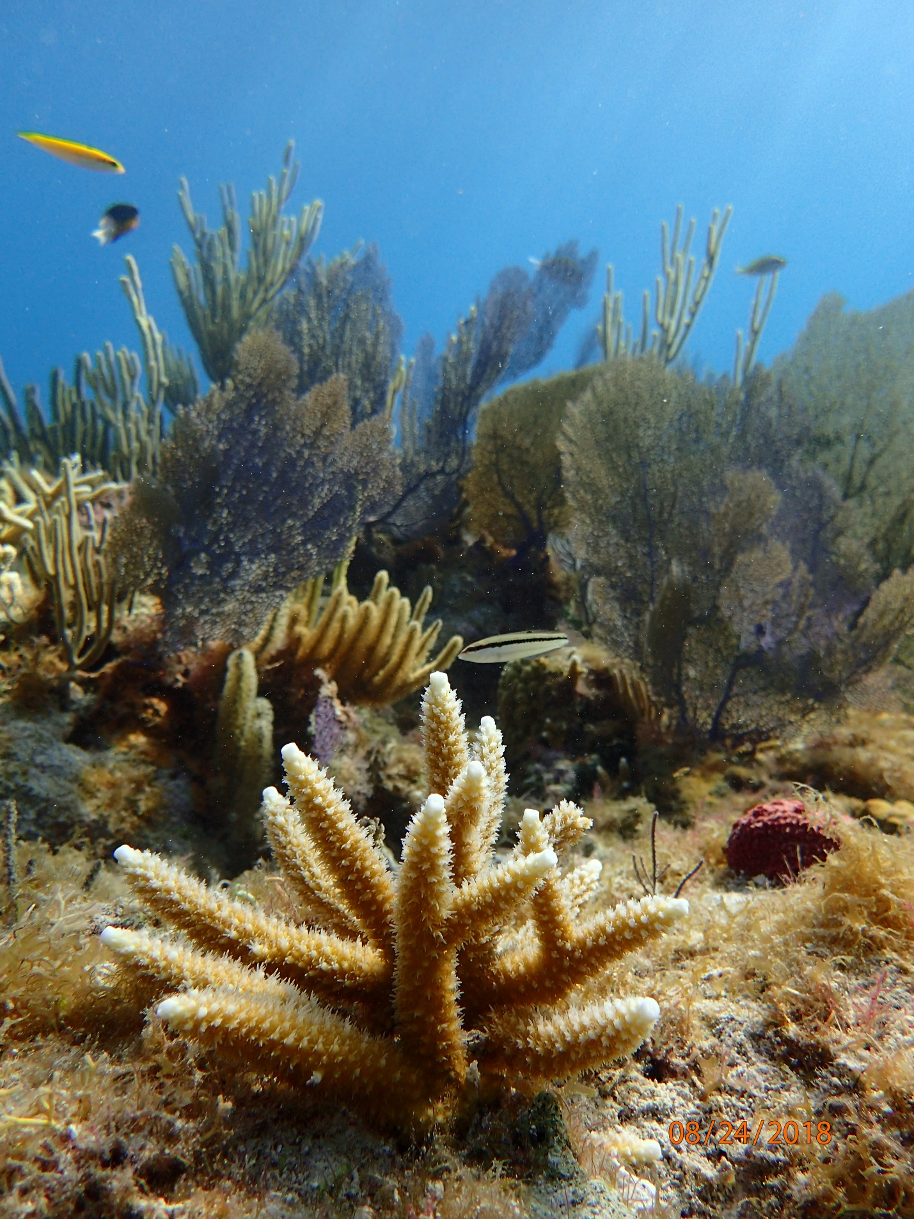
Kristin Jacobs Coral Aquatic Preserve
Management Plan
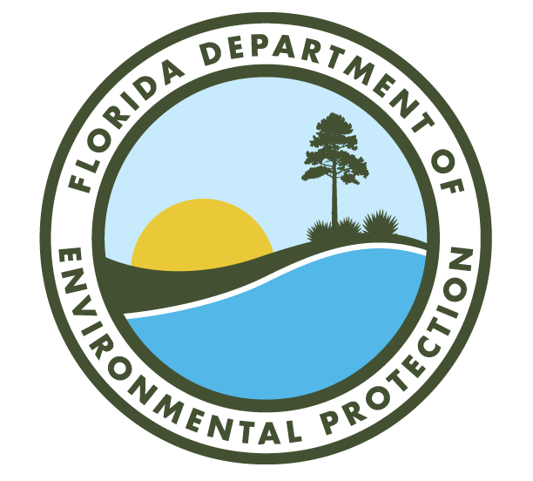
Florida Department of Environmental Protection
Office of Resilience and Coastal Protection
2600 Blair Stone Road, MS #235
Tallahassee, FL 32399
https://floridadep.gov/rcp

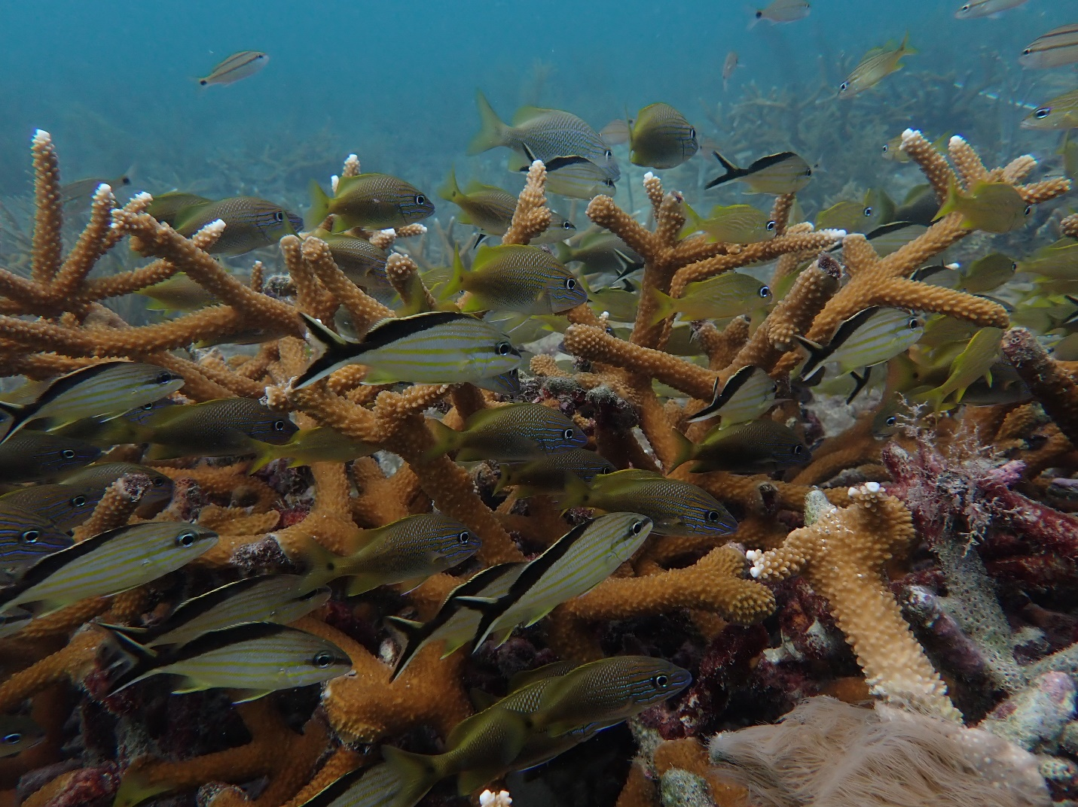
Photo: Acropora cervicornis coral with a school of grunts swimming through it.

Mission Statement

The Office of Resilience and Coastal Protection’s mission is to conserve, protect, restore, and improve the resilience of Florida’s coastal, aquatic, and ocean resources for the benefit of people and the environment.

The four long-term goals of the Office of Resilience and Coastal Protection’s Aquatic Preserve Program are to:

- Protect and enhance the ecological integrity of the aquatic preserves.
- Restore areas to their natural condition.
- Encourage sustainable use and foster active stewardship by engaging local communities in the protection of aquatic preserves.
- Improve management effectiveness through a process based on sound science, consistent evaluation, and continual reassessment.

Executive Summary
Lead Agency: Florida Department of Environmental Protection’s (DEP) Office of Resilience and Coastal Protection (ORCP)

Common Name of Property: Kristin Jacobs Coral Aquatic Preserve (KJCAP) and Cape Florida Aquatic Preserve (CFAP)

Location: Miami-Dade, Broward, Palm Beach, and Martin counties, Florida

Acreage: Kristin Jacobs Coral Aquatic Preserve = 239,107 acres
Cape Florida Aquatic Preserve = 4,163 acres (included in KJCAP acreage)

Management Agency: DEP’s ORCP

Designation: Aquatic Preserve

Unique Features: The natural resources of KJCAP, which extends from the northern boundary of Biscayne National Park to the St. Lucie Inlet, have been a critical part of the livelihoods, recreation, and culture of Southeast Florida since Native Americans first inhabited the area. KJCAP extends to state water limits three (3) nautical miles offshore, and encompasses 105 linear miles of Florida’s Coral Reef, which continues beyond the aquatic preserve and connects additional managed areas in South Florida that include a combined 350 miles of offshore coral reef habitat. KJCAP encompasses the entire area of CFAP, which sits off of the eastern coast of Key Biscayne, extending roughly 3 miles into the Atlantic Ocean with a southern border that mirrors KJCAP’s. The combined area of KJCAP and CFAP will be referred to as KJCAP, unless there is a fact or strategy specific to CFAP, then it will be called out.

This complex ecosystem of the combined aquatic preserves is home to more than 6,000 marine species and provides shoreline protection, economically and recreationally important resources, and tourism opportunities. There are 18 threatened or endangered species, of which three have designated critical habitat within KJCAP. The counties that lie adjacent to KJCAP are some of the most densely populated in Florida and support a variety of land use including agricultural, commercial and residential. This plan seeks to improve the ecological function of the area and to increase coordinated management across the entirety of Florida’s Coral Reef.

Archaeological/Historical Sites: The coral reef within KJCAP has a long history of shipwrecks. Three wrecks are currently designated as Florida Underwater Archeological Preserves and listed by the Florida Division of Historical Resources: the Lofthus, SS Copenhagen and Half Moon (Map 7, 8 & 9, respectively). All three are in shallow water between eight and 30 feet deep and are popular diving and snorkeling sites as well as educational tools.

Area Breakdown by Benthic Habitat Type*
Benthic Habitat | Area within KJCAP (km²)
Coral Reef and Colonized Hardbottom | 209.49
Unconsolidated Sediment (Sand) | 601.22
Artificial Habitat | 15.88
Seagrass Bed | 16.07
Undefined Marine | 124.65
Total Area (km²) | 967.63

*FNAI natural community type maps do not yet extend into the majority of KJCAP. These benthic habitat types are based on benthic habitat communities as described for Southern Florida by the National Oceanic and Atmospheric Administration (Monaco, 2007) and adapted for KJCAP (Riegl et al., 2004). Descriptions and a crosswalk of benthic habitat types is included in section 3.3.7.

Management Needs
Water Quality: Increased offshore monitoring is needed to improve our understanding of how nutrients and pollutants travel from land-based sources to the coral reef. Additionally, forming strong relationships with county and municipal agencies is needed to reduce point and nonpoint sources of pollution, particularly from sewage leaks, stormwater runoff and adjacent coastal development.

Sustainable Economic and Recreational Use: Further studies are needed to understand fishing, diving, and boating use patterns in KJCAP. Identification of high use areas will inform management actions and educational programs aimed at mitigating user conflicts and reducing the impacts from non-extractive uses. Additionally, KJCAP will also support FWC regulatory and educational programs that will reduce impacts from extractive uses.

Ecosystem Disturbance Response and Recovery: Loss of stony corals and hardbottom habitat due to coral bleaching, diseases, sedimentation and physical impacts threatens the ecosystem services provided by Florida’s Coral Reef. Participation in multi-agency disturbance response efforts including monitoring, combined with a reduction in vessel groundings, anchoring incidents and sedimentation from coastal projects, will support the high levels of biodiversity needed in order for Florida’s Coral Reef to provide the ecosystem services that natural and human communities depend on.

Community Education, Engagement, and Access: There needs to be continued and expanded outreach to inform the public about KJCAP, specifically its establishment, issues, and goals. Furthermore, there needs to be active management to reduce the inequities of access to KJCAP for all communities.

Ecosystem Resilience: A variety of impacts are already apparent on Florida’s Coral Reef, especially with the increased frequency and severity of disturbance events such as major storms and rising sea temperatures that can lead to shifts in species distribution and loss of biodiversity. While national and international agencies seek to address contributing factors to environmental change, more studies are needed to better understand the vulnerabilities and strengths that effect the resilience of Florida’s Coral Reef and define management interactions that build resilience.

Public Involvement: Public support is vital to the success of conservation programs. The goal is to create and foster an understanding of the challenges that these ecosystems are facing and the steps to manage these precious resources. The creation of this management plan was guided by recommendations that resulted from previous public process in KJCAP including the Our Florida Reefs Community Working Groups and Fisheries Committee. The Southeast Florida Coral Reef Initiative Team and Technical Advisory Committee were consulted before public meetings were held on the development of the draft KJCAP management plan. The draft management plan will be edited based on the feedback of the advisory committee and public meetings will be held to receive additional feedback. After further edits, the final management plan will be presented to the Acquisition and Restoration Council.

Goals
Many of the issues impacting Kristin Jacobs Coral Aquatic Preserve could be prevented or minimized with improved water quality, enhanced enforcement, a better understanding of anthropogenic impacts, and public education campaigns. Better resource monitoring and analysis will guide our management practices and make them more effective overall. Reducing user conflict at nearby access points will also reduce other negative impacts associated with overuse and encourage more sustainable use of the aquatic preserve.

Issue A: Water Quality Impacts from Land-Based Sources of Pollution and Maritime Industry and Coastal Construction Impacts

Goal A1: Improve water quality both within and entering KJCAP to meet the needs of natural resources.

Objective A1.1: Maintain, expand, and unify monitoring programs within KJCAP in order to detect and identify sources of pollution flowing through inlets, and support data analysis to understand the effects of, and how to effectively mitigate, land-based sources of pollution on coral reef habitat (N-71).

Objective A1.2: Coordinate with municipalities, water management districts local governments, federal partners and advisory group counterparts to reduce point and non-point land-based sources of pollution including wastewater, stormwater and groundwater that enter into KJCAP and associated watersheds to improve water quality and reef condition through management actions. (OFR N-78 and FDOU 52).

Objective A1.3: Coordinate the reduction of vessel-based discharges.

Goal A2: Increase public and industry engagement in actions that can be taken to improve water quality in KJCAP.

Objective A2.1: Work with the local community, visitors, and agency partners to encourage reduction of land-based sources of pollutants entering storm drains and waterways (N-1).

Issue B: Sustainable Economic and Recreational Fishing, Diving, and Other Uses

Goal B1: Characterize the different uses and use trends in KJCAP and correlate trends with other types of data.

Objective B1.1: Update studies on uses, use patterns, crowding (i.e., social acceptance of other activities and user groups), areas of use conflicts, and impacts on KJCAP resources by various resource users.

Objective B1.2: Support continuation of and explore options for expansion of fisheries monitoring programs and protocols to gain a better understanding of the state of fisheries compared to uses and use impacts in KJCAP.

Goal B2: Evaluate and implement management approaches to reduce impacts from fishing, diving, and other uses (recreational and commercial) in KJCAP to support ecosystem integrity and function.

Objective B2.1: Evaluating and implement management options to reduce impacts from fishery use pressure on benthic habitat.

Objective B2.2: Evaluating and implement management options to reduce impacts from diving use pressure on affected resources.

Objective B2.3: Evaluate and implement approaches to minimize impacts from pressure at high use areas and intra- and/or inter-group conflicts over resources.

Goal B3: Assess and develop strategies to increase stakeholder and public awareness on how the improper use of resources can lead to degradation, and promote community engagement in best practices to utilize and appreciate marine resources that reduce negative impacts to those resources.

Objective B3.1: Assess stakeholder and public awareness on the wide-ranging use impacts sustained by marine resources through anthropogenic use and best practices to utilize and appreciate marine resources that minimize negative impacts.

Objective B3.2: Develop strategies to increase stakeholder and public awareness on how the improper use of resources can lead to their degradation over time and engagement in best practices to utilize and appreciate marine resources that minimize negative impacts.

Objective B3.3: Continue to support partner agencies in the enforcement of marine regulations and promotion of best use practices.

Objective B3.4: Assess the effectiveness of stakeholder and public awareness strategies, as related to building awareness on anthropogenic use impacts sustained by marine resources and promoting engagement in best practices to utilize and appreciate marine resources that minimize negative impacts.

Issue C: Ecosystem Disturbance Response and Recovery

Goal C1: Continue, expand and optimize regular monitoring of corals and other KJCAP benthic resources to inform management of KJCAP.

Objective C1.1: Continue, expand and optimize benthic monitoring to inform the management of KJCAP.
Objective C1.2: Continue and optimize monitoring related to coastal construction within and adjacent to KJCAP to inform management processes aimed at reducing impacts to reef resources.
Goal C2: Continue to support the reduction of physical and coastal development impacts on corals and associated resources in KJCAP.

Objective C2.1: Continue to improve management and maintenance activities of beaches to reduce impacts to coral reefs (including nearshore reefs), create more sustainable beaches, and minimize impacts from renourishment projects (S-120).
Objective C2.2: Support improvement of impact minimization and mitigation activities for unavoidable impacts to resources to reduce and offset lost ecosystem functions in KJCAP (OFR N-117 and FDOU 52).

Objective C2.3: Reduce other physical impacts in KJCAP.
Goal C3: Engage the public and stakeholders in management efforts to respond to disturbance events and ongoing stressors on KJCAP habitat.

Objective C3.1: Evaluate and improve public involvement in resource protection.

Goal C4: Improve ecosystem understanding to facilitate decision-making that accounts for ecosystem-scale processes.

Objective C4.1: Work with partner agencies to develop a deeper understanding of ecosystem function in KJCAP to improve holistic management.

Issue D: Community Education, Engagement and Access

Goal D1: Comprehensively evaluate access (virtual, physical, educational) to KJCAP for all communities.

Objective D1.1: Identify existing forms of access and equity of access to KJCAP.

Objective D1.2: Continue to develop and implement tailored approaches to improve KJCAP access across different communities.

Objective D1.3: Assess the effectiveness of adopted access approaches to KJCAP.

Goal D2: Build awareness of KJCAP and its goals and attributes via education and outreach.

Objective D2.1: Using D1 Objectives, establish a baseline to measure and monitor the level of awareness among stakeholders and the general public concerning the interconnectedness of KJCAP and its associated resources.

Objective D2.2: Develop and implement strategies to increase awareness of KJCAP and its conservation goals and ecosystem attributes.

Objective D2.3: Develop and implement strategies to increase awareness of ongoing stressors and ecosystem pressures in KJCAP.

Objective D2.4 Evaluate the effectiveness of outreach and education programs.

Issue E: Building Ecosystem Resilience

Goal E1: Identify and evaluate the effects and impacts of environmental change on KJCAP resources.

Objective E1.1: Establish an adaptive framework to assist managers in assessing environmental change effects on ecosystem function within KJCAP over time.

Goal E2: Evaluate and implement adaptive management measures that promote coral reef ecosystem recovery and resilience.

Objective E2.1: Evaluate and implement the use of ecosystem restoration and propagation techniques for coral reef species.

Objective E2.2: Promote long-term state and local adaptation measures, including engineered structures, that minimize effects of short-term and long-term disturbances, including environmental change, to KJCAP resources.

Objective E2.3: Identify and support actions that prevent the loss of biodiversity and functional redundancy through mitigating the impacts of invasive species on native coral reef ecosystem communities.

Goal E3: Build programmatic resilience by ensuring the long-term fiscal viability of KJCAP management.

Objective E3.1: Develop and implement a sustainable finance plan to support coral reef conservation efforts in KJCAP (N-123).

ORCP approval date:
ARC approval date:
State approval date:

Acronym List
Abbreviation | Meaning
AA | Awareness and Appreciation
ACE | U.S. Army Corps of Engineers
ATBA | Area To Be Avoided
BBAP | Biscayne Bay Aquatic Preserve
BNP | Biscayne National Park
CCCL | Coastal construction control line
CERP | Comprehensive Everglades Restoration Plan
CFAP | Biscayne Bay-Cape Florida to Monroe County Aquatic Preserve
CRCP | Coral Reef Conservation Program
CRPA | Coral Reef Protection Act
CSO | Citizen Support Organization
CZMA | Coastal Zone Management Act
DEAR | DEP’s Division of Environmental Assessment and Restoration
DEP | Florida Department of Environmental Protection
DNR | Department of Natural Resources
ECA | Ecosystem Conservation Area
EPA | Environmental Protection Agency
ERP | Environmental Resource Permit
ESA | Endangered Species Act
FCR | Florida’s Coral Reef
FDOU | Fishing, Diving, and Other Uses
FKNMS | Florida Keys National Marine Sanctuary
FOFR | Friends of Our Florida Reefs
FWC | Florida Fish and Wildlife Conservation Commission
FWRI | Fish and Wildlife Research Institute
GIS | Geographic Information Systems
GC | Gulf Council
ICA | Inlet contributing area
ICW | Intracoastal Waterway
KJCAP | Kristin Jacobs Coral Aquatic Preserve
LAS | Local action strategy
LBSP | Land-Based Sources of Pollution
LiDAR | Light Detection and Ranging
MICCI | Maritime Industry and Coastal Construction Impacts
MMPA | Marine Mammal Protection Act
MPRSA | Marine Protection, Research, and Sanctuaries Act
NCCOS | National Centers for Coastal Ocean Science
NCRMP | National Coral Reef Monitoring Program
NEPA | National Environmental Policy Act
NERR | National Estuarine Research Reserve
NOAA | National Oceanic and Atmospheric Administration
NPS | National Park Service
NSU | Nova Southeastern University
OFR | Our Florida Reefs
OFW | Outstanding Florida Waters
ONMS | Office of National Marine Sanctuaries
ORCP | Office of Resilience and Coastal Protection
PSSA | Particularly Sensitive Sea Area
RBM | Resilience-based management
RIPR | Reef Injury Prevention and Response
RMA | Recommended Management Action
RR | Reef Resilience
SAFMC | South Atlantic Fishery Management Council
SCTLD | Stony Coral Tissue Loss Disease
SEAFAN | Southeast Florida Action Network
SECREMP | Southeast Florida Coral Reef Evaluation and Monitoring Project
SEFAST | Southeast Florida Action Strategy Team
SEFCRI | Southeast Florida Coral Reef Initiative
SEFSC | Southeast Fisheries Science Center
SFRPC | South Florida Regional Planning Council
SFWMD | South Florida Water Management District
SGD | Submarine groundwater discharge
TAC | Technical Advisory Committee
TNC | The Nature Conservancy
UM RSMAES | University of Miami Rosenstiel School of Marine, Atmospheric, and Earth Science
UMAM | Uniform Mitigation Assessment Method
USAID | United States Agency for International Development
USCRTF | U.S. Coral Reef Task Force
USFWS | US Fish and Wildlife Service
USGS | United States Geological Survey

Table of contents

Chapter 1: Introduction 1
1.1 Management Plan Purpose and Scope 3
1.2 Public Involvement 3
Chapter 2: The Florida Department of Environmental Protection’s Office of Resilience and Coastal Protection 5
2.1 Introduction 5
2.2 Management Authority 8
2.3 Statutory Authority 13
2.4 Administrative Rules 14
Chapter 3: The Kristin Jacobs Coral Aquatic Preserve 17
3.1 Historical Background 17
3.1.1 Indigenous communities 17
3.1.2 European settlement and forced indigenous migration 18
3.1.3 Development of major cities and tourism 19
3.1.4 Dredging and drainage to accommodate development 20
3.1.5 History of management affecting Florida’s Coral Reef 21
3.2 General Description 29
3.2.1 International/National/State/Regional Significance 29
3.2.2 Location/Boundaries 30
3.3 Resource Description 31
3.3.1 Surrounding Population Data and Future Projected Changes 31
3.3.2 Topography, Geomorphology, and Geology 32
3.3.3 Soils 34
3.3.4 Hydrology and Watershed 34
3.3.5 Climate 39
3.3.6 Oceanographic Patterns 40
3.3.7 Natural Communities 41
3.2.8 Native Species 48
3.2.9 Listed Species 49
3.2.10 Invasive Non-native and/or Problem Species 50
3.2.11 Archaeological and Historical Resources 51
3.4 Economic Values 55
3.5 Citizen Support Organization 55
3.6 Adjacent Public Lands and Designated Resources 56
3.6.1 Monroe County 56
3.6.2 Miami-Dade County 57
3.6.3 Broward County 60
3.6.4 Palm Beach County 62
3.6.5 Martin County 62
3.7 Surrounding Land Use 64
Chapter 4: The Kristin Jacobs Coral Aquatic Preserve Management Issues 69
4.1 Issue A: Water Quality Impacts from Land-Based Sources of Pollution including Marine Industry and Coastal Construction Impacts 72
4.2 Issue B: Sustainable Economic and Recreational Fishing, Diving, and Other Uses 79
4.3 Issue C: Ecosystem Disturbance Response and Recovery 89
4.4 Issue D: Community Education, Engagement, and Access 95
4.5 Issue E: Building Ecosystem Resilience 102
Chapter 5: Administrative Plans 108
5.1 Staffing 108
5.2 Staffing Needs 112
Chapter 6: Facilities Plans 114
6.1 Buildings & Infrastructure 114
6.2 Vehicles and Vessels 116
6.3 Future facilities, construction and maintenance needs 117
List of Appendices 118
Appendix A: Legal Documents 119
A.1. Aquatic Preserve Resolution 119
A.2. Florida Statutes 122
A.3. Florida Administrative Code (F.A.C.) 122
Appendix B: Resource Data 123
B.1. Glossary of Terms 123
B.2. References 131
B.3. Species List 147
B.3.1. Native Species List 147
B.3.2. Listed Species 166
B.3.3. Invasive Non-native and/or Problem Species List 167
B.4 Archaeological Sites Associated with Kristin Jacobs Coral Aquatic Preserve 167
Appendix C: Public Involvement 168
C.1 / Advisory Committee 168
C.1.1 / List of members and their affiliations 168
C.1.2 / Florida Administrative Register Postings 168
C.1.3 / Meeting Summary 168
C.2 / Formal Public Meeting 168
C.2.1 / Florida Administrative Register Posting 168
C.3.2 / Advertisement Flyer 168
C.2.3 / Newspaper Advertisement 168
C.2.4 / Summary of the Formal Public Meetings 168
Appendix D: Goals and Objectives 169
D.1 Current Goals and Objectives Budget Table 169
D.3 Prioritized List of Our Florida Reefs Recommended Management Actions 172
Priority 1 172
Priority 2 173
Priority 3 174
Priority 4 175
D.4 FDOU 52 Fisheries Committee Recommended Management Actions Table 176
Water (22) 176
Fishing and Boating (13) 177
Habitat (7) 178
Agency and Processes (5) 179
Education (8) 179
Appendix E: Other Requirements 180
E.1 Acquisition and Restoration Council Management Plan Compliance Checklist 180
E.2 Management Procedures for Archaeological and Historical Sites on State-Owned or Controlled Lands 188
E.3 Letter of Compliance with County Comprehensive Plan 191
E.4 Division of State Lands Management Plan Approval Letter 192

List of Maps
Map 1: DEP’s Office of Resilience and Coastal Protection system. 2
Map 2: KJCAP and adjacent managed areas of Florida’s Coral Reef. 31
Map 3: Everglades Ecosystem. 35
Map 4: Inlet contributing areas (ICAs) adjacent to KJCAP. 37
Map 5: Florida’s Unified Reef Habitats within the KJCAP boundaries (FWC, 2016). 42
Map 6: Artificial reef locations within KJCAP. 47
Map 7: Lofthus. 52
Map 8: SS Copenhagen. 53
Map 9: Half Moon. 54
Map 10: Miami-Dade publicly managed conservation lands. 59
Map 11: Broward publicly managed conservation lands. 61
Map 12: Martin and Palm Beach publicly managed conservation lands. 63
Map 13: Land Use and Land Cover for Martin and Palm Beach Counties 67
Map 14: Land Use and Land Cover for Broward and Miami-Dade Counties 68
Map 15: Sampling locations from DEP’s water quality assessment program within KJCAP. 74
Map 16: Enforced vessel groundings and anchoring incidents. 82

List of Figures
Figure 1: State Management Structure. 16
Figure 2: Locations of several indigenous tribes in the 1500s (Brevard, 1919). 18
Figure 3: Illustration of a typical reef terrace structure as an example of what can be found in KJCAP. 33
Figure 4: Issue-based adaptive management. 71

List of Tables
Table 1: Summary of estimated nutrient loads (lb/yr) from land uses in each Inlet Contributing Area within KJCAP. (Pickering & Baker, 2015) 38
Table 2: Crosswalk between FNAI Natural Communities and KJCAP Benthic Habitats. 41
Table 3: Summary of benthic habitat types in KJCAP (Florida’s Unified Reef Map [FWC, 2016]). 43

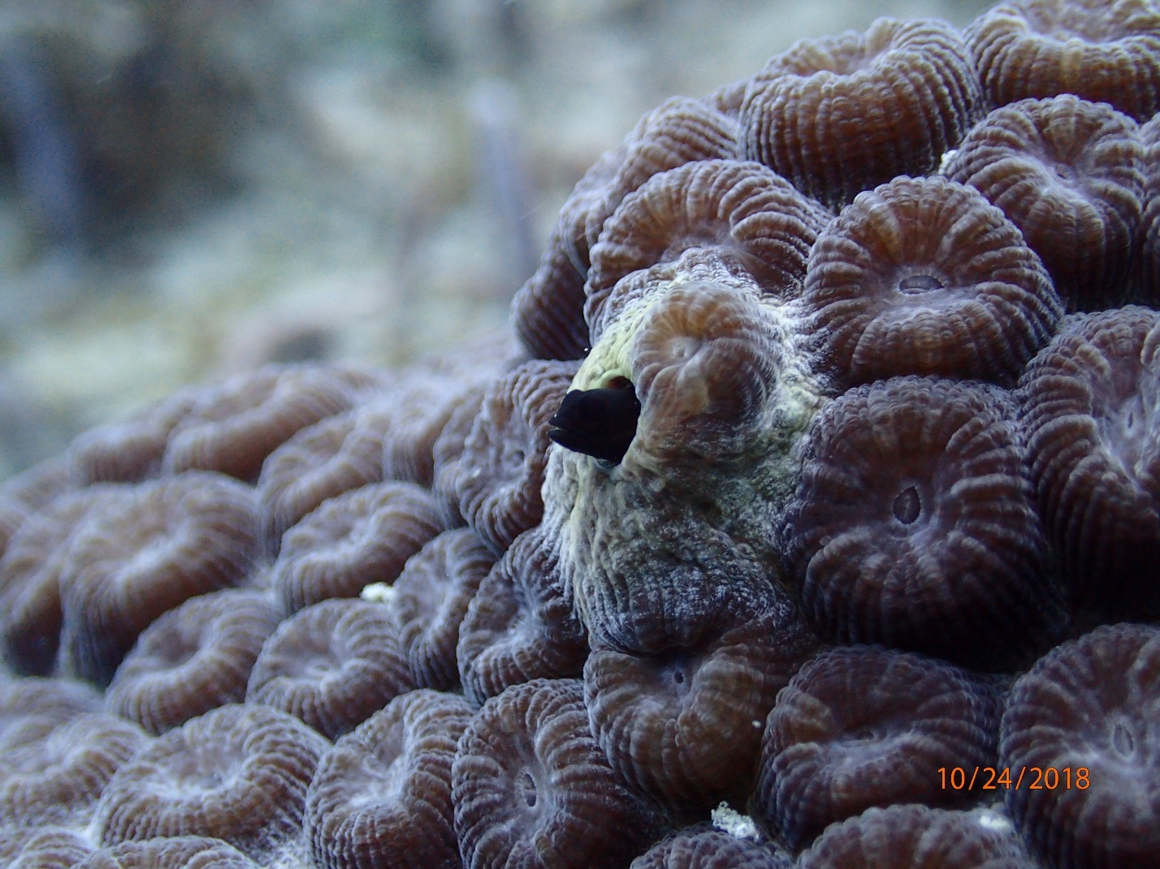Photo: Close up of the polyps of a Montastraea cavernosa coral colony with a resident goby.

Chapter 1: Introduction
The Florida aquatic preserves are administered on behalf of the state by the Florida Department of Environmental Protection’s (DEP) Office of Resilience and Coastal Protection (ORCP) as part of a network that includes 43 aquatic preserves, three National Estuarine Research Reserves (NERRs), and the co-management of the Florida Keys National Marine Sanctuary (Map 1). This provides for a system of significant protections to ensure that our most popular and ecologically important underwater ecosystems are cared for in perpetuity. Each of these special places is managed with strategies based on local resources, issues and conditions.

Our extensive coastline and wealth of aquatic resources have defined Florida as a subtropical oasis, attracting millions of residents and visitors, and the businesses that serve them. Florida’s submerged lands play important roles in maintaining good water quality, hosting a diversity of wildlife and habitats (including economically and ecologically valuable nursery areas), and supporting a treasured quality of life for all. In the 1960s, it became apparent that the ecosystems that had attracted so many people to Florida could not support rapid growth without science-based resource protection and management. To this end, state legislators provided extra protection for certain exceptional aquatic areas by designating them as aquatic preserves.

Title to submerged lands not conveyed to private landowners is held by the Board of Trustees of the Internal Improvement Trust Fund (the Trustees). The Governor and Cabinet, sitting as the Trustees, act as guardians for the people of the state of Florida (§253.03, Florida Statutes [F.S.]) and regulate the use of these public lands. Through statute, the Trustees have the authority to adopt rules related to the management of sovereignty submerged lands (Florida Aquatic Preserve Act of 1975, §258.36, F.S.). A higher layer of protection is afforded to aquatic preserves including areas of sovereignty lands that have been “set aside forever as aquatic preserves or sanctuaries for the benefit of future generations” due to “exceptional biological, aesthetic, and scientific value” (Florida Aquatic Preserve Act of 1975, §258.36, F.S.).

The tradition of concern and protection of these exceptional areas continues, and now includes the Rookery Bay NERR in southwest Florida, designated in 1978; the Apalachicola NERR in northwest Florida, designated in 1979; and the Guana Tolomato Matanzas NERR in northeast Florida, designated in 1999.

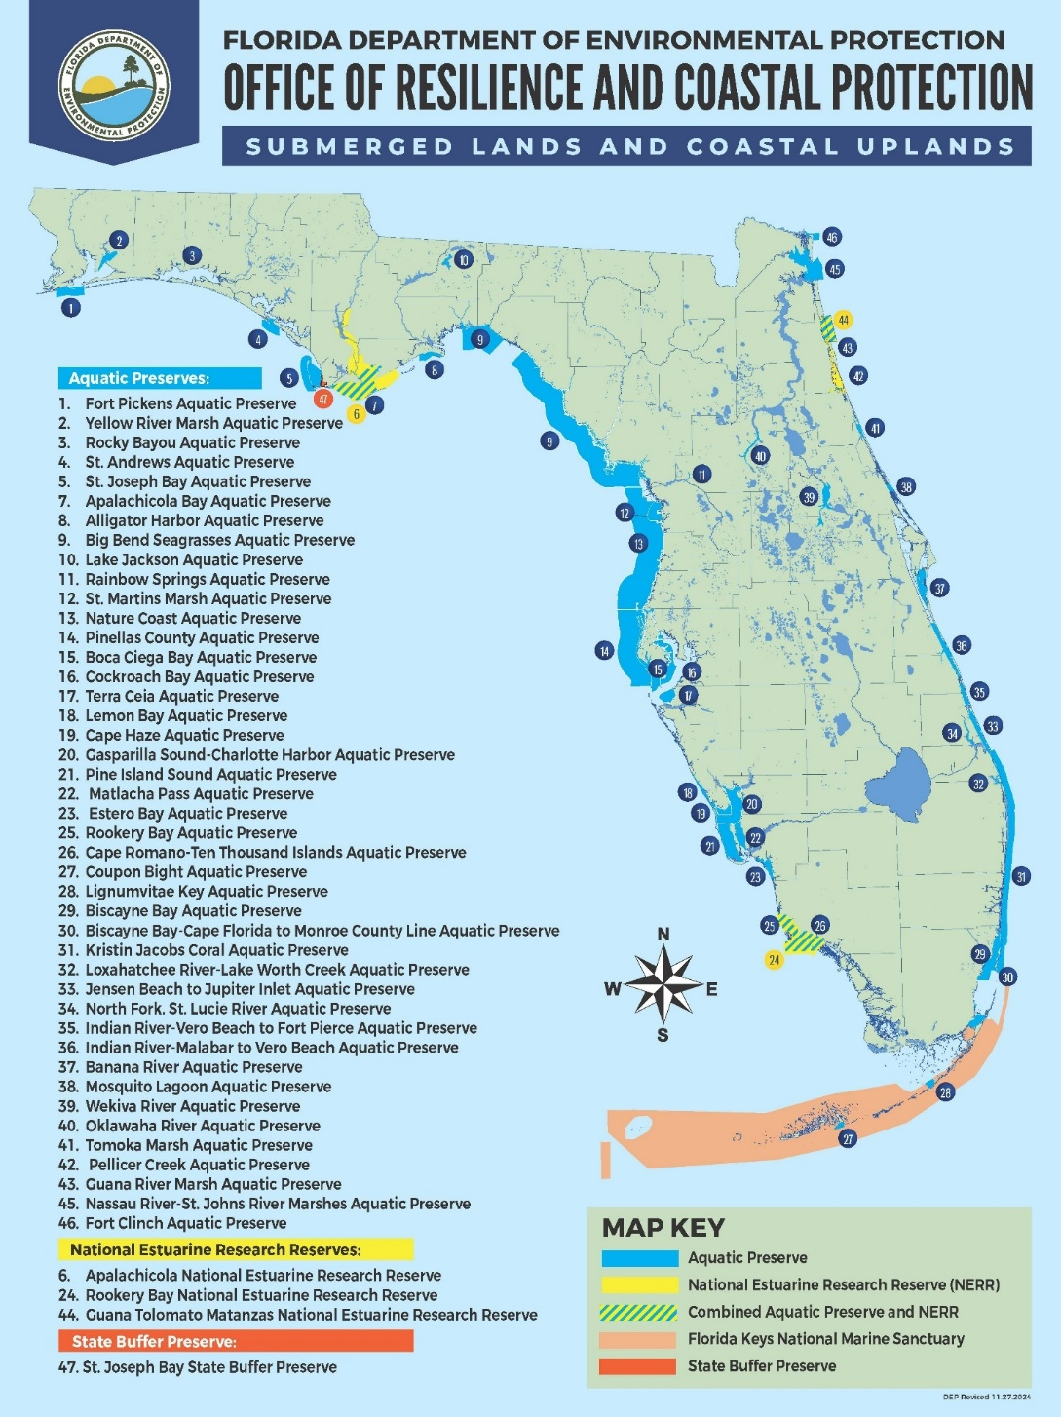
Map 1: DEP’s Office of Resilience and Coastal Protection system.

1.1 Management Plan Purpose and Scope
Florida's aquatic resources are at risk from both direct and indirect impacts of increasing development and recreational use, as well as resulting economic pressures, such as energy generation and increased fish and shellfish harvesting to serve and support the growing population. These potential impacts to resources can reduce the health and viability of the ecosystems that contain them, requiring active management to ensure the long-term health of the entire network. Effective management plans for the aquatic preserves are essential to address this goal and each site’s own set of unique challenges. The purpose of these plans is to incorporate, evaluate, and prioritize all relevant information about the site into a cohesive management strategy, allowing for appropriate access to the managed areas while protecting the long-term health of the ecosystems and their resources.

The mandate for developing aquatic preserve management plans is outlined in Section 18-20.013 and Subsection 18-18.013(2) of the Florida Administrative Code. Management plan development and review begins with the collection of resource information from historical data, research and monitoring, and includes input from individual ORCP managers and staff, area stakeholders, and members of the general public. The statistical data, public comment, and cooperating agency information is then used to identify management issues and threats affecting the present and future integrity of the site, its boundaries, and adjacent areas. The information is used in the development and review of the management plan, which is examined for consistency with the statutory authority and intent of the Aquatic Preserve Program. Each management plan is evaluated periodically and revised as necessary to allow for strategic improvements. Intended to be used by site managers and other agencies or private groups involved with maintaining the natural integrity of these resources, the plan includes scientific information about the existing conditions of the site and the management strategies developed to respond to those conditions.

Each aquatic preserve management plan The plan will also identify the program and facility needs required to meet the goals, objectives, and strategies of the management plan. These components are key elements for achieving the resource protection mission of each aquatic preserve.

1.2 Public Involvement
ORCP recognizes the importance of stakeholder participation and encourages stakeholder involvement in the management plan development process. ORCP is also committed to meeting the requirements of Florida's Government-in-the-Sunshine Law s.286.011, F.S.), including:

- meetings of public boards or commissions must be open to the public;
- reasonable notice of such meetings must be given; and
- minutes of the meetings must be recorded.

Several key steps are being taken during the development of the management plan. First, a draft plan was composed after gathering information on current and historic uses; resource, cultural and historic sites; and other valuable information regarding the property and surrounding areas. Almost two decades of ecological and socioeconomic research and input from local stakeholder groups were synthesized in the creation of the draft plan, with the intent of balancing the ecological needs of the region with extensive commercial, recreational, and economic use.

This will be updated after the public process.

For additional information about the advisory committee and the public meetings refer to Appendix C - Public Involvement. Implementation of the plan will be adaptive to the best available science and public input, while also prioritizing outreach programs to help educate the local community about the importance and efficacy of these protection efforts.

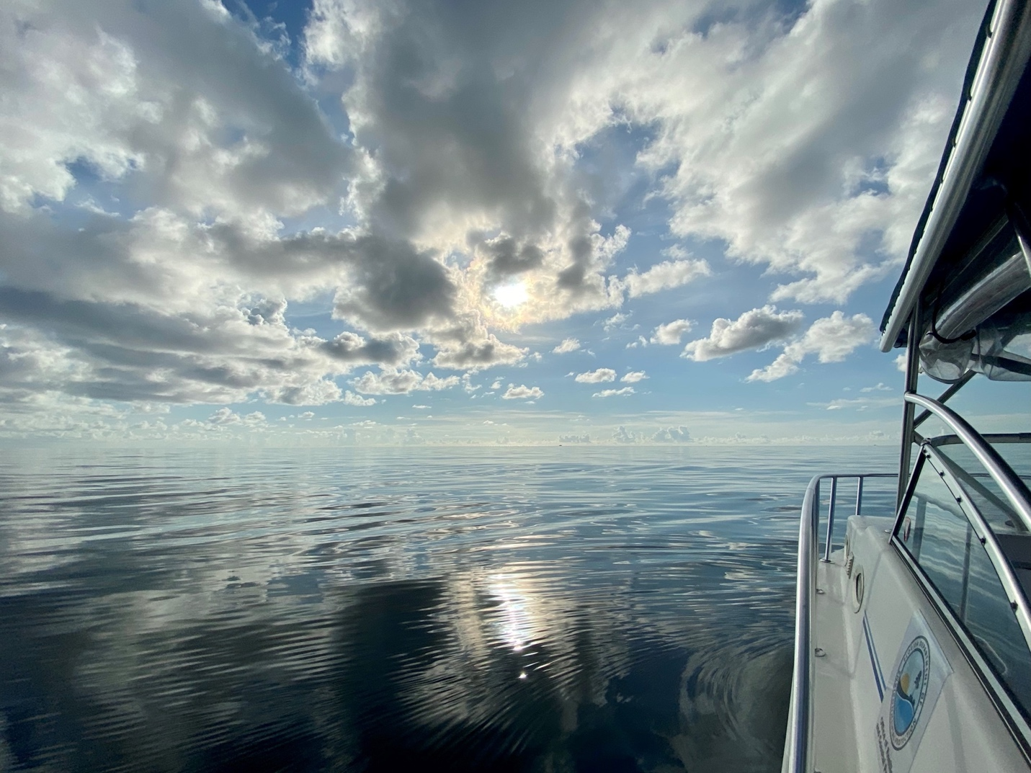
Photo: View of the Kristin Jacobs Coral Aquatic Preserve during calm summer weather from CRCP’s research vessel.

Chapter 2: The Florida Department of Environmental Protection’s Office of Resilience and Coastal Protection

2.1 Introduction
The Florida Department of Environmental Protection (DEP) protects, conserves and manages Florida's natural resources and enforces the state's environmental laws. DEP is the lead agency in state government for environmental management and stewardship and commands one of the broadest charges of all the state agencies, protecting Florida’s air, water and land. DEP is divided into three primary areas: Regulatory Programs, Land and Recreation, and Ecosystem Restoration. Florida’s environmental priorities include restoring America’s Everglades; improving air quality; restoring and protecting the water quality in our springs, lakes, rivers and coastal waters; conserving environmentally sensitive lands; and providing citizens and visitors with recreational opportunities, now and in the future
The Office of Resilience and Coastal Protection (ORCP) is the unit within the DEP that manages more than five million acres of submerged lands and select coastal uplands. These areas are managed for the conservation and protection of natural and historical resources and resource-based public use. This includes 43 aquatic preserves, three National Estuarine Research Reserves (NERRs), and the Florida Keys National Marine Sanctuary (FKNMS). The three NERRs and FKNMS are managed in cooperation with the National Oceanic and Atmospheric Administration (NOAA). ORCP also provides management support for these submerged lands through the Coral Reef Conservation Program, the Coral Protection and Restoration Program, the Florida Coastal Management Program, the Outer Continental Shelf Program, the Clean Boating Program, the Resilient Florida Program, and the Beaches Programs. Each of these program areas are discussed below.

ORCP manages sites in Florida for the conservation and protection of natural and historical resources and resource-based public use that is compatible with the conservation and protection of these lands. ORCP is a strong supporter of the NERR system and its approach to coastal ecosystem management. Florida has three designated NERR sites, each encompassing at least one aquatic preserve within its boundaries. Rookery Bay NERR includes Rookery Bay Aquatic Preserve and Cape Romano-Ten Thousand Islands Aquatic Preserve; Apalachicola NERR includes Apalachicola Bay Aquatic Preserve; and Guana Tolomato Matanzas NERR includes Guana River Marsh Aquatic Preserve and Pellicer Creek Aquatic Preserve. These aquatic preserves provide discrete areas designated by additional protection beyond that of the surrounding NERR and may afford a foundation for additional protective zoning in the future. Each of the Florida NERR managers serve as a regional manager overseeing multiple aquatic preserves in their region. This management structure advances ORCP’s ability to manage its sites as part of the larger statewide system. In the Southeast region, where there is no NERR, the regional administrator oversees the Coral Reef Conservation Program (CRCP), the co-management of FKNMS, Kristin Jacobs Coral Aquatic Preserve (including Cape Florida Aquatic Preserve), Biscayne Bay Aquatic Preserve and the Florida Keys Aquatic Preserves.

FKNMS, established in 1990 by the U.S. Congress and then confirmed in 1997 by the Board of Trustees of the Internal Improvement Trust Fund (Trustees), covers 2.3 million acres of state and federal submerged lands. FKNMS contains unique and nationally significant marine resources, including the southern portion of Florida’s Coral Reef (the country’s largest barrier reef system), extensive seagrass beds, mangrove-fringed islands and more than 6,000 species of marine life. ORCP leads state co-management efforts in the Sanctuary in partnership with the Florida Fish and Wildlife Conservation Commission (FWC) and NOAA. Lignumvitae Key and Coupon Bight Aquatic Preserves are completely within FKNMS as well as the Card Sound portion of Biscayne Bay Aquatic Preserve.

The Coral Reef Conservation Program (CRCP) manages coral reefs, hardbottom communities, and associated reef resources within KJCAP. CRCP coordinates research and monitoring, conducts education and outreach, develops management strategies, promotes partnerships and encourages stakeholder engagement to protect the coral reefs, hardbottom communities and associated reef resources along Miami-Dade, Broward, Palm Beach, and Martin counties, pursuant to the U.S. Coral Reef Task Force’s National Action Plan. CRCP also leads the implementation of Florida’s Local Action Strategy, the Southeast Florida Coral Reef Initiative (SEFCRI). Pursuant to the Florida Coral Reef Protection Act (§403.93345, F.S.), CRCP is responsible for leading response to, and management of, coral reef and hardbottom injuries resulting from direct, unplanned impacts such as vessel grounding, anchoring and cable drag events in Southeast Florida.
The Coral Protection and Restoration Program (CPR) was established in 2020 to support the holistic management of Florida’s Coral Reef (FCR) CPR’s strategic priority areas include administration of funds appropriated from the Legislature, provide leadership for the Florida’s Coral Reef Resilient Program, supporting the development and implementation of state restoration priorities, and coordinating information sharing.

The Florida Coastal Management Program is based on a network of agencies implementing 24 statutes that protect and enhance the state's natural, cultural and economic coastal resources. The goal of the program is to coordinate local, state and federal government activities using existing laws to ensure that Florida's coast is as valuable to future generations as it is today. ORCP is responsible for directing the implementation of the statewide coastal management program. The Florida Coastal Management Program provides funding to promote the protection and effective management of Florida's coastal resources at the local level through the Coastal Partnership Initiative grant program.

The Outer Continental Shelf Program is responsible for coordinating the state’s review, oversight, monitoring and response efforts related to activities that occur in federal waters on the Outer Continental Shelf to ensure consistency with state laws and policies, and primarily to ensure that these activities do not adversely affect state resources. Reviews are conducted under federal laws, including the Outer Continental Shelf Lands Act; Coastal Zone Management Act, National Environmental Policy Act; Deepwater Ports Act; Marine Protection, Research and Sanctuaries Act; Rivers and Harbors Act; Clean Air Act; Clean Water Act; Marine Mammal Protection Act; the Endangered Species Act as well as their implementing regulations.

The Clean Boating Program includes Clean Marina designations to bring awareness to marine facilities and boaters regarding environmentally friendly practices intended to protect and preserve Florida’s natural environment. Marinas, boatyards and marine retailers receive “clean” designations by demonstrating a commitment to implementing and maintaining a host of best management practices. Via the Clean Boating Program, the Clean Vessel Act provides grants, with funding provided by the U.S. Fish and Wildlife Service (USFWS), for construction and installation of sewage pump-out facilities and purchase of pump-out boats and educational programs for boaters.

The Resilient Florida Program’s mission is synergizing community resilience planning and natural resource protection tools and funding to prepare Florida’s coastline for the effects of environmental change, especially rising sea levels. This program is working to ensure Florida’s coastal communities are resilient and prepared for the effects of rising sea levels, including coastal flooding, erosion, ecosystem changes, and storm surges. The program is synergizing community resilience planning and natural resource protection tools; providing funding and technical assistance to prepare Florida’s coastal communities for sea level rise; and continuing to promote and ensure a coordinated approach to sea level rise planning among state, regional, and local agencies.

A healthy beach and dune system provides protection for upland development and critical infrastructure, preservation of critical wildlife habitat for threatened and endangered species, and a recreational space that drives the state’s tourism industry and economy. In order to protect, preserve and manage Florida’s valuable sandy beaches and adjacent coastal systems, the Legislature adopted the Florida Beach and Shore Preservation Act, Chapter 161, Florida Statutes, in 1986. The Act provides for the creation of a statewide, comprehensive beach management program that integrates coastal data acquisition, coastal engineering and geology, biological resource protection and analyses, funding initiatives and regulatory programs designed to protect Florida’s coastal system both above and below the water line. This comprehensive approach allows DEP’s Beaches Programs to collaborate with coastal communities to address erosion caused by managed inlets, imprudent construction, rising seas and storm impacts. DEP’s Beaches Programs consist of the following: Beach Survey Services, Coastal Engineering and Geology Group, the Coastal Construction Control Line Program, the Beaches, Inlets and Ports Program and the Beach Management Funding Assistance Group.

2.2 Management Authority
Established by law, aquatic preserves are exceptional areas of submerged lands and associated waters that are to be maintained in their natural or existing conditions. The intent was to forever set aside submerged lands with exceptional biological, aesthetic, and scientific values as sanctuaries, called aquatic preserves, for the benefit of future generations.

The laws supporting aquatic preserve management are the direct result of the public's awareness of and interest in protecting Florida's aquatic environment. The extensive dredge and fill activities that occurred in the late 1960s spawned this widespread public concern. In 1966, the Trustees created the first offshore reserve, Estero Bay, in Lee County.

In 1967, the Florida Legislature passed the Randall Act (Chapter 67-393, Laws of Florida), which established procedures regulating previously unrestricted dredge and fill activities on state-owned submerged lands. That same year, the Legislature provided the statutory authority (§253.03, F.S.) for the Trustees to exercise proprietary control over state-owned lands. Also in 1967, government focus on protecting Florida's productive water bodies from degradation due to development led the Trustees to establish a moratorium on the sale of submerged lands to private interests. An Interagency Advisory Committee was created to develop strategies for the protection and management of state-owned submerged lands.

In 1968, the Florida Constitution was revised to declare in Article II, Section 7, the state's policy of conserving and protecting natural resources and areas of scenic beauty. That constitutional provision also established the authority for the Legislature to enact measures for the abatement of air and water pollution. Later that same year, the Interagency Advisory Committee issued a report recommending the establishment of 26 aquatic preserves.

The Trustees acted on this recommendation in 1969 by establishing 16 aquatic preserves and adopting a resolution for a statewide system of such preserves. In 1975, the state Legislature passed the Florida Aquatic Preserve Act of 1975 (Act) that was enacted as Chapter 75-172, Laws of Florida, and later became Chapter 258, Part II, F.S. This Act codified the already existing aquatic preserves and established standards and criteria for activities within those aquatic preserves. Additional aquatic preserves were individually adopted with the newest aquatic preserve being designated in 2024.

In 1980, the Trustees adopted the first aquatic preserve rule, Chapter 18-18, Florida Administrative Code (F.A.C.), for the administration of the Biscayne Bay Aquatic Preserve. All other aquatic preserves are administered under Chapter 18-20, F.A.C., which was originally adopted in 1981. These rules apply standards and criteria for activities in the aquatic preserves, such as dredging, filling, and building docks and other structures that are stricter than those of Chapter 18-21, F.A.C., which apply to all sovereignty lands in the state.

This plan is in compliance with the Conceptual State Lands Management Plan, adopted March 17, 1981, by the Trustees and represents balanced public utilization, specific agency statutory authority, and other legislative or executive constraints. The Conceptual State Lands Management Plan also provides essential guidance concerning the management of sovereignty lands and aquatic preserves and their important resources, including unique natural features, seagrasses, endangered species, and archaeological and historical resources.

Through delegation of authority from the Trustees, the DEP and ORCP have proprietary authority to manage the sovereignty lands, the water column, spoil islands (which are merely deposits of sovereignty lands), and some of the natural islands and select coastal uplands to which the Trustees hold title.

Enforcement of state statutes and rules relating to criminal violations and non-criminal infractions rests with the FWC law enforcement, DEP Environmental Crimes Unit, and local law enforcement agencies. Enforcement of administrative remedies rests with ORCP, the DEP Districts, and Water Management Districts. FWC through Article IV, Section 9 and Chapter 68 of the Florida Administrative Code, and with support provided by Chapter 379, F.S., regulates saltwater fisheries and provides enforcement authority and powers for law enforcement officers. Additionally, it provides similar powers relating to wildlife conservation and management. FWC is responsible for the management of wildlife resources including finfish and shellfish, permit authorizations for special activity licenses related to educational and research activities as well as for the collection of marine species for aquaculture purposes, the development and enforcement of fisheries laws and regulations. represents the main enforcement authority for many issues occurring within KJCAP including fishing and boating violations, and plays a significant role in the execution of CRCP management objectives. However, DEP also plays a role in the enforcement of environmental laws and regulations. In 2019, DEP reestablished their enforcement program that now includes both the Office of Emergency Response and Environmental Crimes Unit, which was transferred from FWC to DEP. This program is responsible for ensuring compliance with environmental laws through inspection and enforcement as well as response to reports of incidents that result in environmental impacts.

Permitting and Enforcement
Oversight for activities that may affect coral reefs in KJCAP is split between several federal, state, and county agencies. At the federal level, the Clean Water Act, Endangered Species Act, and the Magnuson Stevens Act) all require consultations or permitting for actions within KJCAP. For dredge and fill, as well as other engineering projects, the U.S. Army Corps of Engineers (USACE) is a lead agency in compliance and enforcement for all three federal statutes with required consultations with NOAA Fisheries, USFWS, and the South Atlantic Fisheries Management Council (SAFMC). The U.S. Coast Guard is responsible for issuing permits for on-water activities such as airshows, regattas, and marine parades, and for establishing safety zones for the protection of the participants, spectators, and the environment. The Endangered Species Act and Magnuson-Stevens Act are the most direct protections of coral reefs. The Endangered Species Act prohibits taking of any of the seven coral species listed as threatened under the act, and the Magnuson-Stevens Act designates all coral reefs in the region, including KJCAP, as Essential Fish Habitat, which gives NOAA Fisheries a consulting role in approving any federal actions that may affect the habitat. Section 404 of the Clean Water Act dictates the permitting process and criteria for projects that may affect water quality and can include provisions for corals (Lindeman & Ruppert, 2011).

Florida has numerous state laws that assign regulatory authority to DEP regarding water quality, submerged lands, and benthic communities. The Environmental Resource Permitting Program (ERP) regulates activities in, on or over wetlands and other surface waters. Proposed dredge and fill projects are subject to environmental regulations under Chapters 403 and 373, Florida Statutes (F.S.) and all Chapters in Florida Administrative Code (F.A.C.) used to implement ERP Permitting activities. The primary ERP program rules are adopted by DEP as Chapter 62-330, F.A.C. Projects occurring on sovereign submerged lands are also reviewed for consistency with Chapters 253 and 258, F.S. See Section 1.4.2 of the Environmental Resource Permit Applicant’s Handbook Volume I (South Florida Water Management District [SFWMD], 2024) for more information on ERP rules. Regarding corals specifically, DEP is responsible for evaluating whether an applicant has provided reasonable assurances that a regulated activity will not impact the values of other surface water functions so as to cause adverse impacts to the abundance and diversity of fish, wildlife, listed species and the habitat of fish, wildlife, and listed species (Section 10.2.2; SFWMD, 2024). As part of the assessment of the impacts of regulated activities upon fish and wildlife, the Agency will provide a copy of all notices of applications for individual (including conceptual approval) permits that propose regulated activities in, on, or over wetlands and other surface waters to the Florida Fish and Wildlife Conservation Commission (FWC) for review and comment, in accordance with Section 20.331(10), F.S. In addition, DEP staff may solicit comments from the FWC regarding other applications to assist in the assessment of potential impacts to fish and wildlife and their habitats, particularly with regard to listed species.

Florida Statutes 373.413 and 373.414 require an Environmental Resource Permit (ERP) for activities that could affect surface water quality, including dredging and filling. Projects, whether on the beach, including the nearshore zone, or inlet facing the Atlantic Ocean, Straits of Florida must apply for a joint coastal permit (JCP) through the Beaches, Inlets and Ports Program (BIPP). JCP’s include statutory authorities of Chapter 161, F.S. (Coastal Construction), Part IV of Chapter 373, F.S. (ERP), and Chapter 253, F.S.(State Lands). Activities that require a JCP include beach restoration or nourishment; construction of erosion control structures such as groins and breakwaters; public fishing piers; maintenance of inlets and inlet-related structures; and dredging of navigation channels that include disposal of dredged material onto the beach or in the nearshore area. Construction of nearshore artificial reefs should also be evaluated for any potential influence on coastal processes. These projects generally are below the mean high water line, extend into the sovereign submerged lands and are likely to affect the distribution of sand along the beach. BIPP also processes ERPs for navigational dredging of deepwater ports.

Additionally, Chapter 62-302, F.A.C., has multiple sections that establishes surface water quality standards for different classes of water bodies. KJCAP is classified as a Class III marine water body, with designated uses of fish consumption; recreation, propagation and maintenance of a healthy, well-balanced population of fish and wildlife. Further designations would increase the minimum standards and oversight for the water body, such as being listed as an Outstanding Florida Water, which is the highest designation offered by the State. The Coral Reef Protection Act, Fla. Stat. § 403.93345 was established to reduce physical impacts to reefs by giving DEP the ability to levy fines for vessel grounding and anchor damage. In addition, the Marine Life Rule, 68B-42, F.A.C., protects Florida’s Coral Reef by prohibiting the harvest of any hard corals as well as two sea fan species and fire corals (Lindeman & Ruppert, 2011). DEP is the sole agency responsible for enforcing the civil penalties under the Coral Reef Protection Act, which was last updated in 2020 to increase the civil penalty fee schedule, while the Marine Life Rule is enforced as a criminal process by FWC. FWC also has permitting authority under 68B-8 F.A.C. to require a Special Activity License for activities that may affect corals, including mitigation and restoration activities, such as relocation and outplanting, respectively.

The four counties also have some degree of permitting regarding coastal construction projects that may affect corals, mangroves, seagrasses, and other significant habitats. Chapter 62-344, F.A.C., (Delegation of the Environmental Resource Permit Program to Local Governments) provides procedures for delegating all or a portion of the ERP program to qualified local governments. Several local governments implement the ERP program under the delegated authority in Section 373.441, F.S. Broward County has delegated authority, but Miami-Dade County’s Department of Environmental Resource Management (DERM) only has authority to issue sovereign submerged lands authorizations. The applicant must obtain a separate permit from DERM. Palm Beach and Martin counties do not have their own specific versions of an Environmental Resource Permit but do have environmental protection programs that review permits before approval (Lindeman & Ruppert, 2011).
Mitigation
Coastal construction impacts can be mitigated through the creation, restoration, enhancement, or preservation of ecological communities. ERP applicants are required to eliminate or reduce adverse direct and secondary impacts to the furthest extent practicable, pursuant to Section 10.2.1, Vol. I (SFWMD, 2024). Upon demonstration that the applicant meets this criterion, the applicant then must provide a mitigation plan to offset all remaining adverse impacts in accordance with Section 10.3, Vol. I (SFWMD, 2024). When impacts are unavoidable, compensatory mitigation is required and “in-kind” mitigation is used to directly offset adverse impacts to the habitat type that was affected by the proposed work. Mitigation can be conducted on-site, off-site, or through the purchase of credits from a mitigation bank, or through a combination of approaches, as long as it offsets anticipated adverse impacts to wetlands and other surface waters and meets all other criteria for permit issuance. Often a project can be completed with enough impact avoidance and minimization that compensatory mitigation is not necessary (Gilliam & Moulding, 2012). For instance, many beach renourishment projects, which are extremely common on the beaches adjacent to KJCAP, can reduce the effects of sedimentation merely by limiting the scope of the project. When there are unexpected impacts, such as vessel groundings, compensatory mitigation is the only option, and uses in-kind mitigation, including physical restoration with substrate stabilization and construction as well as biological restoration of corals. In some cases, the addition of mooring balls in the area has been considered in-kind mitigation for anchor damage as it directly helps the area that was affected and reduces the root cause of the impact (USFWS, 2004). Mitigation requirements for coral reefs have involved the installation of artificial reefs to replace hardbottom habitat either on site or at another suitable location, the relocation of live coral to the area, or some combination of both (USFWS, 2004).
Chapter 62-345, F.A.C., Uniform Mitigation Assessment Method (UMAM), establishes a standardized procedure for assessing functions provided by different habitats, the amount those functions are reduced by the proposed impact, and the amount of mitigation needed to offset that impact. The Department of Environmental Protection is responsible for verifying the information provided and applying this assessment method to determine the amount of mitigation necessary to offset the proposed impacts.

Artificial Reef Programs
Habitat restoration and enhancement is also conducted through the installation of artificial reefs. All four counties adjacent to KJCAP have artificial reef programs that place structures at permitted locations to achieve goals like providing habitat for fish and structure for the recruitment of coral larvae. The structures can also provide an alternative fishing and diving location to shift pressure away from natural reefs. All artificial reef placement within KJCAP requires permits from USACE and DEP ERP, as well as a permit or letter of support from the adjacent county where it will be placed. Depending on the proposed installation, additional permits may also be required. Any new installations proposed within a permitted county-specific area would need review and documented support from the respective county, confirming the proposal aligns with their strategic plans and conservation goals. For more information on Artificial Reef Programs both within KJCAP and the State of Florida you can refer to FWC's Artificial Reef (FWC, n.d.a) and Martin County (MC, 2025), Palm Beach County (PBC, 2025), Broward County (BC, 2022), and Miami-Dade County (MDC, 2025) Artificial Reef Programs.

Artificial reefs may also be used as compensatory mitigation for permitted construction projects (e.g., dredging and beach re-nourishment) that cannot eliminate their impacts to the natural reef. Mitigation reef structures are engineered to compensate for replacing or restoring the equivalent of the coral reef injured or ecosystem services lost (Florida Silver Jackets, 2025). Hybrid reefs may seem similar to mitigation reefs; however, they differ in their objectives and construction. Hybrid reefs are strategically designed and engineered to address environmental risks such as coastal erosion and storm impacts (Florida Silver Jackets, 2025). They combine the use of natural coral colonies with engineered structures designed to enhance and support coral growth, while also providing ecosystem services like shoreline protection, and should be located with precision to promote ecosystem functionality. Nearshore, permittable substrate within KJCAP will be prioritized for hybrid reef structures that are designed with the goal of performing shoreline protection. Hybrid reefs will likely impact coastal processes, and therefore, need to be evaluated by DEP’s Beaches, Inlets, and Ports Program with an accompanying Joint Coastal Permit (JCP).

KJCAP management priorities focus on natural reef enhancement, including outplanting of corals and other reef associated organisms, however the value of artificial reefs for certain purposes (e.g., mitigation, habitat creation, shoreline protection, reduced anthropogenic pressure on natural reef) is recognized. In such cases, artificial reefs should be designed to minimize their impact on nearby habitat, and are required to be specifically engineered to perform a primary function (e.g., shoreline protection or creating substrate for coral recruitment). Artificial reef is defined in Chapter 18-20 (F.A.C.) as material acceptable to DEP that is placed “for the purpose of fish attraction, habitat creation, enhancement, or restoration”. These intended purposes should be proven through engineered design and locations chosen based on sound scientific data, and cannot be assumed based on placement alone. Purpose and location of a proposed artificial reef to be placed within KJCAP will help determine if the project is in the public interest in accordance with Chapter 18-20 (F.A.C.) as well as this management plan, and whether in-kind projects or donations marked for projects within KJCAP will be required. KJCAP manager and/or staff should be consulted and included in the process to determine public interest for all applications within the aquatic preserve.

Allowable materials for artificial reefs are determined by USACE and ERP, however preferred materials for artificial reef construction in KJCAP are natural materials or those materials that most closely mimic existing coral reef habitats. Materials such as limestone rock and concrete provide habitat that allows for coral recruitment, are non-polluting yet able to withstand marine environments and storms, and can be used to create structures that fulfill various intended purposes of artificial reef design (Lindberg & Seaman, 2011). It is recommended to use natural materials whenever possible. Artificial reef deployments should also have sufficient density or be firmly anchored so as to remain stable at the depth and currents in which they will be deployed. Based on the increased prevalence and severity of extreme weather events along Florida’s coastline and the expectation for this trend to continue (Ali et al., 2023), all material placed on an artificial reef site within KJCAP shall be able to withstand a “100-year storm” (i.e., wind, wave, and current conditions that would have a 1% chance of occurring in any given year).

Artificial reef should not be placed on hardbottom habitat or other benthic resources, although exceptions for use of artificial reef material may be permitted on a case-by-case basis for activities such as restoring the structural complexity of a site damaged by a vessel. However, it should be noted that placement on hardbottom or coral reef habitat will be considered an impact. The most recent bathymetry and benthic habitat maps should be used to locate existing natural resources and verified with in-water site visits before placement. Where natural resources occur, appropriate buffer zones are necessary to ensure protection of the resources during placement and from the potential of storm-induced movement. Buffer zone distance from resources will be outlined in the required permits, but will depend on the size and method of artificial material placement, and may vary depending on site specific environmental conditions such as prevailing current direction and strength (Lindberg & Seaman, 2011). For most installations, a minimum buffer distance of at least 150ft from reef resources shall apply. It should also be noted that benthic habitats in marine environments can be ephemeral, as they are vulnerable to both natural and anthropogenic disturbances (Tillman, 2024), and the potential exists for benthic habitat changes to occur between the time that a permit is approved and construction begins. One example of this could be hardbottom becoming exposed after a storm event where there was previously only sand or rubble. This could necessitate a permit modification or preclude the placement of artificial reef structure.

The development and design of future artificial reefs should clearly define an ecological or biological goal or purpose for the structure, and ensure the project takes conservation and restoration goals of KJCAP into account. While artificial reefs are a beneficial restoration tool, they are not sufficient as a direct replacement for natural coral reef habitat since it is not feasible to fully reconstruct the intricate complexities of a coral reef ecosystem.

2.3 Statutory Authority
The fundamental laws providing management authority for the aquatic preserves are contained in Chapters 258 and 253, F.S. These statutes establish the proprietary role of the Governor and Cabinet, sitting as the Board of Trustees of the Internal Improvement Trust Fund, as Trustees over all sovereignty lands. In addition, these statutes empower the Trustees to adopt and enforce rules and regulations for managing all sovereignty lands, including aquatic preserves. The Florida Aquatic Preserve Act was enacted by the Florida Legislature in 1975 and is codified in Chapter 258, F.S.

The legislative intent for establishing aquatic preserves is stated in Section 258.36, F.S.: "It is the intent of the Legislature that the state-owned submerged lands in areas which have exceptional biological, aesthetic, and scientific value, as hereinafter described, be set aside forever as aquatic preserves or sanctuaries for the benefit of future generations." This statement, along with the other applicable laws, provides a foundation for the management of aquatic preserves. Management will emphasize the preservation of natural conditions and will include lands that are statutorily authorized for inclusion as part of an aquatic preserve.

Management responsibilities for aquatic preserves may be fulfilled directly by the Trustees or by staff of the DEP through delegation of authority. Other governmental bodies may also participate in the management of aquatic preserves under appropriate instruments of authority issued by the Trustees. ORCP staff serves as the primary managers who implement provisions of the management plans and rules applicable to the aquatic preserves. ORCP does not “regulate” the lands per se; rather, that is done primarily by the DEP Districts (in addition to the Water Management Districts) which grant regulatory permits. The Florida Department of Agriculture and Consumer Services through delegated authority from the Trustees, may issue proprietary authorizations for marine aquaculture within the aquatic preserves and regulates all aquaculture activities as authorized by Chapter 597, Florida Aquaculture Policy Act, F.S. Staff evaluates proposed uses or activities in the aquatic preserve and assesses the possible impacts on the natural resources. Project reviews are primarily evaluated in accordance with the criteria in the Act, Chapter 18-20, F.A.C., and this management plan.

Comments of ORCP staff, along with comments of other agencies and the public, are submitted to the appropriate permitting staff for consideration in their issuance of any delegated authorizations in aquatic preserves or in developing recommendations to be presented to the Trustees. This mechanism provides a basis for the Trustees to evaluate public interest and the merits of any project while also considering potential environmental impacts to the aquatic preserves. Any activity located on sovereignty lands requires a letter of consent, a lease, an easement, or other approval from the Trustees.

Florida Statutes that authorize and empower non-ORCP programs within DEP or other agencies may also be important to the management of ORCP sites. For example, Chapter 403, F.S., authorizes DEP to adopt rules concerning the designation of “Outstanding Florida Waters" (OFWs), a program that provides aquatic preserves with additional regulatory protection (the entire Florida Keys are designated an OFW). Chapter 379, F.S., regulates saltwater fisheries, and provides enforcement authority and powers for law enforcement officers. Additionally, it provides similar powers relating to wildlife conservation and management. The sheer number of statutes that affect aquatic preserve management prevents an exhaustive list of all such laws from being provided here.

2.4 Administrative Rules
Chapters 18-18, 18-20 and 18-21, F.A.C., are the three administrative rules directly applicable to the uses allowed in aquatic preserves specifically and sovereignty lands generally. These rules are intended to be cumulative, meaning that Chapter 18-21 should be read together with Chapter 18-18 or Chapter 18-20 to determine what activities are permissible within an aquatic preserve. If Chapter 18-18 or Chapter 18-20 are silent on an issue, Chapter 18-21 will control; if a conflict is perceived between the rules, the stricter standards of Chapter 18-18 or Chapter 18-20 supersede those of Chapter 18-21. Because Chapter 18-21 concerns all sovereignty lands, it is logical to discuss its provisions first.

Originally codified in 1982, Chapter 18-21, F.A.C., is meant “to aid in fulfilling the trust and fiduciary responsibilities of the Trustees for the administration, management and disposition of sovereignty lands; to insure maximum benefit and use of sovereignty lands for all the citizens of Florida; to manage, protect and enhance sovereignty lands so that the public may continue to enjoy traditional uses including, but not limited to, navigation, fishing and swimming; to manage and provide maximum protection for all sovereignty lands, especially those important to public drinking water supply, shellfish harvesting, public recreation, and fish and wildlife propagation and management; to insure that all public and private activities on sovereignty lands which generate revenues or exclude traditional public uses provide just compensation for such privileges; and to aid in the implementation of the State Lands Management Plan.”

To that end, Chapter 18-21, F.A.C., contains provisions on general management policies, forms of authorization for activities on sovereignty lands, and fees applicable for those activities. In the context of the rule, the term “activity” includes “construction of docks, piers, boat ramps, boardwalks, mooring pilings, dredging of channels, filling, removal of logs, sand, silt, clay, gravel or shell, and the removal or planting of vegetation” (Rule 18-21.003, F.A.C.). In addition, activities on sovereignty submerged lands must be not contrary to the public interest (Rule 18-21.004, F.A.C.). Chapter 18-21 also sets policies on aquaculture, geophysical testing (using gravity, shock wave and other geological techniques to obtain data on oil, gas or other mineral resources), and special events related to boat shows and boat displays. The rule also addresses spoil islands, preventing their development in most cases.

Chapters 18-18 and 18-20, F.A.C., apply standards and criteria for activities in the aquatic preserves that are stricter than those of Chapter 18-21. Chapter 18-18 is specific to the Biscayne Bay Aquatic Preserve as is noted in that site’s management plan. Chapter 18-20 is applicable to all other aquatic preserves. It further restricts the type of activities for which authorizations may be granted for use of sovereignty lands and requires that structures that are authorized be limited to those necessary to conduct water dependent activities. Moreover, for certain activities to be authorized, “it must be demonstrated that no other reasonable alternative exists which would allow the proposed activity to be constructed or undertaken outside the preserve” (Paragraph 18-20.004(1)(g), F.A.C.).

Chapter 18-20, F.A.C., expands on the definition of “public interest” by outlining a balancing test that is to be used to determine whether benefits exceed costs in the evaluation of requests for sale, lease, or transfer of interest of sovereignty lands within an aquatic preserve. The rule also provides for the analysis of the cumulative impacts of a request in the context of prior, existing, and pending uses within the aquatic preserve, including both direct and indirect effects. The rule directs management plans and resource inventories to be developed for every aquatic preserve. Further, the rule provides provisions specific to certain aquatic preserves and indicates the means by which the Trustees can establish new or expand existing aquatic preserves.

Aquatic preserve management relies on the application of many other DEP and outside agency rules. Perhaps most notably, Chapter 62-302, F.A.C., the surface water quality standards rule that contains the classification and designated uses of surface waters in the State of Florida, applicable surface water criteria, and the process to designate waters as OFWs. An OFW is a waterbody deemed worthy of special protection because of its natural attributes (e.g., excellent water quality, or exceptional ecological, social, educational, or recreational value). No activity may be permitted within an OFW that degrades ambient water quality unless the activity is determined to be in the public interest. Once again, the list of other administrative rules that do not directly address ORCP’s responsibilities but do affect ORCP-managed areas is so long as to be impractical to create within the context of this management plan.

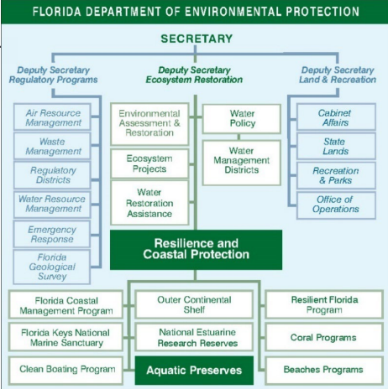
Figure 1: State Management Structure.
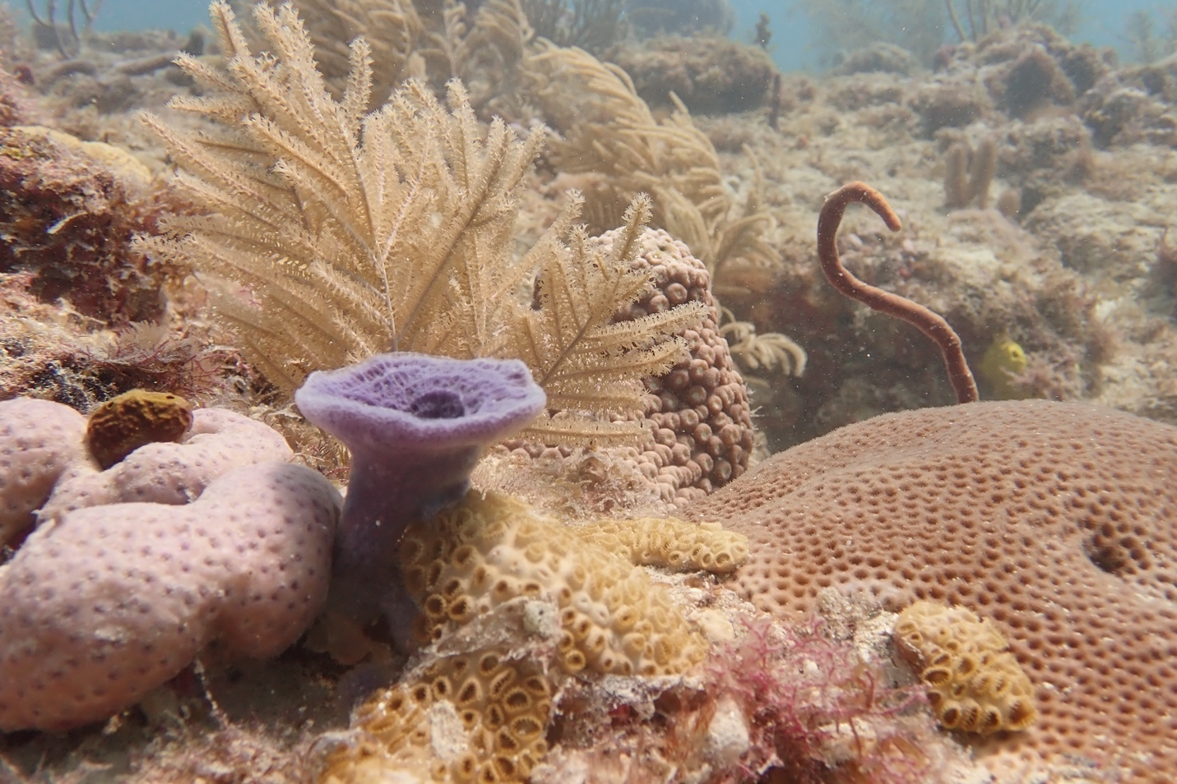
Photo: A benthic community in the Kristin Jacobs Coral Aquatic Preserve including corals, sponges, and algae.

Chapter 3: The Kristin Jacobs Coral Aquatic Preserve

3.1 Historical Background

3.1.1 Indigenous communities
Prior to European contact in the early 1500s, present-day Florida held approximately three quarters of a million indigenous peoples (Henderson et al., 2014). In South Florida, these communities had lived from the land and sea for thousands of years, leaving behind evidence of extensive and advanced socio-cultural structures and resource use techniques (Smithers, 2019). In 1513, Juan Ponce de Leon and his crew landed on the Northeast Coast of Florida; while his efforts at colonialization failed to bear fruit, news of his voyage served to precipitate more attempts (Henderson et al., 2014).

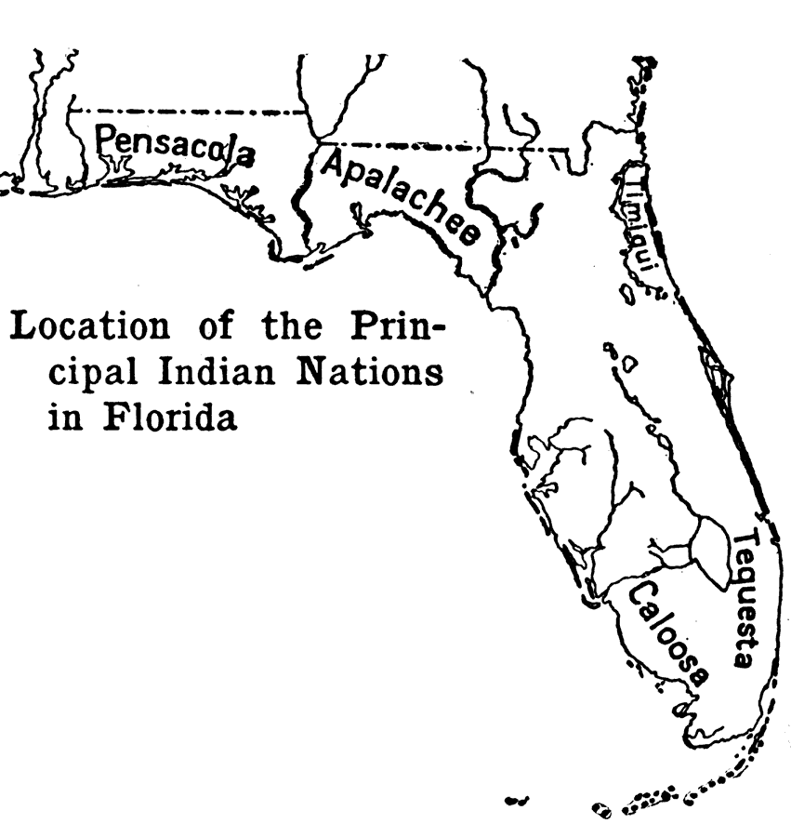
Figure 2: Locations of several indigenous tribes in the 1500s (Brevard, 1919).

3.1.2 European settlement and forced indigenous migration
Spanish settlements in Florida began in 1565 with Pedro Menéndez de Avilés, who was sent to protect the Gulf Stream route for the Spanish treasure ships by removing French settlements that began to appear in the area (Clark, 2014). Shifting alliances and interactions between the Spanish and the Tequesta, a Native American tribe, remained the norm for several decades, including attempts to build a fort off what is now Miami to establish a strategic position relative to the frequent shipwrecks along the reef tract (Carr, 2012).

The 1700s saw the populations of the Tequesta and many other South Floridian tribes dwindle, both from diseases brought by the Spanish and raids by the Lower Creeks tribes, to the point where by 1743, the vicinity around the Miami River was host to only six remaining tribes that accounted for about 280 people (Carr, 2012). The few remaining South Floridian indigenous groups were scattered and survived by fishing and trading with Cuba (Carr, 2012).

As the 19th century approached, the English had formed a few settlements in South Florida in their brief control over the region, and some Bahamian developments began in what would become Miami-Dade and Broward counties after the American Revolution (Carr, 2012). Those who did settle in the area relied heavily on the reef, subsisting mainly on catching sea turtles and wrecking, the process of salvaging wrecked cargo for profit (Carr, 2012). Members of what is today known as the Seminole tribe began moving into the area in the late 1700s after the decimation of the Tequesta and Calusa, with the earliest Seminole settlement believed to be on the border between what is now Miami-Dade and Broward counties (Carr, 2012). Throughout the century, indigenous groups that were forced south from the Second and Third Seminole Wars also settled further inland, with the coastal population being predominantly white. Even with these new settlements coming from both within and outside the United States, South Florida remained perceived as “frontier land” (Carr, 2012).

3.1.3 Development of major cities and tourism
Miami-Dade County (originally Dade County) was officially designated in 1836 and originally incorporated much of today’s Monroe, Broward, and Palm Beach counties (MDC, n.d.). The Homestead Act brought some new residents from northern states by making it easier to own and keep a home; however, it was not until Henry Flagler expanded the Florida East Coast Railway that the City of Miami, the county, and the counties on the route began to develop into the major population centers that we see today (Clark, 2014; MDC, n.d.). Like many of Henry Flagler’s construction projects, the railway was built through leasing convict laborers from the state, and hiring immigrants indebted for their transportation costs, with workers being subjected to harsh working and living conditions (Carper, 1976).

Tourism in Florida began as a prescription for many tuberculosis patients, with physicians sending their patients primarily to St. Augustine (Clark, 2014). Flagler started converting that industry into a winter getaway, building two hotels in St. Augustine and marketing them to his wealthy friends (Clark, 2014). In 1894, as Flagler expanded his hotel businesses further and further south, connecting each one with his ever-expanding railroad, he saw a barrier island across from Lake Worth where he could provide more exclusive experiences for his guests by controlling access to the island (Clark, 2014). He bought swaths of land on either side of the lake, developing the island into Palm Beach with another hotel for the wealthy elite, and the mainland into West Palm Beach for his hotel staff and railroad employees (Clark, 2014). At this point those wealthy guests decided to build houses of their own, leading to a major housing boom in the area (Clark, 2014). The ensuing growth led to the establishment of Palm Beach County in 1909 (Kleinberg, 2006). As access to the area increased, new towns like Boynton Beach, Delray Beach, and Boca Raton sprung up along the railway, originating as farming communities and slowly growing over time (McIver, 1976). In what would later be Martin County, the stop on the route to Palm Beach made the relatively inaccessible area of Stuart open to a new influx of people, also leading to the growth of the city of Stuart and farms emanating from the train station along the St. Lucie River (McGoun, 1998). While Miami saw the highest influx of people in South Florida, the increase was state-wide, leading to the establishment of Pompano, Ft. Lauderdale, and Dania, which all became incorporated in the first decade of the 20th Century, eventually resulting in the establishment of Broward County in 1915 and Martin County in 1925 (McGoun, 1978, 1998).

After extensive lobbying by Julia Tuttle, a resident of Miami who saw its growth potential, Flagler agreed to buy the land necessary to extend the Florida East Coast Railway to Miami (Clark, 2014). In April 1896, the first train rolled into Miami, setting the stage for a major boom in population (Clark, 2014). Almost immediately, new residents flooded in from the rest of the United States and the Bahamas (Bramson, 2007). Through the first quarter of the 20th century land sales were booming; the railroad, followed by the expansion of national highways and the increase in aviation made Southeast Florida more accessible than ever, bringing a dramatic increase in tourism and leading some visitors to settle there (Bramson, 2007; Clark, 2014). An amendment to the State Constitution, which eliminated state income and inheritance tax, also caused an increase in the demand for land with two-thirds of sales to people who had never visited their properties (Clark, 2014). A significant portion of that population increase also came from South America and the Caribbean as refugees from Cuba, Mexico, Haiti, Nicaragua, the Dominican Republic, and more came to start anew, especially in Miami (Clark, 2014).

The burst of the housing bubble came after the Great Miami Hurricane of 1926. This devastating hurricane made first landfall in downtown Miami on the morning of September 18, killing 372 people, injuring another 6,000, making 18,000 homeless, and destroying many of the new buildings and structures. (Derr, 1998) Two years later, in 1928, another powerful hurricane hit the region, striking West Palm Beach and then moving inland where its powerful winds felled a dike off Lake Okeechobee, washing away the farm towns of Belle Glade and South Bay and killing up to 2,400 people, mostly Black farmers, and injuring thousands more. Shortly after the 1928 hurricane, an exodus of land investors began, followed shortly thereafter by the Great Depression, putting Southeast Florida’s rapid growth on hold until WWII. The influx of soldiers in training, followed by a boom in tourism in the 1950s, once again led to the rapid expansion of Florida in general and Southeast Florida in particular (Clark, 2014).

Threats to the marine environment increased as development and construction continued throughout the 20th century. Coastal construction impacts first occurred along the coastal fringe and ridge, followed by the alteration of inland hydrology, and dredging and filling of wetlands through land reclamation processes (Derr, 1998; Kruczynski & Fletcher, 2012). Canals were built to divert freshwater, inlets were dredged to provide vessel access, and outfalls were built to release partially treated wastewater, which have all impacted the offshore environment and its resources. Offshore water quality continued to decline due to coastal development impacts from coastal construction projects and nonpoint sources of pollution (Kruczynski & Fletcher, 2012). As more structures and inlets were built and excavated along the Southeast Florida coastline, beaches began experiencing extensive erosion due to changes in longshore transport and deposition (Wanless, 2009). Port development and maintenance, especially along the three main ports in Southeast Florida, affected almost 600 hectares of corals and associated hardbottom communities (Walker et al., 2012) through the early 21st century.

3.1.4 Dredging and drainage to accommodate development
Through much of the 1800s, the shallowness of Biscayne Bay meant that Miami was not a significant port of trade – instead, supplies would come up from Key West where there was a deep-water port (Chapman, 1993). In 1897, after encouragement from Julia Tuttle and William and Mary Brickell, Henry Flagler dredged a 12-foot-deep channel that ran from Cape Florida to Miami and expanded the existing pier infrastructure. When this channel was still too shallow for major passenger and cargo vessels, in 1902 an even deeper channel was established through Miami Beach, separating the southern tip to create Government Cut and Fisher Island. These dredging projects were controversial among many prominent residents given the massive number of spoils they produced, impeding the aesthetics and navigation of waters along the Miami coast.

Port Everglades in Fort Lauderdale hosts many of the world’s largest cruise ships. This trajectory began in 1928 with the establishment of its deep-water port, followed in the 1950s and 1960s with rapidly increasing traffic from cargo vessels and ocean liners (Kaye, 2015). As cruise travel to the Caribbean became more popular in the 1970s, Port Everglades was a constant port of call. Major advancements in theme parks and further development of the tourism industry, combined with multiple waves of new immigration to the state, have led to the progressive development of the area around KJCAP to this day (Clark, 2014).

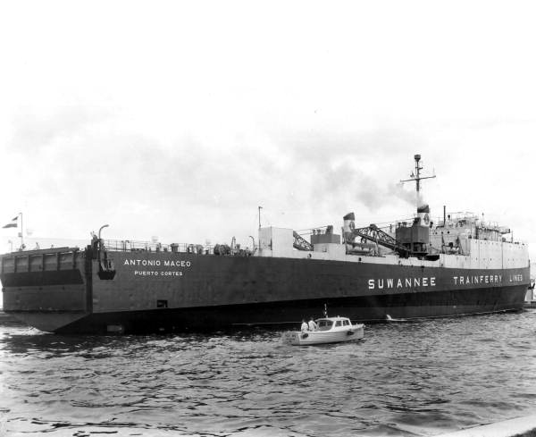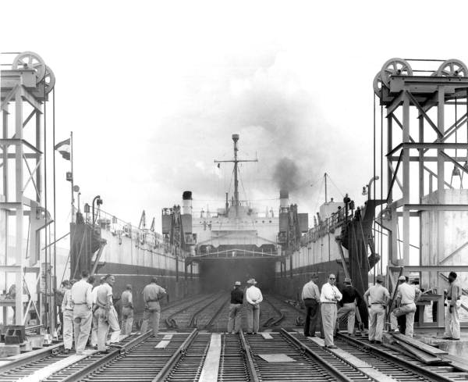
Photo 4: The docking and cargo loading of the Antonia Maceo at Port Everglades in 1953. This vessel was a Cuban car ferry loaded directly from the railroad lines (Photo: State Archives of Florida).
This period also saw the drainage of the Everglades, an idea encouraged since the 1840s that finally came to fruition under Governor Broward (Clark, 2014; McGoun, 1978). In 1913, the State Legislature allowed all localities to drain as they wished, leading to the development of tracts of land, first for agriculture, and eventually for residential and urban areas across South Florida (Clark, 2014). The rapid population growth that caused —and was aided by— the draining of the Everglades has caused ecological effects that are still being felt today in marine estuaries and coastal environments throughout South Florida. One of the first large-scale water alteration projects was the construction of the Herbert Hoover Dike. Construction for the dike surrounded Lake Okeechobee on all sides, and the completed project effectively blocked natural sheet flow south to the Everglades. Although the southern part of the Everglades was nominally protected as a national park in 1947, that same decade witnessed the start of the Central and Southern Project for Flood Control, the largest civil works project in the nation that in 20 years would restructure waterflow in the region, including Southeast Florida (SFWMD, n.d.b). These profound alterations from the natural hydrology of the region alongside increased land use for agriculture precipitated many of the issues we see today on Florida’s Coral Reef. Currently, runoff from the Everglades, which reaches the reef, includes water that has flowed through the agricultural and urban regions from as far north as Orlando. During periods of increased runoff (e.g., high rainfall events), there are greater influxes of nutrients from throughout the watershed into the coastal waters of South Florida, increasing likelihood of eutrophication and associated coral reef stress (Lapointe et al., 2019)

3.1.5 History of management affecting Florida’s Coral Reef
Management of Florida’s Coral Reef began in the early 1900s with the federal designation of the National Wildlife Refuge System, followed by the designation of the Fort Jefferson National Monument in 1935, then continued in 1960 with the establishment of John Pennekamp Coral Reef State Park, the first undersea park in the United States. Federal involvement began shortly after when Congress designated the Biscayne National Monument in 1968, which was later expanded to become Biscayne National Park in 1980. The development of managed areas continued in the Florida Keys where the Key Largo National Marine Sanctuary was established in 1975, followed shortly by the Looe Key National Marine Sanctuary in 1981. Continued degradation of coral reef ecosystems throughout the 1980s led to the development of the Florida Keys National Marine Sanctuary and Protection Act in 1990, which unified federal and state management of Florida’s Coral Reef in the Keys. Later, additional areas such as the Tortugas Ecological Reserve and Dry Tortugas National Park were established for increased conservation and protection, and are managed by the National Park Service (NPS).

A series of spatial and regulatory measures were ushered in with the prohibition of all coral harvest from inside park boundaries of John Pennekamp Coral Reef State Park (§370.114, F.S.), including banning the take of sea fans, stony corals, and fire corals; fishery gear regulations to minimize impacts on coral habitat; contamination regulations; and stricter dredge and fill requirements (Gulf Council [GC] & SAFMC, 1982). While most of these regulatory measures did not require ecosystem science research (e.g., long-term monitoring), the actions did stimulate long-term studies on Southeast Florida coral reefs.

Throughout the 1970s new environmental policies and permitting requirements were implemented (e.g., for the construction of seawalls, fishing piers, inlet hardening, inlet dredging and beach nourishment). Federal oversight and support for the state’s efforts in environmental conservation was initiated by the passage of several key federal environmental legislation, including but not limited to the National Environmental Policy Act (NEPA), the Coastal Zone Management Act (CZMA), Marine Mammal Protection Act (MMPA), the Clean Water Act, Endangered Species Act, and Marine Protection, Research, and Sanctuaries Act (MPRSA), (Andrews, 2006; Chandler & Gillelan, 2004; Kraft, 2000). Additionally, state-federal cooperation also began in the 1970s through the protection of stony corals, octocorals, and sea fans, which became illegal to harvest in any quantity under §370.114, F.S. and were similarly protected in federal waters, with the exception of a small harvest of octocorals under the Fishery Management Plan created by the Gulf Council and South Atlantic Fisheries Management Council(GC & SAFMC, 1982).

The South Atlantic Fishery Management Council, created under the Fisheries Conservation and Management Act of 1976 (reauthorized in 2006 as the Magnuson-Stevens Act), passed several Fishery Management Plans and related amendments that address KJCAP resources and habitats, such as the 1982 Coral Reef Fisheries Management Plan, the 1982 Coastal Migratory Pelagic Resources Management Plan, the 1982 Spiny Lobster Fishery Management Plan, and the 1983 Snapper Grouper Fishery Management Plan, among others (SAFMC, n.d.). Each of these plans led to long-term stock assessment and habitat research and monitoring, over time leading to a shift towards ecosystem-based management since 2010 (SAFMC, n.d.).

Additionally in 1983, the legislature created the Marine Fisheries Commission to specifically manage marine fisheries resources. Subsequently in 1999, management of these resources were combined with freshwater fish and wildlife management through a constitutional ballot initiative that created the Florida Fish and Wildlife Conservation Commission. FWC constitutionally manages areas and species within KJCAP pursuant to Article IV, Section 9 of the Florida Constitution, Chapter 68 of the Florida Administrative Code (F.A.C.), and Chapter 379, F.S. FWC manages Critical Wildlife Areas, Wildlife Management Areas, and manages coral reef-associated species essential to KJCAP.
However, despite the creation of these parks along with the passage of strict harvest prohibitions, the decline of Florida’s Coral Reef continued from the 1980s to present day (Pandolfi et al., 2005). Driven by concerns over chronic stressors, declining trends, and an extraordinary, global coral bleaching event, the federal government moved to strengthen coral reef protection in U.S. states and territories (Craig, 2000).

U.S. Coral Reef Task Force
In 1998, President Bill Clinton established the United States Coral Reef Task Force (USCRTF) by Presidential Executive Order #13089 to lead U.S. efforts in the preservation and protection of coral reef ecosystems (Exec. Order No. 13089, 1998). The USCRTF is made up of representatives from 12 federal agencies responsible for various aspects of coral reef conservation, seven U.S. states, territories, and commonwealths, and three freely associated states (Micronesia, Marshall Islands, and Palau). The seven states, territories, and commonwealths include American Samoa, the Commonwealth of the Northern Mariana Islands, Florida, Guam, Hawaii, Puerto Rico, and the U.S. Virgin Islands.

In 2000, the USCRTF adopted the U.S. National Action Plan to Conserve Coral Reefs (USCRTF, 2000). This was the first roadmap for U.S. action to address coral reef resource protection. During the eighth meeting of the USCRTF, held in Puerto Rico in 2002, the Task Force adopted the Puerto Rico Resolution, which called for the development of Local Action Strategies (LAS) by each of the seven member U.S. states, territories, and commonwealths. These LAS were three-year, locally driven roadmaps for collaborative and cooperative action among federal, state, territory and non-governmental partners which identify and implement priority actions needed to reduce key threats to coral reef resources.

The goals and objectives of the LAS were closely linked to those found in the U.S. National Action Plan to Conserve Coral Reefs (DEP, 2004; USCRTF, 2000). From the 13 goals identified in the National Action Plan, the USCRTF prioritized the following six threat areas as the focus for immediate local action: overfishing, land-based sources of pollution, recreational overuse and misuse, lack of public awareness, environmental change and coral bleaching, and disease.

USCRTF members continue to meet biannually to discuss key issues, propose new actions, present progress reports, and update the coral community on past accomplishments and future plans. In cooperation with state, territory, commonwealth, and local government partners, the USCRTF continues to support:
- Coral reef mapping and monitoring.
- Research projects aimed at identifying the major causes and consequences of degradation to coral reef ecosystems.
- Conservation, mitigation, and restoration as solutions to land-based sources of pollution, sedimentation, collection of coral reef species, direct destruction and other issues.
- International cooperation to assess the U.S. role in international trade and protection of coral reef species and implement appropriate strategies and actions to promote conservation and sustainable use of coral reef resources worldwide.

Southeast Florida Coral Reef Initiative
As a member of the USCRTF, the State of Florida committed to uphold Executive Order No. 13089, which called for the preservation and protection of the biodiversity, health, heritage, and social and economic value of U.S. coral reef ecosystems and the marine environment. Originally named the Southeast Florida Action Strategy Team (SEFAST), the Southeast Florida Coral Reef Initiative (SEFCRI) Team was formed and first gathered in May 2003 to focus on coral reefs and associated reef resources

DEP and FWC coordinated the formation of SEFAST from agency resource-related representatives (state, regional and federal), research professionals, and reef use stakeholders. Non-agency participants were part of Issue Teams that provided feedback and guidance to SEFAST. However, in August 2004, recognizing that more collaboration between stakeholders and agency representatives needed to occur, the agency and non-agency members were brought together as one team under SEFCRI, including representatives from academia; non-governmental organizations; the fishing and diving communities; marine industry; and state, local, and federal agencies. Florida charged SEFCRI with developing Local Action Strategies (LAS) to preserve and protect southeast Florida’s coral reefs and associated reef resources from Miami-Dade through Broward, Palm Beach, and Martin counties, emphasizing the balance between resource use and protection, in cooperation with all interested parties. This region was chosen because the coral ecosystems are close to shore, co-exist with intensely urbanized areas, remained relatively unstudied, and lacked a coordinated management plan (like that of the Florida Keys National Marine Sanctuary). More information about the SEFCRI Team can be found by visiting http://southeastfloridareefs.net/.

The SEFCRI Team originally chose to target four priority focus areas:
- Land-Based Sources of Pollution (LBSP)
- Maritime Industry and Coastal Construction Impacts (MICCI)
- Fishing, Diving, and Other Uses (FDOU
- Awareness and Appreciation (AA)

LBSP, FDOU, and AA were previously identified as priorities by the U.S. National Action Plan to Conserve Coral Reefs and by NOAA’s Coral Reef Conservation Program, however, MICCI was created specifically for Florida based on a unique need local to this jurisdiction. Initially, there were 140 projects outlined in the 2004 LAS under these four focus areas. Because of the dearth of information on Florida’s Coral Reef, most of the projects sought to better understand the physical, biological, and socioeconomic dynamics of the ecosystem, while the remainder focused on management initiatives. Until this time, the northern region of Florida’s Coral Reef remained relatively unstudied, except for circumstances involving opportunistic research and offshore impact studies due to coastal construction activities and local university studies.

By 2017, most of the original LAS were completed or neared completion leading the team to develop updated LAS, incorporating those 2004 strategies that remained and introducing 28 new projects to reflect the evolving coral reef ecosystem. At this time, a fifth focus area was introduced, Reef Resilience (RR), to address the ability of the ecosystem to respond to major events, including storms and disease outbreaks, as well as the long-term issue of environmental change and resulting bleaching events and acidification.

The SEFCRI Team continues to identify ongoing and emerging stressors to Southeast Florida’s coral reefs and associated reef resources and recommends and develops priority SEFCRI LAS projects to address those stressors. SEFCRI Team members serve as liaisons between their constituents and communities and the DEP Coral Reef Conservation Program, keeping DEP CRCP staff informed of issues and concerns, as well as performing supportive outreach to their respective communities regarding the SEFCRI LAS. SEFCRI Team members are also a resource to the DEP CRCP and strive to identify, investigate, and secure possible funding mechanisms and other opportunities for SEFCRI LAS implementation.

In 2004, the SEFCRI Team identified the need for specific technical expertise that did not exist, or was not sufficient within their current membership, specifically regarding the LBSP focus area. The SEFCRI Technical Advisory Committee (TAC) was a specific LAS project (LBSP Project 4) identified to provide technical and scientific guidance on LBSP LAS projects. The TAC is composed of members with appropriate levels of scientific and technical expertise in specific areas. Members of the TAC are selected for and asked to represent their area of expertise, not their agency or organization, as is the case for the SEFCRI Team. As part of the 2012 charter revision, the SEFCRI Team reviewed their progress to date, as well as projections for the future, and subsequently determined that the TAC expertise should be expanded to provide guidance to all the SEFCRI focus areas (LBSP, MICCI, FDOU, and AA). The expansion of the SEFCRI TAC has resulted in a body of scientists with expertise in coral reef ecology, coral biology, coral restoration, coral pathology, coral physiology, water quality, oceanography, chemistry, fish ecology, spatial ecology, ecosystem management, and socioeconomics.

Coral Reef Conservation Program
The Coral Reef Conservation Program was established in 2004 by DEP and was charged with managing the coral reef resources from the northern boundary of Biscayne Nation Park in Miami-Dade County through the St. Lucie Inlet in Martin County, and from Mean High Water to the offshore boundary of state waters at three nautical miles. The initial role of the CRCP was to oversee SEFCRI and provide leadership for Florida’s LAS, to contribute to the National Action Plan for Coral Reefs as part of the USCRTF, and to manage the cooperative funding agreement between the National Oceanic and Atmospheric Administration’s Coral Reef Conservation Program (NOAA CRCP) and the state. CRCP was also charged with coordinating research and monitoring, developing management strategies, and promoting partnerships to protect the coral reefs, hardbottom communities, and associated reef resources of Southeast Florida.

The scope of CRCP’s mission expanded beyond Florida’s LAS when they also gained the responsibility of coordinating the Reef Injury Prevention and Response (RIPR) Program in 2008, which leads the state’s response to and management of unplanned, direct coral reef injuries in Southeast Florida, such as vessel groundings and anchor damage incidents. Their authority and duties were further solidified with the passage of the Florida Coral Reef Protection Act (CRPA) by the Florida Legislature in 2009 (§403.93345, F.S.), which makes it illegal to damage coral reef hardbottom habitats in the Southeast Florida five county region (Monroe County through Martin County). The CRPA authorizes DEP to pursue enforcement action against the responsible parties for civil penalties and damages. Any recovered funds are deposited into a trust fund and are designated for coral reef-specific uses, such as injury event response and restoration. In July 2020, the CRPA was updated with an increased civil penalty schedule and higher maximum penalty per incident. It is also worth noting that civil penalties may increase for incidents occurring within an aquatic preserve, among other aggravating circumstances.

Originally, CRCP was made up of only one staff member, the CRCP Manager, who was tasked with managing the SEFCRI Team and subsequent projects. It was immediately recognized that one staff member was insufficient to manage the SEFCRI Team, provide Team leadership, and implement the 140 LAS projects in the three-year timeline set by the USCRTF; this is why several of the original LAS included hiring full-time focus area coordinators. Over the years, new and emerging stressors were identified by the SEFCRI Team.

Stakeholder Engagement Process
Stakeholder engagement is essential to the effective management of KJCAP, providing valuable local expertise and knowledge from those who most closely interact with its economically and ecologically valuable resources. Since 2003, ORCP has engaged with and received input from the Southeast Florida Coral Reef Initiative, a stakeholder advisory group that includes representatives from local, state, and federal governmental agencies, academia, the fishing and diving communities, non-governmental organizations, and the marine industry. In addition to this diverse stakeholder input, expertise and feedback is consistently sought from the academic sector through a Technical Advisory Committee, which includes representatives from various fields of research including, molecular genetics, microbial symbiosis, coral restoration, physical oceanography, coral disease, algal blooms, toxicology, larval settlement and dispersal, socioeconomics, ocean acoustics, coastal water quality, spatial ecology and planning, disturbance response, and microbiology. ORCP further implemented two stakeholder engagement processes, Our Florida Reefs (OFR) and a Fishery Stakeholder Committee, to gather input from a larger number of resource users and ensure participation management of KJCAP. The research, monitoring, and threat reduction data; public comments; and cooperating agency information, particularly the strategies developed by SEFCRI, the OFR community planning process, and the Fisheries Stakeholder Committee, have been used to identify management issues and stakeholder-based recommendations that will drive the present and future management of KJCAP, including development of this management plan.

Our Florida Reefs Community Planning Process
One of the original 2004 LAS’s, FDOU Project 26A, was initiated and hosted by the SEFCRI Team in 2013. This planning process, called Our Florida Reefs (OFR), was a community planning process, where members from various interest groups, including divers, fishers, academics, and governmental and non-governmental organizations were recruited to serve on Community Working Groups tasked with developing Recommended Management Actions (RMAs) specifically for KJCAP region, then known as the SEFCRI region. The Community Working Groups developed the RMAs based on the body of knowledge that had amassed with the implementation of the original SEFCRI LAS projects. The Community Working Groups met monthly starting in March 2014 until they had compiled a draft RMA list, which went through a public review process before being finalized by the working groups in June 2016. In total, the working group members dedicated over 10,000 volunteer hours and received thousands of public comments used in the development of 68 RMAs, which helped define many of the strategies included in this management plan ensuring a strong link between the community and ecosystem conservation. OFR recommendations that were not included in this plan were forwarded to the appropriate agencies with authority to address the recommendation. Although management issues related to fishing were included in the OFR process and RMA’s, towards the end of OFR the fishing community disengaged, and as a result, input and support for the OFR developed RMA’s was lacking from this stakeholder group. This led to the development of another stakeholder engagement process in 2020, FDOU Project 52, which organized a fisheries committee to create additional recommended management actions supported by the fishing community.

Fishery Stakeholder Engagement Process
A two-year long fishery stakeholder engagement process was completed in partnership with FWC and NOAA as a stakeholder supported SEFCRI Local Action Strategy Project called FDOU 52: Data Needs for Fisheries Management. A fisheries committee was formed which included members representative of the recreational, charter, commercial, spearfishing, and marine industry sectors. The committee developed 54 recommended management actions, which were either used to define strategies in this management plan or forwarded to the appropriate agency with authority to address the recommendation. These recommendations were developed through in-depth discussions among members on a variety of environmental issues and concerns including water quality, habitat degradation and restoration, fisheries and boating, education and outreach, and agency processes. The committee’s recommendations received input from the wider fishing community, the general public, and the networks of both the fisheries committee and SEFCRI through a survey and a public meeting. The evaluation of support for the management actions developed by the fisheries committee was a key component of this process that aids in improved resource management prioritization and decision making.

Establishment of Kristin Jacobs Coral Aquatic Preserve
Prior to 2018, only the southern two-thirds of Florida’s Coral Reef had been formally recognized and designated as uniquely valuable ecosystems requiring coordinated management (NOAA, 2007). Despite this notable lack of coordinated management, the northern third of Florida's Coral Reef (from the northern boundary of Biscayne National Park to the St. Lucie Inlet) is no less uniquely valuable as it includes extensive near-shore reef resources adjacent to a highly urbanized shoreline. In 2003 with the formation of the SEFCRI Team and TAC, coordination and communication between researchers, stakeholders, agencies, and non-governmental organizations began to be coordinated north of the Biscayne National Park and the Florida Keys. This area was known informally as the SEFCRI region, however, there was still no formalized management boundary.

The Florida legislature established the Southeast Florida Coral Reef Ecosystem Conservation Area on July 1, 2018, and subsequently renamed the area the Kristin Jacobs Coral Reef Ecosystem Conservation Area (Coral ECA) in 2021, honoring the tremendous support the late Congresswoman provided to this area. The Coral ECA consisted of the “sovereignty submerged lands and state waters offshore of Broward, Martin, Miami-Dade, and Palm Beach counties from the St. Lucie Inlet to the northern boundary of the Biscayne National Park” (Florida Statutes 253.90), equivalent to the area previously referred to as the SEFCRI region. While the area was now formally recognized by the Florida Governor and Legislature, there still were no additional protections added or a designated management entity. Excitingly, this changed in 2024 when the Florida Legislature passed a bill that included approving the Aquatic Preserve designation for the Coral ECA. The designated Kristin Jacobs Coral Aquatic Preserve (KJCAP) is the state of Florida’s 43rd Aquatic Preserve. This recent designation formalized the managing relationship between the northern portion of Florida’s Coral Reef and DEP’s Coral Reef Conservation Program, as well as providing additional biological, aesthetic, and scientific protections for the northern portion of Florida’s Coral Reef. The aquatic preserve designation also ensures holistic management of the area by improving coordination of coral reef restoration and shoreline stabilization projects, streamlining water quality monitoring efforts, and solidifying Florida’s commitment to protecting its coral reef habitat and resources.

The Florida Department of Environmental Protection’s (DEP) Office of Resilience and Costal Protection (ORCP) has developed this management plan for KJCAP to coordinate inter-agency efforts and guide management activities to restore and enhance the marine environment within the boundaries of KJCAP. ORCP recognizes the inherent complexity in governance that exists within KJCAP due to the delegation of management authorities to different federal, state, and local governmental agencies, including DEP, FWC, NOAA, counties, and municipalities. Within Florida’s Coral Reef, there are a variety of managed areas, including Dry Tortugas National Park, the Florida Keys National Marine Sanctuary, Biscayne National Park as well as numerous state parks, aquatic preserves, critical wildlife areas, and wildlife management areas. In addition to the multi-agency coordinated management efforts, ORCP also understands the importance of stakeholder participation and encourages their involvement in the management plan development process.

Continued collaborative action among researchers, government and non-governmental agencies, and stakeholders will allow key issues impacting resources within KJCAP to be addressed, which include water quality/land-based sources of pollution; marine industry and coastal construction impacts; sustainable, economic, and recreational use; ecosystem disturbance response and recovery; community education, engagement, and access; and building ecosystem resilience. Issues affecting KJCAP are addressed using an approach that integrates principles of Ecosystem Science, Resource Management, Education and Outreach, and Public Use Programs, which are overseen by ORCP. This approach (issue-based management) allows the goals, objectives, and strategies associated with an issue to have a greater chance of being accomplished through the actions of multiple partners, in addition to CRCP.

The long-term decline of the environment within KJCAP has led to collaborative action to enhance the conservation of Southeast Florida’s vital ecosystems, including the efforts to develop this management plan and the Kristin Jacobs Coral Aquatic Preserve. Southeast Florida’s growing population has led to increased development, water quality issues including sedimentation and land-based sources of pollution, habitat degradation, and intended and unintended impacts from recreational and commercial use, which have reduced the health and resiliency of the ecosystems within KJCAP. More formalized management is needed to ensure the long-term health of KJCAP. A strategic and effective management plan is essential to address the complexities of KJCAP, which is one part of an inter-connected system of managed areas that make up Florida’s Coral Reef. The purpose of this plan is to incorporate, evaluate, and prioritize all relevant information about the region into a cohesive management strategy, allowing for access to the managed area while balancing use with protecting the long-term health of the ecosystems and their resources.

Cape Florida Aquatic Preserve
Cape Florida Aquatic Preserve (CFAP), formally known as Biscayne Bay-Cape Florida to Monroe County Line Aquatic Preserve, was first designated in 1970. It initially encompassed a vast area of submerged lands and islands, stretching offshore from southern Key Biscayne out to Florida state waters, southward to the Monroe County line and northward along the Intracoastal Waterway back to Key Biscayne, including Bill Baggs Cape Florida State Park. However, with the establishment of Biscayne Bay Aquatic Preserve in 1974 and then Biscayne National Monument in 1980 (later expanded and renamed Biscayne National Park), the preserve's acreage was significantly reduced. Today, the preserve exists as a smaller area off the eastern shore of Key Biscayne. Despite its reduced size, the preserve remains a crucial part of Florida's aquatic ecosystem, providing habitat for diverse marine species.

Historically, CFAP has been managed by Biscayne Bay Aquatic Preserve (BBAP) program. When KJCAP was established, its boundary entirely encompasses CFAP, therefore KJCAP staff have assumed management of this aquatic preserve. Not only do these areas overlap, they also have the same habitats, ecosystems, and natural communities, making the KJCAP staff suited to manage this area. Biscayne Bay Aquatic Preserve staff will continue to provide technical and logistical assistance whenever needed for the monitoring of marine seagrass communities within CFAP. While BBAP is administered under Chapter 18-18, Florida Administrative Code (F.A.C.), that rule does not extend to CFAP, another reason why management was transferred to KJCAP since they are both administered under Chapter 18-20, F.A.C. CFAP is designated as an Outstanding Florida Water (OFW; Rule 62-302.700, F.A.C.), which provides additional regulatory protections. These protections do not currently extend to the rest of the KJCAP area, until that section is amended into the rule. When determining what activities are permissible within the overlapping aquatic preserve area, the stricter standards of Chapter 403, F.S. and Chapter 18-20, F.A.C. will be applied. In this management plan, the areas designated as KJCAP and CFAP will be referred to together as the Kristin Jacobs Coral Aquatic Preserve (KJCAP), unless there is a fact or strategy specific to CFAP, in which case it will be called out specifically.

3.2 General Description

3.2.1 International/National/State/Regional Significance
Florida is the sole continental state to have a bank-barrier reef ecosystem. Florida’s Coral Reef is built off a reef structure supported by stony corals and associated biotic communities; this reef structure provides habitat for more than 6,000 species, including many important fisheries species such as spiny lobster, reef fish, and marine ornamentals (Banks et al., 2008). The five counties bordering the reef are densely urbanized, home to almost 6.4 million residents (United States Census Bureau [U.S. Census], 2020). South Florida’s economy and way of life are inextricably linked to its coastal and marine environments, and the coral reef ecosystem sustain a variety of ecosystem services that provide numerous economic, social, and cultural benefits to the surrounding communities including dive and snorkel tourism, coral reef fisheries, biomedicine, and shoreline protection from flooding and storm damage, among many others.

The 450 square miles of coral reef habitat hosts diverse assemblages of stony, or reef-building corals, octocorals, sponges, and algae that contribute to the integrity and vitality of the reef platform, as well as a myriad of fish, crustaceans, mollusks, and other marine life associated with the ecosystem. As previously stated, the coral reef ecosystem, its productivity, and its health are closely tied to nearshore and inshore habitats, namely seagrass beds, mangroves, and other estuarine areas. Apart from being connected in terms of water quality, nutrient flows, and other biogeochemical processes, these landward habitats are often important refuges for key life stages of ecologically and commercially significant species. While some species may display periodic movements across habitats, others migrate permanently to the reef as the species mature in an age-driven (ontogenetic) migration.

There are three main ports in Southeast Florida that border KJCAP that result in heavy vessel traffic through the area: Port of Miami, Port Everglades, and the Port of Palm Beach (Florida Seaport Transportation and Economic Development Council [FSTEDC], 2019). Port of Miami, a landlord port that provides county funds through the leases of private companies, is the leading cruise ship port in the world, and its 330,000 jobs contribute around $43 billion annually to the local economy (FSTEDC, 2019). Port Everglades in neighboring Broward County also brings in significant revenue at more than $30 billion annually, supporting over 230,000 jobs (FSTEDC, 2019). The port’s proximity to the Florida East Coast Railway makes it an important gateway for goods into the U.S., capable of transporting cargo to 70% of the U.S. population in four days (FSTEDC, 2019). The Port of Palm Beach, another landlord port, is the smallest of the three, generating $260 million in private revenue and $12 million for the state and federal governments, and providing convenient access to the local railroad (FSTEDC, 2019).

KJCAP provides many important ecosystem services; however, among the most critical is its role as a barrier reef. Healthy coral reefs help to prevent flooding by serving as breakwaters that attenuate wave energy. Reefs in KJCAP help to protect a population of 6.4 million from Miami-Dade to Martin County (Office of Economic and Demographic Research, 2019). These communities already represent some of the most environmental change-vulnerable in the country; this vulnerability results from (1) exposure to flooding and shoreline erosion from rising sea levels and (2) environmental change-related increases in the frequency and intensity of hurricanes and severe storms, in combination with (3) vulnerable individuals and communities in the region (Beck et al., 2018; Benevolenza & DeRigne, 2019). Thus, the shield that reefs can offer to these exposed communities will become even more important with time (Elsner et al., 2008; Hauer et al., 2016). Cities like Miami Beach, which are already spending hundreds of millions of dollars on flood mitigation, will see those costs skyrocket as the extent of land and infrastructure impacted by a 100-year storm will increase by an additional 116% by 2100 under the business-as-usual model (Beck et al., 2018; Kulp & Strauss, 2017). Florida’s Coral Reef has the potential to provide almost $324 million per year in flood protection benefits to buildings and to protect $286 million in annual economic activity in peninsular Florida (Storlazzi et al., 2019).

The coral reef ecosystem is also culturally important, providing a sense of place, identity, and community, indicated by the number of visitors and residents that snorkel, dive, and fish for recreation in KJCAP. The reef’s cultural significance is also reflected in the education, research, and artistic communities and outputs it supports (Cramer et al., 2022).

The total monetary value of KJCAP can be measured as a sum of the use and non-use values to the total suite of users (Davis et al., 2019). Use values consist of values derived from direct uses, indirect uses, and option values. Direct uses are those outputs and services that are consumed directly, and in the case of KJCAP, include the coral reef ecosystem associated fisheries and tourism. Indirect uses are functional benefits that arise from ecosystem functions, such as ecosystem resilience, that assist with, for example, coastal protection, nutrient cycling, and habitat generation, among others. Finally, option values are values derived from future direct and indirect uses. Non-use values consist of bequest values, which are placed on conserving the region and its resources for future generations, and existence values, which are gained from the knowledge that KJCAP (even if it is not visited) will continue to exist. Although a monetary valuation of KJCAP has not been specifically conducted, several publications have quantified certain aspects of the ecosystem.

Strategies identified in Chapter 4 of this management plan, and the conservation of KJCAP, help to protect these critical values and represent an investment into the future of Florida´s economy and ecology.

3.2.2 Location/Boundaries
While Kristin Jacobs Coral Aquatic Preserve is oriented towards the northern 105 miles of Florida’s Coral Reef, the reef runs from the Dry Tortugas to the St. Lucie Inlet (Banks et al., 2008), extending over 350 nautical miles across Monroe, Miami-Dade, Broward, Palm Beach and Martin counties. KJCAP includes the sovereign submerged lands and state waters offshore of Martin, Palm Beach, Broward and Miami-Dade counties from the northern boundary of Biscayne National Park to the St. Lucie Inlet. The northern border of KJCAP overlaps with the offshore waters included within the St. Lucie Inlet Preserve State Park, and KJCAP’s southern boundary encompasses CFAP. KJCAP is uniquely situated in a subtropical climate and in close proximity to the warm waters of the Gulf Stream (Banks et al., 2008).

Southeast Florida is the most populous and densely urbanized region in the state, consisting of approximately a third of Florida’s 23.4 million residents, with large metropolitan areas, several major cities (Miami, Fort Lauderdale, and West Palm Beach), and dozens of municipalities along the shoreline of KJCAP (U.S. Census, 2024). Communities throughout the four-county region are connected by Florida’s Turnpike, Interstate 95, and several large east-west interstates. There are a total of nine inlets that provide coastal access from the Atlantic Intracoastal Waterway to KJCAP. There are two inlets in Miami-Dade County (Government Cut and Baker’s Haulover), two inlets in Broward County (Port Everglades and Hillsborough), four inlets in Palm Beach County (Boca Raton, Boynton, Palm Beach, and Jupiter), and one inlet in Martin County (St. Lucie).

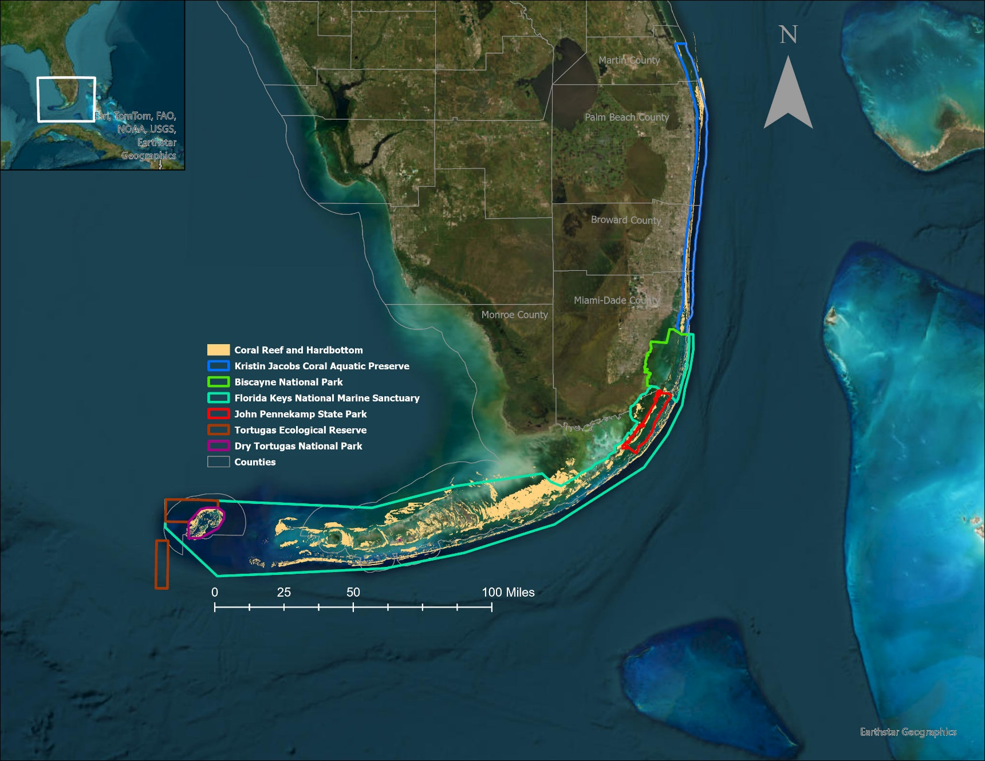
Map 2: KJCAP and adjacent managed areas of Florida’s Coral Reef.
In response to repeated ship groundings and anchor impacts on the reef, the U.S. Coast Guard conducted a review of the Port Everglades anchorage, culminating in emergency rule changes that moved the anchorage farther offshore and limited the time ships could spend there (Walker, 2010). A SEFCRI project (MICCI Project 8), investigated how to modify the anchorages at Port Miami and the Port of Palm Beach, eventually leading to the Port Miami anchorage being split into two sections and reduced in overall area from three square nautical miles to 1.5 square nautical miles (33 Code of Federal Regulations [C.F.R.] 110, 2017; Walker, 2010). Apart from the commercial ports, many marinas, docks, and boat ramps exist in each of the four counties that abut KJCAP.

3.3 Resource Description

3.3.1 Surrounding Population Data and Future Projected Changes
Florida is the third most populous state in the U.S. with a population of 23.4 million residents, exceeded only by California and Texas (U.S. Census, 2024). Home to a population of 6.4 million, Southeast Florida’s population has grown significantly over the past 50 years, increasing by 464% from 1970 to 2019, and it is expected to grow another 23% through 2045, by adding another two million residents.

Southeast Florida’s warm climate and expansive coasts contribute greatly to its popularity for both residents and visitors. Tourism is among the most important economic drivers for the state, playing an essential role in the region’s economy. In 2019, tourism had a total economic impact of $96.5 billion, with 145.4 million out-of-state tourists visiting the state (Rockport Analytics, 2021). In Southeast Florida, tourism accounted for $35.1 billion in total economic impact and contributed to 494,000 jobs, second only to central Florida. Miami-Dade County alone recorded 24.2 million visitors in 2019, and the county’s beaches and climate were the main draw for both overnight visitors and day trippers (Greater Miami Convention and Visitors Bureau [GMCVB], 2020). Regional studies (Johns et al., 2001; Johns, 2004) have shown the importance of Florida’s Coral Reef for recreation and tourism, and more recent extrapolations (e.g., Spalding et al., 2017) have shown a strong, continued use of and demand for KJCAP resources. Stakeholder research conducted in support of SEFCRI priorities has similarly determined the high level of extractive and non-extractive uses in KJCAP region (Shivlani, 2006; Shivlani & Villanueva, 2007).

The growing population and significant tourism load in Southeast Florida present both opportunities and threats to KJCAP’s coral reef ecosystem and associated habitats and resources (Johns et al., 2001). The opportunities range from the economic value that KJCAP provides via visitor expenditures and local employment options, the varied seafood products that the coral reef ecosystem supports for the commercial fishing industry and consumers, and the protection that an intact and healthy coral reef offers a coastal zone otherwise vulnerable to coastal flooding and erosion (Spalding et al., 2017; Woodhead et al., 2019). By contrast, challenges to the integrity and health of KJCAP and its resources can result from the rapid increase in population and tourism. Specifically, increases in resident and tourist populations are expected to: create the need for greater infrastructure development; lead to higher amounts of wastewater discharge through point and non-point sources; lead to more urban stormwater runoff and other land-based sources of pollution; build pressure for developing or modifying watershed hydrology to accommodate human use and habitation; increase fishing pressure; increase the risk of physical damage generated by anchoring, divers, and snorkelers; and increase the risk of vessel-based oil pollution and other hazardous discharges/accidents (Collier et al., 2008).

3.3.2 Topography, Geomorphology, and Geology
Southeast Florida’s continental shelf, which encompasses KJCAP, is relatively narrow, ranging from 3-4 km in width (Banks et al., 2008). A series of ridges, or terraces, run parallel to the region’s coastline, separated by sediment layers of varying thickness. Coral reefs and associated communities grow on these ridges, comprising the inner, middle, and outer reefs of Southeast Florida that extend in a north-south axis from northern Palm Beach County to southern Miami-Dade County. Along its northern extent, past Hillsboro Inlet off northern Broward County, the inner and middle reefs of the nearshore ridge complex are buried due to the seaward accretion of the present-day coast. The outer reef ends off Palm Beach County in a convergence with a series of beach ridges. A Deep Ridge Complex that begins in Palm Beach County extends 2 km into Martin County and consists of three ridges that vary in depth from 18 m to 25 m (Walker, 2012). There is also notable shallow hardbottom habitat around the St. Lucie Inlet at the northernmost point of KJCAP (Walker, 2012). In the southern portion of the region, only the middle and outer reef remain in southern Miami-Dade County, which eventually also disappear under sand seaward of Biscayne Bay (Banks et al., 2008). South of the outer reef terminus, offshore the southern end of Key Biscayne, three small linear reefs occur, but it is unclear whether these structures are a continuation of the outer reef, an independent structure, or the beginning of the Florida Keys reef tract (Banks et al., 2008). The overall offshore area available to support shallow water coral reef ecosystems off Southeast Florida is 19,653 square kilometers; while early and mid-Holocene conditions did support reef building (i.e., an increase in overall reef infrastructure via carbonate accretion) along Florida’s Coral Reef, the reefs at present are not in a framework building phase (Toth et al., 2022).

The outer reef terrace ranges from 16-36 meters below sea level and is a relict Acroporid-framework reef that extends from Biscayne Bay northward to Delray Beach (Banks et al., 2008). The species, location, and zonation of the terrace implies that the outer reef terrace crested in much shallower water than it does today. Geomorphic features, such as reef gaps that occur along the reef zones, suggest the existence of relict inlets or river channels in the underlying substrate. The middle reef terrace crests at 15 meters below sea level and runs from southern Miami-Dade County north to southern Palm Beach County near the Boca Raton Inlet. It is likely that the middle reef was a shoreline when the outer reef was still actively accreting, and it - like the outer reef - has erosional channels, which indicates the existence of paleo-rivers that cut through the inner, middle, and outer reefs. Also present between all three terraces is low ridge-like formations mostly covered by sediment, which may have been framework ridges or lithified sand ridges. The inner reef terrace crests at eight meters below sea level and is comprised mainly of an Acropora palmata framework, which begins off northern Miami-Dade County and extends north to Hillsboro Inlet. Unlike the outer reef, the inner reef is discontinuous, consisting mainly of patch reefs fused to form longer structures in some areas. The nearshore ridge complex, which sits landward of the three main reef terraces (Figure 3), extends from Miami-Dade County north to Hillsboro Inlet, and is comprised of shoreline deposits and karst features, creating a series of pavement and ridges between 3-5 meters below sea level. On the outer, or eastern edge of the ridge complex, a feature exists at six meters below sea level with a vertical relief of approximately 1.5 meters, resembling what Banks et al. (2008) and Raymond (1972) interpreted as a wave-cut cliff, possibly a shoreline from the time the inner reef was alive and accreting.

There are no known mineral resources within KJCAP.
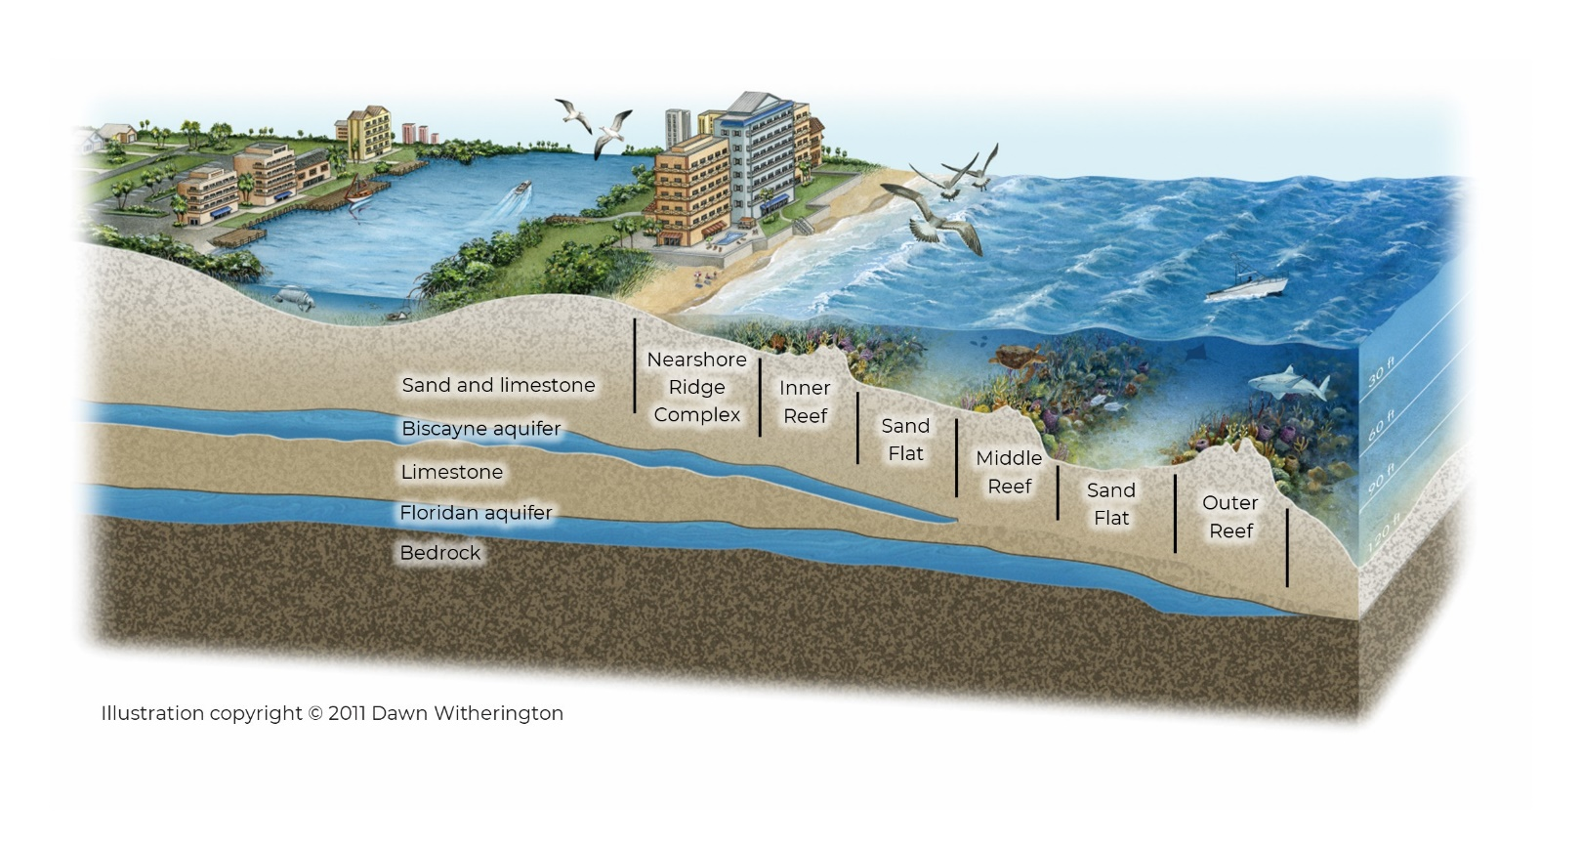
Figure 3: Illustration of a typical reef terrace structure as an example of what can be found in KJCAP.

3.3.3 Soils
Marine sediments in KJCAP include calcium carbonate silt derived from skeletal remains of reef-building and other calcifying organisms, marl, mud, sand, shell and organic matter (FNAI, 2010). However, these sediment types have not been mapped. Compositions are influenced by coastal currents, depth of the seabed, and coastal erosion.

Accumulation of heavy metals, oils, pesticides, and bacteria in marine sediments can become resuspended from wave action or storms, or from anthropogenic activities such as inlet dredging, and harm or kill marine organisms, in particular benthic communities (Giarikos et al., 2023).

3.3.4 Hydrology and Watershed
Before dense urbanization, the South Florida hydrologic system covered an area of about four million acres (Obeysekera et al., 2011) and functioned as an interconnected mixture of freshwater wetlands, uplands, estuaries, and marine ecosystems. Surface waters from the Kissimmee River basin flowed into Lake Okeechobee with the only outlet being periodic overflow of the southern shore during the rainy summer season (June through October). The overflowing water was slowed and filtered across the Everglades thick sawgrass plain, much of it infiltrating into the ground prior to draining into Florida Bay. The Atlantic Coastal Ridge, a marine limestone covered with thin sheets of quartz sand, partially separates the wetlands of the Everglades from the eastern coastal region, rising to a maximum of 20 feet above sea level in some areas. In the north, it spans a width of 3 – 5 miles and in the south, 10 miles (NPS, 2018). The ridge that runs approximately along the current location of Interstate 95 prevented much of the water in the Everglades from flowing east into the Atlantic Ocean, except for a few flow connections in the south, called the transverse glades (Obeysekera et al., 1999). The southern region of what is currently Miami-Dade County, the primary source of freshwater flow into estuaries was through upwelling from the Biscayne Aquifer.

During the late 1800s, coinciding with steady human population increase, water management began to alter the natural slow-moving sheet flow of water through the construction of canals, ditches, dams, and levees. This has been to accommodate agricultural use, oil and gas exploration, and urban development. The Central and South Florida Flood Control Project was initially created in response to disastrous flooding events that occurred in 1926, 1928, and 1947 (Obeysekera et al., 2011). The expertly engineered water management system constructed by the U.S. Army Corps of Engineers (USACE), successfully prevented flooding, while at the same time significantly altering the region’s ecology by decreasing the areal extent of the Everglades by half, reducing flow of freshwater to Florida and Biscayne Bays, and increasing freshwater to estuarine systems in the north (Indian River Lagoon, St. Lucie Estuary, and the Caloosahatchee Estuary). Subsequent realization of the deleterious effects of altering the hydrologic system, the state and federal governments have undertaken many major projects to restore some freshwater flow through the Everglades, as well as to the wetlands adjacent to southern Biscayne Bay.
Map 3: Everglades Ecosystem.
A reconstruction via satellite images of the Everglades ecosystem and surrounding watershed (a) pre-drainage, circa 1850, and (b) post-drainage (1994). Yellow lines indicate the extent of the Everglades ecosystem at both points in time (Source: McVoy et al., 2011).

Hydrology in the region is driven by flat topography, highly variable rainfall, rainfall-generated run-off, groundwater recharge and discharge, and evapotranspiration. The South Florida water management system, alternatively known as the Central and Southern Florida Project, is a vast engineering project, including approximately 2,200 miles of canals, 2,100 miles of levee/berms, and 1,400 water control structures (operated under regulation schedules and operational rules) (SFWMD, 2020). This system was designed to provide flood protection, maintain adequate groundwater elevations in agricultural and urban areas for water supply needs of a growing population, and inhibit potential saltwater intrusion into the freshwater aquifers (Strowd et al., 2017). Constructed wetlands called the Everglades Storm Water Treatment Areas and flow equalization basins for water quality treatment are also components of the South Florida water management system. In addition to surface waters, several groundwater aquifers contribute to the hydrology in South Florida, most responding quickly to rainfall and surface water conditions. The agencies responsible for the region’s water resource management, the South Florida Water Management District (SFWMD) and USACE, have divided the area into four main planning regions: the Kissimmee Basin, Upper East Coast, Lower West Coast, and the Lower East Coast. Each region is supplied water for various uses from their associated aquifers. The primary source of groundwater for the Lower East Coast is the Biscayne Aquifer and for the Upper East Coast, the Surficial Aquifer (SFWMD, 2020). Water Conservation Areas have also been constructed to support urban water supply and protect fish and wildlife in the Everglades.

The connectivity between surface, ground, and seawater is prominent due to the porous limestone which allows for surface water to quickly enter the ground, then flow into various waterways until reaching the ocean. This connectivity between ground and surface water can be illustrated through water chemistry. For example, dissolved oxygen in ground water is commonly very low, so an abnormally low concentration in surface waters may indicate higher than usual inflows of groundwater (DEP, 2019). Nitrogen is also naturally very low in groundwater, so the presence of organic and inorganic nitrogen in human or animal waste, and/or the use of fertilizers can result in increased plant and/or algal growth in surface and coastal waters. Surface waters from the Everglades and north are connected to estuaries and coastal waters through a large network of canals in addition to a few small rivers, remnants of the natural flow. This network often drains nutrient-rich fresh waters from local basins and Lake Okeechobee into the estuaries and the coastal waters, resulting in reduced salinity, and increased phosphorus and nitrogen concentrations, which fuel algal blooms.

Water resources in South Florida are managed in a three-tiered fashion. The primary canal system manages regional water levels, flows, and discharge flood waters throughout the 16-county jurisdiction of the SFWMD. This system’s primary function is to provide regional flood control and groundwater recharge, managed by SFWMD and USACE. Secondary canal systems are governed by designated drainage Districts or private entities and function by collecting runoff from smaller watersheds and draining them into the primary canal system, receiving lakes, or coastal waters. The tertiary drainage system is the smallest subdivision of water management and includes ditches, swales, storm sewers, and detention ponds most commonly owned and maintained by property owners or homeowner associations. These systems generally operate under Environmental Resource Permits issued by SFWMD (SFWMD, n.d.a).

The region’s watershed and hydrology affect the water quality within KJCAP through two primary avenues: surface water (including urban and agricultural runoff) draining out of nine inlets and six wastewater outfalls positioned near the outer reef. Because the natural watershed has been so profoundly altered, the inlets are often referred to as inlet contributing areas (ICAs) instead of as watersheds. In 2015, a watershed scale planning effort was initiated to reduce land-based sources of pollution and map the linkage of land-to-inlet water flow by delineating ICAs to the nine inlets in Southeast Florida (Pickering & Baker, 2015). To an extent, each ICA is connected by the Intracoastal Waterway (ICW). The hydrodynamic processes within the ICW and its connection to the Atlantic Ocean are not well understood. Intense weather events complicate these processes when mixing, flow or wind direction changes for some interim period. Pickering and Baker (2015) state this as a vital data gap hindering the ability to assess and manage land-based sources of pollutant impacts to estuaries and the reef. The amount of management, monitoring, and land use differs among each of the ICAs. Land use, or cover, varies between ICAs; the southern ICAs have more urban development, while the northern ICAs have more agricultural cover (Pickering & Baker, 2015). Based on land use in each ICA, pollutant loads can be estimated using land use runoff coefficients developed by SFWMD. Because these coefficients had not been developed for the watersheds throughout Southeast Florida, Pickering and Baker (2015) used the coefficients developed by SFWMD in the St. Lucie River Watershed Protection Plan (SFWMD, DEP & FDACS, 2009) to estimate nutrient loads for each of the nine ICAs. The ICA with the highest estimated total phosphorus and total nitrogen loads from land use was the St. Lucie Inlet (643,011 lb/yr and 2,809,205 lb/yr), followed by Government Cut (247,342 lb/yr and 1,098,439 lb/yr), see Table 1 (Pickering & Baker, 2015). This estimate does not incorporate the additional load from septic systems.

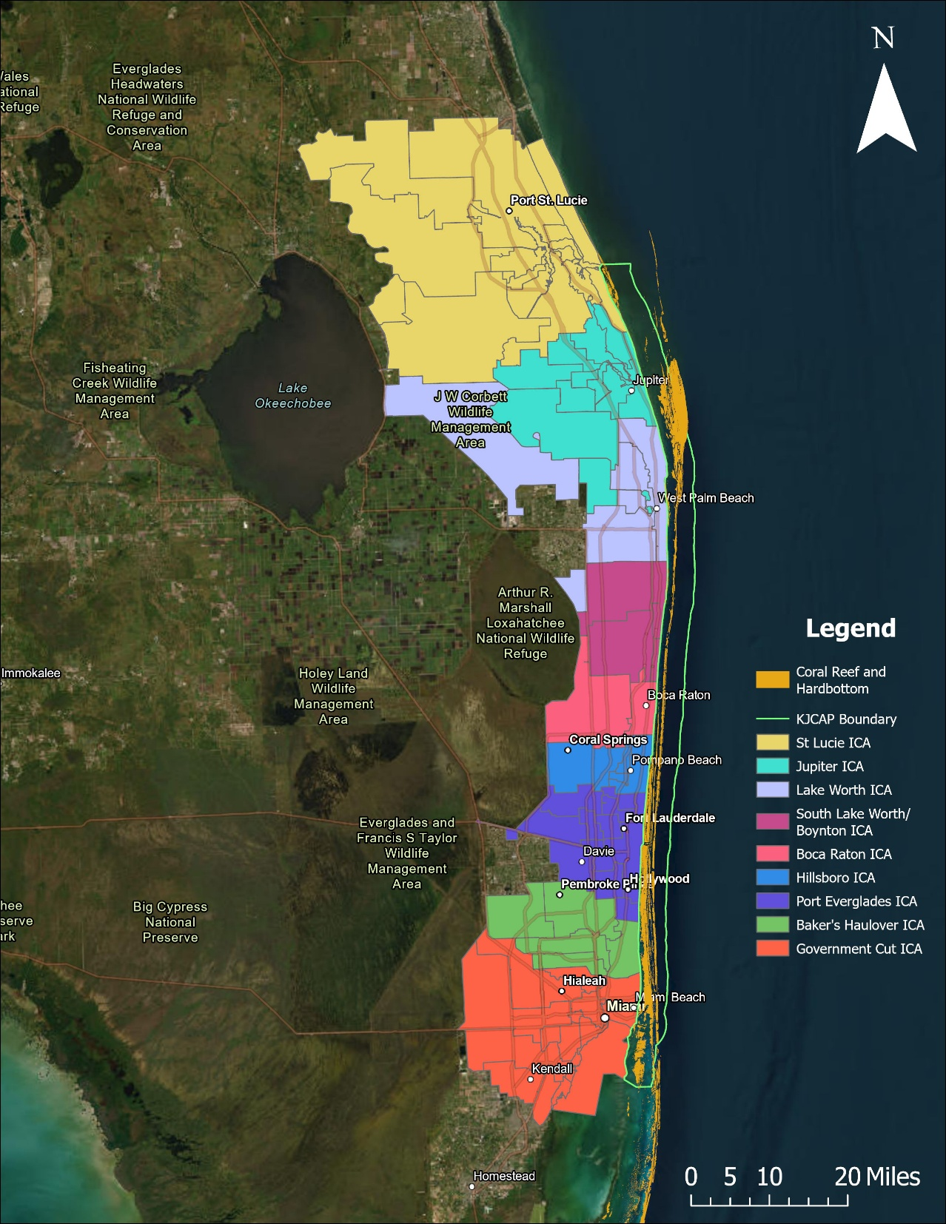
Map 4: Inlet contributing areas (ICAs) adjacent to KJCAP.
Table 1: Summary of estimated nutrient loads (lb/yr) from land uses in each Inlet Contributing Area within KJCAP. (Pickering & Baker, 2015)

Inlet Contributing Area | Phosphorus Loads (lb/yr) | Nitrogen Loads (lb/yr)
St. Lucie Inlet | 643,011 | 2,809,205
Jupiter Inlet | 99,741 | 552,635
Lake Worth Inlet | 157,076 | 816,053
Boynton/S. Lake Worth Inlet | 155,710 | 592,053
Boca Raton Inlet | 107,031 | 432,698
Hillsboro Inlet | 85,087 | 335,189
Port Everglades Inlet | 167,143 | 683,677
Baker’s Haulover Inlet | 144,331 | 610,017
Government Cut Inlet | 247,342 | 1,098,439
TOTAL | 1,806,472 | 7,929,966

In addition to nutrient enrichment, turbidity and sedimentation are additional components of water quality that can affect coral reef condition within KJCAP through surface waters. Discharge from water management canals through inlets can lead to rapid changes in salinity, turbidity, sedimentation, and siltation (PBC, 2008; SFWMD, 2008; SFWMD, DEP & FDACS, 2009). Turbidity is a measurement of water clarity, defined as an optical measure of water and is a measurement of the amount of light that is scattered and absorbed rather than transmitted through the water column. Research has indicated that turbidity shares close relationships with suspended sediments and other particulate matter, such as algae and bacteria (U.S. Geological Service [USGS], n.d.). Turbidity can fluctuate naturally from storm events, land runoff, tidal fluctuations, high winds, waves, or strong currents. Anthropogenic sources of turbidity include dredging, beach nourishment, agricultural activities, urban runoff, construction activities, and resuspension from boat activity. Sedimentation can bury or smother corals and other benthic organisms, leading to partial tissue necrosis and, in cases where corals have difficulty shedding the sediments, complete mortality (Miller et al., 2016; Erftemeijer et al., 2012). Other documented effects of increased sedimentation on corals include reduced species richness, less live tissue cover, lower growth rates and calcification, increased disease prevalence, changes in species composition, and lower rates of reef accretion (Harvell et al., 1999; Rogers, 1990).

Secondary-treated wastewater effluent is discharged through six wastewater outfalls between one and three miles offshore. In 2005, wastewater was released at a combined flow rate of 425 million gallons per day with a projected rate of 474 million gallons per day by the end of 2025 (Koopman et al., 2006). The wastewater released offshore has been treated to remove biodegradable organics and suspended solids (DEP, 2010), which excludes the removal of a significant percentage of nutrients, pharmaceuticals, heavy metals and personal care products (Bloetscher & Gokgoz, 2001). In 2008, the Florida legislature passed legislation that scheduled ocean outfalls to be decommissioned by 2025. However, in 2013, amendments were added to allow the for occasional use of ocean outfalls during periods of peak flow after 2025. These outfalls represent a source of nutrients and other pollutants, including antibiotic-resistant microorganisms, to KJCAP (Carsey et al., 2010). Antibiotic resistance is a recent emergent environmental contaminant that affects pathogen virulence and is a major public health concern (Griffin et al., 2019). Antibiotic- laden sources of pollution, such as wastewater ocean outfalls, can sustain the presence of antibiotic-resistant pathogens presenting human and ecosystem health risks (Griffin et al., 2019). Recent research focused on determining the prevalence of antibiotic resistant genes in bacterial populations near Southeast Florida’s wastewater outfall pipes detected several antibiotic resistant genes with an increase in frequency during the region’s wet season compared to the dry season (Griffin et al., 2019).

Two additional mechanisms that potentially affect water quality in KJCAP are through submarine groundwater discharge and atmospheric deposition of nitrogen. Submarine groundwater discharge most often occurs as diffuse seepage, rather than a single vent feature (Swarzenski et al., 2001). To date, there is little data that describe the quantity and composition of groundwater inputs from submarine groundwater discharge to KJCAP. In addition to surficial wastewater flowing through the ICA’s and outfalls, wastewater is also disposed through sewage injection wells, beachfront air conditioning wastewater injection wells, and septic tanks in Florida. This has inspired more recent research efforts to focus on determining the influence of submarine groundwater discharge on offshore ecological benthic communities (Griffin et al., 2020). Increased reactive nitrogen emissions to the atmosphere are documented to originate from combustion of fossil fuels and ammonia volatilization of nitrogen based fertilizers used in agriculture and lead to excess nitrogen deposition to natural ecosystems (Galloway et al., 2003; Li et al., 2016). Nitrogen from the atmosphere is deposited directly onto surface waters of marine coastal ecosystems from sources like precipitation, and can accumulate in upstream ecosystems. Accumulation of reactive nitrogen in marine coastal regions has the potential to transfer to downstream ecosystems, contributing to eutrophication.

Stakeholder observations of declining water quality in KJCAP, accompanied by the lack of offshore data led to the establishment of a water quality monitoring program in 2016, which was relevant to reef health within KJCAP. Because the natural ecosystems in Southeast Florida have been altered, true baseline water quality values cannot be established. However, a nutrient baseline, recognizing the reef’s current impairment from over a century of anthropogenic stress, has now been established. This may allow for the detection of future changes in water quality and serve as a performance measure for evaluating the effectiveness of management actions (Whitall et al., 2019). Whitall et al. (2019) reported the first three years of data and indicated the following key findings:

- The biogeochemical signal of the inlets is readily apparent in offshore coastal waters and the discharge from the canals generally drives water chemistry to the system.
- The wastewater outfalls result in elevated levels of certain nutrients (urea and ammonium) that are different from the signals observed from freshwater inflow from the inlets.
- Observed levels of nutrients in KJCAP are elevated when compared to previously published threshold values above which corals are likely to be outcompeted by benthic algae.

Spatial patterns in water quality are correlated with indices of biological reef health, but more research is needed to better understand this relationship, especially given that impacts to coral reefs are subjected to multiple stressors.

3.3.5 Climate
The climate in Southeast Florida, defined as a tropical savanna, is characterized by a hot and humid wet, or rainy, season that occurs from late spring into the fall, and a dry season from late fall through spring (Banks et al., 2008). There is less seasonal temperature variation in Southeast Florida than in almost any other place in the continental United States. The Gulf Stream, a warm water current that runs through the Florida Straits north along the east coast of Florida, strongly influences air temperatures, resulting in warmer winters and cooler summers than experienced by other Southeastern states. This is due to the high-heat capacity of water buffering heat exchange at the air-sea interface. Temperatures from January 2010 to 2019 recorded at a Fort Lauderdale weather station ranged from 62.2°F – 76.3°F (16.8°C – 24.6°C) over winter months and from 82.0°F – 85.8°F (27.8°C – 29.9°C) over summer months (NOAA, 2020).

Cold fronts from the northeast occur in southern Florida during the fall and spring months, bringing strong winds that last between 2 and 3 days. According to data from the National Weather Service and NOAA, occasionally cold fronts can depress average temperatures over longer periods, such as the historic cold snap of January 2010 when over 12 days, West Palm Beach, Fort Lauderdale, and Miami experienced daily average temperatures of 49.4°F (9.67°C), 52.1°F (11.17°C), 52.7°F (11.50°C), respectively. This extended cold snap resulted in significant coral bleaching and mortality (Lirman et al., 2011). Over the spring months, weather in the region can be highly variable depending on the position and size of the Bermuda High, which can impede convective cloud development, thereby delaying the wet season.

Rainfall in south Florida averages 53 inches per year with approximately 64% of the precipitation occurring over the five-month wet season from May through October (SFWMD, 2020). Within each wet and dry season, there can often be occurrences of short dry periods during summer and mid-winter heavy rains. Winter precipitation is typically associated with the passage of cold fronts. Wet season precipitation is attributed to differential heating and tropical storms, ranging in severity from thunderstorms to hurricanes. Differential heating results in mesoscale fronts, which promote sea breezes that blow moisture-rich air from various water bodies. Additionally, the high humidity in the Everglades results in a low-pressure trough across the peninsula, generating thunderstorms that move from inland to the coasts. This daily or “diurnal monsoon” is driven by sea breeze circulation and peaks over the summer and fall months.

Southeast Florida lies within “hurricane alley”, a region highly vulnerable to tropical cyclones over the Cabo Verde and Caribbean hurricane season, which runs nominally from June 1 to November 30 of each year. However, tropical cyclones can form as early as March and as late as December. The number of named storms in the 2020 season was unprecedented, totaling 30 named storms, which included a Category-5 storm (Hurricane Iota, which reached Category-5 status on November 16, 2020). Tropical cyclones form when water temperatures are warm and can provide the energy necessary to form and support a developing system. A few of the more recent major hurricane (Category 3 or higher) to directly impact Southeast Florida since Hurricane Andrew in August 1992, include Hurricane Wilma (2005) and Hurricane Irma (2017) that both made landfall as a Category 5.

While these are the current conditions, environmental change is already causing average sea surface temperatures to rise throughout Florida’s Coral Reef, especially in the summer months (Heron et al., 2016). The rise in temperature is increasing the frequency and severity of coral bleaching events and hurricanes, and the coral species composition within KJCAP has the lowest bleaching resistance of any region along Florida’s Coral Reef (Heron et al., 2016; Maynard et al., 2017). Additionally, driven by the increased temperatures from environmental change, global sea levels are rising at an increasing rate, up to 3.1 mm/year (Page & Swanenberg, 2014). If the rate of sea level rise continues to accelerate, it could put corals in jeopardy by increasing their depths and reducing light penetration (Page & Swanenberg, 2014). Acroporid corals, in particular, have an accretion rate of 10 mm/year, and future projections put them at risk from sea level rise impacts (Page & Swanenberg, 2014). Looking forward, our actions to manage KJCAP are critical to increase its resilience and ensure its sustainability through the changing climate.

3.3.6 Oceanographic Patterns
The oceanographic regime for KJCAP, especially as it relates to the presence of reef building corals and associated communities, is influenced by the northward flow of the Florida Current, a portion of the Gulf Stream that affects the Southeastern Florida shelf. As this western boundary current moves northward, characterized by its warm, deep, and fast-moving water, it influences much of the coastal circulation along the shelf (Jaap & Hallock, 1990).

Water temperatures in KJCAP region can vary as much as 53.6°F (12°C) between maximum and minimum monthly averages, but temperatures in the shallow water above the reef tends to gain and lose heat faster than do waters seaward of the reef (Banks et al., 2008).

The average semi-diurnal tidal amplitude along the Southeast Florida coast is only 0.8 meters, and tides affect circulation mainly along the nine inlets such that water is exchanged from inlets to the shelf over high and low tides. Inlet configurations, the width of the shelf at individual inlets, salinity, the distance of the Florida Current, and seasonal precipitation rates are among the factors that affect coastal circulation (Banks et al., 2008).

Much of the east coast of Florida is affected by long period swells over winter months, resulting from the formation of low-pressure systems over the U.S. East Coast; however, the Bahamian Archipelago does prevent Broward and Miami-Dade counties from receiving such high energy waves. These long period, wind-driven waves can and do reach the northern half of KJCAP (Palm Beach and Martin counties), delivering increased sediments to the shallow waters along the coast.

3.3.7 Natural Communities
The benthic communities in KJCAP are classified using NOAA Coral Reef Conservation Program’s hierarchical classification scheme for mapping shallow-water coral ecosystems of southern Florida (Monaco, 2007) and the categories used in prior efforts to map the coral reef habitats in southeast Florida (Riegl et al., 2007). Florida’s Unified Reef (FWC, 2016) Maps were used to calculate the total area for each of the benthic habitats found within KJCAP. Aquatic preserve management plans often use the natural community classification system as developed by the Florida Natural Areas Inventory (FNAI, 2010). However, FNAI mapping does not yet extend into the majority of KJCAP so the benthic community classification scheme described below was used instead. A crosswalk between the FNAI natural communities and closely related benthic habitats within KJCAP is provided in Table 2 below.

Table 2: Crosswalk between FNAI Natural Communities and KJCAP Benthic Habitats.

FNAI |  |  | Florida/NOAA CRCP
Category | Natural Community |  | Benthic Habitat | Type
Marine and Estuarine | Coral Reef |  | Coral Reef and Colonized Hardbottom^ | Colonized Pavement
 | Octocoral Bed |  |  | Ridge
 | Sponge Bed |  |  | Scattered Rock in Sand
 | Worm Reef |  |  | Patch Reef
 | Consolidated Substrate |  |  | Linear Reef
 | Algal Bed |  |  | Spur & Groove
 | Seagrass Bed |  | Submerged Vegetation | Seagrass
 | Unconsolidated Substrate |  | Unconsolidated Sediment | Sand
 | Composite Substrate* |  | Artificial Habitat⁺ | Artificial Reef
 |  |  |  | Dredged/Excavated

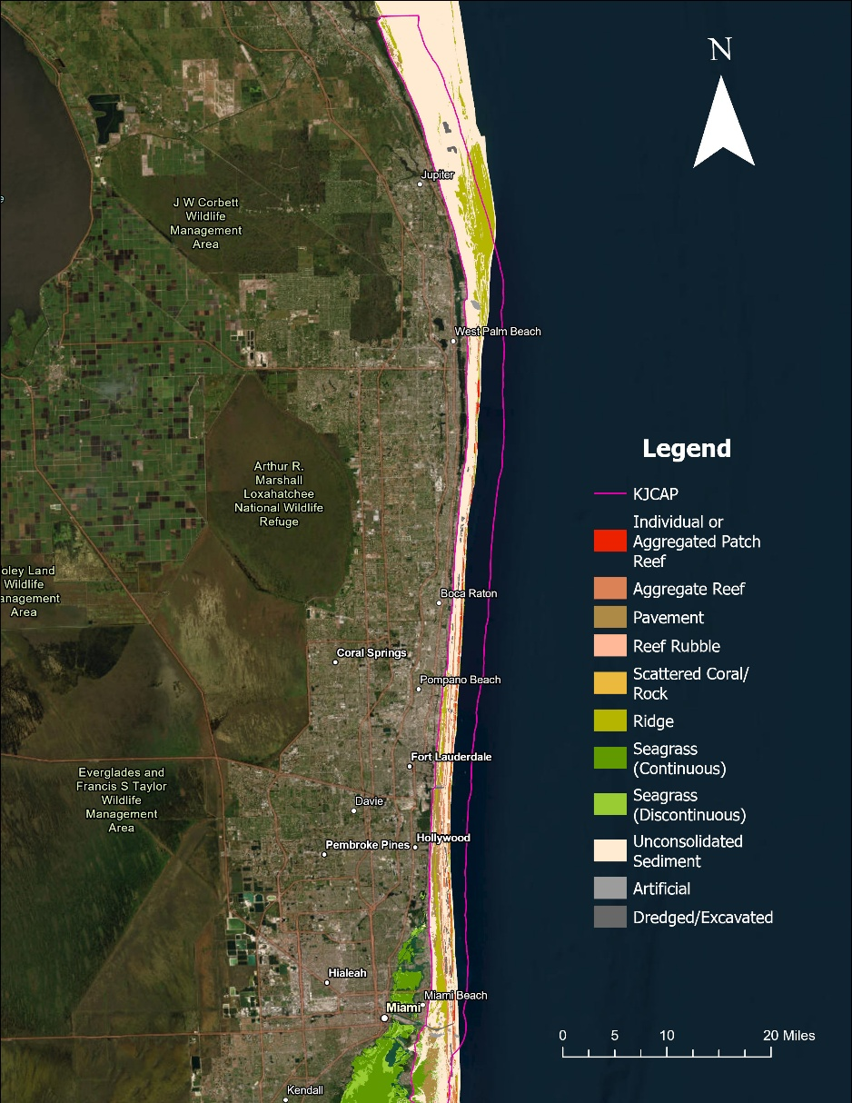
Map 5: Florida’s Unified Reef Habitats within the KJCAP boundaries (FWC, 2016).

*FNAI defines composite substrate as consisting of any combination of marine and estuarine sessile flora or fauna natural communities. Any of the Florida/NOAA CRCP benthic habitats could exist within a composite substrate community. Much of the coral reef and colonized hardbottom in KJCAP exist as composite substrate including stony corals, octocorals, sponges, algae, and unconsolidated substrate all living among each other.

^All of the FNAI Marine and Estuarine Natural Communities listed in Table 2 are found within KJCAP, but the area each covers is not yet mapped and they are often found overlapping or interspersed with each other. The benthic habitats and types describe more clearly the different structural zones found within KJCAP that contain the various FNAI natural communities.

⁺FNAI lists Altered Landcover Types, but none are comparable to marine artificial reef and/or dredged/excavated habitat as defined by the benthic habitat types.

Table 3: Summary of benthic habitat types in KJCAP (Florida’s Unified Reef Map [FWC, 2016]).
 | Area (km²) per habitat type [% total area] within KJCAP
 | Martin County | Palm Beach County | Broward County | Miami-Dade County | Total (Entire KJCAP)
Coral Reef and Colonized Hardbottom | 7.72 [0.01] | 87.46 [0.09] | 50.21 [0.05] | 64.10 [0.07] | 209.49 [0.22]
Unconsolidated Sediment | 313.57 [0.32] | 145.40 [0.15] | 47.73 [0.05] | 94.52 [0.10] | 601.22 [0.62]
Artificial Habitat | 2.37 [0.002] | 3.23 [0.003] | 2.63 [0.003] | 7.65 [0.01] | 15.88 [0.02]
Seagrass | 0.00 [0.00] | 0.00 [0.00] | 0.00 [0.00] | 16.07 [0.02] | 0.00
Undefined Marine |  |  |  |  | 124.65 [0.13]
All Habitat Types |  |  |  |  | 967.64 [1]

Coral Reef and Colonized Hardbottom
Coral reef and colonized hardbottom in Southeast Florida is defined as hardened substrate formed by the deposition of calcium carbonate by reef building corals and other organisms (relict or ongoing) that has some colonization by live coral (Monaco, 2007; Riegl et al., 2007).

The main benthic habitat type found in KJCAP is ridge, characterized by discontinuous bands of low relief features oriented parallel to shore and found throughout KJCAP (Riegl et al., 2007). Ridge habitat type is colonized by macroalgae, hard coral, gorgonians, and other sessile invertebrates. It is presumed that the Ridge was the foundation for the formation of Linear Reefs found south of Martin County, which are linear coral formations that follow the contours of the shore. Patch Reefs are isolated coral formations often surrounded by sand or other habitats with no organized structural axis relative to the contours of the shore. Spur and Groove habitat is characterized by alternating sand and coral formations that are oriented perpendicular to the shore, with high vertical relief on the coral formations (spurs) compared to the sand channels (grooves) that separate them. Patch Reefs and Spur and Groove formations peter out toward the northern portion of KJCAP. Colonized Pavement is found throughout KJCAP and is comprised of flat, low relief, solid carbonate substrate colonized by macroalgae, hard coral, gorgonians, and other sessile invertebrates. Scattered Rock in Sand is used to describe areas of primarily sand bottom with scattered rocks that are too small to be delineated individually.
The natural communities found among the types of Coral reef and colonized hardbottom include coral reef, worm reef, octocorals, sponges and algae (FNAI, 2010). Maps of the distribution of benthic biomass of certain indicator groups including gorgonians, macroalgae, and barrel sponges were created for portions of KJCAP (Riegl et al., 2007). They are most often found living and growing interspersed with one another, rather than finding monoculture beds of just hard corals or just sponges, for example. Coral reefs are formed from various carbonate precipitating organisms of the phylum Cnidaria, primarily Hydrozoa and Anthozoa. Hydrozoans include fire corals and are capable of withstanding temperate water temperatures, however they are not considered true corals. The class Anthozoa is divided into two subclasses: Octocorallia and Zoantharia. Octocorallia, which includes gorgonians, sea fans and sea whips, and are distinguished by their soft bodies and polyps with eight tentacles surrounding the mouth, which is why they are commonly called octocorals. Zoantharia includes the order Scleractinia, which are the true hard corals that are primarily responsible for building reef structures. Coral reefs serve as important feeding ground and nursery habitat for several species of turtles, fish and invertebrates, and help protect Southeast Florida’s shorelines from erosion.

KJCAP is home to over 45 species of reef-building corals, three species of which account for 69% of the region’s stony corals (Porites astreoides, Siderastrea siderea and Agaricia agaricites) (Gilliam et al., 2020). The six most common species make up 93% of the total abundance (Porites astreoides, Siderastrea siderea, Agaricia agaricites, Stephanocoenia intersepta, Montastraea cavernosa, and Porites porites), which is a higher percentage than in past years, meaning that, while overall diversity is consistent, the abundance of stony corals is becoming more concentrated in fewer species (Gilliam et al., 2020). Mortality events from SCTLD have caused two of the area’s historically dominant species (M. cavernosa and Meandrina meandrites) to decrease in abundance since 2015 (Gilliam et al., 2020).

Sponges, of the phylum Porifera, are also found interspersed with Anthozoans throughout coral reef and colonized hardbottom habitat. They provide habitat for several species such as the Caribbean spiny lobster (Panulirus argus). Some common species of sponges found in KJCAP include the giant barrel sponge (Xestospongia muta) that are among the largest on reef habitat and Cliona delitrix that can be seen colonizing portions of live hard corals.

Worm reef is characterized by large colonial assemblies of Sabellariid worm tubes made from grains of sand and attached to form massive mounding reef-like structures. Within KJCAP, worm reef is mainly found offshore of Martin County in St. Lucie Inlet Preserve State Park, but can also be found throughout the other counties adjacent to KJCAP (FWC, 2009).

Large populations of macro and micro algae can be found throughout KJCAP, often competing with other organisms like hard corals for space to colonize due to increases in land-based nutrient pollution (Lapointe et al., 2005). Algal species commonly seen in KJCAP include Codium isthmocladum and Lyngbya species. Typical populations can quickly grow into thick accumulations that cover reef surfaces and smother many sessile organisms and outcompete corals and other aquatic vegetation for space when waters are nutrient enriched.

Submerged Vegetation – Seagrass Beds
Seagrass beds in KJCAP, defined as habitat with 10% or more cover of Thalassia testudinum and/or Syringodium filiforme (Monaco, 2007; Walker, 2009), are characterized as expansive stands of vascular plants. This community occurs in subtidal (rarely intertidal) zones, in clear, coastal waters where wave energy is moderate. Seagrasses, including the epiphytic algae and invertebrates commonly found attached to the leaf blades, serve as important food sources for manatees, marine turtles, and many fish, including spot croaker (Leiostomus xanthurus), and sheepshead (Archosargus probatocephalus). The dense seagrasses also serve as shelter or nursery grounds for many marine invertebrates, as well as fish, such as tarpon (Megalops atlanticus), bonefish (Albula vulpes), seahorses (Hippocampus, spp.), and Florida pompano (Trachinotus carolinus).

The dense leaf blades reduce wave energy and facilitate settling of suspended particles, while the network of roots and rhizomes of seagrasses help to stabilize the particles of the unconsolidated substrates that they typically occur on and promote soil accumulation. Underneath the soil, seagrasses store immense amounts of organic carbon and can keep it sequestered for much longer periods of time than terrestrial forests where wildfires periodically release stored carbon (Fourqurean et al., 2012). Consequently, seagrass die-offs are not just reducing the ocean’s capacity for carbon storage, but also release a significant amount of carbon into the atmosphere (Fourqurean et al., 2012).

One of the more important factors influencing seagrass communities is the amount of solar radiation reaching the leaf blades. In general, the water must be fairly clear because turbidity blocks essential light necessary for photosynthesis. The rapid growth rate of seagrass under optimum conditions rivals that of most intensive agricultural practices and occurs without energy input from humans. Marine and estuarine seagrass beds are often associated with and grade into unconsolidated substrate, coral reefs, mangrove swamps, and salt marshes, but they may also be associated with any other marine and estuarine natural communities. Marine and estuarine seagrass beds are extremely vulnerable to human impacts. Many have been destroyed through dredging and filling activities, vessel groundings and prop scars, or have been damaged from degraded water quality by wastewater and stormwater outfalls. In these instances, the seagrass beds are either physically destroyed, or succumb as a result of decreased solar radiation from increased water turbidity.

Currently, continuous and discontinuous patches of seagrass are prevalent in the southern portion of KJCAP, north of CFAP, and east of both Key Biscayne and Virginia Key (FWC, 2021b). Seagrasses are an important habitat in the Miami-Dade County portion of KJCAP, comprising 16.55% of the total habitat in mostly continuous meadows. However, while there is no continuous seagrass habitat elsewhere in KJCAP, discontinuous patches exist throughout the ICW adjacent to KJCAP, and there are large, continuous patches in the Indian River Lagoon, just north of the St. Lucie Inlet where KJCAP terminates (FWC, 2021b).

Unconsolidated Sediment
Unconsolidated Sediments found within the KJCAP, defined as having less than 10% cover of submerged vegetation (Walker et al., 2012), comprise expansive, open areas of sand that lack substantial populations of sessile plant or animal species due to the unsolid nature of the material comprising the substrate type (FNAI, 2010). The habitat instead supports infaunal species (i.e., invertebrate species living in the benthic substrate) and transient pelagic and planktonic species. Much of KJCAP is dominated by unconsolidated substrates, especially as shallow and deep sand habitats, which increase as a percentage of total habitat extending north from Miami-Dade County to Martin County.

Adjacent to Miami-Dade County, sandy patches are evident throughout the different habitats; however, the portions that are sand-dominant are divided into shallow and deep sections (Walker, 2009). The deep section is found at depths deeper than the 20m reef formations with a finer sand and some scattered Halophila spp. and turfed macroalgae (Walker, 2009). The shallow section (<20m) is dominated by mobile pockets of sand buffered by the higher energy wave environment west of the inner reef, particularly along the shoreline (Walker, 2009). Broward County showed a similar configuration as that adjacent to Miami-Dade County, with both shallow and deep sandy environments, although the deep sand primarily acts as the divide between the inner, middle, and outer reefs (Riegl et al., 2004). Palm Beach County showed the same characteristics with deep and shallow sand segments, although the depth margin was 25m, based on changes in the infaunal composition (Riegl et al., 2007). In Martin County, the reef tract shows a significant change in composition with the majority of the seafloor composed of sand and the majority of the hardbottom habitat located adjacent to the St. Lucie Inlet where KJCAP ends (Walker, 2012). Here, the dividing line between the shallow and deep sand segments was again 25m (Walker, 2012). Lastly, there are several pits of dredged sand both in the form of inlet channels and as the remains of beach nourishment projects.

Artificial Habitat
Artificial, or man-made, habitat in KJCAP includes submerged wrecks, large piers, submerged portions of rip-rap jetties, and materials placed as artificial reefs (Monaco, 2007; Riegl et al., 2007). Many of these structures were placed in the KJCAP as part of the counties’ artificial reef programs. Artificial habitat in KJCAP also includes areas where natural geomorphology is disrupted or altered by excavation or dredging (Monaco, 2007). These habitats and the natural communities once found there have been converted or altered by direct anthropogenic activity.

For information specific to each county’s artificial reef program, including GPS coordinates, please visit their respective websites provided below:

- Broward County: https://www.broward.org/NaturalResources/BeachAndMarine/Pages/ArtificialReefProgram.aspx#Resources
- Martin County: https://www.martin.fl.us/martin-county-services/artificial-reef-locations
- Miami-Dade County: https://www.miamidade.gov/environment/reefs-artificial.asp
- Palm Beach County: https://discover.pbc.gov/erm/Pages/Reefs.aspx

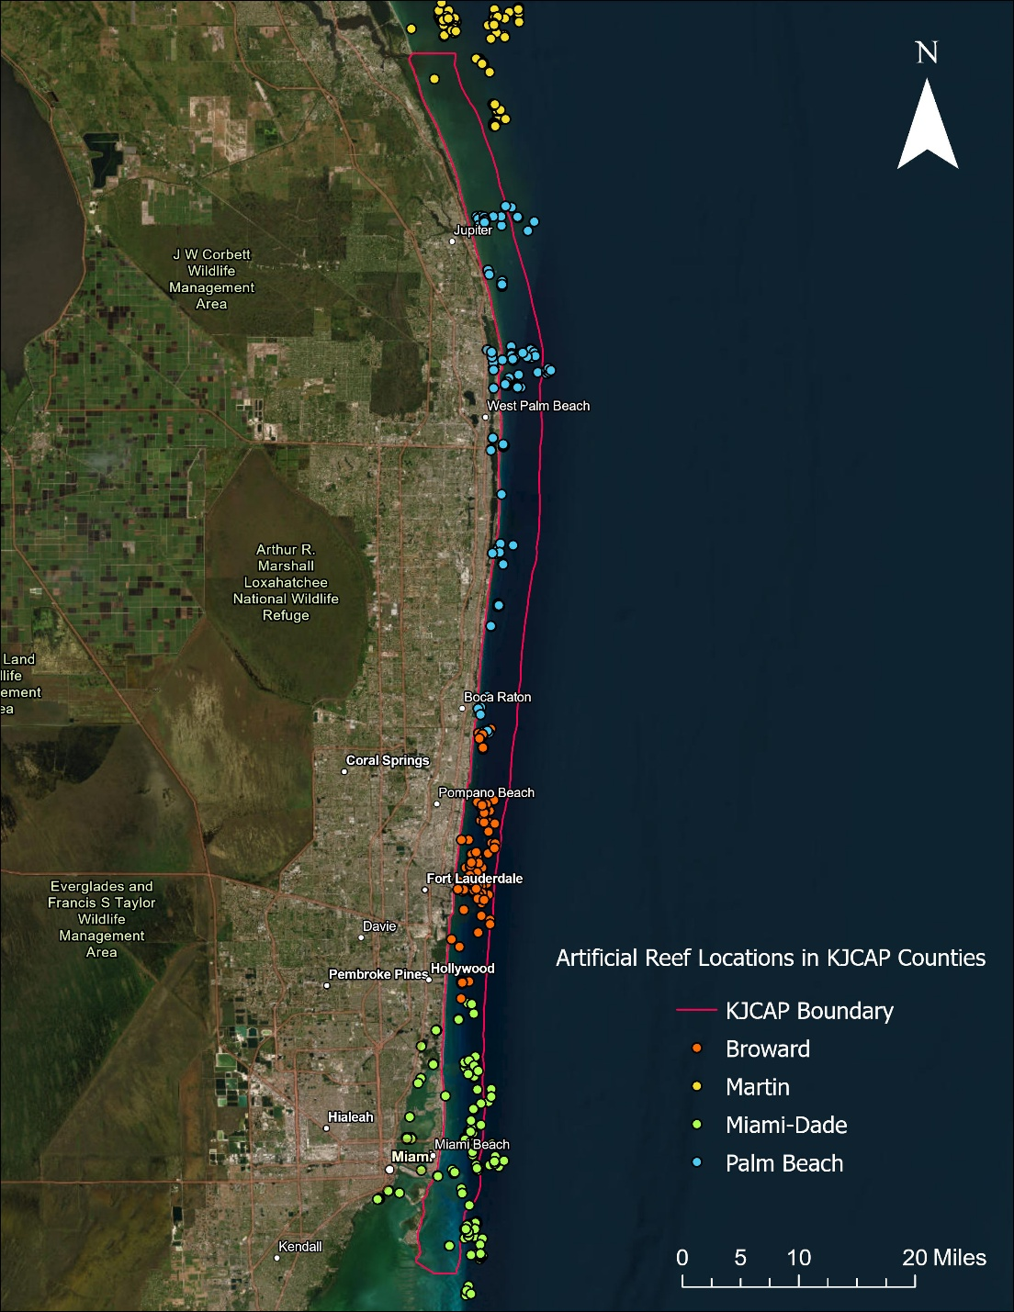
Map 6: Artificial reef locations within KJCAP.

3.2.8 Native Species
The diverse and rich fauna found in KJCAP varies by habitat and depth, supporting nearshore, reef, and offshore species within its boundaries. KJCAP’s seagrass meadows, limited to its southern extent, serve as a food source and habitat for a number of important species. The Florida manatee (Trichechus manatus latirostris) is a significant grazer, and while it can be found along other nearshore portions of KJCAP, its feeding distribution is linked mainly to the seagrass communities. Also associated with seagrasses are important recreational species such as bonefish, pompano, spotted sea trout, tarpon, and permit. Commercial species that are also found in and around seagrasses include hogfish, stone crab, spiny lobster, pink and brown shrimp, and various species of grouper and snapper. Also, these and other nearshore areas of KJCAP host transient populations of marine turtles, transient and resident populations of marine mammals, elasmobranchs (sharks and rays), and seabirds, as well as commercially and recreationally important coastal migratory species, such as cobia, king mackerel, and Spanish mackerel.

Faunal communities along the coral reef and other hardbottom communities of KJCAP consist of numerous species, including commercially and recreationally important species, such as spiny lobster and various reef fish including grouper and snapper, (Appendix B.3.1). Fish communities vary across the northern (northern Palm Beach and Martin counties) and southern regions (Miami-Dade, Broward, and central Palm Beach counties), likely due to the differences in temperature regimes resulting from cold-water upwelling and the divergence of the Florida Current in the northern region. Species richness is at its highest off southern Palm Beach County, where the mixing zone between the warm and cold-water regimes leads to overlap between tropical and more temperate fish communities. Over 350 fish species have been identified in Miami-Dade and Broward counties (Kilfoyle et al., 2018), and 400 fish species in Palm Beach County (Banks et al., 2008). Deep, or mesophotic, reefs adjacent to KJCAP also support large varieties of fish species, which differ from those found in shallower water.

Highly migratory species found in the offshore environment within KJCAP include commercially important species such as cobia, Mahi-Mahi, wahoo, tarpon, and tuna, as well as billfish (e.g., sailfish, marlin and swordfish). Along with sharks, these species also support a large charter fishing fleet in Southeast Florida (Shivlani & Villanueva, 2007). By nature, these species’ life stages extend beyond the boundaries of KJCAP to include coastal and pelagic habitats in the Caribbean and western Atlantic; they link the food chains of those habitats as well. Many of these migrations and subsequent reproductive events (spawning, mating, and giving birth) are driven by seasonal cues such as water temperature (Farmer et al., 2017). For instance, blacktip sharks (Carcharhinus limbatus) that spend the warmer summer months in the coastal waters of North Carolina, South Carolina, and Georgia to give birth will migrate to South Florida when the northern waters begin to cool (Kajiura & Tellman, 2016). KJCAP’s reef fish population is a critical prey source to these predators. By sustaining this population, KJCAP helps to sustain the ecosystem services that the migrating sharks provide in other regions they visit, and vice versa. Similarly, Mahi-Mahi (Coryphaena hippurus) spend time in KJCAP ahead of spawning further off the coast (Schlenker et al., 2021).

The reef benthic community is also highly diverse, including more than 45 species of stony coals, 35 species of octocorals, as well as sponges, other invertebrates and algae. Stony corals are the primary reef-building organisms on Florida’s Coral Reef; common species seen in KJCAP include brain (Diploria labrynthiformis and Diploria strigosa), star (Montastraea cavernosa and Siderastrea siderea) and finger (Porites porites) corals. Common octocorals include sea whips, sea plumes and sea fans. Sponges, such as the giant barrel sponge, also contribute to the reef’s structure and help to filter the water. Herbivores such as wrasses, parrotfish and sea urchins help corals by grazing on algae that compete for space on the reef.

3.2.9 Listed Species
Rapid human population growth in Florida stresses species that are dependent on coastal habitats. Listed species can become threatened due to habitat destruction, over-utilization, disease or natural or anthropogenic factors. Listed species include any species determined to be in danger of extinction or likely to become extinct within the foreseeable future throughout all or a significant portion of its range based upon the best scientific and commercial data available. All federally listed species that occur in Florida are now also included on Florida’s list as Federally-designated endangered or Federally-designated threatened species. In addition, the state has a listing process to identify species that are not federally listed but at risk of extinction. These species will be called “State-designated Threatened.” More detailed descriptions and management prescriptions are available on the FWC website (FWC, 1999b). State and/or federal agencies provide special protection and conservation measures to promote recovery of a listed species. “Conserve” is defined under the ESA as all measures and procedures needed to delist a species. Under Article IV, Section 9 of the Florida Constitution, the FWC has constitutional authority to “exercise the regulatory and executive powers of the state with respect to wild animal life and freshwater aquatic life, and shall also exercise regulatory and executive powers of the state with respect to marine life...”.

Protected species found in KJCAP include a variety of finfish, reptiles, marine mammals, and invertebrates. Five threatened and endangered marine turtle species, the green sea turtle (Chelonia mydas), the hawksbill sea turtle (Eretmochelus imbricata), loggerhead sea turtle (Caretta caretta), leatherback sea turtle (Dermochelys coriacea) and Kemp’s ridley sea turtle (Lepidochelys kempii), are found in KJCAP waters (NPS, n.d.). Marine turtles rely on KJCAP at every stage in their life history, with hatchlings using offshore sargassum mats, juveniles using the nearshore areas, and larger juvenile and adults feeding and/or moving within or through KJCAP boundaries. The main issues facing marine turtles include a warming climate that affects sex ratios of hatchlings and overall hatchling success, marine plastics, and light pollution, among others.

Florida manatees are also found in KJCAP, mainly occupying shallow nearshore areas and seagrass meadows. Manatees were down-listed from endangered to threatened by the U.S. Fish and Wildlife Service in 2017, but still face threats in KJCAP and across their range from vessel-related collisions, which is the main source of manatee mortality.

Along with manatees, there are other species that have critical habitat that extends into parts of KJCAP, including the federally-listed American crocodile (Crocodylus acutus) and smalltooth sawfish (Pristis pectinata); both are highly coastal in nature and seldom found in the coral reef or offshore waters of the conservation area.

The goliath grouper (Epinephelus itajara) and queen conch (Lobatus gigas) are both protected from all fishing effort within the state, while boulder star coral (Orbicella franksi), elkhorn coral (Acropora palmata), lobed star coral (Orbicella annularis), mountainous star coral (Orbicella faveolata), pillar coral (Dendrogyra cylindricus), rough cactus coral (Mycetophyllia ferox), and staghorn coral (Acropora cervicornis) are federally listed as threatened under the ESA (USFWS, n.d.a; NOAA Fisheries, 2020; NOAA Fisheries, n.d.-a). KJCAP is part of the designated critical habitat for elkhorn and staghorn (NOAA Fisheries, 2020).

3.2.10 Invasive Non-native and/or Problem Species
Invasive non-native species are species that have been introduced to an area and begin to thrive where they don’t naturally live, causing environmental or economic harm including changing or displacing natural habitats, competing with native wildlife, and threatening biodiversity (USFWS, n.d.b). Not all introduced, non-native species become invasive and the ones that do are generally opportunistic, aggressive, and early colonizing species in their native range. In some cases, native wildlife may also pose special management problems including property damage, labelled as nuisance animals (FWC, 1999a). Florida is second only to Hawaii in the number of established invasive species (Simberloff, 1994). Introductions of non-native marine invertebrates and seaweeds to coastal habitats in the United States have increased one hundred-fold in the last 200 years (Jacoby et al., 2003), and invasive fish species can have lasting implications on marine and coastal biodiversity (NOAA Fisheries, n.d.b).

One of the most significant non-native species that has settled in KJCAP is the Indo-Pacific lionfish (Pterois volitans) (Côté, Green & Hixon, 2013; Morris & Whitfield, 2009). The species was first reported off Dania Beach in 1985 and since then has proliferated over all of Southeast Florida and, in fact, much of the Southeastern U.S., Caribbean Sea, and even in the tropical Atlantic to northern Brazil. Lionfish populations are of particular concern because they are prolific spawners (and year-round), venomous, and voracious carnivores. They feed on native fish and compete for food and habitat with native predators. In its introduced range, the lionfish has no predators and is thus not subject to any significant top-down control. FWC has a comprehensive strategy to manage lionfish, including education and awareness programs that teach divers how to target and handle lionfish, derby fishing tournaments that incentivize lionfish harvest, and culinary shows and recipes that promote lionfish consumption, as described on the FWC lionfish website (FWC, n.d.b). FWC acknowledges that its strategy and other actions will not be sufficient to eradicate lionfish from the region, but research, monitoring, and control efforts are essential in controlling the species’ impact on native populations and habitats.

Two other invasive species in KJCAP are the orange cup coral (Tubastraea coccinea) and the Caulerpa brachypus macroalgae (Lapointe & Bedford, 2010; Office of National Marine Sanctuaries [ONMS], 2011). Orange cup coral is native to the Indo-Pacific and was first documented in the Caribbean in 1943, appearing in Curaçao and Puerto Rico (Fenner & Banks, 2004). It was first noticed in Florida off Key Largo in 1999, and has since spread into KJCAP (ONMS, 2011). While the Orange cup coral is generally only found on artificial reefs, particularly wrecks, it has developed into a persistent problem due to its ability to outcompete, and even cause partial mortality of native coral species (ONMS, 2011). Major macroalgal blooms off Broward and Palm Beach counties from the late 1980s through the 1990s coincided with the invasion of C. brachypus, which thrived because of elevated nitrogen levels supplied by land-based sources of pollution, including sewage (Lapointe & Bedford, 2010). The thick mats formed by C. brachypus continue to pose a threat to native algae species through competition and pose a threat to corals and seagrasses that depend on sunlight (Lapointe & Bedford, 2010).

A non-invasive problem that is pervasive in KJCAP is benthic cyanobacteria. Multiple species of the genus Lyngbya have had increasingly frequent and widespread periodic blooms in South Florida reefs since it was first seen off Broward County in 2002 (Paul et al., 2005). Anthropogenic factors, such as increased sea surface temperatures and nutrient pollution, have created conditions for cyanobacteria to thrive, and their presence has been shown to have a negative impact on coral larval settlement and recruitment (Arthur et al., 2009; Kuffner & Paul, 2004).

3.2.11 Archaeological and Historical Resources
Because KJCAP covers the areas east of the mean high-water line, it does not include the many bridges, structures, and historic sites that comprise Southeast Florida history, such as the many pre-Columbian sites and remains of coastal settlements. However, these places are inextricably linked to KJCAP, both in terms of how the region developed over time and how that development affected KJCAP and its resources.

The Florida Division of Historical Resources recognizes three shipwreck preserves in KJCAP (Maps 7, 8 and 9). These preserves are recognized attractions for divers and snorkelers that host an abundance of marine life and are living museums showcasing KJCAP’s past. CRCP acknowledges that they are required to consult with the Division of Historical Resources, Department of State before taking actions that may adversely affect archeological or historical resources, such as the three historical shipwrecks detailed below. The southernmost of these preserves is the Half Moon, a German-built, two-masted schooner yacht that sank in the early 1930s and came to rest just outside of Bear Cut between Virginia Key and Key Biscayne in central Miami-Dade County. The 154-foot vessel can be easily accessed, as it sits in 8-10 feet of water. The wreck was officially added as the seventh Underwater Archaeological Preserve in November 2000 and a year later was listed on the National Register of Historic Places.

The SS Copenhagen, a 325-foot-long steamer, is another underwater preserve, located in 15-30 feet of water outside the second reef on the Pompano Ledge, which is 0.75 miles offshore of Lauderdale-By-The-Sea in Broward County. The vessel ran into a reef in May 1900 and while efforts were taken to dislodge the steamer from the reef, it was finally considered a total loss and sank over time. Recognized as the fifth Underwater Archaeological Preserve in 1994, the SS Copenhagen was listed on the National Register of Historic Places in 2001.

The third of the historic shipwrecks in KJCAP is the Lofthus, a 222.8-foot iron sailing ship which ran aground in 1898 off Manalapan in south-central Palm Beach County. Located in 15-20 feet of water, the Lofthus is accessible 175 yards from the shore. The wreck sits in different sections on the seafloor as a result of the vessel first being stripped, and then destroyed through the use of dynamite. The Lofthus became the eighth Underwater Archaeological Preserve in 2001 and was listed on the National Register of Historic Places in 2003.
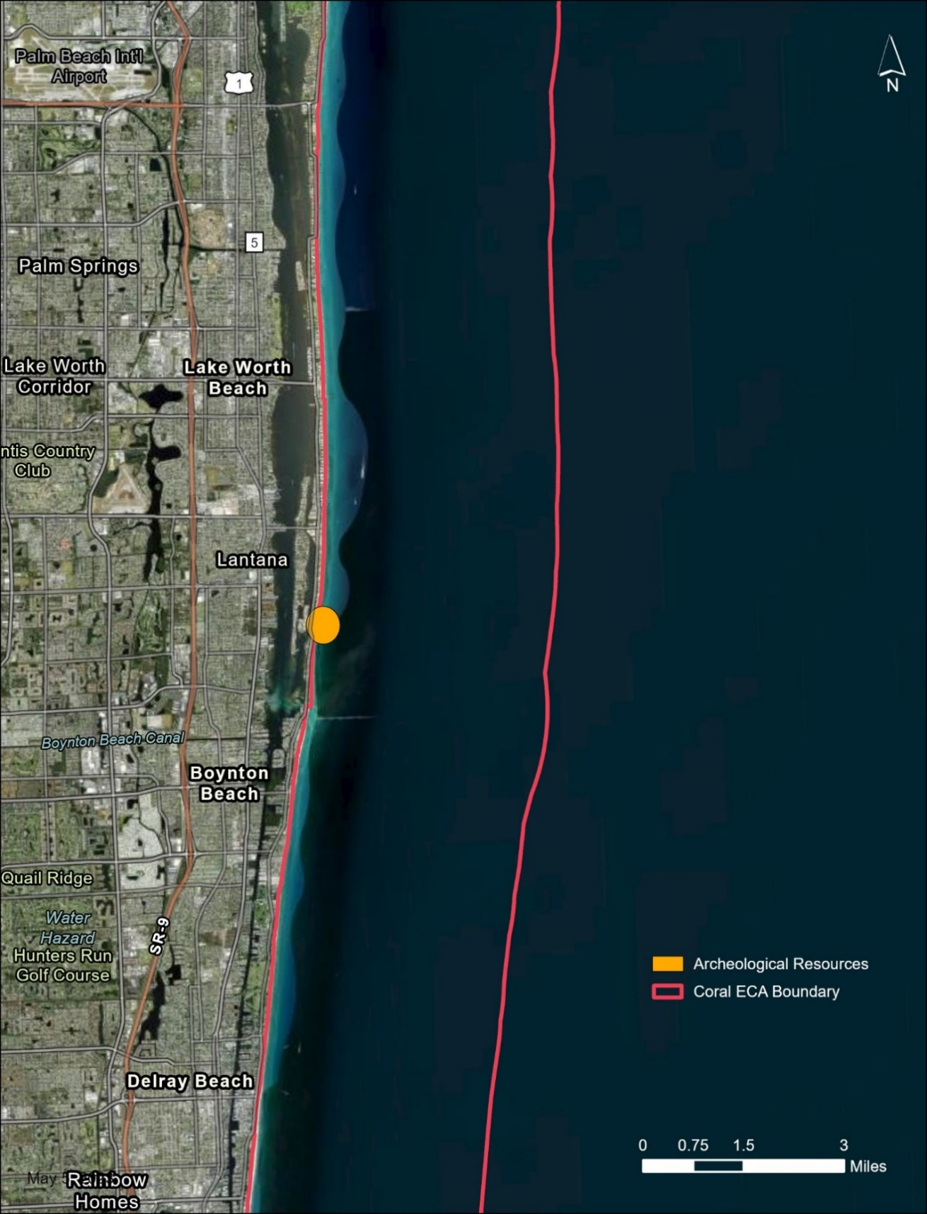
Map 7: Lofthus.
This map shows the location of the northern most shipwreck called the Lofthus, which is located in 15-20 feet of water and is accessible 175 yards from the shore.
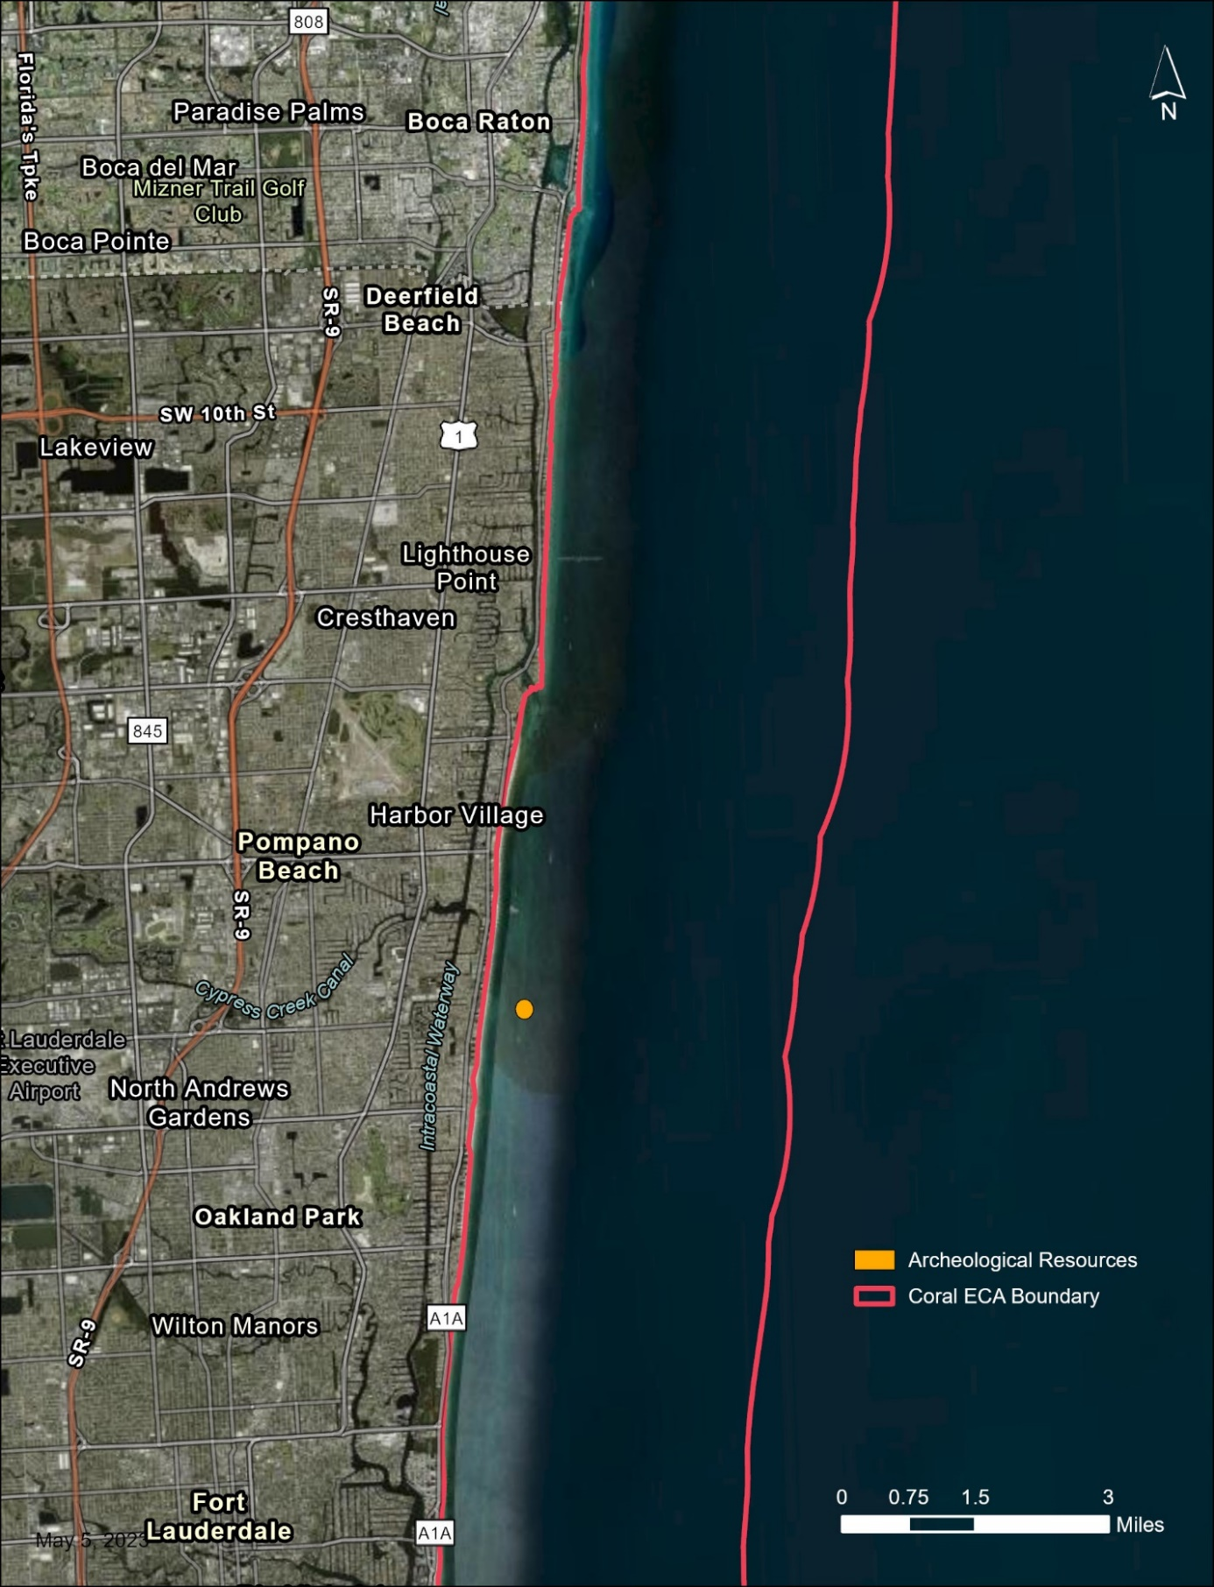
Map 8: SS Copenhagen.
This map shows the location of the SS Copenhagen, a 325-foot-long steamer, located in 15-30 feet of water outside the second reef on the Pompano Ledge, which is 0.75 miles offshore of Lauderdale-By-The-Sea in Broward County.
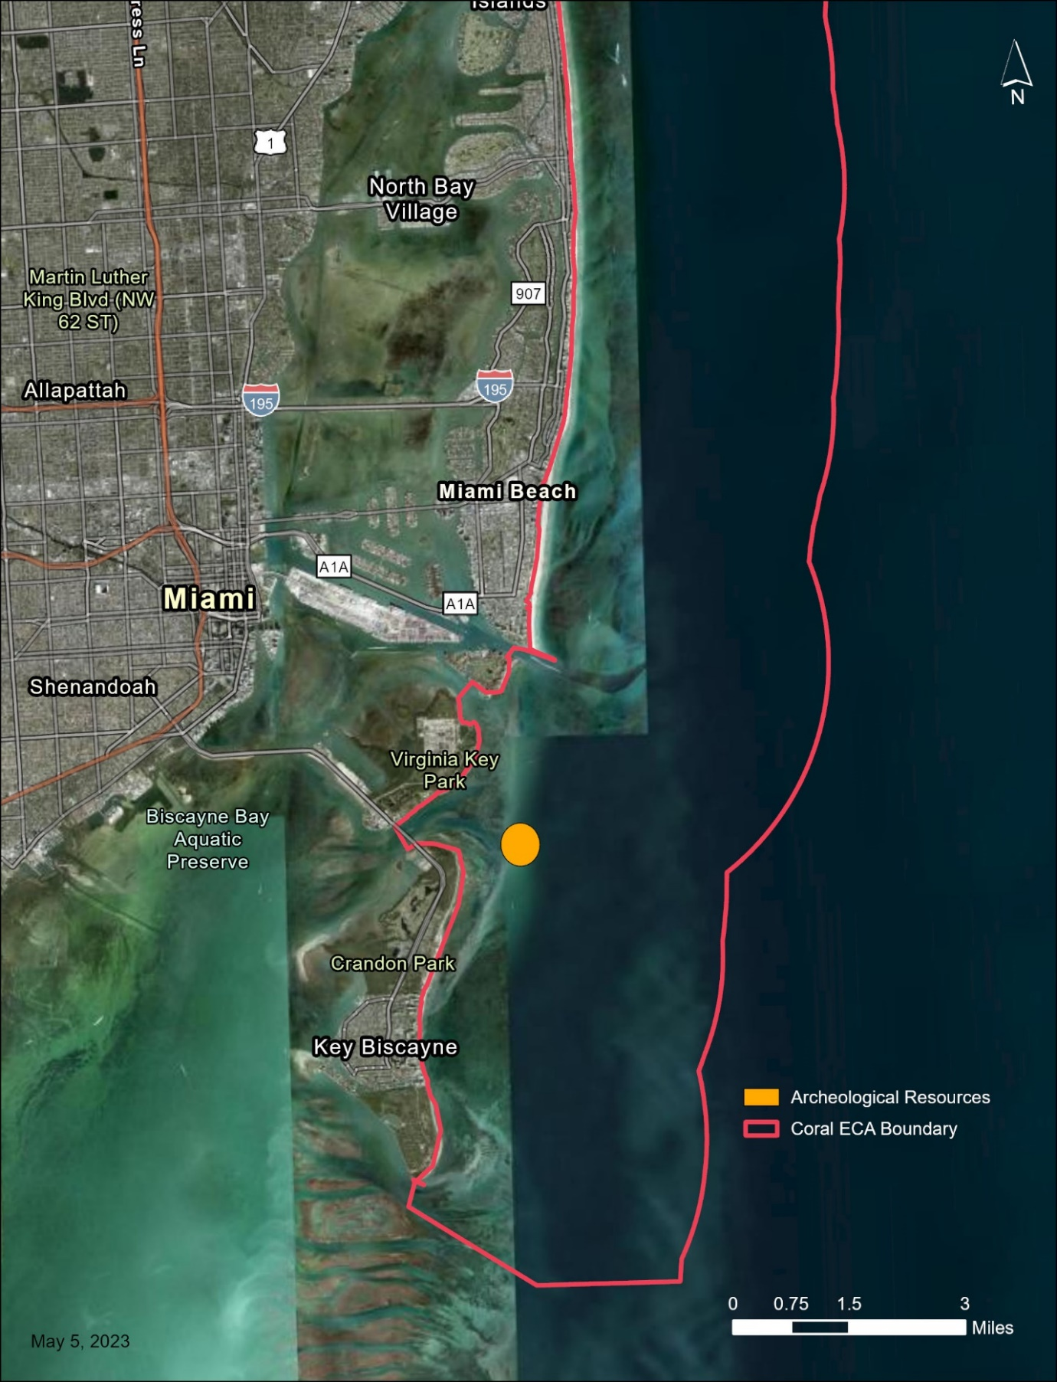
Map 9: Half Moon.
This map shows the location of the southernmost of these preserves, called the Half Moon, which is located just outside of Bear Cut between Virginia Key and Key Biscayne in central Miami-Dade County. The 154-foot vessel can be easily accessed, as it sits in 8-10 feet of water.

3.4 Economic Values
Species diversity and abundance in KJCAP support a lucrative recreational fishery and a robust commercial fishing industry. Southeast Florida has historically been well known for excellent opportunities for fishing. Revenue and income from recreational, charter, and commercial fishing-related businesses comprise a vital part of Southeast Florida’s economy, and the presence of coastal operations maintains a historic working waterfront (i.e., a waterfront area supporting commercial fishing infrastructure and open to the public for launching and storing vessels). Certain reef-dependent species, such as spiny lobster and reef fish, comprise key commercial fisheries in the region, supporting the working waterfronts in southern and central Miami-Dade County. Commercial fishing operations further north, from Broward to Martin counties, rely on a mix of reef-related and coastal migratory fin fish (Flinn, 2014; Johnson et al., 2007; Shivlani & Villanueva, 2007). Recreational fishing contributes considerable revenues across a variety of different fishing modes - shoreline, reef, and offshore angling, spear fishing, lobster diving - and accounts for over two-thirds of all fisheries catch in Southeast Florida (Johnson et al., 2007). Fishing and diving provide major economic benefits to the region. For example, Florida’s recreational fishing industry on its Atlantic and Gulf coasts are individually larger than any other state in the country (NOAA Fisheries, 2021). NOAA estimates the economic value of coral reefs in Florida add up to a total economic contribution of $4.4 billion in local sales, $2 billion in local income, and over 70,400 jobs (NOAA, 2020). Follow-up work conducted by Wallmo et al. (2021b) that focused on a narrower set of economic impacts directly associated with coral reefs estimated that over the course of one year, reef-related snorkeling and diving activities generated $902 million in total economic output and supported 8,688 jobs in the Southeast Florida region including the four counties adjacent to KJCAP as well as the Keys.

KJCAP is an important economic driver through recreation, education, and scientific research. Spalding et al. (2017) used a coarse method based on total visitation by distance from the coast to calculate reef visitation for Florida’s Coral Reef at 3.2 million users per year, resulting in a total annual value of $1.1 billion. Florida has the most registered vessels in the U.S., and in 2024, the four-county region abutting KJCAP accounted for 17.3% (178,092 vessels) of the state’s 1,030,053 registered vessels; about 2.6% (4,557) of the region’s total were commercial vessels, a category that consists mainly of fishing vessels (Florida Highway Safety and Motor Vehicles [FLHSMV], 2024). Shivlani (2006) determined that between 68-74% of recreational vessel owners in Miami-Dade and Broward counties take fishing trips within KJCAP, making it among the most popular activities.

3.5 Citizen Support Organization
Citizen Support Organizations (CSOs) are recognized by statute (Sections 20.058 and 112.3251, F.S) as citizen-support led organizations with a special interest in the managed area they support. Local citizens from the four-county Southeast Florida region formed Friends of Our Florida Reefs (FOFR) in April 2015, inspired by DEP CRCP’s community planning process, known as Our Florida Reefs. FOFR’s mission is to assist and enhance the critical efforts of CRCP to conserve and protect the northern third of Florida’s Coral Reef, within KJCAP. FOFR accomplishes this by helping fill budget gaps, preparing for rapid response to reef-related emergencies, initiating and participating in education and outreach activities, and other self-initiated direct actions. Since its inception, FOFR has supported logistical efforts for stakeholder meetings affecting KJCAP including the SEFCRI Team and Technical Advisory Committee, and Our Florida Reefs community planning process meetings. FOFR successfully collected funds and in-kind support to assist CRCP in hosting the 2017 U.S. Coral Reef Task Force meeting in Fort Lauderdale, Florida where members from all coral reef jurisdictions were able to report on local initiatives and discuss resolutions regarding coral reefs and their conservation. FOFR has helped to enhance the on-going Southeast Florida Action Network Bleach Watch coral bleaching and disease community science monitoring program through funding in-water trainings. In 2018, FOFR purchased a 3D printer for CRCP outreach, enabling in-house production of 3D coral polyp models using materials that allow for the demonstration of bleaching. The organization has also provided support to update and renew materials used in public school coral reef educational kits that are sent to different teachers throughout the region and school year. FOFR also continues to support CRCP’s efforts to promote clean reefs by aiding with advertisement, logistical planning, and fundraising for the Southeast Florida Annual Coral Reef Cleanup in partnership with local dive shops. Committed to maintaining funding reserves, FOFR also raises additional funds for their operational expenses and CRCP approved needs. FOFR files annual articles of incorporation as a 501(c)(3) nonprofit organization with the Florida Department of State.

3.6 Adjacent Public Lands and Designated Resources

3.6.1 Monroe County
Florida Keys National Marine Sanctuary (FKNMS)
The FKNMS organizes their strategies into a series of action plans that address (among other strategies): marine zoning, mooring buoys, waterway management, and water quality, which is their top priority (NOAA, 1996; NOAA, 2007; NOAA, 2024). The zones have several different levels of restrictions that vary depending on the state of the area and the purpose of protecting it. For example, the Sanctuary Preservation Areas (SPA), which only permit limited catch-and-release fishing, are designated around shallow reef habitats that face a high concentration of user groups, leading to conflicts and physical degradation. The Ecological Reserves are even more stringent with regards to extractive uses, and they are designed to protect critical habitat for the life cycles of the species, such as feeding or mating grounds. The Mooring Buoy and Waterway Management Action Plans both serve to reduce physical impacts on corals by eliminating the need for anchoring and by guiding vessels away from shallow habitats. The Water Quality Action Plan’s goal is to coordinate efforts between federal, state, and local authorities to monitor and protect the water quality of FKNMS by conducting water quality sampling, assisting in the development of management plans for neighboring areas, and by helping to improve waste management facilities.

John Pennekamp Coral Reef State Park
First established in 1959, John Pennekamp Coral Reef State Park encompasses 72 nautical square miles and allows both commercial and recreational fishing throughout the park (Department of Parks and Recreation & DEP, 2019). The park has also established Protected Zones, which limit terrestrial development that would impact certain plant and animal species, including all corals. The zones also serve to implement restoration efforts that aim to recover coral and seagrass species and to re-establish natural water flow in certain areas of the park that have been disturbed by development projects. Coral restoration had been limited to repairing areas affected by boat groundings; however, the DEP Division of Recreation and Parks included plans for a more proactive monitoring and restoration effort involving staghorn coral (Acropora cervicornis) in its 2019 management plan.

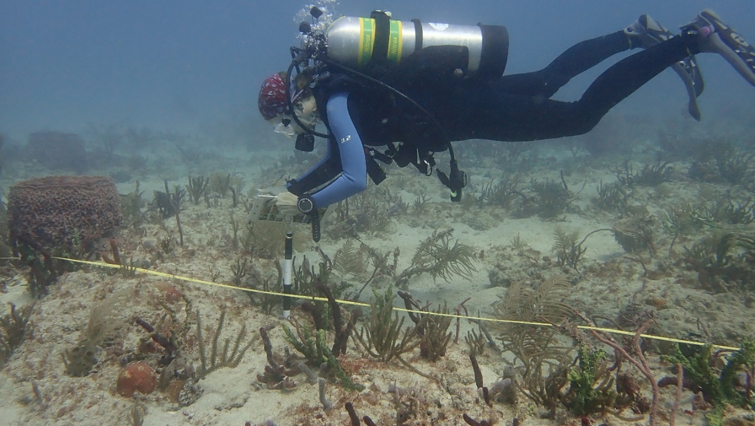
Photo: CRCP diver performing benthic surveys for disturbance response monitoring in KJCAP.

The Florida Keys' Particularly Sensitive Sea Area was created in 2002 to enhance protection of the 3,000 square miles around the Florida Keys coral reefs, specifically from international shipping vessels (Kachel, 2008).

3.6.2 Miami-Dade County
Biscayne National Park (BNP)
The Biscayne National Park identified physical impacts from fishers, boaters, and divers to be the main threat to the corals within the park and utilizes a zoning approach to try and balance resource use and protection. By protecting the reef from physical damages, the corals will hopefully be resilient enough to withstand the impacts from environmental change as well as land-based sources of pollution that are common in the area. Approximately 70% of the coral reef areas remain open to recreational fishing, but slow speed and idle zones, combined with no anchoring zones, aim to reduce groundings and physical damage. The marine reserve zone, where extractive activities are prohibited except for lionfish hunting, does allow swimming, snorkeling, and SCUBA diving in order to protect critical species while allowing visitors to witness a healthier reef. BNP is currently (as of 2025) revising their General Management Plan and Fisheries Management Plan, to guide management for the next two decades.

Bill Baggs Cape Florida State Park
The Bill Baggs Cape Florida State Park (est. 1967) is located at the southern tip of Key Biscayne and acts as a convergence point between the waters of Biscayne Bay and the Atlantic Ocean. The state park has a 400-foot-wide management zone that extends into KJCAP from the shore where roughly 95% of the area is dominated by seagrass. Its southernmost point is home to the oldest standing structure in Miami-Dade County, the Cape Florida Lighthouse. The Cape Florida Lighthouse was a meeting place for enslaved people to board ships to seek freedom in the Bahamas. In 2004, the park was designated a National Underground Railroad Network to Freedom Site. The park allows both single day and overnight anchoring for a fee. Fishing is allowed where it falls within Biscayne Bay Aquatic Preserve and CFAP, and conforms to their regulations. The area is marked off for swimmers, which prevents prop scarring from most boats. However, they note that more enforcement is needed to address boats coming to shore to pick up and drop off visitors, and there needs to be regular trash cleanups of the seagrass. The 2012 management plan will guide management through the present.

Biscayne Bay Aquatic Preserve (BBAP)
For BBAP, water quality is the highest priority issue but, as is the case with BNP, the preserve lacks the ability to directly change point and nonpoint sources of pollution coming from the mainland. Instead, the preserve undertakes extensive research and monitoring operations to identify the most problematic sources and to develop total maximum daily load levels to inform lawmakers on how to address these significant issues. Additionally, the legal authority of BBAP allows them to regulate and restrict harmful development around the preserves that would degrade habitat and water quality, especially as it is designated Outstanding Florida Waters. The overlap between KJCAP and CFAP provides strong protection for the corals and seagrasses that reside in that portion of KJCAP. BBAP has recently revised its plan and is awaiting final approval to guide management from 2025-2035.

Critical Wildlife Areas
The Bill Sadowski Critical Wildlife Area is a 700-acre area northwest of Virginia Key. The Critical Wildlife Area boundary includes the lagoon and emergent vegetation areas where a variety of birds roost and forage. The area is also a manatee protection zone and closed year-round to all vessels.

County Beach Parks
Crandon Park (est. 1947) is located on the north side of Key Biscayne, opposite to Bill Baggs, and is managed by Miami-Dade County. A marina is located on the bay side adjacent to Bear Cut, providing quick access to KJCAP waters. The Half Moon Underwater Archeological Preserve is adjacent to Crandon Park near Bear Cut. It protects a racing sailboat that sunk in shallow waters in 1930 and seven decades later was listed on the National Register of Historic Places. The park is home to many important species, many of which can be seen in The Bear Cut Preserve, which has walking and biking trails throughout the upland portion of the park. Eco-tours and kayaks are available in the park, but fishing is not allowed.

Haulover Beach Park (est. 1948) is also managed by Miami-Dade County and located just north of Miami Beach. This Park contains the longest stretch of undeveloped beach in Miami-Dade County. Historically, the site was part of the mail carrier walking route from Miami to Palm Beach and a site of liquor offloading during Prohibition. Today, the park is home to a marina with 152 wet slips and a boat ramp for visitors, situated on the Intracoastal side of the park. Baker’s Haulover Inlet was cut in 1925 and opens to the Atlantic Ocean. Fishing is permitted at certain sites along the Intracoastal and the Cut, as well as along the beach front. The northern section of Haulover Beach is a popular clothing-optional beach.

Historic Virginia Key Beach Park (est. 1945) was first designated as a park by the city of Miami in 1945 after protests from the African American community in Miami sought the right to use the beach at Bear Cut, which at that time was only accessible by boat. The area became a significant social gathering place and even hosted religious services. The city closed the park in 1982, but in 1999 local activists established the Virginia Key Beach Park Civil Rights Task Force to prevent proposed development of the area, eventually leading to the management under the Virginia Key Beach Park Trust. In 2002, the preservation of the park was ensured by being added to the National Register of Historic Places, and eventually reopened as the Historic

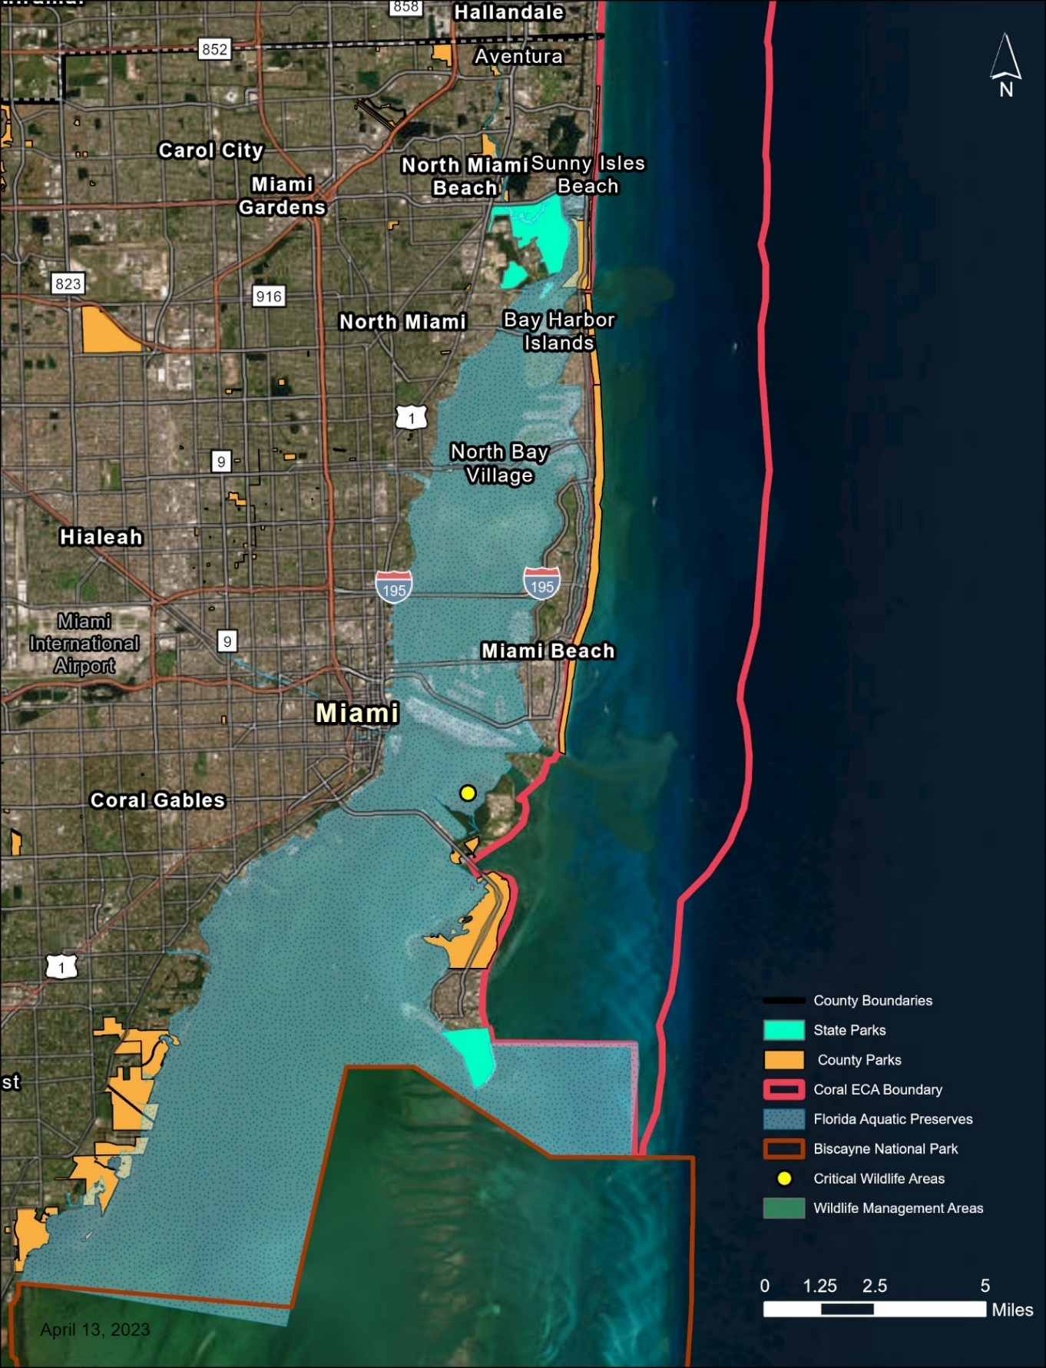
Map 10: Miami-Dade publicly managed conservation lands.
This map shows the publicly managed conservation lands and designated resources adjacent to KJCAP within Miami-Dade County. These lands include state parks, county parks, aquatic preserves, critical wildlife areas, and wildlife management areas.
Virginia Key Beach Park in 2008. There are numerous endangered plant and animal species within the protected habitat and fishing is prohibited as a rule in all city parks. The park is the site of a mangrove restoration project.

The Key Biscayne Special Management Zone was designated in 1990 by the National Oceanic and Atmospheric Administration in order to limit the impacts of “unrestrained fishing pressure” (i.e., highly efficient or selective fishing gear) within the boundaries of the Key Biscayne Artificial Reef Site, while maintaining most recreational uses of the site. Fish traps, bottom longlines, and spear guns of any type, are prohibited from use within the special management zone.

Municipal Parks
There are nine municipal parks with access to KJCAP in Miami-Dade County, all of which are managed by the City of Miami Beach: South Pointe Park, Marjory Stoneman Douglas Ocean Beach Park, Lummus Park, Collins Park, Indian Beach Park, Beach View Park, Allison Park, Altos del Mar Park, and North Beach Oceanside Park.

3.6.3 Broward County
Dr. Von D. Mizell-Eula Johnson State Park
Dr. Von D. Mizell-Eula Johnson State Park (est. 1973) is located just south of Port Everglades. The beach associated with this state park once formed the route for the mail carriers who traveled by foot between Palm Beach and Miami before the Florida East Coast Railway Railroad connected the two in the late 19th and early 20th centuries. Later in the 20th century, the beach became a site of civil rights protests as African American residents around Florida would travel to use the beaches, only to be denied access by oceanfront property owners. Dr. Von D. Mizell, the founding president of the Broward County National Association for the Advancement of Colored People (Broward NAACP), was instrumental in pressuring local lawmakers into guaranteeing access to the beach. However, the county deliberately dragged its feet on providing an access road to the beach, culminating a decade later in “wade-in” protests organized by the NAACP Chapter President Eula Johnson and supported by Dr. Von D. Mizell. The park was renamed to honor their work for integration in 2016. The park offers kayak rentals for trips into the mangroves and has a boat ramp for access to the ocean for boats up to 36 feet long. Fishing is permitted along the beach in accordance with state laws upon the stipulation that no swimmers be in the area.

Hugh Taylor Birch State Park
Hugh Taylor Birch State Park (est. 1951) is situated on a barrier island between the intracoastal and the Atlantic Ocean. The former estate of Hugh Taylor Birch was donated to the State of Florida in 1941 and maintains natural scenery in the middle of urbanized Ft. Lauderdale. Kayaking rentals are available on the lake with some access to the ocean. Fishing is allowed along the beach into KJCAP and in select locations on the intracoastal side.

Critical Wildlife Areas
The 56-acre Deerfield Island Park Critical Wildlife Area retains one of the last populations of gopher tortoise within Broward County. Upland areas with suitable tortoise habitat are closed to public access, while other areas of the park remain open to visitors. The Critical Wildlife Area, managed by the FWC, is only accessible by boat or shuttle

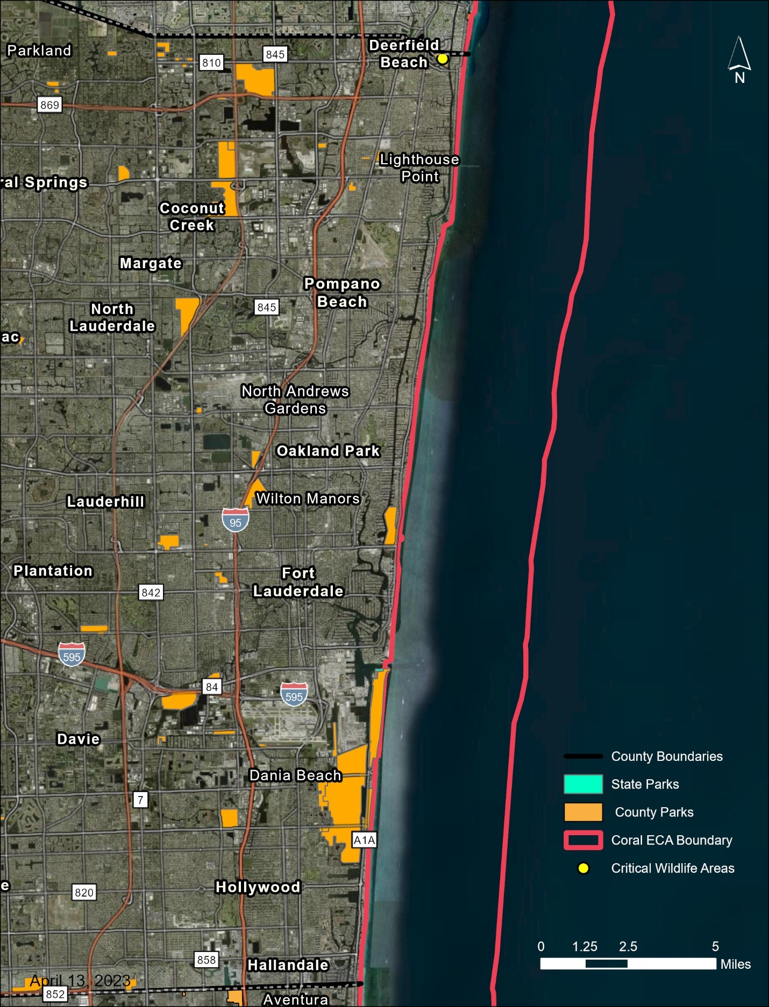
Map 11: Broward publicly managed conservation lands.
This map shows the publicly managed conservation lands and designated resources adjacent to KJCAP within Broward County. These lands include state parks, county parks, aquatic preserves, critical wildlife areas, and wildlife management areas.

County Beach Parks
Hollywood North Beach Park (est. 1958), a 56-acre park managed by the county, provides access to both the Intracoastal and the Atlantic Ocean with its five pocket beach parks: Loggerhead, Kemp's Ridley, Leatherback, Hawksbill, and Green. Fishing is only permitted on the Intracoastal side.
Municipal Parks
Broward County has nine municipal parks with beach access. The city of Hollywood manages four: Keating Park, Harry Berry Park, Chernow Park, and Dog Beach. Ft. Lauderdale manages the remaining five municipal parks with general waterfront access: the Fort Lauderdale Beach Park, DC Alexander Park, Earl Lifshey Park, Vista Park, and Willingham Park. The Ft. Lauderdale Beach Park also includes a boat ramp but only for non-motorized vessels. Fishing is legal on public beaches between the hours of 6 p.m. and 8 a.m.

3.6.4 Palm Beach County
John D. MacArthur Beach State Park
The John D. MacArthur Beach State Park lies on a narrow stretch of land between Lake Worth Lagoon and the Atlantic Ocean and is home to seven plant and 22 animal species that are listed as endangered or threatened under the ESA. Kayak rentals are available, and fishing is permitted within state laws.

County Beach Parks
Palm Beach County is home to an impressive list of twelve county beach parks. Coral Cove (14.6 acres), Jupiter Beach (46.5 acres), Carlin (120.3 acres), and Ocean Cay (13.4 acres) all offer beach access to KJCAP along the Jupiter waterfront, in the northern section of Palm Beach County. Further south in the Juno Beach area, Juno Beach (5.2 acres) and Loggerhead Park (17.3 acres) offer access to KJCAP. Ocean Reef Park (12.6 acres) is located south of John D. McArthur Beach State Park and is part of a complex of inlet and oceanfront parks designated in Riviera Beach. R. G. Kreusler Park (4.2 acres), Ocean Inlet (11.4 acres), Ocean Ridge Hammock (8.5 acres), and Gulfstream Park (6.8 acres) are three other parks that offer beachfront access along the south-central part of Palm Beach County. Finally, South Inlet (11.1 acres), located off Boca Raton, provides access to KJCAP along the county’s southern boundary. All county parks have similar rules and regulations, such as open beach access, fishing access outside of designated swimming areas, and a prohibition on balloons. Ocean Inlet is the only one that offers a marina, with 20 day-use wet slips.

Municipal parks
Municipal parks include the South Beach, Red Reef, Phipps Ocean, Oceanfront, and Atlantic Dunes Parks. These local parks have beach access to the Atlantic Ocean and permit fishing from shore outside of designated swimming areas and hours.

3.6.5 Martin County
Nathaniel P. Reed Hobe Sound National Wildlife Refuge
Martin County is home to the federally-protected Nathaniel P. Reed Hobe Sound National Wildlife Refuge, which is managed by the U.S. Fish and Wildlife Service. The refuge is divided into two sections by the Indian River Lagoon. The eastern side, on Jupiter Island, maintains the largest continuous, undeveloped beach in Southeastern Florida and represents a critical sea
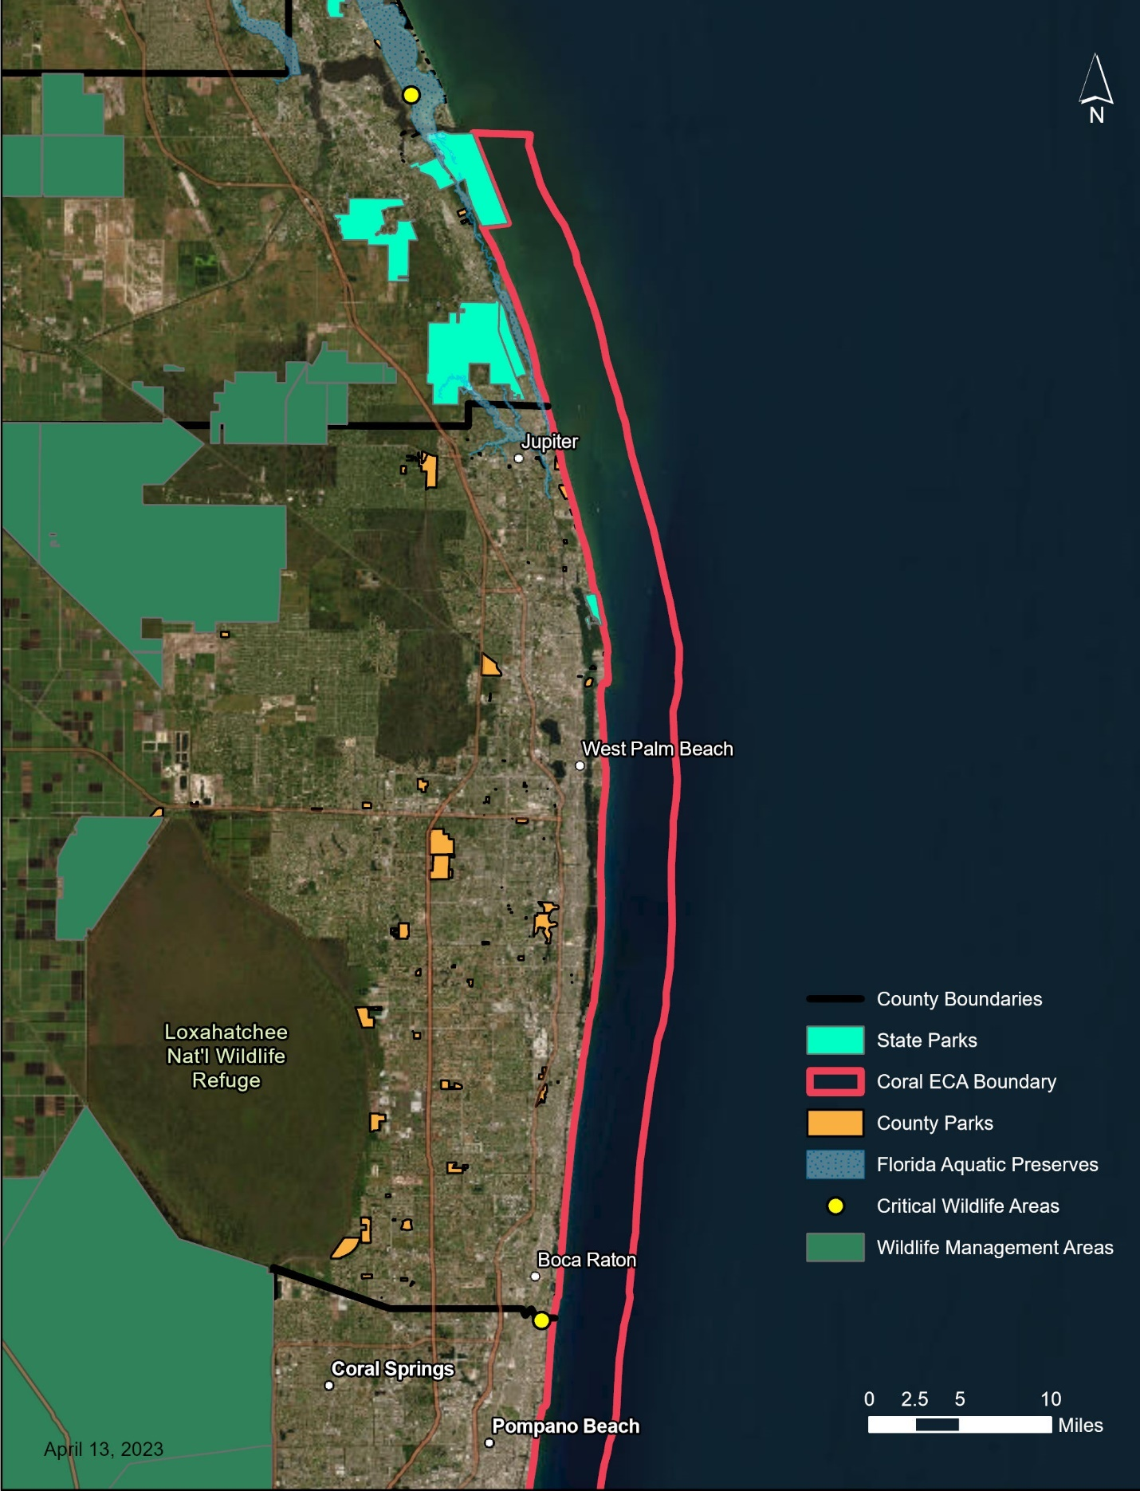
Map 12: Martin and Palm Beach publicly managed conservation lands.
This map shows the publicly managed conservation lands and designated resources adjacent to KJCAP within Martin and Palm Beach County. These lands include state parks, county parks, aquatic preserves, critical wildlife areas, and wildlife management areas.

turtle nesting habitat. Fishing is permitted from the beach with some restrictions on gear and in accordance with state limits on catch sizes and species. Nathaniel P. Reed Hobe Sound National Wildlife Refuge, which is managed by the U.S. Fish and Wildlife Service. The refuge is divided into two sections by the Indian River Lagoon. The eastern side, on Jupiter Island, maintains the largest continuous, undeveloped beach in Southeastern Florida and represents a critical sea turtle nesting habitat. Fishing is permitted from the beach with some restrictions on gear and in accordance with state limits on catch sizes and species.

St. Lucie Inlet Preserve State Park
The St. Lucie Inlet Preserve State Park was established in 1969 and extends its marine zone one mile into KJCAP at the northernmost point of Florida’s Coral Reef. Their location in front of the inlet exposes them to high vessel traffic and fishing activities. Cleanup dives are regularly conducted to remove debris and fishing line from the reef. Fishing is allowed, if it conforms to state laws regarding seasons for certain species and size limits. Only spearfishing and shell collection are prohibited, as in all State Parks. Buoys have been installed to better delineate the park boundary and to assist law enforcement in identifying illegal spearfishing within the park. Additionally, drainage from Lake Okeechobee frequently is directed past the park leading to turbidity issues. The Florida Fish and Wildlife Commission is seeking to conduct water quality assessments to determine the level of light reaching the coral reef and to understand the negative impacts on photosynthetic abilities. The beach of the park also provides sea turtle nesting habitat for federal, and state listed species. In addition to monitoring the nests to reduce predation, they have periodic beach nourishment projects and seek to restore dune vegetation to reduce erosion. The 2014 management plan guides management through the present.

County Beach Parks
The Hobe Sound Beach Park is an open-access beach with shore fishing within KJCAP. While there are more county and municipal beach parks just north of KJCAP, it is the only county or municipal beach park within Martin County that is south of the St. Lucie Inlet.

Blowing Rocks Preserve (est. 1969), the result of Jupiter residents donating 73 acres to the Nature Conservancy, is a privately managed area that spans the width of Jupiter Island. It has been restored to the natural floral and beach composition that allows for native plant and animal species, some of which are endangered, to flourish. The preserve prohibits pets, picnicking, and spearfishing in an effort to maximize public use while still preventing degradation.

3.7 Surrounding Land Use
The four counties adjacent to KJCAP are largely urbanized with a mix of commercial and residential areas, with some agricultural lands primarily towards their western borders (Bean et al., 2019). The area can be further divided into inlet contributing areas (ICAs), where each area corresponds to one of the nine inlets that feed water from terrestrial sources into KJCAP (Pickering & Baker, 2015). While each ICA has mixed uses, the most heavily urbanized areas occur from Boca Raton Inlet in southern Palm Beach County to Government Cut in Miami-Dade, while the northern areas around the St. Lucie Inlet have the highest levels of agricultural land use (Pickering & Baker, 2015). Within the agricultural lands, crop agriculture is far more prevalent than animal agriculture, accounting for about 20% and 0.3% of land use within the ICAs, respectively. In addition to the freshwater runoff from the nine inlets, six domestic wastewater outfalls exist between Miami-Dade and Palm Beach counties, discharging about 300 million gallons per day of secondary-treated wastewater effluent between one and three miles offshore into KJCAP ecosystem. The ocean outfalls are in the process of being phased out as mandated by Florida Statute 403.086 (Pickering & Baker, 2015).

Examining the land use of each ICA is crucial for understanding the relationship of nutrient transfer between the terrestrial and marine ecosystems. Pollution from intensive land use is one of the top issues facing coral reefs (USCRTF, 2000) and varies from both point and nonpoint sources, as well as between urban and agricultural areas. Agricultural practices release high levels of nitrogen and phosphorus into the groundwater or surface water runoff to nearby canals, eventually discharging to the ocean (Pickering & Baker, 2015). Nitrogen is limited in the ocean, especially in reef environments, and its influx provides the conditions for algal blooms, leading to high levels of mortality in coral and seagrass species (Bean et al., 2019). Urban environments are also important sources of nutrient pollution; the impervious surfaces that dominate urban areas eliminate natural filtration of stormwater through the soil, allowing runoff to reach canals and be drained into the ocean much more quickly with far less filtration (Bean et al., 2019).
In 2018, NOAA CRCP and DEP CRCP funded a pilot study in the Boynton Inlet Contributing Area (Boynton ICA) to identify the optimal methods for reducing nitrogen and phosphorous pollution in the coastal waters for the protection of the offshore coral reef. This ultimately resulted in the development of the Boynton Inlet Contributing Area Watershed Management Plan. The plan describes four strategies for reducing eutrophication and their relative costs: reducing fertilizer use through local ordinances; converting septic systems to sewer, especially on the barrier islands; upgrading stormwater treatment centers; and improving monitoring of water quality and quantity at critical sites. While the recommendations were developed specifically for the Boynton ICA, they provide useful ideas for water quality management throughout KJCAP. Future work will continue to develop watershed management plans for each of the inlet contributing areas within KJCAP.

Aside from nonpoint source pollution from storm and agricultural runoff, another high priority concern in KJCAP region is the use of septic tanks. While the prevalence of septic systems are decreasing over time, there are still a significant number throughout the four counties, particularly in rural areas (Pickering & Baker, 2015). When used properly, septic systems are effective at removing bacteria and phosphorus from wastewater, but studies in Florida estuaries have shown that nitrogen loading remains an issue (Bean et al., 2019). That is even before considering the increase in compromised septic systems in South Florida. Septic systems require at least 24 inches of soil to filter the nutrients out of wastewater before that water reaches the groundwater. During the rainy season, from May to October, the water table rises, often far above the 24-inch buffer, and as sea levels continue to rise, the issue will only become more significant with higher levels of nutrient pollution (Bean et al., 2019).

Agencies at the county, state, and federal levels are working to address some of these issues. DEP coordinates with local governments to create septic to sewer conversion programs in order to incentivize and provide financial assistance to eliminate obsolete septic systems in critical areas (Bean et al., 2019). Additionally, along with county land acquisition programs, Florida Forever is a statewide environmental land acquisition program that, with its predecessor, has purchased more than 2.5 million acres of land to be used for conservation (DEP, 2025b). The program nominates and selects sites through a 10-member committee consisting of state agency members and governor appointees (DEP, 2025b). There are several Florida Forever projects in south Florida with conservation goals including protecting upland hammock communities, mangroves, and coral reef in the Florida Keys, as well as protecting rare species and preserving natural waterflow as much as possible in the Everglades system (DEP, 2025b). Federally, the Comprehensive Everglades Restoration Plan is a 35-year collaborative project between the U.S. Army Corps of Engineers and the South Florida Water Management District to restore natural freshwater flow from Lake Okeechobee through the Everglades, providing habitat for many wetland species and reducing nutrient flow into KJCAP and South Florida estuaries (NPS, 2019; SFWMD, n.d.a).

Throughout the shoreline adjacent to KJCAP, there are 113.2 miles of beaches (Office of Economic and Demographic Research, 2024), of which 91.7 miles are critically eroded (DEP, 2025a). DEP’s Beaches, Inlets and Ports Program (BIPP) is responsible for updating and maintaining the Strategic Beach Management Plan and Inlet Management Plans to address critical erosion along Florida’s coastline and inlet maintenance through beach renourishment and dredging projects. BIPP is also the regulatory program responsible for the evaluation, reduction, and mitigation of the environmental impacts from both beach-renourishment and dredging activities, which are known to have negative effects on Florida’s coral reef and hardbottom communities as well as sea turtle nesting habitats.

All Florida counties are required by the Local Government Comprehensive Planning and Land Development Regulation Act to have a comprehensive management plan with elements related to different governmental functions (e.g., housing, physical facilities, conservation, land use and coastal zone protection). One goal in having a management plan for KJCAP is to guide county governments during their planning process, or as comprehensive plans are revised, toward developing local planning criteria and standards that will be consistent with the objectives of the program. Each plan, in effect, is intended to guide the future development of each respective county. Cities and counties are to adopt land development regulations and conform to the criteria, policies, and practices of their comprehensive plans, which must be updated periodically as required by statute. In addition to land acquisition, many strategies are consistent throughout the four counties including coastal erosion control methods, septic tank conversion programs, stormwater management, light pollution limits, water quality monitoring, and artificial reef programs.
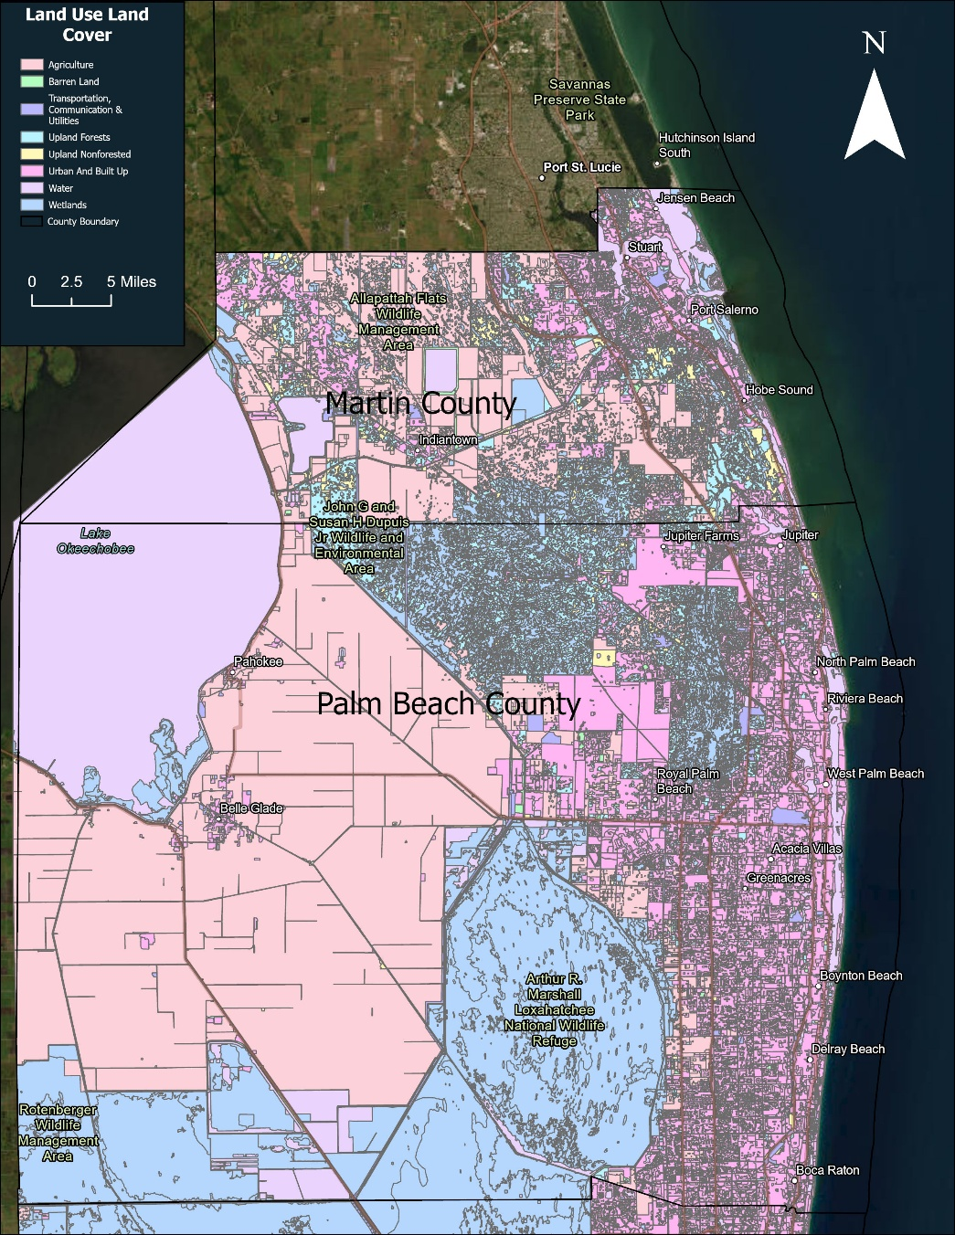
Map 13: Land Use and Land Cover for Martin and Palm Beach Counties (data provided by the South Florida Water Management District for 2021-2023.)

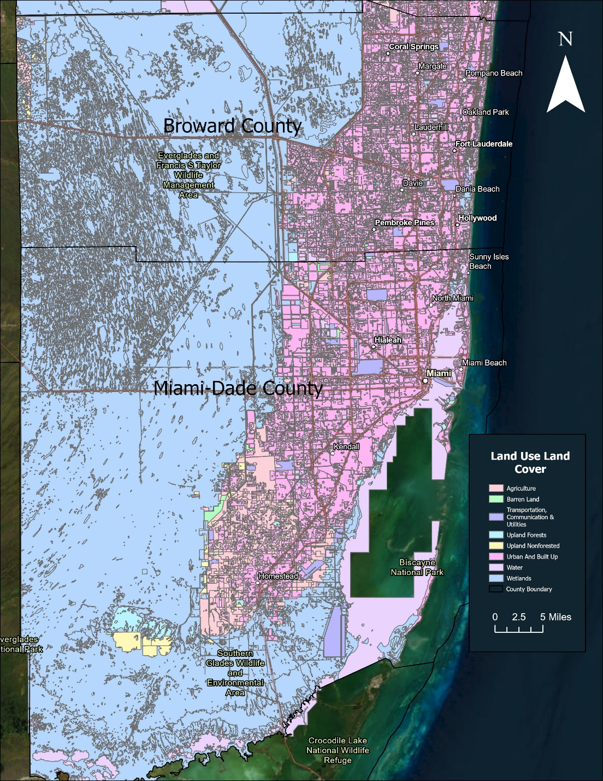
Map 14: Land Use and Land Cover for Broward and Miami-Dade Counties (data provided by the South Florida Water Management District for 2021-2023.)

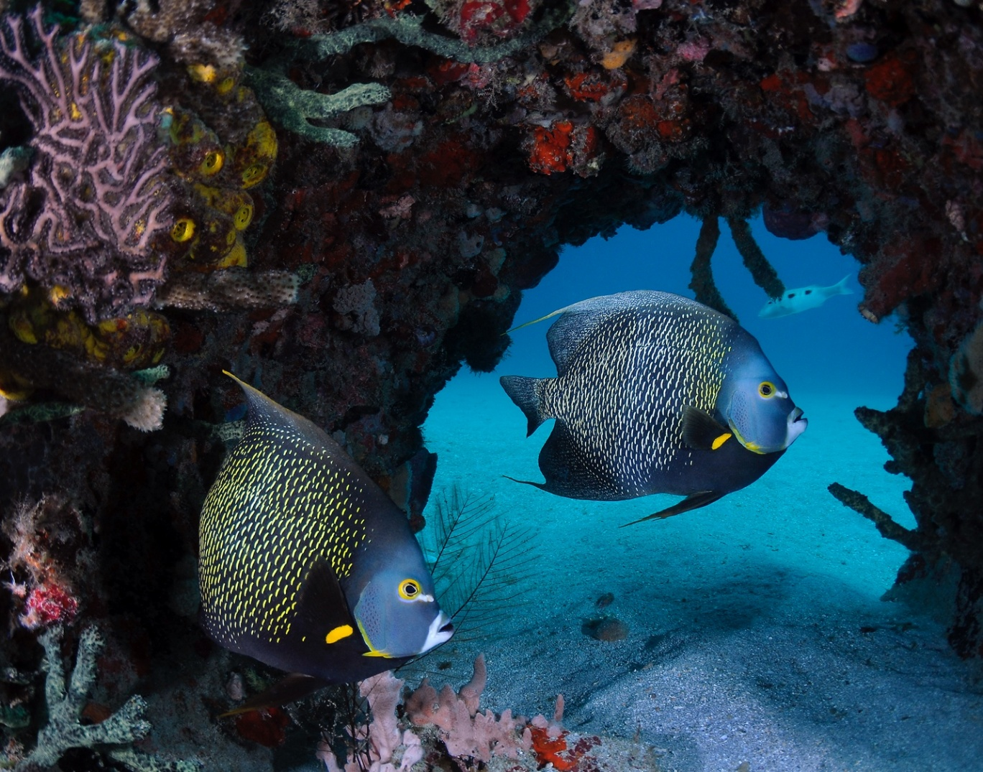
Photo: Two French angelfish in KJCAP. (photo: Joe Marino)

Chapter 4: The Kristin Jacobs Coral Aquatic Preserve Management Issues
The hallmark of Florida’s Aquatic Preserve Program is that each site’s natural resource management efforts are in direct response to, and designed for, unique local and regional issues. Given the breadth of KJCAP, its diverse resources, and multi-scalar challenges, issue-based adaptive management represents a tested and integrated approach to target management within the region. Issues are addressed using a mechanism that incorporates goals, objectives, and strategies to assess the source of the problem, devise and implement interventions to correct it, assess the effectiveness of the interventions and educate the public on how to become better stewards of the resource. For instance, an aquatic preserve may address declines in water quality by monitoring levels of nutrients and turbidity, applying principles and best management practices to reduce nutrient loads, and creating a program that educates and engages local communities to pledge to take actions such as reduced use of fertilizers.

Issue-based management is a means through which any number of partners may become involved with an aquatic preserve in addressing an issue. Partnering is a necessity; by bringing issues into a broad public consciousness, partners are welcome to ensure that a particular issue receives input from perspectives that the aquatic preserve may not normally include. Given the distribution of authority between several local, state, and federal agencies, issue-based management allows KJCAP to focus efforts on the most critical challenges facing the region. Within the issue-based management framework, this plan seeks to incorporate elements of resilience-based management (RBM) by considering the connections between social and ecological systems and by partnering with agencies at all levels of government to integrate the management of terrestrial resources with offshore resources. RBM is a management approach that uses knowledge of current and future drivers influencing ecosystem functions to prioritize, implement, and adapt management actions that enhance the resilience of ecosystems, communities, and social-ecological systems (Mcleod et al., 2019). RBM is unique in that it acknowledges humans as capable of driving adaptation and transformation in natural systems and attempts to manage for future changes including uncertainty (Reef Resilience Network, 2025). Due to the complexity of relationships in an ecosystem, RBM needs to be adaptive, in that it must monitor and assess management outcomes with the understanding that changes in management may be required to achieve desired results, and management actions must be adaptive to new information and changing dynamics across the ecosystem.

This section will explore issues that impact the management of KJCAP directly or are of significant local or regional importance that the aquatic preserve’s participation in them may prove beneficial. While an issue may be the same from preserve to preserve, the goals, objectives, and strategies employed to address the issue will likely vary depending on the ecological and socioeconomic conditions present within and around a particular aquatic preserve’s boundary. In this management plan, KJCAP will characterize each of its issues and delineate the unique goals, objectives and strategies that will set the framework for meeting the challenges presented by the issues.

Each issue will have associated goals, objectives, and strategies. Goals are broad statements of what the organization plans to do and/or enable for the next 10 years. They should address identified needs and advance the mission of the organization. Objectives are a specific statement of expected results that contribute to the associated goal, and strategies are the general means by which the associated objectives will be met. Appendix D contains a summary table of all the goals, objectives and strategies associated with each issue.

SEFCRI and CRCP are managed under six focus areas: Awareness and Appreciation; Land-Based Sources of Pollution; Maritime Industry and Coastal Construction Impacts; Fishing, Diving, and Other Uses; Reef Resilience; and Reef Injury Prevention and Response. However, for the purposes of this management plan, the issue-based adaptive management outlined in this section recognizes the strong overlap that exists between issues, meaning many management actions are applicable across multiple issues, and thus will highlight the 5 issues described extensively below.

In this management plan for KJCAP, some goals, objectives, and strategies have been adapted from the Our Florida Reefs (OFR) and FDOU 52 Fisheries Committee Recommended Management Actions, as well as from previously developed and ongoing SEFCRI Local Action Strategy projects. Less actionable words like ‘support’ and ‘partner with’ are used in some strategies that refer to items that have been identified as strong priorities by partners and stakeholders. Regular monitoring, as well as new research, provides information to adapt goals, objectives, and strategies as necessary to best accommodate the dynamic nature of the resource over the next ten years. The development or support of a strategy by OFR and FDOU 52 is denoted next to the corresponding goal, objective, or strategy within this chapter. Appendix D.3. and D.4. provide tables of developed recommended management actions from the OFR and FDOU 52 processes, respectively.

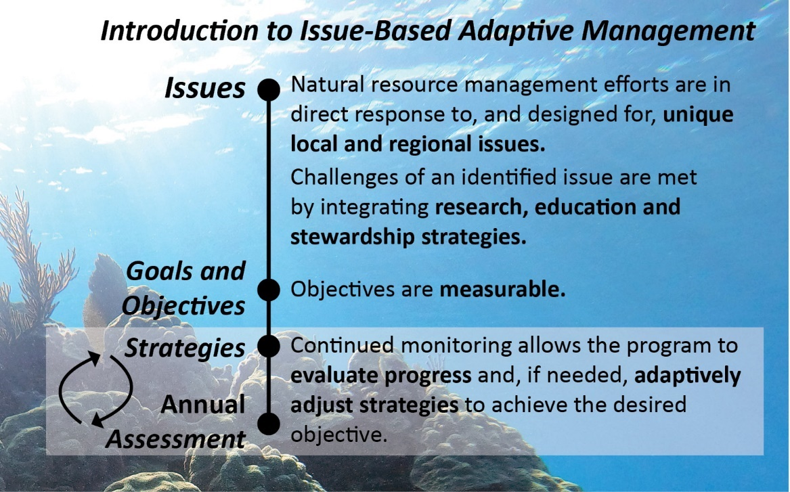
Figure 4: Issue-based adaptive management.
Along with enforcement, adequate funding is a critical piece that ensures effective management and compliance with environmental regulations (Osmond et al., 2010). With more formal management of the area and more regulations to enforce, dedicated funding streams are necessary to ensure the long-term sustainability of management efforts. Moreover, the ecological effects of protected areas take time to develop. A combined analysis of ecological, long-term, time series data showed direct effects on target species becoming apparent on average after five years of enforced protection and more than ten years for the indirect effects to other species (Babcock et al., 2010). Therefore, funding for KJCAP needs to be consistent and sustained to produce the desired ecological benefits. Lastly, coordination and communication among federal, state, and local agencies as well as other partner organizations and stakeholder groups should continue. Communication between groups should aim to identify approaches to more effectively and efficiently coordinate and communicate ongoing research, inform decisions on targeted management actions, and define disturbance response mechanisms for collaborative action. KJCAP should also collaborate with partners to update existing monitoring programs and associated data, planned conservation initiatives, and stakeholder outreach and education initiatives. Participatory management planning where stakeholders are engaged in decision-making and are more aware and knowledgeable of ongoing agency efforts increases the likelihood that implemented management actions will be successful.

4.1 Issue A: Water Quality Impacts from Land-Based Sources of Pollution including Marine Industry and Coastal Construction Impacts
Coral reefs have evolved to thrive in clear, low-nutrient waters with ample sunlight for their photosynthetic symbionts while limiting the abundance of macroalgae that can overgrow corals (Whitall et al., 2019). Nearshore reefs are particularly susceptible to land-based sources of pollution that can (1) increase the turbidity of the water, (2) reduce the sunlight corals receive, and (3) deliver nutrients, including phosphorus and nitrogen, to coastal waters, creating the ideal conditions for macroalgae to thrive. Sediment and nutrients originate from a variety of sources on land. During rainfall, these sediments and nutrients will frequently wash into inland waterways and are then carried to the ocean through canals and inlets. Common sources of nitrogen and phosphorus include fertilizers that are used on commercial farms and residential lawns, as well as human and animal waste (Whitall et al., 2019). Coastal development, dredging, and beach nourishment projects are some examples of common anthropogenic activities with high risk of mobilizing sediment into coastal waters.

Due to the flat terrain and highly managed network of drainage canals in Southeast Florida, the flow of water is not dictated by natural changes in elevation that normally control downslope water movement and define watersheds; instead, the canals and hydraulic systems make waterflow to the coast largely human-controlled (Pickering & Baker, 2015). Consequently, the Southeast Florida region adjacent to KJCAP is divided into nine Inlet Contributing Areas (ICAs, map 4) that define how water moves through the various artificial pathways into inlets that then feed into KJCAP.

Threats to the marine environment increased as development and construction continued throughout the 20th century. Coastal construction impacts first occurred along the coastal fringe and ridge, followed by the alteration of inland hydrology, and dredging and filling of wetlands through land reclamation processes (Derr, 1998; Kruczynski & Fletcher, 2012). Canals were built to divert freshwater, inlets were dredged to provide vessel access, and outfalls were built to release partially treated wastewater, which have all impacted the offshore environment and its resources. Offshore water quality continued to decline as a result of coastal development impacts from coastal construction projects and nonpoint sources of pollution (Kruczynski & Fletcher, 2012). As more structures and inlets were built and excavated along the Southeast Florida coastline, beaches began experiencing extensive erosion due to changes in longshore transport and deposition (Wanless, 2009). Port development and maintenance, especially along the three main ports in Southeast Florida, affected almost 600 hectares of corals and associated hardbottom communities (Walker et al., 2012) through the early 21st century.

While the efficient flow of water through canals has allowed agriculture and development to thrive in the South Florida region, it has also reduced nutrient uptake—the mechanism by which soil and plants naturally absorb nutrients as water slowly makes its way to the coast. Nutrient uptake by soil and plants is further reduced in the five southernmost ICAs, which contain the most urbanized portions of the region. Extensive impervious surfaces exist that prevent water and nutrients from filtering through the soil into the groundwater before finding their way into inlets (Pickering & Baker, 2015). Therefore, nutrients from point and nonpoint sources fill the water management canals and inlets and are carried directly into KJCAP with the tides (Whitall et al., 2019) or via larger pulses of freshwater released in preparation for or in response to high rainfall events. While the northern ICAs have more agricultural land and fewer impervious surfaces than the southern ICAs, the higher use of chemical fertilizers due to agriculture presents its own nutrient pollution problems (Pickering & Baker, 2015). Additional nutrient pollution sources into KJCAP include leaking septic systems, which will only increase in severity as sea level rise compromises more systems, and six wastewater outfalls that were slated to be reduced to 5% of their full capacity by 2025 (Gregg, 2013), but many of which are behind schedule. The effects of these nutrient inputs still require further study and monitoring as most monitoring programs in the area do not extend offshore (Whitall et al., 2019).

The flow of nutrients from terrestrial sources into canals and inlets, and then into the offshore environment, has significant effects on KJCAP reef systems. While the phase shift to increased macroalgal cover is a multifaceted issue with many causes, including the decline of the long-spined sea urchin (Diadema antillarum), land-based sources of nitrogen and phosphorous have been shown to help drive conditions that promote algal blooms in Southeast Florida (Gregg, 2013). In addition to introducing higher levels of nutrients, outfalls have been linked to Black Band and White Pox diseases, both affecting coral species within KJCAP (Whitall et al., 2019).

Beach nourishment and dredging projects have resulted in excess sediment on corals along Florida’s Coral Reef (Gregg, 2013; Miller et al., 2016). In addition to the potentially lethal effects of smothering corals, sediment interrupts respiration and other biological processes, causing negative effects for the surviving organisms of the benthic community (Gregg, 2013). Reef sediment has also been shown to transmit Stony Coral Tissue Loss Disease (SCTLD) (Studivan et al., 2022). Reduction of light penetration due to particles in the water column is another factor leading to a higher proportion of macroalgae and cyanobacteria, as they are more tolerant of lower light levels and may gain a competitive advantage over corals (Gregg, 2013). Sediment has also been shown to inhibit coral larval settlement (Birrell et al., 2005; Goh & Lee, 2008).

Water quality research conducted in Southeast Florida regarding pollutants entering the system from outfalls, inlets, upwelling, groundwater discharge, Everglades restoration effects, and increased carbon dioxide emissions (Trnka & Logan, 2006) has historically focused on the intracoastal waterway and other inland waters. Although there are six ocean outfalls that exist within KJCAP, which release freshwater between 0.95 and 3.56 miles offshore within 27.3 to 32.5 meters of depth, discharge permit limits were not set to protect the adjacent coral reef ecosystem. State numeric nutrient criteria are only in effect in nearshore areas and do not extend to the coral reef. No numeric criteria specific to sensitive coral reef resources were established through applicable federal, state, or local water quality regulations and prior to the 2003, no long-term ecological monitoring occurred on the coral reefs near outfall discharges.

Whitall et al. (2019) under NOAA’s NCCOS and National Ocean Service, collaborated with DEP to design and conduct a monthly monitoring effort that collects quantifiable data to address the negative perceptions local stakeholders have regarding water quality impacts to Florida’s Coral Reef. Map 15 shows the distribution of ongoing collection sites. This effort has been ongoing since 2016 due to federal and state collaborations. Results revealed that discharge from canals and inlets significantly affect the offshore coastal area, driving much of the chemistry changes. Additionally, results showed elevated levels of urea and ammonia at outfall discharge sites, which are unique to those areas.

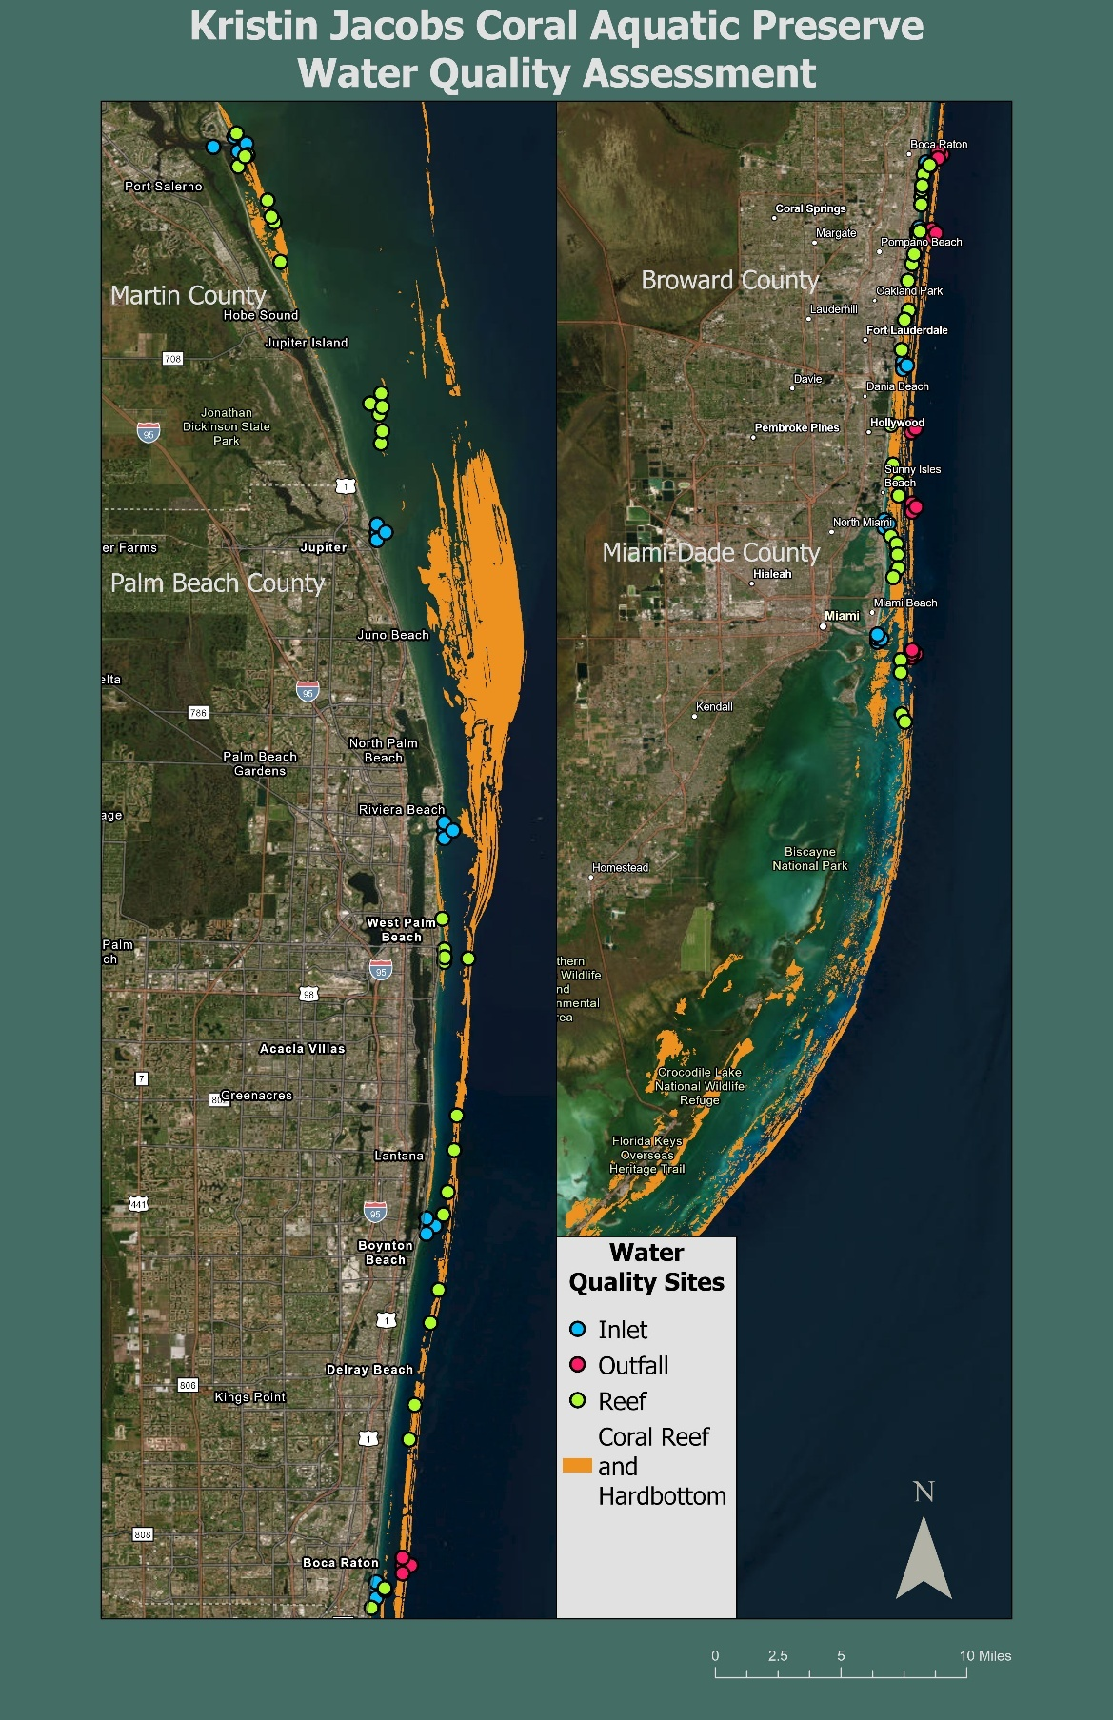
Map 15: Sampling locations from DEP’s water quality assessment program within KJCAP.
Blue circles represent the sample locations near the inlet, red circles represent sample locations near the outfalls, and the green circles represent sample locations within reef habitat.
Each county also conducts water quality monitoring with varying applicability to KJCAP. The most significant monitoring occurs in Biscayne Bay, which provides some insight into nutrients entering KJCAP. Miami-Dade County’s Division of Environmental Resource Management (DERM), as part of their National Pollution Discharge Elimination System (NPDES) monitoring program, conducts monthly surface water sampling at more than 100 sites around the Bay and within the drainage canals that feed into it, measuring water quality parameters including phosphorus, nitrogen, chlorophyll-a, bacteria, and turbidity (MDC, 2021). Their findings are published in an annual Report Card. SFWMD also has several monitoring sites within the Bay and in other bodies within the region that feed into KJCAP, including the St. Lucie River in Martin County. Broward County’s Environmental Monitoring Lab conducts an Ambient Water Quality Monitoring Program, which collects data on LBSP including agricultural and stormwater runoff, and public sewer and septic system pollution by taking measurements from 46 sites throughout the county (BC, n.d.a). They test the surface waters of the canals and ICW for total nitrogen, total phosphorus, chlorophyll a, dissolved oxygen, specific conductance, and salinity. All four counties’ Departments of Health conduct beach water sampling for bacteria as part of the State Healthy Beaches Program, but no data is collected that would provide insight into LBSP for the offshore coral reef.

Additionally, DEP’s Division of Environmental Assessment and Restoration (DEAR) geographically defines Florida’s waterbodies using Water Body Identification (WBID) numbers. WBIDs are polygons that roughly delineate the drainage basins surrounding the water body and are used to identify areas that are listed as Waters Not Attaining Standards, in the Total Maximum Daily Load (TMDL) program, to define Basin Management Action Plans (BMAP), as well as other applications. Current impairment information, along with TMDL and BMAP listings for the state can be viewed using the Water Quality Assessments, TMDLs, and BMAPs webmap at https://fdep.maps.arcgis.com/home/webmap/viewer.html?webmap=1b4f1bf4c9c3481fb2864a415fbeca77. Currently there are several beach WBIDs within KJCAP that are impaired for bacteria and multiple WBIDs upstream of KJCAP impaired for various other parameters such as Chlorophyll, metals, phosphorus and nitrogen.

Along with the issues from sedimentation and eutrophication that are understood, research must continue to identify the additional and potentially synergistic effects of other anthropogenic pollutants — for instance, plastics, pesticides, herbicides, pharmaceuticals, personal care products and other pollutants of emerging concern — and firmly establish how pollutants disperse to the offshore coral reef from inlets, outfalls and through submarine groundwater discharge (Gregg, 2013; Whitall et al., 2019).

An effort should be made, whenever possible, to unify water quality monitoring programs and data reporting for waters both within and contributing to KJCAP. Within CRCP, consistent techniques are used, when applicable, to strengthen the state of Florida’s ability to assess the baseline and relative conditions of coastal resources, enabling objective analysis of the changes occurring in the state’s natural and cultural resources. Ensuring comparability of monitoring programs between different agencies increases the usability of data and reduces the need for redundancies in monitoring. Similarly, ensuring comparability between inland and offshore monitoring programs would allow for a better understanding of sources and pathways of LBSP. Long-term monitoring programs collect high quality data that is maintained in a way that makes them readily accessible for use by resource managers and scientists.

Detailed mapping studies have been conducted under the LBSP SEFCRI focus area. From 2004 to 2013, researchers from Nova Southeastern University developed detailed benthic habitat maps for each of the four counties in KJCAP. Using LiDAR bathymetry surveys, aerial photography, acoustic ground discrimination, and video ground truthing, approximately 954 km² of ocean floor was surveyed within the region, identifying changes in substrate and sub-habitats along the reef and between the three offshore reefs (Riegl et al., 2004, 2007; Walker, 2009; Walker et al., 2012). These offshore mapping efforts allowed for the discovery of over 110 undocumented large coral colonies at the onset of the SCTLD outbreak (Walker and Klug, 2015), as well as a deeper understanding of the distribution of coral species listed as threatened under the ESA within KJCAP (Walker, 2017).

Beyond research, best management practices that promote water storage and treatment and reduce nutrient pollutant loading should be supported in order to improve the quantity and quality of wastewater, stormwater, and groundwater reaching KJCAP. For example, DEP’s Clean Marina and Clean Boating programs provide assistance in implementing Best Management Practices that address critical environmental issues such as sensitive habitat, waste management, storm water control, spill prevention and emergency preparedness. Reduction of LBSP can be done on a small scale through the use of Florida Friendly Landscaping practices, using more sustainable alternatives to single-use plastics, or using Green Stormwater Infrastructure in communities to capture and treat stormwater runoff at the source. It can alternatively be done on a much larger scale by promoting innovative solutions to wastewater treatment and reuse, supporting agricultural best practices, working with partners to ensure coastal development projects are planned and carried out as to reduce cumulative impacts to coral reefs, and supporting the reduction of vessel-based discharges.

Goal A1: Improve water quality both within and entering KJCAP to meet the needs of natural resources.

Objective A1.1: Maintain, expand, and unify monitoring programs within KJCAP in order to detect and identify sources of pollution flowing through inlets, and support data analysis to understand the effects of, and how to effectively mitigate, LBSP on coral reef habitat (N-71).

Integrated Strategy A1.1.1: Continue to develop circulation models to determine nutrients and pollutant movements from ICAs to reefs.
Integrated Strategy A1.1.2: Investigate and/or develop circulation models to characterize sediment movements and potentially associated pollutants from ICAs to reefs.
Integrated Strategy A1.1.3: Continue pairing water quality monitoring sites with fixed historical sites or other biological monitoring sites on coral reef habitat, such as SECREMP, to improve understanding of the relationships between potential sources of LBSP and offshore reef biological data.
Integrated Strategy A1.1.4: Conduct or support research into the cycling of pollutants and toxins through flora, fauna and microbes, including macroalgae and cyanobacteria.
Integrated Strategy A1.1.5: Conduct or support research into contaminants and pathogens introduced from dredging and other coastal construction projects, and their effects on the reef.
Integrated Strategy A1.1.6: Continue to work with partners to encourage the use of DEP water quality SOP’s, uniform naming conventions, standardized collection and analysis methods and existing databases, such as WIN and SEACAR, wherever possible (FDOU 52).
Integrated Strategy A1.1.7: Continue to support water quality (e.g., turbidity, nutrients and sediment) research and synthesis of data to determine baseline conditions and organismal thresholds in KJCAP and upstream water bodies, with the goal of informing and improving resource management (e.g., construction, dredging, wastewater treatment plants, ocean outfalls, septic to sewer conversions and the Comprehensive Everglades Restoration Plan).
Integrated Strategy A1.1.8: Continue to support research on emerging and unregulated contaminants or toxins of concern such as heavy metals, pharmaceuticals, pesticides and herbicides, and their effect on corals.
Integrated Strategy A1.1.9: Regularly review existing programs and incorporate new and emerging information and technology to ensure water quality monitoring in KJCAP is effectively meeting management needs.

Performance Measures A1.1
- Water quality data is uploaded into WIN and other pertinent databases quarterly, as well as synthesized in the annual report.
- LBSP Coordinator to attend one local water quality related meeting or event annually to share KJCAP water quality priorities and learn about new information and technology.
- Circulation models, research, and data is synthesized and shared with SEFCRI, DEP DEAR, and other pertinent partners.
- Water quality monitoring protocols are reviewed annually and optimized as necessary.

Objective A1.2: Coordinate with municipalities, water management districts, local governments, federal partners and advisory group counterparts to reduce point and non-point land-based sources of pollution including wastewater, stormwater and groundwater that enter KJCAP and associated watersheds to improve water quality and reef condition through management actions. (OFR N-78 and FDOU 52).

Integrated Strategy A1.2.1: Coordinate with municipalities and local governments to promote best management practices to residential and community facilities to improve water quality and reduce nutrient and pollutant loading, such as the use of Florida-Friendly Landscaping practices, regenerative gardening/landscaping and permaculture, and promotion of education on fertilizer ordinances (OFR N-68, OFR N-8 and FDOU 52).
Integrated Strategy A1.2.2: Support septic to sewer conversions in the four counties adjacent to KJCAP and evaluate current impacts and potential improvements to offshore ecosystems from the conversions.
Integrated Strategy A1.2.3: Support implementation of existing or create new innovative solutions at all scales that increase stormwater storage, reduce stormwater runoff, enhance treatment, increase reuse, and reduce nutrients, turbidity and other contaminants to the watershed (OFR N-82 and FDOU 52).
Integrated Strategy A1.2.4: Support timely closure of all treated wastewater outfall pipes as established in existing sewage treatment outfall legislation (Section 403.086, F.S.) and upgrades to infrastructure for advanced water treatment and reuse capacity to improve ocean water quality and maintain current sources of potable water from local aquifers (OFR S-25 and FDOU 52).
Integrated Strategy A1.2.5: In collaboration with county and municipality partners, support the continuation of existing and implementation of new marine debris and plastic waste reduction projects, including education and outreach to promote more sustainable alternatives to single-use plastics.
Integrated Strategy A1.2.6: Strengthen partnerships and increase collaboration and shared knowledge between regulatory agencies, counties, and municipalities on topics including permitted beach nourishment and inlet maintenance projects in order to facilitate practices that promote improved water quality.
Integrated Strategy A1.2.7: Support the development and implementation of turbidity and nutrient limits applicable to coral reef organisms throughout their life stages.
Integrated Strategy A1.2.8: Support research to understand and identify sources of groundwater effects on water quality in KJCAP and based on findings, recommend inclusion of strategies to reduce aquifer and offshore pollution via groundwater into Inlet Contributing Area management plans, such as septic to sewer conversions.
Integrated Strategy A1.2.9: Support County and municipality research and implementation of innovative wastewater and stormwater treatment options to address contaminants of emerging concern, such as pharmaceuticals (FDOU 52).
Integrated Strategy A1.2.10: Support the implementation and evaluate the effectiveness of using natural/green/alternative infrastructure at the county and municipality level to treat and/or reduce volume of wastewater and stormwater (FDOU 52).
Integrated Strategy A1.2.11: Partner with regulatory agencies to revise the coastal permitting process to ensure development and coastal construction projects do not occur during periods when corals are more susceptible to impacts (e.g., bleaching, spawning, other disturbance events) to reduce cumulative impacts to reefs (Southeast Florida Coastal Ocean Task Force RMAs; FDOU 52).
Integrated Strategy A1.2.12: Support development of and implementation of recommendations from local watershed management plans when appropriate.

Performance Measures A1.2
- All outreach events that promote messaging around best practices to reduce stormwater and groundwater pollution at a residential level are reported in the quarterly measures report.
- All outreach events that promote messaging related to reducing marine debris and single-use plastics are reported in the quarterly measures report.
- Attend a minimum of one meeting annually with partners to discuss how KJCAP staff can support efforts to promote BMPs relating to improving quality and quantity of storm and wastewater.
- Provide and synthesize data as needed to show trends in water quality related to wastewater treatment plant ocean outfalls.
- Nutrient and turbidity data collected by KJCAP and partners is synthesized and shared with DEP DEAR annually in an annual report.

Objective A1.3: Coordinate the reduction of vessel-based discharges.

Integrated Strategy A1.3.1: Investigate the potential for a No Discharge Zone into KJCAP, similar to the Florida Keys.
Integrated Strategy A1.3.2: Support the U.S. Coast Guard’s enforcement of ballast water regulations within state waters and inform them of ongoing research.
Integrated Strategy A1.3.3: Support existing programs, including Clean Boating and Clean Marinas, that promote free pump out stations to improve water quality and allow vessels a better option than dumping three nautical miles offshore (OFR N-75 and FDOU 52).

Performance Measures A1.3
- Outreach messaging promoting best practices to reduce pollution from vessel-based discharges, as well as related resources and programs, is shared at four outreach events annually.
- Emergent studies and recommendations on ballast water effects on reef resources are shared with the U.S. Coast Guard as appropriate.
- Report suspected or identified instances of vessel-based discharge violations to appropriate regulatory and enforcement agencies.

Goal A2: Increase public and industry engagement in actions that can be taken to improve water quality in KJCAP.

Objective A2.1: Work with the local community, visitors, and agency partners to encourage reduction of land-based sources of pollutants entering storm drains and waterways (N-1).

Integrated Strategy A2.1.1: Coordinate and promote coastal and inland "living shoreline" objectives to increase the use and protection of natural infrastructure with the agreement of property owners (e.g., coral reefs, native vegetation and mangrove wetlands) to improve water quality and maintain coastal biodiversity (N-116 and FDOU 52).
Integrated Strategy A2.1.2: Work with SFWMD and the counties to promote and support training programs and adaptive best management practices for all golf courses, businesses and property owners to eliminate adverse impacts on the coastal environment and its watersheds (N-94).
Integrated Strategy A2.1.3: Using social science methods, gauge level of understanding and perceptions from local residents on water quality issues in KJCAP, as well as identifying educational gaps and barriers amongst communities.
Integrated Strategy A2.1.4: Using knowledge gathered from A2.1.3, update existing communication messaging and engagement to provide information to residents and stakeholders on how to incorporate healthy water quality practices.
Integrated Strategy A2.1.5: Continue coordination and information sharing with partners at local/state/federal agency levels (e.g., Miami Dade County’s reasonable assurance plan, Florida’s Coral Reef Resilience Program (FCRRP), FCRCT, state and federal working groups, etc.).

Performances Measure A2.1
- Attend a majority of quarterly meetings with the counties adjacent to KJCAP to discuss how to support actions that can be taken to improve water quality.
- Results of social science studies are shared with SEFCRI team and TAC.
- KJCAP staff continue regular participation in reginal partner meetings and working groups (e.g. FCRRP, USCRTF and FCRCT) to facilitate information sharing about water quality.

4.2 Issue B: Sustainable Economic and Recreational Fishing, Diving, and Other Uses
Consumptive commercial activity and human recreation can have significant and long-lasting impacts on our reef resources. At the same time, positive opportunities exist when motivated stakeholders and community members are engaged in collectively stewarding reef ecosystems. Promoting targeted efforts to diminish human impacts and cultivate reef-friendly behaviors among audiences who work and recreate in KJCAP will go a long way towards ensuring the sustainable future use and enjoyment of Florida’s Coral Reef.

As previously discussed in Chapter 3, KJCAP provides a wide array of ecosystem services to communities living in proximity to the reef and to the influx of tourists who visit South Florida every year, all of whom use KJCAP in various ways. For example, the region supports a robust blue economy, comprised of extensive ocean commerce, and an ever-expanding cruise and maritime leisure industry. Likewise, the region supports a diverse fisheries resource base, attracting commercial fishers, charter fishing operations, recreational anglers, and spearfishers year-round. Similarly, the clear waters and wide variety of dive environments — from easily accessible shore dives to more advanced drift dives aided by the close proximity of the Gulf Stream current — makes KJCAP a world-renowned destination for recreational scuba divers and snorkelers alike. However, when left unchecked, the uses associated with these ecosystem services can cause pressure on KJCAP’s reef resources that presents a direct threat to the region and its socioeconomic and environmental wellbeing. For example, commercial shipping can lead to large-scale changes to sensitive coral habitats, either directly through vessel-based damage (e.g., anchoring, vessel pollution, and groundings) or indirectly via the creation of coastal infrastructure, channel dredging, and port expansion.

In KJCAP, coral reef habitat and associated water quality are mainly managed by DEP, while coral, marine invertebrates, fishes, and other marine organisms are mainly managed by FWC. However, in the case of management of scleractinian corals, there is overlap between the two agencies as they are both habitat and species. Enforcement in KJCAP, for both fisheries and non-fisheries laws, is predominantly managed by FWC. Adequate enforcement and compliance is one of the defining features of successful protected areas (Agardy et al., 2011). Therefore, it is imperative that strong cooperation exists between DEP and FWC in the management of the region and that there is a clearly defined mechanism to resolve disagreements between the two agencies. Cooperation between other partner agencies that would regulate activities within KJCAP is also necessary, for example both the U.S. Army Corps of Engineers and counties issue permits for mooring buoys, artificial reefs, and certain beach projects.

Although commercial and recreational fisheries are an emblematic and lucrative part of KJCAP, many reef-dependent and associated species remain heavily fished in Florida (Ault et al., 2020; Ault & Franklin, 2011). While FWC conducts stock assessments for several commercially and recreationally important finfish species in Florida, their regional fisheries stock assessment boundaries extend larger than KJCAP. Therefore, decision-making involving fishery species tends to occur at larger, less locally informative spatial scales. Without an accurate snapshot of fisheries stocks at a geographically smaller scale, it is difficult to understand the extent of impacts from overfishing within KJCAP. Additionally, fishing gear such as derelict lobster traps and monofilament entanglement cause harm to coral reef habitat and associated species (Chiappone et al., 2005). Even seemingly less consumptive activities such as recreational scuba diving and snorkeling, if practiced without adhering to conservation best practices, can permanently alter coral reefs and other sensitive aquatic habitats (Thurstan et al., 2012).

In the 1980s, fisheries independent and dependent monitoring programs were established (McRae, 2010). Fisheries independent data comes from scientific surveys which target juvenile and sub-adult fishes that have not been subjected to fishing pressure, and can be used to monitor species abundance, seasonal and spatial trends. The SEFCRI Team confirmed the need for fisheries independent data collected within KJCAP beyond existing snapshot data identified in LAS FDOU Project 18 & 20, and thus conducted a five-year fishery-independent study from 2012 to 2016 to establish a baseline of reef fish conditions (Kilfoyle et al., 2018). Since 2014, the National Coral Reef Monitoring Program (NCRMP) has conducted fish monitoring surveys in Florida every other year to detect temporal changes in fish community composition (both target and non-target species), abundance, size structure, and diversity. Although fisheries independent monitoring data were historically absent in KJCAP region, state and federal partners have collected valuable fisheries dependent data throughout Florida’s waters.

Fisheries dependent data is collected directly from fishing activities and is used to monitor catch rates and assess the health of exploited fish populations. FWC (state level) and NOAA (federal level) monitor fisheries using fisheries-dependent approaches that collect valuable information from commercial, recreational, and for-hire fishers (headboats, charter vessels and guide boats) to understand trends in landings, catches, fishing effort and catch-per-unit-effort. This data is important for conducting stock assessments. In addition, NOAA Fisheries collects recreational fishing information on catch and effort, frequency of fishing trips per year, fishing location, and type of fishing by conducting recreational angler surveys via the Marine Recreational Information Program. Johnson et al. (2007) completed a ten-year (1990-2000) analysis of commercial, headboat, charter, and recreational fisheries for KJCAP region, specifically. The authors determined that half of the fisheries harvested over the decade were caught in coastal and reef zones, showing the importance of KJCAP to the region’s fishery sectors. While no trends were found in the amount of reef fish caught by recreational fishers, the study did find significant declines in headboat and commercial reef fish harvests. While both state and federal efforts have obtained invaluable information on fisheries trends that are used in fisheries management and other measures, the data do not easily translate to a map of fishing pressure. Nevertheless, given that there are several target species that are reef-dependent or have been identified via fisheries independent surveys in KJCAP (as shown by Kilfoyle et al., 2018), harvest and effort statistics provide important insights on coral reef species populations in the region.

Studies reviewing historic and recent port development and dredging projects (Miller et al., 2016; Walker et al., 2012) have shown how project-specific and maintenance-related activities can affect KJCAP resources, including federally and state protected corals and other hardbottom communities. Additionally, the placement of shipping lanes for the three major KJCAP ports bring vessels close to shore and to nearshore reefs, whereas in the Florida Keys, for example, the reef carries the designation of a Particularly Sensitive Sea Area and an Area To Be Avoided, which pushes commercial shipping activity farther offshore and away from the coral reef (NOAA, 2007). Similarly, large vessels that anchor along the reef line adjacent to major ports have been shown to create chronic impacts (Walker et al., 2012; Waters, 2015) (Map 16). However, it should be noted that anchorage relocations have led to a decrease in direct impacts. After numerous vessel groundings and anchoring incidents, the Port Everglades and Port of Miami anchorages were relocated in 2008 and 2017, respectively, resulting in a reduction of major grounding incidents (Map 16).

Recognizing the importance of Florida’s Coral Reef and to prevent similar grounding and anchoring impacts from recreational and commercial vessels, the state enacted the Florida Coral Reef Protection Act (CRPA), §403.93345 F.S., in 2009. The CRPA makes it illegal to anchor on or otherwise damage coral reef and hardbottom resources in the Southeast five-county region, from Martin through Monroe counties. The law grants DEP the authority to use a civil process to recover penalties and damages to coral reef and hardbottom resources from the responsible party. DEP’s Reef Injury Prevention and Response (RIPR) Program conducts site investigations and pursues CRPA violations within state waters. RIPR holds an annual CSI for Coral Reefs training specifically for resource trustees that aid RIPR in performing site checks and damage assessments. The training includes one day in the classroom to review protocols and procedures, and one day in the field to practice assessments underwater. In the past, the RIPR Program relied solely on partnerships with multiple agencies and stakeholders to receive reports. However, with continuous advances in technology to monitor commercial vessel traffic, it is easier to receive injury reports and be more vigilant against threats to Florida’s Coral Reef and hardbottom resources. Therefore, while reconfiguring the commercial anchorages has led to a decrease in major incidents, specifically groundings, it is not necessarily reflected in the number of enforced CRPA cases (Map 16). However, there is still a need for better methods to address impacts from recreational boat anchoring as these vessels are harder to monitor. While the CRPA is being enforced in its current capacity with the assistance of resource trustees, stronger partnership is needed between DEP and FWC to increase enforcement success. The majority of CRPA cases involve larger commercial vessels with AIS tracking capabilities, but unfortunately many potential impacts from smaller recreational vessels often go unreported, and therefore not enforced. Additionally, there are other ways to incorporate the CRPA as an enforcement tool into KJCAP management that warrant further exploration (e.g., offshore permit conditions, marine event planning and mooring buoy promotion to reduce anchoring).

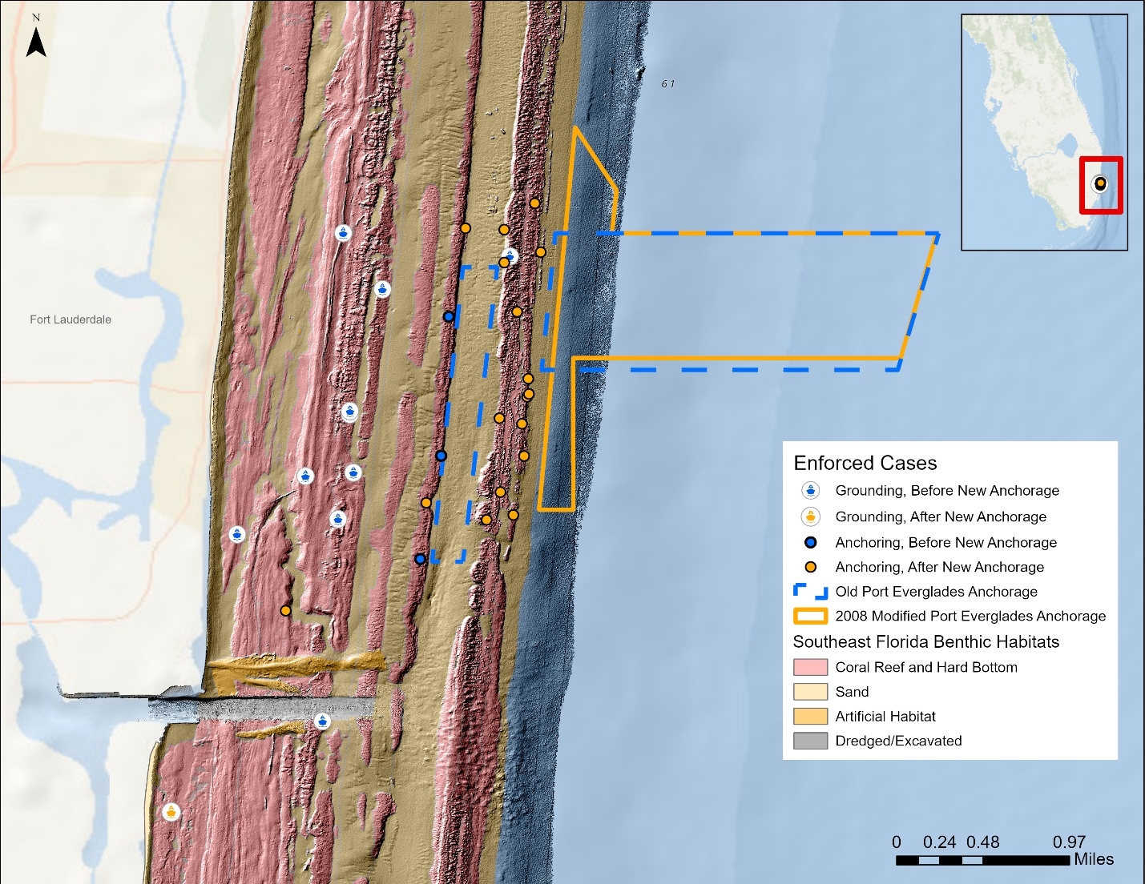
Map 16: Enforced vessel groundings and anchoring incidents.
This map shows all enforced vessel groundings and anchoring incidents at Port Everglades before (blue dots) and after (yellow dots) the 2008 reconfiguration of the Port Everglades Commercial Vessel Anchorage.

While commercial fishing participation has declined considerably in the south Florida region (Shivlani, 2014), recreational angling has increased in popularity over time. In 2016, an estimated 3.91 million anglers fished from the shore, 2.29 million from a private or rented vessel, and over 108,000 from a charter fishing vessel in the four counties adjacent to KJCAP (Wallmo et al., 2021a). Over one year, reef-related recreational angling generated an estimated economic output of $43.8, $43.8, $79.7, and $28.4 million in Miami-Dade, Broward, Palm Beach, and Martin counties, respectively; supporting 440, 442, 803, and 286 jobs in the respective counties as well (Wallmo et al., 2021a). Given how popular fishing in and adjacent to KJCAP is to anglers and the considerable economic impact generated by the activity, these fisheries merit continued conservation to ensure their continued sustainable use into the future. Conservation measures must also prioritize ecosystem function, without which fisheries could further decline, leading to the imbalance and eventual collapse of broader reef ecosystems.

Florida’s Coral Reef provides a unique opportunity for recreational boaters, snorkelers, and divers to experience the only barrier coral reef ecosystem in the continental United States. Recreational vessel registrations have grown steadily in each of the four counties adjacent to KJCAP, and in 2024, there were 178,092 registered vessels in the region (FLHSMV, 2024). As pointed out by past SEFCRI studies (Behringer & Swett, 2011; Shivlani & Estevanez, 2011), recreational vessels tend to cluster at certain locations based on the time of the week and activities undertaken, which is why many community members and visitors who use KJCAP perceive high levels of user conflict on the water. According to the U.S. Census (2020), the population in Martin, Palm Beach, Broward, and Miami-Dade counties increased by 10.3% from 2010 to 2020. As the region’s population continues to grow, it is expected that the number of residents recreating in KJCAP will increase, exacerbating the already crowded conditions experienced by many boaters and other users. One approach to alleviate use conflict has been to separate incompatible or competing uses for conflict resolution and safety purposes. User conflicts have also been addressed by the Florida Keys National Marine Sanctuary through the development of Sanctuary Preservation Areas, which only allow non-consumptive activities like snorkeling and diving (NOAA, 1996). FWC prohibits all marine life collection in the Blue Heron Bridge/Phil Foster Park in Palm Beach County to maintain a high-quality snorkeling and diving experience and reduce user conflicts (FWC, 2019).

Snorkeling, diving, and glass bottom boating are also economically and culturally important activities in KJCAP. Wallmo et al. (2021b) found that the reef-related snorkel and dive industry based and operating in the four counties bordering KJCAP and including the Keys generated $902 million in total economic output and supported 8,668 jobs in the region. This significant economic output demonstrates the socioeconomic importance of KJCAP, and the inseparable link between the region’s economy and a healthy ecosystem. The entire region adjacent to KJCAP relies on a sustainable ecosystem, as that is what is marketed to, and expected by, visitors. Thus, conserving KJCAP and its resources makes long-term economic sense and continues to distinguish the region from others as a unique destination and place to live.

Under the FDOU focus area, use mapping projects were funded to evaluate use and damage patterns of marine vessels. FDOU LAS Project 10, conducted by Shivlani and Villanueva (2007), used stakeholder surveys to determine areas of use based on activity type, which indicated that fishery stakeholder use varied based on target species and dive operator use occurred throughout KJCAP, basing site selection on a combination of proximity to shore and the type of dive activity. Two LAS Projects (33A and 33B), conducted by Behringer and Swett (2011) and Behringer et al. (2011), combine to map vessel use patterns within KJCAP and the reef degradation associated with that use. The authors found that almost all vessels were either fishing or diving and snorkeling, and that most of them were recreational. Furthermore, recreational boaters were significantly more likely to anchor, and based on boat size and class it may be possible to effectively target anchoring management strategies. The authors also found that while Miami-Dade County has the highest cumulative level of degradation, the reef throughout KJCAP is likely experiencing higher levels of use than are sustainable; therefore, active management, especially around anchoring, could significantly reduce the physical threat. CRCP, along with partners, has developed tools to increase public outreach of alternatives to anchoring on the reef including maps of mooring buoy locations within KJCAP and the coral reef locator app, which displays your location in real time against FWC’s Unified Reef Map created from 2013 to 2016.

Additionally, KJCAP’s cultural significance is of equal importance in imbuing a unique sense of place. In a 2019 survey on socioeconomics conducted as part of NOAA’s National Coral Reef Monitoring Program, more than three quarters of South Florida residents believed that coral reefs were important or very important to their family’s cultural beliefs and practices (Allen et al., 2021).

The continued assessment and characterization of the different uses discussed above, use trends and patterns, and the management of user concerns and perceptions all provide important information to resource management decision-making processes. This information can provide insights into areas of high use, intra- (between members of the same user groups) and inter- (between members of different user groups) group conflicts, the importance of specific areas to certain user groups, and topics of concern for those who use KJCAP. Previous assessments have been conducted to better understand and characterize existing user groups, use types and patterns, existing user conflicts, and user perceptions of resource condition and management options (Shivlani & Villanueva, 2007); however, updated information is needed for more accurate and informed resource management decision-making.

Goal B1: Characterize the different uses and use trends in KJCAP and correlate trends with other types of data.

Objective B1.1: Update studies on uses, use patterns, crowding (i.e., social acceptance of other activities and user groups), areas of use conflicts, and impacts on KJCAP resources by various resource users.

Integrated Strategy B1.1.1: Partner with agencies and/or secure funding aimed at different user studies such as user demographics, and surveys of use patterns, preferences, and perceptions.
Integrated Strategy B1.1.2: Partner with agencies and/or secure funding aimed at high resolution aerial photography images, or other innovative technologies (e.g., drones, radar program and AIS) to determine areas of use, types of use, high use areas, and areas of high impact in portions of KJCAP.
Integrated Strategy B1.1.3: Partner with agencies and/or secure funding aimed at understanding and modelling long-term use changes in KJCAP as gleaned from local ecological knowledge.
Integrated Strategy B1.1.4: Continue working with and evolving the SEFCRI Team to regularly exchange information on resource use changes, conditions, and impacts in KJCAP.
Integrated Strategy B1.1.5: Coordinate with appropriate partner agencies to facilitate information sharing, and identification of changes in use and use patterns (e.g., recreational fishing licenses, commercial fishing licenses, registered vessels, dive operations, charter operations, coastal zip code population and visitor numbers) to support adaptive management.

Performance Measures B1.1
- Results from use studies are synthesized and shared with relevant partner agencies, SEFCRI team and TAC, and the public.
- Integrate updated use study data into the existing decision support tool for the KJCAP region.
- Annual SEFCRI Team and TAC meetings as well as SEFCRI project team meetings are facilitated annually.

Objective B1.2: Support continuation of and explore options for expansion of fisheries monitoring programs and protocols to gain a better understanding of the state of fisheries compared to uses and use impacts in KJCAP.

Integrated Strategy B1.2.1: Promote holistic management of fisheries in KJCAP by supporting continued monitoring and information sharing by FWC and NOAA Fisheries of fishery dependent data for commercial fisheries in KJCAP, thereby enhancing institutional sharing with fishery managers.
Integrated Strategy B1.2.2: Promote holistic management of fisheries in KJCAP by supporting continued monitoring and information sharing of fishery dependent data from NOAA Fisheries Marine Recreational Information Program and FWC’s State Reef Fish Survey for recreational fisheries in KJCAP, thereby enhancing institutional sharing with fishery managers.
Integrated Strategy B1.2.3: Support continued and increased (e.g., annually or seasonally) monitoring of fishery independent data in KJCAP, as generated by FWC and NOAA Fisheries.

Performance Measures B1.2
- Fisheries data from KJCAP are incorporated into the decision support tool as they become available.
- Hold a minimum of one meeting annually with fisheries groups to discuss how KJCAP can support fisheries monitoring.

Goal B2: Evaluate and implement management approaches to reduce impacts from fishing, diving, and other uses (recreational and commercial) in KJCAP to support ecosystem integrity and function.

Objective B2.1: Evaluate and implement management options to reduce impacts from fishery use pressure on benthic habitat.

Integrated Strategy B2.1.1: Use data obtained through studies in goal B1.1 (a study of use patterns and impacts), and work with recreational fishing industry in KJCAP to draft updated fishing guidance for improved conservation practices to alleviate user impacts.
Integrated Strategy B2.1.2: Partner with FWC, NOAA, and other local agencies to support research efforts to conduct a KJCAP-specific fisheries analysis using NCRMP data.
Integrated Strategy B2.1.3 Support continued research by FWC and NOAA and engagement with fishery stakeholder groups to identify critical areas that support biodiversity within KJCAP, such as fish spawning aggregations and larval sources (FDOU 52).
Integrated Strategy B2.1.4: Support FWC evaluation of fishing gear (including hook, line, spearfishing, and lobster traps) impacts on natural coral reef habitats and effectiveness of current management options for reducing impacts (FDOU 52).

Performance Measures B2.1
- Data on and locations of critical areas supporting biodiversity that warrant increased protections are incorporated into the decision support tool as they become available.
- Findings on ways to reduce impacts from fishery use pressure on benthic habitat are summarized in an annual report and shared with FWC, the SEFCRI Team and Fishing Vice Chair, and in annual report.

Objective B2.2: Evaluate and implement management options to reduce impacts from diving use pressure on affected resources.

Integrated Strategy B2.2.1: Use data obtained through studies in goal B1.1 (a study of use patterns and impacts), and work with recreational diving industry in KJCAP to draft updated industry guidance for improved conservation practices to alleviate user impacts.
Integrated Strategy B2.2.2: Develop a communication network between monitoring projects and dive operators, so researchers can effectively communicate to operator’s specific areas of concern to avoid.

Performance Measure B2.2
- Findings and newly drafted guidelines are summarized in an annual report and shared with SEFCRI Team and Diving Vice Chair for wider dissemination.

Objective B2.3: Evaluate and implement approaches to minimize impacts from pressure at high use areas and intra- and/or inter-group conflicts over resources.

Integrated Strategy B2.3.1: Conduct a literature review to understand how intra- and inter-group conflicts have been addressed in other regions/areas.
Integrated Strategy B2.3.2: Utilizing findings from Strategy B2.3.1, and data collected from Objective B1.1, work with user groups to identify areas of overlapping use and find areas of consensus, and work toward solutions to minimize conflict.
Integrated Strategy B2.3.3: Compare areas of high ecological integrity with existing areas of use to identify hotspots to establish recommended activities based on area.
Integrated Strategy B2.3.4: Utilize present and (modeled) future use patterns to investigate the use of different mooring buoy strategies (e.g., rotating dive sites, increasing locations and reducing density of mooring buoys) to reduce pressure at high use sites. These techniques may have to vary based on location and user demographics.
Integrated Strategy B2.3.5: Use data obtained through studies in objective B1.1 and results from literature review in strategy B2.3.1 to evaluate use patterns between natural and artificial sites, then work with FWC to investigate the efficacy of artificial reefs in alleviating crowding and reducing user conflicts, if appropriate (FDOU 52).
Integrated Strategy B2.3.6: Evaluate barriers to education, outreach, and enforcement of the CRPA, continue to educate users on the importance of using mooring buoys and not anchoring on natural reef or hardbottom (e.g., by using signage at boat ramps and marinas) and create other effective communication channels and technologies (e.g., social media) through agency collaborations (FDOU 52).
Integrated Strategy B2.3.7: Coordinate with the counties and FWC to communicate how proposed artificial reefs relate to existing and upcoming natural reef restoration efforts.

Performance Measures B2.3
- Findings from literature review, use studies and educational barriers with SEFCRI, FWC and counties.
- Facilitate a minimum of one FWC and one Southeast District meeting annually to discuss implementing strategies based on use studies and coordination of artificial reef proposals.
- Facilitate at least one diving and one fishing SEFCRI project team meeting annually to discuss implementation and effectiveness of mooring buoy strategies to relieve use pressure.

Goal B3: Assess and develop strategies to increase stakeholder and public awareness on how the improper use of resources can lead to degradation, and promote community engagement in best practices to utilize and appreciate marine resources that reduce negative impacts to those resources.

Objective B3.1: Assess stakeholder and public awareness on the wide-ranging impacts sustained by marine resources through anthropogenic use and best practices to utilize and appreciate marine resources that minimize negative impacts.

Integrated Strategy B3.1.1: Partner with agencies and/or secure funding aimed at awareness assessment studies to measure the level of public and stakeholder knowledge of and educational barriers to anthropogenic use impacts.
Integrated Strategy B3.1.2: Engage different stakeholder groups in identifying best practices to utilize and appreciate marine resources that reduce negative impacts to those resources.

Performance Measure B3.1
- Findings from assessments are summarized in an annual report and shared with SEFCRI and other pertinent partners.

Objective B3.2: Develop strategies to increase stakeholder and public awareness on how the improper use of resources can lead to their degradation over time and engagement in best practices to utilize and appreciate marine resources that minimize negative impacts.

Integrated Strategy B3.2.1: Create a tailored approach to target different user groups to increase awareness on anthropogenic use impacts sustained by marine resources.
Integrated Strategy B3.2.2: Coordinate a targeted communication strategy, including social media and related tools, to highlight use impacts and promote best practices.
Integrated Strategy B3.2.3: Work with FWC, stakeholder/industry groups, and local agencies to create and implement a certification program (e.g., Blue Star or Green Fins Programs) for fishing charters and guides, diving/snorkeling charters, and other marine charters working within KJCAP. Incorporate local programs (e.g. Sea Grant’s Florida Friendly Fishing Guide certification program) into the framework as applicable (N-23).
Integrated Strategy B3.2.4: Support FWC and other local partner organizations (e.g., UF Sea Grant, NOAA and the South Atlantic Fisheries Management Council) to increase user awareness and knowledge of reef fishing best management practices (e.g., venting and descending devices) to reduce post-release mortality, bycatch, and any other unintended impacts.
Integrated Strategy B3.2.5: Work with diving industry, partners, and other organizations to increase user awareness and knowledge of snorkeling and diving impacts and best practices to reduce touching or standing on hardbottom communities, especially corals.
Integrated Strategy B3.2.6: Working with FWC, encourage methods to prevent, track, and reduce impacts to coral reef habitat from lost gear (e.g., labeling of lead line for all cast nets, reporting lost nets to SEAFAN and coordinating with dive shops and fishermen for retrieval on an as-needed basis) (N-64).

Performance Measures B3.2
- Updated strategies and resulting outreach materials are shared with FWC and SEFCRI and at two outreach events annually.
- Outreach materials shared digitally via two social media posts on FOFR’s accounts annually.

Objective B3.3: Continue to support partner agencies in the enforcement of marine regulations and promotion of best use practices.

Integrated Strategy B3.3.1: Partner with industries and agencies (e.g., boating and salvage industries, FWC, county governments and local municipalities) to build awareness on and develop best practices for the response to anchorings, groundings, collisions, and vessel-based pollution.
Integrated Strategy B3.3.2: Update existing KJCAP-specific boating regulation and safety educational materials, where feasible, and implement or incorporate into existing programs as appropriate.
Integrated Strategy B3.3.3: Ensure that universally accepted nautical charts featuring reef benthic natural resource coverage in KJCAP region are widely available and accessible to boaters, divers, recreational and commercial fishers, and other stakeholders (N-19).
Integrated Strategy B3.3.4: Collaborate and support the update of existing cross-training program(s), where appropriate, for local marine units to improve recognition of conservation regulations, support increased law enforcement presence on the water and encourage the use of additional enforcement for peak periods in order to decrease reef damage due to marine-related violations (N-35).
Integrated Strategy B3.3.5: Support state and local agency penalties and offer online education for marine-related violations (N-44).
Integrated Strategy B3.3.6: Improve on-water enforcement of the Florida Coral Reef Protection Act (CRPA) with partners and resource trustees (F.S. 403.93345), including exploring new partnership opportunities with FWC, county government, and local municipalities for interlocal agreements for enforcement and updating response protocols as necessary (S-125).
Integrated Strategy B3.3.7: Ensure resource trustees are aware of current management strategies, including injury assessment protocols, to assist in the enforcement process of the CRPA.

Performance Measures B3.3
- KJCAP boundary is submitted for inclusion into universally accepted nautical charts.
- Updated educational materials that include best management practices are shared with SEFCRI, FWC, county government and local municipalities.
- CSI for Corals refresher training is conducted annually by RIPR program with resource trustees on enforcement and injury site assessment protocols related to enforcement of the CRPA.
- Hold one meeting annually with FWC to discuss education and enforcement of the CRPA and to discuss potential inclusion of KJCAP related educational materials into boating regulation and safety programs.

Objective B3.4: Assess the effectiveness of stakeholder and public awareness strategies, as related to building awareness on anthropogenic use impacts sustained by marine resources and promoting engagement in best practices to utilize and appreciate marine resources that minimize negative impacts.

Integrated Strategy B3.4.1 Assess effectiveness of awareness strategies developed in Objective B3.2 to improve upon their design for future iterations.

Performance Measure B3.4
- Awareness strategies relating to anthropogenic use impacts are updated based on assessment results and shared with SEFCRI, FWC and the counties.

4.3 Issue C: Ecosystem Disturbance Response and Recovery
A healthy and functioning ecosystem provides services to both the natural and human communities that depend on and use its resources. Ecosystem services can be broadly separated into supporting, regulating, provisioning, and cultural, each of which are invaluable components of KJCAP (Woodhead et al., 2019). The coral reef ecosystem supports high levels of biodiversity, contains critical habitat for various species over their life stages, and interacts with other nearshore and deeper marine ecosystems. Corals and associated benthic communities regulate the environment by creating a coastal buffer that provides coastal protection, reduces storm damage, and assists in the cycling of nutrients and other materials. The ecosystem is also rich in fishery resources, which provide a source of income and recreation for the region. Additionally, reef tourism is part of an ever-expanding sector, which accounts for income and jobs across Southeast Florida. Furthermore, this diversity may yield biotechnological benefits, as certain coral reef ecosystem species are used for medications, such as the Caribbean sea whip that is used to produce anti-inflammatory compounds.

The northernmost extent of the contiguous habitat range for stony coral species is the northern boundary of KJCAP, which is largely a result of the location of the Gulf Stream in relation to the Southeast Florida coast (Banks et al., 2008). Compared to the Florida Keys and Dry Tortugas, the stony coral, hardbottom, and other related communities within KJCAP persist in more variable conditions, forming the basis for a highly diverse ecosystem. In order to understand how disturbances affect an ecosystem, we need to understand how the ecosystem functions as a whole, as well as the roles of the individual components that comprise the ecosystem. The ecosystem is not solely comprised of stony corals but is rather a combination of different benthic communities that include stony corals. Thus, in the management of KJCAP, the whole ecosystem must be considered with the diversity and resilience of benthic communities extending along the various substrates in the region. Conserving the long-term, sustainable functionality of these various and interacting communities in KJCAP is critical to maintaining the ecosystem services the reef provides.

Live coral cover in KJCAP ecosystem has declined significantly over recent decades (Gilliam et al., 2021). Stony corals, considered the framework builders of the reef, provide many ecosystem services including fish and invertebrate habitat and storm surge and flood protection. However, warming events and disease outbreaks have resulted in lower reef function and thus ecosystem services (Gilliam et al., 2019; Perry et al., 2013). Losses of stony corals and hardbottom habitat have implications for the health of the ecosystem and the safety of coastal residents (Yates et al., 2017).

In recent years, a major contributor to the loss of stony corals has been the emergence of the Stony Coral Tissue Loss Disease (SCTLD), which was first documented off Miami-Dade County in 2014 (DEP, 2021b; Gilliam et al., 2019). From 2015 to 2018, live tissue area within KJCAP, which is a measurement of all coral tissue, declined by 40%, and stony coral cover decreased by 57% (Gilliam et al., 2019). Recent monitoring shows improvements in stony coral density and a reduction in SCTLD prevalence. However, as the recovery of the reef has progressed, the composition of stony corals has changed; recruitment has been limited to just a few species (Leinbach et al., 2025) and typified by pioneer/weedy species in a secondary succession.

To promote reef recovery from SCTLD, DEP and numerous partners from federal, state and local agencies, non-governmental organizations, universities, and members of the community collaborated on a multifaceted response effort from 2014-2023. The SCTLD response was structured as a steering committee with representatives from DEP, FWC, NOAA and NPS, and nine teams that aided in coordinating the greater response effort including research and epidemiology, coral rescue, coral propagation, restoration trials, data management, regulatory, communications and outreach, and Caribbean cooperation. Continued management and interventions are needed to restore ecosystem functions and should focus on increasing coral cover to improve reef structural complexity and prevent erosion of reef substrate. Furthermore, the impact of SCTLD illustrated the need for an established disturbance response program to manage bleaching events, storm impacts, and future emergent diseases.

Florida’s Coral Reef Resilience Program (FCRRP) originated in 2023 from discussions among reef managers who recognized the need to extend the collaboration established in response to SCTLD to address additional threats facing Florida’s coral reef ecosystems. The former Florida Reef Resilience Program had provided a forum for reef managers to address coral reef issues since 2005, with a focus on building the long-term resilience of this critically important ecosystem. Merging the two initiatives, Florida Reef Resilience Program and the SCTLD response structure, into FCRRP enhanced advancements in coral reef conservation and restoration. This merger enables the community to continue to study SCTLD and track its movement within FCR, but also to tackle a wider range of ecological disturbances such as other diseases, thermal stress, bleaching, anthropogenic impacts, and water quality, ensuring sustained progress in safeguarding this vital ecosystem. Considering the role other chronic and acute stressors have on ecosystem health will be an important factor when supporting the recovery of Florida’s Coral Reef to a resilient, self-sustaining ecosystem.

In the early 1970s, one to two million tires were deployed off the coast of Broward County for fishery enhancement purposes. This artificial reef composed of tires is commonly known as the Osborne Tire Reef . It was quickly determined that the tires did not make suitable artificial reef habitat due to their highly unstable nature. Since deployment, natural currents and high-energy wave action during storm events have scattered the tires across all four reef complexes (Morley et al., 2008). DEP has been managing the tire removal and restoration efforts since 2015, though numerous tires still remain on reef and sand habitat. Additional restoration efforts include removing 1400 corals from tires, donating corals to researchers and outplanting corals to reef habitat. In 2023, the Florida Legislature enacted the Restoration of Osborne Reef Act (Chapter No. 2023-126 [HB641/SB546]) requiring DEP to develop a plan to remove all remaining tires. In June 2024, KJCAP submitted the Osborne Tire Reef Restoration Plan, which provides a plan to salvage coral colonies growing on tires prior to their removal, remove tires from hardbottom and sand habitats, outplant corals to restore reef potentially damaged by the tire installation, and continue to supplement the ongoing tire removal and coral salvaging projects.

Monitoring of benthic resources allows managers to track the severity and extent of seasonal stressors (Disturbance Response Monitoring, DRM) and monitor the status and trends in the benthic communities along Florida’s Coral Reef (Southeast Florida Coral Reef Evaluation Monitoring Project, SECREMP, and National Coral Reef Monitoring Program, NCRMP). Monitoring associated with coastal construction projects and dredging is important in order to minimize impacts to adjacent coral reef communities. Early resource monitoring efforts in KJCAP began in the 1970s as Florida increased its oversight on fisheries, protected species, and vulnerable habitats. State agencies initiated benthic monitoring and assessment requirements in association with state-permitted coastal construction projects related to dredging, beach re-nourishment, as well as marina, seawall, and dock construction (e.g., coastal construction control line permits, environmental resource permits and joint coastal permits) (Banks et al., 2008). However, these monitoring efforts were limited in scope, short-term, and largely occurred within nearshore areas and the intracoastal waterway. Environmental assessments and environmental impact statements required by NEPA for major federal projects, such as the dredging of the ports in KJCAP, mandated increased monitoring to assess project impacts.

Extensive monitoring of the coral reef is part of what helped to establish KJCAP and continues to be a major factor in its management. Ongoing benthic monitoring has occurred since 2003 under the Southeast Florida Coral Reef Evaluation and Monitoring Project (SECREMP), which was identified as a local action strategy need by the SEFCRI Team. SECREMP includes annual monitoring at fixed sites within KJCAP, collecting data on coral reef benthic community composition; stony coral abundance, diversity, and condition; and more recently, added assessments of juvenile abundance and impacts to the reef from SCTLD (Gilliam et al., 2021). In 2005, Disturbance Response Monitoring (DRM) was established to annually assess reef condition, including coral bleaching and disease severity, during the months of peak thermal stress (Florida Reef Resilience Program, 2016). Another monitoring program, the National Coral Reef Monitoring Program (NCRMP), which compliments both DRM and SECREMP, was developed by NOAA CRCP in 2010. The program monitors benthic, fish, climate, and socioeconomic indicators in shallow water (0-30m) tropical coral reef ecosystems in NOAA CRCP’s priority geographic areas (Miller et al., 2011). Results show that the mean density of corals in Southeast Florida has significantly declined since 2014 and is dominated by a few species including Siderastrea siderea, Stephanocoenia intersepta, Montastrea cavernosa, and Porites astreoides.

A few ‘snapshot’ social science studies have also been conducted to determine stakeholder uses and perceptions of Southeast Florida coral reefs and KJCAP (Behringer et al., 2011; Behringer & Swett, 2011; Shivlani, 2006; Shivlani & Villanueva, 2007). NCRMP, by contrast, has established a socioeconomic monitoring component, which was implemented in 2014 and reoccurs every five years to obtain human dimension information relevant to the region’s coral reef ecosystem and associated resources. While the survey suggested that coral reefs are important culturally and economically, findings also indicated that most KJCAP residents had a low awareness of the threats facing coral reef ecosystems. The survey also assessed the support by KJCAP residents for specific management needs and efforts which include coral restoration, water quality improvements through stricter regulations on land-based sources of pollution, and public outreach on sea level rise and environmental change (Allen et al., 2021).

Physical impacts from anthropogenic activities such as direct damage to Florida’s Coral Reef from vessels or marine debris can be reduced through the use of reporting networks. For example, the Southeast Florida Action Network (SEAFAN), is a community reporting and response system managed by DEP and designed to allow KJCAP visitors to report unusual sightings related to groundings, anchor damage, and marine debris, among other disturbance events. SEAFAN also includes a BleachWatch program, which trains recreational, commercial, and scientific divers to collect coral bleaching and disease data that contributes to the monitoring of current conditions during the warmest summer months (DEP, 2021a). Engaging the community in disturbance response efforts can be an effective way to improve public involvement in resources protection.

Goal C1: Continue, expand and optimize regular monitoring of corals and other KJCAP benthic resources to inform management of KJCAP.

Objective C1.1: Continue, expand and optimize benthic monitoring to inform the management of KJCAP.
Integrated Strategy C1.1.1: Collaborate with partners to continue and optimize FCRRP DRM, SECREMP and NCRMP benthic monitoring and investigate the expansion of monitoring programs as appropriate to address needs for management of KJCAP.
Integrated Strategy C1.1.2: Collaborate with partners to review data from FCRRP DRM, SECREMP and NCRMP monitoring so that results are useful for management priorities.

Performance Measures C1.1
- Participate annually in DRM in Miami-Dade and Broward counties.
- Participate in NCRMP benthic surveys when they are conducted in Florida every other year, with a focus in Martin County.
- Identify funding to continue to support annual SECREMP monitoring and data synthesis.
- Participate in an annual partner meeting to discuss monitoring results as they relate to KJCAP management priorities.

Objective C1.2: Continue and optimize monitoring related to coastal construction within and adjacent to KJCAP to inform management processes aimed at reducing impacts to reef resources.
Integrated Strategy C1.2.1: Work with regulatory agencies to update and streamline statewide monitoring protocols and provide guidance for coastal development projects so that monitoring is comparable between projects whenever possible.
Integrated Strategy C1.2.2: Update existing methodologies to improve quality of turbidity and/or sedimentation data that are used to evaluate project-related threats to resources and provide educational training to ensure compliance.
Integrated Strategy C1.2.3: Compile and analyze existing literature and data from long-term biological monitoring programs conducted in accordance with DEP SOPs (Kosmynin et al., 2016) to improve understanding of sedimentation impacts to offshore habitat and biological communities with KJCAP.

Performance Measures C1.2
- Coordinator continue to meet with DEP BIPP and ERP staff as permit applications occur to provide guidance on coral-related resources.
- Conduct one meeting with DEP BIPP and one meeting with DEP ERP annually to discuss permitting and compliance requirements related to optimizing turbidity monitoring during coastal construction projects.
Goal C2: Continue to support the reduction of physical and coastal development impacts on corals and associated resources in KJCAP.

Objective C2.1: Continue to improve management and maintenance activities of beaches to reduce impacts to coral reefs (including nearshore reefs), create more sustainable beaches, and minimize impacts from renourishment projects (S-120).
Integrated Strategy C2.1.1: Supplement existing efforts to develop appropriate turbidity and/or sedimentation standards for beach maintenance projects, marine construction and dredging to limit damage to reefs and associated habitats (S-104).
Integrated Strategy C2.1.2: Support DEP’s regulatory programs through permit assistance and project review as needed and assist with improving efficiencies and compliance through integration of best management practices to minimize impacts to coral reefs from coastal construction projects.
Integrated Strategy C2.1.3: Support efforts by DEP BIPP to revise/create Uniform Mitigation Assessment Method (UMAM) for coral reef and hardbottom habitat to improve application of this rule to coastal ecosystems, provide more consistent/accurate calculations, and ensure maintenance of ecological functions (S-108).

Performance Measures C2.1
- MICCI Coordinator continue to coordinate with DEP ERP and BIPP to review all permits that fall within KJCAP.
- Synthesize turbidity and sediment data in an annual report and share with DEP DEAR.
- Conduct one annual meeting with DEP Beaches and ERP staff to discuss turbidity and sediment data as relating to permit requirements.

Objective C2.2: Support improvement of impact minimization and mitigation activities for unavoidable impacts to resources to reduce and offset lost ecosystem functions in KJCAP (OFR N-117 and FDOU 52).

Integrated Strategy C2.2.1: Using MICCI LAS project 6 and global examples of effective minimization and mitigation practices as a reference, continue, update, and promote a training program based on existing best management practices that will be required for on-site coastal construction project contractors, as referenced in coastal construction permits (S-101).
Integrated Strategy C2.2.2: Create and implement a mechanism that encourages permitting agencies to apply lessons learned from past projects to future projects to minimize impacts to resources and improve success of mitigation activities (S-114).
Integrated Strategy C2.2.3: Evaluate effectiveness of previous SEFCRI-developed MICCI related tools and documents and update as appropriate to ensure tools are useful for management priorities.
Integrated Strategy C2.2.4: Work more closely with DEP’s regulatory programs to ensure in-kind mitigation to offset lost ecosystem functions within KJCAP.

Performance Measures C2.2
- Updated tools and training programs are shared with DEP’s regulatory programs.
- Updated documents and guidance are shared with SEFCRI Team and TAC and other pertinent partners.
- Suggest options and priorities (e.g. locations, species) for in-kind mitigation in KJCAP, as needed, to regulatory programs.

Objective C2.3: Reduce other physical impacts in KJCAP.
Integrated Strategy C2.3.1: Continue supporting the removal of tires and debris from sand and reef habitat to eliminate future damage to natural reef caused by the Osborne Tire Reef (S-1).
Integrated Strategy C2.3.2: Continue removing and relocating corals from tires to reef and temporary nursery sites to facilitate tire removal in support of the Osborne Tire Reef Restoration Plan.
Integrated Strategy C2.3.3: Continue to coordinate with U.S. Coast Guard and local agencies/organizations to protect reefs from anchor damage, optimize reporting, and reduce impacts to coral reefs in KJCAP, with increased attention during beach and coastal events (e.g., festivals and air shows) (S-92).
Integrated Strategy C2.3.4: Work with partners and stakeholders to strengthen marine debris removal networks.

Performance Measures C2.3
- RIPR team to hold one annual meeting with the U.S. Coast Guard.
- Measure of corals removed from tires and tires removed from hard bottom or sand included are shared with SEFCRI and included in the annual report.
- Associate Coordinator facilitate a minimum of one SEFCRI marine debris project team meeting annually to discuss partners to expand debris removal networks.

Goal C3: Engage the public and stakeholders in management efforts to respond to disturbance events and ongoing stressors on KJCAP habitat.

Objective C3.1: Evaluate and improve public involvement in resource protection.

Integrated Strategy C3.1.1: Continue to enhance community science efforts by expanding and optimizing SEAFAN and SEAFAN BleachWatch programs to facilitate reporting of marine incidents such as coral bleaching and disease.
Integrated Strategy C3.1.2: Continue to share SEAFAN and SEAFAN BleachWatch report data between appropriate agencies and organizations to inform and expedite relevant decision making.
Integrated Strategy C3.1.3: Continue to promote the incorporation of SEAFAN and SEAFAN BleachWatch in partners’ public engagement/community science opportunities for coral health monitoring within restoration programs (e.g., University of Miami’s Rescue-A-Reef program and Iconic Reef Guardians).

Performance Measures 3.1
- Promote SEAFAN at a minimum of two outreach events per year.
- Associate Coordinator shares all relevant data reported through SEAFAN to appropriate partners as it is received.
Goal C4: Improve ecosystem understanding to facilitate decision-making that accounts for ecosystem-scale processes.

Objective C4.1: Work with partner agencies to develop a deeper understanding of ecosystem function in KJCAP to improve holistic management.

Integrated Strategy C4.1.1: Evaluate the need for and work with partners to update existing KJCAP ecosystem conceptual models.
Integrated Strategy C4.1.2: Work with partners and stakeholders to continue identifying key ecosystem components, data sources, data gaps, and research needs to increase ecosystem understanding.
Integrated Strategy C4.1.3: Explore different ecosystem-based modeling tools/software that can be applied to undertake scenario analyses (e.g., Atlantis and Ecopath with Ecosim) to facilitate management decisions.
Integrated Strategy C4.1.4: Continue to support and expand transparent data visualization and decision support tools for managers and the public.
Integrated Strategy C4.1.5: Continue working with local, state, and federal regulatory agencies to improve agency coordination and enforcement of, as well as stakeholder compliance with, existing laws (e.g., Clean Water Act, fisheries regulations, Endangered Species Act listings and associated rules, Coral Reef Protection Act).

Performance Measures C4.1
- Findings on ecosystem function are incorporated into existing decision support tool.
- Findings related to current ecosystem function in KJCAP are summarized in an annual report and shared with SEFCRI.

4.4 Issue D: Community Education, Engagement, and Access
The entirety of KJCAP lies offshore of Southeast Florida’s coast, and thus is most easily accessed via piers, boat ramps, docks, marinas, beaches and inlets. As past SEFCRI research (Shivlani, 2006) has shown, most residents and visitors have historically been unaware that corals and associated communities exist off Southeast Florida. However, while CRCP has made considerable progress in increasing public awareness of KJCAP’s resources, it is unclear how much the knowledge base has grown and remains an information gap. Furthermore, inequities in access for low-income residents of Florida are often experienced through minimal public transit options, parking fees, price of boat/kayak rentals or trip fees, and a lack of affordable lodging in coastal communities. Although the four counties adjacent to KJCAP boast over 178,000 registered vessels, the majority of which are recreational privately-owned vessels (FLHSMV, 2024), and have some of the most expensive real estate in the country, there exist vast income disparities within the region. For example, Greater Miami is second only to New York City in terms of income inequality within the nation, and African American and Hispanic residents are 2.5 times and twice as likely, respectively, to live in poverty compared to white residents (Florida & Pedigo, 2019). Higher levels of income inequality can be found among the coastal municipalities and neighborhoods, as compared to areas more inland, in Miami-Dade and Palm Beach counties. In addition to socioeconomic restrictions, access to beaches and KJCAP for people with mobility impairments is an important aspect of social inclusion and can impede the ability for these stakeholders to build familiarity with the resource (Darcy et al., 2023). This is especially important in Florida as, according to the 2020 U.S. Census, Florida has an elderly population of over 4.5 million adults aged 65 and older. The Florida State Plan on Aging (Department of Elder Affairs, 2022) estimates that by 2045, more than 30% of the state’s population will be ages 60 and older. Many parks within KJCAP offer beach wheelchairs, accessible restrooms and other accommodations such as synthetic mats for wheelchairs to pass on the sand. If access is not facilitated for all residents in the region, KJCAP, its resources, and its heritage will be enjoyed by only the select few who can afford access. This disparity has long-term, even intergenerational, impacts, in that those residents who do not have access to experience or appreciate KJCAP will likely be the least equipped and willing to take action to protect it into the future.

One of KJCAP’s critical management challenges during the next 10 years will be balancing anticipated increases in public use with the need to ensure conservation of site resources for future generations. Managing of KJCAP seeks to enhance equitable access to the resource while making the current recreational and economic uses sustainable. It is essential for staff to analyze existing public uses and define management strategies that balance these activities in a manner that protects natural, cultural, and aesthetic resources, and broadens access to underserved communities—both as a moral imperative and to broaden the local emotional investment in the health of the resource. Supporting sustainable public access will require gathering existing information on use, needs, and opportunities, as well as a thorough consideration of the existing and potential impacts to critical upland, wetland, and submerged habitats. The effort will also include the coordination of visitor program planning using social science research to ensure equitable and effective opportunities and experiences. Existing access points to KJCAP should be maintained and improved, while additional access points should be created, with equity of access in mind. However, weighing the benefits of additional access against resource impacts should be part of the consideration. Apart from physically experiencing KJCAP, educational facilities can introduce the population to KJCAP without requiring a first-hand immersive experience which may not be appropriate for all stakeholders.

The four counties adjacent to KJCAP have also stated their intent through their comprehensive development plans to increase public waterfront access by limiting coastal public land sales and converting those lands instead to marinas and other access points. Going forward, it is incumbent on KJCAP and the four counties to partner together to ensure that increases in access also open new opportunities for more communities to experience and enjoy the resources in KJCAP. Such an expansion in equitable community access can be developed with respect to the carrying capacity of the ecosystem for human activities.

Outreach, education, and access capacity should be coordinated, expanded, and tailored to the desired audience to increase the likelihood of success. The value of reaching out to, informing, and building trust among stakeholders and the public when implementing the strategies in this plan cannot be understated. Targeted audiences include all ages and walks of life from elementary school children to governmental agencies and the fishing and diving communities. Building and maintaining relationships and conveying knowledge to the community are invaluable components in successful management. In fact, despite KJCAP’s existing initiatives, many stakeholders remain unaware of the existence of the aquatic preserve, its designated boundaries, and related policies. Community engagement strategies should ideally be implemented early in the management process, as has been the case with SEFCRI, to achieve two purposes: (1) to promote informed stewardship of KJCAP within local communities by providing information and promoting participation; and (2) to curtail the spread of misinformation that might otherwise fill the vacuum if participation and information are not available (Suman et al., 1999).

Future outreach and education efforts to build access to KJCAP should be coordinated by partners and be distributed across multiple channels. Social media plays an important role in modern communications and can be readily accessed by large numbers of a population for free, but more research is required on how exactly to tailor social media messaging for differing segments of the population, their social media platform preferences, and other characteristics. Similarly, given the population to be targeted, outreach and education products should be developed in the population’s language preference. For example, 75.1% of Miami-Dade County residents speak a language other than English, with the next most common languages spoken being Spanish (66.3% of residents) and other Indo-European languages including Creole (7.2% of residents) (U.S. Census American Community Survey, 2023). In Broward County, more than 44% of the population speaks a language other than English with the most widely spoken languages being Spanish (29%) followed by Haitian Creole (6%) (Broward County Urban Planning Division, 2024). While most of these residents are bilingual, using their preferred language can be helpful in building trust and avoiding misperceptions on terms (Valdes-Pizzini, 1990).

Outreach and education material should also be distributed across the community via trusted (often differentiated) sources at a level where the information is not jargony or otherwise overly technical. Formalizing stakeholder engagement via representation on a council or advisory body, similar to the Sanctuary Advisory Councils across the National Marine Sanctuary Program, can increase the connections and information sharing between management entities and stakeholders. SEFCRI has relied on stakeholder representatives to serve as ambassadors to various industries and regions.

Over the past 20 years, CRCP has strived to develop a comprehensive outreach and education program. These projects include the development and distribution of public service announcements, educational resources, brochures and posters. The creation and distribution of Coral Reef Teaching Trunks provides teachers in the four KJCAP adjacent counties with curricula, lesson plans and customized learning materials for grades K-12 to help give their students local information on coral reef biology, conservation and stewardship. Additionally, SEFCRI and CRCP have utilized existing organizations for disseminating information, such as having RIPR staff include KJCAP information in presentations to local law enforcement (e.g., FWC and U.S. Coast Guard) and by distributing informational materials about KJCAP to the U.S. Coast Guard Auxiliary and Power Squadrons for use in their boater safety classes. In 2011, SEFCRI completed the Wayside Exhibit project, installing large signs at 20 boat ramps throughout the area. In 2022, the signs were updated with the most recent information on the ecosystem and the diversity of species that live there, the legal protections of corals, and how users can help the resource both when they go out on the water and in their daily lives. These signs, as well as the online content they link to will be updated to reflect new management measures imposed in this plan, as well as Spanish-language content to increase accessibility of information. Many initial projects are still ongoing, including the production of public service announcements that are distributed digitally and participating in community events. Since 2017, numerous new SEFCRI projects have been underway and involve: translating online resources to be accessible to the entire South Florida community, updating the original inventory of regional educational programs, improving stakeholder education with regards to water quality as well as the connection of water quality with better environmental and economic outcomes, and incorporating KJCAP information more permanently into curricula of local schools.

Moreover, CRCP has partnered with Friends of Our Florida Reef (FOFR), a citizen support organization that seeks to enhance the efforts to conserve KJCAP by filling in budget gaps, disseminating information to the community with reduced response times, initiating self-directed action, and providing education and outreach. Regional and community partners have also enhanced capacity for outreach, education, and access-building among stakeholders for Florida’s Coral Reef. For instance, regional science museums, such as Frost Science in Miami-Dade County, have built exhibits and hosted programming that highlights Florida’s Coral Reef. Another example is the Blue Scholars Initiative, which hosts youth from underserved communities at hands-on marine conservation opportunities. Palm Beach County’s Youth Services also periodically provides educational events and internships for students related to Florida’s Coral Reef.

Finally, as stated above, building awareness via outreach and education cannot be viewed as a static exercise. Awareness changes over time and across stakeholder groups. Any KJCAP outreach and education program should aim to inform stakeholders, but also routinely gauge their understanding of issues, such that management can pivot to modify approaches and quickly dispel misinformation as required (Giakoumi et al., 2018).

Goal D1: Comprehensively evaluate access (virtual, physical, educational) to KJCAP for all communities.

Objective D1.1: Identify existing forms of access and equity of access to KJCAP.

Integrated Strategy D1.1.1: Conduct and/or secure funding aimed at studies to determine modes of access, visitor types, and equity of access.
Integrated Strategy D1.1.2: Using social science study above, identify communities that experience the lowest levels of access, whether in terms of lack of access sites, lack of amenities that facilitate equitable access, or low participation rates in access.

Performance Measure D1.1
- Survey results from access studies are shared with SEFCRI Team and other pertinent partners.

Objective D1.2: Continue to develop and implement tailored approaches to improve KJCAP access across different communities.

Integrated Strategy D1.2.1: Encourage and promote school programs to expand education (e.g., planting living shorelines or snorkeling on KJCAP) and target underserved communities for KJCAP access.
Integrated Strategy D1.2.2: Support county and municipal efforts to increase the number of and improve amenities that facilitate equitable use of access points to KJCAP by identifying gaps in access and making recommendations.
Integrated Strategy D1.2.3: Based on results from D1.1.1, partner with FOFR, industry or other stakeholder groups to organize KJCAP tours, targeting school programs and identified communities.
Integrated Strategy D1.2.4: Continue to partner with institutions to build KJCAP exhibits (e.g., fixed, mobile or on-water exhibitions) and incorporate KJCAP messaging. Study different models for mobile exhibitions, on-water exhibitions (e.g., Frost Florida’s Coral Reef exhibit and Sea to Shore Alliance H2O bus) that could be implemented for KJCAP.
Integrated Strategy D1.2.5: Continue working on the development of an interactive website showcasing KJCAP videos, images, activities, etc. and encourage virtual learning opportunities to increase access and appreciation through remote access. Leverage existing resources where appropriate.
Integrated Strategy D1.2.6: Continue to create and promote tours, exhibitions, and outreach materials in Spanish, American Sign Language, Creole, and other target languages to increase access among KJCAP residents and visitors.
Integrated Strategy D1.2.7: Partner with community leaders to disseminate KJCAP information, activities, and visitation opportunities to their associated groups.
Integrated Strategy D1.2.8: Work to identify and establish lines of communication with underrepresented local subsistence fishers to engage this community in opportunities to participate in relevant projects and actions within KJCAP and to raise awareness of resources DEP provides that relay water quality status.
Integrated Strategy D1.2.9: Develop a (tri-lingual) KJCAP website that includes location, access points, educational resources, and other basic information easily accessible via low bandwidth, as well as videos, interactive materials, and other high-resolution educational resources that require higher bandwidth.

Performance Measure D1.2
- In conjunction with partners and FOFR, debut one new physical or virtual KJCAP resource or exhibit per year.
- The number of tours provided by direct partner organizations within KJCAP is summarized in an annual report and shared with SEFCRI.

Objective D1.3: Assess the effectiveness of adopted access approaches to KJCAP.

Integrated Strategy D1.3.1: Partner with agencies and/or secure funding aimed at standardized studies or other methods (e.g., questionnaires and exit surveys) to evaluate changes in and levels of satisfaction concerning access opportunities by different communities.
Integrated Strategy D1.3.2: Continue to evaluate effectiveness of school programs by levels of participation, follow-up surveys, and other monitoring tools.
Integrated Strategy D1.3.3: Utilize results from standardized evaluation and other studies to revise implementation strategies, as needed.

Performance Measure D1.3
- Results from methods to evaluate changes in level of satisfaction concerning acess to KJCAP are summarized in an annual report and shared with SEFCRI.
- Strategies to improve access to KJCAP are updated regularly based on studies and surveys.

Goal D2: Build awareness of KJCAP and its goals and attributes via education and outreach.

Objective D2.1: Using D1 Objectives, establish a baseline to measure and monitor the level of awareness among stakeholders and the general public concerning the interconnectedness of KJCAP and its associated resources.

Integrated Strategy: D2.1.1: Partner with agencies and/or secure funding aimed at studies to establish a baseline, measure and monitor the level of awareness of KJCAP, and its goals and attributes, especially as to determine how awareness varies across socioeconomic, socio-demographic, and regional lines.
Integrated Strategy D2.1.2: Continue to work with partners and local stakeholders to understand how education and outreach is best disseminated in their respective groups.
Integrated Strategy D2.1.3: Review education and outreach materials used in local, state, and federal agencies, NGOs, and other groups concerning coastal and marine areas for KJCAP messaging to better understand knowledge gaps in outreach messaging used by regional partners.

Performance Measures D2.1
- Baseline survey results are shared with SEFCRI team and other pertinent partners.
- Hold one meeting annually with partners and local stakeholders to discuss gaps in awareness and best ways to address them.

Objective D2.2: Develop and implement strategies to increase awareness of KJCAP and its conservation goals and ecosystem attributes.

Integrated Strategy D2.2.1: Build on existing SEFCRI AA initiatives to promote KJCAP via PSAs, videos, media kits, signs, exhibits and maps.
Integrated Strategy D2.2.2: Tailor promotional material based on local and intergeneration preferences for media types, ways of engaging with KJCAP, and levels of awareness, to ensure they can be provided in the appropriate language, messaging, and media type.
Integrated Strategy D2.2.3: Support partners in the development of live underwater webcams in strategic locations (e.g., restoration areas, artificial reefs and hardbottom communities) to showcase KJCAP via the website.
Integrated Strategy D2.2.4: Partner with local industries (e.g., dive shops, bait and tackle stores, charter fishing operations and public transit) to provide KJCAP promotional materials, run KJCAP PSAs/videos, and/or describe KJCAP to customers in our region.
Integrated Strategy D2.2.5: Enhance and update KJCAP reefs and ecosystems curriculum, promoting available resources and their incorporation into school programs for elementary school, middle school and high school by educators, thereby providing a science-based foundation and instilling the stewardship of coral reefs into our future decision makers (N-5).
Integrated Strategy D2.2.6: Promote the citizen support organization, Friends of Our Florida Reefs, to enable better community engagement in coral reef efforts and target funding for conservation activities more effectively and efficiently (N-15).
Integrated Strategy D2.2.7: Enhance current distribution of materials, highlighting the economic and recreational values of Florida’s Coral Reef to educate residents, elected officials, and visitors (N-14).
Integrated Strategy D2.2.8: Augment existing fishery and coral reef education programs to incorporate multi-cultural fishing practices, including addressing environmental ethics (i.e., responsible fishing practices), to promote awareness of coral reef habitat to multi-cultural resource users (N-18).
Integrated Strategy D2.2.9: Support and partner with the Florida tourism board and visitor centers to develop and incorporate welcome information into digital video or image packages for new Florida residents and visitors with a focus on the four counties adjacent to KJCAP. Resources should provide information on impacts to reef systems and how they can be addressed with the goal of raising influencing behavioral changes to reduce impacts to reefs (N-21).
Integrated Strategy D2.2.10: Partner with local agencies, non-governmental organizations, and educational facilities to include KJCAP-specific information and examples in existing impacts awareness initiatives.
Integrated Strategy D2.2.11: Partner with local agencies and build contact networks to increase awareness of best practices via literature, signage, and other material at KJCAP access points (e.g., marinas and boat ramps).

Performance Measures D2.2
- Updated strategies and resulting outreach materials are shared with FOFR, SEFCRI Team, and other applicable partners, including the number of people and/or partners the outreach materials are shared with.
- Resulting outreach materials are shared annually at two outreach events.
- Resulting outreach materials are digitally shared via two social media posts on FOFR accounts annually.
- Resulting outreach materials are shared digitally with Florida tourism board and visitor centers.

Objective D2.3: Develop and implement strategies to increase awareness of ongoing stressors and ecosystem pressures in KJCAP.

Integrated Strategy D2.3.1: Regularly incorporate new and emerging information about environmental change and coral reef ecosystems information into guided tours, signage, staff training, and promotional materials.
Integrated Strategy D2.3.2: Work with local diving/snorkeling and fishing operators to educate their customers on the effects of environmental change and actions they can take to reduce impacts on KJCAP, similar to the FKNMS Blue Star Program.
Integrated Strategy D2.3.3: Continue to educate the public, local stakeholders and partner organizations about direct impacts to coral reef resources and promote awareness of the CRPA.

Performance Measure D2.3
- Resulting outreach materials aimed at increasing awareness of ongoing stressors and ecosystem pressures are shared with FOFR, SEFCRI Team, and other applicable partners.

Objective D2.4 Evaluate the effectiveness of outreach and education programs.

Integrated Strategy D2.4.1: Partner with agencies and/or secure funding aimed at standardized studies or other methods (e.g., questionnaires and exit surveys) to evaluate changes in the level of awareness of KJCAP and its goals and attributes.
Integrated Strategy D2.4.2: Work with law enforcement and other agencies to determine changes in behavior on/in the water, as related to fisheries infractions, groundings, anchoring impacts, etc., following outreach and education efforts.
Integrated Strategy D2.4.3: Coordinate with partners to review outreach and educational materials on a periodic basis, to ensure that these address prevailing conditions and are updated and accurate based on findings from studies to evaluate changes in level of awareness in Strategy D2.4.1.

Performance Measures D2.4
- Conduct one meeting annually to discuss survey results with partners.
- Existing outreach and education programs are updated based on results from surveys or studies.

4.5 Issue E: Building Ecosystem Resilience
Anthropogenic impacts are leading to more severe and frequent disturbance events impacting coral reefs (Hughes et al., 2017). Stressors of anthropogenic origin that impact coral reefs include rising sea temperatures, ocean acidification, extreme weather events and changes in ocean circulation patterns. These stressors contribute to environmental change and promote increased frequency of coral diseases, shifts in species distribution, and loss of biodiversity.

Environmental change impacts such as ocean acidification and thermal stress can lead to the loss of coral reef habitat. Ocean acidification is defined as a reduction in the pH of the ocean over an extended period caused primarily by uptake of carbon dioxide from the atmosphere. This makes it harder for corals to build and maintain their skeletons, inhibiting coral growth and the formation of new reef structure. Thermal stress can cause corals to lose their algal symbionts, which produce their primary food source, in a process known as coral bleaching. When increased water temperatures are sustained and corals do not have the chance for recovery, bleaching can lead to coral death and loss of coral reef habitat (Hughes et al., 2017; Poloczanska et al., 2016). Even moderate bleaching has prolonged individual colony and community-wide effects by reducing coral growth rates and reproductive capacity and increasing vulnerability to disease (Doney et al., 2012).

While some mobile fish may migrate poleward with rising temperatures, this option is severely limited for corals due to their sunlight requirements and light penetration constraints during winter at higher latitudes (Muir et al., 2015; Poloczanska et al., 2016). Warming trends are unlikely to assist in the northward migration of stony coral species in KJCAP; instead, they may lead to a prolonged decline due to increasing extreme weather events (Toth et al., 2021). Even under suitable temperature regimes, coastal development would hinder poleward migration of corals by impeding the generation of suitable habitat for coral recruitment and colonization (Walker, 2012).

As much as one-third of all coral species are at risk of extinction, posing a threat to marine species reliant on coral reefs such as lobsters, tropical reef fish, and marine megafauna (Doney et al., 2012). Without significant reductions in global carbon emissions, the average maximum summertime temperature will exceed the average maximum temperature threshold of all species in tropical and subtropical communities between 2050 and 2100 (Bruno et al., 2018). Although reducing global carbon emissions is a vital step in curbing the effects of environmental change, resource managers can also enhance ecosystem resilience by mitigating local stressors from human activities, enabling ecosystems to better withstand climate-related disturbances and maintain ecosystem functions (Maynard et al., 2017; Worm et al., 2006). Ecosystem function refers to the dynamic and integrated processes that occur within coral reef ecosystems contributing to overall health, stability, and productivity. Key aspects of ecosystem function in coral reefs include biodiversity support, primary production, nutrient cycling, fisheries habitat, coastal protection, carbon storage, reef connectivity, as well as tourism and recreation.

Ecosystem resilience is defined as the ability of a system to resist and recover from a disturbance event (Bruno et al., 2019). Numerous factors have been shown to affect the resiliency of a system, and managed resilience focuses on reducing background pressures that make it harder for a system to remain resilient. Indicators of reef resilience include coral cover, macroalgae cover, bleaching resistance, coral diversity, coral disease, herbivore biomass, and temperature variability. High resilience has been found to be most closely associated with high levels of coral cover, bleaching resistance and herbivore biomass, and low levels of disease. Across the various strata of Florida’s Coral Reef, relatively high resilience was found in the Florida Keys and Dry Tortugas, whereas relatively low resilience was found in KJCAP (Maynard et al., 2017). Thus, there is a need in KJCAP to evaluate and implement adaptation measures that promote coral reef recovery and resilience.

Reef managers from across the world are working towards identifying and managing drivers of resilience, such as connectivity and biodiversity, by using a resilience-based management (RBM) approach that focuses on enhancing the resilience of ecosystems, communities, and socio-ecological systems (McLeod et al., 2019). Globally and locally, marine management strategies are emphasizing the need for integrating RBM and prioritizing management strategies that increase the resilience of the social-ecological system.

The Florida Reef Resilience Program (2021) released a Resilience Action Plan for Florida’s Coral Reef which calls for around 200 actions to maintain or improve reef resilience including reducing greenhouse gas emissions, reducing direct threats and increasing coral restoration efforts. Management agencies continue to implement these actions and identify new resilience strategies to increase the ability of KJCAP to resist and recover from the effects of environmental change. The Resilience Action Plan for Florida’s Coral Reef highlighted that although government, private, and nonprofit entities continue to address environmental stressors impacting the reef, Florida’s coral species are unable to recover without assistance. Without continued bold and aggressive action, we will lose critical functions and benefits of the reef.

In 2023, Executive Order 23-06 established the Florida’s Coral Reef Restoration and Recovery (FCR3) Initiative, which aims to support the long-term recovery of at least 25% of Florida’s Coral Reef by 2050. The FCR3 initiative plans to support the development of infrastructure, technology, skilled workforce, and logistics necessary to achieve restoration objectives in three phases. Utilizing funding from DEP and FWC, the initiative supports evidence-based propagation and outplanting programs to repopulate Florida’s Coral Reef to re-establish and strengthen natural reproduction, dispersal, and recruitment patterns while prioritizing enhanced flood protection.

In conjunction with FCR3, a tiered approach to coral reef restoration planning in Florida is being implemented to inform where reef restoration has the potential to contribute most to overall recovery of the entire reef. Tier 1 (FCRRP, 2024) includes all of Florida’s Coral Reef and uses maps for the entirety of the system to indicate where, based on data and modeling, restoration could contribute to natural recovery. Tier 2 is composed of jurisdictional restoration plans, including KJCAP, and further narrows the areas where restoration would be beneficial. The Tier 2 KJCAP Reef Restoration Strategy (in progress) identifies goals for the region and describes what methods could be implemented to reach those goals. Tier 3 restoration plans, such as Mission: Iconic Reefs Carysfort Reef plan (NOAA, n.d.), will pinpoint exact sites for restoration, dictate what types of restoration activities will take place and outline monitoring and adaptive management strategies related to each site. Tier 3 restoration plans have not yet been created for KJCAP. These three tiers work together to give high level guidance, inform restoration priorities within KJCAP and plan site specifics for restoration work done by practitioners around the state, which is critical so that efforts are combined to maximize the resilience and recovery of local reefs.

In-water and land-based coral nurseries play a pivotal role in the ability to increase ecosystem resilience. Nurseries serve as temporary homes for coral fragments and adult colonies, fostering growth and maintaining key genetic diversity. Restoration initiatives, such as coral spawning hubs, contribute to population replenishment and genetic resilience. Integrating these practices into comprehensive management strategies enhances ecosystem resilience, contributing to the long-term sustainability of coral reefs in the face of environmental change and other stressors.

Both biological restoration and engineered reefs are key components in preserving the ecosystem benefits that local stakeholders gain from Florida’s Coral Reef, but represent distinct approaches to coral reef restoration. Biological restoration leverages natural processes such as coral propagation, and efforts focus on cultivating and reintroducing corals to enhance the reef’s inherent recovery capabilities. This method relies on the resilience of native ecosystems to restore biodiversity and ecological balance in a natural way. Alternatively, engineered reefs involve the deployment of artificial structures or technologies to create habitats conducive to coral growth. These man-made structures have the potential to increase shoreline stabilization, reduce coastal erosion, and mitigate flooding through wave attenuation. While KJCAP management priorities focus on biological restoration, both approaches aim to enhance ecological and economic benefits, although they differ in their reliance on either natural processes or human-designed interventions.

Another type of restoration includes physical restoration, which focuses on the repair, stabilization, and recovery of reefs from physical damage including from anchors, vessel groundings, and hurricanes. In 2012, CRCP initiated a project to restore two previous vessel grounding sites, those of the M/V Spar Orion and the M/V Clipper Lasco, both of which ran aground in 2006 on the middle reef west of the Port Everglades anchorage in Broward County. CRCP worked with FWC, Nova Southeastern University, Olsen Engineering, and Callaway Marine Inc. to design, develop, and implement physical restoration at the sites. This was CRCP’s first management-led restoration project of this scale. Construction was completed in December 2015 and CRCP has been monitoring the project’s success and site recovery ever since. After review of the five-year monitoring report, CRCP plans to continue restoration by conducting additional biological enhancement at these sites.

Given the highly localized nature of resilience due to the complex interactions in KJCAP, the goals in this section are sequential and cyclical, in that they build off each other and work as an adaptive loop. The first goal acknowledges the need for further research to better identify the specific needs, stressors, vulnerabilities, and strengths of KJCAP ecosystems and resources. The second goal proposes management interventions that can be implemented to aid in building or reinforcing resilience. Since the goals incorporate adaptive management, interventions will be monitored and evaluated when new information is acquired, and management strategies can be modified based on what has been learned.

Goal E1: Identify and evaluate the effects and impacts of environmental change on KJCAP resources.

Objective E1.1: Establish an adaptive framework to assist managers in assessing environmental change effects on ecosystem function within KJCAP over time.

Integrated Strategy E1.1.1: Conduct climate vulnerability assessments of KJCAP resources that include exposure, sensitivity, and adaptive capacity and are designed to aid management decisions.
Integrated Strategy E1.1.2: Partner with local and federal agencies to identify, evaluate and establish quantifiable markers for effects of environmental change stressors on ecosystem function including a monitoring system to evaluate long-term forecasting and change in function over time.
Integrated Strategy E1.1.3: Continue to support partnerships and efforts to understand factors (e.g., genetic diversity in the system, relatedness and potential resistant traits) driving variability in susceptibility of KJCAP species to temperature, disease and other stressors.

Performance Measure E1.1
- Synthesize findings into an adaptive environmental framework for the KJCAP and share with partners across disciplines as a report.

Goal E2: Evaluate and implement adaptive management measures that promote coral reef ecosystem recovery and resilience.

Objective E2.1: Evaluate and implement the use of ecosystem restoration and propagation techniques for coral reef species.

Integrated Strategy E2.1.1: Continue to support research on larval connectivity for reef species and identify source locations as candidates for spawning hubs.
Integrated Strategy E2.1.2: Support the maintenance and expansion of coral spawning hubs that would source larva throughout KJCAP.
Integrated Strategy E2.1.3: Partner with organizations and universities to designate offshore nursery sites and continue to support local agencies in the implementation of protocols in land-based and offshore nurseries for optimized out-planting and monitoring that maximize coral survival and reproduction.
Integrated Strategy E2.1.4: Continue to support the development and implementation of the KJCAP Restoration Strategy that supports Florida’s Coral Reef Restoration Priorities.
Integrated Strategy E2.1.5: Research/test novel interventions to promote resilience, such as those outlined by the National Academy of Sciences, Engineering and Medicine study report: A Research Review of Interventions to Increase the Persistence and Resilience of Coral Reefs (2019) and support implementation where appropriate.
Integrated Strategy E2.1.6: Continue to work with DEP programs to support local organizations by establishing, expanding, and optimizing land-based and in-water coral nurseries to scale-up propagation (both corals and herbivores) and restoration within KJCAP.
Integrated Strategy E2.1.7: Using resources such as the KJCAP Restoration Strategy as guidance, establish coral reef restoration sites which are areas for the recovery, restoration, and recruitment of corals and fish, and monitor for effectiveness (S-8).
Integrated Strategy E2.1.8: Work with partners to support research on ecosystem restoration including benthic reef species such as sponges and octocorals.

Performance Measures E2.1
- Meet with partners and practitioners as projects are proposed to ensure alignment of ongoing and potential restoration activities with the KJCAP Restoration strategies.
- RR Coordinator attends two regional restoration meetings annually to support restoration efforts in KJCAP.

Objective E2.2: Promote long-term state and local adaptation measures, including engineered structures, that minimize effects of short-term and long-term disturbances, including environmental change, to KJCAP resources.

Integrated Strategy E2.2.1: Encourage the development and experimentation of innovative, engineered hybrid reef designs both nearshore and offshore, using approved materials that aim to improve wave attenuation and increase the likelihood of coral recruitment (FDOU 52).
Integrated Strategy E2.2.2: Support state and local efforts to encourage the use of green infrastructure solutions to increased sea levels, tidal flooding, and storm surge, such as using living shorelines and coastal zone green spaces to avoid further development of, and retrofit existing, armored shorelines and impervious surfaces when possible.
Integrated Strategy E2.2.3: Continue to stay active and engaged in the Florida’s Coral Reef Resilience Program (FCRRP), including implementing recommendations and agreed-upon strategies from the Resilience Action Plan.

Performance Measures E2.2
- Maintain engagement in FCRRP Working Groups.
- Attend two meetings annually with local, state, and federal agencies to discuss innovative engineered hybrid reef designs and green infrastructure solutions within KJCAP.

Objective E2.3: Identify and support actions that prevent the loss of biodiversity and functional redundancy through mitigating the impacts of invasive species on native coral reef ecosystem communities.

Integrated Strategy E2.3.1: Investigate the cause and effects of environmental factors that promote specific nutrient transport pathways that lead to blooms of invasive species such as Caulerpa brachypus and Lyngbya spp. and incorporate results into mitigation strategies for water quality improvement plans.
Integrated Strategy E2.3.2: Support efforts by FWC and other agencies to prevent and reduce invasive marine species present in KJCAP, such as reporting invasive corals and harvesting lionfish to decrease population levels (S-67).
Integrated Strategy E2.3.3: Continue to collaborate with agency partners (e.g., USGS, NOAA and FWC) to identify potential novel invasive species and develop plans to prevent and/or respond to novel invasive species that threaten coral reef health.
Integrated Strategy E2.3.4: Evaluate monitoring data to assess how tropicalization and ocean acidification impact the presence of invasive species within KJCAP.

Performance Measures E2.3
- Maintain engagement in FCRRP Working Groups, including supporting research on what environmental factors promote the proliferation of invasive species.
- Promote SEAFAN at a minimum of one outreach event annually as a mechanism for reporting invasive species.
- Promote FWC Lionfish Derbies via FOFR, SEFCRI team, and the public.

Goal E3: Build programmatic resilience by ensuring the long-term fiscal viability of KJCAP management.

Objective E3.1: Develop and implement a sustainable finance plan to support coral reef conservation efforts in KJCAP (N-123).

Integrated Strategy E3.1.1: Continue to build programmatic resilience by securing federal and state funding to support KJCAP.
Integrated Strategy E3.1.2: Explore external funding through different strategies and opportunities, partnering with Friends of Our Florida Reefs when appropriate.
Integrated Strategy E3.1.3: Support Friends of Our Florida Reefs in initiating additional fundraising strategies, such as the creation of a “KJCAP” Florida license plate or the creation of a voluntary donation program for KJCAP reef users via licensed dive boats or fishing boats/charters. Donations would support reef conservation programs or projects (S-75).

Performance Measure E3.1
- CRCP maintains its ability to manage the KJCAP region, including performing necessary field work.

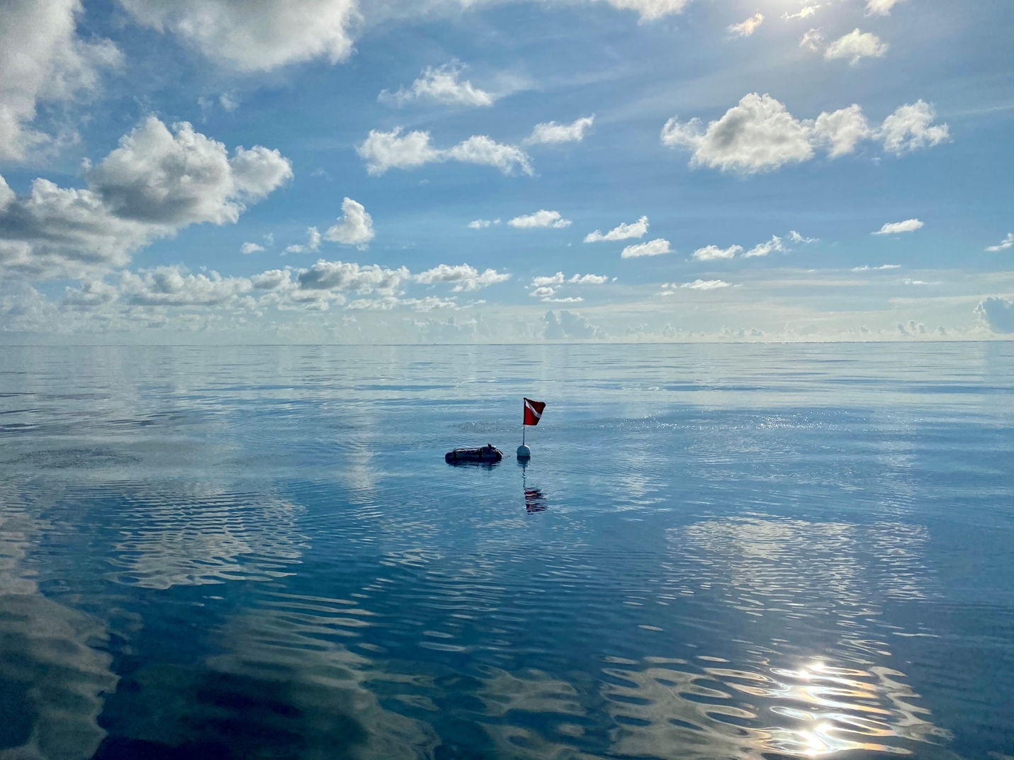
Photo: Dive flag with CRCP scientists performing work below in KJCAP.

Chapter 5: Administrative Plans

5.1 Staffing
Successful implementation of Kristin Jacobs Coral Aquatic Preserve projects/initiatives and the goals outlined in this management plan are dependent upon adequate staffing, facilities, and funding. Community support and the cooperation of partnering agencies, non-governmental organizations, and other groups are also critical. Staff leverage grant funding and state dollars to advance KJCAP’s mission, along with support from federal, state and local partners, and non-governmental organizations, including other Offices and Divisions within the Department of Environmental Protection, the Florida Fish and Wildlife Conservation Commission, National Oceanic and Atmospheric Administration, Florida Sea Grant, universities, and KJCAP’s four Southeast Florida counties (Miami-Dade, Broward, Palm Beach, and Martin).

Regional Office

Each of the state’s 43 aquatic preserves is supervised by one of the Office of Resilience and Coastal Protection’s (ORCP) four regional headquarters that are separated geographically into Northwest, Northeast, Southwest, and Southeast. The Southeast Regional Program Administrator supervises three field offices (West Palm Beach, Miami and Marathon) that house staff representing the Biscayne Bay Aquatic Preserve (BBAP), Florida Keys National Marine Sanctuary and Florida Keys Aquatic Preserves (FKAP), in addition to KJCAP and CFAP.

- Southeast Regional Administrator - The administrator oversees the management and maintenance of KJCAP facilities and staff based in Marathon, Miami, and West Palm Beach, including coral reef and seagrass resource management, monitoring, enforcement, research, threat reduction, restoration, public education and outreach programs and activities, partnership building, permit review and compliance, policy development, and administrative responsibilities including supervision of staff in Southeast Florida. Within KJCAP, the Administrator directly supervises the Office Manager and the Manager. To improve the holistic management of Florida’s Coral Reef, the administrator encourages consistency, collaboration and capacity building across the region’s programs. The Administrator also oversees the BBAP Manager and the FKNMS Liaison and FKAP Manager and their associated programs and responsibilities (e.g., natural resource management, monitoring, enforcement, research, threat reduction, restoration, public education and outreach programs, partnership building, permit review and compliance, policy development and administrative responsibilities including supervision of staff). The Administrator oversees direction of DEP’s responsibilities under the Memorandum of Understanding (MOU) with the FKNMS. The primary reason for this involvement and oversight is to increase the coordination and communication between Florida’s coral and aquatic preserve programs, resulting in direct benefits to CRCP and Southeast Florida Coral Reef Initiative (SEFCRI). Also within the Southeast Region, the Administrator oversees the Coral Protection and Restoration Administrator and program. This position directly supervises four Full Time Equivalent (FTE) positions (State-funded FTE).

Local Offices

The KJCAP and BBAP headquarters are located at the Biscayne Bay Environmental Center (BBEC) in Miami. However, some KJCAP staff work out of a satellite office in West Palm Beach in the South Florida Water Management District facility. KJCAP personnel includes the following managers, supervisors, and staff who perform resource management, local action strategy (LAS) project development, as well as administrative and facilities related tasks:

- Operations Manager (FTE) - The Operations Manager oversees daily KJCAP, BBAP and FKAP business operations and provides administrative tasks and guidance. The Operations Manager’s key responsibilities include overseeing personnel forms and procedures; preparing, processing and approving purchase requisitions and reviewing procurement by the Administrative Assistant; obtaining competitive bids from authorized vendors for goods and services; budget preparation and tracking; preparing, reviewing, and tracking invoices; timesheets; reviewing and processing travel authorizations; contract and grant review and routing; and supervising one FTE position, the Facilities Coordinator, and one Other Personal Services (OPS) position, the Administrative Program Assistant. The Operations Manager also provides support for community-based and field-based Local Action Strategy (LAS) projects, staff health and safety training, and is the Miami Unit Diving Safety Officer for the DEP Diving Program.

- Administrative Program Assistant (OPS) - This position provides administrative support to all staff, but especially the Operations Manager, assisting with accounts payable and procurement as well as other tasks, such as providing field support.

- Facilities Coordinator (FTE) - Administers the maintenance services for all vehicles, vessels, grounds and facilities at the Biscayne Bay Environmental Center or provides these services personally, as appropriate. This position also provides boating training, field support, and representation at community events, as needed.

- KJCAP Manager (FTE) - Plans, directs, and coordinates the implementation of KJCAP, CRCP and SEFCRI LAS. The manager serves as SEFCRI Team Chair and supervises the CRCP Assistant Manager, as well as the Land-based Sources of Pollution (LBSP), Fishing, Diving, and Other Uses (FDOU), Reef Injury Prevention and Response (RIPR), Maritime Industry and Coastal Construction Impacts (MICCI), Awareness and Appreciation (AA), and Reef Resilience (RR) Coordinators.

- KJCAP Assistant Manager (FTE) - Assists the KJCAP Manager in planning, directing, and coordinating the implementation of KJCAP, CRCP and SEFCRI. This position is typically held in concert with one of the other FTE Coordinator positions described below. This position also typically oversees one OPS position, the Associate Coordinator.

- Land-Based Sources of Pollution Coordinator (FTE) - Provides technical assistance and leads the coordination and implementation of LBSP related projects identified in the KJCAP management plan, SEFCRI LAS and related CRCP resource management activities including coordinating the SEFCRI Technical Advisory Committee (TAC).

- Awareness and Appreciation Coordinator (FTE) - Provides technical assistance and leads the coordination and implementation of AA related projects identified in the KJCAP management plan, SEFCRI LAS and related CRCP resource management activities including coordinating KJCAP communications efforts and education and outreach activities.

- Maritime Industry and Coastal Construction Impacts Coordinator (FTE) - Provides technical assistance and leads the coordination and implementation of MICCI related projects identified in the KJCAP management plan, SEFCRI LAS and related CRCP resource management activities including coordinating with internal and external regulatory staff and reviewing permit applications for work proposed in KJCAP.

- Fishing, Diving, and Other Uses Coordinator (FTE) - Provides technical assistance and leads the coordination and implementation of FDOU related projects identified in the KJCAP management plan, SEFCRI LAS and related CRCP resource management activities including assisting the KJCAP Manager in the development, implementation and tracking of the KJCAP management plan.

- Reef Resilience Coordinator (FTE) - Provides technical assistance and leads the coordination and implementation of RR related projects identified in the KJCAP management plan, SEFCRI LAS and related CRCP resource management activities. Coordinates the development and implementation of activities to identify and respond to marine biological incidents, and better understand the resilience of reef resources in Southeast Florida including assisting the KJCAP Manager in the coordination and implementation of ECA Restoration Strategy and associated projects.

- Reef Injury Prevention and Response Coordinator (FTE) - Provides technical assistance and leads the coordination and implementation of RIPR related projects identified in the KJCAP management plan, SEFCRI LAS and related CRCP resource management activities. Coordinates development of management options and activities to respond to and prevent damage to reef resources from anchoring and groundings, including implementation of the recommendations for reef injury response preparation and coordination priorities identified in the SEFCRI “Rapid Response and Restoration for Coral Reef Injuries in Southeast Florida” document. Additionally, leads the biological monitoring of the recently completed Grounding Restoration Project, and leads the development and implementation of the Coral Reef Protection Act (CRPA) educational campaign. Oversees two OPS positions, the RIPR Technician and RIPR Specialist.

- Reef Injury Prevention and Response Technician (OPS) - Supports the Assistant Manager/RIPR Coordinator in the development of management options and activities to respond to and prevent damage to reef resources from anchoring and groundings, co-leads the biological monitoring of the recently completed Grounding Restoration Project, and assists with CRPA enforcement cases.

- Reef Injury Prevention and Response Specialist (OPS) - Supports the Assistant Manager/RIPR Coordinator and RIPR Technician in the development of management options and activities to respond to and prevent damage to reef resources from anchoring and groundings, and leads the development of the CRPA educational campaign, focusing on the northern portion of Florida’s Coral Reef.

- Associate Coordinator (OPS) - This position is responsible for providing administrative and research support to the KJCAP coordinators, with an emphasis on community science and marine debris programs (e.g., SEAFAN, BleachWatch and the Marine Debris Program) and assisting with public education and outreach efforts.

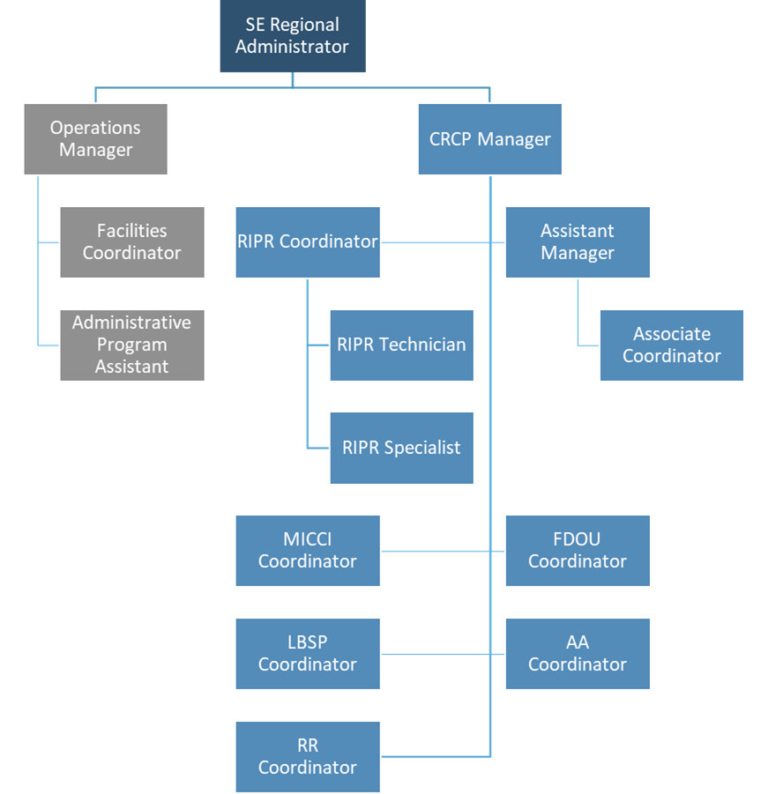
Figure 5: CRCP and supporting staff structure.

5.2 Staffing Needs

Many of the strategies identified in this plan will be implemented using existing staff and funding. However, several objectives, and the strategies necessary to accomplish them, cannot be completed during the life of this plan without additional resources. The plan’s recommended actions, time frames, and cost estimates will guide the DEP Office of Resilience and Coastal Protection’s (ORCP) planning and budgeting activities over the period of this plan. These recommendations are based on the information that exists at the time the plan was prepared. A high degree of adaptability and flexibility must be built into this process to ensure that ORCP can adjust to changes in the availability of funds, unexpected events such as hurricanes, and changes in statewide issues, priorities and policies. Also, maintenance of staff qualifications for required job duties should be considered for KJCAP including capacity to continue to qualify KJCAP staff as DEP SCUBA divers, First Aid and Emergency Oxygen certifications, and acquiring, maintaining, or replacing SCUBA and field equipment as needed.

Statewide priorities for management and restoration of submerged and coastal resources are evaluated each year as part of the process for planning ORCP’s annual budget. When preparing ORCP’s budget, it considers the needs and priorities of the entire aquatic preserve program, other programs within ORCP, and the projected availability of funding from all sources during the upcoming fiscal year. ORCP pursues supplemental sources of funds and staff resources whenever possible, including grants, volunteers, and partnerships with other entities. ORCP’s ability to accomplish the specific actions identified in the plan will be determined largely by the availability of resources, which may vary from year to year. Consequently, the target schedules and estimated costs identified in Appendix D may need to be adjusted during the ten-year management planning cycle.

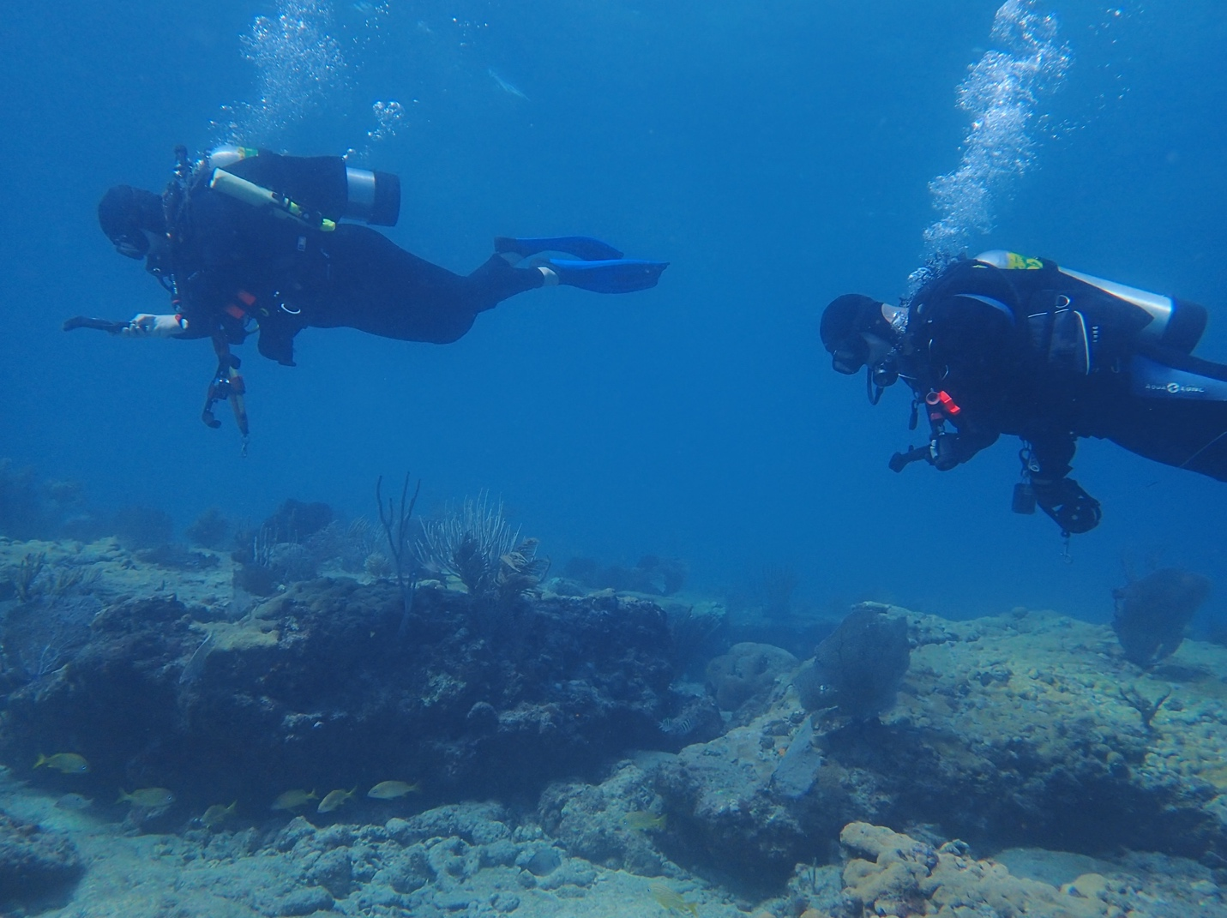
Photo: Divers surveying for coral reef damage in KJCAP.

Chapter 6: Facilities Plans

6.1 Buildings & Infrastructure
Kristin Jacobs Coral Aquatic Preserve main office is housed within the Biscayne Bay Environmental Center (BBEC) at Pelican Harbor Island in the City of Miami, and a satellite office is leased in West Palm Beach at a building owned by South Florida Water Management District.

Pelican Harbor Island was created from dredged material associated with Atlantic Intracoastal Waterway construction in 1928. Throughout the decades, dredged material was added on both the north and south side of the causeway creating the island, owned by Miami-Dade County (MDC), with boat slips to the north and boat ramps and a parking area to the south; riprap has been placed to allow for shoreline stabilization. The 0.73 acre of land on which the BBEC is located was submerged land deeded to MDC by the Board of Trustees of the Internal Improvement Fund of the State of Florida in 1934. DEP occupies the land through a 99-year lease agreement with MDC signed in 1976, and subsequently the state constructed the approximately 3,500 sq. foot BBEC office building.

The property also includes a sub-leased parcel with a 300-foot-tall tower and 800 MHz trunked radio system used by state agencies for law enforcement communications, as well as a building containing a propane-fueled generator to support the tower operations in case of power failure. These facilities are managed by contractors hired by the Florida Department of Management Services.

The state also owns a 700 sq. foot wood-framed storage garage. All property maintenance tools and equipment, some field equipment, hurricane shutters for BBEC, and kayaks are stored in this building. The 220 sq. foot dive shed is used for storing SCUBA diving gear and some field equipment.

These outbuildings are enclosed within an eight-foot, protective fence with three locked access gates. Inside is a cement and asphalt lot where the vessels and trailers are stored when they are not in use or secured at the dock. The state also owns an L-shaped aluminum floating dock with a ramp securing it to the land. A mangrove shoreline protects the eastern 200 feet of the property, of which 80 feet was restored with riprap in 2015 to prevent further erosion. The parking lot was re-paved and striped in 2019 in compliance with the Americans with Disabilities Act (ADA). Other infrastructure improvements include additional and upgraded parking lot and entrance lighting that were added in 2018 to comply with MDC requirements for certification of 40-year-old buildings.

The financial responsibility of running BBEC is shared between Biscayne Bay Aquatic Preserves (BBAP) and KJCAP program budgets, including the cost of a new roof in 2014 and a new air conditioning unit in 2020. The BBEC has been subdivided into eleven office spaces and three storage closets which are shared between BBAP and CRCP staff, and a water quality lab which includes a bench table and refrigerator exclusively for BBAP that has recently been carved out of some of the storage. BBEC indoor space includes a break room, library, restrooms, and educational support closets. ADA upgrades were made, including the renovation of one unisex restroom in 2017, and replacement of the entrance ramp with an appropriate slope and handrails in 2020. BBEC equipment includes a leased copier/fax machine/printer, plotter (drivers are no longer supported), tv for conducting outreach, giving presentations, and conducting working meetings, and WIFI available to DEP staff.

The available space has been maximized and no practical further expansion is possible to the existing building. Although Florida Marine Patrol used an office trailer on the north side of the leased property for overflow when they occupied the BBEC prior to BBAP and CRCP, MDC has suggested that it would not approve a replacement trailer as an expansion option now. The option of adding a second floor onto BBEC was explored, but it was determined to be cost-prohibitive as the architectural plan rough quote was upwards of $1.3M in 2012.

Following a theft on BBEC property in 2010, a security system and video recording devices were installed. In case of an emergency, the buildings, vehicles, and vessels are secured according to the BBEC Emergency Action Plan (EAP) which is updated annually by the Facilities Coordinator. The EAP includes the hurricane plan for the office and defines necessary preparations for other potential disasters. A copy of this plan is stored in the Facilities Coordinator’s office and emailed to each staff member as it is updated. An annual safety review meeting is scheduled in advance of the hurricane season for all staff to attend.

A desire to have representation in the northern part of the ECA, and a lack of office space at the BBEC as KJCAP capacity expanded, spurred the establishment of a satellite office in West Palm Beach. KJCAP partnered with DEP’s Southeast Regulatory District (SED) to lease space in the South Florida Water Management District (SFWMD) facility to house staff, as needed. Amenities include dive lockers, access to conference rooms, break rooms, desks, phone/internet, parking and security, etc. Proximity to SED and SFWMD staff make this an ideal location for coordination on permitting and related projects.

6.2 Vehicles and Vessels
The vehicles and vessels identified in the strategic plan as necessary to accomplish program goals have been acquired, but replacements are needed as this equipment ages. Use of KJCAP and BBAP programs’ vessels and vehicles are shared, depending on staff and project needs. As part of the programs’ strategic planning cycle, all vehicles and vessels undergo a monthly inspection, cleaning, and scheduled maintenance by the Facilities Coordinator. The average annual cost for fuel and maintenance is approximately $3,500 for the KJCAP vessel and $4,500 for KJCAP vehicles. These numbers are expected to increase with the changing cost of fuel and as the vessel and vehicles age. Each staff member who has access to vehicles and vessels is granted a personal identification number to use in tandem with the Florida State Fuel Card Program for security and to properly allocate the cost to the program.

6.2.1 Vehicles
- 2020 Chevrolet Traverse Sport Utility Vehicle with Towing Package (located in West Palm Beach): Purchased new in 2020 through a Legislative Budget Request for state funding, the vehicle battery has already required replacement. Staff typically utilize this vehicle for travel to off-site meetings, trainings, field work, and community outreach events. When not in use by KJCAP staff, it is available for the use of DEP’s Restoration Planning and Project Management Section that provided the surplus vehicle for exchange making the purchase possible.
- 2017 GMC Terrain Sport Utility Vehicle with Towing Package (located in Miami): Purchased new in 2017 through a Legislative Budget Request for state funding, staff typically use this vehicle for travel to off-site meetings, trainings, field work, and community outreach events. It replaced the 2005 Ford Escape which was transferred to the Florida Keys for the use of Southeast region staff there, then to Central Office staff based in West Palm Beach.
- 2007 Dodge 3/4-ton 4WD Pick-up Truck with Towing Package (located in Miami): Purchased new in 2007 with federal grant funding from the National Oceanic and Atmospheric Administration (NOAA), this quad-cab vehicle is typically used for towing the vessels or transporting large items (SCUBA tanks, boxes, furniture, kayaks, etc.) and occasionally for staff travel to off-site meetings, trainings, field work, and community outreach events.

6.2.2 Vessels
- 2007 26-foot Twin Vee Catamaran with one 2007 and one 2017 Yamaha 150 HP Four-stroke Outboard Engine and Trailer (located in Miami): Purchased new in 2007 with federal grant funding from NOAA, this vessel is legally rated for a maximum of 12 persons, but when outfitted with additional gear needed for SCUBA diving and research, it can accommodate five to six persons safely. Despite regular maintenance, major mechanical repairs or replacements in the last 13 years have included: replacement engine, replacement lower units, and repeated hydraulic system issues. The Twin Vee is typically used to SCUBA or snorkel for coral monitoring, injury investigation, water quality sample collection, training, and occasionally VIP familiarization tours. All staff are expected to train for qualification for vessel operation, as defined in position descriptions.

6.2.3 Additional vehicles and vessels available for the use of KJCAP, as needed:

The following vehicles and vessels are maintained by BBAP or the Clean Boating Program.

Vehicles
- 2023 Ford Explorer with Towing Capacity
- 2019 Ford Fusion Passenger Vehicle

Vessels
- 3 Single & 3 Double Person Ocean Kayaks
- 2005 20-foot Pathfinder vessel
- 2023 27-foot Defense Marine Catamaran vessel

6.3 Future facilities, construction and maintenance needs
Future facilities, construction and maintenance needs include, but are not limited to:

- Obtaining office space necessary to house additional staff, possibly in conjunction with laboratory space for BBAP.
- Replacing office furniture, flooring, and equipment (e.g., plotter), as necessary.
- Acquiring a larger vessel in Miami, replacing as needed.
- Acquiring a vessel in West Palm Beach to conduct field work in the northern part of the ECA.
- Replacing the 2007 Dodge truck when necessary (based on age or odometer), for safely towing vessels.
- Upgrading technological tools (such as digital white board, tech platform customized to our outreach) as the technology becomes available.

List of Appendices

Appendix A: Legal Documents 119
A.1. Aquatic Preserve Resolution 119
A.2. Florida Statutes 122
A.3. Florida Administrative Code (F.A.C.) 122
Appendix B: Resource Data 123
B.1. Glossary of Terms 123
B.2. References 131
B.3. Species List 147
B.3.1. Native Species List 147
B.3.2. Listed Species 166
B.3.3. Invasive Non-native and/or Problem Species List 167
B.4 Archaeological Sites Associated with Kristin Jacobs Coral Aquatic Preserve 167
Appendix C: Public Involvement 168
C.1 / Advisory Committee 168
C.1.1 / List of members and their affiliations 168
C.1.2 / Florida Administrative Register Postings 168
C.1.3 / Meeting Summary 168
C.2 / Formal Public Meeting 168
C.2.1 / Florida Administrative Register Posting 168
C.3.2 / Advertisement Flyer 168
C.2.3 / Newspaper Advertisement 168
C.2.4 / Summary of the Formal Public Meetings 168
Appendix D: Goals and Objectives 169
D.1 Current Goals and Objectives Budget Table 169
D.3 Prioritized List of Our Florida Reefs Recommended Management Actions 172
Priority 1 172
Priority 2 173
Priority 3 174
Priority 4 175
D.4 FDOU 52 Fisheries Committee Recommended Management Actions Table 176
Water (22) 176
Fishing and Boating (13) 177
Habitat (7) 178
Agency and Processes (5) 179
Education (8) 179
Appendix E: Other Requirements 180
E.1 Acquisition and Restoration Council Management Plan Compliance Checklist 180
E.2 Management Procedures for Archaeological and Historical Sites on State-Owned or Controlled Lands 188
E.3 Letter of Compliance with County Comprehensive Plan 191
E.4 Division of State Lands Management Plan Approval Letter 192

Appendix A: Legal Documents

A.1. Aquatic Preserve Resolution
WHEREAS, the State of Florida, by virtue of its sovereignty, is the owner of the beds of all navigable waters, salt and fresh, lying within its territory, with certain minor exceptions, and is also the owner of certain other lands derived from various sources; and

WHEREAS, title to these sovereignty and certain other lands has been vested by the Florida Legislature in the State of Florida Board of Trustees of the Internal Improvement Trust Fund, to be held, protected and managed for the long range benefit of the people of Florida; and

WHEREAS, the State of Florida Board of Trustees of the Internal Improvement Trust Fund, as a part of its overall management program for Florida’s state-owned lands, does desire to insure the perpetual protection, preservation and public enjoyment of certain specific areas of exceptional quality and value by setting aside forever these certain areas as aquatic preserves or sanctuaries; and

WHEREAS, the ad hoc Florida Inter-Agency Advisory Committee on Submerged Land Management has selected through careful study and deliberation a number of specific areas of state—owned land having exceptional biological, aesthetic and scientific value, and has recommended to the State of Florida Board of Trustees of the Internal Improvement Trust Fund that these selected areas be officially recognized and established as the initial elements of a statewide system of aquatic preserves for Florida;

NOW, THEREFORE, BE IT RESOLVED by the State of Florida Board of Trustees of the Internal Improvement Trust Fund:

THAT it does hereby establish a statewide system of aquatic preserves as a means of protecting and preserving in perpetuity certain specially selected areas of state-owned land: and

THAT specifically described, individual areas of state-owned land may from time to time be established as aquatic preserves and included in the statewide system of aquatic preserves by separate resolution of the State of Florida Board of Trustees of the Internal Improvement Trust Fund; and

THAT the statewide system of aquatic preserves and all individual aquatic preserves established thereunder shall be administered and managed, either by the said State of Florida Board of Trustees of the Internal Improvement Trust Fund or its designee as may be specifically provided for in the establishing resolution for each individual aquatic preserve, in accordance with the following management policies and criteria:

(1) An aquatic preserve is intended to set aside an exceptional area of state-owned land and its associated waters for preservation essentially in their natural or existing condition by reasonable regulation of all human activity which might have an effect on the area.

(2) An aquatic preserve shall include only lands or water bottoms owned by the State of Florida, and such private lands or water bottoms as may be specifically authorized for inclusion by appropriate instrument from the owner. Any included lands or water bottoms to which a private ownership claim might subsequently be proved shall upon adjudication of private ownership be automatically excluded from the preserve, although such exclusion shall not preclude the State from attempting to negotiate an arrangement with the owner by which such lands or water bottoms might be again included within the preserve.

(3) No alteration of physical conditions within an aquatic preserve shall be permitted except: (a) minimum dredging and spoiling for authorized public navigation projects, or (b) other approved activity designed to enhance the quality or utility of the preserve itself. It is inherent in the concept of the aquatic preserve that, other than as contemplated above, there be: no dredging and filling to create land, no drilling of oil wells or excavation for shell or minerals, and no erection of structures on stilts or otherwise unless associated with authorized activity, within the confines of a preserve - to the extent these activities can be lawfully prevented.

(4) Specifically, there shall be no bulkhead lines set within an aquatic preserve. When the boundary of a 126 preserve is intended to be the line of mean high water along a particular shoreline, any bulkhead line subsequently set for that shoreline will also be at the line of mean high water.

(5) All human activity within an aquatic preserve shall be subject to reasonable rules and regulations promulgated and enforced by the State of Florida Board of Trustees of the Internal Improvement Trust Fund and/or any other specifically designated managing agency Such rules and regulations shall not interfere unduly with lawful and traditional public uses of the area, such as fishing (both sport and commercial), hunting, boating, swimming and the like.

(6) Neither the establishment nor the management of an aquatic preserve shall infringe upon the lawful and traditional riparian rights o private property owners adjacent to a preserve. In furtherance of these rights, reasonable improvement for ingress and egress, mosquito control, shore protection and similar purposes may be permitted by the State of Florida Board of Trustees of the Internal Improvement Trust Fund and other jurisdictional agencies, after review and formal concurrence by any specifically designated managing agency for the preserve in question.

(7) Other uses of an aquatic preserve, or human activity within a preserve, although not originally contemplated, may be permitted by the State of Florida Board of Trustees of the Internal improvement Trust Fund and other jurisdictional agencies, but only after a formal finding of compatibility made by the said Trustees on the advice of any specifically designated managing agency for the preserve in question.

IN TESTIMONY WHEREOF, the Trustees for and on behalf of the State of Florida Board of Trustees of the Internal Improvement Trust Fund have hereunto subscribed their names and have caused the official seal of said State of Florida Board of Trustees of the Internal Improvement Trust Fund to be hereunto affixed, in the City of Tallahassee, Florida, on this the 24th day of November A. D. 1969.

CLAUDE R. KIRK, JR, Governor TOM ADAMS, Secretary of State
EARL FAIRCLOTH, Attorney General FRED O. DICKINSON, JR., Comptroller
BROWARD WILLIAMS, Treasurer FLOYD T. CHRISTIAN, Comm. of Education
DOYLE CONNER, Comm. of Agriculture

As and Constituting the State of Florida Board of Trustees of the Internal Improvement Trust Fund

A.2. Florida Statutes
All the statutes can be found according to number at:

http://www.leg.state.fl.us/Statutes

- Florida Statutes, Chapter 253: State Lands
- Florida Statutes, Chapter 258: State Parks and Preserves 6. Part II (Aquatic Preserves)
- Florida Statutes, Chapter 267: Historical Resources
- Florida Statutes, Chapter 370: Saltwater Fisheries
- Florida Statutes, Chapter 372: Wildlife
- Florida Statutes, Chapter 403: Environmental Control
(Statute authorizing the Florida Department of Environmental Protection (DEP) to create Outstanding Florida Waters is at 403.061(27))
- Florida Statutes, Chapter 597: Aquaculture

A.3. Florida Administrative Code (F.A.C.)
All rules can be found according to number at:

https://www.flrules.org/Default.asp

- Florida Administrative Code, Chapter 18-20: Florida Aquatic Preserves
https://www.flrules.org/gateway/ChapterHome.asp?Chapter=18-20
- Florida Administrative Code, Chapter 18-21: Sovereignty Submerged Lands Management
https://www.flrules.org/gateway/ChapterHome.asp?Chapter=18-21
- Florida Administrative Code, Chapter 62-302: Surface Water Quality Standards (Rule designating Outstanding Florida Waters is at 62-302.700)
https://www.flrules.org/gateway/ChapterHome.asp?Chapter=62-302

Appendix B: Resource Data

B.1. Glossary of Terms
algal bloom – an explosive increase in the density of phytoplankton (microscopic, single-celled plants).
alternative – a reasonable way to fix the identified problem or satisfy the stated need, a choice between things.
ambient – of, or related to surrounding environmental conditions. (Calow, 2009)
Anastasia formation – underlies Miami in places, outcrops and forms the Atlantic coastal ridge from Palm Beach County north. Ranges in composition from shelly sandstone to coquina limestone.
aquaculture – the cultivation of aquatic organisms. (Lincoln et al., 2003)
aquatic – living in or near water; used of plants adapted for a partially or completely submerged life.
aquifer – permeable underground rock strata that holds water.
archaeology – the scientific study of ancient cultures through the examination of their material remains such as buildings, graves, tools, and other artifacts. (Encarta)
archaic – belonging or relating to a much earlier period. (Encarta)
Atlantic Intracoastal Waterway (AIWW) – a system of inland and coastal waterways along the Atlantic coast of the U.S. from Cape Cod to Florida Bay.
baseline data – data describing some original or ‘normal’ state of the system. (Calow, 2009)
basin/sub-basin – the entire tract of land drained by a river and its tributaries; smaller portion of a larger tract of land drained by a river and its tributaries.
benthic – of, related to, or occurring at the bottom of a body of water.
benthic community – organisms that live on the sea floor.
benthos – organisms that dwell on the unconsolidated bottoms of marine and freshwater systems (e.g., worms and zooplankton).
biocide – a genetic term for anything that kills (or inhibits) organisms. (Calow, 2009)
biodiversity – the existence of a wide variety of species of plants, animals and microorganisms in a natural community or habitat or of communities within a particular environment; genetic variation within a species.
biogeography – the science that studies the geographic distribution of organisms; the study of the geographical distributions of organisms, their habitats and the historical and biological factors which produced them.
biota – all the organisms living in a particular region, including plants, animals and microorganisms.
biotic community – biological community or association, ecological community; an assemblage of species living in a prescribed area or physical habitat; a group of interacting species coexisting in a particular habitat.
bivalve – any mollusk, as the oyster, clam, scallop or mussel of the class Bivalvia, having two shells hinged together, a soft body and lamellate gills.
brackish – applied to water that is saline, but less so than sea water. (Oxford Dictionary of Ecology)
breeding habitat – habitat used by migratory birds or other animals during the breeding season.
brood – to incubate eggs.
buffer – to protect a system from change by external factors; anything that reduces an impact.
calcareous – applied to areas containing calcium carbonate. (Allaby, 1998)
climate – average weather conditions in a location over many years.
community – a grouping of populations of different organisms found living together in a particular environment.
community type – a particular assemblage of plants and animals, named for the characteristic plants.
Comprehensive Everglades Restoration Plan (CERP) – a comprehensive plan for the water resources of central and southern Florida authorized in the Water Resources Development Act of 2000. The overarching objectives of this CERP are the restoration, preservation, and protection of the south Florida ecosystem while providing for the other water-related needs of the region.
conservation – the management of natural resources to prevent loss or waste; the planned management of natural resources; the retention of natural balance, diversity and evolutionary change in the environment; preservation.
consolidated substrate – a compacted mass of sediment, typically stratified.
contamination – release of a byproduct of human activity, chemical or physical. (Calow, 1999)
convective – to transfer (heat or a fluid) by convection.
cultural resource – evidence of historic or prehistoric human activity, such as buildings, artifacts, archaeological sites, documents, oral or written history. Cultural resources include historical, archaeological and/or architecturally significant resources.
cyanobacteria – the blue-green bacteria or chloroxybacteria. Both groups obtain their food by photosynthesis in a manner very similar to that of green plants and true algae, producing oxygen in the process. They occur in all aquatic habitats.
database – a mass of data in a computer, arranged for rapid expansion, updating, and retrieval.
data sonde – an automated electronic instrument for measuring and recording water quality parameters.
degradation – breakdown into smaller or simpler parts; reduction of complexity.
derelict – deserted by the owner; abandoned.
detritus – non-living particulate organic material. It includes the bodies of dead organisms colonized by microorganisms that decompose the material. Together with plankton are components of the estuarine food chain.
disease – disorder of function or order in an organism that usually is symptomatic.
dispersal – the movement of organisms away from a location, such as point of origin.
disseminate – to scatter widely or disperse.
disturbance – any process that destroys plant or animal biomass. (Calow, 1999)
diversity – a measure of the number of species and their relative abundance in a community.
drainage basin – the total land area that drains into a body of water.
dredge – an apparatus for scooping up mud, for deepening channels.
dredge spoil – material or soil taken out of an area mechanically and stored in a pile or ridge or graded evenly.
easement – a right that one may have in another’s land. (Neufeldt & Sparks, 1990)
ecology – the branch of science that studies the distribution and abundance of organisms and the relationship between organisms and their environment, the study of the inter-relationships between living organisms and their environment.
ecosystem – a community of organisms and their physical environment interacting as an ecological unit. (Lincoln et al., 2003)
ecosystem-based management – a management approach that uses ecological criteria and human uses to identify ecosystem level interactions and prioritize conservation measures, including tradeoffs to protect the ecosystem.
effluent – wastewater that flows into a receiving stream by way of a domestic or industrial point source.
encroachment – influencing strongly; impact.
endangered species – an animal or plant species in danger of extinction throughout all or a significant portion of its range. (USFWS, 2015)
endemic – native to, and restricted to, a particular geographical region. (Lincoln et al., 2003)
environment – the physical, chemical and biological surroundings of an organism at any given time.
environmental change - a long-term change in the average weather patterns that have come to define Earth’s local, regional, and global climates marked by observed effects. (https://climate.nasa.gov/resources/global-warming-vs-climate-change/)
epibenthic – living on the surface of (usually) the sea bottom. (Calow, 1999)
epifauna – the animal life inhabiting a sediment surface or water surface.
epiphyte – a plant that usually lives on other plants without damaging them.
equilibrium – a state of balance between opposing forces.
established – introduced from another region and persisting.
estuary – 1) A coastal embayment where there is freshwater input that is influenced by tides. 2) The part of a river that is affected by tides. 3) The region near a river mouth in which the fresh water of the river mixes with the salt water of the sea.
exotic – an introduced nonnative species. (Allaby, 1998)
extinction – the disappearance of a species from a given habitat; dying out, usually global, of a species for extinction throughout all or a significant portion of its range.
fauna – the animal life of a given region, habitat or geological stratum. (Lincoln et al., 2003)
flora – the plant life of a given region, habitat or geological stratum. (Lincoln et al., 2003)
Geographic Information System (GIS) – computer system supporting the collection, storage, manipulation and query of spatially referred data, typically including an interface for displaying geographical maps. (Lincoln et al., 2003)
Geology – the structure of a specific region of the earth’s crust.
Geomorphology – the study of form, nature, and evolution of the earth’s surface.
georeferencing – providing geographic location coordinates for data or images.
Glade’s culture – an archaeological culture in southernmost Florida that lasted from about 500 BCE until shortly after European contact.
Global Positioning System (GPS) - a navigational system involving satellites and computers that can determine the latitude and longitude of a receiver on Earth by computing the time difference for signals from different satellites to reach the receiver.
gray infrastructure – traditional, human-engineered systems designed to manage stormwater and wastewater by moving it away from built environments, often resulting in untreated water discharging into a local waterbody.
greater everglades ecosystem – an area consisting of the lands and waters within the boundary of the South.
green infrastructure – the range of measures that use plant or soil systems, permeable pavement or other permeable surfaces or substrates, stormwater harvest and reuse, or landscaping to store, infiltrate, or evapotranspirate stormwater and reduce flows to sewer systems or to surface waters.
Green stormwater infrastructure – a specific type of green infrastructure that is designed to mimic nature and focuses on managing stormwater runoff using natural or engineered systems to treat stormwater at its source.
groundwater – water that occurs below the earth’s surface, contained in pore spaces within regolith and bedrock. (Allaby, 1998)
habitat – the living place of an organism or community, characterized by its physical or biotic properties.
habitat conservation – the protection of an animal or plant’s habitat to ensure that the use of that habitat by the animal or plant.
habitat degradation – the process of transitioning from a higher quality to a lower quality wildlife habitat.
habitat fragmentation – breaking up of a specific habitat into smaller unconnected areas.
hardbottom communities – a classification of coral communities that occur in temperate, subtropical, and tropical regions that lack the coral diversity, density, and reef development of other types of coral communities.
harmful algal bloom (HAB) – a dense concentration (bloom) of a single-celled, plant like marine organism.
hazardous waste – by-products of society that can pose a substantial or potential hazard to human health or the environment when improperly managed. Possesses at least one of four characteristics (ignitability, corrosivity, reactivity, or toxicity), or appears on special EPA lists.
headwaters – the place from which the water in the river or stream originates.
herbaceous – characteristic of a nonwoody herb or plant part.
hydrocarbons – a naturally occurring compound that contains carbon and hydrogen. (Allaby, 1998)
hydrodynamic – the branch of science that deals with the dynamics of fluids, especially incompressible fluids, in motion.
hydrologic – dealing with the properties, distribution, and circulation of water.
hydrology – the study of the hydrologic cycle. (Allaby, 1998)
indigenous – native to a particular area; an organism or species occurring naturally in an environment or region.
infauna – the animal life within a sediment; epifauna. (Lincoln et al., 2003)
inlet – a narrow channel that connects the open sea with a lagoon or bay. (Allaby, 1998)
intertidal zone – the shore zone between the highest and lowest tides; littoral.
introduction – a plant or animal moved from one place to another by man.
invasive exotic species – non-native species that have been introduced into an ecosystem and, because of their aggressive growth habits and lack of natural predators, displace native species.
listed species – a species, subspecies, or distinct population segment that has been added to a federal or state list of endangered and threatened wildlife and plants. (USFWS, 2015)
local community – the area or locality in which a group of people resides and shares the same government.
longshore transport – a wave and/or tide-generated movement of shallow-water coastal sediments parallel to the shoreline.
low energy environments – coastlines where wave and tidal forces are typically relatively small.
macroalgae – algae large enough to be detected with the naked eye. Often used as a synonym of seaweeds. (Levinton, 2008)
management alternative – a set of objectives and the strategies needed to accomplish each objective.
mandate - an order or command; the will of constituents expressed to their representative, legislature, etc. (Neufeldt & Sparks, 1990)
marsh – an area of soft, wet, or periodically inundated land, generally treeless and characterized by grasses.
mean high water – the average elevation of all high waters recorded at a particular point or station over a considerable period of time, usually 19 years. (www.csc.noaa.gov/text/glossary.html)
migratory – referring to a movement in an organism that could be seasonal or permanent for a variety of life history purposes.
mitigation – actions taken to compensate for the negative effects of a particular project or action.
modeling – designing and analyzing a mathematical representation of an economic system to study the effect of changes to system variables.
monitoring – measurement of environmental characteristics over an extended period of time.
moorings – 1.) The act or an instance of making fast a vessel, as by a cable or anchor. 2.) A place or structure to which a vessel can be moored. 3.) Equipment, such as anchors or chains, for holding fast a vessel.
native – the plant and animal species, habitats or communities that originated in a particular region or area.
nearshore – in beach terminology, an indefinite zone extending seaward from the shoreline well beyond the breaker zone. Used in this management plan to differentiate KJCAP habitat specifically being called out as close to the shoreline, e.g., seagrass beds or shallow coral reef ecosystems.
nonpoint sources – diffuse runoff without a single point of origin that flows over the surface of the ground by stormwater and is then introduced to surface or ground waters. They include atmospheric deposition and runoff or leaching from agricultural lands, urban areas, unvegetated lands, onsite sewage treatment and disposal systems, and construction sites.
nutrients – substances that provide enrichment to organisms and allow for growth (enrichment can lead to overgrowth of algae, for example).
octocorals – water-based organisms related to sea anemones and stony corals found in coral reef communities in Florida’s Coral Reef.
offshore – referring to being located within the marine habitat east of Florida’s eastern shoreline.
parameters – a measurable property whose value is a determinant of the characteristics of a system (i.e., temperature, pressure and density are parameters of the atmosphere).
particulate – 1.) Fine liquid or solid particles such as dust, smoke, mist, fumes, or smog, found in air or emissions. 2.) Very small solids suspended in water; they can vary in size, shape, density and electrical charge and can be gathered together by coagulation and flocculation.
patch reefs – a small, irregular organic reef with a flat top forming a part of a reef complex.
pelagic – relating to, living, or occurring in the open sea.
peripheral – organisms on or near the edge of their geographical ranges.
permeable – a substance, substrate, membrane or material that absorbs or allows the passage of water.
pesticide – a chemical agent that kills insects and other animal pests.
photosynthesis – the manufacture by plants of carbohydrates and oxygen from carbon dioxide mediated by chlorophyll in the presence of sunlight.
phytoplankton – microscopic, single-celled plants that live in the sea.
pollutant – generally, any substance introduced into the environment that adversely affects the usefulness of a resource or the health of humans, animals, or ecosystems.
pollution – the contamination of a natural ecosystem.
population – all individuals of one or more species within a prescribed area. A group of organisms of one species, occupying a defined area and usually isolated to some degree from other similar groups. (Lincoln et al., 2003)
potable water – water that is palatable and safe for human consumption.
refugium/refugia – an isolated habitat that retains the environmental conditions that were once widespread.
regime – a regular pattern of occurrence, action, or conditions (as of seasonal rainfall).
reservoir – any natural or artificial holding area used to store, regulate, or control water.
residence time – the duration of persistence of a mass or substance in a medium or place.
resource management – managing human impact on the environment in a way that is sustainable.
restoration – management actions that aid in returning an ecosystem to a stable state with a higher level of ecosystem function and structure.
riparian – related to, living, or occurring on the bank of a natural watercourse.
runoff – part of precipitation that is not held in the soil but drains freely away. (Lincoln et al., 2003)
saline – consisting of or containing salt.
salinity - a measure of the total concentration of dissolved salts in seawater. (Lincoln et al., 2003)
saltwater intrusion – the invasion of fresh surface or ground water by salt water. If it comes from the ocean, it may be called seawater intrusion.
sea level rise – increase in the world’s ocean level as a result of environmental change, caused by glacier melt and expanding water due to heating.
sediment – material derived from preexisting rock deposited at or near the Earth’s surface.
sediment core – a hollow tube is driven into the sediment and taken up to obtain a continuous, undisturbed cross-section of the seafloor. (www.csc.noaa.gov/benthic/mapping/techniques/sensors/cores.htm)
sedimentation – the action or process of forming or depositing sediments.
sediment – material derived from preexisting rock deposited at or near the Earth’s surface.
septic leachate – forms in landfills (even those that are closed or abandoned) when water from rain, sleet, or snow soaks through and becomes polluted after coming into contact with the decaying waste, (www.csc.noaa.gov/magazine/2002/01/ncarolina.html)
sessile – non-motile; permanently attached at the base. (Lincoln et al., 2003)
shapefile – computerized maps and images depicting different natural features created with geographic information.
sheet flow – the flow of water across a given surface area such as a field, parking lot, or road during a rain event without a formal conveyance system (e.g., pipe, swale).
shoal – a shallow place in a river, sea etc.; a sand bar forming a shallow place.
shoreline stabilization - measures to retard erosion to protect upland property.
silt – sedimentary materials composed of fine or intermediate-sized mineral particles.
South Florida Water Management District (SFWMD) – regional governmental district that oversees water resources from Orlando to the Florida Keys. (https://www.sfwmd.gov/)
sovereignty of lands – supreme and independent power or authority in government as possessed or claimed by a state or community.
spatial data - data pertaining to the location and spatial dimensions of geographical entities.
species - a group of organisms, minerals or other entities formally recognized as distinct from other groups, the basic unit of biological classification. (Lincoln et al., 2003)
species abundance – the relative distribution of the number of individuals of each species in a community.
species diversity – either the absolute number of species or a measure of both the number of species and their relative abundance.
spoil material – sediment that results from an excavation, and discarded off site on spoil heaps.
stakeholder – individual or organization that stand to gain or lose from the success or failure of a system or program.
stormwater – diffuse runoff without a single point of origin that flows over the surface of the ground by stormwater and is then introduced to surface or ground waters.
stratification – separating into layers.
submerged – occurring below the surface of the water; completely underwater.
submerged aquatic vegetation (SAV) – aquatic plants, also called hydrophytic plants or hydrophytes, are plants that have adapted to living in or on aquatic environments, seagrasses.
subsidence – a lowering of land elevation often caused by underground processes like groundwater removal.
subsistence fishing – the practice of catching fish primarily for personal or family consumption, rather than for sport or commercial sale or trade.
substrate – the soils and sediments that comprise the ground. (Allaby, 1998)
subtidal – environment which lies below the mean low water level. (Allaby, 2005)
supratidal – the zone on the shore above mean high tide level. (Lincoln et al., 2003)
subtropical – relating to areas or latitudes located next to the tropics.
Surface Water Quality Standards – state-adopted and EPA approved ambient standards for water bodies.
sustainability - of, relating to, or being a method of harvesting or using a resource so that the resource is not depleted or permanently damaged. (Johnston et al., 2007)
synoptic – affording or taking a general view of the principal parts of a subject.
take – to harass, harm, pursue, hunt, shoot, wound, kill, trap, capture, collect or attempt to collect or to engage an organism or resources.
temperate – free from extremes; mild; or characteristic of such weather or climate.
threatened species – an animal or plant species likely to become endangered within the foreseeable future throughout all or a significant portion of its range. (USFWS, 2015)
tidal flat – unvegetated sandy or muddy land area that is covered and uncovered by the rise and fall of the tide.
topography – the surface features of a place or region.
trawl or trawl net – a net in the form of an elongated bag with the mouth kept open by various means and fished by being towed or dragged on the bottom. (68B-31.002(2), F.A.C.)
tributaries – a stream or river that flows into a main stem (or parent) river.
trophic – pertaining to nutrition, food or feeding.
turbid – cloudy; opaque with suspended matter. (Lincoln et al., 2003)
unavoidable impacts – negative impacts to the environment or other aspects of a project area that are expected occur despite all reasonable efforts to mitigate or avoid them.
unconsolidated substrate – loose, un-compacted and un-stratified sediment.
underrepresented – provided with insufficient or inadequate representation or inclusion due to various factors like race, ethnicity, disability, or socioeconomic status.
upland – land elevated above other land. (Neufeldt & Sparks, 1990)
vector – any agency responsible for the introduction or dispersal of an animal or plant species.
vegetation – plant life or cover in an area; also used as a general term for plant life.
vegetation type – a plant community with distinguishable characteristics. (Lincoln et al., 2003)
water column – the vertical column of water in a sea or lake extending from the surface to the bottom. (Lincoln et al., 2003)
watershed – an elevated boundary area separating tributaries draining into different river systems; drainage basin. (Lincoln et al., 2003)
wetland – an area of low-lying land, submerged or inundated periodically by fresh or saline water. (Lincoln et al., 2003)

B.2. References
Adame, M. F., Santini, N. S., Tovilla, C., Vázquez-Lule, A., Castro, L., & Guevara, M. (2015). Carbon stocks and soil sequestration rates of tropical riverine wetlands. Biogeosciences, 12(12), 3805–3818. https://doi.org/10.5194/bg-12-3805-2015
Agardy, T., di Sciara, G. N., & Christie, P. (2011). Mind the gap: Addressing the shortcomings of marine protected areas through large scale marine spatial planning. Marine Policy, 35(2), 226–232. https://doi.org/10.1016/j.marpol.2010.10.006
Ali, J., Wahl, T., Enriquez, A. R., Rashid, M. M., Morim, J., Gall, M., & Emrich, C. T. (2023). The role of compound climate and weather extreme events in creating socio-economic impacts in South Florida. Weather and Climate Extremes, 42. https://doi.org/10.1016/j.wace.2023.100625
Allaby, M. (Ed.). (1998). Oxford dictionary of ecology. (2nd ed.). Oxford, UK: Oxford University Press.
Allaby, M. (Ed.). (2005). Oxford dictionary of ecology. (3rd ed.). Oxford, UK: Oxford University Press.
Arthur, K., Paul, V., Paerl, H., O’Neil, J., Joyner, J., & Meickle, T. (2009). Effects of nutrient enrichment of the cyanobacterium Lyngbya sp. On growth, secondary metabolite concentration and feeding by the specialist grazer Stylocheilus striatus. Marine Ecology Progress Series, 394, 101–110. https://doi.org/10.3354/meps08311
Allen, M. E., Fleming, C. S., Zito, B. M., Gonyo, S. B., Regan, S. D., & Towle, E. K. (2021). National Coral Reef Monitoring Program Socioeconomic Monitoring Component: Summary Findings for South Florida, 2019. NOAA technical memorandum. https://doi.org/10.25923/w6pa-hv50
Andrews, R. N. (2006). Managing the environment, managing ourselves: A history of American environmental policy. Yale University Press. https://books.google.com/books?hl=en&lr=&id=ZqRjI6JcgrMC&oi=fnd&pg=PP2&dq=US+marine+environmental+policy+and+permitting+1970s&ots=Mcvmy5hG3x&sig=cMDyf4nrcj5r6QmSBbu0HkEcdwM#v=onepage&q&f=false
Ault, J. S., Abdo, M. E., & McLaughlin, C. (2020). Biscayne National Park fishery management plan reef fishery regulations and science plan analysis. National Parks Conservation Association. www.nationalparkstraveler.org/sites/default/files/attachments/bnp_fisheries_analyses-ault_npca_06feb20.pdf
Ault, J.S., and Franklin, E.C. (2011) Fisheries Resource Status and Management Alternatives for the Southeast Florida Region. Report to Florida DEP. Miami Beach, FL. Pp 105.
Babcock, R. C., Shears, N. T., Alcala, A. C., Barrett, N. S., Edgar, G. J., Lafferty, K. D., McClanahan, T. R., & Russ, G. R. (2010). Decadal trends in marine reserves reveal differential rates of change in direct and indirect effects. Proceedings of the National Academy of Sciences, 107(43), 18256–18261.
Banks, K. W., Riegl, B. M., Richards, V. P., Walker, B. K., Helmle, K. P., Jordan, L. K., Phipps, J., Shivji, M. S., Spieler, R. E., & Dodge, R. E. (2008). The reef tract of continental Southeast Florida (Miami-Dade, Broward and Palm Beach counties, USA). In Coral Reefs of the USA (175-220). Springer, Dordrecht.
Bean, E., Jarrett, L., Searcy, J. K., & Szoka, M. (2019). Low-Impact Development & Green Infrastructure: Pollution Reduction Guidance for Water Quality in Southeast Florida (Projects 20 & 23, Land-Based Sources of Pollution, p. 177). Southeast Florida Coral Reef Initiative.
Beck, M., Losada, I., Menéndez Fernández, P., Reguero, B., Diaz-Simal, P., & Fernández, F. (2018). The global flood protection savings provided by coral reefs. Nature Communications, 9. https://doi.org/10.1038/s41467-018-04568-z
Behringer, D. C., & Swett, R. A. (2011). Determining Vessel Use Patterns in the Southeast Florida Region (Project 33A; Fishing, Diving, and Other Uses, p. 98). Southeast Florida Coral Reef Initiative.
Behringer, D. C., Swett, R. A., & Frazer, T. K. (2011). Determining Coral Reef Impacts Associated with Boat Anchoring and User Activity in Southeast Florida (Project 33B; Fishing, Diving, and Other Uses, p. 81). Southeast Florida Coral Reef Initiative.
Benevolenza, M. A., & DeRigne, L. (2019). The impact of climate change and natural disasters on vulnerable populations: A systematic review of literature. Journal of Human Behavior in the Social Environment, 29(2), 266-281. https://doi.org/10.1080/10911359.2018.1527739
Birrell, C. L., McCook, L. J., & Willis, B. L. (2005). Effects of algal turfs and sediment on coral settlement. Marine pollution bulletin, 51(1-4), 408-414. https://doi.org/10.1016/j.marpolbul.2004.10.022Get rights and content
Bloetscher, F., & Gokgoz, S. (2001). Comparison of water quality parameters from south Florida wastewater treatment plants versus potential receiving waters. Florida Water Resources Journal, 37-39.
Bramson, S. (2007). Miami: The Magic City. Arcadia Publishing. https://books.google.com/books?hl=en&lr=&id=8H-RVTjot-QC&oi=fnd&pg=PA6&dq=Miami:+The+Magic+City&ots=UOqfUyu50s&sig=jBqb-gkWIY-cZND4rchNNrfJ31E#v=onepage&q=Miami%3A%20The%20Magic%20City&f=false
Brevard, C.M. (1919). A History of Florida. American Book Company. https://books.google.com/books?hl=en&lr=&id=OEkzAQAAMAAJ&oi=fnd&pg=PA11&dq=A+History+of+Florida+&ots=_uY6ZK_xqY&sig=q-Wr7XlUMpctFJ8fj_pAJPr_hLw#v=onepage&q=A%20History%20of%20Florida&f=false
Broward County (BC). (n.d.). Broward County’s Ambient Water Quality Program. https://www.broward.org:443/NaturalResources/Lab/AboutUs/Pages/canalwaterquality.aspx
Broward County (BC). (2022). Artificial Reef Program. https://www.broward.org/NaturalResources/BeachAndMarine/Pages/ArtificialReefProgram.aspx#History
Broward County Urban Planning Division. (2024). Broward by the Numbers, English Fluency. https://www.broward.org/Planning/Demographics/Documents/BBTN_EnglishFluency_No_202402ADA_V2.pdf
Bruno, J. F., Bates, A. E., Cacciapaglia, C., Pike, E. P., Amstrup, S. C., van Hooidonk, R., Henson, S. A., & Aronson, R. B. (2018). Climate change threatens the world’s marine protected areas. Nature Climate Change, 8(6), 499–503. https://doi.org/10.1038/s41558-018-0149-2
Bruno, J. F., Côté, I. M., & Toth, L. T. (2019). Climate Change, Coral Loss, and the Curious Case of the Parrotfish Paradigm: Why Don’t Marine Protected Areas Improve Reef Resilience? Annual Review of Marine Science, 11(1), 307–334. https://doi.org/10.1146/annurev-marine-010318-095300
Calow, P (Ed). (1999). The Blackwell’s Concise Encyclopedia of Ecology. Wiley.
Calow, P (Ed). (2009). The Blackwell’s Concise Encyclopedia of Ecology. 11th ed. Wiley.
Carper, N.G. (1976). Slavery Revisited: Peonage in the South. Phylon (1960-), 37(1), 85-99. https://doi.org/10.2307/274733
Carr, R. (2012). Digging Miami. University Press of Florida.
Carsey, T., Casanova, H., Drayer, C., Featherstone, C., Fischer, C.J., Goodwin, K., Proni, J., Saied, A., Sinigalliano, C., Stamates, S.J., Swart, P., & Zhang, J. (2010). FACE outfalls survey cruise, October 6-19, 2006. NOAA Technical Report. OAR AOML-38. NOAA-AOML.
Chandler, W. J., & Gillelan, H. (2004). The history and evolution of the National Marine Sanctuaries Act. Envtl. L. Rep. News & Analysis, 34, 10505.
Chapman, Arthur. (1993). Watch the Port of Miami. Tequesta, 53(11), 7-30.
Chiappone, M., Dienes, H., Swanson, D. W., & Miller, S. L. (2005). Impacts of lost fishing gear on coral reef invertebrates in the Florida Keys National Marine Sanctuary. Biological Conservation, 121(2), 221-230. https://doi.org/10.1016/j.biocon.2004.04.023
Clark, J. C. (2014). A Concise History of Florida. History Press.
Collier, C., Ruzicka, R., Banks, K., Barbieri, L., Beal, J., Bingham, D., Bohnsack, J., Brooke, S., Craig, N., Dodge, R., Fisher, L., Gadbois, N., Gilliam, D., Gregg, L., Kellison, T., Kosmynin, V., Lapoint, B., McDevitt, E., Phipps, J., & Warrick, D. (2008). The state of coral reef ecosystems of Southeast Florida. NOAA technical memorandum.
Côté, I. M., Green, S. J., & Hixon, M. A. (2013). Predatory fish invaders: Insights from Indo-Pacific lionfish in the western Atlantic and Caribbean. Biological Conservation, 164, 50-61. https://doi.org/10.1016/j.biocon.2013.04.014
Craig, R. K. (2000). The coral reef task force: protecting the environment through executive order. Envtl. L. Rep. News & Analysis, 30, 10343.
Cramer, K., Bernard, M., Bernat, I., Gutierrez, L., Murphy, E., Sangolquí, P., Surrey, K., & Gerber, L. (2022). The Present and Future Status of Ecosystem Services for Coral Reefs. In Imperiled: The Encyclopedia of Conservation: Volume 1-3 (pp. 46-54). Elsevier. https://doi.org/10.1016/B978-0-12-821139-7.00177-X.
Darcy, S., Maxwell, H., Edwards, M., & Almond, B. (2023). Disability inclusion in beach precincts: beach for all abilities–a community development approach through a social relational model of disability lens. Sport Management Review, 26(1), 1-23. https://doi.org/10.1080/14413523.2022.2059998
Davis, K. J., Vianna, G. M., Meeuwig, J. J., Meekan, M. G., & Pannell, D. J. (2019). Estimating the economic benefits and costs of highly‐protected marine protected areas. Ecosphere, 10(10), e02879.
Department of Elder Affairs. (2022). Florida State Plan on Aging 2022-2025. https://elderaffairs.org/wp-content/uploads/FINAL-Florida-State-Plan-on-Aging-2022-2025-10182021.pdf
Department of Parks and Recreation/Florida Department of Environmental Protection (DRP/DEP). (2018). John Pennekamp Coral Reef State Park: Advisory group draft unit management plan. https://floridadep.gov/sites/default/files/JPCR_WS_AG%20Draft.pdf.
Derr, M. (1998). Some kind of paradise: A chronicle of man and the land in Florida. University Press of Florida.
Doney, S. C., Ruckelshaus, M., Emmett Duffy, J., Barry, J. P., Chan, F., English, C. A., Galindo, H. M., Grebmeier, J. M., Hollowed, A. B., Knowlton, N., Polovina, J., Rabalais, N. N., Sydeman, W. J., & Talley, L. D. (2012). Climate Change Impacts on Marine Ecosystems. Annual Review of Marine Science, 4(1), 11–37. https://doi.org/10.1146/annurev-marine-041911-111611
Elsner, J. B., Kossin, J. P., & Jagger, T. H. (2008). The increasing intensity of the strongest tropical cyclones. Nature, 455(7209), 92–95. https://doi.org/10.1038/nature07234
Erftemeijer, P, Bernhard, R, Hoeksema, B, Todd, P. (2012). Environmental impacts of dredging and other sediment disturbances on corals: A review. Marine Pollution Bulletin 64:1737-1765. https://doi.org/10.1016/j.marpolbul.2012.05.008
Farmer, N. A., Heyman, W. D., Karnauskas, M., Kobara, S., Smart, T. I., Ballenger, J. C., Reichert, J. M., Wyanski, D. M., Tishler, M. S., Lindeman, K. C., Lowerre-Barbieri, S. K., Switzer, T. S., Solomon, J. J., McCain, K., Marhefka, M., & Sedberry, G. R. (2017). Timing and locations of reef fish spawning off the southeastern United States. PLoS One, 12(3), e0172968. https://doi.org/10.1371/journal.pone.0172968
Fenner, D., & Banks, K. (2004). Orange Cup Coral Tubastraea coccinea invades Florida and the Flower Garden Banks, Northwestern Gulf of Mexico. Coral Reefs, 23, 505–507. https://doi.org/10.1007/s00338-004-0422-x
Flinn, A. (2014). The socioeconomic importance of fishing in Port Salerno, Florida. MAF Master of Professional Sciences Internship Report.
Florida Department of Environmental Protection. (n.d.). Our Lands. Our Legacy. https://www.arcgis.com/apps/Cascade/index.html?appid=455fac62c3bc49bc82df3433f3b27458
Florida Department of Environmental Protection (DEP). (2004). Southeast Florida Coral Reef Initiative: A Local Action Strategy. SEFCRI. https://floridadep.gov/sites/default/files/SEFCRI_LAS_FINAL_20May05.pdf
Florida Department of Environmental Protection (DEP). (2010). Implementation of Chapter 2008-232, Laws of Florida Domestic Wastewater Ocean Outfalls 2010 Annual Report. https://floridadep.gov/sites/default/files/ocean-outfall-2010_0.pdf
Florida Department of Environmental Protection (DEP). (2019). Final integrated water quality assessment for Florida: 2018 Sections 303(d), 305(b), and 314 report and listing update. https://floridadep.gov/sites/default/files/2018_integrated_report_master%20final_revised_3-12-19.pdf
Florida Department of Environmental Protection (DEP). (2021a). SEAFAN - The Southeast Florida Action Network | Florida Department of Environmental Protection. https://floridadep.gov/ORCP/coral/content/seafan-Southeast-florida-action-network
Florida Department of Environmental Protection (DEP). (2021b). Stony Coral Tissue Loss Disease Response. https://floridadep.gov/ORCP/coral/content/stony-coral-tissue-loss-disease-response
Florida Department of Environmental Protection (DEP). (2025a). Critically Eroded Beaches in Florida. https://floridadep.gov/sites/default/files/FDEP_Critically%20Eroded%20Beaches_08-2025_FINAL_0.pdf
Florida Department of Environmental Protection (DEP). (2025b). Florida Forever. https://floridadep.gov/lands/environmental-services/content/florida-forever
Florida Highway Safety and Motor Vehicles (FLHSMV). (2024). 2019 Alphabetical Vessel Statistics by County. https://www.flhsmv.gov/motor-vehicles-tags-titles/vessels/vessel-owner-statistics/
Florida Fish and Wildlife Conservation Commission (FWC). (n.d.a). Artificial Reefs. https://myfwc.com/fishing/saltwater/artificial-reefs/
Florida Fish and Wildlife Conservation Commission (FWC). (n.d.b). Lionfish. https://myfwc.com/fishing/saltwater/recreational/lionfish/
Florida Fish and Wildlife Conservation Commission (FWC). (1999a). FAQs: Nuisance Wildlife. https://myfwc.com/conservation/you-conserve/wildlife/faqs/
Florida Fish and Wildlife Conservation Commission (FWC). (1999b). Profiles. https://myfwc.com/wildlifehabitats/profiles/
Florida Fish and Wildlife Conservation Commission (FWC). (2009). Worm Reef Habitats Florida East Coast. https://geodata.myfwc.com/datasets/myfwc::worm-reef-habitats-florida-east-coast/explore?location=25.614308%2C-79.938503%2C9.79
Florida Fish and Wildlife Conservation Commission (FWC). (2016). Users Guide to the Unified Florida Reef Tract Map Version 2 (p. 14). https://myfwc.com/media/20088/unifiedreefmap-usersguide-version20.pdf
Florida Fish and Wildlife Conservation Commission (FWC). (2019, February 2019). FWC News: FWC Commission approves changes to maintain high-quality snorkeling and diving opportunities at Blue Heron Bridge dive site. https://myfwc.com/news/all-news/blue-heron-dive/
Florida Fish and Wildlife Conservation Commission (FWC). (2021a). 2021 preliminary manatee mortality table. https://myfwc.com/research/manatee/rescue-mortality-response/statistics/mortality/
Florida Fish and Wildlife Conservation Commission (FWC). (2021b). Seagrass Habitat in Florida. https://geodata.myfwc.com/datasets/seagrass-habitat-in-florida
Florida Natural Areas Inventory (FNAI). (2010). Guide to the Natural Communities of Florida (p. 276). https://www.fnai.org/PDFs/Full_FNAI-Natural-Community-Classification-Guide-2010_20150218.pdf
Florida Reef Resilience Program. (2016). Disturbance Response Monitoring Quick Look report (p. 9). https://ocean.floridamarine.org/FRRP/TrainingDocs/2016%20Summer%20DRM%20Quick%20Look%20Report.pdf
Florida Reef Resilience Program. (2021). Resilience Action Plan for Florida’s Coral Reef (2021-2026). https://www.nature.org/content/dam/tnc/nature/en/documents/Resilience-Action-Plan-for-Floridas-Coral-Reef-2021-2026.pdf
Florida’s Coral Reef Resilience Program. (2024). Ecological Restoration of Florida’s Coral Reef: Tier 1 Strategy. https://www.nature.org/content/dam/tnc/nature/en/photos/e/c/Ecological-Restoration-Floridas-Coral-Reef.pdf
Florida Seaport Transportation and Economic Development Council. (2019). Port Profiles: 2019-2023 Five Year Florida Seaport Mission Plan (p. 21). Florida Department of Transportation. https://smhttp-ssl-63157.nexcesscdn.net/wp-content/uploads/2019_FLPorts_PortProfiles-web.pdf
Florida Silver Jackets. (2025). Navigating Hybrid Reef for Coral Reef Restoration and Coastal Protection in Florida: Project Guidance Using Hazard Mitigation Grant Program. Flood Risk Management Program.
Florida, R., & Pedigo, S. (2019). Toward a more inclusive region: Inequality and poverty in Greater Miami. Miami Urban Future Initiative, Florida International University. https://digitalcommons.fiu.edu/cgi/viewcontent.cgi?article=1002&context=mufi-reports
Fourqurean, J. W., Duarte, C. M., Kennedy, H., Marbà, N., Holmer, M., Mateo, M. A., Apostolaki, E. T., Kendrick, G. A., Krause-Jensen, D., McGlathery, K. J., & Serrano, O. (2012). Seagrass ecosystems as a globally significant carbon stock. Nature Geoscience, 5(7), 505–509. https://doi.org/10.1038/ngeo1477
Galloway, J. N., Aber, J. D., Erisman, J. W., Seitzinger, S. P., Howarth, R. W., Cowling, E. B., & Cosby, B. J. (2003). The nitrogen cascade. Bioscience, 53(4), 341-356. https://doi.org/10.1641/0006-3568(2003)053[0341:TNC]2.0.CO;2
Giakoumi, S., McGowan, J., Mills, M., Beger, M., Bustamante, R. H., Charles, A., Christie, P., Fox, M., Garcia-Borboroglu, P., Gelcich, S., Guidetti, P., Mackelworth, P., Maina, J. M., McCook, L., Micheli, F., Morgan, L. E., Mumby, P. J., Teyes, L. M., White, A., Grorud-Colver, K., & Possingham, H. P. (2018). Revisiting “success” and “failure” of marine protected areas: a conservation scientist perspective. Frontiers in Marine Science, 5, 223.
Giarikos, D., White, L., Daniels, A., Santos, R., Baldauf, P., & Hirons, A. (2023). Assessing the ecological risk of heavy metal sediment contamination from Port Everglades Florida USA. PeerJ, 11, e16152.
Gilliam, D. S., Hayes, N. K., Ruzicka, R., & Colella, M. (2020). Southeast Florida Coral Reef Evaluation and Monitoring Project Year 17 Executive Summary 2019 (p. 17).
Gilliam, D. S., Hayes, N. K., Ruzicka, R., & Colella, M. (2021). Southeast Florida Coral Reef Evaluation and Monitoring Project 2020 Year 18 Final Report (p. 81).
Gilliam, D. S., Hayes, N. K., Ruzicka, R., Hayes, N. K., Ruzicka, R., & Colella, M. (2019). Southeast Florida Coral Reef Evaluation and Monitoring Project 2018 Year 16 Final Report (p. 85).
Gilliam, D. S., & Moulding, A. L. (2012). A Study to Evaluate Reef Recovery Following Injury and Mitigation Structures Offshore Southeast Florida: Phase I (Projects 14-16; Maritime Industry and Coastal Construction Impacts). Southeast Florida Coral Reef Initiative. https://www.ncei.noaa.gov/data/oceans/coris/library/NOAA/CRCP/other/other_crcp_publications/SEFCRI/MICCI_Project/MICCI_14_15_16_Phase_I.pdf
Goh, B. P. L., & Lee, C. S. (2008, July). A study of the effect of sediment accumulation on the settlement of coral larvae using conditioned tiles. In Proceedings Eleventh International Coral Reef Symposium, Ft. Lauderdale, Florida (pp. 7-11).
Greater Miami Convention and Visitors Bureau (GMCVB). (2020). 2019 Visitor Industry Overview (p. 99). https://www.miamiandbeaches.com/getmedia/414b53a1-6b69-4eae-91f2-ed4585389a58/2019_Visitor_Industry_Overview_051320.aspx?ext=.pdf
Gregg, K. (2013). Literature Review and Synthesis of Land-Based Sources of Pollution Affecting Essential Fish Habitats in Southeast Florida (p. 55). NOAA Fisheries Southeast Region.
Griffin, D. W., Benzel, W. M., Fisher, S. C., Focazio, M. J., Iwanowicz, L. R., Loftin, K. A., Reilly, T. J., & Jones, D. K. (2019). The presence of antibiotic resistance genes in coastal soil and sediment samples from the eastern seaboard of the USA. Environmental monitoring and assessment, 191(2), 1-17.
Griffin, D. W., Banks, K., Gregg, K., Shedler, S., & Walker, B. K. (2020). Antibiotic Resistance in Marine Microbial Communities Proximal to a Florida Sewage Outfall System. Antibiotics, 9(3), 118.
Gulf Council/South Atlantic Fishery Management Council (GC/SAFMC). (1982). Fishery management plan for coral and corals reefs of the Gulf of Mexico and South Atlantic. http://cdn1.safmc.net/Library/pdf/RevCoralFMP1982.pdf
Harvell, C., Kim, K., Burkholder, J., Colwell, R, Epstein, P., Grimes, D., Hofmann, E., Lipp, E., Osterhaus, A., Overstreet, R., Porter, J., Smith, G., & Vasta, G. (1999). Emerging marine diseases--climate links and anthropogenic factors. Science, 285(5433), 1505-1510.
Hauer, M. E., Evans, J. M., & Mishra, D. R. (2016). Millions projected to be at risk from sea-level rise in the continental United States. Nature Climate Change, 6(7), 691–695. https://doi.org/10.1038/nclimate2961
Henderson, A. L., Mormino, G. R., Cano, C. J. (2014). Spanish Pathways in Florida, 1492-1992: Caminos Españoles en La Florida, 1492-1992. Pineapple Press.
Heron, S. F., Maynard, J. A., van Hooidonk, R., & Eakin, C. M. (2016). Warming Trends and Bleaching Stress of the World’s Coral Reefs 1985–2012. Scientific Reports, 6(1), 38402. https://doi.org/10.1038/srep38402
Hughes, T., Kerry, J., Álvarez-Noriega. M., Álvarez-Romero, J., Anderson, K., Baird, A., Babcock, R., Beger, M., Bellwood, D., Berkelmans, R., Bridge, T., Butler, I., Byrne, M., Cantin, N., Comeau, S., Connolly, S., Cumming, G., Dalton, S., Diaz-Pulido, G., Eakin, C., Figueira, W., Gilmour, J., Harrison, H., Heron, S., Hoey, A., Hobbs, J., Hoogenboom, M., Kennedy, E., Kuo, C., Lough, J., Lowe, R., Liu, G., McCulloch, M., Malcom, H., McWilliam, M., Pandolfi, J., Pears, R., Pratchett, M., Schoepf, V., Simpson, T., Skirving, W., Sommer, B., Torda, G., Wachenfeld, D., Willis, B., & Wilson, S. (2017). Global warming and recurrent mass bleaching of corals. Nature, 543(7645), 373–377. https://doi.org/10.1038/nature21707
Jaap, W.C. & Hallock, P. (1990) Coral Reefs, in R. L. Myers & J. J. Ewel (Eds.), Ecosystems of Florida, University Press of Florida, p. 574-616.
Johns, G. (2004). Socioeconomic study of reefs in Martin County, Florida. Report prepared for Martin County, Florida by Hazen and Sawyer P.C.
Johns, G., Leeworthy, V., Bell, F., & Bonn, M. (2001). Socioeconomic Study of Reefs in Southeast Florida (p. 348). NOAA and Florida Fish and Wildlife Conservation Commission.
Johnson, D. R., Harper, D. E., Kellison, G. T., & Bohnsack, J. A. (2007). Description and discussion of Southeast Florida fishery landings, 1990-2000. NOAA Technical Memorandum NMFS-SEFSC-550.
Johnston, P., Everard, M., Santillo, D., & Robèrt, K. (2007). Reclaiming the definition of sustainability. Environmental science and pollution research international, 14(1), 60-66. https://doi.org/10.1065/espr2007.01.375
Kachel, M. J. (2008). Particularly sensitive sea areas. The IMO's Role in Protecting Vulnerable Marine Areas, 1-184.
Kajiura, S. M., & Tellman, S. L. (2016). Quantification of massive seasonal aggregations of blacktip sharks (Carcharhinus limbatus) in Southeast Florida. PLoS One, 11(3), e0150911.
Kaye, K. (2015, August 23). Sailing back in history: A look at South Florida’s ports. South Florida Sun Sentinel.
Kilfoyle, K., Walker, B. K., Gregg, K., Fisco, D. P., & Spieler, R. E. (2018). Southeast Florida Coral Reef Fishery-Independent Baseline Assessment: 2012-2016 Summary Report (p. 121). NOAA CRCP.
Kleinberg, E. (2006). Palm Beach Past: The Best of Post Time. Arcadia.
Koopman, B., Heaney, J. P., Cakir, F. Y., Rembold, M., Indeglia, P., & Kini, G. (2006). Ocean outfall study. Report for Florida Department of Environmental Protection.
Kosmynin, V., Edwards, L., Peterson, J., & Biggs, B. (2016). Standard operation procedures for nearshore hardbottom monitoring of beach nourishment projects. Florida Dept. of Environmental Protection, Division of Water Resource Management (p. 75).
Kraft, M. E. (2000). U.S. Environmental Policy and Politics: From the 1960s to the 1990s. Journal of Policy History, 12(1), 17-42.
Kruczynski, W.L. and P.J. Fletcher (eds.). (2012). Tropical Connections: South Florida’s marine environment. IAN Press, University of Maryland Center for Environmental Science.
Kuffner, I., & Paul, V. (2004). Effects of the benthic cyanobacterium Lyngbya majuscula on larval recruitment of the reef corals Acropora surculosa and Pocillopora damicornis. Coral Reefs, 23, 455–458. https://doi.org/10.1007/s00338-004-0416-8
Kulp, S., & Strauss, B. H. (2017). Rapid escalation of coastal flood exposure in US municipalities from sea level rise. Climatic Change, 142(3), 477–489. https://doi.org/10.1007/s10584-017-1963-7
Lapointe, B. E., Barile, P. J., Littler, M. M., & Littler, D. S. (2005). Macroalgal blooms on southeast Florida coral reefs: II. Cross-shelf discrimination of nitrogen sources indicates widespread assimilation of sewage nitrogen. Harmful Algae, 4(6), 1106-1122.
Lapointe, B. E., & Bedford, B. J. (2010). Ecology and nutrition of invasive Caulerpa brachypus f. Parvifolia blooms on coral reefs off Southeast Florida, U.S.A. Harmful Algae, 9(1), 1–12. https://doi.org/10.1016/j.hal.2009.06.001
Lapointe, B. E., Brewton, R. A., Herren, L. W., Porter, J. W., & Hu, C. (2019). Nitrogen enrichment, altered stoichiometry, and coral reef decline at Looe Key, Florida Keys, USA: a 3-decade study. Marine Biology, 166(8), 1-31.
Leinbach SE, Gilliam DS, Ruzicka R, Colella M. (2025). Southeast Florida Coral Reef Evaluation and Monitoring Project 2024 Year 22 Final Report (p. 95).
Levinton, J. (2008). Marine Biology: Function, Biodiversity, Ecology. (3rd ed.). Oxford University Press.
Li, Y., Schichtel, B., Walker, J., Schwede, D., Chen, X., Lehmann, C., Puchalski, M., Gay, D., & Collett Jr, J. (2016). Increasing importance of deposition of reduced nitrogen in the United States. Proceedings of the National Academy of Sciences, 113(21), 5874-5879.
Lincoln, R.J., Boxshall, G.A., & Clark, P.F. (2003). A dictionary of ecology, evolution and systematics. Cambridge University Press.
Lindberg, W.J. (Ed.) & W. Seaman (Ed.). (2011). Guidelines and Management Practices for Artificial Reef Siting, Use, Construction, and Anchoring in Southeast Florida. (Project 18 & 19, Maritime Industry and Coastal Construction Impacts, p. 207). Southeast Florida Coral Reef Initiative.
Lindeman, K., & Ruppert, T. (2011). Policy Recommendations and Training to Improve Agency Permitting, Compliance, and Enforcement for Coral Resource Conservation in Southeast Florida (Project 4, 21, 23 & 24, Maritime Industry and Coastal Construction Impacts, p. 207). Southeast Florida Coral Reef Initiative.
Lirman, D., Schopmeyer, S., Manzello, D., Gramer, L. J., Precht, W. F., Muller-Karger, F., Banks, K., Barnes, B., Bartels, E., Bourque, A., Byrne, J., Donahue, S., Duquesnel, J., Fisher, L., Gilliam, D., Hendee, J., Johnson, M., Maxwell, K., McDevitt, E., Monty, J., Rueda, D., Ruzicka, R., Thanner, S. (2011). Severe 2010 Cold-Water Event Caused Unprecedented Mortality to Corals of the Florida Reef Tract and Reversed Previous Survivorship Patterns. PLOS ONE, 6(8). https://doi.org/10.1371/journal.pone.0023047
Martin County (MC). (2025). Artificial Reefs. https://www.martin.fl.us/Artificial-Reefs
Maynard, J., Byrne, J., Kerrigan, K., Tracey, D., Pagan, F., Walczak, J., & Williams, G. J. (2017). Coral reef resilience to climate change in the Florida Reef Tract (pp. 30). Report to Florida Department of Environmental Protection (p. 30).
McGoun, W. E. (1978). A History of Broward County. Broward Legacy, 2(3–4), 15–22.
McGoun, W. E. (1998). Southeast Florida Pioneers: The Palm and Treasure Coasts. Pineapple Press.
McIver, S. B. (1976). Yesterday’s Palm Beach, Including Palm Beach County. E. A. Seemann Publishing.
Mcleod, E., Anthony, K., Mumby, P., Maynard, J., Beeden, R., Graham, N., Heron, S., Hoegh-Guldberg, O., Jupiter, S., MacGowan, P., Mangubhai, S., Marshall, N., Marshall, P., McClanahan, T., Mcleod, K., Nystrom, M., Obura, D., Parker, B., Possingham, H., Salm, R., & Tamelander, J. (2019). The future of resilience-based management in coral reef ecosystems. Journal of environmental management, 233, 291-301.
McRae, G. (2010). A History of Florida's Fish and Wildlife Research Institute. Gulf of Mexico Science, 28(1), 19.
McVoy, C., W. Park Said, J. Obeysekera, J. VanArman, and T. Dreschel. (2011). Landscapes and Hydrology of the Predrainage Everglades. University Press of Florida.
Miami-Dade County (MDC). (n.d.). About Miami-Dade County. https://www.miamidade.gov/global/disclaimer/about-miami-dade-county.page
Miami-Dade County (MDC). (2021). Biscayne Bay Report Card 2021. https://mdc.maps.arcgis.com/apps/MapSeries/index.html?appid=bea607f9b3ed40bc88e51807a4c544a5
Miami-Dade County (MDC). (2025). Artificial Reef Program. https://www.miamidade.gov/environment/reefs-artificial.asp
Miller, J., Battista, T., Pritchett, A., Rohmann, S., & Rooney, J. (2011). Coral Reef Conservation Program Mapping Achievements and Unmet Needs. NOAA Coral Reef Conservation Program.
Miller, M. W., Karazsia, J., Groves, C. E., Griffin, S., Moore, T., Wilber, P., & Gregg, K. (2016). Detecting sedimentation impacts to coral reefs resulting from dredging the Port of Miami, Florida USA. PeerJ, 4. https://doi.org/10.7717/peerj.2711
Monaco, Mark E. (2007). Classification scheme for mapping the shallow-water coral ecosystems of southern Florida Version 2.1. NOAA Coral Reef Conservation Program.
Morley, D. M., Sherman, R. L., Jordan, L. K., Banks, K. W., Quinn, T. P., & Spieler, R. E. (2008). Environmental enhancement gone awry: characterization of an artificial reef constructed from waste vehicle tires. Environmental Problems in Coastal Regions, 7, 73-87.
Morris, J.A., & Whitfield, P. E. (2009). Biology, ecology, control and management of the invasive Indo-Pacific lionfish: An updated integrated assessment. NOAA Technical Memorandum NOS NCCOS 99.
Muir, P. R., Wallace, C. C., Done, T., & Aguirre, J. D. (2015). Limited scope for latitudinal extension of reef corals. Science, 314(5800), 787–790. https://doi.org/10.1126/science.1259911
National Academies of Sciences, Engineering, and Medicine. (2019). A Research Review of Interventions to Increase the Persistence and Resilience of Coral Reefs. The National Academies Press. https://doi.org/10.17226/25279
National Parks Service (NPS). (n.d.). Everglades National Park – Fact Sheets. https://www.nps.gov/ever/learn/nature/sfnrcfactsheets.htm
National Park Service (NPS). (2018, February 13). Everglades National Park – Geology. https://www.nps.gov/ever/learn/nature/evergeology.htm
National Oceanic and Atmospheric Administration (NOAA). (n.d.). Mission: Iconic Reefs Carysfort Reef. https://media.fisheries.noaa.gov/dam-migration/carysfort_reef_v3.pdf
National Oceanic and Atmospheric Administration (NOAA). (1996). Florida Keys National Marine Sanctuary Final Management Plan/Environmental Impact Statement: Volume I of III, Management Plan. OCRM/NOS/NOAA.
National Oceanic and Atmospheric Administration (NOAA). (2007). Florida Keys National Marine Sanctuary revised management plan.
National Oceanic and Atmospheric Administration (NOAA). (2024). Florida Keys National Marine Sanctuary Restoration Blueprint: Revised Draft Management Plan.
Neufeldt, V., & Sparks, A.N. (1990). Webster’s new world dictionary (3rd ed.). Warner Books.
NOAA Fisheries. (n.d.a). Atlantic Goliath Grouper. https://www.fisheries.noaa.gov/species/atlantic-goliath-grouper
NOAA Fisheries. (n.d.b). Invasive and Exotic Marine Species. https://www.fisheries.noaa.gov/insight/invasive-and-exotic-marine-species
NOAA Fisheries. (2020). Acropora: Elkhorn and Staghorn Coral Critical Habitat Map and GIS Data. https://www.fisheries.noaa.gov/resource/map/acropora-elkhorn-and-staghorn-coral-critical-habitat-map-and-gis-data
NOAA Fisheries. (2021). Fisheries Economics of the United States, 2016. https://www.fisheries.noaa.gov/content/fisheries-economics-united-states-2016
Obeysekera, J., Browder, J., Hornugn, L., & Harwell, M. 1999. The natural South Florida system I: Climate, geology, and hydrology. Urban Ecosystems, 3, 223-244.
Obeysekera, J., Irizarry, M., Park, J. et al. (2011). Climate change and its implications for water resources management in south Florida. Stoch Environ Res Risk Assess 25, 495–516.
Office of Economic and Demographic Research. (2019). Population and Demographic Data – Florida Products. http://edr.state.fl.us/Content/population-demographics/data/index-floridaproducts.cfm
Office of Economic and Demographic Research. (2024). Annual Assessment of Florida’s Beaches. https://edr.state.fl.us/content/natural-resources/2024_AnnualAssessmentBeaches_Chapter2.pdf
Office of National Marine Sanctuaries (ONMS). (2011). Florida Keys National Marine Sanctuary Condition Report 2011 (p. 105). Florida Keys National Marine Sanctuaries.
Osmond, M., Airame, S., Caldwell, M., & Day, J. (2010). Lessons for marine conservation planning: A comparison of three marine protected area planning processes. Ocean & Coastal Management, 53, 41–51. https://doi.org/10.1016/j.ocecoaman.2010.01.002
Page, G. G., & Swanenberg, A. (2014). An analysis of issues affecting the management of coral reefs and the associated capacity building needs in Florida. Prepared for Coral Reef Managers in Florida & National Oceanic and Atmospheric Administration’s Coral Reef Conservation Program.
Palm Beach County (PBC). (2008). Lake Worth Lagoon Management Plan. Department of Environmental Resources Management.
Palm Beach County (PBC). (2025). Reefs. https://discover.pbcgov.org/erm/Pages/Reefs.aspx
Pandolfi, J. M., Jackson, J. B., Baron, N., Bradbury, R. H., Guzman, H. M., Hughes, T. P., Kappel, C. V., Micheli, F., Ogden, J. C., Possingham, H.P., & Sala, E. (2005). Are U.S. coral reefs on the slippery slope to slime?. Science, 307 (5716), 1725-1726.
Paul, V. J., Thacker, R. W., Banks, K. & Golubic, S. (2005). Benthic cyanobacterial bloom impacts the reefs of South Florida (Broward County, USA). Coral Reefs, 24(4), 693–697. https://doi.org/10.1007/s00338-005-0061-x
Perry, C. T., Murphy, G. N., Kench, P. S., Smithers, S. G., Edinger, E. N., Steneck, R. S., & Mumby, P. J. (2013). Caribbean-wide decline in carbonate production threatens coral reef growth. Nature Communications, 4(1), 1402. https://doi.org/10.1038/ncomms2409
Pickering, N., & Baker, E. S. (2015). Watershed Scale Planning to Reduce Land-Based Sources of Pollution (LBSP) for the Protection of Coral Reefs in Southeast Florida (p. 121). NOAA.
Poloczanska, E. S., Burrows, M. T., Brown, C. J., García Molinos, J., Halpern, B. S., Hoegh-Guldberg, O., Kappel, C. V., Moore, P. J., Richardson, A. J., Schoeman, D. S., & Sydeman, W. J. (2016). Responses of Marine Organisms to Climate Change across Oceans. Frontiers in Marine Science, 3. https://doi.org/10.3389/fmars.2016.00062
Raymond, W. F. (1972). A geologic investigation of the offshore sands and reefs of Broward County, Florida. Doctoral dissertation, Florida State University.
Reef Resilience Network. (2025). Resilience-Based Management (RBM). https://reefresilience.org/resilience/resilience-based-management/
Riegl, B., Walker, B., Foster, G., & Foster, K. (2007). Development of GIS maps for Southeast Florida Coral Reefs (Project 7; Land Based Sources of Pollution, p. 69). Southeast Florida Coral Reef Initiative.
Riegl, B., Walker, B., Moyer, R., Hernandez-Cruz, L., Foster, J., & Foster, C. (2004). Development of GIS Maps for Southeast Florida Coral Reefs (Project 6; Land Based Sources of Pollution, p. 71). Southeast Florida Coral Reef Initiative.
Rockport Analytics. (2021). Florida’s Tourism Economy Experiences Another Record Year in 2019 But Shifts into a Lower Gear of Growth (p. 36). Visit Florida. https://www.visitflorida.org/media/30679/florida-visitor-economic-large-impact-study.pdf
Rogers, C. S. (1990). Responses of coral reefs and reef organisms to sedimentation. Marine ecology progress series. Oldendorf, 62(1), 185-202.
Schlenker, L. S., Faillettaz, R., Stieglitz, J. D., Lam, C. H., Hoenig, R. H., Cox, G. K., ... & Grosell, M. (2021). Remote Predictions of Mahi-Mahi (Coryphaena hippurus) Spawning in the Open Ocean Using Summarized Accelerometry Data. Frontiers in Marine Science, 8, 626082.
Shivlani, M. (2006). South Florida Coral Reef Initiative (SEFCRI) coral reef needs assessment study. (Project 6; Awareness and Appreciation, p. 94). Southeast Florida Coral Reef Initiative.
Shivlani, M. (2014). The impacts of fisheries management on the performance and resiliency of the commercial fishing industry and fishing communities in the Florida Keys (Monroe County, Florida) from 1950-2010. FIU Electronic Theses and Dissertations. https://digitalcommons.fiu.edu/etd/1234.
Shivlani, M., & Estevanez, M. (2011). Development of management alternatives for the Southeast Florida region according to stakeholder working panels. (Project 10; Fishing Diving, and Other Uses, p. 200). Southeast Florida Coral Reef Initiative.
Shivlani, M., & Villanueva, M. (2007). A compilation and comparison of social perceptions on reef conditions and use in Southeast Florida. (Project 18 & 20B; Fishing Diving, and Other Uses, p. 210). Southeast Florida Coral Reef Initiative.
Simberloff, D. (1994). Why is Florida being invaded. An assessment of invasive non-indigenous species in Florida’s public lands. Florida Department of Environmental Protection Technical Report No. TSS-94–100.
Smithers, G. D. (2019). Native Southerners: Indigenous History from Origins to Removal. University of Oklahoma Press.
South Atlantic Fisheries Management Council (SAFMC). (n.d.). Managing federal fisheries from North Carolina to Florida. https://safmc.net/
South Florida Water Management District (SFWMD). (n.d.a). CERP Project Planning. Retrieved May 26, 2021, from https://www.sfwmd.gov/our-work/cerp-project-planning
South Florida Water Management District (SFWMD). (n.d.b). History. Retrieved June 2, 2021, from https://www.sfwmd.gov/who-we-are/history
South Florida Water Management District (SFWMD). (2008). Lake Worth Lagoon Watershed and Stormwater Loading Analysis.
South Florida Water Management District (SFWMD). (2020). 2020 South Florida Environmental Report. https://www.sfwmd.gov/science-data/scientific-publications-sfer
South Florida Water Management District (SFWMD). (2024). Environmental Resource Permit Applicant’s Handbook (General and Environmental) Vol 1.
South Florida Water Management District (SFWMD), Florida Department of Environmental Protection (DEP) & Florida Department of Agriculture and Consumer Services (FDACS). (2009). St. Lucie River Watershed Protection Plan. https://www.sfwmd.gov/sites/default/files/documents/ne_slrwpp_main_123108.pdf.
Spalding, M., Burke, L., Wood, S. A., Ashpole, J., Hutchison, J., & Zu Ermgassen, P. (2017). Mapping the global value and distribution of coral reef tourism. Marine Policy, 82, 104-113.
Storlazzi, D., Reguero, B., Cole, A., Lowe, E., Shope, J., Gibbs, A., Nickel, B., McCall, R., Dongeren, A., & Beck, M. (2019). Rigorously valuing the role of U.S. coral reefs in coastal hazard risk reduction. U.S. Geological Survey Open-File Report 2019–1027, p. 42. https://doi.org/10.3133/ofr20191027
Strowd, T., Kivett, J., Gassman, N., Cunningham, B., Bregman, J., & Smith, E. (2017). Regional impacts of climate change and issues for stormwater management. Southeast Florida Regional Climate Change Compact. http://www.Southeastfloridaclimatecompact.org/wp-content/uploads/2015/11/Stormwater-Guide.pdf
Studivan, M. S., Rossin, A. M., Rubin, E., Soderberg, N., Holstein, D. M., & Enochs, I. C. (2022). Reef Sediments Can Act as a Stony Coral Tissue Loss Disease Vector. Frontiers in Marine Science, 2046.
Suman, D., Shivlani, M., & Milon, J. W. (1999). Perceptions and attitudes regarding marine reserves: a comparison of stakeholder groups in the Florida Keys National Marine Sanctuary. Ocean & Coastal Management, 42(12), 1019-1040.
Swarzenski, P. W., Martin, J., & Bowker, R. (2001). Groundwater-surface-water exchange in Tampa Bay; results from a preliminary geochemical and geophysical survey. In Geological Society of America Abstracts with Programs, 33(6).
Thurstan, R. H., Hawkins, J. P., Neves, L., & Roberts, C. M. (2012). Are marine reserves and non-consumptive activities compatible? A global analysis of marine reserve regulations. Marine Policy, 36(5), 1096-1104.
Tillman, M. C. (2024). Effects of substrate type, depth, hurricanes, and proximity to the Caloosahatchee River plume on epibenthic community structure in the Southwest Florida Shelf. Master Thesis: Florida Gulf Coast University.
Toth, L. T., Courtney, T. A., Colella, M. A., Kupfner Johnson, S. A., & Ruzicka, R. R. (2022). The past, present, and future of coral reef growth in the Florida Keys. Global Change Biology, 28(17), 5294-5309.
Toth, L. T., Precht, W. F., Modys, A. B., Stathakopoulos, A., Robbart, M. L., Hudson, J. H., Oleinik, A. E., Riegl, B. M., Shinn, E. A., & Aronson, R. B. (2021). Climate and the latitudinal limits of subtropical reef development. Scientific Reports, 11(1), 13044. https://doi.org/10.1038/s41598-021-87883-8
Trnka, M., Logan, K., & Krauss, P. (2006). Land-based sources of pollution Local Action Strategy Combined Projects 1 & 2. Southeast Florida Coral Reef Initiative.
United States Census Bureau (U.S. Census). (2023). American Community Survey 1-Year Estimates Miami-Dade County, Florida. https://data.census.gov/profile/Miami-Dade_County,_Florida?g=050XX00US12086
United States Census Bureau (U.S. Census). (2020). Florida. https://data.census.gov/profile?g=040XX00US12
United States Census Bureau (U.S. Census). (2024). U.S. Census Bureau QuickFacts: Florida. https://www.census.gov/quickfacts/fact/table/FL/PST040224
United States Geological Survey (USGS). (n.d.). Turbidity and water. https://www.usgs.gov/special-topic/water-science-school/science/turbidity-and-water?qt-science_center_objects=0#qt-science_center_objects.
United States Coral Reef Task Force (USCRTF). (2000). The National Action Plan to Conserve Coral Reefs (p. 41). https://www.coralreef.gov/assets/about/CRTFAxnPlan9.pdf
U.S. Fish and Wildlife Service (USFWS). (n.d.a). Queen Conch. Retrieved June 28, 2021, from https://www.fws.gov/international/animals/queen-conch.html
U.S. Fish and Wildlife Service (USFWS). (n.d.b). Invasive Species. https://www.fws.gov/program/invasive-species
U.S. Fish and Wildlife Service (USFWS). (2015). Endangered Species Glossary. www.fws.gov/endangered/about/glossary.html
Valdés-Pizzini, M. (1990). Fishermen associations in Puerto Rico: praxis and discourse in the politics of fishing. Human Organization, 164-173.
Walker, B. K. (2009). Benthic Habitat Mapping of Miami-Dade County: Visual Interpretation of LADS Bathymetry and Aerial Photography (Project 8; Land Based Sources of Pollution, p. 47). Southeast Florida Coral Reef Initiative.
Walker, B. (2010). A Study to Minimize or Eliminate Hardbottom and Reef Impacts from Anchoring Activities in Designated Anchorages at the Ports of Miami and Palm Beach (Project 8; Maritime Industry and Coastal Construction Impacts, p. 63). Southeast Florida Coral Reef Initiative.
Walker, B. (2012). Spatial analyses of benthic habitats to define coral reef ecosystem regions and potential biogeographic boundaries along a latitudinal gradient. PloS one, 7(1). https://doi.org/10.1371/journal.pone.0030466
Walker, B. (2017). Characterize the Condition of Previously Known and Newly Identified Large Dense Acropora cervicornis Patches in Southeast Florida. (p. 76). https://nsuworks.nova.edu/occ_facreports/126
Walker, B., Gilliam, D., Dodge, R., & Walczak, J. Dredging and Shipping Impacts on Southeast Florida Coral Reefs. (2012). Marine & Environmental Sciences Faculty Proceedings, Presentations, Speeches, Lectures. (p. 45).
Walker, B. K., & Klug, K. (2015). Southeast Florida Large Coral Assessment 2015. (p.151). https://nsuworks.nova.edu/occ_facreports/125
Wallmo, K., Lovell,S., Gregg, K., and Allen, M. (2021a). Economic Impact Analysis of Recreational Fishing on Florida Reefs. NOAA National Ocean Service, National Coral Reef Conservation Program. NOAA Technical Memorandum CRCP 41. (p. 11) https://doi.org/10.25923/rsgj-ta64
Wallmo, K., Edwards, P., Steinback, S., Wusinich-Mendez, D., and Allen, M. (2021b). Economic Impact Analysis of Snorkeling and SCUBA Diving on Florida Reefs. NOAA National Ocean Service, National Coral Reef Conservation Program. NOAA Technical Memorandum CRCP 42. (p. 48). https://doi.org/10.25923/g8ex-r982
Wanless, H. R. (2009). A history of poor economic and environmental renourishment decisions in Broward County, Florida. America’s most vulnerable coastal communities (pp. 111-119). Geological Society of America. https://doi.org/10.1130/SPE460
Waters, L. (2015). Acute and chronic effects of large-vessel anchoring on coral reef communities inside a designated commercial anchorage. Master's thesis. Nova Southeastern University. (40). https://nsuworks.nova.edu/occ_stuetd/40
Whitall, D., Bricker, S., Cox, D., Baez, J., Stamates, J., Gregg, K., & Pagan, F. (2019). Southeast Florida Reef Tract Water Quality Assessment. NOAA Technical Memorandum NOS NCCOS 271. https://doi.org/10.25923/kyft-ja41
Woodhead, A. J., Hicks, C. C., Norström, A. V., Williams, G. J., & Graham, N. A. (2019). Coral reef ecosystem services in the Anthropocene. Functional Ecology, 33(6), 1023-1034.
Worm, B., Barbier, E. B., Beaumont, N., Duffy, J. E., Folke, C., Halpern, B. S., Jackson, J. B. C., Lotze, H. K., Micheli, F., Palumbi, S. R., Sala, E., Selkoe, K. A., Stachowicz, J. J., & Watson, R. (2006). Impacts of biodiversity loss on ocean ecosystem services. Science, 314(5800), 787–790. https://doi.org/10.1126/science.1132294

B.3. Species List

B.3.1. Native Species List
Legend: FT = Federally- and State-Designated Threatened • FE = Federally-and State-Designated Endangered • ST = State-Designated Threatened • SE = State-Designated Endangered
Common Name | Species Name | Protected Status
PROTISTS - PROTISTA
Macroalgae and Cyanobacteria
Coralline Alga | Amphiroa sp.
Alga | Bryopsis pennata f. secunda
Red Alga | Bryothamnion triquetrum
Alga | Caulerpa mexicana
Green Grape Alga | Caulerpa racemosa
Alga | Caulerpa racemosa f. macrophyso
Feather Alga | Caulerpa sertularioides
Invasive Alga | Caulerpa brachypus
Alga | Caulerpa verticillata
Alga | Codium sp.
Y-Branched Alga | Dictyota menstrualis
Y-Branched Alga | Dictyota pulchella
Red Tube Alga | Galaxaura marginata
Red Algae | Galaxaura obtusata
Large disk Alga | Halimeda discoidea
Watercress Algae | Halimeda opuntia
Alga | Halimeda tuna
Scalloped Disk Alga | Halimeda tuna f. platydisca
Alga | Halymenia echinophysa
Alga | Halymenia floresia
Pink Segmented Algae | Jania adhaerens
Red Bush Alga | Laurencia poiteaui
Cyanobacteria | Lyngbya confervoides
Cyanobacteria | Lyngbya polychroa
Scroll Alga | Padina sanctae-crucis
Alga | Padina perindusiata
Blade Alga | Udotea sp.
PLANTS - PLANTAE
Seagrass
Shoal Grass | Halodule wrightii
Paddle Grass | Halophila dicipiens
Johnson’s Seagrass | Halophila johnsonii
ANIMALS - ANIMALIA
Scleractinia
Staghorn Coral | Acropora cervicornis | FT
Elkhorn Coral | Acropora palmata | FT
Lettuce Coral | Agaricia agaricites
Fragile Saucer Coral | Agaricia fragilis
Low-relief Lettuce Coral | Agaricia humilis
Lamarck's Sheet Coral | Agaricia lamarcki
Tube Coral | Cladocora arbuscula
Boulder Brain Coral | Colpophyllia natans
Pillar Coral | Dendrogyra cylindrus | FT
Elliptical Star Coral | Dichocoenia stokesii
Knobby Brain Coral | Pseudodiploria clivosa
Grooved Brain Coral | Diploria labyrinthiformis
Symmetrical Brain Coral | Pseudodiploria strigosa
Smooth Flower Coral | Eusmilia fastigiata
Golfball Coral | Favia fragum
Sinuous Cactus Coral | Isophylla sinuosa
Ten-Rayed Star Coral | Madracis decactis
Yellow Pencil Coral | Madracis mirabilis
Encrusting Star Coral | Madracis pharensis
Rose Coral | Manicia areolata
Maze Coral | Meandrina meandrites
Great Star Coral | Montastrea cavernosa
Lobed Star Coral | Orbicella annularis | FT
Mountainous Star Coral | Orbicella faveolata | FT
Boulder Star Coral | Orbicella franksi | FT
Spiny Flower Coral | Mussa angulosa
Rough Ridge Cactus Coral | Mycetophyllia ferox | FT
Ridged Cactus Coral | Mycetophyllia lamarckiana
Knobby Cactus Coral | Mycetophyllia aliciae
Diffuse Ivory Bush Coral | Oculina diffusa
Robust Ivory Tree Coral | Oculina robusta
Delicate Ivory Bush Coral | Oculina tenella
Large Ivory Coral | Oculina varicosa
Hidden Cup Coral | Phyllangia americana
Mustard Hill Coral | Porites astreoides
Finger Coral | Porites porites
Artichoke Coral | Scolymia cubensis
Fleshy Disk Coal | Scolymia lacera
Lesser Starlet Coral | Siderastrea radians
Massive Starlet Coral | Siderastrea siderea
Smooth Star Coral | Solenastrea bournoni
Knobby Star Coral | Solenastrea hyades
Blushing Star Coral | Stephanocoenia intersepta
Rose Lace Coral | Stylaster rosea
Octocorallia
Corky Sea Finger | Briareum asbestinum
White Telesto | Carijoa riisei
Colorful Sea Rod | Diodogorgia nodulifera
Devil's Sea Whip | Ellisella barbadensis
Encrusting Gorgonian | Erythropodium caribaeorum
Knobby Sea Rod | Eunicea calyculata
Knobby Candelabra Coral | Eunicea clavigera
Doughnut Sea Rod | Eunicea fusca
Black Sausage Coral | Eunicea laciniata
Tube-Knob Candelabrum Coral | Eunicea laxispica
Palmer's Eunicea | Eunicea palmeri
Knight's Flexble Sea Rod | Eunicea pinta
Shelf-Knob Sea Rod | Eunicea succinea
Knobby Candelabra Coral | Eunicea tourneforti
Common Sea Fan | Gorgonia ventalina
Black Sea Fan | Iciligorgia schrammi
Regal Sea Fan | Leptogorgia hebes
Colorful Sea Whip | Leptogorgia virgulata
Red Gorgonian | Lophogorgia cardinalis
Delicate Spiny Sea Rod | Muricea laxa
Spiny Sea Fan | Muricea muricata
Pinnate Spiny Sea Fan | Muricea pendula
Spiny Candelabra Coral | Muriceopsis petila
Bushy Sea Whip | Nicella schmitti
Bent Sea Rod | Plexaura flexuosa
Double-Forked Sea Rod | Plexaurella dichotoma
Spindled Sea Rod | Plexaurella fusifera
Gray Sea Rod | Plexaurella grisea
Dwarf Sea Rod | Plexaurella pumila
False Cross Plexaura | Pseudoplexaura crucis
Common Sea Plume | Pseudopterogorgia acerosa
Slimy Sea Plume | Pseudopterogorgia Americana
Deichmann's Sea Plume | Pseudopterogorgia elisabethae
Slimy Sea Plume | Pseudopterogorgia navia
Slimy Sea Plume | Pseudopterogorgia rigida
Yellow Sea Whip | Pterogorgia citrina
Grooved-Blade Sea Whip | Pterogorgia guadalupensis
Red Polyp Octocoral | Swiftia exserta
Porifera
Orange Elephant Ear Sponge | Agelas clathrodes
Brown Tube Sponge | Agelas conifera
Brown Clustered Tube Sponge | Agelas wiedermyeri
Erect Rope Sponge | Amphimedon compressa
Brown Variable Sponge | Anthosigmella varians
Row Pore Rope Sponge | Aplysina cauliformis
Yellow Tube Sponge | Aplysina fistularis
Scattered Pore Rope Sponge | Aplysina fulva
Giant Tube Sponge | Aplysina lacunose
Azure Vase Sponge | Callyspongia plicifera
Branching Vase Sponge | Callyspongia vaginalis
Chickenliver sponge | Chondrilla nucula
Orange Ball Sponge | Cinachyra sp.
Yellow Boring Sponge | Cilona celata
Red Boring Sponge | Cliona deletrix
Red Boring Sponge | Cliona lampa
Orange Sieve Encrusting Sponge | Diplastrella sp.
Red-Orange Encrusting Sponge | Diplastrella megastellata
Ethereal Sponge | Dysidea sp.
Leathery Barrel Sponge | Geodia sp.
Brown Encrusting Octopus Sponge | Ectyoplasia ferox
Tubular Sponge | Haliclona spp.
Red Sponge | Haliclona rubens
Green Sponge | Haliclona viridis
Lumpy Overgrowing Sponge | Holopsamma helwigi
Green Finger Sponge | Iotrochota birotulata
Vase Sponge | Ircinia campana
Sponge | Ircinia fasciculata
Stinker sponge | Ircinia felix
Black Ball Sponge | Ircinia strobolina
Variable Loggerhead Sponge | Ircinia variabilis
 | Microciona juniperina
Pink Lumpy Sponge | Monachora sp.
Red Encrusting Sponge | Monachora barbadensis
Rope Sponge | Niphates sp.
Pink Vase Sponge | Niphates digitalis
Lavender Rope Sponge | Niphates erecta
Sponge | Pellina carbonaria
Sponge | Poecilosclerida sp.
Sticky Orange Sponge | Pseudaxinella lunaecharta
Branching Tube Sponge | Pseudoceratina crassa
Tree Sponge | Ptilocaulis sp.
Blue Caribbean Sponge | Sigmadocia caerulea
Loggerhead Sponge | Spheciospongia vesparium
Maui Sponge | Strongylacidon sp.
Fire Sponge | Tedania ignis
Orange Sponge | Ulosa sp.
Orange Lumpy Encrusting Sponge | Ulosa ruetzleri
Pitted Sponge | Verongula rigida
Giant Barrel Sponge | Xestospongia muta
Zoanthids
White Encrusting Zoanthid | Palythoa caribaeorum
Sun Zoanthid | Palythoa grandis
Maroon Sponge Zoanthid | Parazoanthus puertoricense
Zoanthid | Zoantharia sp.
Hydroids
Feather Plume Hydroid | Aglaophenia lateccarinata
Branching Fire Coral | Millepora alcicornis
Blade Fire Coral | Millepora complanata
Branching Hydroid | Sertullarella speciosa
Yellow Branch Hydroid | Sertularella arbuscula
Portuguese Man-of-War | Physalia physalis
By-the-Wind Sailor | Velella velella
Ctenophores
Sea Walnut | Mnemiopsis mccradyi
Scyphozoa
Moon Jellyfish | Aurelia aurita
Polychaetes
Split-Crown Feather Duster | Anamobaea orstedii
Black Spotted Feather Duster | Brachioma nigromaculata
Parchment tube worm | Chaetopterus variopedatus
Spaghetti Worm | Eupolymnia crassicornis
Bearded Fireworm | Hermodice carunculata
Medusa worm | Loimia medusa
Worm Rock | Phragmatopoma caudata
Magnificent Feather Duster | Sabellastarte magnifica
Christmas Tree Tube Worm | Spirobranchus giganteus
Crustaceans
Ivory barnacle | Balanus eburneus
Boxed Blue Crab | Calappa sp.
Orange Claw Hermit Crab | Calcinus tibicen
Lesser Blue Crab | Callinectes similis
Blue Crab | Callinectes sapidus
Land Crab | Cardisoma guanhumi
Batwing Coral Crab | Carpilius corallinus
Say's Mud Crab | Dyspanopeus sayi
Mangrove Crab | Goniopsis cruentata
Calico Crab | Hepatis epheliticus
Spider Crab | Libinia dubia
Horseshoe Crab | Limulus polyphemus
Channel Clinging Crab | Mithrax spinosissimus
Stone Crab | Mennipe mercenaria
Ghost Crab | Ocypode quadrata
Florida Spiny Lobster | Panularis argus
Spotted Spiny Lobster | Panularus guttatus
Pink Shrimp | Penaeus duorarum
Nimble Spray Crab | Percnon gibbesi
Giant Hermit Crab | Pterochirus diogenes
Slipper Lobster | Scyllarides aequinoctialis
Marsh Crab species | Sesarma cinereum
Banded Coral Shrimp | Stenopus hispidus
Arrow Crab | Stenorhyncus seticornis
Fiddler Crab | Uca mordax
Atlantic Sand Fiddler | Uca pugilator
Mudflat Fiddler | Uca rapax
Mollusks
Spotted sea hare | Aplysia dactylomela
Star snail species | Astrea sp.
Long-spined star shell | Astralium phoebium
Lightening whelk | Busycon contrarium
Common Atlantic bubble | Bulla striata
Flyspeck cerith | Cerithium muscarum
Apple murex | Chicoreus pomum
Flamingo tongue | Cyphoma gibbosum
Cayenne keyhole limpet | Diodora cayenensis
Atlantic yellow cowry | Erosaria acicularis
Banded tulip conch | Fasciolaria hunteria
True tulip conch | Fasciolaria tulipa
Regal sea goddess | Hypselodoris edenticulata
Purple sea snail | Janthina janthina
Mangrove periwinkle | Littorina angulifera
Atlantic deer cowry | Macrocypraea cervus
Measled cowry | Macrocypraea zebra
Crown conch | Melongena corona
Buttonsnail | Modulus modulus
Lace murex | Murex florifer
Colorful moonsnail | Naticarius canrena
Florida horse conch | Pleuroploca gigantean
Shark’s eye | Polinices duplicatus
Coffee bean trivia | Pusula pediculus
Netted olive | Oliva reticularis
Florida rock snail | Stramonita haemastoma floridana
Brown baby ear | Sinum maculatum
Florida fighting conch | Strombus alatus
Queen conch | Strombus gigas | FT
Hawk-wing conch | Strombus raninus
Bivalves
Transverse ark | Anadara transversa
Stiff penshell | Atrina rigida
Half-naked penshell | Atrina seminude
Scaly scallop | Caribachlamys sentis
Cross-barred venus | Chione cancellata
Eastern oyster | Crassostrea virginica
Atlantic giant cockle | Dinocardium robustum
Disc dosinia | Dosinia discus
Elegant dosinia | Dosinia discus
Variable coquina clam | Donax variabilis
Ribbed mussel | Geukensia demissa
Scorched mussel | Hormomya exusta
Purse-oyster species | Isognomon sp.
Flat tree oyster | Isognomon alatus
Sunray venus | Macrocallista nimbosa
Southern quahog | Mercenaria campechiensis
Pen shell | Pinna carnea
Favored telling | Tellina fausta
Cephalopods
Atantic pygmy octopus | Octopus joubini
Common octopus | Octopus vulgaris
Caribbean reef squid | Sepioteuthis sepiodea
Echinoderms
Sea Urchins
Common arbacia urchin | Arabacia punctulata
Long-spined sea | Diadema antillarum
Rock-boring urchin | Echinometre lucunter
Reef urchin | Echinometra viridis
Slate-pencil sea urchin | Eucidaris tribuloides
Variegated urchin | Lytechinus variegatus
Heart urchin | Moira atropos
West Indian sea egg | Tripnuestes ventricosus
Five-keyhole sand dollar | Mellita quinquiesperforata
Sea Stars | Sea
Gray Sea Star | Luidia clathrata
Blunt-spined brittle star | Opheocoma echinata
Cushion sea star | Oreaster reticulates
Crinoids
Golden crinoid | Davidaster rubiginosa
Black and white crinoid | Nemaster grandis
Sea Cucumbers
Five toothed sea cucumber | Actinopygia agassizii
Florida sea cucumber | Holothuria floridana
Three-rowed sea cucumber | Isostichopus badionotus
Hidden sea cucumber | Pseudothyone belli
Tunicates
Black tunicate | Ascidia nigra
Black condominium tunicate | Eudistoma obscuratum
Purple berry compound | Eudistoma spp
Smooth condiminium tunicate | Eudistoma spp
Hard purple/brown tunicate | Eudistoma spp
Pleated sea squirt | Styela plicata
Chondrichtyes | Cartilagenous fishes
Spotted eagle ray | Aetobatus narinari
Bull shark | Carchrhinus leucas
Blacktip shark | Carcharhinus limbatus
Southern stingray | Dasyatis americana
Atlantic stingray | Dasyatis sabina
Bluntnose stingray | Dasyatis say
Nurse shark | Ginglymostoma cirratum
Spiny butterfly ray | Gymnura altavela
Smooth butterfly ray | Gymnura micrura
Manta ray | Mobulaa birostris | FT
Bonnethead shark | Sphyma tiburo
Scalloped Hammerhead Shark | Sphyrna lewini
Yellow stingray | Urolophus jamaicensis
Osteichtyes | Bony Fishes
Sergeant major | Abudefduf saxatillis
Doctorfish | Acanthurus chirurgus
Ocean surgeonfish | Acanthurus bahianus
Blue tang | Acanthurus coeruleus
Key worm eel | Ahlia egmontis
Scrawled filefish | Aluterus scriptus
Orange filefish | Aluterus schoepfi
Redspotted hawfish | Amblycirrhitus pinos
Black margate | Anisostremus surinamensis
Porkfish | Anisostremus virginicus
Barred cardinalfish | Apogon binotatus
Flamefish | Apogon maculates
Two-spot cardinalfish | Apogon pseudomaculatus
Belted cardinalfish | Apogon townsendi
Sheepshead | Archosargus probatocephalus
Sea bream | Archosargus rhomboidalis
Hardhead catfish | Arius felis
Blackfin cardinalfish | Astropogon puncticulatus
Gafftopsail catfish | Bagre marinus
Striped croaker | Bairdiella sanctaeluciae
Gray triggerfish | Balistes carolinensis
Queen triggerfish | Balistes vetula
Spotfin hogfish | Bodianus pulchellus
Spanish hogfish | Bodianus rufus
Peacock flounder | Bothus lunatus
Atlantic menhaden | Brevoortia tyrannus
Sharpnose puffer | Canthigaster rostrata
Jolthead porgy | Calamus bajonado
Saucereye porgy | Calamus calamus
Sheepshead | Calamus penna
Whitespotted filefish | Cantherhines macrocerus
Orangespotted filefish | Cantherhines pullus
Ocean triggerfish | Canthidermis sufflamen
Yellow jack | Caranx bartholomaei
Blue runner | Caranx crysos
Jack crevalle | Caranx hippos
Horse-eye jack | Caranx latus
Bar jack | Caranx rubber
Black jack | Caranx lugubris
Fat snook | Centropomus parallelus
Common snook | Centropomus undecimalis
Black sea bass | Centropristes striata
Cherubfish | Centropyge argi
Graysby | Cephalopholis cruentata
Coney | Cephalopholis fulva
Yellowface pikeblenny | Chaenopsis limbaughi
Atlantic spadefish | Chaetodipterus faber
Longnose butterflyfish | Chaetodon aculeatus
Four-eye butterflyfish | Chaetodon capistratus
Reef butterflyfish | Chaetodon sedentarius
Spotfin butterflyfish | Chaetodon ocellatus
Banded butterflyfish | Chaetodon striatus
Spotted burrfish | Chilomycterus atinga
Striped burrfish | Chilomycterus schoepfi
Atlantic bumper | Chlororscombrus chrysurus
Blue chromis | Chromis cyanea
Yellowtail reeffish | Chromis enchrysura
Brown chromis | Chromis multilineata
Purple reeffish | Chromis scotti
Creole wrasse | Clepticus parrae
Colon goby | Coryphopterus dicrus
Bridled goby | Coryphopterus glaucofraenum
Masked goby | Coryphopterus personatus
Bluelip parrotfish | Cryptotomus roseus
Atlantic flying fish | Cypselurus heterurus
Siver seatrout | Cynoscion nothus
Flying gurnard | Dactylopterus volitans
Round scad | Decapterus punctatus
Mackerel scad | Decapterus macarellus
Irish mojarra | Diapterus auratus
Striped mojarra | Diapterus plumieri
Sand perch | Diplectum formosum
Silver porgy | Diplodus argenteus
Spottail pinfish | Diplodus holbrooki
Balloonfish | Diodon holocanthus
Porcupinefish | Diodon hystrix
Sharksucker | Echeneis naucrates
Chain moray | Echidna catenata
Rainbow runner | Elagatis bipinnulata
Lady fish | Elops saurus
Sailfin blenny | Emblemaria pandionis
Rock hind | Epinephelus adscensionis
Red hind | Epinephelus guttatus
Goliath grouper | Epinephelus itajara
Red grouper | Epinephelus morio
Nassau grouper | Epinephelus striatus | FT
Highhat | Equetus acuminatus
Jackknife fish | Equetus lanceolatus
Spotted drum | Equetus punctatus
Cubbyu | Equetus umbrosus
Silver jenny | Eucinostomus gula
Mottled mojarra | Eucinostomus lefroyi
Flagfin mojarra | Eucinostomus melanopterus
Little tunny | Euthynnus alletteratus
Golden topminnow | Fundulus chrysotus
Marsh killifish | Fundulus confluentis
Gulf killifish | Fundulus grandis
Yellowfin mojarra | Gerres cinereus
Goldspot goby | Gnatholepis thompsoni
Orangesided goby | Gobiosoma dilepsis
Spotlight goby | Gobiosoma louisae
Neon goby | Gobiosoma oceanops
Green moray | Gymnothorax funebris
Goldentail moray | Gymnothorax miliaris
Spotted moray | Gymnothorax moringa
Purplemouth moray | Gymnothorax vicinus
White margate | Haemulon album
Tomtate | Haemulon aurolineatum
Caesar grunt | Haemulon carbonarium
Smallmouth grunt | Haemulon chrysargyreum
French grunt | Haemulon flavolineatum
Spanish grunt | Haemulon macrostomum
Cottonwick | Haemulon melanurum
White grunt | Haemulon plumieri
Sailors choice | Haemulon parra
Bluestriped grunt | Haemulon sciurus
Striped grunt | Haemulon striatum
Slippery dick | Halichoeres bivittatus
Yellowhead wrasse | Halichoeres garnoti
Rainbow wrasse | Halichoeres pictus
Blackear wrasse | Halichoeres poeyi
Puddingwife | Halichoeres radiatus
Clown wrasse | Halichoeres maculipinna
Scaled sardine | Harengula jaguana
Pearly razorfish | Hemipteronotus novacula
Balao | Hemiramphus balao
Ballyhoo | Hemiramphus brasiliensis
Glasseye snapper | Heteropriacanthus cruentatus
Townsend angelfish | Holocanthus sp
Blue angelfish | Holacanthus bermudensis
Queen angelfish | Holacanthus ciliarus
Rock beauty | Holacanthus tricolor
Squirrelfish | Holocentrus ascensionsis
Longspine squirrelfish | Holocentrus rufus
Barred blenny | Hypleurochilus bermudensis
Barred hamlet | Hypoplectrus puella
Yellowtail hamlet | Hypoplectrus chlorurus
Black hamlet | Hypoplectrus nigricans
Barred hamlet | Hypoplectrus puella
Butter hamlet | Hypoplectrus unicolor
Bermuda chub | Kyphosus sectatrix
Palehead blenny | Labrisomus gobio
Downy blenny | Labrisomus kalisherae
Hairy blenny | Labrisomus nuchipinnis
Hogfish | Lachnolaimus maximus
Spotted trunckfish | Lactrophrys bicaudalis
Scrawled cowfish | Lactrophrys quadricornis
Pinfish | Lagodon rhomboids
Spot croaker | Leiostomus xanthurus
Wrasse bass | Liopropoma eukrines
Mutton snapper | Lutjanus analis
Schoolmaster snapper | Lutjanus apodus
Blackfin snapper | Lutjanus buccanella
Gray snapper | Lutjanus griseus
Dog snapper | Lutjanus jocu
Mahogany snapper | Lutjanus mahogoni
Lane snapper | Lutjanus synagris
Sand tilefish | Malacanthus plumeiri
Rosy blenny | Malacoctenus macropus
Saddled blenny | Malacoctenus triangulates
Tarpon | Megalops atlanticus
Black durgon | Melichthys niger
Whiting | Merlangius merlangus
Atlantic croaker | Micropogon undalatus
Harlequin pipefish | Micrognathus ensenadae
Yellowtail damselfish | Microspathodon chrysurus
Fringed filefish | Monocanthus ciliatus
Planehead filefish | Monacanthus hispidus
Slender filefish | Monocanthus tuckeri
Black mullet | Mugil cephalus
Silver mullet | Mugil curema
Yellow goatfish | Mulloidichthys martinicus
Goldentail moray | Muraena miliaris
Black grouper | Mycteroperca bonaci
Gag grouper | Mycteroperca microlepis
Yellowmouth grouper | Mycteroperca interstitialis
Scamp | Mycteroperca phenax
Sharptail snake eel | Myrichthys breviceps
Blackbar soldierfish | Myripristis jacobus
Yellowtail snapper | Ocyurus chrysurus
Reef croaker | Odontoscion dentex
Atlantic leatherjacket | Oligoplites saurus
Redlip blenny | Ophioblennius atlanticus
Yellowhead jawfish | Opistognathus aurifrons
Banded jawfish | Opistognathus macrognathus
Spotfin jawfish | Opistognathus robinsi
Threadfin herring | Opistonema oglinum
Seaweed blenny | Parablennius marmoreus
Banded blenny | Paraclinus fasciatus
Lancer dragonet | Paradiplogrammus bairdi
Gulf flounder | Paralichthys albigutta
Southern flounder | Paralichthys lethostigma
Glassy sweeper | Pempheris schomburgkii
Dusky cardinalfish | Phaeoptyx pigmentaria
Gray angelfish | Pomacanthus arcuatus
French angelfish | Pomacanthus paru
Black drum | Pogonias cromis
Barbu | Polydactylus virginicus
Bluefish | Pomatomus saltatrix
Bigeye | Priacanthus arenatus
Spotted goatfish | Psuedopeneus maculates
Blue goby | Ptereleotris calliurus
Red lionfish | Pterois volitans
Cobia | Rachycentro canadum
Atlantic guitarfish | Rhinobatos lentiginosus
Mangrove rivulus | Rivulus marmoratus
Spotted soapfish | Rypticus subbifrenatus
Whitespotted soapfish | Rypticus maculates
Greater soapfish | Rypticus saponaceus
Molly miller | Scartella cristata
Midnight parrotfish | Scarus coelestinus
Blue parrotfish | Scarus coeruleus
Striped parrotfish | Scarus iseri
Rainbow parrotfish | Scarus guacamaia
Princess parrotfish | Scarus taeniopterus
Queen parrotfish | Scarus vetula
Red drum | Sciaenops ocellatus
King mackerel | Scomberomorus cavalla
Spanish mackerel | Scomberomorus maculates
Cero mackerel | Scomberomorus regalis
Spotted scorpionfish | Scorpaena plumieri
Cigar minnow | Sardinella anchovia
Spanish sardine | Sardinella aurita
Bigeye scad | Selar crumenophthalmus
Lookdown | Selene vomer
Greater amberjack | Seriola dumerili
Pygmy sea bass | Serraniculus pumilio
Lantern bass | Serranus baldwini
Twinspot bass | Serranus flaviventrus
Pygmy seabass | Serranus pumilio
Belted sandfish | Serranus subligarius
Tobaccofish | Serranus tabacarius
Harlequin bass | Serranus tigrinus
Greenblotch parrotfish | Sparisoma atomarium
Redband parrotfish | Sparisoma aurofrenatum
Redtail parrotfish | Sparisoma chrysopterum
Yellowtail (redfin) parrotfish | Sparisoma rubripinne
Stoplight parrotfish | Sparisoma viride
Southern puffer | Sphoeroides nephelus
Bandtail puffer | Sphoeroides splengleri
Checkered puffer | Sphoeroides testudineus
Great barracuda | Sphyraena barracuda
Southern sennet | Sphyraena picudilla
Guachanche barracuda | Sphyraena guachancho
Checkered blenny | Starksia ocellata
Longfin damselfish | Stegastes diencaeus
Scarlet damselfish | Stegastes dorsopunicans
Dusky damselfish | Stegastes adustus
Beaugregory | Stegastes leucostictus
Bicolor damselfish | Stegastes partitus
Threespot damselfish | Stegastes planifrons
Cocoa damselfish | Stegastes variabilis
Atlantic needlefish | Strongylura marina
Redfin needlefish | Strongylura notata
Channel flounder | Syacium micrurum
Inshore lizardfish | Synodus foetens
Sand diver | Synodus intermedius
Bluehead wrasse | Thalassoma bifasciatum
Pompano | Trachinotus carolinus
Permit | Trachinotus falcatus
Palometa | Trachinotus goodie
Hogchoker | Trinectes maculates
Rosy razorfish | Xyrichtys martinicensis
Green razorfish | Xyrichtys splendens
Green razorfish | Xyrichtys splendens
Anemones
Corkscrew Anemone | Bartholomea annulata
Giant Anenome | Condylactis gigantea
Mat Anemone | Zoanthus pulchellus
Reptiles
Crocodilians
American crocodile | Crocodylus acutus
Sea Turtles | Tortoises
Loggerhead turtle | Caretta caretta | FT
Green turtle | Chelonia mydas | FT
Leatherback turtle | Dermochelys coriacea | FE
Hawksbill sea turtle | Eretmochelys imbricata | FE
Birds
Loons
Common loon | Gavia immer
Pelicaniformes
Anhinga | Anhinga anhinga
Magnificent frigate bird | Fregata magnificens
Northern gannet | Morus bassanus
American white pelican | Pelecanus erythrorhynchos
Brown pelican | Pelecanus occidentalis
Double-crested cormorant | Phalocrocorax auritus
Wading Birds | Birds
Roseate spoonbill | Ajaia ajaja | ST
Great egret | Ardea alba
Great blue heron | Ardea herodias
Cattle egret | Bubulcus ibis
Green heron | Butorides virescens
Little blue heron | Egretta caerulea | ST
Reddish egret | Egretta rufescens | ST
Snowy egret | Egretta thula
Tricolored heron | Egretta tricolor | ST
White ibis | Eudocimus albus
Wood stork | Mycteria americana | FT
Black-crowned night heron | Nycticorax nycticorax
Yellow-crowned night heron | Nyctanassa violacea
Shorebirds
Spotted sandpiper | Actitis macularia
Ruddy turnstone | Arenaria interpres
Sanderling | Calidris alba
Dunlin | Calidris alpine
Rufa red knot | Calidris canutus rufa | FT
Least sandpiper | Calidris minutilla
Semipalmated sandpiper | Calidris pusilla
Willet | Catoptrophorus semipalmatus
Piping plover | Charadrius melodus
Semipalmated plover | Charadrius semipalmatus
Wilson's plover | Charadrius wilsonia
Killdeer | Charadrius vociferous
American oystercatcher | Haematopus palliates
Short-billed dowitcher | Limnodromus griseus
Long-billed dowitcher | Limnodromus scolopaceus
Marbled godwit | Limosa fedoa
Black-bellied plover | Pluvialis squatarola
Gulls, Terns | Terns and Skimmers
Black tern | Chlidonias niger
Herring gull | Larus argentatus
Laughing gull | Larus atricilla
Ring-billed gull | Larus delawarensis
Lesser blacked-back gull | Larus fuscus
Great black-backed gull | Larus marinus
Bonaparte's gull | Larus philadephia
Osprey | Pandion haliaetus
Black skimmer | Rynchops niger | ST
Least tern | Sterna antillarum | ST
Caspian tern | Sterna caspia
Forster's tern | Sterna forsteri
Common tern | Sterna hirundo
Royal tern | Sterna maxima
Gull-billed tern | Sterna nilotica
Sandwich tern | Sterna sandvicensis
Lesser yellowlegs | Tringa flavipes
Greater yellowlegs | Tringa melanoleuca
Belted kingfisher | Ceryle alcyon
Mammals
Florida manatee | Trichechus manatus | ST
Bottlenosed dolphin | Tursiops truncatus
Atlantic spotted dolphin | Stenella frontalis
Pigmy sperm whale | Kogia breviceps

B.3.2. Listed Species
Common Name | Species Name | Protected Status
Scleractinia
Staghorn Coral | Acropora cervicornis | FT
Elkhorn Coral | Acropora palmata | FT
Pillar Coral | Dendrogyra cylindrus | FT
Lobed Star Coral | Orbicella annularis | FT
Mountainous Star Coral | Orbicella faveolata | FT
Boulder Star Coral | Orbicella franksi | FT
Rough Ridge Cactus Coral | Mycetophyllia ferox | FT
Queen conch | Strombus gigas | FT
Manta ray | Mobulaa birostris | FT
Nassau grouper | Epinephelus striatus | FT
Loggerhead turtle | Caretta caretta | FT
Green turtle | Chelonia mydas | FT
Leatherback turtle | Dermochelys coriacea | FE
Hawksbill sea turtle | Eretmochelys imbricata | FE
Roseate spoonbill | Ajaia ajaja | ST
Little blue heron | Egretta caerulea | ST
Reddish egret | Egretta rufescens | ST
Tricolored heron | Egretta tricolor | ST
Wood stork | Mycteria americana | FT
Rufa red knot | Calidris canutus rufa | FT
Black skimmer | Rynchops niger | ST
Least tern | Sterna antillarum | ST
Florida manatee | Trichechus manatus latirostris | FT

B.3.3. Invasive Non-native and/or Problem Species List
Common Name | Species Name
Mollusks
Red-rim melania | Melanoides tuberculatus
Crustaceans
Bocourt swimming crab | Callinectes bocourti
Fish
Lionfish | Pterois volitans
Corals
Orange cup coral | Tubastrea coccinea
Cyanobacteria
Benthic cyanobacteria | Lyngba spp.

B.4 Archaeological Sites Associated with Kristin Jacobs Coral Aquatic Preserve

Site Name | Site Type | Year | D_NR Listed
HALF MOON | Shipwreck | 1930 | 5/23/2001
LOFTHUS | Shipwreck | 1898 | 1/6/2004
SS COPENHAGEN | Shipwreck | 1900 | 5/31/2001

Appendix C: Public Involvement

C.1 / Advisory Committee
This will be added after the public process.

C.1.1 / List of members and their affiliations
This will be added after the public process.

C.1.2 / Florida Administrative Register Postings
This will be added after the public process.

C.1.3 / Meeting Summary
This will be added after the public process.

C.2 / Formal Public Meeting
The following Appendices contain information about the Formal Public Meeting which was held in order to obtain input from the public about the Kristin Jacobs Coral Aquatic Preserve Draft Management Plan.

C.2.1 / Florida Administrative Register Posting
This will be added after the public process.

C.3.2 / Advertisement Flyer
This will be added after the public process.

C.2.3 / Newspaper Advertisement
This will be added after the public process.

C.2.4 / Summary of the Formal Public Meetings
This will be added after the public process.

Appendix D: Goals and Objectives

D.1 Current Goals and Objectives Budget Table
The following table provides a cost estimate for conducting the management activities identified in this plan. The table does not account for inflation over the next ten years. The data is organized by year and Management Program with subtotals for each program and year. The following represents the proposed budgetary needs for managing the resources of the aquatic preserve. This budget was developed using data from the Office of Resilience and Coastal Protection (ORCP) and other cooperating entities, and is based on actual costs for management activities, equipment purchases and maintenance, and for development of fixed capital facilities. This budget assumes optimal staffing levels to accomplish these strategies, and includes the costs associated with staffing such as salary or benefits. Please note, this budget does not include staffing costs, as they are currently received through an annual NOAA Block Grant.

Issues, Goals & Objectives |  | 10 Year Total
Issue A: Water Quality Impacts from Land-Based Sources of Pollution including Maritime Industry and Coastal Construction Impacts
Goal A.1: Improve water quality both within and entering KJCAP to meet the needs of natural resources.
Objective A1.1: Maintain, expand, and unify monitoring programs within KJCAP in order to detect and identify sources of pollution flowing through inlets, and support data analysis to understand the effects of, and how to effectively mitigate, LBSP on coral reef habitat. | Ongoing | $9,420,000
Objective A1.2: Coordinate with municipalities, water management districts local governments, federal partners and advisory group counterparts to reduce point and non-point land-based sources of pollution including wastewater, stormwater and groundwater that enter into KJCAP and associated watersheds to improve water quality and reef condition through management actions. | Ongoing | $1,295,000
Objective A1.3: Coordinate the reduction of vessel-based discharges. | Ongoing | $2,500
Goal A2: Increase public and industry awareness about water quality issues in KJCAP and actions that can be taken to improve water quality.
Objective A2.1: Work with the local community, visitors, and agency partners to encourage reduction of land-based sources of pollutants entering storm drains and waterways. | Ongoing | $97,500
Issue B: Sustainable Economic and Recreational Fishing, Diving, and other Uses
Goal B1: Characterize the different uses and use trends in KJCAP and correlate trends with other types of data.
Objective B1.1: Update studies on uses, use patterns, crowding (social acceptance of other activities and user groups), areas of use conflicts, and impacts on KJCAP resources by various resource users. | Ongoing | $425,000
Objective B1.2: Support and expand fisheries monitoring programs and protocols to gain a better understanding of the state of fisheries compared to uses and use impacts in KJCAP. | Ongoing | $1,000,000
Goal B2: Evaluate and implement management approaches to reduce impacts from fishing, diving, and other uses (recreational and commercial) in KJCAP to support ecosystem integrity and function.
Objective B2.1: Support evaluating management options to reduce impacts from fishery use pressure on benthic habitat. | Ongoing | $120,000
Objective B2.2: Support evaluating management options to reduce impacts from diving use pressure on affected resources. | Ongoing | $5,000
Objective B2.3: Evaluate and implement approaches to minimize impacts from pressure at high use areas and intra- and/or inter-group conflicts over resources. | Ongoing | $290,000
Goal B3: Assess and develop strategies to increase stakeholder and public awareness on how the improper use of resources can lead to degradation, along with ways to impart best practices to utilize and appreciate marine resources that reduce negative impacts to those resources.
Objective B3.1: Assess stakeholder and public awareness on the wide-ranging use impacts sustained by marine resources through human use and best practices to utilize and appreciate marine resources reduce negative impacts to those resources. | Ongoing | $90,000
Objective B3.2: Develop strategies to increase stakeholder and public awareness on how the improper use of resources can lead to their degradation over time best practices to utilize and appreciate marine resources that reduce negative impacts to those resources. | Ongoing | $602,500
Objective B3.3: Continue to support partner agencies in the enforcement of marine regulations and promotion of best use practices. | Ongoing | $10,000
Objective B3.4: Assess the effectiveness of stakeholder and public awareness strategies, as related to building awareness on use impacts sustained by marine resources through human use and best practices to utilize and appreciate marine resources that reduce negative impacts to those resources. | Ongoing | $20,000
Issue C: Ecosystem Disturbance Response and Recovery
Goal C1: Continue, expand and optimize regular monitoring of corals and other KJCAP benthic resources to inform management of KJCAP.
Objective C1.1: Continue, expand and optimize benthic monitoring to inform the management of KJCAP. | Ongoing | $2,000,000
Objective C1.2: Continue and optimize monitoring related to coastal construction within and adjacent to KJCAP. | Ongoing | $70,000
Goal C2: Continue to support the reduction of physical and coastal development impacts on corals and associated resources in KJCAP.
Objective C2.1: Continue to improve management and maintenance activities of beaches to reduce impacts to coral reefs (including nearshore reefs), create more sustainable beaches, and minimize impacts from renourishment projects. | Ongoing | $150,000
Objective C2.2: Support improvement of impact minimization and mitigation activities for unavoidable impacts to resources to reduce and offset lost ecosystem functions in KJCAP. | Ongoing | $10,000
Objective C2.3: Reduce other physical impacts in KJCAP. | Ongoing | $2,500
Goal C3: Engage the public and stakeholders in management efforts to respond to disturbance events and ongoing stressors on KJCAP habitat.
Objective C3.1: Evaluate and improve public involvement in resource protection. | Ongoing | $5,000
Goal C4: Improve ecosystem understanding to facilitate decision-making that accounts for ecosystem-scale processes.
Objective C4.1: Work with partner agencies to develop a deeper understanding of ecosystem function in KJCAP to improve holistic management. | Ongoing | $100,000
Issue D: Community Education, Engagement, and Access
Goal D1: Evaluate access (virtual, physical, educational) and equity of access to KJCAP.
Objective D1.1: Identify existing forms of access and equity of access to KJCAP. | Ongoing | $90,000
Objective D1.2: Continue to develop and implement tailored approaches to improve KJCAP access across different communities. | Ongoing | $205,000
Objective D1.3: Assess the effectiveness of adopted access approaches to KJCAP. | Ongoing | $140,000
Goal D2: Build awareness of what KJCAP is and its goals and attributes via education and outreach.
Objective D2.1: Using D1 Objectives, establish a baseline to measure and monitor the level of awareness among stakeholders and the general public concerning the interconnectedness of KJCAP and its associated resources. | Ongoing | $90,000
Objective D2.2: Increase awareness of KJCAP and its goals and attributes. | Ongoing | $285,000
Objective D2.3: Increase awareness of ongoing stressors and ecosystem pressures in KJCAP. | Ongoing | $5,000
Objective D2.4: Evaluate the effectiveness of outreach and education programs. | Ongoing | $120,000
Issue E: Building Ecosystem Resilience
Goal E1: Identify and evaluate the effects and impacts of climate change on KJCAP resources.
Objective E1.1: Establish an adaptive framework to assist managers in assessing climate change effects on ecosystem function within KJCAP over time. | Ongoing | $160,000
Goal E2: Evaluate and implement adaptation measures that promote coral reef ecosystem recovery and resilience.
Objective E2.1: Evaluate and implement the use of ecosystem restoration and propagation techniques for coral reef species. | Ongoing | $85,000
Objective E2.2: Promote long-term state and local adaptation measures, including engineered structures, that minimize effects of short-term and long-term disturbances, including climate change, to KJCAP resources. | Ongoing | $85,000
Objective E2.3: Identify and support actions that prevent the loss of biodiversity and functional redundancy through mitigating the impacts of invasive species on native coral reef ecosystem communities. | Ongoing | $100,000
Goal E3: Build programmatic resilience by ensuring the long-term fiscal viability of KJCAP management.
Objective E3.1: Develop and implement a sustainable finance plan to support coral reef conservation efforts in KJCAP. | Ongoing | $10,000
Other Budgetary Items
Building, vehicle, and vessel maintenance; dive program maintenance | Ongoing | $775,880

D.3 Prioritized List of Our Florida Reefs Recommended Management Actions

Priority 1
N-70 | Protect and restore mangroves, seagrass beds, oyster reefs and other estuarine habitats.
N-146 | Establish and implement a Marine Protected Area (MPA) zoning framework for areas of special interest within the OFR region to enable sustainable use, reduce user conflict, and improve coral reef ecosystem conditions. Tools that could be used to improve coral reef habitat may include no-take reserves, no anchor areas, restoration areas, and seasonal protection for spawning aggregations.
S-99 | Increase number of FWC enforcement officers; funding for enforcement; recruitment and retention of on water officers to improve enforcement for better protection of resources.
N-68 | Reduce and regulate fertilizers, herbicides, fungicides, and pesticides and promote BMPs to reduce nutrient and pollutant loading to improve water quality and provide protection to the reefs and promote the use of Florida friendly herbicides and pesticides to eliminate adverse impacts to the coastal environment and its watershed.
N-82 | Support and promote existing and create innovative new initiatives that increase storm water storage, and reduce stormwater runoff, enhance treatment, increase reuse, and reduce nutrients and other contaminants to the watershed, especially from surface water, to restore healthy estuaries.
N-78 | Reduce ground water pollution from sources such as septic and storage tank infrastructure to watersheds associated with priority reef areas to improve water quality and reef health.
S-104 | Set new and appropriate water turbidity standards and support the efforts to improve turbidity monitoring methods for marine construction to limit damage from coastal constructions to reefs and associated habitats.
N-69 | Support and provide money incentives and initiatives to restore and preserve wetlands north of Lake Okeechobee to stop discharges to coastal estuaries to protect estuaries and reefs.
S-28 | Support Everglades flow restoration to reduce LBSP and improve water quality in estuaries and inlet contributing areas connected to the coral reef ecosystems of SE Florida.
S-65 | Nominate the Southeast Florida Coral Reef Initiative region for consideration as a National Marine Sanctuary to be co-managed with the State of Florida to engender protection and benefits, a legal forum, discussion, understanding and collaboration, and balance uses towards sustainable resources.
N-71 | Maintain and coordinate a unified monitoring program to detect, identify, and eliminate sources of pollution flowing through inlets to improve water quality and protection to reef.
N-97 | Target, prioritize, and implement LBSP reduction activities at identified pollution hotspots within SEFCRI watersheds to improve coastal water quality.
S-92 | Protect reefs from anchor damage during beach and coastal events (i.e. festivals, air shows, etc.).
S-120 | Improve management and maintenance activities of beaches to reduce impacts to coral reefs (including nearshore reefs), make beaches more sustainable, and minimize need for future renourishment projects.
N-35 | Develop and implement a cross-training program for local marine units and beach patrol officers, to improve recognition of conservation regulations, increase law enforcement presence on the water and provide additional enforcement for peak periods to build relationships between agencies and decrease marine-related violations.
N-137 | Designate the entire SEFCRI region as a particularly sensitive sea areas (PSSA) and/or area to be avoided (ATBA).
S-8 | Establish coral reef gardens, which are areas for the recovery, restoration, and recruitment of corals and fish, created under strong guidance from scientists and monitored by the community through an educational campaign.

Priority 2
N-5 | Enhance the SEFCRI Florida reefs and ecosystems curriculum, including educating educators on available resources, and mandate that it be taught once in elementary school, once in middle school and once in high school (every school year) to provide science-based foundation for making future decisions to protect coral reefs.
S-25 | Strongly encourage elected and regulatory officials to oppose extensions to dates established in existing sewage treatment outfalls legislation to ensure the timely closure (prior to 2025) of all treated wastewater outfall pipes and build/upgrade infrastructure for advanced water treatment and reuse capacity to improve ocean water quality.
N-113 | Eliminate Lake Worth inlet port expansion project to reduce siltation on coral reefs and keep coastal communities and habitat in balance.
N-114 | Reinstate funding for regulatory agencies (reinstate SED DEP Dive Teams ) to provide in water permit compliance monitoring as needed for reef related projects, and assist other agencies with monitoring (fish/coral surveys).
N-116 | Coordinate and implement regional "living shoreline" objectives to increase the use and protection of natural infrastructure (e.g., coral reefs, native vegetation, mangrove wetlands) to provide natural barriers to storm surge and maintain coastal biodiversity with the agreement of property owners.
N-1 | Educate the public on the effects of land-based sources of pollution to reduce the amount of pollutants entering storm drains and waterways.
S-1 | Remove tires and debris from failed Broward County (Ft. Lauderdale and Deerfield Beach) (a.k.a. Osborne tire reef) artificial tire reef projects and the reef tract to eliminate damage to existing corals.
S-100 | Support redefining the Port of Miami anchorage zone to remove four areas with reported coral from the existing anchor zone, reduce anchor damage currently being caused by ships anchoring zone which includes some coral reef.
S-102 | Develop and integrate more effective quality control procedures in the regulatory framework, and triggers within permits for corrective action during coastal development projects to ensure protection of marine habitat and species.
N-44 | Educate relevant judges and prosecuting attorneys on the importance of imposing penalties for environmental violations that are severe enough to prevent future violations.
N-15 | Promote citizen supported organization (CSO) Friends of Our Florida Reefs to enable better community engagement in coral reef efforts and target funding for conservation activities more effectively and efficiently.
S-108 | Revise/create UMAM (Uniform Mitigation Assessment Method) for coral reef environments to improve application of this rule to coastal ecosystems, to provide more consistent/accurate calculations, and to ensure ecological functions are maintained.
S-103 | Incorporate existing, and adaptively integrate, Best Management Practices into project design and construction practices to avoid and minimize impacts to coral reefs from coastal construction projects.
S-97 | In order to reduce habitat damage that occurs during lobster mini season, maintain lobster mini season but reduce the bag limit to six lobsters per person per day to be consistent reef-tract wide, and require the review of educational materials and completion of an educational quiz in order to receive an annual spiny lobster permit.
S-2 | educational materials and completion of an educational quiz in order to receive an annual spiny lobster permit. S-2 Create and fund one SEFCRI-wide mooring buoy program as a more coordinated and cost effective way of protecting reefs from anchor damage.
N-25 | Strengthen penalties and fines for non-compliance of reef- related regulations, to include civil penalties, to discourage illegal activities, and to express that violations will not be tolerated.
S-54 | Apply for United Nations Educational Scientific and Cultural Organization (UNESCO) world heritage site status for entire Florida Reef Tract to increase awareness and appreciation of the ecological and cultural significance of Florida’s coral reef ecosystem.

Priority 3
S-114 | Create and implement a mechanism that allows permitting agencies to apply lessons learned from past projects to future projects to minimize impacts to resources and improve success of mitigation activities.
S-124 | Facilitate the creation of regional (inlet-to-inlet) beach management strategies, such as can be achieved through a beach management agreement (BMA), which take an ecosystem approach to projects such as beach nourishment and storm-water pipe removal to maintain beaches and protect resources.
N-59 | Establish maximum size limits to complement existing regulations for ecologically significant reef-associated fish species (including but not limited to grouper and snapper species and hogfish) to increase numbers of the larger, more fecund individuals within the southeast Florida assemblage.
N-8 | Promote public education programs like “be Floridian”, “rain gardens”, “nature scape”, and “Florida Yards and Neighborhoods” to encourage eco-friendly yard and garden maintenance to help reduce the amount of nutrients and other pollutants reaching the reefs through residential run-off.
N-120 | Encourage influential entities to lobby for legislation to overturn current legislation restricting bans on plastic bags to protect marine habitats and wildlife.
N-75 | Promote/offer free pump out stations to better water quality and allow boats a better option than dumping off shore.
S-125 | Request FWC to make a rule change in the marine life rule to better define the word “take” (take, touch, anchor on, or damage in any way) to improve enforcement of Coral Reef Protection Act.
S-107 | Encourage region-wide biological monitoring (e.g. via BMAs) to document condition of resources that may be impacted by nourishment projects and inform regulatory decisions to ensure ecological functions are maintained.
S-101 | Create a training program based on existing Best Management Practices (BMPs) that will be required for coastal construction on-site project contractors to be implemented by January 1, 2020, as required in a coastal construction permit.
S-67 | Provide incentives to divers and fishermen to eradicate invasive species of marine organisms proliferating the SEFCRI coral reef system to provide a natural ecological balance of marine and plant life for the coral reef system.
N-117 | Improve impact minimization and mitigation activities for unavoidable impacts to resources to reduce and offset lost ecosystem function; including the use of non-traditional mitigation strategies.
S-95 | Perform comprehensive study to determine how to improve law enforcement management to match assets and personnel to public needs to increase efficiency and improve employee retention.
S-116 | Maintain the ecological function of the wrackline by reducing beach raking practices.
N-23 | Following the example and spirit of successful “Blue Star” programs in Florida other develop areas of the world, create a voluntary marine industry education/certification program in the SEFCRI region to increase professional and consumer user awareness, responsibility, and personal pride, leading to voluntary reduction of typical user reef damage and negative impacts.
S-87 | Modify or enhance existing regulations to increase protection for parrotfish and other important herbivores for coral ecosystem protection.
N-19 | Make nautical charts featuring reef benthic natural resource coverage in the SEFCRI region widely available and accessible to boaters.
S-106 | Establish an educational turbidity monitoring certification program to improve the quality of turbidity data that are used to evaluate project-related threats to resources.

Priority 4
S-110 | Eliminate over beach discharge of water to eliminate those sources of beach erosion reducing the amount of beach fill needed which may improve near shore water quality.
N-123 | Develop and implement a sustainable finance plan to support coral reef conservation efforts in the SEFCRI Region.
S-86 | Ban live mounts of all shark species (catch for the sole purpose of taxidermy/mounting or marketing with no intention to retain) in order to reduce shark mortality due to charter fishing practices that ensure mount sales and dockside marketing and promote proper handling and release techniques for shark species to reduce mortality in catch & release scenarios.
N-94 | Create, support and promote a certification program and adaptive Best Management Practices for all golf courses (similar to Blue Star for dive industry and clean marina programs) to provide an incentive mechanism for golf courses to eliminate adverse impacts on the coastal environment and its watershed.
S-98 | Simplify FWC rules and regulations to reduce complexity (fish sizes fork length versus overall - snapper one size, grouper one size, and pelagic) to make rules simpler and standardize catch size limits for important species with similar life histories and appearance to make it easier to enforce regulations and catch within limits.
N-64 | Encourage voluntary labeling of lead line for all cast nets over six feet, as well as reporting the day, time and coordinates of any lost nets to St. Lucie Inlet Preserve State Park staff, SEAFAN, or participating local dive shops for retrieval on an as needed basis, for commercial and recreational fisherman, within the preserve to prevent and track lost gear (ghost nets).
N-37 | Continue to improve existing Florida Fish and Wildlife Conservation Commission hotline and significantly increase (at least double existing investment in) marketing about the hotline to more efficiently report emergencies or violations, send pictures, and be able to report a problem to assist agencies to enforce the regulations that protect our coral reefs.
N-36 | Develop a stakeholder initiative to raise the cost of recreational lobster stamps statewide and dedicate the additional funds for improved species enforcement in the southeast Florida region (including Monroe County).
N-7 | Offer an online exam to receive a discount on fishing licenses (create an incentive-based program).
N-14 | Enhance distribution of materials (continue current activities) highlighting the economic and recreational values of southeast Florida reefs to enhance awareness by residents, elected officials, and visitors.
N-18 | Augment existing fishery and coral reef education programs to incorporate multi-cultural fishing practices including addressing environmental ethics.
S-91 | Develop a telephone app to allow the public to photograph violations and document time, boat numbers, GIS coordinates, and violation to state FWC and federal enforcement personnel to improve regulatory compliance and enforcement and improve public involvement, outreach and education concerning coastal protection in Florida.
N-21 | Develop and distribute welcome information digital video or image packages for new Florida residents and visitors that provide information on impacts to reef systems and how they can be addressed to raise awareness and influence behavior change to reduce impacts to reefs.
N-27 | Establish co-management agreements with capable and responsible local communities and NGOs to address staff capacity gaps at FWC and DEP.
S-75 | Initiate voluntary donation program from all reef users via licensed dive boats or fishing boats/charters. This donation would support reef conservation programs or projects.
N-41 | Develop a voluntary “Florida Reef Tract Stewardship and Job Creation fund” fee to fund education and conservation programs.
S-52 | Create an effective reef protection mascot/logo campaign to increase awareness for protection.

D.4 FDOU 52 Fisheries Committee Recommended Management Actions Table
Recommended Management Actions (RMAs) from the FDOU52 Fisheries Stakeholder Committee, sorted by theme and topic. The originating committee meeting is indicated for each RMA in parentheses. During the development process of the KJCAP management plan staff identified RMAs that were outside of the purview of DEP and would be more relevant for other agencies and organizations, and thus were not included in the strategies in this management plan. Those RMAs are denoted in the table below by an asterisk (*).

Water (22)
Category | Strategy
Herbicides | - W.H.1. Encourage the state and municipalities to continue their exploration of alternative methods of herbicide use in state managed waterbodies. (meeting 10.1)  - *W.H.2. Encourage state to lead by example by reducing herbicide use and adopting best practices. (meeting 10.1)  - *W.H.3. Encourage agencies to transition to mechanical harvest of nuisance vegetation and find uses for the harvested materials. (meeting 10.2)  - *W.H.4. Contracts for sprayers must include the installation of a GPS system on the guns that tracks and records herbicide use to create an interactive map with herbicide type and acreage. (meeting 12.2)
Fertilizers | - W.F.5. Encourage local governments and municipalities to create or enforce rules that will decrease amount of fertilizer being utilized that ends up in canals and waterways. (meeting 12.1/12.2)  - W.F.6. Encourage regenerative gardening/landscaping and permaculture to lower fertilizer and pesticide use (meeting 14.1/PM2)
Agricultural BMPs | - W.A.7. Improve monitoring and enforcement of agricultural industry best management practices. (meeting 10.2)
Septic Sewer | - W.S.8. Prioritize and incentivize septic to sewer conversion in areas close to water systems, e.g. tax rebate, funding, community efforts (meeting 10.1)  - *W.S.9. Find government financial assistance and/or creative marketing (e.g. lottery) where local municipalities/counties could match the funding for septic to sewer conversion. (meeting 10.2)  - W.S.10. Encourage municipalities with aging sewer systems to upgrade infrastructure. (meeting 10.2)  - W.S.11. Compile a database of septic to sewer conversion incentive programs. (meeting 10.2)  - W.S.12. Encourage full implementation of the Clean Waterways Act. (meeting 12.2)
Water Treatment | - W.W.13. Explore proven ways of treating wastewater naturally where feasible, e.g. use of wetlands (meeting 10.2)  - *W.W.14 Recycle wastewater for irrigation. (meeting 12.1)  - *W.W.15. Bivalve and seagrass restoration in estuaries for water filtration. (meeting 12.1)  - W.W.16. Support existing ocean outfall legislation to cease using the southeast Florida outfalls with water discharges (meeting 14.1/PM2)
Pharmaceuticals | - W.P.17. Continue to explore and prioritize innovative additional wastewater treatment options to address pharmaceuticals and other contaminants of emerging concern. (meeting 12.2)
Boat waste disposal | - W.B.18. Increase opportunities for boats to dispose of their waste and increase enforcement for ones who don’t. (meeting 12.1)
Runoff | - W.R.19. Improve run off filtration from roads. (meeting 10.1)
Canals | - *W.C.20. Consider use of triploid carp for vegetation control in canals. (meeting 10.2/12.2)  - Encourage municipalities to mitigate pollution from canals. (meeting 12.1)
Lake Okeechobee | - *W.L.21. Prioritize cleaning up Lake Okeechobee. (meeting 10.1)
Sedimentation | - W.S.22. Prioritize methodologies that minimize impacts from activities that increase sedimentation, including but not limited to dredging.

Fishing and Boating (13)
Category | Strategy
Lobster Traps | - F.L.6. Shift from longlines to single lines for lobster/crab traps. (meeting 11.1)
Anchoring | - F.L.7. Help find ways to provide additional funding to coastal counties that will support the installation and ongoing maintenance of day use mooring buoys. (meeting 11.2)  - *F.L.8. Encourage the establishment of mooring fields and the development of additional pump out stations. (meeting 12.2)
Spawning Aggregations | - F.S.9. Research - find out what reef species are aggregating where on the reef (meeting 13.1)  - F.S.10. Evaluate biological, ecological, oceanographic, and other scientific data to determine potential contributions to conservation that seasonal area protections for spawning aggregations would provide. Identify areas and species to be protected based on stock assessments and best available science (meeting 13.1/14.2)  - F.S.11. If seasonal area protections for spawning aggregations are warranted for consideration as part of a sound conservation strategy with measurable benefits, while also accounting for social and economic factors, consider creating spatial area regulations to protect spawning aggregations. In such areas, restrict fishing, diving and other uses and activities targeting reef fish species but allow pelagic fishing if scientifically appropriate. A research plan to evaluate the benefits of such regulations should also be implemented. (meeting 13.1/14.2)
Shark Depredation | - *F.S.12. Explore and research shark depredation and develop strategies to address it. (meeting 13.2/PM2)
Marine Reserves | - *F.M.13. Consider spatial fishing, diving and other use restrictions (e.g. marine reserves) only when there is credible scientific evidence supporting a need to protect an area, habitat, species, or spawning aggregation. Require public engagement in zoning and rule-making. Where possible use temporary measures rather than permanent (year-round) restrictions. Mandate periodic reviews (e.g. every 5 years) of spatial management measures and a sunset provision to take effect unless measures are extended. Consider effects of fishing effort displacement from restricted areas and opportunities for enhancing fishing opportunities in open areas (e.g. new artificial reefs). (meeting 13.2/14.2)

Habitat (7)
Category | Strategy
Living Shorelines | - *H.L.1. Use flood plain predictions to determine where we use living shorelines. (meeting 11.1)  - H.L.2. Replace seawalls with living seawalls/living shorelines as appropriate and add this to the new sea level rise resilience Florida law. (meeting 11.1)  - H.L.3. Encourage and incentivize property owners to incorporate living wall/reef on all new and repaired seawalls and docks (e.g. grants, break on permit fee, tax break). (meeting 11.1)
Habitat Restoration | - *H.H.4. Promote environmental policies that will promote the regrowth of seagrass in the Bay and in the flats. (meeting 11)  - *H.H.5. Encourage continued use of creative mitigation strategies to protect and restore seagrass. (meeting 11.1)  - H.H.6. Also encourage use of creative mitigation strategies to protect and restore corals. (meeting 11.1)
Pole and Troll | - *H.P.7. Explore creation of pole and troll areas to reduce damage from boats in sensitive seagrass areas. (meeting 13.2)

Agency and Processes (5)
Category | Strategy
Communication | - A.C.1. Promote communication and collaboration across agencies to reduce bureaucracy and encourage agencies to periodically review together process efficiency. (meeting 11.1)  - *A.C.2. Develop a communication network of key groups, such as fishing clubs, commercial and charter groups, tropical fish collectors, CCA, ASA, IGFA, captains for clean water, and recreational and commercial diving groups, (but not limited to these) to standardize and/or synthesize a process of reporting fishing information and trends to be managed by FWC. (meeting 10.2)  - *A.C.3. Standardize names and definitions for spatial management. (meeting 10.2)
Compile and synthesize information | - A.C.4. Compile information on all projects from different agencies relating to water quality under one same database. (meeting 11.1)  - *A.C.5. Create a primary clearing house that synthesizes existing fisheries data collection efforts from various research agencies, government entities, NGO’s, etc. that will help identify trends and will give resource managers more complete information to make future policy. (meeting 11.2)

Education (8)
Category | Strategy
Herbicides | - E.H.1. Create an education program led by municipalities for homeowners and homeowner association to reduce herbicide use and adopt herbicide best practices. (meeting 10.1)
Fertilizers | - E.F.2. Educate homeowners and commercial companies to reduce use of fertilizers, pesticides and herbicides (meeting 10.1/14.1/PM2)  - E.F.3. Ensure that municipalities and state use education campaigns for fertilizer regulation updates. (meeting 12.1)
Pharmaceuticals | - *E.P.4. Develop a system - involving education and enforcement - for municipalities to implement to avoid medications from being disposed through the sewage system. (meeting 12.2)
Anchoring | - E.A.5. Continue to educate users with the importance of using mooring buoys and not anchoring adjacent to the buoys by using signage at boat ramps and marinas and creating other effective communication channels and technologies (e.g. social media) through agency collaborations. (meeting 10.2)
Living Shorelines | - *E.L.6. Also educate on environmental benefits and advantages to the longevity of the structure. (meeting 11.1)
Climate change | - E.C.7. Create outreach opportunities to educate the public about effect of climate change on our oceans and nearshore waters, including our coral reefs. (meeting 14.2/PM2)
Plastic pollution | - E.P.8. Educate citizens and the private sector on the effects of plastic pollution on reef ecosystems and provide guidance on how to reduce use and mitigate impacts. (meeting 14.2/PM2)

Appendix E: Other Requirements

E.1 Acquisition and Restoration Council Management Plan Compliance Checklist
Land management Plan Compliance Checklist: Required for State-owned conservation lands over 160 acres

Section A: Acquisition Information Items
Item # | Requirement | Statute/Rule | Page Numbers and/or Appendix
1 | The common name of the property. | 18-2.018 & 18-2.021 | Executive Summary
2 | The land acquisition program, if any, under which the property was acquired. | 18-2.018 & 18-2.021 | p. 1-2
3 | Degree of title interest held by the Board, including reservations and encumbrances such as leases. | 18-2.021 | p. 1-2, 8-9
4 | The legal description and acreage of the property. | 18-2.018 & 18-2.021 | Executive Summary
5 | A map showing the approximate location and boundaries of the property, and the location of any structures or improvements to the property. | 18-2.018 & 18-2.021 | p. 30
6 | An assessment as to whether the property, or any portion, should be declared surplus. Provide Information regarding assessment and analysis in the plan, and provide corresponding map. | 18-2.021 | N/A
7 | Identification of other parcels of land within or immediately adjacent to the property that should be purchased because they are essential to management of the property. Please clearly indicate parcels on a map. | 18-2.021 | N/A
8 | Identification of adjacent land uses that conflict with the planned use of the property, if any. | 18-2.021 | p. 18-20
9 | A statement of the purpose for which the lands were acquired, the projected use or uses as defined in 253.034 and the statutory authority for such use or uses. | 259.032(10) | p. 8-9, 13-14
10 | Proximity of property to other significant State, local or federal land or water resources. | 18-2.021 | p. 57-66

Section B: Use Items
Item # | Requirement | Statute/Rule | Page Numbers and/or Appendix
11 | The designated single use or multiple use management for the property, including use by other managing entities. | 18-2.018 & 18-2.021 | p. 14-15
12 | A description of past and existing uses, including any unauthorized uses of the property. | 18-2.018 & 18-2.021 | p. 16-27
13 | A description of alternative or multiple uses of the property considered by the lessee and a statement detailing why such uses were not adopted. | 18-2.018 | N/A
14 | A description of the management responsibilities of each entity involved in the property’s management and how such responsibilities will be coordinated. | 18-2.018 | p. 6-8, 9-13, 71-110
15 | Include a provision that requires that the managing agency consult with the Division of Historical Resources, Department of State before taking actions that may adversely affect archeological or historical resources. | 18-2.021 | p. 51
16 | Analysis/description of other managing agencies and private land managers, if any, which could facilitate the restoration or management of the land. | 18-2.021 | p. 6-8, 9-13
17 | A determination of the public uses and public access that would be consistent with the purposes for which the lands were acquired. | 259.032(10) | p. 71-110
18 | A finding regarding whether each planned use complies with the 1981 State Lands Management Plan, particularly whether such uses represent “balanced public utilization,” specific agency statutory authority and any other legislative or executive directives that constrain the use of such property. | 18-2.021 | p. 8-11
19 | Letter of compliance from the local government stating that the LMP is in compliance with the Local Government Comprehensive Plan. | BOT requirement | TBA App. E3
20 | An assessment of the impact of planned uses on the renewable and non-renewable resources of the property, including soil and water resources, and a detailed description of the specific actions that will be taken to protect, enhance and conserve these resources and to compensate/mitigate damage caused by such uses, including a description of how the manager plans to control and prevent soil erosion and soil or water contamination. | 18-2.018 & 18-2.021 | p. 71-110
21 | *For managed areas larger than 1,000 acres, an analysis of the multiple-use potential of the property which shall include the potential of the property to generate revenues to enhance the management of the property provided that no lease, easement, or license for such revenue-generating use shall be entered into if the granting of such lease, easement or license would adversely affect the tax exemption of the interest on any revenue bonds issued to fund the acquisition of the affected lands from gross income for federal income tax purposes, pursuant to Internal Revenue Service regulations. | 18-2.021 & 253.036 | N/A
22 | If the lead managing agency determines that timber resource management is not in conflict with the primary management objectives of the managed area, a component or section, prepared by a qualified professional forester, that assesses the feasibility of managing timber resources pursuant to section 253.036, F.S. | 18-021 | N/A
23 | A statement regarding incompatible use in reference to Ch. 253.034(10). | 253.034(10) | N/A
*The following taken from 253.034(10) is not a land management plan requirement; however, it should be considered when developing a land management plan: The following additional uses of conservation lands acquired pursuant to the Florida Forever program and other state-funded conservation land purchase programs shall be authorized, upon a finding by the Board of Trustees, if they meet the criteria specified in paragraphs (a)-(e): water resource development projects, water supply development projects, storm-water management projects, linear facilities and sustainable agriculture and forestry. Such additional uses are authorized where: (a) Not inconsistent with the management plan for such lands; (b) Compatible with the natural ecosystem and resource values of such lands; (c) The proposed use is appropriately located on such lands and where due consideration is given to the use of other available lands; (d) The using entity reasonably compensates the titleholder for such use based upon an appropriate measure of value; and (e) The use is consistent with the public interest.

Section C: Public Involvement Items
Item # | Requirement | Statute/Rule | Page Numbers and/or Appendix
24 | A statement concerning the extent of public involvement and local government participation in the development of the plan, if any. | 18-2.021 | TBA Section 1.2, App. C
25 | The management prospectus required pursuant to paragraph (9)(d) shall be available to the public for a period of 30 days prior to the public hearing. | 259.032(10) | TBA App. C
26 | LMPs and LMP updates for parcels over 160 acres shall be developed with input from an advisory group who must conduct at least one public hearing within the county in which the parcel or project is located. Include the advisory group members and their affiliations, as well as the date and location of the advisory group meeting. | 259.032(10) | TBA App. C
27 | Summary of comments and concerns expressed by the advisory group for parcels over 160 acres | 18-2.021 | TBA App. C
28 | During plan development, at least one public hearing shall be held in each affected county. Notice of such public hearing shall be posted on the parcel or project designated for management, advertised in a paper of general circulation, and announced at a scheduled meeting of the local governing body before the actual public hearing. Include a copy of each County’s advertisements and announcements (meeting minutes will suffice to indicate an announcement) in the management plan. | 253.034(5) & 259.032(10) | TBA App. C
29 | The manager shall consider the findings and recommendations of the land management review team in finalizing the required 10-year update of its management plan. Include manager’s replies to the team’s findings and recommendations. | 259.036 | N/A
30 | Summary of comments and concerns expressed by the management review team, if required by Section 259.036, F.S. | 18-2.021 | N/A
31 | If manager is not in agreement with the management review team’s findings and recommendations in finalizing the required 10-year update of its management plan, the managing agency should explain why they disagree with the findings or recommendations. | 259.036 | N/A

Section D: Natural Resources
Item # | Requirement | Statute/Rule | Page Numbers and/or Appendix
32 | Location and description of known and reasonably identifiable renewable and non-renewable resources of the property regarding soil types. Use brief descriptions and include USDA maps when available. | 18-2.021 | p. 31-33
33 | Insert FNAI based natural community maps when available. | ARC consensus | p. 40, 47
34 | Location and description of known and reasonably identifiable renewable and non-renewable resources of the property regarding outstanding native landscapes containing relatively unaltered flora, fauna and geological conditions. | 18-2.021 | N/A
35 | Location and description of known and reasonably identifiable renewable and non-renewable resources of the property regarding unique natural features and/or resources including but not limited to virgin timber stands, scenic vistas, natural rivers and streams, coral reefs, natural springs, caverns and large sinkholes. | 18-2.018 & 18-2.021 | p. 31-32
36 | Location and description of known and reasonably identifiable renewable and non-renewable resources of the property regarding beaches and dunes. | 18-2.021 | N/A
37 | Location and description of known and reasonably identifiable renewable and non-renewable resources of the property regarding mineral resources, such as oil, gas and phosphate, etc. | 18-2.018 & 18-2.021 | N/A
38 | Location and description of known and reasonably identifiable renewable and non-renewable resources of the property regarding fish and wildlife, both game and non-game, and their habitat. | 18-2.018 & 18-2.021 | p. 48-50, App. B.3
39 | Location and description of known and reasonably identifiable renewable and non-renewable resources of the property regarding State and Federally listed endangered or threatened species and their habitat. | 18-2.021 | p. 49, App. B.3.2
40 | The identification or resources on the property that are listed in the Natural Areas Inventory. Include letter from FNAI or consultant where appropriate. | 18-2.021 | N/A
41 | Specific description of how the managing agency plans to identify, locate, protect and preserve or otherwise use fragile, nonrenewable natural and cultural resources. | 259.032(10) | p. 9-13, 49, 51-54
42 | Habitat Restoration and Improvement | 259.032(10) & 253.034(5)
42-A. | Describe management needs, problems and a desired outcome and the key management activities necessary to achieve the enhancement, protection and preservation of restored habitats and enhance the natural, historical and archeological resources and their values for which the lands were acquired. | 259.032(10) & 253.034(5) | p. 71-110
42-B. | Provide a detailed description of both short (2-year planning period) and long-term (10-year planning period) management goals, and a priority schedule based on the purposes for which the lands were acquired and include a timeline for completion. | 259.032(10) & 253.034(5) | App. D.1
42-C. | The associated measurable objectives to achieve the goals. | 259.032(10) & 253.034(5) | p. 79-110
42-D. | The related activities that are to be performed to meet the land management objectives and their associated measures. Include fire management plans - they can be in plan body or an appendix. | 259.032(10) & 253.034(5) | p. 71-110
42-E. | A detailed expense and manpower budget in order to provide a management tool that facilitates development of performance measures, including recommendations for cost-effective methods of accomplishing those activities. | 259.032(10) & 253.034(5) | App. D.1
43 | ***Quantitative data description of the land regarding an inventory of forest and other natural resources and associated acreage. See footnote. | 253.034(5) | Executive Summary, p. 42
44 | Sustainable Forest Management, including implementation of prescribed fire management | 18-2.021, 253.034(5) & 259.032(10)
44-A. | Management needs, problems and a desired outcome (see requirement for # 42-A). | 18-2.021, 253.034(5) & 259.032(10) | N/A
44-B. | Detailed description of both short and long-term management goals (see requirement for # 42-B). | 18-2.021, 253.034(5) & 259.032(10) | N/A
44-C. | Measurable objectives (see requirement for #42-C). | 18-2.021, 253.034(5) & 259.032(10) | N/A
44-D. | Related activities (see requirement for #42-D). | 18-2.021, 253.034(5) & 259.032(10) | N/A
44-E. | Budgets (see requirement for #42-E). | 18-2.021, 253.034(5) & 259.032(10) | N/A
45 | Imperiled species, habitat maintenance, enhancement, restoration or population restoration | 259.032(10) & 253.034(5)
45-A. | Management needs, problems and a desired outcome (see requirement for # 42-A). | 259.032(10) & 253.034(5) | p. 71-110
45-B. | Detailed description of both short and long-term management goals (see requirement for # 42-B). | 259.032(10) & 253.034(5) | p. 71-110, App. D.1
45-C. | Measurable objectives (see requirement for #42-C). | 259.032(10) & 253.034(5) | p. 79-110
45-D. | Related activities (see requirement for #42-D). | 259.032(10) & 253.034(5) | p. 71-110
45-E. | Budgets (see requirement for #42-E). | 259.032(10) & 253.034(5) | App. D.1
46 | ***Quantitative data description of the land regarding an inventory of exotic and invasive plants and associated acreage. See footnote. | 253.034(5) | p. 50, App. B.3.3
47 | Place the Arthropod Control Plan in an appendix. If one does not exist, provide a statement as to what arrangement exists between the local mosquito control district and the management unit. | BOT requirement via lease language | N/A
48 | Exotic and invasive species maintenance and control | 259.032(10) & 253.034(5)
48-A. | Management needs, problems and a desired outcome (see requirement for # 42-A). | 259.032(10) & 253.034(5) | p. 50, p. 109, App. B3.3.3
48-B. | Detailed description of both short and long-term management goals (see requirement for # 42-B). | 259.032(10) & 253.034(5) | p. 109
48-C. | Measurable objectives (see requirement for #42-C). | 259.032(10) & 253.034(5) | p. 109
48-D. | Related activities (see requirement for #42-D). | 259.032(10) & 253.034(5) | p. 104-110
48-E. | Budgets (see requirement for #42-E). | 259.032(10) & 253.034(5) | App. D.1

Section E: Water Resources
Item # | Requirement | Statute/Rule | Page Numbers and/or Appendix
49 | A statement as to whether the property is within and/or adjacent to an aquatic preserve or a designated area of critical state concern or an area under study for such designation. If yes, provide a list of the appropriate managing agencies that have been notified of the proposed plan. |  | p. 8-9, TBA App. C
 |  | 18-2.018 & 18-2.021
50 | Location and description of known and reasonably identifiable renewable and non-renewable resources of the property regarding water resources, including water classification for each water body and the identification of any such water body that is designated as an Outstanding Florida Water under Rule 62-302.700, F.A.C. | 18-2.021 | Executive Summary, p. 10, 27, 77
51 | Location and description of known and reasonably identifiable renewable and non-renewable resources of the property regarding swamps, marshes and other wetlands. | 18-2.021 | N/A
52 | ***Quantitative description of the land regarding an inventory of hydrological features and associated acreage. See footnote. | 253.034(5) | p. 40-47
53 | Hydrological Preservation and Restoration | 259.032(10) & 253.034(5)
53-A. | Management needs, problems and a desired outcome (see requirement for # 42-A). | 259.032(10) & 253.034(5) | p. 18-20, 74-81, 104-110
53-B. | Detailed description of both short and long-term management goals (see requirement for # 42-B). | 259.032(10) & 253.034(5) | p. 18-20, 74-81, 104-110
53-C. | Measurable objectives (see requirement for #42-C). | 259.032(10) & 253.034(5) | p. 78-81, 107-110
53-D. | Related activities (see requirement for #42-D). | 259.032(10) & 253.034(5) | p. 18-20, 74-81, 104-110
53-E. | Budgets (see requirement for #42-E). | 259.032(10) & 253.034(5) | App. D.1

Section F: Historical Archaeological and Cultural Resources
Item # | Requirement | Statute/Rule | Page Numbers and/or Appendix
54 | **Location and description of known and reasonably identifiable renewable and non-renewable resources of the property regarding archeological and historical resources. Include maps of all cultural resources except Native American sites, unless such sites are major points of interest that are open to public visitation. | 18-2.018, 18-2.021 & per DHR’s request | p. 51-54, App. B.4
55 | ***Quantitative data description of the land regarding an inventory of significant land, cultural or historical features and associated acreage. | 253.034(5) | p. 51-54, App. B.4
56 | A description of actions the agency plans to take to locate and identify unknown resources such as surveys of unknown archeological and historical resources. | 18-2.021 | p. 51
57 | Cultural and Historical Resources | 259.032(10) & 253.034(5)
57-A. | Management needs, problems and a desired outcome (see requirement for # 42-A). | 259.032(10) & 253.034(5) | p. 82-98
57-B. | Detailed description of both short and long-term management goals (see requirement for # 42-B). | 259.032(10) & 253.034(5) | p. 82-98
57-C. | Measurable objectives (see requirement for #42-C). | 259.032(10) & 253.034(5) | p. 87-92
57-D. | Related activities (see requirement for #42-D). | 259.032(10) & 253.034(5) | p. 82-98
57-E. | Budgets (see requirement for #42-E). | 259.032(10) & 253.034(5) | App. D.1

Section G: Facilities (Infrastructure, Access, Recreation)
Item # | Requirement | Statute/Rule | Page Numbers and/or Appendix
58 | ***Quantitative data description of the land regarding an inventory of infrastructure and associated acreage. See footnote. | 253.034(5) | p. 116-119
59 | Capital Facilities and Infrastructure | 259.032(10) & 253.034(5)
59-A. | Management needs, problems and a desired outcome (see requirement for # 42-A). | 259.032(10) & 253.034(5) | p. 109, 116-119, App. D.1
59-B. | Detailed description of both short and long-term management goals (see requirement for # 42-B). | 259.032(10) & 253.034(5) | p. 109, 116-119, App. D.1
59-C. | Measurable objectives (see requirement for #42-C). | 259.032(10) & 253.034(5) | p. 109, 116-119
59-D. | Related activities (see requirement for #42-D). | 259.032(10) & 253.034(5) | p. 109, 116-119
59-E. | Budgets (see requirement for #42-E). | 259.032(10) & 253.034(5) | App. D.1
60 | *** Quantitative data description of the land regarding an inventory of recreational facilities and associated acreage. | 253.034(5) | p. 116-119
61 | Public Access and Recreational Opportunities | 259.032(10) & 253.034(5)
61-A. | Management needs, problems and a desired outcome (see requirement for # 42-A). | 259.032(10) & 253.034(5) | p. 82-92, 98-104
61-B. | Detailed description of both short and long-term management goals (see requirement for # 42-B). | 259.032(10) & 253.034(5) | p. 82-92, 98-104, App. D.1
61-C. | Measurable objectives (see requirement for #42-C). | 259.032(10) & 253.034(5) | p. 87-92, 101-104
61-D. | Related activities (see requirement for #42-D). | 259.032(10) & 253.034(5) | p. 82-92, 98-104,
61-E. | Budgets (see requirement for #42-E). | 259.032(10) & 253.034(5) | App. D.1

Section H: Other/Managing Agency Tools
Item # | Requirement | Statute/Rule | Page Numbers and/or Appendix
62 | Place this LMP Compliance Checklist at the front of the plan. | ARC and managing agency consensus | TBA Front and App. E.1
63 | Place the Executive Summary at the front of the LMP. Include a physical description of the land. | ARC and 253.034(5) | Executive Summary
64 | If this LMP is a 10-year update, note the accomplishments since the drafting of the last LMP set forth in an organized (categories or bullets) format. | ARC consensus | N/A
65 | Key management activities necessary to achieve the desired outcomes regarding other appropriate resource management. | 259.032(10) | p. 71-110
66 | Summary budget for the scheduled land management activities of the LMP including any potential fees anticipated from public or private entities for projects to offset adverse impacts to imperiled species or such habitat, which fees shall be used to restore, manage, enhance, repopulate, or acquire imperiled species habitat for lands that have or are anticipated to have imperiled species or such habitat onsite. The summary budget shall be prepared in such a manner that it facilitates computing an aggregate of land management costs for all state-managed lands using the categories described in s. 259.037(3) which are resource management, administration, support, capital improvements, recreation visitor services, law enforcement activities. | 253.034(5) | App. D.1
67 | Cost estimate for conducting other management activities which would enhance the natural resource value or public recreation value for which the lands were acquired, include recommendations for cost-effective methods in accomplishing those activities. | 259.032(10) | App. D.1
68 | A statement of gross income generated, net income and expenses. | 18-2.018 | N/A

*** = The referenced inventories shall be of such detail that objective measures and benchmarks can be established for each tract of land and monitored during the lifetime of the plan. All quantitative data collected shall be aggregated, standardized, collected, and presented in an electronic format to allow for uniform management reporting and analysis. The information collected by the DEP pursuant to s. 253.0325(2) shall be available to the land manager and his or her assignee.

E.2 Management Procedures for Archaeological and Historical Sites on State-Owned or Controlled Lands
(revised June 2021)
These procedures apply to state agencies, local governments, and non-profits that manage state-owned properties.

A. Historic Property Definition

Historic properties include archaeological sites and historic structures as well as other types of resources. Chapter 267, Florida Statutes states: “ ‘Historic property’ or ‘historic resource’ means any prehistoric district, site, building, object, or other real or personal property of historical, architectural, or archaeological value, and folklife resources. These properties or resources may include, but are not limited to, monuments, memorials, Indian habitations, ceremonial sites, abandoned settlements, sunken or abandoned ships, engineering works, treasure trove, artifacts, or other objects with intrinsic historical or archaeological value, or any part thereof, relating to the history, government, and culture of the state.”

B. Agency Responsibilities

Per Chapter 267, F.S. and state policy related to historic properties, state agencies of the executive branch must provide the Division of Historical Resources (Division) the opportunity to comment on any undertakings with the potential to affect historic properties that are listed, or eligible for listing, in the National Register of Historic Places, whether these undertakings directly involve the state agency, i.e., land management responsibilities, or the state agency has indirect jurisdiction, i.e. permitting authority, grants, etc. No state funds should be expended on the undertaking until the Division has the opportunity to review and comment on the undertaking. (267.061(2)(a)) State agencies must consult with the Division when, as a result of state action or assistance, a historic property will be demolished or substantially altered in a way that will adversely affect the property. State agencies must take timely steps to consider feasible and prudent alternatives to the adverse effect. If no feasible or prudent alternatives exist, the state agency must take timely steps to avoid or mitigate the adverse effect. (267.061(2)(b)) State agencies must consult with Division to establish a program to locate, inventory and evaluate all historic properties under ownership or controlled by the agency. (267.061(2)(c)) State agencies are responsible for preserving historic properties under their control. State agencies are directed to use historic properties available to the agency when that use is consistent with the historic property and the agency’s mission. State agencies are also directed to pursue preservation of historic properties to support their continued use. (267.061(2)(d))

C. Statutory Authority

The full text of Chapter 267, F.S. and additional information related to the treatment of historic properties is available at: https://dos.myflorida.com/historical/preservation/compliance-and-review/regulations-guidelines/

D. Management Implementation

Although the Division sits on the Acquisition and Restoration Council and approves land management plans, these plans are conceptual and do not include detailed project information. Specific information for individual projects must be submitted to the Division for review and comment. 214 Managers of state lands must coordinate any land clearing or ground disturbing activities with the Division to allow for review and comment on the proposed project. The Division’s recommendations may include, but are not limited to: approval of the project as submitted, recommendation for a cultural resource assessment survey by a qualified professional archaeologist, and modifications to the proposed project to avoid or mitigate potential adverse effects. Projects such as additions or alterations to historic structures as well as new construction must also be submitted to the Division for review. Projects involving structures fifty years of age or older must be submitted to the Division for a significance determination. In rare cases, structures under fifty years of age may be deemed historically significant. Adverse effects to historic properties must be avoided when possible, and if avoidance is not possible, additional consultation with the Division is necessary to develop a mitigation plan. Furthermore, managers of state property should make preparations for locating and evaluating historic properties, both archaeological sites and historic structures.

E. Archaeological Resource Management (ARM) Training

The ARM Training Course introduces state land managers to the nature of archaeological resources, Florida archaeology, and the role of the Division in managing state-owned archaeological resources. Participants gain a better understanding of the requirements of state and federal laws with regard to protecting and managing archaeological sites on state managed lands. Participants also receive a certificate recognizing their ability to conduct limited monitoring activities in accordance with the Division’s Review Procedure, thereby reducing the time and money spent to comply with state regulations. Additional information regarding the ARM Training Course is available at:
https://dos.myflorida.com/historical/archaeology/education/arm-training-courses/

F. Matrix for Ground Disturbance on State Lands

The matrix is a tool designed to help streamline the Division’s Review Procedure. The matrix allows state land managers to make decisions about balancing ground disturbance and stewardship of historic resources. The matrix establishes types of undertakings that are either minor or major disturbances and then guides the land manager to consult the Division, conduct ARM-trained project monitoring, or proceed with the project.

Additional information regarding the matrix is available at:
https://dos.myflorida.com/historical/archaeology/education/dhr-matrix-for-ground-disturbance-on-statelands/

G. Human Remains Treatment

Chapter 872, Florida Statutes makes it illegal to willfully and knowingly disturb human remains. In the event human remains are discovered, cease all activity in the area that may disturb the remains. Leave the bones and nearby items in place. Immediately notify law enforcement or the local district medical examiner of the discovery and follow the provisions of Chapter 872, FS. Additional information regarding the treatment of human remains and cemeteries is available at:

https://dos.myflorida.com/historical/archaeology/human-remains/
https://dos.myflorida.com/historical/archaeology/human-remains/abandoned-cemeteries/what-are-theapplicable-laws-and-regulations/

H. Division of Historical Resources Review Procedure

Projects on state owned or controlled properties may submit projects to the Division for review using the streamlined State Lands Consultation Form. The form provides instructions to submit projects for review 215 and outlines the necessary information for the Division to complete the review process. The State Lands Consultation Form and additional information about the Division’s review process is available at:

https://dos.myflorida.com/historical/preservation/compliance-and-review/state-lands-review/

Questions relating to the treatment of archaeological and historic resources on state lands should be directed to:

Compliance and Review Section
Bureau of Historic Preservation Division of Historical Resources
R. A. Gray Building
500 South Bronough Street
Tallahassee, FL 32399-0250

StateLandsCompliance@dos.myflorida.com
Phone: (850) 245-6333
Toll Free: (800) 847-7278
Fax: (850) 245-6435

E.3 Letter of Compliance with County Comprehensive Plan
This will be added after the final draft.

E.4 Division of State Lands Management Plan Approval Letter
This will be added after the final draft.

Kristin Jacobs Coral Aquatic Preserve Management Plan
Florida Department of Environmental Protection
Office of Resilience and Coastal Protection
2600 Blair Stone Road, MS #235
Tallahassee, FL 32399
www.floridacoasts.org

