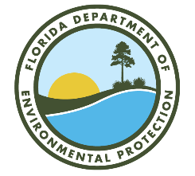

Upper Ocklawaha River Basin Management Action Plan (BMAP)

Annual Meeting

Via Webinar
Webinar Registration Link:
https://attendee.gotowebinar.com/register/4500446682013277278

April 21, 2026
10 AM EDT

Agenda

- Upper Ocklawaha River Basin Management Action Plan (BMAP) Background.

- Annual Progress Update.

- BMAP Deadlines or Important Dates and Requirements.

- Questions/Comments.

- SJRWMD Updates.

- Questions/Comments.

- SJR Model Update.

- Questions/Comments.

Please note the site for documents relating to the Upper Ocklawaha River BMAP:
BMAP Public Meetings | Florida Department of Environmental Protection

For more information on the Upper Ocklawaha River BMAP, contact: Jessica Fetgatter, 850-245-8107, Jessica.Fetgatter@FloridaDEP.gov

