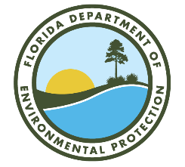

Lake Okeechobee Basin Management Action Plan (BMAP)

Annual Meeting

Via Webinar
Webinar Registration Link:
https://attendee.gotowebinar.com/register/6400109196450818655

April 29, 2025
1 PM EDT

Agenda

- Lake Okeechobee Basin Management Action Plan (BMAP) Background.

- Statewide Annual Report and Reduction Progress for Lake Okeechobee BMAP.

- Programmatic Updates.

- Questions/Comments.

- Technical Updates.

- Look Ahead and Resources.

- Questions/Comments.

Please note the site for documents relating to the Lake Okeechobee BMAP:
BMAP Public Meetings | Florida Department of Environmental Protection

For more information on the Lake Okeechobee BMAP, contact: Chandler Keenan, 850-245-8555.
Chandler.B.Keenan@FloridaDEP.gov

