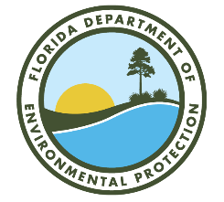

St. Lucie River and Estuary Basin Management Action Plan (BMAP)

Annual Meeting

Via Webinar
Webinar Registration Link:
https://attendee.gotowebinar.com/register/6400109196450818655

April 29, 2025
10 AM EDT

Agenda

- St. Lucie River and Estuary Basin Management Action Plan (BMAP) Background.

- Statewide Annual Report and Reduction Progress for St. Lucie River and Estuary BMAP.

- Programmatic Updates.

- Questions/Comments.

- Technical Updates.

- Look Ahead and Resources.

- Questions/Comments.

Please note the site for documents relating to the St. Lucie River and Estuary BMAP:
BMAP Public Meetings | Florida Department of Environmental Protection

For more information on the St. Lucie River and Estuary BMAP, contact: Tony Tomalewski, 850-245-8683.
Anthony.Tomalewski@FloridaDEP.gov

