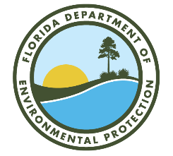

Lake Jesup Basin Management Action Plan (BMAP)

Annual Meeting

Via Webinar
Webinar Registration Link:
https://attendee.gotowebinar.com/register/4530859173753516637

May 5, 2026
1 PM EDT

Agenda

- Lake Jesup BMAP Background.

- Annual Progress Update.

- BMAP Deadlines or Important Dates and Requirements.

- Questions/Comments.

- St. Johns River Water Management District Updates.

- Questions/Comments.

- SJR Model Update.

- Questions/Comments.

Please note the site for documents relating to the Lake Jesup BMAP:
BMAP Public Meetings | Florida Department of Environmental Protection

For more information on the Lake Jesup BMAP, contact: Evelyn Becerra, 850-245-8587, Evelyn.Becerra@FloridaDEP.gov

