Documentation in Support of Category 4e

Waterbody/Watershed Identification
 | Organization | Florida Department of Environmental Protection
 | Point of Contact | Kevin O’Donnell, 2600 Blairstone Rd Tallahassee, FL 32399  Kevin.ODonnell@dep.state.fl.us, (850) 245-8469
 | Waterbody(s) | WBID 3194A – TenMile Creek
 | No. Waterbody / Pollutant Combinations | Based on data from IWR run 56 this waterbody is impaired for these parameters: Nutrients (Total Phosphorus), Biology and Dissolved Oxygen (Percent Saturation)
 | EPA Completed TMDL | EPA has not completed a TMDL for the impaired waterbody segment listed in this document.
Description of Baseline Conditions
 | Watershed(s) | St. Lucie - Loxahatchee – Group 2  Southeast Coast – FDEP South District  WBID 3194A – TenMile Creek
 | Baseline Data | Group 2 Cycle 4 – IWR Run 56, 2019  (Verification Period: January 1, 2012 through June 30, 2019)  Nutrients (Total Phosphorus)  Stream Criterion: AGM ≤ 0.12 mg/L, annual geometric mean total phosphorus values exceeded the criterion more than once in a three-year period.  Stations used in the Total Phosphorus assessment:  21FLSFWMGORDYRD, 21FLGW42400, 21FLGW42398, 21FLGW42404, 21FLGW42403, 21FLGW42396, 21FLGW42407, 21FLGW44249, 21FLGW44243, 21FLGW44245, 21FLGW44251, 21FLGW45707, 21FLGW45702, 21FLGW45716, 21FLGW45713, 21FLGW47623, 21FLGW47629, 21FLGW49604, 21FLGW49612, 21FLGW49610, 21FLWPB 28010045, 21FLWPB G2SE0009, 21FLGW51480, 21FLGW45706  Dissolved Oxygen (Percent Saturation)  DOSAT impairment threshold: ≥ 38 %; The group 2 cycle 4 exceedance ratio for the verified period is 121/326.  Stations used in the DO percent saturation assessment:  21FLSFWMGORDYRD, 21FLGW42400, 21FLGW42398, 21FLGW42404, 21FLGW42403, 21FLGW42396, 21FLGW42407, 21FLGW44249, 21FLGW44243, 21FLGW44245, 21FLGW44251, 21FLGW45707, 21FLGW45702, 21FLGW45716, 21FLGW45713, 21FLGW47623, 21FLGW47629, 21FLGW49604, 21FLGW49612, 21FLGW49610, 21FLWPB 28010045, 21FLWPB G2SE0009, 21FLGW51480  See table below for a baseline water quality data summary for the Group 2 cycle 4 Verified Period.
  Nutrient AGM - Verified Period
  Year | CHLAC (µg/L) | TN (mg/L) | TP (mg/L)
  2012 | 7 | 1.05 | 0.22
  2013 | 9 | 0.84 | 0.17
  2014 | 3 | 0.83 | 0.17
  2015 | 2 | 0.82 | 0.16
  2016 | No AGM | 0.9 | 0.21
  2017 | 15 | 0.89 | 0.19
  2018 | No AGM | 0.77 | 0.13
 | Map | 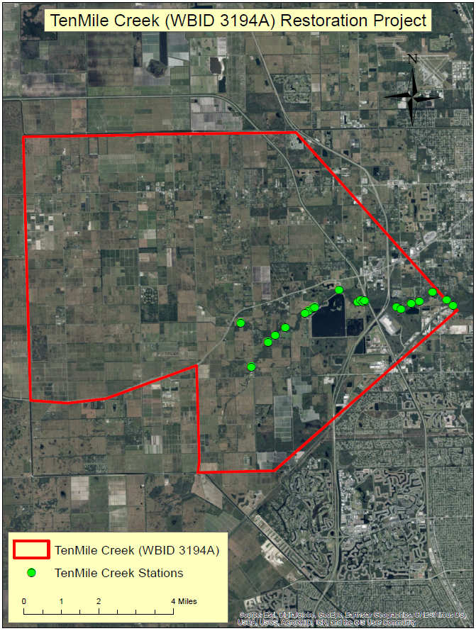

Evidence of Watershed Approach
 | Area of Effort | The TenMile Creek watershed (WBID 3194A) is located in St. Lucie County, near the city of Fort Pierce at the headwaters of the North Fork of the St. Lucie River Aquatic Preserve. The TenMile Creek water preserve area (WPA) project is located directly South of TenMile Creek and just to the West of the I-95/Florida Turnpike interchange. The preserve project has an area of approximately 700 acres surrounded by a 12-15-foot-tall embankment. The reservoir is approximately 526 acres and has a capacity of 2,500 acre-feet of water at an average depth of 4-5 feet. Approximately half of this water is passed into a 132-acre treatment cell (STA), where additional water quality treatment occurs through natural biogeochemical processes. The purpose of the TenMile Creek WPA is to provide seasonal and temporary storage of peak stormwater flows from the TenMile Creek basin and to slowly release those flows back into the creek to help moderate the salinity levels and reduce sediment and nutrient loads in the downstream St. Lucie River and Estuary.  Location of the TenMile Creek Water Preserve Area (WPA) Project.  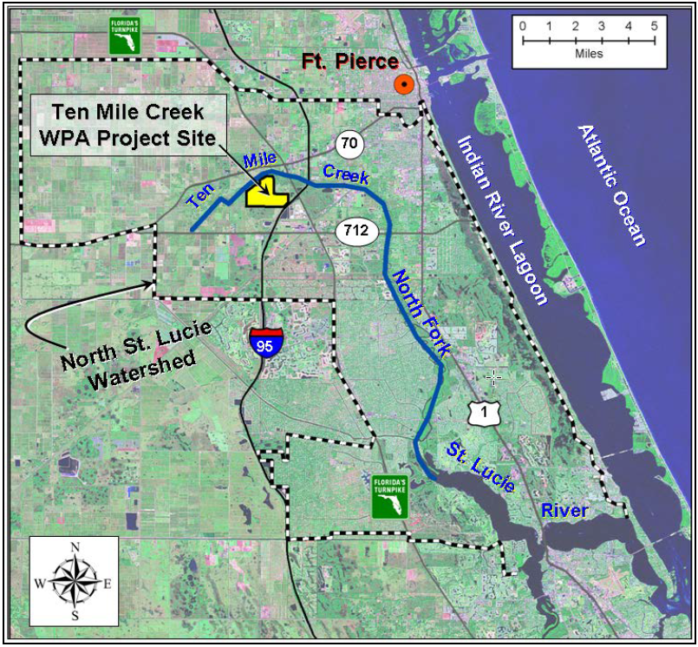
 | Key Stakeholders Involved and Their Roles | The key stakeholders that have been instrumental in developing and executing these restoration projects are listed below.  - U.S. Army Corps of Engineers  - South Florida Water Management District  - St. Lucie County  - Department of Environmental Protection
 | Watershed Plan & Other Supporting Documentation | The area includes the watershed drainage area from TenMile Creek within WBID 3194A where extensive natural resource management is taking place. This WBID is impaired for nutrients (total phosphorus) and dissolved oxygen (percent saturation) based on the AGMs for nutrients and the number of exceedances for the sample size for dissolved oxygen. The objectives outlined by the TenMile Creek Water Preserve Area Critical Project will address these impairments.  The WBID drainage area corresponds to the key project as follows: The TenMile Creek Water Preserve Area
 | Point Sources and Indirect Source Monitoring (Sites) | There are several NPDES Facilities that discharge indirectly to WBID 3194A. These facilities are listed in the table below.  All land areas within the State of Florida surrounding this WBID are regulated by a Municipal Separate Storm Sewer System (MS4) permit – NPDES MS4 Permit No. FLR04E029, permitee is St. Lucie County. The most current MS4 permit was issued on February 1, 2018 and expires on February 28, 2023.  The entire area is regulated by a Municipal Separate Storm Sewer System (MS4) permit #FLR04E029  Note: Generic Permits for stormwater discharge from large and small construction activities are considered temporary; therefore, are not included in this listing.
  NPDES Facility ID | NPDES Facility Name
  FLR10RO93 | Palm Breezes Club
  FLR10PH84 | Florida Power & Light Adams Substation
  FLR20CG85 | SR-713 King's Highway
  FLR10QZ35 | Sunshine Kitchen Food Business Incubator
  FLR10QL81 | Wawa Florida LLC #5254
  FLR10QS71 | Creekside
  FLR10MZ69 | Smirna Petecostal
  FLR05F895 | Bottling Group LLC
  FLR20CJ84 | Creekside - Parcel A
  FLR10SN04 | Carriage Pointe Estates
  FLR10QX67 | I-95 Bridge Deck Replacement
  FLR20BB49 | SFWMD TenMile Creek Reserve
  FLR20BT47 | St Lucie county landfill
  FLRNEE410 | Wal-Mart Distribution Center #7038
  FLR05H561 | WMIF - Fort Pierce Transfer and Recycling Facility
  FLR05E185 | Ranger Construction Industries
  FLR05B469 | St Lucie County Sanitary Landfill
  FLR05A560 | Tropicana Manufacturing Company Inc
  FLR10P830 | Glades Cut - Off Rd Utility Extensions
  FLR10RQ98 | FPL Midway Service Center
  FLR10RP60 | A & G Concrete Pools
  FLR05G776 | Glades WWTF
 | Nonpoint Sources | The land use breakdown for the TenMile Creek watershed is as follows:  Urban and Built-Up – 13.91%  Agriculture – 68.75%  Rangeland – 3.50%  Upland Forest – 5.43%  Water – 1.65%  Wetlands – 2.61%  Barren Land – 0.43%  Transportation, Communication, and Utilities – 3.71%  Special Classifications – 0.00%  The anthropogenic land use component is approximately 86.63%  Wastewater Facilities in the Area:  DLF Packing LLC  Florida Gas Transmission – Station #20  Central Concrete Supermix – Ft Pierce  Titan Florida LLC – Ft Pierce Plant  St Lucie County Sanitary Landfill  Tropicana Manufacturing Company Inc  Port St Lucie Utilities – PSLU Glades WWTF  Wastewater Facilities in the area with surface water discharges:  St Lucie County Sanitary Landfill – Facility ID FL0041483  Central Concrete Supermix – Ft Pierce – Facility ID FLG110611  Titan Florida LLC – Ft Pierce Plant – Facility ID FLG110574  Solid Waste Facilities in the area:  Southbound I-95 St. Lucie Rest Area  Weekley – Ft. Pierce  Kimberly P Hall  Treasure Coast Tractor Services, Inc.  Treasure Coast Land Clearing, Inc.  Waste Management Fort Pierce Transfer Station  East Coast Recycling  Sneeds Rd. and CR 613  St. Lucie County Baling and Recycling Facility  St. Lucie Recycling
 | Water Quality Criteria | It is expected that the Class III freshwater water quality standards for total phosphorus will be attained upon implementation of the specified watershed improvement project. It is also expected that the water quality criteria for dissolved oxygen will be attained.
 | Restoration Work | The TenMile Creek Water Preserve Area (TMC WPA) Critical Project was authorized under section 528(b)(3) of the Water Resources Development Act of 1996, by Public Law 103-404. A state of Florida water quality certification was issued to the U.S. Army Corps of Engineers (Corps) by the Florida Department of Environmental Protection (FDEP) via Comprehensive Everglades Restoration Plan Regulation Act (CERPRA), file number 0192879-001. FDEP issued the original operations permit to South Florida Water Management District (SFWMD) under file number 0192879-002. Subsequent modifications have been made to the permit under the base permit number 0192879 for both Permittees. The permit is set to expire on July 10, 2018. SFWMD submitted an application requesting a five-year renewal of the TMC WPA to FDEP on March 3, 2016, therefore the SFWMD permit expiration date will be revised once the final permit modification is issued.  The TMC WPA is an above ground reservoir located in St. Lucie County, Florida, near Fort Pierce. The TMC WPA includes an emergency overflow spillway and a pump station to move water from TenMile Creek into the reservoir and then, on to a treatment cell (also referred to as a polishing cell) with a pump station and culvert to move water from the reservoir into the treatment cell; and a culvert for release of water back into TenMile Creek; as well as all associated access roads, haul roads, ditches, and canals. The TMC WPA is designed to capture and retain water in the landscape for gradual release, for the purposes of mimicking a more natural stormwater flow regime.  The reservoir capacity is approximately 2,500 acre-feet and has an average operating pool depth of 4-5 feet. The Non-Federal sponsor is the SFWMD. TenMile Creek flows west to east across the northern portion of the site. The project provides water quality improvements in TenMile Creek and regulates delivery of fresh water to the St. Lucie River and in turn, to the Indian River Lagoon estuary (IRL). As originally intended, the reservoir would capture peak stormwater flows from TenMile Creek and route them to an adjacent stormwater treatment area (STA) to be slowly released back into the creek to moderate the salinity levels in the downstream St. Lucie River and Indian River Lagoon estuaries. For a detailed layout and description of the TMC WPA and STA please see the below schematics. Moderating salinity levels to achieve a more natural salinity regime in the estuaries will improve habitat conditions for a wide variety of estuarine species such as fish, oysters, and seagrasses. The reservoir’s natural settlement processes would initially reduce particulates and phosphorus (P) concentrations. In the STA, the biological processes and emergent vegetation would further reduce nutrients and particulates. Water released from the STA would be cleaner than upstream creek flows and it would provide both salinity moderation and nutrient reduction benefits to TenMile Creek and the downstream estuaries. Construction of TMC WPA was completed in January 2006. During project testing and monitoring from December 2011 to March 2012, significant design and construction-related problems were identified. The reservoir has been drawn down to minimize the potential for risks to public health, safety, and property damage. Consequently, the project cannot be operated at the designed pool depth and won’t be able to achieve the originally intended project benefits because the benefits were based on the reservoir’s original capacity of up to 6,000-acre feet of water, at an average depth of 10 feet. The purpose of the TenMile Creek WPA is to provide seasonal and temporary storage of peak stormwater flows from the TenMile Creek basin and to slowly release those flows back into the creek to moderate the salinity levels and reduce the nutrient and sediment loads in the downstream St. Lucie River and Estuary. In December 2015, Corps was directed to transfer the project to the non-Federal sponsor, the SFWMD by section 107 of the Consolidated Appropriations Act of 2016, Public Law 114-113. Upon execution of the agreement to transfer the project, it would no longer be federally authorized. The transfer agreement requires the SFWMD to continue to operate the transferred project as an environmental restoration project to provide water storage and water treatment options.  TenMile Creek WPA Project Components  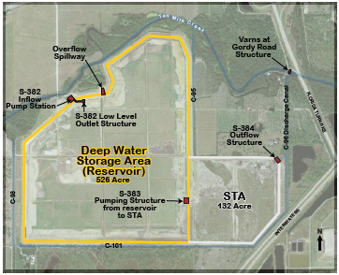  The TenMile Creek WPA will consist of a Hybrid Wetland Treatment Technology (HWTT), which is a combination of wetland and chemical treatment technologies to remove phosphorus at the sub-basin and parcel scales. Chemical coagulants are added, either continuously or intermittently, to the front end of the wetland treatment system, which contain one or more deepwater zones to capture the resulting floc material. Recycling techniques are employed for additional phosphorus sorption. The HWTT system was developed to maximize nutrient removal per unit of chemical coagulant by incorporating novel design and multiple operational strategies. In addition to passive and active recycling/reuse of chemical floc, other optimization includes the sequencing and configuring of wetland unit processes to provide desirable nitrogen and phosphorus species transformations. An example schematic of the HWTT system is displayed in the below figure.  Hybrid Wetland Treatment Technology (HWTT) System Features  Reservoir and STA photos below

Critical Milestones/Monitoring
 | Anticipated Critical Milestone(s) and Completion Dates: |  | Below is a timeline of when critical milestones were completed for this project.  - Original construction was physically completed in 2006  - Interim Operations and Monitoring by the SFWMD occurred in 2007  - Due to problems identified during the operational testing phase the project could not be operated as intended and it has been in a passive operating state since 2009  - Temporary operational testing and monitoring occurred between December 2011 and March 2012  - August 2014, the SFWMD formally requested that the U.S. Army Corps of Engineers de-authorize the TenMile Creek project.  - December 2015 Corps was directed to transfer the project to the non-Federal sponsor, the SFWMD.  - The Corps and SFWMD executed the transfer agreement on May 12, 2016  - Began operations and started pumping water in July 2017  The TenMile Creek project was authorized by Congress in 1996 and built by the Army Corps of Engineers at a cost of about $35 million. But soon after completion in 2006, the reservoir began leaking. The project lay idle while the Army Corps and the engineering firm that designed the project fought in court over who was at fault. The project has since been de-authorized, and possession has been transferred over to the SFWMD.  What the SFWMD has completed so far:  - Retrofitted pump station sitting unused at site for several years  - Removed a weir in middle of reservoir  - Burned vegetation in bottom of reservoir  - Mowed levees  Cost: About $1 million  Effect: Allows about a foot of water (about 171 million gallons) to be stored in reservoir and sent through stormwater treatment area.  What the SFWMD still proposes to do:  - Fix canal (fill in some portions and line others) that's eating away at foot of reservoir wall and causing leaks.  - Remove "stair steps" on interior of reservoir to prevent wildlife, especially turtles, from getting trapped.  Estimated Cost: $7 million  Effect: Would allow up to 4 feet of water (nearly 685.6 million gallons) in reservoir to be sent through STA.
 | Monitoring Component |  | Water quality monitoring for TenMile Creek is a cooperative effort between several entities, including DEP, the South Florida Water Management District and the City of West Palm Beach. Sampling frequency varies by entity and site depending on classification, parameter group, and hydrologic conditions (e.g., water depth and flow).  The monitoring component of the water preserve area is led by the South Florida Water Management District. During the Flow-through Period, the focus of the WPA performance monitoring will be on establishing flow-weighted mean concentrations and loads entering and leaving the WPA. Total water column phosphorus and nitrogen samples will be collected weekly at the inflow and outflow structures. Water quality data at the WPA outlet will be obtained on the upstream side of the S-384 discharge structure. Samples will be collected by an automatic sampler and weekly grab samples. The S-384 structures will be instrumented to provide computed flow rates by using upstream and downstream stage sensors in combination with gate opening information. A MOSCAD remote terminal unit will total the discharge and trigger the automatic sampler.  Schematic of TenMile Creek Hydrologic and Water Quality Monitoring Sites.  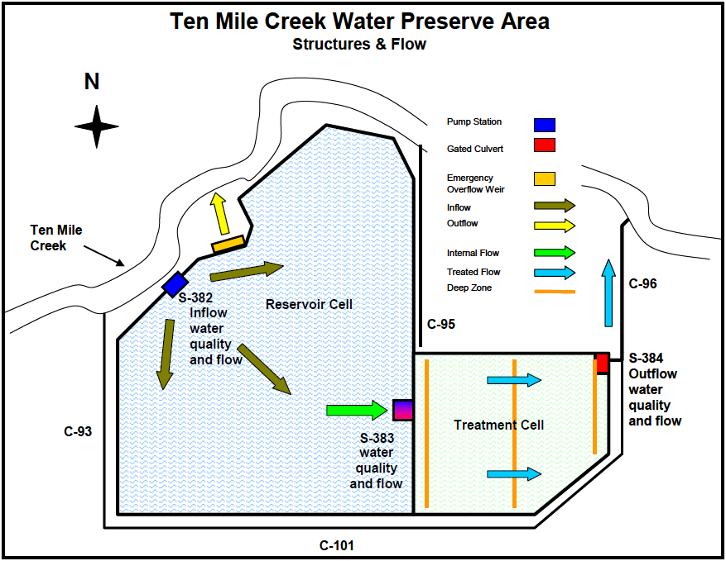  Data from these samples will be evaluated for the permit as follows:  1. Rolling 3-month flow-weighted mean total phosphorus and nitrogen concentrations  for the WPA shall be calculated for the outflow and inflow structures.  2. The flow-weighted mean outflow concentrations of total phosphorus and nitrogen  for the WPA at the outflow structure shall be compared to flow-weighted mean  concentrations at the inflow structure using the student’s t-test with a 95%  confidence interval on log transformed data.  If the evaluation indicates that the flow-weighted mean outflow concentration is less than the flow-weighted mean inflow concentration, then the discharges from the project shall be deemed to be in compliance with Specific Condition 15A. If after six months, discharges from the WPA are not achieving a net reduction in total phosphorus and nitrogen, the vegetation conditions shall be evaluated and strategies to achieve the net improvement are to be identified. In addition to nutrients, the permit contains conditions requiring either a net improvement in concentrations, or discharges to be at or below applicable criteria. For dissolved oxygen the permit requires demonstration that the WPA is not responsible for degradation of dissolved oxygen in downstream receiving waters. Additional details are found in the FDEP construction permit. Although not explicitly required by the permit, it is recommended that the SFWMD monitor flow and nutrients at S-383, the outlet from the reservoir into the treatment cell once flow-through operation begins. This will enable direct estimates of nutrient removal performance of each cell, which will allow operational feedback to optimize removal performance.  All water quality data submittals required by the FDEP construction permit shall be transmitted to the FDEP in an Annual Report. Specific Condition 19 of the FDEP permit contains the minimum information to be contained in the Annual Reports. A summary of the nutrient related monitoring requirements is shown in the table below.  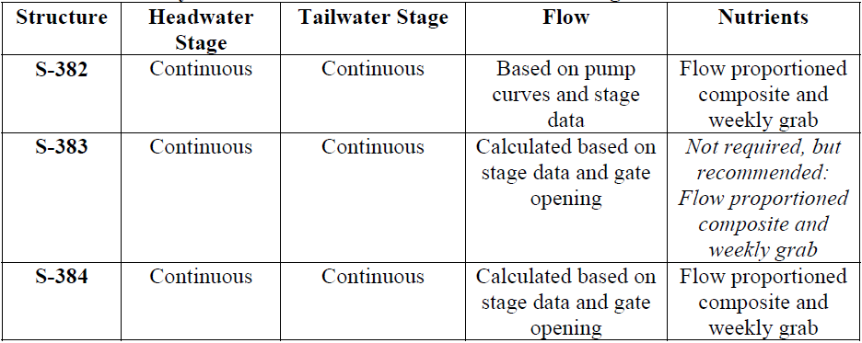
Other Key Dates
 | Estimated Delisting Date | WBID 3194A is in the state’s Group 2 Basin in the DEP Southeast District. The current review and assessment cycle (cycle 4) is scheduled for 2019. This waterbody is currently impaired for nutrients (total phosphorus) and dissolved oxygen (percent saturation), the earliest opportunity for delisting would happen during the upcoming cycle 4 assessment. It will still be delisted from the Verified List and placed in category 4e but will remain on the 303(d) List.

Financial Commitments

 | Estimated Implementation Cost | The total project cost, including land acquisition was $57,000,000.  The estimated 20-year operation and maintenance cost is $ TBD.  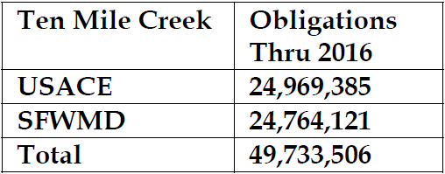
 | Land Acquisition  (if applicable) | Funding Source:  Total……………………………………………………………………...$ NA  The property proposed for this project was already in public ownership prior to the commencement of these activities. The two figures below map when the land was acquired and what the funding source was used for the acquisition.  TenMile Creek land ownership figures.
 | Design and Construction  (if applicable) | Funding Source:  Total……………………………………………………………………...$ 43,000,000
References:

“TenMile Creek Water Preserve Area Critical Project St. Lucie County, Florida Environmental Assessment and Finding of no Significant Impact” by US Army Corps of Engineers Jacksonville District. April 2016.

