Documentation in Support of Category 4e

Waterbody/Watershed Identification
 | Organization | Martin County
 | Point of Contact | Dianne Hughes  NPDES MS4 Permit Manager  Environmental Programs Coordinator  772-219-4980
 | Waterbody(s) | WBID 3208B – Willoughby Creek
 | No. Waterbody / Pollutant Combinations | Based on data from IWR run_60 this waterbody is impaired for Nutrients (Chlorophyll-a) and Enterococci
 | EPA Completed TMDL | EPA has not completed a TMDL for the impaired waterbody segment listed in this document.
Description of Baseline Conditions
 | Watershed(s) | St. Lucie - Loxahatchee – Group 2  Southeast Coast – FDEP South District  Willoughby Creek – Florida Southeast Coast (HUC 03090206)
 | Baseline Data | Initial Biennial Assessment – IWR Run 60, 2020  (Verification Period: January 1, 2013 through June 30, 2020)  Non-ENR Estuary Criterion: Chlorophyll-a (CHLA) annual geometric means (AGM) ≤ 11µg/L, CHLA values exceeded the criterion in 2018 and 2019 with a value of 12 µg/L in both years respectively (please see below table). The state of Florida does not currently have total nitrogen (TN) and total phosphorus (TP) criteria for non-ENR estuaries. Annual geometric means were not calculated for these parameters, for this waterbody.  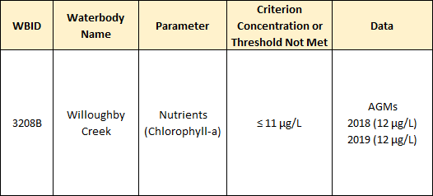  Stations used in Chlorophyll-a assessment:  21FLWPB G2SE0034
 | Map | Attachment 1 delineates the watershed area.

Evidence of Watershed Approach
 | Area of Effort | The Willoughby Creek watershed (WBID 3208B) is located in the Northeastern portion of Martin County and has an area of 222 square miles. The Willoughby Creek Stormwater Treatment Area is located in the South-central part of WBID 3208B and is directly connected to the Indian River via the St. Lucie River inlet system.
 | Key Stakeholders Involved and Their Roles | Martin County – Design and construction  South Florida Water Management District -Permitting  Florida Department of Environmental Protection – 319(h) Grant funding
 | Watershed Plan & Other Supporting Documentation | The WBID drainage area corresponds to the key projects as follows:  Willoughby Creek Stormwater Treatment Area (Please see Attachment 2)  Septic to Sewer Conversion Plan – Golden Gate Community (Please see Attachment 3)
 | Point Sources and Indirect Source Monitoring (Sites) | Willoughby Creek is being routinely monitored by the South Florida Water Management District and DEP’s Southeast Regional Operations Center (ROC). For additional monitoring information please see the Willoughby Creek STA WQ monitoring report: Final Report submitted to Martin County on 8/26/2021.  Attached is the 5-year septic to sewer conversion map and nutrient monitoring study monitoring map.
 | Nonpoint Sources | The Land use breakdown for the Willoughby Creek watershed is as follows:  Urban and Built-Up – 67.92%  Agriculture – 0.00%  Rangeland – 0.23%  Upland Forest – 9.43%  Water – 2.35%  Wetlands – 0.33%  Barren Land – 0.00%  Transportation, Communication, and Utilities – 19.75%  Special Classifications – 0.00%  The anthropogenic land use component is approximately 87.67%  Utilizing the FDEP’s Landscape Development Intensity Index (LDI), the land use around Willoughby Creek is dominated by Urban and Built-up (67.92%), Transportation, Communication, and Utilities (19.75%) and Upland Forest (9.43%) land uses. Resulting in an LDI value of 6.94 for Willoughby Creek.  Wastewater Facilities in Area:  Caribbean Key Condominium Association WWTF  This WWTF is part of the Golden Gate assessment. They will be notified when sewer service is available and given 1 year to physically connect.  Solid Waste Facilities in area:  Martin County Fairgrounds  This is a disaster debris management area (DDMA) used for vegetative waste after hurricanes or severe tropical storms, which to date has never been used.  The entire area is regulated by a phase II MS4 permit # FLR04E013, issued by FDEP to Martin County.  Note: Generic Permits for stormwater discharge from large and small construction activities are considered temporary; therefore, are not included in this listing.
 | Water Quality Criteria | It is expected that the Class III water quality standards derived from the Narrative Nutrient Criteria associated with estuary waterbody types for Nutrients (Chlorophyll-a) will be attained upon implementation of the specified watershed improvement projects.
 | Restoration Work | Project locations, descriptions, cost and completion dates are included below and summarized in greater detail within Attachments 1-3.  Ongoing  - The Golden Gate community is currently included in the County’s 5-Year Septic to Sewer Conversion Plan 2020 – 2026 and is under construction. Infrastructure will be available to 7,394 units with an estimated annual reduction of approximately 72K, lbs. of TN and 15K lbs. of TP. This project is part of a larger project called the 10—Year Connect to Protect Program 2020-2029. Which will be approximately a $160M infrastructure investment for the County in sewer and water. We are also working with FDEP on a Golden Gate nutrient monitoring study to measure loads before, during and after connection to develop an ArcNLET model.  ArcNLET is an ArcGIS-based Nitrate Load Estimation Toolket. ArcNLET is intended to model the fate and transport of nitrate in surficial groundwater, originating from onsite wastewater treatment systems (OWTS), namely septic tanks. The program produces an estimated value of nitrate load to specified surface waterbodies while taking into account the nitrate removal mechanism of denitrification. Please see reference section for additional information.  Completed  - The Willoughby Creek Stormwater Treatment Area (STA) is a 24.50-acre stormwater treatment area that provides water quality treatment through the use of native vegetation. The project consists of capturing and diverting runoff from portions of the nearby airport property, Martin County Fair Grounds, Field Operations compound and school bus depot, in addition to businesses along US 1 between Indian Street and Monterey Road. The treatment train system is expected to achieve high levels of load reductions in the lakes by maximizing storage capacity, attenuation and residence time for physical settling of suspended solids. Another objective of this project was to alleviate the high potential for culvert failure that would cause significant environmental impacts and flooding. To determine the effectiveness of the Stormwater Treatment Area in nutrient load reduction, water samples were collected and analyzed over thirteen (13) events from August 2020 to July 2021. Please see the Willoughby Creek STA WQ monitoring report for additional information and sampling results.  Dissolved oxygen improved as water moved through the system. The lowest DO values were typically recorded at the Inflow, with an average of 3.15 mg/L for all qualifying events combined, and the highest readings recorded at the Outflow, with an average of 6.04 mg/L, excluding Event 7 where the Fairgrounds ditch had higher DO. A reduction in average TP, TN, and TSS nutrient values between the Inflow and Outflow was reported for all qualifying events combined. As outlined in the Quality Assurance Project Plan, the Total Maximum Daily Loads (TMDL) established for the St. Lucie Estuary are 0.081 mg/L for TP and 0.720 mg/L for TN. The average values for TP and TN at the Outflow (Site 3) were 0.045 mg/L and 0.614 mg/L, respectively, below the corresponding TMDLs. In addition, the average value for TSS at the Outflow was 5.6 mg/L, a reduction of 6.7 mg/L from the average value recorded at the Inflow. The Grant Work Plan of the DEP Grant Agreement Number NS035 reported nutrient reduction expectations of 65% for TP and 37% for TN per year. When comparing average values, TP was reduced by 49% and TN by 17%. In addition, TSS was reduced by 54%, all qualifying events combined. This indicates that the STA is trending toward effectiveness. With the continued growth of wetland vegetation, and the development of more natural chemical and biological processes throughout the project area, nutrient levels can be expected to decrease even more over time. Please see Attachments 4 and 5 for a schematic of the STA and sampling locations.  The objectives outlined by the Willoughby Creek Stormwater Treatment Area Project will address these impairments.

Critical Milestones/Monitoring
 | Anticipated Critical Milestone(s) and Completion Dates: |  | Willoughby Creek STA construction completion: May 2020  Golden Gate Septic to Sewer vacuum system construction completion: Projecting a substantial completion date of 10/17/2022  Golden Gate Septic to Sewer anticipated hook-ups: within 365 days of construction completion per ordinance  Development of FDEP ArcNLET model completion: February 2022
 | Monitoring Component |  | Willoughby Creek STA WQ monitoring report: Final Report submitted to Martin County on 8/26/2021. Please see the references section for document information.  Golden Gate nutrient monitoring study report: March 2023
Other Key Dates
 | Estimated Delisting Date | WBID 3208B (Willoughby Creek) is in the state’s Group 2 St. Lucie – Loxahatchee Basin. The current review and assessment cycle (the initial biennial assessment) is scheduled for completion in 2022. This waterbody is currently impaired for enterococci and nutrients (chlorophyll-a) and the earliest opportunity for delisting would happen during the ongoing biennial assessment. However, if these parameters do not meet delisting requirements, they will remain in assessment category 4e for an additional biennial assessment cycle, which will postpone TMDL development.

Financial Commitments

 | Estimated Implementation Cost | Willoughby Creek STA……………………………………………..$1,961,235.97  Golden Gate Septic to Sewer………………………………………..$13,030,605.74
 | Land Acquisition  (if applicable) | Funding Source:  Total project real estate cost………………………………………..$N/A
 | Design and Construction  (if applicable) | Funding Source:  Willoughby Creek STA  Total…TMDL/319 .………………………………………………….$1,403,770.85  Martin County Grant Match…………………………….……………$352,000  Indian River Lagoon Grant…………………………………….……..$185,465  Golden Gate Septic to Sewer  Total  Legislative Appropriations Grant…………………………………...$2,000,000  State Revenue Sharing……………………………………...……….$1,300,000
References:

Willoughby Creek Stormwater Quality Improvement Project Florida Department of Environmental Protection Grant NS035 Stuart, Martin County, Florida

Willoughby Creek Stormwater Quality Retrofit Improvement Project, Drainage Report

Willoughby Creek Water Quality Improvement Project, Project Description

ArcNLET: An ArcGIS-Based Nitrate Load Estimation Toolkit

Attachment 1 – Location Maps

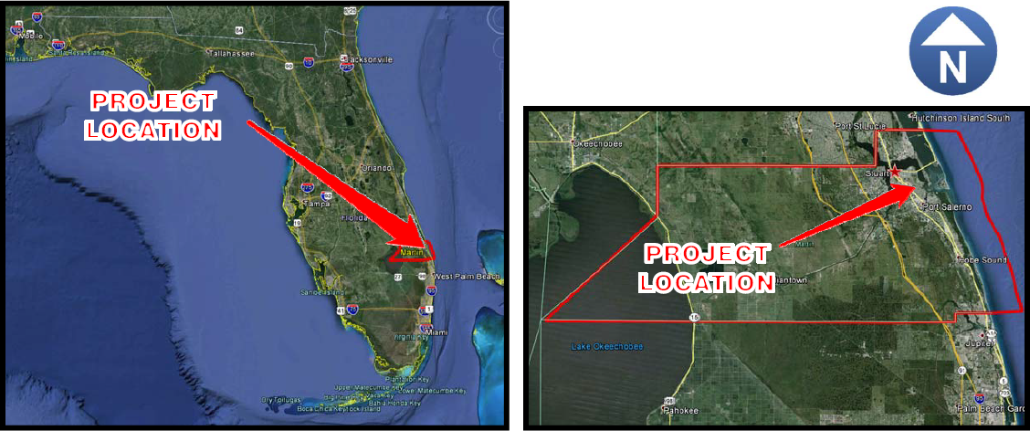
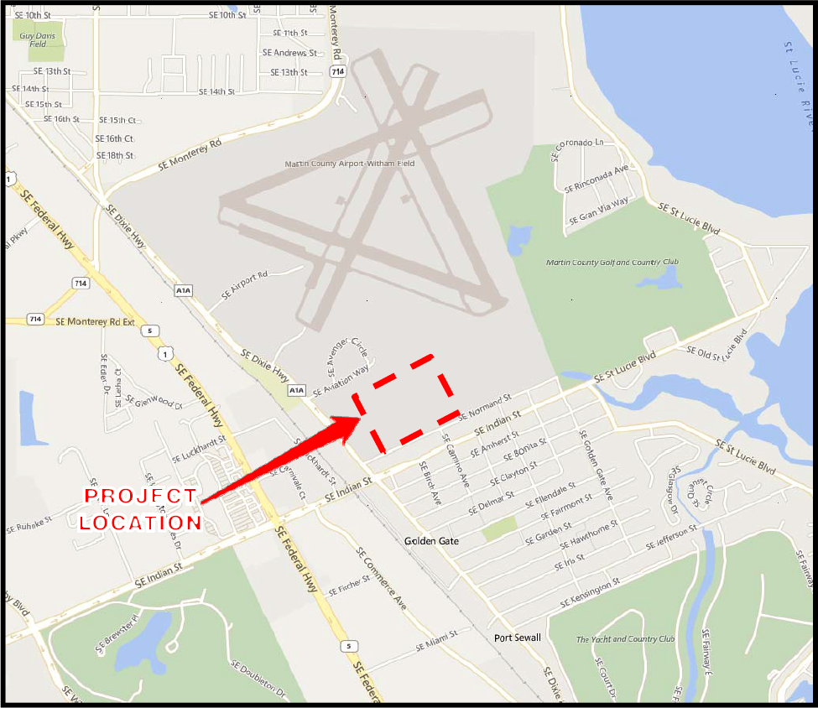

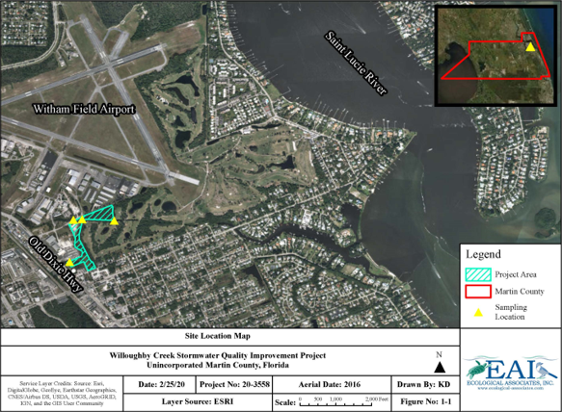

Attachment 2 – Willoughby Creek Stormwater Treatment Area Flyer

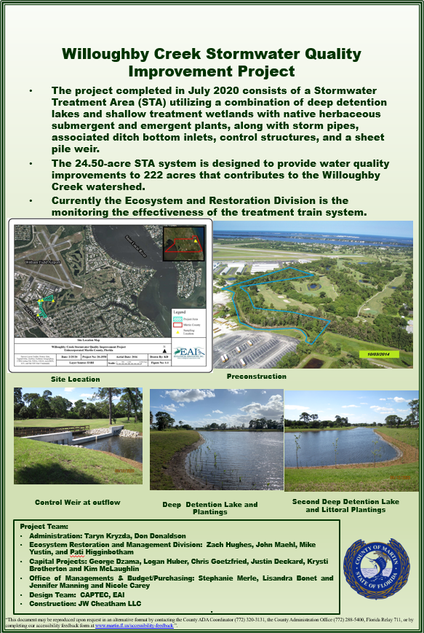
Attachment 3 – Golden Gate Community Septic to Sewer

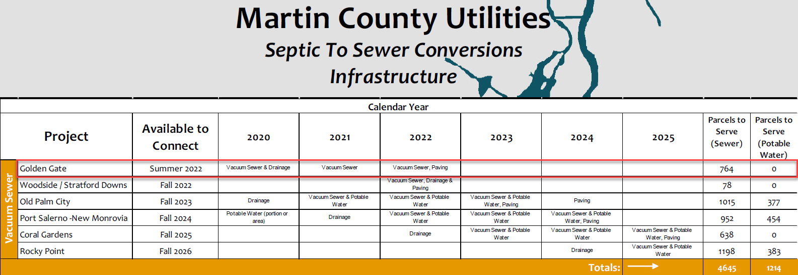

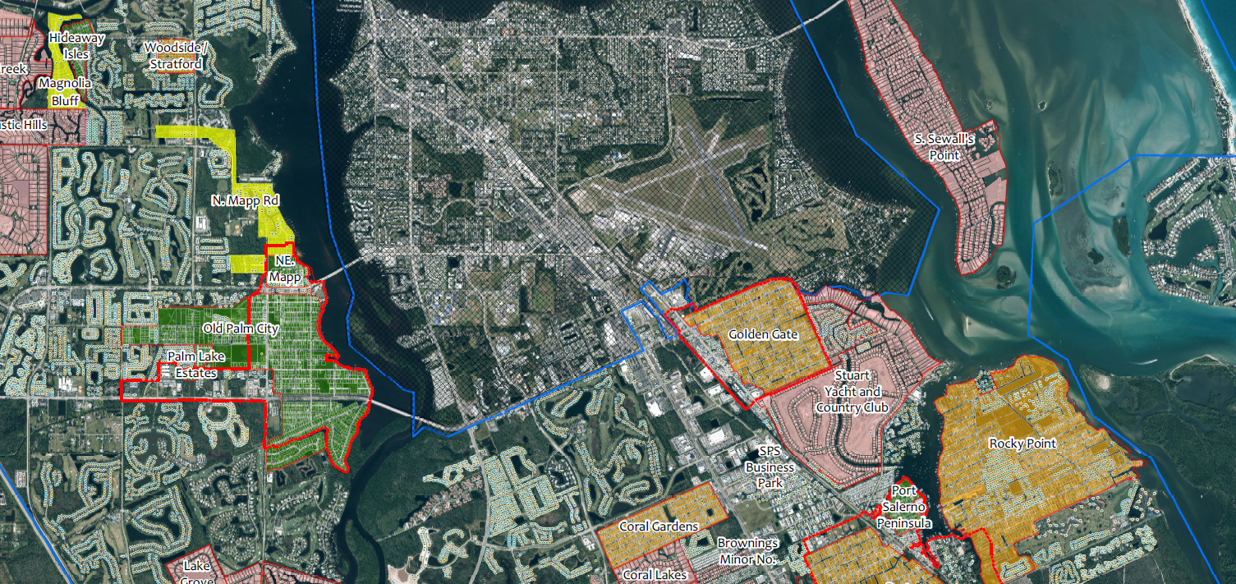

Attachment 4 – Willoughby Creek Stormwater Quality Improvement Project Sampling Locations (Eastern Portion)
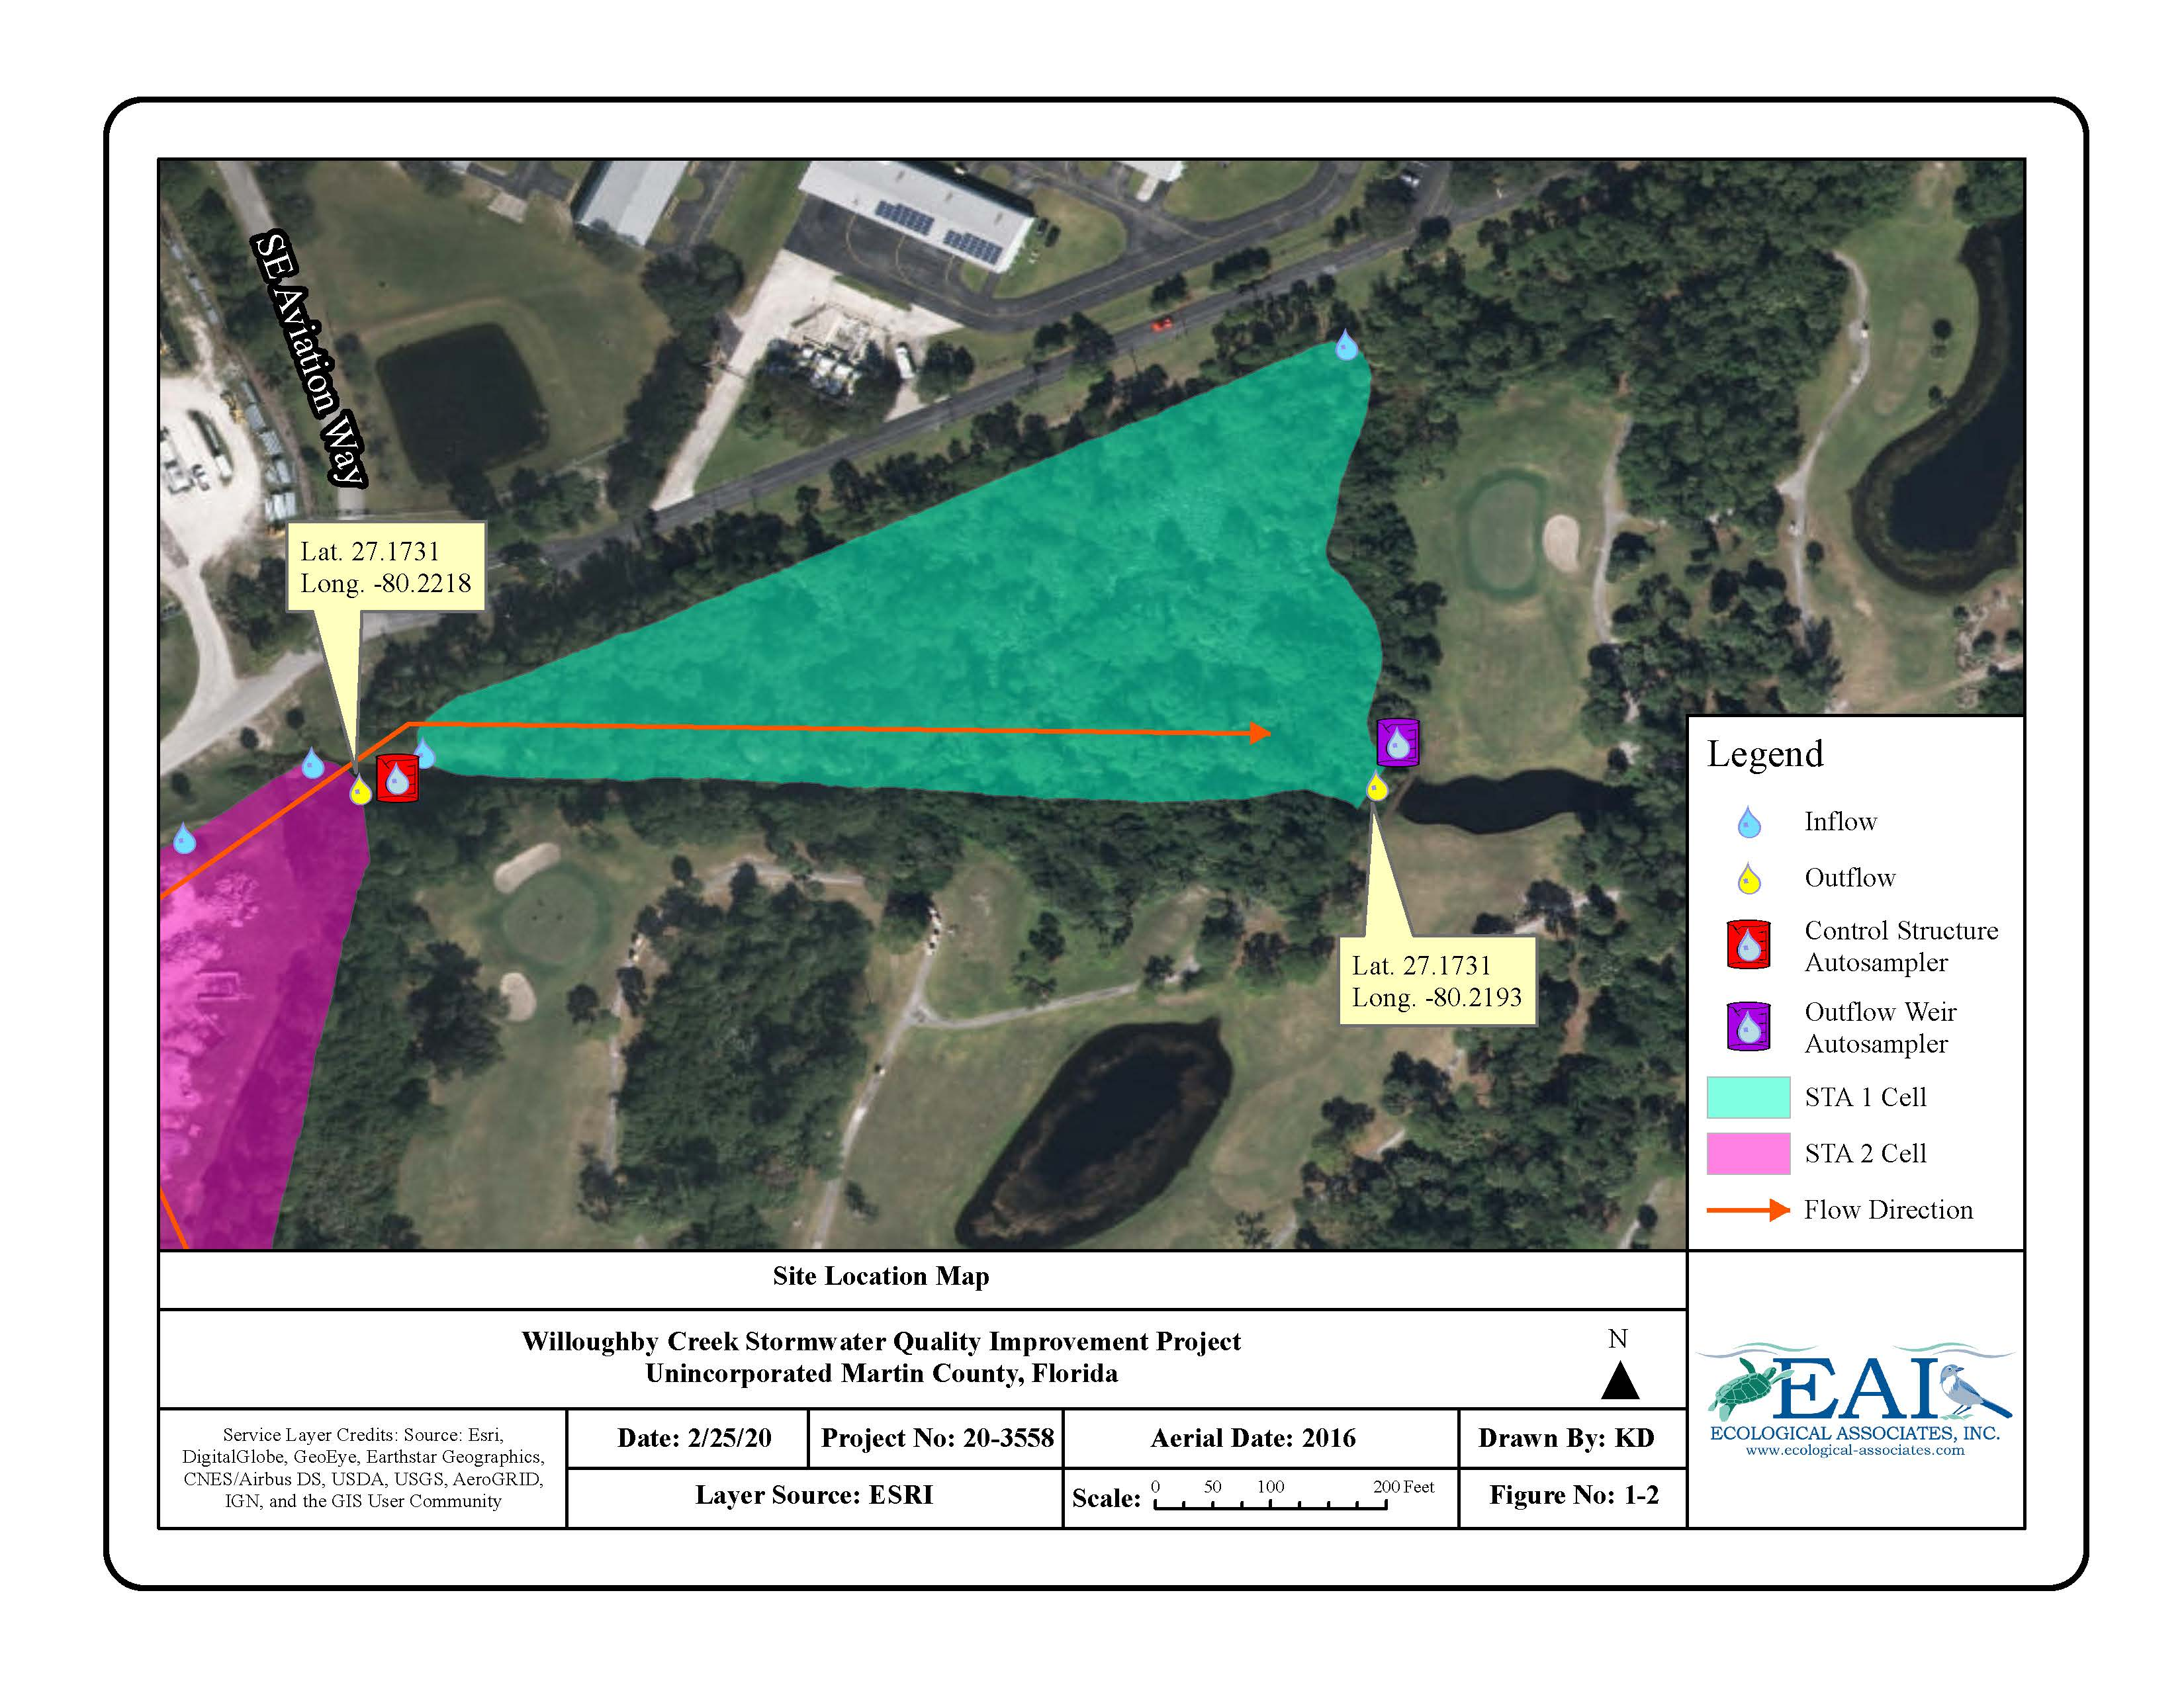

Attachment 5 – Willoughby Creek Stormwater Quality Improvement Project Sampling Locations (Western Portion)
