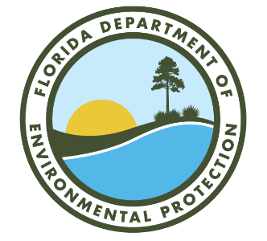
Florida Department of Environmental Protection
DEP Form # 62-705.900(1)

Form Title: Application for Grease Waste Hauler License

Effective Date: ______________

Incorporated by Reference in Rule 62-705.300, F.A.C.

DEP Application No.
(Completed by DEP)
Bob Martinez Center 2600 Blair Stone Road
Tallahassee, Florida 32399-2400

APPLICATION FOR GREASE WASTE HAULER LICENSE

Pursuant to subsection 62-705.300(2), Florida Administrative Code, a hauler shall submit the following information on this form to the Department to obtain a grease waste hauler license and approval to transport grease waste.

License: □ New □ Renewal
Part I- Business Information:

- Business name of Hauler: WACS ID Number:
(Assigned by Department)

- Other business names of Hauler (DBA's, if applicable):

- Mailing address of Hauler:

City State Zip

- Street address of Hauler (if different than Mailing Address):

City County State Zip

- Telephone number of Hauler: ( ) Email address:

- Have any enforcement actions been taken by the Department or other governmental agency against the applicant for violation of Department rules relating to the collection or disposal of grease waste? This includes any Complaint, Notice of Violation, revocation or suspension of a license, as well as any Consent Order in which a violation of Department rules is admitted. You are not required to include any instance where a Warning Letter, Warning Notice, Notice of Noncompliance, or other similar document was issued if no further enforcement action was taken by the Department or other governmental entity.

□ Yes □
No If yes, attach a history and description of the enforcement actions.

Part II- Company Point of Contact for Grease Waste Collection Operations:

- Name of Point of Contact:

- Telephone number of Point of Contact: ( ) Email address:

Part III- Processing and Disposal Information:

List all known locations where you will be delivering or depositing grease waste for recycling or disposal (attach additional sheets if necessary):

Name Address City State

Part IV. Certification
To the best of my knowledge and belief, I certify the information provided in this application is true, accurate, and correct. I have attached all documents and/or authorizations that are required. Further, the undersigned agrees to comply with the provisions of Chapter 403, Florida Statutes (F.S.), and all rules and regulations of the Department. Pursuant to s. 403.161(1), F.S., it shall be a violation of this chapter, and it shall be prohibited for any person to knowingly make any false statement, representation, or certification in any application, record, report, plan, or other document filed or required to maintained under this chapter.

Print Name of Officer or  Authorized Agent |  | Signature of Officer or  Authorized Agent |  | Date
 |  | Mail completed form to:
 |  | Florida Department of Environmental Protection
 |  | Division of Waste Management / Grease Waste
 |  | 2600 Blair Stone Road, MS 4550
 |  | Tallahassee, Florida 32399-2400

