9.0 Stormwater Quality Treatment Requirements

9.1 Calculating Required Nutrient Load Reduction
Applicants are required to provide nutrient load reduction calculations in their application. To calculate the required stormwater nutrient load reduction for a project, the applicant shall:
- Determine whether the site falls within the same HUC 12 as, and is upstream of, an OFW or impaired water, and select the corresponding performance standard from Section 8.3 of this volume. HUC 12s are incorporated by reference in Appendix X.
- Determine the pre-development average annual average mass loading of the project site for both total nitrogen (TN) and total phosphorus (TP) through modeling or as described in section 9.2.
- Calculate the project site’s post-development annual average mass loading without treatment for both TN and TP through modeling or as described in section 9.2.
- Determine the percent TN and TP reduction needed to meet a reduction such that the post-development condition average annual loading of nutrients does not exceed the predevelopment condition nutrient loading as described in section 9.3. Compare the result to the percent reduction required in the applicable paragraph(s) of section 8.3 of this volume. The greater percent load reduction will be the requirement for the project.
- Determine which BMPs will be used to meet the required TN and TP load reductions. Information on how to calculate nutrient load reduction for BMP Treatment Train is found in Section 9.5 of this volume.

9.2 Calculating Nutrient Loading
9.2.1 Calculating Predevelopment and Post development Hydrology

The applicant shall determine the pre-development and post development characteristics of the project site. If the project site encompasses multiple drainage basins or catchments, determine this for each at the project site. For the purposes of this analysis, estimates of annual runoff volumes shall be performed using the method described herein or another methodology based on modeling. If modeling is used to determine hydrology, at a minimum the applicant shall submit the program used, inputs, and outputs. The methodology to determine the hydrology of the site by hand is outlined in paragraphs a. through f. below.

a. The Handbook’s methodology provides tabular solutions to a series of calculations for determining annual runoff volumes for each of the state’s designated meteorological zones as indicated in Figure 9.1. Table 9.3 lists the counties included in each meteorological zone. Use this table to determine the project’s meteorological zone first and then continue to the determination of mean annual run off associated with the project location.

b. The percent of Directly Connected Impervious Area (DCIA) should be calculated for each land use type in the project area. DCIA consists of those impervious areas that are directly connected to the stormwater conveyance system. Impervious areas also are considered to be DCIA if stormwater from the area occurs as concentrated shallow flow over a short pervious area such as grass or a swale. Non-directly connected impervious (Non-DCIA) areas include all pervious areas and portions of impervious areas that flow over at least 10 feet of pervious areas with HSG A or B soils and over at least 20 feet of pervious area for other soil types.

c. Appendix Y provides a summary of calculated mean annual runoff coefficients (“ROC value”) as a function of curve number and DCIA for each of the five designated meteorological zones. The values summarized in Appendix Y reflect the average long-term ROC values for each of the five designated zones over a wide range of DCIA and curve number combinations. Determine the ROC value for each land use category in a catchment for the project area. Linear interpolation can be used to estimate annual runoff coefficients for combinations of DCIA and curve numbers that fall between the values in the Table. For “naturally occurring” undeveloped conditions, it should be assumed that the percent DCIA is equal to 0.0.

d. This method should be used for each catchment area on the site to provide the most accurate runoff volume.

e. To calculate hydrology and pollutant loading from a catchment area in the proposed project site, applicants can develop a table similar to Table 9.1 to summarize land use information.

Table 9.1 Example Land Use Categories Matrix to Calculate Loadings

Pre-development | Total watershed area | Non-DCIA CN | DCIA percentage | Calculated ROC Value
Low Density Residential
Single Family
Multi-Family
Low Intensity Commercial
High Intensity Commercial
Light Industrial
Highway
Natural Vegetated Community

Post-development | Total watershed area | Non-DCIA CN | DCIA percentage | Calculated C
Low Density Residential
Single Family
Multi-Family
Low Intensity Commercial
High Intensity Commercial
Light Industrial
Highway
Natural Vegetated Community

f. Determine the Annual Runoff Volume. The information contained in Table 9.1 and Appendix Y is used to estimate the Annual Runoff Volume for a given catchment area under either predevelopment or post-development conditions. The Average Annual Rainfall should be obtained using the method described in section 9.4. To calculate the Annual Runoff Volume for the site; the area of the site, average annual rainfall, and the appropriate ROC value are multiplied. This is shown in equation 9-1:

Equation 9-1
$Annual Runoff Volume (ac-ft.) = Area (acres) x Average Annual Rainfall (inches) x ROC Value x (1ft/12in)$

9.2.2 Calculation of Predevelopment and Post Development Stormwater Nutrient Loading

a. To calculate the predevelopment and post development annual mass loadings of TN and TP , multiply the predevelopment annual runoff volume (derived in Section 9.2.1) by the land use specific runoff characterization data (event mean concentrations or EMCs) for TN and TP. EMC Values are listed in Table 9.2 for different types of land use categories. These land use categories are described in Appendix Z. EMC values for the natural land uses must consider vegetation cover, soils, and topography and must match the latest assigned Florida Land Use and Cover Classification System (FLUCCS) code. Applicants must use the most up-to-date verified EMC values available for their project region. Applicants also must comply with the applicable special basin or geographic area criteria in chapter 62-330.301(1)(k), F.A.C. including any EMC values specified in the applicable Applicant’s Handbook Volume II;

Table 9.2 Standardized Statewide Stormwater Nutrient EMC Values

Land Use Category | Total N (mg/l) | Total P (mg/l)
Low Density Residential | 1.65 | 0.270
Single Family | 2.07 | 0.327
Multi-Family | 2.32 | 0.520
Low Intensity Commercial | 1.13 | 0.188
High Intensity Commercial | 2.40 | 0.345
Light Industrial | 1.20 | 0.260
Highway | 1.52 | 0.200
General Natural | 1.22 | 0.213
General Agricultural | 2.29 | 0.381
Pasture | 3.03 | 0.593
Citrus | 2.11 | 0.180
Row Crops | 2.50 | 0.577

b. At the time of the application, an applicant may propose to use TN and TP EMC values accepted by the Agency which denote EMC values derived from regional studies or those adopted by local ordinance. Any study conducted must be submitted with the permit application for the Agency records. If EMC values from a study are to be used, data collected must follow quality assurance provisions outlined in chapter 62-160, F.A.C., and include:
- Data collected at a wide range of rainfall depths;
- Minimum of 7-10 rainfall events;
- Minimum of two years of data;
- Use of autosamplers to allow for runoff to be sampled throughout entire rainfall event;
- Volume weighted composite averaging;
- Sampling occurring at point of discharge just upstream of any stormwater treatment on site;
- Minimum of three or more sites with this land use category depending on the variability of the land use category; and
- Data collected for all land use EMCs for the region.

Additionally, the contributing area to the sample site should represent a single land use type, and the results of the study should be reasonably consistent with other similar scientific studies and watershed plans. If this study is intended to be used for more than one site area, then this study will only be applicable for the region specified by the study area, not to exceed a HUC 8 area.

c. Determine the average annual mass loading. The average annual mass loading calculation is provided in Equation 9-2 below.

Equation 9-2
$$Annual Average Mass Loading = Annual Runoff Volume x EMC$$

The components of Equation 9-2 are expressed in different units and require some conversion
factors, as provided below.
$$Annual Mass Loading (lb./year) = Annual Runoff Volume (ac-ft./year) * 43,560 ft2$$
$$/ac * 7.48 gal/ft3 x 3.785 liter/gal * EMC (mg/l) * 1 lb./453,592 mg$$

9.3 Determination of required treatment efficiency
Predevelopment and post development loadings are calculated, and subsequently compared, based on the average annual loading of TN and TP discharged. Equation 9-3 calculates the treatment efficiency needed so that the post development average annual loading of nutrients equals the predevelopment nutrient loading:

Equation 9-3: Percent reduction calculation
$$\left(1-\left(\frac{Predevelopment loading}{Post development Loading before treatment}\right)\right)×100$$

Compare the result from equation 9-3 to the percent reduction required in the applicable paragraph of section 8.3. The greater load reduction (the more protective) will be the requirement for the project. Once the load reduction has been determined, use Equation 9-4 to find the required treated loading rate for TN and TP for the project.

Equation 9-4: Post development maximum load to meet % treatment required

$$=\left(1-Load Reduction\right)Post development Loading Before Treatment$$

Another method to determine the loading rate required for the project is to use the percent reduction required in Section 8.3 of this volume in Equation 9-4 then compare the result to the predevelopment loading. If the resultant loading of Equation 9-4 is less than that of the predevelopment loading, then the percent reduction required in the applicable paragraph of section 8.3 must be used in the stormwater design. If the resultant loading is greater than that of the predevelopment loading, than the applicant must treat the site to a level that would result in a post development loading equal to or less than that of the predevelopment loading.

9.4 Rainfall data
Calculations for the annual average mass loading will use the average annual rainfall data determined by National Centers for Environmental Information for the site area. Figure 9.2 displays an isopleth of the average annual rainfall data. This data can be further regionalized by going to https://ncei-normals-mapper.rcc-acis.org/. This rainfall data has been averaged from the last 30 years of rainfall data and is updated every 10 years.

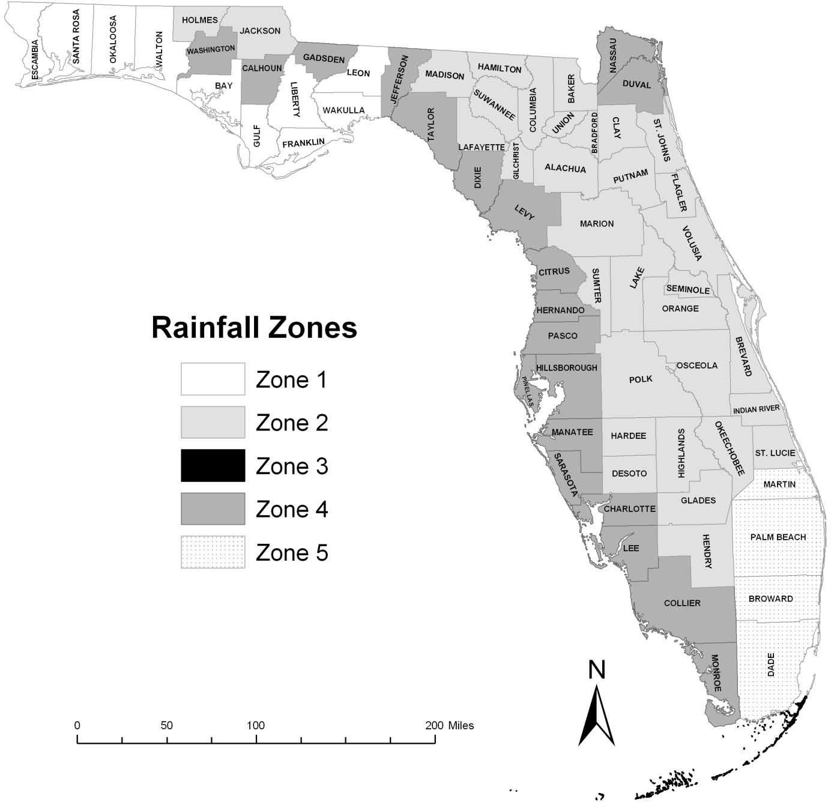
Figure 9.1 Designated Meteorological Regions (Zones) in Florida

Table 9.3 Counties Included in the Designated Meteorological Zones
ZONE 1 | ZONE 2 | ZONE 3 | ZONE 4 | ZONE 5
Bay | Alachua | Monroe County - | Charlotte | Broward
Escambia | Baker | Florida Keys from | Citrus | Miami-Dade
Franklin | Bradford | Key Largo to Key | Collier | Martin
Gulf | Brevard | West | Dixie | Palm Beach
Leon | Calhoun |  | Duval
Liberty | Clay |  | Hernando
Okaloosa | Columbia |  | Hillsborough
Santa Rosa | Desoto |  | Jefferson
Wakulla | Flagler |  | Lee
Walton | Gadsden |  | Levy
 | Gilchrist |  | Manatee
 | Glades |  | Mainland Monroe
 | Hamilton |  | Nassau
 | Hardee |  | Pasco
 | Hendry |  | Pinellas
 | Highlands |  | Sarasota
 | Holmes |  | Taylor
 | Indian River |  | Washington
 | Jackson
 | Lafayette
 | Lake
 | Madison
 | Marion
 | Okeechobee
 | Orange
 | Osceola
 | Polk
 | Putnam
 | Seminole
 | St. Johns
 | St. Lucie
 | Sumter
 | Union
 | Volusia

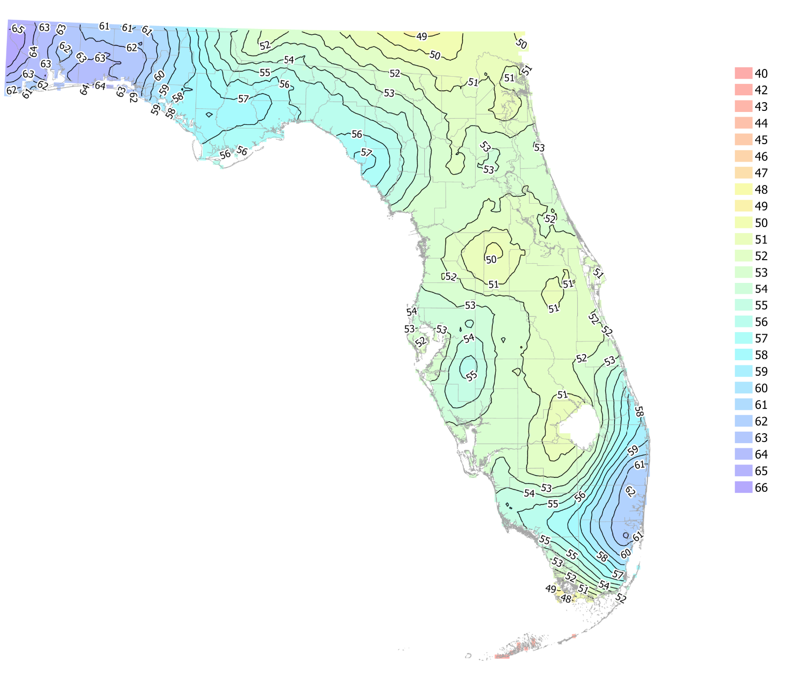
Figure 9.2 Rainfall Isopleth Map for Florida

9.5 Best Management Practices (BMPs) for Stormwater Treatment
Once the pre-development and post-development loadings have been calculated and the
required percent reduction of TN and TP have been established, the stormwater treatment
system can be designed. Stormwater treatment can be achieved in a variety of ways. Best management Practices (BMPs) are an effective tool for achieving the treatment efficiencies required by Section 8. The applicant must show that the stormwater treatment system complies with the hydraulic and hydrologic general design requirements in the applicable AH Volume II. If the applicant chooses to use a BMP that is not listed in the applicable AH Volume II, section 9.5.2 below describes the requirements for alternative designs.

If the post development maximum load for TN and TP are met with a single BMP, the applicant shall complete the design of the stormwater treatment system. If the maximum load is not met, the applicant shall either modify the selected BMP or incorporate additional BMPs to achieve the required TN or TP load reductions.

9.5.1 Treatment Train Nutrient Reduction

BMPs can be implemented in combination or in conjunction with one another in a series called a "BMP Treatment Train." If used, BMP Treatment Train efficiencies must account for the reduced loading transferred to subsequent downstream treatment devices. As stormwater pollutant concentrations are reduced in each BMP in the treatment train, the ability of a BMP Treatment Train to further reduce stormwater pollutant concentrations and loads is diminished. This is shown in Equation 9-5. This equation assumes each BMP acts independently of upstream BMPs and that upstream BMPs do not impact performance of downstream BMPs. If the BMP acts in combination with the upstream BMP, the designer will consider the use of another methodology to determine the resultant efficiency of the BMP Treatment Train.

Equation 9-5: Overall Treatment Train Efficiency for systems in series
$$Overall Treatment Train Efficiency = Eff1 +\left[\left(1 – Eff1\right)x Eff2\right]+[(1 – (Eff1 + Eff2)) x Eff3 ]$$

Eff1 = efficiency of initial treatment system
Eff2 = efficiency of second treatment system
Eff3 = efficiency of third treatment system

9.5.2 Alternative Designs

An applicant can propose alternative BMPs not listed in the AH Volume II Handbooks. These will be considered by the Agency as alternative designs and evaluated based on engineering plans, quality assurance plans, representative monitoring data in Florida, and test results for the specific site conditions of the project. Applicants must provide reasonable assurance that their proposed alternative designs provide the level of treatment that they claim and that will achieve the required performance standards in this Volume, either by the alternative design by themself or in conjunction with other BMPs. In determining whether the alternative design provides this reasonable assurance, the Agency will consider:

    - Whether the alternative BMP has been appropriately tested and reviewed by scientific methods to substantiate its treatment efficiency claim; and
    - Whether acceptable provisions have been made to ensure that the system will be effectively operated and maintained, as described in section 12 of this volume.

9.5.3 Green Stormwater Infrastructure and Low Impact Design

The Agencies encourage the use of Low Impact Design (LID) approaches, such as Green Stormwater Infrastructure (GSI), which can be used to supplement or replace traditional stormwater infrastructure for managing the impacts of rain and stormwater runoff. GSI and LID reduce pollution and treat stormwater by retaining rainfall near its source instead of directing it to a centralized pond or treatment system. When applied early in the design process, low impact design techniques can reduce stormwater runoff volume and pollutants generated from project sites. Thus, the use of GSI and LID may reduce stormwater treatment BMP size requirements. GSI and LID, depending on the technology, can also treat stormwater in a manner similar to a traditional BMP by treating TN and TP. Typical GSI and LID features are described in the Applicant’s Handbook Volume IIs and BMP library.

9.6 Off-site Stormwater
The volume of runoff to be treated from a site shall be determined by the minimum level of treatment set forth in Section 8 of this Volume; the type of treatment system (e.g., retention, wet detention, etc.); and the meteorological region (rainfall zone) where the project is proposed. If stormwater runoff from off-site areas is allowed to co-mingle with on-site runoff, then the effects of runoff from these off-site areas must be addressed in the load reduction calculations for the project site, unless the project is exempt from this provision under section 373.413(6), F.S.

9.7 Compensating Stormwater Treatment
Two methods have been developed to compensate for the lack of treatment for a portion of a project. The first method is to treat the runoff that is captured to a greater extent than required by rule (i.e., "overtreatment"). The second method is to provide treatment for an off-site area which currently is not being treated (i.e., "off-site compensation"). Each method is designed to furnish the same level of treatment as if the runoff from the entire project site was captured and treated in accordance with the provisions of this Volume.

Either of these methods will only be allowed as a last resort, and the applicant is strongly encouraged to schedule a pre-application conference with Agency staff to discuss the project if these alternatives are being considered. Other rule criteria, such as peak discharge attenuation, will still have to be met if the applicant utilizes these methods. Each alternative is described in more detail in the following sections.

9.7.1 Overtreatment

Overtreatment means to treat the runoff from the project area that flows to a treatment system to a higher level than the rule requires to make up for the lack of treatment for a portion of the project area. The average treatment efficiency of the treated and untreated areas must meet the pollutant removal goals of Section 8 outlined in this Volume. To meet these goals, the area not being treated generally must be small (less than 10% of total site area or less than one acre for pervious area or half an acre for semi- impervious/impervious area, whichever is less) in relation to the area which is captured and treated. Agency staff can aid in determining the proper level of overtreatment for a particular situation.

9.7.2 Off-site Compensation
Off-site Compensating Stormwater Treatment may be used when on-site treatment is not sufficient to meet the required performance standards. Off-site compensating stormwater treatment used to meet the requirements of Section 8 is ineligible to also be used for any water quality credit in the trading provisions/programs in Chapter 62-306, F.A.C.

The following criteria must be met when using off-site treatment, unless off-site treatment is explicitly allowed by section 311.106, F.S.:

    - The proposed off-site area must be owned by the permittee and located within a HUC-12 subwatershed containing the proposed project. The proposed off-site area must be upstream of the proposed project and hydraulically connected to the same water waterbody of concern as the proposed project, unless otherwise noted by the special basin criteria;
    - The applicant shall use modeling techniques to provide reasonable assurance that the off-site treatment system provides an equivalent amount of pollutant reductions at the point of discharge for the project as if all of the treatment was performed on-site;
    - The modeling must provide reasonable assurance that there will not be localized adverse impacts to the receiving waterbody or in downstream waters, which may require the application of adjustments based on location and,
    - Easement(s) shall be granted to the operation and maintenance entity, as required in Section 12.4 of this volume, for the area being used for off-site treatment to allow for perpetual operation and maintenance access of the off-site treatment area.

9.7.3 Reserved - Water Quality Enhancement Areas Credit Trading

Appendix Y
Mean Annual Runoff Coefficients (ROC Value) as a Function of DCIA Percentage and Non-DCIA Curve Number

ZONE 1
Mean Annual Runoff Coefficients (ROC Value) as a Function
of DCIA Percentage and Non-DCIA Curve Number
NDCIA  CN | Percent DCIA
 | 0 | 5 | 10 | 15 | 20 | 25 | 30 | 35 | 40 | 45 | 50 | 55 | 60 | 65 | 70 | 75 | 80 | 85 | 90 | 95 | 100
30 | 0.006 | 0.048 | 0.090 | 0.132 | 0.175 | 0.217 | 0.259 | 0.301 | 0.343 | 0.386 | 0.428 | 0.470 | 0.512 | 0.554 | 0.596 | 0.639 | 0.681 | 0.723 | 0.765 | 0.807 | 0.849
35 | 0.009 | 0.051 | 0.093 | 0.135 | 0.177 | 0.219 | 0.261 | 0.303 | 0.345 | 0.387 | 0.429 | 0.471 | 0.513 | 0.555 | 0.597 | 0.639 | 0.681 | 0.723 | 0.765 | 0.807 | 0.849
40 | 0.014 | 0.056 | 0.098 | 0.139 | 0.181 | 0.223 | 0.265 | 0.307 | 0.348 | 0.390 | 0.432 | 0.474 | 0.515 | 0.557 | 0.599 | 0.641 | 0.682 | 0.724 | 0.766 | 0.808 | 0.849
45 | 0.020 | 0.062 | 0.103 | 0.145 | 0.186 | 0.228 | 0.269 | 0.311 | 0.352 | 0.394 | 0.435 | 0.476 | 0.518 | 0.559 | 0.601 | 0.642 | 0.684 | 0.725 | 0.767 | 0.808 | 0.849
50 | 0.029 | 0.070 | 0.111 | 0.152 | 0.193 | 0.234 | 0.275 | 0.316 | 0.357 | 0.398 | 0.439 | 0.480 | 0.521 | 0.562 | 0.603 | 0.644 | 0.685 | 0.726 | 0.767 | 0.808 | 0.849
55 | 0.039 | 0.079 | 0.120 | 0.161 | 0.201 | 0.242 | 0.282 | 0.323 | 0.363 | 0.404 | 0.444 | 0.485 | 0.525 | 0.566 | 0.606 | 0.647 | 0.687 | 0.728 | 0.768 | 0.809 | 0.849
60 | 0.052 | 0.092 | 0.132 | 0.172 | 0.212 | 0.252 | 0.291 | 0.331 | 0.371 | 0.411 | 0.451 | 0.491 | 0.531 | 0.570 | 0.610 | 0.650 | 0.690 | 0.730 | 0.770 | 0.810 | 0.849
65 | 0.069 | 0.108 | 0.147 | 0.186 | 0.225 | 0.264 | 0.303 | 0.342 | 0.381 | 0.420 | 0.459 | 0.498 | 0.537 | 0.576 | 0.615 | 0.654 | 0.693 | 0.732 | 0.771 | 0.810 | 0.849
70 | 0.092 | 0.130 | 0.167 | 0.205 | 0.243 | 0.281 | 0.319 | 0.357 | 0.395 | 0.433 | 0.471 | 0.508 | 0.546 | 0.584 | 0.622 | 0.660 | 0.698 | 0.736 | 0.774 | 0.812 | 0.849
75 | 0.121 | 0.158 | 0.194 | 0.230 | 0.267 | 0.303 | 0.340 | 0.376 | 0.412 | 0.449 | 0.485 | 0.522 | 0.558 | 0.595 | 0.631 | 0.667 | 0.704 | 0.740 | 0.777 | 0.813 | 0.849
80 | 0.162 | 0.196 | 0.230 | 0.265 | 0.299 | 0.334 | 0.368 | 0.402 | 0.437 | 0.471 | 0.506 | 0.540 | 0.574 | 0.609 | 0.643 | 0.678 | 0.712 | 0.746 | 0.781 | 0.815 | 0.849
85 | 0.220 | 0.252 | 0.283 | 0.315 | 0.346 | 0.378 | 0.409 | 0.441 | 0.472 | 0.503 | 0.535 | 0.566 | 0.598 | 0.629 | 0.661 | 0.692 | 0.724 | 0.755 | 0.787 | 0.818 | 0.849
90 | 0.312 | 0.339 | 0.366 | 0.393 | 0.419 | 0.446 | 0.473 | 0.500 | 0.527 | 0.554 | 0.581 | 0.608 | 0.634 | 0.661 | 0.688 | 0.715 | 0.742 | 0.769 | 0.796 | 0.823 | 0.849
95 | 0.478 | 0.496 | 0.515 | 0.533 | 0.552 | 0.571 | 0.589 | 0.608 | 0.626 | 0.645 | 0.664 | 0.682 | 0.701 | 0.719 | 0.738 | 0.757 | 0.775 | 0.794 | 0.812 | 0.831 | 0.849
98 | 0.656 | 0.666 | 0.676 | 0.685 | 0.695 | 0.705 | 0.714 | 0.724 | 0.734 | 0.743 | 0.753 | 0.763 | 0.772 | 0.782 | 0.792 | 0.801 | 0.811 | 0.821 | 0.830 | 0.840 | 0.849
ZONE 2
Mean Annual Runoff Coefficients (ROC Value) as a Function
of DCIA Percentage and Non-DCIA Curve Number
NDCIA  CN | Percent DCIA
 | 0 | 5 | 10 | 15 | 20 | 25 | 30 | 35 | 40 | 45 | 50 | 55 | 60 | 65 | 70 | 75 | 80 | 85 | 90 | 95 | 100
30 | 0.002 | 0.043 | 0.083 | 0.123 | 0.164 | 0.204 | 0.244 | 0.285 | 0.325 | 0.366 | 0.406 | 0.446 | 0.487 | 0.527 | 0.567 | 0.608 | 0.648 | 0.688 | 0.729 | 0.769 | 0.809
35 | 0.004 | 0.044 | 0.085 | 0.125 | 0.165 | 0.205 | 0.246 | 0.286 | 0.326 | 0.366 | 0.407 | 0.447 | 0.487 | 0.528 | 0.568 | 0.608 | 0.648 | 0.689 | 0.729 | 0.769 | 0.809
40 | 0.007 | 0.047 | 0.087 | 0.127 | 0.167 | 0.207 | 0.248 | 0.288 | 0.328 | 0.368 | 0.408 | 0.448 | 0.488 | 0.528 | 0.569 | 0.609 | 0.649 | 0.689 | 0.729 | 0.769 | 0.809
45 | 0.010 | 0.050 | 0.090 | 0.130 | 0.170 | 0.210 | 0.250 | 0.290 | 0.330 | 0.370 | 0.410 | 0.450 | 0.490 | 0.530 | 0.570 | 0.610 | 0.650 | 0.690 | 0.729 | 0.769 | 0.809
50 | 0.015 | 0.055 | 0.095 | 0.134 | 0.174 | 0.214 | 0.254 | 0.293 | 0.333 | 0.373 | 0.412 | 0.452 | 0.492 | 0.531 | 0.571 | 0.611 | 0.651 | 0.690 | 0.730 | 0.770 | 0.809
55 | 0.022 | 0.061 | 0.101 | 0.140 | 0.179 | 0.219 | 0.258 | 0.298 | 0.337 | 0.376 | 0.416 | 0.455 | 0.494 | 0.534 | 0.573 | 0.613 | 0.652 | 0.691 | 0.731 | 0.770 | 0.809
60 | 0.030 | 0.069 | 0.108 | 0.147 | 0.186 | 0.225 | 0.264 | 0.303 | 0.342 | 0.381 | 0.420 | 0.459 | 0.498 | 0.537 | 0.576 | 0.615 | 0.654 | 0.693 | 0.731 | 0.770 | 0.809
65 | 0.042 | 0.080 | 0.119 | 0.157 | 0.195 | 0.234 | 0.272 | 0.311 | 0.349 | 0.387 | 0.426 | 0.464 | 0.502 | 0.541 | 0.579 | 0.618 | 0.656 | 0.694 | 0.733 | 0.771 | 0.809
70 | 0.057 | 0.095 | 0.133 | 0.170 | 0.208 | 0.245 | 0.283 | 0.321 | 0.358 | 0.396 | 0.433 | 0.471 | 0.509 | 0.546 | 0.584 | 0.621 | 0.659 | 0.697 | 0.734 | 0.772 | 0.809
75 | 0.079 | 0.116 | 0.152 | 0.189 | 0.225 | 0.262 | 0.298 | 0.335 | 0.371 | 0.408 | 0.444 | 0.481 | 0.517 | 0.554 | 0.590 | 0.627 | 0.663 | 0.700 | 0.736 | 0.773 | 0.809
80 | 0.111 | 0.146 | 0.181 | 0.216 | 0.251 | 0.285 | 0.320 | 0.355 | 0.390 | 0.425 | 0.460 | 0.495 | 0.530 | 0.565 | 0.600 | 0.635 | 0.670 | 0.705 | 0.740 | 0.774 | 0.809
85 | 0.160 | 0.192 | 0.225 | 0.257 | 0.290 | 0.322 | 0.355 | 0.387 | 0.420 | 0.452 | 0.485 | 0.517 | 0.550 | 0.582 | 0.614 | 0.647 | 0.679 | 0.712 | 0.744 | 0.777 | 0.809
90 | 0.242 | 0.270 | 0.299 | 0.327 | 0.355 | 0.384 | 0.412 | 0.440 | 0.469 | 0.497 | 0.526 | 0.554 | 0.582 | 0.611 | 0.639 | 0.667 | 0.696 | 0.724 | 0.753 | 0.781 | 0.809
95 | 0.404 | 0.424 | 0.444 | 0.464 | 0.485 | 0.505 | 0.525 | 0.546 | 0.566 | 0.586 | 0.606 | 0.627 | 0.647 | 0.667 | 0.688 | 0.708 | 0.728 | 0.749 | 0.769 | 0.789 | 0.809
98 | 0.595 | 0.605 | 0.616 | 0.627 | 0.638 | 0.648 | 0.659 | 0.670 | 0.680 | 0.691 | 0.702 | 0.713 | 0.723 | 0.734 | 0.745 | 0.756 | 0.766 | 0.777 | 0.788 | 0.799 | 0.809
ZONE 3
Mean Annual Runoff Coefficients (ROC Value) as a Function
of DCIA Percentage and Non-DCIA Curve Number
NDCIA  CN | Percent DCIA
 | 0 | 5 | 10 | 15 | 20 | 25 | 30 | 35 | 40 | 45 | 50 | 55 | 60 | 65 | 70 | 75 | 80 | 85 | 90 | 95 | 100
30 | 0.008 | 0.047 | 0.087 | 0.126 | 0.165 | 0.205 | 0.244 | 0.283 | 0.323 | 0.362 | 0.401 | 0.441 | 0.480 | 0.519 | 0.559 | 0.598 | 0.637 | 0.677 | 0.716 | 0.756 | 0.795
35 | 0.012 | 0.051 | 0.090 | 0.129 | 0.168 | 0.207 | 0.247 | 0.286 | 0.325 | 0.364 | 0.403 | 0.442 | 0.482 | 0.521 | 0.560 | 0.599 | 0.638 | 0.677 | 0.717 | 0.756 | 0.795
40 | 0.016 | 0.055 | 0.094 | 0.133 | 0.172 | 0.211 | 0.250 | 0.289 | 0.328 | 0.367 | 0.406 | 0.445 | 0.483 | 0.522 | 0.561 | 0.600 | 0.639 | 0.678 | 0.717 | 0.756 | 0.795
45 | 0.022 | 0.061 | 0.099 | 0.138 | 0.177 | 0.215 | 0.254 | 0.292 | 0.331 | 0.370 | 0.408 | 0.447 | 0.486 | 0.524 | 0.563 | 0.602 | 0.640 | 0.679 | 0.718 | 0.756 | 0.795
50 | 0.029 | 0.067 | 0.105 | 0.144 | 0.182 | 0.220 | 0.259 | 0.297 | 0.335 | 0.374 | 0.412 | 0.450 | 0.488 | 0.527 | 0.565 | 0.603 | 0.642 | 0.680 | 0.718 | 0.757 | 0.795
55 | 0.037 | 0.075 | 0.113 | 0.151 | 0.189 | 0.227 | 0.265 | 0.302 | 0.340 | 0.378 | 0.416 | 0.454 | 0.492 | 0.530 | 0.568 | 0.605 | 0.643 | 0.681 | 0.719 | 0.757 | 0.795
60 | 0.048 | 0.085 | 0.123 | 0.160 | 0.197 | 0.235 | 0.272 | 0.309 | 0.347 | 0.384 | 0.421 | 0.459 | 0.496 | 0.533 | 0.571 | 0.608 | 0.645 | 0.683 | 0.720 | 0.758 | 0.795
65 | 0.061 | 0.098 | 0.134 | 0.171 | 0.208 | 0.244 | 0.281 | 0.318 | 0.355 | 0.391 | 0.428 | 0.465 | 0.501 | 0.538 | 0.575 | 0.611 | 0.648 | 0.685 | 0.721 | 0.758 | 0.795
70 | 0.078 | 0.114 | 0.149 | 0.185 | 0.221 | 0.257 | 0.293 | 0.329 | 0.365 | 0.400 | 0.436 | 0.472 | 0.508 | 0.544 | 0.580 | 0.616 | 0.651 | 0.687 | 0.723 | 0.759 | 0.795
75 | 0.100 | 0.135 | 0.170 | 0.204 | 0.239 | 0.274 | 0.308 | 0.343 | 0.378 | 0.413 | 0.447 | 0.482 | 0.517 | 0.552 | 0.586 | 0.621 | 0.656 | 0.691 | 0.725 | 0.760 | 0.795
80 | 0.131 | 0.164 | 0.197 | 0.231 | 0.264 | 0.297 | 0.330 | 0.363 | 0.397 | 0.430 | 0.463 | 0.496 | 0.529 | 0.562 | 0.596 | 0.629 | 0.662 | 0.695 | 0.728 | 0.762 | 0.795
85 | 0.177 | 0.208 | 0.239 | 0.269 | 0.300 | 0.331 | 0.362 | 0.393 | 0.424 | 0.455 | 0.486 | 0.517 | 0.548 | 0.579 | 0.609 | 0.640 | 0.671 | 0.702 | 0.733 | 0.764 | 0.795
90 | 0.252 | 0.279 | 0.306 | 0.333 | 0.360 | 0.388 | 0.415 | 0.442 | 0.469 | 0.496 | 0.523 | 0.550 | 0.578 | 0.605 | 0.632 | 0.659 | 0.686 | 0.713 | 0.741 | 0.768 | 0.795
95 | 0.399 | 0.419 | 0.439 | 0.458 | 0.478 | 0.498 | 0.518 | 0.538 | 0.557 | 0.577 | 0.597 | 0.617 | 0.637 | 0.656 | 0.676 | 0.696 | 0.716 | 0.735 | 0.755 | 0.775 | 0.795
98 | 0.578 | 0.589 | 0.600 | 0.611 | 0.622 | 0.633 | 0.643 | 0.654 | 0.665 | 0.676 | 0.687 | 0.697 | 0.708 | 0.719 | 0.730 | 0.741 | 0.752 | 0.762 | 0.773 | 0.784 | 0.795
ZONE 4
Mean Annual Runoff Coefficients (ROC Value) as a Function
of DCIA Percentage and Non-DCIA Curve Number
NDCIA  CN | Percent DCIA
 | 0 | 5 | 10 | 15 | 20 | 25 | 30 | 35 | 40 | 45 | 50 | 55 | 60 | 65 | 70 | 75 | 80 | 85 | 90 | 95 | 100
30 | 0.004 | 0.045 | 0.086 | 0.127 | 0.168 | 0.209 | 0.250 | 0.291 | 0.332 | 0.373 | 0.414 | 0.455 | 0.496 | 0.536 | 0.577 | 0.618 | 0.659 | 0.700 | 0.741 | 0.782 | 0.823
35 | 0.007 | 0.048 | 0.089 | 0.129 | 0.170 | 0.211 | 0.252 | 0.293 | 0.333 | 0.374 | 0.415 | 0.456 | 0.497 | 0.537 | 0.578 | 0.619 | 0.660 | 0.701 | 0.741 | 0.782 | 0.823
40 | 0.011 | 0.051 | 0.092 | 0.133 | 0.173 | 0.214 | 0.254 | 0.295 | 0.336 | 0.376 | 0.417 | 0.458 | 0.498 | 0.539 | 0.579 | 0.620 | 0.661 | 0.701 | 0.742 | 0.782 | 0.823
45 | 0.016 | 0.056 | 0.096 | 0.137 | 0.177 | 0.217 | 0.258 | 0.298 | 0.339 | 0.379 | 0.419 | 0.460 | 0.500 | 0.540 | 0.581 | 0.621 | 0.662 | 0.702 | 0.742 | 0.783 | 0.823
50 | 0.022 | 0.062 | 0.102 | 0.142 | 0.182 | 0.222 | 0.262 | 0.302 | 0.342 | 0.382 | 0.423 | 0.463 | 0.503 | 0.543 | 0.583 | 0.623 | 0.663 | 0.703 | 0.743 | 0.783 | 0.823
55 | 0.030 | 0.070 | 0.109 | 0.149 | 0.189 | 0.228 | 0.268 | 0.308 | 0.347 | 0.387 | 0.427 | 0.466 | 0.506 | 0.546 | 0.585 | 0.625 | 0.664 | 0.704 | 0.744 | 0.783 | 0.823
60 | 0.040 | 0.080 | 0.119 | 0.158 | 0.197 | 0.236 | 0.275 | 0.314 | 0.353 | 0.393 | 0.432 | 0.471 | 0.510 | 0.549 | 0.588 | 0.627 | 0.667 | 0.706 | 0.745 | 0.784 | 0.823
65 | 0.054 | 0.092 | 0.131 | 0.169 | 0.208 | 0.246 | 0.285 | 0.323 | 0.362 | 0.400 | 0.438 | 0.477 | 0.515 | 0.554 | 0.592 | 0.631 | 0.669 | 0.708 | 0.746 | 0.785 | 0.823
70 | 0.071 | 0.109 | 0.147 | 0.184 | 0.222 | 0.259 | 0.297 | 0.335 | 0.372 | 0.410 | 0.447 | 0.485 | 0.522 | 0.560 | 0.598 | 0.635 | 0.673 | 0.710 | 0.748 | 0.785 | 0.823
75 | 0.096 | 0.132 | 0.168 | 0.205 | 0.241 | 0.277 | 0.314 | 0.350 | 0.387 | 0.423 | 0.459 | 0.496 | 0.532 | 0.568 | 0.605 | 0.641 | 0.678 | 0.714 | 0.750 | 0.787 | 0.823
80 | 0.130 | 0.165 | 0.199 | 0.234 | 0.268 | 0.303 | 0.338 | 0.372 | 0.407 | 0.442 | 0.476 | 0.511 | 0.546 | 0.580 | 0.615 | 0.650 | 0.684 | 0.719 | 0.754 | 0.788 | 0.823
85 | 0.182 | 0.214 | 0.246 | 0.278 | 0.310 | 0.342 | 0.374 | 0.406 | 0.438 | 0.470 | 0.502 | 0.534 | 0.566 | 0.599 | 0.631 | 0.663 | 0.695 | 0.727 | 0.759 | 0.791 | 0.823
90 | 0.266 | 0.294 | 0.322 | 0.350 | 0.378 | 0.406 | 0.433 | 0.461 | 0.489 | 0.517 | 0.545 | 0.573 | 0.600 | 0.628 | 0.656 | 0.684 | 0.712 | 0.740 | 0.767 | 0.795 | 0.823
95 | 0.429 | 0.449 | 0.469 | 0.488 | 0.508 | 0.528 | 0.547 | 0.567 | 0.587 | 0.606 | 0.626 | 0.646 | 0.665 | 0.685 | 0.705 | 0.725 | 0.744 | 0.764 | 0.784 | 0.803 | 0.823
98 | 0.616 | 0.626 | 0.636 | 0.647 | 0.657 | 0.667 | 0.678 | 0.688 | 0.699 | 0.709 | 0.719 | 0.730 | 0.740 | 0.750 | 0.761 | 0.771 | 0.782 | 0.792 | 0.802 | 0.813 | 0.823
ZONE 5
Mean Annual Runoff Coefficients (ROC Value) as a Function
of DCIA Percentage and Non-DCIA Curve Number
NDCIA  CN | Percent DCIA
 | 0 | 5 | 10 | 15 | 20 | 25 | 30 | 35 | 40 | 45 | 50 | 55 | 60 | 65 | 70 | 75 | 80 | 85 | 90 | 95 | 100
30 | 0.008 | 0.048 | 0.088 | 0.128 | 0.168 | 0.208 | 0.248 | 0.288 | 0.328 | 0.368 | 0.408 | 0.448 | 0.488 | 0.528 | 0.568 | 0.608 | 0.648 | 0.688 | 0.728 | 0.768 | 0.808
35 | 0.012 | 0.052 | 0.092 | 0.132 | 0.171 | 0.211 | 0.251 | 0.291 | 0.331 | 0.370 | 0.410 | 0.450 | 0.490 | 0.529 | 0.569 | 0.609 | 0.649 | 0.689 | 0.728 | 0.768 | 0.808
40 | 0.018 | 0.057 | 0.097 | 0.136 | 0.176 | 0.215 | 0.255 | 0.294 | 0.334 | 0.373 | 0.413 | 0.452 | 0.492 | 0.531 | 0.571 | 0.611 | 0.650 | 0.690 | 0.729 | 0.769 | 0.808
45 | 0.025 | 0.064 | 0.103 | 0.142 | 0.182 | 0.221 | 0.260 | 0.299 | 0.338 | 0.377 | 0.417 | 0.456 | 0.495 | 0.534 | 0.573 | 0.612 | 0.651 | 0.691 | 0.730 | 0.769 | 0.808
50 | 0.034 | 0.072 | 0.111 | 0.150 | 0.189 | 0.227 | 0.266 | 0.305 | 0.343 | 0.382 | 0.421 | 0.460 | 0.498 | 0.537 | 0.576 | 0.614 | 0.653 | 0.692 | 0.731 | 0.769 | 0.808
55 | 0.044 | 0.082 | 0.121 | 0.159 | 0.197 | 0.235 | 0.273 | 0.312 | 0.350 | 0.388 | 0.426 | 0.464 | 0.502 | 0.541 | 0.579 | 0.617 | 0.655 | 0.693 | 0.732 | 0.770 | 0.808
60 | 0.057 | 0.095 | 0.132 | 0.170 | 0.207 | 0.245 | 0.282 | 0.320 | 0.357 | 0.395 | 0.433 | 0.470 | 0.508 | 0.545 | 0.583 | 0.620 | 0.658 | 0.695 | 0.733 | 0.770 | 0.808
65 | 0.073 | 0.110 | 0.147 | 0.183 | 0.220 | 0.257 | 0.294 | 0.330 | 0.367 | 0.404 | 0.441 | 0.477 | 0.514 | 0.551 | 0.588 | 0.624 | 0.661 | 0.698 | 0.735 | 0.771 | 0.808
70 | 0.093 | 0.129 | 0.165 | 0.201 | 0.236 | 0.272 | 0.308 | 0.344 | 0.379 | 0.415 | 0.451 | 0.486 | 0.522 | 0.558 | 0.594 | 0.629 | 0.665 | 0.701 | 0.737 | 0.772 | 0.808
75 | 0.120 | 0.155 | 0.189 | 0.223 | 0.258 | 0.292 | 0.327 | 0.361 | 0.395 | 0.430 | 0.464 | 0.498 | 0.533 | 0.567 | 0.602 | 0.636 | 0.670 | 0.705 | 0.739 | 0.774 | 0.808
80 | 0.157 | 0.189 | 0.222 | 0.254 | 0.287 | 0.319 | 0.352 | 0.385 | 0.417 | 0.450 | 0.482 | 0.515 | 0.547 | 0.580 | 0.613 | 0.645 | 0.678 | 0.710 | 0.743 | 0.775 | 0.808
85 | 0.209 | 0.239 | 0.269 | 0.299 | 0.329 | 0.359 | 0.389 | 0.419 | 0.449 | 0.479 | 0.509 | 0.538 | 0.568 | 0.598 | 0.628 | 0.658 | 0.688 | 0.718 | 0.748 | 0.778 | 0.808
90 | 0.292 | 0.318 | 0.343 | 0.369 | 0.395 | 0.421 | 0.447 | 0.472 | 0.498 | 0.524 | 0.550 | 0.576 | 0.602 | 0.627 | 0.653 | 0.679 | 0.705 | 0.731 | 0.756 | 0.782 | 0.808
95 | 0.445 | 0.464 | 0.482 | 0.500 | 0.518 | 0.536 | 0.554 | 0.572 | 0.590 | 0.609 | 0.627 | 0.645 | 0.663 | 0.681 | 0.699 | 0.717 | 0.736 | 0.754 | 0.772 | 0.790 | 0.808
98 | 0.614 | 0.624 | 0.633 | 0.643 | 0.653 | 0.662 | 0.672 | 0.682 | 0.692 | 0.701 | 0.711 | 0.721 | 0.730 | 0.740 | 0.750 | 0.760 | 0.769 | 0.779 | 0.789 | 0.798 | 0.808

