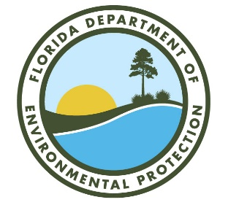
GREASE WASTE REMOVAL AND DISPOSAL
CHAPTER 62-705 RULE DEVELOPMENT WORKSHOP AGENDA

FLORIDA DEPARTMENT OF ENVIRONMENTAL PROTECTION
MARCH 22, 2024 | 9:00 AM – NO LATER THAN 12:00 PM
DEP BOB MARTINEZ CENTER - CONFERENCE ROOM 609
THIS MEETING IS OPEN TO THE PUBLIC

- Call to Order; the Division of Waste Management is proposing Rules to Chapter 62-705, Florida Administrative Code (F.A.C.). This rule development workshop was published in the Florida Administrative Register on March 7, 2024.

- Introduction of DEP Staff and Housekeeping Information.

- Reminder - this workshop is being recorded.

- Review of proposed Chapter 62-705, F.A.C., draft rule language.

- Public comments on proposed rules.
  - In-room Attendee Comments
  - Microsoft Teams Meeting Attendee Comments

- Overview of rulemaking timeline.
  - Provide written comments no later than Friday, April 19, 2024. Comments can be submitted to SWPP@FloridaDEP.gov or Florida Department of Environmental Protection, Solid Waste, 2600 Blair Stone Road, MS 4565, Tallahassee, FL 32399-2400. ATTN: Melissa Walsh, Environmental Consultant.

- Adjourn.

