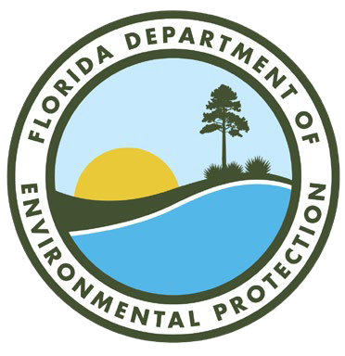**FLORIDA DEPARTMENT OF**

Environmental Protection

Bob Martinez Center 2600 Blair Stone Road

Tallahassee, FL 32399-2400

**Ron DeSantis**

Governor

**Jeanette Nuñez**

Lt. Governor

**Shawn Hamilton**

Secretary

**HEARING AGENDA**

**Coal Combustion Residuals (CCR) Rulemaking**

DEPARTMENT OF ENVIRONMENTAL PROTECTION

Florida DEP Bob Martinez Center 2600 Blair Stone Road

BMC Conference Room 609

Tallahassee, Florida

Friday, December 3, 2021

9:00 am to no later than 12:00 pm

Remote Attendance – [Microsoft Teams](https://teams.microsoft.com/l/meetup-join/19%3ameeting_YjFmZDkxOTktM2UzNC00MjQzLTg3ODktMTM1NDg3MTI4MjUy%40thread.v2/0?context=%7b%22Tid%22%3a%22679d4c83-aea2-4635-b4f1-9f5012551b6a%22%2c%22Oid%22%3a%229c58037e-f4c8-4c20-9a5c-9bab265cd291%22%7d)

Call In (Audio Only) Phone: 850-629-7330 Phone Conference ID: 363 252 64#

THIS MEETING IS OPEN TO THE PUBLIC

1. Call to order and indicate meeting is being recorded, statement of purpose of hearing & indicate the date the meeting was published in the Florida Administrative Register (FAR).
   * Purpose of hearing: The Department is holding a public hearing on Chapter 62-701, Florida Administrative Code (F.A.C.), concerning comments received from the United States Environmental Protection Agency (EPA) on proposed new Rule 62-701.805, F.A.C., and minor revisions to Rule 62-701.900, F.A.C.
   * Date notice of hearing was published in the FAR: October 5, 2021
2. Introduce DEP Staff
3. Overview of Proposed State CCR Rules and EPA Comments
4. Receive Public comments on rulemaking
5. Adjourn

Additional Information:

* Rulemaking documents:

[https://floridadep.gov/waste/permitting-compliance-assistance/content/chapter-62-701-fac-](https://floridadep.gov/waste/permitting-compliance-assistance/content/chapter-62-701-fac-rulemaking) [rulemaking](https://floridadep.gov/waste/permitting-compliance-assistance/content/chapter-62-701-fac-rulemaking)

* Solid Waste Contacts:

El Kromhout, Environmental Administrator, [Elizabeth.Kromhout@FloridaDEP.gov](mailto:Elizabeth.Kromhout@FloridaDEP.gov) Kim Walker, Program Administrator, [Kim.Walker@FloridaDEP.gov](mailto:Kim.Walker@FloridaDEP.gov)