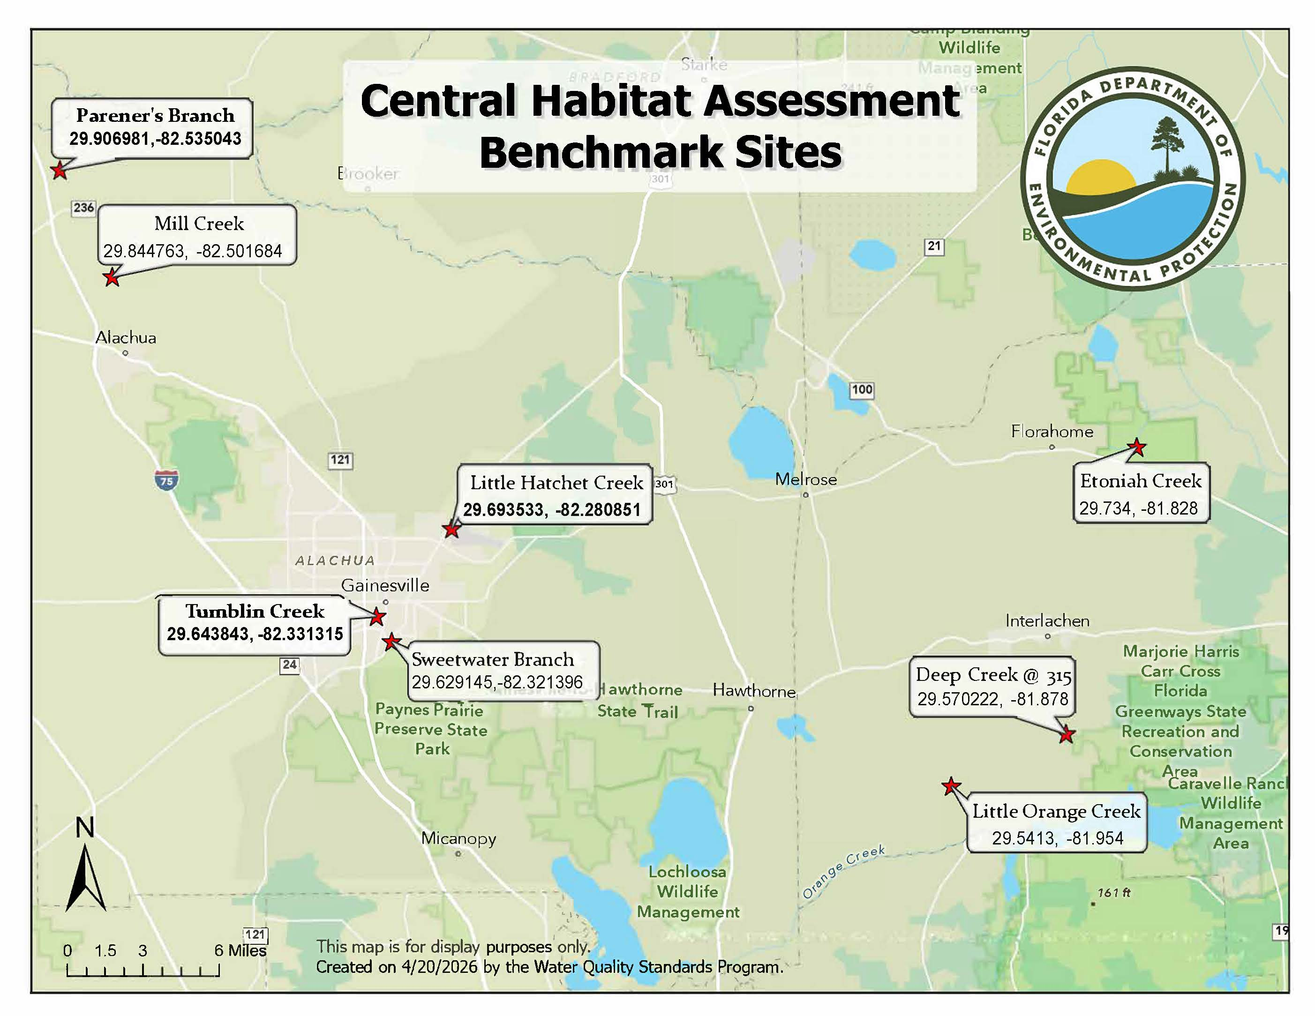
Select any group of sites for testing. Within the group, test at the bolded site and any other two sites. Refer to local hydrographs to determine which sites are appropriate for testing.

group 1
- Parener’s Branch
- Mill Creek
- Little Hatchet Creek
- Tumblin Creek
- Sweetwater Branch

group 2
- Tumblin Creek
- Sweetwater Branch
- Little Orange Creek
- Deep Creek
- Etoniah Creek

