**DRAFT**

# **Guidance for Stormwater Management Systems within a Contaminated Site**

**Florida Department of Environmental Protection**

**Division of Waste Management**

**District & Business Support Program**

**Tallahassee, FL**

**Disclaimer:**

This document is only intended as guidance. Nothing in this guidance supersedes any Federal, State, or Local requirements. This guidance does not authorize or provide design requirements for any construction of a stormwater feature. This guidance does not authorize dewatering or meet the requirements needed to obtain a dewatering permit. All applicable Florida Department of Environmental Protection, Water Resource Management Rules must be adhered to and are located at the following link: [Water Resource Management Rules](https://floridadep.gov/water/water/content/water-resource-management-rules).

**Problem Statement:**

Conditional Site Rehabilitation Completion Orders (CSRCOs) under Rule 62-780.680(2) or (3), F.A.C. may restrict construction of new and/or alteration of existing stormwater management systems (SWMS). The State supports reuse of contaminated sites and recognizes that new construction requires placement of SWMS to appropriately manage runoff from impervious surfaces. Contaminated sites may require expansion of the impervious areas (new building foundations, parking, pavement, access roads etc.) and may trigger modification of the existing SWMS.

In the case of contaminated sites that qualify for a conditional site rehabilitation completion order (CSRSO), the planning for potential areas on the site for future SWMS is important so as not to violate the possible engineering control, or otherwise cause contamination to circumvent the control and spread contamination to either previously uncontaminated areas or offsite. If such a spread or impact occurred, it would render the CSRCO void.

**Goal:**

The construction or modification of SWMS should not affect contamination at the site (cause leaching from soil or mobilize the groundwater contaminant plume). In some cases, the construction of SWMS may be addressed prior to closure and the restriction removed from the CSRCO. Please note that adequate demonstration must be provided that neither the currently proposed or any future modification of the SWMS will exacerbate the contamination at the site. Potential future development including the type and location of the SWMS should be evaluated. Guidance on addressing SWMS construction prior to closure is provided below.

For situations where prior SWMS evaluation is not possible, this guidance can also assist in obtaining approval for the construction of a new or modification of an existing SWMS on a contaminated site following closure.

**SWMS - Design & Best Practices at Contaminated Soil and/or Groundwater Sites in Relation to CSRCOs**

Due to the potential to cause leaching from soils, create a hydraulic head to spread contamination in groundwater across the site or off site to previously uncontaminated areas, the placement, design and use of stormwater structures, ponds, and pathways is a critical part of a plan to prevent the spread of pollution at known contaminated sites.

In general, stormwater structures, ponds and pathways are placed in previously non-contaminated areas of a site to prevent and/or reduce the possibility of causing the contamination to spread or increase from leaching or hydraulic head.

**Dry Pond vs Wet Pond**. Depending on the SWMS reviewing agencies, dry ponds must be designed to recover within 72 hours of a rain event. Dry Ponds with underdrains should recover within 36 hours. It is recommended that the bottom of the dry pond be at least 2 ft above the Seasonal High-Water Table (SHWT). Wet ponds have to recover to their static elevation within a certain timeframe (usually noted in the construction application) and the pond bottom is below the SHWT.

SWMS must be designed with site groundwater elevation data in mind to not adversely affect the contaminated areas of the site. A sufficient number of wells or piezometers must be used, and groundwater elevation contour maps developed to accurately demonstrate the direction of groundwater flow at the site for all aquifers that may be impacted. The stormwater design may only be placed in specific areas in such a way to not impact or cause vertical or horizontal movement of contamination.

Further consideration is needed to evaluate the placement of engineering controls, to clearly define the appropriate or available locations for the construction of SWMS.

The following questions should be considered during the planning stages of the development

* What will be the type of the future development, residential or commercial?
* Because of the land use and size as well as the underlying lithology, what type of stormwater system will work better:
  1. Wet detention system
  2. Detention with effluent filtration
  3. Dry system (retention pond)
  4. Underground exfiltration (subterranean gallery)
  5. Sand chimney
* What is the extent and depth of the groundwater plume in the restrictive area?
* Is the restriction for the use of groundwater and/or irrigation wells?
* Is soil contamination under an engineering control (EC) and will the EC be breached?
* Will dewatering during construction of the SWMS affect vertical or horizontal plume migration?
* How will the water from the dewatering operations be disposed (sanitary sewer, generic permit, NPDES)?

**Groundwater:**

A mounding model can be used to support that a SWMS installed some distance or location away from the plume will not cause the plume to migrate vertically or horizontally. Approved models and design requirements must be consistent with the agencies responsible for reviewing the SWMS application.

**Prior to Closure**

a. Depth to contaminant – A demonstration is provided that groundwater is at a depth that the infiltration from the SWMS will not cause the plume to migrate then it may be possible to remove the stormwater restriction from the CSRCO. The demonstration or modeling should be based upon the appropriate design storm event usually 100-yr/24-hour or 25-year/24-hour depending on the type of system (open or closed) and the reviewing agency. The SWMS should be engineered to impact only the upper surficial aquifer.

b. Plume in relationship to confining layer – If groundwater contamination is below a competent confining layer, stormwater restrictions should not be necessary. However, language may need to be included in the CSRCO that the confining unit cannot be breached in the construction of the SWMS and indicate actions to be taken if a breach occurs during construction of the SWMS.

c. If construction of the SWMS will occur on top of the plume and cannot be addressed by a. or b. above, then the CSRCO can specify that any SWMS construction will require use of a liner thereby eliminating the need for subsequent Department (Waste Management) approval. Please note that lined ponds are for storage/evaporation and need to have outflow structures. The outflow should direct runoff to areas away from the contamination and be designed so that the runoff does not remain or pond on the site.

**Subsequent to Closure**

SWMS constructed on top of the groundwater plume will require a liner unless a. and b. from “Prior Closure Section” above can be demonstrated.

SWMS constructed upgradient, cross-gradient or downgradient of the plume will require a mounding analysis be submitted to determine if the mound intersects the plume.

**Soil:**

If soil contamination is present, the impact of the proposed SWMS on potential leaching or direct exposure must be addressed.

If soils exceed the Leachability Soil Cleanup Target Level (L-SCTL), Synthetic Precipitation Leachate Procedure (SPLP, EPA Method SW-846-1312) testing can be conducted prior to closure to demonstrate that the contamination will not leach and the restriction on SWMS can be removed. An appropriate number of samples should be collected from different lithologies and the highest concentrations within those lithologic units used in the SPLP analysis. A minimum of three samples per lithologic unit is recommended, but additional samples may be required depending on the size of the impacted area.

If a dry pond is to be constructed on top of soil that exceeds the direct exposure soil cleanup target level, the pond bottom must have an engineering control in place to mitigate the exposure risk. This could be in the form of a 2-foot clean fill barrier, impermeable liner, or the use of an alternative soil cleanup target level for an appropriate exposure scenario. The control would be included in the Institutional Control Registry and documented in the CSRCO.

**Dewatering**

Pursuant to Rule 62-621.300(2), F.A.C, coverage under this generic permit constitutes authorization to discharge groundwater from dewatering operations through a point source to surface waters of the State. Please ensure that the parameters of concern in the groundwater restricted area are below the surface water criteria. See below.

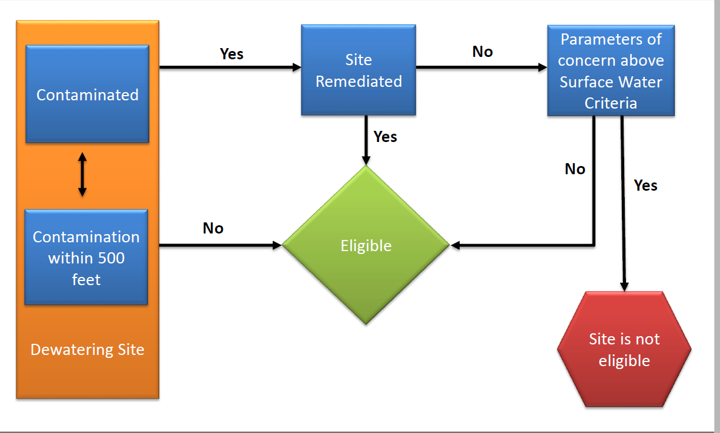

If the site does not qualify for a non-contaminated site permit, then an option is to contact the municipality for approvals to Discharge to the sanitary sewer. The Dewatering permit is processed by DEP District Offices.

**Further Consideration**

It may be prudent to label areas acceptable and non-acceptable to stormwater structures, ponds, and pathways as part of the draft CSRCO Process. This in effect would be a secondary restrictive area(s) for non-acceptable future stormwater structure construction zones. The primary restrictive area would be the contaminated area(s) itself. Each CSRCO site would have specific maps which specifically designates these areas and defines the extent of contamination and the restricted area(s). The secondary restrictive area map would create a future stormwater use map for each site.

For additional information please contact Lynn Walker at lynn.walker@floridadep.gov or 850-245-7502. You may also contact the contributors listed below.

*References:*

1. *Water Resource Management Rules - https://floridadep.gov/water/water/content/water-resource-management-rules*
2. *Operating Agreement Concerning Regulations under Part IV, Chapter 373 F.S. between SWFWMD and DEP*
3. *SWFWMD Environmental Resource Permit Applicant Handbook Volume II, effective June 1, 2018*
4. *DEP-NWFWMD ERP References and Design Aids*

Contributors

Lanita “Lynn” Walker, P.E.

District & Business Support Program

Florida Department of Environmental Protection

2600 Blair Stone Road

Tallahassee, Florida 32399

850-245-7502

[Lynn.Walker@floridadep.gov](mailto:Lynn.Walker@floridadep.gov)

Alex Webster, P.G.

Cleanup Section Supervisor

FDEP Northwest District

160 West Government St, Suite 308

Pensacola, FL 32502

850-595-0664

[Alex.Webster@floridadep.gov](mailto:Alex.Webster@floridadep.gov)

Yanisa G. Angulo, P.E., Environmental Administrator

Permitting and Waste Cleanup Program

Florida Department of Environmental Protection-Southwest District

13051 N. Telecom Parkway, Suite #101

Temple Terrace, FL 33637

Direct: 813-470-5757 | Main: 813-470-5700

[Yanisa.Angulo@floridadep.gov](mailto:Yanisa.Angulo@floridadep.gov)

Simone Core, Professional Engineer II

Permitting & Waste Cleanup Program Southwest District

Florida Department of Environmental Protection

13051 North Telecom Parkway

Temple Terrace, Florida 33637-0926

813-470-5753

[Simone.Core@floridadep.gov](mailto:Simone.Core@floridadep.gov)

John R. Sego, P.G.

Permitting & Waste Cleanup Program Southwest District

Florida Department of Environmental Protection

13051 North Telecom Parkway

Temple Terrace, Florida 33637-0926

Phone: 813-470-5756

[John.R.Sego@FloridaDEP.gov](mailto:John.R.Sego@FloridaDEP.gov)

Dale Melton, Environmental Consultant

Permitting and Waste Cleanup Program

Florida Department of Environmental Protection - Central District

3319 Maguire Blvd., Suite 232, Orlando, FL 32803-3767

407-897-4326

[Dale.Melton@floridadep.gov](mailto:Dale.Melton@floridadep.gov)

Indar Jagnarine, P.E.

Florida Department of Environmental Protection

Southeast District – West Palm Beach

3301 Gun Club Road, MSC 7210-1

West Palm Beach, FL 33406-3007

Office: 561-681-6640

Main: 561-681-6600

[Indarjit.Jagnarine@floridadep.gov](mailto:Indarjit.Jagnarine@floridadep.gov)

Missy Palcic, Professional Engineer III

Waste Cleanup Program Coordinator

FDEP - Northeast District

8800 Baymeadows Way West, Suite 100

Jacksonville, FL 32256

904-256-1544

[Merrilee.L.Palcic@floridadep.gov](mailto:Merrilee.L.Palcic@floridadep.gov)

Craig Parke, Professional Geologist II

FDEP - Northeast District

8800 Baymeadows Way West, Suite 100

Jacksonville, FL 32256

904-256-1542

[Craig.Parke@FloridaDEP.gov](mailto:Craig.Parke@FloridaDEP.gov)