**ISSUE INFORMATION COVER SHEET**

**_____ ACTION REQUEST (or) __X__ FYI ONLY**

To: All Regulatory Staff

From: Michael P. Halpin, Assistant Deputy Secretary**,** Regulatory Programs

Date: December 11, 2017

Subject: Tracking of Regulatory Program Enforcement Corrective Actions Requirements

**New Enforcement Corrective Actions Tracking:**

This guidance is intended to ensure that all requirements with due dates embodied within Consent Orders, Final Orders and Final Judgments are tracked for timely completion. To facilitate this tracking, an Access database has been developed and is required to be used in all Regulatory programs.

The “CAP Access Database” is a multipurpose database that tracks work plans and compliance activities across all programs, and is particularly useful in tracking enforcement. This was created as a single information location to contain all District and Division CAP staffs’ workload actions; to provide the capability to track follow-up and response to CAP activities; and to track corrective actions of enforcement documents. The flexible report functions can be used to ensure every action is completed in a timely manner. The CAP Access Database replaces the current spreadsheet format that many program areas needed for work-plans and tracking other compliance and enforcement deliverables. It also provides a holistic look at each inspector’s work load, and a reference for managers and above to track and follow-up on projects.

**How it should be used to track enforcement**:

In tracking enforcement, the CAP Access Database should be used to capture the existence of the enforcement document itself, as well as each corrective action required by that legal document and its due date. This is done by entering the details of the case on the appropriate program Case Management tab, as shown in the screenshot example below:

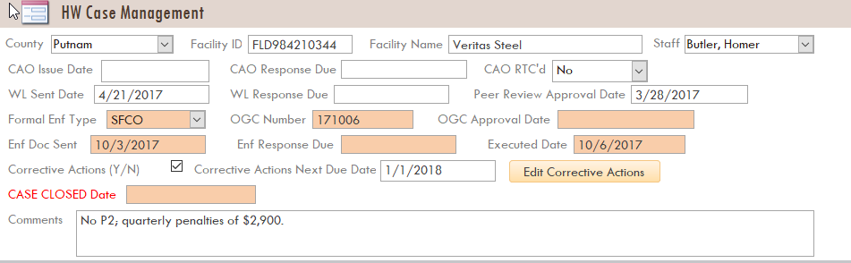

To capture each corrective action, click the ‘Edit Corrective Actions’ button and enter the name, penalty value, due date, etc., as shown in the screenshot below:

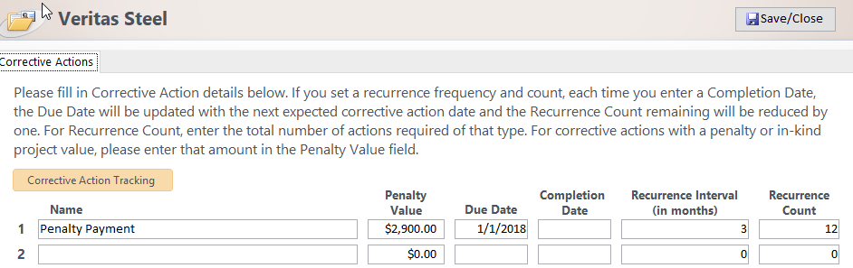

Fields are provided for frequency and total number of deliverables for actions that recur. As corrective actions are completed the ‘Completion Date’ field should be entered and, upon completion of all corrective actions, the ‘CASE CLOSED Date’ on the Case Management tab should be entered and a Closure Memo sent to OGC. Management and staff should regularly run reports showing upcoming and overdue corrective actions in order to follow-up on missing items and ensure upcoming due dates are met. Several reports, including ‘Cases with Corrective Actions (CA) Due’ are easily accessible in the lower left corner of the main screen, as shown in the screenshot below.

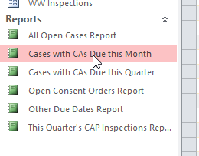

Effective immediately, the use of this database is required for all Regulatory Consent Orders and Final Orders, and Final Judgments. Should you have questions, please discuss with your Assistant or Deputy Director.