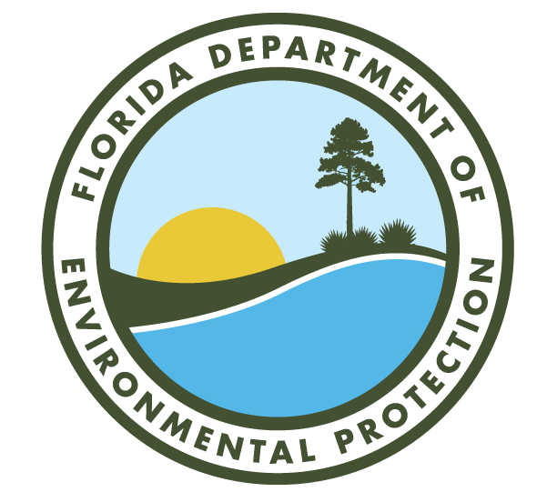

DEP Business Portal Help Guide

1. Registration Process 4
a. How to Register for an Account: 4

2. E-mail Verification and Complete Account Registration 6
b. How to Verify E-mail Address and Complete Registration: 6
c. Why Verify? 6
d. Verify E-mail: 7

3. Account Log In 9
a. How to Log In: 9

4. PIN 10
b. Purpose of PIN: 10
c. How to Apply for a PIN: 10
d. How to Reset PIN: 13
e. How to Report a Possible Compromised PIN: 14
f. How to Change PIN Security Questions: 14

5. Frequently Asked Questions (FAQs) 16
a. Account Creation FAQs: 16
b. Account Verification FAQs: 16
c. Account FAQs: 16
d. Issues not Covered in FAQs: 23
- Registration Process
  - How to Register for an Account:
  - Visit the DEP Business Portal at https://www.fldepportal.com/DepPortal/go/home. Locate and click Register from the top right corner of the screen.

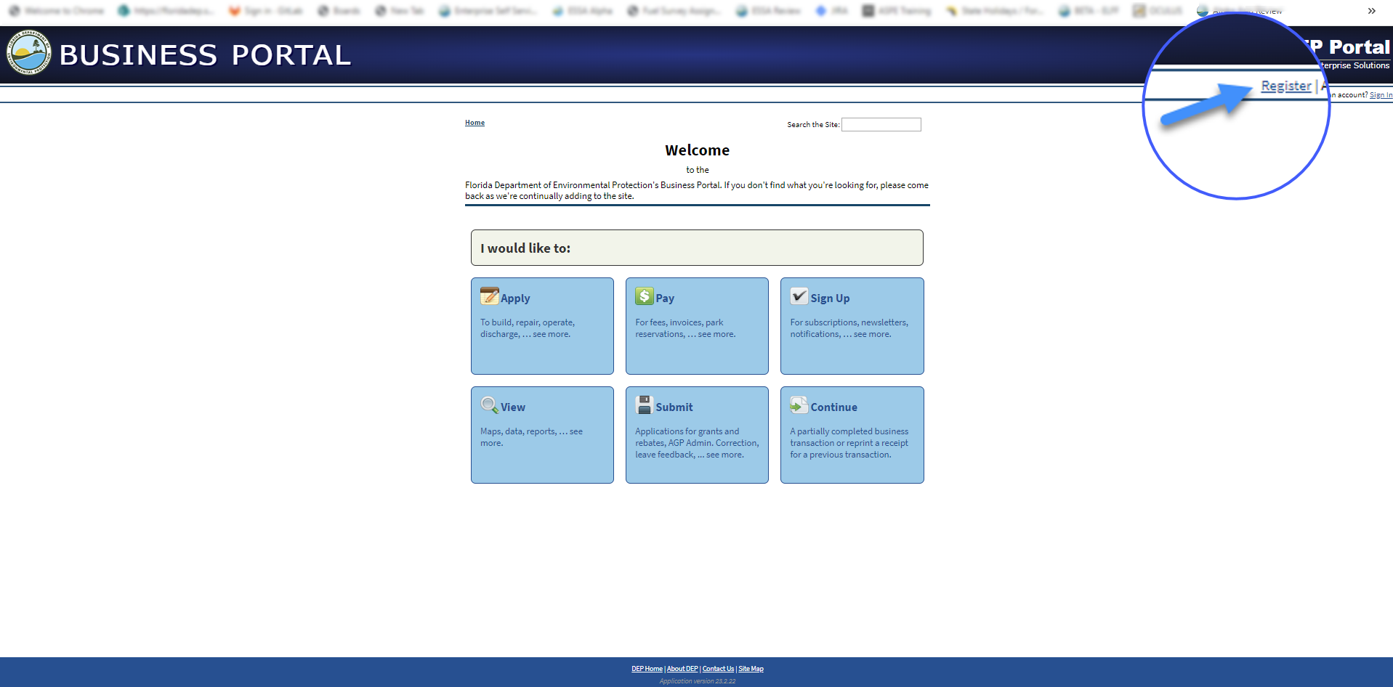

Enter and/or select the below required fields, then click Register.
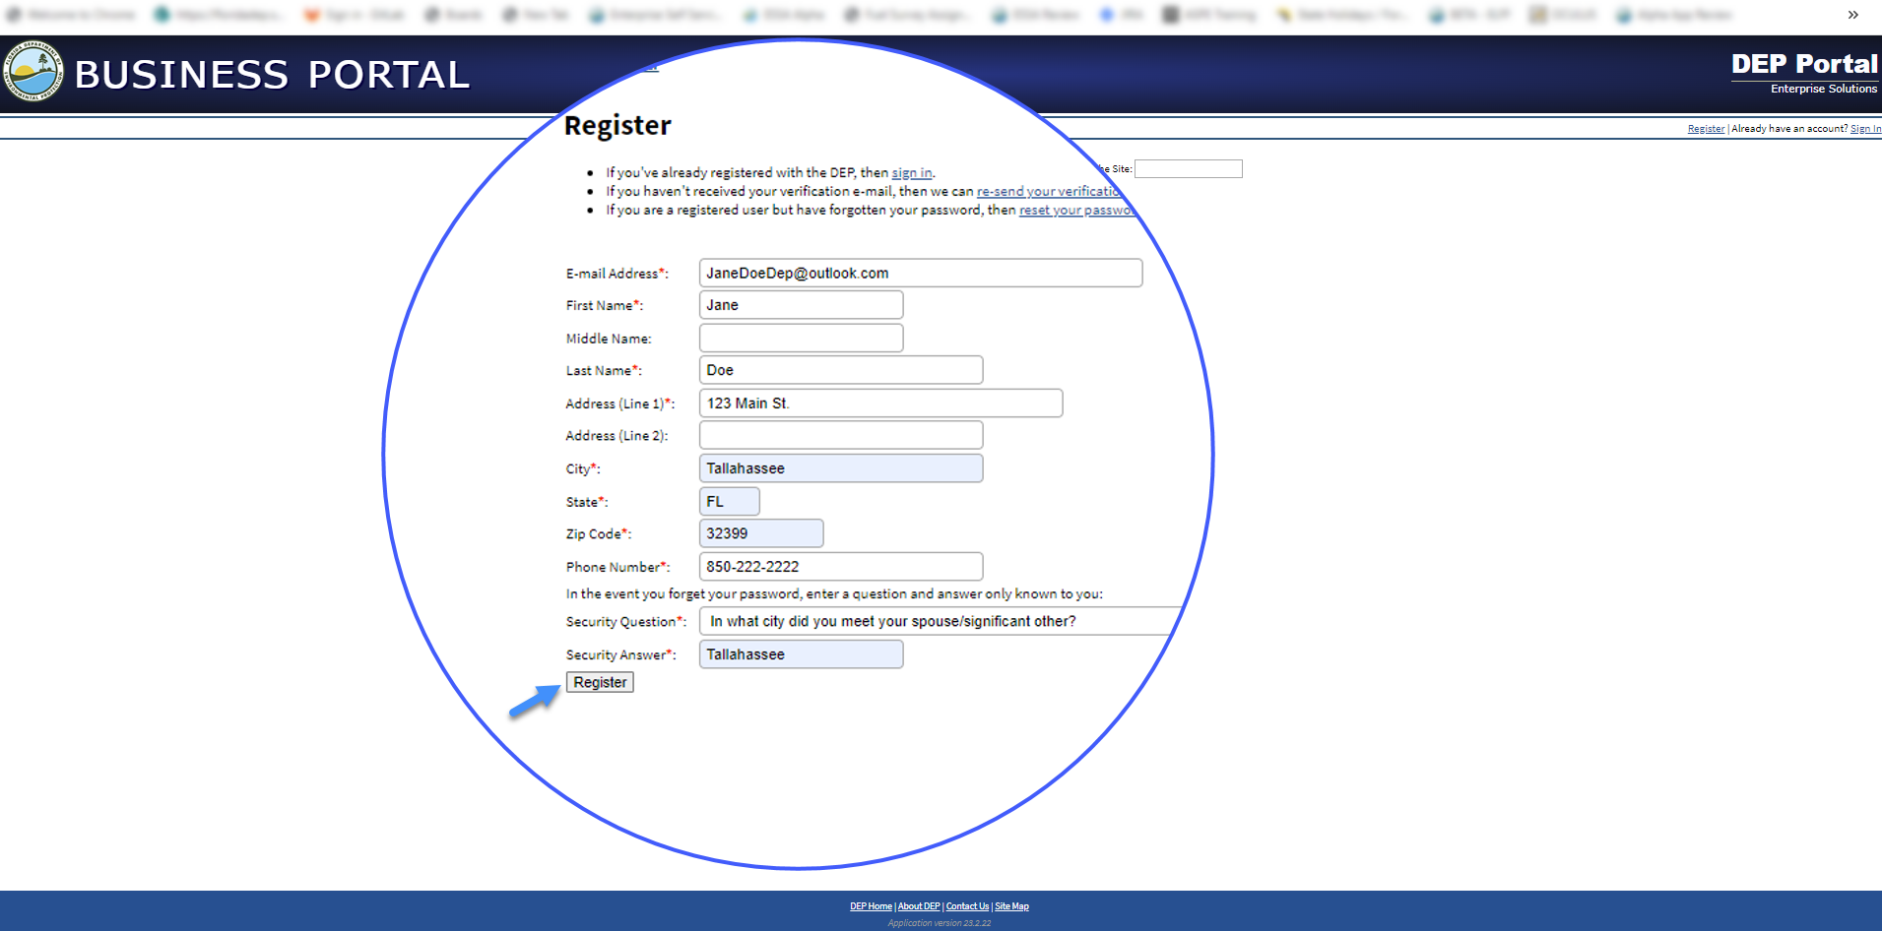
The DEP Business Portal displays the following confirmation message:
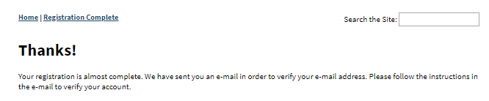
- E-mail Verification and Complete Account Registration
  - How to Verify E-mail Address and Complete Registration:
- Check the e-mail inbox that you registered your DEP Business Portal account with to confirm you received the FDEP Business Portal Registration Confirmation e-mail. To complete your registration and set your password, please verify your e-mail address by clicking the link in the e-mail.

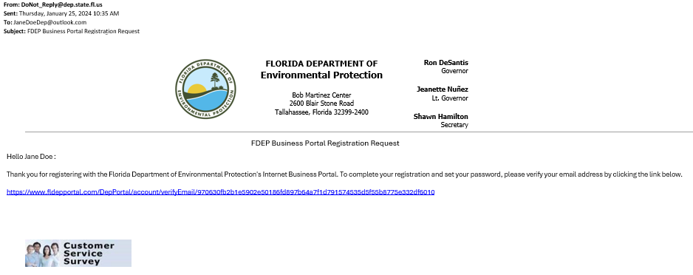
  - Why Verify?
- This is for enhanced security and account protection, users must click the link in the e-mail to verify their e-mail address and to complete the registration process to access their account.

  - Verify E-mail:
- Click the link in the FDEP Business Portal Registration Confirmation e-mail, you will be redirected to the ‘Verify E-mail’ page. Enter the answer to the security question, new password and confirm password, then click Create Password.
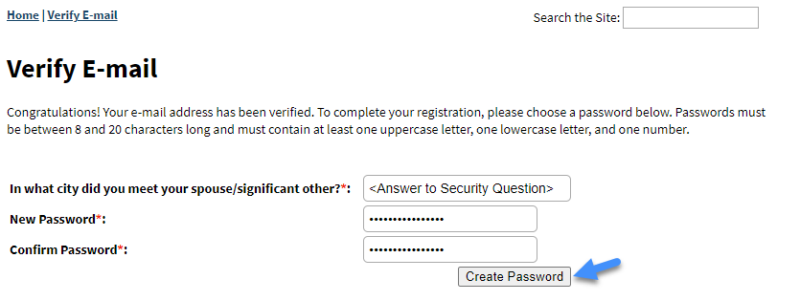

Check the e-mail inbox associated with your account to verify you received the FDEP Business Portal Registration Complete e-mail.
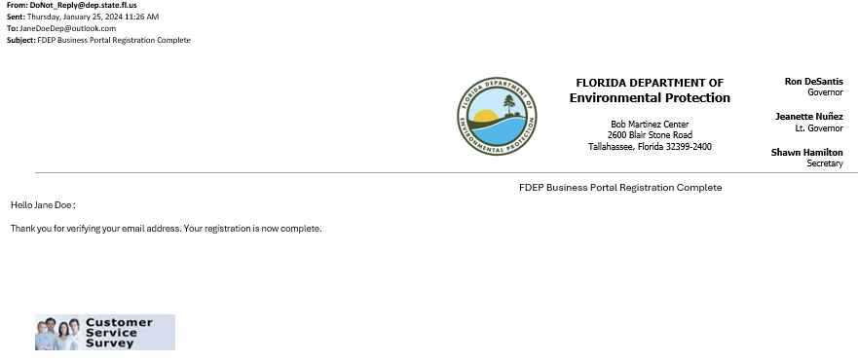
The system then redirects you to the ‘Sign In’ page.

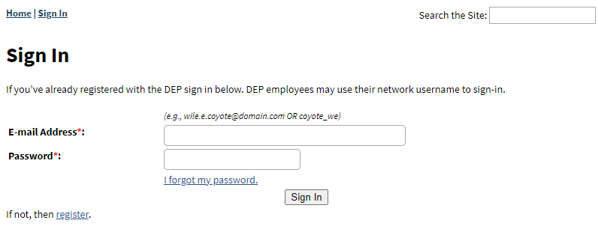
- Account Log In
- How to Log In:
- If you are not currently signed in to the DEP Business Portal, click Sign In in the top right corner of the screen, then enter your credentials and click Sign In.
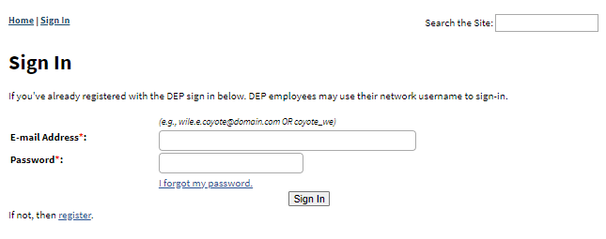
Once logged in you should see your name in the top right corner of the screen, next to Sign Out, indicating you are logged into your account.
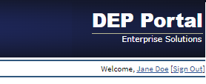

- PIN
- Purpose of PIN:
- To be able to electronically sign documents for DEP. Most DEP online business activity does not require a PIN signature.
- How to Apply for a PIN:
- Once logged into your account, click on your First Name Last Name, from the top right corner of the screen, the system will then redirect to ‘Your Account Details’ page. Scroll down to the PIN section. If you have not yet applied for a PIN, the screen will contain “Your account has not been approved for a PIN. If you need to electronically sign documents for DEP, you may apply for a PIN”. Please click apply for a PIN. If you have already obtained a PIN, the screen will show the status of the PIN.

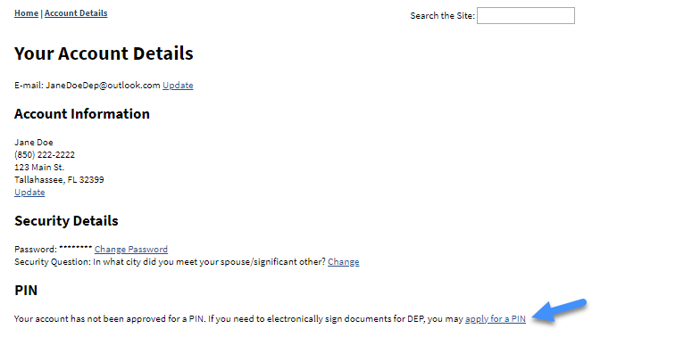

The system will redirect you to the ‘PIN Request’ page. Once here, select and enter the security questions and answers, then click Generate PIN Application.
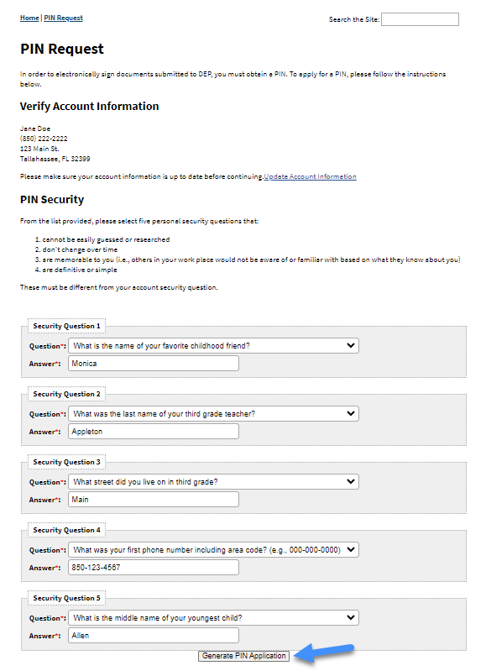

The system displays the following message, “We have sent an email to <YOUR_EMAIL_ADDRESS> with a form which must be notarized and mailed to us. Full instructions are included in the email.”
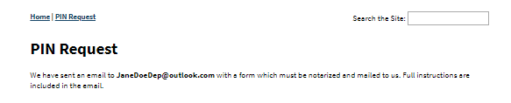
Check the e-mail inbox associated with your account to verify you received the PIN Request e-mail, with pdf pin request attachment, then follow the instructions in the e-mail to complete your PIN request.
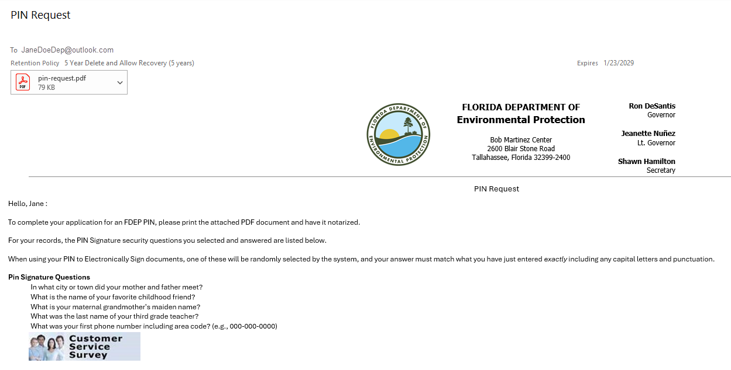
When your PIN request has been approved, you will receive a PIN Request Approved e-mail indicating that your PIN has been approved and to click the link in the e-mail to verify.
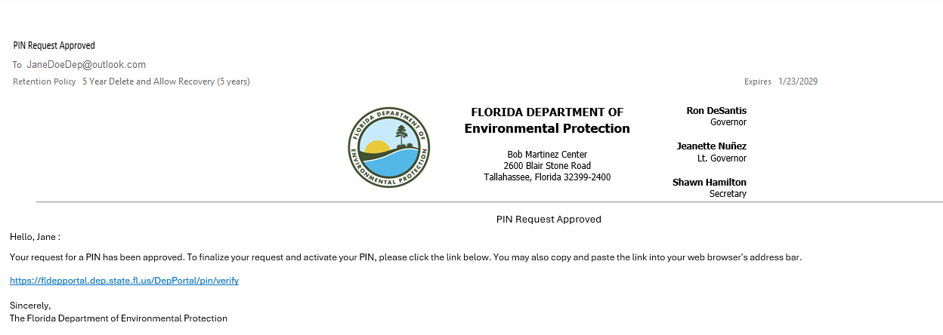
- How to Reset PIN:
- You can reset your PIN from ‘Your Account Details’ page, under the PIN section by clicking the reset link from “If you have forgotten your PIN, you can reset it.”
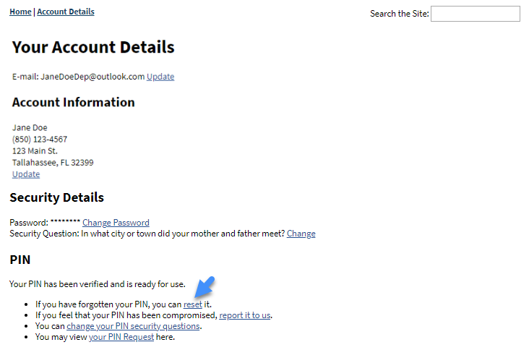
The system will redirect you to the ‘Reset PIN’ page. Enter the answer to your security question. The PIN displayed on the screen is the newly issued PIN, enter it in the ‘Confirm PIN’ field, then click Reset PIN. Save this new PIN for use on screens requiring a PIN signature. The system will then redirect you back to ‘Your Account Details’ page.
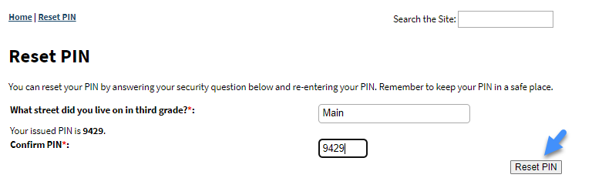
- How to Report a Possible Compromised PIN:
- You can report it to us from ‘Your Account Details’ page, under the PIN section, by clicking the report it to us link from “If you feel that your PIN has been compromised, report it to us.”
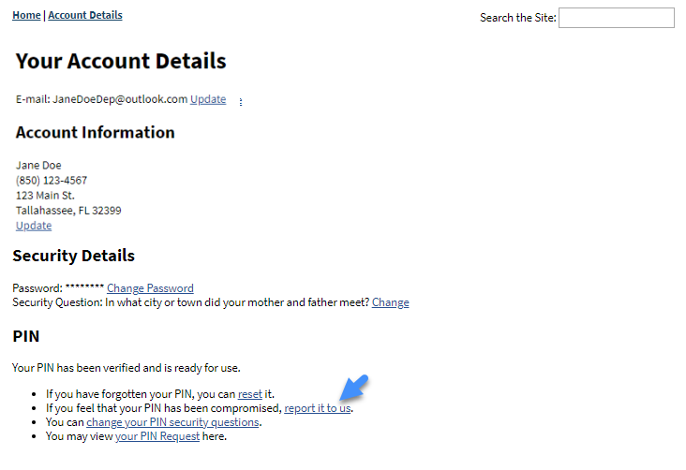
- How to Change PIN Security Questions:
- You can change your PIN security questions from ‘Your Account Details’ page, under the PIN section, by clicking change your PIN security questions link from “You can change your PIN security questions.”
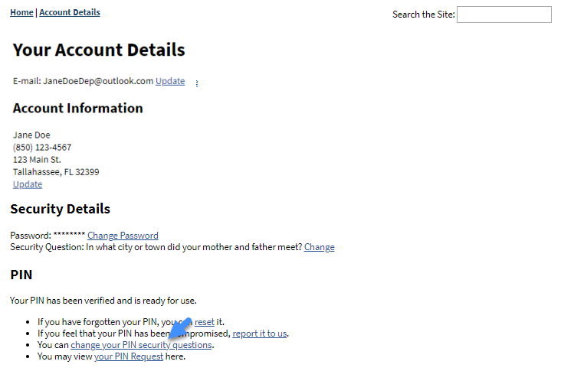
The system will redirect you to the ‘Change PIN Security’ page. Enter your PIN and select and answer the 5 PIN security questions. Note: the selected questions must be different from your account security question. Click Update PIN Security.
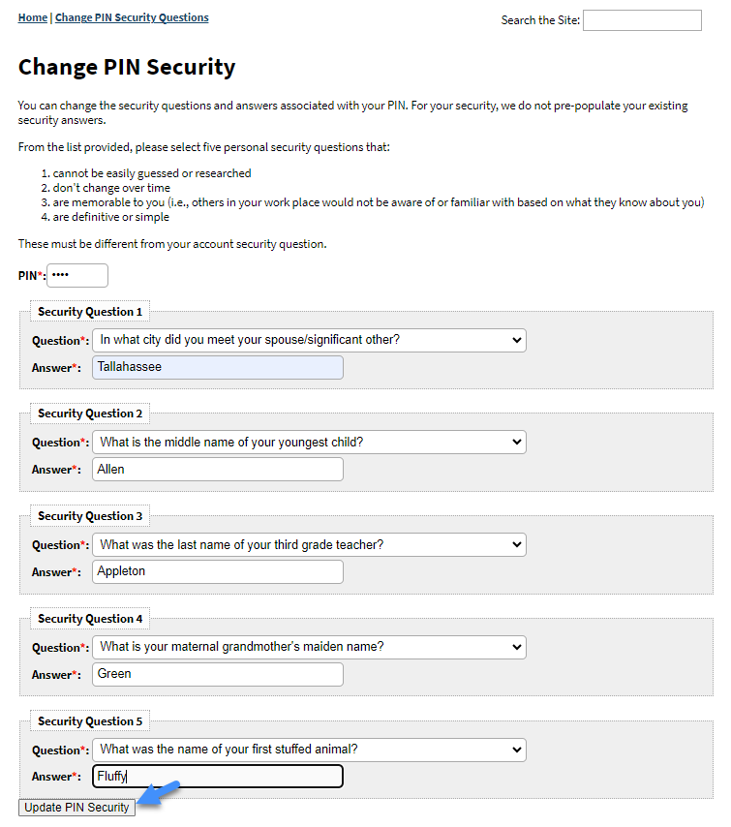
The system will then redirect you back to ‘Account Details’ page.
- Frequently Asked Questions (FAQs)
      - Account Creation FAQs:

Q: I registered for a new account, but I never received my verification e-mail.

A: Go to: https://www.fldepportal.com/DepPortal/account/resendVerificationEmail and enter your “E-mail Address” associated with your account and click Resend Verification E-mail. Please check your e-mail inbox associated with your account to verify your e-mail address.

Q: What are the password requiements?

A: Passwords must be at least 8 and 20 characters long and must contain at least one uppercase letter, one lowercase letter, and one number.
      - Account Verification FAQs:

Q: Why do I need to verify my account?
A: This is for enhanced security, account protection, and you must click the link in the e-mail to verify your e-mail address and to complete the registration process to access your account.

Q: How long does verification take?

A: Verification usually takes a few minutes, but it may vary based on the volume of requests or your email service provider.
      - Account FAQs:

Q: What if I forgot my password?
A: Go to the DEP Business Portal home page, in the right corner of the screenclick Sign In. The system will display the ‘Sign In’ page, once there, click I forgot my Password. The system will display the ‘Reset Password’ page with ‘E-mail Address’ field. Enter your “E-mail Address” associated with your account and click Continue. The system will display the following message, “Please check your e-mail. If an account matching the provided e-mail address exists, password reset instructions have been sent to it.” Please check your e-mail inbox associated with your account, locate the e-mail with a subject of FDEP Business Portal Confirmation Password Reset (see fig 1. below). Click the link in the e-mail, you will then be redirected to the ‘Verify Password Reset’ page. Once here, enter the required security answer, new password and confirm password, then click Create Password (see fig. 2). The system will return user to the ‘Account Details’ page.
Confirmation Password Reset E-mail (fig.1):
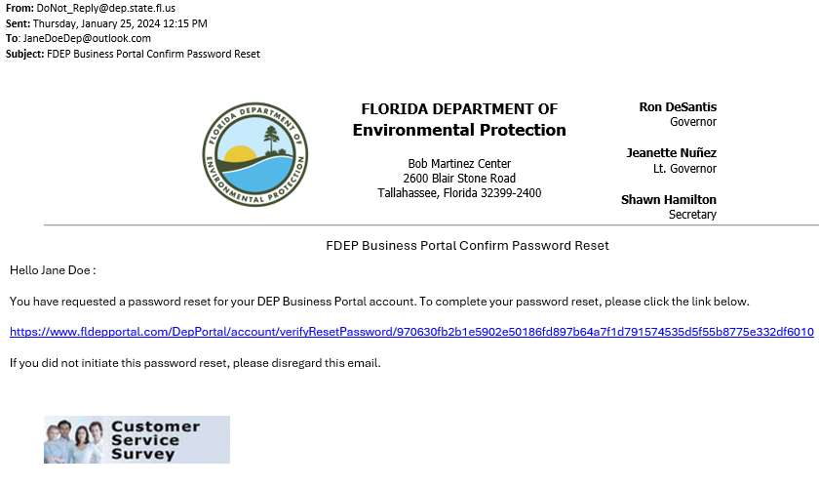
Verify Password Reset (fig. 2):
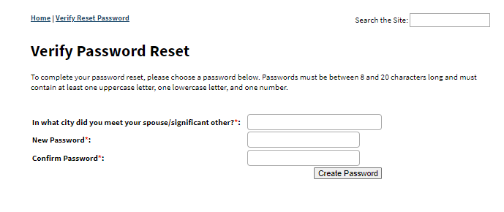
Q: What if I need to update my Account Information?
A: If you are not currently signed in to the DEP Business Portal, click Sign In from the top right corner of the screen, then enter your credentials and click Sign In. Once logged in you should see your name in the top right corner of the screen, next to Sign Out.
Click on your First Name Last Name, from the top right corner of the screen, the system will then redirect to ‘Your Account Details’ page.
Once here, under ‘Your Account Details’, click Update next to your e-mail address, the system will redirect you to the ‘Change E-mail’ page. Enter your new “E-mail Address” and “Confirm E-mail Address”, then click Change E-Mail.
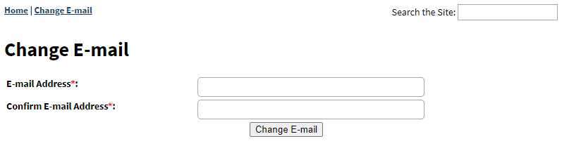
The system will display the following message:
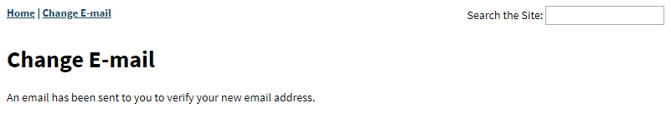
Check the e-mail inbox for the e-mail address you just updated to and verify you received the FDEP Business Portal Confirm Email Change e-mail.
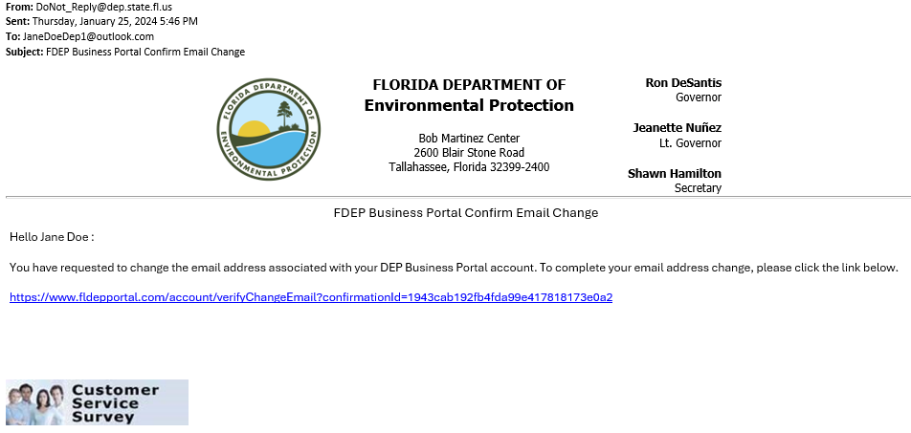
Click the link in the e-mail, it will redirect you to ‘E-mail Changed’ page, with the following message.
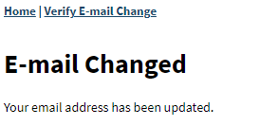
The current account associated e-mail address will also receive an e-mail, FDEP Business Portal Email Change Notification.
Note: No action is needed, unless you did not make this change and feel your account has been compromised. If you feel that your account has been compromised, click the report compromised link in the e-mail.
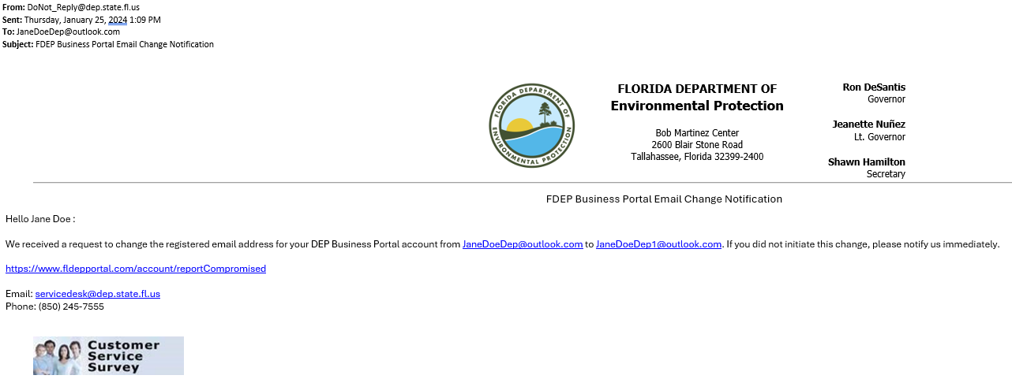
After clicking on the report compromised link in the e-mail, you are redirected to the ‘Report Account Compromised’ page. Enter your e-mail address that is associated with your account, then click Continue.
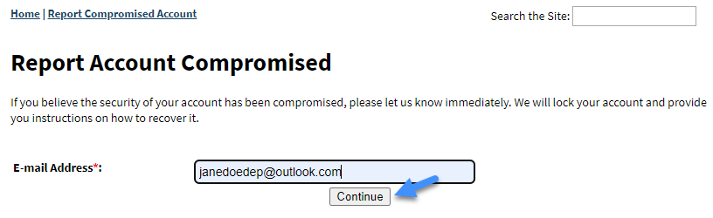

Also from ‘Your Account Details’, under the Account Information section, click Update to change any additional account information.
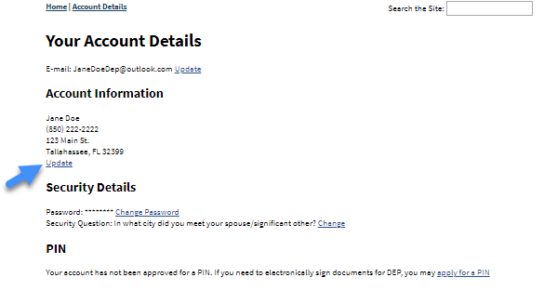
The system will redirect to ‘Update Account Information’, once here, make any desired changes, then click Update Account Information. The system will return you to ‘Your Account Details’.
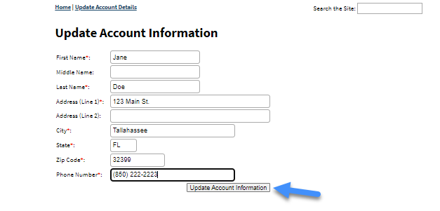
Q: What if I need to change my password?
A: If you are not currently signed in to the DEP Business Portal, click Sign In from the top right corner of the screen, then enter your credentials and click Sign In. Once logged in you should see your name in the top right corner of the screen, next to Sign Out.
Click on your First Name Last Name, from the top right corner of the screen, the system will then redirect to ‘Your Account Details’ page. Once here, under Security Details section, click Change Password.
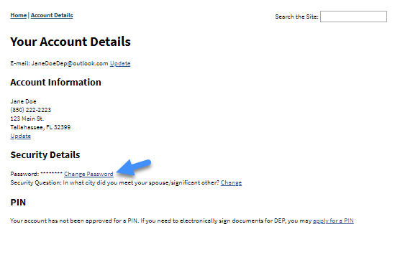
The system will redirect you to the ‘Change Password’ page. Once here, enter your existing password, then enter a new password and re-enter the new password again to confirm, then click Change Password. The system returns you to the ‘Sign In’ page.
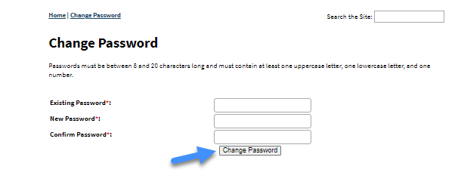
Q: What if I need to change my security question?
A: If you are not currently signed in to the DEP Business Portal, click Sign In from the top right corner of the screen, then enter your credentials and click Sign In. Once logged in you should see your name in the top right corner of the screen, next to Sign Out.
Click on your First Name Last Name, from the top right corner of the screen, the system will then redirect to the ‘Your Account Details’ page. Once here, under Security Details section, click Change.
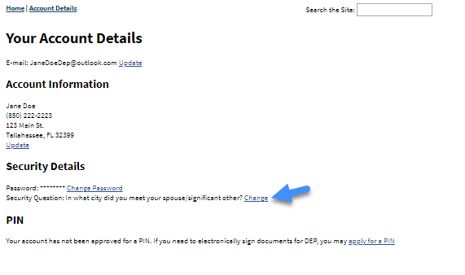
The system will redirect to ‘Change Account Security’ page. Once here, select a different Security Question from the ‘Security Question’ dropdown, then enter the answer to the security question that was selected in the ‘Security Answer’ field, then click Update Security.
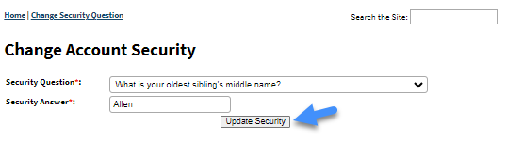
The system displays the following message, “Your security question and answer have been updated.”
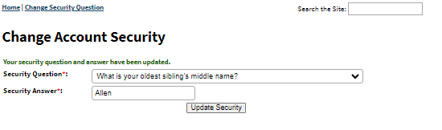
Q: What if I believe my account has been compromised?
A: From DEP Business Portal Home screen, at the bottom middle of the screen, click on Contact Us.
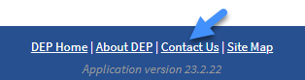
Under the Account Security section, click on report the compromise to us.
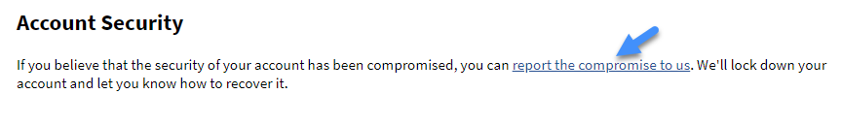
      - Issues not Covered in FAQs:

Q: What if I need to I have another issue not covered in the FAQ section?
A: From DEP Business Portal Home screen, at the bottom middle of the screen, click on Contact Us.
Under the ‘Contact Us’ section, click on e-mail address to e-mail us, or call us at the phone number listed below.
