Department of Environmental Protection Standard Operating Procedures for Field Activities

DEP-SOP-001/01

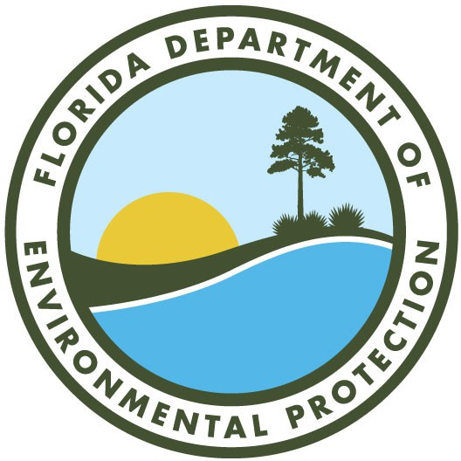

Florida Department of Environmental Protection 2600 Blair Stone Road
TALLAHASSEE, FL 32399-2400

May 2026

