Table of Contents
1.0 Supplemental Regulatory Measures General Provisions 1
1.1 Definitions 1
1.2 Status of MFL Compliance Points 3
1.3 Modification of Existing Permits 4
1.4 Environmental Resource and Consumptive Use Permitting Concurrency 4
2.0 Evaluation of Impacts to the Lower Santa Fe and Ichetucknee Rivers 5
3.0 Recovery Strategy Requirements for Existing and New Authorized Uses 5
3.1 Existing Use - Offsetting Impacts to MFL Recovery Points for Base Condition Water Use 6
3.2 New Use - Offsetting Impacts to MFL Recovery Points for New Uses 7
3.3 Methods for Offsetting Impacts to the MFL Recovery Points 8
3.3.1. Permits Subject to Revocation 8
3.3.2. Offset Credits for Retirement 8
3.3.3. Assignment of Benefits 9
3.4 Plan Submittal and Requirements for Offsetting Impacts 9
4.0 Temporary Allocations 11
5.0 Water Conservation 12
5.1 Public Supply Water Conservation Requirements 12
5.1.1. Standard Water Conservation Plan 13
5.1.2. Goal-Based Water Conservation Plan 16
5.1.3. Uniform Method for Calculating Residential Per Capita Daily Water Use 17
5.1.4. Public Supply Compliance Monitoring 17
5.2 Agricultural Water Conservation 17
5.2.1. Irrigation System Maintenance and Evaluation 18
5.2.2. Seepage Irrigation 18
5.2.3. Irrigation System Management 18
5.2.4 Agricultural Compliance Monitoring 20
5.3 Commercial/Industrial/Institutional (CII), Landscape Recreation (LR), and Mining/Dewatering (MD) Water Conservation Compliance Monitoring 20
6.0 Private Residential Irrigation 20
7.0 Prevention Strategy for MFL Compliance Points 21

1.0 Supplemental Regulatory Measures General Provisions

These rules are adopted by the Department of Environmental Protection (Department) in paragraph 62-42.300(XX), Florida Administrative Code (F.A.C.), pursuant to Section 373.042(5), Florida Statutes (F.S.), as a component of the overall Recovery Strategy for the Lower Santa Fe and Ichetucknee Rivers and Associated Priority Springs (LSFIR) minimum flows (MFLs), adopted in paragraph 62-42.300(XX), F.A.C. In accordance with Section 373.042(5), F.S., each water management district (District or Districts) shall implement the Department’s minimum flow or minimum water level and recovery or prevention strategy without the need for District’s adoption by rule.

These Supplemental Regulatory Measures apply to all uses of water authorized under Chapter 373, F.S., with withdrawal points within the North Florida Regional Water Supply Partnership (NFRWSP) area (Figure A), which includes Alachua, Baker, Bradford, Clay, Columbia, Duval, Flagler, Gilchrist, Hamilton, Nassau, Putnam, St. Johns, Suwannee, and Union counties.

Unless otherwise stated, these rules supplement (are in addition to) the rules of the Suwannee River Water Management District (SRWMD) and the St. Johns River Water Management District (SJRWMD) for regulating consumptive uses of water in the NFRWSP area. Notwithstanding, where explicitly stated, these rules supersede (replace) specifically identified rules of the Districts regulating the consumptive use of water in the NFRWSP area.

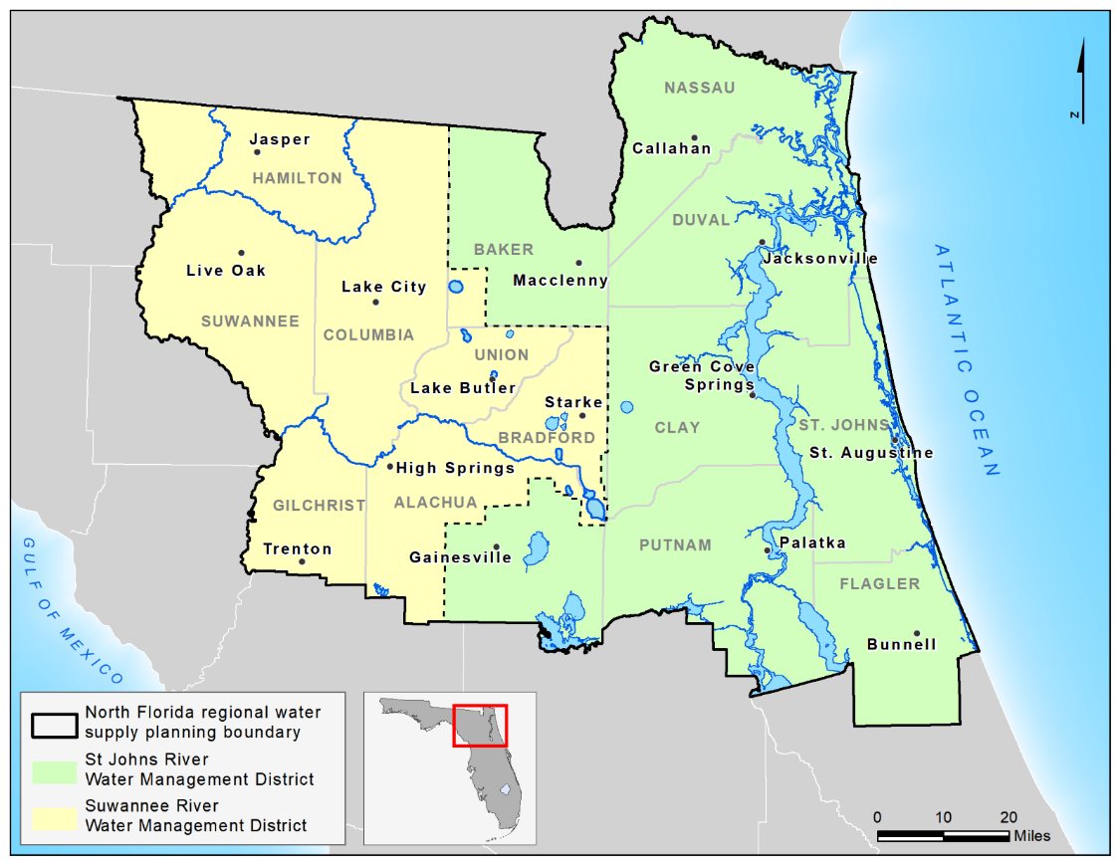
Figure A. Map of North Florida Regional Water Supply Partnership area

1.1 Definitions

- Authorized uses: Uses of water authorized by a consumptive use permit issued by the applicable District, Department, general permit by rule, or by statute.

- Consumptive use permit (CUP): a permit that authorizes the consumptive use of particular quantities of ground or surface water. The phrases “Consumptive Use Permit,” “Consumptive Use Permitting,” and “Consumptive Use Applicants” are synonymous with “Water Use Permit,” “Water Use Permitting,” and “Water Use Applicants,” respectively, as used by agencies implementing Part II of Chapter 373, F.S

- MFL Compliance Point: The point at which an MFL is set forth in Rule 62-42.300, F.A.C., which is used for evaluation and compliance.

- MFL Prevention Points: An MFL Compliance Point that is evaluated in accordance with section 1.2 as meeting its MFL, but, based on 20-year water use projections, would not meet its MFL.

- MFL Recovery Points: An MFL Compliance Point that is evaluated in accordance with section 1.2 as not meeting its MFL.

- Offset: An action to reduce or eliminate a harmful impact that has occurred or would otherwise occur as a result of withdrawals but for the offset. An offset shall be evaluated in cubic feet per second (cfs) at the MFL Compliance Points.

- Base Condition Water Use (BCWU):
- For the purposes of the Lower Santa Fe and Ichetucknee River MFL Recovery Strategy, the Base Condition Water Use (BCWU) for Existing Uses shall be defined as the average quantity of groundwater in million gallons per day (mgd) from the Upper and Lower Floridan aquifers that was withdrawn by the permittee between January 1, 2014, and December 31, 2018. In determining the BCWU, the Districts shall consider and allow adjustments if the applicant demonstrates the 2014 – 2018 average water use is not representative of normal operations. Supporting evidence of withdrawal quantities shall be provided by the applicant if withdrawals were unmetered during the BCWU time period. Where no supporting evidence is available, the Districts shall utilize the best available information to support a BCWU. Such information may include, but is not limited to, the Florida Statewide Agricultural Irrigation Demand (FSAID) database, metered monitoring, or electric usage estimates. If a permittee or applicant fails to demonstrate a withdrawal quantity for a specific year and no reliable information is available, then the water use associated with the permit for that year shall be zero.

- For permits that were initially issued between January 1, 2014, and December 31, 2018, the BCWU will be calculated using the average of the actual water use for the duration of the permit prior to December 31, 2018.

- For the purposes of the Lower Santa Fe and Ichetucknee River MFL Recovery Strategy, the BCWU for New Uses shall be zero.

- Existing Uses: Actual water use associated with any authorized consumptive uses in effect as of December 31, 2018.

- New Uses: Any use of water other than Existing Uses. New Uses include Group A and Group B. Where in this rule no group is identified, the provision shall apply to both groups.
- Group A includes New Uses that occurred between January 1, 2019, and the effective date of this rule.

- Group B includes New Uses that will occur after the effective date of this rule.

- Temporary Allocation: An authorized use of water that is temporarily required by an applicant or permittee to meet their reasonable demands during the implementation of a project to achieve the required offset.

- North Florida Regional Water Supply Partnership (NFRWSP) area: The area depicted in Figure A.

1.2 Status of MFL Compliance Points
Each MFL Compliance Point was evaluated to determine the current and projected waterbody condition relative to the MFL. The MFL Compliance Points were identified as meeting their adopted MFLs, being in prevention, or being in recovery.

As of [effective date], the status of the MFL Compliance Points as set forth in Rule 62-42.300(1)(XX), F.A.C., are identified in Table 1 below.

Table 1. MFL Compliance Point Status
MFL Compliance Point | Status | 2014-2018 Net Flow Deficit  (cfs)
Santa Fe River near Fort White  (USGS ID 02322500) | Meeting | N/A
Santa Fe River at US HWY 441 near High Springs  (USGS ID 02321975) | Recovery | -1.0
Ichetucknee River at HWY 27 near Hildreth  (USGS ID 02322700) | Recovery | -6.3

The Districts shall, in coordination with the Department, evaluate the status of the MFL Compliance Points periodically using the best available tools and data for each MFL Compliance Point and revise the status assessment of the MFL Compliance Points by rule, as needed.

1.3 Modification of Existing Permits

Following the effective date of these rules, each District shall modify all applicable existing consumptive use permits with withdrawal points within the NFRWSP area by letter modification to be consistent with Rule 62-42.300(1), F.A.C., and these Supplemental Regulatory Measures. Notice of agency action will be provided to the permittee and to persons who have requested notice as required by Section 120.60, F.S.

At a minimum, such permit modifications of existing consumptive use permits within the NFRWSP area shall incorporate the applicable measures and conditions described in sections 1.1 (Definitions), 2.0 (Evaluation of Impacts to the Lower Santa Fe and Ichetucknee Rivers), 3.0 (Recovery Strategy Requirements for Existing Authorized Uses), 5.0 (Water Conservation), and 8.0 (Special Permit Conditions) of these Supplemental Regulatory Measures, including all subparts. Specifically:

- All permits shall be modified to be consistent with the provisions of section 3.0. Offsets will be calculated in accordance with the evaluated impacts of the permitted use as described in section 2.0, and the corresponding method of recovering those impacts as described in section 3.0.

- The applicable permit conditions specified in section 8.0 shall be incorporated into all existing consumptive use permits in the NFRWSP area and shall be placed on all permits for New Uses within the area.

1.4 Environmental Resource and Consumptive Use Permitting Concurrency

If an individual consumptive use permit (CUP) application includes either of the following two requests for a consumptive use of water, then the CUP application shall not be considered complete until the applicant has submitted a complete application for an environmental resource permit (ERP), pursuant to Chapter 62-330, F.A.C.:

- Requests to irrigate golf course areas, cemeteries, nursery plants, agriculture crops, or landscaped areas, that are part of an artificially created surface water management system that requires an individual or general ERP; or

- Requests to dewater associated with a project that requires an individual or general ERP under Chapter 373, F.S.
In all other cases, the District can take final agency action on the CUP application without regard for the status of the ERP application.

The requirement to submit a complete application for an ERP shall not apply to:

- Requests for a consumptive use of water associated with phosphate mining with an approved reclamation plan pursuant Chapter 378, F.S.; or

- Requests for a consumptive use of water associated with an ERP project that qualifies for a general permit under Section 403.814(12), F.S.; or

- A CUP application that does not meet the conditions for issuance in applicable Rule 40B-2.301 or 40C-2.301, F.A.C.

2.0 Evaluation of Impacts to the Lower Santa Fe and Ichetucknee Rivers

All permittees and applicants for renewals, modifications, and New Uses, shall be evaluated for their predicted impact on the MFL Compliance Points utilizing best available information. Impacts from water withdrawals will be evaluated for each MFL Compliance Point.

Impacts to the MFL Compliance Points will be evaluated by comparing the existing natural system to the predicted post withdrawal conditions. The evaluation of MFL Compliance Points will consider their hydrologic characteristics and susceptibility to impacts resulting from hydrologic alterations attributed to the proposed water withdrawals individually and cumulatively. The assessment of impacts expected due to the water use will be based on the best available information. An applicant shall only be required to address its relative contribution to impacts on the MFL Compliance Points from its water use in accordance with section 3.0.

To evaluate the conditions below, the applicant must provide the following supporting information as applicable to assist in the impact evaluation. Applicants are encouraged to provide any additional evidence that supports the applicant's evaluation of impact and seek technical assistance from the Districts.

- Information regarding the potential impact of the individual and cumulative effects of the proposed water use on the MFL Compliance Points in their current condition.

- A summary report of any modeling performed and electronic copies of any modeling files for District staff to review. When a permittee or applicant submits a groundwater flow model in support of its application or its impact analysis as described below, the permittee or applicant must provide reasonable assurance that the model accurately simulates potential impacts to the MFL Compliance Points. When submitting the results of a groundwater flow model, impacts to the MFL Compliance Points shall be reported as simulated changes in flow. The modeling report must also include any proposed impact offset results.

- Where there is potential for impacts, information demonstrating that an offset eliminates the impacts to MFL Recovery Points is required to determine whether impacts to MFL Recovery Points can be eliminated pursuant to section 3.0 and information required to determine whether impacts to MFL Prevention Points can be eliminated pursuant to section 7.0.

3.0 Recovery Strategy Requirements for Authorized Uses

The rules contained within this section address the status of authorized water uses while the projects and strategies to recover the MFL Recovery Points are being implemented, and the responsibilities of existing permittees in the recovery of the MFL Recovery Points.

All Authorized Uses shall be considered consistent with the Recovery Strategy and will not be subject to revocation in whole or in part, provided the permittee meets the conditions of its permit as modified pursuant this strategy, and meets all requirements within this rule. Permittees that do not meet the requirements within this rule will be subject to permit revocation in whole or in part. Nothing in this section shall be construed to alter the District’s authority to enforce or modify a permit under circumstances not addressed in this section.

3.1 Existing Use - Offsetting Impacts to MFL Recovery Points for Base Condition Water Use

All Existing Uses shall offset their proportionate share of BCWU impacts as calculated below. Such offset shall be accomplished as soon as practicable but in no case more than 20 years from [effective date]. An existing permit with an increase in use or allocation above the BCWU (i.e., a New Use) must also offset impacts for the New Use according to section 3.2.

A permittee’s required offset shall be their proportionate share of the recovery for an MFL Recovery Point, based on the permittee’s proportionate share of impacts from the permittee’s BCWU on the MFL Recovery Point (I_{p}) divided by the total impact to the MFL Recovery Point (I_{t}) using the best available estimate of average water uses in 2014-2018 for the model area outlined in Figure B and multiplied by the 2014-2018 Net Flow Deficit (Table 1) (I_{nfd}) at the MFL Recovery Point.

Permittee’s proportionate share of recovery = [(I_{p})/(I_{t})] x (I_{nfd})

For example, if a permittee’s BCWU has an impact that reduces the flow at an MFL Recovery Point by 1 cubic foot per second (cfs) and the total impact to the MFL Recovery Point from the best available estimate of average water uses in 2014-2018 is 10 cfs, and the 2014-2018 Net Flow Deficit at the MFL Recovery Point is 6.3 cfs as:

(I_{p}) is 1 cfs,
(I_{t}) is 10 cfs,
(I_{nfd}) is 6.3 cfs,

then the permittee’s calculated proportionate share of the recovery that must be offset would be (1 cfs/10 cfs) x 6.3 cfs = 0.63 cfs.

The net benefit of an offset implemented by the permittee in accordance with section 3.3, that provides a benefit to an MFL Recovery Point shall be calculated and applied to offset the permittee’s proportionate share of impact. The net benefit of the offset must be calculated and incorporated into the permittee’s permit for the benefits of the offset to be credited to the permittee. If the permittee ceases operation of the offset project or its contribution to the operation of the offset project, or the project does not achieve the anticipated benefit, or water use occurs where an offset credit for retirement was granted, then either an equivalent replacement offset must be provided (or contribution thereto), or the permit allocation must be reduced to below the BCWU to address the permittee’s proportionate share of impacts to the MFL Recovery Points.
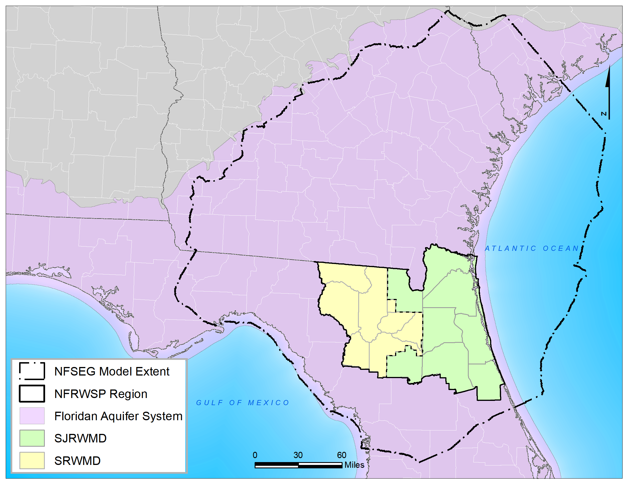
Figure B. Map of NFSEG Model Extent

3.2 New Use - Offsetting Impacts to MFL Recovery Points for New Uses
Permittees and applicants for New Uses Group A shall fully eliminate or offset their proportionate share of their BCWU and 100% of their authorized use in excess of their BCWU as soon as practicable and in no case more than 20 years from [effective date] unless a Temporarily Allocation is approved pursuant to section 4.0. Permittees and applicants for New Uses Group B shall fully offset such new impacts to the MFL Recovery Points as soon as practicable and in no case more than 10 years from [effective date].

The net benefit of any offset project(s) implemented in accordance with section 3.3, must be calculated and incorporated into the permittee’s consumptive use permit for the benefits of the offset project(s) to be credited to the permittee. If the permittee ceases operation of any offset project or its contribution to the operation of an offset project, or the project does not achieve the anticipated benefit, or water use occurs where an offset credit for retirement was granted, then either an equivalent replacement offset must be provided (or contribution thereto), or the permit allocation must be reduced to address the permittee’s impacts to the MFL Recovery Points.

3.3 Methods for Offsetting Impacts to the MFL Recovery Points
Impacts associated with New and Existing Uses may be offset in any of the following ways:

- Implementation of water resource or water supply development projects.

- Retirement of water use subject to sections 3.3.1. and 3.3.2.

- Other means to reduce impact at an MFL Recovery Point.

An offset (including partial offset) will be approved to the extent the applicant or permittee demonstrates an increase in flow in whole or in part to the MFL Recovery Point(s).

3.3.1. Permits Subject to Revocation

Permits that are subject to revocation in whole or in part by a District pursuant to section 373.243, F.S., are not eligible to be used for offset credit regardless of whether such permit has been revoked. The reduction of water use from those permits will accrue to the resource.

Agricultural water uses with no water use for five consecutive years due to rotational practices, weather, or low water-use commodities, must show evidence of agricultural operations existing over that time period.

3.3.2. Offset Credits for Retirement

An applicant is eligible to receive offset credit for the net benefit of the offset from retiring all or part of the BCWU of an Existing Use, except as otherwise provided in 3.3.2.1.

3.3.2.1 Ineligible Offset Credits

An offset credit for retirement of an Existing Use shall not be available when:

- The Existing Use is subject to revocation due to nonuse regardless of whether such permit has been revoked; or

- The water use is not authorized under an existing consumptive use permit issued pursuant to part II, Ch. 373, F.S.; or

- The net impact of the Existing Use does not require an Impact Offset Plan pursuant to section 3.4.
No offset credit available for revocation of New Uses.

3.3.2.2 Calculation of Offset Credit for Retirement of Existing Uses

To receive an offset credit for the retirement of Existing Uses, the offset associated with the retiring permit shall be the lesser of:

- The retiring Existing Use’s net impact on the MFL Recovery Point associated with its BCWU minus its proportionate share of recovery as calculated in section 3.1; or

- The retiring permit’s net impact on the MFL Recovery Point associated with its average water use in the most recent five-year period minus its proportionate share of recovery as calculated in section 3.1; or,
- The retiring permit’s net impact on the MFL Recovery Point associated with its average demand for the average 5-in-10 year (normal year) rainfall condition minus its proportionate share of recovery as calculated in section 3.1.

Any offset credit shall accrue according to section 3.3.3.

Benefits of retirement or reduction in consumptive uses existing as of the BCWU years that are not part of an offset shall accrue according to section 3.3.3.

3.3.3. Assignment of Benefits

The benefit of any offset project, or a portion thereof, shall accrue to the entity providing the offset project, one or more entities designated by the providing entity, or the natural systems. For any offset benefit applied to a permit at the time of offset project implementation, the providing entity or designated entity must demonstrate a demand for the water and meet the conditions for permit issuance.

If the providing entity or designated entity cannot demonstrate a demand for all the water made available by the offset project during the duration of the permit, any remaining water shall be available for use in the following order:

- Deficits associated with existing exempt and sub-threshold uses.

- Deficits associated with anticipated exempt and sub-threshold uses.

- Deficits associated with existing permitted uses.

- Applications for New Uses or increases in allocation in accordance with Department and District rules.
In no case can a permittee receive an offset credit greater than the permittee’s net impact to an MFL Recovery Point based on the end of permit allocation.

3.4 Plan Submittal and Requirements for Offsetting Impacts
In accordance with the plan due dates below, permittees shall submit to the District an Impact Offset Plan for review and approval that demonstrates how the permittee will offset their proportionate share of impacts to the MFL Recovery Points in accordance with sections 3.1 through 3.3, above. If a permittee impacts more than one MFL Recovery Point, the plan due date, as listed below, is based on the greatest impact to the MFL Recovery Points.
Offsets that will be implemented during the duration of the permit shall be evaluated every five years in Form XX - Impact Offset Plan Status Report after the Impact Offset Plan due dates identified below in Table 2, and at critical milestones for projects identified in the plan to ensure the successful implementation of the identified project(s).

Table 2. Impact Offset Plan Due Dates
Impact from water use | Impact Offset Plan Due Date
0.1 cfs or greater at any MFL Recovery Points as of the BCWU | No later than two years after [effective date], or upon application for modification to increase allocation or renewal, or 10-year compliance review, whichever is sooner.
0.01 cfs or greater but less than 0.1 cfs at any MFL Recovery Points as of the BCWU | No later than 10 years after [effective date], or upon application for modification to increase allocation or renewal, or 10-year compliance review, whichever is sooner.
All New Uses after the effective date of this rule as defined in section 1.1 | Upon application.

At a minimum, the Impact Offset Plan shall include:

- For Existing Uses, a description of each project or strategy the permittee intends to implement to offset their proportionate share of impacts (in cfs) from their BCWU at the MFL Recovery Points in accordance with section 3.1, as applicable. If intending to utilize an offset credit for retirement, the specific retiring permit must be identified in a permit condition of the permit receiving the credit.

- For New Uses, a description of each project or strategy the permittee intends to implement or participate in to offset impacts (in cfs) in excess of their BCWU in accordance with section 3.2, as applicable.

- An estimate of the benefits of each project or strategy to the MFL Recovery Points including all necessary supporting information used to calculate the benefits and a proposed method for ensuring the project achieves the anticipated benefit.

- For offset projects implemented by a party other than the permittee (e.g., one of the Districts), the permittee shall provide a copy of the participation agreement between the permittee and the other party, which must include the project description, total estimated benefits of the project, methods for ensuring the project will achieve the anticipated benefits, and total offset benefit credited to the permittee.

- A water conservation plan consistent with implementation of water conservation elements and reporting requirements unless previously submitted as required in section 5.0.

- A schedule for implementation of the projects and strategies including a start and completion date. The completion date should be as soon as feasible, and consistent with the requirements for offsetting impacts as described in sections 3.1 and 3.2 for Existing and New Uses, respectively. For offsets that will be completed during the duration of the permit, the schedule should include at a minimum 5-year milestones and major milestones, such as permitting, design, bidding, start and end of construction, etc.
Existing water supply or water resource development projects (such as aquifer recharge, impact offsets as described in rule 62-40.416(7), F.A.C., or substitution credits as described in rule 62-40.416(8), F.A.C.) shall not be considered an offset unless the project and water resource benefit was incorporated into the permit prior to [effective date].

Upon approval by the District, the Impact Offset Plan shall be made part of the permit.

4.0 Temporary Allocations

An applicant or permittee with an Existing Use or a New Use that meets all conditions for issuance excluding meeting their proportionate share of recovery at the MFL Recovery Points, upon permit renewal or modification, may request a temporary allocation of groundwater not to exceed the permittee’s existing authorized allocations as of [effective date].

To request a temporary allocation to facilitate implementation of projects and measures approved as a part of this recovery strategy or to comply with permit conditions in accordance with an MFL or MFL implementation strategy, the permittee must have an approved Impact Offset Plan.
The phasing of these temporary allocations shall be consistent with the permit conditions.

The permit conditions governing the quantity, timing and duration of the temporary allocations shall be based on expected due diligence of the applicant as determined by applying the factors in 1 through 6 below, to implement the projects or measures in an expeditious manner.

- The time required for design, receipt of necessary authorizations, and construction of the alternative supply or offset project.

- The timing of demands to be met for the impact offset project.

- Other factors that indicate the reasonable period required to develop the impact offset project.

- The temporary allocation expires when water from the offset project is deemed available by the District, or upon expiration of the permit, whichever is sooner.

- The temporary allocation can only be authorized for a period up to five years and must be approved by the Governing Board based on evidence of progress towards implementation of the planned offset and reasonable assurance that the project will be completed within the approved duration.

- The temporary allocation only remains effective if the permittee continues to meet the conditions for issuance.

Further need of a temporary allocation shall only be considered through the modification of the permit.

5.0 Water Conservation

Within the North Florida Regional Water Supply Partnership area, these Supplemental Regulatory Measures supersedes section 2.2.2.5, inclusive of subsections 2.2.2.5.1 through 2.2.2.5.1B, of the SJRWMD Applicant’s Handbook and 2.3.2.3, inclusive of subsections 2.3.2.3(a) through 2.3.2.3(b), of the SRWMD Applicant’s Handbook.

5.1 Public Supply Water Conservation Requirements

All public water supply permittees and applicants shall implement a standard water conservation plan, as described below in section 5.1.1 or a goal-based water conservation plan, as described in section 5.1.2. The proposed water conservation plan shall allow no reduction in overall utility-specific water conservation effectiveness, and increase water conservation effectiveness where environmentally, technically, and economically feasible. The permittee or applicant may use publications and materials from the American Water Works Association Water Conservation Programs, the Alliance for Water Efficiency, and other similar industry guidance to assist in developing and supporting the selection of measures in its conservation plan and in demonstrating that increases in water use efficiency were and will be achieved through water conservation.

The water conservation plan shall include a conservation goal for reducing residential per capita water use. The permittee or applicant shall meet the requirements of the conservation goal by demonstrating achievement of or progress toward a residential per capita daily water use rate of no greater than 75 gallons per capita day (gpcd). The plan shall include interim per capita reduction targets (e.g., every five years). If the permittee is unable to achieve the approved goals, the permittee shall submit documentation upon request from the District which explains the reasons for not being able to meet the per capita goals.

The permittee or applicant shall provide the elements and implementation schedule for the water conservation plan to the District for approval as part of an Impact Offset Plan, application for renewal or modification to increase allocation or duration, and every five years from the date of permit renewal through a Water Conservation Five-Year Report in accordance with section 5.1.5. In reviewing the permittee or applicant’s proposed plan for sufficiency, the District will consider whether the elements and sub-elements proposed in the plan, taken as a whole, will promote effective conservation. The water conservation plan shall be subject to the implementation schedule in the water conservation plan and reporting requirements specified in the permit.

5.1.1. Standard Water Conservation Plan

The permittee or applicant shall implement each of the following five elements as necessary to achieve efficient water use to the extent economically, environmentally, and technically feasible. The permittee or applicant will submit supporting documentation which explains how its proposed plan will effectively promote water conservation, and be implemented as soon as technically, environmentally, and economically feasible. The plan shall include the time period for implementation, demonstration of funding sources for plan implementation, and identify measurable conservation goals associated with each of the following five elements.

- A water conservation public education program. A program shall consist of the 10 sub-elements listed below tailored to best suit the individual circumstances of the utility to the maximum extent possible. For any sub-element determined by the permittee to not be feasible, the water conservation plan shall include an explanation detailing why specific sub-elements are not feasible. For public supply individual permittees with an annual average daily quantity of less than 1 mgd, a water conservation public education program shall consist of at least the first three (a–c) of the sub-elements listed below. Implementation of sub-elements may be achieved through collaboration with other utilities, local governments, water management districts, or other entities. For each educational sub-element included in the permittee or applicant’s program, the program shall identify the frequency, duration, and implementation schedule for the sub-element, including:
- Provide water conservation information in customer bills, including electronic billing, or separate mailings or e-mails; or
- Provide water conservation information posted on the applicant’s website;
- Provide water conservation information to customers regarding year-round landscape irrigation conservation measures;
- Provide water conservation speakers, posters, literature, videos, and/or other information to schools and community organizations;
- Provide water conservation public service announcements;
- Provide public water conservation exhibits in public places such as trade shows, festivals, shopping malls, utility offices, and government buildings;
- Provide water conservation articles and/or reports to local news media;
- Implement a water audit customer assistance program to address indoor and outdoor water use;
- Provide landscape irrigation audits and irrigation system operating instructions to local businesses and residents;
- Provide other means of communication proposed by the applicant, which may include construction, maintenance, and publicization of water efficient landscape demonstration projects.

- An outdoor water use reduction program. The permittee or applicant shall implement the following sub-elements.
- For permittees or applicants with authorized or requested allocations greater than 1 mgd, the provision of a landscape irrigation audit/evaluation program for the highest quartile of water use customers among businesses and residents, including the provision of information to assist customers in implementing the recommendations of the audit. The permittee or applicant shall provide a description of the program including implementation details and the content of the audits to be provided. At a minimum, such audit program shall include education on applicable irrigation restrictions, rain sensor installation and replacement, and the use of Smart irrigation controllers. If data analytics tools (e.g., Advanced Metering Infrastructure, Automated Meter Reading, Advanced Metering Analytics) are available, these data shall be provided to customers to assist them in understanding their water use practices and to target more effective water conservation measures (WCMs).
- An education element focusing on outdoor conservation as part of the water conservation public education program required by paragraph 5.1.1.1.
- The permittee or applicant shall consider the following sub-elements.
  - The adoption of an ordinance or condition of service limiting lawn and landscape irrigation which is either no less stringent than or consistent with any irrigation restrictions adopted by the District. This sub-element shall include details regarding how the permittee or applicant intends to enforce such lawn and landscape irrigation ordinance or condition of service.
  - The adoption of an ordinance or condition of service requiring the use of Florida-Friendly landscaping principles, Florida Water Star Gold, U.S. Environmental Protection Agency (EPA) Water Sense Gold, EPA Water Sense, or other generally accepted water conservation programs, guidelines, or criteria that address outdoor water conservation.
  - The adoption of an ordinance or condition of service consistent with Sections 373.62(1) through (6), F.S. relating to automatic landscape irrigation systems.
- Any other conservation measures or programs proposed by the permittee or applicant designed to reduce outdoor water use.

- The selection of a rate structure designed to promote the efficient use of water by providing economic incentives. A rate structure may include, but not be limited to, increasing block rates, seasonal rates, quantity-based surcharges, and/or time of day pricing as a means of reducing demands. The District shall afford a utility wide latitude in adopting a rate structure in accordance with Section 373.227(3), F.S. Upon request, the District will assist the permittee or applicant by providing available demographic data, computer models, and literature. In evaluating whether a proposed rate structure promotes water conservation, the District will consider customer demographics, the potential for effectiveness, the appropriateness to the permittee or applicant’s particular circumstances, and other relevant factors specific to the service area.

- A water loss reduction program if water losses exceed 10%. The water loss reduction program must include the following sub-elements.
- An audit of the amount of water used in the permittee or applicant's production and treatment facilities, transmission lines, and distribution system using Form XX - Water Audit Form incorporated by Rule 62-42.300(1)(XX), F.A.C., must be submitted. The audit shall include all existing production, treatment, and distribution systems accessible to the applicant. The audit period must include at least 12 consecutive months within the three-year period preceding the application submittal.
- A permittee or applicant is required to perform a meter survey, and to correct the water audit to account for meter error, if the initial unaccounted-for water is 10% or greater based on the results of the initial water audit. The purpose of this survey is to determine a potential correction factor for metered water use by testing a representative sample of meters of various ages. The survey also helps to determine the appropriateness of a meter change-out program. As part of the survey, the permittee or applicant must randomly test 5% or 100 meters, whichever is less. The sampling must be of meters representing an even distribution of type and age, or cumulative lifetime flow. A documented meter change-out program that can provide an estimate of the overall meter accuracy may be substituted for this requirement.
- A permittee or applicant whose water audit, as required under paragraph A.4.(a), shows greater than 10% unaccounted for water use, must complete the leak detection evaluation portion of the District’s Water Audit Form. Based upon this evaluation, a permittee or applicant may choose to implement a leak detection program immediately or develop an alternative plan of corrective action to address water use accountability and submit a new water audit to the District within two years. If the subsequent audit shows greater than 10% unaccounted for water, the permittee or applicant must implement a leak detection and repair program within one year unless the permittee or applicant demonstrates that implementation is not economically feasible. In all cases, this evaluation and the repair program may be designed by the applicant to first address the areas which are most suspect for major leaks. The evaluation and repair program may be terminated when the permittee or applicant demonstrates that its unaccounted-for water loss no longer exceeds 10%.
- Implementation within the first year after permit issuance of a meter replacement program will be required for those applicants whose small and medium meter survey indicates that a group or type of meters is not, on average, accurate to within +/- 5%. Permittees or applicants will be required to replace meters which have been in operation for 15 years or longer or have a cumulative lifetime flow exceeding the maximum lifetime operational flow specified by the manufacturer unless a comparison of meter survey information to meter manufacturer specifications indicates a decreased accuracy of the meters. An alternative meter replacement schedule shall be approved by the District upon a showing by the permittee or applicant that the meter manufacturer specifications predict a different lifetime or gallonage capacity or based upon the results of a meter survey performed.
- When an audit and/or other available information indicates that there is a need for additional water conservation measures in order to reduce a project’s water use to a level consistent with projects of a similar type, or when an audit and/or other information indicates that additional significant water conservation savings can be achieved by implementing additional measures, other specific measures will be required by the District, to the extent feasible, as a condition of the permit.

- An indoor water use conservation program. The permittee or applicant will consider indoor conservation sub-elements such as those listed below. Implementation of these sub-elements may be achieved through collaboration with other entities, including the District. For each indoor conservation sub-element included in the permittee or applicant’s program, the program shall provide the frequency, duration, and implementation schedule for the element, including:
- plumbing retrofit rebates;
- faucet aerator and showerhead giveaways;
- the adoption of an ordinance or condition of service requiring the use of Florida Water Star Gold, EPA Water Sense or other generally accepted water conservation programs, guidelines, or criteria that are designed to reduce indoor water consumption.
- an education element focusing on indoor conservation as part of the water conservation public education program required by paragraph section 5.1.1.1.; or
- other indoor conservation measures proposed by the permittee or applicant.

5.1.2. Goal-Based Water Conservation Plan

A public water supply applicant may propose a goal-based water conservation plan in lieu of a standard water conservation plan. A goal-based plan allows the applicant to demonstrate, over a proposed timeframe, effective water conservation by selecting plan elements that are different from those in the standard water conservation plan, but which are appropriate to the applicant’s service area. A permittee operating under a standard conservation plan pursuant to this rule, or conservation plan required by a permit issued prior to August 14, 2014, may request to convert its current conservation plan to a goal-based plan through a letter modification.

A goal-based water conservation plan shall contain the following:

- A timeline for implementation of each element determined to be appropriate for the permittee or applicant’s service area, an analysis of funding needs and possible funding options for plan implementation, and identification of measurable conservation goals with each element.

- A water conservation public education program consistent with section 5.1.1.1.;

- An outdoor water use reduction program consistent with section 5.1.1.2;

- A water loss reduction program, if water losses exceed 10%, consistent with section 5.1.1.4.;

- A description of water conservation measures selected for implementation based on the service area analysis, and an implementation schedule for each measure;

- An explanation of why the alternative elements included in the goal-based plan are appropriate to achieve effective water conservation in the permittee or applicant’s service area if a rate structure designed to promote efficient use, or indoor water conservation program are not selected for inclusion in the goal-based plan.

If a public water supply utility provides reasonable assurance that the goal-based plan will achieve efficient water use by meeting the above criteria, the District shall consider the goal-based plan to achieve effective water conservation at least as well as a standard water conservation plan.

5.1.3. Uniform Method for Calculating Residential Per Capita Daily Water Use

Residential Per Capita is defined as Total Residential Water Use (or Water Use by Dwelling Units) divided by Service Area Residential Population (RP)

Residential Population (for a Utility Service Area) is based upon total residential dwelling units served, which include Single Family Residential, Multi-Family Residential (apartments, townhomes, condos, duplexes) and Mobile Homes, multiplied by a utility-specific estimate of persons per household. The permittee or applicant shall provide reasonable assurance that the utility specific persons per household value used demonstrates a reasonable method for determining persons per household within its service area. Examples of typically reliable data include census-based averages, University of Florida - Bureau of Economic and Business Research (BEBR) persons per household estimates, documented seasonal changes in population, and utility documented surveys.

5.1.4. Public Supply Compliance Monitoring

For all public supply permittees with an allocation of 100,000 gallons per day (gpd) or greater, the permittee shall verify ongoing implementation of their water conservation plan on an annual basis and submit a completed Form XX - Public Supply Annual Report (PSAR) incorporated by Rule 62-42.300(1)(XX), F.A.C., by April 1st of each year.

Permittees with an allocation of 100,000 gpd or greater shall submit a Water Conservation Five-Year Report every five years from the permit issuance. The report shall evaluate the effectiveness of their water conservation program, including all the sub-elements referenced in section 5.1.1. The report shall describe how programs are implemented to maximize conservation potential and quantify any savings achieved. For public supply permittees with an allocation greater than 1 mgd, the report shall also include data analytics to demonstrate the effectiveness of the water conservation program. To satisfy this requirement, the permittee may utilize water conservation tracking and quantification tools.

5.2 Agricultural Water Conservation

All permittees and applicants shall use and maximize best available water-efficient practices for all irrigation systems installed and shall take reasonable actions to maintain that efficiency throughout the term of the permit. Reasonable actions are those that are technically, environmentally, and economically feasible and include retrofitting irrigation systems over time, regular maintenance, and other manufacturer recommendations.

An applicant or permittee with an authorized or requested water use allocation greater than 100,000 gpd shall implement the agricultural conservation measures in this section and subsequent subsections.

5.2.1. Irrigation System Maintenance and Evaluation

For the purposes of this strategy, distribution uniformity is a measure of how uniformly water is applied to the area being irrigated and is not the irrigation system efficiency. Permittees shall maintain the minimum distribution uniformity requirements provided in Table 3. An applicant shall submit a Mobile Irrigation Lab (MIL) evaluation or its equivalent, as approved by the District during permit application to ensure the minimum distribution uniformities are met. MIL evaluations or their equivalent shall be required to be submitted upon application for renewal, modification to increase allocation or permit duration, or 10-year compliance review using Form XX – Agricultural Water Conservation Measures as required in section 5.2.4. For each irrigation system, if the assessment determines the irrigation system does not meet the minimum requirements as set forth below, the permittee must submit a plan to the District outlining how the minimum requirements will be met and a timeline for achieving those requirements. Permittees that have been allocated water based on the use of above-ground drip tubing that is replaced each growing season shall be exempt from the reporting requirement of this section.

Table 3. Irrigation Distribution Uniformity Minimums
Irrigation System Type | Minimum Distribution Uniformity (DU), %
Micro-Drip | 80–90
Micro-Spray | 75–85
Low Pressure Center Pivot or Lateral Move | 75–85
Standard Center Pivot with End Guns | 65–75
In-Place Overhead Sprinklers | 70–75

5.2.2. Seepage Irrigation

An applicant requesting a water allocation for use with seepage irrigation shall, as part of the permit application, submit a plan to transition to more efficient irrigation system within permit duration to the extent as environmentally, technically, and economically feasible.

5.2.3. Irrigation System Management

The permittee or applicant shall implement water saving practices as appropriate to their specific field conditions and must be implemented project-wide. Water conservation measures (WCM), outlined below in Table 4, are scored based on their water savings potential.

Table 4. Water Conservation Measures
Level 5
- Soil Moisture Sensors w/ Irrigation System Centralized/Automated Remote Controlling
- Conversion from Seepage to Center Pivot Irrigation/Irrigation Drain Tile
Level 4
- Conversion of Solid Set Sprinklers/Overhead Sprinklers to Micro-Spray/Single-Pot Irrigation
- Irrigate based on Soil Moisture Sensors
- Centralized/Automated Remote Controlling for center pivot, drip, and other irrigation systems
- Implementing sod-based rotation with cattle
- Conversion of overhead irrigation systems to drip/micro-spray systems
- Conversion from high pressure to low pressure systems
Level 3
- Variable Rate Irrigation w/ Variable Frequency Drive
- End Gun Removal w/ Low-Pressure End of Pivot Retrofit
- Conservation tillage with cover crops
- Implementing sod-based rotation without cattle
- Plant a mixture of grasses, legumes, and brassica cover crops when no crops are growing (i.e. winter (SRWMD) or summer (SJRWMD)
Level 2
- Weather Station w/ ET Measurements
- Self-reporting using Flow Meters
- Variable Rate Irrigation
- Conservation tillage without cover crops
- Plant at least one cover crop in periods when no crops are growing (i.e. winter (SRWMD) or summer (SJRWMD)
- Use of soil amendments that increase water holding capacity of soil(s)
- Plant area covered by center pivot end guns in a crop that doesn’t need irrigation (i.e. grass, pine trees, etc.) so the end guns would not be needed
Level 1
- Automated Rain Shut-off Valves
- Automated Pressure Shut-off Valves
- Retrofit irrigation system to more efficient drops or sprinklers
- Adjust end guns in accordance with MIL evaluation report
- Irrigate in mornings/evenings when temperature is cooler and/or when winds are relatively low
- Shade Cloth in lieu of Irrigation for Heat Stress
- Precision Land Grading

A permittee must demonstrate current implementation or propose a minimum suite of conservation measures equivalent to a level 5 tier by combining multiple lower-level WCM options. If alternative WCMs are proposed, the permittee or applicant must submit supporting information demonstrating the effectiveness of the WCMs proposed.

Tailwater recovery systems and Alternative Water Supply (AWS) projects will be given significant weight based on their total water saving potential. These projects may be approved to offset a permittee or applicant’s proportionate share of impacts to the MFL Recovery Points, based on the reduction in groundwater use, provided the use meets the provisions of section 3.4. Permittees that plan to implement and maintain a Tailwater Recovery System or AWS Project may be exempt from this section provided the water savings is higher than the estimated WCMs appropriate for their specific field conditions.

5.2.4 Agricultural Compliance Monitoring

For all agricultural applicants or permittees with an authorized or requested water use allocation greater than 100,000 gpd, upon application for a modification to increase allocation or duration, renewal, or 10-year compliance review, the permittee is required to provide verification to the District that the selected WCMs are still in place using Form XX – Agricultural Water Conservation Measures. Permittees shall provide District staff reasonable access to the project to verify WCMs are still in place.

5.3 Commercial/Industrial/Institutional (CII), Landscape Recreation (LR), and Mining/Dewatering (MD) Water Conservation Compliance Monitoring
All CII, LR and MD applicants or permittees, with an authorized or requested water use allocation greater than 100,000 gpd, shall evaluate the effectiveness of the water conservation plan and update their existing water conservation plan upon application for modification to increase allocation or permit duration, or renewal, or 10-year compliance review in a Water Conservation Plan Effectiveness Report. The applicant or permittee shall list any applicable practice(s), measure(s), program(s), device replacement(s), or other actions being implemented as part of their water conservation plan to improve or maintain expected water use efficiency. The evaluation must include an assessment of the effectiveness of activities taken to improve or maintain water use efficiency and include estimated water savings for those activities, where applicable. Additionally, the applicant or permittee must include projected water conservation activities and benefits associated with those practice(s), measure(s), program(s), device replacement(s), improvements to facility or manufacturing designs, which improve or maintain the applicants or permittee’s water use efficiency.

6.0 Private Residential Irrigation

No new private residential irrigation wells used solely for irrigation shall be constructed in the Floridan aquifer after [effective date] where a lower quality water source is available for irrigation or public supply or reclaimed water is available at or immediately adjacent to the property boundary.

No private residential irrigation water use from new wells constructed in the Floridan aquifer after [effective date] shall be allowed or authorized by a general permit by rule where a lower quality water source is available or public supply or reclaimed water is available at or immediately adjacent to the property boundary at the time of well construction.

7.0 Prevention Strategy for MFL Compliance Points

If an MFL Compliance Point is determined to be in prevention, the strategies below shall apply to applicants for individual consumptive use permits impacting the MFL Prevention Point.

- All applicants for renewals, modifications, and New Uses, shall be evaluated for their predicted impact on the MFL Prevention Point according to section 2.0.

- All applicants for New Uses, including increases in allocation, shall offset 100% of the expected impacts from their proposed new water uses, to prevent the violation of the MFL.

- All applicants, including new permits, renewals, and modifications, shall:
  - Comply with sections 5.1 through 5.3, which remain in full force and effect for MFL prevention points.

