Documentation in Support of Category 4e

Waterbody/Watershed Identification
 | Organization | Florida Department of Environmental Protection
 | Point of Contact | Kevin O’Donnell, 2600 Blairstone Rd Tallahassee, FL 32399  Kevin.ODonnell@dep.state.fl.us, (850) 245-8469
 | Waterbody(s) | WBID 3215 – Danforth Creek
 | No. Waterbody / Pollutant Combinations | Group 2 Cycle 4  WBID 3215 – Nutrients (Total Phosphorus) and Dissolved Oxygen (Percent Saturation)
 | EPA Completed TMDL | EPA has not completed a TMDL for the impaired waterbody segment listed in this document.
Description of Baseline Conditions
 | Watershed(s) | St. Lucie – Loxahatchee – Group 2  South St. Lucie – Indian River Lagoon – FDEP Southeast District  WBID 3215 – Danforth Creek
 | Baseline Data | Group 2 Cycle 4 – IWR Run 58, 2019  (Verification Period: January 1, 2012 through June 30, 2019)  3215 – Nutrients (Total Phosphorus)  Stream Criterion: AGM ≤ 0.12 mg/L, annual geometric mean total phosphorus values exceeded the criterion in 2012, 2013, 2014, 2015 and 2016 with values of 0.18 mg/L, 0.17 mg/L, 0.15 mg/L, 0.14 mg/L, 0.13 mg/L, respectively.  See table below for a baseline water quality data summary for the Group 2 Cycle 4 Verified Period.  Stations used in the Total Phosphorus assessment:  21FLWPB G2SE0018, 21FLGW 47621, 21FLGW 53954, 21FLGW 42395, 21FLGW 45710, 21FLSFWMSLT-7, 21FLGW 45712  3215 – Dissolved Oxygen (Percent Saturation)  Stream impairment threshold: ≥ 38%; The group 2 cycle 4 exceedance ratio for the verified period is 1/16.  Stations used in the DO percent saturation assessment:  21FLWPB G2SE0018, 21FLGW 47621, 21FLGW 53954, 21FLGW 42395, 21FLGW 45710, 21FLSFWMSLT-7
  Nutrient AGM - Verified Period
  Year | CHLAC (µg/L) | TN (mg/L) | TP (mg/L)
  2012 | No Data | 1.08 | 0.18
  2013 | No Data | 0.95 | 0.17
  2014 | No Data | 1.06 | 0.15
  2015 | No Data | 1.02 | 0.14
  2016 | No Data | 0.95 | 0.13
  2017 | 2 | 0.98 | 0.11
 | Map | 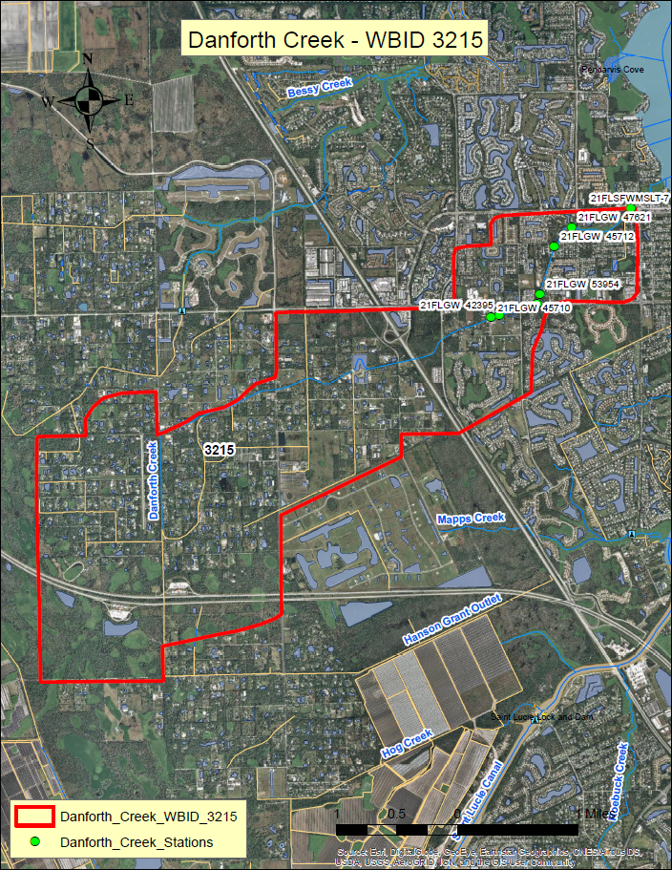

Evidence of Watershed Approach
 | Area of Effort | Danforth Creek (WBID 3215) is located in Palm City, in the West central part of Martin County. The Danforth Creek watershed is situated West of the South Fork St. Lucie River and East of the I-95 corridor and has a length of roughly 5.5 miles. The Danforth Creek Stormwater Treatment Area project is centrally located within the waterbody, on Leighton Farm Road and treats an area of approximately 2,400 acres.
 | Key Stakeholders Involved and Their Roles | The key stakeholders that have been instrumental in developing and executing these restoration projects are listed below.  - South Florida Water Management District  - Martin County  - Department of Agriculture and Consumer Services  - Department of Environmental Protection
 | Watershed Plan & Other Supporting Documentation | The area includes the watershed drainage area of approximately 2,400 acres. This project increases storage capacity within the watershed and will assist in relieving flooding and improving overall hydraulic conveyance. WBID 3215 is impaired for nutrients (total phosphorus) and dissolved oxygen (percent saturation) based on the AGMs for nutrients and the number of exceedances for the sample size for dissolved oxygen. The objectives outlined by the Danforth Creek stormwater treatment area project will address these impairments.  The WBID drainage area corresponds to the key project as follows: Danforth Creek Stormwater Treatment Area.
 | Point Sources and Indirect Source Monitoring (Sites) | All land areas within the State of Florida surrounding this WBID are regulated by a Municipal Separate Storm Sewer System (MS4) permit – NPDES MS4 Permit No. FLR04E013, permittee is Martin County. The most current MS4 permit was issued on October 25, 2017 and expires on February 28, 2023.  The entire area is regulated by a Municipal Separate Storm Sewer System (MS4) permit #FLR04E013  Note: Generic Permits for stormwater discharge from large and small construction activities are considered temporary; therefore, are not included in this listing.
 | Nonpoint Sources | The land use breakdown for the Danforth Creek watershed is as follows:  Urban and Built-Up – 56.55%  Agriculture – 9.87%  Rangeland – 1.61%  Upland Forest – 18.93%  Water – 1.41%  Wetlands – 7.27%  Barren Land – 0.00%  Transportation, Communication, and Utilities – 4.35%  Special Classifications – 0.00%  The anthropogenic land use component is approximately 70.77%  Wastewater Facilities in Area:  Martin County Rest Area I-95 – Permit #FLA013777  Solid Waste Facilities in area:  FDOT – Perimeter Road Rest Area – Permit #99974  FDOT – Perimeter Road, Southbound I-95 Rest Area – Permit #99975
 | Water Quality Criteria | It is expected that the Class III freshwater water quality standards for Total Phosphorus and Dissolved Oxygen (Percent Saturation) will be attained upon implementation of the specified watershed improvement projects.
 | Restoration Work | The Danforth Creek basin is located in Palm City and is comprised of a total of 3,847 acres, consisting primarily of residential and commercial development in the eastern and central portion of the basin and agricultural and residential ranchettes in the western portion of the basin. The Danforth Creek Stormwater Treatment Area serves approximately 2,400 acres and increases storage capacity to assist in relieving flooding and improving hydraulic conveyance. Monitoring by the South Florida Water Management District determined Danforth Creek to be ranked fifth overall in Martin County for the highest concentrations of total nitrogen, phosphorus and copper. This cooperative project was funded in total by the Florida Department of Agriculture and Consumer Services. This project was completed in 2016.  The hybrid wetland treatment technology (HWTT) combines chemical treatment with conventional wetland treatment. Water will be pumped to the facility and a chemical, such as aluminum sulfate is added. Nutrients in the water settle out and then the water is further polished through floating and submerged aquatic vegetation ponds.  The Danforth Creek HWTT system is situated on nine acres of land adjacent to an existing 11‐acre storm‐water project (referred to as Danforth Creek Phase I STA) owned by Martin County. The site lies within Section 23, Township 38S, Range 40E, encompassing Tract 35 of the Palm City Farms Subdivision. The Danforth HWTT system contains two parallel contact ponds, a settling pond, and downstream floating aquatic vegetation (FAV) and submerged aquatic vegetation (SAV) wetlands. The inflow pump station can provide a maximum flow of 25 cfs from the existing Phase I STA. The outflow from the HWTT facility is discharged just downstream of the STA outflow weir. It is estimated that the HWTT facility will be able to treat approximately 35% to 55% of the total annual runoff originating from an estimated 2,400 acres of urban and agricultural land located upstream of the project site.  Below is a schematic of the HWTT facility, including sampling locations.  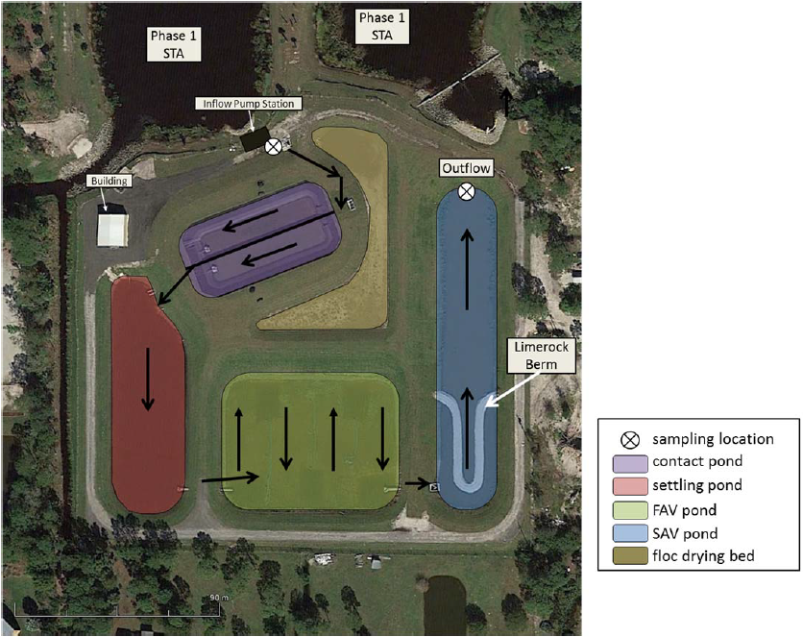  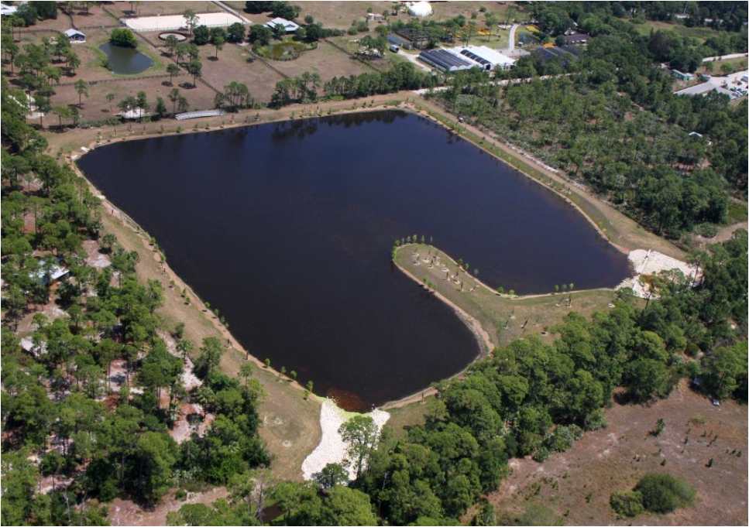  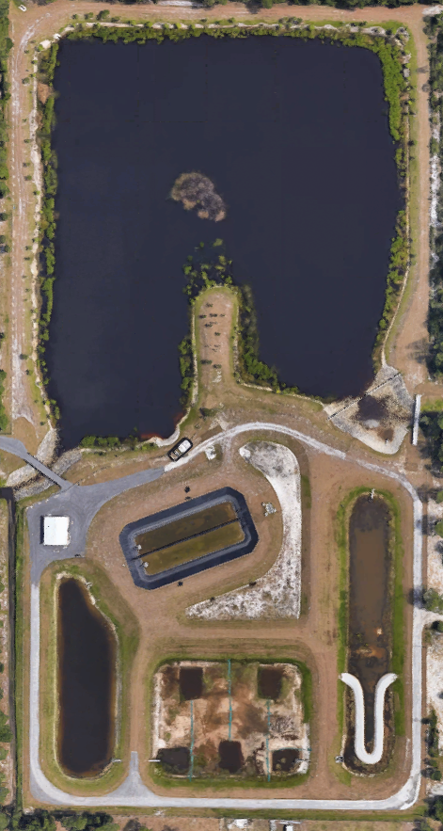

Critical Milestones/Monitoring
 | Anticipated Critical Milestone(s) and Completion Dates: |  | The Danforth Creek wet detention pond was completed in 2014 and the hybrid wetland treatment technology project was completed in June 2016 in conjunction with FDACS, and funding for the operation of the project became available in July 2016.  Testing of the HWTT facility was conducted on April 28, 2016. Upon completion in April 2016, the site was placed on temporary inactive status during Project Periods 10, 11, and 12 due to lack of funding. During this time, drainage improvements were made to convey off‐project groundwater seepage away from the south bank of the project’s submerged aquatic vegetation (SAV) pond. Additionally, undesirable aquatic vegetation that had invaded the floc drying bed and floating aquatic vegetation (FAV) pond was treated with herbicide during this period. During June, the facility was initialized and water quality tests of inflow waters to the site were conducted.  In early June 2016, a temporary diesel pump was deployed to commence filling of the system with Danforth Creek waters. Since a principal goal of this initialization effort was to flood the FAV and SAV ponds with nutrient‐laden waters to promote macrophyte standing crop expansion, these waters were not dosed with coagulants. Floating and submerged macrophyte species were inoculated during this period with species selection based partly on availability of plants within the watershed and on the findings of a mesocosm study performed previously at Danforth Creek by Watershed Technologies, LLC. Due to the plant inoculation activities at the facility, coagulant optimization trials for Danforth Creek waters were performed using laboratory jar tests on Danforth Creek waters. A total of 3.6 million gallons of Danforth Creek waters were pumped into the HWTT facility through June 30, 2016, and 900 gallons of alum were delivered on-site during this period.
 | Monitoring Component |  | The Danforth Creek phase I - wet detention pond nutrient reductions were calculated to be a 2,434 lbs./year TN reduction and a 1,010 lbs./year TP reduction. The hybrid wetland treatment technology, which is the phase II component of the overall project has a calculated TN reduction of 5,274 lbs./year and a TP reduction of 1,281 lbs./year. Routine monthly monitoring is ongoing at station 21FLSFWMSLT-7. This station is located at the far downstream extent of the waterbody, downstream of the STA and HWTT facilities.
Other Key Dates
 | Estimated Date for Delisting from Verified List or Removal from Study List | Danforth Creek (WBID 3215) is in the state’s Group 2 St. Lucie - Loxahatchee basin in the department’s Southeast District. The current review and assessment cycle (cycle 4) is ongoing and will be completed in the spring of 2020. This waterbody is currently impaired for dissolved oxygen (percent saturation) and nutrients (total phosphorus). The earliest opportunity for removing this waterbody from the 303(d) List would happen during the cycle 5 assessment. If this waterbody doesn’t attain the nutrient criterion in the next assessment cycle, it will remain in assessment category 4e.

Financial Commitments

 | Estimated Implementation Cost | The total project cost, including land acquisition (if applicable) was $4,981,799.  The cost includes a 319(h) Clean Water Act Section grant of $ NA.  The estimated 20-year operation and maintenance cost is $ TBD.
 | Land Acquisition  (if applicable) | Funding Source:  Total……………………………………………………………………...$ NA
 | Design and Construction  (if applicable) | Funding Source:  Total……………………………………………………………………...$4,981,799
References:

"Implementation of Hybrid Wetland Treatment Technology in the Northern Everglades Watershed” Prepared for: Florida Department of Agriculture and Consumer Services (FDACS). Prepared by: Watershed Technologies LLC, Satellite Beach, FL. September 14, 2016.

