Uploading Attachments in EPSAP

When you upload an attachment in EPSAP, first you must indicate to the system there will be an attachment to upload. There a menu option for Supplemental or Additional attachments in both the Facility Menu and the Emissions Unit Menu. In both cases it’s the last option on the list. The first step is to click the link for the Additional/Supplemental Attachment you need to include.
Facility:
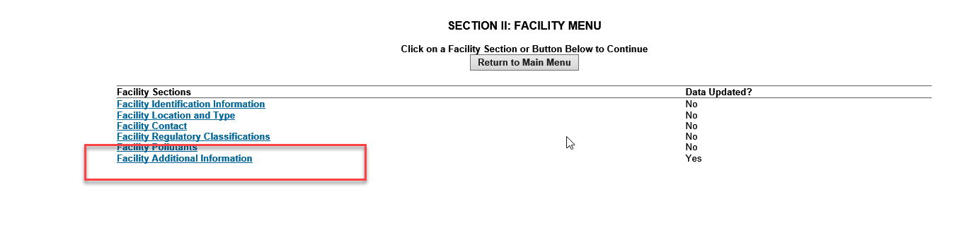
Emission Unit:
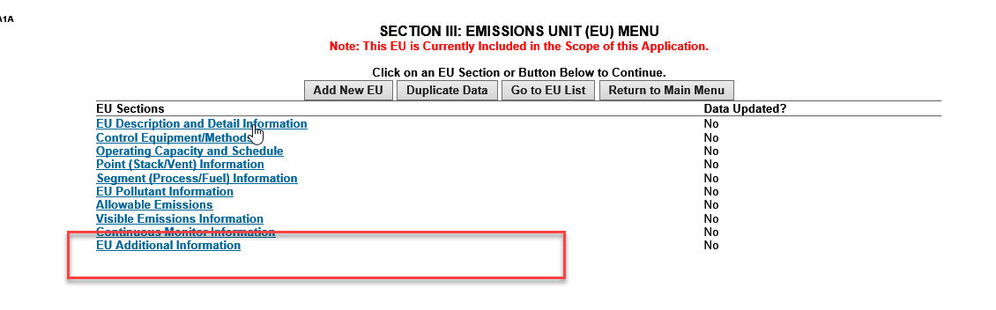

Additional Attachment Item List:

From the menu you’ll navigate to the Additional Requirement List. Select the item you need to indicate there are attachments to enumerate.

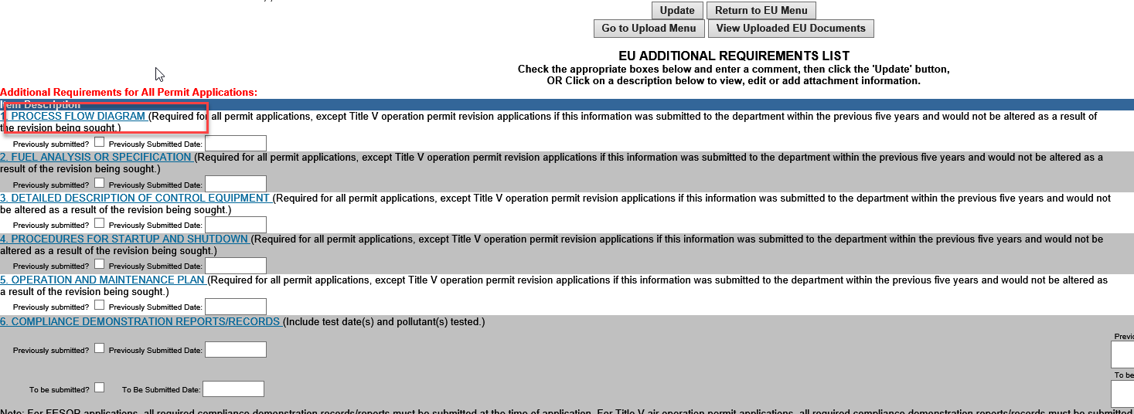
This will navigate to the Attachment Item screen.
- Indicate Option 1 is selected for an electronic attachment.
- Then, describe the attachment in the comment box at the bottom of the screen.
- Click Update to save the record.

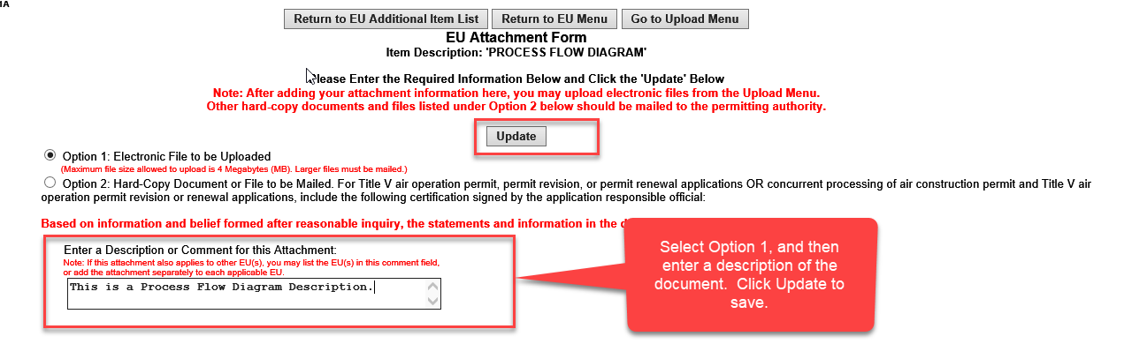

Once you have saved the record, you can either continue adding descriptions of attachments if you need to identify more documents that will be submitted electronically, or you can go directly to the upload menu using the “Go to Upload Menu” button.

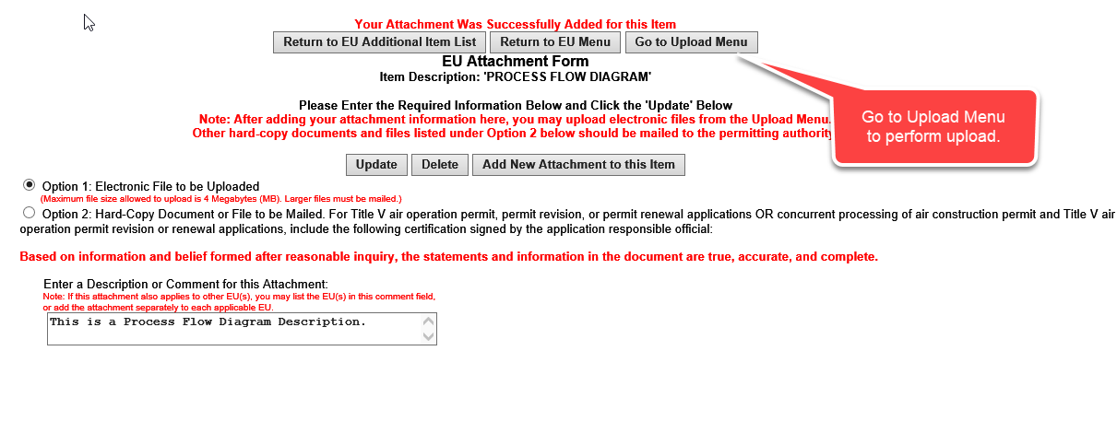
The Upload menu allows you to upload attachments that have been identified in the supplemental/additional items, or view attachments that have already been uploaded.
To complete the upload Click on the Upload EU files or Upload Files Button. This will take you to the screen to actually choose the file to upload.

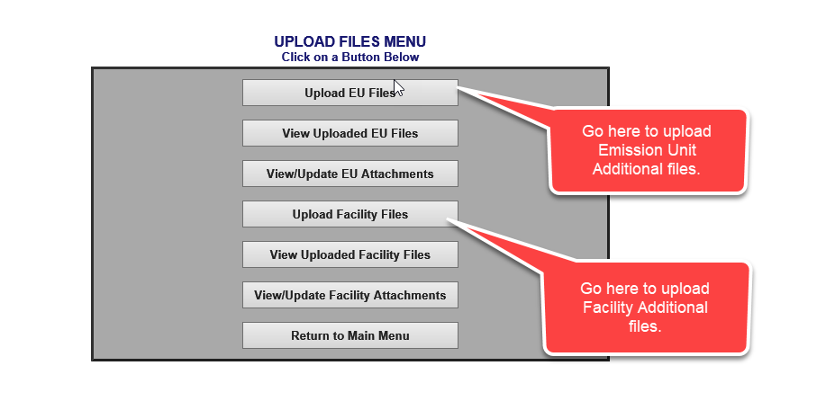

This is the example from the Upload EU Files we identified earlier in these instructions. Click Browse… to choose the file.
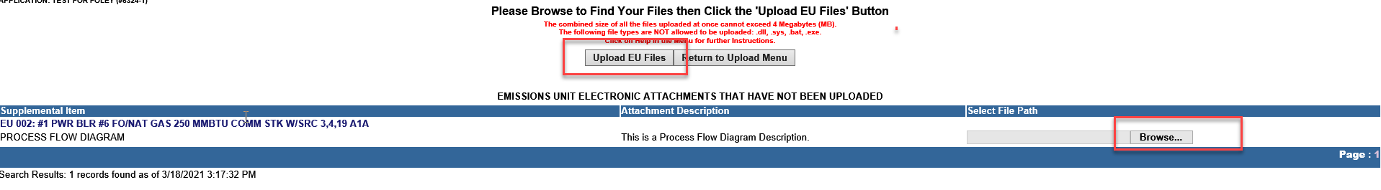
Select the file to be uploaded and click Open.

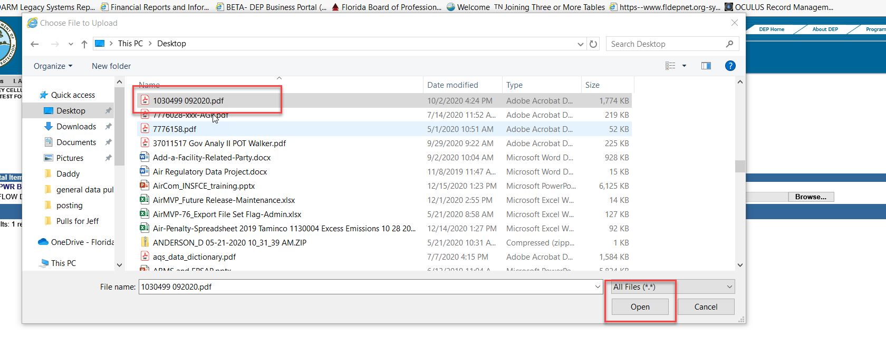
After you click Open, it will return to the Upload screen. Click Upload (EU/Facility) Files button and the document will upload.
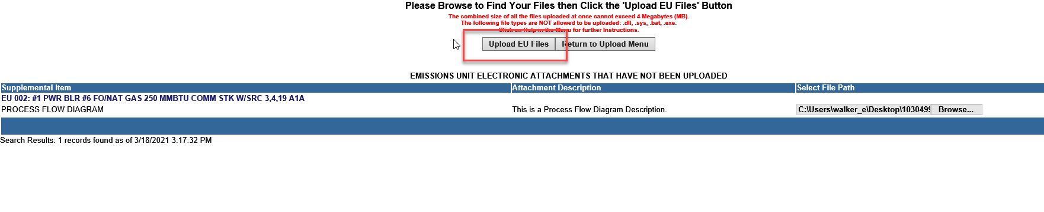
View Documents that have already been uploaded.
To View documents you’ve already uploaded, you can select the options below from the Upload Files menu.
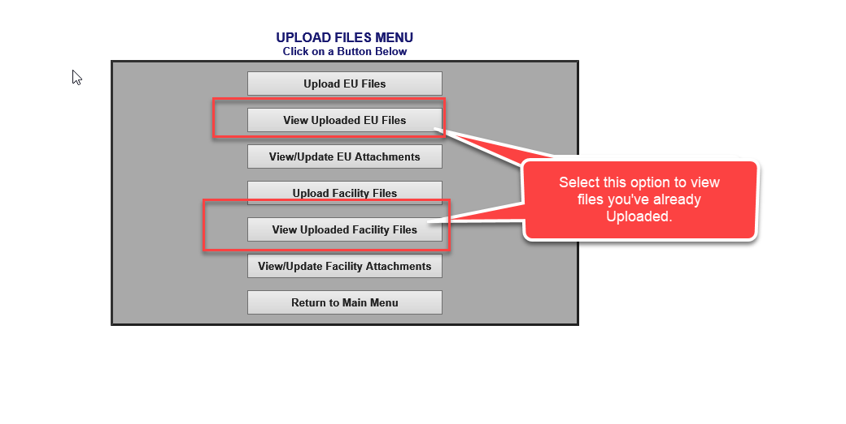
It will navigate to a page with a link to the files that have been uploaded as part of the application for the facility or EU sections. Click the link to view the document.

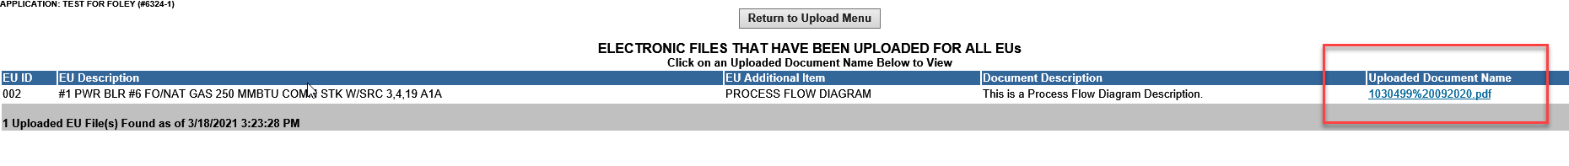

Note: You will not be able to edit and save the documents back to the server. In order to edit the documents, you must download the document, edit and then save it. Follow the instructions below to delete the uploaded file, and the re-upload the document.

Deleting Uploaded files.
Go to the Facility/EU Additional or Supplement menu option to see the list of items available to submit additional files. Locate the item and click on it.
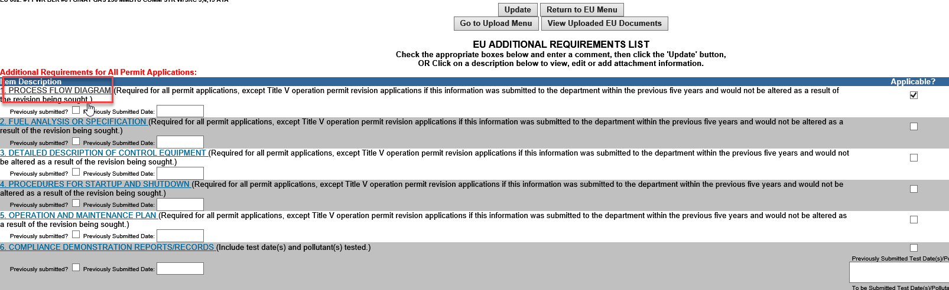
You’ll be navigated to the list of files identified for this Item. Click on the item you want to delete.

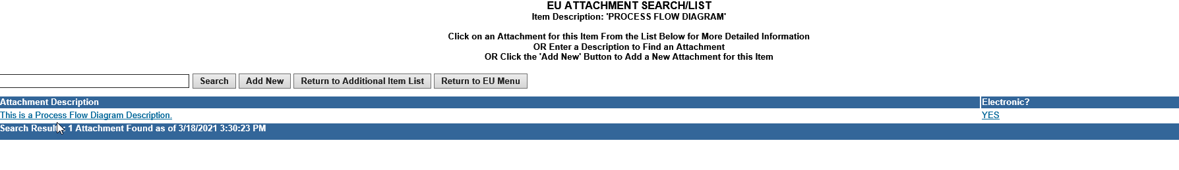
Once you see the Facility/EU Attachment form, verify it is the item you want to delete and click the DELETE button. This will delete it from the application and the document from the server.
