EXHIBIT F
DEP AGREEMENT NO. Insert Agreement Number

INSERT PROJECT TITLE

Insert Grantee Name

Final Project Report

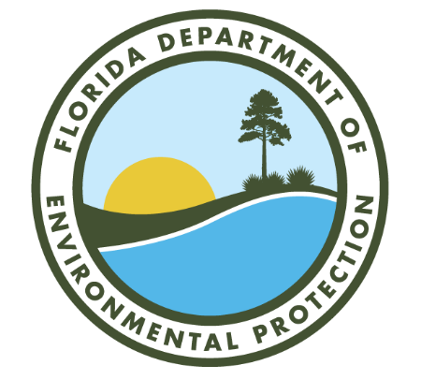

Insert Month & Year

This report is funded in part through a grant agreement from the Florida Department of Environmental Protection. The views, statements, findings, conclusions, and recommendations expressed herein are those of the author(s) and do not necessarily reflect the views of the State of Florida or any of its subagencies.

Part I. Executive Summary

Part II. Methodology

Part III. Outcome
Include the following: 1) evaluation of project’s ability to meet goals and expected performance measures and provide explanation for why goals were not met, if applicable; 2) identify successful outcomes, areas for improvement, and quantifiable metrics (including the assigned metric in Exhibit A, if applicable) as a result of the project; and 3) final project photos, if an implementation construction project.

Part IV. Further Recommendations

Instructions for completing Exhibit F Final Project Report Form:
DEP AGREEMENT NO.: This is the number on your grant agreement.
GRANTEE NAME: Enter the name of the grantee’s agency.
PROJECT TITLE: Enter the title shown on the first page of the grant agreement.
MONTH & YEAR: Enter month and year of publication
The final Project Report must contain the following sections: Executive Summary, Methodology, Outcome, and Further Recommendations. The Final Project Report must comply with the publication requirements in the grant agreement. Please limit the final project report to no more than five (5) pages. One electronic copy shall be submitted to the Department’s Grant Manager for approval. Final payment will be held until receipt and approval of the Final Project Report.
Questions regarding completion of the Final Project Report should be directed to the Department’s Grant Manager, identified in paragraph 18 of this agreement.

