WATER FACILITIES PLAN

for

CITY OF GOOD HOPE

FLORIDA

Prepared by

Florida Department
of Environmental Protection

July 2000

Forward

This is a fictitious water facilities plan for a small rural community with relatively simple water needs. The needs addressed are typical of small communities in Florida and do not have environmental constraints.

While we would expect a more comprehensive plan for a community faced with more complex needs, the level of detail presented need not exceed that demonstrated in this facilities plan to meet the requirements for funding. This plan may aid in preparing a water facilities plan expeditiously and at a minimum cost. It has been designed with comments throughout the document to assist the planner in meeting facility planning requirements in accordance with 62-552.700(4) F.A.C.. These comments are easily identified using Microsoft Word when downloaded from our web site at www.dep.state.fl.us/water/wff.

Facility planning consists of those necessary plans and studies that directly relate to the construction of treatment works. Facilities planning should demonstrate the need for the proposed facilities. Through a systematic evaluation of feasible alternatives, it will also demonstrate that the selected alternative is cost-effective, i.e., is the most economical means of meeting established water quality goals while recognizing environmental and social considerations.

Project sponsors and their consultants are expected to exercise judgement in determining the content of water facilities plans.

Don W. Berryhill, P.E., Chief
Bureau of Water Facilities Funding
TABLE OF CONTENTS

Forward i
Chapter 1.0 - Summary of Findings and Recommendations 1
Chapter 2.0 - Introduction 2
2.1. Background 2
2.2. Need 2
2.3. Scope of Study 2
Chapter 3.0 - Environmental Impacts 5
3.1. Description of Planning Area 5
3.1.5. Surface and Ground Water Hydrology, Quality and Uses. 7
3.1.6. Sourcewater Protection 7
3.1.7. Environmentally Sensitive Areas or Features 9
3.1.8. Flood Plain 9
3.1.9. Air Quality 10
3.2. Socio-economic Conditions 10
3.3. Water Supply, Treatment, and Transmission/Distribution System 11
3.4. Managerial Capacity 16
Chapter 4.0 - Development of Alternatives 17
4.1. General 17
4.2. Cost-effectiveness 17
4.3. Raw Water Transmission System. 18
4.4. Water Treatment 18
4.5. Plant Waste Disposal. 19
Chapter 5.0 - The Selected Plan. 21
5.1. Description of Proposed Facilities 21
5.2. Environmental Impacts of Proposed Facilities. 24
5.3. Cost to Construct Facilities. 24
5.4. Consistency with the Comprehensive Plan. 24
Chapter 6.0 - Implementation and Compliance 25
6.1. Public Hearing/Dedicated Revenue Hearing 25
6.2. Regulatory Agency Review 25
6.3. Financial Planning 25
6.4. Implementation 26
6.5. Implementation Schedule 26
6.6. Compliance 27
Appendix A 28
Cost Information of the Selected Alternative 29
Appendix B 30
Potential Sources of Contamination to Municipal Water Supply Wells 31
Appendix C 34
Detailed Cost Information and Present Worth Analysis for all Alternatives 35
Appendix D 39
SUMMARY OF PUBLIC/DEDICATED REVENUE HEARING 40
Affidavit of Publication 42
Appendix E 43
CAPITAL FINANCING PLAN WORKSHEETS 44
FINANCIAL BURDEN RATIO 51
Appendix F 52
User Rate System 53
Appendix G 61
FLOOD INSURANCE RATE MAP FOR THE CITY OF GOOD HOPE 62
Appendix H 64
SANITARY SURVEY REPORT 65

TABLES

Table 1: Design Demand 13
Table 2: Historical Service Population and Finished Water Production Annual Averages and Service Population Projections 14
Table 3: Proposed Budget 54
Table 4: Budget Cost Breakdown 55
Table 5: Water User Rate 56

FIGURES

Figure 1: City of Good Hope Planning Area 4
Figure 2: Soil Survey Map for the City of Good Hope 6
Figure 3: Site Map for the City of Good Hope 8
Figure 4: Water Demand and Service Population Projections 15
Figure 5: Schematic Process Flow Diagram of the Recommended Facilities 23

Chapter 1.0 - Summary of Findings and Recommendations

This Facilities plan was prepared by the Florida Department of Environmental Protection (FDEP) to meet the requirements of the State Revolving Fund (SRF) loan funding of drinking water systems. The area considered in preparing this plan includes the City of Good Hope and contiguous lands located in Small County. The planning period extends through the year 2020. This facilities plan addresses the need of the planning area in the year 2020. Average annual daily demand is projected to be 2.25 million gallons per day (MGD). The recommendations resulting from this study are consistent with both the City’s and the County’s Local Comprehensive Plans.

The existing treatment plant and the raw water transmission system are not adequate to serve the planning year needs and they need to be expanded. The distribution system is currently adequate but will require additions before the end of the planning period. A storage tank needs to be constructed in the distribution system to equalize the diurnal variations between the supply and demand. The disposal of backwash water and clarifier blow-down at the plant is not satisfactory and needs to be improved. The improvements proposed involve collecting the wastes and disposing them in a multi-cell lagoon at the plant site. The existing population (2000) is 14,100. In addition, the system serves a trucking company and a prison. Also, the City gets tourists and migrant workers during the season.

The capacity of the raw water transmission main is to be increased by providing an additional 10-inch force main and installing larger capacity raw water pumps. At the treatment plant, a new coagulation/flocculation tank, two additional clarifiers and two additional sand filters with expanded chlorination facilities are proposed. New higher capacity finished water pumps are to be installed to pump the finished water into the distribution system. The capacity of the water treatment plant will be 2.5 MGD after the improvements are completed.

The project cost of the proposed facilities is estimated at $5,794,800. The annual cost (including operation and maintenance cost [O&M] and debt service for the SRF Loan of the capital cost at 3% interest rate*) for the proposed facilities is $870,000. The details of capital and annual O&M costs are shown in Appendix A.

The City operates a combined Water and Sewer Utility Fund. The pledged revenues for debt payments are the water and sewer charges by the Utility. The SRF Loan will be repaid in 40 semi-annual installments.

Chapter 2.0 - Introduction

2.1. Background
The City of Good Hope is responsible for the planning and implementation of the service area infrastructure needs. It is considered a small, agriculturally based community. Its two major employers are the Department of Corrections, which operates the state prison and Trucking Co., Inc., which owns and operates a freight depot and services trucks. Both establishments are served by the Good Hope water system.

The planning area (Figure 1) includes the City of Good Hope and contiguous lands located in central Small County approximately 25 miles north of Gulf of Mexico and 30 miles east of the City of Metropolis.

The City treats surface water from New Creek at its treatment plant located about a mile east of the intake, in the southern portion of the planning area, before distribution to the customers.

2.2. Need
An existing 1.5-MGD water treatment plant, serves the area within the incorporated limits of Good Hope, however, due to equipment failures, the water is not adequately treated. Defective equipment needs to be repaired and the capacity of the plant needs to be increased to meet the planning year demand.
The existing distribution system is currently adequate, but will require additional lines before the end of the planning period because of continuing development. The existing raw water transmission system (the 10-inch force main from the intake structure to the treatment plant and the raw water pumps) does not have adequate capacity for the design year needs. The transmission main needs to be provided with an additional 10-inch relief main. Higher capacity raw water pumps need to be installed. Presently, two 30-HP pumps are used to pump the finished water. They need to be changed to three 50-HP pumps.
The treatment plant does not have adequate capacity for the design year needs. Equipment malfunction has happened numerous times resulting in inadequately treated water being distributed to the consumers. Backwash water and clarifier blow-down disposal is unacceptable. A new disposal system is needed.

2.3. Scope of Study
The scope of the facilities plan is described below:

- Inventory existing water facilities, service area characteristics, and environmental conditions.
- Establish design needs for the planning period.
- Identify and evaluate various water system alternatives to satisfy the planning year needs.
- Recommend the most cost-effective, environmentally sound facilities to meet the planning needs.
- Describe, in detail, the recommended facilities and their cost.
- Present a schedule of implementation of the recommended facilities.
- Identify any adverse environmental impacts and propose mitigating measures.
- Identify a source of financing and estimate the cost per household.
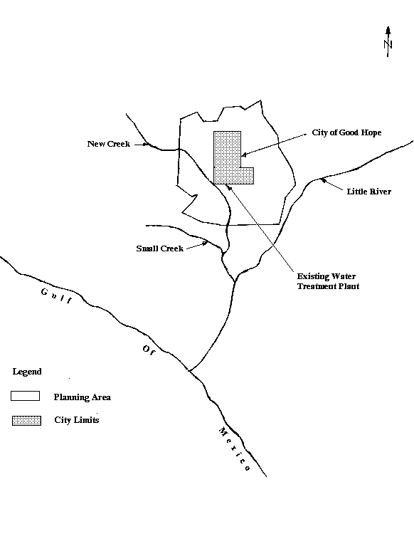
Figure 1: City of Good Hope Planning Area
(Scale: 1 inch = 10 Miles)

Chapter 3.0 - Environmental Impacts

3.1. Description of Planning Area

3.1.1. Planning/Service/Project Area
The planning area and the service area are the same. The planning area is bounded on the north by No Name County; on the south and west by New Creek; and on the east by Little River. The surface features include gently rolling hills, several rivers, creeks, and wetlands. The northern part of the planning area is densely vegetated while the southern half contains areas of little to no vegetation.

3.1.2. Climate
Due to the proximity to the Gulf Coast, the area is humid with warm temperatures and is characteristic of long summers and mild winters. According to the Soil Survey of the area provided by the USDA Soil Conservation Service, the average annual temperature is approximately 65ºF. During brief periods extending from the month of June through the month of August, daytime temperatures often exceed 90° F. Winters are generally short and mild, with average daily temperatures ranging from 40° F to 55° F, although rare cold spells can drop temperatures to as low as 10° F. On the average, there are nine freezes annually.
The average annual rainfall is approximately 50 inches. Rainfall is commonly high in January and February and again in July and August. Rainfalls of more than eight inches may occur during hurricane events.

3.1.3. Topography and Drainage
The USDA Soil Conservation Survey of the planning area is characterized by gently rolling hills and interspersed with forests, wetlands and creeks. The urban area is relatively flat in comparison with the more rural areas. The average elevations in the service area range from 5 to 20 feet above mean sea level. The topography changes from 100 feet to 150 feet in rural areas. Soils in the area are somewhat poorly drained to poorly drained soils.

3.1.4. Geology, Soils and Physiography.
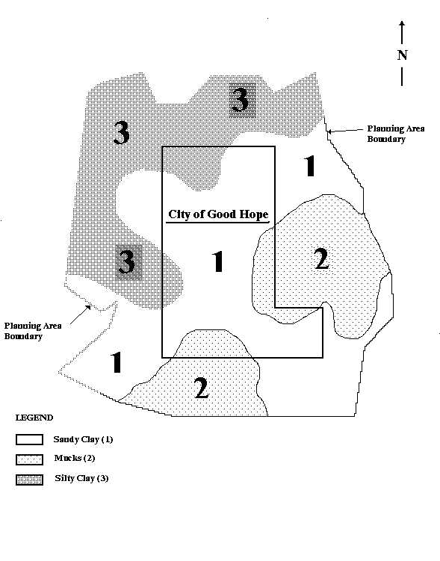
Sand, clay and limestone deposits are characteristic of the geologic formation in the area. Limestone outcrops are found in this area. Sand and clay deposits reach depths of several hundred feet and represent an unconfined aquifer used mostly for agricultural purposes. The underlying limestone formation represents
Figure 2: Soil Survey Map for the City of Good Hope
(Not to Scale)
the Floridan Aquifer.
Soils have been mapped for the Soil Conservation Service of the U.S. Department of Agriculture (Figure 2). Silty clay and sandy clay are characteristic of the northern and western portions of the planning area while sandy clay and mucks are characteristic of the southern and somewhat characteristic of the eastern portion of the planning area.
There are two physiographic divisions through the planning area. The southern portion of planning area is located in the Gulf Coastal Lowlands. It contains a series of coast-parallel plains or terraces. The northern portion of the planning area is located in the Western Highlands. The highlands are believed to be the remnants of a Pliocene-Pleistocene delta that covered older Miocene deposits. The former delta has been eroded by numerous streams, leaving remnant hills that may be up to 100 feet higher than the surrounding land.

3.1.5. Surface and Ground Water Hydrology, Quality and Uses.

3.1.5.1. Surface and Ground Water Hydrology
There are no Outstanding Florida Waters in the planning area. All surface waters are designated class III waters, suitable for recreation and for propagation of fish and wildlife. The planning area is located within the Little River drainage basins. One of the major tributaries is New Creek, which is the source of drinking water for the City of Good Hope. New Creek is slow moving except during wet weather conditions. It flows southeast and is bordered by urban development in the north and wetlands, forests, and farmlands as it flows southeast. The water quality in Little River and New Creek is good. There are no wild or scenic rivers in the planning area.

3.1.5.2. Surface Water and Ground Water Quality
The water quality in Little River and New Creek is good. Other tributaries to the Little River have been sampled and they exhibit marginal to good water quality. All of the ground waters in the planning area are designated class G-II (potable water use).

3.1.5.3. Water Uses
New Creek is used as the source of drinking water for the City of Good Hope, in addition to being used for agriculture, boating and fishing purposes. Little River is mostly used for agricultural purposes.

3.1.6. Sourcewater Protection
In accordance with Rule 62-552.200(30)2 FAC, a sourcewater protection area, (SWPA) including the watershed upstream of the intake structure, is prepared and shown on the USGS Hydrologic Unit Map – 1974, State of Florida, in Figure 3. The City has undertaken a survey to identify the source of pollution listed in Appendix E of EPA publication 816-97-009 dated August 1997 on “State Source Water Assessment and Protective Programs Guidance”. Potential sources of contamination are shown in Appendix B. As a result of the survey, the existence of an underground storage tank in the SWPA has come to light. The location of this storage tank is shown on Figure 3. This tank is an abandoned petroleum tank and is no longer in use. This source is downstream of the surface water intake and poses no threat to our source water. Other potential sources listed in the EPA publication within the watershed include agriculture, pasture grazing, highway maintenance and runoff, recreational boating and fishing, and contamination from natural sources.
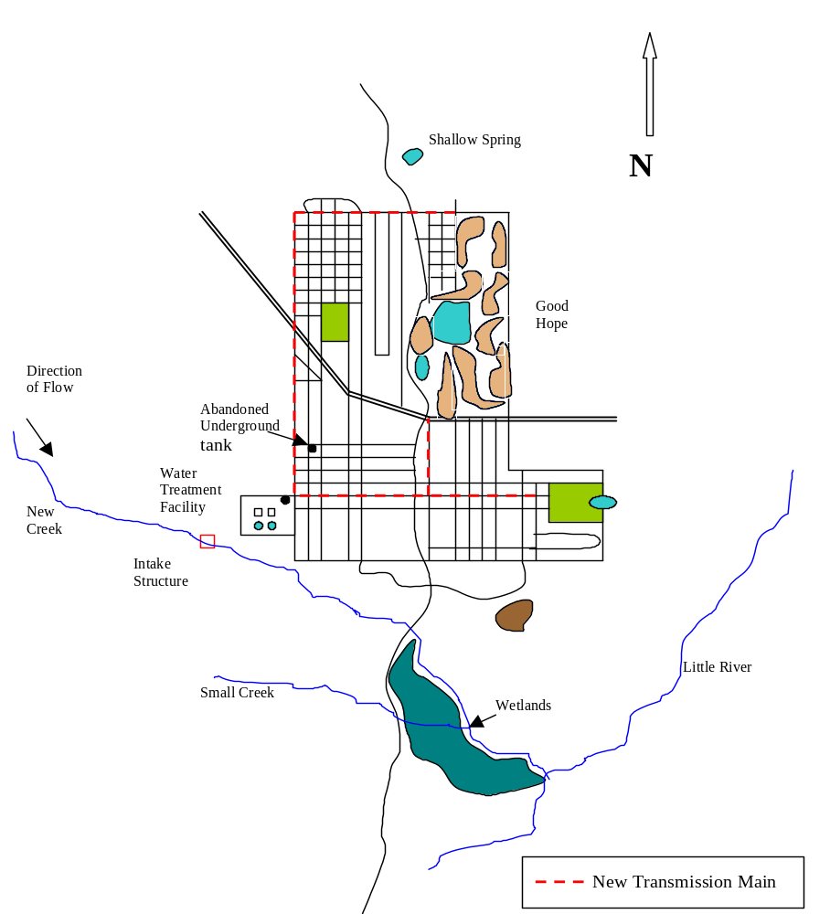Figure 3: Site Map for the City of Good Hope
(Not to Scale)

3.1.7. Environmentally Sensitive Areas or Features

3.1.7.1. Wetlands
According to the U.S. Department of the Interior National Wetland Inventory Map, numerous freshwater wetlands border surface water bodies that drain the City. Wetlands are increasingly more common south of the planning area (see figure 3). There are no wetlands associated with the many creeks and rivers impacted by this project.

3.1.7.2. Environmentally Sensitive Lands
According to the USDA Natural Resources Conservation Service, there are no prime or unique farmlands in the planning area.

3.1.7.3. Plant and Animal Communities (Endangered Species)
The dominant types of natural vegetation are the long leaf pine, turkey oak, and hard wood trees. Marsh and herbivorous plants are also common in the southern portions of the planning area. There are no rare, endangered or threatened species of vegetation. White tailed deer, black bear, wild turkey, squirrels, rabbits, feral hogs, otter, beaver, mink, fox and raccoon can be found in the planning area and its environs. Amphibian and reptiles include various species of toads, tree frogs, sirens, salamanders, turtles, lizards, and snakes. A wide variety of water and land birds are present in the area. There are no rare, endangered or threatened species of animals within the project area.

3.1.7.4. Archeological and Historical sites.
Discussions have been held with the State Historic Preservation Officer of the Division of Historical Resources of the Florida Department of State regarding potential historical or archaeological sites within the project area. There are no national or natural landmarks in the planning area. However, a shallow spring site in the northern portion of the City (figure 3) has been identified as a historical and archeologically significant site. This proposed project will have no impact on this site.

3.1.8. Flood Plain
Flood zones for the City are designated on the Flood Insurance Rate Map (FIRM), see Appendix G. The areas in which the proposed infrastructure improvements are to be constructed are located in Zone C. FIRM defines Zone C as an area of minimal flooding. Flood plains are confined to the areas immediately adjacent to Little River and New Creek.

3.1.9. Air Quality
The air quality in Small County is high due to a lack of major sources of air emissions. According to FDEP, Small County is classified as an area of attainment with respect to the National Ambient Air Quality Standards and for all of the criteria air pollutants. There are no major sources of emissions permitted by FDEP in Small County.

3.2. Socio-economic Conditions

3.2.1. Population
Only one percent of the planning area population, comprising the farm population, lives outside the corporate limits of the City of Good Hope. The population projections shown in Table 2. Good Hope Chamber of Commerce estimates that 200 tourists reside in the planning area during the months of February through April. Approximately 100 migrant workers are in the planning area during June and October. The prison has an inmate population of 400 and a staff of 65. Good Hope’s trucking company employs 50 people on a daily basis.
The population of the City is calculated using the available information for the different census tracts. Using the past history of the census tracts’ population, the future population projection is made for the census tracts. The City’s future population is estimated by summing all of these census tract population projections.

3.2.2. Land Use and Development
The existing land use map divides the City into five regions: Northwest, North Central, Central, South Central and South. The Northwest Region is agricultural in nature and a large part of this land is being slowly converted to residential property. The North Central Region is residential. The Central Region is well developed with residential and commercial properties. The South Central Region is moderately well developed with residential and commercial properties. The South Region is relatively undeveloped and is zoned for industry and agriculture. The prison and the trucking depot are located in the South Region. Land use is established in the comprehensive plan for Good Hope.
Residential development is expected to continue in the Northwest Region. Commercial development is expected in the South Central Region. Industrial growth is expected in the South Region. Land value is expected to increase by three percent annually.

3.3. Water Supply, Treatment, and Transmission/Distribution System

3.3.1. Description of the Existing Water system
The City’s Water and Sewer Utility serve the entire city. No other private or public utility provides water or sewer services in the planning area. Most of the farms in the area adjoining the City are served by private water wells. The County Health Department reports these wells as being of good quality and having no known problems. The City Utility operates all drinking water and wastewater treatment facilities.
The original water system was constructed in the early 1950’s. The system was expanded in 1965, 1973, and 1987. Presently, the distribution system has 230,000 linear feet of 2” to 10” diameter pipe and 20 booster pump stations. In the past two years, improvements were made which include replacement of five booster pump stations and installation of alarm systems on all booster pump stations to alert operators of problems. The conditions of the distribution pipes varies from “fair” for some of the original pipes in the Central Region to “good” for the more recent additions (and for rehabilitated pipes). The City has an on-going pipe upgrade/replacement program.
The raw water source for the system is New Creek. Raw water is pumped approximately 5,000 feet to the treatment facilities through a 10-inch force main by means of 2 25-HP centrifugal pumps. The intake chamber, raw water pumps and the raw water transmission main are in good condition.
The original treatment plant was part of the water system constructed in the early 1950s. In 1987, the plant was expanded to 1.5 MGD. The treatment of raw water consists of rapid mixing, flocculation/coagulation, sedimentation, filtration, and chlorination. The filtered water is stored in a 2 MG underground reservoir at the treatment plant site. Two 25-HP constant speed pumps pump the water into the distribution system from the underground reservoir. The wastewater from the filter backwash and the clarifier blow-down is recycled to the front of the plant.

3.3.2. Present and historical water usage.
The per capita water consumption is 100 GPD. Water consumption at the prison is 100 gallons/day/inmate and employee. The workers at the Trucking Company consume at an average rate of 20 GPCD. The consumption by each of the tourists is estimated at 80 GPD. Migrant workers consume at the rate of 75 GPCD. Commercial establishments consume 60,000 GPD. Residential users’ consumption is estimated to be 10,000 GPD. The present total residential, institutional, and commercial water consumption is nearly 1.45 MGD.

3.3.3. Water Conservation
Individual water meters are used throughout the City. Utility consumers are periodically reminded, via monthly billing, that water bills depend on water use. Information about water saving faucets and plumbing fixtures is also sent out periodically with the billings.

3.3.4. Performance of Existing Water System.
The distribution system, being old, experiences problems of pipe bursting and leakage. Operational problems occur at several booster pump stations. The City staff constantly attends to the maintenance of these facilities.
The treatment plant is inadequate to treat the projected demand to occur by 2020 and the raw water transmission main to the treatment plant does not have adequate capacity. Malfunction of the chlorination equipment occurs periodically. Replacement of the coagulation/flocculation chamber is also needed.

3.3.5. Water Demand Projection.
The water demand for 2020 is developed based upon the assumptions listed below. Results are shown in Table 1 below.
- A 25 percent increase in the number of prison inmates and the number of migrant workers.
- A 50 percent increase in the tourist, municipal, commercial, and industrial demand.
- A 100 percent increase in the trucking company demand.
- An excess demand for unpredicted future growth of 40,000.
- There will be no measurable increase in fire demand.
- There will be no change in prison staff.

Table 1: Design Demand

 | Category of Service | Demanding Population | Average Daily Demand (MGD)
1. | Domestic Demand | 17,205 | 1.721
2. | Prison Demand | 565 | .057
3. | Migrant Workers Demand | 125 | .009
4. | Tourists Demand | 300 | .024
5. | Trucking Co. Demand | 100 | .002
6. | Municipal Demand |  | .015
7. | Commercial & Industrial Demand |  | .090
8. | Unforeseen Demand |  | .400
 | Total |  | 2.318

3.3.7. Service Population and Finished Water Projections
Table 2 gives service population and actual finished water production annual averages for five previous years and service population forecasts through the year 2020. The service populations forecast was obtained using an annual population increase of one percent. Figure 4 shows plots of the Annual Average Daily Flow, Average Maximum Daily Flow, and Service Population projections. The finished water forecasts shown in figure 4 were obtained as straight-line projections of the annual averages given by Table 2.
As can be seen in figure 4, maximum daily water production (or demand) should reach the existing WTP capacity of 1.5 MGD by the year 2002 with a corresponding 0.80 MGD average daily flow and service population of 14,380. By the year 2020 the maximum daily water production should be approximately 2.3 MGD; well in excess of the present WTP capacity but within the capacity of 2.5 MGD which would be obtained by constructing additional treatment units. By the year 2020 the service population is forecasted to be approximately 17,205 persons.
Table 2: Historical Service Population and Finished Water Production Annual Averages and Service Population Projections

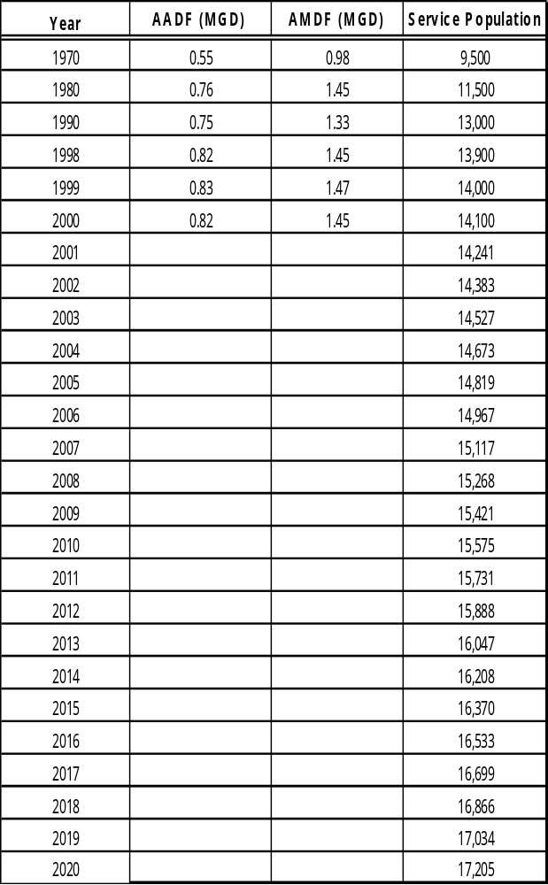

Figure 4: Water Demand and Service Population Projections
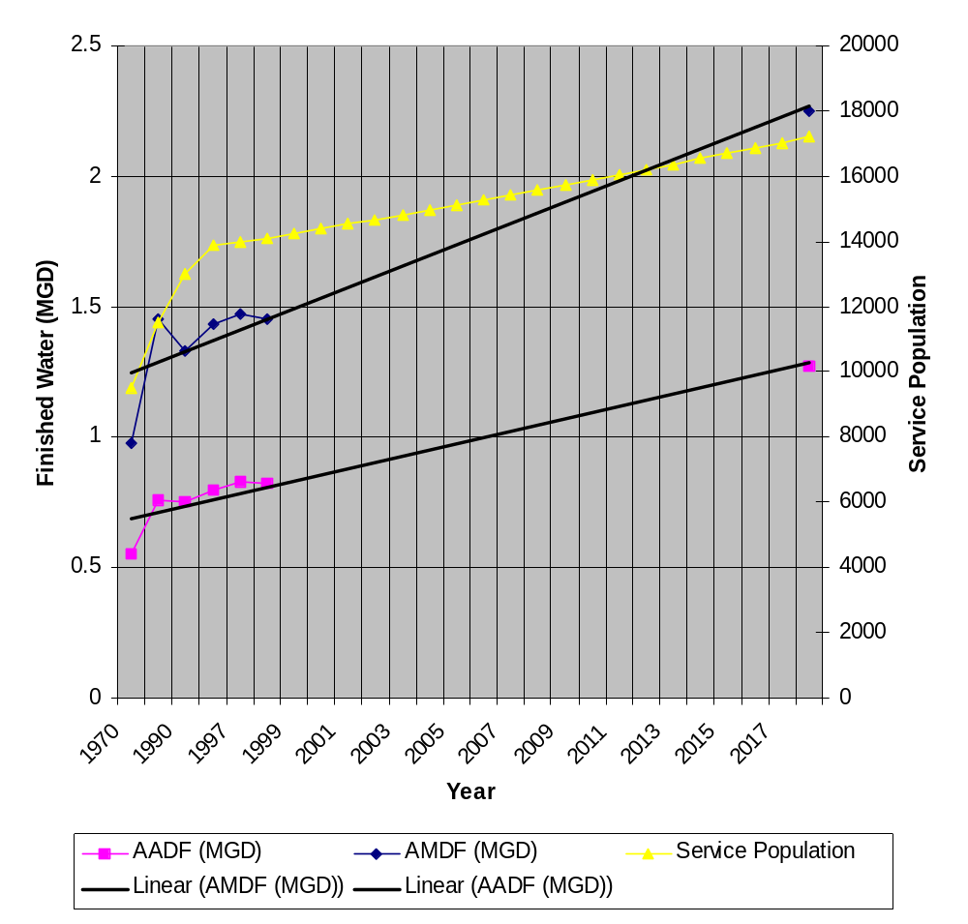

3.3.8. Plant Waste.
The filter backwash and the clarifier blowdown operations produce wastewater in the plant. This wastewater is estimated to be 100,000 GPD for the plant’s production of 2.25 MGD. Water for filter backwashing is presently obtained from the ground storage tanks. All waster are disposed of in an on site lagoon. Periodically, the lagoon must be cleaned and the dried sludge removed. Lagoon cleaning and ultimate waste disposal is presently conducted by a third party service and is not conducted by WTP staff.

Managerial Capacity
The City of Good Hope has the sole responsibility and authority to build, operate, and maintain the water system. No inter-local agreements are necessary for the City to provide drinking water services throughout the planning area. The City’s water and sewer utility department provides the drinking water services. A director who is a licensed professional engineer in the State of Florida heads the utility department. The system is operated continuously with three shifts: the two shifts with the highest flows are staffed with at least one person licensed as a Class C Drinking Water Operator or higher. The lead operator is assigned the shift with the highest flow and must be licensed as a Class B Drinking Water Operator or higher. The utility department maintains a laboratory where routine water analysis is performed.

3.4.1. Operation and Maintenance Program.
The Utility staff are maintaining and operating the water system. Repairs/rehabilitation of the water mains due to broken pipes and joints are periodically made. Recently, telemetry has been installed in all the booster pump stations. The treatment plant is operated continuously with three shifts.

Chapter 4.0 - Development of Alternatives

4.1. General
The alternatives for solving Good Hope’s water system problems require an evaluation of raw water transmission system, treatment facilities and plant waste disposal system. It is planned to design the facilities for the year 2020, covering a design period of 20 years. The planning year is also 2020. The capital and O&M costs along with the present worth of all alternatives are given in Appendix C.
The Options for the Raw Water Transmission Main are:
- No Action.
- Installing a Relief Main with Higher Capacity Pumps.
- Installing a New Main with Higher Capacity Pumps.
The Options for Water Treatment are:
1. No Action.
2. Enlarging/Improving the Existing Plant.
3. Constructing a New Plant
The Options for Plant Waste Disposal are:
1. No Action.
2. Discharging into the Municipal Sewer.
3. Lagooning.

4.2. Cost-effectiveness
Present worth has been used to compare the various alternatives developed in this facilities plan. Present worth combinations for the viable alternatives incorporated the following considerations:
- Planning period of 20 years.
- A discount rate of 7.125% was used in this analysis (the current discount rate is published on the Bureau’s drinking water page or you can contact the Bureau for current discount rate).
- Capital costs (land acquisition, construction, contingency, engineering, legal, fiscal, and administrative costs).
- Operation and maintenance costs.
- Salvage values based on appropriate useful lives of various project components (land - permanent, conveyance and treatment related structures, including piping, tanks, buildings and appurtenances - 40 years: and equipment - 20 years).
- Costs are obtained from recent bids and sales representatives/consultants in the area.

4.3. Raw Water Transmission System.

4.3.1. No Action
Under this alternative, the existing practice will continue and the inadequate capacity of the transmission system will remain. The system will not convey the required water to meet the demand. This alternative is not viable and hence was rejected.

4.3.2. Installing a New Main with Higher Capacity Pumps.
This alternative involves abandoning the existing 10-inch force main and replacing it with a new 18-inch force main and replacing the existing two 25-HP pumps with three 30-HP pumps. The new main will not cause any adverse impacts on the environment nor will it require land acquisition or easements. However, this alternative will not utilize the optimum use of the existing main and also is not cost effective and hence was rejected.

4.3.3. Installing an Additional Relief Main with Higher Capacity Pumps.
This alternative involves augmenting the capacity of the existing 10-inch force main with an additional 10-inch force main and replacing the existing two 25-HP pumps with three 30-HP pumps. Minor modifications are required at the pump station for interconnecting the main. The route of this relief main will be in the same right-of-way as the existing main and will not involve any land acquisition or easements. There are no adverse environmental impacts expected as a result of the implementation of this alternative. The existing main is in fairly good condition due to the efforts of the Utility staff in replacing/rehabilitating the defective portion. This alternative is cost-effective and hence was selected.

4.4. Water Treatment

4.4.1. No action
Under this alternative, the existing water treatment plant will continue to be in operation. The plant has already attained its optimum operational level. Operational problems continue and quality water cannot be produced in sufficient quantity to meet the design year demand. This option is not viable and hence was rejected.

4.4.2. Constructing a New Treatment Plant.
This alternative involves abandoning the existing treatment plant and constructing a new 2.5-MGD plant. This alternative will not utilize the optimum use of the existing facilities. This alternative is not cost-effective and hence was rejected.

4.4.3. Enlarging/Improving the Existing Treatment Plant.
Under this alternative, the capacity of the clarifiers and filters will be increased to 2.5 MGD from its present 1.5–MGD capacity by building additional units. New coagulation/flocculation tanks and disinfecting system will be installed. There is adequate space in the treatment plant site for additional treatment units. Also, the capacity of the underground storage reservoir will be increased from 2 MG to 3 MG. In addition, the capacity of the finished water pumps will be increased to three 50-HP pumps from its present two 30-HP pumps. This alternative will not create any adverse environmental conditions. The additional units proposed are compatible with the existing units and therefore will not cause any problem in operation or procurement of spare parts. This alternative is cost-effective and hence was accepted.

4.5. Plant Waste Disposal.

4.5.1. No action
This alternative will involve continuation of the present practice of recycling the filter back wash water and clarifier blow-down to the front of the treatment plant. This operation is not acceptable since the cumulative solids build-up in the recycle stream cause problems in the plant operation. This is not a viable alternative and, hence was rejected.

4.5.2. Discharging into the Municipal Sewer.
This alternative involves collecting the wastes and transporting them to the municipal sewer for disposal. There is no nearby municipal sewer and hence this alternative will require a long sewer line before discharging into the City sewer. Moreover, the solids in the waste will be expected to range from 1.5 to 3 percent, which may cause serious operational problems at the wastewater treatment facility. Therefore, this alternative is not given any further consideration and was rejected.

4.5.3. Lagooning
This alternative involves construction of a multi-cell lagoon into which the wastes will be discharged. Six cells will be constructed. Each cell will be fed with the wastes for 30 days and then allowed to rest for 150 days for the contents to evaporate/percolate. The supernatant will be returned periodically to the front of the treatment plant. While this cell is in the resting stage, the other five cells will be utilized to receive the wastes in sequence. After five months of resting, the waste solids will be expected to concentrate to about 20 percent when they will be scraped and disposed off in a sanitary landfill. The land required for constructing the lagoon is about 20 acres and it is available next to the treatment plant site. There will be no adverse environmental impacts due to this alternative. Hence, this alternative was selected.

Chapter 5.0 - The Selected Plan.

5.1. Description of Proposed Facilities
The proposed 2.5 - MGD water system, shown in Figure 5, consists of an intake structure, raw water pumps, raw water transmission main, treatment system (consisting of flocculation/coagulation, sedimentation, and chlorination), storage, finished water pumps and lagoon.

5.1.1. Intake Structure and Raw Water Pumps.

The intake structure currently contains two 25-HP constant speed pumps. These pumps will be replaced with three 30-HP constant speed pumps. The pumps will be selected such that two pumps, each shall be capable of pumping the average daily use, with one stand-by pump or being out of service. Alternation of the pumps will be made to equalize the operating time and the wear on the pumps.

5.1.2. Raw Water Transmission Main.

The raw water will be conveyed to the treatment plant for treatment and distribution through the existing 10-inch force main and a newly laid force main of the same size. The length of the transmission mains will be approximately 5,000 linear feet (see figure 3 for the proposed route).

5.1.3. Water Treatment.

A new flocculation/coagulation tank will be constructed with new chemical addition facilities. Two more sand filters and clarifiers, each, will be constructed. The filtered water will be stored in the existing 2 MG underground storage reservoir. This reservoir will be enlarged to 3 MG.

5.1.4. Finished Water Pumps and Distribution System.

Presently, two 30-HP pumps pump the finished water to the distribution system. These will be replaced with three 50-HP pumps. Two pumps, each, will be capable of pumping the average daily demand with one stand–by pump or being out of service. Alternation of the pumps will be made to equalize the operating time and the wear on the pumps. Chlorine solution will be injected into the suction side of the pumps.

5.1.5. Distribution System.

The entire planning area is served by the distribution system, which consists of 2-inch to 10-inch diameter pipes totaling 23,000 linear feet. A new balancing elevated service reservoir of 1.0-MG capacity will be built to equalize the diurnal variation in supply and demand.

Lagoon
Supernatant
To Plant Influent Solids to
Landfill

Chlorine
Solution
Raw Water Backwash
Transmission Main Clarifier Water Finished Water Pumps
New Creek Blow-Down

To Distribution System

Intake Structure/ Flocculation/ Clarifiers Filters Ground
Raw Water Coagulation Storage
Pump Station Tank Tank
(3 – 30HP pumps)
Existing
Proposed

Figure 5: Schematic Process Flow Diagram of the Recommended Facilities

5.1.6 Plant Waste Disposal.

The filter backwash water and the clarifier blowdown will be collected and discharged into a new multi-cell lagoon (six cells). While the solids are settling, the supernatant will be periodically returned to the treatment plant influent. The settled solids at the bottom will be scraped and disposed off in a sanitary landfill.

5.2. Environmental Impacts of Proposed Facilities.
The short-term impacts during construction include increased noise levels, increased airborne particulates and surface run-off during rainfall on the site. Control measures will be implemented to minimize these temporary effects. The long-term impacts of the project are beneficial. The City will have adequate uninterrupted water supply.
The proposed project will not have significant adverse effects on wild and scenic rivers or on flora, fauna, threatened or endangered plant or animal species, prime agricultural lands, wetlands, undisturbed natural areas, or the socio-economic character of the area. The State Historic Preservation Officer has indicated that no archeological, historical or cultural sites are recorded in the area of construction.

5.3. Cost to Construct Facilities.
The details of construction and the O&M costs for the project are presented in Appendix A. The following tabulation presents the total project cost inclusive of the non-construction items.
Construction (including contingency) | $4,829,000
Engineering and inspection @ 15% | 724,350
Legal, fiscal, and administrative @ 5% | 241,450
Total Project Cost | $5,794,800

5.4. Consistency with the Comprehensive Plan.
The recommendation resulting from this study are consistent with both the City’s and the County’s local comprehensive plans.

Chapter 6.0 - Implementation and Compliance

6.1. Public Hearing/Dedicated Revenue Hearing
A public hearing/dedicated revenue hearing was held in the City Hall at 7:00 p.m. on May 15, 2000 after advertising in the area newspapers. Interested parties were individually notified of the hearing. Many citizens attended the hearing and offered comments. Records of the public notice and the hearing are available in the City Office. A summary of the hearings is attached in Appendix D.

6.2. Regulatory Agency Review
To qualify for a subsidized loan from the SRF, various governmental agencies must be satisfied with the way that Good Hope’s water system problem is to be solved. Copies of the facilities plan adopted by the City Commission are to be sent to the following government agencies for review and comments.
1. Florida Department of Environmental Protection
2. Florida Department of Health
3. Southwest Florida Water Management District
4. U. S. Environmental Protection Agency
5. Southwest Florida Regional Planning Council
- Department of Community Affairs, State Clearinghouse

6.3. Financial Planning
The Department of Environmental Protection’s State Revolving Fund is expected to be the financing source for the project. A capital financing plan (CFP) has been prepared to explain to the public and to the State Agency what the financial impact on the users of the water system will be. The CFP is shown in Appendix E. The CFP indicates that the Water and Sewer Utilities serve 5,800 residential customers who pay 90% of the annual cost. Industrial, commercial, municipal and institutional customers pay the balance 10%. A user system rate has been prepared to determine the charges to be paid by each user class. The user system rate with a draft ordinance to implement the same is shown in Appendix F. The average residential user rate is expected to increase by $12.50 per month as a result of the project. The total monthly water bill is expected to average $24.00 for a residential user with normal water consumption.

6.4. Implementation
The City of Good Hope has the sole responsibility and authority to implement the recommended facilities. There are no inter-local agreements necessary for the City to provide drinking water services throughout the planning area.

6.5. Implementation Schedule
June 2000 – Hold public hearing on facilities plan and capital financing plan.
July 2000 – Submit facilities plan to FDEP and other governmental agencies.

October 2000 – Publication of the Department’s environmental information document in the Florida Administrative Weekly.

November 2000 – End of 30-day comment period for the environmental information document and approval of planning documents. Submit plans and specifications to the FDEP (Tallahassee) and submit construction permit application to the FDEP (District Office).

January 2001 – Notice of intent to permit construction of project issued and project added to the priority list.

January 2001 – Submit request for addition of the project to the FDEP’s project priority list.

June 2001 – Hearing to add the project to the Fundable portion of the priority list.

August 2001 – Sign SRF loan agreement.

September 2001 – Advertise for bids.

October 2001 – Open construction bids.

November 2001 – Award contracts.

November 2001 – Start project construction.

November 2002 – Complete construction of the project.

December 2002 – Certify operational performance of the project and close out project.

May 2003 – Begin SRF loan repayments to the FDEP.

6.6. Compliance
- The treated water from the selected alternative will be in compliance with the FDEP drinking water standards.
- The selected alternatives will meet the reliability requirements as per chapter 62-555, F.A.C.
- The residual disposal will meet the requirements of Chapter 62-701, F.A.C. and 40 CFR Part 503.
- The purchase of property for lagoon construction will be in accordance with the Uniform Relocation and Real Property Acquisition Policies Act of 1970.
- The environmental aspects of the proposed facilities are satisfactory.
- The recommended facilities are consistent with Good Hope’s comprehensive plan and with Small County’s comprehensive plan.

Appendix A

Cost Information of the Selected Alternative

Cost Information of the Selected Alternative

Construction Cost
Site Purchase for the Lagoon (20 acres @$5,000/acre) | $100,000
Raw Water Pumps and accessories (three 30-HP each) | 100,000
10-inch Conveyance Main (23,000 feet @ $35/lf) | 175,000
Flocculation/Coagulation Tank (including flash mixing and chemical feed facilities) | 400,000
Clarifiers (two new) | 400,000
Filters (two new) | 400,000
Ground Storage Reservoir (1 MG ) | 1,000,000
Finished Water Pumps and Accessories(three 50-HP each) | 200,000
Chlorinators | 100,000
Balancing Reservoir (0.4 MG) | 800,000
Lagoon Construction | 200,000
Auxiliary Power | 100,000
Site Work, Paving and Grading | 250,000
Electrical, Instrumentation and Controls | 165,000
Subtotal | $4,390,000
Contingency @ 10% | 439,000
Total Construction Cost | $4,829,000

Annual O&M Costs
Raw Water Pumping | $50,000
Force Main @ $500/mile | 500
Flocculation/Coagulation, Sedimentation, and Filtration | 250,000
Finished Water Pumping | 100,000
Chlorination | 50,000
Waste Disposal | 30,000
Total | $480,500

Appendix B

Potential Sources of Contamination to Municipal Water Supply Wells

Potential Sources of Contamination to Municipal Water Supply Wells

Source of Contamination (*indicates sources of microbialcontaminants) |  |  | New Creek
Agriculture
 | Crop-related sources
 |  | Irrigated crop production | X
 |  | Non-irrigated crop production
 |  | Specialty crop production (e.g., horticulture, citrus, nuts, fruits)
 | Grazing-related sources*
 |  | Pasture grazing - riparian and/or upland* | X
 |  | Pasture grazing - riparian*
 |  | Pasture grazing - upland*
 |  | Range grazing - riparian and/or upland*
 |  | Range grazing - riparian*
 |  | Range grazing - upland*
 | Intensive animal feeding operations*
 |  | Concentrated animal feeding operations (CAFOs; permitted; PS)*
 |  | Confined animal feeding operations (NPS)*
 |  | Aquaculture*
Atmospheric deposition
Collection system failure
Combined sewer overflow*
Construction
 | Highway/road/bridge construction
 | Land development
Contaminated sediments
Debris and bottom deposits
Domestic wastewater lagoon*
Erosion from derelict land
Groundwater loadings
Groundwater withdrawal
Habitat modification (other than hydromodification)
 | Removal of riparian vegetation
 | Bank or shoreline modification/destabilization
 | Drainage/filling of wetlands
Highway maintenance and runoff |  |  | X
Hydromodification
 | Channelization
 | Dredging
 | Dam construction
 | Upstream impoundment
 | Flow regulations/modification
Industrial Point Sources
 | Major industrial point sources
 | Minor industrial point sources
Internal nutrient cycling (primarily lakes)
Land disposal
 | Sludge*
 | Wastewater*
 | Landfills*
 | Inappropriate waste disposal/wildcat dumping*
 | Industrial land treatment
 | Onsite wastewater systems (septic tanks)*
 | Hazardous waste
 | Septage disposal*
Leaking underground storage tanks |  |  | X
Marinas and recreational boating
 | In-water releases*
 | On-land releases*
Municipal point sources*
 | Major Municipal Point Sources - dry and/or wet weather discharges*
 | Major Municipal Point Sources - dry weather discharges*
 | Major Municipal Point Sources - wet weather discharges*
 | Minor Municipal Point Sources - dry and/or wet weather discharges*
 | Minor Municipal Point Sources - dry weather discharges*
 | Minor Municipal Point Sources - wet weather discharges*
 | Package plants (small flows)*
Natural sources (e.g., arsenic, radon, wildlife)* |  |  | X
Other
Recreation and tourism activities (other than boating) |  |  | X
 | Golf courses
Resource extraction
 | Surface mining
 | Subsurface mining
 | Placer mining
 | Dredge mining
 | Petroleum activities
 | Mill tailings
 | Mine tailings
 | Acid mine drainage
 | Abandoned mining
 | Inactive mining
Salt storage sites
Sediment resuspension
Sewer lines (leaking)*
Silviculture
 | Harvesting, restoration, residue management
 | Forest management (e.g., pumped drainage, fertilization, pesticide application)
 | Logging road construction/maintenance
 | Silvicultural point sources
Sources outside state jurisdiction or borders*
Spills (accidental)*
Unknown source*
Urban runoff/storm sewers*
 | Nonindustrial permitted*
 | Industrial permitted*
 | Other urban runoff*
 | Illicit connections/illegal hookups/dry weather flows*
 | Highway/road/bridge runoff |  | X
 | Erosion and sedimentation
Waste storage/storage tank leaks (above ground)*

NOTE: EPA's 305(b) guidance also asks states to identify major sources of contamination of waters designated for drinking water supply use. States are urged to coordinate their source water and 305(b) information and programs.

http://www.epa.gov/OGWDW/source/appende.html

Appendix C

Detailed Cost Information and Present Worth Analysis for all Alternatives

Detailed Cost Information and Present Worth Analysis for all Alternatives

I. New Treatment Plant
- Construction Cost
 | Site Purchase (25 acres for plant @ $5,000/acre) |  | $125,000
 | Flocculation/Coagulation Tanks |  | 400,000
 | Clarifiers |  | 800,000
 | Filters |  | 800,000
 | Finished Water Pumps and Accessories |  | 200,000
 | Chlorinators |  | 100,000
 | Auxiliary Power |  | 75,000
 | Site Work, Paving and Grading |  | 250,000
 | Electrical, Instrumentation and Controls |  | 150,000
 |  | Subtotal | $2,900,000
 |  | Contingency @ 10% | 290,000
 |  | Total | $3,190,000
- Annual Operation and Maintenance cost
 | Flocculation/Coagulation, Sedimentation, and Filtration |  | $250,000
 | Finished Water Pumping |  | 100,000
 | Chlorination |  | 50,000
 |  | Total | $400,000
- Salvage Value
 | Site |  | $125,000
 | Flocculation/Coagulation Tanks |  | 200,000
 | Clarifiers |  | 400,000
 | Filters |  | 400,000
 |  | Total | $1,125,000
- Present Worth
 | $3,190,000 + $400,000 x10.4919 - $1,125,000 x 0.1868 = $7,176,610

II. Expansion of Existing Treatment Plant
- Construction Cost
 | Raw Water Pumps |  | $100,000
 | Flocculation/Coagulation Tanks (including Flash Mixing and Chemical Feed Facilities) |  | 400,000
 | Clarifiers |  | 400,000
 | Filters |  | 400,000
 | Finished Water Pumps and Accessories |  | 200,000
 | Auxiliary Power |  | 75,000
 | Site Work, Paving and Grading |  | 100,000
 | Electrical, Instrumentation and Controls |  | 100,000
 |  | Subtotal | $1,775,000
 |  | Contingency @ 10% | 177,500
 |  | Total Construction Cost | $1,952,500
- Annual Operation and Maintenance Cost
 | Flocculation/Coagulation, Sedimentation and Filtration |  | $250,000
 | Finished Water Pumping |  | 100,000
 | Chlorination |  | 50,000
 |  | Total | $400,000
- Salvage Value
 | Flocculation/Coagulation Tanks |  | 200,000
 | Clarifier |  | 200,000
 | Filters |  | 200,000
 |  | Total | $600,000
- Present Worth
 | $1,952,500 + 400,000 x10.4919 – 600,000 x 0.1868 = $6,037,180

III. 10-inch Auxiliary Transmission Main
- Construction Cost
 | Providing an auxiliary Main 10-inch diameter, 5,000 lf @ $35/lf | $175,000
- Annual Operation and Maintenance Cost
 | 10-inch Force main @ $500/mile | $500
- Salvage Value
 | Force main | $82,500
- Present Worth
 | $175,000 + 500 x 10.4919 – 82,500 x 0.1868 = $164,835

IV. 18-inch New Transmission Main
- Construction Cost
 | 5,000 linear feet @ $45/lf | $225,000
- Annual Operation and Maintenance Cost
 | Force main @ $600/mile | $600
- Salvage Value
 | Force Main | $112,500
- Present Worth
 | $225,000 + 600 x 10.4919 – 112,500 x 0.1868 =$210,280

V. Waste Disposal in Lagoon
- Construction Cost
 | Site Purchase, 20 acres @ $5,000/acre |  | $100,000
 | Lagoon Construction Including Site Work, Paving and Grading |  | 200,000
 |  | Total | $300,000
- Annual Operation and Maintenance Cost
 | Lagoon Maintenance |  | $30,000
- Salvage Value
 | Site |  | $100,000
- Present Worth
 | $300,000 + 30,000 x 10.4919 – 100,000 x 0.1868 = $427,957

Appendix D

Summary of Public/Dedicated Revenue Hearing
MINUTES

REGULAR MEETING OF THE CITY COUNCIL
May 15, 2000

Mayor Thomas C called to order at 7:30 P.M May 15, 2000, a public/dedicated revenue hearing for the purpose of discussing and adopting the water facilities plan (inclusive of the capital financing plan) addressing the improvements/expansion to the drinking water system for the City of Good Hope.

Those also in attendance were Commissioners Margaret M, Bill R, Joe B, Mary W, and City attorney Jim S. A total of 18 persons attended the hearing. The list of attendees is attached.

PUBLIC HEARING:

Approve Resolution to Adopt the Water System Facility Plan and the Capital Financing Plan required by Florida Department of Environmental Protection for the Drinking Water State Revolving Fund program.

Mayor Thomas C requested Mr. Tom F of XYZ Engineering Consultants, Inc. to address the water facilities plan that he developed for the City. Tom explained the salient features of the water facilities plan. He dealt with the present and future population to be served by the plan. He discussed the present state of the water system and the necessity to improve and expand the system to meet the regulatory requirements. He considered several alternatives to accomplish the objective and recommended the cost-effective alternative for implementation. He mentioned briefly about all the alternatives but dealt with in detail about the selected alternative. He also detailed the capital and operation and maintenance costs of the selected alternative. Total cost of the proposed project is $4,829,000. He also discussed about the environmental conditions (both present and future) in the planning area and mentioned about improvements to the environment by implementing the project. Then he requested Ms. Dianne K to discuss about the financial implications of the project vis-à-vis the user charges. Ms. K started by detailing the capital financing plan, which is attached in the water facilities plan (Appendix E). She mentioned the project was to be financed by the State Revolving Fund (SRF) loan at 3 percent interest rate. The loan is to be repaid in 20 years with half yearly payments and the dedicated revenue for loan payment is water user charges. She discussed the advantage of going for SRF loan instead of a conventional loan. She discussed the average user charge and the additional charge that a user has to pay due to the project. She stated that the average cost per customer using 12,000 gallons of water per month would be approximately $24.00. This is computed at a $13.63 base rate and usage charge of $0.88 per 1,000 gallons. Both Tom and Dianne made their presentations with appropriate slides and brought to the attention of the attendees that the recommendations of the water facilities plan are in conformance with the comprehensive plans of the City and the County.

At the conclusion of the presentations, Mayor C opened the forum for the public to comment. There were no comments or questions from the public.

There being no further questions from those in the assembly, Mayor C closed the hearing to the public.

MOTION By Councilman Joe B; Seconded by Councilwoman Margaret M, to approve the resolution.

AYES: Thomas C, Margaret M, Bill R, Joe B, Mary W

THE MOTION CARRIED UNANIMOUSLY. (5 TO 0)

The mayor declared the hearing over and adjourned the meeting at 8:30 P.M.

Sandra H, City Clerk |  | Thomas C, Mayor

SIGN IN SHEET FOR
THE CITY OF GOOD HOPE
PUBLIC HEARING
MAY 15, 2000

PLEASE SIGN IN:

Name: Address:
 | Margaret M. |  | Hudson St
 | John Q Public |  | Hwy 19
 | Joe B. |  | Fourth St.
 | Mary W. |  | Grove St.
 | Jim S. |  | 1st Ave
 | John Doe |  | County Morgue
 | Bill Smith |  | XYZ Engineering Consultants
 | Tom Jones |  | Las Vegas
 | Thomas C. |  | Main St
 | Tom F. |  | XYZ Engineering Consultants
 | Dianne K. |  | Captains Cove Road
 | Bill Buffalo |  | Wyoming St
 | S. Graser |  | 2nd Ave
 | Sam Snead |  | Golf Course
 | Good Night |  | Sleepy Hollow
 | Chuck Norris |  | Gym St
 | Kris K. |  | North Pole
 | Arnold P. |  | Golf Course Lane
The Good Hope Weekly

Published Weekly Good Hope, FL

Affidavit of Publication
NOTICE OF PUBLIC HEARING
SPECIAL MEETING
CITY OF GOOD HOPE

Notice is hereby given that the City Commissioners for the City of Good Hope, Florida will hold a special meeting on May 15, 2000. The meeting is at 5:30pm at City Hall at 481 W. Main St, Good Hope, Florida, for the purpose of considering the approval of the proposed City of Good Hope Water Facility Plan. This hearing will include a discussion of the Water Facilities Plan and the financial impact on system users. The hearing is intended to afford the opportunity to individuals to be heard on the economic and social effects of the location, design, and environmental impact of the water system improvements.
A portion of the funding for this project is anticipated to come from the State Revolving Fund (SRF) loan program. Financial impacts on utility users will be presented at the hearing.
Reports, documents and data relevant to the discussion are available for public review at Good Hope City Hall.
Other business which may properly come before the Commission will also be addressed. All interested persons are invited to attend and be heard.
SPECIAL REQUIREMENTS: If you require special aid or services as addressed in the American Disabilities Act, please contact the City Clerk’s Office at (904) 652-8521, no less than five (5) days prior to the above stated hearing date.
City of Good Hope, Florida
Thomas C., Mayor
State of Florida – County of Small

Before the undersigned authority, personally appeared Patty Brant who on oath says she is the Editor of the Good Hope Weekly newspaper published at Good Hope, in Small County, Florida, that the attached copy of advertisement being a Notice of Public Hearing in the matter of a Special Meeting published in said newspaper in the issue of April 1, 2000.

Affiant further says that the said Good Hope Weekly is a newspaper published at Good hope in said Small County, continuously published in said Small County, Florida each week, and has been entered as a Third (3rd) class mail matter at the post office in Good Hope in said Small County, Florida for a period of one year next preceding the first publication of the attached copy of advertisement: and affiant further says that she has neither paid nor promised any person, firm or corporation any discount rebate, commission or refund for the purpose of securing this advertisement for publication in the said newspaper.

Patty Brant
Patty Brant

STATE OF FLORIDA
COUNTY OF SMALL

Sworn to and subscribed before me this 28th day of March, 2000 by Patty Brant, who is personally known to me.
Notary Public State of Florida

Janet Whynot
Notary Public
Janet Whynot #CC8401771

Appendix E

Capital Financing Plan

CAPITAL FINANCING PLAN WORKSHEETS

________________________________________________________________________________________________________________________________________________________________________

City of Good Hope, Florida
Project Sponsoring Agency (DWSRF Project Sponsor)
John Doe, Mayor |  | Jane Smith, Finance Director
Authorized Representative and Title |  | Capital Financing Plan Contact, Title, and Telephone Number
555 Big Street |  | 555 Big Street
Street Address or Other Mailing Address |  | Street Address or Other Mailing Address
Good Hope, Florida 00000 |  | Good Hope, Florida 00000
City, State, and Zip Code |  | City, State, and Zip Code
_________________________________________________________________________________________________________________________________________

The Department needs to know about the financial capabilities of potential Drinking Water State Revolving Fund (DWSRF) loan applicants. Therefore, a financial capability demonstration (and certification) is required well before the evaluation of the actual loan application. Please see Rule 62-552(5) in Chapter 62-552, F.A.C. for further details.

It is expected that the revenues to be dedicated to repaying the loan will be generated either from water and sewer utility operations or from water utility operations alone. If the source of revenues will not be from such enterprises, this set of worksheets alone will not satisfy the Department's needs. (Please contact the Department for further guidance if dedicated revenues will be generated externally to such utilities.)

This form solicits information for the next five years. Ordinarily, the five-year time frame will cover the period of interest to the Department; but, it will be necessary to provide additional yearly information until the reported data includes at least one full year of DWSRF project operation and one annual DWSRF repayment to the Department. Accordingly, attachments may be made to these worksheets. Please use the format established herein when preparing attachments. The worksheets have been developed to identify the minimum information needed. The completed worksheets should be used in disclosing DWSRF project financing to the public during the required dedicated revenue hearing. The worksheets can serve to identify the impacts of the SRF project on residential users and how the project fits into the project sponsor’s overall capital improvement program for the water and sewer utility (or water utility, as appropriate). Supplemental capital financing documentation may be submitted with these worksheets and may be presented at the required dedicated revenue hearing.
.

- Household median annual income, average size, number in the utility service area, and population to be served. (Population to be served is determined by the number of households multiplied by the household size. This data is to be consistent with facilities planning projections.) If the data vary by district or zone, report the data according to district or zone on an attachment.
Note: Indicate the actual fiscal years for Year 1 - Year 5 wherever they appear in the worksheets.
 |  | Year 1 |  | Year 2 |  | Year 3 |  | Year 4 |  | Year 5
1. | Fiscal Year | 2000 |  | 2001 |  | 2002 |  | 2003 |  | 2004
2. | Household income ($/year) | 30,000
3. | Household size (people/household) | 2.43
4. | Number of households | 5,800 |  | 5,820 |  | 5,840 |  | 5,860 |  | 5,880
5. | Serviced population (people) | 14,100 |  | 14,200 |  | 14,350 |  | 14,500 |  | 14,700

- The revenues being dedicated to repayment of the DWSRF loan are:
Water user fees

- What projects (including the DWSRF project) will be financed from the operation of the utility generating the revenues to be dedicated to repaying the DWSRF loan? Total annual cost is the sum of annualized capital costs plus the annual operation, maintenance, and replacement (O/M & R) costs. Note that wastewater facilities information is to be identified only if the dedicated revenues will be generated from operations of a water and sewer utility.

 | Facilities Description | Construction Start Dates (Month/Year) |  | Capital Costs ($) |  | Annualized Capital Costs ($) |  | Annual Cost to Operate, Maintain, and Replace ($) |  | Total Annual Costs ($)
1. | Water supply well
2. | Water treatment plant | 7/99 |  | 2,791,000 |  | 187,665 |  | 330,000 |  | 517,665
3. | Sites and easements
4. | Water transmission systems | 7/99 |  | 627,000 |  | 42,147 |  | 150,500 |  | 192,647
5. | Water storage facilities | 7/99 |  | 2,376,000 |  | 159,715 |  | --- |  | 159,715
6. | Other (explain)___________
7. | Wastewater facilities
 | Total |  |  | 5,794,800 |  | 389,527 |  | 480,500 |  | 870,027

Identify which of the above water facilities are to be financed with the DWSRF loan and combine (as appropriate) the associated costs:
Description | Treatment, transmission and storage |  |  |  | Total Capital Cost | $5,794,800
Total Annualized Capital Costs |  | $389,527 | Total Annual Costs for O/M&R | $480,500 | Total Annual Cost | $870,027

- Identify the DWSRF loan amount scheduled, or to be scheduled, on the project priority list; the interest rate established for the quarter preceding the submittal of the CFP, annual debt service, and expected pledged revenue coverage. Note that DWSRF repayments begin six months after the estimated construction completion. (It is recognized that the information provided is best estimates only.)

DWSRF Loan Amount $ | 5,795,000 | interest rate | 3.0 | % | annual debt service $ |  | 389,527
loan repayment reserve $ | 115,900 | pledged revenue coverage factor |  |  | 15% | semi-annual repayments begin |  | 5/30/2003 | (Date).

- Identify other anticipated debt, which will be repaid from operations of the utility providing the dedicated revenues. N/A

 | Description/Fiscal Year |  | Debt Amount($) |  | Annual Interest Rate(%) |  | Revenue Coverage Rate(%) |  | Annual Debt Service($)
 |  |  |  |  |  |  |  |  | Year 1 |  | Year 2 |  | Year 3 |  | Year 4 |  | Year 5
1.
2.
3.
4.

- What is the existing debt for the utility providing the DWSRF dedicated revenues?

 | Description/Fiscal Year |  | Current Debt Amount($) |  | Annual Interest Rate(%) |  | Revenue Coverage Rate(%) |  | Annual Debt Service($)
 |  |  |  |  |  |  |  |  | Year 1 |  | Year 2 |  | Year 3 |  | Year 4 |  | Year 5
1. | 1987 Rev. Bond (20 yrs) |  | 3,500,000 |  | 6 |  | 15% |  | 350,900 |  | 350,900 |  | 350,900 |  | 350,900
2. | 1990 Rev. Bond (20 yrs) |  | 2,500,000 |  | 5 |  | 15 |  | 230,690 |  | 230,690 |  | 230,690 |  | 230,690
3.
4.
5.
6.
 | Totals ($) |  | 6,000,000 |  |  |  |  |  | 581,590 |  | 581,590 |  | 581,590 |  | 581,590

- Identify the projected annual expenses for the utility providing DWSRF dedicated revenues.

  - Existing facilities

Fiscal Year |  |  | FY | (98 ) |  | FY | (99) |  | FY | ( 00 ) |  | FY | ( 01 ) |  | FY | (02 )
OM&R ($) |  |  | 270,000 |  |  | 290,000 |  |  | 310,000 |  |  | 320,000 |  |  | 340,000
Debt Service ($) |  |  | 581,590 |  |  | 581,590 |  |  | 581,590 |  |  | 581,590 |  |  | 581,590
Other – describe |  | ($)
 | Totals | ($) | 851,590 |  |  | 871,590 |  |  | 891,590 |  |  | 901,590 |  |  | 921,590

2. DWSRF proposed project(s)

Fiscal Year |  |  | FY | ( 98 ) |  | FY | ( 99 ) |  | FY | ( 00 ) |  | FY | ( 01 ) |  | FY | (02 )
OM&R ($) |  |  | 480,500 |  |  | 504,840 |  |  | 530,600 |  |  | 558,000 |  |  | 587,000
Debt Service ($) | (includes 15% coverage |  | 447,956 |  |  | 447,956 |  |  | 447,956 |  |  | 447,956 |  |  | 447,596
Other – describe |  | ($)
 | Totals | ($) | 928,456 |  |  | 952,756 |  |  | 978,556 |  |  | 1,005,956 |  |  | 1,034,956

3. Non-DWSRF proposed project(s) (if any) N/A
Fiscal Year |  |  | FY | ( ) |  | FY | ( ) |  | FY | ( ) |  | FY | ( ) |  | FY | ( )
OM&R ($)
Debt Service ($)
Other – describe |  | ($)
 | Totals | ($)

4. All existing and planned facilities (sum of Items 1, 2, & 3, above)

Fiscal Year |  |  | FY | ( 98 ) |  | FY | ( 99 ) |  | FY | ( 00 ) |  | FY | ( 01 ) |  | FY | ( 02 )
OM&R ($) |  |  | 750,500 |  |  | 794,840 |  |  | 840,000 |  |  | 878,000 |  |  | 927,000
Debt Service ($) |  |  | 1,029,546 |  |  | 1,029,546 |  |  | 1,029,546 |  |  | 1,029,546 |  |  | 1,029,546
Other – describe |  | ($)
 | Totals | ($) | 1,780,046 |  |  | 1,824,386 |  |  | 1,869,546 |  |  | 1,907,546 |  |  | 1,956,546

- Identify the projected annual utility revenues assuming all the planned projects are constructed according to the schedule reported in Item C, above. Compare revenues to expenses identified in Sub-item G.4, above, and explain (on an attachment) how any net loss is covered to keep the utility financially self-sufficient in each deficit year.

Fiscal Year |  |  | FY | (98 ) |  | FY | ( 99 ) |  | FY | (00 ) |  | FY | (01 ) |  | FY | ( 02 )
Operating ($) |  |  | 1,800,000 |  |  | 1,850,000 |  |  | 1,900,000 |  |  | 1,930,000 |  |  | 1,980,000
Non-operating ($)
Other – describe |  | ($)
 | Totals | ($) | 1,800,000 |  |  | 1,850,000 |  |  | 1,900,000 |  |  | 1,930,000 |  |  | 1,980,000

- Identify the projected annual expenses for the water system, assuming all planned water facilities will be constructed. These entries may be skipped if a water utility alone is providing the DWSRF dedicated revenues since the information already will have been presented in Subitem G.4, above.

Fiscal Year |  |  | FY | ( ) |  | FY | ( ) |  | FY | ( ) |  | FY | ( ) |  | FY | ( )
OM&R ($)
Debt Service ($)
Other – describe |  | ($)
 | Totals | ($)

- Identify the projected annual revenues for the water system, assuming all planned water facilities will be constructed. Compare revenues to expenses identified in Item I, above, and explain (on an attachment) how any net loss is covered to keep the water system financially self-sufficient in each deficit year. These entries may be skipped if a water utility alone is providing the DWSRF dedicated revenues since the information already will have been presented in Item H, above.

Fiscal Year |  |  | FY | ( ) |  | FY | ( ) |  | FY | ( ) |  | FY | ( ) |  | FY | ( )
Operating ($)
Non-operating ($)
Other – describe |  | ($)
 | Totals | ($)

- Identify the average water system charge, fees, and assessments. If the utility service area encompasses districts or zones which will be subject to different service charges, fees, etc. attributable to the DWSRF project, it will be necessary to provide the relevant data below separately for the district(s) or zone(s). Difference in charges, fees, etc. should be explained on the attachment used to present the water system data.

Description

 | Fiscal Year/Description |  |  | FY | ( 98 ) |  | FY | (99 ) |  | FY | (00 ) |  | FY | ( 01 ) |  | FY | (02 )
1. | Water System data
 | a. | Total estimated annual water system costs |  | 1,780,046 |  |  | 1,824,386 |  |  | 1,869,546 |  |  | 1,907,546 |  |  | 1,956,546
 | b. | Non-residential share of total annual water system costs |  | 178,005 |  |  | 182,439 |  |  | 186,955 |  |  | 190,755 |  |  | 195,655
 | c. | Residential share of total annual water system costs |  | 1,602,041 |  |  | 1,641,947 |  |  | 1,682,591 |  |  | 1,716,791 |  |  | 1,760,891
 | d. | Number of households |  | 5,800 |  |  | 5,820 |  |  | 5,840 |  |  | 5,860 |  |  | 5,880
 | e. | Average residential system charge /per month/customer $ |  | 23.02 |  |  | 23.51 |  |  | 24.00 |  |  | 24.41 |  |  | 24.96
2. | Average connection fee per residential unit
3. | Average impact fee per residential unit
4. | Average special assessment per residential unit (identify basis below)
5. | Average capacity charge per residential unit (identify basis below)
6. | Other (describe)
7. | DWSRF project capital cost per household (from Item C divided by Item K.1.d) $ |  |  | 999 |  |  | 996 |  |  | 992 |  |  | 989 |  |  | 986

Describe basis for special assessments, such as cost per lot length | N/A
Describe basis for capacity charge, such as cost per volume per day | N/A

- Which, if any, of the following activities must be undertaken to implement the DWSRF project?

1. | Acquire privately held land? | YES | X |  | NO
2. | Acquire land held by another public water system entity? | YES |  |  | NO | X
3. | Enter into inter-local or inter-project sponsoring agency’s agreements? | YES |  |  | NO | X
4. | Hold an election or public referendum? | YES |  |  | NO | X
5. | Comply with special assessment or similar procedural requirements? | YES |  |  | NO | X

- Attach a certification by the project sponsor’s chief financial officer or by an official authorized to commit to the SRF funding that the project sponsor has the financial capability to ensure adequate construction, operation, and maintenance of the water system.

Certification

I |  |  |  | , certify that I have reviewed the information included in the above
 | Chief Financial Officer or Authorized Representative(please print)
capital financing plan worksheets, and to the best of my knowledge, this information accurately reflects the financial capability of
 |  | . I further certify that
Sponsor |  |  |  |  |  | Sponsor
has the financial capability to ensure adequate construction, operation, and maintenance of the water system. This certification is made with full consideration given to other planned projects that will be financed from the revenues to be dedicated to repaying the Drinking Water State Revolving Fund loan.
Signature |  |  |  |  | Date

FINANCIAL BURDEN RATIO

The financial burden ratio is required to determine eligibility for construction grant funding. An example is shown below. The Capital Financing Plan should be completed as if the project was being funded with a 100% loan. Use the results in the calculations below. If it is determined that the sponsor is eligible for a construction grant the Capital Financing Plan should be completed again using the appropriate loan percentage as determined below (15% or 35%).

Actual Median Household Income (MHI): $ 24,884
Source: 1990 US Census

Actual Annual User Charge: $ 207
Source: 100% CFP

Debt Service: $ 48,925
Source: 100% CFP, Line G4

Project Operating Revenues: $ 562,454
Source: 100% CFP, Line J.

FINANCIAL BURDEN RATIO (FBR) – User Charge Method

(Debt Service/Operating Revenues)*(User Charge/MHI)=(48925/562454)*(207/24884)=0.07%

FINANCIAL BURDEN RATIO (FBR) – EDU Method

Monthly Demand Data: (April 2000)
Residential Accounts: 1459 Flow: 17,691 kgal
Commercial Accounts: 257 Flow: 5,901 kgal
Totals: 1716 23,592 kgal

EDU Calculation = (Total Flow)*(Res Accts/Res Flow) = (23592)*(1459/17691) = 1946

FBR = (Debt Service/EDU)/(MHI) = (48925/1946)*(24884) = 0.10%

Median Grant
Household FBR Funding
Income Criteria (%)

< 27,483 >= 1% 65%
>= 21,986 >= 1% 65%
< 21,986 < 0.5% 65%
< 21,986 >= 0.5% 85%

State Median Household Income: $27,483
(State MHI)*80%: $21,986
Good Hope MHI: $24,884 (source: 1990 U.S. Census)

Appendix F

User Rate System and Draft Rate Ordinance

User Rate System

I. INTRODUCTION

The City of Good Hope has a 2.25 MGD water treatment facility. The user rate presented here is designed to equitably distribute to all users the operation, maintenance, replacement and debt service costs of the water system operated by the City of Good Hope. The information presented here should be considered to be preliminary as it is based on estimated O & M costs. After the new water system facilities have been operated for a period of one year, it is recommended that the system is re-examined in the light of actual expenditures and the rates revised as required.

II. THE SYSTEM RATE

The charges that will be assessed each user will reflect the actual cost incurred in order to serve that user. Those costs can be classified under two categories: (1) readiness to serve costs (fixed cost) and (2) costs for treating the water and operating and maintaining the system (variable cost).

In order to determine the costs associated with each of the above listed categories, it was first necessary to prepare a proposed budget for the system (Table 2). Next, it was necessary to separate operation, maintenance and replacement costs into fixed and variable costs (Table 3). Fixed costs are equated with readiness to serve costs (i.e., costs that will be incurred regardless of the volume of water used). Variable costs are those that depend on actual volume of water used.

Table 4 shows the methodology of how the user rate per month per customer is calculated.
Table 3: Proposed Budget

COST CATEGORY |  | PRESENT | DUE TO EXP. FAC. | TOTAL
Personnel |  | $145,800 | $259,470 | $405,270
Chemicals & supplies |  | 70,200 | 124,930 | 195,130
Electricity |  | 40,500 | 72,075 | 112,575
Miscellaneous |  | 13,500 | 24,025 | 37,525
 | Sub-total | 270,000 | 480,500 | 750,500
Debt payment |  | 581,590 | 447,956 | 1,029,546
 | Total annual cost | 851,590 | 928,456 | 1,780,046

Table 4: Budget Cost Breakdown

COST CATEGORY | FIXED | VARIABLE. | TOTAL
Personnel | $21,000 | $384,270 | $405,270
Chemicals & supplies | 0 | 195,130 | 195,130
Electricity | 0 | 112,575 | 112,575
Miscellaneous | 5,000 | 32,525 | 37,525
Debt payment | 1,029,546 | 0 | 1,029,546
Total | 1,055,546 | 724,500 | 1,780,046

Table 5: Water User Rate

Methodology for calculating the user rate:

User Rate = Fixed Cost (C_{f}) + Variable Cost (C_{v}) x (Water Consumption of Individual Customer)
No. of Customers Total Water Consumption

Fixed Cost (C_{f}) = $ 1,055,546/year or $ 87,962/month

Variable Cost (C_{v}) = $ 724,500/year

No. of Customers (all categories) = 6450

Annual Water Usage = 821,250,000 gallons

Therefore, user rate = $ 87,962/month + $724,500/year x (Monthly Water Consumption
6450 users 821,250,000 gallons/year of Individual Customer)

= $ 13.63 + ($0.88/1,000 gals.) x (Customer monthly usage)

Assuming average monthly water consumption by individual customer as 12,000 gallons,

User rate per customer = $ 13.63 + $ 0.88 x 12 = $ 24.19/month.
DRAFT RATE ORDINANCE NO. ---------

An ordinance establishing system rates in the City of Good Hope to provide funds needed to pay for operation and maintenance expenses associated with the City’s water system.

WHEREAS, the City of Good Hope, Florida, has constructed improvements to the water system; and

WHEREAS, it is the City’s intent to establish proportionate system rates that place the costs of conserving potable water and maintaining financial self-sufficiency, and

WHEREAS, the City of Good Hope must pay the operation and maintenance expenses associated with the said water system and charge the users of said water system accordingly:

NOW, THEREFORE, BE IT ORDAINED BY THE Commissioners of the City of Good Hope, Florida, that the following system rates are established.

ARTICLE I

It is determined and declared to be necessary and conducive to the protection of the public health, safety welfare and convenience of the citizen of the City of Good Hope to collect charges from all users who is served by the City’s water system. The proceeds of such charges so derived will be used for the purpose of operating and maintaining the public water system.

ARTICLE II

Unless the context specifically indicates otherwise, the meaning of terms use in this ordinance shall be as follows:

Section 1: “Casing” shall mean the tubular material used to shut off or exclude a stratum or strata other than the source bed and conduct water from only the source bed to the surface.

Section 2: “Commercial User” shall mean all retail stores, restaurants, office buildings, laundries, and other private business and service establishments.

Section 3: “Community Water System” shall mean a public water system which serves at least 15 service connections used by year-round residents or regularly serves at least 25 year-round residents.

Section 4: “Contaminant” shall mean any physical, chemical, biological or radiological substance or matter in water.

Section 5: “Cross-connection” shall mean any physical arrangement whereby a public water supply is connected, directly or indirectly, with any other water supply system, sewer, drain, conduit, pool, storage reservoir, plumbing fixture, or other device which contains or may contain contaminated water, sewage or other waste, or liquid of unknown or unsafe quality which may be capable of imparting contamination to the public water supply as the result of backflow.

Section 6: “Disinfection” shall mean a process that inactivates pathogenic organisms in water by chemical oxidants or equivalent agents.

Section 7: “Industrial User” shall mean any non-governmental, non-residential user of the water system which is identified in the Standard Industrial Classification Manual, 1972, Office of Management and Budget, as amended and supplemented, under the following divisions; Division A-Agriculture, Forestry, and Fishing; Division B-Mining; Division D-Manufacturing; Division E-Transportation, Communications, Electric, Gas and Sanitary; and Division I-Services.

Section 8: “Institutional User” shall mean any social, charitable, religious, and educational activities such as schools, churches, hospitals, nursing homes, penal institutions and similar institutional users.

Section 9: “Governmental User” shall mean legislative, judicial, administrative, and regulatory activities of Federal, State and local governments user of the water system.

Section 10: “Maximum Contaminant Level (MCL)” shall mean the maximum permissible level of a contaminant in water which is delivered to any user of a public water system.

Section 11: “Non-Community Water System” shall mean a public water system which provides piped water for human consumption to at least 15 service connections or which serves at least 25 individuals at least 60 days out of the year but which is not a community water system.

Section 12: “Non-Transient Non-Community Water System” shall mean a public water system that is not a community water system and that regularly serves at least 25 of the same persons over 6 months per year.

Section 13: “Operation and Maintenance” shall mean those functions that result in expenditures during the useful life of the water system for materials, labor, utilities and other items which are necessary for managing and which such system was designed and constructed.

Section 14: “PPM” shall mean parts per million by weight and is equivalent to milligrams per liter.

Section 15: “Person” shall mean an individual, public or private corporation, company, association, partnership, municipality, agency of the State, district, Federal agency, or any other legal entity, or its legal representative, agent, or assigns.

Section 16: “Pollution” shall mean the presence of any foreign substance (organic, inorganic, radiological, biological or thermal) in water that tends to degrade its quality so as to constitute a hazard or impair the usefulness of the water.

Section 17: “Potable Water” shall mean water that is satisfactory for drinking, culinary and domestic purposes meeting the quality standards defined in Chapter 62-550, F.A.C.

Section 18: “Public Water System” shall mean a system that provides piped water to the public for human consumption, if it has at least 15 service connections or regularly serves at least 25 individuals daily at least 60 days out of the year.

Section 19 “Replacement” shall mean expenditures for obtaining and installing equipment, accessories or appurtenances which are necessary during the useful life of the system to maintain the capacity and performance for which such system was designed and constructed.

Section 20: “Residential User” shall mean any user to the water system whose lot, parcel or real estate, or building is used for domestic dwelling purposes only.

Section 21: “Right-of Way” shall mean a strip of ground dedicated by sub-divider, or deeded by the owner, for public use.

Section 22: “Sanitary Sewer” shall mean a conduit that is a part of a gravity or pressurized force main system which receives and transports wastewater for treatment and disposal.

Section 23: “Storm Sewer” shall mean any conduit that is designed to carry storm water.

Section 24: “System Rate” shall mean that portion of the water service charge which is levied in a proportional and adequate manner for the cost of operation, maintenance and replacement of the water system.

Section 25: “Useful Life” shall mean the estimated period during which a water system will be operated.

Section 26: “Virus” shall mean a virus of fecal origin that is infectious to humans by waterborne transmission.

Section 27: “Water Meter” shall mean a water volume measuring and recording device, furnished and/or installed by a user and approved by the City of Good Hope Utility Department.

Section 28: “Well” shall mean any excavation that is drilled, cored, bored, washed, driven, dug, jetted, or otherwise constructed when the intended use of such excavation is to conduct ground water from a source bed to the surface, by pumping or natural flow, when ground water from such excavation is used or is to be used for a public water supply system.

ARTICLE III

Section 1: The revenues collected, as a result of the user system rates levied, shall be deposited in a separate non-lapsing fund known as the Operation, Maintenance and Replacement Fund.

Section 2: Fiscal year-end balances in the operation, maintenance and replacement fund shall be used for no other purposes than those designated. Monies that have been transferred from other sources to meet temporary shortages in the operation, maintenance and replacement fund shall be returned to their respective accounts upon appropriate adjustment of the user system rates for operation, maintenance and replacement. The user system rate(s) shall be adjusted such that the transferred monies will be returned to their respective accounts within six months of the fiscal year in which the monies were borrowed.

ARTICLE IV

Section 1: Each user shall pay for the services provided by the City of Good Hope Utility Department based on his/her use of the water system as determined by water meter readings (or other appropriate methods) acceptable to the City of Good Hope Utility Department.

Section 2: For residential, industrial, institutional and commercial users, monthly user system rates will be based on actual water usage.

Section 3: Each user shall pay a user system rate for operation and maintenance including replacement of $0.88 per 1,000 gallons of water plus $13.63 per month.

Section 4: The user system rates established in this article apply to all users of the City’s water system.

ARTICLE V

Section 1: All users shall be billed monthly. Billings for any particular month shall be made within ten days after the end of the month. Payments are due within twenty days after the end of the month. Any payment not received within thirty days after the end of the month shall be delinquent.

Section 2: A late payment penalty of 1 percent of the user system rate bill will be added to each delinquent bill for each thirty days or portion thereof of delinquency. When any bill is more than ninety days in default, water service to such premise shall be discontinued until such bill is paid.

Section 3: When any bill (including interest and penalty) remains unpaid for one year after the date due, such bill shall be recorded in the land records of City of Good Hope by the treasurer and shall constitute a lien on the property. If such lien (including interest and penalty) remains unpaid for a period of one year after date of recordation, such property shall be subject to public sale by the treasurer.

ARTICLE VI

Section 1: Any user who feels his/her user system rate is unjust and inequitable may make written application to the City Manager requesting a review of his/her user system rate. Said written request shall, where necessary, show the actual or estimated water consumption in comparison with the values upon which the charge is based, including how the measurements or estimates were made.

Section 2: Review of the request shall be made by the City Manager and if substantiated, the system rate for that user shall be recomputed based on revised water consumption and the new system rate shall be applicable to the next billing cycle/period.

ARTICLE VII

Section 1: The City Commission will review the user system rates at least annually and revise the rates as necessary to ensure that adequate revenues are generated to pay the costs of operation and maintenance including replacement and that the system continues to provide for the proportional distribution of operation and maintenance including replacement costs among users and user classes.

Section 2: The City Commission will notify each user at least annually of the rate being charged for operation, maintenance including replacement of the water system.

ARTICLE IX

This ordinance shall take effect upon its final passage and adoption by the City council at its second reading.

Passed and approved on First reading this ------- day of -------.

Passed and approved on Second and Final reading this ------ day of --------.

APPROVED
.
______________________ ______________________
Mayor: Commissioner

______________________
Commissioner

______________________
Commissioner
ATTEST
______________________
Commissioner

______________________
City Clerk

Appendix G

Flood Insurance Rate Map

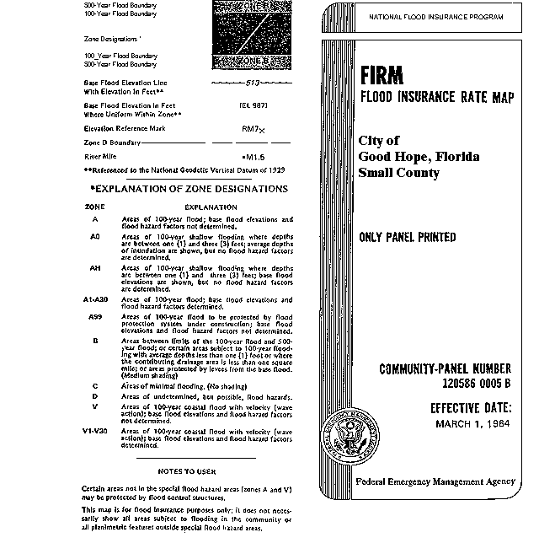
FLOOD INSURANCE RATE MAP FOR THE CITY OF GOOD HOPE

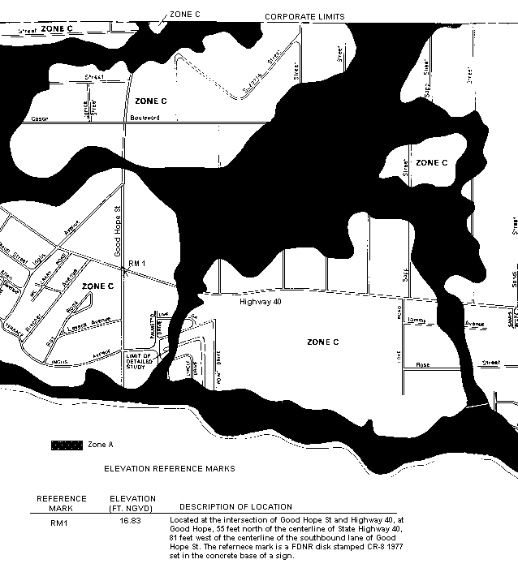

Appendix H

Sanitary Survey
State of Florida
Department of Environmental Protection
District

SANITARY SURVEY REPORT

Plant Name County PWS ID #
Plant Location Phone
Owner Name Phone
Owner Address
Contact Person Title Phone
This Survey Date Last Survey Date Last C.I. Date

PWS TYPE & CLASS
Community
Non-transient Non-community
Non-Community

PWS STATUS
Approved system with approval number & date

Unapproved system

SERVICE AREA CHARACTERISTICS

Food Service: Yes No N/A

OPERATION & MAINTENANCE
Certified Operator: Yes No Not required
Operator(s) & Certification Class-Number

O & M Log: Yes No Not required
Operator Visitation Frequency
Hrs/day: Required Actual
Days/wk: Required Actual
Non-consecutive Days? Yes No N/A
MORs submitted regularly? Yes No N/A
Data missing from MORs? No Yes N/A

Number of Service Connections
Population Served Basis
Average Day (from MORs)
Max. Day (from MORs)
Max-day Design Capacity
Comments

COMET: SITE ID PROJECT ID

RAW WATER SOURCE
GROUND; Number of Wells
SURFACE/UDI; Source
PURCHASED from PWS ID #
Emergency Water Source
Emergency Water Capacity

AUXILIARY POWER SOURCE
Yes None Not Required
Source
Capacity of Standby (kW)
Switchover: Automatic Manual
Standby Plan: Yes No
Hrs Operated Under Load
What equipment does it operate?
Well pumps
High Service Pumps
Treatment Equipment
Satisfy 1/2 max-day demand? Yes No Unk
Comments

TREATMENT PROCESSES IN USE

What additional treatment is needed?

For control of what deficiencies?

DISTRIBUTION SYSTEM
Flow Measuring Device
Meter Size & Type
Backflow Prevention Devices: Yes No
Cross-connections
Written Cross-connection Control Program:
Coliform Sampling Plan: Yes No N/A
Comments

PWS ID #
Date

GROUND WATER SOURCE

Well Number
Year Drilled
Depth Drilled
Drilling Method
Type of Grout
Static Water Level
Pumping Water Level
Design Well Yield
Test Yield
Actual Yield (if different than rated capacity)
Strainer
Length (outside casing)
Diameter (outside casing)
Material (outside casing)
Well Contamination History
Is inundation of well possible?
6’ X 6’ X 4” Concrete Pad
 | Septic Tank
SET | Reuse Water
BACKS | WW Plumbing
 | Other Sanitary Hazard
 | Type
 | Manufacturer Name
PUMP | Model Number
 | Rated Capacity (gpm)
 | Motor Horsepower
Well casing 12” above grade?
Well Casing Sanitary Seal
Raw Water Sampling Tap
Above Ground Check Valve
Fence/Housing
Well Vent Protection

COMMENTS

PWS ID #
Date

CHLORINATION (Disinfection)
Type: Gas Hypo
Make Capacity
Chlorine Feed Rate
Avg. Amount of Cl₂ gas used
Chlorine Residuals: Plant Remote
Remote tap location
DPD Test Kit: On-site With operator
None Not Used Daily
Injection Points
Booster Pump Info
Comments

Chlorine Gas Use Requirements | YES | NO | Comments
Dual System
Auto-switchover
Alarms:
Loss of Cl₂ capability
Loss of Cl₂ residual
Cl₂ leak detection
Scale
Chained Cylinders
Reserve Supply
Adequate Air-pak
Sign of Leaks
Fresh Ammonia
Ventilation
Room Lighting
Warning Signs
Repair Kits
Fitted Wrench
Housing/Protection

AERATION (Gases, Fe, & Mn Removal)
Type Capacity
Aerator Condition
Bloodworm Presence
Visible Algae Growth
Protective Screen Condition
Comments

STORAGE FACILITIES
(G) Ground (H) Hydropneumatic (E) Elevated
(B) Bladder (C) Clearwell
Tank Type/Number
Capacity
Material
Gravity Drain
By-pass Piping
Pressure Gauge
Sight Glass or
Level Indicator
Fittings for
Sight Glass
Protected Openings
PRV/ARV
On/Off Pressure
Access Padlocked
Height to Bottom of Elevated Tank
Height to Max. Water Level
Comments

HIGH SERVICE PUMPS
Pump Number
Type
Make
Model
Capacity (gpm)
Motor HP
Date Installed
Maintenance
Comments

PWS ID #
Date
COMPLIANCE MONITORING
NON-COMMUNITY PUBLIC WATER SYSTEMS
CONTAMINANT | PWS  Screen | # Samples Required &  Sample Location |  | Frequency | Sample  Date | Due  Date
Microbiological (Bacte) | 024 | 1 from each well & |  | monthly  (>1000 persons)
 |  | 2 distribution samples |  | quarterly  (< 1000 persons)
Nitrate & Nitrite (as N) | 030 | 1 sample from POE* |  | annually
MONITORING VIOLATIONS |  |  | MCL VIOLATIONS

* POE = Point of Entry (Samples shall be taken at each entry point to the distribution system that is representative of each source after treatment.)

DEFICIENCIES:

Inspector |  |  | Title |  | Date
Approved by |  |  | Title |  | Date

