Grants Management System
FRDAP Consultant Guidance

Table of Contents
1 FRDAP Consultant User Overview 2
A. View Primary Account Information 3
B. View Applications for the Primary Account 5
C. Add Related Accounts to Your User Profile 7
D. View Applications for Related Accounts 11
E. Change the Account (Entity) for an Application 15

FRDAP Consultant User Overview

The FRDAP Consultant user profile allows a registered Grants Management System (GMS) user to create and submit grant applications for multiple accounts (local governments). FRDAP consultants are not restricted to submitting grant applications for a single account.
As a FRDAP consultant, you are able to:
- View Primary Account Information
- View Applications for the Primary Account
- Add Related Accounts to Your User Profile
- View Applications for Related Accounts
- Change the Account (Entity) for an Application

Guidance for completing each of these functions is listed in the following pages. Please note: You must be registered as a FRDAP consultant in order to complete the screens shown in this document. If you have not registered, please visit http://myeco.force.com to complete registration.

If you need assistance with any of these functions, please contact FLORIDA RECREATION DEVELOPMENT ASSISTANCE PROGRAM staff at 850-245-2501 or SF_recreationgrants@floridadep.gov.

View Primary Account Information
When you register, you are associated with primary account. Each application that you start will be associated with the primary account for your user account. Follow the steps below to view the primary account information associated with your user profile.

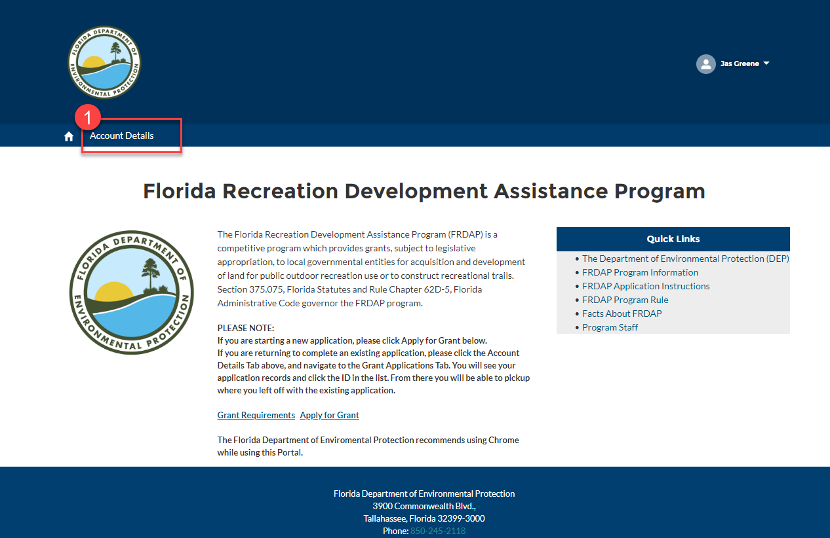
- Select the “Account Details” link.

- The “Account Details” screen will be displayed. Click the “Account” tab to display primary account information. Please note: Only the primary account information will be displayed.
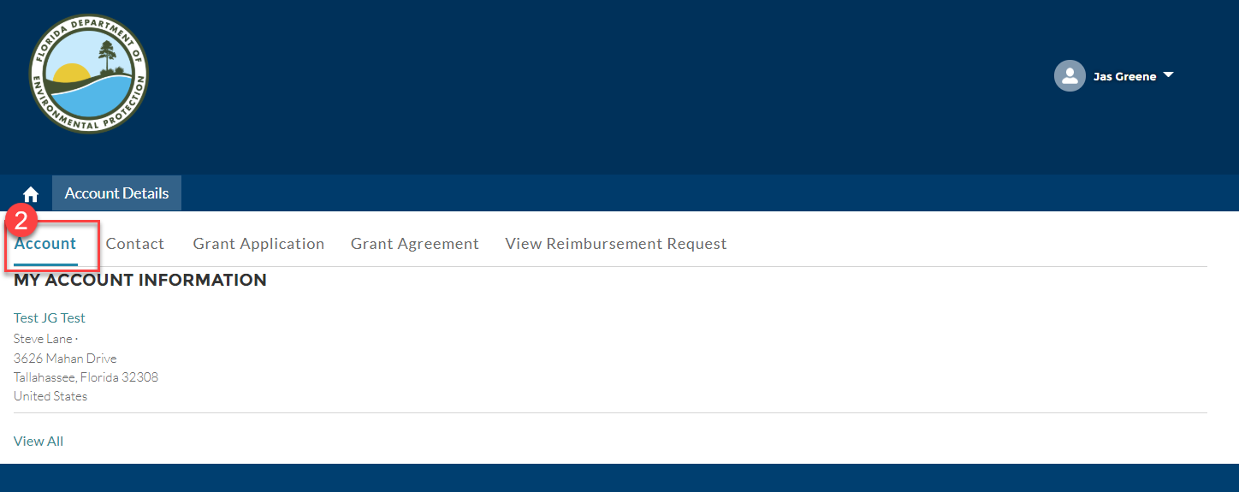
3. Congrats! You have successfully viewed the primary account information associated with your user profile.

View Applications for the Primary Account
Follow the steps below to view applications for a primary account.

- Select the “Account Details” link.

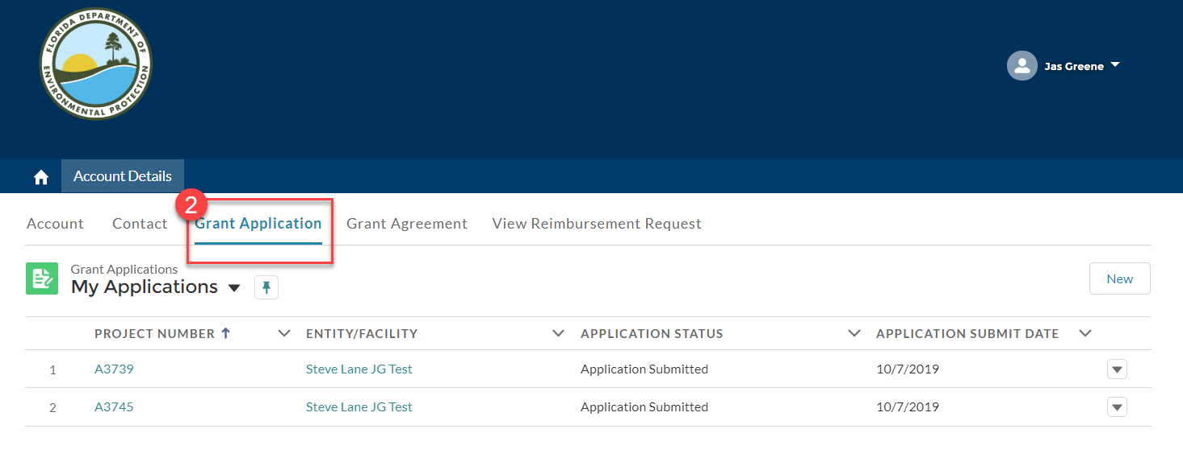
- The “Account Details” screen will be displayed. Click the “Grant Application” tab to display your list of applications. Please note: This listing will only display the applications associated with the primary account.

- Congrats! You have successfully viewed the applications created for the primary account associated with your user profile.

Add Related Accounts to Your User Profile
When you register, you are associated with primary account. Each application that you start will be associated with the primary account for your user profile. Before you are able to complete and submit an application for different entities (accounts), you must add the related account to your user profile.
Follow the steps below to add a Related Account.

- Select the “Account Details” link.

- The “Account Details” screen will be displayed. Click the “Contact” tab to display your contact details.
- Click the contact link (this should be the name under which you registered).
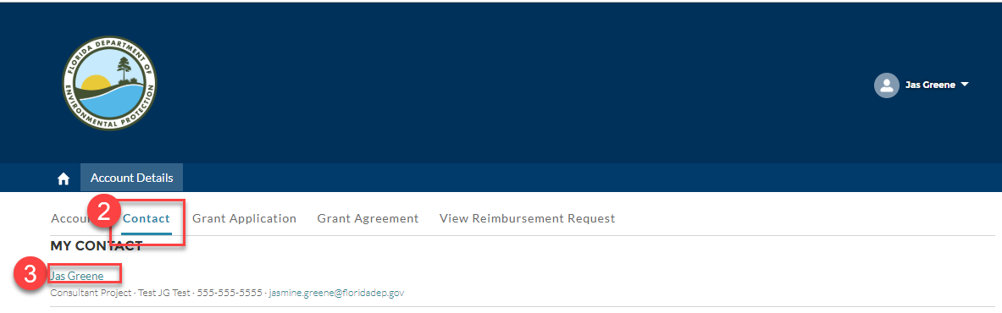

- The “Contact Detail” screen will be displayed. Click the “Add Relationship” button. Please note: account relationships added this way will NOT update the default view.
- Begin typing the account name in the “Account” field.
- Next, select a role by clicking the role name and the arrow.
- Click the “Save” button. Please note: Accounts must be existing. If you need a new account added, you will need to contact our office.
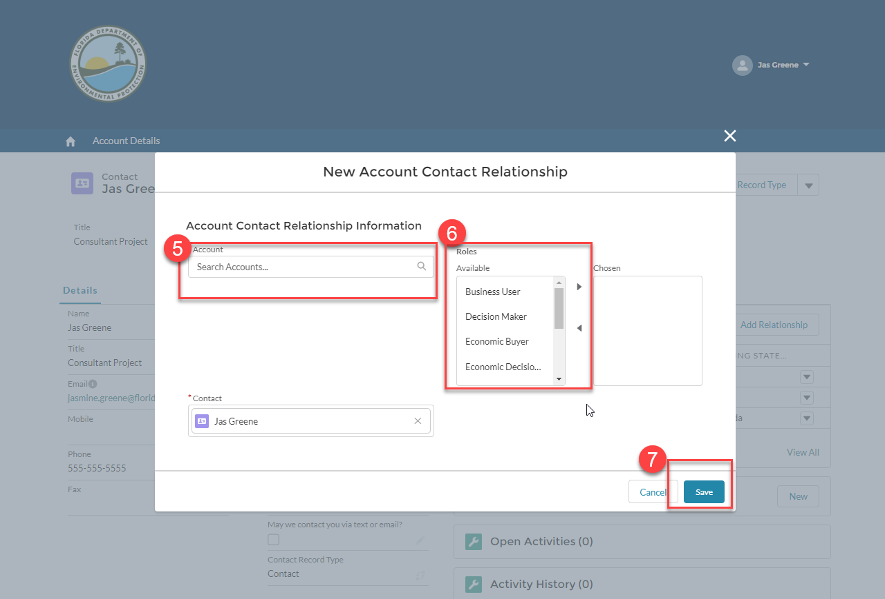

- The “New Account Contact Relationship” window will close. The account name should now be displayed in the “Related Accounts” list. Congrats! You have added a “Related Account”.
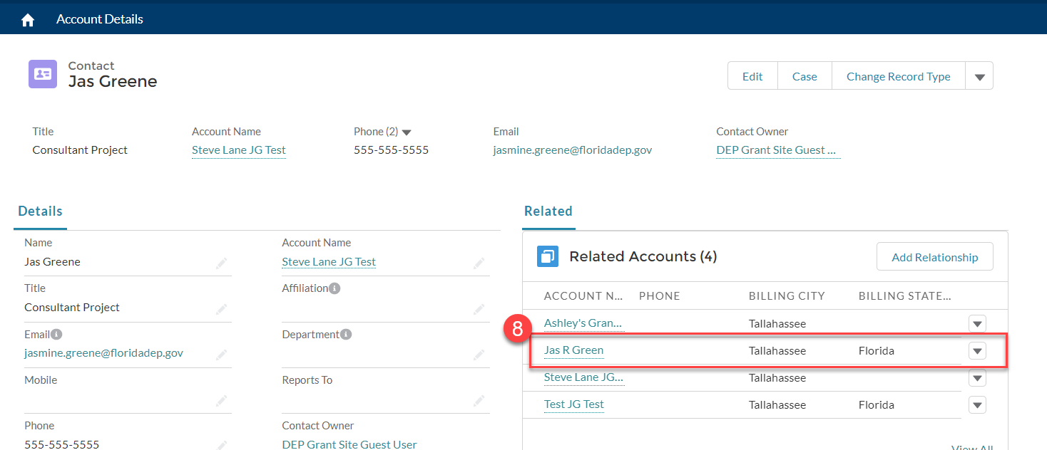

View Applications for Related Accounts
You do not have to update the primary account related to your user profile to view applications that have been entered for related accounts. Once an account relationship has been established, you will be able to view all applications created for the account. If an application has not been submitted, you may also edit the application.
Follow the steps below to view applications for a related account.

- Select the “Account Details” link.

- The “Account Details” screen will be displayed. Click the “Contact” tab to display your contact details.
- Click the contact link (this should be the name under which you registered).

- The “Contact Detail” screen will be displayed. Under “Related Accounts”, select the link for the account you want to view.
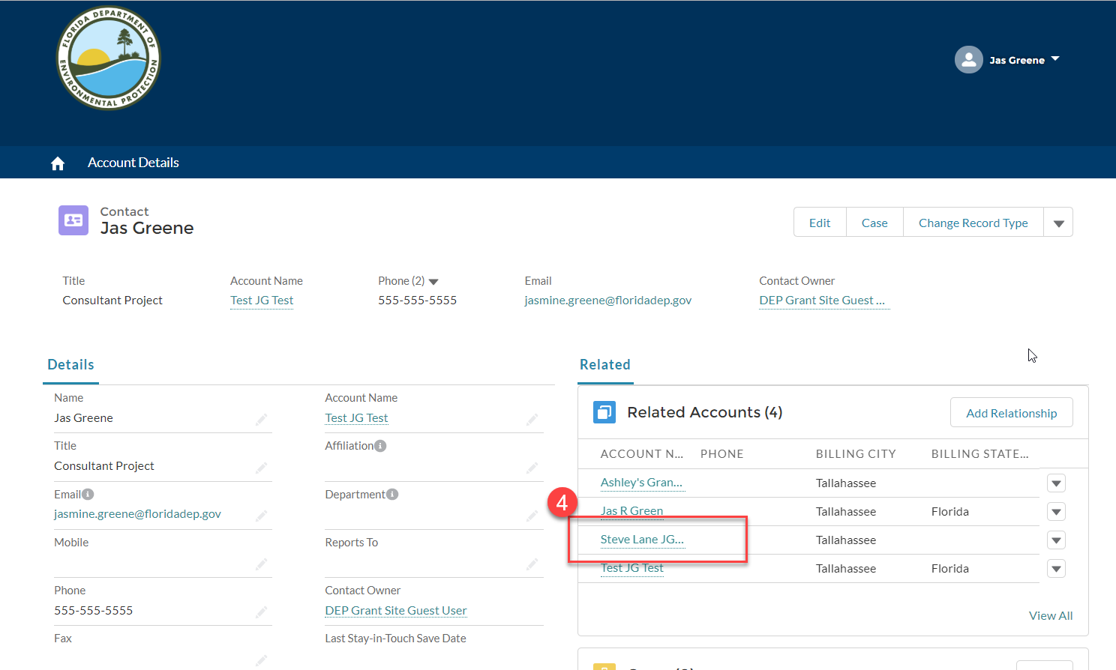
- The “Account” screen will be displayed. Under “Grant Applications” select the application number link for the application you want to view.
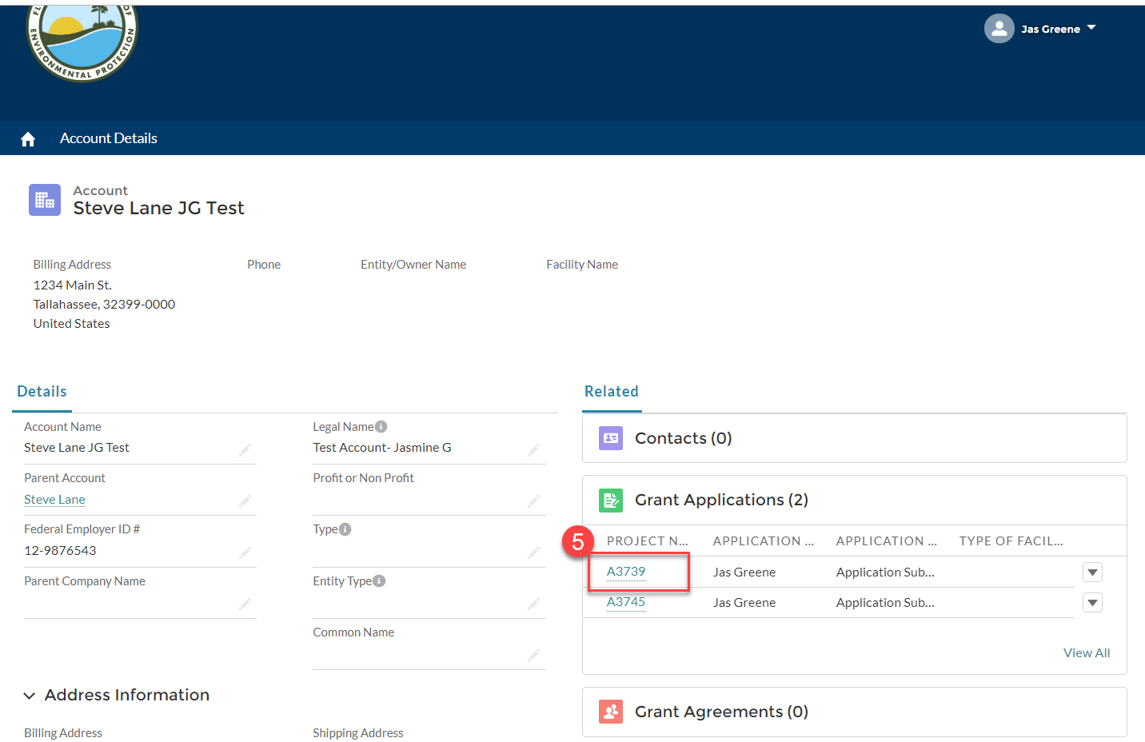

- The “Application Details” screen will be displayed. Congrats! You have successfully viewed an application for a related account. Please note: The screen displayed will be different depending on the application submission status.
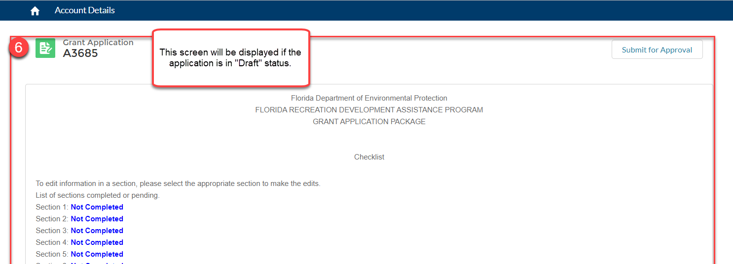
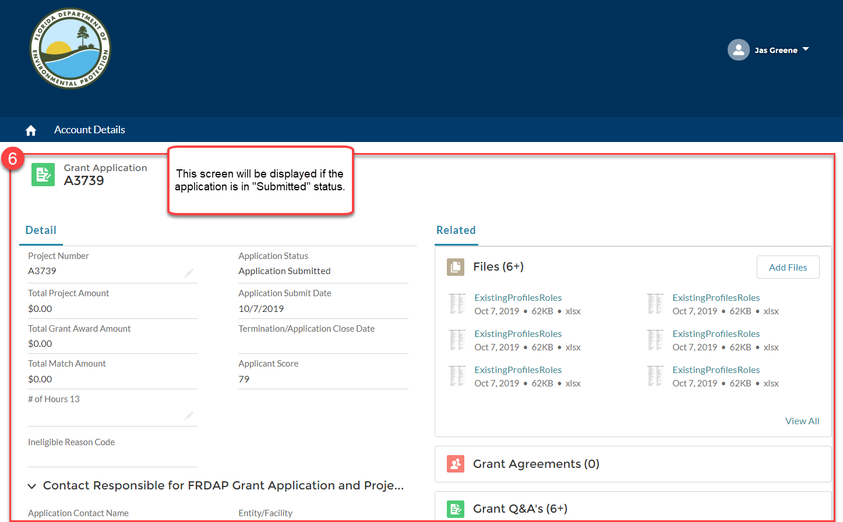

Change the Account (Entity) for an Application
When you register, you are associated with primary account (entity). Each application that you start will be associated with the primary account for your user account. You have two options to update the account for an application. It is important to note that entering a different FEIN during the application will NOT automatically update the account on the application. You must complete the steps below for account changes to be reflected on the application.

- Select the “Account Details” link.

- The “Account Details” screen will be displayed. Click the “Grant Application” tab to display your list of applications. Please note: This listing will only display the applications associated with the primary account.
- Click the arrow of the application you need to update. Select “Edit”.
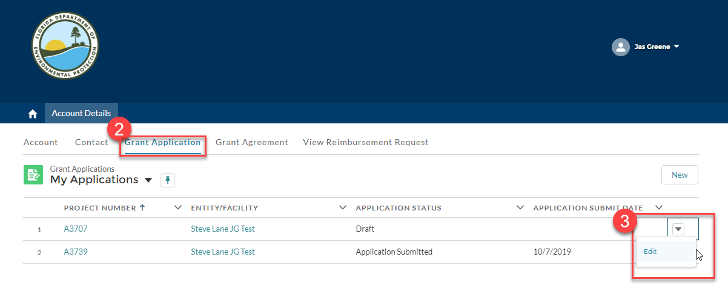
- The “Application Edit” pop-up window will be displayed. Select the pencil icon to edit the account name.
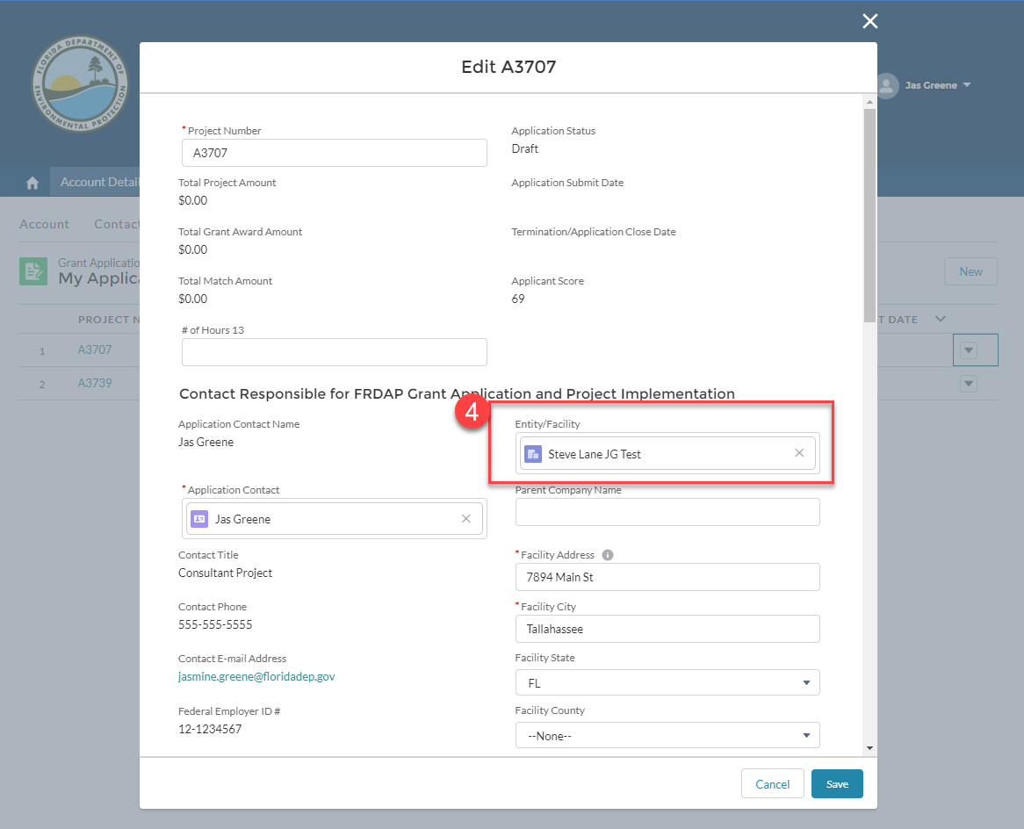

- Click the “X” to clear the “Account Name” field. Once the field is empty, begin typing the account name you want to be the primary account. Please note: Accounts must be existing. If you need a new account added, you will need to contact our office.
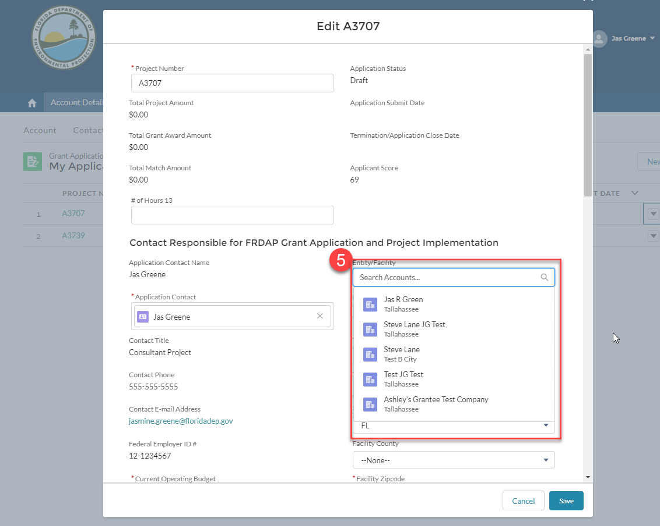

- Select the existing account name.
- Click the “Save” button.
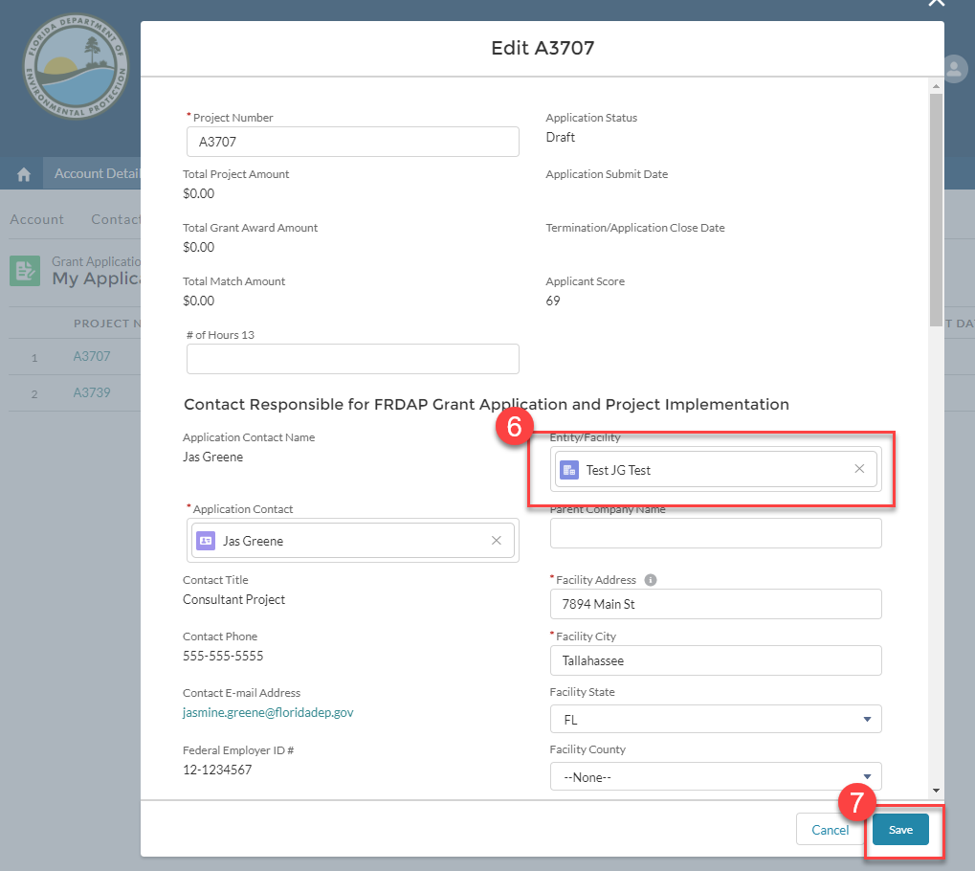
- Congrats! The account for the application is now updated. Please note: This application will no longer be in the “Grant Application” listing. You may view the application by following the steps in the “View Applications for Related Accounts” section of this document.

If you need assistance with any of these functions, please contact FLORIDA RECREATION DEVELOPMENT ASSISTANCE PROGRAM staff at 850-245-2501 or SF_recreationgrants@floridadep.gov.

