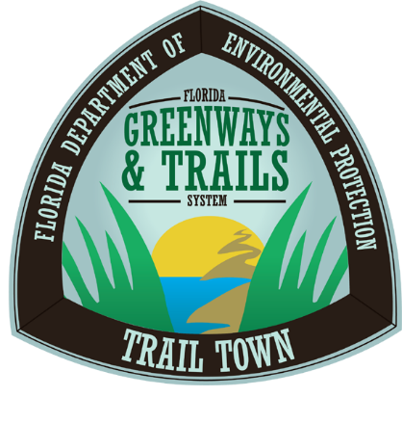
Florida Trail Town Questionnaire

Please fill in the below. Be brief. To assist, a self-assessment and more information are available on the Office of Greenways and Trails website.

TRAIL
What types of trails connect to or are located near your town? (hiking, biking, paddling, shared use non-motorized, multi-use, equestrian, etc.)
List any neighboring trails to your town? (if yes, please specify proximity)
Who maintains your trail(s)? Please identify each trail and the manager.
Yes No Are the trail users day travelers?
Yes No Are the trail users long distance travelers?
Yes No Are there multiple types of trail users entering your town?
Yes No Can trail users refill their supplies and repack their bags to continued their journey?
If you checked Yes to any of the above, please explain how your town accommodates these trail users.

ACCESSIBILITY

How close is/are the trail(s) to your town? Do you think this is a reasonable distance for the trail users to travel? Why or why not?

Yes No Is there a path connecting the trail to your downtown business area?

Can trail users easily recognize that your town is near the trail? Is there direct signage on the trail leading into your town? Please describe.
What kinds of amenities are directly at or near the trail entrance into your town?
Are your business owners and citizens aware that there is a trail near your town? Are they well informed about the trail? If not, what steps will you take to accomplish these goals?

TOWN PARTICIPATION
Do you have a trail-oriented Community Support Organization or a local trail advocacy group? If so, please identify them. If not, please describe who has expressed interest in supporting the community by becoming a Trail Town.
What events take place on or near your trail? Please specify the purpose of the event, local participation, who hosts it, and how often it occurs.
Do you have a Trail Town plan or a local development plan that includes trails? Please describe.
Describe the citizen initiatives in your town that foster and maintain trail growth and traffic.

What efforts have been made to coordinate with neighboring communities for events and trail connectivity? Please describe.

BUSINESSES
What businesses provide necessary goods and services and incentives to trail users? Please list the name of the business, the owner and the goods and services and incentives provided.
For each of the following, list your contact person and their telephone number:
Chamber of Commerce
Visitor, Tourism or Economic Development Council
Mayor or City Council or City Commissioner’s Office
Does your town have a coalition of local businesses that support the trail? Please describe. If not, please list which businesses you have contacted to be Trail Town businesses.

What kind of discounts, deals, or special packages are offered to trail users?

AMENITIES

Yes No Does your town have bike racks, boat dock and launches, hitching posts, etc.? If not, please describe any planned amenities that will be provided.

List the restaurants in your town and near your trail. Describe what kind of food is offered, the distance from the trail and the average prices for each location.
List the overnight accommodations available to trail users and any plans for expanding these options. Include any special rates or packages offered for trail users.

List all water fountains/spigots available for trail users and their distance from the trail.

Where can food be purchased and easily packaged for trail use? Please list all locations and their distance from the trail.

INFORMATION
Is there clear signage on the trail with information about the town? Please describe.
Yes No Is there directional signage leading from the trail into town?
Yes No Is there directional signage in the town with information about amenities?

Do central businesses have pamphlets or other material about what your town offers? Please list these businesses and which ones you may have contacted to begin doing so.
SAFETY

Yes No Does your town have wide sidewalks (10-12’)?
Yes No Does your town have protected bike lanes?
Yes No Does your town have crosswalks?
Yes No Is your downtown business district well-lit?
Yes No Is your downtown business district safely navigable by foot or bicycle?
If you checked No to any of the above, please describe your plans to improve upon safety features.

Are your law enforcement officers and first responders familiar with the trail location, terrain and length? Please describe the extent of their knowledge and any training they have received in this matter.

For each of the following, list your contact person and their telephone number:
Fire Department:

Police Department:

Medical Services:

List all medical services available to trail users, including specialized equipment, specialized training and facilities.

Statement of Intent

It is the intent of _____________________________ (name of community, town, city etc.) to recognize this community as a Florida Trail Town. By execution of this consent, the undersigned confirms the community’s desire to participate in the Office of Greenways and Trails’ Florida Trail Town program.

Date: ___________________________

Printed Name:
_____________________________________________
[Signature of community leadership]

Email or mail to:
Office of Greenways and Trails
Department of Environmental Protection
3900 Commonwealth Blvd., Mail Station 795
Tallahassee, FL 32399-3000
Doug.Alderson@dep.state.fl.us

