Documentation in Support of Category 4e

Waterbody/Watershed Identification
 | Organization | Polk County Parks and Natural Resources (County herein)
 | Point of Contact | Greg Knothe, 4177 Ben Durrance Rd.  Bartow, FL 33830, GregKnothe@polk-county.net, 863-534-7377 ext. 252
 | Waterbody(s) | Lake Hamilton (WBID 15041), Middle Lake Hamilton (WBID 15002), Little Lake Hamilton (15001)
 | No. Waterbody / Pollutant Combinations | 3 Waterbody segments: Verified and/or Impaired as of IWR 61 *Not applicable to Little Lake Hamilton.  Lake Hamilton: Chlorophyll-a, and Total Nitrogen. Total Phosphorus and Biology will be added to the States’ Verified List and the federal 303(d) List, as part of the initial biennial assessment cycle. The annual geometric means are now exceeding their applicable criteria more than once in a three-year period.  Middle Lake Hamilton: Biology, Chlorophyll-a, Total Nitrogen and Total Phosphorus  Little Lake Hamilton: Not listed as impaired currently but will be added to the States’ Verified List and the federal 303(d) List, as part of the initial biennial assessment cycle. The annual geometric means are now exceeding their applicable criteria more than once in a three-year period (2017 and 2018) for Chlorophyll-a and Total Nitrogen.
 | EPA Completed TMDL | No
Description of Baseline Conditions
 | Watershed(s) | Basin Group 3, Sarasota Bay - Peace - Myakka
 | Baseline Data | Data presented below was gathered from FDEP’s IWR run 60 10/05/2020 (MS access database) and from the County’s trends analysis. Baseline water quality data sampling locations are primarily from the County at the center lake location for each WBID. However, due to poor boat ramp conditions the County moved to a shoreline sample for a period of time in Little Lake Hamilton. Additional baseline water quality data was collected by FDEP.  Lake Hamilton:  Water quality stations:  21FLGW 45450  21FLGW 45452  21FLGW 47174  21FLGW 51026  21FLGW 53835  21FLPOLKHAMILTON1  21FLTPA TPHAMIL01L  Total Nitrogen: Annual Geometric Means exceeded the nutrient criteria more than once in a three-year period. Verified period used to determine impairment:  2013 (1.74 mg/L)  2014 (1.58 mg/L)  2015 (1.41 mg/L)  2016 (1.62 mg/L)  2017 (2.32 mg/L)  2018 (2.11 mg/L)  2019 (1.68 mg/L)  2020 (1.83 mg/L)  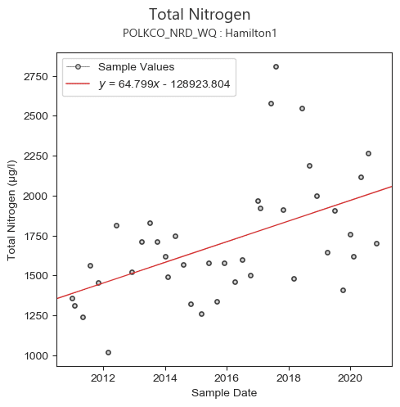  Chlorophyll-a: Annual Geometric Means exceeded the nutrient criteria more than once in a three-year period. Verified period used to determine impairment:  2013 (32 µg/L)  2014 (27 µg/L)  2015 (21 µg/L)  2016 (25 µg/L)  2017 (47 µg/L)  2018 (46 µg/L)  2019 (32 µg/L)  2020 (34 µg/L)  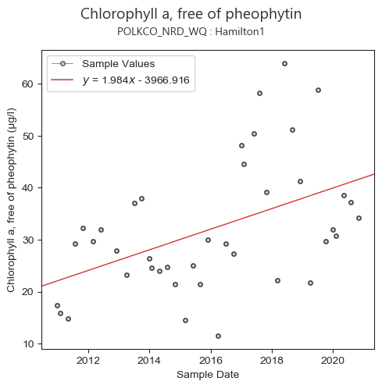  -------------------------------------------------------------------------------------------------  Middle Lake Hamilton:  Water quality stations:  21FLPOLKMDL HAMILTON1  21FLTPA TPMHAML01L  Total Nitrogen: Annual Geometric Means exceeded the nutrient criteria more than once in a three-year period. Verified period used to determine impairment:  2013 (2.07 mg/L)  2014 (1.73 mg/L)  2015 (1.45 mg/L)  2016 (1.38 mg/L)  2017 (1.65 mg/L)  2018 (1.59 mg/L)  2019 (1.35 mg/L)  2020 (insufficient data)  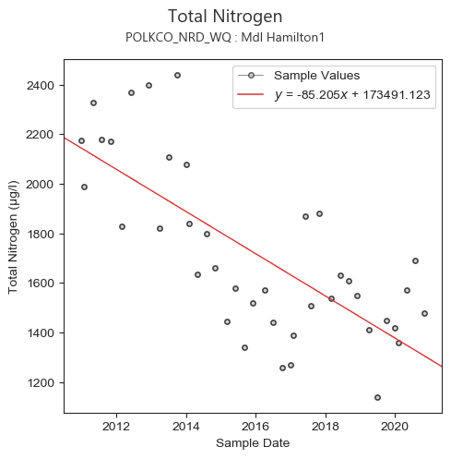  Chlorophyll-a: Annual Geometric Means exceeded the nutrient criteria more than once in a three-year period. Verified period used to determine impairment:  2013 (37 µg/L)  2014 (28 µg/L)  2015 (27 µg/L)  2016 (22 µg/L)  2017 (32 µg/L)  2018 (30 µg/L)  2019 (22 µg/L)  2020 (insufficient data)  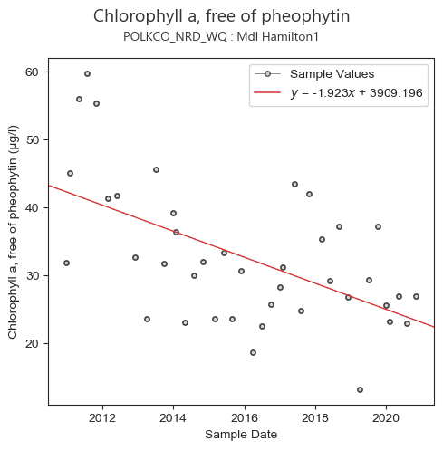  Total Phosphorus: Annual Geometric Means exceeded the nutrient criteria more than once in a three-year period. Verified period used to determine impairment:  2013 (0.07 mg/L)  2014 (0.06 mg/L)  2015 (0.05 mg/L)  2016 (0.05 mg/L)  2017 (0.06 mg/L)  2018 (0.05 mg/L)  2019 (0.03 mg/L)  2020 (insufficient data)  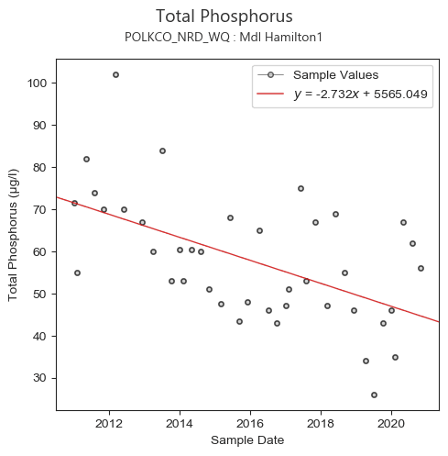  Biology: This waterbody is impaired for this parameter based on failing bioassessments and nutrients have been determined to be the causative pollutant. Average score of at least two temporally independent LVI scores ≥ 43.  LVI  21FLTPA TPMHAML01L (20JUN2013: 31)  21FLTPA TPMHAML01L (24JUN2015: 20)  Polk County Assessment (03SEPT2020: 46) *Passing Threshold of 43  -------------------------------------------------------------------------------------------------  Little Lake Hamilton:  Water quality stations:  LITTLE HAMILTON LK CENTER  Ltl Hamilton Shore  Total Nitrogen: Annual Geometric Means exceeded the nutrient criteria more than once in a three-year period. Verified period used to determine impairment:  2014 (1.70 mg/L)  2015 (1.19 mg/L)  2016 (1.30 mg/L)  2017 (1.64 mg/L)  2018 (1.43 mg/L)  2019 (1.20 mg/L)  2020 (insufficient data)  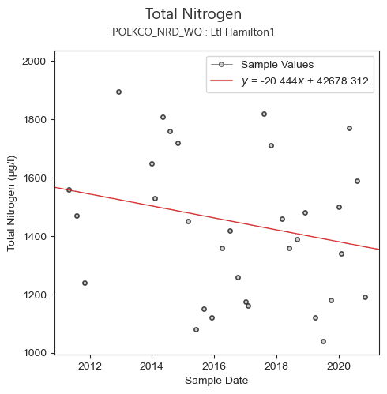  Chlorophyll-a: Annual Geometric Means exceeded the nutrient criteria more than once in a three-year period. Verified period used to determine impairment:  2014 (28 µg/L)  2015 (12 µg/L)  2016 (18 µg/L)  2017 (28 µg/L)  2018 (22 µg/L)  2019 (17 µg/L)  2020 (insufficient data)  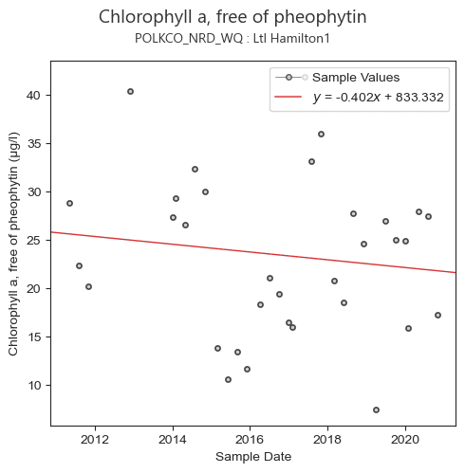
 | Map | See Figure 1.

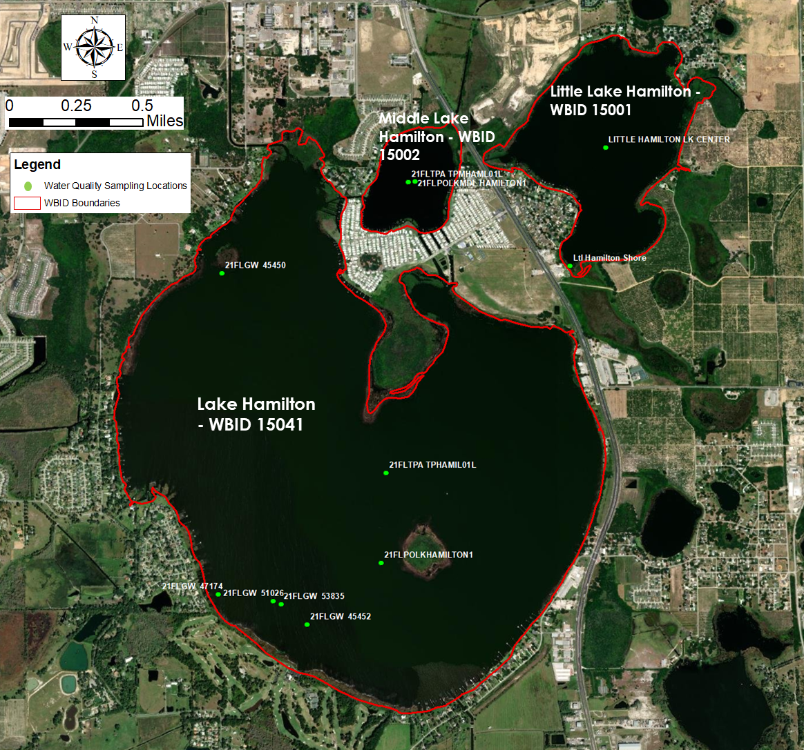
Figure 1. Lake Hamilton, Middle Lake Hamilton, and Little Lake Hamilton WBIDs and water quality sampling sites for baseline data.
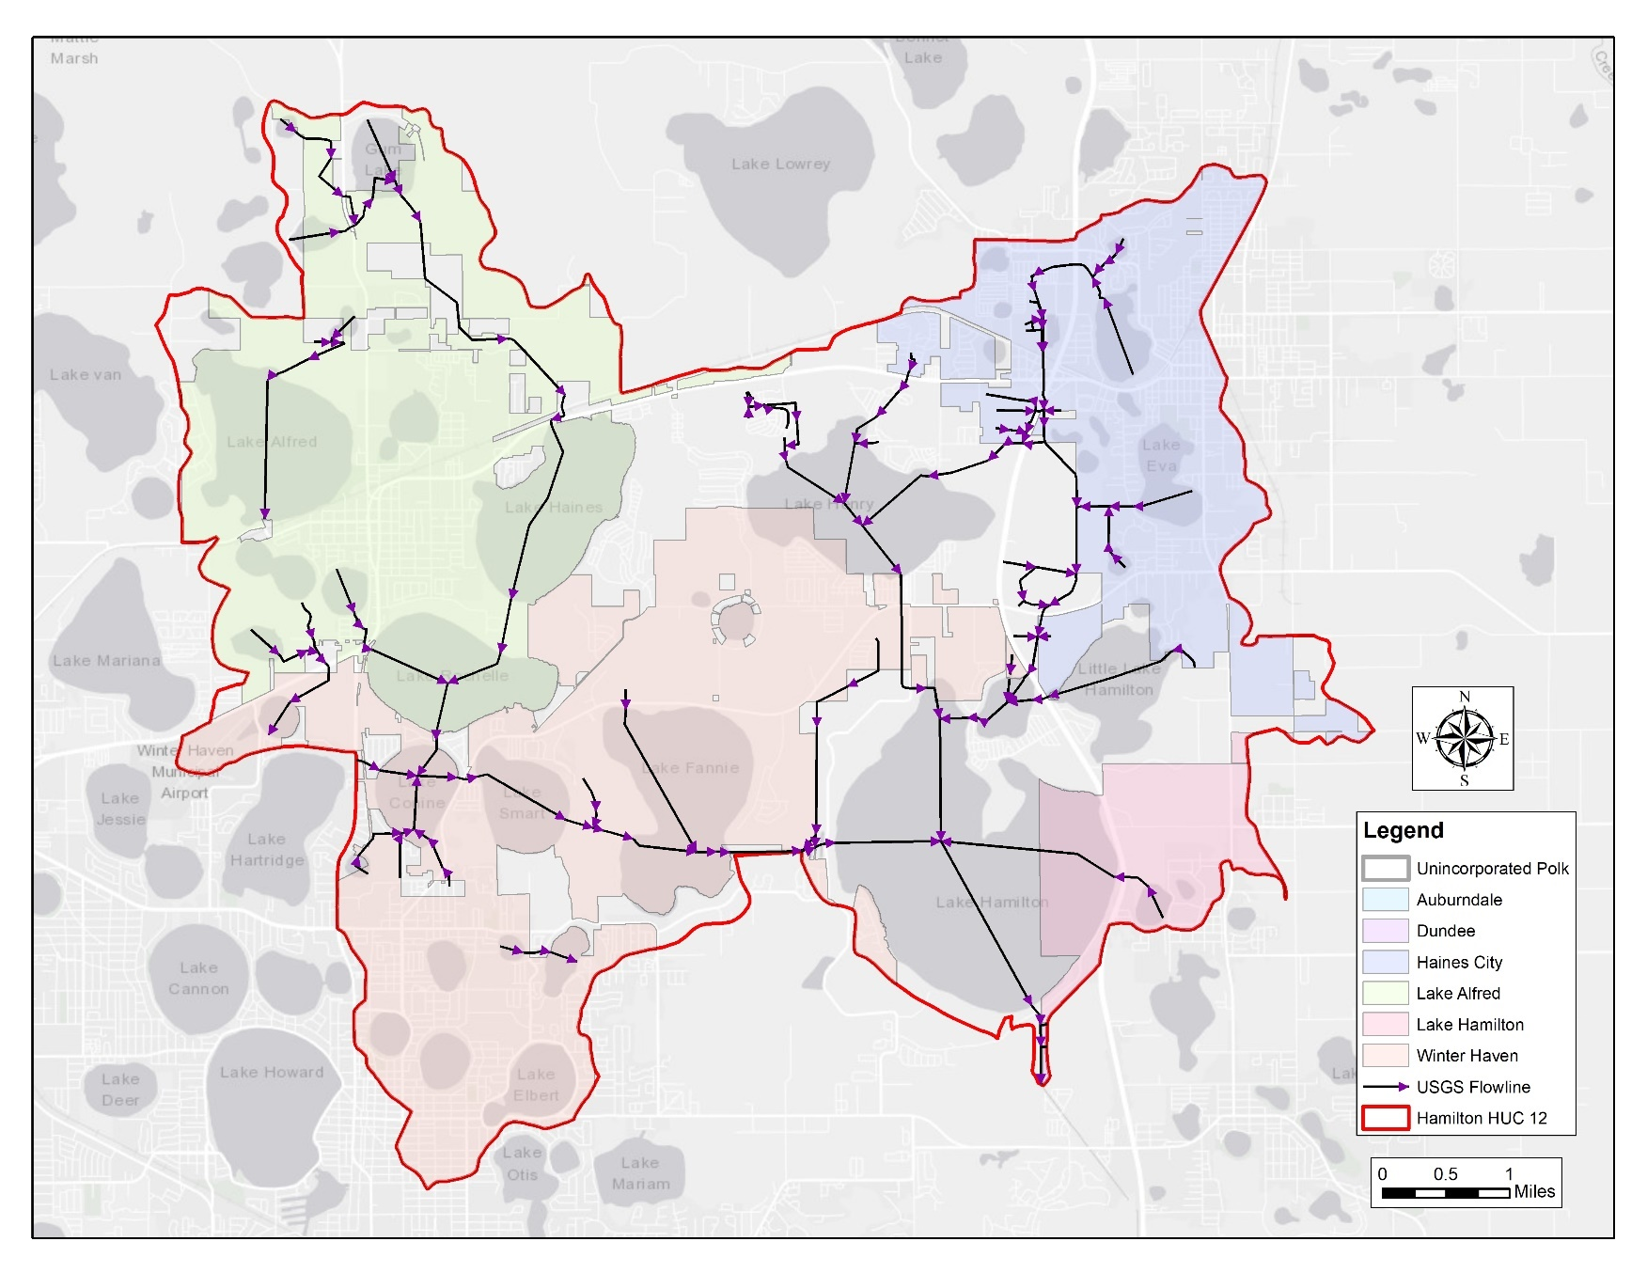
Figure 2. Municipalities boundaries, United States Geological Survey flowlines, and Lake Hamilton HUC 12 subbasin.

Evidence of Watershed Approach
 | Area of Effort | The Hamilton Chain of Lakes is located in the northwest portion of Polk County. The lakes WBIDs are primarily located in unincorporated Polk County with some areas within Haines City, Lake Hamilton, and City of Winter Haven. The Lake Hamilton sub-basin (HUC 12 USGS) is located within jurisdictions of unincorporated Polk County, Auburndale, Dundee, Haines City, Lake Alfred, Lake Hamilton, and Winter Haven.  Lake Area:  Lake Hamilton: 2,185 acres  Middle Lake Hamilton: 107 acres  Little Lake Hamilton: 368 acres
 | Key Stakeholders Involved and Their Roles | Polk County, Haines City, City of Winter Haven. The SWFWMD may be involved in future restoration projects by providing cooperative funding. The Department of Transportation is a potential stakeholder for best management practices enhancement.
 | Watershed Plan & Other Supporting Documentation | The contributing area to Lake Hamilton (WBID 15041) is 29,595 acres, middle lake Hamilton (WBID 15002) is 4,443 acres, and Little Lake Hamilton is 1,492 acres. Lake Hamilton is impaired for Chlorophyll-a and Total Nitrogen (*Total Phosphorus and Biology will be added to the States’ Verified List and the federal 303(d) List, as part of the initial biennial assessment cycle), Middle Lake Hamilton is impaired for Biology, Chlorophyll-a, Total Nitrogen and Total Phosphorus, and Little Lake Hamilton is not listed as impaired currently but will be added to the States’ Verified List and the federal 303(d) List, as part of the initial biennial assessment cycle. The annual geometric means are now exceeding their applicable criteria more than once in a three-year period (2017 and 2018) for Chlorophyll-a and Total Nitrogen.  Our watershed plan is to improve the water quality in the Lake Hamilton Chain of Lakes through a multifaceted approach of identifying and working with stakeholders, identifying, and satisfying water quality/biological data gaps, overhauling outfall data for the Lake Hamilton subwatershed, increasing the street sweeping program, reestablishing historical wetlands, and determining and implementing the most beneficial BMP’s to carry out within the basin. There are several projects already underway in the subbasin that will provide water quality benefits to the Hamilton Chain of Lakes  Haines City and partners (including Polk County) are currently working on several projects that will benefit water quality for the Lake Hamilton Chain of lakes. Since water flows from the Lake Eva and Lake Henry waterbodies down to the Hamilton Chain of Lakes before discharging to the Peace Creek Canal, water quality enhancement of these systems will benefit downstream waterbodies. These projects include wetland enhancement, BMP retrofits, and water storage/groundwater recharge.  The City of Winter Haven and partners (including Polk County, FDEP, and SWFWMD) are in the construction phase of a stormwater treatment area on the south end of Lake Conine that will benefit water quality within the lake and the downstream watershed of Lake Hamilton. Lake Conine is an impaired waterbody with a TMDL set for TN and TP. The project was estimated to reduce TN by 12% and TP by 43% within the 328-acre drainage area on the south end of the lake. The project consists of creating 4 acres of new wetland and enhancing 17 acres.  The City of Lake Hamilton with funding assistance from FDEP is currently in the process of septic to sewer conversion. This project will abandon septic systems from approximately 153 single-family residences and 8 commercial buildings to a central sanitary sewer system for wastewater treatment by the Haines City facility.
 | Point Sources and Indirect Source Monitoring (Sites) | Water flows into the 3 waterbodies primarily through sheet flow and canal systems. There are 12 outfalls discharging to the 3 lakes (see figure below) that are operated by Polk County, City of Winter Haven, Haines City, and City of Lake Hamilton. Currently there are no stormwater monitoring sites.  There are no point sources directly contributing to the lakes. There are 9 multi-sector generic permits for stormwater discharge associated with industrial activity within the Lake Hamilton USGS HUC 12. Two are in the City of Lake Alfred and 7 are located within the City of Winter Haven. Data was summarized from the FDEP Geospatial open data website: NPDES Stormwater Facilities and Activities layer.  The entire area is regulated by a MS4 permit # FLS000015-004, issued by FDEP to Polk County and co-permittees (Auburndale, Dundee, Haines City, Lake Alfred, Lake Hamilton, and Winter Haven).  Note: Generic Permits for stormwater discharge from large and small construction activities are considered temporary; therefore, are not included in this listing.  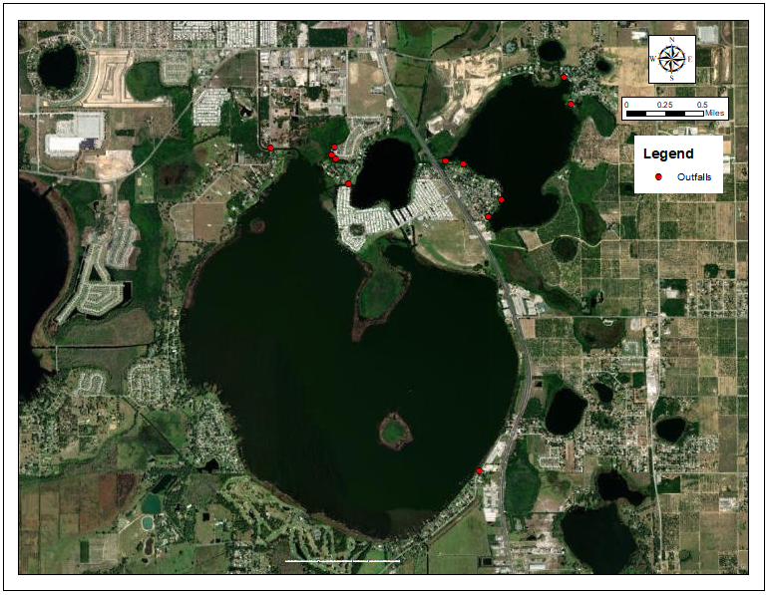
 | Nonpoint Sources | The land use descriptions, acres and percent of total are listed in the following table:  The anthropogenic land use account for 32.8%, natural areas comprise 46.2% and agricultural areas including range lands, pastures, crops, and tree crops represent 13.9% of the Lake Hamilton Subwatershed.  Utilizing the FDEP’s Landscape Development Intensity Index (LDI), the 100-meter buffer around Lake Hamilton is dominated by Residential (41.1%), Natural (35.7%) and Field/Pasture (7.4%) land uses. The resulting LDI value for the 100-meter buffer around Lake Hamilton is 4.86.  The LDI Index of the 100-meter buffer around Middle Lake Hamilton is dominated by Residential (73.8%), Natural (17.0%) and Transportation (5.8%) land uses. The resulting LDI value for the 100-meter buffer around Middle Lake Hamilton is 6.80.  The LDI Index of the 100-meter buffer around Little Lake Hamilton is dominated by Residential (37.9%), Agricultural (26.3%) and Natural (25.4%) land uses. The resulting LDI value for the 100-meter buffer around Little Lake Hamilton is 4.67.
  FLUCCS: Landuse Description Lake Hamilton Subwatershed | Area (acres) | %
  COMMERCIAL AND SERVICES | 987.86 | 3.34
  COMMUNICATION | 0.67 | 0.00
  CROPLAND AND PASTURELAND | 1,498.41 | 5.06
  CYPRESS | 94.66 | 0.32
  DISTURBED | 123.30 | 0.42
  FRESHWATER MARSHES | 2,336.73 | 7.90
  GOLF COURSES | 476.65 | 1.61
  INDUSTRIAL | 643.48 | 2.17
  INSTITUTIONAL | 699.76 | 2.36
  INTERMITTENT PONDS | 37.45 | 0.13
  LAKES | 7,614.22 | 25.73
  MIXED RANGELAND | 25.38 | 0.09
  NON-VEGETATED | 10.66 | 0.04
  NURSERIES AND VINEYARDS | 10.08 | 0.03
  OPEN LAND | 1,946.93 | 6.58
  RECREATIONAL | 94.86 | 0.32
  RESERVOIRS | 156.54 | 0.53
  RESIDENTIAL HIGH DENSITY | 1,648.75 | 5.57
  RESIDENTIAL LOW DENSITY < 2 DWELLING UNITS PER ACRE | 987.39 | 3.34
  RESIDENTIAL MED DENSITY 2 TO 5 DWELLING UNITS PER ACRE | 3,688.03 | 12.46
  SHORELINES | 295.70 | 1.00
  STREAM AND LAKE SWAMPS | 1,746.37 | 5.90
  TRANSPORTATION | 453.11 | 1.53
  TREE CROPS | 2,577.42 | 8.71
  UPLAND CONIFEROUS FOREST | 5.80 | 0.02
  UPLAND HARDWOOD - CONIFEROUS MIX | 132.41 | 0.45
  UPLAND HARDWOOD FORESTS | 51.35 | 0.17
  UTILITIES | 56.84 | 0.19
  WET PRAIRIES | 641.58 | 2.17
  WETLAND FORESTED MIXED | 549.49 | 1.86
  WETLAND HARDWOOD FORESTS | 0.59 | 0.00
  Total | 29,592.48 | 100.00
 | Water Quality Criteria | Lake Hamilton is a clear lake with high alkalinity (lake class 2). Based on the procedure for determining numeric nutrient criteria (NNC), outlined in Rule 62-302.531, F.A.C., the NNC for nutrients in Lake Hamilton are 20 µg/L, 1.05 mg/L – 1.91 mg/L, and 0.03 mg/L – 0.09 mg/L for chlorophyll-a, total nitrogen, and total phosphorus, respectively, which is anticipated to be achieved upon successful completion of all water quality restoration projects.  Middle Lake Hamilton is a high color lake (lake class 1). Based on the procedure for determining numeric nutrient criteria (NNC), outlined in F.A.C 62-302, the NNC for nutrients in Middle Lake Hamilton are 20 µg/L, 1.27 mg/L – 2.23 mg/L, and 0.05 mg/L – 0.16 mg/L for chlorophyll-a, total nitrogen, and total phosphorus, respectively, which are anticipated to be achieved upon successful completion of all water quality restoration projects.  Little Lake Hamilton is a clear lake with high alkalinity (lake class 2). Based on the procedure for determining numeric nutrient criteria (NNC), outlined in F.A.C 62-302, the NNC for nutrients in Middle Lake Hamilton are 20 µg/L and 1.05 mg/L – 1.91 mg/L for chlorophyll-a and total nitrogen, respectively, which is anticipated to be achieved upon successful completion of all water quality restoration projects.
 | Restoration Work | Underway:  Public education: the county regularly conducts educational and outreach events that teach the importance stormwater pollution/management, as well as freshwater ecology. We also hold illicit discharge presentations that help inform the public and other governmental employees when and how to report pollution in the MS4.  Outreach and Educational Programs:  - Annual Water, Wings & Wild Things educational event sponsoring more than 2,000 second grade students from Polk County at the Polk Discovery Center  - 7 Rivers Water Festival  - Polk County Water Atlas  - Lake’s Education Action Drive (LEAD), a Polk County partner  - IFAS extension  - School presentations as part of the Great American Teach in  - Distribution of educational materials including: Stormwater Pollution Prevention  - Illicit Discharge Classes  Fertilizer Ordinance: Polk County passed a Fertilizer Ordinance in 2013 that provides water quality benefits throughout the county.  Invasive Plant Management: The County is the lead agency in the cooperative invasive plant management program with the Florida Fish and Wildlife Conservation Commission. The County regularly evaluates and targets invasive plants for treatment to encourage native aquatic plant growth. The County regularly conducts point intercept and LVI surveys that aid aquatic plant management and herbicide treatments.  Lake Conine Stormwater Treatment Area: The City of Winter Haven and partners (including Polk County, SWFWMD and FDEP) are in the construction phase of a stormwater treatment area on the south end of Lake Conine that will benefit water quality within the lake and the downstream watershed of Lake Hamilton. Lake Conine is an impaired waterbody with a TMDL set for TN and TP. The project was estimated to reduce TN by 12% and TP by 43% within the 328-acre drainage area on the south end of the lake. The project consists of wetland creation of 4 acres and enhancement of 17 acres. Currently the project is approximately 95% complete.  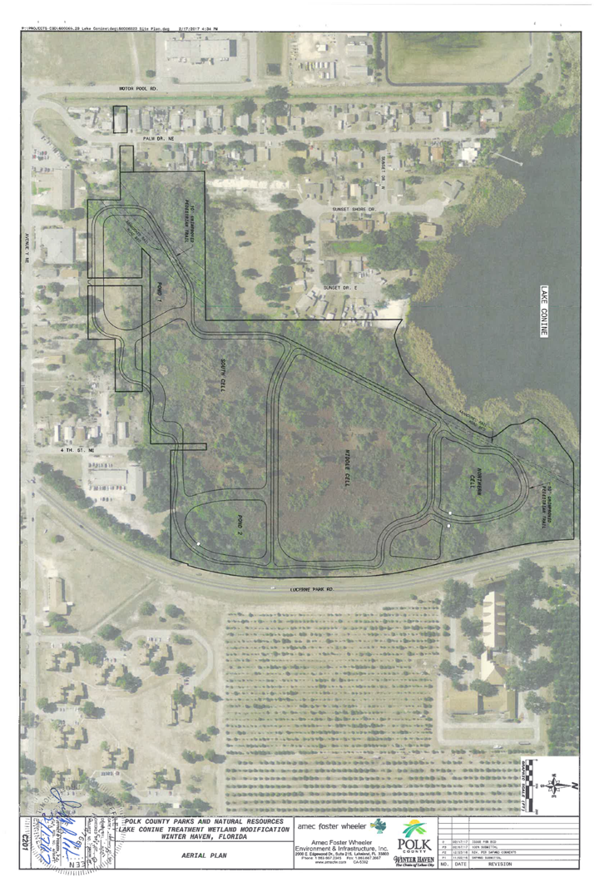  County-Wide Outfall Evaluation: In 2017 the county hired consultants to conduct a GIS assessment using LIDAR data to locate and confidence rank all outfalls. Over 2,000 new outfalls were identified throughout the county. Currently the County is field verifying newly identified outfalls. This project will give a better understanding of the amount and location of outfalls as well as aid in stormwater modeling and assessments. The field verification of the outfall assessment for this basin will be completed by 09/30/22.  Stormwater Enhancements at Lake Eva Park: Polk County is taking the lead on design for the project and has a contractor in place. The County will be working closely with Haines City through the design process. Upon completion of the design, with the measurable benefits from the project the City and County will discuss the funding for the project and seeking Co-op funding for the construction.  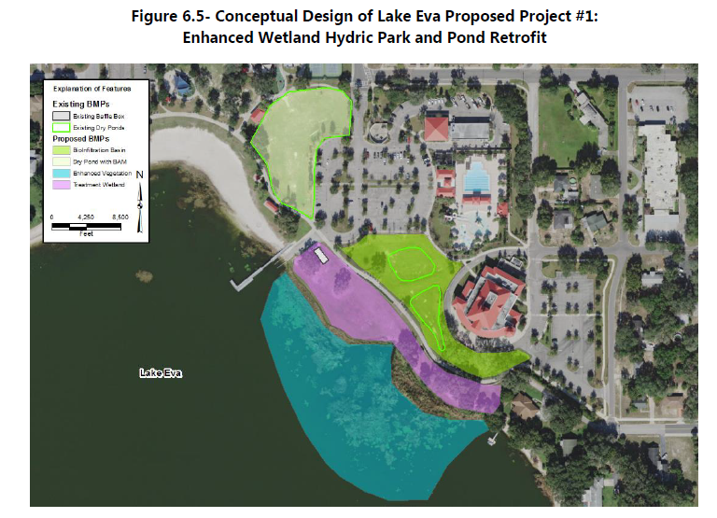  Planned:  Street Sweeping Program: Currently within the Lake Hamilton subbasin a total of 1,056 miles/year are street swept by Polk County, City of Winter Haven, and Lake Hamilton. Moving forward we will expand our program with a partnership with the City of Winter Haven to add an additional 97 miles/month or 1,164 miles/year for a total of 2,220 miles/year. Using the Florida Stormwater Associations BMP load reduction calculator and average removal of total solids from previous data from the County, the additional sweeping will remove approximately 49 pounds of TP/year and 77 pounds of TN/year. The new total (including previous sweeping program) removal for the sub-basin will be 93.2 pounds of TP/year and 146.5 pounds of TN/year.  Seepage Meter Study – Lake Hamilton Proper: The County has a consultant currently under contract that will install and monitor a minimum of 4 seepage meters. The meters will be installed in the current fiscal year (FY20/21) and will monitored for a minimum of 1 year (sampled bimonthly for a total of 6 sampling events). Samples will be analyzed in the County’s water quality laboratory. The meters will provide insight to the quality and quantity of shallow groundwater entering the lake. The areas of installation will be selected to maximize the range of land use and topographic characteristics in upland areas. If, possible the meters will be installed in areas with and without septic tanks to identify possible contributions of septic tank areas. Additional source tracking analysis may be completed by an outside lab, dependent on initial results.  Lake Eva and Lake Henry Restoration Projects: See attachment 1, Lake Eva 4e plan. Since water flows from the Lake Eva and Lake Henry waterbodies down to the Hamilton Chain of Lakes before discharging to the Peace Creek Canal, water quality enhancement of these systems will benefit downstream waterbodies.  City of Lake Hamilton – Septic to Sewer Conversion: See attachment 2, the City of Lake Hamilton with funding assistance from FDEP is currently in the process of septic to sewer conversion. This project will abandon septic systems from approximately 153 single-family residences and 8 commercial buildings to a central sanitary sewer system for wastewater treatment by the Haines City facility. The expected pollutant removal of this project is 1,013 lb./year TN, 244 lb./year of TP, and a significant quantity of fecal coliform bacteria.  Conceptual/Feasibility:  Natural Systems Improvement: Polk County will be completing vegetation monitoring on each of the 3 lakes to determine the best vegetation enhancement options. Once determined the County will submit projects for district cooperative funding and/or FWC AHREs funding.  Outfall Nutrient Loading Study: In accordance with the seepage meter study, the County will be assessing outfall loading through grab samples to determine which outfalls have the highest nutrient loading. Once determine, the County will determine the feasibility of outfall retrofits.

Critical Milestones/Monitoring
 | Anticipated Critical Milestone(s) and Completion Dates: |  | Lake Conine stormwater treatment area: Planned to be finished and operational by end of the current fiscal year (September 30, 2021).  Street Sweeping Program: The improved street sweeping program will begin within the next 2 fiscal years and carry on indefinitely (as funding permits).  Seepage Meter Study – Lake Hamilton Proper: The County has a consultant currently under contract that will install and monitor a minimum of 4 seepage meters. The meters will be installed in the current fiscal year (FY20/21) and will monitored for a minimum of 1 year (sampled bimonthly for a total of 6 sampling events). Additional source tracking analysis may be completed by an outside lab, dependent on initial results. The County may maintain the seepage meters after study by consulting firm if we deem valuable.  Lake Eva restoration projects  •Conduct Feasibility Study to assess existing conditions and restoration alternatives, and complete conceptual design for the selected alternative. Includes stakeholder meetings and input. (Complete)  •Complete 30 Percent Design Package including survey, geotechnical survey, design, regulatory coordination, benefits, and cost estimates (Complete)  •3rd Party Review (2021)  •Complete Design and Submit Permit Applications (2022)  •Complete Final Construction Bid Documents and Permits Issued (2022)  •Complete Project Bidding (2022)  •Complete Construction (2023)
 | Monitoring Component |  | Existing and expanded water quality monitoring program by Polk County Parks and Natural Resource Division:  Ambient water quality sampling program carried out by the County includes quarterly sampling events in each of the three lakes for 20 parameters (see table below).  The County will initiate a 1-year, monthly water quality sampling project (same analytes below) in each of the lakes to provide a more robust water quality data set to evaluate seasonal trends. The County has 21 additional ambient water quality sampling locations within the subbasin sampled on a quarterly basis.  Lake Vegetation Index (LVI) surveys will be conducted at a minimum of every other year to assess the condition of vegetation and changes due to restoration activities.
  Analyte | MDL | Unit | PQL | Unit | Sample Type
  Lab
  Alkalinity as CaCO₃ | 0.6 | mg/L | 6.0 | mg/l | Grab
  Chloride | 0.75 | mg/L | 2.5 | mg/l | Grab
  Chlorophyll a | 3.0 | µg/L | 6.0 | µg/L | Grab
  Chlorophyll a corrected | 3.0 | µg/L | 6.0 | µg/L | Grab
  Color | 2.0 | PCU | 5.0 | PCU | Grab
  Nitrogen ammonia | 0.01 | mg/L | 0.04 | mg/l | Grab
  Nitrogen Kjeldahl | 0.10 | mg/L | 0.40 | mg/l | Grab
  Nitrogen Nitrate + Nitrite | 0.01 | mg/L | 0.04 | mg/l | Grab
  Nitrogen Total | 0.11 | mg/L | 0.44 | mg/l | Grab
  Phosphorus Ortho | 0.01 | mg/L | 0.04 | mg/l | Grab
  Phosphorus Total | 0.02 | mg/L | 0.04 | mg/l | Grab
  Sulfate | 3.6 | mg/L | 5.0 | mg/l | Grab
  Total Suspended Solids | 0.4 | mg/L | 3.0 | mg/l | Grab
  Turbidity | 0.1 | NTU | 0.5 | NTU | Grab
  Field
  Temperature |  |  |  |  | Field-YSI
  Conductivity |  |  |  |  | Field-YSI
  DO % saturation |  |  |  |  | Field-YSI
  DO mg/L |  |  |  |  | Field-YSI
  pH |  |  |  |  | Field-YSI
  Secchi |  |  |  |  | Field
  *Grab samples are collected following FDEP SOP FS2100
Other Key Dates
 | Estimated Date for Delisting from Verified List or Removal from Study List | Lake Hamilton (WBID 15041), Middle Lake Hamilton (WBID 15002), Little Lake Hamilton (15001) are in the state’s Group 3 Sarasota Bay – Peace – Myakka Basin. The current review and assessment cycle (the initial biennial assessment) is scheduled for completion in 2022. The earliest chance for delisting would occur during the next biennial assessment. Based on the current data and water quality trends Lake Hamilton (WBID 15041) will not be delisted in the 2022 assessment for Chlorophyll-a and TN. Total Phosphorus and Biology will be added to the States’ Verified List and the federal 303(d) List, as part of the initial biennial assessment cycle. Depending on the reaction of the waterbody to restorative activities it could potentially be delisted in the 2024 biennial assessment. Middle Lake Hamilton (WBID 15002) could potentially be delisted in the 2022 assessment since it displays improving water quality trends for TN, TP and Chlorophyll-a. Little Lake Hamilton (15001) is set to be added to the verified impaired list during the next biennial assessment. However, Chlorophyll-a and Total Nitrogen levels are very close to meeting the NNC and are displaying a decreasing trend. Therefore, this WBID may be delisted in the 2024 assessment.

Financial Commitments

 | Estimated Implementation Cost | Lake Eva Restoration Projects: See attachment 1, TBD  Lake Conine Restoration Project: ~$3,474,614.78  City of Lake Hamilton – Septic to Sewer Conversion: See attachment 2, ~$838,621  Street Sweeping Project: ~$25,789.68 per year (additional estimated cost)  Stormwater Enhancements at Lake Eva Park: ~$242,572 (TBD)  Water Quality and Biological Monitoring:  - Seepage Meter Study: $23,008.50  - Monthly Water Quality Sampling 1 year: $12,708  - Outfall Grab Samples: ~$6,680 (TBD)  - LVIs: $1,200 per event  Outfall Inventory Update: ~$3,750  Natural Systems Improvement: TBD
 | Land Acquisition  (if applicable) | Funding Source:  Total………………………………………………………………………. $12,000,000  County, Haines City, Winter Haven, FDEP and additional grants
 | Design and Construction  (if applicable) | Funding Source:  Total…………………………………………………………………………$8,450,000  Haines City, Winter Haven, FDEP, SWFWMD and County
Attachment 1. Lake Eva 4e Plan

Documentation in Support of Category 4e

Waterbody/Watershed Identification
 | Organization | Florida Department of Environmental Protection
 | Point of Contact | Kevin O’Donnell, 2600 Blairstone Rd Tallahassee, FL 32399  Kevin.ODonnell@dep.state.fl.us, (850) 245-8469
 | Waterbody(s) | WBID 15101 – Lake Eva
 | No. Waterbody / Pollutant Combinations | Group 3 Cycle 3  WBID 15101 – Nutrients (Chlorophyll-a) and Nutrients (Total Nitrogen)
 | EPA Completed TMDL | EPA has not completed a TMDL for the impaired waterbody segment listed in this document.
Description of Baseline Conditions
 | Watershed(s) | Sarasota Bay – Peace – Myakka – Group 3  Southwest Coast – FDEP Central District  WBID 15101 – Lake Eva
 | Baseline Data | Group 3 Cycle 3 – IWR Run 52, 2016  (Verification Period: January 1, 2008 through June 30, 2015)  15101 - Nutrients (Chlorophyll-a)  Lake Criterion for a lake assessment type 2: AGM ≤ 20 µg/L, annual geometric mean chlorophyll-a values exceeded the criterion in 2009, 2010, 2011, 2012, 2013 and 2014, with values of 41 µg/L, 30 µg/L, 31 µg/L, 33 µg/L, 32 µg/L, and 34 µg/L, respectively.  Stations used in the Chlorophyll-a assessment:  21FLPOLKEVA1N, 21FLPOLKEVA1S, 21FLGW47176  15101 - Nutrients (Total Nitrogen)  Lake Criterion for a lake assessment type 2: AGM ≤ 1.05 mg/L, annual geometric mean total nitrogen values exceeded the criterion in 2009, 2010, 2011, 2012, 2013 and 2014 with values of 2.00 mg/L, 1.83 mg/L, 1.68 mg/L, 1.67 mg/L, 1.69 mg/L, and 1.62 mg/L, respectively.  Stations used in the Total Nitrogen assessment:  21FLPOLKEVA1N, 21FLPOLKEVA1S, 21FLGW47176  See table below for a baseline water quality data summary for the Group 3 Cycle 3 Verified Period.  The below graph is a time series of chlorophyll-a in Lake Eva. Please note that the chlorophyll-a criterion is 20 µg/L and the 2 stations (POL-EVA-1 and POL-EVA-3) did not have any data during this timeframe.  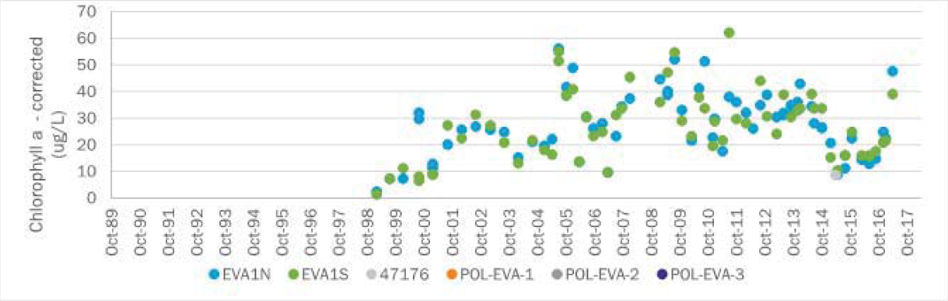  The below graph is a time series of total nitrogen in Lake Eva. Please note that the total nitrogen criterion is 1.05 mg/L.  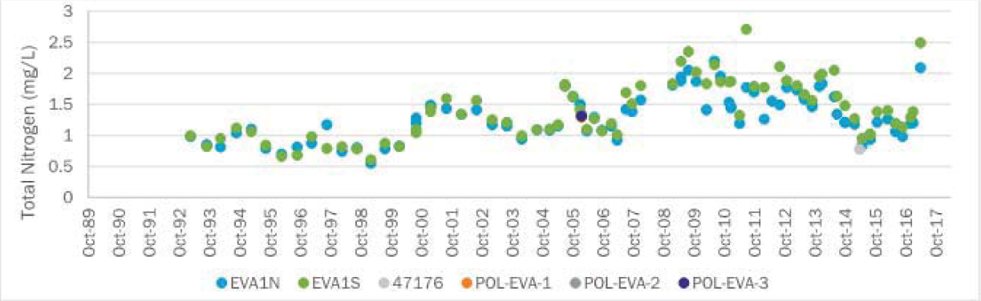  The below graph is a time series of total phosphorus in Lake Eva. Please note that the total nitrogen criterion is 0.03 mg/L.  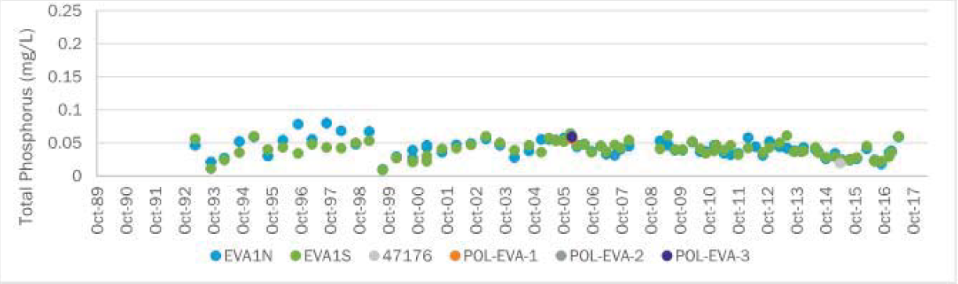
  Nutrient AGM - Verified Period
  Year | CHLAC (µg/L) | TN (mg/L) | TP (mg/L)
  2008 | No Data | No Data | No Data
  2009 | 41 | 2.00 | 0.04
  2010 | 30 | 1.83 | 0.03
  2011 | 31 | 1.68 | 0.02
  2012 | 33 | 1.67 | 0.03
  2013 | 32 | 1.69 | 0.03
  2014 | 34 | 1.62 | 0.02
  2015 | 14 | 1.04 | 0.02

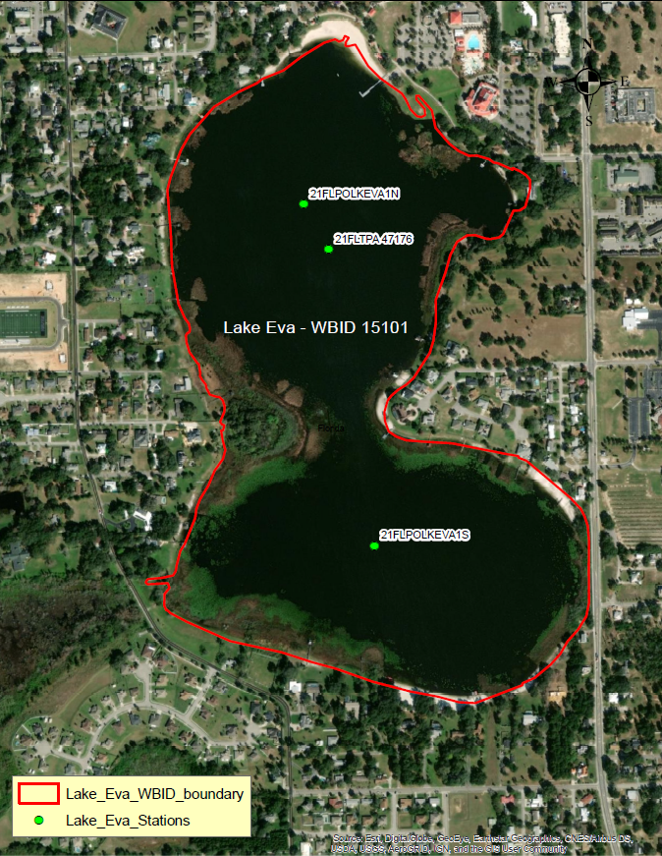

Evidence of Watershed Approach
 | Area of Effort | The Lake Eva watershed (WBID 15101) is located in the North central portion of Polk County, within the limits of Haines City, and has an area of roughly 150 square acres. The Lake Eva and Lake Henry wetland restoration project is located on the West side of the lake Eva, situated between Lakes Eva and Henry. The new wetland treatment area is designed to be 145 acres in size.
 | Key Stakeholders Involved and Their Roles | The key stakeholders that have been instrumental in developing and executing these restoration projects are listed below.  - Southwest Florida Water Management District  - Haines City  - Polk County  - Department of Environmental Protection
 | Watershed Plan & Other Supporting Documentation | The area includes the watershed drainage area from Lake Henry within WBID 1504A where extensive wetland restoration is taking place. WBID 15101 is impaired for Nutrients (Chlorophyll-a) and Nutrients (Total Nitrogen) based on the AGMs. The objectives outlined by the Lake Eva and Lake Henry wetland restoration project will address these impairments.  The WBID drainage area corresponds to the key project as follows: Lake Eva and lake Henry wetland restoration project.
 | Point Sources and Indirect Source Monitoring (Sites) | There are no point sources contributing to Lake Eva. All land areas within the State of Florida surrounding WBID 15101 are regulated by a Municipal Separate Storm Sewer System (MS4) permit – NPDES MS4 Permit No. FLS000015, Permittee is Haines City.  The entire area is regulated by a Municipal Separate Storm Sewer System (MS4) permit #FLS000015. Stormwater outfall structures to Lake Eva are shown in Figures included later in this document.  Note: Generic Permits for stormwater discharge from large and small construction activities are considered temporary; therefore, are not included in this listing.
 | Nonpoint Sources | The land use breakdown for Lake Eva (WBID 15101) is as follows:  Urban and Built-Up – 4.98%  Agriculture – 0.01%  Rangeland – 0.00%  Upland Forest – 0.00%  Water – 87.93%  Wetlands – 7.07%  Barren Land – 0.00%  Transportation, Communication, and Utilities – 0.00%  Special Classifications – 0.00%  The anthropogenic land use component is approximately 4.99%  Wastewater Facilities in Area:  There are no wastewater facilities within this WBID  Solid Waste Facilities in area:  There are no solid waste facilities within this WBID  The land use breakdown for the Lake Eva watershed (WBID 1500A) is as follows:  Urban and Built-Up – 50.39%  Agriculture – 26.85%  Rangeland – 0.00%  Upland Forest – 3.02%  Water – 1.59%  Wetlands – 14.25%  Barren Land – 1.18%  Transportation, Communication, and Utilities – 2.72%  Special Classifications – 0.00%  The anthropogenic land use component is approximately 81.14%  Wastewater Facilities in Area:  Paradise Island Campground WWTF – Permit #FLA013073  Solid Waste Facilities in area:  Southern Sod, INC. – Permit #102483  Orange Blossom Disposal Facility – Permit #95064  C.C. Calhoun, INC. RF #4 – Permit #95108
 | Water Quality Criteria | Lake Eva is a clear lake with high alkalinity (lake assessment type 2). Based on the procedure for determining numeric nutrient criteria (NNC), outlined in Section 62-302.531, F.A.C., If there are sufficient data to calculate the annual geometric mean chlorophyll a and the mean does not exceed the chlorophyll a value for the lake type, then the TN and TP numeric interpretations for that calendar year shall be the annual geometric means of lake TN and TP samples, subject to the minimum and maximum limits. If there are insufficient data to calculate the annual geometric mean chlorophyll a for a given year or the annual geometric mean chlorophyll a exceeds the values for the lake type, then the applicable numeric interpretations for TN and TP shall be the minimum values.  The NNC for nutrients in Lake Eva are 20 µg/L, 0.03 mg/L, and 1.05 mg/L for chlorophyll-a, total phosphorus, and total nitrogen, respectively, which is anticipated to be achieved upon successful completion of all water quality restoration projects.
 | Restoration Work | The following priorities were identified for this project:  - Meet Lake Eva Minimum Level and Low Guidance Level set by the SWFWMD  - Improve water quality in Lake Eva  - Natural Systems Enhancements/Improvement  - Improve groundwater recharge and potentially obtain water supply credits from SWFWMD  - Improve flood protection in the vicinity of Lake Henry, while protecting recreational opportunities  Additionally, Haines City identified the following primary project objectives:  - Improve Lake Eva water quality to eliminate the need for a total maximum daily load (TMDL)  - Connect Lake Henry and Lake Eva through natural systems  - Increase the water supply to Lake Eva to meet SWFWMD guidance levels  - Improve flood protection for the Lake Henry sub-watershed as needed while protecting water recreation opportunities  - Enhance natural systems/wetland areas between the two lakes  - Retain water in natural systems, increase groundwater recharge, and receive water supply credits  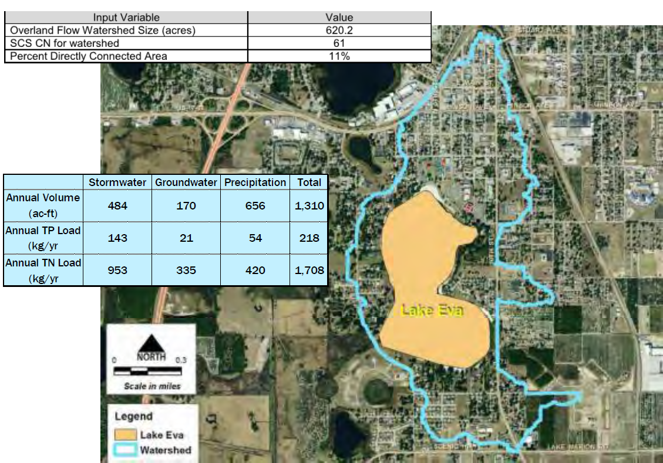  Reducing watershed nutrient loads is proposed to improve surface water quality. For this project, nutrient load reductions will be provided by the restored wetland and the stormwater BMP retrofits. For the stormwater BMP retrofits, subsurface storage in pipes and the surrounding sandy soils are expected to provide a total of about 8 ac-ft of storage in six BMPs. Some of these are existing BMPs and others are located under existing green space. Approximately 0.25-inch runoff retention will be provided when considering storage volume combined with infiltration occurring during storm events due to the extensive surface area and sandy soils. During final design, the stormwater BMP retrofits  will be refined. For some existing BMPs, it may be possible to increase the BMP depth to increase the additional storage volume provided and reduce the required BMP retrofit surface area. Pollutant removal efficiency for infiltration BMPs is a function of the runoff volume retained and the total average annual runoff volume. Based on retaining a 0.25-inch runoff for this specific contributing watershed area, 70 percent pollutant/nutrient removal efficiency is predicted (Evaluation of Current Stormwater Design Criteria Within the State of Florida Final Report, FDEP, June 2007). This is based on the contributing watershed characteristics: 11 percent directly connected impervious area (DCIA), a non-DCIA curve number of 61, and located in Zone 2. The existing and resulting proposed condition Lake Eva stormwater pollutant loads and estimated average annual load reductions are listed in the below table.  Estimated Average Annual Stormwater BMP Retrofit Mass Pollutant Load Reduction for Lake Eva.  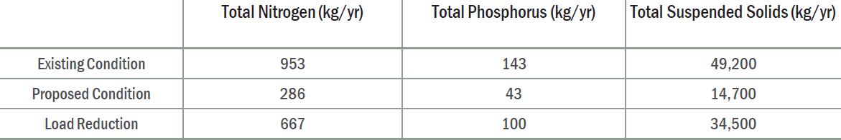  These load reductions do not consider treatment and additional load reduction achieved by the proposed gross pollutant removal structures on three of the primary stormwater outfalls to Lake Eva. Although the FDEP report predicts 70 percent removal efficiency, because of the location of some of the BMPs in close proximity to Lake Eva, actual load reductions may be somewhat less. Regardless, retention of the first 0.25-inch runoff from the urban watershed, in conjunction with the gross pollutant removal structures, is expected to produce measurable load reductions and water quality improvement.  Lake Eva Restoration Project Objectives  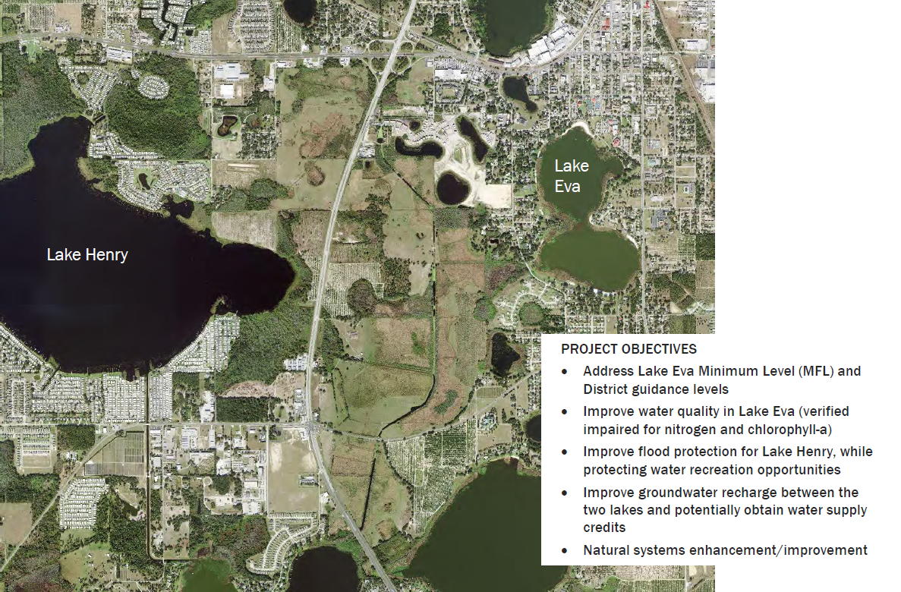  Lake Eva Restoration Project Alternatives Scoring  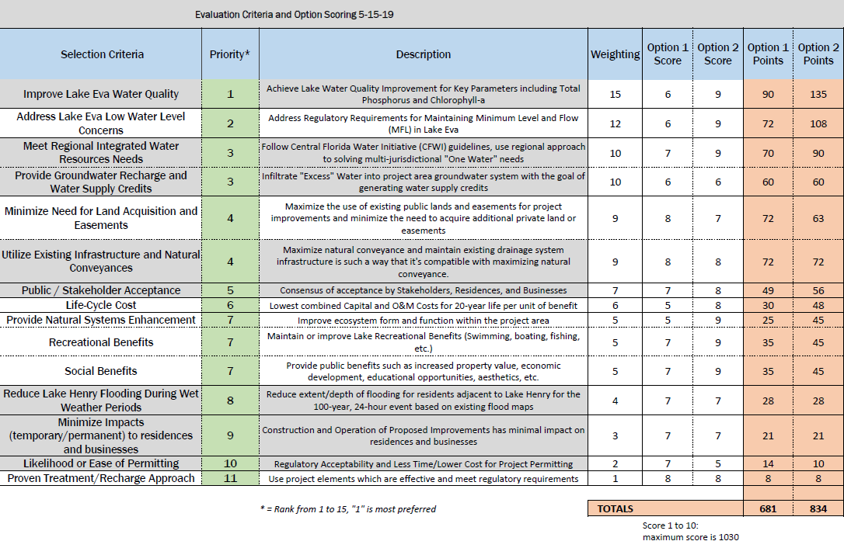  The selected wetland restoration alternative Conceptual Design, as shown below, will divert excess surface discharge from the north, northwest, and Lake Henry through the restored wetland to Lake Eva. This will be accomplished with a very wide earthen weir downstream of the intersection of the Haines City Canal and the outfall channel from Lake Henry. Most of the approximately 145 acres of wetland restoration are located on the Morrison Ranch property, with a smaller portion on the east side located on Sunset Chase Homeowners Association property. The boundary of wetland restoration will be at the existing 121 ft NAVD88 elevation contour and within the historical marsh/wetland and zone of muck soils. The top elevation of the earthen diversion weir will be at approximately 120.5 ft NAVD88 and will be finalized during final design using the ICPRv4 model. Limited grading in the existing wetland is proposed since the existing grade is at approximately 120 ft NAVD88. Some grading of the existing channels to create a slough is proposed along with excavation of some deeper pools (depth approximately 5 ft) for sediment accumulation and wildlife habitat. Filling is only anticipated to construct the diversion weir, the wooded hummock rise on the northern side of the restored wetland, and portions of an access trail around the restored wetland. The trail could also be used for recreation. Two plugs are shown for very small channels on the southern side of the Lake Henry outfall channel to reduce the potential for water to bypass the diversion. An operable control structure is proposed as part of the diversion feature to provide more flexibility in controlling upstream water levels and water release. A box culvert will connect to the operable control structure and extend through the weir to convey flow downstream in the Haines City Canal. The earthen weir is very wide so substantial flow can be conveyed downstream with minimal water depth over the weir. Cleaning and some regrading of the existing channel is needed from Peninsula Drive to Lake Eva to allow proper flow into and out of Lake Eva.  On the Conceptual Design plan, the access trail is shown extending from both US 27 and Peninsula Drive around much of the restored wetland perimeter. Access is needed for routine maintenance and also for recreation and education. Coordination with the property owner is needed to finalize the locations. There is a portion of the wetland perimeter with no trail on the western side of the wetland, so existing forested wetlands will not be disturbed. Approximately 900 LF of optional boardwalk is shown on the Conceptual Design crossing the wetland about midway in the north-south direction to connect the eastern and western sides of the perimeter access trail. This would improve the recreational and educational opportunities at the site. An optional observation deck is also shown at the eastern end of the boardwalk. This would allow visitors to observe the full breadth of the restoration project and adjacent lakes. Educational signage is also depicted on the Conceptual design plan  Conceptual Design typical sections for the proposed wetland restoration element are shown below. The main channel and slough top width will vary from about 40 ft to 100 ft, with water depth from the surface elevation of the restored wetland to the bottom of the channel/slough ranging from 3 ft to 5 ft. Proposed side slopes for the channel/slough and edge of the restored wetland are relatively mild and range from 3 to 4 horizontal to 1 vertical. The top elevation of the access trail may vary from 121 to 122 ft NAVD88.  Below is a conceptual designed wetland restoration typical sections for Lake Eva  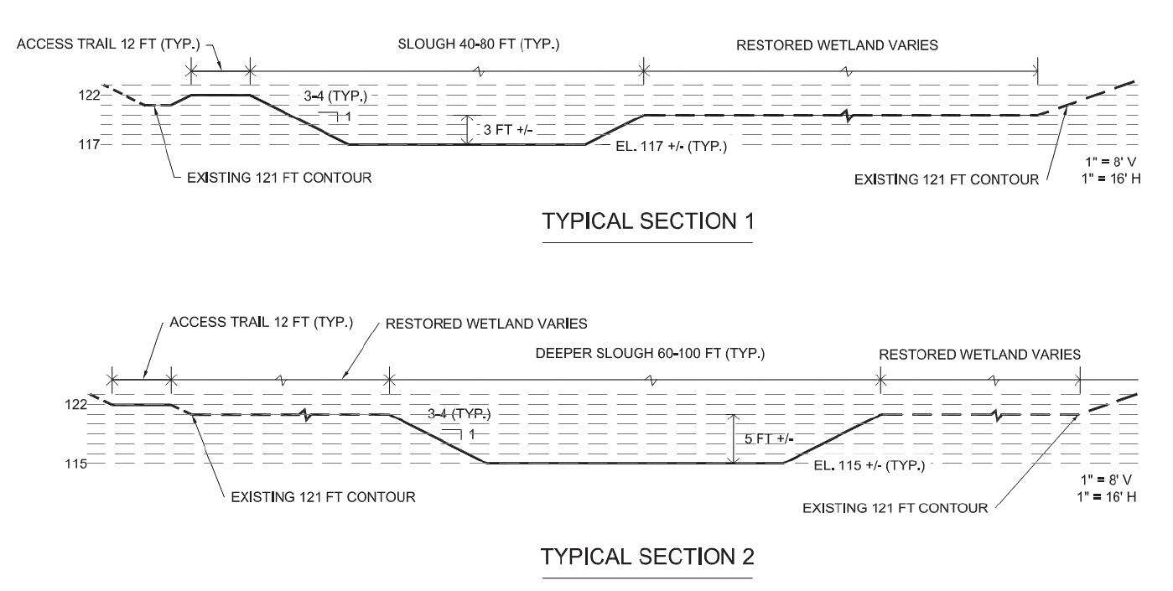  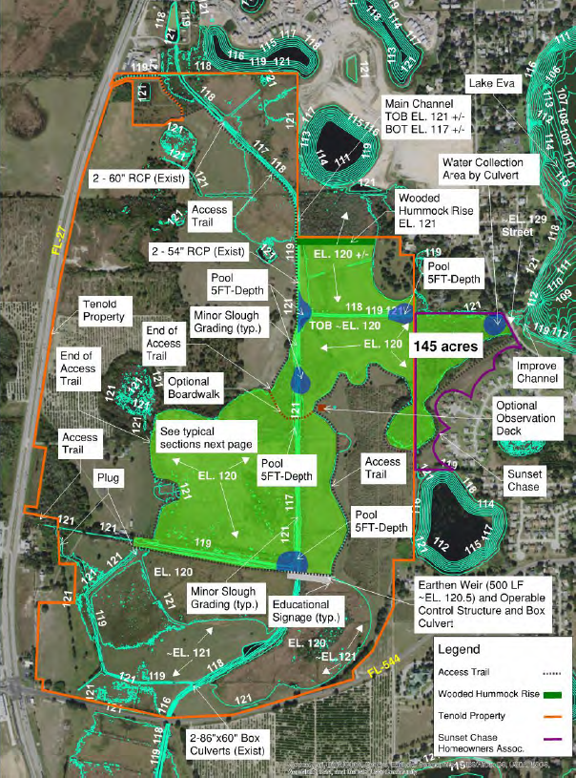  The selected alternative includes six stormwater BMP retrofits for major outfalls discharging into the northern, eastern, and western sides of Lake Eva as shown on the Conceptual Designs on Figures 6-3 and 6-4. This is to reduce the nutrient load to Lake Eva from stormwater runoff and improve surface water quality. The total contributing drainage area is approximately 540 acres. These areas generally contain Candler sands, are 0 percent hydric, with low fines content, excessively drained, with rapid permeability. At the request of the City, only underground practices were considered so that the appearance of the area will not substantially change. Infiltration BMP retrofits are planned to take advantage of the sandy soils in the area. Stormwater runoff flowing in existing storm pipes would be diverted using underground structures and storm pipes into the proposed/modified BMPs. Runoff in excess of the capacity of the BMPs will continue in the existing storm pipes and discharge to Lake Eva. Underground gross pollutant removal structures are proposed for the two largest outfalls located at the northern end of Lake Eva. Located upstream of the proposed underground retention, these will capture trash, organic debris (e.g., grass, leaves), and larger sediment. For the stormwater BMP retrofits, subsurface storage in pipes and the surrounding sandy soils are expected to provide a total of about 8 ac-ft of storage in six BMPs labeled as A1 through A6. All BMP retrofits, with the exception of A1, are proposed within the footprint of existing stormwater BMPs. One of the BMPs, A5, is currently owned by FDOT. All other areas and BMPs are owned by the City of Haines City. Approximately 0.25 inches of runoff retention will be provided when considering storage volume combined with infiltration due to the extensive surface area and sandy soils. During final design, the stormwater BMP retrofits will be refined. For some existing BMPs, it may be possible to lower the BMP bottom elevation to increase the above ground storage volume provided and reduce the underground storage volume.  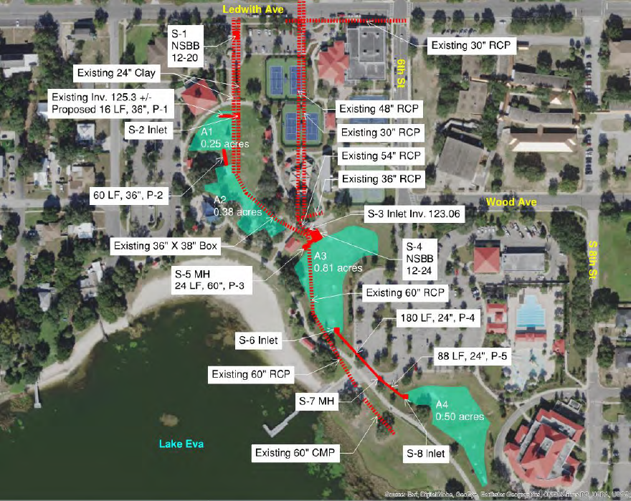  Proposed stormwater BMP retrofits account for about two-thirds of the estimated construction cost, and wetland restoration makes up the remaining one-third. On a life-cycle cost basis, proposed stormwater BMP retrofits account for almost 60 percent of the cost with the remaining 40 percent for wetland restoration. While it may be possible to phase project construction, both the proposed wetland restoration and stormwater BMP retrofit elements are needed to achieve the project objectives.  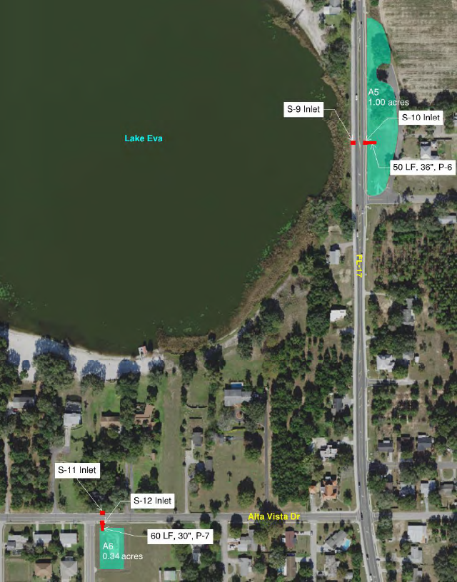

Critical Milestones/Monitoring
 | Anticipated Critical Milestone(s) and Completion Dates: |  | - Conduct Feasibility Study to assess existing conditions and restoration alternatives, and complete conceptual design for the selected alternative. Includes stakeholder meetings and input. (Complete)  - Complete 30 Percent Design Package including survey, geotech, design, regulatory coordination, benefits, and cost estimates (Complete)  - 3rd Party Review (2020)  - Complete Design and Submit Permit Applications (2021)  - Complete Final Construction Bid Documents and Permits Issued (2021)  - Complete Project Bidding (2021)  - Complete Construction (2022)
 | Monitoring Component |  | The Polk County Water Atlas contains water quality data broken down into the following:  - The overall trophic state index  - Nutrient chemistry  - Water clarity  - Bacteria  - Dissolved oxygen  Per the Polk County Water Atlas website (http://www.polk.wateratlas.usf.edu/), Lake Eva has been monitored at seven locations, with a total of 5,224 collected data points from February 4, 1986, through present. Monitoring information can be obtained from the following data sources: Florida Department of Environmental Protection (FDEP), LAKEWATCH Volunteer Water Quality Monitoring, Polk County Parks & Natural Resources Division, and the District. Storage and Retrieval (STORET) and Water Quality Exchange were reviewed, but only contained data for Lake Eva from the Polk County Natural Resource Division.
Other Key Dates
 | Estimated Date for Delisting from Verified List or Removal from Study List | WBID 15101 is in the state’s Group 3 Basin in the DEP Southwest District. The current review and assessment cycle (statewide biennial assessment) is scheduled for completion in 2022. This waterbody is currently impaired for nutrients (chlorophyll-a) and nutrients (total nitrogen), the earliest opportunity for delisting would happen during the next statewide biennial assessment. However, if this WBID doesn’t meet delisting requirements at that time, it will remain in assessment category 4e, which will postpone TMDL development.

Financial Commitments

 | Estimated Implementation Cost | Lake Eva CFI Cost-Benefit Analysis  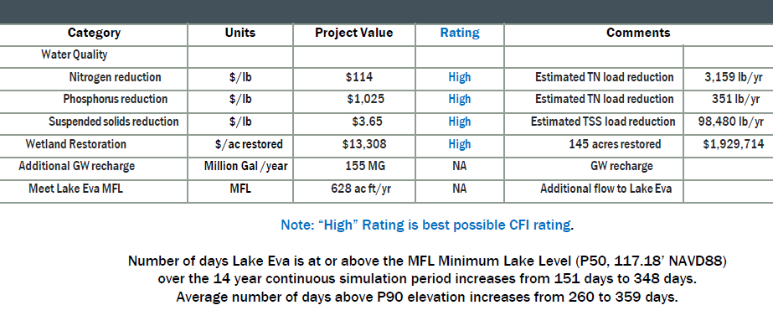  Construction and Life Cycle Cost Summary. Option 2, highlighted in red was selected as the best path to restoration.  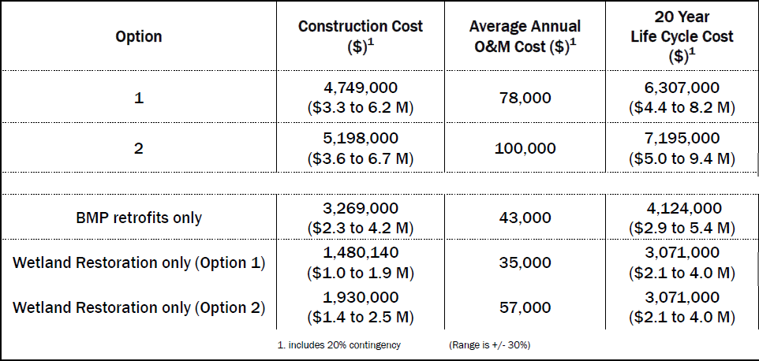  In addition to the District cooperative funding, it may also be possible to obtain an FDEP 319 Grant for project implementation.. Project proposals may be submitted anytime throughout the year. Department review and evaluation periods are expected to occur in September/October and March/April of each year, or as needed.  Polk Regional Water Cooperative (PRWC) is another potential project funding vehicle. The District approved a resolution dedicating $25 million over five years to fund PRWC alternative water supply projects. The Peace Creek Integrated Water Supply Project was identified as one of three priority projects to receive funding support. The Lake Eva and Lake Henry Restoration project provides additional water supply and natural resources benefits within Peach Creek Watershed and should be considered for PRWC funding.  The total project cost, including land acquisition $TBD  The cost includes a 319(h) Clean Water Act Section grant of $TBD  The estimated 20-year operation and maintenance cost is $10,266,000.
 | Land Acquisition  (if applicable) | Funding Source:  Total………………………………………………8,000,000…………………...$ County, Haines City, Winter Haven, FDEP and additional grants
 | Design and Construction  (if applicable) | Funding Source:  Total……………………………………………………………………...$7,128,000 Haines City, Winter Haven, FDEP, SWFWMD and County
References:

“Lake Eva and Lake Henry Restoration Feasibility Study” by Brown and Caldwell – Prepared for Haines City, Florida August 29, 2019.

Attachment 2. Lake Hamilton septic to sewer conversion project.

