This section, CFWI – XXX, shall supersede in its entirety sections XXX of the SJRWMD Applicant’s Handbook; sections XXX of the SWFWMD Applicant’s Handbook and sections XXX of the SFWMD Handbook.

2.3.4 Industrial/Commercial/Institutional/Electric Power Generation (ICI)

2.3.4.1 ICI Demand Components

Reasonable demand is based on the amount of water needed to perform an ICI process in an efficient, non-wasteful and economic manner. Applicants must identify the quantities needed for each demand component, as set forth in section 2.3.4.3, in order to justify the quantities requested in the application. Applicants shall request quantities in gallons per day (gpd) for each demand component.

Applicants for ICI use must identify the demand for the following demand components:
- Processing and manufacturing, which includes water lost in processing and manufacturing where water is an input in the process.
- Office and personnel uses, which includes personal and sanitary use. This demand component shall receive a distinct allocation.
- Landscaping and irrigation. This demand component shall receive a distinct allocation.
- Other needs that are reasonable and which shall include the total requested withdrawal quantity minus the quantity for the demand components identified above. All “other needs” shall be specified in the application along with a statement supporting the need for such quantity.

2.3.4.2 ICI Allocation Expression

2.3.4.2.1 ICI Annual Quantity

The annual quantity for ICI is determined by calculating the total quantity of water to be withdrawn over any 12-month period. A daily average is calculated by dividing the annual quantity by 365. The annual quantity is determined by adding the quantities required by each component of demand for the particular use. The total demand is then considered along with other factors affecting withdrawals such as treatment losses; other sources of water; conservation and water purchased, sold, or transferred to determine the annual quantities.

2.3.4.2.2 ICI Peak Month

Peak month quantities represent the greatest quantity permitted to be used in any single month. Although it is based on an entire month’s pumpage, the monthly quantity is converted to average daily units, by dividing by the number of days in the month. Peak month quantities are determined by identifying monthly use in gpd from use records or documentation for each calendar month. The 31 consecutive days or the month with the greatest use in each year is determined and identified as the peak month quantities (in gpd). Peak month quantities are then divided by the daily average for that year. This division results in the peak month coefficient. The most appropriate peak month coefficient, based on the previous 5 years, is then used as a multiplier to determine proposed peak month quantities.

The peak month quantities is determined by calculating the proposed annual quantities, based on demand projections, and multiplying it by the peak month coefficient to result in the projected peak month quantity.

2.3.4.3 ICI Demand Calculation by Demand Component

2.3.4.3.1 Processing and manufacturing

Demands for processing and manufacturing needs will be calculated by preparing a water balance for the types of activities associated with the application. An example water balance diagram is provided in Figure 2-1. The water balance shall include all of the below information.

      - The Applicant shall provide a written account of where water is used in manufacturing or processing; where and in what quantities water is lost in manufacturing or processing; and where and in what quantities water is disposed in the manufacturing or processing.
- Water balance may be in form of spreadsheet or flow diagram indicating all water sources and losses.
- All water sources that input to activity must be listed – e.g. groundwater from wells, groundwater from dewatering, surface water withdrawals, collected rainfall, recycled or reused water.
- The amount of water used from all sources should equal the sum of the water used, lost and disposed.
      - The Applicant shall list all uses and losses including, as applicable:
        - Water used to wash product.
        - Evaporation from settling/recirculation ponds.
        - Water retained and shipped with product.
        - Water used to separate or beneficiate the product.
        - Water used to transport the product (slurry).
        - Animal needs.
        - Draining or filling augmentation of ponds, pools, flumes and aquatic habitats necessary for processing and manufacturing.
      - The Applicant shall identify the final disposal of all water including, as applicable:
        - Off-site discharges.
        - Disposal/recharge through percolation ponds.
        - Disposal by spray irrigation.
        - Water entrained in clay materials.
        - Recycling of wastewater.

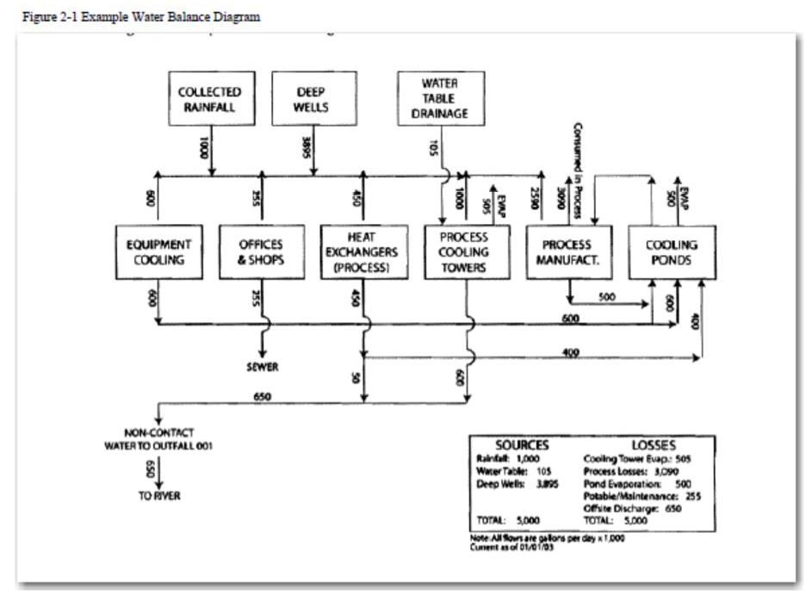

2.3.4.3.2 Office and personnel

Office and personnel water use is exemplified by water needed for personal use such as drinking, bathing, cooking, sanitation, and cleaning office areas. Demands for office and personnel use shall be calculated using gallons per employee or visitor needed based on best available information from appropriate data sources such as US Department of Energy, AWWA Research Foundation, Pacific Institute, Conserve Florida on-line library, or EPA.
          - In determining the number of employees, the applicant shall use the average number of employees per shift, number of shifts per work day, and number of work days per year.
          - In determining the number of visitors, the applicant shall use the annual average number of visitors for the most recent 5 years. Alternative methodologies can be used if an applicant presents reasonable assurance that the methodology is appropriate for the use and that the withdrawal quantities requested are necessary to supply the proposed need or demand.

2.3.4.3.3 Landscaping and irrigation

Demands for landscaping and irrigation will be calculated by providing information utilizing the application of supplemental irrigation need formulas for plants proposed to be irrigated. These formulas are set forth in: XXXXXX .

2.3.4.3.4 Other needs

An applicant may provide reasonable assurance for demands relating to other needs, such as outside use, air conditioning, and unaccounted uses.
This section, CFWI – XXX, shall supersede in its entirety sections XXX of the SJRWMD Applicant’s Handbook; sections XXX of the SWFWMD Applicant’s Handbook and sections XXX of the SFWMD Handbook.

2.3.5 Mining/Dewatering Activities

2.3.5.1 Mining/Dewatering Permitted Withdrawal Quantities

The reasonable-beneficial need for a requested allocation must be based on the amount of water needed to extract subsurface materials or control surface water or groundwater when performing activities such as excavation or construction. Applicants must demonstrate that the quantities applied for relate to reasonable mining, processing, and dewatering needs.

Applicants must identify the quantities needed for each demand component, as defined in section 2.3.5.2, in order to justify the quantities requested in the application. Typically, requested quantities are based on historical information or comparable uses, where available. Applicants shall request quantities in gallons per day (gpd) for each demand component.

2.3.5.2 Mining/Dewatering Demand Components

Applicants for ICI use must identify the demand for the following demand components:

- Mining and dewatering processes
- Office and personnel use, including water for personal needs such as drinking, bathing, cooking, sanitation, or cleaning.
- Other needs that are reasonable and which shall include the total requested withdrawal quantity minus the quantity for the demand components identified above. All “other needs” shall be specified in the application along with a statement supporting the need for such quantity.

2.3.5.3 Mining/Dewatering Allocation Expression

2.3.5.3.1 Mining/Dewatering Annual Quantity

The annual quantity for Mining/Dewatering is determined by calculating the total quantity of water to be withdrawn over any 12-month period. A daily average is calculated by dividing the annual quantity by 365. The annual quantity is determined by adding the quantities required by each component of demand for the particular use. The total demand is then considered along with other factors affecting withdrawals such as treatment losses; other sources of water; conservation and water purchased, sold, or transferred to determine the annual quantities.

2.3.5.3.2 Mining/Dewatering Peak Month

Peak month quantities represent the greatest quantity permitted to be used in any single month. Although it is based on an entire month’s pumpage, the monthly quantity is converted to average daily units, by dividing by the number of days in the month. Peak month quantities are determined by identifying monthly use in gpd from use records or documentation for each calendar month. The 31 consecutive days or the month with the greatest use in each year is determined and identified as the peak month quantities (in gpd). Peak month quantities are then divided by the daily average for that year. This division results in the peak month coefficient. The most appropriate peak month coefficient, based on the previous 5 years, is then used as a multiplier to determine proposed peak month quantities.

The peak month quantities are determined by calculating the proposed annual quantities, based on demand projections, and multiplying it by the peak month coefficient to result in the projected peak month quantity.

2.3.5.4 Mining/Dewatering Demand Calculation

All demand components on contiguous property shall obtain a single permit unless different use types are served by separate withdrawal facilities, at which point an applicant may choose to make separate application for the different use type utilizing the separate withdrawal facility.

Demands for processing and manufacturing needs will be calculated by preparing a water balance. The water balance shall include all three demand components, if applicable, listed in 2.3.5.2, above. The water balance may be in the form of a spreadsheet or flow diagram. The water balance must identify the demand for each of the following components:

- Mining and dewatering processes
- Provide a written account of where water is generated and used in the mining and dewatering processes; where and in what quantities water is lost in the mining and dewatering processes; and where and in what quantities water is disposed of or reused in the mining and dewatering processes.
  - Water balance may be in form of spreadsheet or flow diagram indicating all water sources and losses.
  - All water sources that input to activity must be listed – e.g. groundwater from wells, groundwater from water table dewatering or drainage, surface water withdrawals, collected rainfall, recycled or reused water.
  - The amount of water used from all sources should equal the sum of the water used, lost and disposed.
  - If processing of materials is associated with the mining or dewatering, a water balance diagram combining these activities is preferred versus to separate water balances for each activity.
  - Water needs associated with known variability in the ore body and known production schedules.
- Uses and losses must be listed including as applicable:
      - Water used to wash the product.
      - Evaporation from settling/recirculation ponds.
      - Water retained and shipped with the product (product moisture).
      - Water used to separate or beneficiate the product.
      - Water used to transport the product (slurry).
- The final disposal of all water then must be identified. Disposals include, but are not limited to:
      - Off-site discharges.
      - Disposal/recharge through percolation ponds.
      - Disposal by spray irrigation.
      - Water entrained in clay materials.
      - Recycling of wastewater. The amount of water withdrawn should equal the sum of the system losses and disposals.

- Office and personnel water use is exemplified by water needed for personal use such as drinking, bathing, cooking, sanitation, and cleaning office areas. Demands for office and personnel use shall be calculated using gallons per employee or visitor needed based on best available information from appropriate data sources such as US Department of Energy, AWWA Research Foundation, Pacific Institute, Conserve Florida on-line library, or EPA.
- In determining the number of employees, the applicant shall use the average number of employees per shift, number of shifts per work day, and number of work days per year.
- In determining the number of visitors, the applicant shall use the annual average number of visitors for the most recent 5 years. Alternative methodologies can be used if an applicant presents reasonable assurance that the methodology is appropriate for the use and that the withdrawal quantities requested are necessary to supply the proposed need or demand.

- Other needs. An applicant may provide reasonable assurance for demands relating to other needs, such as outside use, air conditioning, and unaccounted uses.

