I/C/I and Mining/Dewatering Demands
SECOND DRAFT

Note: Nearly all of sections 2.0 and 2.1 represent new or moved language. These sections apply to all sectors and are identical. They are not presented in tracked changes because nearly 100% of the text was in strike-through/underline.

CFWI - 2.0 Demonstration of Water Demand, Allocations, and Source Identification

Within the CFWI Area, sections, CFWI - 2.0, excluding subsections, and CFWI - 2.1, inclusive of subsections, shall supersede it their entirety, section ____ of the SJRWMD Applicant’s Handbook; sections ____ of the SWFWMD Applicant’s Handbook; and sections ____ of the SFWMD Applicant’s Handbook.

To receive a permit, an applicant must demonstrate that the proposed water use is a reasonable-beneficial use of water, as required by Section 373.223, F.S., including meeting the conditions of issuance. The proposed withdrawal of water must be supported with information that provides reasonable assurance that the withdrawal quantities are necessary to supply a certain reasonable demand. Only the portion of demand for which an applicant is able to provide such reasonable assurance will be permitted. Additional or alternative provisions to the below are required for uses within the Southern and Dover/Plant City Water Use Caution Areas in accordance with Rule 62-42.500, F.A.C.

An Applicant’s allocation reflects a consideration of factors including demands and, as applicable, treatment losses, other sources of water (such as reclaimed water), conservation, and water purchased, sold, or transferred. When necessary to prevent water resource impacts, allocations can be expressed in increments over the permit term.

In no case, however, will the allocation be greater than the total rated capacity of all existing and proposed withdrawal facilities.

Applicants using reclaimed water to meet their total water needs are not required to obtain water use permits except as otherwise provided in section 373.250, F.S. However, if reclaimed water is utilized to meet any part of the applicant's water demand, the applicant shall identify the quantities from these sources used to meet the demand.

Each permit issued by the District shall identify the source of withdrawal, the use type, and the location of the withdrawal.

A water user shall obtain one permit for all withdrawals that are intended to serve contiguous property. Two or more properties represented to be separate properties shall be aggregated and treated as a single property for permitting purposes when the District determines that the properties are physically proximate and (a) either share the same irrigation infrastructure or (b) are operated as a common enterprise. However, when multiple use types, as defined in Rule 40C-2.501, F.A.C., are served by separate withdrawal facilities, the District is authorized to issue separate individual permits. For example, a farm on contiguous property which has four wells must apply for one permit; the application will include information about each of the wells, the intended use for the water from each well, or pump, and a general indication of when the water will be withdrawn. This requirement to aggregate two or more properties shall not apply when the separate properties have existing permits that require metering for all withdrawals or the water user requests a permit modification to the permits to require metering for all withdrawals.

CFWI - 2.1 Allocation Expression

Applicants shall request quantities in gallons per day for each component of demand according to the demand components listed for each use type.

CFWI - 2.1.1. Annual Quantity

The annual quantity is determined by calculating the total quantity of water to be withdrawn over a 12-month period. A daily average is calculated by dividing the annual quantity by the days in the year. The annual quantity must equal the quantities required by each demand component for the particular use.

CFWI - 2.1.2. Peak Month

The peak month allocation represents the greatest quantity permitted to be used in any single month. The peak month allocation is determined by identifying the peak month demand for the associated use type.

CFWI - 2.2 Public Supply Use Type

CFWI - 2.3 Industrial/Commercial/Institutional/Electric Power Generation (ICI)

Within the CFWI Area, this section, CFWI – 2.3, shall supersede in its entirety sections ______ of the SJRWMD Applicant’s Handbook; sections ______ of the SWFWMD Applicant’s Handbook and sections ______ of the SFWMD Handbook.

CFWI - 2.3.1 ICI Demand Components

Reasonable demand is based on the amount of water needed to perform an ICI process in an efficient, non-wasteful and economic manner. To demonstrate the quantities applied for are reasonable, applicants must identify the quantities needed for each demand component listed below. Applicants shall request quantities in gallons per day (gpd) for each demand component.

Applicants for ICI use must identify the demand for the following demand components:
- Processing and manufacturing, which includes water lost in processing and manufacturing where water is an input in the process.
- Office and personnel uses, which includes personal and sanitary use. This demand component shall receive a distinct allocation.
- Landscaping and irrigation, which shall receive a distinct allocation.
- Other needs, which shall be reasonable and which shall include the total requested withdrawal quantity minus the quantity for the demand components identified above. All “other needs” shall be specified in the application along with a statement supporting the need for such quantity.

CFWI - 2.3.2 ICI Demand Calculation by Demand Component

CFWI - 2.3.2.1 Processing, manufacturing, and power generation

Demands for processing, manufacturing, and power generation will be calculated by preparing a water balance for the types of activities associated with the application. The water balance may be in the form of a spreadsheet or flow diagram indicating all sources and losses. An example water balance diagram is provided in Figure 2-1. The water balance shall include all of the below information.

      - The Applicant shall provide a written account of where water is used in manufacturing or processing; where and in what quantities water is lost in manufacturing or processing; and where and in what quantities water is disposed in the manufacturing or processing.

- All water sources that input to activity must be listed – e.g. groundwater from wells, groundwater from dewatering, surface water withdrawals, collected rainfall, recycled or reused water.
- The amount of water used from all sources should equal the sum of the water used, lost and disposed.
      - The Applicant shall list all uses and losses including, as applicable:
        - Water used to wash product.
        - Evaporation from settling/recirculation ponds.
        - Water retained and shipped with product.
        - Water used to separate or beneficiate the product.
        - Water used to transport the product (slurry).
        - Animal needs.
        - Draining or filling augmentation of ponds, pools, flumes and aquatic habitats necessary for processing and manufacturing.
      - The Applicant shall identify the final disposal of all water including, as applicable:
        - Off-site discharges.
        - Disposal/recharge through percolation ponds.
        - Disposal by spray irrigation.
        - Water entrained in clay materials.
        - Recycling of wastewater.

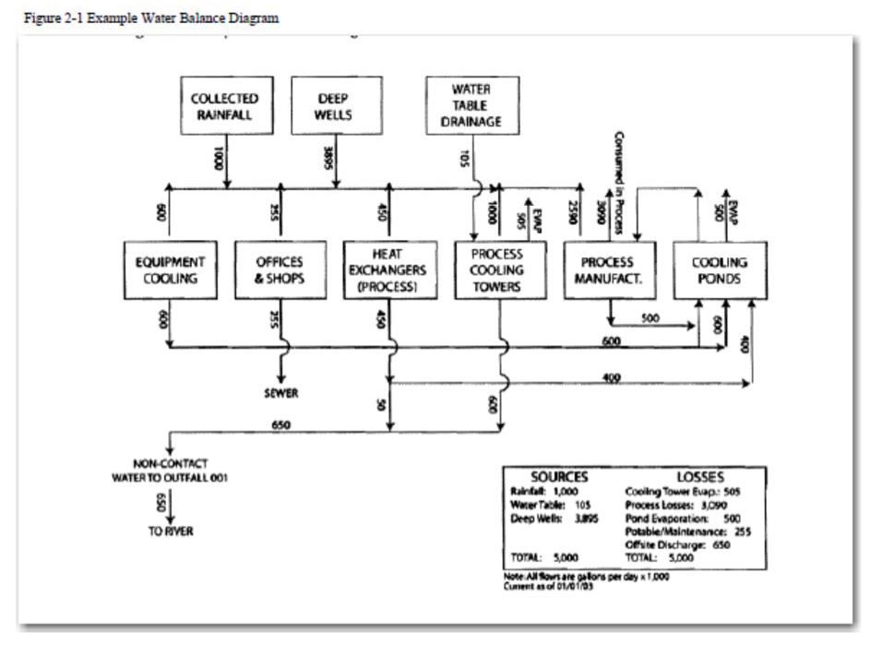

CFWI - 2.3.2.2 Office and personnel

Office and personnel water use is exemplified by water needed for personal use such as drinking, bathing, cooking, sanitation, and cleaning office areas. If water is requested for such purposes, the applicant shall identify whether the water for office and personnel is to be used predominately by employees or visitors, or if it will serve both. Based on the information provided, demands for office and personnel use shall then be calculated using gallons per employee or visitor needed based on best available information from appropriate data sources such as US Department of Energy, AWWA Research Foundation, Pacific Institute, Conserve Florida on-line library, or EPA.
          - In determining the number of employees, if applicable, the applicant shall use the average number of employees per shift, number of shifts per work day, and number of work days per year.
          - In determining the number of visitors, if applicable, the applicant shall use the annual average number of visitors for the most recent 5 years. Alternative methodologies can be used if an applicant presents reasonable assurance that the methodology is appropriate for the use and that the withdrawal quantities requested are necessary to supply the proposed need or demand.

CFWI - 2.3.2.3 Landscaping and irrigation

Demands for landscaping and irrigation will be calculated by providing information utilizing the application of supplemental irrigation demands set forth in section 2.6.1.A.

CFWI - 2.3.2.4 Other needs

An applicant shall provide reasonable assurance for demands relating to other needs, if requested, such as outside use, air conditioning, and unaccounted uses.

This section, CFWI – 2.3.5, shall supersede in its entirety sections 2.2.4. of the SJRWMD Applicant’s Handbook; sections 2.4.4 (excluding subsections) and 2.4.5 (excluding subsections) of the SWFWMD Applicant’s Handbook and sections 2.3.2.D (excluding subsections) and 2.3.2.D.2 of the SFWMD Handbook.

CFWI - 2.4 Mining/Dewatering Use Type

CFWI - 2.4.1 Mining/Dewatering Demand Components

The reasonable-beneficial need for a requested allocation must be based on the amount of water needed to extract subsurface materials or control surface water or groundwater when performing activities such as excavation or construction as well as moving, handling and processing the extracted material. Applicants must demonstrate that the quantities applied for relate to reasonable mining, processing, and dewatering needs.

To demonstrate the quantities applied for are reasonable, an applicant must identify the quantities needed for each demand component. Typically, requested quantities are based on historical information or comparable uses or projected future use, where available. Applicants shall request quantities in gallons per day (gpd) for each demand component.

Applicants for mining/dewatering use must identify the demand for the following demand components:

- Mining, dewatering, and processing
- Office and personnel use, including water for personal needs such as drinking, bathing, cooking, sanitation, or cleaning.
- Landscaping and irrigation, which shall receive a distinct allocation.
- Other needs, which are reasonable and which shall include the total requested withdrawal quantity minus the quantity for the demand components identified above. All “other needs” shall be specified in the application along with a statement supporting the need for such quantity.

CFWI - 2.4.2. Mining/Dewatering Demand Calculation

The Applicant must prepare a water balance to calculate the proposed demands. The water balance shall include all four demand components, if applicable, listed in 2.4.1, above. The water balance may be in the form of a spreadsheet or flow diagram indicating all sources and losses. The water balance must identify the demand for each of the following components:
- Mining, dewatering, and processing
- Provide a written account of where water is generated and used in the mining and dewatering processes; where and in what quantities water is lost in the mining and dewatering processes; where and in what quantities water is disposed of or reused in the mining and dewatering processes; and where and in what quantities water is used for processing extracted materials.

  - All water sources that input to activity must be listed – e.g., groundwater from wells, groundwater from water table dewatering or drainage, surface water withdrawals, collected rainfall, recycled or reused water.
  - The amount of water used from all sources should equal the sum of the water used, lost and disposed.
  - If processing of materials is associated with the mining or dewatering, a water balance diagram combining these activities is preferred versus to separate water balances for each activity.

- Uses and losses must be listed including as applicable:
      - Water used to wash the product.
      - Evaporation from settling/recirculation ponds.
      - Water retained and shipped with the product (product moisture).
      - Water used to separate or beneficiate the product.
      - Water used to transport the product (slurry).
- The final disposal of all water then must be identified. Disposals include, but are not limited to:
      - Off-site discharges.
      - Disposal/recharge through percolation ponds.
      - Disposal by spray irrigation.
      - Water entrained in clay materials.
      - Recycling of wastewater. The amount of water withdrawn should equal the sum of the system losses and disposals.

- Office and personnel water use is exemplified by water needed for personal use such as drinking, bathing, cooking, sanitation, and cleaning office areas. Demands for office and personnel use shall be calculated using gallons per employee/contractor needed based on best available information from appropriate data sources such as US Department of Energy, AWWA Research Foundation, Pacific Institute, Conserve Florida on-line library, or EPA.

In determining the number of employees/contractors, if applicable, the applicant shall use the average number of employees per shift, number of shifts per work day, and number of work days per year.

3. Landscaping and irrigation. Demands for landscaping and irrigation will be calculated by providing information utilizing the application of supplemental irrigation demands set forth in 2.5.1.A.
4. Other needs. An applicant may provide reasonable assurance for demands relating to other needs, such as outside use, air conditioning, and unaccounted for uses.

2.5 Agricultural Use Type

2.6 Landscape/Recreation Use Type

