South Florida Algal Bloom Sampling Results - June
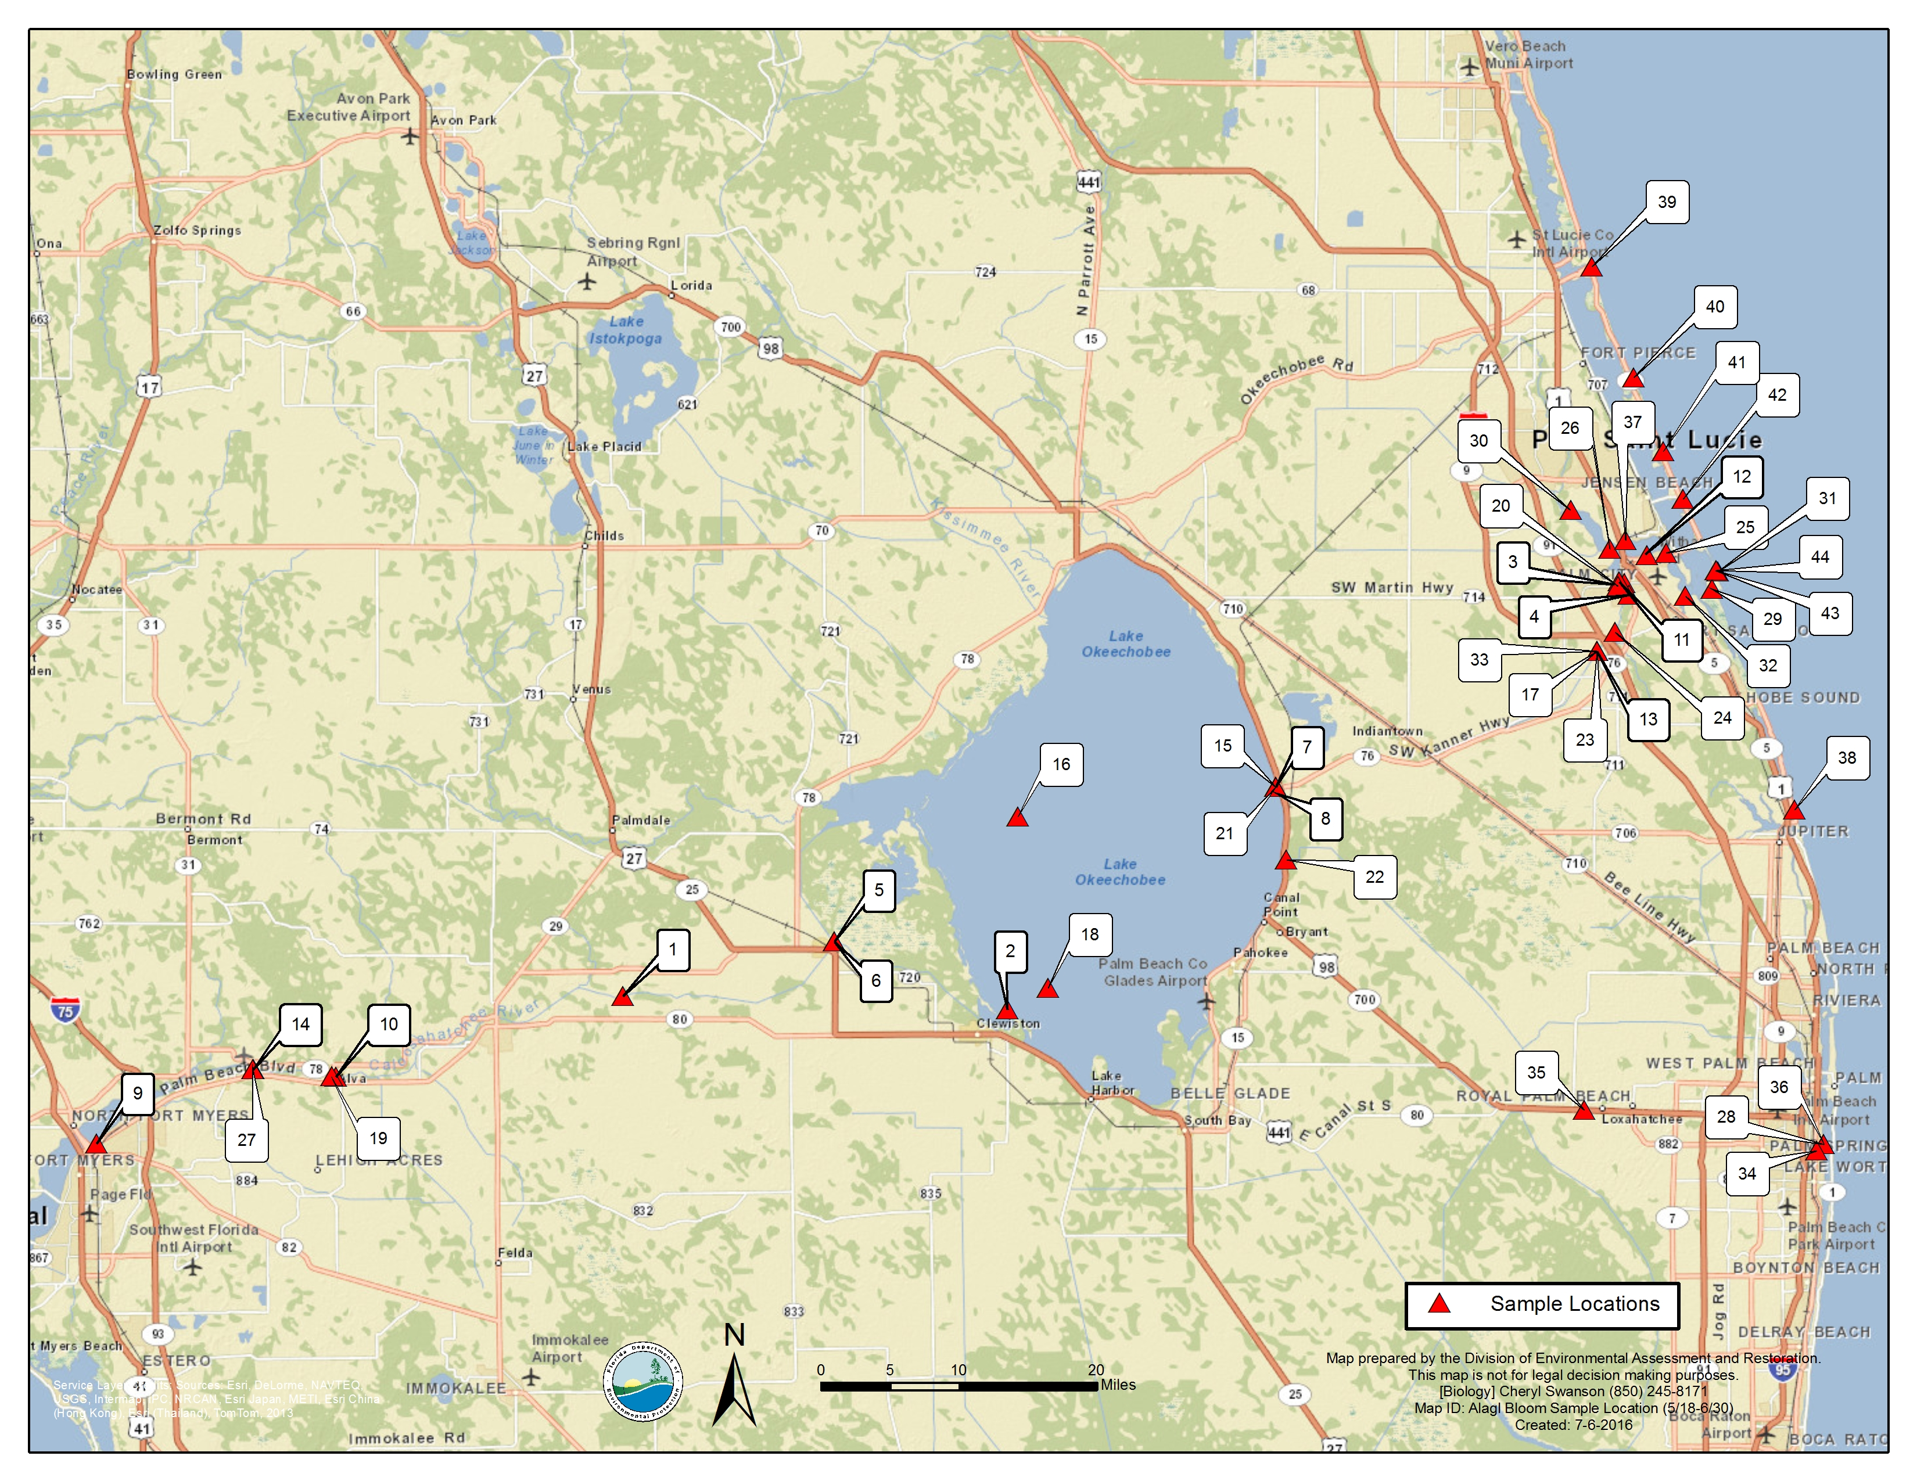

Sample Date | Samples Collected By | Samples Analyzed By | Sampling Location  (Latitude and Longitude) | Depth | Algae ID  (Type of Blue Green Algae) | Microcystin Toxin (measurement in micrograms per liter)
6/30/16  (44) | FDEP | FDEP | Martin County  Atlantic Ocean Bathtub Reef Beach, 5 meters from shore (N 27° 11' 12", W -80° 9' 36") | 0.3 | Dominant taxon: Microcystis aeruginosa | 414.3
6/29/16  (43) | FWRI | FWRI - algal ID; FDEP -toxins | Martin County Bathtub Beach (N 27° 11.222', W -80° 09.625') | 0.5 | mixed algae; no dominant species in sample | not detected
6/29/16  42) | FWRI | FWRI - algal ID; FDEP -toxins | Martin County  Jensen Beach (N 27° 15.214', W -80° 11.695') | 0.5 | mixed algae; no dominant species in sample | not detected
6/29/16  (41) | FWRI | FWRI - algal ID; FDEP -toxins | St. Lucie County  South Hutchinson Island (N 27° 17.859', W -80° 12.937') | 0.5 | mixed algae; no dominant species in sample | not detected
6/29/16  (40) | FWRI | FWRI - algal ID; FDEP -toxins | St. Lucie County  Mid-Hutchinson Beach (N 27° 21.975', W -80° 14.789') | 0.5 | mixed algae; no dominant species in sample | not detected
6/29/16  (39) | FWRI | FWRI - algal ID; FDEP -toxins | St. Lucie County  South Jetty Park (N 27° 28.165', W -80° 17.425') | 0.5 | mixed algae; no dominant species in sample | not detected
6/29/16  (38) | FWRI | FWRI - algal ID; FDEP -toxins | Palm Beach County  Coral Cove (N 26° 57.814', W -80° 04.687') | 0.5 | mixed algae; no dominant species in sample | not detected
6/29/2016  (37) | FDEP | FDEP | Martin County  St. Lucie River, Central Marine Marina (N 27° 12' 55", W -80° 15' 18") | 0.3 | Dominant taxon: Microcystis aeruginosa | 78.3
6/29/2016  (36) | SWFMD | FDEP | Palm Beach County  Summa Beach Park (N 26° 39' 2.81", W -80° 2' 50.50") | 0.3 | mixed algae; no dominant species in the sample | not detected
6/29/2016  (35) | SWFMD | FDEP | Palm Beach County  C51 at Flying Cow Rd. Bridge (N 26° 40' 58.01", W -80° 17' 53.96") | 0.3 | mixed algae; no dominant species in the sample | not detected
6/29/2016  (34) | SWFMD | FDEP | Palm Beach County  S155 (N 26° 38' 41.24", W -80° 3' 17.96") | 0.3 | mixed algae; no dominant species in the sample | 1.4 I
6/28/2016  (33) | SFWMD | FDEP | Martin County  St. Lucie Canal C44S80, upstream of structure (N 27° 6' 41.87", W -80° 17' 06.08") | 0.5 | mixed algae; no dominant species in the sample | 1.0 I
6/27/2016  (32) | FDEP | FDEP | Martin County  St. Lucie Inlet near Sandsprit Park (N 27° 9' 47", W -80° 11' 33") | 0.3 | mixed algae; no dominant species in the sample | 12.7
6/27/2016  (31) | FDEP | FDEP | Martin County  Atlantic Ocean 100m east of Bathtub Reef Beach (N 27° 11' 10", W -80° 9' 30") | 0.3 | mixed algae; no dominant species in the sample | not detected
6/27/2016  (30) | FDEP | FDEP | St. Lucie County  St. Lucie River near Club Med dock (N 27° 14' 35", W -80° 18' 45") | 0.3 | mixed algae; no dominant species in the sample | not detected
6/27/2016  (29) | FDEP | FDEP | Martin County  St. Lucie Inlet near Stuart Sandbar (N 27° 10' 11", W -80° 9' 52") | 0.3 | mixed algae; no dominant species in the sample | 3.6 I
6/22/16  (28) | SFWMD | FDEP | Palm Beach County  Summa Beach Park (N 26° 39' 2.81", W -80° 2' 50.50") | 0.3 m | Dominant taxon: Microcystis aeruginosa | 1.1 I
6/22/16  (27) | FDEP | FDEP | Lee County  Franklin Lock and Dam (N 26° 43' 15", W -81° 41' 34") | 0.3 m | mixed algae; no dominant species in sample | not detected
6/22/16  (26) | FDEP | FDEP | Martin County  Dire Point Canal (N 27° 12' 24.47", W -80° 16' 16.90") | 0.3 m | mixed algae; no dominant species in sample though specks of Microcystis aeruginosa present. | 57
6/22/16  (25) | FDEP | FDEP | Martin County  SE Harbor Pointe Dr. (N 27° 12' 12.44", W -80° 12' 44.77") | 0.3 m | mixed algae; no dominant species in sample though specks of Microcystis aeruginosa present. | 80.3
6/21/16  (24) | FDEP | FDEP | Martin County  C-44 and S. Fork Mouth (N 27° 7' 46.13", W -80° 15' 58.02") | 0.3 m | mixed algae; no dominant species in sample though specks of Microcystis aeruginosa present. | 6.9
6/22/16  (23) | SFWMD | FDEP | Martin County  St. Lucie Locks C44S80 (N 27° 0.6' 41.87", W -80° 17' 06.08") | 0.5 m | mixed algae; no dominant species in sample | 1.9 I
6/20/16  (22) | SFWMD | FDEP | Charlotte County  CULV10A, L-8 Canal Side (N 26° 55' 01.44", W -81° 36' 37") | 0.5 m | mixed algae; no dominant species in sample | 6.1 J
6/20/16  (21) | SFWMD | FDEP | Martin County  S308C, Port Mayaca (N 26° 59' 095", W -80° 37' 288") | 0.5 m | mixed algae; no dominant species in sample | not detected
6/20/16  (20) | FDEP | FDEP | Martin County  Leighton Park, St. Lucie S. Fork (N 27° 10' 20.83", W -80° 15' 47.14") | 0.3 m | mixed algae; no dominant species in sample | 3.9 IJ
6/15/2016  (19) | FDEP | FDEP | Lee County  Alva Bridge (N 26° 42' 51", W -81° 36' 37") | 0.3 | mixed algae; no dominant species in sample | not detected
6/15/2016  (18) | SFWMD | FDEP | Hendry County  LZ30 (N 26° 47' 937", W -80° 51' 544") | 0.3 m | Dominant taxon: Microcystis aeruginosa | 288 µg/L
6/14/2016  (17) | SFWMD | FDEP | Martin County  S-80 (N 27° 06' 41.87", W -80° 17' 06.08") | 0.5 m | Dominant taxon: Planktolyngbya limnetica | not detected
6/14/2016  (16) | SFWMD | FDEP | Glades County  L008 (N 26° 57' 25.62", W -80° 53' 30.08") | 0.5 m | Dominant taxon: Microcystis aeruginosa | 382.3 µg/L
6/2/2016  (15) | FDEP | FDEP | Martin County  Lake Okeechobee @ Port Mayaca (N 26° 59' 5.61", W -80° 37' 17.14") | 0.3 m | mixed algae; no dominant species in sample | 1.6 µg/L

