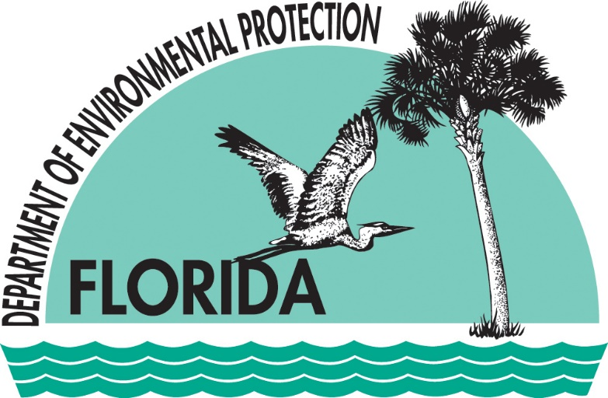

**Sampling and Use of the Lake Vegetation Index (LVI) for Assessing Lake Plant Communities in Florida:**

**A Primer**

**Florida Department of Environmental Protection**

**Division of Environmental Assessment and Restoration**

**Aquatic Ecology and Quality Assurance**

**October 2024**

**Sampling and Use of the Lake Vegetation Index (LVI) for Assessing Lake Plant Communities in Florida: A Primer**

Contents

1. Purpose of this Document 2

2. Development of the LVI, and Intended Uses 2

3. Method Considerations 3

4. QA Considerations 12

5. Conditions Under Which LVI Sampling is Not Appropriate 15

6. Data Usability 18

# Purpose of this Document

The Lake Vegetation Index (LVI) is a bioassessment procedure that measures the degree to which a freshwater lake supports a healthy, well-balanced plant community. DEP SOP LVI 1000 contains instructions for sampling, calculation, and quality assurance activities related to the LVI. The purpose of this document is to provide LVI samplers and data users with additional context and guidance with which to make decisions in the field about sampling with the LVI, and interpretation of LVI data. In addition to understanding the concepts presented in this document, samplers, data analysts, and resource managers who use the LVI must also read DEP SOP LVI1000, for the training, quality assurance, sampling, laboratory, and index calculation Standard Operating Procedures. Furthermore, it is highly recommended that those wishing to implement and interpret the LVI also read and understand “Development of Aquatic Life Use Support Attainment Thresholds for Florida’s Stream Condition Index and Lake Vegetation Index” (DEP-SAS-003/11).

# Development of the LVI, and Intended Uses

The LVI is a multi-metric index that evaluates how closely a lake plant community resembles one which would be expected in a condition of minimal human disturbance. It is based on a rapid field assessment of aquatic and wetland plants as integrators of various effects of human disturbance over time. Plants respond to physical disturbances such as the introduction of exotic species or lakeshore alterations, and chemical disturbances such as the introduction of excess nutrients, particulates, or herbicides from surrounding land uses. Four metrics comprise the index: % native taxa, % FISC Category 1 invasive exotic taxa (determined by the Florida Invasive Species Council [FISC], formerly the Florida Exotic Pest Plant Council [FLEPPC]), coefficient of conservatism (C of C) of the dominant taxon or co-dominant taxa, and % sensitive taxa (C of C ≥ 7). The coefficient of conservatism is a number from 0 to 10 that indicates how broad or narrow a taxon’s ecological niche is, as determined by expert botanists. Exotic and ubiquitous weedy native taxa have low C of C scores, and taxa that display fidelity to a particular community and are sensitive to disturbance have high C of C scores.

The LVI was developed in 2005 by relating plant metrics with indicators of human disturbance, so that the index responds to the effects of human disturbance rather than natural variability among lake plant communities. The LVI was further revised and rescaled in 2007 and 2011. For more information on the LVI index development and calibration, see Fore *et al.* 2007, *Assessing the Biological Condition of Florida Lakes: Development of the Lake Vegetation Index*, available at <http://www.dep.state.fl.us/water/bioassess/pubs.htm>. For more information on DEP’s establishment of the LVI score at which a lake plant community meets its designated use, see DEP 2011, *Development of Aquatic Life Use Attainment Thresholds for Florida’s Stream Condition Index and Lake Vegetation Index*, available at: <http://www.dep.state.fl.us/water/bioassess/pubs.htm>.

The LVI method is performed from a boat, so it is intended for use in lakes and ponds that can be accessed by boat. The LVI shall not be used to assess wetlands or flowing waters. The LVI is a fresh water tool, and should not be used in marine or estuarine waters. Although the method can be used on any publicly or privately-owned waterbody, its applications in support of Florida’s Water Quality Standards (62-302, F.A.C) and in Florida’s Impaired Waters Rule (62-303, F.A.C.), are only for waters of the state (403.031(13), Florida Statutes). It may not be appropriate to conduct a LVI sampling event under certain conditions, described below in Section 5.

For the purpose of the proposed Class III freshwater lake criteria, “lake” shall mean a lentic fresh waterbody with a relatively long water residence time and an open water area that is free from emergent vegetation under typical hydrologic and climatic conditions. Aquatic plants, as defined in subsection 62-340.200(1), F.A.C., may be present in the open water. Lakes do not include springs, wetlands, or streams (except portions of streams that exhibit lake-like characteristics, such as long water residence time, increased width, or predominance of biological taxa typically found in non-flowing conditions).

# Method Considerations

The LVI method is outlined in DEP SOP LVI 1000 (<http://www.dep.state.fl.us/water/sas/sop/sops.htm>). The method should be conducted by samplers who are competent in aquatic and wetland plant identification. Samplers can become competent in plant identification by attending training workshops, reviewing plant ID resources and training presentations on the DEP website (<http://www.dep.state.fl.us/water/bioassess/plantid.htm>), and practicing with experienced samplers. Samplers should bring plant books into the field, as practical, to aid in field identification. See section 4 below (QA Considerations) for the specific quality assurance requirements for using the LVI method and submitting data to DEP.

## Sampling Index Period

SOP LVI 1100 states that the LVI shall be used from April 1 to November 30 in the South LVI region and May 1 to October 31 in the North LVI region (regional boundaries defined in SOP LVI 2200). The purpose of the sampling periods is to ensure that plants have emerged, are identifiable, and have not been killed back by frosts. Samplers should use their professional judgment to determine if sampling is appropriate within this time window, as weather and plant conditions vary statewide and from year to year. For example, in north Florida, it is possible to have a killing frost in October, in which case a sampler should postpone the assessment until May, even though the planned sampling was still in the period allowed by the SOP. If samplers embark on a trip in early May in North Florida and find that most of the plant community is in early growth stages and impossible to identify, samplers should postpone the trip. In the southern part of the state, a wider sampling window from April through November is appropriate due to earlier emergence of vegetation and later senescence.

## Subdividing the Lake

The method requires that samplers divide the lake into 12 sections, and then sample 4 sections. If a lake is roughly circular in shape, it can be divided like a pie (**Figure 1**). If a lake is shaped oddly, it can be divided in any way that gives approximately equal shoreline to each section. To obtain approximately equal shoreline distances, determine the total perimeter of the lake, divide it by 12, and then place points at that distance apart along the shoreline (**Figure 2**). Points dividing sections must be labeled with latitude and longitude.

Number the sections 1-12 in a clockwise fashion, starting with 1 as the section immediately clockwise from the north-south line in the northeast quadrant (**Figure 1**). Randomly select section 1, 2, or 3 as the starting section, and then sample every third section after that, such that sections sampled will be one of the following: 1,4,7,10; 2,5,8,11; 3,6,9,12.

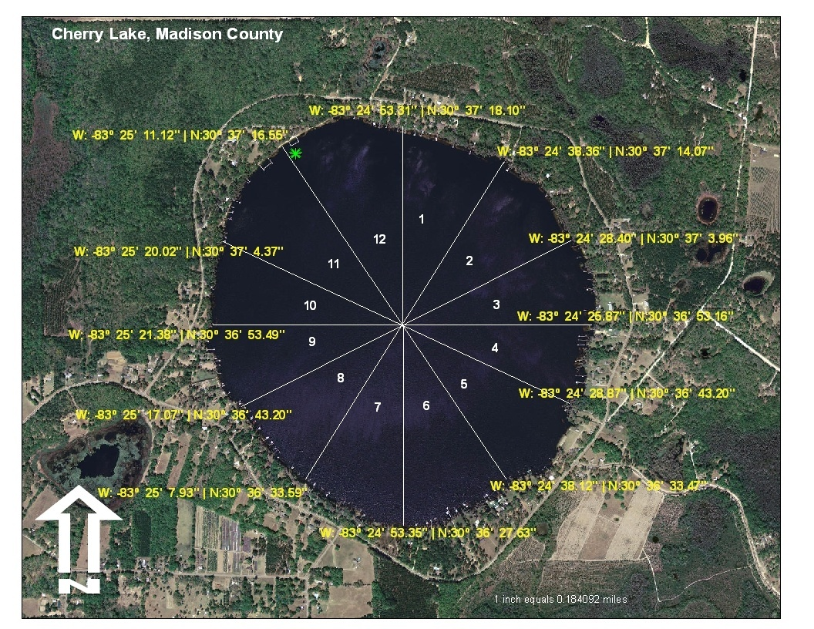

Figure 1. LVI sampling map of an approximately circular lake

When using GIS to make a map of the lake, use the most recent aerial photography available and label the coordinates for the beginning and end of each section. It is most helpful to obtain the coordinates for points where samplers are likely to have access by boat. If a lake has a thick raft of vegetation along the shoreline, the coordinates at the shoreline could be different enough from the coordinates at the vegetation edge to confuse the sampler. Retain the sampling map with other data records from the sampling event.

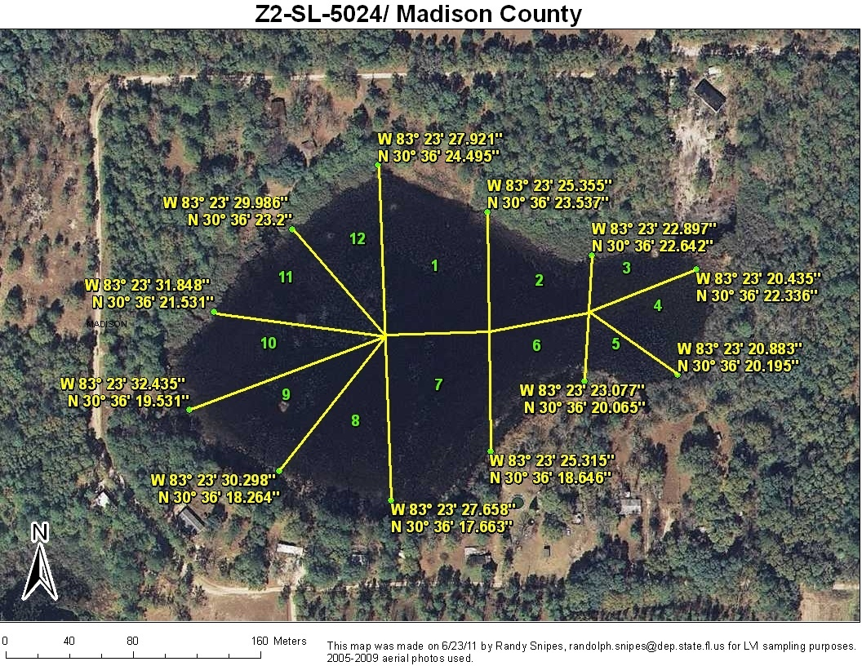

##### Figure 2. LVI sampling map of an irregularly shaped lake

## Drive-by and Transect

As described in the sampling SOP, 4 of 12 sections of a lake are assessed in the LVI. In each of the sections, samplers boat along (“drive-by”) the shoreline at idle speed and record plant species observed. If there is a vegetation island within the section, it should be assessed as part of that section. This method is intended to be a rapid assessment of the plant community. Samplers should not stop frequently or get out of the boat during the drive-by, although it is fine to quickly collect an unknown plant for identification. It is important that sampling teams are making consistent effort in idle-speed observations, and in the one transect per lake section (**Figure 3**). Careful sampling along the 5-meter belt transect gives samplers the opportunity to get out of the boat where practical and more carefully inspect plants that may be growing at the shoreline. For the transect, samplers should choose an area of the lake section where they will likely add species to the list for that section, *i.e*., samplers should target an area of shoreline that contains species they cannot identify from the boat. The transect should be approximately 5 m in width at the shoreline, and extend into the water perpendicular to the shoreline. It is not necessary to exactly measure the transect width, but it is helpful to view the transect as a relatively straight line extending from the shoreline to the center of the lake section, with 2.5 m of sampling area on each side, to ensure consistent effort among sampling teams.

Figure 3. For a given lake section, the sampling team conducts a drive-by survey of plant taxa, and then examines a 5 m stretch of shoreline, followed by frotus throws toward the lake center.

Figure 3. For a given lake section, the sampling team conducts a drive-by survey of plant taxa, and then examines a 5 m stretch of shoreline, followed by frotus throws toward the lake center.

A frotus is a double-sided metal rake attached to a rope, and is used to sample submersed aquatic vegetation. The sampling SOP states that the frotus should be deployed (thrown out, allowed to settle to the bottom, and pulled back) a minimum 5 times within each transect in each of the four sampled lake sections. It should be deployed additional times, if necessary, to determine the extent of submersed plants in the section (*e.g*., for dominance determination) or if additional new plant taxa are still encountered on the fifth throw as you move toward the lake center. The distance between throws will vary depending on the size of the lake; samplers should try to evenly space throws within the estimated zone of submersed vegetation.

## Determination of Dominant or Co-dominant Plants

The determination of dominance is a very important part of the LVI sampling method and metric calculation, so this step should never be overlooked. If a dominant taxon is not assigned, only 3 metrics are used to calculate the LVI score. It is possible for a lake or pond to have so little vegetation that no taxon is abundant and the assignment of a dominant is not possible. Alternatively, it is possible for many species to be equally abundant and none to be dominant or co-dominant. In either of these cases, samplers must note on the field sheet that no dominant was chosen, in order to indicate that they did not simply forget to assign a dominant taxon.

Per SOP LVI 1100, assign one dominant taxon if it is clearly and overwhelmingly the dominant taxa in the section (e.g., if one taxon is twice as abundant as each of the other taxa). Assign two co-dominant taxa if there are two taxa that are abundant and it is unclear that one taxon is twice as abundant as any other. Therefore, if it is difficult to select a single dominant taxon, then select two co-dominant taxa. For example, if *Panicum repens* accounts for approximately 60% of areal extent and *Panicum hemitomon* accounts for approximately 40% of areal extent of taxa in a section, those two taxa should be listed as co-dominant.

### Dominance by Areal Extent

Figure 4. The submersed macrophyte would be dominant because it covers a greater area of the lake than either the floating grass or the cypress trees.Samplers should designate a dominant plant taxon or two co-dominant plant taxa in each lake section by areal extent within the lake. For example, if an emergent grass dominates the shoreline, but there is a dominant submersed species that covers more area in the lake, the submersed species would be dominant (**Figure 4**). For a lake with a zone of cypress or other tree species, consider the canopy overhanging the lake as included in the areal extent. It is also common to have co-dominance between plants in any combination of plant zones (**Figure 5**). No more than two co-dominant taxa may be named.

**Figure 4.** The submersed macrophyte would be dominant because it covers a greater area of the lake than either the floating grass or the cypress trees.

Figure 5. In this case, either the floating grass/submersed species would be dominant or the grass/submersed and cypress trees would be co-dominant.

Figure 5. In this case, either the floating grass/submersed species would be dominant or the grass/submersed and cypress trees would be co-dominant.

### Collection of Dominant Taxa for Further Verification

SOP LVI 1100 requires samplers to collect dominant and co-dominant taxa which are from groups that typically require further examination (e.g., grasses, submersed plants, or tricky “look-alike” taxa, such as those listed in section 4.2.3 below) for verification at their office/ lab or by their expert botanist. These specimens should be compared with verified specimens in the sampling entity’s reference herbarium, and be verified by the expert and included in the herbarium if the taxon is not already represented. It is not necessary to collect easily identified and common dominant taxa (e.g., *Taxodium* spp., *Nymphaea odorata*) for verification; however, samplers should take photographs of these dominant taxa for verification by other LVI samplers. Specimens and photographs should be retained in case the identification of dominant taxa is in question.

## Determining Boundaries of the Lake

The LVI method is an assessment of the plant community of the lake. That community includes submersed, floating, and emergent vegetation, as well as trees and shrubs that comprise the lake shoreline. The LVI does not assess surrounding uplands or wetlands outside of the lake footprint. It can be difficult at times to distinguish the boundary of the lake. Samplers should use field indicators of seasonal high water level (see below at 3.5.1), as well as the wetland status of the species they observe to guide field judgments.

### Seasonal High Water Level

For the LVI, samplers should assess plants that occur in the lake and up to the seasonal high water level. Seasonal high water is defined in 62-340.200(15), F.A.C., as “the elevation to which the groundwater and surface water can be expected to rise in a normal wet season…The presence of hydrologic indicators must be used with reasonable scientific judgment.” Hydrologic indicators are listed and described in 62-340.500, F.A.C. They include the presence of algal mats, aquatic mosses and liverworts, aquatic plants, rafted debris lines, elevated lichen lines, morphological plant adaptations, and water marks. These guidelines are useful in determining if plants are indeed “in the lake” or if they are part of the surrounding upland.

The LVI assessment should characterize the plants in the lake, not in the surrounding uplands, so do not include plants that are growing in lawns and surrounding woods above the seasonal high water level in their assessment. If plants are growing in saturated soil at the shoreline or on fringe mud flats, include them in the assessment. If plants are growing on the upland side of a seawall structure, determine if they are growing in saturated or dry soil, and if the plants are wetland or upland plants. Include them if they are wetland plants growing in saturated soil, but not if they are upland plants growing in dry soil.

Sites with low gradient lake shores may have extensive fringe wetlands (swamps or marshes). In those cases, samplers **are not** expected to observe plants all the way up to the seasonal high water level if those areas are inaccessible from the boat and shoreline.

Refer to the Uniform Mitigation Assessment Method (UMAM) document or the Florida Wetlands Delineation Manual : [Wetland Delineation and UMAM Resources | Florida Department of Environmental Protection](https://floridadep.gov/water/submerged-lands-environmental-resources-coordination/content/wetland-delineation-and-umam)for more information and photos for determining the seasonal high water line.

### Wetland Status

Only aquatic and wetland plants are included in LVI assessments. If a species is not defined as aquatic, obligate (OBL), facultative wet (FACW), or facultative (FAC) in 62-340, Florida Administrative Code (F.A.C.), it shall not be included in the LVI assessment. Information about Florida wetland status of species is available in 62-340, Appendix B, F.A.C, or at the Institute for Systematic Botany Atlas of Vascular Plant website ([ISB: Atlas of Florida Plants (usf.edu)](https://florida.plantatlas.usf.edu/)).

Exceptions to this rule include *Pinus elliottii* and vines that are part of the lake plant community. The field sampler decides whether or not to include vines as follows. Vines should be included if they are rooted in saturated soils, creeping out onto the water, growing intermixed with emergent vegetation, or covering a large portion of shoreline shrubs or trees that are part of the assessment.

## Plants Intentionally Planted by Humans

Samplers may encounter situations in which wetland taxa were intentionally planted by lakeshore residents. If the taxa are indeed wetland taxa, are within the seasonal high water line, and are flourishing, they should be included in the LVI assessment. If the plants are planted in a portion of the yard that is above the seasonal high water line, or behind a structure, or they are not wetland taxa, they should not be included.

## Collecting Specimens of Unknown Taxa

It is very important to collect specimens of unknown taxa to bring back to your office/lab or to send to an expert for species identification. Handling technique is critical to maintaining important identification features of the specimen. The best way to collect plants in the field and to ensure that they remain in good condition for identification is to collect them in sealed plastic bags (e.g., Ziploc or other plastic bag) and place them on ice. Do not put water in the bag with the plant, as this can cause the specimen to rot prior to identification.

It is best to collect whole plants, including roots (rinsed), stem base, flowers, and fruits. If a plant is too large for full collection, make notes or take photos of the plant’s habit, base, bark texture if a woody plant, etc. These characteristics can be especially important for species identification of grasses or woody plants. Photographs can also be very useful for resolving unknown identifications.

Fresh plants are best for identification, so shipping or delivery of fresh specimens to experts is best. However, if a quick identification is not possible, pressed specimens often can be readily identified. See the DEP plant resources website for guidance on making good pressed specimens: ([Plant Identification Resources | Florida Department of Environmental Protection](https://floridadep.gov/dear/bioassessment/content/plant-identification-resources).)

## Lake Size Considerations

There is no lake size limit for the LVI and DEP has no reason to believe that the assessment of a very large or small (boat accessed) lake would not be valid. For lakes greater than 5,000 acres in surface area, however, the method should be modified slightly to make the assessment more feasible. For each section, samplers should survey the lakeshore at idle speed for approximately 1,000 m, and then survey the remainder of the section at a greater traveling speed, slowing to idle speed again if new taxa or a change in the plant community are encountered. The entire lake section should be considered in the determination of dominant or co-dominant species.

When a lake is large and has distinct lobes or segments, consideration should be given to whether a single LVI assessment is conducted for the entire area, or whether it is better to conduct LVIs on each distinct segment. Water control structures, major physical barriers such as berms, or even natural features that serve to separate areas hydrologically may mean it is more appropriate to do more than one LVI. These decisions should be made on a case by case basis, and should include an evaluation of the nature and degree of the hydrologic separation, access, and the purpose of the sampling.

## Aquatic Plant Control Considerations

Some Florida lakes with an overabundance of plants (nonnative or native) are treated periodically with herbicides or undergo mechanical harvesting to improve the condition of the lake.  The LVI is an appropriate tool to evaluate the effects of lake management activities, including aquatic plant control.   However, consideration should be given to the purpose of the LVI study, as effects of the control measures on target and non-target species will be reflected in the assessment.  If the LVI is conducted both before and after activities to control invasive plants, the LVI scores will provide an objective determination concerning the relative success of the management measures.  Because the effects of different plant control treatments differ in scale and duration, it is difficult to establish a standard period for how long a sampling entity should wait before conducting the LVI on a lake where plant control has occurred.  However, if samplers observe plant damage associated with recent management activities, the LVI assessment should be postponed until representative conditions have returned. If there is evidence of recent plant management, note it on your field sheets. If samplers know or suspect that aquatic plant control has occurred at a lake, it is helpful to contact the management/control entity for specifics on the activities, which can inform decisions on the appropriateness of LVI sampling. The Florida Fish and Wildlife Conservation Commission Aquatic Plant Management program is the primary management entity for aquatic plants in Florida lakes. [Aquatic Plant Management | FWC (myfwc.com)](https://myfwc.com/wildlifehabitats/habitat/invasive-plants/aquatic-plant/)

# QA Considerations

## QA in DEP Standard Operating Procedures (SOPs)

For LVI data to be submitted to the DEP, certain quality assurance measures must be taken. Any team submitting data must participate in and pass a field team proficiency test biennially (SOP LVI 1200). In addition, at least one team member must take and pass the LVI online test biennially. The SOPs require sampling entities to retain an expert botanist with training in plant taxonomy to verify unknown specimens or settle disagreements between samplers about species identification (SOP LVI 2100). Once unknowns are verified, samplers must make the appropriate corrections to their datasheets before entering data into a database or using the data. DEP staff doing LVI sampling shall participate in an internal DEP QC exercise for plant identification per SOP LVI 2110. It is recommended that external parties submitting LVI data to DEP conduct their own internal QC checks of plant identification per SOP LVI 2110.

SOP LVI 2100 requires sampling entities to maintain a reference herbarium. This reference herbarium does not have to contain all species ever seen by that entity, but it must be the repository for specimens verified by the expert botanist and must contain the most common taxa encountered, with plant parts critical to species identification intact. All specimens in the herbarium must be verified by an expert botanist. The purpose of the herbarium is to provide samplers with verified specimens with which to compare unknowns brought back from the field. It is possible to maintain a digital herbarium, but that herbarium must contain photos of plant parts critical to species identification, such as flowers, fruits, and achenes with size reference in the photo, and that sampling entity must have access to a traditional herbarium if comparison with materials is necessary.

## Appropriate Taxonomic Level for Plant Identifications

Most of the plant attributes that contribute to the LVI metrics apply to species, not genera, so it is important to make species-level identifications of plants whenever possible, even if you need to take the plant back to the lab or send it to an expert for verification. Consider that the four LVI metrics are % native, % invasive exotic (FISC Category 1), % sensitive (based on C of C score), and C of C score of the dominant or co-dominant taxa. Some genera include exclusively native or non-native species. Other genera, however, contain both native and non-native species, and therefore nativity cannot be assigned at genus level in these cases. The lack of information could artificially deflate the score for that metric. The FISC taxa are all at species level, so it is important to be able to identify those taxa to species level.

### C of C Scores for Taxonomic Levels Other Than Species Level

C of C scores have been assigned at taxonomic levels higher than species level for certain genera where species within the genus all have similar C of C scores (*e.g*., *Taxodium*) or for subsets of genera that often are not possible to identify to species due to lack of flowers or fruits (*e.g*., submersed viviparous *Eleocharis* species). Identification of the following to genus level is acceptable, given the caveats described below:

* *Hydrocotyle;*
* *Lemna;*
* *Nuphar;*
* *Peltandra;*
* *Sphagnum;*
* *Taxodium;*
* *Typha;*
* Submersed viviparous *Eleocharis* species (includes *E. baldwinnii*, *E. vivipara*, *E. acicularis*);
* *Utricularia*, only if species level identification is not possible;

The last two groups listed should always be identified to species unless identifying structures are not available. Samplers should make an effort to obtain a species level identification from their expert botanist if identifying characteristics are available. For example, a field sampler may have difficulty identifying an abundant *Utricularia* species without flowers, but s/he should collect a specimen for further attempts by an expert botanist, especially if that species is dominant or co-dominant. If the taxon is dominant or co-dominant but cannot be positively identified, then the designated C of C for the genus or group may be used.

### Genera for Which Identification at Genus Level is Acceptable for LVI

For LVI sampling, the following additional genera may be left at genus level. CC scores are not assigned for these genera. For these genera identification to species level can be difficult or impractical, and usually does not yield information relevant to the index, *unless* the taxon is dominant or co-dominant. Species level identification is required if a species is dominant or co-dominant. Species level data are also acceptable at any time, if it is possible to make a positive identification at the species level. Because *Ludwigias* are common, and often can be dominant or co-dominant, every effort should be made to ID them to species. Because there are many native *Ludwigia* species that resemble each other, it can happen that the sampler cannot speciate a specimen because of lack of flowers or fruits, but can determine that a specimen is a native species and not a nonnative *Ludwigia* such as *L. peruviana* or *L. grandiflora*, so that the “native” information is available for the index. These genera are listed on the LVI datasheet (FD 9000-27), with “sp.” following the genus name.

* *Andropogon;*
* *Baccharis;*
* *Ludwigia* native*,* only if species level identification is not possible.
* *Pluchea;*
* *Solidago;* and
* *Xyris.*

### Genera to Identify with Magnification

The following genera, which include numerous species with similar characteristics, should be identified with magnification. Some species of these genera may be readily apparent in the field (*e.g.,Panicum repens,*  *Fuirena scirpoidea*,*Ludwigia peruviana*), while others require more careful inspection, either with a hand lens (10X) or a dissecting microscope. On the LVI datasheet (FD9000-27), these genera are denoted by an asterisk (*):

* *Commelina;*
* *Cyperus;*
* *Echinochloa;*
* *Eleocharis;*
* *Eriocaulon;*
* *Fuirena;*
* *Hypericum* (field observation is important as well);
* *Juncus;*
* *Ludwigia;*
* *Myriophyllum;*
* *Najas;*
* *Panicum;*
* *Paspalum;*
* *Persicaria;*
* *Potamogeton;*
* *Rhexia;*
* *Rhynchospora;*
* *Sagittaria;*
* *Schoenoplectus;*
* *Sesbania;* and
* *Utricularia.*

# Conditions Under Which LVI Sampling is Not Appropriate

The effect of climatic events on a lake’s water level will vary and depend on the hydrology of the lake. If the lake is small, isolated, and rain-dependent, its character is susceptible to change from heavy rains or drought conditions. If a lake receives large amounts of surface water inputs, its water level could increase significantly after heavy rainfall. A lake containing water control structures could either be very stable in its water level due to control measures, or experience great fluctuations due to water management practices. The character of a lake’s plant community, specifically the relative abundance of submersed, floating rooted, floating mat, emergent, or woody species, can also influence whether or not it will be greatly affected by changes in water level. If submersed and floating mat species comprise most of the plant community, a change in water level may not affect a sampler’s ability to observe the species present. Conversely, if emergent and rooted floating vegetation comprise most of the community, these species may be more difficult to observe after a recent increase in water level. Samplers should make judgments in the field about whether or not a representative plant community may be observed after recent water level changes. The LVI should not be conducted if the representative plant community cannot be identified.

## Flooding

If a recent rain event has caused the water level to rise high enough that emergent or floating plants are now submersed or dying (**Figure 6**), the sampling event should be postponed until water levels return to normal and the littoral zone has recovered, which may be the following year.

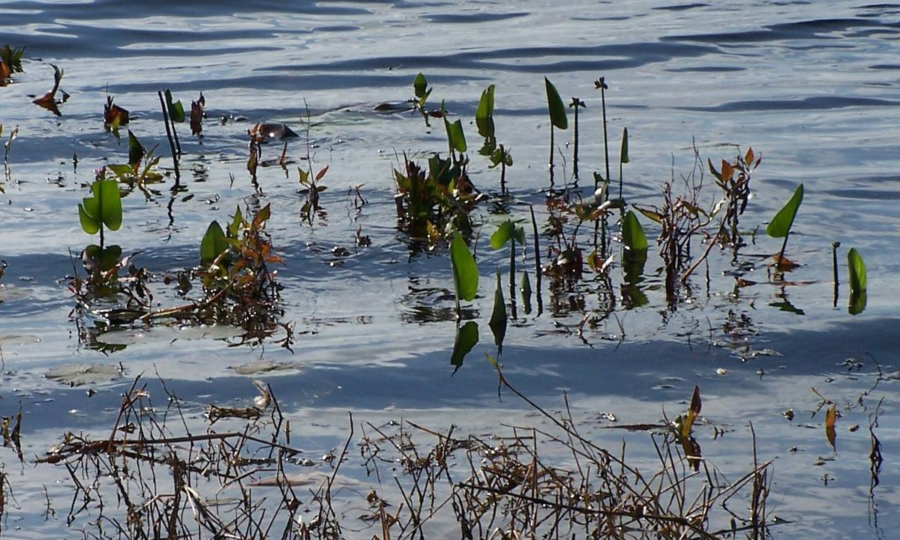

Figure 6. Pontedaria cordata leaves barely out of the water at Carr Lake (Leon County) because the water level is two feet deeper than the prevailing depth of the growing season.

## Drought

If a lake’s water level has receded so far that most or all of the littoral zone plants have been stranded and there are few taxa left in the water (**Figure 7**), the sampling event should be postponed until the water level has come up far enough and long enough to support the expected plant community. This expected plant community may not return until the next year, if there is sufficient rain during the fall and winter. If a sampler conducted the method during a drought and included all plants up to the seasonal high water line, s/he would probably include upland plants that had moved into the area, and miss the aquatic plants that likely would be missing due to the dry conditions.

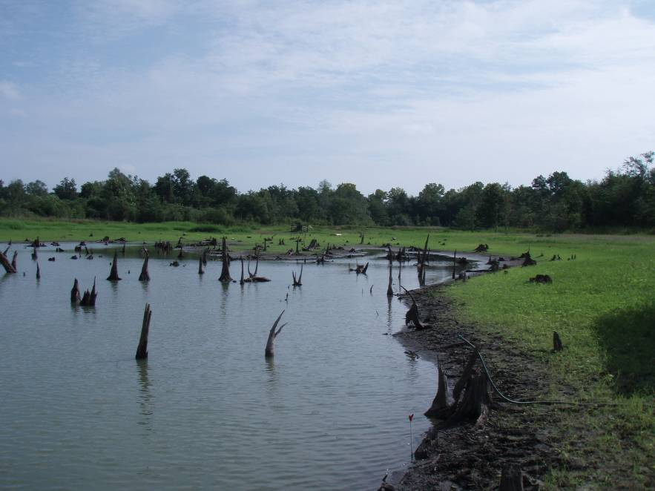 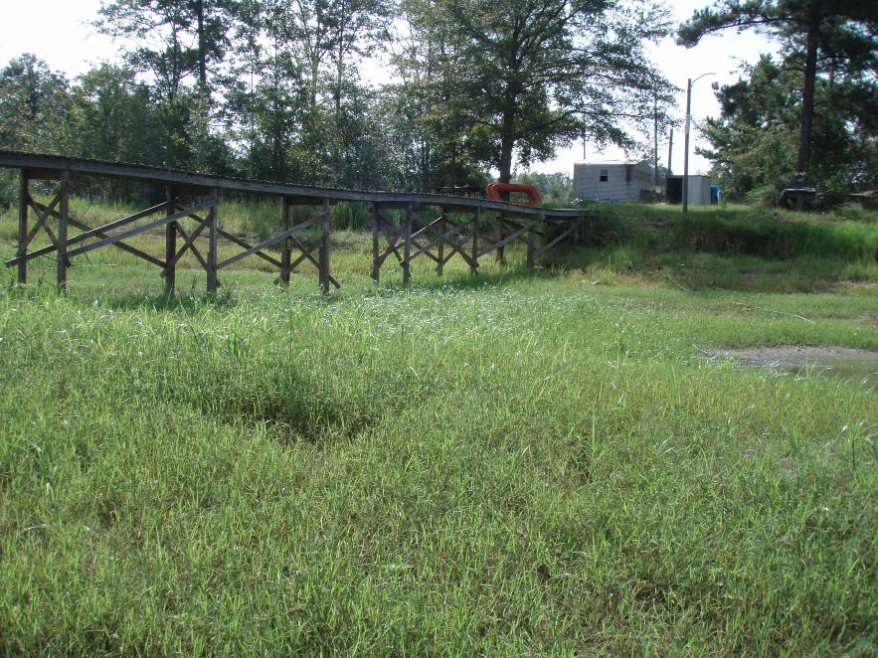

Figure 7. The water level is so low that there are no plants in the water and terrestrial plants are encroaching into the basin at a small pond.

## Saltwater species

The LVI is a freshwater assessment tool. Abort sampling if plant taxa that occur strictly in marine waters are present. Examples of marine taxa include mangroves, *Spartina alterniflora, Spartina patens, Juncus romerianus*, *Salicornia* spp., and *Batis maritima*. The presence of these taxa would indicate that the system is not a freshwater lake, and therefore the LVI should not be used.

## Highly Vegetated Lakes

The LVI is a rapid field method that should be conducted from a boat. Some lakes are so full of vegetation that it is very difficult to maneuver in the lake by boat (**Figure 8**). If the vegetation is so thick that observers cannot see shoreline from the boat when doing the drive-by portion of the method, or cannot access an area of shoreline at which to conduct the belt transect, sampling should either be aborted or conducted via airboat. If an airboat is used, measures should be taken to ensure that samplers can adequately communicate and record their observations so they don’t miss important taxa. Some lakes have areas of thick floating vegetation or floating tussocks. Those lakes can be sampled as long as the samplers can observe the majority of lake area and shoreline in the sampling sections.

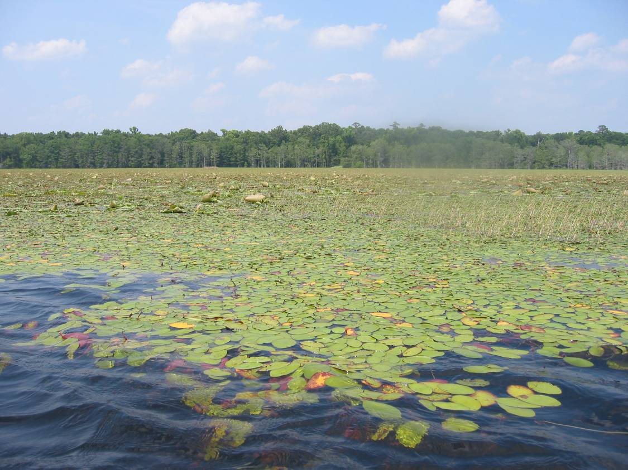

Figure 8. Brasenia schreberi and Nymphaea odorata hinder boat access for much of Lake Miccosukee in Jefferson County.

## Impoundments

Impoundments have been created for various reasons throughout Florida, and are various sizes. The LVI can be conducted on impoundments, as long as the waterbody has been in place long enough for aquatic vegetation to colonize.

## Artificial Waterbodies

The LVI can be conducted on artificial waterbodies; however, data users should use the data appropriately. If the waterbody is not a water of the state (403.031(13), Florida Statutes), water quality standards and Impaired Waters Rule criteria would not apply.

# Data Usability

The intent of this section is to provide a procedure for how Lake Vegetation Index data will be used for DEP environmental decisions.

Determining if data are usable for a particular purpose is a complex task, requiring a logical and balanced evaluation of many factors. The procedural components of the LVI assessment must be performed by staff with sufficient scientific expertise and demonstrated proficiency, as mandated by Rule 62-160, F.A.C. Additionally, the following must be considered during a biological data usability determination:

* Understanding the purpose for the bioassessment sampling, including specific project objectives, and determining the extent to which the bioassessment data set fulfills the objectives of the project or program. The environmental conditions associated with the sample (*e.g*., climatic, hydrologic) must be consistent with the study objectives;
* Evaluating laboratory and field quality control measures and other supporting data, including the determination of the pattern, frequency, and magnitude of any quality control deficiencies associated with the results. This also may involve evaluating corroborative data (e.g., performance tests, data from other sampling entities);
* Determining the relationship between the bioassessment result, the associated decision or action level (e.g., water quality criteria), and the minimum detectable difference associated with the method; and
* Determining the reasonable cause for a poor bioassessment score (*e.g*., water quality, hydrology, and/or habitat) and ensuring that the data are appropriately used to address the causative factor(s) (i.e. LVI stressor identification) .

## Determining the Extent to Which the Bioassessment Data Set Fulfills the Objectives of the Project

Designing a sampling strategy that focuses on answering specific environmental questions is critical in the bioassessment process, so confounding variables may be controlled for to the degree possible. Data collected to evaluate one environmental stressor may not be suitable for determining the influence from other stressors. The Department shall examine the purpose of the data collection, the associated potential confounding variables, and ensure that the results are used in a manner consistent with the study objectives.

*Example: DEP scientists design a study to evaluate the effects of water level drawdown on the plant community of a lake. LVIs were collected at typical water levels prior to the drawdown to establish background LVI scores. Subsequent to the drawdown, LVIs were collected during extremely low water levels. After the scheduled drawdown was complete and water levels were adjusted to pre-drawdown conditions, additional LVIs were collected to assess pre- vs. post- conditions. Although LVI failures were noted during the drawdown, significant increases in LVI scores were observed between pre- and post-management actions. In this scenario, the LVI failures observed during the low water levels should not be included in Impaired Waters Rule (IWR) listing decisions, because these samples were collected during conditions inconsistent with the objectives of IWR studies.*

## Evaluating Staff Capability, Quality Control Measures, and Other Supporting Data

Data must be collected by qualified samplers, using the appropriate DEP Standard Operating Procedures (SOPs), following the concepts outlined in this LVI Primer. The LVI must be performed by a team that has passed the most recent team proficiency test and contains at least one member in “pass” status for the annual plant ID test, as described in DEP SOP LVI 1200. Samplers must conduct the assessment per DEP SOP LVI 1100, following other guidelines outlined in this Primer. LVI scores should be calculated in accordance with SOP LVI 2200.

Team proficiency testing was not incorporated into the DEP QA Rule until December 3, 2008. Therefore, data collected before that time should only be used for planning purposes, or in conjunction with data collected after that QA evaluation was in place.

Quality control information will be evaluated systematically and assessed against the objectives of the study before a usability decision will be made. For example, the purpose for which bioassessment data are collected can vary widely, and may include such diverse activities as: monitoring reference condition lakes to assess change over time, assessing waters for IWR purposes, or determining whether management activities on a lake have been successful. A quality control failure that may be tolerated for a screening study would not be acceptable for IWR purposes or determining the success or failure of a restoration project.

As applicable to the data usability assessment process, any record associated with a reported sample result or set of sample results may be audited, per Chapter 62-160.240 and 62-160.340, F.A.C. Both original (“raw”) and reduced or summarized versions of data records may be inspected to determine the acceptability of results, based on an evaluation of the sample data and associated quality control records.

If any aspect of the assessment appears erroneous or suggests that the assessment was not made according to the SOPs (e.g., excessive inappropriate genus-level identifications, consistent lack of assignment of dominant taxa, sampling conducted during extreme water levels not in accordance with the sampling objectives), the Department will further investigate the credibility of the bioassessment results. This may involve follow up audits of samplers.

*Example: An LVI was conducted in a small pond in a National Forest as part of a probabilistic sampling network. Sampling was conducted during a drought year, and the pond’s water level had receded so far that there were very few plants growing in the water. The only plants identified during the LVI assessment were weedy and upland plants, and the pond received a failing score. When the results were considered for IWR listing purposes (Chapter 62-303, F.A.C.), data users examined the taxa list and determined, from the dominance of upland plants and from site photos, that the severely low water level did not allow for a representative assessment of the pond’s plant community. Therefore, these results were not used for IWR listing purposes.*

*Example: An LVI was conducted on a residential lake as part of a routine sampling network, during which LVIs are conducted annually. During years 1 and 2 of the program, the lake’s LVI scores were 45 and 50, respectively, both passing scores. On year 3, a new sampling team conducted the LVI, and the lake received a failing score of 25. Upon investigation of the year 3 sampling sheets, data users noted that a high proportion of taxa were identified to the genus level only (not to the required species level). Because the SOPs were not properly followed, the year 3 LVI data were considered unusable.*

## Determining the Relationship Between the Bioassessment Result, the Water Quality Criterion, and the Minimum Detectable Difference Associated with the Method

As in all scientific measurements, there is a quantified level of uncertainty associated with bioassessment results, known as the Minimum Detectable Difference (MDD). When LVIs are compared along a temporal gradient, differences in scores greater than the MDD (plus or minus 12 points) are considered to be statistically reliable (see Fore, L. 2007, [**Lake Vegetation Index (LVI) Report**](http://publicfiles.dep.state.fl.us/dear/sas/sopdoc/lvi_final07.pdf). Assessing the Biological Condition of Florida Lakes: Development of the Lake Vegetation Index).

*Example: Staff from the Florida Fish and Wildlife Conservation Commission Invasive Plant Management program conducted an herbicide treatment in a lake to control the FISC Category I invasive exotic plant, Hydrilla verticillata. The LVI score before control efforts was 25, and the score after control efforts was 50 (an increase of 25 points). Because the difference in LVI scores was greater than the MDD (statistically reliable), the management actions were considered successful.*

## Determining the Reasonable Cause for a Bioassessment Failure

Failure of the LVI indicates that the lake plant community exhibits poor ecological structure and function; it does not explain the reason for the poor condition. For IWR purposes, a pollutant causing the biological degradation must be identified prior to developing a TMDL. Although a lake could have a failing LVI due to water quality problems (e.g., excess nutrients), it is possible that excessive lakeshore alteration or other physical disturbance are significant stressors. If factors other than water quality are determined to be the cause of the LVI failure, DEP will strive to mitigate those factors through other programs.

*Example: A lake fails the LVI for three consecutive years, but data indicate it is not impaired for nutrients or any other water quality parameter. DEP biologists determine that the lake received failing LVI scores because an invasive aquatic plant dominates the shorelines. This species was originally planted by lakeshore residents and it subsequently spread to other areas because homeowners had cleared the native vegetation from the shoreline. In this scenario, pollutant reduction is not required, but education of landowners on proper methods to maintain native shoreline vegetation, or coordination of a restoration project would be appropriate actions.*

## Summary

To determine appropriate actions associated with bioassessment results, DEP will review and evaluate the following information:

* The purpose for collecting the bioassessment data and the degree to which the study fulfilled the objectives;
* The documented quality control measures and other supporting data, as well as the pattern, frequency, and magnitude of any quality control deficiencies associated with the results;
* The relationship between the results, the water quality criterion, and the Minimum Detectible Difference associated with the method; and
* A reasonable determination of the cause of the bioassessment failures.

From this evaluation, DEP will determine how the data can be used by the relevant DEP programs. Biological health usability assessments will evaluate the above factors relative to DEP program or project objectives, and follow the principles characterized in this guidance document to draw an “overall conclusion” concerning the usability of the data set which is consistent with the processes and examples provided in this document.