Documentation in Support of Category 4e for WBIDs 1497B: Lake Parker
March 03, 2021

Waterbody/Watershed Identification
 | Organization | City of Lakeland (COL) – Local Government Agency
 | Point of Contact | Laurie Smith, 407 Fairway Avenue, Lakeland, FL 33801, laurie.smith@lakelandgov.net, 863-834-6276
 | Waterbody(s) | WBID ID 1497B – Lake Parker
 | No. Waterbody / Pollutant Combinations | 1 waterbody segment; Verified and/or Impaired for nutrients (chlorophyll-a, total nitrogen, and total phosphorus) on the Sarasota Bay- Peace- Myakka/Cycle 3 Verified List.
 | EPA Completed TMDL | Yes. The total maximum daily load (TMDL) for Lake Parker is defined for TN and TP in the document entitled “Nutrient Total Maximum Daily Loads for the Lake Parker (WBID 1497B)” (EPA 2006).
Description of Baseline Conditions
 | Watershed(s) | Basin Group 3, Sarasota Bay- Peace- Myakka (HUC 03100101)
 | Baseline Data | Lake Parker is a clear lake with high alkalinity. The available Cycle 3 data for Lake Parker are provided below. Bioassessments and Annual geometric mean (AGM) Chlorophyll-a (CHLA), Total Nitrogen (TN), and Total Phosphorous (TP) were reviewed to assess verified impairments during the 2008 though 2014 Verified period. The long-term true color and alkalinity geometric means were calculated to be 24.6 PCU and 64.5 mg/L, respectively using the long-term period of record data from 1965 to 2020.Data were obtained from Impaired Waters Run 60.
  WBID | Waterbody Name | Parameter | Criterion Concentration or Threshold Not Met | Data*
  1497B | Lake Parker | Biology | Average score of at least two temporally independent LVI scores ≥ 43. | LVI  21FLGW 37017  (23JUL2009: 34)  21FLGW 41633  (21MAY2012: 43)  21FLTPA 25020247  (02JUL2012: 28)  21FLTPA 25020247  (25JUL2013: 34)  21FLGW 47179  (13APR2015: 35)  LAKELANDPARKER(CENTER)  (07NOV2019: 27)
  WBID | Waterbody Name | Parameter | Criterion Concentration or Threshold Not Met | Data*
  1497B | Lake Parker | Nutrients (CHLA) | ≤ 20 µg/L | AGMs  2008 (161 µg/L)  2009 (47 µg/L)  2010 (47 µg/L)  2011 (83 µg/L)  2012 (87 µg/L)  2013 (80 µg/L)  2014 (44 µg/L)  2015 (65 µg/L)  2016 (64 µg/L)  2017 (48 µg/L)  2018 (43 µg/L)  2019 (63 µg/L)  2020 (37 µg/L)
  1497B | Lake Parker | Nutrients (TN) | Chl-a AGM ≤ 20 µg/L, TN AGM ≤ 1.91 mg/L;  If Chl-a has Insufficient or No Data to calculate AGM or if Chl-a AGM > 20 µg/L, TN AGM ≤ 1.05 mg/L | AGMs  2008 (4.74 mg/L)  2009 (3.23 mg/L)  2010 (2.52 mg/L)  2011 (2.80 mg/L)  2012 (2.65 mg/L)  2013 (2.48 mg/L)  2014 (1.93 mg/L)  2015 (2.06 mg/L)  2016 (1.95 mg/L)  2017 (1.69 mg/L)  2018 (1.54 mg/L)  2019 (1.57 mg/L)  2020 (1.41 mg/L)
  1497B | Lake Parker | Nutrients (TP) | Chl-a AGM ≤ 20 µg/L, TP AGM ≤ 0.09 mg/L;  If Chl-a has Insufficient or No Data to calculate AGM or if Chl-a AGM > 20 µg/L, TP AGM ≤ 0.03 mg/L | AGMs  2008 (0.11 mg/L)  2009 (0.07 mg/L)  2010 (0.06 mg/L)  2011 (0.06 mg/L)  2012 (0.05 mg/L)  2013 (0.05 mg/L)  2014 (0.05 mg/L)  2015 (0.05mg/L)  2016 (0.06 mg/L)  2017 (0.05mg/L)  2018 (0.05 mg/L)  2019 (0.05 mg/L)  2020 (0.07 mg/L)
  *Bolded values represent data used in the verified period assessment
 | Map | Attachment 1 delineates the watershed area.

Evidence of Watershed Approach
 | Area of Effort | Lake Parker is located at the boundary of the City of Lakeland and unincorporated Polk County, Florida. The contributing basin includes sub-basins: Lake Crago, “Griffin Road” major tributary, and a large wetland area (part of the reclaimed Tenoroc area) to the northeast end of the Lake. The surface water drainage area of the Lake Parker watershed is located within the Lake Hancock Basin (upstream of Saddle Creek). The estimated surface area of the Lake is 2,185 acres, with a drainage area of approximately 15,231 acres. Average water depth is 5.3 ft with a maximum depth of 10 ft. The Lake Parker watershed is primarily composed of commercial and medium-high density residential development.
 | Key Stakeholders Involved and Their Roles | The COL and Polk County are partners for the Lake Parker assessment and restoration projects. The Southwest Florida Water Management District (SWFWMD) and/or Florida Department of Transportation (FDOT) may be involved in future restoration projects by providing cooperative funding.
 | Watershed Plan & Other Supporting Documentation | Impaired Waters Listing  The area includes the watershed drainage area from the Lake Parker watershed within 1497B. This WBID is impaired for nutrients (chlorophyll-a, TP, and TN) and biology (LVI scores <43) based on the years the AGMs were exceeded during the Verified Period (2008-2014). The objectives outlined by Wood’s Lake Parker TMDL Implementation Report- Results of Select Monitoring/ Data Collection address these impairments.  Watershed Plan  The City’s overall Watershed Plan to restore Lake Parker includes projects to improve water quality in the lake. The City will focus on the implementation of structural and non-structural stormwater improvements in the watershed and in the lake, and will also include sediment and erosion control, sediment inactivation, wetland influence re-establishment, aquatic vegetation management (with the assistance of County staff), street sweeping and public education. The projects from the previous Wood 2020 report identified the top pollutant load- producing stormwater outfalls to Lake Parker, provided stormwater monitoring results at the chosen outfalls, lake water phytoplankton identification results, sediment core sampling results, a bathymetric survey and updated pollutant load estimates. The report proposed various stormwater BMPs and sediment restoration alternatives (further detail is provided in the Restoration Work Section). Laboratory analyses of stormwater and sediment samples as compared with historical surface water quality monitoring data indicated that internal nutrient cycling from sediment flux may have a significant impact on water quality conditions in the lake.  Supporting Documentation  The preliminary sediment characterization and phosphorus fractionation study results from the TMDL Implementation Report found that Lake Parker acts as a considerable source for both nitrogen and phosphorus with an average of 75,039 lbs./yr. and 21,197 lbs./yr., respectively, which is contributed from the sediment to the water column. Therefore, water quality restoration projects will also focus on sediment management alternatives such as chemical amendment and/or targeted sediment removal, in addition to addressing stormwater loads.
 | Point Sources and Indirect Source Monitoring (Sites) | There are 138 Municipal Separate Storm Sewer System (MS4) outfalls discharging to Lake Parker (please see Attachment 2). Of these 138 outfalls, 127 are City of Lakeland MS4 outfalls and 11 are private outfalls. Prioritized outfall basins (see Attachment 3) were selected due to the high potential for significant nutrient contribution to Lake Parker and to determine the contribution from adjacent waterbodies. These basins included: Basin PK056 (with 2 monitoring stations), Griffin Road Stormwater Treatment (with 3 monitoring stations), Lake Crago Canal Discharge (1 grab sample location), Teneroc Fish Management Reclaimed Wetlands Discharge (2 grab samples locations), and Little Lake Parker Discharge (1 grab sample location). The nutrient loads from the MS4 to Lake Parker were estimated as 4,784.16 lbs./yr for TP and 27,921.70 lbs./yr for TN.  The entire area is regulated by a MS4 permit # FLS000015-004, issued by FDEP to Polk County and co-permittee City of Lakeland.  Two fossil fuel power generation facilities, Lakeland Electric McIntosh Plant (NPDES FL0026301) and Lakeland Larson Memorial Plant (NPDES FL0026298), are located on the banks of Lake Parker for which the lake is used for recirculating power plant cooling water.  Note: Generic Permits for stormwater discharge from large and small construction activities are considered temporary; therefore, are not included in this listing.
 | Nonpoint Sources | The contributing sub-basins to Lake Parker that will be focused on for restoration consist mostly of residential and commercial land uses (Attachments 4 and 5). It is noted that the land use shown in Attachment 5 does not account for the entire Lake Parker watershed, which is estimated to be 15,231 acres. Excluded areas are either other water bodies or jurisdictional U.S. Waters to where the City of Lakeland MS4 directly discharges or are non-MS4 contributing drainage areas of which the City has no control from a stormwater management perspective.  The primary nonpoint sources of nutrients are surface water runoff of residential fertilizers, internal sediment loading via benthic flux, soil erosion, pet waste, and wildlife and atmospheric deposition.
 | Water Quality Criteria | Lake Parker is a clear lake with high alkalinity (lake category 2). Based on the procedure for determining numeric nutrient criteria (NNC), outlined in F.A.C 62-302, the NNC for nutrients in Lake Parker are 20 ug/L, 0.03 – 0.09 mg/L, and 1.05 – 1.91 mg/L for chlorophyll-a, total phosphorus, and total nitrogen, respectively, which is anticipated to be achieved upon successful implementation of the Water Quality Restoration Plan noted above.
 | Restoration Work | City of Lakeland  Individual project locations, descriptions, cost and completion dates (actual and  anticipated) are included below and summarized in greater detail within Attachment 7.  Ongoing  - The City of Lakeland and Polk County have street sweeping programs in place where the streets within the Lake Parker watershed are swept approximately 1-18 times per year; downtown Lakeland streets within the contributing drainage of Lake Parker are swept twice per week. See Attachment 8 for the current street sweeping routes and schedule.  - Polk County passed a Fertilizer Ordinance in 2013. See Attachment 9 for ordinance document. Additional relevant City ordinances are provided at the end of this document for reference.  - The City regularly participates in educational and outreach events that provide education regarding stormwater pollution and lake ecology. The education and outreach program consists of public events, social and digital media, and school presentations:  - Public events such as the annual Green Celebration Earth Day event every April  - Annual Water, Wings & Wild Things educational event sponsoring more than 2,000 second grade students from Polk County  - School presentations to more than 10 classrooms annually as part of the Great American Teach in each November (K-5)  - Cardboard Boat Challenge and Lakes Festival attended by more than 500 participants each October  - Social Media (City of Lakeland Facebook and Instagram) posts featuring “Water Warriors Tuesday” and “Lakefront Friday” with 486,000 impressions in FY19 and up almost 300,000 in FY20  - The City has produced public service announcements featuring Toby’s Water Warriors (Toby the Turtle, Finn the Fish, Ollie the Otter, and Hope the Heron) highlighting the importance of healthy lakes and stormwater pollution prevention actions that are shown before each movie screening at Lakeland movie theaters, (as well as on multiple cable TV channels combining for more than 2,000,000 views annually  - Distribution of educational materials including: educational activity books, Adopt a Lake, Living at the Lake, and Stormwater Pollution Prevention brochures (more than 1,000 pieces annually)  - The City and County have robust submerged and emergent aquatic plant management plans that include targeted removal of nuisance and invasive species in effort to encourage native vegetation growth. Efforts also include introduction of beneficial aquatic, native plants for water quality and shoreline protection. The City conducts annual LVIs to evaluate progress on the aquatic vegetation restoration efforts.  - Employment of a City Environmental Code Enforcement Officer that focuses on stormwater pollution prevention, illicit discharge identification and elimination activities within City limits  Completed  - City of Lakeland CIP - Completed since 2004  - Six stormwater capital improvement projects were completed within the Lake Parker watershed since 2004, totaling $1.29 million. The projects focused on construction, conversion, connection, expansion, and enhancement of stormwater ponds in the PK056 and PK101 basins. Additional project objectives focused on sediment removal, installation of PCDs, and construction of an in-lake wetland treatment system.  - Nuisance vegetation removal to reduce decomposing organic matter was completed in 2019  - Nutrient trends related to Completed Projects are provided in Attachment 6  Planned  Specific pollutant load reductions were not calculated for the Lake Parker projects, but the cumulative effect of these projects will reduce nutrient loadings and may improve water quality of the subject waters.  - City of Lakeland CIP  - Eight additional stormwater capital improvement projects are planned within the Lake Parker Watershed with an estimated cost of $8.03 million. Several of the projects are set to commence upon approval of the 4e application, while some are currently underway, with an estimated completion date of 2027. Similar to the completed projects, these BMPs will focus on improvement of stormwater treatment and attenuation, reductions in sediment transport from erosion, and targeted sediment removal.  - Submerged and emergent aquatic plant management  The City is exploring a few effective options to conceptualize BMPs in the Florida Fish and Wildlife (FWC) managed wetlands systems known as the Teneroc Management area north and northeast of Lake Parker. Projects that would reduce loads from legacy mined areas could potentially be implemented in a collaborative multi-agency format.  Additional information regarding planned and/or existing stormwater BMPs in regard to the City’s MS4s is provided in the NPDES Annual Report (see References section at the end of this document for link to the report).

Critical Milestones/Monitoring
 | Anticipated Critical Milestone(s) and Completion Dates: |  | Additional information is contained within Attachment 7.  - Pond G (PK056) expansion/retrofit- In progress, with an anticipated completion date of June 2022  - Magnolia Pond (PK056) retrofit- In progress, with an anticipated completion date of October 2021  - Lake Parker Tributary Swamp Restoration- In progress, (property acquisition, updated feasibility study, design and permitting) with an anticipated completion date of June 2025  - PK056 Basin BMP Extension- Planned, with an anticipated completion in 2022  - Lake Parker Inland Wetland Maintenance- Ongoing (routine sediment removal and aquatic plant management activities)  - PK101 outfall structure modification- Planned, with an anticipated completion of 2027  - Lake Parker Canal Restoration & Retrofit- Planned, with an anticipated completion date of January 2026  - Lake Parker Sediment Nutrient Reduction Project- Planned, with an anticipated completion date of January 2027
 | Monitoring Component |  | Existing and ongoing City of Lakeland and Polk County Division of Natural Resources ambient water quality monitoring programs:  Station PARKER 1 at the center of the lake is sampled quarterly by the County (since 2005 to present) for 28 parameters. A list of sampled parameters is provided as Attachment 10. Additional historical stations include station PARKER 5 and PARKER 2 (both sampled once in 1990), PARKER COL (sampled periodically from 2009 to 2013), and PARKER (sampled periodically from 1986 to 1992). The County will continue monitoring PARKER 1 station and it is expected that the PARKER 1 station will be used to assess progress following implementation of restoration projects due to its long term and continuous database.  Existing and ongoing City of Lakeland in-situ water column profile monitoring program:  In addition to the above sampling, the City of Lakeland is collecting profile (vertical) monthly water quality readings at five locations within the lake and started this effort in September 2017. Parameters collected during these events include Temperature, Specific Conductance, pH, and Dissolved Oxygen.  City of Lakeland Phytoplankton Monitoring:  Phytoplankton samples were collected quarterly from November 2017 to August 2018 and analyzed for cyanobacteria. A full list of parameters and results can be found in Appendix C of the Wood TMDL Implementation Draft Report. The City began quarterly sampling of phytoplankton in April 2019, and data can be provided upon request.  Wood sediment flux sampling for City of Lakeland:  On April 26, 2018, eight samples were collected from Lake Parker for phosphorous fractionation extractions analysis. After review of the initial phosphorous fractionation data, intact sediment flux cores were collected on September 24, 2018 from 12 representative locations, which were used to calculate sediment nutrient flux rates and internal loads. In-situ measurements of pH, temperature, specific conductance, and dissolved oxygen were also collected in the lake at various depths to inform optimal lab test conditions. A full list of parameters can be found in Appendix B of the Wood TMDL Implementation Report. Results of this sampling plan will inform potential implementation of BMP or other chemical amendment alternatives.  SWFWMD water level monitoring program:  The SWFWMD collects water levels monthly (1989 to present) at Station 24906 and on an hourly basis (April 2020 to present) at Station 937622.  Wood targeted stormwater monitoring for City of Lakeland MS4 outfalls/ areas:  Wood deployed five automatic samplers to areas/outfalls estimated to contribute the highest nutrient pollutant load to Lake Parker (Basin PK056 and Griffin Road Stormwater Treatment). The monitoring stations consisted of a 3700 ISCO autosampler, a Campbell Scientific data logger, a pressure transducer, suction intake, and cell phone modem. The sampling stations each produced composite, flow-weighted samples between September 2018 and October 2019. The storm event characteristics of the 10 sampled rainfall events are shown in Appendix A of the Wood TMDL Implementation Draft Report.  Monthly grab samples were collected from four additional locations (Lake Crago Canal Discharge, TFM Reclaimed Wetlands Discharge, and Little Lake Parker Discharge) between August 2018 and July 2019. Sampling included collection of monthly samples when higher flow was present due to storm events. For low rainfall months, samples were taken and considered as baseflow discharge from the upgradient contributing waterbodies. During normal flow conditions, there was no high-water bypass to the wetlands, so TFM Reclaimed Wetlands samples were obtained from the canal.  The water quality parameters collected at all stations included orthophosphate, ammonia, total Kjeldahl nitrogen, total phosphorus, total suspended solids, nitrate + nitrite, and total nitrogen. Flow and rainfall were also measured.
Other Key Dates
 | Estimated Date for Delisting from Verified List or Removal from Study List | WBID 1497B (Lake Parker) is in the state’s Group 3 Sarasota Bay – Peace – Myakka Basin. The current review and assessment cycle (the initial biennial assessment) is scheduled for completion in 2022. This waterbody is currently impaired for nutrients (chlorophyll-a, total nitrogen and total phosphorus) and the earliest opportunity for delisting would happen during the upcoming biennial assessment. However, if this WBID doesn’t meet delisting requirements, it will remain in assessment category 4e for an additional biennial assessment cycle, which will postpone TMDL development.

Financial Commitments
 | Estimated Implementation Cost
  Total Financial Commitment of Completed Projects  Total Anticipated Ongoing /Planned Financial Commitments  The estimated 20-year operation and maintenance cost  *The cost includes a potential SWFWMD Cooperative Funding Initiative (CFI) grant of $80,000 for FY22. Additional grant applications may be submitted for subsequent activities, including SWFWMD CFI and/or 319(h) Clean Water Act Section grants | $1,372,500  $8,025,000*  $400,000
 | Land Acquisition  (if applicable) | Funding Source: City of Lakeland Stormwater CIP  Total……………………………………………………………………...$_400,000______
 | Design and Construction  (if applicable) | Funding Source: City of Lakeland Stormwater CIP  Total……………………………………………………………………...$7,625,000
References:

City of Lakeland Codes/Ordinances:
Code of the City of Lakeland, Ordinance no. 5080, Chapter 86, Section 86-3:
It shall be unlawful for any person to throw, spill, place deposit or leave, or cause to be thrown, spilled, placed, deposited or left, or to permit any servant, agent or employee to throw, spill, place deposit in or upon any street, highway, alley, sidewalk, park or other public place in the city any dirt, sweepings, filth, shells, garbage, vegetables, dead carcasses, sewage, slops excrement, compost, stable manure, ashes, soot, tin cans, rags, wastepaper, leaves, brush, weeds, grass, straw, hay, excelsior, shavings, barrels, crates, boxes, litter, or loose combustible material; materials subject to be carried by the wind, or unwholesome, noisome or putrescible matter of any kind.

Code of the City of Lakeland Land Development Regulations under Natural Resource Protection Regulations, Article no. 34.06.05.01:
Adequate measures of erosion control shall be established upon all applicable sites. Compilation of all features on site may necessitate unified measures of control. Adequate measure of control shall be defined as those needed to minimize or eliminate any transfer or removal of soil from a site during a rainfall event.

Code of the City of Lakeland, Chapter 86, Ordinance 5080 Section 86-4
It shall be unlawful for any person to allow any swill, slops or malodorous or noxious liquids to run, drop, or fall into or upon any sidewalk, street, alley, park, lake, stream, or other public place and it shall be unlawful for any person to allow any water, grease, or any slippery matter to fall, drop, or to be deposited upon any sidewalk, street, highway, or alley within the city.

MS4 Annual Report: ftp://ftp.dep.state.fl.us/pub/NPDES_Stormwater/Phase_I_MS4s/FLS000015_Polk_County/Lakeland/Permit%204%20Year%203%20Annual%20Report/

Attachments: Supporting Documentation
- Lake Parker Location Map
- Lake Parker Contributing Outfalls Map
- Prioritized Outfall Basins Map
- Lake Parker Land Use Map
- Land Use Description and Acreage Table
- AGM Time Series
- City of Lakeland Completed & Planned Projects
- City of Lakeland Street Sweeping Route and Zones
- Polk County Fertilizer Ordinance
- Water Quality Monitoring Program Sampled Parameters Table
- Lake Parker TMDL Implementation Report Results of Select Monitoring / Data Collection Draft Report, 2020 (provided under separate cover as a .zip file)
Attachment 1- Location Map
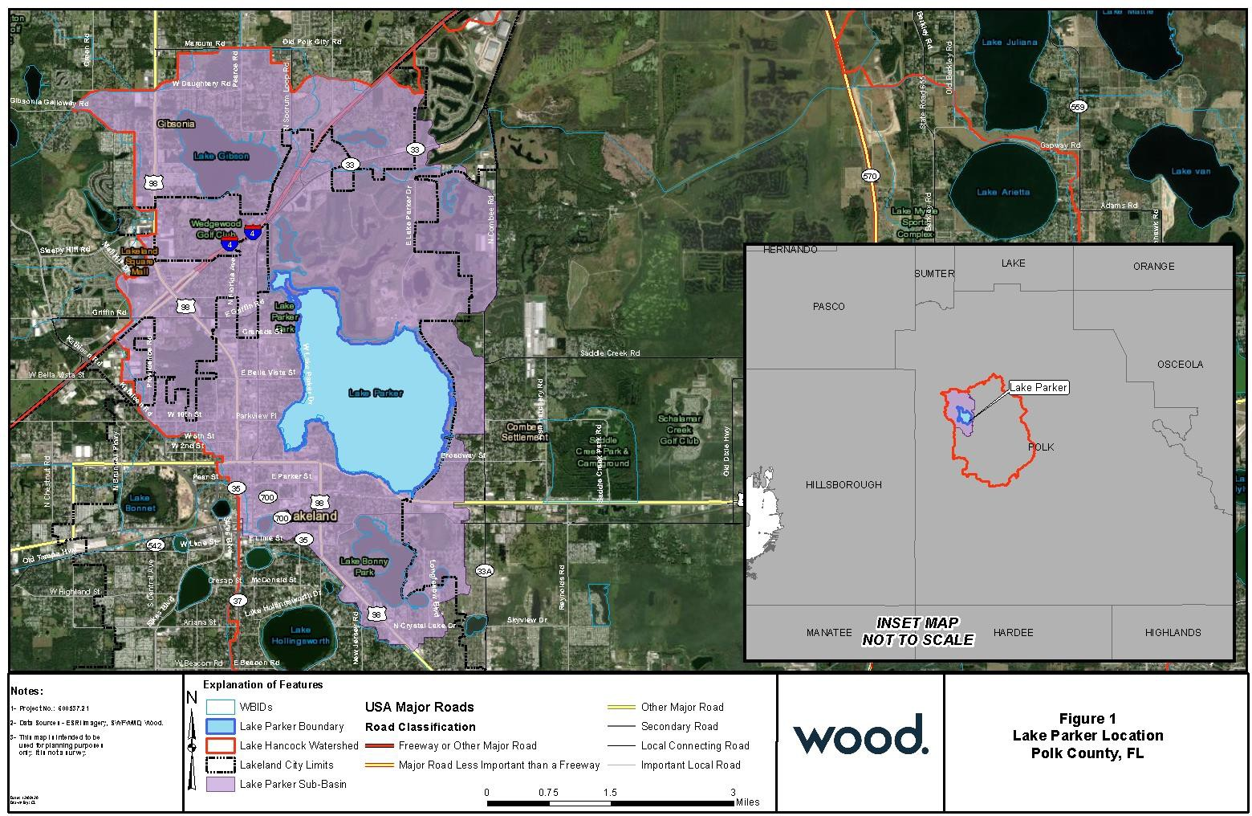

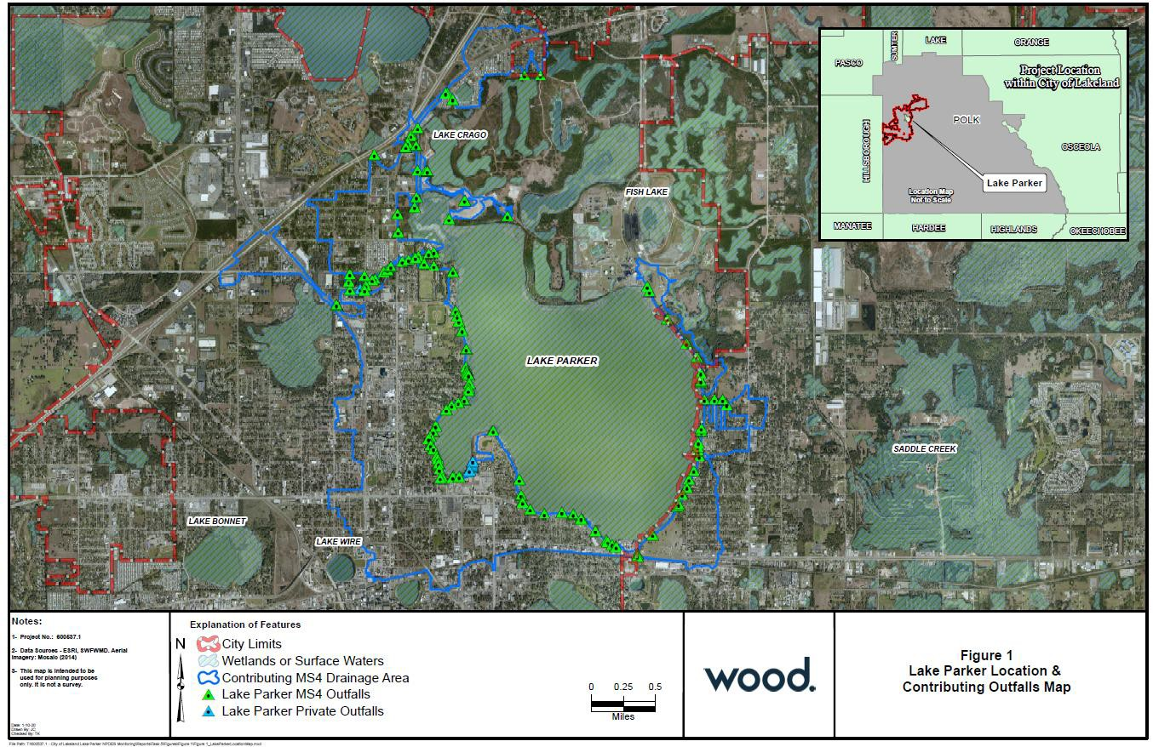
Attachment 2- Contributing Outfalls Map

Attachment 3- Prioritized Outfall Basins Map
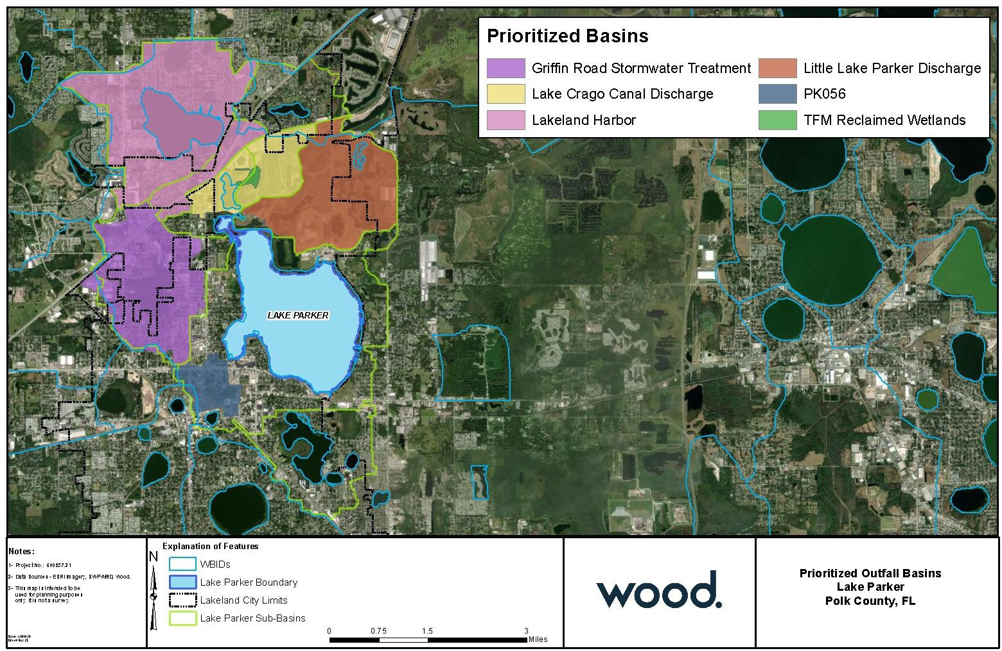

Attachment 4- Land Use Map
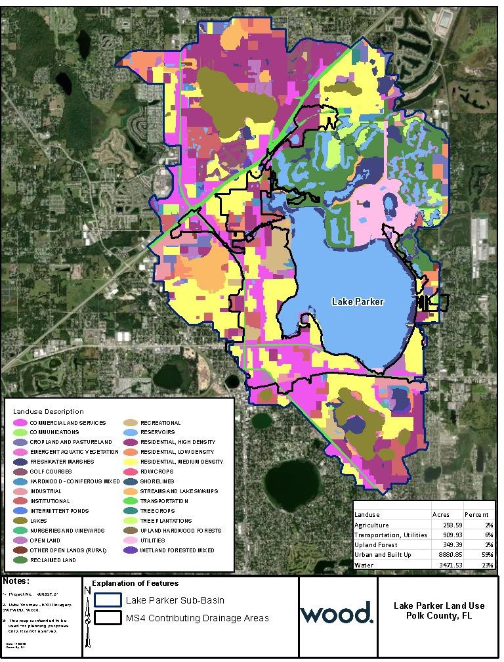

Attachment 5- Land Use Description Table

FLUCCS CODE | LAND USE DESCRIPTION | AREA (AC) | PERCENT
1200 | RESIDENTIAL MED DENSITY 2->5 DWELLING UNIT | 885.5 | 34.02%
1400 | COMMERCIAL AND SERVICES | 618.3 | 23.76%
1300 | RESIDENTIAL HIGH DENSITY | 305.1 | 11.72%
1700 | INSTITUTIONAL | 166.0 | 6.38%
1800 | RECREATIONAL | 162.6 | 6.25%
8100 | TRANSPORTATION | 140.2 | 5.39%
1900 | OPEN LAND | 98.5 | 3.79%
1650 | RECLAIMED LAND | 57.0 | 2.19%
1500 | INDUSTRIAL | 40.5 | 1.56%
8300 | UTILITIES | 26.0 | 1.00%
5300 | RESERVOIRS | 23.9 | 0.92%
4340 | HARDWOOD CONIFER MIXED | 22.5 | 0.86%
1100 | RESIDENTIAL LOW DENSITY < 2 DWELLING UNITS | 22.3 | 0.86%
8200 | COMMUNICATIONS | 6.9 | 0.26%
6410 | FRESHWATER MARSHES | 6.4 | 0.25%
6440 | EMERGENT AQUATIC VEGETATION | 4.8 | 0.18%
5200 | LAKES | 4.4 | 0.17%
2600 | OTHER OPEN LANDS <RURAL> | 3.1 | 0.12%
2140 | ROW CROPS | 2.9 | 0.11%
6400 | VEGETATED NON-FORESTED WETLANDS | 2.6 | 0.10%
6530 | INTERMITTENT PONDS | 1.9 | 0.07%
4400 | TREE PLANTATIONS | 0.9 | 0.03%
6150 | STREAM AND LAKE SWAMPS (BOTTOMLAND) | 0.2 | 0.01%
2100 | CROPLAND AND PASTURELAND | 0.2 | 0.01%
TOTAL |  | 2602.7 | 100%
It is noted that the land use shown in Attachment 5 does not account for the entire Lake Parker watershed, which is estimated to be 15,231 acres. Excluded areas are either other water bodies or jurisdictional U.S. Waters to where the City of Lakeland MS4 directly discharges or are non-MS4 contributing drainage areas of which the City has no control from a stormwater management perspective.

Attachment 6- Annual Geometric Mean (AGM) Time Series for (a) Chlorophyll-a, (b) Total Nitrogen, and (c) Total Phosphorus, in Respect to Project Completion

(a) 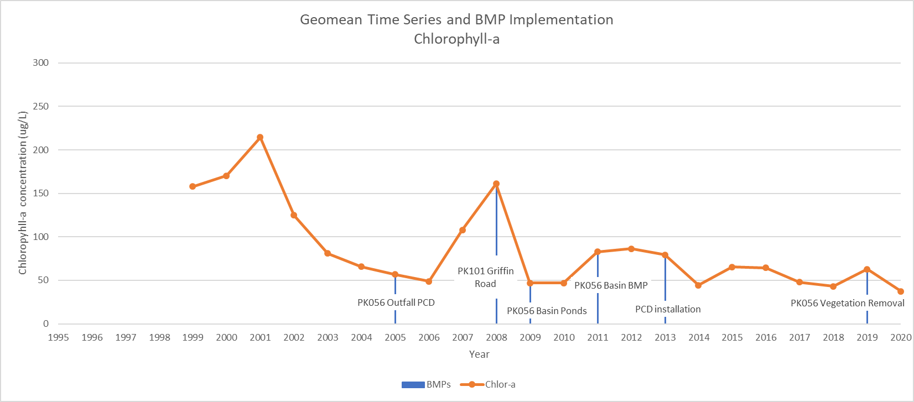

Attachment 6 (cont’d)

(b)
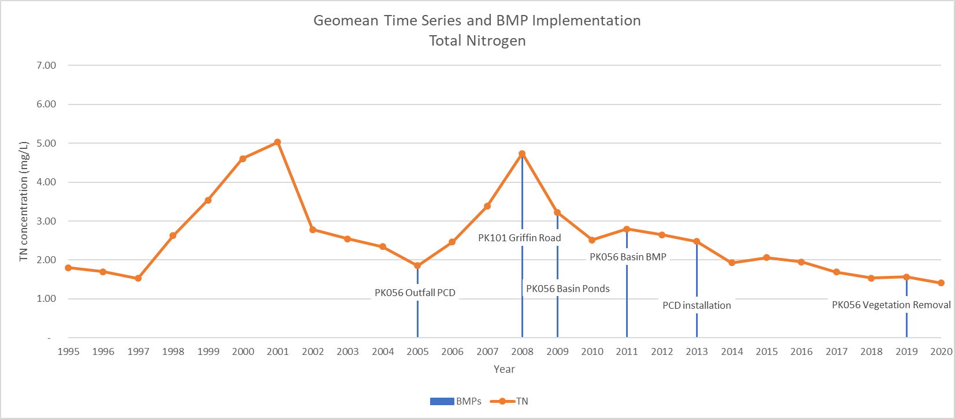

Attachment 6 (cont’d)

(c)
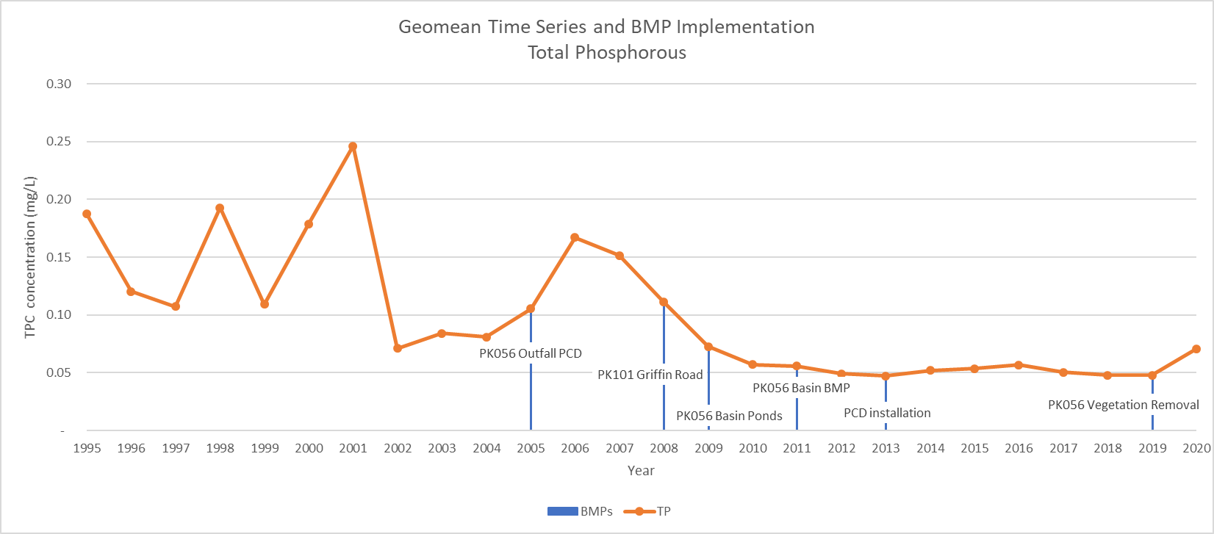
Attachment 7

City of Lakeland Stormwater Projects in the Lake Parker Watershed
Completed Projects
Project Name | Description | Cost |  | Nutrient Removal | Completion Date
PK056 Basin City Pond G, Pond K, and Magnolia Pond | Stormwater treatment and attenuation. Construction of three stormwater treatment ponds (Pond G, Pond K, and Magnolia Pond) within the basin to treat stormwater prior to discharging to PK056 | $400,000 |  | Attenuation of nutrients and sediment utilizing wet retention pond | 2009
PCD installation at Pond G | Installation of a second-generation Pollutant Control Device (PCD) with baffles | $120,000 |  | Removal of floatable trash, sediments and nutrients from stormwater stream prior to entering Pond G | 2013
Inland Wetland Construction with PCD at PK056 Outfall | Sediment delta removal and construction of an in-lake treatment wetland within the southwestern lobe of Lake Parker. A pollution control device (PCD) designed to remove litter, sediment, and debris was constructed at the PK056 outfall prior to discharging to the lake | $400,000 |  | Nutrient and sediment attenuation within the in-lake treatment wetland provides enhances treatment to stormwater prior to discharging to Lake Parker | 2005
Lake Parker Nuisance Vegetation Removal | Harvester-removal of nuisance plants in Southwest part of lake | $80,000 |  | Reduction in decomposing organic matter contribution to lake bottom muck | 2019
PK056 Basin Stormwater Pond | Litter/sediment removal on the Pond A/ Pond B system. ±450 CY of sediment was removed | $20,000 |  | Removal efficiency improved approximately 22% for TP, 53% for TN, and 138% for TSS. | March 2019
PK056 Basin BMP | The city uses floating turbidity barriers to restrict the discharge of litter from the stormwater treatment BMP. | $2,500 |  | Sediment, nutrient and trash removal from stormwater flow prior to entering Lake Parker | 2011
PK101 Griffin Road Treatment Wetland Enhancement | Retrofit of dry detention and wet detention ponds including expansion of total footprint and conversion to wet retention systems | $350,000 |  | Sediment, nutrient and trash removal from stormwater flows prior to discharge to Lake Parker | 2008

Attachment 7 (cont’d)

Planned Future Projects
Project Name | Description | Cost | Nutrient Removal | Completion Date
Lake Parker Tributary Swamp Stormwater treatment BMP Projects | A conceptual plan is being developed to rehydrate and restore the swamp and improve stormwater detention within the swamp to improve nutrient and sediment removal prior to discharging to Parker canal | $950,000 | Nutrient and sediment attenuation within the restored wetland | Est. 2025
Lake Parker Stormwater treatment BMP Projects – Pond G | A City pond is located east of the Plum Street / N Vermont Avenue intersection (Pond G). The City purchased the adjacent property (905 North Vermont Avenue) and plans to expand and utilize this for stormwater treatment and attenuation | $350,000 | Nutrient and sediment attenuation | Est. 2022
PK056 Basin Stormwater Pond Retrofit – Magnolia Pond Expansion | Retrofit of Magnolia Pond to provide additional stormwater treatment | $75,000 | Attenuation of nutrients and sediment utilizing wet retention pond | Est. 2022
PK056 Basin BMP Extension | Extending the hydraulic flow path before discharge over the fabriform weir will improve on the City’s existing effort to restrict the discharge of litter from the stormwater treatment BMP | $50,000 |  | Est. 2022
PK056 Basin City Inland Wetland Pond Maintenance | Routine cleaning/sediment removal of the Ponds A/ Pond B system every 2-3 years | $50,000 | Increased efficiency of nutrient and sediment attenuation | Ongoing
Basin PK101 modification | Modification of the existing east outfall structure serving the Griffin Road BMP to include greater discharge capacity and reduce residence time in the system | $350,000 |  | Est. 2027
Lake Parker Canal Restoration & Retrofit | Restore natural flow patterns and vegetation to Lake Parker drainage canal originating within the Lake Parker Tributary Swamp | $1,200,000 |  | Est. 2026
Lake Parker Dredging and/or Sediment Inactivation | Targeted dredging and/or treatment of the sediment via chemical inactivation to reduce internal nutrient cycling and loads to the lake | $5,000,000 |  | Est. 2027

Attachment 8- Street Sweeping Routes and Zones
Attachment 8- Street Sweeping Routes and Zones

Attachment 10- Water Quality Monitoring Program Parameters

Polk County Sampled Water Quality Parameters
Alkalinity, Total (total hydroxide+carbonate+bicarbonate)
Calcium
Chloride
Chlorophyll a, corrected for pheophytin
Chlorophyll-a, uncorrected for pheophytin
Dissolved oxygen (DO)
Hardness, Ca + Mg
Iron
Magnesium
Nitrogen, ammonia (NH3) as NH3
Nitrogen, ammonia as N
Nitrogen, Kjeldahl
Nitrogen, mixed forms (NH3)+(NH4)+organic+(NO2)+(NO3)
Nitrogen, Nitrite (NO2) + Nitrate (NO3) as N
pH
Phosphorus as P
Phosphorus, orthophosphate as P
Secchi disk depth
Sodium
Specific conductance
Sulfur, sulfate (SO4) as SO4
Temperature, water
Total Organic Carbon (TOC)
Total Solids
Total Suspended Solids (TSS)
True Color
Turbidity

