Documentation in Support of Category 4e

Waterbody/Watershed Identification
 | Organization | Polk County
 | Point of Contact | Greg Knothe, 4177 Ben Durrance Rd.  Bartow, FL 33830, GregKnothe@polk-county.net, 863-534-7377
 | Waterbody(s) | Lake Smart (WBID 1488A)
 | No. Waterbody / Pollutant Combinations | One waterbody segment: Verified and/or Impaired for Biology (Lake Vegetation Index) and Nutrients (Chlorophyll-a and Total Nitrogen).
 | EPA Completed TMDL | Yes. The total maximum daily load (TMDL) for Lake Smart was established for nutrients in the document entitled “Nutrient Total Maximum Daily Loads for the Winter Haven Northern Chain of Lakes, Lake Haines and Lake Smart (WBIDs 1488C, 1488A)” (EPA 2006).
Description of Baseline Conditions
 | Watershed(s) | Basin Group 3, Sarasota Bay - Peace - Myakka
 | Baseline Data | Data presented below was gathered from FDEP’s IWR run 64 (Microsoft access database). Verified period assessment data are below with red text displaying exceedances of NNC.  Lake Smart:  Water quality stations:  21FLPOLKSMART1  21FLGW 56173  21FLGW 51034  Total Nitrogen: Annual Geometric Means exceeded the nutrient criteria more than once in a three-year period.  2015 (1.32 mg/L)  2016 (1.16 mg/L)  2017 (1.63 mg/L)  2018 (1.10 mg/L)  2019 (1.03 mg/L)  2020 (1.22 mg/L)  2021 (1.34 mg/L)  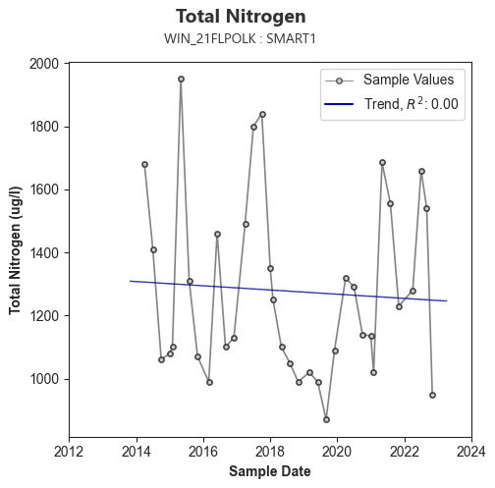  Chlorophyll-a: Annual Geometric Means exceeded the nutrient criteria more than once in a three-year period.  2015 (24 µg/L)  2016 (22 µg/L)  2017 (42 µg/L)  2018 (19 µg/L)  2019 (20 µg/L)  2020 (24 µg/L)  2021 (24 µg/L)  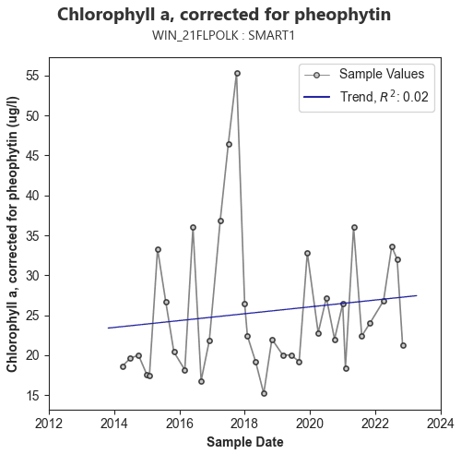  Total Phosphorus: Annual Geometric Means did not exceed the nutrient criteria more than once in a three-year period. However, TP may be listed in future following assessments pending data from 2022 and 2023.  2015 (0.02 mg/L)  2016 (0.02 mg/L)  2017 (0.02 mg/L)  2018 (0.02 mg/L)  2019 (0.02 mg/L)  2020 (0.02 mg/L)  2021 (0.05 mg/L)  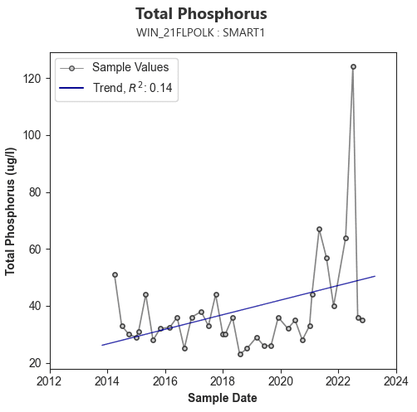  Biology: LVI is impaired if, the average score of at least two temporally independent LVI scores < 43; or either of the two most recent LVI scores < 43; or if there are only two LVI scores and there is less than or equal to a 20-point difference.  21FLGW 51034 (4/18/2017: Score: 43)  21FLGW 56173 (5/28/2019: Score: 47)  EXTBIO03USFWI104 (6/11/2020: Score: 37)
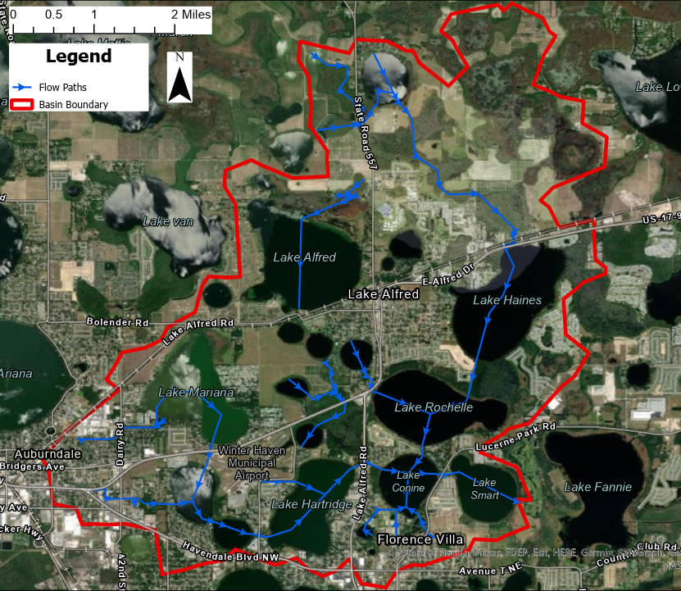
Figure 1. Map of the Lake Smart contributing basin delineation and flow paths (determined by Polk County’s Peace River Watershed Assessment Model (PR WAM)).

Evidence of Watershed Approach
 | Area of Effort | Lake Smart (264 acres) is centrally located in Polk County. The lake is primarily surrounded by the City of Winter Haven’s jurisdictional boundaries and a portion of the south side of the lake is within unincorporated Polk County. The lake’s contributing basin is in unincorporated Polk County, City of Winter Haven, Lake Alfred’s, and Auburndale jurisdictional boundaries.
 | Key Stakeholders Involved and Their Roles | Polk County and City of Winter Haven. The SWFWMD and FDEP may be involved in future restoration projects by providing grant funding.
 | Watershed Plan & Other Supporting Documentation | The contributing basin to Lake Smart (WBID 1488A) is large (16,603 acres) since it is part of the Winter Haven Chain of Lakes. Lake Smart is impaired for Chlorophyll-a and Total Nitrogen. However, the lake may be listed impaired for Total Phosphorus in the future based on an upward trend of recent data. Over the past 10 years water quality data is depicting a slight increasing trend for chlorophyll a, an increasing trend for total phosphorus, and no significant trend for total nitrogen. Lake levels have remained relatively steady over the last 10 years (Figure 2), with the exception of the large increase in levels in 2013 following a dry period.  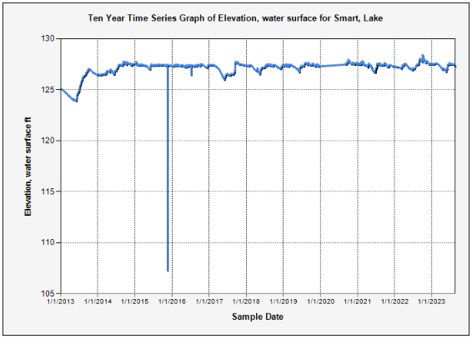  Figure 2. Water levels over the past 10 years (2013 – 2023) for Lake Smart. Note: equipment failure in 2015 and resulting erroneous data.  Our watershed plan is to improve the water quality in Lake Smart by identifying and filling water quality data gaps, providing educational outreach, confirming County outfall locations for the Lake Smart Basin, and implementation of the Lake Conine Wetland Restoration project and Lake Smart sediment inactivation project.  The County completed a sediment nutrient loading analysis for the lake in 2023.The study assessed the lake bathymetry and completed a sediment phosphorus characterization. The results of the sediment phosphorus characterization revealed exceptionally high levels of soluble reactive phosphorus (SRP) contributing to lake eutrophication. SRP is readily utilized form of phosphorus by biological processes. This accumulation of fine sediment in Lake Smart is the result of long-term historic discharge of untreated stormwater from its large contributing basin.  The County identified a sediment inactivation project to be the most effective means to shift nutrient ratios in Lake Smart. The inactivation project will mitigate an estimated 8,000 lbs. of phosphorus in the top 4-cm of sediment using EutroSORB. Monitoring will be carried out to assess the results of the sediment inactivation project to the sediment and surface waters. Lake Smart has a relatively robust submersed and emergent aquatic vegetation (SAV and EAV, respectively) community, however through the reduction of bio-available phosphorus in the system we expect the chlorophyll a level (planktonic green and blue-green algae) to also reduce. Once the chlorophyll concentrations reduce in the lake, we expect that the SAV and EAV to expand greatly and in the process assimilate nitrogen and phosphorus from the lake. Aquatic vegetation will be assessed through yearly point-intercept and sonar surveys (SAV bio-volume).  Another project that has been completed and will directly improve water quality in Lake Smart was the Lake Conine Wetland Restoration Project. This project was completed through a partnership between the City of Winter Haven, Polk County, FDEP, and SWFWMD in 2022. This project treated one of the primary pollution sources that prevents Lake Conine from meeting NNC, a 328-acre drainage area of untreated stormwater on the south side of the lake. The treatment of this drainage area was listed as one of the five priority stormwater projects in the SWFWMD SWIM Plan for the Winter Haven Chain of Lakes. Pollutant load reductions for the project are estimated to be 725 lbs./yr. of TN and 50 lbs./yr. of TP. Due to the direct connection of Lake Conine to Lake Smart we expect realized water quality benefits from this project since there is little distance for nutrient attenuation between these waterbodies.  Street sweeping is another valuable and effective BMP that is underway within the Lake Smart Contributing Basin and is carried out by Polk County, the City of Winter Haven, and City of Lake Alfred. Polk County sweeps almost all county roads within the basin following the 2022 street sweeping expansion. Winter Haven currently sweeps a small portion of roads within the basin but will explore the option to adding more road miles depending on available locations within City Limits on City-maintained roads. Lake Alfred also implements a sweeping program that sweeps most of the City’s roads within the contributing basin.  Through the implementation of these water quality enhancement and monitoring projects the County is confident that FDEP established water quality goals (Numerical Nutrient Criteria, NNC) for Lake Smart can be achieved. Additionally, the restoration of water quality in Lake Smart will be realized in downstream waters including Lake Hamilton (WBID 15041), a waterbody with an accepted alternative restoration plan in place.
 | Point Sources and Indirect Source Monitoring (Sites) | Lake Smart has a relatively large contributing basin (16,603 acres) which contributes to non-point source pollution. There are 5 major and 34 minor outfalls within the County’s jurisdiction of the Lake Smart contributing basin, and none directly discharge to the lake. The City of Winter Haven has 94 minor outfalls and no major outfalls within their jurisdictional boundaries of the Lake Smart contributing basin, and none directly discharge to the lake.  The only point sources directly discharging to the lake are resulting from private entities and Florida Department of Transportation (FDOT). Data was collected from the FDEP Geospatial open data website: NPDES Stormwater Facilities and Activities layer. There are no multi-sector generic permits for stormwater discharge associated with industrial activity directly discharging to Lake Smart.  The entire area is regulated by a Municipal Separate Storm Sewer System (MS4) permit # FLS000015-004, issued by FDEP to Polk County and co-permittees (City of Winter Haven, City of Lake Alfred, City of Auburndale, and FDOT).
 | Nonpoint Sources | List and Describe: Land uses (including % and type); pollutant loading sources.  We utilized Polk County’s Peace River Watershed Assessment Model (PR WAM) to delineate Lake Smarts contributing basin, land use within the basin (Figure 3), and estimate attenuated nutrient loadings from land uses (Figures 4-7). The anthropogenic land use account for 36%, natural areas comprise 52% and agricultural areas including range lands, pastures, crops, and tree crops represent 12% of the Lake Smart contributing basin. There are a total of 1,091 known septic tanks and 2,396 likely septic tanks within the contributing basin (DOH 2023), all of which are accounted for in the PR WAM. For more information regarding the PR WAM, please refer to the technical report titled: Assessment of Hydrology and Water Quality in the Upper Peace River and Peace Creek Basins using the Watershed Assessment Model. See figures below for TN and TP loads for each land use type within the Lake Smart contributing basin.  Figure 3. Landuse types by acre and percent within the Lake Smart contributing basin (PR WAM).  Figure 4. Attenuated total nitrogen loads from land uses within the Lake Smart Contributing basin (PR WAM).  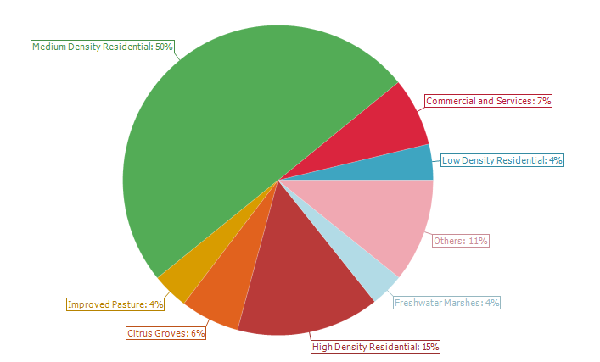  Figure 5. Pie chart of attenuated total nitrogen loads by land use within Lake Smart’s contributing basin (PR WAM).  Figure 6. Attenuated total phosphorus loads from land uses within the Lake Smart Contributing basin (PR WAM).  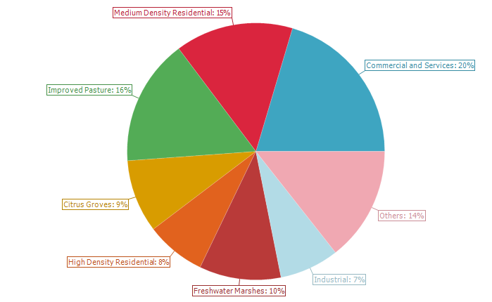  Figure 7. Pie chart of attenuated total phosphorus loads by land use within Lake Smart’s contributing basin (PR WAM).  Additionally, utilizing the FDEP’s Landscape Development Intensity Index (LDI) and the SWFWMD LULC 2017 data the 100-meter buffer around Lake Smart is primarily natural (40%), residential (28%), and agricultural (18%) land uses. The resulting LDI value for the 100-meter buffer around Lake Smart is 4.12. This LDI score indicates a moderately low level of human activities that may adversely impact the ecological processes and natural communities of the lake. Scores less than 2 indicate minimally disturbed.
  Land Use | Area (acre) | Percent (%)
  Barren Land | 27.2 | 0.2
  Bay Swamps | 76.6 | 0.5
  Citrus Groves | 1,250.3 | 7.5
  Commercial and Services | 985.9 | 5.9
  Coniferous Plantations | 19.8 | 0.1
  Cypress | 27.2 | 0.2
  Freshwater Marshes | 2,201.7 | 13.3
  Hardwood Conifer Mixed | 148.3 | 0.9
  High Density Residential | 827.8 | 5.0
  Improved Pasture | 689.4 | 4.2
  Industrial | 274.3 | 1.7
  Low Density Residential | 427.5 | 2.6
  Managed Landscape | 79.1 | 0.5
  Medium Density Residential | 2,322.8 | 14.0
  Mixed Wetland Hardwoods | 4.9 | 0.0
  Open Water | 247.1 | 1.5
  Open Water (Hydrography) | 3,966.0 | 23.9
  Scrub and Brushland | 793.2 | 4.8
  Transportation Corridors | 580.7 | 3.5
  Tree Nurseries | 27.2 | 0.2
  Undeveloped Urban Land | 474.4 | 2.9
  Wetland Forested Mixed | 1,151.5 | 6.9
  Total: | 16,603 | 100
  Land Use | Area (acre) | Mean TN (lbs/acre/y) | Sum TN (lbs/yr)
  Barren Land | 27.2 | 0.09 | 2.5
  Bay Swamps | 76.6 | 0.21 | 15.8
  Citrus Groves | 1,250.3 | 1.31 | 1,634.6
  Commercial and Services | 985.9 | 1.92 | 1,888.7
  Coniferous Plantations | 19.8 | 0.58 | 11.5
  Cypress | 27.2 | 0.30 | 8.2
  Freshwater Marshes | 2,201.7 | 0.42 | 931.9
  Hardwood Conifer Mixed | 148.3 | 0.61 | 90.2
  High Density Residential | 827.8 | 4.77 | 3,951.0
  Improved Pasture | 689.4 | 1.46 | 1,003.5
  Industrial | 274.3 | 2.41 | 660.0
  Low Density Residential | 427.5 | 2.34 | 999.6
  Managed Landscape | 79.1 | 0.89 | 70.3
  Medium Density Residential | 2,322.8 | 5.70 | 13,241.0
  Mixed Wetland Hardwoods | 4.9 | 1.55 | 7.7
  Open Water | 247.1 | 0.35 | 87.1
  Open Water (Hydrography) | 3,966.0 | 0.00 | 0.0
  Scrub and Brushland | 793.2 | 0.15 | 118.4
  Transportation Corridors | 580.7 | 1.24 | 720.9
  Tree Nurseries | 27.2 | 1.15 | 31.2
  Undeveloped Urban Land | 474.4 | 0.67 | 316.2
  Wetland Forested Mixed | 1,151.5 | 0.62 | 718.1
  Total: | 16,603 | 28.7 | 26,508.5
  Land Use | Area (acre) | Mean TP (lbs/acre/yr) | Sum TP (lbs/yr)
  Barren Land | 27.2 | 0.01 | 0.3
  Bay Swamps | 76.6 | 0.00 | 0.1
  Citrus Groves | 1,250.3 | 0.07 | 89.8
  Commercial and Services | 985.9 | 0.20 | 199.6
  Coniferous Plantations | 19.8 | 0.00 | 0.0
  Cypress | 27.2 | 0.03 | 0.8
  Freshwater Marshes | 2,201.7 | 0.05 | 100.4
  Hardwood Conifer Mixed | 148.3 | 0.03 | 4.4
  High Density Residential | 827.8 | 0.09 | 73.6
  Improved Pasture | 689.4 | 0.23 | 155.6
  Industrial | 274.3 | 0.27 | 73.0
  Low Density Residential | 427.5 | 0.03 | 12.4
  Managed Landscape | 79.1 | 0.03 | 2.1
  Medium Density Residential | 2,322.8 | 0.06 | 144.9
  Mixed Wetland Hardwoods | 4.9 | 0.05 | 0.3
  Open Water | 247.1 | 0.02 | 4.9
  Open Water (Hydrography) | 3,966.0 | 0.00 | 0.0
  Scrub and Brushland | 793.2 | 0.01 | 7.7
  Transportation Corridors | 580.7 | 0.07 | 40.6
  Tree Nurseries | 27.2 | 0.07 | 1.9
  Undeveloped Urban Land | 474.4 | 0.05 | 25.7
  Wetland Forested Mixed | 1,151.5 | 0.03 | 39.6
  Total: | 16,602.9 | 1.4 | 977.7
 | Water Quality Criteria | Lake Smart is a low color, high alkalinity lake (Lake Assessment Type 2). Based on the procedure for determining NNC, outlined in Rule 62-302.531, F.A.C., the NNC for nutrients in Lake Smart are 20 µg/L, 1.05 mg/L – 1.91 mg/L, and 0.03 mg/L – 0.09 mg/L for chlorophyll-a, total nitrogen, and total phosphorus, respectively, which is anticipated to be achieved upon successful completion of all water quality restoration projects.
 | Restoration Work | Completed:  Lake Conine Wetland Restoration Project:  The Lake Conine Wetland Restoration Project was completed through a partnership between the City of Winter Haven, Polk County, FDEP, and SWFWMD in 2022. This project treated one of the primary pollution sources that prevents Lake Conine from meeting NNC, a 328-acre drainage area of untreated stormwater on the south side of the lake. The treatment of this drainage area was listed as one of the five priority stormwater projects in the SWFWMD SWIM Plan for the Winter Haven Chain of Lakes. Pollutant load reductions for the project are estimated to be 725 lbs/yr of TN and 50 lbs/yr of TP. Figures 8-10 show the location, site construction plans, and post-construction imagery, respectively. Lake Conine flows directly into Lake Smart via a canal (Figure 1) and is the last waterbody in the North Winter Haven Chain of Lakes prior to Lake Smart.  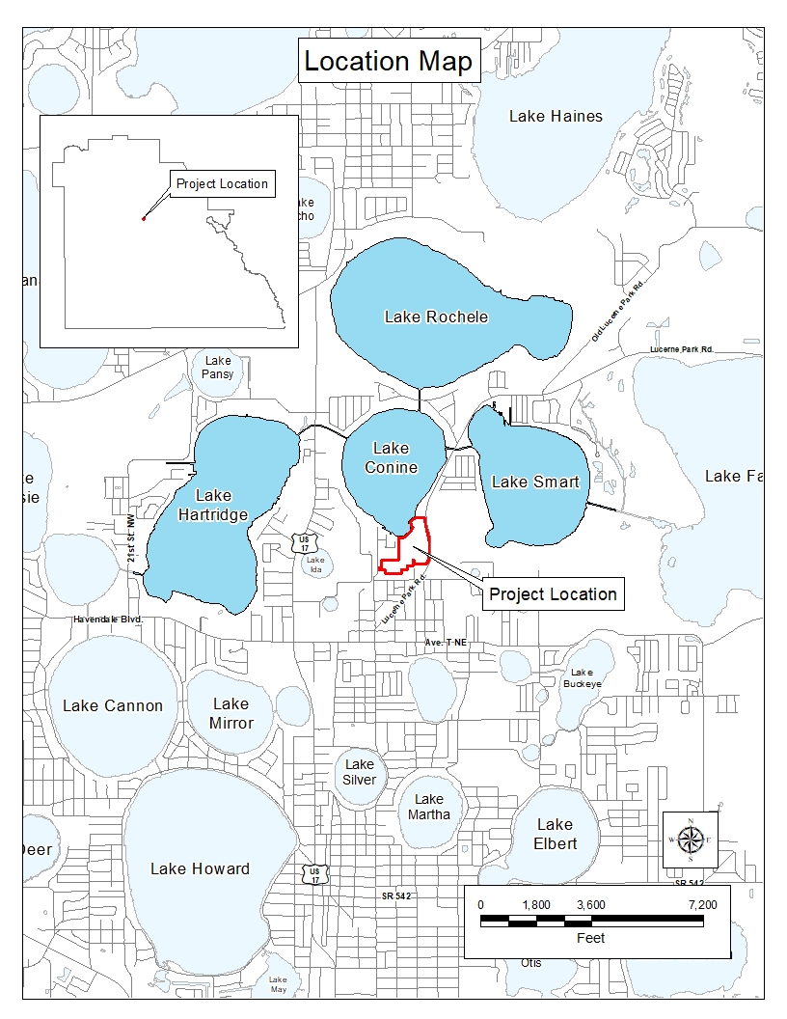  Figure 8. Lake Conine Wetland Restoration location.  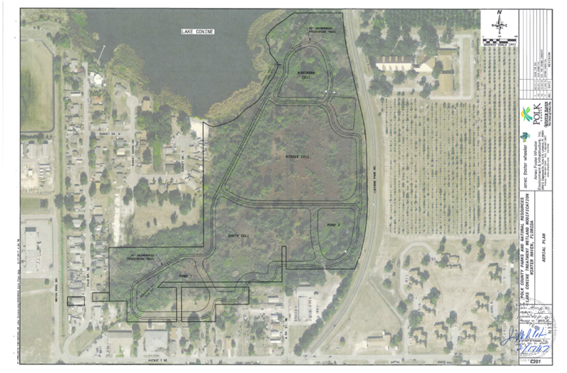  Figure 9. Lake Conine Wetland Restoration design.  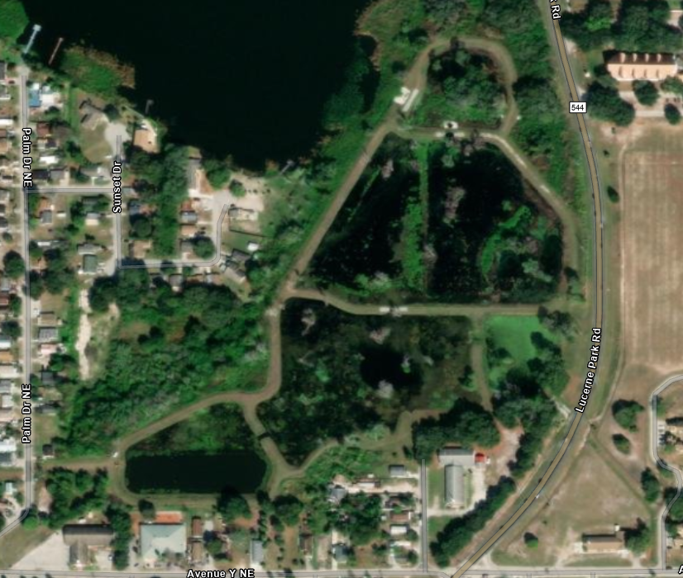  Figure 10. Lake Conine Wetland Restoration completed.  Lake Mariana (WBID 1521L) Stormwater Treatment Area (STA):  Lake Mariana is a 502-acre lake in north central Polk County and is part of the headwaters for the Winter Haven Chain of Lakes and is in the Lake Smart Contributing Basin (Figure 1). Lake Mariana is listed impaired for chlorophyll-a and total nitrogen. The County conducted a feasibility study to determine the highest loading basins and opportunities to improve the water quality of Lake Mariana. The study determined the highest loading basin to the lake was on the southwest side of the lake and is approximately 600 acres (Figure 11). This highly urbanized basin was primarily untreated stormwater since most of this region was developed prior to the enactment of the 1984 stormwater regulations. The County acquired a 10-acre parcel and constructed a 6-acre stormwater treatment area in partnership with the SWFWMD and FDEP costing approximately $1,500,000 in 2005. The post-construction water quality analysis determined a nutrient reduction of 24.7% TN and 45% TP.  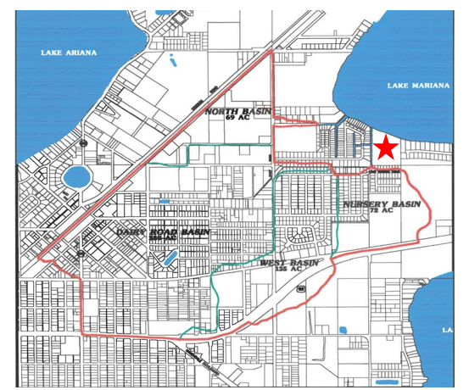  Figure 11. Contributing basin to the Mariana Stormwater Treatment Area.  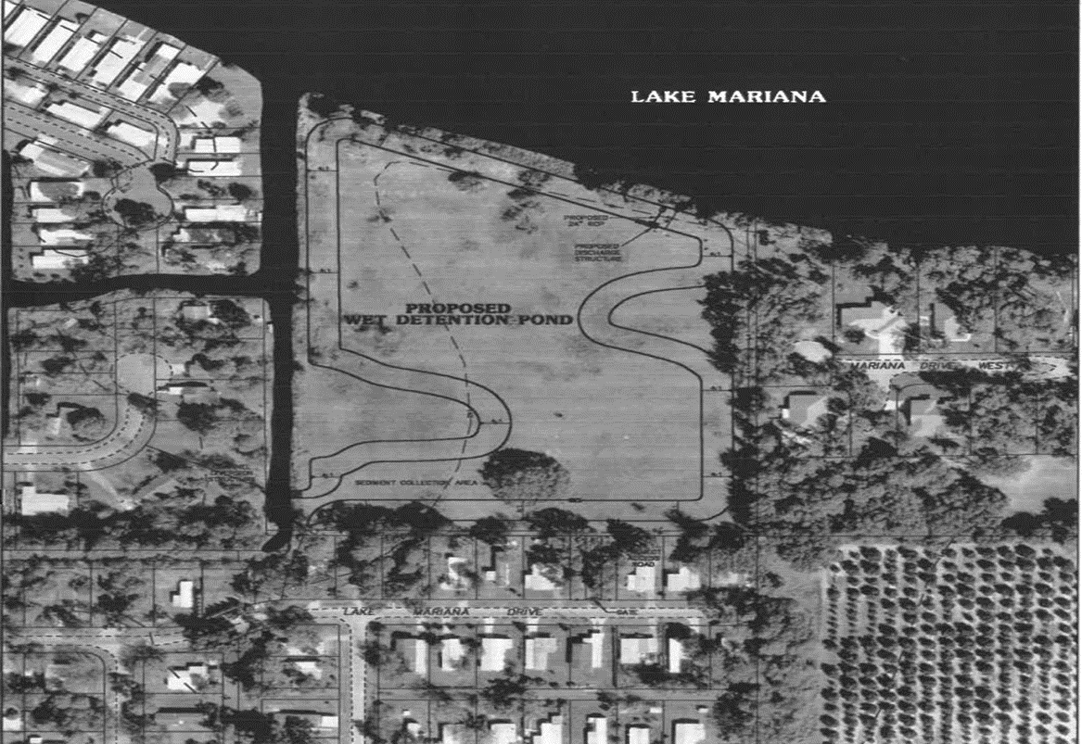  Figure 12. Conceptual design of the Mariana Stormwater Treatment Area.  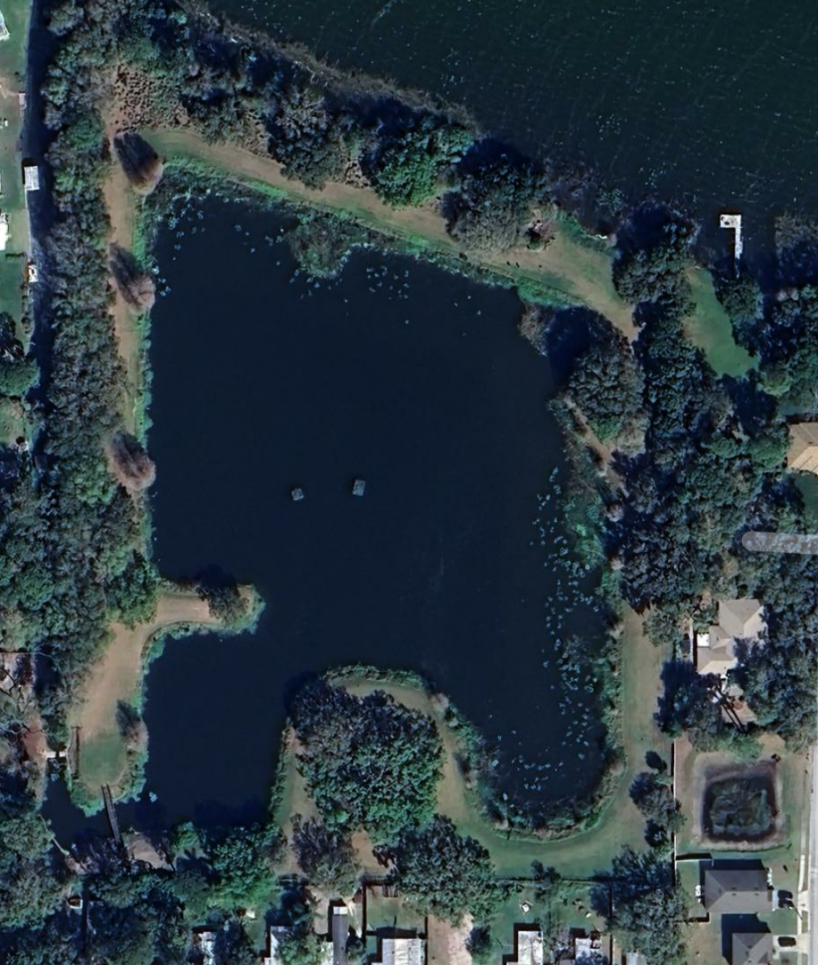  Figure 13. 2022 imagery of the Mariana Stormwater Treatment Area.  Underway:  Public education: the County regularly conducts educational and outreach events that teach the importance of stormwater pollution/management, as well as freshwater ecology. We also hold illicit discharge presentations that help inform the public and other governmental employees when and how to report pollution in the MS4.  Outreach and Educational Programs:  - Annual Water, Wings & Wild Things educational event sponsoring more than 2,000 second grade students from Polk County at the Polk Discovery Center  - 7 Rivers Water Festival  - Polk County Water Atlas  - Lake’s Education Action Drive (LEAD), a Polk County partner  - IFAS extension  - Distribution of educational materials including Stormwater Pollution Prevention  - Illicit Discharge Classes  - “Dump no waste drains to lake” signs on storm drains.  Fertilizer Ordinance: Polk County passed a Fertilizer Ordinance in 2013 that provides water quality benefits throughout the county.  Invasive Plant Management: The County is the lead agency in the cooperative invasive plant management program with the Florida Fish and Wildlife Conservation Commission. The County regularly evaluates and targets invasive plants for treatment to encourage native aquatic plant growth. The County and City of Winter Haven regularly conducts point intercept and LVI surveys that aid aquatic plant management and herbicide treatments. In recent years, Lake Smart has not required substantial invasive plant management.  County-Wide Outfall Evaluation: In 2017 the County hired consultants to conduct a GIS assessment using LIDAR data to locate and confidence rank all outfalls. Over 2,000 new outfalls were identified throughout the county. Currently the County is field verifying newly identified outfalls. This project will give a better understanding of the amount and location of outfalls as well as aid in stormwater modeling and assessments. The field verification of the outfall assessment for this basin was completed.  Sediment Inactivation Study and Implementation: Lake Smart is a 264-acre nutrient-impaired lake with an average depth of 7 feet. Lake Smart is classified as a eutrophic lake and is on the 303.d verified impaired list. In early 2023, historical data were reviewed, and additional sampling was completed. Data collection included water quality and sediment sampling from 6 locations (Figure 14). This data (Figure 15) was used to develop a lake treatment implementation plan involving the application of EutroSORB® SI, a newly developed liquid lanthanum product for sediment phosphorus inactivation. Following the EutroSORB SI application, the lanthanum ions react preferentially with free phosphate compounds in water (removing soluble reactive phosphorus (SRP) and rapidly forms a highly stable insoluble mineral. The resulting mineral complex becomes integrated as an inert component into the natural sediments of the waterbody and is not bioavailable. Due to the specificity of EutroSORB SI to phosphate it will continually bind new incoming phosphorus from internal and external sources. During application, EutroSORB SI will be applied evenly over the surface of the lake. EutroSORB SI requires no mixing like other EutroSORB products and has a higher lanthanum concentration requiring less overall product thereby reducing application costs and time. The proposed project would be implemented in the spring of 2025 with the application of ~20,350 gallons of EutroSORB SI to mitigate an estimated 8,000 lbs. of phosphorus in the top 4-cm of sediment.  Monitoring will be essential to track and quantify improvements made in Lake Smart water quality. Water quality samples will be collected pre-treatment, two weeks post-treatment, and then monthly for twelve months and analyzed for total phosphorus (TP), SRP, dissolved oxygen (DO), and temperature. In addition to the water quality monitoring program sediment core samples will be collected pre-, 6-, 12-, and 18-months post-treatment from 6 sites and analyzed for % solids in addition to the following phosphorus fractions as mg P/kg: labile, reductant-soluble, metal-oxide, organic, and apatite/residual.  Polk County has submitted for several grants to fund this sediment treatment project and is awaiting award determinations.  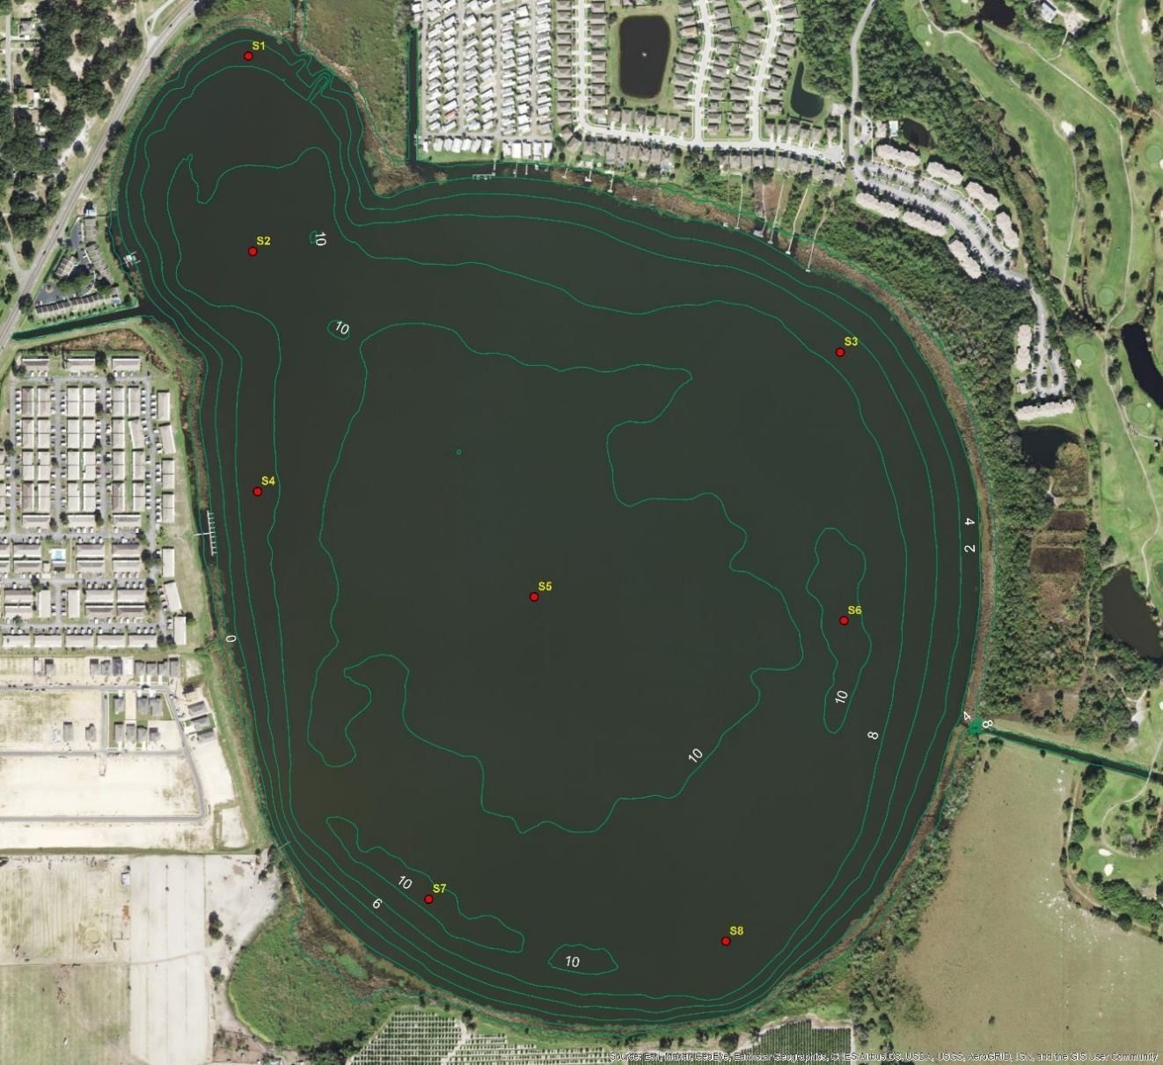  Figure 14. Sediment sample locations and bathymetry of Lake Smart. Note: samples from sites S2 and S3 were not collected due to insufficient fine sediment.  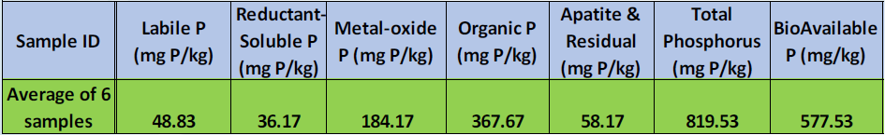  Figure 15. Results from sediment fractionation.  The City of Winter Haven Septic to Sewer Conversion Projects: The City of Winter Haven has been proactive in planning and developing projects that maintain or improve the quality of its lakes which are a centerpiece of the city. The City has identified the elimination of septic systems as an important aspect in maintaining the health of the lakes by improving water quality. As a result, the City completed a Septic to Sewer Master Plan in 2021. Through this plan, a scoring matrix was developed to prioritize areas within the municipal boundary for conversion from septic to sewer (see attachment 1 – City of Winter Haven Septic to Sewer Master Plan Remediation Scoring Matrix Memo). The prioritization matrix evaluated proximity to lakes, existing utilities, estimated age of septic systems, nutrient loading density, and length of potable water pipe within remediation area. One of the highest-ranking areas to convert to centralized sewer was located in between Lake Hartridge and Lake Conine (Remediation Area 6 (RA6)) which has a direct surface water and groundwater connection to Lake Smart. RA6 has been selected to be the first project to be constructed and consists of approximately 111 septic tanks (see attachment 2 – Septic to Sewer Remediation Area Scoring Heatmap). The estimated project cost is 5.1 million dollars and is planned to be completed by 2026. The City will complete other high ranking projects subsequent (which other high ranking sites are located within the Lake Smart contributing basin), to funding and permitting.  Street Sweeping Program: Street sweeping is carried out by Polk County, the City of Winter Haven, and Lake Alfred. Polk County sweeps almost all county roads within the basin following the 2022 street sweeping expansion (Figure 16). Winter Haven currently sweeps a small portion of roads within the basin but will explore the option to adding more road miles depending on available locations within City Limits on city-maintained roads. Lake Alfred also implements a sweeping program that sweeps most of the City’s roads within the contributing basin. As of April 2022, the county expanded its street sweeping program to add all county roads within the basin (66.6 miles/month or 799.2 miles/year).  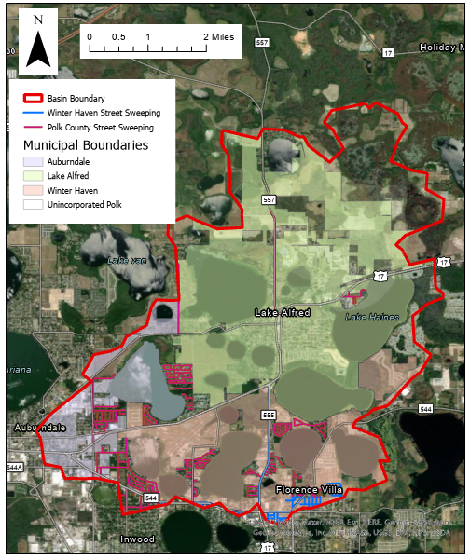  Figure 16. Street Sweeping routes within the Lake Smart Basin.  Conceptual/Feasibility:  Natural Systems Improvement: Polk County will be completing vegetation monitoring on the lake to determine the best vegetation enhancement options. Once surveyed the County may submit projects for district cooperative funding and/or FWC AHREs funding if deemed beneficial. However, currently the lake is exceeding FDEP LVI thresholds.

Critical Milestones/Monitoring
 | Anticipated Critical Milestone(s) and Completion Dates: | Sediment Inactivation Implementation and monitoring: Sediment inactivation project planned to occur in the fiscal year (10/1/2024 – 9/30/2025). Timing is contingent upon permitting and funding.  The City of Winter Haven Septic to Sewer Conversion Project: The septic to sewer conversion project for remediation area 6 has been selected as the first project to be constructed and is scheduled to be completed by 2026.  Street Sweeping Program: The expanded street sweeping program in the Lake Smart basin began in April 2022 and will be carried out indefinitely (as funding permits). Expansion of the City of Winter Haven’s street sweeping program will be assessed and potentially added to their work plan in fiscal year 23/24.
 | Monitoring Component | Existing and expanded water quality monitoring program by Polk County Parks and Natural Resource Division:  Ambient water quality sampling program carried out by the County includes quarterly sampling events in the lake for 20 parameters (see table below).  The County will initiate a 1-year, monthly water quality sampling project (same analytes below) in the lake to provide a more robust water quality data set to evaluate seasonal trends starting in calendar year 2024.  Lake Vegetation Index (LVI) surveys will be conducted at a minimum of every other year to assess the condition of vegetation and changes due to restoration activities.
  Analyte | MDL | Unit | PQL | Unit | Sample Type
  Lab
  Alkalinity as CaCO₃ | 0.6 | mg/L | 6.0 | mg/l | Grab
  Chloride | 0.75 | mg/L | 2.5 | mg/l | Grab
  Chlorophyll a | 3.0 | µg/L | 6.0 | µg/L | Grab
  Chlorophyll a corrected | 3.0 | µg/L | 6.0 | µg/L | Grab
  Color | 2.0 | PCU | 5.0 | PCU | Grab
  Nitrogen ammonia | 0.01 | mg/L | 0.04 | mg/l | Grab
  Nitrogen Kjeldahl | 0.10 | mg/L | 0.40 | mg/l | Grab
  Nitrogen Nitrate + Nitrite | 0.01 | mg/L | 0.04 | mg/l | Grab
  Nitrogen Total | 0.11 | mg/L | 0.44 | mg/l | Grab
  Phosphorus Ortho | 0.01 | mg/L | 0.04 | mg/l | Grab
  Phosphorus Total | 0.02 | mg/L | 0.04 | mg/l | Grab
  Sulfate | 3.6 | mg/L | 5.0 | mg/l | Grab
  Total Suspended Solids | 0.4 | mg/L | 3.0 | mg/l | Grab
  Turbidity | 0.1 | NTU | 0.5 | NTU | Grab
  Field
  Temperature |  |  |  |  | Field-YSI
  Conductivity |  |  |  |  | Field-YSI
  DO % saturation |  |  |  |  | Field-YSI
  DO mg/L |  |  |  |  | Field-YSI
  pH |  |  |  |  | Field-YSI
  Secchi |  |  |  |  | Field
  *Grab samples are collected following FDEP SOP FS2100
Other Key Dates
 | Estimated Date for Delisting from Verified List or Removal from Study List | Lake Smart (WBID 1488A) is in the state’s Group 3 Sarasota Bay – Peace – Myakka Basin. The most recent review and assessment cycle (the initial biennial assessment) was completed in 2022. This waterbody is impaired for biology (Lake Vegetation Index) and nutrients (chlorophyll-a and TN) and the earliest opportunity for delisting would occur during the current biennial assessment (2024). However, since restoration activities are not expected to be completed at that time, it is not likely that this waterbody will meet delisting requirements. Improvements in water quality are expected by the subsequent biennial assessment cycle, which begins in 2024; during that assessment cycle an updated dataset will be used to assess the WBID, and if the waterbody is no longer impaired, DEP is expected to request the WBID be delisted from the federal 303(d) list. If this water does not meet delisting requirements, this waterbody may remain in assessment category 4e for an additional assessment cycle beginning in 2026, which will postpone TMDL development. Following implementation of the projects outlined within this document it is anticipated that Lake Smart will attain all applicable water quality standards.

Financial Commitments

 | Estimated Implementation Cost | Lake Conine Wetland Restoration Project: ~$3,500,000  Lake Mariana Stormwater Treatment Area: ~$1,500,000  The City of Winter Haven Septic to Sewer Conversion Project: ~$5,100,000  Street Sweeping Project: ~$28,771 per year (estimated cost for Polk County only)  Sediment Inactivation Implementation: ~ $1,533,032  Water Quality and Biological Monitoring:  •Monthly Water Quality Sampling 1 year: $12,708  •LVIs: $1,200 per event  Outfall Inventory Update: ~$3,750
 | Land Acquisition  (if applicable) | Funding Source:  Total……………………………………………………………………...$____NA___
 | Design and Construction  (if applicable) | Funding Source:  Total……………………………………………………………………...$___NA____

Attachments:
1) City of Winter Haven Septic to Sewer Master Plan Remediation Scoring Matrix Memo
2) Septic to Sewer Remediation Area Scoring Heatmap

Attachment 1 – City of Winter Haven Septic to Sewer Master Plan Remediation Scoring Matrix Memo

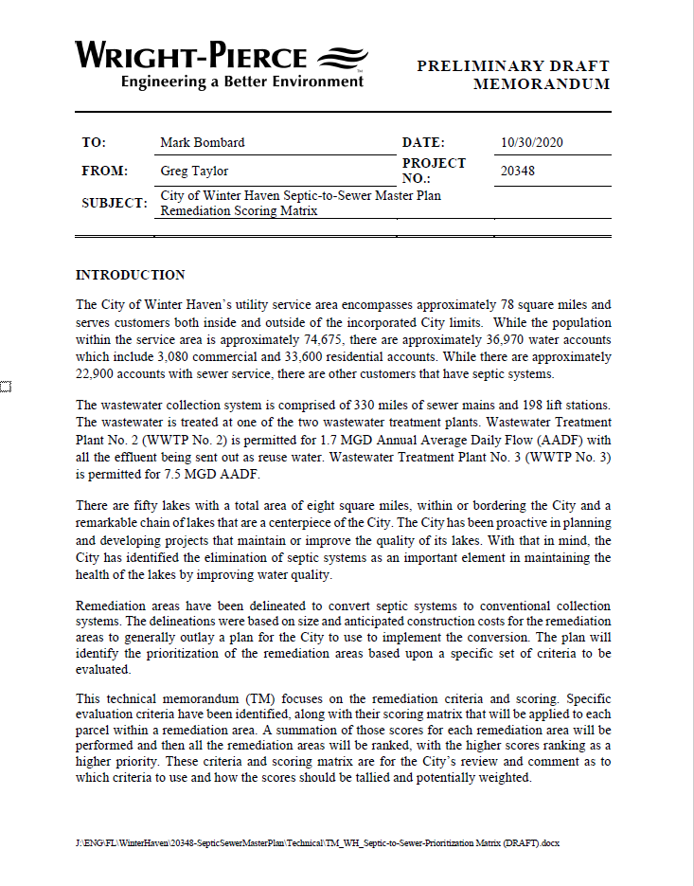
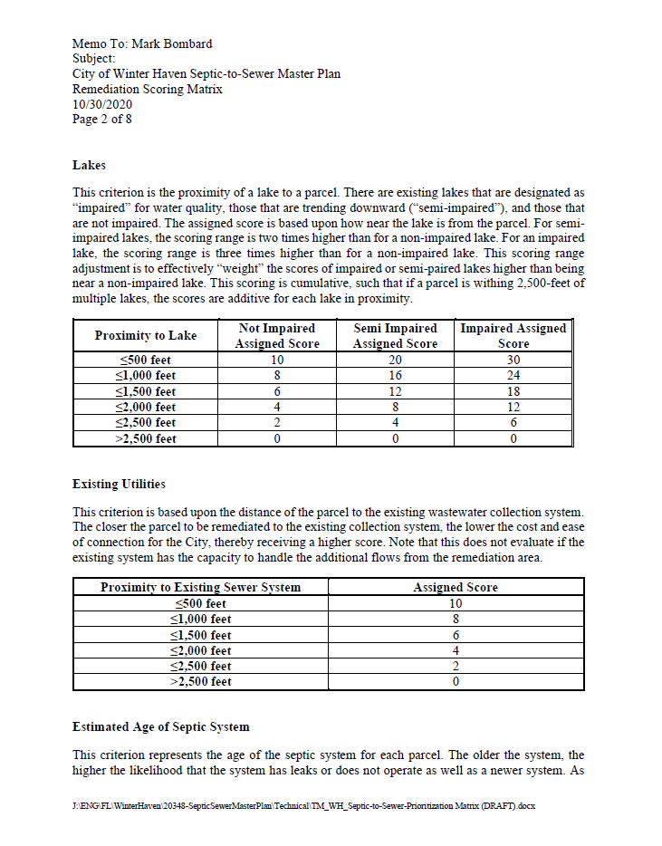

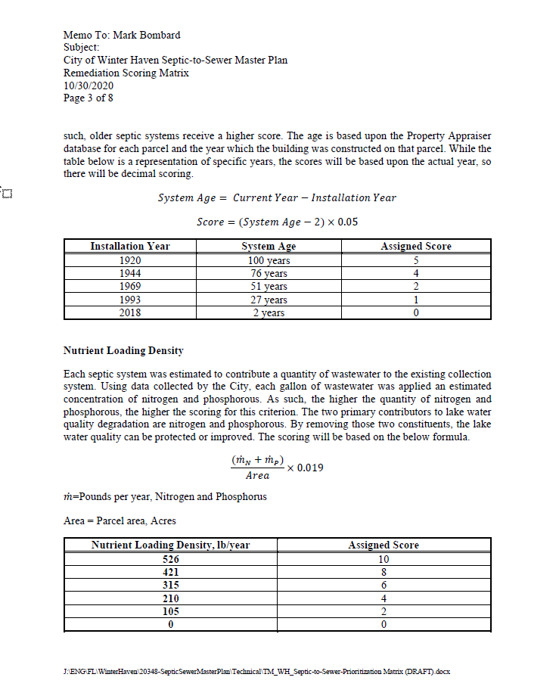

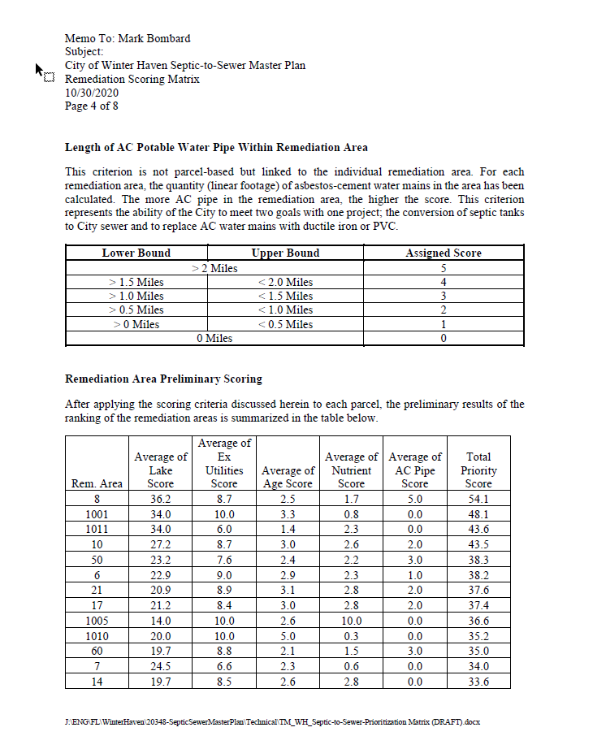

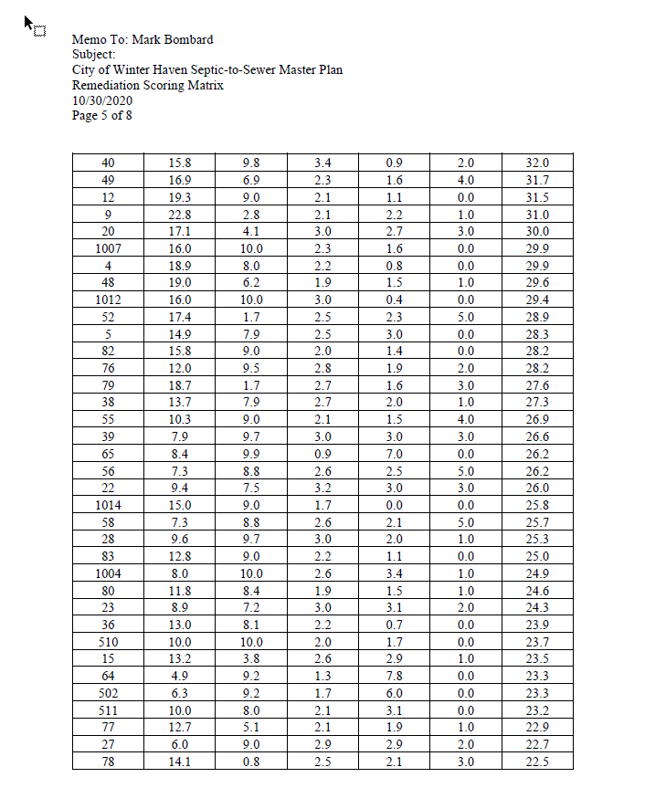

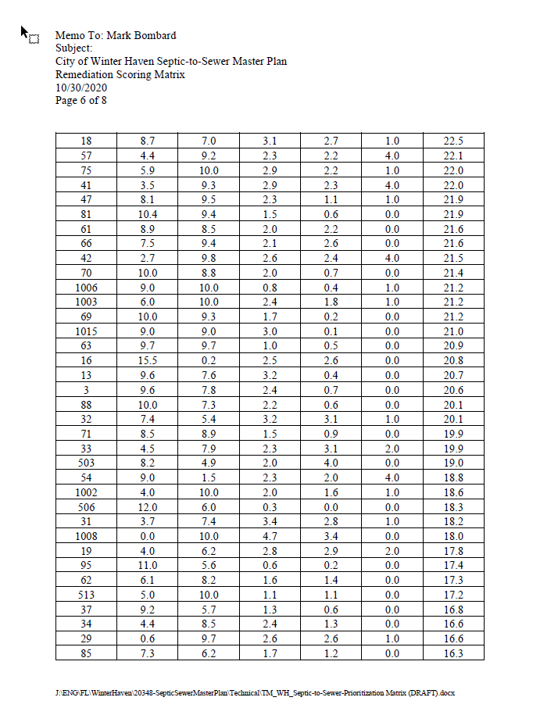

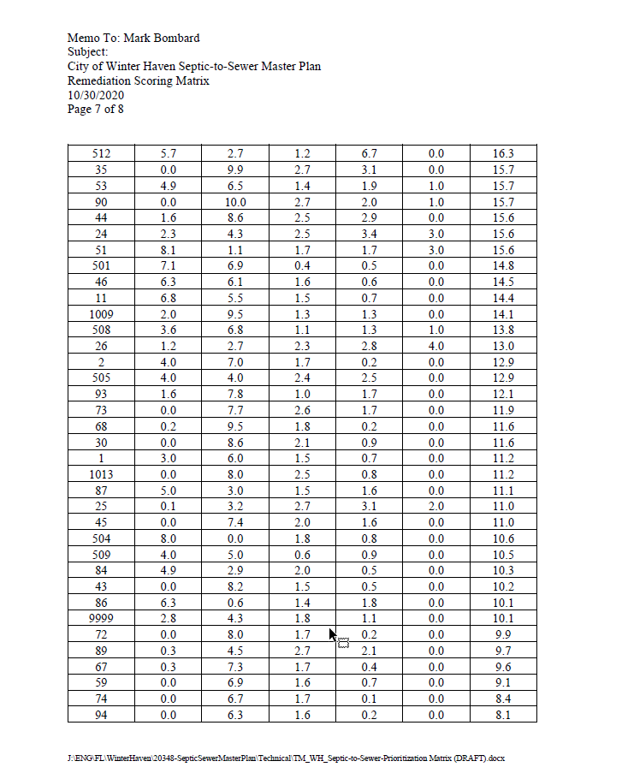

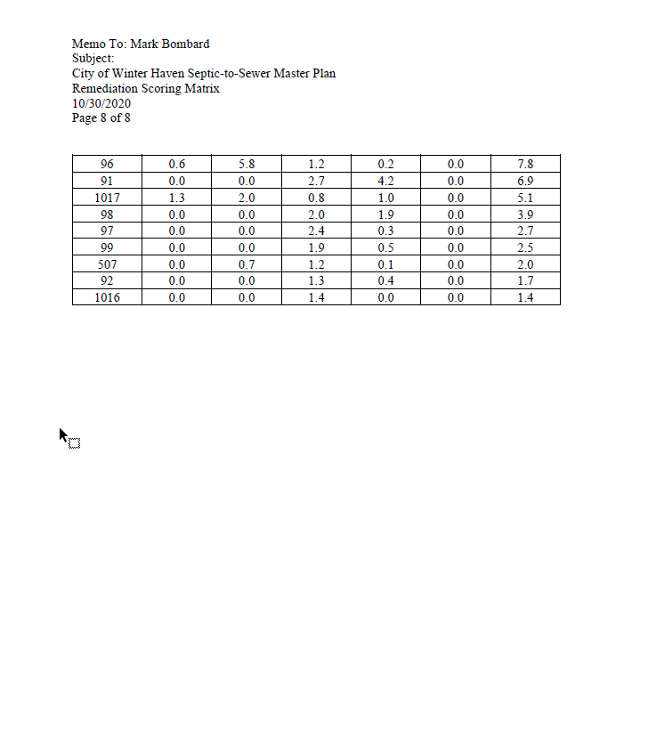

Attachment 2 – Septic to Sewer Remediation Area Scoring Heatmap

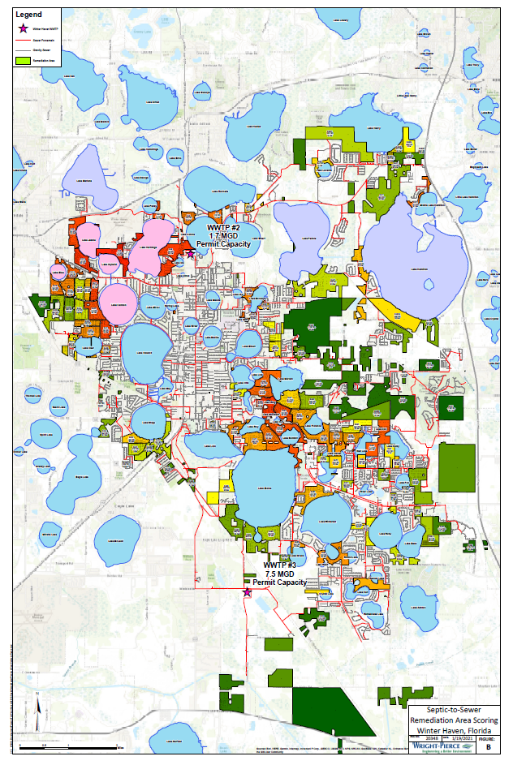
Attachment 2 - Septic to Sewer Remediation Area Scoring Heatmap – Zoomed

