Development of Type III Site Specific Alternative Nutrient Criteria for Lake Tarpon in Pinellas County, Florida



Prepared by:

Florida Department of Environmental Protection

Division of Environmental Assessment and Restoration

Water Quality Standards Program

2600 Blair Stone Rd.

Tallahassee, FL 32399

July 2025

**Table of Contents**

Executive Summary 3

1. Introduction 3

1.1. Purpose of report 3

1.2. Background Information 4

1.2.1. Background on surface water quality standards 4

1.2.2. Background on site specific alternative criteria 4

2. Characterization of proposed SSAC area 6

2.1. System description 6

2.1.1. Hydrogeological setting 8

2.1.2. Land use 10

2.1.3. Potential sources of anthropogenic influence 12

2.2. Planning and Restoration Efforts 15

3. Overview of historic and existing water quality 17

3.1. Applicable Numeric Nutrient Criteria 17

3.2. 303(d) Assessment History 18

3.3. Paleolimnological Study 18

3.4. Characterization of existing water quality conditions 19

3.4.1. Data Screening and Handling 19

3.4.2. Summary of Existing Water Quality Data 20

4. Characterization of historic and existing biological conditions 26

4.1. Aquatic Vegetation Community Health 26

4.2. Phytoplankton community data 37

4.3. Fish community data 40

5. SSAC development methodology 42

5.1. Proposed Type III SSACs 42

5.2. Downstream Waters Protection 45

5.3. Endangered Species Act Considerations 52

6. Summary of Recommendations 53

7. References 54

Appendix A. Summary of Water Quality Data for Brooker Creek, Lake Tarpon, and the Lake Tarpon Discharge Canal Segments. 56

Appendix B. Lake Tarpon Lake Vegetation Index Survey Taxa Lists 57

Appendix C. Lake Tarpon Phytoplankton Data 61

# **Executive Summary**

The Florida Department of Environmental Protection (department or DEP) developed Type III Site Specific Alternative Criteria (SSAC) for total phosphorus (TP), total nitrogen (TN), and chlorophyll-*a* (Chl-*a*) for Lake Tarpon in Pinellas County, Florida. For this effort, the department evaluated historical and existing water quality and biological data to determine the most appropriate Period of Record (POR) to protect the lake’s healthy existing biological condition while accounting for fluctuations in Chl-*a* above FDEP’s generally applicable criterion. Data collected over the period from 2015 to 2022 indicated that the lake supported healthy biological communities. Based on guidance from the *Development of Type III Site Specific Alternative Criteria for Nutrients* document, the department expanded the POR used to derive the SSACs to 2003 through 2022 to capture the full range of natural variability in the lake. The Chl-*a*, TN, and TP SSACs were calculated as the 90 percent prediction interval of the annual geometric mean concentrations for the period from 2003 through 2022. The recommended SSACs developed through this effort are outlined in **Table 1** below.

Summary of proposed Type III nutrient SSACs for Lake Tarpon

|  |  |
| --- | --- |
| **Parameter** | **Proposed SSAC Value** |
| Chlorophyll*-a* | 28 µg/L |
| TN | 1.15 mg/L |
| TP | 0.04 mg/L |

The recommended Chl*-a*, TN, and TP SSACs for Lake Tarpon will be applied such that the annual geometric mean (AGM) concentrations in the lake (WBID 1486A) will not exceed the SSAC values more than once in any consecutive three-year period.

# 1. Introduction

## Purpose of report

The purpose of this report is to describe and document the development of proposed total nitrogen (TN), total phosphorus (TP), and chlorophyll*-a* (Chl*-a*) Type III site specific alternative criteria (SSACs) for Lake Tarpon (WBID 1486A) in Pinellas County. The Type III nutrient SSACs proposed for this system were developed to be protective of the lake’s designated uses and healthy existing biological condition while accounting for the fluctuations in Chl*-a* above DEP’s generally applicable criterion.

This report is organized to first provide general background information about water quality standards and SSACs (**Section 1**). **Section 2** characterizes the system proposed for SSAC development including the hydrogeological setting, land use within the Lake Tarpon and adjacent Brooker Creek watersheds, potential sources of anthropogenic influence, and restoration efforts. **Section 3** provides information about the generally applicable lake nutrient criteria, details concerning the 303(d) assessment history for Lake Tarpon, and historic and existing water quality data characterizations. **Section 4** provides information about historic and existing biological conditions. **Section 5** outlines the SSAC development methodology, explains the proposed SSACs, and describes downstream waters protection and Endangered Species Act (ESA) considerations. **Section 6** provides a summary of DEP’s SSAC recommendations. References cited are provided in **Section 7**. **Appendix A** provides a summary of the existing water quality data for Lake Tarpon, the Brooker Creek tributary to the lake, and the two segments of the downstream discharge canal. **Appendix B** summarizes the plant taxa observed during Lake Vegetation Index (LVI) surveys of Lake Tarpon. **Appendix C** contains Lake Tarpon phytoplankton data evaluated by the department.

## Background Information

### Background on surface water quality standards

Surface water quality standards are the foundation of the water quality-based pollution control program under the federal Clean Water Act (CWA). Florida’s water quality standards include designated uses and the corresponding waterbody classifications, water quality criteria, antidegradation requirements, and moderating provisions. A waterbody’s designated use describes the uses of the waterbody. These uses may include public water supply; propagation and maintenance of fish, shellfish, and wildlife; and recreational, agricultural, industrial, and navigational purposes. The designated uses for a waterbody are based on the physical, chemical, and biological characteristics of the waterbody, its geographical setting, aesthetic qualities, and economic considerations. Florida’s waterbody classifications are assigned based on the present and future most beneficial uses of the waters of the state, as set forth in Chapter 62-302, F.A.C., pursuant to subsection 403.061(10), Florida Statutes (F.S.), and the CWA.

To protect designated uses, states are required to adopt appropriate water quality criteria for each use. These criteria must be based on a sound scientific rationale and must contain sufficient parameters or constituents to protect all applicable uses. Water quality criteria provide the minimum requirements necessary to protect a waterbody’s designated use.

### Background on site specific alternative criteria

SSACs are alternative surface water quality criteria that are developed for a particular waterbody or segment of a waterbody and are designed to more accurately reflect site-specific conditions, while fully protecting the designated and existing uses of the waterbody. There are three types of SSACs (Type I, Type II, and Type III) in Rule 62-302.800, F.A.C., and each have individual requirements for demonstrating that an alternative criterion is more appropriate for a specific waterbody or waterbody segment than the generally applicable criterion.

Type I SSACs (defined in subsection 62-302.800(1), F.A.C.) are based on natural background (minimally disturbed conditions) and are adopted through Secretarial Final Order. Type II SSACs (defined in subsection 62-302.800(2), F.A.C.) are developed based on scientifically defensible methods that demonstrate the SSAC fully maintains and protects designated uses (recreation, human health, and/or aquatic life). Type II SSACs are typically established for a waterbody that includes some level of anthropogenic influence. Type II SSACs are adopted by rule and must be approved for adoption by the Environmental Regulation Commission (ERC). Type III SSACs (defined in subsection 62-302.800(3), F.A.C.) are limited to nutrients in streams and lakes, must demonstrate that full aquatic life use support will be maintained, and their development is limited to the prescriptive process outlined in the document noted below that has been incorporated by reference into Chapter 62-302, F.A.C. Type III SSACs are adopted by Secretarial Final Order. Because Type III SSACs are applicable to this effort, they are discussed in more detail below.

In order to demonstrate that the waterbody achieves the narrative nutrient criteria in paragraph 62-302.530(48)(b), F.A.C., a Type III SSAC for lakes must include information on chlorophyll*-a* levels, algal mats or blooms indicating that there is not an imbalance in flora or fauna, and at least two temporally independent LVIs, with an average score of 43 or above. Additionally, the SSAC must be developed with sufficient data to characterize water quality conditions, including temporal variability, that are representative of the biological data used to support the SSAC, and downstream waters must be protected. A document titled [*Development of Type III Site Specific Alternative Criteria (SSAC) for Nutrients*](http://www.flrules.org/Gateway/reference.asp?No=Ref-06044),(DEP-SAS-004/11), dated October 24, 2011, was developed and adopted by reference into Chapter 62-302, F.A.C., to provide a more detailed description of the process to develop Type III SSACs.

All types of SSACs must demonstrate that the alternative criterion would fully maintain and protect the designated uses (human health and aquatic life), existing uses, and the water quality of adjacent waters and waters downstream of the SSAC. Demonstration of downstream protection for Type III SSACs can be made through one of the following methods:

a. Downstream waters are attaining water quality standards related to nutrient conditions pursuant to Chapter 62-303, F.A.C., or

b. If the downstream waters do not attain water quality standards related to nutrient conditions:

I. The nutrients delivered by the waterbody subject to the Type III SSAC meet the allocations of a downstream total maximum daily load (TMDL), or

II. The nutrients delivered by the waterbody are shown to provide for the attainment and maintenance of water quality standards.

# Characterization of proposed SSAC area

## **System description**

Lake Tarpon (WBID 1486A) is a 2,500-acre Class III freshwater lake with a catchment area of approximately 32,000 acres (including the Brooker Creek watershed) located in Pinellas County within the Tampa Bay sub-basin. Lake Tarpon is the largest lake in the county and has a surface area of over four square miles and a maximum water depth of approximately 20 feet (Atkins, 2017). **Figure 1** illustrates the general bathymetric features of Lake Tarpon. All state-owned submerged lands within the boundaries of Pinellas County, including the freshwater areas such as Lake Tarpon, are considered part of the Pinellas County Aquatic Preserve that was established in 1972 (FDEP, N.D). The waters within the Pinellas County Aquatic Preserve, including Lake Tarpon, were designated as Outstanding Florida Waters (OFW) on March 1, 1979. Conservation lands in the surrounding Lake Tarpon and adjacent Brooker Creek watersheds include the John Chesnut Senior Park, A.L. Anderson Park, Brooker Creek Preserve, Brooker Creek Headwaters Nature Preserve, Cow Branch Management Area, and the Lake Tarpon Management Area.

Lake Tarpon receives groundwater and stormwater inputs and inflow from Brooker Creek on the southeastern side of the lake. Currently, Lake Tarpon has one outlet at the southern end of the lake at the Lake Tarpon Canal that was constructed by the U.S. Army Corps of Engineers (USACE) in 1967. Historically, the lake had a sinkhole conduit connection to the Anclote River on the northwestern shore of the lake. However, as an additional measure of flood protection, the Southwest Florida Water Management District (SWFWMD) built an earthen dike around the sinkhole. After the sink was closed off and the outfall canal (Lake Tarpon Canal) was constructed, the lake lost its connection to the river and the historical tidal and saltwater influences. Additionally, lake levels are managed to limit large fluctuations for flood mitigation. Lake Tarpon Canal now exists as the only point of discharge from Lake Tarpon proper. The Type III SSACs for TN, TP, and Chl*-a* proposed as part of this effort will apply to Lake Tarpon proper based on the boundaries of WBID 1486A **(Figure 2).**

Salinity data gathered as part of a 1955 United States Geological Survey (USGS) study showed that from 1945 to 1952 (before closing off the sink), salinity in the lake ranged from 0.3–7.9 ppt, with a median of 1.7 ppt. The historical dataset showed that salinity was consistently low after disconnection of the sink. Therefore, based on these data, Lake Tarpon was predominantly fresh before and after disconnection of the sink. Prior to disconnection, the lake exhibited intermittent but un-sustained periods of increased salinity, presumably after flushing and mixing events. The limited available data prior to 1970 in the Impaired Waters Rule (IWR) database shows a range of 1.6–11.3 ppt with a median of 4.7 ppt. Data (Pinellas County and IWR database) for the period from 1970 to 2020 indicate that salinity ranged from 0.01–2.4 ppt with a median of 0.3 ppt.

1. 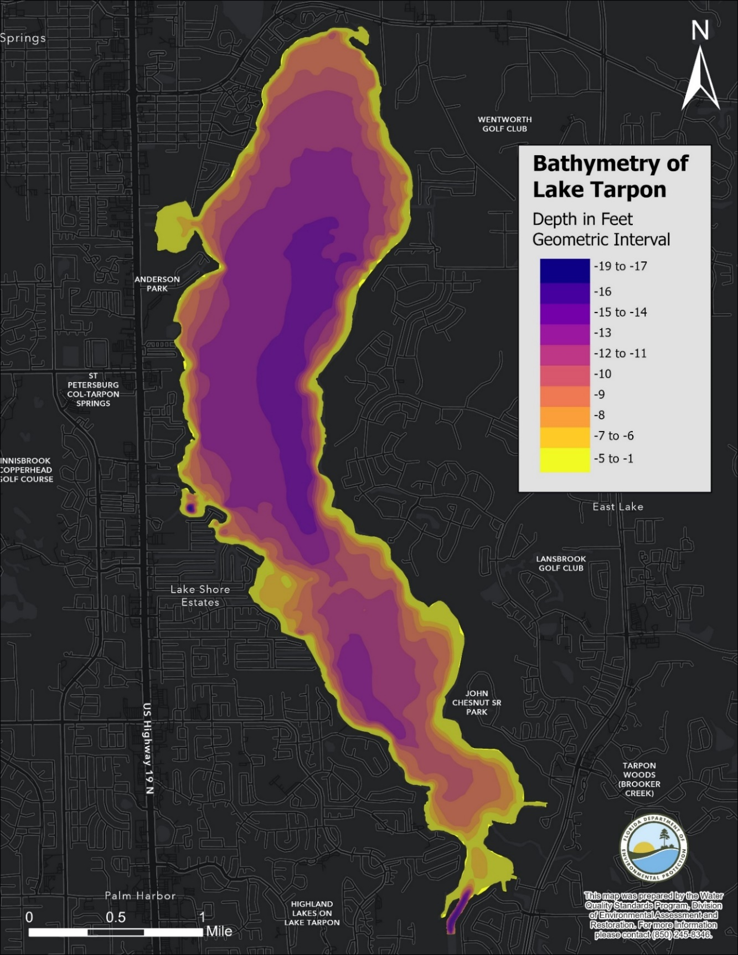General Bathymetric features of Lake Tarpon. Source: FWC Bathymetry of Select Lakes in Florida GIS coverage
2. 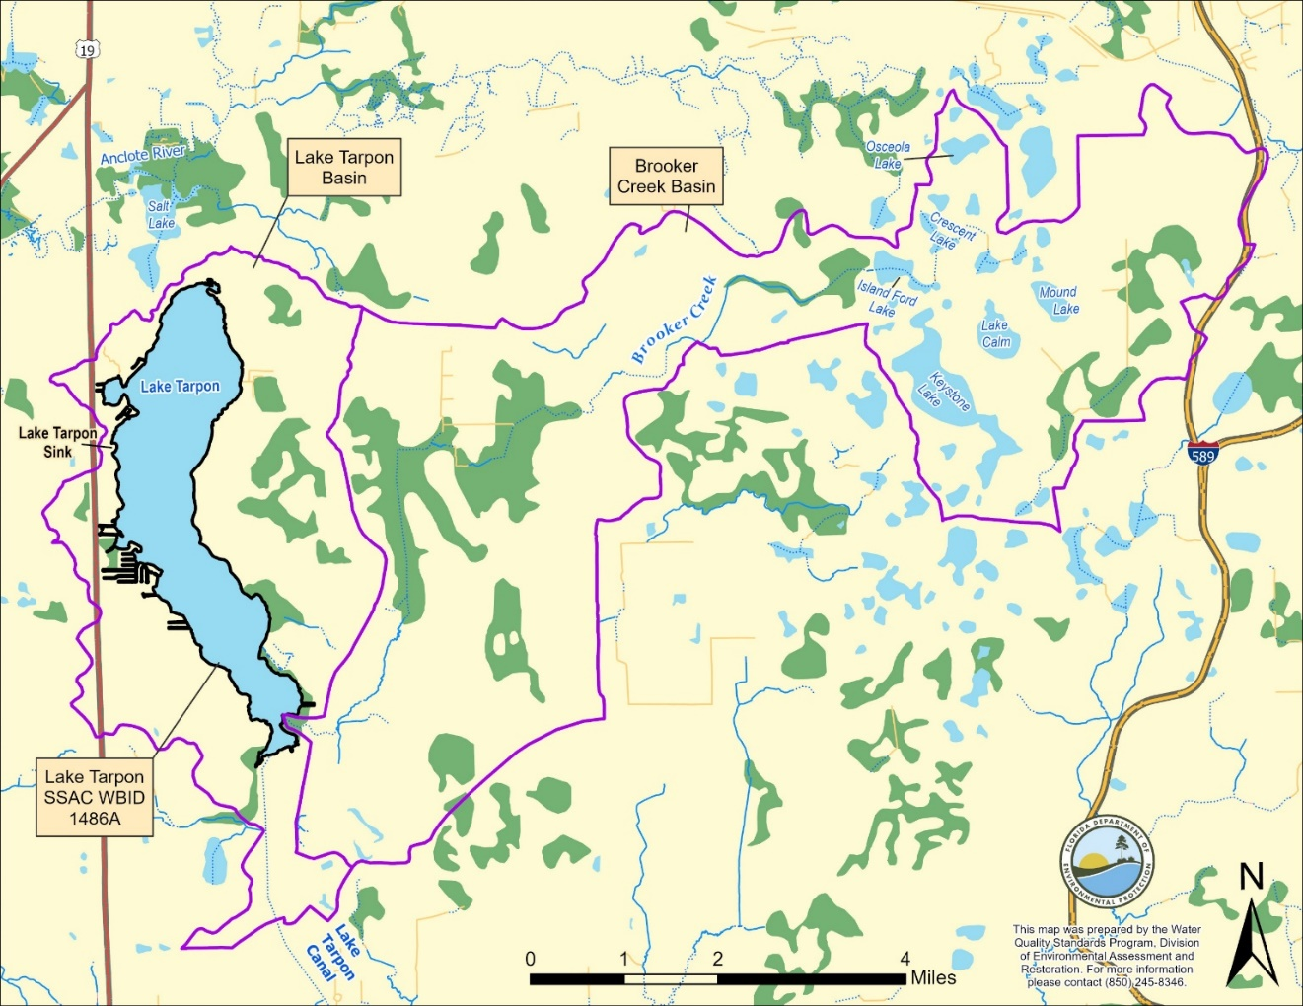Map illustrating the proposed extent of the Type III Lake Tarpon Nutrient SSACs (WBID 1486A) and associated drainage basins.

### Hydrogeological setting

The Lake Tarpon watershed has a subtropical climate and receives an annual average rainfall of approximately 52 inches (Pinellas County Water Atlas, N.D.). Atkins (2017) analyzed data from 1995 to 2012 and showed that variations in Chl*-a* were related to water levels and residence time, which are affected by rainfall and lake level control. Lower rainfall years are likely to have higher Chl*-a*.

Lake Tarpon is located in the Tampa Plain Lake region. The soils in the western half of the Lake Tarpon watershed are predominantly NRCS hydrologic soil group (HSG) type A, which are well-drained sandy soils. In the eastern half of the watershed, soils range from type A to type D, but are mostly type B/D (moderately drained). Water elevation in Lake Tarpon proper is likely to respond quickly during rainfall events due to the predominance of soil types with high infiltration rates in the immediate watershed (Atkins, 2017). **Figure 3** provides a general overview of the soil types located within the Lake Tarpon Watershed.

1. 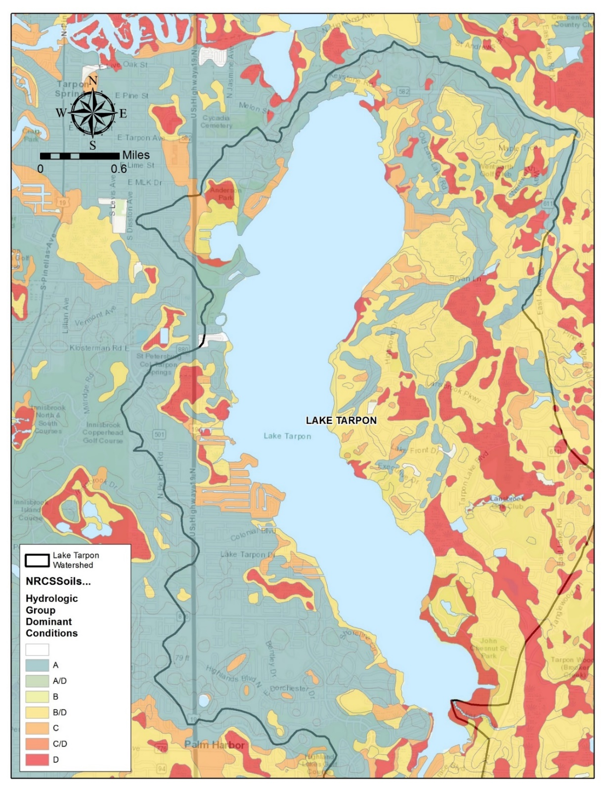General overview of the soil types located within the Lake Tarpon Watershed.

### Land use

The department’s publicly available Statewide Land Use Land Cover GIS data layer was utilized to evaluate and summarize current Level 2 land uses in the Lake Tarpon and adjacent Brooker Creek watersheds (boundaries based on SWFWMD drainage basins). The Level 2 land use is the second highest level designation in a hierarchical coding scheme that contains 4 levels that describe land information of increasing specificity (FDOT, 1999). The Statewide Land Use Land Cover GIS layer is a compilation of the land use/land cover imagery-based datasets created by the five water management districts. Summaries of the Level 2 land use categories contained within these individual watersheds are provided in **Tables 2 and 3**. The Lake Tarpon and Brooker Creek watersheds are primarily comprised of urban land uses (approximately 51% and 35%, respectively). Wetland areas comprise the second-most prevalent land use type in these watersheds (Tarpon- approximately 15%, Brooker- approximately 30%). Additionally, there are two large lakeshore parks, John Chesnut Sr. Park and A.L. Anderson Park, both maintained by Pinellas County.

1. Level 2 Land Use in Lake Tarpon Watershed

| Level 2 Land Use | Level 2 Land Use Code | Acres | Percent of Total Acres |
| --- | --- | --- | --- |
| Commercial and Services | 1400 | 305.42 | 3.05 |
| Communications | 8200 | 1.94 | 0.02 |
| Institutional | 1700 | 165.83 | 1.65 |
| Lakes | 5200 | 2509.25 | 25.02 |
| Non-Vegetated Wetlands | 6500 | 16.47 | 0.16 |
| Nurseries and Vineyards | 2400 | 0.47 | 0.00 |
| Open Land | 1900 | 107.20 | 1.07 |
| Recreational | 1800 | 534.67 | 5.33 |
| Reservoirs | 5300 | 228.76 | 2.28 |
| Residential High Density | 1300 | 2170.86 | 21.64 |
| Residential Low Density | 1100 | 753.15 | 7.51 |
| Residential Medium Density | 1200 | 1291.17 | 12.87 |
| Streams and Waterways | 5100 | 71.82 | 0.72 |
| Transportation | 8100 | 233.25 | 2.33 |
| Upland Coniferous Forests | 4100 | 31.75 | 0.32 |
| Upland Mixed Forests | 4300 | 98.53 | 0.98 |
| Utilities | 8300 | 62.70 | 0.63 |
| Vegetated Non-Forested Wetlands | 6400 | 203.11 | 2.03 |
| Wetland Coniferous Forests | 6200 | 326.61 | 3.26 |
| Wetland Forested Mixed | 6300 | 126.92 | 1.27 |
| Wetland Hardwood Forests | 6100 | 789.88 | 7.88 |
| Total | N/A | 10029.77 | 100 |

1. Level 2 Land Use in the Brooker Creek Watershed

| **Level 2 Land Use** | **Level 2 Land Use Code** | **Acres** | **Percent of Total Acres** |
| --- | --- | --- | --- |
| Commercial and Services | 1400 | 42.03 | 0.22 |
| Cropland and Pastureland | 2100 | 1221.86 | 6.33 |
| Disturbed Lands | 7400 | 19.63 | 0.10 |
| Extractive | 1600 | 91.46 | 0.47 |
| Herbaceous | 3100 | 9.69 | 0.05 |
| Institutional | 1700 | 136.04 | 0.70 |
| Lakes | 5200 | 1053.67 | 5.46 |
| Mixed Rangeland | 3300 | 143.40 | 0.74 |
| Non-Vegetated Wetlands | 6500 | 26.08 | 0.14 |
| Nurseries and Vineyards | 2400 | 96.07 | 0.50 |
| Open Land | 1900 | 365.05 | 1.89 |
| Other Open Lands <Rural> | 2600 | 297.58 | 1.54 |
| Recreational | 1800 | 508.51 | 2.64 |
| Reservoirs | 5300 | 525.83 | 2.73 |
| Residential High Density | 1300 | 885.34 | 4.59 |
| Residential Low Density | 1100 | 2888.33 | 14.97 |
| Residential Medium Density | 1200 | 2165.43 | 11.22 |
| Shrub and Brushland | 3200 | 69.29 | 0.36 |
| Specialty Farms | 2500 | 83.43 | 0.43 |
| Transportation | 8100 | 148.38 | 0.77 |
| Tree Crops | 2200 | 36.39 | 0.19 |
| Tree Plantations | 4400 | 136.90 | 0.71 |
| Upland Coniferous Forests | 4100 | 1026.40 | 5.32 |
| Upland Hardwood Forests | 4200 | 5.48 | 0.03 |
| Upland Mixed Forests | 4300 | 1854.96 | 9.61 |
| Utilities | 8300 | 90.04 | 0.47 |
| Vegetated Non-Forested Wetlands | 6400 | 558.41 | 2.89 |
| Wetland Coniferous Forests | 6200 | 2871.27 | 14.88 |
| Wetland Forested Mixed | 6300 | 725.38 | 3.76 |
| Wetland Hardwood Forests | 6100 | 1214.06 | 6.29 |
| Total | N/A | 19296.42 | 100.00 |

### Potential sources of anthropogenic influence

Wastewater facilities

There are no NPDES facilities that have direct surface water discharges to Lake Tarpon. There are two permitted wastewater treatment facilities (WWTFs) just outside of the Lake Tarpon watershed boundary, less than a mile west of the lakeshore that discharge through land applications but could potentially affect the groundwater surrounding the lake. The first is the Tarponaire Mobile Resort WWTF (permit FLA012907), which has a permitted capacity of 0.0125 million gallons per day (MGD) as a three-month rolling average daily flow. It is a type III, extended aeration domestic wastewater treatment plant, and effluent is land-applied to rapid infiltration basins (RIBs). The second is the Quality Inn WWTF-Tarpon Springs (permit FLA012903), which has a permitted capacity of 0.020 MGD as a three-month rolling average daily flow. It is also a type III, extended aeration domestic wastewater treatment plant (WWTP), and effluent is land-applied to RIBs.

There is also one permitted WWTF on the border of the Brooker Creek watershed in Hillsborough County (Silver Dollar Resort WWTP-permit FLA012140). This facility has a 0.0485 MGD as a three-month average daily flow permitted capacity land application system. Reclaimed water from the WWTF is routed through two polishing ponds having a total bottom area of 31,514 square feet prior to discharge to the reuse land application system. R-001 consists of a Part II Restricted Public Access spray irrigation system consisting of a spray irrigation field having a total area of seven acres. The location of each of these facilities is illustrated in **Figure 4.** It is not anticipated that any of these facilities are adversely impacting the water quality in Lake Tarpon.

There are also several reuse systems in the surrounding area that utilize reclaimed water for irrigation purposes. The William E Dunn Water Reclamation Facility (FL0128775) transfers reclaimed water meeting Part III public access quality standards to the Northwest Pinellas Master Reuse System. The Northwest Pinellas Master Reuse System is an existing 12.8 MGD Annual Average Daily Flow (AADF) permitted capacity slow-rate public access system. The reuse system is generally located in northern Pinellas County and is primarily composed of spray irrigation of golf courses, common areas, residential subdivisions, parks, schools, athletic facilities, and other various public and private parcels. Additional reclaimed water meeting Part III Public Access standards is provided by two existing separately permitted facilities: City of Clearwater Master Reuse System (FL0186261) – 3.0 MGD AADF and City of Oldsmar Advanced WWTF (AWWTF) (FL0027651) – 0.800 MGD AADF. Reclaimed water may be stored in irrigation lakes. The storage lake systems may intermittently overflow through control structures during storm events. If overflow were to occur, the receiving waterbody for the Tarpon Woods Driving Range Lake, Tarpon Woods Back Pond, East Lake Woodlands North Pond, and East Lake Woodlands Maintenance Area Pond is Brooker Creek. The locations of these irrigation ponds and reuse systems are not included in **Figure 4.** It is not anticipated that these intermittent discharges are adversely affecting the water quality in Lake Tarpon.

1. 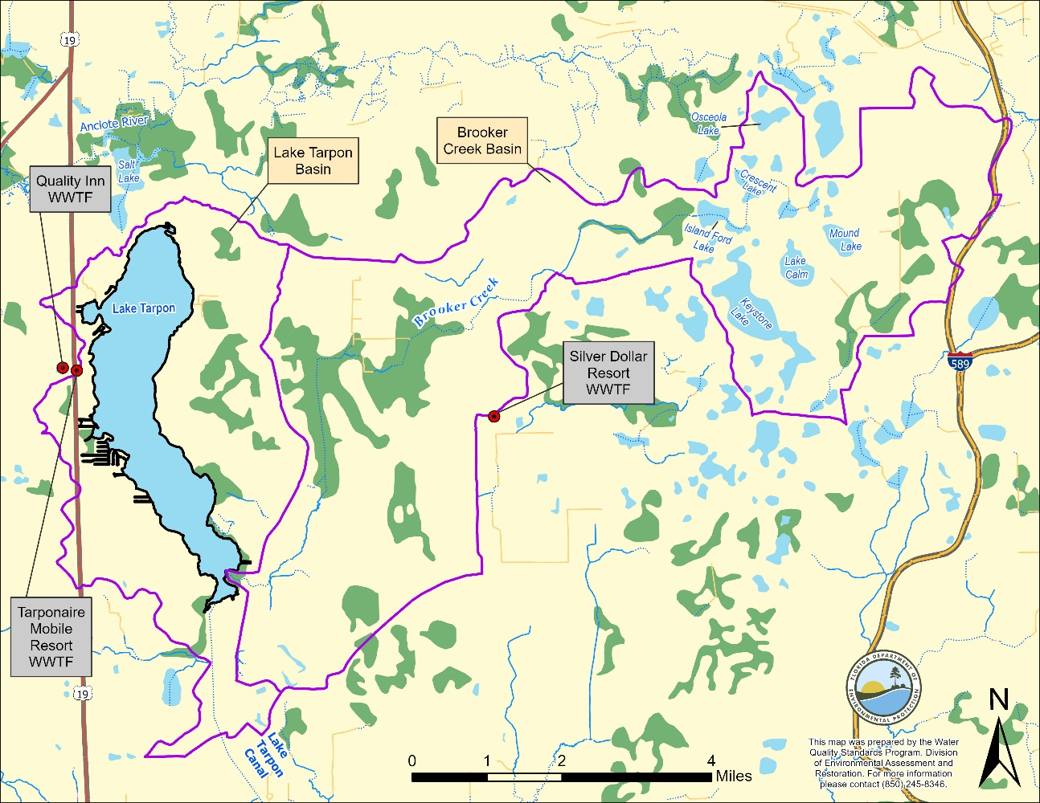Map illustrating the permitted wastewater treatment facilities in or near the Lake Tarpon or Brooker Creek Basins.

Municipal Separate Storm Sewer System (MS4) permits

NPDES Phase I_C MS4 permit ID FLS000005, whose permittee is Pinellas County and several other co-permittees, covers the entirety of the Lake Tarpon watershed. The Pinellas County Board of Commissioners also adopted a [comprehensive stormwater management plan](https://pinellas.gov/wp-content/uploads/2021/11/Stormwater_Manual.pdf) for the county. The current version of the manual has an effective date of April 23, 2024.

Onsite Sewage and Treatment Systems (OSTDS; aka septic systems)

There are also septic systems within the Lake Tarpon watershed, primarily located in the northernmost portion of the watershed near Tarpon Springs (**Figure 5**). However, these domestic wastewater sources would not have any direct surface water discharges but could potentially influence the surficial groundwater in the lake’s watershed. **Figure 5** also shows septic systems in the Brooker Creek watershed, primarily located within Hillsborough County, surrounding Keystone Lake.

1. 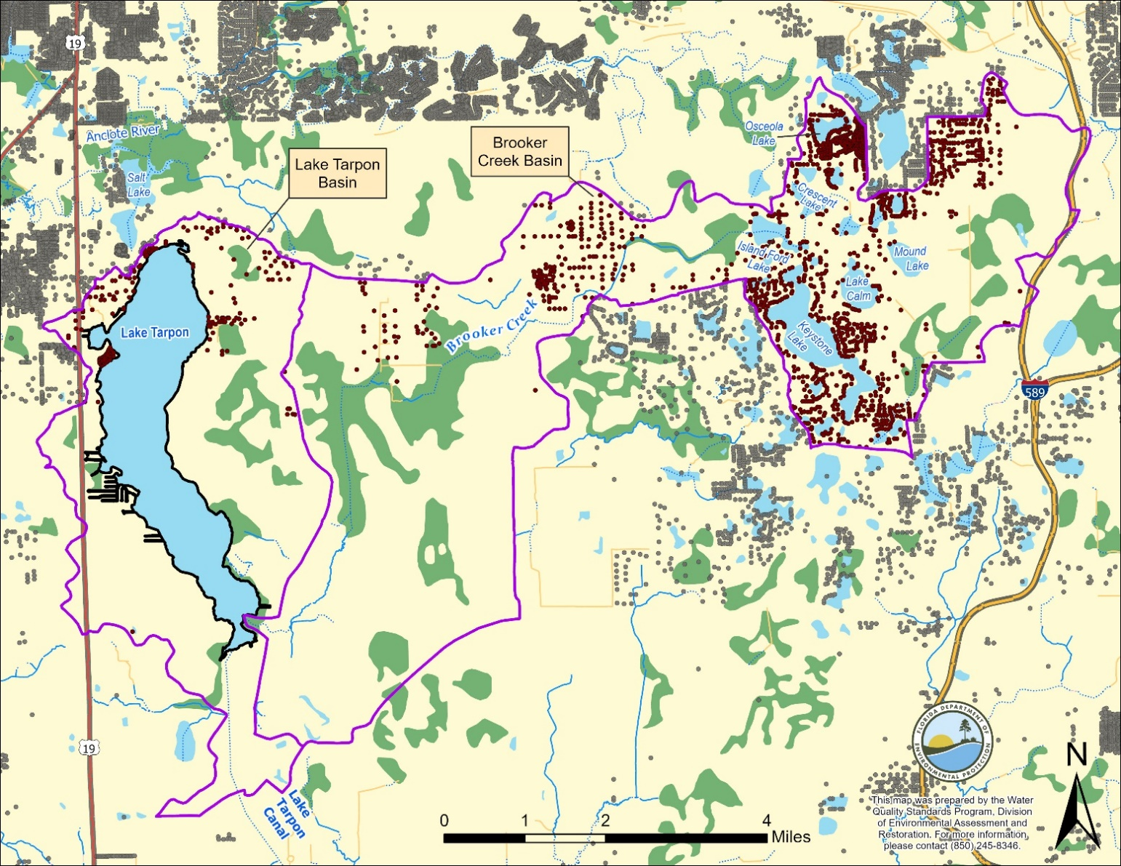General location of centroid of the properties that contain septic systems in the Lake Tarpon and Brooker Creek Drainage Basins. Source: Florida Water Management Inventory 2021 OSTDS layer.

## Planning and Restoration Efforts

Lake Tarpon is a regionally important waterbody for recreation and quality of life in Pinellas County, and there have been many efforts to study the lake and address water quality and ecological problems over the past 35 years. In 1987, there was a major algal bloom on the lake that spurred the establishment of the Lake Tarpon Management Committee and ultimately the development of the first Surface Water Improvement and Management (SWIM) plan for the lake in 1989. The SWIM Program evaluates priority waterbodies of state significance, identifies issues and drivers, and implements projects to improve water quality and habitat. Since then, several research and management reports have been written, and they contain recommendations for habitat restoration and nutrient reduction actions. The habitat restoration is primarily focused on the littoral zone, with removal of cattails and planting of a more diverse native plant community. Nutrient reduction efforts have been directed at stormwater management systems and homeowners, with the goal of protecting a variety of native submersed plants and preventing algal blooms. Pinellas County and the SWFWMD have invested millions of dollars into the restoration projects described below, and they are committed to maintaining these projects and initiating new projects to protect Lake Tarpon from effects of increased urbanization.

Local ordinances

The Lake Tarpon basin was designated as a nutrient-sensitive watershed by the Pinellas County Board of Commissioners and City of Tarpon Springs Board of Commissioners in 1999.

Pinellas County instituted a [comprehensive fertilizer ordinance](https://pinellas.gov/pinellas-county-fertilizer-ordinance/) in 2010 intended to reduce stormwater runoff of nutrients. The ordinance includes seasonal and weather-related restrictions, fertilizer-free zones, and guidance regarding fertilizer content, application rate, and mode of application relevant to different landscape types.

Other Restoration Efforts

In 2009, Pinellas County initiated the Lake Tarpon Area 6 Stormwater Treatment Facility project. Through this project, the County constructed an alum stormwater treatment system to more effectively treat runoff from the northwest portion of the Lake Tarpon Watershed before it enters the lake. The system works by diverting runoff to a retention pond system where it is treated with alum prior to entering the system. The retention pond system outfalls over a control structure to a wetland that drains through Pinellas-owned A.L. Anderson Park and eventually into Lake Tarpon (Pinellas County Public Works Department, 2017). The parameters primarily targeted for reduction through this system are TN, TP, and total suspended solids (TSS).

The County has undertaken several habitat restoration and vegetation removal projects. Of note are two John Chesnut Sr. Park projects that occurred in 2008/2009 and 2022. In 2008, seven areas along the park had exotic vegetation removed. These areas were subsequently replanted with transplanted native vegetation such as pickerelweed (*Pontederia cordata*), arrowhead (*Sagittaria lancifolia*), bulrush (*Schoenoplectus californicus*), and yellow water lily (*Nuphar* sp.). In 2022, several acres of nuisance and invasive aquatic vegetation were removed in the southeastern portion of the lake and replanted with native freshwater vegetation including jointed spikerush (*Eleocharis interstincta*), arrowhead, bulrush, and yellow Canna (*Canna flacida*).

**Current Management Goals**

The SWFWMD oversees review and revision of the SWIM plan for Lake Tarpon. The draft 2025 SWIM plan revision includes a goal of maintaining the existing healthy conditions of Lake Tarpon. The plan also goes into more detail about the completed and planned restoration activities in the lake and watershed. In this updated plan, the SWFWMD notes that the Chl*-a* concentrations in Lake Tarpon have not declined, even as TN has declined and TP has remained low (see Section 3) with source reduction efforts. They perceive the current and recent conditions on the lake to be healthy, despite the periodic exceedances of the statewide Chl*-a* criterion.

**Recently Completed Restoration Efforts (status June 2024)**

**Lake Tarpon John Chesnut Sr. Park Shoreline Enhancement Project**

* The goal of this project was to enhance approximately 5 acres of the Pinellas County Parks’ shorelines. This was accomplished through treatment (herbicide application and harvesting) of existing invasive and nuisance aquatic plants (mainly cattail [*Typha* sp.] and primrose [*Ludwigia peruviana*]) and replanting with native vegetation. This included 25,000 bulrush (Schoenoplectus californicus), 5,000 jointed spikerush, and 5,000 Egyptian paspalidium (*Paspalidium geminatum*). This project was completed in Winter/Spring of 2024 with support being provided by Pinellas County and the Florida Fish and Wildlife Conservation Commission (FWC).

**Brooker Creek and Lake Tarpon Watershed Management Plan Updates**

* Pinellas County recently completed watershed management plan updates for both the Brooker Creek and Lake Tarpon watersheds. These plans updated the existing stormwater models, revised floodplain delineations and provided new best management practice recommendations to improve water quality, reduce flooding, and better protect natural systems. The projects were completed in January 2024 for Lake Tarpon and in April 2024 for Brooker Creek.

Future Restoration Efforts

**Septic to Sewer Conversions**

* Pinellas County Utilities is currently developing a septic to sewer conversion project in the Lake Tarpon and Brooker Creek Watersheds. Four neighborhoods in these watersheds (two in Brooker Creek and two in Lake Tarpon) have been identified as being on septic and are targets of the project. Pinellas County Utilities is conducting the first phase of the project which consists of design for the two neighborhoods in the Brooker watershed. They expect this portion to be completed within two years. The second phase will focus on the Lake Tarpon neighborhoods.

# Overview of historic and existing water quality

## Applicable Numeric Nutrient Criteria

Lake Tarpon is a Class III (fresh) waterbody, with a designated use of fish consumption, recreation, and propagation and maintenance of a healthy, well-balanced population of fish and wildlife. Florida’s generally applicable lake nutrient criteria are contained in Rule 62-302.531, F.A.C. Florida adopted numeric nutrient criteria (NNC) for lakes, spring vents, and streams in 2011. These were approved by the EPA in 2012 and became effective in 2014.

The applicable lake NNC are dependent on the long-term POR geometric mean alkalinity level, measured in milligrams per liter as calcium carbonate (mg/L as CaCO3) and true color (color), measured in platinum cobalt units (PCU). Florida lakes are classified into three categories based on their color and alkalinity as described in Rule 62-302.531, F.A.C. Lakes with long-term color levels above 40 PCU are considered “colored” lakes. Lakes with color less than 40 PCU and alkalinity above 20 mg/L are “clear alkaline” lakes, and lakes with color less than 40 PCU and alkalinity of 20 mg/L or less are “clear acidic” lakes.

The applicable NNC for each lake class are provided in **Table 4**. The applicable NNC for TN and TP can vary annually depending on whether the Chl*-a* criterion is achieved. If the AGM chlorophyll criterion for the applicable lake class is achieved, the TN and TP criteria for that year will be the maximum values listed in **Table 4**. In contrast, for years in which the Chl*-a* criterion is exceeded, or if there is insufficient data, the applicable TN and TP criteria shall be the minimum values listed in **Table 4**. The lake NNC are assessed as AGM values not to be exceeded more than once in any consecutive three-year period.

Based on data from IWR Run 64 database, Lake Tarpon is classified as a colored (> 40 PCU) lake. The chlorophyll*-a* NNC for colored lakes is an AGM value of 20 micrograms per liter (µg/L), The associated TP and TN criteria for a lake can vary annually from minimum values of 0.05 and 1.27 mg/L, respectively, to maximum values of 0.16 and 2.23 mg/L, respectively, depending on the Chl*-a* concentrations in the lake and data availability.

1. Generally Applicable Nutrient Criteria for Florida Lakes.

|  |  |  |  |  |  |
| --- | --- | --- | --- | --- | --- |
| **Long Term Geometric Mean Lake Color and Alkalinity** | **Annual Geometric Mean Chlorophyll *a*** | **Minimum Calculated Numeric Interpretation** | | **Maximum Calculated Numeric Interpretation** | |
| **Annual Geometric Mean Total Phosphorus** | **Annual Geometric Mean Total Nitrogen** | **Annual Geometric Mean Total Phosphorus** | **Annual Geometric Mean Total Nitrogen** |
| >40 Platinum Cobalt Units | 20 µg/L | 0.05 mg/L | 1.27 mg/L | 0.16 mg/L | 2.23 mg/L |
| ≤ 40 Platinum Cobalt Units and >20 mg/L as CaCO3 | 20 µg/L | 0.03 mg/L | 1.05 mg/L | 0.09 mg/L | 1.91 mg/L |
| ≤ 40 Platinum Cobalt Units and ≤20 mg/L as CaCO3 | 6 µg/L | 0.01 mg/L | 0.51 mg/L | 0.03 mg/L | 0.93 mg/L |

## 303(d) Assessment History

According to the IWR Run 64 database, Lake Tarpon was placed in assessment Category 5 (impaired) for nutrients (Chl*-a*) and for biology (LVI) during the Group 1 Cycle 4 (2019) assessment. Prior to the revision of the dissolved oxygen (DO) criteria and the development of NNC, the lake was historically listed for DO (mg/L) in 2002 and 2009 and for nutrients (historic trophic state index, TSI) during the 2009 assessment. However, following the adoption of the revised DO criteria and NNC, Lake Tarpon was delisted for both DO (percent saturation) and nutrients (historic TSI) in 2019. Additionally, during the 2020–2022 biennial assessment, Lake Tarpon was delisted from Category 5 and moved to Category 4d (study list) for biology (LVI).

## Paleolimnological Study

To help assess the current water quality and ecological status of Lake Tarpon compared to historical pre-disturbance conditions, the University of Florida (UF), Auburn University, the University of South Florida (USF), and Wood Environment & Infrastructure Solutions, Inc. conducted a paleolimnological study of the lake on behalf of Pinellas County (Wood, 2018). The study consisted of radioactive dating and analysis of three sediment cores collected in different portions of the lake. UF used radioactive dating techniques to provide a chronology of algal pigments and the chemical and physical composition of the sediments, while researchers at USF developed a chronology of historic TP and Chl*-a* levels based on sedimented diatoms by applying statistical models that are calibrated using a large number of Florida lakes. These techniques allowed the estimation of pre-disturbance (pre-1880) water quality conditions in the lake.

The analysis of the three cores suggests that the lake has always been circumneutral to slightly alkaline pH. The results from the study also indicated that Lake Tarpon has always been highly productive ranging between mesotrophic and eutrophic conditions. More specifically, based on the analyses conducted on the three sediment cores, pre-disturbance (pre-1880) TP concentrations were estimated to range from 47 to 67 µg/L with Chl*-a* levels consistently being above 20 µg/L, ranging from 21.6 to 42.5 µg/L prior to anthropogenic influence. Due to the variability, both spatially (depth) and temporally, the results from the paleolimnological study were not considered adequate for use as the sole basis for Type I SSACs for nutrients based on natural background conditions. However, the results of the study do provide important information about the pre-disturbance condition of the lake. It is also important to note that the water quality in lake Tarpon continues to exhibit significant temporal and spatial variability comparable to that observed in the paleolimnological study.

## Characterization of existing water quality conditions

To characterize the water quality for Lake Tarpon, existing water quality data for the lake were compiled, screened (following the method below), and summarized for use in derivation of the proposed SSACs. Water quality data for Lake Tarpon (WBID 1486A) and the upstream and downstream WBIDs collected during the period from 1995 through 2022 were retrieved from the DEP’s IWR database (Run 64). The period starting in 1995 was chosen because it is consistent with other analyses conducted by consultants from Atkins and ESA and presented in the 2017 *Lake Tarpon Water Quality Management Plan* (Atkins, 2017) and reflects the start of a stable period following the successful control of large-scale *Hydrilla* and algae blooms that covered a significant portion of the lake and nutrient concentration peaks that occurred in the 1970s and 1980s.

### Data Screening and Handling

Water quality data were screened based on laboratory qualifier codes, consistent with the DEP’s Quality Assurance Rule (Chapter 62-160, F.A.C.). Any datum associated with a fatal qualifier (H, J, N, O, V, Q, Y, or ?) indicating a potential data quality problem was removed from the analysis. Values that exceeded possible physical or chemical measurement constraints (*e.g*., negative DO levels), had temperatures well outside seasonal norms (*e.g*., 4° Celsius in July), or represented data transcription errors were excluded. In the Lake Tarpon dataset, approximately 33 reported TN data points were obviously in error (values significantly different from results of TKN + NOx) and were recalculated from the Total Kjeldahl Nitrogen (TKN) and Nitrate + Nitrite (NOx)data. For field parameters, measurements collected at multiple depths at the same location on the same day were considered one sample, with the arithmetic mean used to represent the vertical profile.

An additional consideration in the handling of water quality data is the accuracy and sensitivity of the laboratory method used. For the purposes of summary statistics presented in this document, data reported as less than the Method Detection Limit (MDL) were assigned a value of one-half the MDL unless otherwise noted. All data presented in this report were handled consistently with regard to screening and MDL replacement.

The screened dataset was then used to summarize water quality conditions for Lake Tarpon and the surrounding waters. The summary statistics calculated for each area and parameter include the number of samples, standard deviation, mean, median, and 10th, 25th, 75th, and 90th percentiles. The existing water quality data for nutrients and several related parameters for the area proposed for SSAC development are summarized and discussed below.

To account for the natural variability within Lake Tarpon, potential SSAC values were calculated as the 90 percent prediction interval of the AGMs for the period demonstrated to support healthy biological communities. The final proposed SSACs will be expressed as AGMs and applied such that they can be exceeded no more than once during any consecutive three-year period. Calculation of the SSACs in this manner is consistent with the derivation of NNC for other Florida waters and is expected to balance and minimize Type I (incorrectly concluding that a system is impaired, when it is actually healthy, a “false positive”) and Type II (incorrectly concluding that a system is healthy, when it is actually impaired, a “false negative”) errors associated with the application of the SSACs.

### Summary of Existing Water Quality Data

In the past 25 plus years, Lake Tarpon has been characterized by generally low nutrient (*i.e*., TN and TP) concentrations with fluctuating Chl*-a* levels that frequently exceed the 20 µg/L criterion. **Table 5** provides a summary of the available nutrient data and the data for several other associated parameters for Lake Tarpon during the period from 1995 through 2022. During this period, corrected Chl*-a* concentrations exhibited a median of 22.6 µg/L with 10th and 90th percentiles of 11.6 and 41.1 µg/L, respectively (**Table 5**). The analysis also indicates that approximately 60% of the 1,231 Chl-*a* measurements collected during this period exceeded the current 20 µg/L criterion. In contrast, the TN and TP concentrations for the lake were lower than expected given the slightly elevated Chl-*a* levels. During the 1995 to 2022 period, both TN and TP concentrations were consistently below or slightly above the lower end of the allowable criteria range provided in **Table 4**. TN concentrations exhibited a median concentration of 1.02 mg/L with 10th and 90th percentiles of 0.75 and 1.37 mg/L, respectively. Likewise, the median TP level was 0.04 mg/L with 10th and 90th percentiles of 0.01 and 0.06 mg/L, respectively.

Further analysis of the Chl*-a* and nutrient levels indicated that the lake produces more Chl-*a* than would typically be expected given the low TN and TP levels. **Figures 6 and 7** show the AGM Chl-*a* plotted versus the AGM TN and TP concentrations, respectively. The figures also include the data used to develop the generally applicable NNC for colored lakes for comparison. The figures indicate that Chl*-a* and nutrient relationships for Lake Tarpon are consistently well above the central tendency and near the upper confidence limits of the relationships used to derive the NNC for colored lakes. AGM Chl-*a* levels in Lake Tarpon are typically at or above 20 µg/L at AGM TN and/or TP levels that are below the generally applicable criteria, which indicates that the Chl-*a* response in Lake Tarpon is different from the relationship used to derive the generally applicable colored lake NNC. Specifically, Lake Tarpon tends to grow more algal biomass at lower TN and TP levels than is assumed under the generally applicable NNC. The single year in which the relationship was near the centroid of the relationship used to derive the lakes NNC was 2006 when a significant portion of the available data were collected in South Cove (*i.e*., the far southern extent of the lake) which exhibited lower Chl-*a* levels (*i.e.*, <0.85 to 2.3 µg/L) that were not characteristic of the lake in general. This analysis again indicates that Lake Tarpon has higher Chl-*a* levels than typically expected and that the generally applicable Chl-*a* criterion may not be appropriate for the lake. These findings are consistent with the paleolimnological study that indicated that the lake has always been slightly eutrophic with Chl-*a* levels commonly above 20 µg/L even prior to human disturbance.

Plots of AGM Chl*-a*, TN, and TP concentrations over the 1995 to 2022 period provided in **Figures 8 to 10**, respectively, indicate that there is not an increasing or decreasing trend in nutrient concentrations over the period. Additionally, the fluctuations in Chl*-a* concentrations do not appear to be associated with changes in nutrient levels. This is consistent with the analyses conducted by Atkins and ESA on behalf of Pinellas County and presented in the 2017 *Lake Tarpon Water Quality Management Plan* (Atkins, 2017). They provided an analysis of the 18 years of water quality data collected from 1995 to 2012 and concluded that there were no increasing or decreasing trends in TN, TP, or Chl*-a* over the study period. Further, they found that the fluctuating Chl*-a* concentrations were more related to lake elevation management, residence time, and the abundance and treatment of submerged aquatic vegetation (SAV) than nutrient levels. Higher Chl*-a* concentrations were associated with periods of lower rainfall and longer residence time of water in the lake and were also associated with periods of large-scale herbicide treatments to control invasive SAV.

Elevated nutrient levels can also potentially depress DO levels by increasing oxygen demand. However, the percent DO saturation is consistently above the Peninsula freshwater criterion of 38% (subsection 62-302.533(1), F.A.C.) with median levels of 84.1% and 10th and 90th percentiles of 58.5 and 100.2%, respectively (**Table 5**). Also, DO saturation (%) has not shown a decreasing trend over the 1995 to 2022 period (**Figure 11**) indicating the DO levels are not being adversely affected by nutrients in Lake Tarpon.

The pH in Lake Tarpon is characterized by slightly alkaline pH levels with a median pH of 7.8 units since 1995. Lake Tarpon’s pH levels are consistently within the allowable range of 6.0 to 8.5 pH units. Lake Tarpon also has slightly higher specific conductance levels than many Florida lakes with a median level of 669 µmhos/cm and 10th and 90th percentiles of 453 and 982 µmhos/cm, respectively. Specific conductance levels in Lake Tarpon are consistently below the freshwater criteria that allows a maximum of 1275 µmhos/cm or 50% above background, whichever is greater (subsection 62-302.530(22), F.A.C.). Additionally, the lake has moderate levels of total organic carbon (TOC) with a median concentration of 13 mg/L since 1995. A more complete summary of the water quality for Lake Tarpon, the Brooker Creek tributary, and the waters of the Lake Tarpon Discharge Canal can be found in **Appendix A**.

Summary of water quality for Lake Tarpon (WBID 1486A) for the period from 1995 through 2022.

|  |  |  |  |  |  |  |  |  |
| --- | --- | --- | --- | --- | --- | --- | --- | --- |
| Parameter | Count | Standard Deviation | Mean | 10th Percentile | 25th Percentile | Median | 75th Percentile | 90th Percentile |
| Alkalinity, mg/L as CaCO3 | 309 | 8 | 58 | 49 | 53 | 58 | 61 | 67 |
| Chlorophyll*-a* (corrected), µg/L | 1231 | 11.75 | 24.78 | 11.56 | 16.4 | 22.6 | 31.3 | 41.08 |
| Color, PCU | 649 | 23 | 57 | 35 | 40 | 50 | 70 | 90 |
| DO Saturation, % | 1483 | 17.1 | 81.4 | 58.5 | 71.8 | 84.1 | 92.8 | 100.2 |
| pH, standard units | 1525 | 0.4 | 7.8 | 7.3 | 7.5 | 7.8 | 8.1 | 8.4 |
| Specific Conductance, µmhos/cm | 1526 | 208 | 699 | 453 | 540 | 669 | 839 | 982 |
| Total Nitrogen, mg/L | 996 | 0.25 | 1.05 | 0.75 | 0.88 | 1.02 | 1.18 | 1.37 |
| Total Organic Carbon, mg/L | 55 | 2.8 | 13.6 | 11 | 12 | 13 | 14 | 17 |
| Total Phosphorus, mg/L | 1206 | 0.022 | 0.039 | 0.01 | 0.03 | 0.04 | 0.05 | 0.06 |

1. 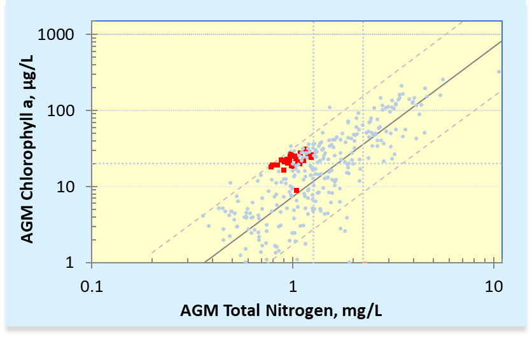Chlorophyll*-a* annual geometric mean (AGM) versus total nitrogen (TN) AGM relationship used to derive generally applicable NNC for lakes (blue points) and dashed lines (confidence limits) with chlorophyll-*a* and TN data for Lake Tarpon (red squares) for 1995 to 2022. Dotted lines show chlorophyll-*a* and minimum and maximum TN thresholds.

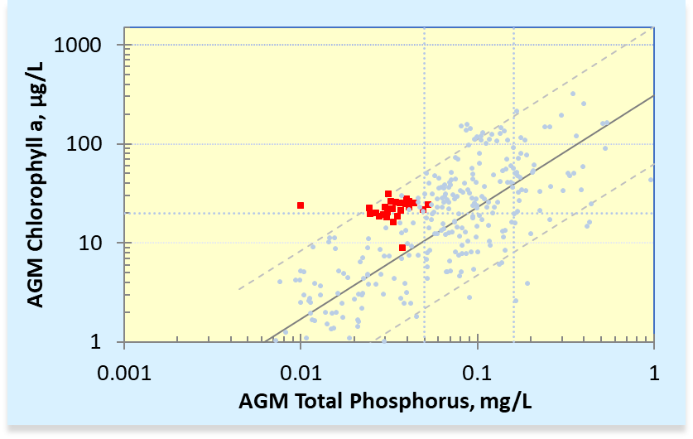

1. Chlorophyll*-a* annual geometric mean (AGM) versus total phosphorus (TP) AGM relationship used to derive generally applicable NNC for lakes (blue points) and dashed lines (confidence limits) with chlorophyll*-a* and TP data for Lake Tarpon (red squares) for 1995 to 2022. Dotted lines show chlorophyll-*a* and minimum and maximum TP thresholds.
2. 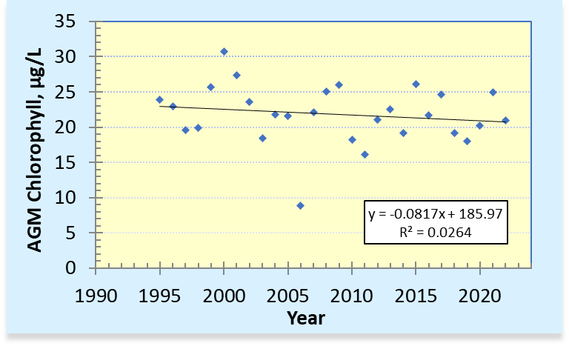Annual geometric mean (AGM) chlorophyll*-a* concentrations for Lake Tarpon from 1995 to 2022 (*p* = 0.4089).

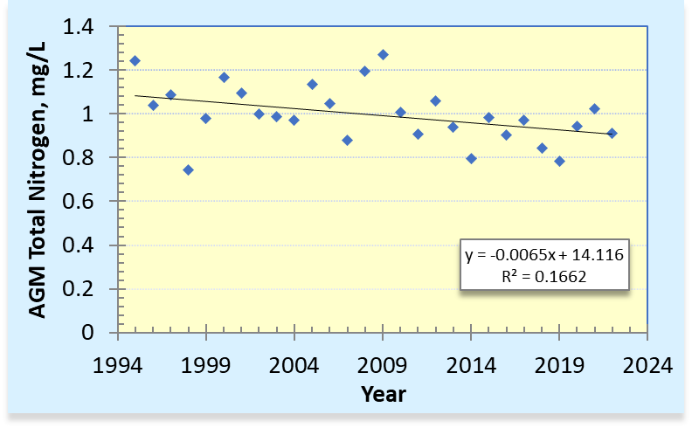

1. Annual geometric mean (AGM) total nitrogen concentrations for Lake Tarpon from 1995 to 2022 (*p* = 0.0313).
2. 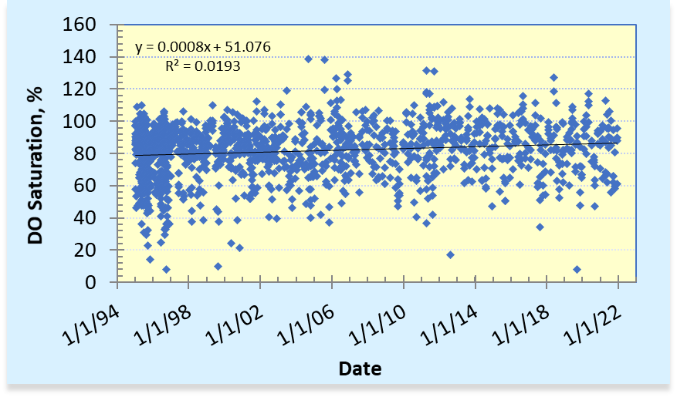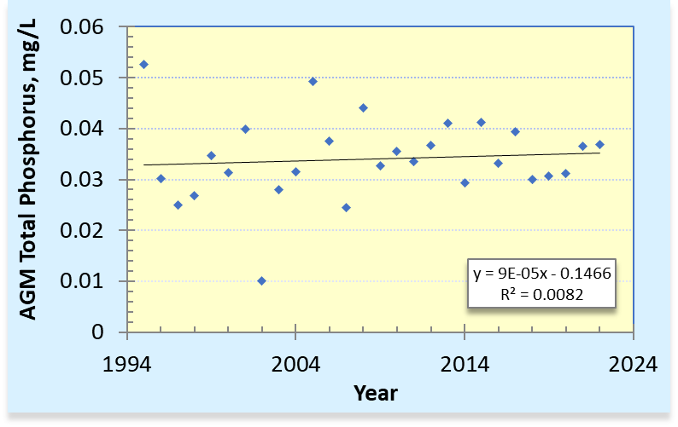Annual geometric mean (AGM) total phosphorus concentrations for Lake Tarpon from 1995 to 2022 (*p* = 0.6474).
3. Dissolved oxygen (DO) saturation (%) levels for Lake Tarpon from 1995 to 2022.

# Characterization of historic and existing biological conditions

As previously stated, a Type III SSAC for lakes must include information on Chl*-a* levels, algal mats or blooms indicating that there is not an imbalance in flora or fauna, and at least two temporally independent LVIs, with an average score of 43 or above. For this biological demonstration, the department evaluated available LVI data, other vegetation surveys, plant management data, phytoplankton community data, and fish community data summaries in order to determine a period of time with healthy, well-balanced communities. TN, TP, and Chl*-a* data from that period could then be used to calculate SSACs for Lake Tarpon that would be protective of the designated use. Evaluation of these biological data showed that there were spikes in abundance of invasive, non-native plants and in potentially toxin-producing cyanobacteria prior to 2010. Vegetation surveys show that Lake Tarpon has been dominated by beneficial native plants since detailed surveys began in 2015, and the average LVI score from 2017 to 2022 meets the department’s threshold for a healthy, well-balanced plant community. Fish survey data show that Lake Tarpon consistently supports a strong fishery with a balanced community of sport and prey fish. Detailed review for each of these community types is provided below.

## Aquatic Vegetation Community Health

Lake Vegetation Index (LVI) Surveys

Pinellas County and the department have surveyed the health of aquatic and wetland plants since 2010 using the department’s LVI methodology. The LVI is a multi-metric index of biological integrity that is sampled and calculated using methods described in the department’s Standard Operating Procedure (SOP) [LVI 1000](https://www.flrules.org/gateway/reference.asp?No=Ref-07982). Using this method, samplers conduct a visual survey of aquatic and wetland plants within four randomly selected sections (out of 12 total sections) of the lake and determine one dominant or two codominant taxa for each section. Four metrics comprise the final LVI score. Three metrics are calculated based on percentages of types of taxa present/absent in each of the four sections, and the fourth metric is based on the dominant and codominant plant taxa. The department developed impairment thresholds for the LVI by evaluating scores of reference sites and through the evaluation of community structure and function based on lake taxa lists by lake plant experts (Wellendorf *et al*., 2019). An average score of 43 or above is considered healthy. At least two temporally independent LVIs with an average score of 43 or above are needed as part of the narrative nutrient criterion attainment demonstration for a Type III SSAC.

All LVI data collected by the department and Pinellas County for Lake Tarpon were pulled from the department’s SBIO database or received by the department in spreadsheets, respectively. Those data were combined and summarized to demonstrate the health of the system. All sampling teams that produced these data passed DEP’s required LVI team proficiency demonstrations, and all data were reviewed for calculation errors. Lake Tarpon LVI scores ranged from 34 to 52 for the 14 measurements collected during the period from 2010 to 2022, for an average and median score of 41 (**Table 6**). The seven measurements collected in the last five years (*i.e*., 2017 to 2022) averaged 43.6. A summary of the plant species identified during the LVI sample collections is located in **Appendix B**.

The range of scores does not clearly indicate an upward or downward trend, but rather is a result of the variability in the relative abundance of taxa from year to year, the inherent variability in the method (includes effects of selected sampling sections and different investigators), and other factors such as water level and management activities. LVI metric data also show generally consistent quality of codominant taxa, and consistent percentages of native, sensitive, and invasive exotic taxa, which are affected by the total number of taxa observed (**Figure 12**). Since three of the four LVI metrics are calculated based on taxon presence/absence, minimal occurrence of exotic and nuisance plant taxa can depress the final LVI score, even if more desirable plants are dominant or codominant. The LVI survey includes emergent vegetation in addition to submersed vegetation. In Lake Tarpon, the emergent vegetation composition has been affected by water level control because maintenance of high water allowed cattails (*Typha* sp.) to expand along the shorelines. While cattails are native plants, they are tolerant species and therefore contribute to low LVI scores. Active restoration efforts are underway in areas where cattails are abundant to replace them with a more diverse array of native plants.

Most LVI scores collected in Lake Tarpon since 2017 have passed the impairment threshold of 43 points, and the average of those scores meets the threshold, indicating that Lake Tarpon and its water quality support a healthy plant community.

Available LVI results for Lake Tarpon 2010-2022.

| **Sample Date** | **Sampling Agency** | **LVI Result** | **Dominant Taxa\*** |
| --- | --- | --- | --- |
| 7/28/2010 | DEP | 52 | *P. illinoensis, C. demersum* |
| 6/20/2011 | DEP | 35 | *P. illinoensis, C. demersum, Typha* |
| 9/12/2011 | DEP | 40 | *P. illinoensis, S. californicus, Typha* |
| 9/8/2014 | DEP | 36 | *P. illinoensis, C. demersum, Typha* |
| 9/12/2014 | Pinellas Co | 34 | *P. illinoensis, C. demersum* |
| 8/26/2015 | Pinellas Co | 40 | *P. illinoensis, C. occidentalis* |
| 8/10/2016 | Pinellas Co | 35 | *P. illinoensis, C. demersum* |
| 8/25/2017 | Pinellas Co | 42 | *P. illinoensis, C. demersum* |
| 8/21/2018 | Pinellas Co | 44 | *P. illinoesnis, C. demersum, V. americana* |
| 9/6/2019 | Pinellas Co | 43 | *P. illinoesnis, C. demersum, V. americana* |
| 7/16/2020 | Pinellas Co | 38 | *P. illinoensis* |
| 7/9/2021 | Pinellas Co | 45 | *P. illinoensis, C. demersum* |
| 5/1/2022 | DEP | 43 | *P. illinoensis, Typha* |
| 8/23/2022 | Pinellas Co | 50 | *P. illinoensis* |

*\*Potamogeton illinoensis* = Illinois pondweed; *Ceratophyllum demersum* = coontail; *Typha* = cattails; *Schoenoplectus californicus* = bulrush; *Cephalanthus occidentalis* = buttonbush; *Vallisneria americana* = eelgrass.

1. Total LVI score, total taxa observed, and average scores for LVI metrics for each LVI assessment listed in Table 6.

To more thoroughly evaluate the aquatic plant community in Lake Tarpon, a more in-depth analysis of the extensive surveys of the aquatic plant community performed by FWC and the USF was conducted to help interpret the LVI and the fluctuations observed in the scores. The results of these analyses are provided below.

Integrated Plant Management Surveys and Treatment

The FWC conducts rapid visual plant surveys on Lake Tarpon for its Integrated Plant Management Program (IPM) to determine whether coverage of invasive exotic plants is sufficient to warrant control. These surveys represent estimates of plant coverage but also provide a good long-term view of invasive exotic plant coverage on Lake Tarpon. FWC’s management objective for Lake Tarpon is to “*manage floating invasive plants at low levels to conserve or enhance the major uses and functions of the waterbody.* Hydrilla *populations will be monitored. Burhead sedge, crested floating heart, and water primrose are all managed to prevent further establishment and expansion throughout the lake and to prevent loss of beneficial native species diversity*.” FWC works to maintain low abundance of invasive exotics by preventive treatment, and competition from native plants helps to suppress the invasive exotics. The department pulled plant survey and treatment data from FWC’s interactive “[What’s Happening on My Lake](https://gis.myfwc.com/whoml/)” website.

Based on the long-term IPM data, large expanses of the invasive non-native submersed *Hydrilla* (*Hydrilla verticillata*) were present in Lake Tarpon from 1982 to 2008 (**Figure 13**), with a maximum of 500 acres observed in 1992. While invasive exotic species are still present on the lake, they are much less abundant (**Figure 13**) and fewer acres were treated with herbicides in recent years compared to years prior to 2010 (**Figure 14**). Since 2010, fewer than 100 *cumulative* acres (*i.e*., less than approximately 0.3% of the 32,000-acre total lake area) have been treated annually.

Atkins (2017) suggested that higher annual average Chl-*a* concentrations were associated with larger scale *Hydrilla* treatments in Lake Tarpon from 1994 to 2002. LVI data were not available prior to 2010. However, when LVI data for Lake Tarpon are plotted against TN and TP concentrations (**Figures 15 and 16**), there is a positive, but not statistically significant, relationship (*i.e.*, as TN and TP concentrations increase, the LVI scores also increase). The relationship between LVI scores and Chl-*a* concentrations is not as strong, but the LVI tended to increase as Chl-*a* levels increased (**Figure 17**). While these relationships do not necessarily indicate a cause and effect, they do indicate that the current (since 2010) range of nutrients observed in Lake Tarpon are not having an adverse effect on the plant community.

1. Total acres of invasive exotic plants observed per year on Lake Tarpon from 1982 to 2022 shown on the upper graph, with the period of 2010 to 2022 shown on a smaller scale in the lower graph. Taxa were included if they had > 1 acre coverage in at least one year. Source: FWC Invasive Plant Management Section.
2. 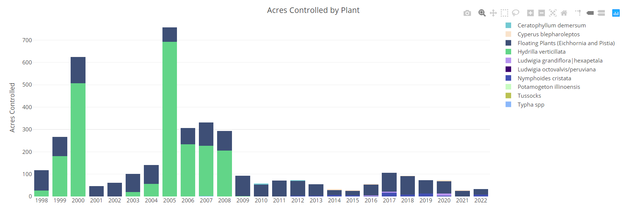Acres of plants controlled on Lake Tarpon from 1998 to 2022. Acres represent the cumulative acres treated throughout each year. Source: FWC Invasive Plant Management Section.

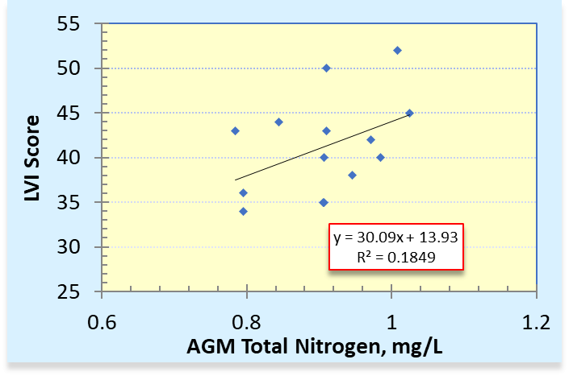

1. Relationship between LVI scores and total nitrogen concentrations in Lake Tarpon for the period from 2010 to 2022 (*p* = 0.125).
2. 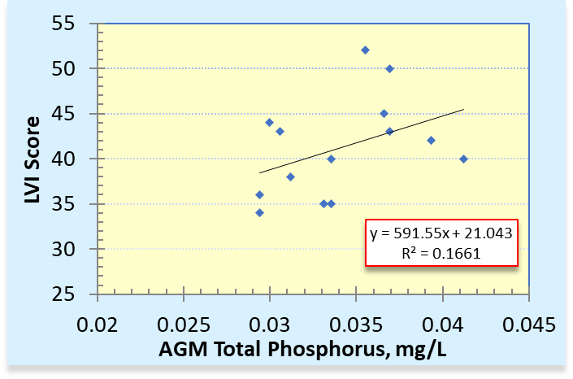Relationship between LVI scores and total phosphorus concentrations in Lake Tarpon for the period from 2010 to 2022 (*p* = 0.148).

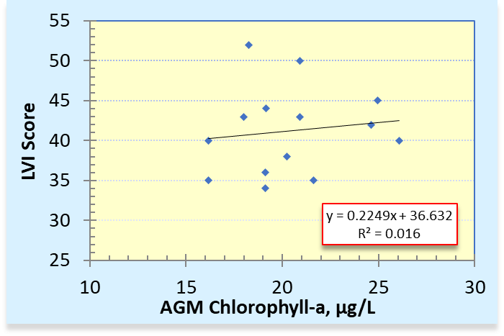

1. Relationship between LVI scores and chlorophyll*-a* concentrations in Lake Tarpon for the period from 2010 to 2022 (*p* = 0.667).

FWC and USF Lake Vegetation Surveys

FWC and USF mapped SAV in Lake Tarpon using hydroacoustic sensors with field verification from 2015 to 2021. The department received USF data through reports from Pinellas County and received FWC data from FWC staff. These surveys include bathymetric mapping along pre-defined grids throughout the lake and detection of SAV with hydroacoustic sensors. The hydroacoustic data were processed to calculate percent area covered (PAC) and percent volume inhabited (PVI) by vegetation in Lake Tarpon. The hydroacoustic mapping quantified the amount of SAV but not the species composition. To determine which SAV species were present, both groups used an underwater rake at verification points throughout the inhabited area and they also noted emergent species observed at verification points. FWC investigators noted the density of each taxon at the verification points as sparse, moderate, or dense. Percent coverage of each species sampled with the rake was calculated from the total number of vegetated points.

Results show that the SAV was restricted to the perimeter of Lake Tarpon due to the lake’s bathymetry (**Figure 18**), and the average deep edge of the SAV beds was typically 7–8 feet. The PAC for FWC surveys was around 20% for all years. Similarly, the USF survey results for 2015 and 2019 showed PAC values of 16% and 20%, respectively. The PVI values for the two USF surveys are 1.6% and 1.9%, respectively, while PVI values for the FWC surveys ranged from 5% to 9%. These PVI estimates probably differ between investigators due to variation in calculation approaches and/or bathymetry data used to estimate volume.

**Tables 7 and 8** list the most common species found at these verification points and some measure of frequency and density. Illinois pondweed (*Potamogeton illinoensis*)*,* coontail(*Ceratophyllum demersum*)and eelgrass (*Vallisneria americana*)were the most common SAV species present during all events by both entities and each of these species are beneficial Florida natives.

It is notable that both surveys show a slight increase in the percent occurrence of *Hydrilla* since 2015, but the percentage of verification points where it occurred remained at or below 7% during all years. Further, no increase in the dominance of *Hydrilla* was observed (**Tables 7 and 8**). FWC monitors *Hydrilla* annually and will treat to remove it if it becomes too abundant. Some of the changes in the relative abundance of species observed from 2016 to 2017 in FWC surveys may reflect an increase in the density of the survey grid.

Additional historical perspective can be gained from a 2003 report by Allen *et al.*, which reported on aquatic plant habitat mapping efforts from 1999 to 2002. Allen *et al*. (2003) reported that the most common species observed at Lake Tarpon were cattail, coontail, *Hydrilla*, and eelgrass, and that cattail beds were spaced intermittently along the entire shoreline in 1999 and 2001. In contrast, recent FWC and USF surveys show a native plant community that is not dominated by *Hydrilla*, and the LVI assignments of dominance generally show limited prevalence of cattails (**Table 5**).

Frequency of occurrence and dominance of most common species observed at verification points during SAV surveys conducted by USF in 2015 and 2019.

| **Species** | **2015 Percentage of Points Present** | **2015 Percentage of Points Dominant** | **2019 Percentage of Points Present** | **2019 Percentage of Points Dominant** |
| --- | --- | --- | --- | --- |
| ***Ceratophyllum demersum*** | 58% | 32% | 63% | 37% |
| ***Chara* spp.** | 0% | 0% | 0% | 0% |
| **Filamentous Algae** | 1% | 1% | 12% | 6% |
| ***Hydrilla verticillata*** | 3% | 1% | 7% | 0% |
| ***Myriophyllum heterophyllum*** | 0% | 0% | 1% | 0% |
| ***Najas guadalupensis*** | 13% | 3% | 9% | 0% |
| ***Nitella* spp.** | 11% | 3% | 3% | 0% |
| ***Potamogeton illinoensis*** | 51% | 37% | 53% | 41% |
| ***Vallisneria americana*** | 58% | 25% | 47% | 15% |
| **Total Vegetated Points Assessed** | **416** |  | **371** |  |

Plant species composition (and average density [1=sparse, 2=moderate, 3=dense] for most abundant species) of vegetated verification points during SAV surveys conducted by FWC from 2015 to 2021.

| **Species** | **Percentage of Points Present** | | | | | |
| --- | --- | --- | --- | --- | --- | --- |
| **2015** | **2016** | **2017** | **2018** | **2019** | **2021** |
| ***Ceratophyllum demersum*** | 51% (1.9) | 51% (1.9) | 47% (1.6) | 49% (1.9) | 57% (1.9) | 28% (1.9) |
| ***Eichhornia crassipes*** | 1% | 1% | 0% | 2% | 3% | 2% |
| **Filamentous algae** | 15% (1.2) | 15% (1.2) | 5% (1.4) | 15% (1.3) | 0% | 11% (1.2) |
| ***Hydrilla verticillata*** | 0% | 0% | 6% | 3% | 6% | 7% |
| ***Najas guadalupensis*** | 12% (1.6) | 12% (1.6) | 3% (1.0) | 13% (1.1) | 8% (1.1) | 17% (1.3) |
| ***Nitella* spp.** | 12% | 12% | 1% | 1% | 1% | 5% |
| ***Nuphar luteum*** | 0% | 0% | 3% | 5% | 4% | 5% |
| ***Nymphoides cristata*** | 0% | 0% | 5% | 5% | 6% | 5% |
| ***Panicum repens*** | 1% | 1% | 1% | 0% | 2% | 3% |
| ***Paspalidium geminatum*** | 0% | 0% | 1% | 1% | 2% | 2% |
| ***Potamogeton illinoensis*** | 47% (1.8) | 47% (1.8) | 62% (2.0) | 49% (1.9) | 58% (2.0) | 59% (2.0) |
| ***Salvinia minima*** | 1% | 1% | 0% | 7% | 5% | 1% |
| ***Schoenoplectus* sp.** | 1% | 1% | 6% | 4% | 4% | 4% |
| ***Typha* sp.** | 7% (1.3) | 7% (1.3) | 14% (1.2) | 15% (1.4) | 12% (1.3) | 16% (1.3) |
| ***Vallisneria americana*** | 55% (1.6) | 55% (1.6) | 14% (1.3) | 33% (1.6) | 34% (1.5) | 36% (1.7) |
| **Total Vegetated Points Assessed** | **85** | **85** | **156** | **159** | **181** | **182** |

Summary of Vegetation Evaluation

Lake Tarpon has recovered from having an ecologically imbalanced plant community dominated by *Hydrilla* to its current and recent state of a diverse community dominated by beneficial native species, as reflected in the LVI scores and more extensively documented by intensive surveys conducted by FWC and USF. Invasive exotic plants continue to be present in low quantities but have been largely controlled by FWC and a healthy native plant community. The invasive exotic plants are ubiquitous components of aquatic plant communities in the Florida peninsular region and can rarely be eliminated altogether, so FWC continues to actively manage invasive exotics on an as-needed basis to maintain a low abundance of these taxa. However, due to the health of the native plant community in Lake Tarpon, control measures have been drastically reduced in recent years. Because the LVI, which is used by the department to evaluate the biological health of the plant community, is strongly influenced by the presence or absence of exotic species, even the presence of low numbers of exotic species will depress LVI scores. The LVI scores collected in Lake Tarpon since 2017 have passed the 43-point threshold. However, historically the LVI scores for Lake Tarpon have fluctuated between passing and failing scores. Therefore, to more thoroughly evaluate the aquatic plant community in Lake Tarpon, a more in-depth analysis of the extensive surveys of the aquatic plant community performed by FWC and USF was conducted. Results of this more comprehensive assessment indicate that Lake Tarpon has supported a stable and healthy plant community since 2015.

1. 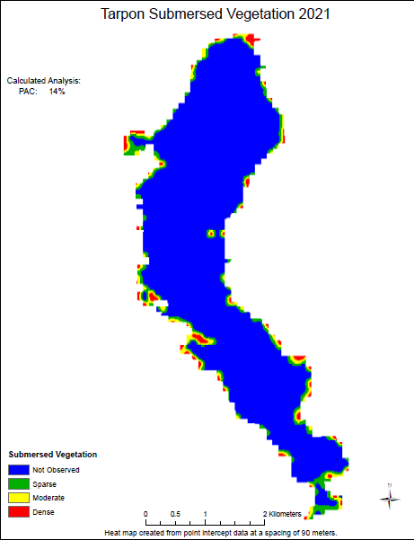The location and density ranks of submersed aquatic vegetation in Lake Tarpon, as reported in FWC’s 2021 survey.

## Phytoplankton community data

Phytoplankton are important primary producers in most waterbodies and as such are the base of the aquatic food web, being a food source for many aquatic organisms and fish communities. Phytoplankton are, by definition, photosynthetic, and include cyanobacteria as well as algae. In excess, phytoplankton can result in harmful algal blooms with certain species having the ability to produce biotoxins. These toxic blooms can adversely affect aquatic life as well as humans. Phytoplankton blooms can also result in fish kills when the phytoplankton bloom dies and sinks to the bottom. The decomposition of the phytoplankton depletes the oxygen in the water to a point where the fish cannot survive. For a Type III SSAC to be appropriate for a waterbody, the information on Chl-*a* levels, algal mats, and blooms cannot indicate that there is an imbalance in flora or fauna.

Pinellas County sampled the phytoplankton community at several sites in Lake Tarpon approximately monthly between 2000 and 2018 and has provided the data to the department. More recent data are not available because that component of their sampling program ended in 2018. The department determined if the taxa observed had the potential to produce algal toxins based on literature determinations and consistent with the information used for the [department’s algal bloom response efforts](https://floridadep.gov/AlgalBloom). **Appendix C** provides all raw data provided to the department by Pinellas County and the assignments of potential toxin production as an embedded spreadsheet. The data include the cell/colony counts of the phytoplankton taxa found in each sample. While the data represent a wealth of information, there are some limitations that make performing a detailed analysis of the data challenging. However, the department has used the data to make some important general observations that help support the fact that nutrient levels in Lake Tarpon are not causing an imbalance in flora or fauna, and the lake supports healthy biological communities. The analyses of the data performed by the department are discussed below.

Cyanophyta, or blue-green algae, appear to be the dominant division of phytoplankton found in all Lake Tarpon samples (**Figure 19**). This is typical for Florida lakes where blue-green algae are ubiquitously found. An examination of the 6,040 phytoplankton samples collected from Florida lakes since 1990 revealed that Cyanophyta was the dominant type of algae in 60% of the samples. Similarly, blue-green algae were dominant in approximately 64% of the 3,513 samples collected in the peninsula bioregion in which Lake Tarpon is located. Cyanophyta can be dominant without causing conditions that impair a lake’s designated uses.

Chlorophyta (*i.e.*, green algae) and Chrysophyta (*i.e.*, golden algae) are the next most common groups of phytoplankton found in Lake Tarpon (**Figure 19**). Additionally, Caulobacteriales, Euglenophyta, and Pyrrhophyta (not shown in **Figure 19**) make up minor portions of the phytoplankton in Lake Tarpon. The phytoplankton samples show that there were cell/colony count spikes prior to 2010, but consistently low levels with an average cell/colony count of 10,000 or fewer for all phytoplankton groups in all samples collected since 2010 (**Figure 19**). The lower phytoplankton cell counts are consistent with the fact that no nuisance algal blooms or fish kills have been reported in Lake Tarpon during that time period. As discussed previously, the median Chl-*a* concentration in the lake is 22.6 µg/L and the 90th percentile is 41.1 µg/L for the 1995 to 2022 period (**Table 5**). The 90th percentile Chl-*a* concentration from 2010 to 2022 is 34 µg/L, which means only 10% of Chl-*a* results were greater than 34 µg/L during that period. This limited range of Chl*-a* levels is not indicative of significant algal blooms in Lake Tarpon.

As with most Florida lakes, the phytoplankton community in Lake Tarpon includes potential toxin producing species. Even though they are ubiquitously present, the potential toxin-producing species generally only produce significant quantities of toxin during rapid growth conditions typically experienced during algal blooms. The lack of reported algal blooms indicates that the conditions conducive to high toxin production are not typically found in Lake Tarpon. One of the most common groups of potential toxin-producing algae is *Microcystis* sp., which can produce toxins called microsystins under some conditions. *Microcystis* sp*.* levels in Lake Tarpon have been consistently low, especially since 2010 as shown in **Figure 20**. Additionally, there is not a significant relationship between the number of *Microcystis* sp*.* colonies and Chl-*a* levels in Lake Tarpon (**Figure 21**). Other potential toxin-producing algae taxa including *Cylindrospermopsis, Lyngbya, Oscillatoria*, and *Pseudoanabaena*, were also found in Lake Tarpon at low levels and showed a similar lack of relationship between their abundance and Chl-*a* levels. These findings indicate that the range of Chl-*a* levels found in the lake are not indicative of high levels of toxin-producing algae.

The department typically only conducts an analysis for algal toxins when there are citizen reports of algal blooms. No such reports have been made for Lake Tarpon since such reporting was initiated in 2016. The department’s Status Monitoring Network has included random stations within Lake Tarpon, and algal toxin data were collected on 5/23/2022 at two stations within the lake. Results were non-detect for all microcystin congeners, nodularin, cylindrospermopsin, and anatoxin for both samples, except that there was a trace detection (1 µg/L, which is the limit of quantitation for this analyte) of Microcystin LR at one of the stations.

1. 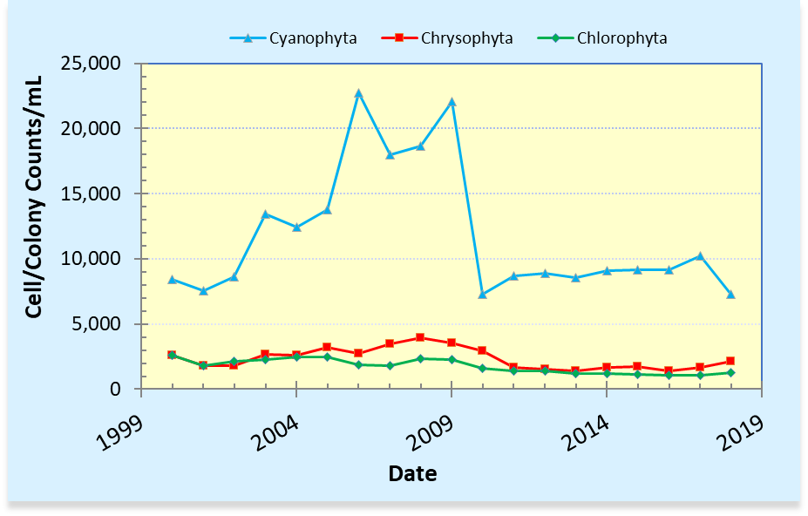Average cell/colony counts/mL of the three most abundant divisions of phytoplankton in samples collected in Lake Tarpon from 2000 to 2018.
2. 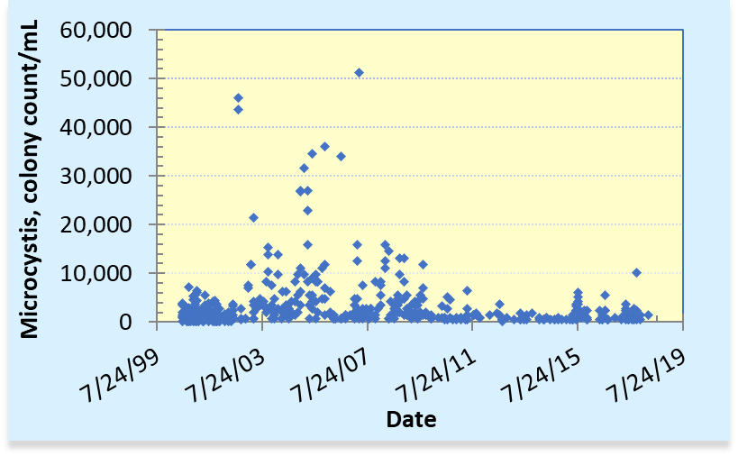Colony counts/mL of *Microcystis* sp. in samples collected in Lake Tarpon from 2000 through 2018.
3. 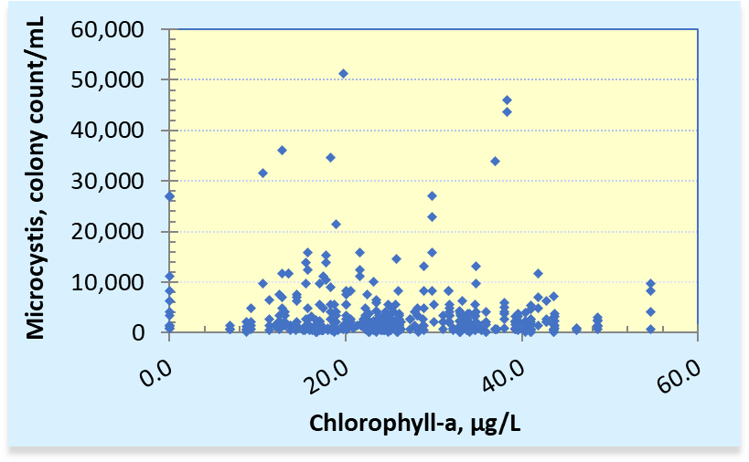Lack of relationship between *Microcystis* sp. colony counts and chlorophyll*-a* levels in samples collected in Lake Tarpon from 2000 through 2018.

## Fish community data

Lake Tarpon is an important sport fishing lake in Pinellas County. It was designated as a state fish management area in 1963 and has been monitored by the FWC since the 1970s (SWFWMD, 2001). Popular species to catch at Lake Tarpon include largemouth bass, bluegill, redear sunfish, and black crappie. Lake Tarpon is one of the FWC’s long term monitoring (LTM) core lakes, so the agency conducts annual surveys of sport fish and non-target fish species via electrofishing at randomly selected sites throughout the lake. Monitoring data are available for 2013 to 2022 and show that a variety of fish were consistently caught during the monitoring in Lake Tarpon every year, with expected natural variability (**Figure 22**). FWC biologists also track catch per unit effort (CPUE) for largemouth bass from year to year, and the catch rates for Lake Tarpon are consistently in the top five of all FWC LTM lakes in Florida (**Figure 23,** FWC biologist, personal communication). These data show that Lake Tarpon supports a healthy fish community and a stable underlying food web.

1. 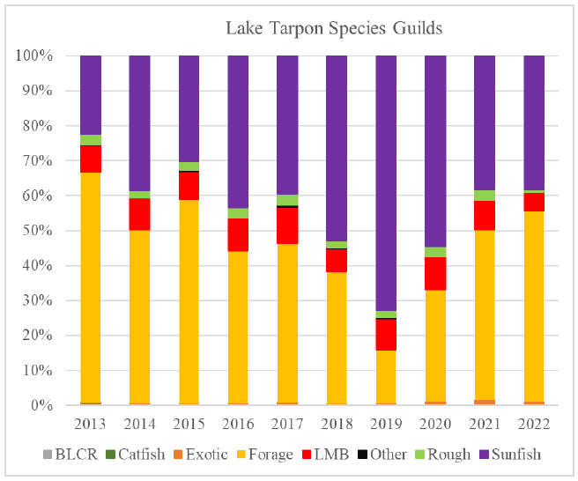Percent composition of fish collected during fall community sampling at Lake Tarpon, Florida, from 2013 to 2022. Categorical breakdown of species follows FWC Long Term Monitoring fish groupings. BLCR = black crappie, LMB = largemouth bass.
2. Total annual electrofishing catch per unit effort (CPUE) rates of largemouth bass from Lake Tarpon from 2011 to 2022. Error bars represent standard error.

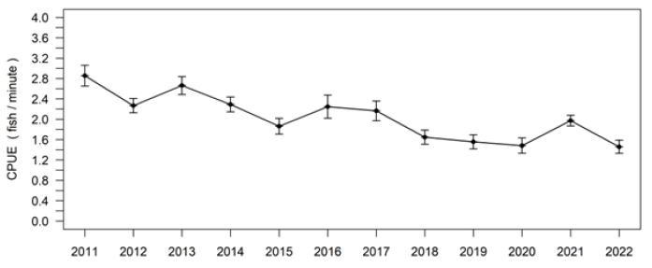

# SSAC development methodology

## Proposed Type III SSACs

The proposed SSACs for TN, TP, and Chl*-a* were developed based on water quality data from the screened dataset summarized in Section 3 above. As described in Section 4, the available data indicate that Lake Tarpon supported healthy biological communities during the period from 2015 to 2022. However, the water quality during this relatively short eight-year period does not fully capture the expected range of natural variability in the lake. Therefore, based on the Type III SSAC guidance document (FDEP, 2011) that indicates that the period used to derive the SSAC values can be expanded beyond the period in which there are biological data indicating healthy biological communities if there is a demonstration that “*there has not been a statistically significant trend in nutrients throughout the expanded period of record including the study period*.” The guidance further states that this approach is “*based on the logical argument that if concentrations during the SSAC study are protective of healthy biology and nutrient concentrations have not changed over the period of record, then the historic concentrations must have been protective of healthy biology.”*

In accordance with the Type III SSAC guidance, the period of record used to derive the proposed SSACs for Lake Tarpon was expanded from 2015 to 2022 in which there were sufficient data to show the lake supported healthy biological communities to 2003 through 2022 to capture the full range of natural variability. Based on a Mann-Kendall trend analysis none of the nutrients (chl-*a* *p* = 0.6732, TN *p* = 0.07435, TP *p* = 0.7264) exhibited a significant trend during the expanded period. In addition to not showing a trend in nutrient concentrations, the expanded 2003 to 2022 period corresponds to the time when the County was conducting their comprehensive randomized monitoring program in Lake Tarpon, which is likely more representative of the overall condition in the lake. To account for the range of natural variability within Lake Tarpon, the potential SSACs were calculated as the 90% prediction interval of the natural log transformed annual geometric mean nutrient concentrations observed during the expanded period. The final recommended SSACs will be applied such that they can be exceeded no more than once during any consecutive three-year period. Calculation of the SSACs in this manner is consistent with the derivation of NNC for other Florida waters and will maintain the current data distribution shown to support the healthy existing condition. Using this methodology is also expected to account for the natural temporal variability while balancing Type I and Type II errors associated with the application of the SSACs.

**Table 9** provides the annual geometric mean Chl-*a*, TN, and TP concentrations for the period from 1995 through 2022. Pinellas County’s surface water monitoring program utilizes a randomized design that was initiated in 2003 and represents the most consistent source of data during the recent period of record. Prior to 2003, multiple agencies, including Pinellas County, SWFWMD, and USGS monitored the Lake for various purposes. The table also provides the proposed SSAC calculations based on the expanded 2003 to 2022 period.

Annual geometric mean (AGM) nutrient concentrations for the period from 1995 to 2022 with criteria calculations based on the 2003 to 2022 period.

|  |  |  |  |  |  |  |
| --- | --- | --- | --- | --- | --- | --- |
| **Year** | **Chlorophyll*-a* Count** | **AGM Chlorophyll*-a*, µg/L** | **TN Count** | **AGM TN, mg/L** | **TP Count** | **AGM TP, mg/L** |
| 1995 | 97 | 23.9 | 95 | 1.24 | 98 | 0.053 |
| 1996 | 99 | 22.9 | 21 | 1.04 | 115 | 0.030 |
| 1997 | 56 | 19.6 | 8 | 1.09 | 63 | 0.025 |
| 1998 | 54 | 19.9 | 3 | N/A | 57 | 0.027 |
| 1999 | 58 | 25.6 | 58 | 0.98 | 58 | 0.035 |
| 2000 | 68 | 30.7 | 61 | 1.17 | 68 | 0.031 |
| 2001 | 60 | 27.4 | 60 | 1.10 | 60 | 0.040 |
| 2002 | 64 | 23.6 | 0 | N/A | 8 | 0.010 |
| 2003 | 36 | 18.5 | 36 | 0.99 | 36 | 0.028 |
| 2004 | 45 | 21.8 | 45 | 0.97 | 45 | 0.031 |
| 2005 | 31 | 21.6 | 32 | 1.13 | 32 | 0.049 |
| 2006 | 58 | 8.9 | 58 | 1.05 | 54 | 0.038 |
| 2007 | 36 | 22.1 | 32 | 0.88 | 36 | 0.024 |
| 2008 | 32 | 25.1 | 32 | 1.19 | 32 | 0.044 |
| 2009 | 32 | 26.0 | 32 | 1.27 | 32 | 0.033 |
| 2010 | 34 | 18.2 | 34 | 1.01 | 30 | 0.036 |
| 2011 | 44 | 16.2 | 56 | 0.91 | 56 | 0.034 |
| 2012 | 33 | 21.1 | 33 | 1.06 | 33 | 0.037 |
| 2013 | 31 | 22.5 | 32 | 0.94 | 32 | 0.041 |
| 2014 | 27 | 19.1 | 31 | 0.80 | 30 | 0.029 |
| 2015 | 32 | 26.1 | 32 | 0.99 | 28 | 0.041 |
| 2016 | 31 | 21.6 | 32 | 0.91 | 32 | 0.033 |
| 2017 | 36 | 24.6 | 36 | 0.97 | 36 | 0.039 |
| 2018 | 32 | 19.1 | 32 | 0.84 | 32 | 0.030 |
| 2019 | 33 | 18.0 | 33 | 0.78 | 33 | 0.031 |
| 2020 | 31 | 20.3 | 31 | 0.95 | 31 | 0.031 |
| 2021 | 33 | 24.9 | 33 | 1.03 | 31 | 0.037 |
| 2022 | 8 | 20.9 | 8 | 0.91 | 8 | 0.037 |
| 2003-2022 | n | 20 |  | 20 |  | 20 |
|  | Avg | 20.83 |  | 0.9781 |  | 0.0351 |
|  | Std | 3.98 |  | 0.1230 |  | 0.0059 |
|  | Var | 15.85 |  | 0.0151 |  | 0.000035 |
| **90% Prediction Interval** | | **28.1** |  | **1.15** |  | **0.04** |

During the 1995 to 2022 period, AGM Chl*-a* concentrations ranged from 8.9 to 30.7 µg/L with an average of 21.8 µg/L. The average annual Chl*-a* concentration for the 2003 to 2022 period was 20.8 µg/L with a range from 8.9 to 26.1 µg/L. The similarity of the 2003 to 2022 Chl-*a* concentrations with those reported for the entire 1995 to 2022 period is consistent with the observation of no significant trend in concentrations over the period of record (POR). A Chl*-a* SSAC of 28µg/L, based on the 90% prediction interval of the annual geometric means of the chlorophyll data collected in Lake Tarpon during the 2003 to 2022 period, is recommended for adoption.

The AGM TN and TP concentrations and the potential SSACs calculated as the 90% prediction intervals are consistently at or slightly below the minimum of the generally applicable criteria ranges for colored lakes. The AGM TN concentrations observed during the 1995 to 2022 period ranged from 0.78 to 1.27 mg/L with an average AGM level of 1.01 mg/L. For the 2003 to 2022 period, AGM TN concentrations averaged 0.98 mg/L and ranged from 0.78 to 1.27 mg/L. The potential SSAC value based on the 2003 to 2022 period is 1.15 mg/L for TN. Similarly, AGM TP concentrations were consistently low during the 1995 to 2022 period ranging from 0.010 to 0.053 mg/L with an average AGM of 0.034 mg/L. During the 2003 to 2022 period, AGM TP levels averaged 0.035 mg/L with a range from 0.0250 to 0.049 mg/L. A potential SSAC value of 0.04 mg/L for TP was derived using data from the 2003 to 2022 period.

The recommended Chl*-a* SSAC of 28 µg/L, the TN SSAC of 1.15 mg/L, and the TP SSAC of 0.04 mg/L will be applied such that the AGM concentration in Lake Tarpon will not exceed the SSAC value in no more than once in any consecutive three-year period.

## Downstream Waters Protection

SSAC petitions need to provide an affirmative demonstration that the SSAC(s) will protect not only the waterbody for which the SSAC is established, but also downstream waters. 40 CFR 131.10(b) requires that “in designating uses of a waterbody and the appropriate criteria for those uses, the State shall take into consideration the water quality standards of downstream waters and shall ensure that its water quality standards provide for the attainment and maintenance of water quality standards of downstream waters” (U.S.EPA, 2014).

Lake Tarpon’s outflow is managed at approximately three feet (NGVD 29) by the SWFWMD and discharges to the south to the Lake Tarpon Outfall Canal. The S-551 salinity control structure is located approximately at the midpoint of the three-mile-long Lake Tarpon Outfall Canal. The Class III freshwater portion of the Lake Tarpon Canal (WBID 1541B) upstream of the S-551 structure is the immediate receiving water for the Lake Tarpon discharge and was not listed as impaired for any parameter during the 2020-2022 Biennial Assessment conducted under Chapter 62-303, F.A.C. Downstream of the S-551 structure (WBID 1541A), the canal transitions to a Class III marine system that was listed as impaired for nutrients (Chl*-a*). There is limited data available for the marine portion of the canal, however, the chlorophyll levels exceeded the 11 µg/L assessment threshold during both 2005 and 2011. The chlorophyll levels above 11 µg/L appear to be caused by multiple factors. First, there is a considerable difference between the 11 µg/L assessment threshold applied to the marine waters downstream of the S-551 structure and the 20 µg/L criterion applied upstream of S-551. In 2005, all the chlorophyll data were collected at a single station just downstream of the control structure. Likewise, half of the data for 2011 was also collected near the S-551 structure. Even though the freshwater upstream of the structure can be below the 20 µg/L criterion, as soon as it passes over the control structure it exceeds the more stringent marine 11 µg/L assessment threshold. Additionally, the S-551 structure acts as a salinity control structure that prevents downstream marine water from moving upstream into the Lake. Therefore, unless there is discharge from the Lake Tarpon flowing over S-551, the canal is poorly flushed and the water is relatively stagnant, which can be a highly productive situation. Further, the Lake Tarpon Canal is a man-made canal constructed to minimize flooding concerns in the surrounding highly urbanized area. Due to the urbanization surrounding the canal, there is also runoff from these areas, likely carrying elevated nutrients, entering the canal. The canal also has inputs from other tributaries as well. Cow Branch and Saint George Lake through South Creek enter the freshwater portion of the canal (see **Figure 24**), and Possum Branch/Briar Creek is an input to the marine portion of the canal (see **Figure 25**). The Possum Branch/Briar Creek input is impaired for total phosphorus while the South Creek inflow is impaired for chlorophyll. The chlorophyll impairment documented for the marine portion of the canal likely results from a combination of these factors.

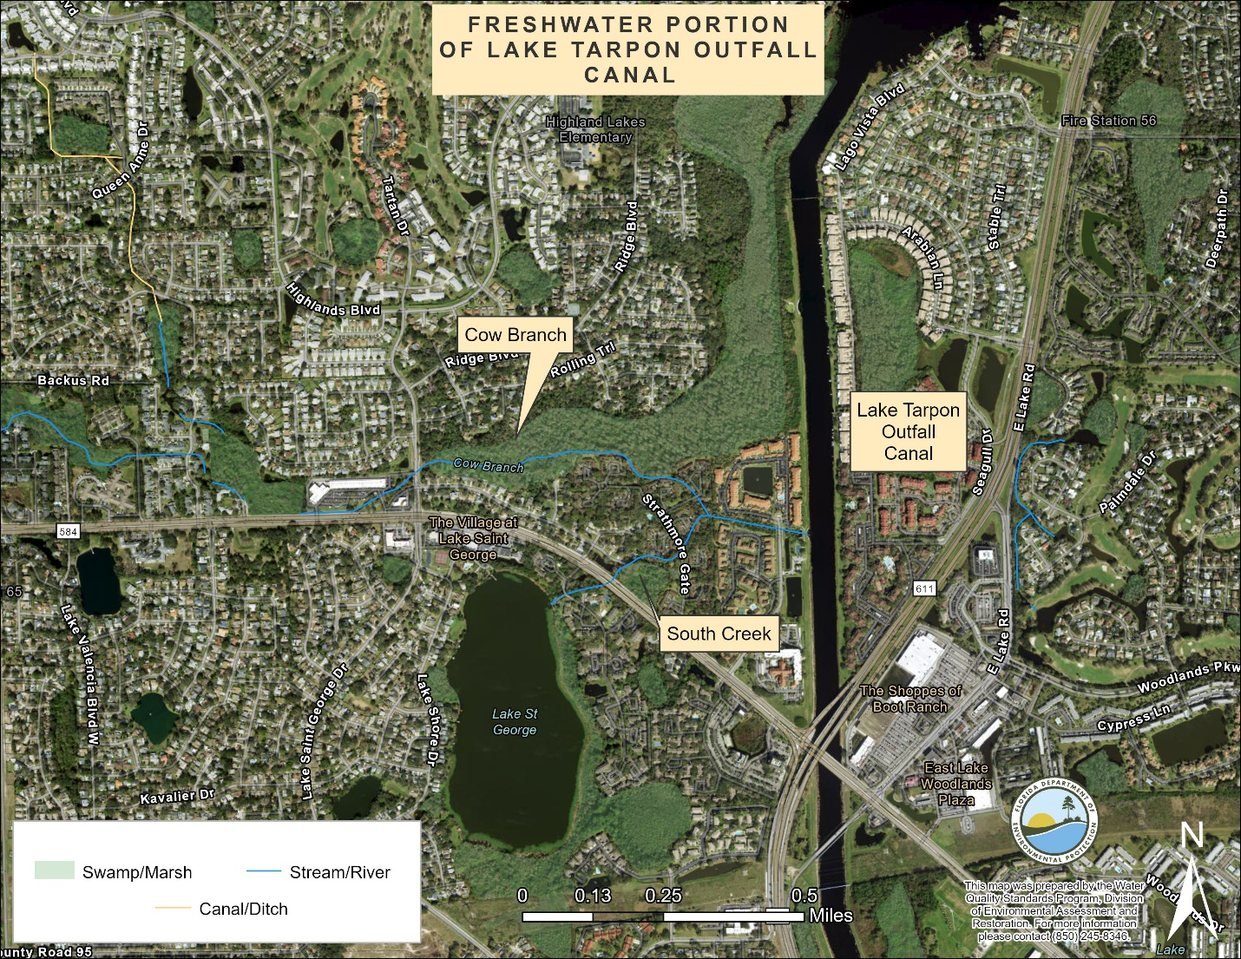

1. Map illustrating the freshwater portion of the Lake Tarpon Outfall Canal and the inflow from Cow Branch and South Creek.

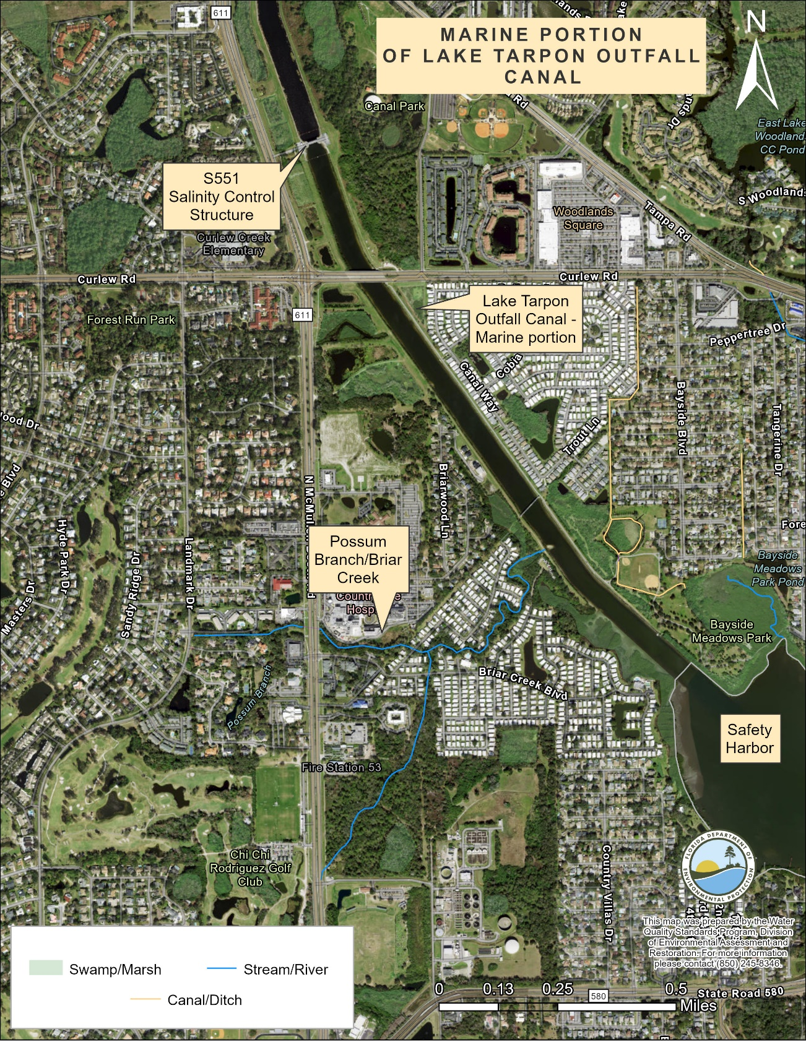

1. Map illustrating the marine portion of the Lake Tarpon Outfall Canal, the S551 salinity control structure, inflow from Possum Branch/Briar Creek, and the downstream waters of Safety Harbor

The Lake Tarpon Canal ultimately flows into Safety Harbor (WBID 1558IA). Safety Harbor was listed as impaired for nutrients (Chl-*a*) in the 2009 assessment. The Chl-*a* exceedances in Safety Harbor are scattered throughout the WBID, and no “hot spots” have been identified. In addition to the Lake Tarpon discharge, Moccasin Creek (1530A) and Bishop Creek (1569A) are direct inputs to Safety Harbor and impact its water quality (see **Figure 26**).

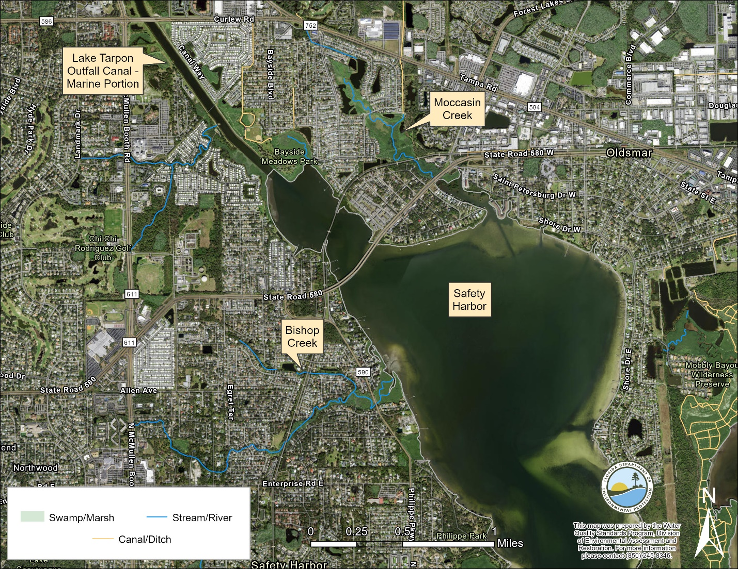

1. Map illustrating the marine portion of the Lake Tarpon Outfall Canal, downstream Safety Harbor, and direct inflows to Safety Harbor from Bishop Creek and Moccasin Creek.

Both Moccasin Creek and Bishop Creek were listed as impaired for nutrients in 2019. Moccasin Creek (1530A) was listed as impaired for nutrients (Chl-*a*, TN, and TP), with AGM Chl-*a* concentrations ranging up to 65 µg/L, AGM TN concentrations between 1.34 and 1.63 mg/L, and AGM TP levels up to 0.17 mg/L. Likewise, Bishop Creek (1569A) was listed as impaired for nutrients based on AGM TP concentrations exceeding the 0.12 mg/L threshold and a macrophyte community that failed the Linear Vegetation Survey (LVS). Additionally, Possum Branch/Briar Creek (WBID 1541C), which flows into the southern portion of the Lake Tarpon Canal before it reaches Safety Harbor, was listed as impaired for nutrients in the 2019 assessment for TP concentrations exceeding the 0.12 mg/L criterion. Because the proposed 1.15 mg/L TN and 0.04 mg/L TP SSACs for Lake Tarpon are below the applicable criteria of 1.54 and 0.12 mg/L for TN and TP, respectively, for the downstream freshwaters, adoption of the SSACs will be protective of these waters. Likewise, the proposed 0.04 mg/L TP SSAC for Lake Tarpon is well below the TP criterion for Old Tampa Bay, including Safety Harbor (*i.e*., 0.23 tons/million m3 or 0.21 mg/L). Also, the proposed TN SSAC for Lake Tarpon is only slightly above the 1.08 tons/million m3 (*i.e*., 0.98 mg/L) TN criteria for Old Tampa Bay. Because the TN and TP SSACs proposed for Lake Tarpon are more restrictive than the applicable criteria for the lake and the downstream freshwaters and similar to or below the criteria for Safety Harbor and Old Tampa Bay, no adverse impacts are expected from the adoption of the SSACs.

The ultimate receiving water for the Lake Tarpon discharge is a portion of Old Tampa Bay (WBID 1558I), which is currently listed in Category 4b (*i.e*., impaired for one or more designated uses but does not require TMDL development because the water will attain water quality standards due to existing or proposed measures). Tampa Bay has a reasonable assurance plan (RAP) that addresses nitrogen loading to the system. Based on flow and nutrient data collected at the S-551 control structure from 2010 to 2021, the Lake Tarpon discharge comprised an average of approximately 11% of the TN loading target for Old Tampa Bay. Annually, the Lake Tarpon discharge constituted approximately 7.8 to 14.9% of the target TN load, with most of the variation resulting from changes in flow. This is consistent with modelling performed by the TBEP (Sherwood, *et al*., 2016) which estimated that the complete removal of the Lake Tarpon discharge from Old Tampa Bay would only reduce the organic carbon input by 13% and would only increase the number of acres with adequate light to support seagrass by 5%.

Despite meeting the nitrogen targets, most portions of Tampa Bay, including Old Tampa Bay, have experienced significant losses in the coverage of their seagrass communities in recent years (Tampa Bay Nitrogen Management Consortium, 2022) as shown in **Figure 27**. Additionally, Old Tampa Bay exceeds the 9.3 µg/L Chl-*a* target, which is also the applicable NNC, specified in the RAP. The [2022 Tampa Bay RAP update](https://drive.google.com/file/d/18HHMx4U6vHNrFyepEFuoTJ_sEKyTA_gu/view) reported that Old Tampa Bay exceeded its Chl-*a* threshold (NNC) in four out of five years from 2017 through 2021. The 2022 update concluded that the bay segment met its TN load target, but the assimilative capacity may have changed. In contrast, other portions of Tampa Bay have consistently met their Chl-*a* targets but show similar declines in the seagrass community. Additionally, TN levels in Old Tampa Bay have been reduced dramatically since 2000 and have remained low or continued to decrease even during the recent seagrass loss (**Figure 28**). In addition to ongoing and future nitrogen load reduction projects across the major source categories, the TBEP is also starting to explore other factors (*e.g*., sea level rise, limited tidal flushing, increasing water temperatures, organic carbon inputs, increased abundance of macroalgae, and *Pyrodinium bahamense* blooms) that likely contribute 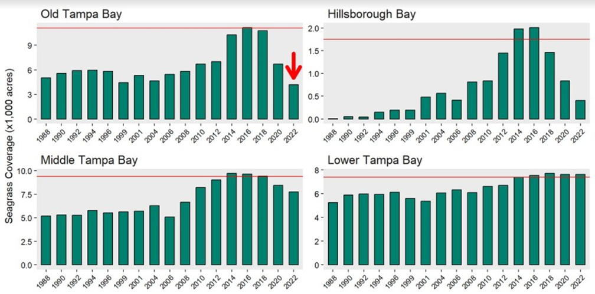to the loss of seagrass, especially in the upper portions of Tampa Bay.

1. Seagrass coverage measured in different portions of Tampa Bay over time. Figure produced by Tampa Bay Estuary Program.

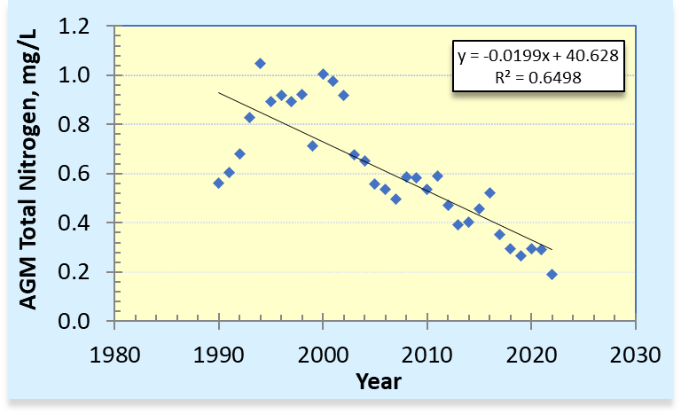Figure 28 Annual geometric mean (AGM) total nitrogen concentrations in Old Tampa Bay over time (*p* = <0.0001). Based on data extracted from Run 64 of the IWR database.

While the proposed Chl-*a* SSAC for Lake Tarpon is above the applicable limits for the marine portion of the Lake Tarpon Discharge Canal and Safety Harbor, Chl-*a* is considered a response variable that reflects nutrient (TN and TP) levels in a waterbody and is not itself a pollutant. Chlorophyll levels in freshwater lakes are commonly higher than found in downstream estuaries. Further, the Chl-*a* SSAC for Lake Tarpon was established to maintain existing conditions that are within the range estimated to have prevailed during periods of seagrass recovery and expansion in Old Tampa Bay.

The recommended SSACs for TN and TP for Lake Tarpon are below the lower end of the range of the generally applicable criteria for the lake. Therefore, the recommended SSACs will be considerably more restrictive than the current NNC, by fixing the TN and TP limits at levels below the lower end of the range allowed by the generally applicable criteria and not allowing nutrient concentrations to increase significantly during periods when the Chl-*a* criterion is met. The proposed TN and TP SSACs are also well below the nutrient criteria applicable to the freshwater streams downstream of the lake. Therefore, the proposed SSACs will be protective of the immediate freshwater portion of the Lake Tarpon Canal. Additionally, because the proposed SSACs will maintain the nutrient levels in Lake Tarpon found over the past seven or more years, including periods when seagrass levels in Tampa Bay peaked and are below or similar to the nutrient criteria for Safety Harbor and Old Tampa Bay, the nutrient SSACs recommended for Lake Tarpon are expected to be protective of all downstream waters.

## Endangered Species Act Considerations

The U.S. Fish and Wildlife Service Information for Planning and Consulting (IPaC) endangered species survey tool was used to identify threatened or endangered plant and animal species within the Lake Tarpon watershed (SWFWMD drainage basin). The endangered species identified within the drainage basin boundary include the Hawksbill Sea Turtle (*Eretmochelys imbricata*), Leatherback Sea Turtle (*Dermochelys coriacea*), and the Florida Golden Aster (*Chrysopsis floridana*). The threatened species include the West Indian manatee (*Trichechus manatus*), Red Knot (*Calidriscanutus rufa*), Wood Stork (*Mycteria americana*), Audubon’s Crested Caracara (*Polyborus plancus audubonii*), Eastern Black Rail (*Laterallus jamaicensis* ssp*. jamaicensis*) Eastern Indigo Snake (*Drymarchon corais couperi*), and Loggerhead Sea Turtle (*Caretta caretta*). The Gopher Tortoise (*Gopherus polyphemus*) is a proposed candidate for threatened or endangered status. Manatees and sea turtles are not found within the Lake Tarpon proposed SSAC area because S-551, a salinity barrier and flood control structure, acts as a physical barrier to movement upstream. The IPaC results also showed that there are no critical habitats for the listed species within the Lake Tarpon watershed. Because the recommended SSACs for Lake Tarpon are intended to maintain existing Chl-*a* and nutrient conditions, adoption of the SSACs is not expected to result in any adverse effects to native species within the watershed.

# Summary of Recommendations

The department evaluated the available water quality and biological data for Lake Tarpon (WBID 1486A), as well as other available information and studies that have been conducted. Lake Tarpon currently does not meet the generally applicable Chl*-a* criteria despite low nutrient (TN and TP) concentrations. As a result of this evaluation, the department recommends that the proposed Type III nutrient SSACs be adopted for Lake Tarpon. Although the lake does not meet the generally applicable Chl-*a* criterion, the existing Chl-*a* levels above the generally applicable criterion have been demonstrated to support healthy biological communities.

Because the proposed nutrient SSACs were developed based on existing conditions within Lake Tarpon, their adoption is expected to result in no or minimal impacts to permitted activities in the watershed. In summary, the department is recommending Type III SSACs for TN, TP, and Chl*-a* in Lake Tarpon (WBID 1486A) as indicated in **Table 1:** 28 µg/L for Chl-*a*, 1.15 mg/L for TN, and 0.04 mg/L for TP.

The recommended Chl*-a*, TN, and TP SSACs for Lake Tarpon will be applied such that the AGM concentrations in the lake (WBID 1486A) will not exceed the SSAC values more than once in any consecutive three-year period.

# References

Allen, M.S., Tate, W., Tugend, K.I., Rogers, M., & Dockendorf, K.J. 2003. Effects of Water Level Fluctuations on the Fisheries of Lake Tarpon. Gainesville: The University of Florida Department of Fisheries and Aquatic Sciences.

Atkins. 2017. Lake Tarpon Water Quality Management Plan. Prepared for Pinellas County. Tampa, Florida.

FDEP. N.D. Pinellas County and Boca Ciega Bay Aquatic Preserves Management Plan: [Pinellas County and Boca Ciega Bay Aquatic Preserves Management Plan (state.fl.us)](http://publicfiles.dep.state.fl.us/CAMA/plans/Pinellas-County-Boca-Ciega-Bay-AP-Management-Plan.pdf)

FDEP Bureau of Assessment and Restoration. 2011. Development of Type III Site Specific Alternative Criteria for Nutrients. Available from: <https://floridadep.gov/sites/default/files/type_III_ssac.pdf>

FDOT. 1999. Florida Land Use, Cover and Forms Classification System. Surveying and Mapping Office, Geographic Mapping Section. Available from: <http://www.fdot.gov/geospatial/documentsandpubs/fluccmanual1999.pdf>

Pinellas County Public Works Department. 2017. Lake Tarpon Area 6- Stormwater Treatment Facility Pinellas County, Florida: Final Monitoring Report, State of Florida Department of Environmental Protection Agreement No. G0212. Available upon request.

Pinellas County Water Atlas. (N.D.). Radar-based Rainfall Estimates. Lake Tarpon Watershed: [Radar-Based Rainfall Estimates - Pinellas.WaterAtlas.org (usf.edu)](https://www.pinellas.wateratlas.usf.edu/rainfall/estimates/)

Sherwood, E., H. Greening, L. Garcia, K. Kaufman, T. Janicki, R. Pribble, B. Cunningham, S. Peene, J. Fitzpatrick, K. Dixon, and M. Wessel1. 2016. In Stringer, C., E. K. Krauss, and J. Latimer, eds. 2016. Headwaters to estuaries: advances in watershed science and management-Proceedings of the Fifth Interagency Conference on Research in the Watersheds. March 2-5, 2015, North Charleston, South Carolina. e-Gen. Tech. Rep. SRS-211. Asheville, NC: U.S. Department of Agriculture Forest Service, Southern Research Station. 302 p.

SWFWMD. 2001. Lake Tarpon Surface Water Improvement and Management (SWIM) Plan. Available from: [Lake Tarpon SWIM Plan (state.fl.us)](https://www.swfwmd.state.fl.us/sites/default/files/medias/documents/lake_tarpon-swim.pdf)

Tampa Bay Nitrogen Management Consortium, 2022. Tampa Bay Nutrient Management Strategy 2022 Reasonable Assurance Update. (<https://floridadep.gov/dear/alternative-restoration-plans/content/tampa-bay-estuary-rap>)

U.S.EPA. 2014. Protection of Downstream Waters in Water Quality Standards: Frequently Asked Questions. EPA-820-F-14-001. Available from: <https://nepis.epa.gov/Exe/ZyPDF.cgi/P100LIJF.PDF?Dockey=P100LIJF.PDF>

Wellendorf, J., Fore, L., and Frydenborg, R. 2019. Development of a Lake Vegetation Index (LVI) to assess the biological condition of Florida lakes. Florida Scientist 82, 1–32.

Wood. 2018. Pinellas County Environmental Management Department Final Report: Lake Tarpon Paleolimnological Study Task 2.6. Available upon request.

Appendix A. Summary of Water Quality Data for Brooker Creek, Lake Tarpon, and the Lake Tarpon Discharge Canal Segments.



Appendix B. Lake Tarpon Lake Vegetation Index Survey Taxa Lists

| **Taxa observed\**  **Sampling date** | 7/28/2010 | 6/20/2011 | 9/12/2011 | 9/8/2014 | 9/12/2014 | 8/26/2015 | 8/10/2016 | 8/25/2017 | 8/21/2018 | 9/6/2019 | 7/16/2020 | 7/9/2021 | 5/23/2022 | 8/23/2022 | **Total Observations** |
| --- | --- | --- | --- | --- | --- | --- | --- | --- | --- | --- | --- | --- | --- | --- | --- |
| *Acer rubrum* | 4 | 3 | 4 | 4 | 3 | 2 | 3 | 4 | 3 | 3 | 3 | 3 | 3 | 3 | **45** |
| *Acrostichum danaeifolium* |  | 2 | 1 | 2 | 4 | 2 | 2 | 4 | 2 | 3 | 2 | 4 |  | 3 | **31** |
| *Alternanthera philoxeroides* | 3 | 3 | 4 | 4 | 4 | 4 | 4 | 3 | 3 | 1 | 2 |  | 4 | 1 | **40** |
| *Andropogon* |  |  |  |  |  |  | 1 |  | 1 |  |  |  |  |  | **2** |
| *Andropogon glomeratus* |  |  | 1 | 1 |  |  |  |  |  |  |  |  |  |  | **2** |
| *Azolla caroliniana* |  |  |  |  |  |  |  |  |  | 1 |  | 1 |  |  | **2** |
| *Baccharis* |  |  |  |  |  | 1 | 2 | 1 | 2 |  | 2 | 2 |  |  | **10** |
| *Baccharis glomeruliflora* | 2 | 2 | 3 | 3 | 2 |  |  |  |  |  |  |  |  |  | **12** |
| *Bacopa monnieri* | 1 |  |  |  |  |  |  |  |  |  |  |  | 1 |  | **2** |
| *Bidens alba* |  |  |  | 2 |  |  |  |  |  |  |  |  |  |  | **2** |
| *Bidens laevis* |  |  |  |  |  | 1 |  |  |  |  |  |  |  |  | **1** |
| *Blechnum serrulatum* | 1 |  | 3 | 2 | 1 |  | 1 | 1 |  | 2 |  | 3 |  |  | **14** |
| *Boehmeria cylindrica* | 1 |  | 1 |  |  |  |  |  |  |  |  | 1 | 2 |  | **5** |
| *Cabomba caroliniana* |  |  |  |  |  |  |  |  |  |  |  | 1 |  | 1 | **2** |
| *Canna flaccida* |  |  |  |  |  | 1 |  |  |  |  |  |  |  |  | **1** |
| *Canna x generalis* |  |  |  | 1 |  |  |  |  |  |  |  |  |  |  | **1** |
| *Casuarina* |  | 1 | 1 | 1 |  |  | 1 | 1 |  | 2 |  |  |  |  | **7** |
| *Casuarina cunninghamiana* |  |  |  |  |  |  |  |  | 2 |  |  |  |  |  | **2** |
| *Casuarina equisetifolia* | 1 |  |  |  | 1 |  |  |  |  |  | 1 |  |  |  | **3** |
| *Cephalanthus occidentalis* |  |  | 1 | 2 |  | 4 |  |  |  | 1 |  |  | 2 |  | **10** |
| *Ceratophyllum demersum* | 4 | 4 | 4 | 3 | 4 |  | 3 | 4 | 4 | 4 | 3 | 4 | 4 | 2 | **47** |
| *Chara* | 1 |  |  |  |  |  |  |  | 1 |  |  |  |  |  | **2** |
| *Cicuta maculata* |  |  |  |  |  |  |  |  |  |  |  |  | 2 |  | **2** |
| *Cladium jamaicense* | 1 |  |  | 1 |  |  |  |  | 1 |  |  |  | 1 |  | **4** |
| *Colocasia esculenta* | 4 | 3 | 4 | 4 | 4 | 4 | 4 | 4 | 3 | 1 | 3 | 3 | 4 | 4 | **49** |
| *Crinum americanum* |  |  | 2 | 2 |  | 1 | 1 | 2 | 2 | 1 |  |  | 2 | 2 | **15** |
| *Cyperus alternifolius* |  | 1 | 1 |  | 1 |  | 2 | 1 | 1 | 1 |  |  |  |  | **8** |
| *Cyperus odoratus* |  | 2 | 3 | 1 | 1 | 3 | 1 | 4 | 1 | 1 | 2 | 1 |  | 3 | **23** |
| *Cyperus papyrus* | 1 |  |  |  |  |  |  |  |  |  | 1 |  |  |  | **2** |
| *Cyperus polystachyos* | 1 |  | 1 |  |  | 1 |  | 2 |  |  | 1 |  |  |  | **6** |
| *Cyrilla racemiflora* |  |  |  |  |  |  |  |  |  |  |  |  | 1 |  | **1** |
| *Diodia virginiana* |  |  |  |  |  |  |  | 1 |  |  |  |  |  |  | **1** |
| *Dioscorea bulbifera* | 2 |  |  |  |  |  |  |  |  |  |  |  |  |  | **2** |
| *Echinochloa walteri* |  | 1 | 2 | 1 |  |  | 1 |  | 1 |  | 1 | 1 | 1 |  | **9** |
| *Eclipta prostrata* |  |  |  |  |  |  |  | 1 |  |  |  |  |  |  | **1** |
| *Eichhornia crassipes* | 2 | 4 | 4 | 3 | 4 | 3 | 4 | 4 | 3 | 4 | 3 | 4 | 3 | 1 | **46** |
| *Eleocharis* |  | 1 | 1 |  |  |  |  |  |  |  |  | 2 |  |  | **4** |
| *Eleocharis* (submersed viviparous but unable to ID to species) |  |  |  |  |  |  | 1 |  |  |  |  |  |  |  | **1** |
| *Eleocharis baldwinii* | 3 |  |  |  |  |  |  |  |  |  |  |  |  |  | **3** |
| *Eleocharis interstincta* |  |  | 1 |  |  |  |  |  |  |  |  | 2 |  |  | **3** |
| *Eupatorium capillifolium* |  | 1 | 3 | 2 | 1 |  | 2 | 2 |  | 2 | 1 | 2 | 1 | 1 | **18** |
| *Fimbristylis autumnalis* | 1 |  |  |  |  |  |  |  |  |  |  |  |  |  | **1** |
| *Fraxinus caroliniana* |  |  | 1 |  |  |  |  |  |  |  |  |  | 1 |  | **2** |
| *Gordonia lasianthus* |  |  |  | 1 |  | 1 |  | 1 |  |  | 1 |  |  |  | **4** |
| *Hibiscus coccineus* | 1 |  |  |  |  |  |  |  |  |  |  |  |  |  | **1** |
| *Hibiscus grandiflorus* | 2 | 2 | 2 |  |  |  |  | 2 |  |  | 2 |  |  |  | **10** |
| *Hydrilla verticillata* | 2 | 3 | 3 | 1 |  | 1 |  | 2 | 1 |  | 2 | 1 | 3 | 0 | **19** |
| *Hydrocotyle* | 3 | 3 | 4 | 3 | 3 | 2 | 3 | 4 | 3 | 3 | 1 | 3 | 4 | 3 | **42** |
| *Hymenachne amplexicaulis* | 1 |  |  |  |  |  |  |  |  |  |  |  |  |  | **1** |
| *Ilex cassine* | 1 |  | 2 |  |  | 1 |  | 1 | 1 |  |  |  |  |  | **6** |
| *Ipomoea aquatica* |  |  |  | 2 |  |  |  |  |  |  |  |  |  |  | **2** |
| *Juncus effusus* | 1 |  |  |  |  |  |  |  |  |  |  |  |  |  | **1** |
| *Kosteletzkya pentacarpos* |  |  | 2 |  |  | 1 | 2 | 2 | 1 |  | 2 |  |  |  | **10** |
| *Kosteletzkya virginica* |  |  |  | 2 |  |  |  |  |  |  |  |  |  |  | **2** |
| *Lachnanthes caroliniana* |  |  |  |  |  |  |  | 1 |  | 1 |  |  |  |  | **2** |
| *Landoltia punctata* |  |  |  |  |  |  |  | 1 |  |  | 1 |  |  |  | **2** |
| *Lemna* |  |  | 1 | 3 |  | 1 |  |  | 2 | 2 | 1 |  | 2 |  | **12** |
| *Limnobium spongia* |  |  | 1 |  |  |  |  |  |  |  |  |  |  |  | **1** |
| *Liquidambar styraciflua* |  |  |  |  |  |  |  |  |  |  |  |  | 1 |  | **1** |
| *Ludwigia* (native) |  |  |  |  |  |  |  |  |  |  |  |  | 1 |  | **1** |
| *Ludwigia grandiflora* |  |  |  |  | 2 |  |  |  |  | 2 |  | 2 | 1 |  | **7** |
| *Ludwigia hexapetala* |  |  |  |  |  | 2 |  |  |  |  |  |  |  |  | **2** |
| *Ludwigia leptocarpa* | 1 | 1 | 2 | 3 | 3 | 4 | 1 | 3 | 1 | 4 | 1 | 1 |  | 1 | **26** |
| *Ludwigia octovalvis* | 1 |  |  |  | 1 |  |  | 1 |  | 3 |  |  |  |  | **6** |
| *Ludwigia peploides* |  |  |  |  |  |  | 3 |  | 4 |  | 3 |  |  |  | **10** |
| *Ludwigia peruviana* | 3 | 3 | 4 | 3 | 4 | 4 | 4 | 4 | 4 | 4 | 2 | 4 | 3 | 4 | **50** |
| *Ludwigia repens* | 2 | 3 | 4 | 1 |  |  |  |  |  |  |  |  |  |  | **10** |
| *Magnolia grandiflora* | 1 |  |  |  |  |  |  |  |  |  |  |  |  |  | **1** |
| *Magnolia virginiana* | 3 | 1 | 2 |  | 1 | 3 | 1 |  |  | 2 |  |  | 1 | 1 | **15** |
| *Melaleuca quinquenervia* | 1 | 1 | 2 |  |  |  | 1 | 1 | 1 | 1 | 1 | 1 |  |  | **10** |
| *Melia azedarach* |  |  |  | 1 |  |  |  |  |  |  |  |  |  |  | **1** |
| *Mikania scandens* |  | 2 | 1 |  | 2 |  | 1 | 2 | 1 |  | 2 | 1 | 1 |  | **13** |
| *Musa* | 1 |  |  |  |  |  |  |  |  |  |  |  |  |  | **1** |
| *Myrica cerifera* | 4 | 3 | 4 | 4 | 3 | 3 | 4 | 4 | 1 | 4 | 3 | 3 | 2 | 3 | **45** |
| *Myriophyllum aquaticum* |  |  |  |  |  |  |  | 1 | 1 |  | 2 | 1 |  |  | **5** |
| *Myriophyllum heterophyllum* |  |  | 1 |  |  |  |  |  |  |  |  | 1 |  |  | **2** |
| *Myriophyllum spicatum* |  |  |  |  |  |  |  |  |  |  |  |  | 1 |  | **1** |
| *Najas guadalupensis* | 2 | 2 | 2 | 2 |  | 1 | 3 | 2 | 1 | 2 | 1 | 1 | 2 | 1 | **22** |
| *Nephrolepis exaltata* | 2 |  |  |  |  |  |  |  |  |  |  |  | 1 |  | **3** |
| *Nitella* |  |  |  |  |  | 1 |  |  |  |  |  |  |  |  | **1** |
| *Nuphar* |  |  | 2 | 2 | 1 | 3 | 2 | 1 | 2 | 2 |  | 2 | 2 | 1 | **20** |
| *Nymphaea capensis* |  | 1 |  |  |  |  |  |  |  |  |  |  |  |  | **1** |
| *Nymphaea capensis zanzibariensis* |  |  |  | 1 |  |  |  |  |  |  |  |  |  |  | **1** |
| *Nymphaea mexicana* |  |  |  |  |  |  | 1 |  |  |  |  |  |  |  | **1** |
| *Nymphaea odorata* |  |  | 2 | 1 | 1 |  | 1 | 1 |  | 1 |  | 2 |  | 2 | **11** |
| *Nymphoides aquatica* |  | 1 |  | 4 |  |  |  |  |  |  |  |  | 1 |  | **6** |
| *Nymphoides cristata* |  | 1 | 2 |  | 4 | 4 | 4 | 4 | 2 | 4 | 3 | 3 | 2 | 3 | **36** |
| *Nyssa sylvatica biflora* | 3 |  |  |  |  |  |  |  |  |  |  |  |  |  | **3** |
| *Osmunda regalis* | 1 |  |  |  |  |  |  |  |  |  |  | 1 | 1 |  | **3** |
| *Oxycaryum cubense* |  | 2 | 3 | 3 | 2 | 2 | 3 |  |  | 1 | 2 | 2 | 2 |  | **22** |
| *Panicum hemitomon* | 3 |  | 2 | 2 |  |  |  |  |  | 2 |  |  | 2 |  | **11** |
| *Panicum maximum* |  |  | 2 |  |  |  |  |  | 1 |  |  |  |  |  | **3** |
| *Panicum repens* | 3 | 3 | 4 | 4 | 4 | 4 | 4 | 4 | 4 | 4 | 3 | 4 | 3 | 4 | **52** |
| *Paspalidium geminatum* | 2 | 3 | 2 | 1 | 2 | 3 | 3 | 2 | 1 | 2 | 3 | 3 | 1 | 2 | **30** |
| *Paspalum distichum* |  |  | 1 |  |  |  |  |  |  |  |  |  |  |  | **1** |
| *Paspalum repens* |  |  | 1 |  | 1 |  |  |  |  |  |  |  |  |  | **2** |
| *Peltandra virginica* |  |  |  | 1 |  |  |  |  |  |  |  |  |  |  | **1** |
| *Persea palustris* | 3 | 1 |  |  |  |  |  |  |  |  |  |  |  |  | **4** |
| *Persea sp.* |  |  |  |  |  |  |  |  | 1 |  |  |  | 1 |  | **2** |
| *Phyla nodiflora* |  | 1 | 1 |  |  |  |  |  |  |  |  |  |  |  | **2** |
| *Pinus elliottii* | 4 | 2 | 2 |  | 2 | 2 |  | 1 |  |  |  |  | 2 |  | **15** |
| *Pistia stratiotes* | 1 |  |  | 1 |  | 4 | 3 | 2 |  | 2 | 1 | 1 | 1 |  | **16** |
| *Pluchea* |  |  |  |  |  |  |  |  | 1 |  |  |  | 1 |  | **2** |
| *Pluchea odorata* | 1 | 1 |  |  |  |  |  |  |  |  |  | 1 |  |  | **3** |
| *Polygonum densiflorum* | 1 |  |  |  |  |  |  |  |  |  |  |  |  |  | **1** |
| *Polygonum punctatum* | 1 |  |  |  |  |  |  |  |  |  |  |  |  |  | **1** |
| *Pontederia cordata* | 2 | 1 | 4 | 2 | 3 | 2 | 3 | 3 | 2 | 3 |  | 3 | 2 | 4 | **34** |
| *Potamogeton illinoensis* | 4 | 4 | 4 | 4 | 4 | 4 | 4 | 4 | 4 | 4 | 4 | 4 | 4 | 4 | **56** |
| *Sabal palmetto* | 3 |  |  | 2 |  | 3 |  | 1 |  |  | 2 | 2 | 2 | 2 | **17** |
| *Sacciolepis striata* |  | 1 | 1 |  | 1 | 3 | 2 | 2 | 1 |  | 2 |  |  |  | **13** |
| *Sagittaria graminea* |  |  |  | 1 |  |  | 1 | 1 |  |  | 2 |  |  |  | **5** |
| *Sagittaria lancifolia* | 3 | 1 | 4 | 3 | 2 | 3 | 3 | 4 | 3 | 4 | 4 | 4 | 2 | 4 | **44** |
| *Sagittaria latifolia* |  |  | 3 |  | 1 | 1 | 1 | 3 | 2 |  | 2 | 1 |  |  | **14** |
| *Salix caroliniana* | 4 | 3 | 4 | 3 | 3 | 2 | 4 | 4 | 3 | 3 | 3 | 4 | 3 | 2 | **45** |
| *Salvinia minima* | 2 | 1 | 3 | 4 | 4 | 4 | 4 | 4 | 4 | 3 | 3 | 3 | 3 | 2 | **44** |
| *Sambucus canadensis* | 1 |  | 1 |  |  |  |  |  |  |  |  |  |  |  | **2** |
| *Sambucus nigra* |  |  |  |  |  |  |  | 1 |  | 1 | 1 | 2 |  |  | **5** |
| *Sapium sebiferum* | 1 | 1 |  |  |  |  |  |  |  |  | 1 |  |  |  | **3** |
| *Sarcostemma clausum* |  |  | 1 |  |  |  |  |  |  |  |  |  |  |  | **1** |
| *Saururus cernuus* |  |  |  |  |  |  |  | 1 |  |  |  |  |  |  | **1** |
| *Schinus terebinthifolius* | 3 | 2 | 4 | 4 | 4 | 2 | 2 | 3 | 3 | 3 | 3 | 3 | 3 | 4 | **43** |
| *Schoenoplectus californicus* | 3 | 3 | 4 | 3 | 3 | 2 | 4 | 3 | 3 | 1 | 4 | 3 | 3 |  | **39** |
| *Schoenoplectus tabernaemontani* | 3 |  |  |  |  | 1 |  | 1 | 2 | 1 |  | 1 |  |  | **9** |
| *Sesbania* |  |  | 1 |  |  |  |  |  | 1 |  |  |  |  |  | **2** |
| *Sesbania herbacea* |  |  |  |  |  |  | 1 |  |  |  |  |  |  |  | **1** |
| *Sesbania vesicaria* |  |  |  |  |  |  |  | 1 |  |  |  |  |  |  | **1** |
| *Setaria parviflora* |  |  |  | 2 |  |  |  |  |  |  |  |  |  |  | **2** |
| *Spartina bakeri* |  |  | 1 | 1 |  |  |  |  |  |  |  |  |  |  | **2** |
| *Sphagneticola trilobata* |  | 1 | 2 | 3 |  |  |  |  |  |  |  |  | 2 |  | **8** |
| *Taxodium* |  | 3 | 4 |  | 4 | 4 | 4 | 4 | 4 | 4 | 3 | 4 | 4 | 4 | **46** |
| *Taxodium ascendens* | 4 |  |  | 4 |  |  |  |  |  |  |  |  |  | 1 | **9** |
| *Taxodium distichum* | 2 |  |  | 1 |  |  |  |  |  |  |  |  |  |  | **3** |
| *Thalia geniculata* |  |  |  |  |  |  |  |  |  |  | 1 |  |  |  | **1** |
| *Thelypteris* |  | 1 | 3 | 1 |  |  |  |  |  |  |  |  |  |  | **5** |
| *Thelypteris interrupta* |  |  |  |  | 3 | 2 |  | 2 | 1 | 1 |  | 3 |  | 1 | **13** |
| *Thelypteris ovata* | 2 |  |  |  |  |  |  |  |  |  |  |  |  |  | **2** |
| *Thelypteris palustris pubescens* |  |  |  |  |  |  | 2 |  | 1 |  | 2 |  | 1 |  | **6** |
| *Typha* | 4 | 4 | 4 | 4 | 4 | 4 | 4 | 4 | 4 | 4 | 3 | 4 | 4 | 4 | **55** |
| *Urena lobata* |  |  | 2 |  |  |  |  |  |  |  |  |  |  |  | **2** |
| *Urochloa mutica* |  |  |  |  | 1 | 1 |  |  |  |  | 3 |  | 1 |  | **6** |
| *Vallisneria americana* | 3 | 4 | 4 | 4 | 2 | 4 | 4 | 4 | 4 | 4 | 4 | 4 | 4 | 4 | **53** |
| *Vigna luteola* | 1 |  |  |  |  |  |  |  |  |  |  |  |  |  | **1** |
| *Vitis* | 2 | 1 | 3 | 2 |  |  |  |  |  |  |  |  |  |  | **8** |
| *Woodwardia virginica* |  |  |  |  |  |  |  |  |  |  |  |  | 1 |  | **1** |
| *Xyris* | 1 |  |  |  |  |  |  |  |  |  |  |  |  |  | **1** |

Appendix C. Lake Tarpon Phytoplankton Data

