Date

Facility Owner, Title
Facility Name
Street Address
City, State Zip
email address

Re: Consent Order
OGC Case No. ##-####
Facility Name:
Facility/Site/Project ID No. #######
Other Info:

Dear Respondent(s):

Enclosed is the executed Consent Order to resolve the above-referenced case. This copy is for your records.

The effective date of the Consent Order is the filing date entered by the designated Department Clerk on the signature page.

Should you have any questions or comments, please contact First Name Last Name at XXX-XXX-XXXX or via e-mail at FirstName.LastName@FloridaDEP.gov. Your cooperation in resolving this matter is appreciated.

Sincerely,
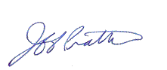

Final Reviewer
Title

Enclosure

cc: FDEP: Lea Crandall

