Select any group of sites for testing. Within the group, test at the bolded site and any other two sites. Refer to local hydrographs to determine which sites are appropriate for testing.

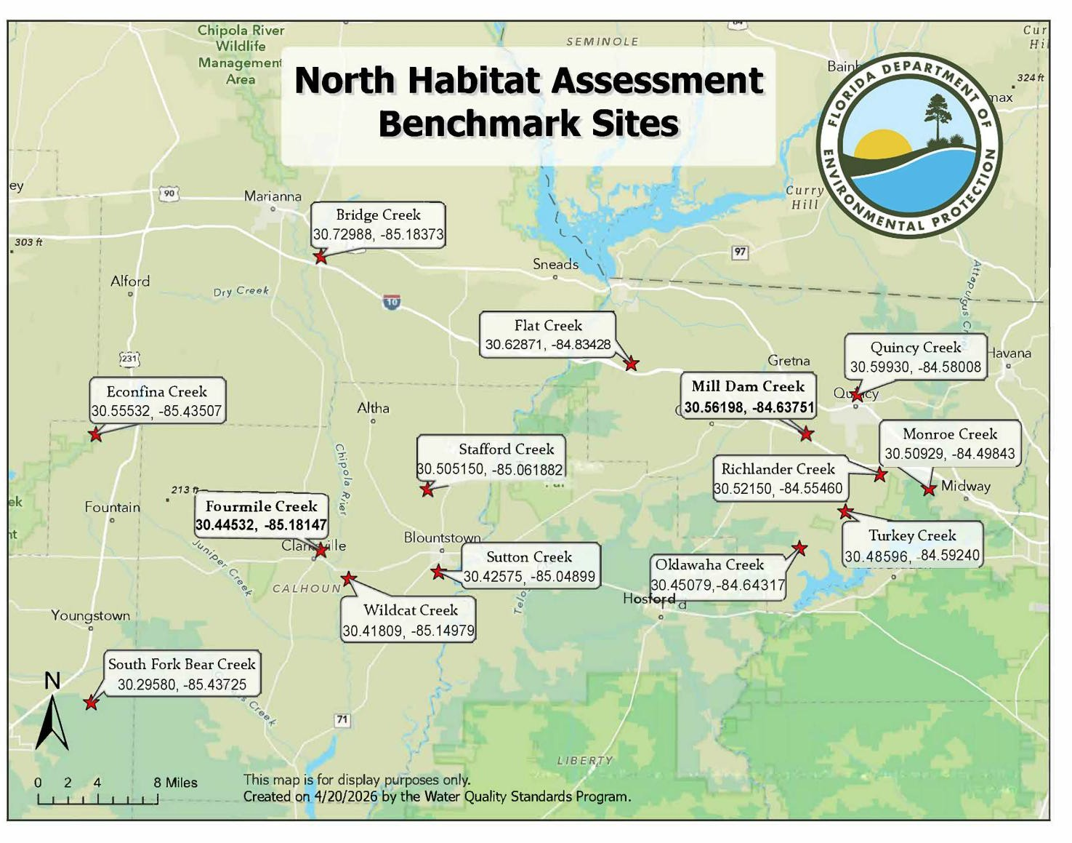
group 1
- Bridge Creek
- Econfina Creek

Fourmile Creek
- South Fork Bear Creek
- Wildcat Creek group 2

Fourmile Creek
- Wildcat Creek
- Sutton Creek
- Stafford Creek
- Flat Creek
group 3

Mill Dam Creek
- Monroe Creek
- Richlander Creek
- Turkey Creek
- Oklawaha Creek group 4
- Bridge Creek
- Flat Creek

Mill Dam Creek
- Quincy Creek
- Monroe Creek

