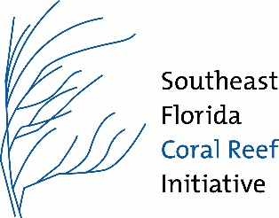

**Southeast Florida Coral Reef Initiative (SEFCRI)**

**Team and Technical Advisory Committee (TAC) Meeting**

**August 13, 2024**

***9am – 5pm***

**In Person Only**

**Location: Tree Tops Park**

**3900 SW 100th Ave,**

**Davie, FL 33328**

**Meeting Objectives**

* Presentations on what the Aquatic Preserve designation will mean for the Kristin Jacobs Coral Reef Ecosystem Conservation Area.
* Overview of feedback on Chapter 5 of the Coral ECA Plan Goals, Objectives, and Strategies from the last SEFCRI meeting.
* Review Chapter 5 of the Coral ECA Plan with an understanding that it will inform the Coral ECA Aquatic Preserve management plan.

**Agenda**

**Tuesday, August 13, 2024**

**8:45 - 9:00**  **Registration**

**9:00 - 9:30**   **Welcome, Meeting Overview, and Introductions**

*Allie Shatters, DEP CRCP*

**9:30 - 10:45** **Introduction to the Kristin Jacobs Coral Reef Ecosystem Conservation Area Aquatic Preserve**

*Allie Shatters, DEP CRCP*

**10:45 - 11:00 NOAA AP Background**

*Jocelyn Karazsia***,** *NOAA*

**11:00-11:15** **Break**

**11:15-11:30 Restoration Strategies Update**

*Caitlin Lusic, TNC*

**11:30-12:00 Overview of Chapter 5**

*Allie Shatters, DEP CRCP*

* Present changes incorporated into Chapter 5 based on feedback from stakeholders during the last SEFCRI meeting.
* Overview of breakout group process and goals.

**12:00 – 12:15** **Public Comment**

**12:15 - 1:15**  **Lunch**

**1:15- 1:20 Review Breakout Group Goals.**

**1:20 - 2:20** **Breakout Group 1**

* Small group discussion on first Issue of choice.

**2:20 - 2:30 Break**

**2:30 - 3:30** **Breakout Group 2**

* Small group discussion on second Issue of choice.

**3:30 - 3:40 Break**

**3:40 - 4:40** **Breakout Group 3**

* Small group discussion on third Issue of choice.

**4:40 Coral Champion**

**4:50 Adjourn**