Robert Barto – East Coast Greenway, Florida Coordinator
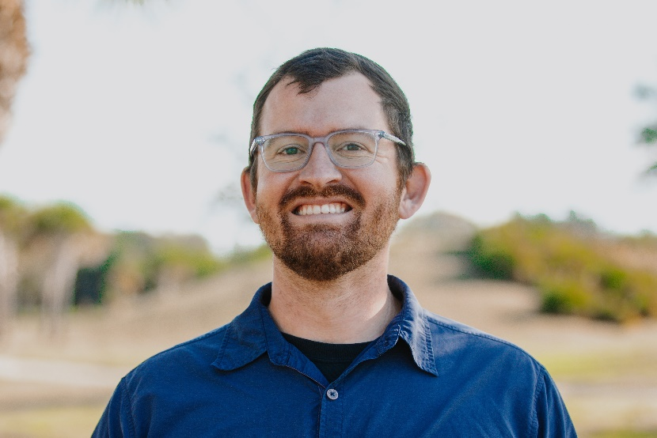
A native Floridian based in Brevard County, Robert Barto is the East Coast Greenway Alliance’s Florida Coordinator. In this role, Robert carries state-wide responsibilities for all aspects of Greenway development, advocacy and state committee and volunteer engagement. Robert supports communities along the route in Florida as they plan, build and maintain sections of the Greenway.
Previously, he served as a neighborhood specialist for municipal governments, where he implemented neighborhood greenways, complete streets and wayfinding enhancements, while also administering neighborhood improvement grants. Experienced in contract management, grants administration and neighborhood planning strategies, Robert is trained in Complete Streets, NACTO and MUTCD design standards.
Robert holds a Bachelor’s of Science degree in environmental science and policy from the University of South Florida. In his free time he enjoys hiking, biking and paddling with his wife and two dogs.

