Sampling and Use of the Stream Condition Index (SCI) for Assessing Flowing Waters: A Primer

DEP-SAS-001/11



Florida Department of Environmental Protection 2600 Blair Stone Road
Tallahassee, FL 32399-2400

Water Quality Standards Program
Aquatic Ecology and Quality Assurance Section

May 2026
Contents
1. Purpose and Introduction 3
1.1. SCI Samplers Must Exercise Best Professional Judgment 4
1.2. Maintaining Linkages between SCI and Important Related Data 4
1.3. Summary of the Development of SCI Metrics 4
1.4. The 10 SCI Metrics 6
2. How Objectives Affect SCI Sampling Decisions and Interpretation 12
2.1. Water Quality Investigations for the Watershed Assessment / Total Maximum Daily Load Program and for Determining a Causative Pollutant 13
2.2. Point Source Studies 14
2.3. Best Management Practices (BMPs) Effectiveness Studies 15
2.4. Stream Restoration Studies 15
2.5. Minimum Flow and Levels Studies 16
2.6. Integrated Water Resource Monitoring (Status and Trends) Program 16
2.7 Use Attainability Analyses and Class III-Limited Reclassifications 18
3. Water Level and the SCI 18
4. Overview of SCI Sampling Process 24
4.1. Sampling Site Selection and System Classification 24
4.2. Non-Perennial Water Segments 27
Stream Flow Characteristics as an Indicator 27
Biological Information as an Indicator 28
Geomorphology as an Indicator 31
4.3 Large Rivers 32
4.4 Appropriate Antecedent Hydrologic Conditions 34
4.5 Optimal Habitat Selection 34
5. SCI Training 35
5.1. Field Sorting as a Training Tool 35
5.2. Apprenticeship 36
6. SCI Data Usability 36
6.1 Determining the Extent to Which the Bioassessment Data Set Fulfills the Objectives of the Project 37
6.2 Evaluating Staff Capability, Quality Control Measures, and Other Supporting Data 37
7. SCI Training Materials, Training Requirements, and Checklists 40
8. Literature Cited 40
Appendix A 41

Purpose and Introduction
The Stream Condition Index (SCI) is a biological assessment procedure that measures the degree to which flowing fresh waters support a healthy, well-balanced biological community, as indicated by benthic macroinvertebrates. The BioRecon is a companion tool to the SCI, which provides screening level information. For both the SCI and BioRecon, the principles in this document must be followed for successful application of the methods. In addition to the concepts presented in this document, samplers, data analysts, and resource managers who use the SCI (or BioRecon) must also read DEP SOP SCI 1000 and BRN 1000, for the training, quality assurance, sampling, laboratory, and index calculation Standard Operating Procedures. Those wanting a greater understanding on the background and development of the SCI can read “Development of Aquatic Life Use Support Attainment Thresholds for Florida’s Stream Condition Index and Lake Vegetation Index” (DEP-SAS-003/11).

Because multiple natural and anthropogenic factors affect biological results (Figure 1), it is critical that SCI users fully understand the method to ensure any conclusion regarding potential human environmental effects is scientifically defensible.
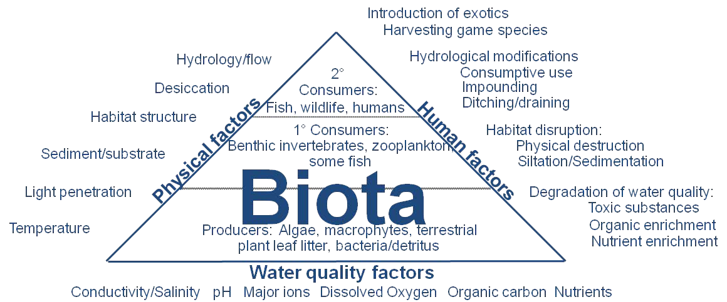

Figure 1. Many factors affect biological community composition. To conclude that human disturbance is primarily responsible for biological degradation, reasonable knowledge of the influence of natural factors is essential.

The SCI consists of ten metrics that quantitatively describe stream community structure and function that are summarized as a dimensionless index (the SCI), which scores between 0 and 100. DEP established a protective threshold SCI score based on a combination of the reference site data distribution and EPA’s Biological Condition Gradient approach. More information on the background, development, and refinement of the SCI is available upon request.

DEP and EPA have concluded that a balanced faunal community is achieved if the average score of at least two temporally independent SCIs, performed at representative locations and times, is 40 or higher, with neither of the two most recent SCI scores less than 35. Attainment of the SCI threshold is an indication that the faunal community of the stream is not being adversely affected by stressors to the extent that there is a loss in designated use. While the stressor may not be known, a failed SCI does indicate that fauna is not well- balanced.

The BioRecon is a companion tool to the SCI with six metrics and a total score of zero to ten. A BioRecon score of 4 is equivalent to an SCI score of 40 (see Fore 2007). While BioRecon results may be considered as additional information, BioRecon should not be used as the only evidence (in the absence of SCI and other measures) to demonstrate attainment or nonattainment of biological health.

SCI Samplers Must Exercise Best Professional Judgment
Only an experienced, qualified SCI sampler is able make the difficult field decisions necessary for proper application of the method. Field staff must be confident they fully understand the objectives of the sampling to enable these necessary field decisions. Samplers should NOT be burdened by undo pressures to sample when conditions are not appropriate for the method and objective (e.g., there should NOT be a binding contract that stipulates collecting a specific number of samples by a certain date if conditions are not appropriate). Additionally, samplers must collect sufficient ancillary data (e.g., water level, habitat, photographs) to document, and assist with determining the usability of a given SCI result for a particular purpose or objective (see section 6 below).

Maintaining Linkages between SCI and Important Related Data
Because many factors affect aquatic biota and the SCI results, it is imperative that all associated data (flow conditions, habitat scores, other physical factors affecting a site, etc.) be linked to the SCI results, so that a determination may be made that each sample is, or is not, consistent with the study objectives. There is a high likelihood that indiscriminate use of SCI scores, in the absence of these associated data, will result in inappropriate or incorrect environmental decisions. It is the responsibility of the staff and managers analyzing the data and making environmental decisions to fully understand the complexities associated with the SCI scores and to use the data appropriately. Samplers must also assist data analysts and managers in determining that SCI results are, or are not, appropriate for a given objective.

Summary of the Development of SCI Metrics
DEP considered a diverse array of community attributes (Figure 2) and used the
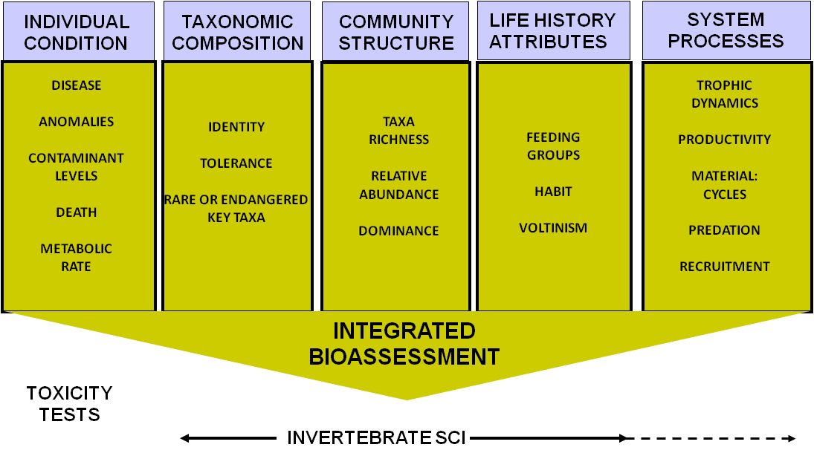
Figure 2. Major attribute categories, and example metrics, for determining biological integrity.
Human Disturbance Gradient approach to objectively select metrics that respond to human influences in a predictable manner (Fore et al. 2007). The Human Disturbance Gradient is composed of four factors:
    - The Landscape Development Intensity Index (Brown and Vivas 2004)
    - Habitat Assessment scores (DEP SOP FT 3000)
    - Hydrologic Modification Index; and
    - Water column ammonia concentration.

These components, described in detail by Fore et al. (2007), were converted into a dimensionless index, with low values denoting low disturbance and increasing values associated with more intense human influences. The Human Disturbance Gradient was used as the x-axis for testing a wide variety of biological attributes associated with the measurement of ecological integrity (Figure 2). Figure 3 depicts the absolute value of correlation coefficients (Spearman’s r) for a variety of biological attributes against the HDG. Once an attribute is demonstrated to respond predictably to human influence, it is termed a metric. The 10 selected attributes metrics were chosen to:
    - Represent as many attribute categories as possible.
    - Provide meaningful and predictable assessment of human effects.
    - Avoid redundancy if several correlated metrics provide similar information.

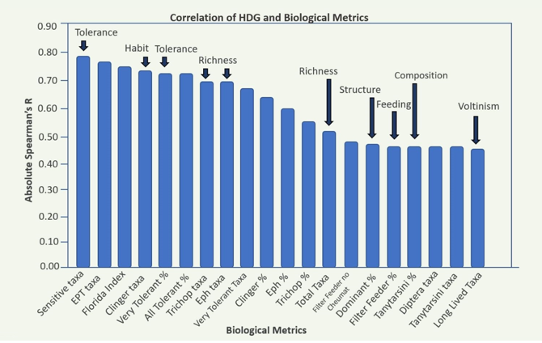
Figure 3. Correlation between various metrics and the Human Disturbance Gradient. Arrows indicated metrics selected for the SCI, and associated attribute group.

The 10 SCI Metrics
A description of the ten metrics is presented here. When aggregated into the SCI, these provide a comprehensive and robust assessment of stream biological health.

Percent Tanytarsini
Tanytarsini midges are sensitive to disturbance, so the metric was included in the SCI as the best available measure of the chironomid assemblage, which is an important group in stream invertebrate communities (Figure 4). There are 14 genera that belong to the Tanytarsini tribe in Florida. Within these genera, there are about 50 species and 31 are represented in the SCI. Tanytarsini midge taxa decline with increasing human disturbance.
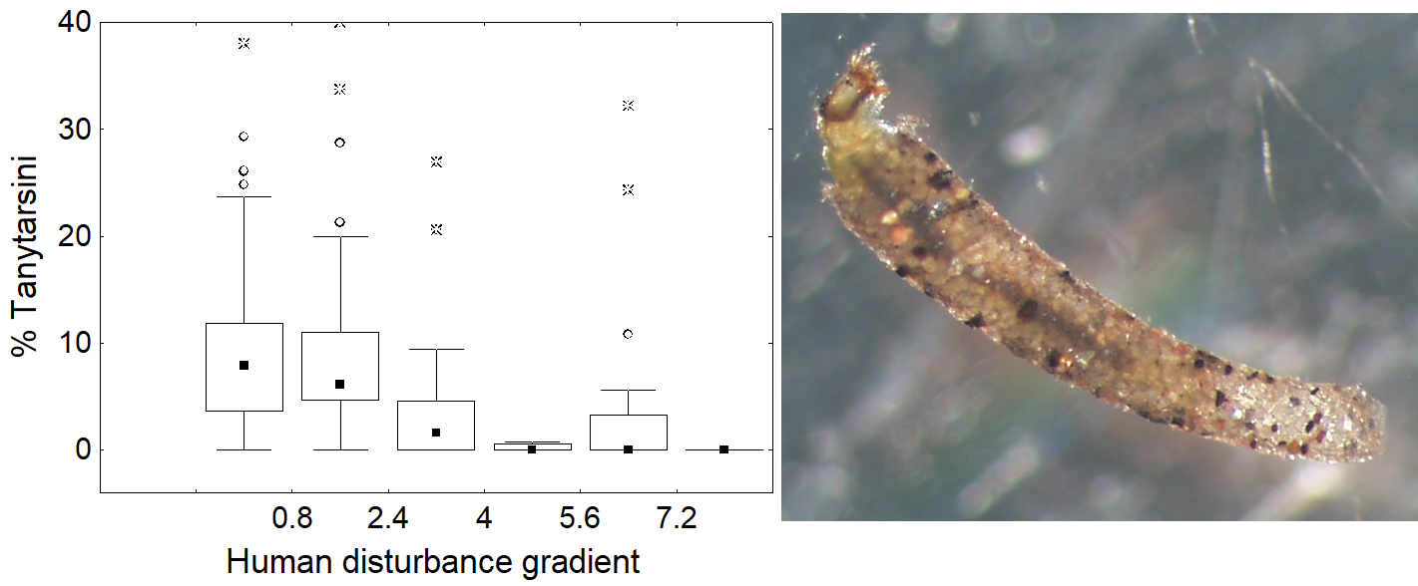
Figure 4. Response of the percent Tanytarsini metric to the HDG. The photo is of a tube building midge of the genus, Stempellina.

Number of Sensitive Taxa
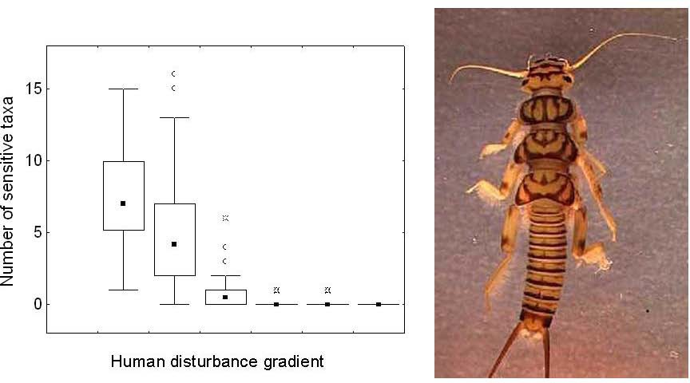
Lists of sensitive and very tolerant macroinvertebrates were established by analyzing the responses of individual species to the HDG (Fore et al. 2007a). The number of taxa selected as sensitive equaled around 12% of the taxa tested; many of the sensitive species included Ephemeroptera, Trichoptera, Odonata; as well as several chironomids. All Plecoptera were included as sensitive taxa (Figure 5).

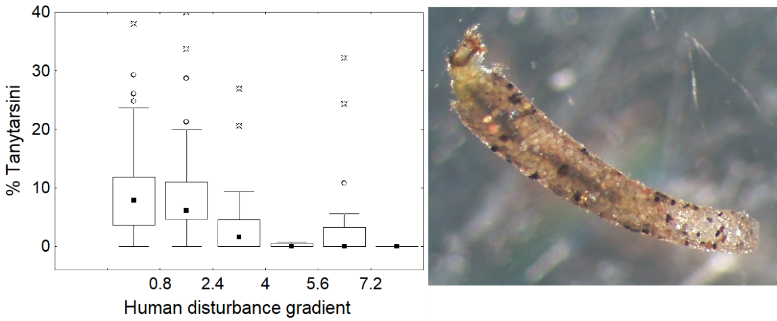
Figure 5. Response of the number of sensitive taxa metric to the HDG. The photo is of a Plecopteran (stonefly).

Percent Very Tolerant Taxa
The number of very tolerant taxa was approximately 10% of taxa tested. The percent very tolerant individuals were highly correlated with the HDG (Figure 6).
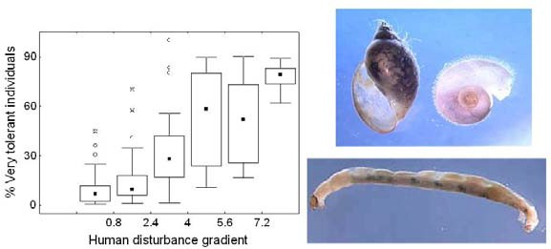
Figure 6. Response of the percent very tolerant metric to the HDG. Photos are of lunged snails (top) and tolerant midges (bottom).

    - Number of Total Taxa
Total taxa richness was selected as an indicator of the variety of taxa that a stream site could support (Figure 7). Three metrics represent taxa richness: total number of taxa, number of Trichoptera taxa, and number of Ephemeroptera taxa. Total taxa decrease in response to human disturbance.
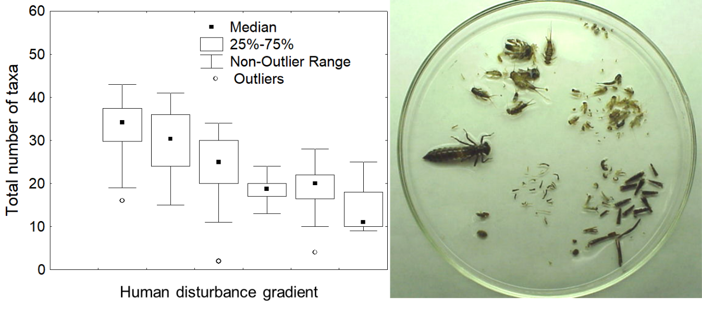
Figure 7. Response of the total number of taxa metric to the HDG.

- Number of Ephemeroptera Taxa
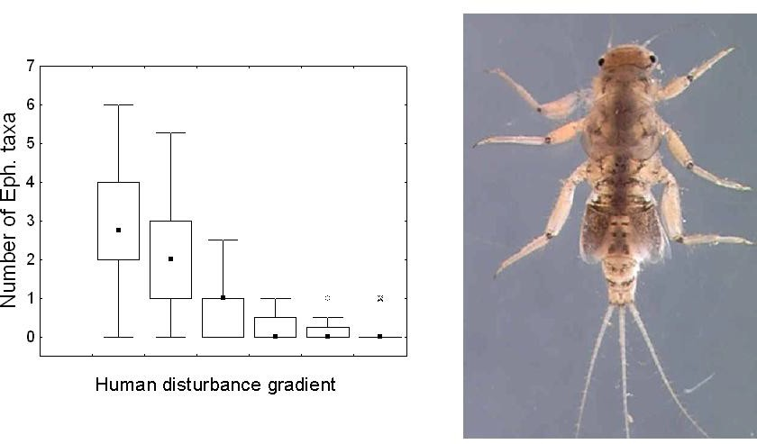
The number of different types of organisms present and the richness of the Trichoptera (caddisflies) and Ephemeroptera (mayflies) have historically been shown to decrease with human disturbance. Figure 8 depicts the response of the number of Ephemeroptera taxa to human disturbance, which is similar to the response of the Trichoptera taxa (Figure 9) and Total Taxa metrics. These three measures were chosen since each metric may respond differently, depending on the type of disturbance (e.g., mayflies are more sensitive to metals, certain caddisflies may be more sensitive to flow disruption).
Figure 8. Response of the Ephemeroptera metric to the HDG. The photo is of Tricorythodes, a sensitive mayfly. The number of Ephemeroptera taxa declines with human disturbance.

    - Number of Trichoptera Taxa
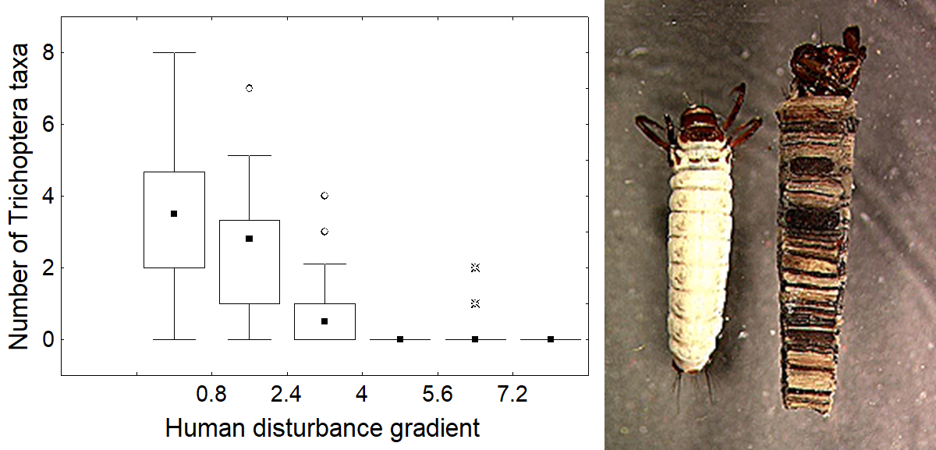
Figure 9. Response of the number of Trichoptera taxa metric to the HDG. The photo is of case-building caddisfly larvae.

Percent Dominant Taxon
Substantial shifts in proportions of major groups of organisms, compared to reference conditions, may indicate degradation (Figure 10). The percent dominant taxon, which increases in conditions where a few pollution-tolerant organisms are very abundant, to the exclusion of other taxa, was selected as a metric.

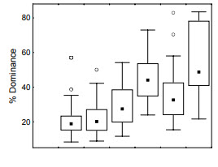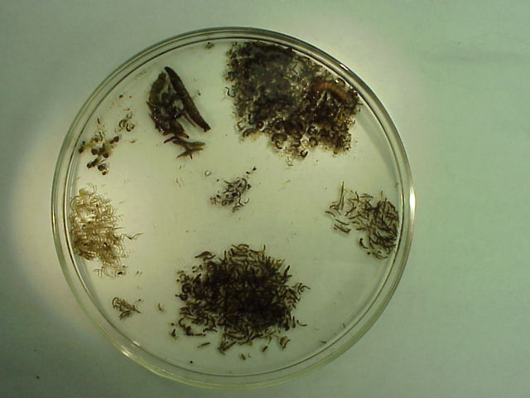
Figure 10. Response of the Percent Dominance metric to the HDG.

Percent Filterers or Suspension Feeders
Disruption of food webs has long been associated with human influence, especially organic pollution. Of the functional feeding group measures, the relative abundance of filterers or suspension feeders (percentage of filter feeding individuals) had the highest correlation and most consistent relationship with the HDG (Figure 11). Filter feeders extract nutrients by straining food particles from the water column. If the water flow or quality of the organic matter in the water is compromised, a reduction in filter feeders will occur.

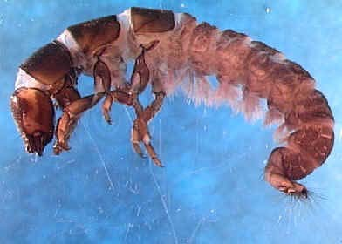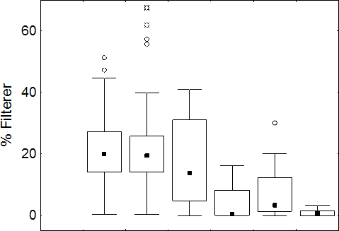

Human disturbance gradient
Figure 11. Response of the percent filter-feeder metric to the HDG. The photo is of a net- spinning caddisfly.

Number of Long-Lived Taxa
Voltinism refers to the number of distinct reproductive cycles for a given organism that may take place in a year. Long-lived taxa included semi-voltine insects and non-insects that require greater than one year to complete their life cycles. Long-lived taxa richness would be expected to decrease if a disturbance event (e.g., sporadic illegal dumping, periodic pulses of chemicals from rain events) occurred at a site within a year of sample collection (Figure 12).
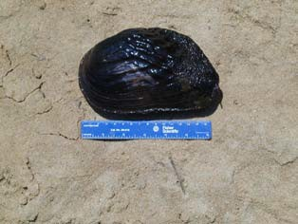
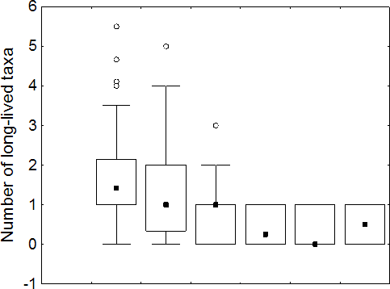
Human disturbance gradient
Figure 12. Response of the long-lived taxa metric to the HDG. The photo is of a mollusk, the threatened purple bank climber.

Number of Clinger Taxa
Clingers are those taxa morphologically adapted to hold onto substrates during routine flow conditions and would be expected to decline as humans alter a stream’s hydrograph (e. g. channelization), especially during abrasive events caused by high stormwater inputs from impervious surfaces. Clinger taxa richness was highly correlated with the HDG (Figure 13).

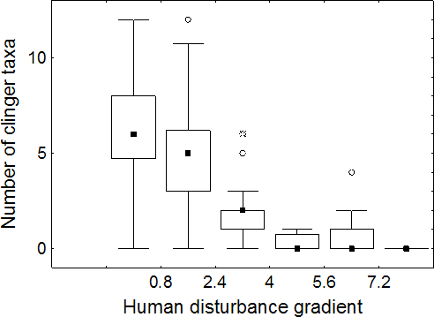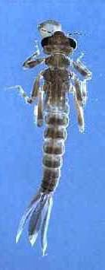
Figure 13. Response of the clinger taxa metric to the HDG. The photo is of a damselfly larva.

How Objectives Affect SCI Sampling Decisions and Interpretation

It was mentioned previously that biota respond to natural and human stressors alike (Figure 1). It is imperative the study objectives associated with each SCI sample are clearly articulated and that efforts are taken to control for confounding factors that may interfere with the appropriate interpretation of the SCI scores. Although there may be multiple factors to consider, the three main issues to be aware of during an SCI study are:
- existing and antecedent flow conditions,
- habitat conditions at a given site, and
- water quality, especially human degradation of water quality (such as exceeding water quality criteria).

Potential uses of the SCI and other environmental measurements, in context of DEP program decisions, are mentioned below and interaction of these components and their effects on score interpretation is discussed.

Water Quality Investigations for the Watershed Assessment / Total Maximum Daily Load Program and for Determining a Causative Pollutant
The objective for an impaired waters assessment/causative pollutant identification study is to decide if water quality issues are adversely affecting biological health. To list a waterbody on the verified list of impaired waters, DEP must reasonably demonstrate the pollutant responsible for poor SCI scores. Since water flow significantly affects stream biota, the investigator must first determine if the existing and antecedent flow conditions were appropriate for sampling. It may seem obvious, but aquatic organisms will die if a site goes dry. If desiccation has occurred within the past 6 months of a sampling event, the recent dry conditions, not water quality, may dominate the invertebrate response.

The SCI SOP contains a provision that SCI sampling be postponed for 6 months after a site has gone completely dry (with no refugia for organisms) and then has begun flowing again, before sampling (although additional information on this issue, including use of site-specific information, is provided in section 3 below). This wait will help ensure that desiccation was not the most prominent factor influencing the SCI score. Similarly, stream organisms are rheophilic (“flow loving”). If water velocity is very low (standing water, stagnant conditions), it is very likely to adversely affect the assemblage of organisms, even if water quality is excellent. Therefore, sampling for impaired waters assessments/causative pollutant identification purposes shall be conducted during periods when water velocity has been 0.05 m/sec or greater for at least 28 days (one month). Controlling for these water flow issues (not sampling during inappropriate conditions) will help minimize the influence of desiccation and water velocity on the SCI results.

Additionally, habitat conditions significantly affect macroinvertebrate communities. Since the objective of an impaired waters assessment /causative pollutant identification study is to isolate water quality factors causing degradation, efforts should be taken to establish sites where habitat is not a substantial factor limiting potential biological health. This means that the investigator must establish sampling sites (where possible) in stream reaches with adequate substrate diversity and availability, intact stream morphology (little or no artificial channelization), adequate flow, and optimal riparian buffer zones. Figure 14 shows an example of a site where habitat and hydrology are significant adverse influences, meaning that an alternate site in the stream segment should be selected for SCI sampling, if one is available. If the entire stream reach has habitat and hydrological limitations and funding for restoration is not available, reclassification to a Class III-Limited category should be considered (as described in Rules 62-302.400 and 62-302.800, Florida Administrative Code (F.A.C.). Note that deleterious sediment input may result in habitat smothering, and that restoration would involve upland erosion control and other Best Management Practices.

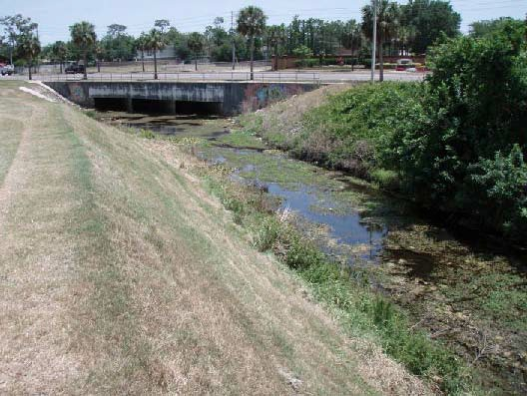

Figure 14. A site where habitat and hydrology significantly and adversely influence the biological community, meaning that an alternate site in the stream segment should be selected for SCI sampling (if possible) during an impaired waters assessment /pollutant identification study.

Specific conductance (conductivity) is a water quality parameter worthy of special discussion. Elevated conductivity at a site may be due to its proximity to natural saline conditions (e.g., at tidally influenced systems) or due to human sources. The SCI was designed for freshwater streams, and as such, it would not be appropriate to use the tool where conductivity is naturally elevated (e.g., near estuarine areas). However, if a human discharge has artificially elevated a stream’s conductivity, the SCI may be used to document the resulting potential adverse community response. One must take care to assess the source of conductivity when deciding the appropriateness of the SCI.

In conclusion, if flow and habitat limitations are controlled for during an impaired waters assessment /causative pollutant identification study, and sufficient water quality data are collected, the water quality factor(s) responsible for any observed biological degradation are more effectively identified.

Point Source Studies
Point source studies involve an evaluation of effluent quality and whether existing permit limits are sufficient to maintain surface water quality standards (Rule 62-302.530, F.A.C.) and prevent degradation of the biological communities in the receiving waters. To assess the influence of the discharge, an upstream-downstream SCI study is routinely employed, while controlling for important variables (e.g., habitat) between the upstream (control) and downstream (test) sites. Selection of similar habitats from areas of similar water velocity is important to determine if the effluent is associated with any changes in the SCI scores. Additionally, the use of replicate sampling stations, for both control and test sites, will better characterize the variability of the biological data. If reductions in the SCI scores occur between the control and test sites, the intra-site variability and the magnitude of the change should be assessed, as well as potential categorical shifts.

Best Management Practices (BMPs) Effectiveness Studies
Previous studies on the effectiveness of forestry best management practices, using the SCI, followed a typical Before-After-Control-Impact design. This design may be applicable to other BMP studies. Stream reaches were selected where neither flow, habitat, nor water quality were limiting to aquatic communities. An upstream “control site” and a downstream “test site” were established, and both were sampled (with replicate stations) prior to the onset of the human activities (conducted with BMPs). Sampling continued at the same control and test sites after the potentially damaging human activities (with mitigating BMPs) had taken place and SCI scores were compared, both pre- and post- disturbance (see Figure 15). In this case, Analysis of Variance indicated that no significant differences between the control and test sites had occurred after the forestry activities, demonstrating that the BMPs were effective in protecting stream biota.
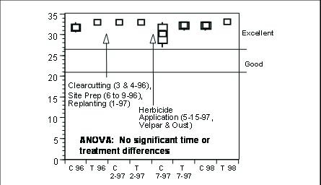Figure 15. SCI results of a Before-After-Control-Impact study assessing the effectiveness of forestry Best Management Practices. “C” and “T” mean control and test sites, respectively. Note that a different version of the SCI was used during the time period, but the concepts apply to the current SCI.

Stream Restoration Studies
The objectives for a stream restoration study are to determine if one or all the following factors have been improved or mitigated in a manner that adequately supports aquatic communities:
    - Stream morphology
    - Habitat
    - Water supply to the stream and in-stream water velocity; and
    - Water quality.
The investigator shall measure each of these important variables over time, along with conducting SCI sampling. This will enable a demonstration that the restoration activities can be successfully linked with a positive biological response (improving the SCI score as the desired environmental endpoint). Past studies of reclaimed streams in mining areas have suggested that all four factors listed above need to be adequately addressed to ensure a positive biological response. It is important that data collected as part of a restoration study not be indiscriminately used for unintended purposes (e.g., placing a waterbody on the verified list impaired waters list when habitat, not water quality, was the limiting issue).

Minimum Flow and Levels Studies
As mentioned above, sufficient water flow is critical to stream biological community health. Biological communities will be negatively affected when humans adversely modify watershed hydrology or artificially reduce water inputs to a stream (leading to extended dry or stagnant conditions). However, care must be taken to distinguish between effects of natural droughts and the similar effects caused by human reductions in water quantity. Also, if a study design calls for using SCI sampling after stream desiccation (e.g. within 6 months) or during periods of stagnant water velocities (not generally appropriate for conducting the SCI SOP), it is important that the resulting data (probable SCI failures) not be misinterpreted as water quality issues (see Section 6 on maintaining associated data with the SCI below).

Integrated Water Resource Monitoring (Status and Trends) Program
The Integrated Water Resource Monitoring program (IWRM, aka Status and Trends) is a monitoring program designed to determine the quality of Florida’s fresh surface and ground waters at a large scale, using two differing approaches. The first (Trend network) is a fixed-point monitoring program that is designed to determine changes in water quality over time at 78 set surface water locations around the state. The sampling locations were selected to capture the quality of waters that flow into the state, and at the bottom of watershed basins (determined using a Hydrological Unit Code, [HUC]). Water samples are collected monthly at all surface water Trend sites, and the SCI is conducted annually.

The second component of the program uses a random stratified (probabilistic) sampling network, called the Status monitoring network. The objective of the Status network is to provide an estimate of water resource conditions within the state for surface and ground waters. Because of the extent of aquatic resources within the state, no one sampling network could adequately sample all waters in Florida each year due to logistical and practical limitations. The probabilistic design was selected to balance resources, provide a scientific and statistically sound platform, and provide coverage of waterbodies at a reasonable scale. A subsample of the water resource is selected, collected, and analyzed during a specified sampling window referred to as a “sampling period.” The design is based on a set geographic boundary or reporting unit (“zone”) that follows the Water Management District boundaries.

The SCI tool was adopted as part of the Impaired Waters Rule listing process and was incorporated into use by the IWRM program in both the Status and Trend monitoring networks in 2004.

To assist samplers in making the decision whether to sample SCI at a particular site for the IWRM program, the following rules have been developed:

    - Do not sample if the system is not functioning as a stream or river (it is more like a lake, estuary, wetland, marsh, prairie, canal, ditch, etc.).
    - Do not sample if the system is currently dry or disconnected or has been completely dry within 6 months prior to the site visit. If this cannot be determined with confidence, do not sample.
    - Do not sample if flood conditions exist and water levels are > 0.5 meters above normal.
    - Do not sample if the system is tidally influenced (regardless of conductivity values).
    - Do not sample if the system is a spring run with conductivity values > 600 µmhos.
    - Do not sample if the average velocity is < 0.05 m/s or has been < 0.05 m/s in 28 days prior to the site visit. If this cannot be determined with confidence, do not sample.
    - Do not sample if conditions are unsafe; and
    - Do not sample in the South Florida Bioregion (south of Lake Okeechobee).
- Do not sample sites in the immediate vicinity of water control structures.
- Do not sample sites with drainage areas less than 5 sq. miles unless you have site-specific information demonstrating it is appropriate for SCI sampling.

The assumption was made at the onset of the use of the SCI tool in the IWRM program that it applied to all Class III freshwaters. Many of the Class III waters within the central and southern region of the state have been hydrologically altered or have been created for the primary purpose of flood control. Canals and ditches, even if they are connected to waters of the state, are currently excluded for sampling because they do not function as a stream or river.

Due to the random design of the probabilistic network, samples are collected only where the site is specifically selected, based on a 1:100,000 scale map. This results in sites being selected in areas that are possibly not optimum habitats but should be representative of the stream or river resources in the reporting unit. The objective, as stated above, is to characterize the condition of waters within a zone. The intent is not to characterize any specific stream or river. Therefore, when results are reported, they pertain only to the estimate of condition of representative resources within the zone.

For the Status Monitoring Network samples are collected at random, unbiased locations. Considering that random site locations may not be appropriate for SCI sampling, SCI sampling for the Status Network was discontinued beginning in 2012. Water quality samples and Habitat Assessment are still collected within the selected 100-meter stretch.

For the Trend network, samplers are permitted to orient the 100 meter stretch upstream or downstream from the water quality sample collection point as necessary to provide the most representative habitat stretch for the system. The designated water quality sampling point does not have to reside within the 100-meter stretch, but it must be no farther than 200 meters away from the HA stretch. However, if moving the HA stretch 200 meters away still does not meet the acceptable criteria for performing the HA/SCI, do not perform the HA/SCI.

Use Attainability Analyses and Class III-Limited Reclassifications

Rules 62-302.400 and 62-302.800, F.A.C., describe the requirements to reclassify Class III waterbody to a Class III-Limited waterbody. For a downgrade in classification, a Use Attainability Analysis (UAA) must be conducted, as explained in Rule 62-302.400(9), F.A.C.

Because a downgrade to the Class III-limited category is restricted to physically and hydrologically altered waterbodies, biological sampling should occur in areas representative of these human stressors. Consequently, the waterbody segment will likely be habitat limited and the hydrologic modifications may be such that the waterbody is frequently dry or not flowing. Although both conditions would likely prevent the waterbody from supporting a healthy biological community, it is appropriate to sample SCI and other biological measures under these obviously stressed conditions because it is consistent with the study objectives (see example in section 3 below).

Water Level and the SCI

All scientific methods have limitations that must be understood to effectively use the technique for making valid decisions. As previously mentioned, aquatic organisms will die if a site goes dry. For pollutant identification studies (including nutrient studies), wait a minimum of 6 months after a completely dry site has begun flowing again before considering sampling, unless site specific information is available that indicates a particular stream invertebrate community recovers more quickly than 6 months (e.g., 3- 4 months). In these situations, sampling may occur after the suitable period of time has elapsed that allows for biological recolonization from the desiccation event. For example, if the investigator has the necessary taxonomic skills, exploratory dip net sweeps may be conducted, and the organisms field identified to determine the degree of recovery from dry conditions. If it appears that a typical stream community is present, the investigator may commence sampling, documenting the reasons behind the decision.

The SCI is routinely performed only within approximately 0.5 m of the water’s surface (the arm length of an average sampler). It is imperative that the sampler be confident that the “reachable” habitat in this top 0.5 m has been fully inundated with water for a minimum of one month (28 days) prior to sampling (Figure 16). If water level at a site increases into this reachable zone to the extent that the sampler is not confident that the accessible habitats were inundated, the sampler should wait a minimum of 28 days to allow time for stream organisms to colonize the formerly exposed habitats.

As an example, Figures 17 and 18 depict a recent increase in water level that would limit a sampler’s ability to collect organisms from the previously wet and colonized substrate. When conditions such as these are encountered, the sampler must have sufficient knowledge and training to abort SCI sampling. Understanding hydrographs from streams in the general area (not every stream has a gauge) and extrapolating that information to the study stream is extremely valuable for determining when sampling is, or is not, appropriate. Smaller streams typically have more spikes in their hydrographs, where the water level rises quickly and significantly but then returns to “normal” levels within days (Figure 19). A valid SCI sample can be collected when the formerly colonized habitats may be reached; however, it is important that samplers exercise caution to make sure that the substrates selected for sampling have been appropriately inundated.
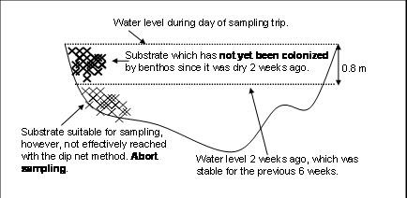
Figure 16. Schematic cross section of a stream showing recent increases in water levels indicating the SCI sampling should not be conducted.

In streams with natural geomorphology and sinuosity, the habitats targeted for SCI sampling act as refugia from scouring during flood events, and sampling may be conducted when inundated substrates are reachable. However, in channelized systems there may be significant scouring after routine rain events. Depending on the study objectives, sampling may be conducted after a rain event in a channelized system to demonstrate the adverse effects of hydrological modification on the system. All SCI samplers must fully understand how water levels affect their ability to collect a valid, meaningful SCI sample, and abort sampling when conditions are not suitable. The following examples will help illustrate this concept.

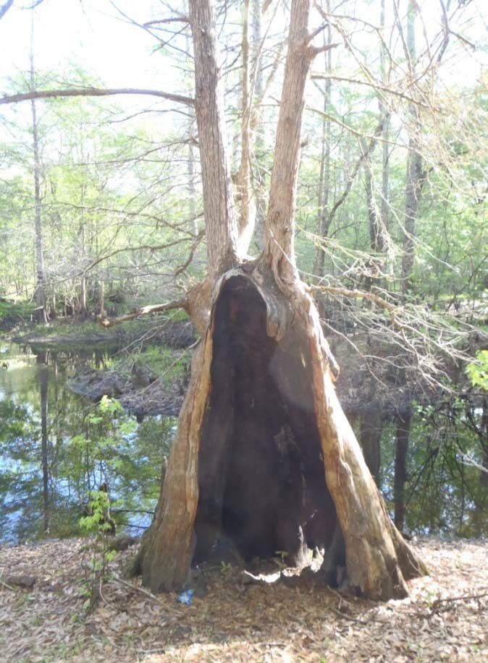
Figure 17. Stream water level two weeks prior to scheduled SCI sampling.

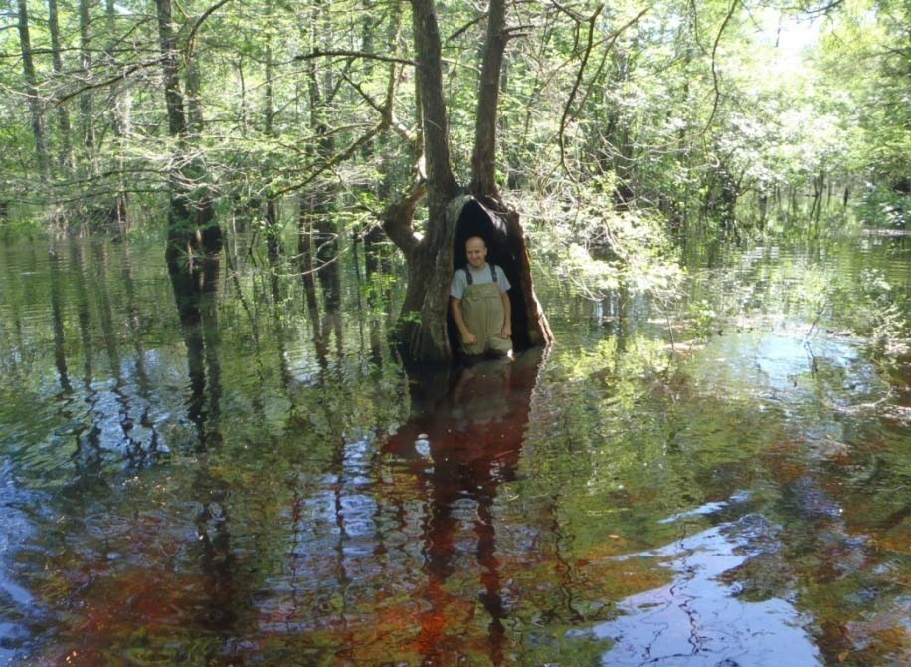
Figure 18. Stream level on day SCI was scheduled to be performed. Note that reachable substrates were dry in the previous photo. SCI sampling should be aborted when these conditions occur.

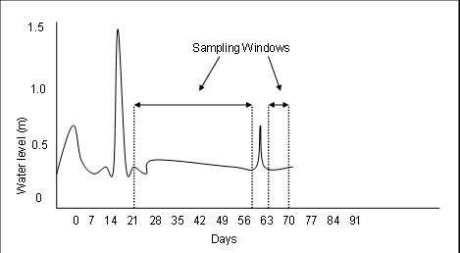
Figure 19. Hydrograph shows times when substrates are reachable.

Similarly, if a site did not go completely dry, but essentially stopped flowing, samplers should wait at least 28 days after flow has commenced (with a minimum water velocity of > 0.05 m/sec), before sampling. Note that it may take longer than 28 days for organisms to re-inhabit previously dry substrates and for rheophilic organisms to recolonize stagnant reaches, depending on site characteristics. Avoid sampling sites after these low water level/stagnant events until sufficient time passes to eliminate these water level effects as confounding factors in interpreting the SCI results. If there is doubt about a particular sampling event, samplers should communicate with data analysts to flag the SCI results as potentially being affected from these water level issues.

Example 1, Sampling for Impaired Waters Assessment
A sampler is collecting SCI data to determine if water quality degradation (in this case, nutrient enrichment) is sufficient to list a waterbody on the verified list of impaired waters. When arriving at the site, the sampler determines that almost all the productive habitats (roots, snags, leaf packs) are exposed to air due to extremely low water levels (see Figure 20). Hydrographs from nearby streams indicate these low water conditions have occurred for the past few months. Water velocity in the stream is not measurable (0.00 m/sec). Should the sampler collect the SCI? No, the conditions are such that the lack of inundated habitat and adequate velocity are the dominant factors affecting the stream biota. Collecting the SCI and attributing the low scores to poor water quality is not scientifically defensible, as factors other than water quality were highly influential.
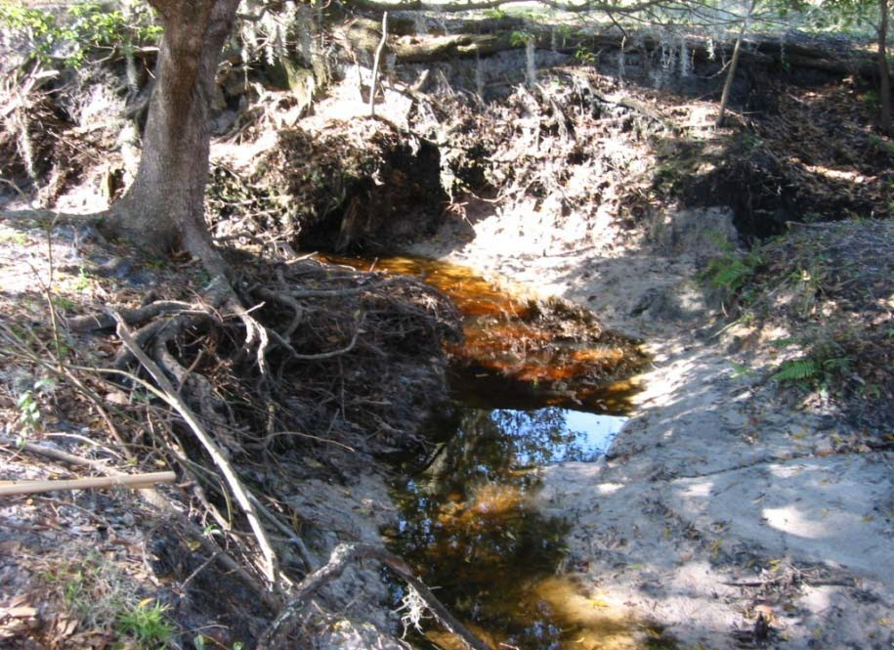
Figure 20. Photo of low water conditions resulting in the desiccation of viable stream habitats. SCI sampling for Total Maximum Daily Load (TMDL)/pollutant identification studies should not be conducted under these conditions.

Example 2, MFL Sampling
A study is attempting to establish a relationship between water quantity in a stream and the SCI scores with the hypothesis that more water yields higher scores. Water levels in the stream rose by one meter during the past week. The sampler notes that terrestrial vegetation is currently under water and reachable substrates in the top 0.5 m (snags, limestone) have no “slimy” feel. Should the sampler collect the SCI? No, the recent increase in water level means the organisms have not yet colonized the accessible substrates. Sampling under these conditions would erroneously produce data indicating reductions in SCI scores with increased water delivery.

Example 3, TMDL/Pollutant Identification Sampling
Due to heavy rains, a stream has water levels two meters over its banks into the riparian floodplain (see Figures 21 and 22 for photos of typical and flooded conditions). This condition has occurred for four weeks. The sampler notes that there is no access to the actual stream channel due to the water depth, but some habitat in low velocity backwaters of the floodplain can be reached. Should the sampler collect the SCI? No, the actual stream cannot be sampled. The few organisms that may have colonized the low velocity backwaters of the floodplain would not be representative of the actual stream health. Again, collecting the SCI and attributing the low scores to poor water quality is not scientifically defensible, as factors other than water quality were highly influential.
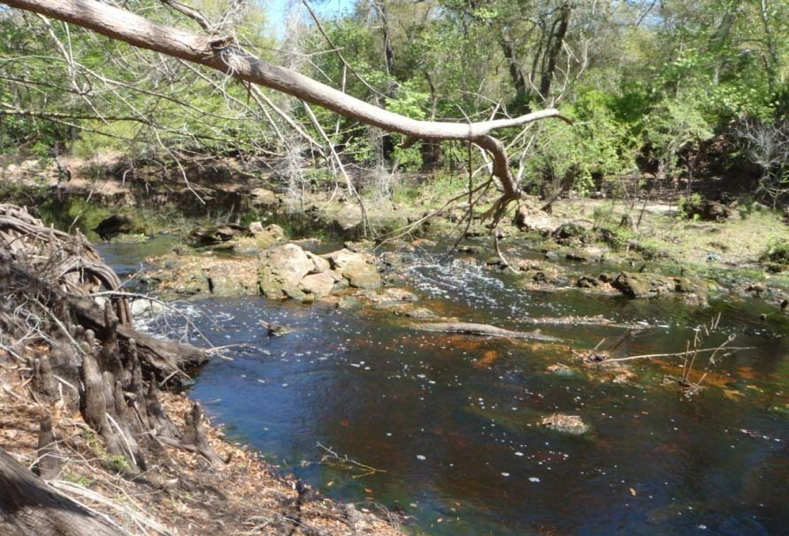
Figure 21. Typical flow conditions at a sampling site.
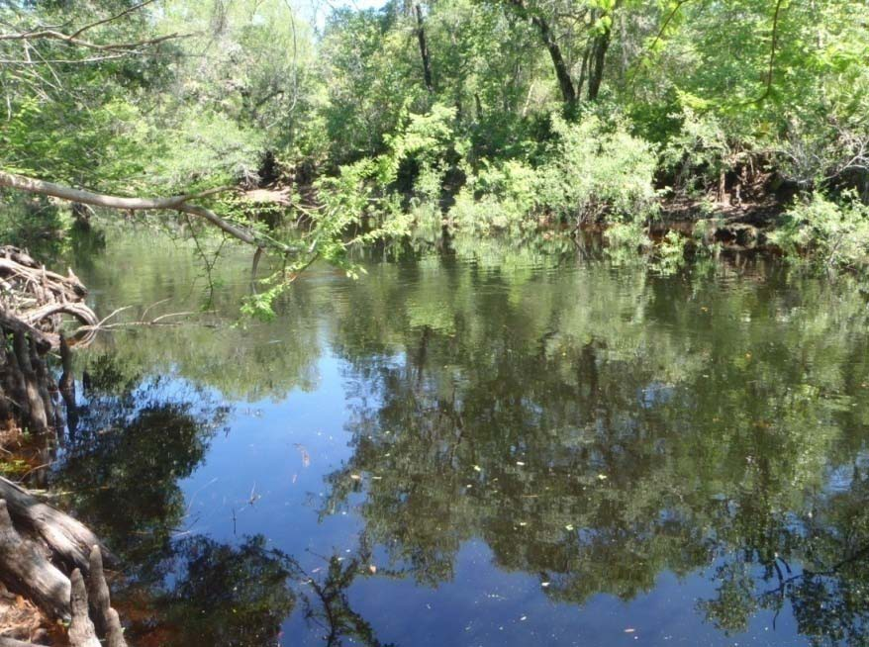
Figure 22. Flow conditions at the same site shown in Figure 21, associated with a high-water event, including floodplain inundation, when SCI sampling would not be appropriate.

Example 4, Sampling for Use Attainability Analyses

An entity is proposing to sample a series of severely hydrologically modified systems, including canals and urban ditches, as part of a Use Attainability Analysis to reclassify the systems into the Class III-Limited category, as described in Rules 62-302.400 and 62-302.800, F.A.C. Although the canals do not typically go dry, the hydrologic modifications are such that the canals are characterized by consistently low water velocity (< 0.05 m/sec), except for during flood events. Can the canals be sampled for SCI under typical conditions? Yes, because the defined objective is to determine if the hydrologic modifications (and corresponding habitat limitations) have interfered with the development of a healthy community, the investigator may sample during the typical velocity conditions, even if they are below 0.05 m/sec. Similarly, the urban ditches in the study rarely contain water for more than 3 or 4 months and are usually dry during the remainder of the year. Again, because the study objectives are to determine the influence of the hydrologic modifications, it is appropriate for the investigator to sample the ditches after they contain water for the typical maximum amount of time, even if that is only 3 or 4 months.

Overview of SCI Sampling Process

Fundamental to SCI sampling is the selection of the best available habitats, in the optimal flow, to collect the indicator organisms in the areas they typically inhabit. This was how all the reference and potentially disturbed sites for calibrating the SCI were sampled. If the “healthy” organisms are not found in their optimal living quarters (best habitat and flow) one may conclude that some disturbance (human or natural) was responsible for their absence. A pristine stream, if not sampled according to the SCI protocol (e.g., if one erroneously sweeps only sand or low velocity backwaters), will assuredly fail the SCI. Conversely, if the very best habitat and flow conditions are sampled in accordance with the SOP in a human-damaged system, the SCI result will accurately reflect the level of disturbance. Therefore, training and ethics of SCI samplers is very important. A biologically healthy site, if sampled poorly, will fail the SCI. A disturbed site with an impaired community will also fail, even when sampled with a bias toward the best available habitats, but due to environmentally relevant reasons, not as a sampling artifact. Samplers must thoroughly understand the concepts associated with the Standard Operating Procedures (SOPs), and consistently follow the SOPs, and operate in an ethical manner to prevent sampling errors (see DEP SOP SCI 2100.

Sampling Site Selection and System Classification

First, the study objectives must be clearly understood, and a 100 m segment of stream that is appropriate to address the objectives should be selected as a sample site. For purposes of site selection, it is important to understand there are variations in a stream’s flow, habitat, and biota as it moves through the landscape, and this variability has implications for the proper application of the SCI. Within a single reach of a stream or river, there are areas of higher and lower densities and diversities of macroinvertebrates. These differences occur both on the local scale (i.e., different qualities of in-stream habitats; snags vs. muck in a 100 m section) and the landscape scale (i.e., different flow regimes and habitat diversity over a 5–10-mile section of stream).

For defining DEP’s inherent biological expectations associated with the SCI, stream or river segments that generally had flow (with velocities ranging from 0.05 m/sec to 0.4 m/sec except during seasonal droughts or floods) and typical “stream” habitats were selected. In other words, the SCI should be applied to streams that have similar and comparable characteristics to those streams used in the calibration data set.

Comparing biological communities from swamp-like, lake-like or tidally affected segments of streams to the biological expectations established for “typical” streams is not scientifically defensible. Proper classification of the system type one is attempting to sample is another fundamental concept for appropriate application of the SCI. However, it should be noted that the SCI may be used to assess human alterations in habitat and hydrology via a logically designed study.

Over a short distance, a stream may change from a system with a well-defined natural channel, good flow, and an abundance of habitats to a forested swamp with little to no defined channel and very little perceivable flow. If the system is behaving like a swamp, and not a flowing stream in that specific area, one would not expect the swamp-like segment to perform well on the SCI. Conversely, if a study is attempting to assess the detrimental effects of stream impoundment, it may be appropriate to sample a former stream segment that has been hydrologically modified to resemble a lake, because such sampling is consistent with the study objectives. Example photos of sites unsuitable for the SCI method are provided in Figures 23, 24, and 25.

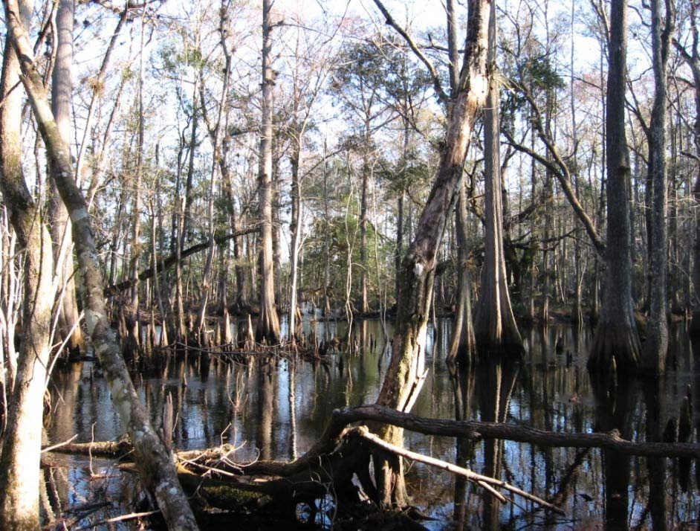
Figure 23. Example of swamp conditions present, indicating that the SCI is inappropriate at this site.
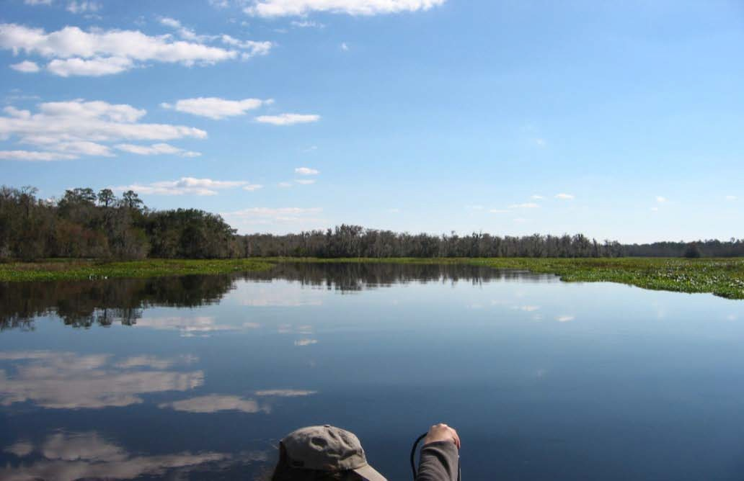
Figure 24. Example photo of lake conditions present, indicating that the SCI is inappropriate at this site.

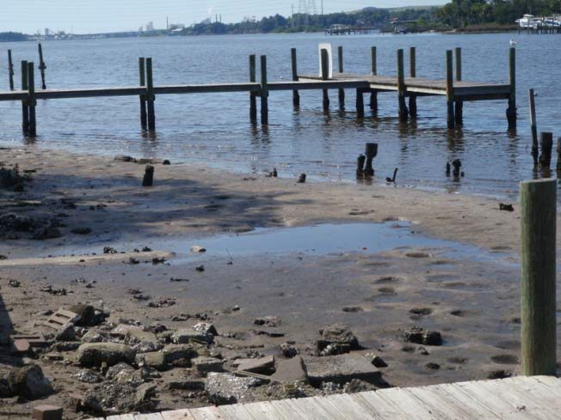
Figure 25. Example photo of tidal influence, meaning SCI is not the appropriate tool.

Thus, atypical areas not representative of the stream reach should be avoided when using the SCI as an indicator of biological integrity, unless the study objectives dictate otherwise. For example, unless the study objectives are to determine adverse habitat effects of road construction, sampling directly adjacent to or under a bridge (usually disturbed by channelization) should be avoided, as this area would not be representative of the stream reach.

4.2. Non-Perennial Water Segments

While any healthy system may fail the SCI if it is not sampled according to proper protocols, this is especially true for large rivers and non-perennial systems. Non-perennial systems are those where fluctuating hydrologic conditions, including periods of desiccation, typically result in the dominance of wetland/semi-aquatic and/or terrestrial taxa (and corresponding reduction in obligate fluvial or lotic taxa). The duration and frequency of surface flow in streams must be understood to avoid confounding effects of natural drying events when assessing the ecological integrity of flowing waters. The drying process causes changes in the physical and chemical conditions (e.g., loss of wetted habitat, reduced dissolved oxygen), which can exclude some species while allowing others to thrive. Hydrological, biological, and geophysical indicators may be used individually or in combination to make a demonstration whether a segment is non-perennial.
There are three methods to help determine if a segment is non-perennial for purposes of SCI sampling: 1) site specific gage and discharge data, 2) biological information based on the resident flora or fauna, and 3) geomorphology as an indicator of flow permanence. Any method can be used independently to establish non-perenniality. Demonstrations may be strengthened by employing multiple methods. Each method is described below. Other methods that provide this demonstration with similar accuracy will be considered by the Department if they are a means to predicting the resulting biological conditions discussed below.

Stream Flow Characteristics as an Indicator
Perennial flow has been defined in several ways, including threshold-based definitions (such as 90% flow durations) and biologically based criteria (such as 180 consecutive days of flow to support macroinvertebrate taxa). The terminology used here combines both elements. Perennial streams are defined as those that have non-zero flow for at least 180 consecutive days (i.e., 6 months) in at least 90% of years in the available period of record. Likely perennial steams have measurable flow for at least 180 consecutive days in greater than 50% of years. Seasonally flowing streams achieve 90-day (i.e., 3 months) flow spells in at least 75% of years and can be appropriate for SCI sampling if the sampler has site-specific knowledge of when the system has had a minimum of 90-days of measurable flow. Non-perennial segments typically do not meet the flow thresholds for SCI sampling.

A demonstration that a stream is neither perennial or likely perennial, as defined above, can be made using pre-existing gage data or by deploying gages specifically for determining flow duration in the streams of interest. Monitoring must be representative of a consecutive 12-month period. The demonstration shall include the mean annual flow, mean monthly flows, and 30-day low-flow frequencies. Longer periods of record will provide greater confidence that the mean, high, and low flow conditions have been adequately characterized. Streamflow statistics can be estimated using accepted regression equations for the region and site of interest and will be evaluated on a case-by-case basis for data sufficiency and accuracy.

Biological Information as an Indicator
The Department has long relied on lists of vascular plants including obligate wetland indicators, facultative wetland indicators, and facultative neutral indicators, as one component of the method used to identify and delineate wetland boundaries, as defined in Chapter 62-340, F.A.C. If available, vascular plant community composition (such as that collected in the Linear Vegetation Survey, DEP SOP FS 7320) will help distinguish streams from non-perennial water segments. Often, both types of systems contain few or no rooted herbaceous plants in the stream channel, because natural turbidity, canopy cover, and color reduce the light available for photosynthesis. If herbaceous plants are present, perennial and non-perennial systems often share many taxa, particularly in areas where they transition to adjacent floodplains. However, the presence of certain facultative or facultative-wetland herbaceous species within the stream bed can be a valid indication that the stream is non-perennial. These taxa may require moist or saturated conditions to germinate and grow but would not tolerate the inundation of a perennially flowing stream. Examples of these taxa include grasses such as Chasmanthium latifolium and Tripsacum dactyloides, sedges such as Cyperus esculentus and Cyperus retrorsus, forbs such as Cuphea cartagenensis, Bidens pilosa, and Sphagneticola trilobata, and ferns such as Woodwardia virginica and Thelypteris spp. (see complete lists of obligate wetland, facultative wetland and facultative taxa in Chapter 62-340, F.A.C.). During a habitat assessment or Linear Vegetation Survey conducted during a site visit, the presence of facultative and facultative-wetland herbaceous vascular plant taxa in the channel bed would be an indicator that the system is non-perennial. Many plants within a permanently wetted channel are aquatic plants, which are defined but not listed in Chapter 62-340, F.A.C. Under extremely dry conditions, terrestrial taxa could also invade the channel bed of a non-perennial system.

If available, macroinvertebrates can also be used to distinguish perennial from non-perennial /wetland systems. Most rheophilic invertebrates require relatively consistent inundation and water velocity to complete their life cycle, although many have mechanisms to survive extreme drought conditions, if perennial streams reduce to a series of pools. These pools typically exhibit slow flowing water with connecting flows between the pools existing in the sediments below the temporarily non-inundated sections of the stream bed. Other mostly wetland taxa are adapted to survive the frequent (generally annual) periods of desiccation associated with non-perennial streams or wetlands. Some invertebrate species classified as facultative (semi-aquatic), can occupy both perennial streams and non-perennial flowing waterbodies. This is due in part to the colonization of non-perennial flowing waterbodies by movement of invertebrates from nearby perennial waters, especially those with adaptations that allow them to survive in short hydroperiod environments, such as a multivoltine life cycle, highly mobile adults, and rapid growth during the wet season. Some may be completely lacking in aquatic invertebrates (terrestrial animals may be present) or have a limited number of species that can complete their life cycles rapidly before the stream dries.

The Department has compiled taxa lists to distinguish perennial from non-perennial waterbodies/non-flowing systems (Tables 1 and 2). The SCI is not appropriate for waterbody segments where there is a dominance of wetland, semi-aquatic and/or terrestrial taxa, with a corresponding reduction in obligate fluvial or lotic taxa.

The presence of long-lived aquatic species (benthic macroinvertebrates that require water for their entire life cycle) is another reliable method to determine if a stream is more characterized by perennial flow or wetland/terrestrial conditions. A list of long-lived taxa is included in DEP SOP SCI 2100.

Table 1. The most commonly encountered invertebrate taxa in SCI samples collected in Florida. Taxa information was retrieved from the Florida Statewide Biological DataBase (“SBIO”) and represents 6,695 perennial stream samples collected statewide from 2004 through 2024. Some of the organisms are ubiquitous (e.g., Chironomidae) and are found in several system types, however, in flowing systems there are a large number of rheophilic and long-lived taxa that are not commonly encountered in wetlands or non-perennial streams.
Taxa | Number of Occurrences (n=6,695)
Chironomidae | 5750
Hyalella azteca | 4196
Polypedilum illinoense grp. | 3640
Caenis | 3556
Stenelmis | 3400
Cheumatopsyche | 3294
Ancylidae | 3238
Polypedilum flavum | 3071
Rheotanytarsus exiguus grp. | 3063
Microcylloepus pusillus | 2897
Tubificidae | 2869
Coenagrionidae | 2826
Stenochironomus | 2802
Dubiraphia vittata | 2612
Simulium | 2320
Ceratopogonidae | 2293
Polypedilum scalaenum grp. | 2264
Ablabesmyia mallochi | 2238
Sphaeriidae(mollusca) | 2210
Argia | 2138
Oecetis | 2122
Corbicula fluminea | 1983
Enallagma | 1930
Heptageniidae | 1914
Physa | 1879
Palpomyia/bezzia grp. | 1866
Pentaneura inconspicua | 1866
Palaemonetes | 1853
Hemerodromia | 1812
Hydroptila | 1803
Rheotanytarsus pellucidus | 1775
Hydrobiidae | 1768
Baetidae | 1670
Triaenodes | 1626
Ablabesmyia rhamphe grp. | 1626
Thienemannimyia grp. | 1618
Cambaridae | 1616
Pseudochironomus | 1594
Micromenetus | 1558
Oxyethira | 1552

Table 2. The most abundant invertebrate taxa found in wetland systems in Florida from 221 samples retrieved from SBIO. The organisms are dominated by oligochaetes (e.g., represented by the genera Dero, Bratislavia and others), midges (e.g., Polypedilum and Goeldichironomus), and damselflies and dragonflies (e.g., Coenagrionidae and Libellulidae).
Taxa | Number of Occurrences (n=221)
Hyalella azteca | 173
Chironomidae | 140
Dasyhelea | 139
Larsia decolorata | 115
Palpomyia/bezzia grp. | 114
Polypedilum trigonus | 104
Palaemonetes | 97
Ceratopogonidae | 95
Caenis | 93
Larsia | 92
Parakiefferiella sp. f epler | 92
Coenagrionidae | 85
Polypedilum sp. a epler | 83
Arrenurus | 82
Bratislavia unidentata | 81
Chironomus | 81
Tanytarsus sp. g epler | 81
Polypedilum illinoense grp. | 75
Parachironomus alatus | 73
Libellulidae | 72
Tanytarsus | 71
Ancylidae | 67
Planorbella | 67
Cladotanytarsus sp. a epler | 64
Paratanytarsus | 63
Tanytarsus sp. r epler | 63
Hydrobiidae | 61
Berosus | 53
Dero digitata complex | 52
Pelocoris | 49
Desmopachria | 48
Corixidae | 46
Tanytarsus limneticus | 45
Derallus | 42
Naididae | 42
Hydrocanthus | 40
Polypedilum halterale grp. | 40
Gastropoda | 39
Odontomyia | 39
Dero pectinata | 37

Geomorphology as an Indicator
Given the large number of potentially non-perennial flowing waterbodies, GIS resources can help identify candidate non-perennial segments. Drainage area and dominant water source (surface versus groundwater) can be determined using readily available GIS layers, which in turn provide insight into the typical flow regime and degree of flow permanence in a stream segment. Drainage area in this context refers only to the contributing area upstream of a sampling location. As drainage area increases, groundwater storage increases and as it approaches the streambed level, it ensures a more continuous flow. (Exceptions to this include springs and seepage streams where even the upper reaches sustain year-round surface flow.) Thus, as groundwater's relative contribution (versus surface water) increases, so does the permanence of flow in a system.
Elements of the HydroBioGeomorphic (HBG) Classification System developed by John Kiefer (2010) and subsequently refined under DEP contract (AMEC, 2013; references provided for informational purposes only) provide critical information that can be used to estimate if a stream is perennial at a given location. Details of how to apply the HBG as an indicator of flow permanence are described in the Appendix.

4.3 Large Rivers
Large rivers present many challenges for the SCI sampler. The habitat in these systems is typically limited to what can be reached from a boat or wading along a narrow strip of shore. Because the SCI is routinely performed only within the top 0.5 meter of the water’s surface (the arm length of an average sampler), it is critical in large non-wadeable systems that adequate productive habitat be within the upper 0.5 m. Water levels often rise over 0.5 m without being easily observed. On the other hand, there is typically a gaging station available for larger rivers and data from stage height recorders should be carefully examined to determine when conditions are appropriate for sampling. If there has been more than a 0.5 m increase in water level in the previous 28 days, postpone sampling until conditions are conducive.

Also, consider large rivers that become very wide with dramatic reductions in flow as they transition toward estuarine conditions. These areas may be acting more like a low velocity, flow-through lake, reverse flow direction, or have no flow when the incoming tide pushes water upstream resulting in a lack of flow in either direction. Other systems may experience small increases in specific conductance during high tides which suggest they are being influenced tidally. Minimal or reverse flow conditions are not appropriate for the SCI. Consult the gauges on the lower portions of these systems for these are other such indicators.

In a large stream or river where the water lever has risen more than 0.5 m but not outside its banks, an SCI can be collected if the proper colonization period has occurred (minimum of 28 days) and there is sufficient reachable, productive habitat.

Avoid sampling near water control structures (e.g. Apalachicola River at Chattahoochee, Withlacoochee River at Wysong Dam, Ocklawaha River above Rodman Dam) unless the study objectives specifically dictate doing so. These areas are subject to extreme changes in flow, making it difficult to plan or predict conditions prior to sampling. Steep spikes in the associated hydrographs are indications of highly managed flows. Instead, look for areas where hydrographs have more gradual changes in water level (Figure 26 and 27). The rapid and frequent changes in water level seen in Figure 26 make a successful SCI sampling event difficult. Compare this to the gradual changes in water level at the site further downstream (Figure 27). Conditions at this site allow the macroinvertebrates to colonize available habitats and increase the likelihood of capturing organisms during typical hydrologic conditions.

The HBG Classification system as outlined in the Appendix, coupled with the guidance provided in Table A3, provides additional guidance on the applicability of SCI sampling in large rivers.

If sampling in a large river, follow these steps:
- Check the drainage area recommendations in Table A3 in the Appendix.
- Check the nearest gaging station and ensure the water level hasn’t increased >0.5 m in the previous 28 days.
- Make sure the site isn’t immediately upstream or downstream of a water control structure.
- Check specific conductance values to make sure site is not tidally influenced. Values >600 µmhos/cm may indicate tidal conditions.

If sampling is not prohibited, try to approach habitat from downstream and use the motor to provide resistance to the current. This will aid in holding the boat steady while the sampler is reaching the available habitat. A third sampler can also help by holding on to the sampler or near-by limbs or snags, if available.

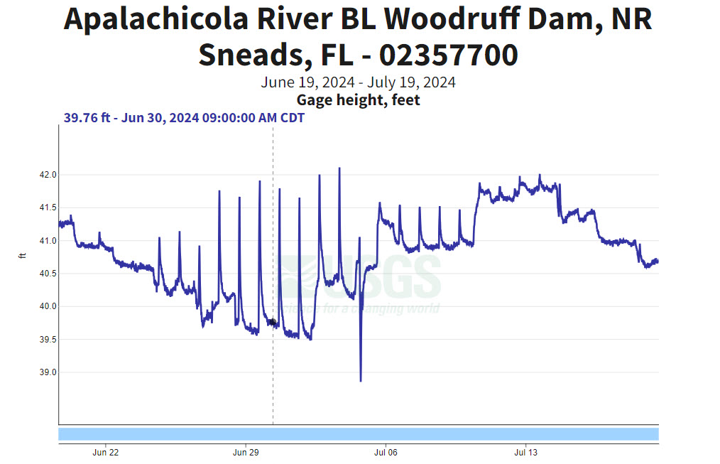
Figure 26. Hydrograph of the Apalachicola River below Woodruff Dam between June 19, 2024, and July 19, 2024, showing rapid changes in water level associated with releases from the dam.

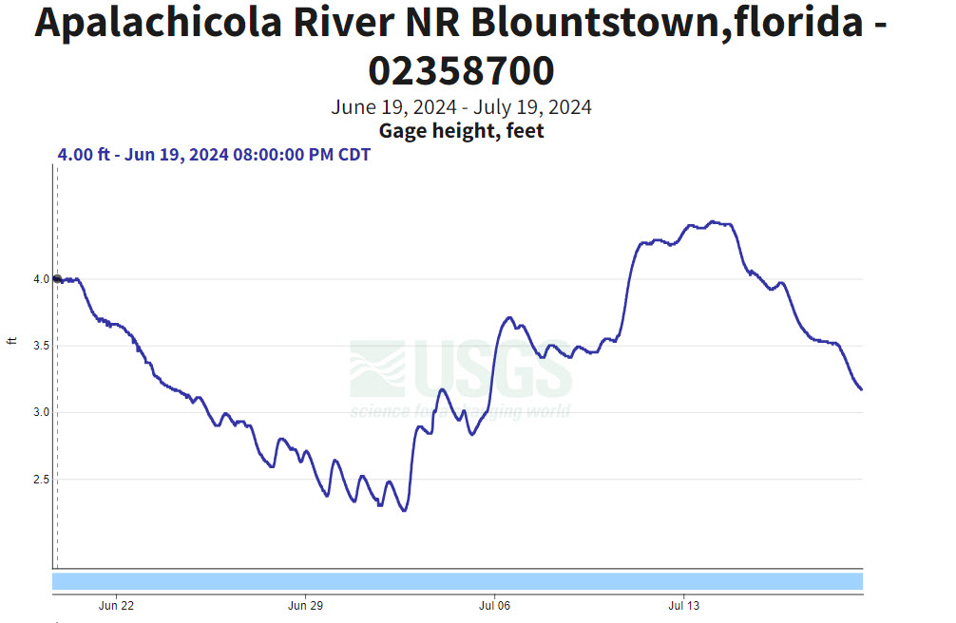
Figure 27. Hydrograph of the Apalachicola River further downstream near Blountstown, Florida between June 19, 2024, and July 19, 2024. It shows a more gradual rise and fall in water levels during the same period.

Appropriate Antecedent Hydrologic Conditions
Water levels should be examined as outlined above to determine if conditions are appropriate for the purpose of the study (see section 3 above). Samplers must be careful to consider how long habitats in the top 0.5 m of the surface have been inundated. If the habitats have been recently dry, they should not be sampled. Samplers must develop intimate familiarity with the hydrology of streams in their regions and learn to extrapolate the information from available hydrographs to nearby streams to determine if antecedent hydrological conditions were appropriate.

Optimal Habitat Selection
Once it’s been decided the hydrologic conditions are suitable for the objectives of the study, the sampler must identify the best available habitats where the macroinvertebrates reside. This is accomplished by performing the habitat assessment procedures to determine the types and quantity of substrates present (see DEP SOP FT 3000, Aquatic Habitat Characterization.

The dip net sweeps are apportioned by determining the number of productive habitats (roots, woody debris, leaf material, macrophytes or rock) present with a surface area greater than 2 m² (see SCI 1100). When targeting specific substrates to sample in particular areas of the stream (best available habitats), samplers should keep in mind how macroinvertebrates use the substrates. It is important to “think like a bug”. Some examples are:

    - The invertebrate taxa important for calculating many of the SCI metrics (e.g., sensitive taxa, Trichoptera, Ephemeroptera, filter feeders) are rheophyllic, meaning they prefer areas with higher water velocity, which also often translates into areas with higher effective concentrations of dissolved oxygen and food availability. Therefore, leaf packs (leaves caught on snags above the substrate) that are in the main flow are preferred over leaf mats (leaves on the bottom), which tend to be associated with lower velocity and potential anaerobic conditions. Additionally, snags, roots, macrophytes and rocks in the flow are better habitats than the snags, roots, etc. in lesser flow or backwater areas.
    - Organisms use the substrates as refugia from predators (e.g., fish, other invertebrates) and as a place to feed. Fine fibrous roots are preferred substrates, since they have more surface area and therefore more areas to hide, when compared with larger diameter roots. Similarly, snags with softer, deteriorating bark have more hiding places and attachment points for organisms (e.g., net spinning caddisfly filter feeders, hellgrammites) than fresh, smooth snags (e.g., cypress knees). This makes the deteriorating snag with many crevices a much-preferred habitat. Similarly, jagged rocks with a rough architecture (i.e., with nooks and crannies) are preferred over smooth rocks.
    - Since aquatic organisms need to live in the water, habitats that are constantly inundated with water are preferred over ones that go dry. For example, samplers should focus on the types of aquatic macrophytes that can survive long periods of inundation rather than those species which typically may be exposed to air for long periods. When terrestrial plants are seen submerged in a stream, it is a “dead giveaway” that the water level at a site has recently increased, and depending on the magnitude of the increase, aborting the trip should be given serious consideration.

SCI Training

Field Sorting as a Training Tool
Field sorting at reference sites is a useful activity for a “sampler-in-training” to learn whether their selection of habitats and dip netting techniques are effective for capturing macroinvertebrates. After a sampler chooses a particular habitat and samples it, they should bring the contents of the net to the stream bank, and using a white tray, sort through the material searching for organisms. Before sorting, the material in the net should be thoroughly rinsed with site water to eliminate turbidity. During sorting, only a small amount of material should be placed into the tray with about a centimeter of site water, so that approximately half of the white background is visible. Samplers should systemically search the tray and using forceps and pipettes, remove organisms for additional examination with a hand lens. Samplers must become familiar with the basic orders and families of aquatic macroinvertebrates, as outlined in DEP SOP SCI 2230.
Although there are many comprehensive taxonomic guides, a useful field book for beginners is “A Guide to Common Freshwater Invertebrates of North America”, by J. Reese Voshell, Jr., published in 2002 by the McDonald and Woodward Publishing Company, Blacksburg, Virginia. During field sorting, the sampler should compare the relative diversity of taxa found in individual sweeps taken from various habitats and flow regimes. This type of systemic examination will provide immediate feedback regarding the degree of success associated with the sampler’s field decisions.

Apprenticeship
Because of the complexities mentioned above, DEP requires that novice sampling staff undergo a systematic training /apprenticeship program. The goal of the training is to produce SCI samplers able to demonstrate the necessary critical thinking skills and sampling technique required by the SOP. Training shall consist of numerous field visits (minimum of 10) at a variety of sites (starting at reference sites, followed by disturbed sites) and different water levels, where novice staff receives instruction from the experienced staff (who have passed the SCI audit) on the concepts presented here. As training progresses, the novice staff should gradually demonstrate the required best professional judgment and sound sampling technique (see below for training checklists). Once training has been completed, a field audit with the Aquatic Ecology and Quality Assurance Section to assess a sampler’s ability to adhere to the SOPs may be scheduled.

SCI Data Usability

The intent of this section is to provide a procedure for how Stream Condition Index (SCI) data will be used for DEP environmental decisions.

Determining if data are usable for a particular purpose is a complex task, requiring a logical and balanced evaluation of many factors. The procedural components of the SCI assessment must be performed by staff with sufficient scientific expertise and demonstrated proficiency, as mandated by Chapter 62-160, F.A.C. Additionally, the following must be considered during a biological data usability determination:

- Understanding the purpose for the bioassessment sampling, including specific project objectives, and determining the extent to which the bioassessment data set fulfills the objectives of the project or Program. The environmental conditions associated with the sample (e.g., climatic, hydrologic, site location, habitat, etc.) must be consistent with the study objectives.
- Evaluating laboratory and field quality control measures and other supporting data, including the determination of the pattern, frequency, and magnitude of any quality control deficiencies associated with the results. This also may involve evaluating corroborative data (e.g., performance tests, data from other sampling entities).
- Determining the relationship between the bioassessment result, the associated decision or action level (e.g., water quality criteria), and the minimum detectable difference associated with the method; and

- Determining the reasonable cause for a poor bioassessment score (e.g., water quality, hydrology, and/or habitat) and ensuring that the data are appropriately used to address the causative factor(s).

6.1 Determining the Extent to Which the Bioassessment Data Set Fulfills the Objectives of the Project

Designing a sampling strategy that focuses on answering specific environmental questions is critical in the bioassessment process, so that confounding variables may be controlled for to the degree possible. Data collected to evaluate one environmental stressor may not be suitable for determining the influence from other stressors. The Department shall examine the purpose of the data collection, the associated potential confounding variables, and ensure that the results are used in a manner consistent with the study objectives.

Example: DEP scientists design a study to evaluate the effects of water withdrawals on the invertebrate community of a stream. SCIs were collected at typical water levels prior to the withdrawals to establish background SCI scores. After significant consumptive water use, SCIs were collected during extremely low water levels. Although the stream had high SCI scores prior to the consumptive water use, numerous SCI failures were noted after the water withdrawals. In this scenario, the SCI failures observed during the low water levels should not be included in Impaired Waters Rule (IWR) listing decisions, because these samples were collected during conditions inconsistent with the objectives of IWR studies.

6.2 Evaluating Staff Capability, Quality Control Measures, and Other Supporting Data
Data must be collected by qualified samplers, using the appropriate DEP Standard Operating Procedures (SOPs), following the concepts outlined in this SCI Primer. The SCI must be performed by individuals that have passed the proficiency test described in DEP SOP SCI 1300. Samplers must conduct the assessment per DEP SOP SCI 1100, following other guidelines outlined in this Primer. SCI scores must be calculated in accordance with SOP SCI 2100.

Quality control information will be systematically evaluated and assessed against the objectives of the study before a usability decision will be made. For example, the purpose for which bioassessment data are collected can vary widely and may include such diverse activities as: initial screening or scoping studies, assessing waters for IWR purposes, or determining whether a stream created as part of an Environmental Resource Permit mitigation project has been successful. A quality control failure that may be tolerated for a screening study would not be acceptable for IWR purposes or declaring the success or failure of a restoration project.

As applicable to the data usability assessment process, any record associated with a reported sample result or set of sample results may be audited, per Rules 62-160.240 and 62-160.340, F.A.C. Both original (“raw”) and reduced or summarized versions of data records may be inspected to determine the acceptability of results, based on an evaluation the sample data and associated quality control records.

If any aspect of the assessment appears erroneous or suggests that the assessment was not made according to the SOPs (e.g., excessive family-level identifications, sampling conducted during extreme water levels not in accordance with the sampling objectives), the Department will further investigate the credibility of the bioassessment results. This may involve follow-up audits of samplers or analysts and potential data rejection.

Example: An SCI was conducted in a small stream in a National Forest as part of a probabilistic sampling network. Sampling was conducted during a drought year, and the stream’s water level was low enough that the majority of the habitat was exposed to air. Very few invertebrates were present in the sample (less than 150 individuals, however, the lab failed to qualify the sample with “x”), and the stream received a failing SCI score. When the results were considered for IWR listing purposes (Chapter 62-303, F.A.C.), data users examined the rainfall and hydrograph data from the area and determined, from these data and from site photos, that the severely low water level did not allow for a representative assessment of the stream’s invertebrate community. Further, the minimum required number of individual organisms (two aliquots of 150) were not identified in the laboratory (and the sample was not properly qualified with “x”). Therefore, these SCI results were not used for IWR listing purposes.

Example: A county conducts SCI sampling twice annually on a river of local interest. During the first three years of the program, the average SCI scores were 42, 55, and 48 (all passing scores). On the fourth year, a new consultant (including the sampling team and laboratory) conducted the SCIs, and the river received a failing score of 25. Upon investigation, data users noted that no one on the sampling team had passed the SCI proficiency test and that a high proportion of taxa identified in the laboratory were to the family level only (not to the level required by the SOP). Because the samplers did not demonstrate the required expertise and the laboratory SOPs were not properly followed, the year 4 SCI data were not considered usable, and DEP worked with the county to correct the deficiencies.

6.3 Determining the Relationship Between the Bioassessment Result, the Water Quality Criterion, and the Minimum Detectable Difference Associated with the Method

As in all scientific measurements, there is a quantified level of uncertainty associated with bioassessment results, known as the Minimum Detectable Difference (MDD).
When SCIs are compared along a longitudinal or temporal gradient, differences in scores greater than the MDD (plus or minus 13 points) are considered statistically reliable.

Example: Staff from the Florida Fish and Wildlife Conservation Commission Invasive Plant Management program conducted an herbicide treatment in a spring-fed river to control the invasive exotic plant, Hydrilla verticillata. The average SCI score before control efforts was 24, and the average score nine months after control efforts was 50 (an increase of 26 points). Because the difference in SCI scores was greater than the MDD (statistically reliable), the management actions were considered successful.

6.4 Determining the Reasonable Cause for a Bioassessment Failure

Failure of the SCI indicates that the stream does not meet the Clean Water Act goal of biological integrity, as measured by community structure and function, but the reason for the unacceptable condition must still be explained. For IWR purposes, the pollutant causing the biological degradation must be identified prior to developing a TMDL. Although a stream could have a failing SCI due to water quality problems (e.g., toxic substances or excess nutrients), it is possible that habitat disruption, hydrologic alterations, or other physical disturbances are significant stressors. If factors other than water quality are determined to be the cause of the SCI failure, DEP will address those factors through avenues other than the TMDL program.

Example: A stream fails the SCI, but data indicate the stream is not impaired for any water quality parameter. DEP biologists determine that the stream habitat assessment score was less than 80, and that the system had been artificially channelized in the 1960s. In this scenario, pollutant reduction is not required, but physical restoration activities or reclassification of the waterbody would be potentially appropriate actions.

6.5 Summary of SCI Data Usability

- To determine appropriate actions associated with bioassessment results, DEP will review and evaluate the following information:

- The purpose for collecting the bioassessment data and the degree to which the study fulfilled the objectives.
- The documented quality control measures and other supporting data, as well as the pattern, frequency, and magnitude of any quality control deficiencies associated with the results.
- The relationship between the results, the water quality criterion, and the Minimum Detectible Difference associated with the method; and A reasonable determination of the cause of the bioassessment failures. From this evaluation, DEP will determine how the data can be used by the relevant Department programs. Biological health usability assessments will evaluate the above factors relative to DEP program or project objectives, and the follow the principles characterized in this guidance document to draw an “overall conclusion” concerning the usability of the data set consistent with the processes and examples provided in this document.

SCI Training Materials, Training Requirements, and Checklists
- FD 9000-34 Stream HA Training Checklist and Event Log
- FD 9000-35 SCI and BioRecon Training and Evaluation Log

Literature Cited
AMEC Environment & Infrastructure, Inc. 2013. Technical Support for Nutrient Concentration Sensitivities Associated with Different Types of Florida Freshwater Streams, 191 pp, (reference for informational purposes only).
Brown, M. T., and B. Vivas. 2004. Landscape development intensity index.
Environmental Monitoring and Assessment 101: 289-309 (reference for informational purposes only)
Fore, L.S, R.B. Frydenborg, D. Miller, T. Frick, D. Whiting, J. Espy, and L. Wolfe. 2007. Development and Testing of Biomonitoring Tools for Macroinvertebrates in Florida Streams. Florida Dept. Environmental Protection. 110 pp. (reference for informational purposes only)
Kiefer, John. H. (2010). Hydrobiogeomorpholgy of Fluvial Systems in Peninsular Florida: Implications to Classification, Conservation, and Restoration. [Unpublished doctoral dissertation, University of Florida]. UF Digital Collections. (reference for informational purposes only).

Appendix A

The first step in applying the HBG Classification Systems involves segregating streams based on broad differences in regional climate and geology (Figure A1). There are three regions for stream classification purposes: Northwest Florida Coastal Plain (NWFCP), Northeast Florida Coastal Plain (NEFCP), and Peninsula Florida Coastal Plain (PFCP). A fourth region, the South Florida Coastal Plain (SFCP) has been fundamentally hydrologically altered and thus is not included in this discussion. The NWFCP generally comprises the Florida panhandle west of and including the Ochlockonee River basin. The NEFCP lies to the east of the Ochlockonee River and north of an imaginary diagonal line running from the mouth of the Waccasassa River on the west (Gulf) coast to the mouth of the St Johns River on the east (Atlantic) coast. It is important to note that sites near regional boundaries require more careful consideration and may exhibit characteristics that are intermediate between the bordering regions. If the system under evaluation crosses multiple regions, then each region should be evaluated. Department staff should be contacted if there is any uncertainty when conducting these determinations.
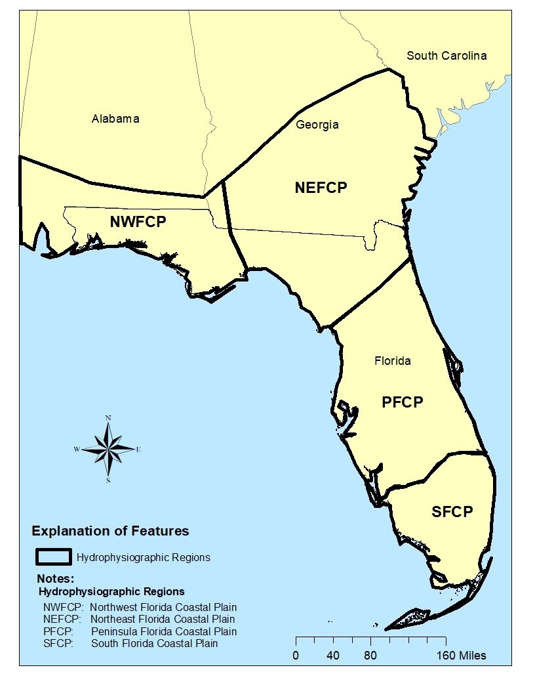
Figure A1. Hydrophysiographic regions. Figure adapted from AMEC 2013.

The second step divides streams into classes (karst, highlands, and flatwoods) based on the soils and dominant mode of water delivery in a watershed and is described in greater detail in a later paragraph (Table A1). Florida’s geology results in three distinctly different water delivery systems for Florida streams (karst, highlands, and flatwoods). Karst systems are those with abundant and steady groundwater discharged through limestone springs under pressure. The steady groundwater flow typical of karst systems exempts them from further non-perennial discussion. Highlands systems have unconfined lateral groundwater seepage through thick columns of sand through relict dunes, and flatwoods streams are dominated by surface water runoff seasonally coursing through and over combinations of flat, shallow, organic, and sandy soils. Accurately determining the dominant water source for highlands and flatwoods systems requires calculating the percentage of well-drained soils in the watershed of a given site. Surrogates for this information, such as the presence or absence of tannins in the water, i.e. color, is highly variable and not a reliable long-term indicator.

There are clear differences between the soil composition between the flashy, surface water dominated flatwoods systems and the steady, groundwater-dominated highlands systems among the three regions. Highlands generally have well-drained soils, low water tables, and rolling topography. Flatwoods generally have an abundance of poorly drained soils, high water tables, and flat topography.

Soils are classified by the Natural Resource Conservation Service (NRCS) into four hydrologic soil groups based on the soil's runoff potential. The four hydrologic soil groups are A, B, C and D. A-soils are the most well-drained and generally have the smallest runoff potential, and D soils are the poorest drained and have the greatest runoff potential. If a soil is assigned to a dual hydrologic group (A/D, B/D, or C/D), the second letter should be used in the calculation. The first letter expresses the “potential” for a soil to be well-drained if drained or otherwise altered.

To determine the hydrologic soil groups in the drainage area of a given site, a Geographic Information System (GIS) layer (e.g. NRCS, SSURGO) with hydrologic soil content is required. The percent of hydric soils in the drainage area of interest should be calculated by adding up the soil types A and C in the PFCP region and the soil types A and B in the NEFCP and NWFCP regions. In GIS, this feature is typically designated as “HYDRGRP” or something similar in the attribute table of the soil layer. The percent thresholds in Table A1 should be used to determine whether the site is highlands or flatwoods.

Table A1. Hydrologic soil thresholds for Flatwoods and Highlands stream by HBG Region.
Region | Flatwoods | Highlands
Peninsula (PFCP) | <40% A+C Soils | ≥40% A+C Soils
Northeast (NEFCP) | <40% A+B Soils | ≥40% A+B Soils
Northwest (NWFCP) | <40% A+B Soils | ≥40% A+B Soils

Peninsula
The peninsula's distinct wet and dry seasons lead to the state’s largest seasonal water deficits, which are most severe in April and May. The wet season typically starts in June and usually ends in November. The seasonal water stress creates the potential for a highly variable flow regime that is ameliorated in areas where the watershed's dominant soil characteristics consist of thick columns of unsaturated sands that allow for substantial infiltration consistent with the highland’s physiography.

- Flatwoods Streams - Streams in the peninsular region with watersheds smaller than 5 sq. miles have highly variable hydroperiods and are inherently non-perennial. Streams with drainage areas above 5 square miles but less than 20 sq. miles are seasonally flowing. Peninsula flatwoods streams are likely perennial with drainage areas of at least 20 sq. miles and perennial above 50 square miles. Adequate flow volumes should not be an issue in these systems.
- Highlands Streams - In contrast to the flatwoods systems, highlands streams have a more consistent base flow and become perennial with much smaller drainage areas. Streams smaller than 1 sq. mile are typically non-perennial, but those above this size are likely perennial.

Northeast
Streams in the northeast achieve perenniality in smaller basins than in the peninsula due to a more equitable distribution of rainfall throughout the year and lower evaporation potential.

- Flatwoods Streams - Northeast flatwoods streams with drainage areas less than 1 sq. mile are non-perennial. Systems between 1 and 5 sq. miles are seasonally flowing. Streams with drainage areas greater than 5 sq. miles are either seasonally flowing or perennial.
- Highlands Streams - There are very few highlands sites in the northeast region. Stream with drainage areas less than 3 sq. miles are likely to be non-perennial.

Northwest
Streams in the northwest region receive more rain than the peninsula or northeast regions, primarily in the winter and spring. With evapotranspiration potential the lowest and rainfall the highest, streams achieve perenniality in smaller basins when compared to the other regions.

- Flatwoods Streams – There are a limited number of these systems in the northwest region; most in this region tend to occur in or near the Apalachicola River basin. Given the climatic regime, it is likely that flatwoods sites become perennial when the drainage area exceeds 5 sq. miles.
- Highlands Streams – All sizes of highlands streams in northwest Florida are likely to be perennial.

A summary of the perenniality based on region, water source, and drainage area is provided in Table A2. As noted in Table A2, peninsula flatwoods streams with a DA less than 5 square miles and peninsula highlands with a DA less than 1 square mile are expected to be non-perennial. The non-perennial DA threshold for candidates in both Northeast and Northwest flatwoods is 1 square mile. While there is no DA threshold below which non-perenniality can be concluded for Northeast and Northwest highlands cautioned should be used to ensure adequate available habitat prior to sampling.

Table A2. Summary of HBG factors based on region, water source, and drainage area.
Region | Water Source | Drainage Area (DA) sq. miles | Flow Permanence
Peninsula | Flatwoods | DA <5 | Non-perennial
Peninsula | Flatwoods | ≥5 DA <20 | Seasonally Flowing
Peninsula | Flatwoods | ≥20 DA <50 | Likely Perennial
Peninsula | Flatwoods | DA ≥50 | Perennial
Peninsula | Highlands | DA <1 | Non-perennial
Peninsula | Highlands | ≥1 DA ≤5 | Likely Perennial
Peninsula | Highlands | DA ≥ 5 | Perennial
Northeast | Flatwoods | DA <1 | Non-perennial
Northeast | Flatwoods | ≥1 DA <5 | Seasonally Flowing
Northeast | Flatwoods | ≥5 DA <20 | Likely Perennial
Northeast | Flatwoods | DA ≥20 | Perennial
Northeast | Highlands | DA <3 | Seasonally Flowing
Northeast | Highlands | 3 ≥DA ≥5 | Likely Perennial
Northeast | Highlands | DA ≥5 | Perennial
Northwest | Flatwoods | DA <1 | Non-perennial
Northwest | Flatwoods | ≥1 DA <5 | Seasonally Flowing
Northwest | Flatwoods | ≥5 DA <10 | Likely Perennial
Northwest | Flatwoods | DA ≥10 | Perennial
Northwest | Highlands | DA <1 | Seasonally Flowing
Northwest | Highlands | ≥1 DA <5 | Likely Perennial
Northwest | Highlands | DA ≥5 | Perennial

Using the same instructions provided above for non-perennial systems, determine the dominant water source and drainage area for large rivers, and compare those thresholds to the guidance provided in Table A3 to target systems most appropriate for SCI sampling.

Table A3. Large river summary of recommendations for SCI based on drainage area analysis.
