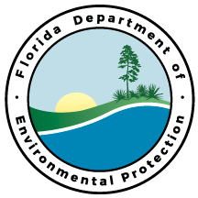 | Department of Environmental Protection
STD–09061815.1.0 |  | Page 1 of 1
Java Coding Standard

Purpose
This standard specifies the code conventions for DEP Java software applications. The software industry estimates that 80% of the lifetime cost of software applies to maintenance. Code conventions improve the readability of software allowing developers understand and perform code changes more quickly and efficiently, thereby reducing maintenance costs.

Scope
This standard applies to all Java code developed for and/or by the Department.

Standard
All DEP Java software applications shall follow the Code Conventions for the JavaTM Programming Language (Sun Microsystems, 1999), available for download from the Sun Microsystems web site at http://java.sun.com.

DEP uses CheckStyle to verify adherence to the Sun Java Coding Standards. A full report of all CheckStyle errors is automatically generated by DEP’s server-side build environment and published on the Java Hosting Service website for each project.

Deviation from Use
Any deviation from this standard shall be documented in associated project and contract documentation. For contracts, deviation from standard shall be documented and approved by the DEP contract manager. For non-contract work, deviation from use shall be documented in the project plan/scope of work and approved by the project manager.

Bibliography
Sun Microsystems. (1999). Code Conventions for the Java Programming Language. Mountain View, CA: Sun Microsystems.

Approved by R. John Willmott, CIO __________6/18/09___________
Approval Date

