 | Department of Environmental Protection
STD-170123.1.0 | Page 1 of 3
Accessibility Standard for Electronic Document Deliverables

Purpose
This document specifies the Florida Department of Environmental Protection’s (DEP) accessibility requirements for Microsoft Office and Adobe Acrobat Portable Document Format (pdf) electronic document deliverables provided by vendors as part of an IT contracted activity.

Scope
This standard applies to all final electronic deliverable documents in Microsoft Office (e.g., .docx, .xlsx, .ppt) and Adobe Acrobat (.pdf) that are provided as part of an IT contract. Additional accessibility requirements associated with Section 508 of the Rehabilitation Act of 1973 as Amended as it relates to software applications and/or web-based content shall be addressed directly in the specific contract language that governs the IT vendor activity.

Standard
All electronic document deliverables provided as part of a IT contracted activity must be checked for accessibility compliance using the accessibility checker function included with the software product used to produce the deliverable. The following sections provide instructions on running accessibility checks in Adobe Acrobat and Microsoft Office products, and specifies the minimum compliance requirements.

Adobe Acrobat (PDF) Documents
PDF documents must not contain any “Failed” checks when the Adobe Accessibility Checker is run. The “Needs Manual Check” alerts must be minimized and those which remain must be justifiable. Figure 1 provides instructions on running the Acrobat DC Accessibility Checker:

Figure 1
Checking Accessibility with Acrobat DC
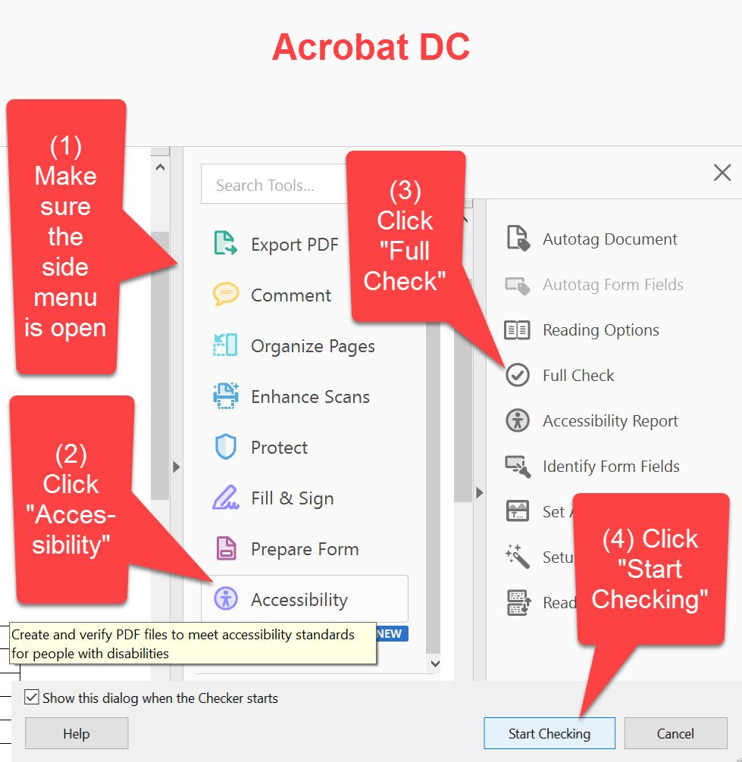

Microsoft Office Documents
Microsoft Office documents must not contain any “Errors” when the Office Accessibility checker is run. “Warnings” must be minimized and those which remain must be justifiable. Figure 2 shows how to run the Accessibility Checker in Microsoft Office:

Figure 2
Checking Accessibility with Microsoft Office
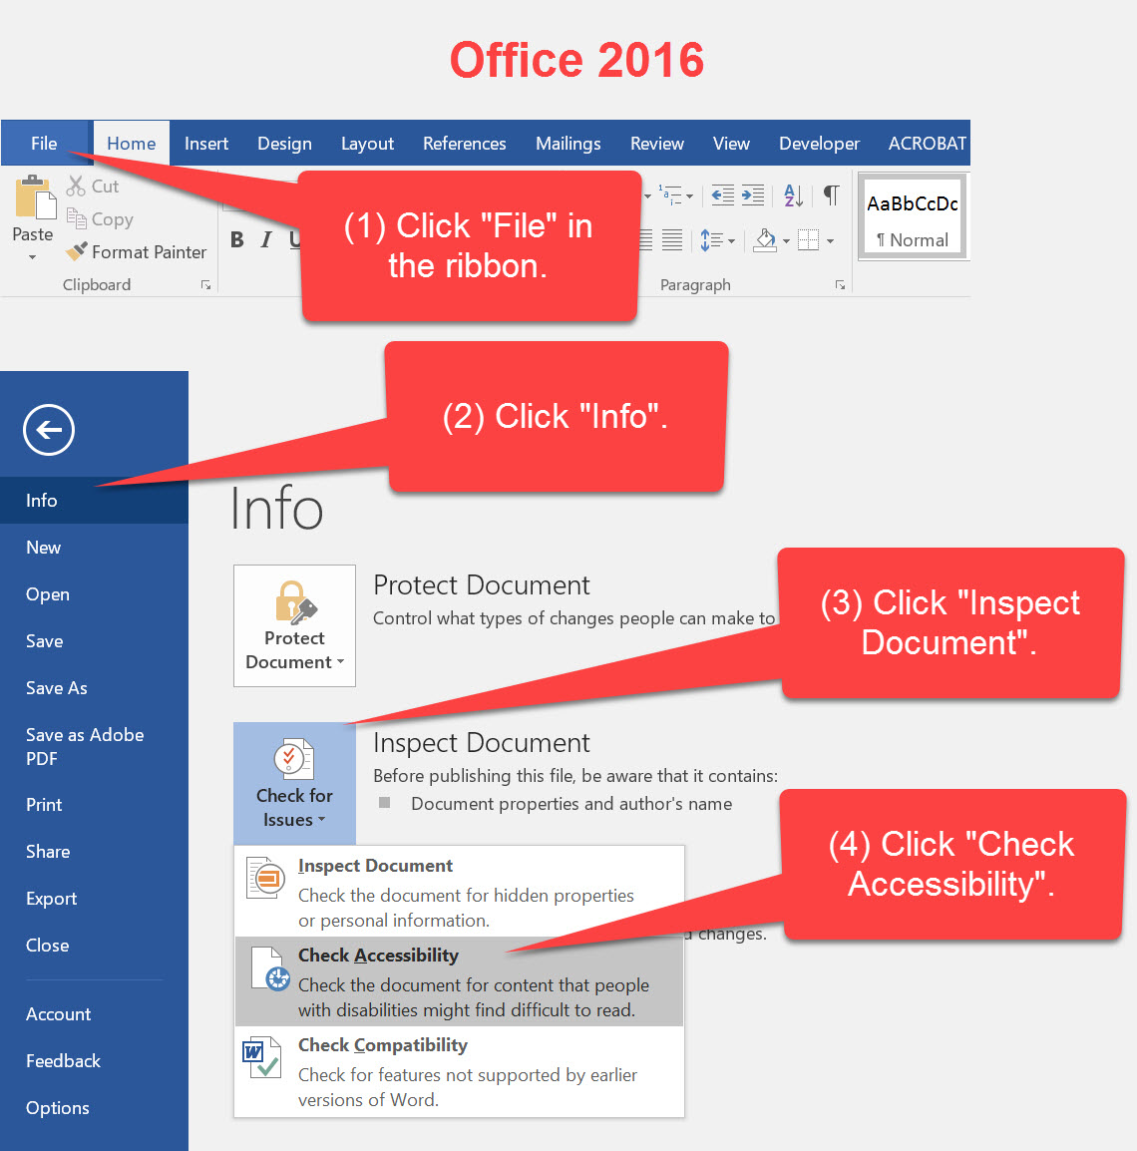

Additional Resources
The following Adobe and Microsoft resources should be consulted for specific procedures on checking pdf files, Word documents, Excel spreadsheets, and Outlook emails.
- Using the Acrobat Pro DC Accessibility Checker
- Make your Word 2016 documents accessible
- Make your Excel 2016 spreadsheets accessible
- Make your Outlook 2016 email accessible

Deviation from Use
Any deviation from this standard must be approved by approved by the Chief Information Officer or his/her delegate. The DEP/OTIS Contract Manager shall also document and approve any deviations for contracted projects.

Approvals

Approved by DEP Chief Information Officer 01/23/17
Approval Date

