**FY 2016-17**

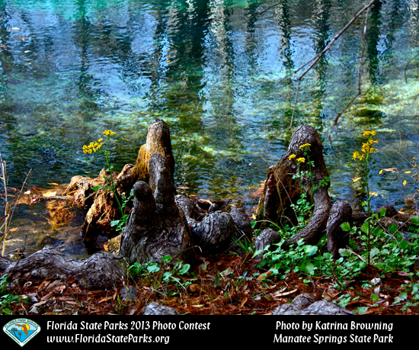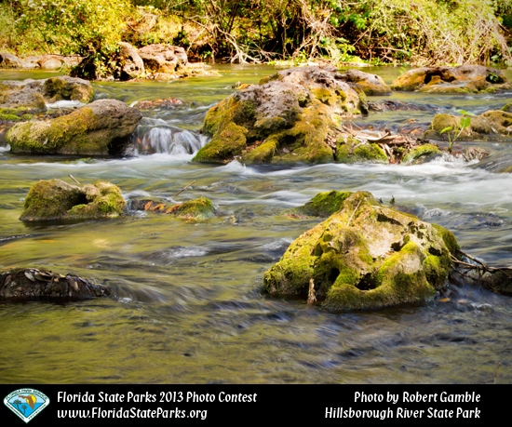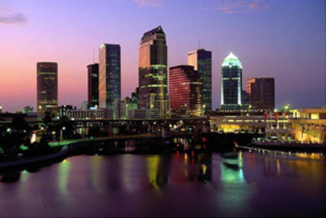

Southwest District Business Plan

**SOUTHWEST DISTRICT**

**Florida Department of Environmental Protection**

Version 17.2

# EXECUTIVE SUMMARY

The six District Offices represent a public presence for the Department’s Regulatory Programs. In addition to issuing various kinds of program-specific permits, these offices conduct the majority of the day-to-day environmental inspections, including the performance of compliance assistance and enforcement functions.

Within each District Office, a District Director provides guidance and oversight to the program areas, while an Assistant Director coordinates the compliance functions. The Divisions do not supervise the district program areas, but provide guidance for policy and consistency between the districts. Three of the District Offices (Northwest District Office, Southeast District Office and South District Office) span 200 miles or more and include Branch Offices in Panama City, and Marathon Key.

The Legislature appropriates funding in a lump sum to the District Offices, which is then allocated internally by the Department to each District Office. Approximately 21% of the funding appropriated to the District Offices comes from General Revenue, while the remaining 79% is provided from an aggregate of eleven different trust funds.

The Southwest District is home to Tampa Bay, Florida's largest open-water estuary which encompasses nearly 400 square miles.  It is also the crown jewel of the National Estuary Program. In addition, we enjoy a variety of scenic waterways including the Myakka River, Homosassa Springs, Hillsborough River, Manatee River, and portions of the Peace River.  The best of our coastal landscapes have been set aside for protection as aquatic preserves. Cockroach Bay, Terra Ceia, Boca Ciega Bay and Pinellas County Aquatic Preserves are all situated in the Southwest District.

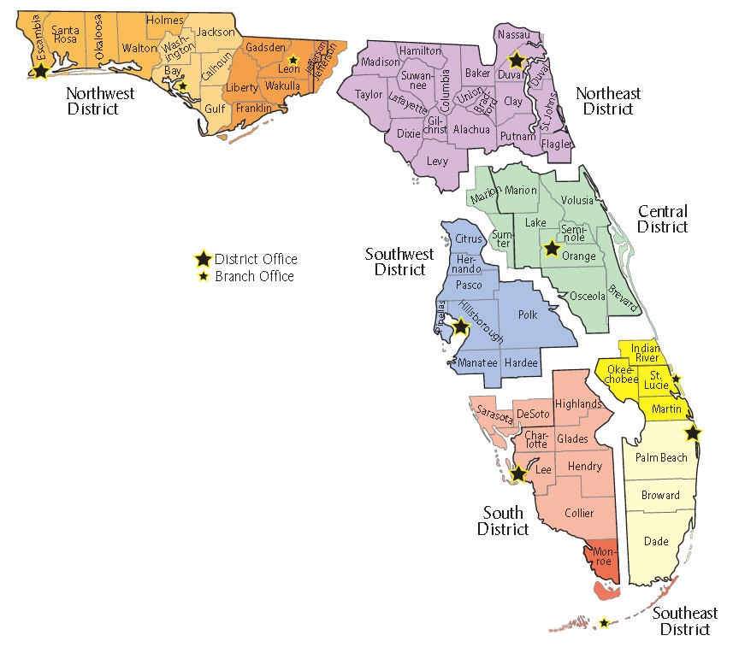The Southwest District is committed to performing at our highest level to meet the changing needs of our communities and our workforce. Building and maintaining strong relationships with our partners and stakeholders is the cornerstone to providing unprecedented customer service. This business plan will help the reader understand the key performance metrics and goals we are striving to accomplish this year. It also highlights many of the achievements and lessons-learned that serve as a foundation to build a more efficient, more cost effective, and more customer oriented district.

# TABLE OF CONTENTS

EXECUTIVE SUMMARY 2

TABLE OF CONTENTS 3

VISION, VALUES, STRATEGIC GOALS & OBJECTIVES 4

Vision 4

Values 4

Strategic Goals & Objectives 5

CLIENT SERVICES 7

ORGANIZATIONAL STRUCTURE 9

District Office Staffing 10

ORGANIZATIONAL UNIT DESCRIPTIONS 10

Compliance Assurance Program (CAP) 10

District Permitting 10

Business Administration 10

Public Outreach 11

DISTRICT OFFICE BUDGET OVERVIEW 12

Budget Utilization 12

STRATEGIC GOALS & OBJECTIVES 14

MID AND LONG-TERM GOALS 27

Successes, Achievements & Continuous Improvement 29

Appendix A – DEO FL 5-Year Strategic Plan for Economic Development 30

Appendix B – Revision History 31

Appendix C – Budget Projection Worksheet 32

Appendix D – Supplemental Information 33

Appendix E – Career Path 34

# VISION, VALUES, STRATEGIC GOALS & OBJECTIVES

## Vision

Creating strong community partnerships, safeguarding Florida’s natural resources and enhancing its ecosystems.

## Values

* **Integrity:** We operate honorably, ethically and respectfully with our customers and each other.
* **Accountability**: We take personal ownership for our actions and responsibilities.
* **Communication**: We operate transparently by sharing information frequently and honestly.
* **Innovation**: We continuously seek innovative ways to improve our operations to protect and restore the environment.
* **Service:** We serve our communities and work to enhance our stakeholders’ experience.

Strategic Goals & Objectives

|  |  |  |  |
| --- | --- | --- | --- |
| **#** | **Strategic Goals** | **#** | **Objectives** |
| 1 | Community Impact:  Focus taxpayer resources on projects that provide a direct benefit to the environment and local communities | 1.1 | Improve funding decisions to align with water quality and quantity priorities |
| 1.2 | Streamline contract processing, improve contract management, and award contracts efficiently and effectively |
| 1.3 | Develop and implement restoration strategies and projects through stronger partnerships with local communities to restore waterbodies, springs and the Everglades |
| 2 | Partnership:  Partner with communities and businesses to protect natural resources and promote economic growth | 2.1 | Implement regulatory changes to promote consistency, improve quality and enhance protections for the State's natural resources |
| 2.2 | Leverage state funding with local partners to expeditiously expand restoration and protection efforts |
| **3** | **Measure Performance:**  **Establish and consistently use clear metrics to evaluate and strengthen the Department's programs, activities and services** | 3.1 | Improve quality, transparency and accountability of the Department's metrics |
| 3.2 | Identify, prioritize and implement continuous improvement projects |
| 3.3 | Improve accountability to the public by reporting metrics through the Department's dashboard |
| 4 | Improve Resource Management:  Improve the quality of natural resources through long-term planning, restoration and maintenance | 4.1 | Improve park conditions and enhance access to outdoor recreational opportunities, so even more Floridians and visitors can enjoy Florida’s award-winning state parks. |
| 4.2 | Move more acres within Florida State Parks from a restoration condition to a more natural and less labor intensive maintenance condition. |
| **5** | **Empower Employees:**  **Empower employees to solve problems through innovation and efficiency** | 5.1 | Create a professional development culture by providing training, communicating tools and measuring success |
| 5.2 | Recruit and hire the best people |
| 5.3 | Reward top performers |
| **6** | **Effective Communication:**  **Proactively communicate a clear and consistent message both internally and externally** | 6.1 | Use appropriate, targeted tools to better communicate the State's restoration activities and successes to media, stakeholders and the general public |
| **6.2** | Create a consistent message which perpetuates the Department's vision and strategic goals |
| 6.3 | Ensure internal communication is frequent and interactive |

**Division/District/Office support for Strategic Goals and Objectives:**

**Southwest District Support for Strategic Goals and Objectives:**

*The District has been and will continue to use metrics in all of our programs to evaluate and compare our success with other Districts and Divisions. We are expanding our metrics to measure the quality of our services as well as the quantity of the products we produce. Continuous Improvement tools are utilized throughout the district to streamline processes improving our work product.*

*The Southwest District is actively engaging with the Waste Water Facilities to facilitate the appropriate use of State Revolving Loan Funds to ensure compliance with Department Rules. We are very active in the Brownfields Program which brings underutilized properties back to highest and best use. We also provide outreach to the regulated communities who appear to struggle with compliance. We will continue to have our Annual Open House and our regularly scheduled Utilities Open House.*

*It is our intent to expand our Outreach Program to the general public to raise awareness of the positive impact the Department has on the state.*

*The District has implemented training for all of our program disciplines and currently provide a syllabus to each CAP staff member. This is expanding to include our permitting staff members. We have also implemented an Effective Communication Program. In addition, we are developing a Leadership Training Program for our managers, based on resources from John C. Maxwell.*

*We have found great success in our recent hiring. We focus on newer graduates and match their goals with what we can provide. We are using Career Pathing to promote high achieving employees and merit increases for exceptional performers.*

*Our employees are required to have frequent and interactive communication with their peers, both within and across district and division boundaries. This helps promote consistency and supports our goal of smaller, better trained workforce.*

# CLIENT SERVICES

The District Office has three main client segments which we must responsibly balance and ensure that all decisions are consistent throughout the Department:

**The Citizens and Visitors of Florida** expect that the District Office will reasonably, respectfully, and responsibly implement Florida’s laws and regulations. Services provided on behalf of these clients include:

* Issuing permits which meet state and federal requirements
* Ensuring compliance of regulated facilities
* Responding to public concerns related to regulated and non-regulated facilities
* Providing opportunities for the public to share its thoughts and concerns, and in turn, ensuring that the public has timely and efficient access to our public records
* Training to understand the rules associated with the various programs
* Technical assistance with permitting, compliance and enforcement cases

**The Regulated Community** expects that District Office will provide regulatory certainty and consistency along with fair solutions. Services provided on behalf of these clients include:

* Issuance of reasonable, law-based permits in a timely manner
* Ensuring regulatory certainty and consistency
* Providing professional and timely review of permit applications
* Providing opportunities for the regulated community to share its thoughts and concerns, and in turn, ensuring that the regulated community has timely and efficient access to our public records
* Training to understand the rules associated with the various programs
* Technical assistance with permitting, compliance and enforcement cases

**The Department’s Regulatory Divisions and Local Delegated Programs** expect the District Office to assist them in achieving goals as established by the Secretary’s Office. This assistance includes:

* Feedback regarding consistent application of regulations and policies throughout District programs
* Producing work products as stipulated in Division goals
* Sharing information and allowing input regarding projects that fall within their respective boundaries and programs

**Our Major Industries Include**:

* Fertilizer Industries (Air and Water Programs)
* Single Family Homes (Environmental Resource Program)
* Domestic Waste Water Facilities (Domestic Waste)
* Port Tampa Bay (Environmental Resource, Air, Industrial Waste Water, Hazardous Waste Programs)
* Defense Contractors, Circuit Board Manufacturing (Hazardous Waste and Air Programs)

# ORGANIZATIONAL STRUCTURE

**Florida Department of Environmental Protection – Southwest District**

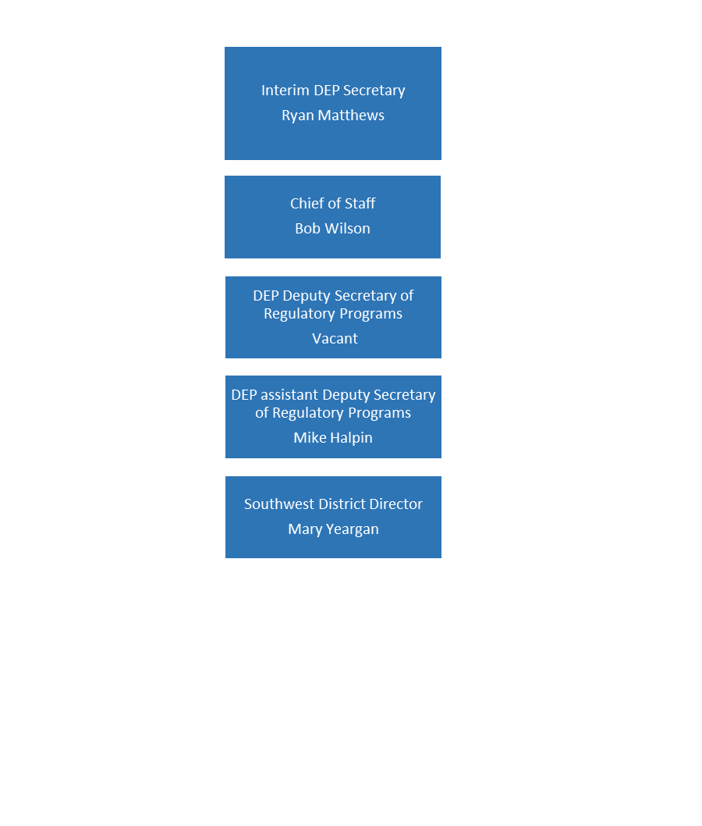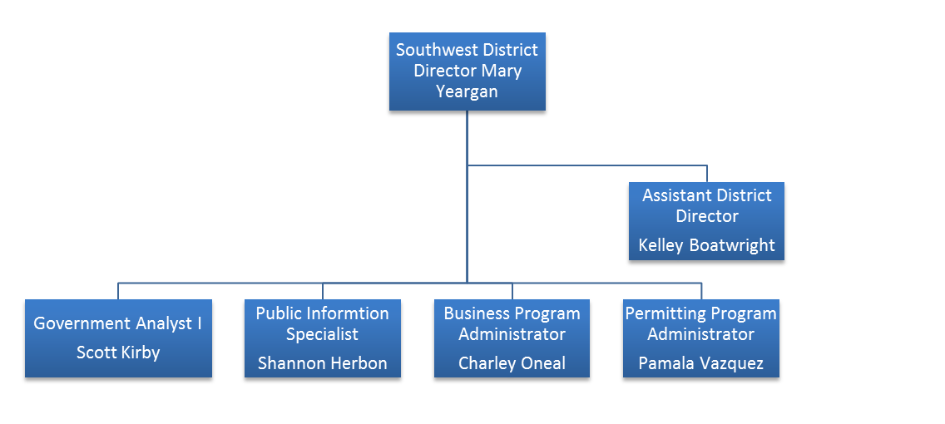

## **District Office Staffing**

Chart of District Staffing

# ORGANIZATIONAL UNIT DESCRIPTIONS

## Compliance Assurance Program (CAP)

* Provide fair, consistent, and efficient service
* Provide timely and thorough inspections which meet state and federal requirements
* Provide the regulated community with compliance assistance to build a healthy economy and environment
* Provide technical assistance

## District Permitting

* Provide certainty in permitting
* Issue fair and timely permits and authorizations
* Assist facilities with their permit requirements, ensuring a complete application
* Provide technical assistance
* Implement the Waste Cleanup and Brownfields Programs, providing timely reviews and approvals to ensure cleanup of contaminated sites

## Business Administration

* Provide administrative support to program areas through customer service, document management, and the purchasing/tracking of supplies
* Balance district budget and provide budget analysis to ensure fiscal responsibility and support of Department goals and initiatives
* Manage information systems, data and document storage
* Provide ombudsman support and to foster productive relationships with internal and external customers, including media outlets and legislative offices
* Fulfill Public Records Requests and accurate records management
* Personnel Management in coordination with the Bureau of Human Resource Management
* Provide internal support for fleet operation & maintenance, safety, facilities and IT services
* Manage the Discipline Training Program for staff
  + Planning, coordination, and tracking of training for staff based on need, Level of service, and building the bench through better staff development.
  + Support and development of District Level of service /Work plan through data analysis, continual work plan review, and Business Plan reporting.
  + Support all program through coordination of overlap, tools for communication, and evaluation of resources to get the job done across program boundaries.

## Public Outreach

* Individual consultations
* Workshops
* Facility recognition for consistent compliance
* Participating in community events
* Mentoring through State Parks and School programs (Life Program)

# DISTRICT OFFICE BUDGET OVERVIEW

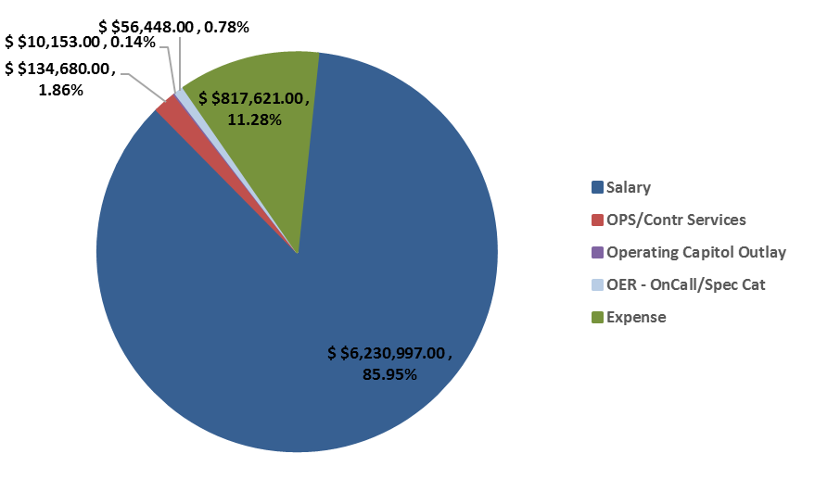FY16-17 OPERATING BUDGET ALLOTMENT

|  |  |  |  |  |
| --- | --- | --- | --- | --- |
| FY15-16 Total |  | FY16-17 Total |  | FY17-18 Total |
| Allotted: $8,202,702 |  | Allotted: $7,249,899 |  | Proj. Allotted: $6,675,614 |
| Expended: $7,216,621 |  | Proj. Exp.: $7,058,005 |  | Proj. Expended: $6,524,960 |

## Budget Utilization

**2**

**1**

The Southwest District’s annual operating budget as provided by Tallahassee is $7,100,000. This fiscal year we will continue to achieve savings through the following actions:

* Fiscal Accountability: Target a minimum 5% recurring reduction within FY 2016/17 budget.
* Vacancies will continue to be evaluated to determine if those position responsibilities can be reassigned to other FTEs without impacting core missions, then identifying that vacancy for reduction or transfer within the district. Rate and salary dollars generated by staff reductions will be evaluated for merit increases. These steps support the Department’s strategic goals by ensuring taxpayer resources provide a direct benefit to the environment and local communities.
* Procurement of goods is being evaluated on a district level to avoid surplus purchasing, and to ensure that each requested purchase supports core missions. This also allows for sharing resources across program responsibilities. We will also collaborate on major purchases with other regulatory districts, as well as with our division counterparts to ensure consistency and best management practices.
* Fleet resources will continue to be managed and maintained to a degree which reduces operational and maintenance costs.

**4**

**3**

# STRATEGIC GOALS & OBJECTIVES

**Southwest District**

| **2. Partner with communities and businesses to protect natural resources and promote economic growth.** | | | | | | **# 16, 18, 19, 25** | | | |
| --- | --- | --- | --- | --- | --- | --- | --- | --- | --- |
| **Objective (KPM[1])** | **Action[2]** | **KPI[3]** | **Responsible Party** | **Baseline/Target[4]** | **Due Date** | **Q1** | **Q2** | **Q3** | **Q4** |
| **Implement regulatory changes to promote consistency, improve quality and enhance protections for the State's natural resources.** | Ensure overall Time To Process Permits for FY 15/16 is maintained or improved for FY 16/17 | Average number of days to process a permit. | District Director/PPA | Average TTP for FY 15/16 (XX) | Within 30 days of the end of the quarter | See Permitting Section table on Page 23 | | | |
| See Permitting Waste Cleanup Program table on Page 23 | | | |
| See Permitting Non-Program Petroleum Cleanup table on Page 23 | | | |
| **Implement regulatory changes to promote consistency, improve quality and enhance protections for the State's natural resources.** | Ensure overall actual compliance rate for FY 15/16 is maintained for FY 16/17. | Percent of facilities in non-compliance | District Director/ADD | 93%  1119/1201  (82 SNCs)  Based on data pull for FY 15/16 | Within 30 days of the end of the quarter | 90%  188/209 (21 SNCs) | 91%  262/288  (26 SNCs) |  |  |

| **3. Establish and consistently use clear metrics to evaluate and strengthen the Department’s programs, activities and services.** | | | | | | **#16, 18, 19, 25** | | | |
| --- | --- | --- | --- | --- | --- | --- | --- | --- | --- |
| **Objective (KPM[5])** | **Action[6]** | **KPI[7]** | **Responsible Party** | **Baseline/Target[8]** | **Due Date** | **Q1** | **Q2** | **Q3** | **Q4** |
| **Identify, prioritize and implement continuous improvement projects.** | Develop and implement a district-specific Continuous Improvement Initiative to identify processes in need of improvement that will result in standardized efficient processes, cost savings, and/or better internal and external customer experience, while operating a leaner organization. | Track quarterly continuous improvement projects including quantifying improvements in time to process, cost savings, etc. | District Director | TBD | Minimum one per quarter | 2 | 1 |  |  |

| **5. Empower employees to solve problems through innovation and efficiency.** | | | | | | **#18, 19, 20, 25,27, 28, 29** | | | |
| --- | --- | --- | --- | --- | --- | --- | --- | --- | --- |
| **Objective (KPM[9])** | **Action[10]** | **KPI[11]** | **Responsible Party** | **Baseline/Target[12]** | **Due Date** | **Q1** | **Q2** | **Q3** | **Q4** |
| **Create a professional development culture by providing training, communicating tools and measuring success.** | Identify mission critical training opportunities for inclusion in the FY 16-17 Employee Development Plan | Percent of trainings completed | District Director | Pending FY 15-16 Q4 results | Within 30 days of the end of each quarter | 8%,  3 out of 38 | 18%,  7 out of 38 |  |  |
| **Reward top performers.** | Create focus teams aligned towards strategic goals and district expectations. | Recognition Team: Develop & manage recognition program to facilitate recognition of top performers & employees who demonstrate DEP’s values. | Employee Committee | Identify 1 top performer per Quarter | Business Plan Quarterly Updates | Nick Roff | Melissa Madden |  |  |

| **6. Proactively communicate a clear and consistent message both internally and externally.** | | | | | | **#13, 16, 18, 19, 25,** | | | |
| --- | --- | --- | --- | --- | --- | --- | --- | --- | --- |
| **Objective (KPM[13])** | **Action[14]** | **KPI[15]** | **Responsible Party** | **Baseline/Target[16]** | **Due Date** | **Q1** | **Q2** | **Q3** | **Q4** |
| **Create a consistent message which perpetuates the Department's vision and strategic goals.** | Issue quarterly “Director’s Messages” to District staff | Newsletter is to be submitted to the ADS & Communications Office within 30 days of the end of the Quarter | District Director | N/A | Within 30 days of the end of the Quarter | L:\Library\Newsletters\September_2016_Quarterly_Newsletter.pdf | ..\..\..\Library\Newsletters\2016\December 2016_Quarterly_Newsletter.pdf |  |  |
| **Ensure internal communication is frequent and interactive.** | Conduct quarterly sessions for supervisory personnel addressing leadership issues and provide copies to the Assistant Deputy Secretary (ADS) via inclusion in the business plan update | Provide Quarterly Update | District Director | 1 Per Quarter | Within 30 days of the end of the Quarter | U:\Southwest District\SWD Business Plan FY 16-17\All Manager Meeting Summaries Quarter 1.docx | <file://fldep1/RegulatoryCommon/Southwest%20District/SWD%20Business%20Plan%20FY%2016-17/All%20Manager%20Meeting%20Summaries%2016-17.docx> |  |  |

| **District Goals and Objectives** | | | | | | | | | |
| --- | --- | --- | --- | --- | --- | --- | --- | --- | --- |
| **Objective (KPM[17])** | **Action[18]** | **KPI[19]** | **Responsible Party** | **Baseline /**  **Target [20]** | **Due Date** | **Q1** | **Q2** | **Q3** | **Q4** |
| **Reduce the Cost of Doing Business** | Target a minimum of 5% recurring reduction from FY 16-17 budget assigned by the ADS | Projection of FY-end recurring reduction percent | District Director | $7,111,899 | Within 30 days of the end of each quarter | 5% | 5% |  |  |
| **Prompt response to public inquiries for public records** | Provide timely and accurate responses to PRR requests | Average number of days to respond to and complete PRR requests | District Director | 3 Days | Provide requested information within 3* business days (*PRRs not requiring special handling) | .941 days | 1.553 days |  |  |
| **Plan for Future LBR Readiness** | Prepare FY 18-19 LBR in accordance with s. 216.023, F.S. | Compliance with S. 216.023, F.S. | District Director | FY 17-18 operating budget | Within 30 days of the end of each quarter | NA | NA |  |  |
| **Develop and implement efforts to improve safety** | Interview injured employee, make recommendation to avoid recurrence, and share the injury interview and review report with the Assistant Deputy Secretary within 30 days of the injury. | The injury interview and review report is to be sent to the ADS within 30 days of the injury | District Director | N/A | Within 30 days of the injury occurring. | 0 | <file://fldep1/RegulatoryCommon/Southwest%20District/SWD%20Business%20Plan%20FY%2016-17/Injury%20Report%202nd%20Qtr%2016-17%20revised.docx> |  |  |
| **Increase Customer Outreach** | Coordinate and attend at least one informal one-on-one meeting with facility owners/managers within the District boundaries as to enhance our stakeholder relationships | Number of Informal meetings held with facility owners/managers | District Director | 4/4 | Summary Due to ADS within 30 days of the end of each quarter | 5 events  U:\Southwest District\SWD Business Plan FY 16-17\Increase Customer Outreach.docx | 9 events  <file://fldep1/RegulatoryCommon/Southwest%20District/SWD%20Business%20Plan%20FY%2016-17/Increase%20Customer%20Outreach%2016-17.docx> |  |  |
| Was the summary provided to the ADD with the BP update? |
| **Improve the Permitting Experience** | Improve the applicant’s permitting experience within your District. Ensure permits are written in plain language, are simple to understand, enforceable and contain necessary information without redundancy. | Provide Customer Satisfaction Survey updates to ADS | District Director/Permitting Program Administrator | 10 customers a quarter | Within 30 days of the end of each quarter | 10/13/2016 | 1/17/17 |  |  |
| **District Outreach Events** | Based on compliance rates & permit RAIs, target specific industries (DW, PW, and ERP) for participation in outreach events. Strategically plan for reaching the largest number of participants. | Tracking and reporting the number of outreach events participated in by the District | District Director | n/a | Within 30 days of the end of each quarter | 10 events  No. of attendees: 2,299 | 7 events  No. of attendees:  17,200 |  |  |

**Key Performance Goals & Objectives**

| ***Ensure Regulatory Certainty, Consistency and Protection Across the State*** | | | | | | | | | |
| --- | --- | --- | --- | --- | --- | --- | --- | --- | --- |
| **Strategic Goal** | **Objective**  **(KPM)** | **Action** | **KPI** | **Baseline** | **Target /**  **Due Date** | **Q1** | **Q2** | **Q3** | **Q4** |
| 2 | Complaint Investigation Response Time | Target a 24-hour acknowledgement to complainant. Achieve a 14 calendar day referral and closure or conduct initial site visit. | Tracking and reporting of District’s response times to the Assistant Deputy Secretary’s Office. | 96%/96% | Within 1-month of the end of each quarter | 97.6%/24 hr 98.0%/10 d | 97.6%/24 hr 97.6%/10 d |  |  |
| 2 | Review OGC Cases | Review 100 % of open OGC cases annually to determine closure options and report the number of cases closed. | Report number of cases closed on a quarterly basis. | n/a | 30-Jun-17  (report number of cases closed quarterly) | 10 | 3 |  |  |

**Southwest District – District Director**

**Compliance Assurance Program, Responsible Party – Assistant District Director**

|  |  |  |  |  |  |  |  |  |  |
| --- | --- | --- | --- | --- | --- | --- | --- | --- | --- |
| ***Ensure Regulatory Certainty, Consistency and Protection across the state*** | | | | | | | | | |
| **Strategic Goal** | **KPM** | **Action** | **KPI** | **Baseline** | **Target /**  **Due Date** | **Q1** | **Q2** | **Q3** | **Q4** |
| **2** | **Percent of Level of Service inspections required** | Conduct all required Level of Service inspections for each compliance assurance program area. | Calculate percentage of Level of Service inspections conducted in each compliance assurance program area on a quarterly basis. | 100% | 100%/ Consecutive Quarterly updates  **Federal Fiscal Year**  **10/1 – 9/30** | 100% [21]  1321/1321  Goal 100% | 27.7 %  Goal 25% | Goal 50% | Goal 75% |
| **2** | **Improve State Review Framework Data Quality** | Conduct district’s data quality audit of thirty facilities, ten from each delegated program, using EPA’s audit criteria.  Audit files from previous 12-month period with focus on facilities with recent return to compliance that had violations resolved with or without enforcement. | Report each quarter the percent of facilities out of ten audited per program that were 100% consistent. Identify potential corrective actions for inconsistencies found and report to division. | Air:  NA | 100% Data Consistency | 80% | 100% |  |  |
| Water:  NA | 100% Data Consistency | 60% | 89% |  |  |
| Waste:  NA | 100% Data Consistency | 100% | 98% |  |  |
| **2** | **Meet established programmatic timelines for performing data entry and issuance of inspection reports** | Complete data entry and issue inspection reports within established timelines. | Report time to issue inspection reports. | 30-days | Meet or improve 30-day time to issue inspection reports | 92.9%  222/239  inspection mailed within 30 days or less | 98%  304/310  inspection mailed within 30 days or less |  |  |

**Permitting & Waste Cleanup, Responsible Party – Program Administrator**

| ***Ensure Regulatory Certainty, Consistency and Protection across the state*** | | | | | | | | | |
| --- | --- | --- | --- | --- | --- | --- | --- | --- | --- |
| **Strategic Goal** | **KPM** | **Action** | **KPI** | **Baseline** | **Target /**  **Due Date** | **Q1** | **Q2** | **Q3** | **Q4** |

|  |  |  |  |  |  |  |  |  |  |
| --- | --- | --- | --- | --- | --- | --- | --- | --- | --- |
| **2** | **Maintain Time to Process (TTP) Permits** | Each program should maintain FY 15/16 permit processing time during FY16/17 | Average number of days to process a permit | [Pending FY 15-16 Q4 Results]  District Ave: XX  DW-  IW-  PW-  Air-  SW-  ERP- | Within 30 days of the end of each quarter | District Ave: 15.3  DW-12.4  IW-10.3  PW-3.4  Air-27.7  SW-38.5  ERP-17.0  UIC-4.4 | District Ave: 15.4  DW-10.1  IW-6.7  PW-3.9  Air-29.7  SW-44.3  ERP-19.4  UIC-3.8 | District Ave: XX  DW-  IW-  PW-  Air-  SW-  ERP-  UIC- | District Ave: XX  DW-  IW-  PW-  Air-  SW-  ERP-  UIC- |
| **2** | **Maintain Waste Cleanup Document Review Time** | Maintain the target goal achieved during FY 2015/16. | Provide quarterly updates to the Assistant Deputy Secretary’s Office | 21.9 | Quarterly | 13.36 | 14.92 |  |  |
| **2** | **Maintain Non-Program Petroleum Cleanup Document Review Time.** | Maintain the target goal achieved during FY 2015/16 | Provide quarterly updates to the Assistant Deputy Secretary’s Office | 29.2 | Quarterly | 15.15 | 15.14 |  |  |
|  | **Reduce number of permit applications in house** | Ensure current processes prevent excessive number of in-house permits | # of permits in house over 90 days | Reduce by 75% by end of FY | Quarterly | 35 | 35 |  |  |
| **2&3&6** | **Permit Quality- External Feedback** | Distribute a minimum of thirty (30) Permitting Experience Surveys to recent customers to obtain feedback on permit work product, quality, and customer service | Percentage of satisfied customers. Rated as Smooth Sailing | Baseline: 83% Smooth Sailing | Quarterly | 83% | 87% |  |  |

**Business Administration, Responsible Party – Program Administrator**

| ***Ensure Regulatory Certainty, Consistency and Protection across the state*** | | | | | | | | | |
| --- | --- | --- | --- | --- | --- | --- | --- | --- | --- |
| **Strategic Goal** | **KPM** | **Action** | **KPI** | **Baseline** | **Target /**  **Due Date** | **Q1** | **Q2** | **Q3** | **Q4** |
| **Environmental Consultants** | | | | | | | | | |
| **5 & 6** | **Discipline Training** | Environmental Consultants will continue to coordinate with Division and Districts to completion. | CAP inspectors must be Assigned Level 1, 2, or 3 templates as appropriate for their respective program areas. | NA | 100% | 100% | 100% |  |  |
| Maintain CAP Disciplines for each of the CAP program areas. | NA | 100% | 100% | 100% |  |  |
| Complete Level 1, 2, and 3 templates for each of the Permitting program areas. Maintain and implement moving forward. | 100% | 31-March-17(complete) | 80% | 100% |  |  |
| Implement effective training for all staff working Level 1, 2, or 3 templates in all program areas. | Achieve an overall training program score of ≥ 70% on the semi-annual EC survey | 31-Dec-16(1st survey)  30-Jun-17(2nd survey) | 100% | 100%  To be provided end of Jan. (6 months from 7-2016 survey) |  |  |
| **Continuous Improvement (CI)** | | | | | | | | | |
| **2** | **Increase Efficiencies** | Identify and implement a program specific process to insert electronic documents into Oculus. | Track quarterly number of documents inserted into Oculus and average time to process. | NA | 30-Jun-17 | 2,342, Avg TTP=3 days | 2,298, Avg TTP=6.4 days |  |  |
| **2** | **Reduce Costs** | Maintain or reduce commodity spend as compared to FY 15/16 | Review administrative costs/employee NOT including rent, Salary & benefits, or PC refresh (*based on 040000 expenditures) | Avg. commodity spend fy 15/16 | Avg. Qtrly dollar amount | FY15/16=$21,200  FY16/17=$20,244  Diff=$956 (5% reduction) | FY15/16=$22,947  FY16/17=$18,331  Diff=  $4,615 (20% reduction) |  |  |
| **6** | **Improve Communications and consistency across Districts** | Increase communication and collaboration between District offices to build consistency, replicate successes and promote best management practices | Conduct monthly teleconferences to share common issues and solutions | 10 calls per year | 30-Jun-17 | 1 | 1 |  |  |

MID AND LONG-TERM GOALS

**Mid-Term Goals -**

* **Continuous Improvement Initiative** - Processes will be identified and evaluated for efficiency and improvements. A staff person will be assigned to each process who will annually review it to ensure any changes in rules, policies, technology, and etc. are implemented accordingly. This will be an ongoing goal.
* **Effective Communication Program** – The District values its workforce and knows that investing in our staff members’ professional development will help achieve Department goals, as well as promote individual growth. To that end, this program will assist staff in developing and honing their communication skills. It will focus on meeting facilitation, staying within time limits, and crafting and presenting information in a public setting.
* **Training Program** - The District has implemented a multimedia approach to conducting inspections and writing permits. Training staff so they are proficient in the various inspection and permitting/waste cleanup programs is paramount. The District will develop and implement an effective and sustainable regulatory training program in alignment with the Department-wide initiative.
* **Focused Outreach** – Conducted to educate the customer and result in improved client submittals. Develop seminars and present materials to DEP’s clients by hosting training at the District, or by participating in other organizations’ events and conferences. In addition, investigate opportunities to reduce economic burden for our customers. District will develop “traveling displays” that would be placed in various locations to educate customers regarding “hot topics” such as the proper way to trim mangroves, how to access public records electronically, steps to reducing nutrients in stormwater, etc.
* **Leadership Development** - The District has identified the need for development of future leaders, especially at the mid-management level. Our focus is on succession planning, and we have implemented a manager in training position. This program will involve training courses, mentoring by senior staff, shadowing of current managers. Participants will have an individual development plan.
* **Permitting & Waste Cleanup Program Improvements** – As part of an ongoing collaboration between District Permitting Program Administrators and Division Deputy Directors, the permitting program will begin transitioning toward a more uniform statewide program dedicated to quality, consistency, and efficiency. Several short term workgroups led by Program Administrators have been created to review current procedures and recommend innovative adjustments to the permitting program. In order to continue to provide high levels of customer service, “time to process” will be maintained at the current levels and customer feedback will be collected and analyzed to measure quality and efficiency.

**Long-Term Goals –**

* **High Performance Organization -** We will continue to improve our performance by utilizing the Sterling Management System and other key tools.
* **Focused Outreach Phase Two** - To monitor and measure effectiveness of targeted outreach to continue to reduce non-compliance, to enhance the caliber of our submittals, and to increase the protection of our natural resources.
* **Continuous Improvement Initiative** - To enhance an already robust personal and professional developmental initiative.

# Successes, Achievements & Continuous Improvement

Achievements -

* Participated in 35 outreach events during the current fiscal year, with participants totaling approximately 9,830. This included targeted outreach events. SWD staff met with area utility representatives to discuss reduction of sanitary sewer overflows, both individually and in roundtable setting.
* Implemented an Effective Communication Program to help staff develop their communication and leadership skills. The program is fashioned after Toastmasters. So far, ~ 30 staff have shown interest in the program.
* Development of the CAP Disciplines is complete. Syllabi have been created in all program areas except IW, SW, NPDES (partly), and Beaches. Draft versions are in the works. Operation and maintenance of the Disciplines and syllabi will continue in perpetuity.
* Permitting Disciplines are being developed and are ~50% complete. This will be a major point of emphasis in the upcoming FFY.
* 33 staff assigned a syllabus (at least one, and possibly two or three) during the last FFY.
* CAP Managers are having regular meetings with their individual program counterparts to discuss ways to improve consistency across the Districts.
* CAP & Permitting Managers are having regular quarterly meetings with individual local programs.
* Feedback from permittees or their consultants who recently went through the permitting process with the SWD was very positive.

Lessons Learned -

* Implementing training plans has been difficult in the programs without coverage by an EC.
* It’s difficult to measure quality of a report and data entry timeliness since some databases do not allow this type of information to be evaluated. SWD will reach out to other Districts.
* Pre-application meetings are designed to ensure permit applications are as complete as possible, however some meetings did not generate the desired results. In some cases, consultants were under pressure to submit applications by a certain deadline even if the applications were grossly incomplete.

Continuous Improvement -

* The STCM turnaround time report was proposed. We worked with the Division of Waste Management to develop the report, conducted beta testing, and comments were provided. Minor changes made and the report is now used to run metrics for the petroleum sites.
* Administration evaluated the visitor sign-in and meeting attendee sheets process. Afterward, the District was able to initiate one electronic process, saving time and paper.
* Administration along with ERP permitting, evaluated the incoming application procedure as it pertains to receiving payments and creating sites. After reviewing the process, staff were able to remove 5 steps from the process and reduce time from 7 days to 2 days.

# Chart of Strategic Plan for Economic DevelopmentAppendix A – DEO FL 5-Year Strategic Plan for Economic Development

# Appendix B – Revision History

Version 17.0 – Initial Draft – 06/13/2016

Version 17.1 – 1Q 2017 update – 10/31/2016

Version 17.2 – 2Q 2017 update - 01/31/2017

# Appendix C – Budget Projection Worksheet





# Appendix D – Supplemental Information

# Appendix E – Career Path

**DEP Regulatory Division and District**

**Career Service Progression Plan**

**Permitting and Compliance Programs**

The following document provides guidance that applies for all new employees in Career Service positions in an effort to promote cross-training and exposure early in an employee’s tenure with the Department, regardless of whether the new employee is based in a regulatory Division or District office. Specific career path and experience guidelines are also provided for Regulatory Division employees regardless of whether they work in permitting or compliance related programs. Separate guidelines are also provided for District employees based on whether or not their primary duties are in the Compliance Assurance Program (CAP) or performing permitting functions.

These guidelines are intended to provide recommendations for career advancement for Department employees, and also for consistent minimum experience requirements for recruitment of internal or external candidates for vacant positions. For the purpose of this guidance, district employees with emergency response or waste cleanup duties may be considered under either District career path at the discretion of the District Director.

Table of Contents

Page

New Employees – Probationary Evaluations for Career Service Positions -----------------------------------------2

DEP Regulatory Divisions Career Path for Permitting and Compliance Programs--------------------------------3

DEP Regulatory Districts Career Path for Compliance Assurance Program (CAP) Inspector -----------------4

DEP Regulatory Districts Career Path for Permitter ----------------------------------------------------------------------5

Additional Requirements for all Career Paths ------------------------------------------------------------------------------6

Date: 8/29/2016

DEP Regulatory Career Service Progression Plan

**New Employees – Probationary Evaluations for Career Service Positions**

One of the most important selection criteria for new employees is the selection of persons who bring a positive attitude, personal initiative, and have the potential to sharpen leadership qualities. In addition to meeting a position’s required knowledge, skills, and abilities, it is important to identify candidates that have the ability to convey and support the Department’s mission of protecting the environment. Evaluating such traits is a critical part of identifying successful candidates with the potential to join the Program and for future promotions under the recommended career service career path.

For new hires the following additional requirements should be incorporated in the new hire’s probationary evaluation period:

• Within the first 12 months of initial hire into the Division/District, a 2 week minimum rotation period, or equivalent cross-training, to provide exposure within all parts of the Division/District should be implemented by the new employee’s supervisor

• Continued service beyond the probationary period must be determined based in part upon feedback from the supervisors who oversaw portions of the rotation prior to the probationary period ending; failure to receive 100% approval requires further review by the Director to determine if the probationary period is to be extended or whether termination should result

• Recommendations for increasing lengths of relevant experience (e.g., years) have been outlined for the career progression for each of the classifications above entry level

• A cross-training requirement exists between permitting, compliance, and specialty functions within the permitting and compliance assurance program

• Staff should continue to exhibit a positive and problem solving attitude for successful promotional and career progression

Date: 8/29/2016 Page 2

DEP Regulatory Career Service Progression Plan

**DEP Regulatory Divisions Career Path for**

**Permitting and Compliance Programs**

|  |  |
| --- | --- |
| Position | Recommendations for Career Service Career Progression |
| Environmental  Specialist I, Planner I(1), Engineering Specialist I | • 4 year degree from an accredited college or university with a major in engineering, environmental science or one of the natural sciences (2)  • 4 or more years of related professional experience may substitute for Planner series positions  • Within the first 12 months of initial hire into the Division, a minimum 2-week rotation period, or equivalent cross-training, to provide exposure within all parts of the Division. |
| Environmental  Specialist II, Planner II Engineering Specialist II | All items for Env./Eng. Specialist I/Planner I plus the following:  • Must have at least one year of related professional experience, or an advanced professional degree in a related discipline  • Able to successfully draft/evaluate intermediate to moderately complex permits or similar compliance concerns within the program area  • Approved to perform basic compliance inspections in primary program with appropriate training (basic Inspector Discipline Training) |
| Environmental  Specialist III, Planner III Engineering Specialist III | All items for Env./Eng. Specialist II/Planner II plus the following:  • Must have additional two years of related professional experience  • Able to successfully draft/evaluate intermediate to moderately complex permits or similar compliance concerns within the program area or provide guidance to District or Division Office staff regarding the evaluation of these types of projects  • Able to perform permitting/compliance tasks within your program area with appropriate training (intermediate Inspector Discipline Training)  • Able to provide guidance and/or training to District or Division staff within your program area on intermediate to moderately complex projects |
| Planner IV,  Engineering  Specialist IV | All items for Env./Eng. Specialist III/Planner III plus the following:  • Must have additional two years of related professional experience  • Able to successfully draft/evaluate intermediate to moderately complex permits or similar compliance concerns within your program area (advanced/specialty Inspector Discipline Training)  • Able to provide guidance and/or training to District or Division staff within your program area on intermediate to moderately complex projects. |
| Environmental  Consultant, Program Consultant, Professional Geologist I, Professional Engineer I | All items for Env./Eng. Specialist III/Planner III plus the following:  • Must have additional two years of related professional experience  • Registration in the State of Florida as a Professional Geologist or Professional Engineer, as applicable  • Able to successfully draft/evaluate complex and/or controversial permits or similar compliance concerns within your program area, with sufficient expertise for managing complex issues  • Able to provide guidance and/or training to District or Division staff within your program area on complex and/or controversial permits or similar compliance concerns |
| Professional  Geologist II, Professional Engineer II | All items for Professional Geologist/Engineer I levels, plus the following:  • Registration in the State of Florida as a Professional Geologist or Professional Engineer  • Must have additional two years of related professional experience |
| Professional  Geologist III, Professional Engineer III | All items for Professional Geologist/Engineer II levels plus the following:  • Approval from the Deputy Secretary for promotion to or a new hire filing a vacancy at this level  • Registration in the State of Florida as a Professional Geologist or Professional Engineer  • Must have additional four years of related professional experience |

Date: 8/29/2016 Page 3

DEP Regulatory Career Service Progression Plan

**DEP Regulatory Districts Career Path**

**Compliance Assurance Program (CAP) Inspector**

|  |  |
| --- | --- |
| Position | Recommendations for Career Service Career Progression |
| Environmental  Specialist I, Engineering Specialist I | 4 year degree from an accredited college or university with a major in engineering,  environmental science or one of the natural sciences required for this entry level position. During first year, must successfully complete:  • Compliance training in a primary media  • Minimum of 25% cross-training time in additional media and/or permitting  • Approved to conduct basic solo inspections in one media after completion of training  • 4-6 weeks of exposure to permitting activities or equivalent experience within first year of employment is preferred |
| Environmental  Specialist II, Engineering Specialist II | All items for Env./Eng. Specialist I plus the following:  • Minimum of at least one year of inspection/compliance or other related professional experience, or an advanced professional degree in a related discipline  • Achieved competency to conduct intermediate solo inspections in primary media  • Achieved competency to conduct basic solo inspections in at least one additional media  • Able to successfully review/evaluate basic to moderately complex permits in at least one media |
| Environmental Specialist III, Engineering Specialist III | All items for Env./Eng. Specialist II plus the following:  • Minimum of an additional 2 years of inspection/compliance or other related professional experience  • Achieved competency to conduct solo complex inspections in primary media;  • Achieved competency to conduct intermediate solo inspections in at least one additional media  • Achieved competency to conduct basic solo inspections in a second additional media (i.e., third media), as workload demands.  • Able to successfully draft/evaluate basic to moderately complex permits in at least one media |
| Engineering  Specialist IV | All items for Env./Eng. Specialist III, plus the following:  • Minimum of an additional 2 years of inspection/compliance or other related professional experience  • Able to perform and manage complex inspections in primary program  • Competent performing compliance inspections in multiple program areas |
| Environmental  Consultant, Program Consultant, Professional Geologist I, Professional Engineer I | All items for Env./Eng. Specialist III plus the following:  • Registration in the State of Florida as a Professional Geologist or Professional  Engineer, as applicable  • Minimum of an additional 2 years of inspection/compliance or other related professional experience  • Proficient in all disciplines within a primary media  • Capable of coordinating level of service for primary media  • Able to successfully draft/evaluate basic to moderately complex permits in primary media |
| Professional  Geologist II, Professional Engineer II | All items for Professional Geologist/Engineer I levels, plus the following:  • Registration in the State of Florida as a Professional Geologist or Professional  Engineer  • Must have additional two years of related professional experience |
| Professional  Geologist III, Professional Engineer III | All items for Professional Geologist/Engineer II levels plus the following:  • Approval from the Deputy Secretary for promotion to or a new hire filing a vacancy at this level  • Registration in the State of Florida as a Professional Geologist or Professional  Engineer  • Must have additional four years of related professional experience |

Date: 8/29/2016 Page 4

DEP Regulatory Career Service Progression Plan

**DEP Regulatory Districts Career Path for**

**Permitter**

|  |  |
| --- | --- |
| Position | Recommendations for Career Service Career Progression |
| Environmental Specialist I, Engineering Specialist I | • 4 year degree from an accredited college or university with a major in engineering, environmental science or one of the natural sciences  • 4-6 weeks of exposure to Compliance Assurance Program within first year of employment is preferred |
| Environmental Specialist II, Engineering Specialist II | All items for Env./Eng. Specialist I plus the following:  • Must have at least one year of permit processing or other related professional experience, or an advanced professional degree in a related discipline  • Approved to write basic to intermediate to moderately complex permits in primary program  • Approved to perform basic compliance inspections in primary program with appropriate training |
| Environmental Specialist III, Engineering Specialist III | All items for Env./Eng. Specialist II plus the following:  • Must have additional two years of permit processing or other related professional experience  • Able to write moderately complex permits in primary program  • Able to write basic permits in at least one other permitting program with appropriate training |
| Engineering  Specialist IV | All items for Env./Eng. Specialist III plus the following:  • Must have additional two years of permit processing or other related professional experience  • Able to draft and manage complex and/or controversial permits in primary program  • Capable of reviewing permits in primary program for technical and formatting accuracy  • Approved to write basic permits in at least two other permitting programs with appropriate training  • Able to perform basic compliance inspections in second media with appropriate training |
| Environmental Consultant, Program  Consultant,  Professional Geologist I, Professional Engineer I | All items for Env./Eng. Specialist III plus the following:  • Must have additional two years of permit processing or other related professional experience  • Registration in the State of Florida as a Professional Geologist or Professional  Engineer, as applicable  • Feedback from Permitting Managers in terms of retaining in position  • Able to successfully draft/evaluate complex and/or controversial permits or similar compliance concerns for most program areas within the Division/District, with sufficient expertise for managing complex issues in at least one program area |
| Professional  Geologist II, Professional Engineer II | All items for Engineering Specialist III plus the following:  • Registration in the State of Florida as a Professional Geologist or Professional  Engineer  • Must have additional two years of related professional experience |
| Professional  Geologist II, Professional Engineer III | All items for Engineering Specialist IV plus the following:  • Registration in the State of Florida as a Professional Geologist or Professional  Engineer  • Approval from the Deputy Secretary for promotion to or a new hire filing a vacancy at this level  • Must have additional two years of related professional experience |

Date: 8/29/2016 Page 5

DEP Regulatory Career Service Progression Plan

**Additional Requirements for all Career Paths**

• Staff should continue to exhibit a positive and problem solving attitude in order to be considered for successful promotional and career progression.

• Recommendations for promotion must be obtained by immediate supervisor, program administrator, Deputy/Assistant Director, and Director in order for promotion to occur.

• Staff who display exceptional performance beyond expectations may be eligible for promotion outside of the path with Deputy Secretary approval.

Notes:

(1) For the Planner series, the following requirements shall apply:

• 2 or 4 year degree from an accredited college or university; and

• 1 year’s related work experience required for Planner II

• 3 year’s related work experience required for Planner III;

• 5 year’s related work experience required for Planner IV;

(2) Natural sciences are defined as programs of study for astronomy, biology, chemistry, earth science, geology, meteorology, and physics, and may be expanded upon approval of the Deputy Secretary’s office for Regulatory Programs.

Date: 8/29/2016 Page 6

*Dept. of Environmental Protection*

Southwest District Office

Mary Yeargan

Southwest District Director

Mary.Yeargan@dep.state.fl.us

13051 N. Telecom Parkway, Temple Terrace, FL 32399-3000

www.dep.state.fl.us/southwest

P: 813-470-5700

F: 813-470-5995

1. Key Performance Measure (KPM) – What is to be achieved / measured?
2. Action – What is to be done to achieve the objective?
3. Key Performance Indicator (KPI) – What is the indicator/measure that the objective is being achieved?
4. Baseline/Target – Current status or initial measurement and what is the performance target?
5. Key Performance Measure (KPM) – What is to be achieved / measured?
6. Action – What is to be done to achieve the objective?
7. Key Performance Indicator (KPI) – What is the indicator/measure that the objective is being achieved?
8. Baseline/Target – Current status or initial measurement and what is the performance target?
9. Key Performance Measure (KPM) – What is to be achieved / measured?
10. Action – What is to be done to achieve the objective?
11. Key Performance Indicator (KPI) – What is the indicator/measure that the objective is being achieved?
12. Baseline/Target – Current status or initial measurement and what is the performance target?
13. Key Performance Measure (KPM) – What is to be achieved / measured?
14. Action – What is to be done to achieve the objective?
15. Key Performance Indicator (KPI) – What is the indicator/measure that the objective is being achieved?
16. Baseline/Target – Current status or initial measurement and what is the performance target?
17. Key Performance Measure (KPM) – What is to be achieved / measured?
18. Action – What is to be done to achieve the objective?
19. Key Performance Indicator (KPI) – What is the indicator/measure that the objective is being achieved?
20. Baseline/Target – Current status or initial measurement and what is the performance target?
21. The Level of Service includes all programs with the exception of OER.