The City of Clarkston is planning on constructing a multi-use path from Southwest 1st Street to the existing trailhead east of the intersection of SW 1st Street and May Avenue in Clark County, Florida (see Attachment A). This project may be funded by federal funds from the Florida Department of Environmental Protection’s (FDEP) Recreational Trails Grant Program.
The scope of work includes [describe scope of work, including ground-disturbing activities. If possible, note maximum depth of necessary ground disturbance]. The work is located [include brief description of existing conditions like landscaping, hardscaping, or disturbances from sidewalk construction, utilities, etc. Is the project within existing right-of-way (ROW) owned by the applicant?].
On behalf of the City of Clarkston, BCI Consultants conducted a desktop analysis for the project in April 2019. The purpose of the analysis was to identify any previously recorded resources listed in or considered eligible for listing in the National Register of Historic Places (NRHP), and to discuss the potential for unrecorded resources in the project’s Area of Potential Effect (APE). This review was completed by individuals that meet the Secretary of the Interior’s Historic Preservation Professional Qualification Standards (62 FR 33708).
The project’s APE is shown in Attachment B. Based on the scale and nature of the activities, it is unlikely that the project will result in any effects outside of the immediate footprint of construction. There does not exist a significant potential for indirect (visual or audible) or cumulative effects as a result of the type of activities included in the project plans. Therefore, because of the project type and location of proposed work, the APE for the project is limited to the footprint of construction.
Background research indicates that five cultural resource assessment surveys (CRAS) have been conducted near the project corridor (ArchResearch 1994, 2005, 2012BCI 1992a, 1992b;). The Florida Master Site File (FMSF) records indicate that one archaeological site, Veterans Park (8CC145), and one historic structure (8CC1944) are located within the project APE (see Attachment B). A historic linear resource, Old FEC Railroad Grade (8CC873) parallels the eastern side of the project corridor (see Attachment B).
Veterans Park (8CC145), a prehistoric lithic scatter, was identified during cultural resource assessments of SR 39 (US 18) (BCI 1992a, 1994). As a result of the field surveys, the site was determined to be ineligible for listing in the NRHP. The State Historic Preservation Officer (SHPO) concurred with this determination in May 1993. Old FEC Railroad Grade (8CC873) was identified during assessments of segments of SR 39 (US 18) south of the current project corridor. As a result of these assessments, this resource was determined to be ineligible for listing in the NRHP. The SHPO concurred with this determination in September 2010.
While previously recorded resources are present within the project’s APE, a majority of the project footprint has been previously disturbed by sidewalk construction and utility installation. As such, there appears to be a moderate potential for the presence of previously unrecorded cultural resources within the APE.

If this project is awarded a grant from the FDEP Recreational Trails Program, further survey and assessment will be necessary to identify any previously unrecorded historic properties within the APE. If such properties exist, the Criteria of Adverse Effect, as set forth in 36 CFR 800.5(a)(1), will be applied to determine how the project will impact these resources. This information must be provided in accordance with the provisions of the National Historic Preservation Act of 1966 (as amended), which are implemented by the procedures contained in 36 CFR Part 800.

Attachment A: Project Location Map
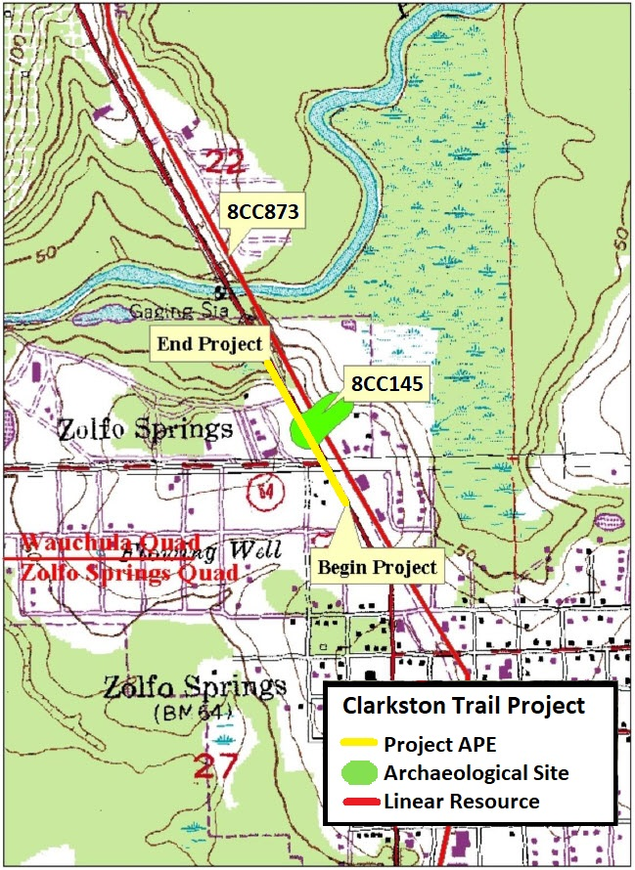

Attachment B: APE Map with site locations
