Introduction
The City of DeLand is proposing to construct a 1.2-mile recreational trail along Dogwood Avenue in Lake County, FL. The proposed improvements are from SR 44 to Big Foot Way and include installation of a 12' wide paved surface with 2' wide unpaved shoulders, sodding, and fencing. No additional right-of-way will be acquired. See Attachment A – Project Location Map.

A desktop analysis and a detailed field review of the project and immediate adjacent areas was
conducted for the presence and potential occurrence of federal and state-listed species and their
habitat; wetlands and other surface waters; and Essential Fish Habitat.

Methodology
The desktop analysis was completed using available online GIS data for project area. The Efficient Transportation Decision Making (ETDM) Environmental Screening Tool (EST), United States Fish and Wildlife Service (USFWS) South Florida Ecological Services website, USFWS wood stork nesting colony database, Florida Fish and Wildlife Conservation Commission (FWC) Endangered and Threatened Species List, and FWC bald eagle nest locator database were reviewed for protected species and their habitat that have been documented or have a potential to occur within or adjacent to the project limits.

On November 29, 2019, a field review of the project and immediate adjacent areas was conducted by a qualified biologist for the presence of protected species and their habitat. The results from the desktop analysis and field review are outlined below.

Results
Protected Species and Habitat
During the site reviews, a pedestrian survey was conducted for state and federally-listed
species with the potential to occur within the project footprint. In addition, an Authorized Agent conducted pedestrian surveys of the project footprints to determine whether a gopher tortoise (Gopherus polyphemus) population occurs. Finally, a review of the FWC bald eagle nest database was conducted to determine if there are any known bald eagle nests that could affect the timing of construction of each project.

The pedestrian surveys did not identify any gopher tortoises or their burrows within or immediately adjacent to the project footprint. Based on the regularly maintained condition of right-of-way, and its adjacency to development and existing roadways, these areas do not represent suitable habitat for this state-listed species. In accordance with the effect determination key for the Eastern indigo snake (Drymarchon corais couperi), since the field reconnaissance did not find more than 25 acres of xeric habitat or 25 gopher tortoise burrows, the project will Not Likely Adversely Affect the Eastern Indigo Snake. See Attachment B Eastern indigo snake effect determination key. There are surface waters located .5 miles away from the project area and therefore can be potential wood stork foraging habitat. However, no core foraging habitat is located where the proposed trail will be constructed. There were no bald eagle nests within the project area.

Wetlands and other Surface Waters
There are no wetlands in the project area. There are surface waters in the project area, but the construction of the trail will not have any impacts to the surface waters.

Essential Fish Habitat
The project area does not contain any Essential Fish Habitat.

Conclusion
The proposed project will be constructed entirely within the existing road right-of-way. No listed species were identified within any portion of the project area, and the project is not anticipated to adversely impact any state/federally-listed wildlife. No wetlands or Essential Fish Habitat occur within the project footprint. Based on the results of the desktop review and field reconnaissance, it is unlikely that any federal and state-listed species or their habitat will be adversely affected by the proposed project.

Attachments:
Attachment A – Project Location Map
Attachment B – Eastern Indigo Snake Effect Determination Key

Attachment A – Project Location Map

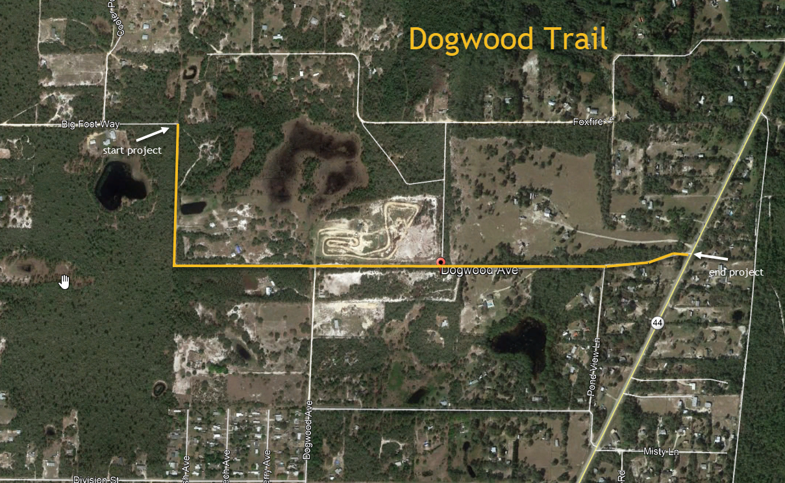

Attachment B – Eastern Indigo Snake Effect Determination Key

