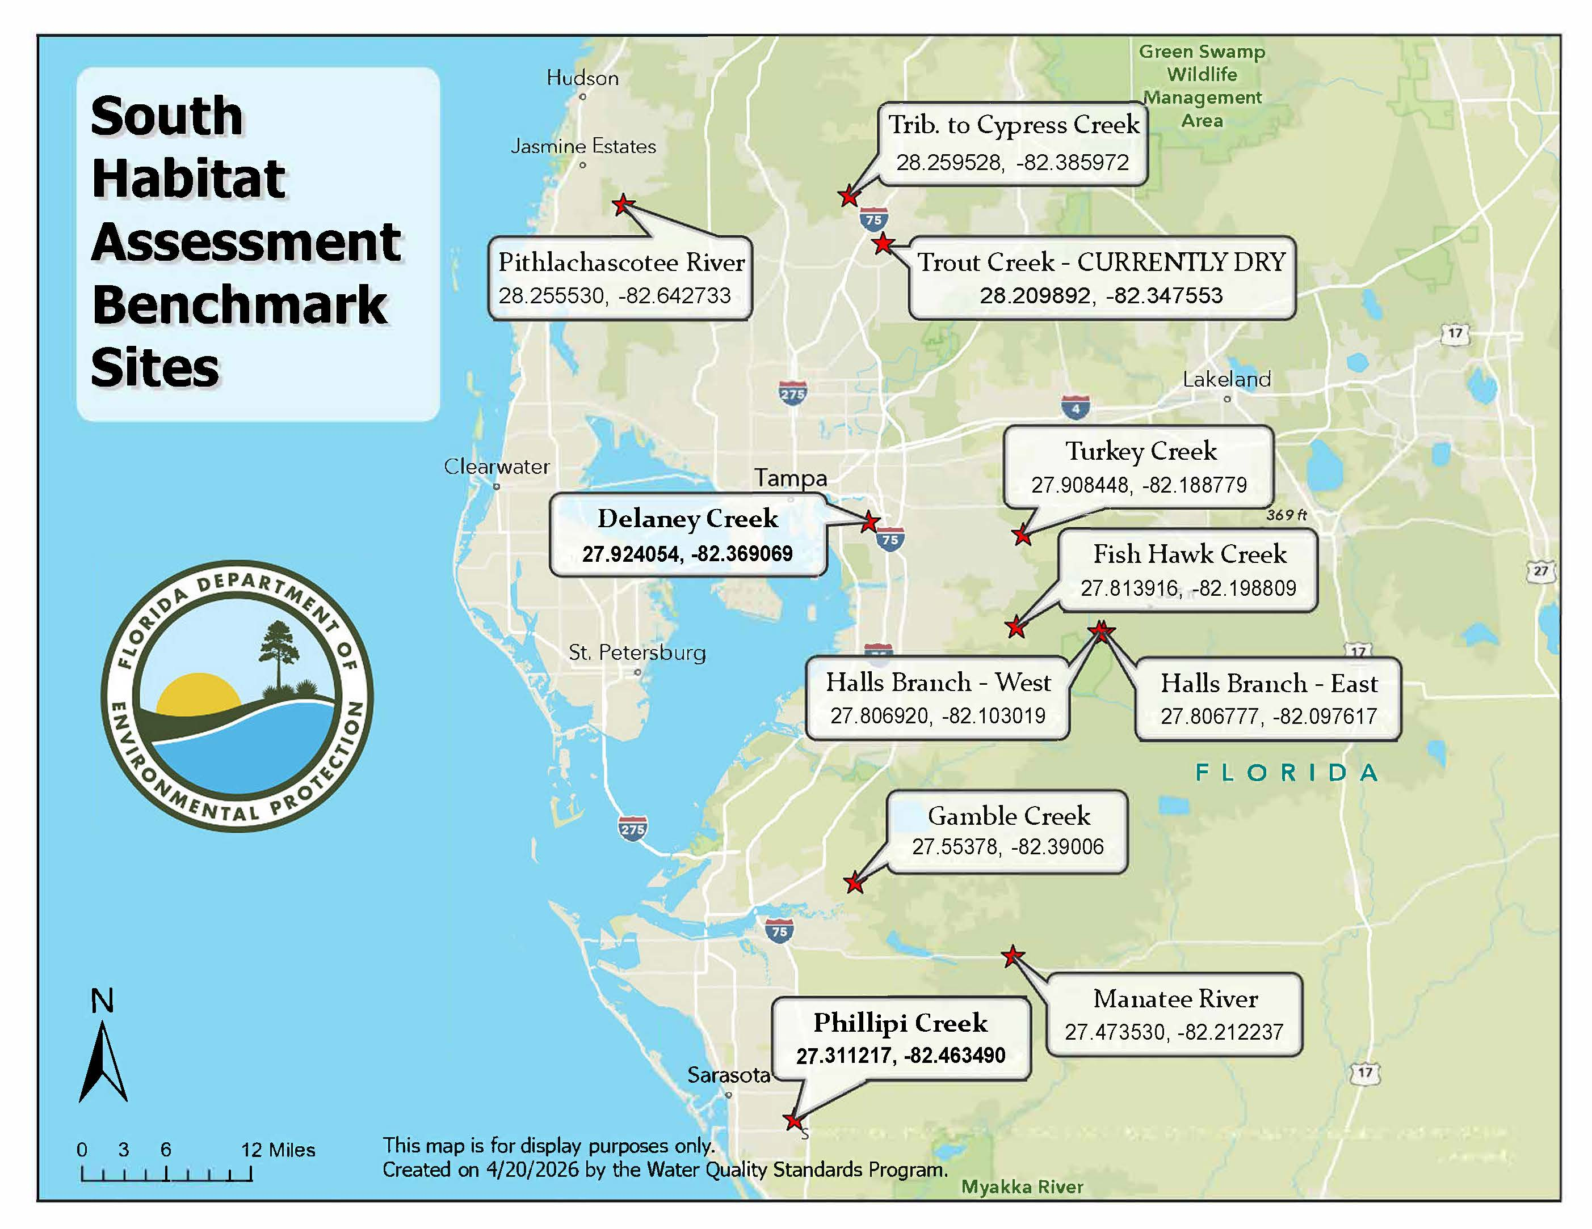
Select any group of sites for testing. Within the group, test at the bolded site and any other two sites. Refer to local hydrographs to determine which sites are appropriate for testing.

group 1
- Pithlachascotee River
- Tributary to Cypress Creek
- Trout Creek
- Turkey Creek
- Delaney Creek
group 2
- Delaney Creek
- Turkey Creek
- Fish Hawk Creek
- Halls Branch - East
- Halls Branch – West
group 3
- Phillipi Creek
- Manatee River
- Gamble Creek
- Halls Branch – East
- Halls Branch – West

