TANKS INSPECTION MANUAL
Version 2.0 April 4, 2022
Florida Department of Environmental Protection
Division of Waste Management – Storage Tank Compliance

Table of Contents
Table of Contents 2
Introduction 3
Document Conventions 4
Chapter 1 Navigation 5
Logging In 6
Open Activities 7
Submitted Activities 8
Session 9
Search 14
Common Navigation Terms of FIRST 17
Chapter 2 Go To Menu Navigation & Project Description 20
Go To 21
Projects (General Description) 31
Chapter 3 Inspection Activities in FIRST 33
Initiating an Inspection 34
Inspection Information 36
Site Visit Information 37
Checklists 39
AOCs/Violations 43
Regulatory Data 47
Comments 65
Attachments 68
Participants 73
Completing an Inspection – Entry Level Inspector 77
Completing an Inspection – Experienced Inspector 81
Letter Activities 84
Document Management Activities 90
Phone Activities 92
Meeting Activities 93
Electronic Communication Activity 94
Engineering Requests 95
Record Document Activities 96
Issue Document Activities 97
Chapter 4 Project Specific Activities 98
Routine Compliance, Installation, Non-Compliance, Compliance Assistance, QA/QC, and Complaint Project Specific Information 99
Closure Project Specific Information 102
Incident Project Specific Information 103
Discharge Project Specific Information 105
Enforcement Project Specific Information 108
Chapter 5 Additional Notes & Guidance 114

Introduction
The purpose of the Tank Inspectors Manual (TIM) is to provide the users with a detailed process that guides them through an inspection including proper entry into the FIRST (Florida Inspection Reporting for Storage Tanks) Application for all FIRST activities. It will also include other guidance documents to be used as reference so that inspectors can successfully complete their duties and meet the standards that have been established by the Division of Waste Management.
Inspectors use the FIRST Application, a web-based application, to collect points of observational data from field inspections using tablet devices and synchronize their data back to the DEP network where it is widely available to various individuals and groups. The department uses the FIRST Application via the DEP Business Portal to track and report on all compliance and enforcement activities regarding the Storage Tank Compliance Program. Others, such as the Office of General Counsel, Office of the Inspector General and Petroleum Restoration Program, use the FIRST Application to view all the detailed information collected by the inspectors out in the field during an inspection.
This book is organized by chapters, FIRST Application and Guidance Documents. Each chapter is then broken into sections. The FIRST chapter describes the general subjects of FIRST, entering data, and project required specifics. The guidance documents will be included in detail after the activities.
This document is a living document and will be continuously updated when necessary. It can be found on the Florida Department of Environmental Protections (DEP) website under the Waste Management Division.

Document Conventions
To add clarity and comprehension, the following conventions will be used in this document.
Body Text Is used for Windows, screen names, menus.
Bold Underline Is used for activity and section names.
Bold Is used for field names.
Bold Italic Is used for information to be entered by the user, or external references.
Italic Bold Is used for Project names.
Button Text Is used for buttons.
Italic Is used to highlight comments in examples.
Underline Is used for links.
Black Underline Is used for emphasis or important information.

Chapter 1
Navigation

Logging In
The FIRST Application can be found using the web address http://prodenv.dep.state.fl.us/DwmFIRST After logging into FIRST, use the appropriate Username (for County Personnel it will be email address, and for District Personnel it will be your last name_first initial (possibly middle) and network Password, the Facility Browser screen will appear.
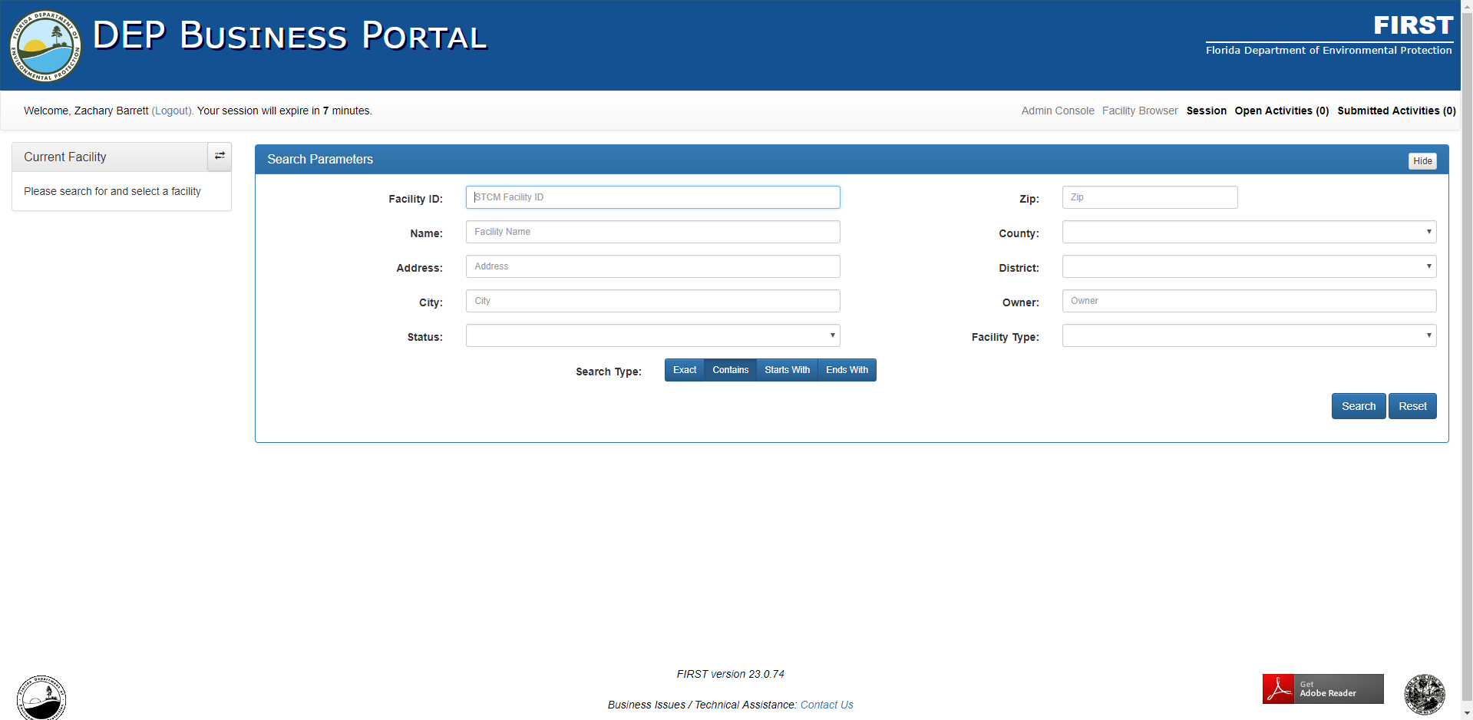
Figure 1: Facility Browser/Search Screen
From this screen, the user may Search for a facility, create a Session (prepare for disconnected), review their Open Activities, and review their Submitted Activities.

Open Activities
To review Open Activities, click Open Activities in the upper right portion of the screen. This will provide a list of all open activities in which you are involved along with the opened date and status of the activity.
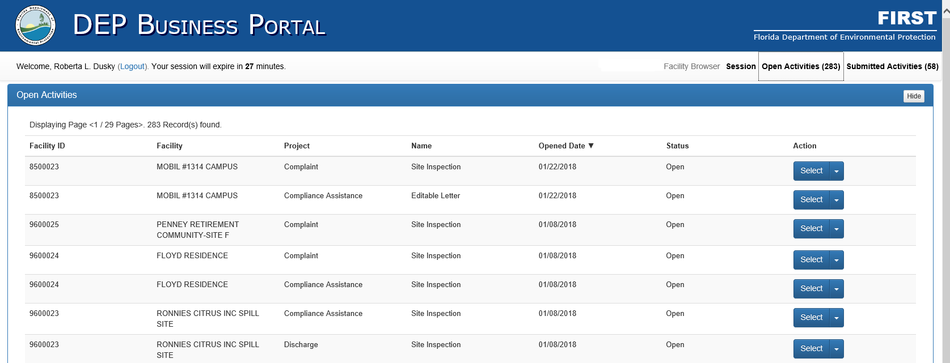
Figure 2: Open Activities Screen

The user may can click the Select button to the right of the activity and will be taken to that activity.
The user may also delete any open activity from the Open Activities list, by clicking the Dropdown Arrow next to Select, and then clicking Delete from the dropdown.

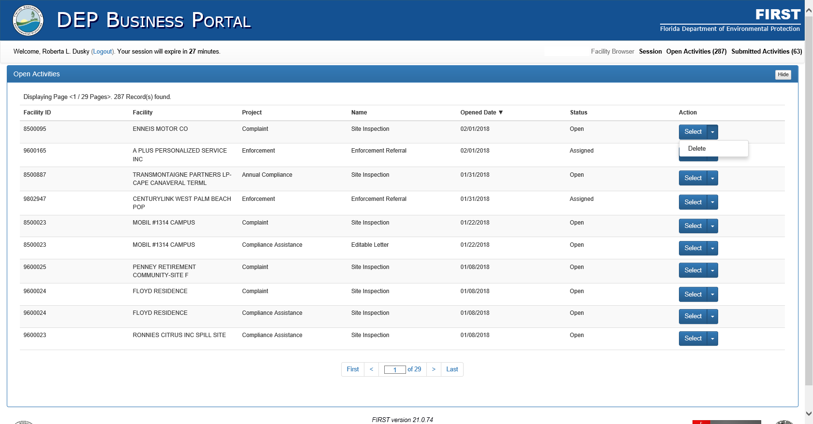
Figure 3: Open Activities-Select/Delete

Submitted Activities
To review your Submitted Activities click Submitted Activities in the upper right corner. This provides a list of all submitted activities in which you are involved.
This screen will provide the type of activity, the opened date, the user who opened the activity, the inspector for the activity, the approver of the activity, and the status of the activity.

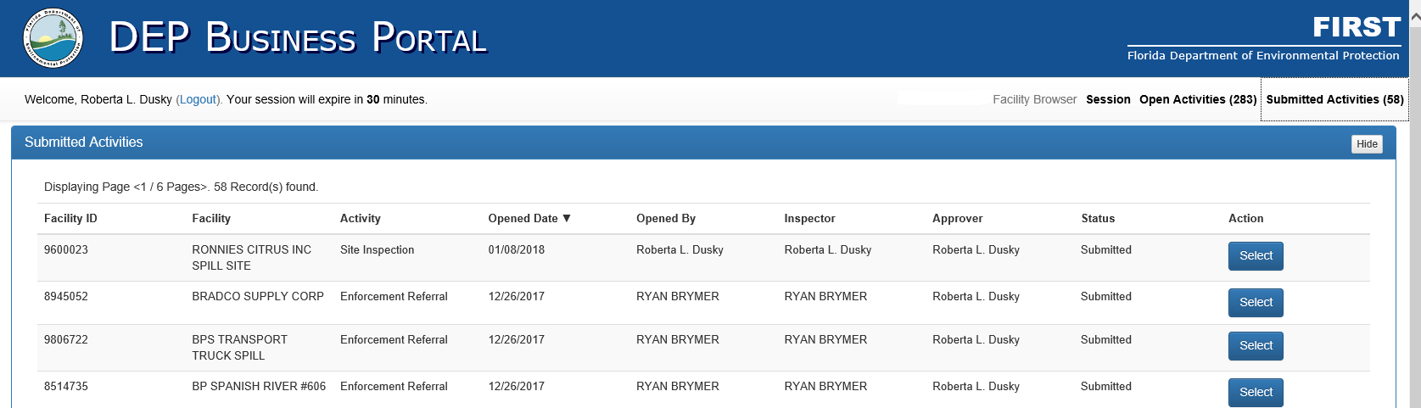
Figure 4: Submitted Activities Screen

The user may can click the Select button to the right of the activity and will be taken to that activity.

Session
A Session is created in preparation for going Disconnected and taking the device out into the field where the user will not have the ability to be connected to the internet. The users will be able to load up to 10 facilities per session.

Preparing a Session
To begin a Session, the user must be in Connected Mode to start.

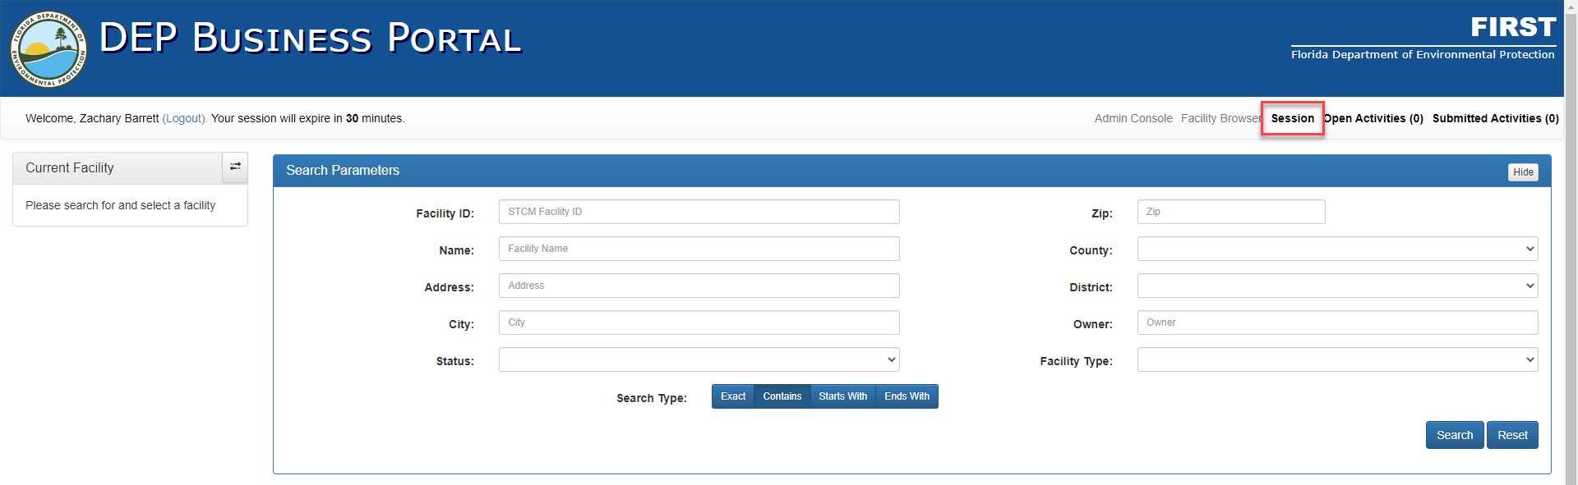
Figure 5: Beginning of Session

From here, the user will select Session located in the Top Navigation Bar.

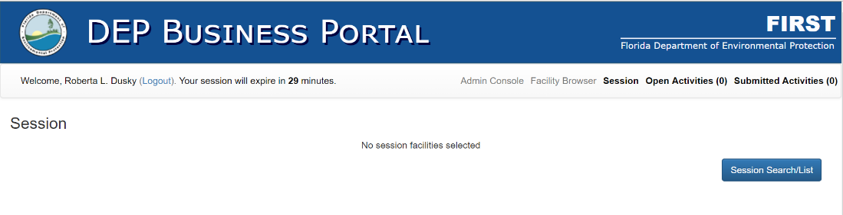
Figure 6: Session Button

To start creating a Session, click Session Search/List. The screen will appear identical to the normal search screen that you are used to using. Once you have completed your search, your results will appear below the search.
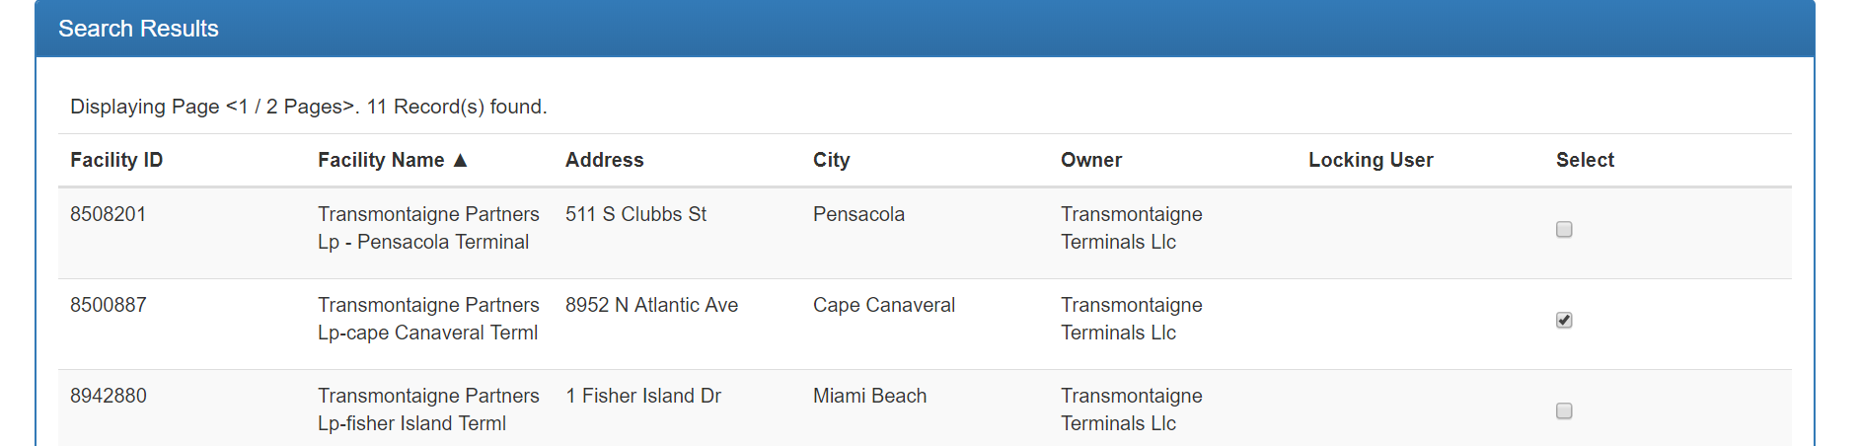
Figure 7: Results Screen

As shown in the figure above, you would click in the box under the Select column for the desired facilities. You can currently load up to 10 facilities at a time. Then choose Save.

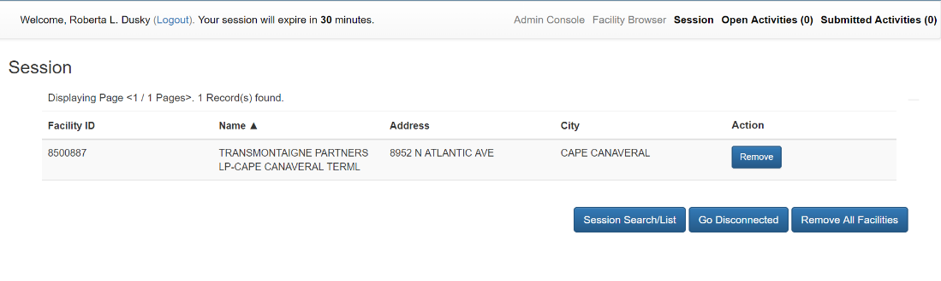
Figure 8: Session ready for to go Disconnected

Once you have completed choosing the desired facilities for a session, select Go Disconnected. The other selections: Session Search/List returns you to the Search page; Remove All Facilities will remove all facilities chosen for disconnect, and Remove located under Action will only remove that facility from the Session.
Once Go Disconnected is chosen, several progress bars like the ones in the figure below will be displayed on the screen.

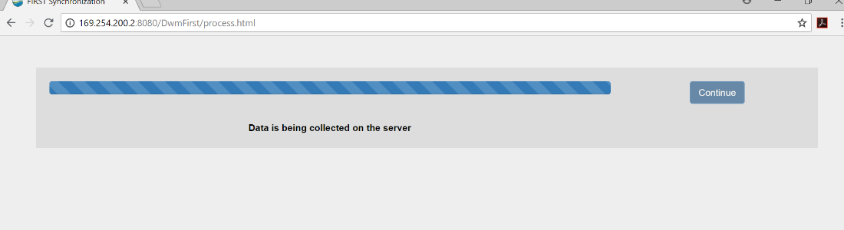
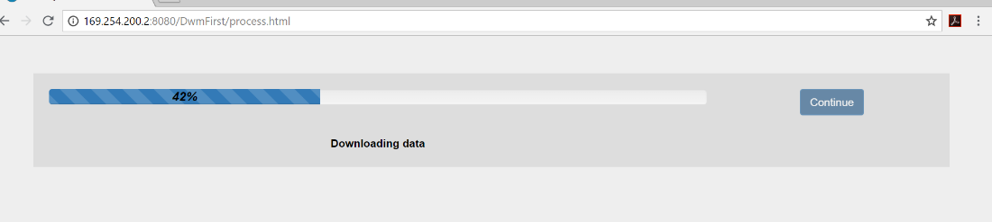
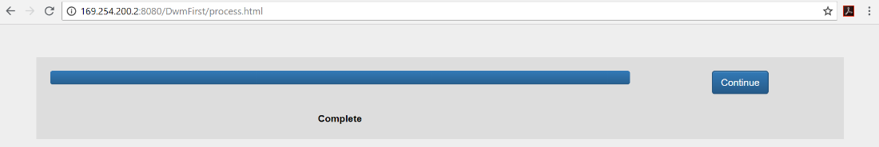
Figure 9: Disconnected Progress Screen Examples

To complete going disconnected, select Continue, after receiving the Complete progress bar indicated above. You will be able to tell that you are now in Disconnected Mode as your screen will now be displayed with the following IP address in the browser 169.254.200.2:8080/DwmFirst, and the screen will also state that you are in Disconnected Mode.

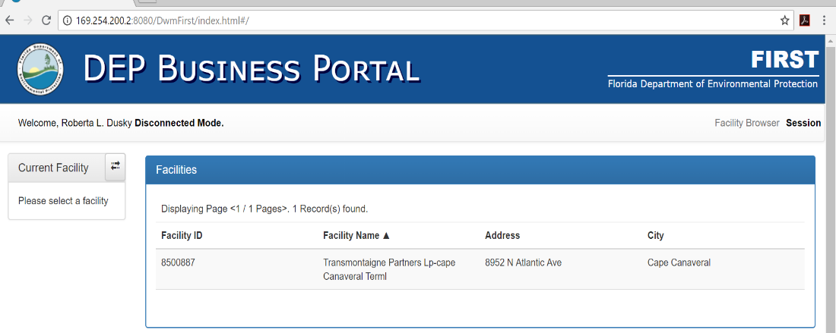
Figure 10:Disconnected Mode Main Page
From here you can work as you normally would in FIRST.
Once completed with your work in Disconnected Mode, it is time to synchronize your work back to the DEP server.

Synchronizing
To Sychronize, select the FIRST Disconnected shortcut icon located on the ToughBook desktop, by double clicking on it.
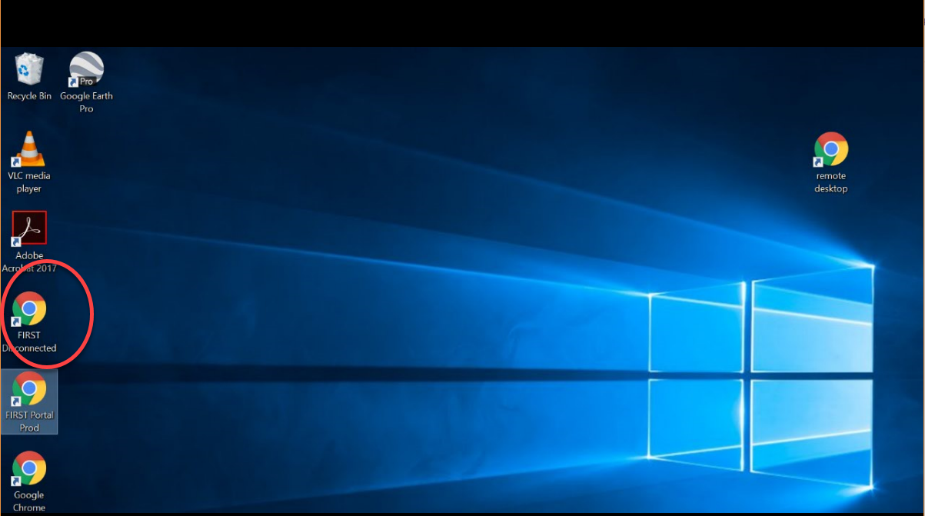
Figure 11: ToughBook Desktop Display

The Disconnected Facility Browser page will be displayed.
Figure 12: Disconnected Facility Browser Page

Select Session located in the right corner of the Top Navigation Panel. A screen displaying a list of the facilities that were in your session will be displayed like the one below.

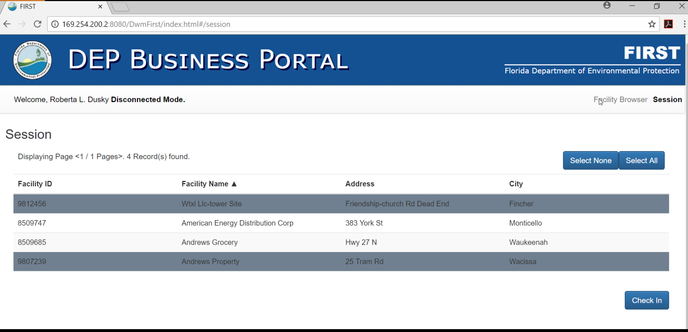
Figure 13:Check-in Screen Example

You may begin checking facilities back in at this time. It is not necessary to check all facilities back in at one time, however, to start the process you must click Select All. All you need to do to unselect facilities for check in is to click in the line of the facility that you wish not to check in. Once you have identified the facility(ies) for check in, select Check In. Progress bars will appear, and the final one will look like the one below, select Continue.

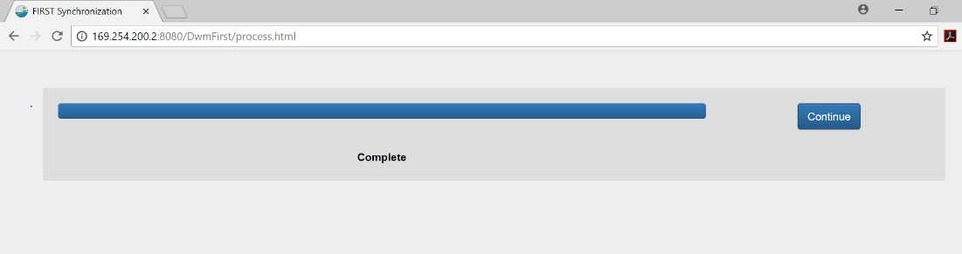
Figure 14:Synchronization Complete

Selecting Continue will return you to the Production side of FIRST indicated by the URL of prodenv.dep.state.fl.us, and the screen will not state Disconnected Mode.

Search
On the Search Parameters page, the user can search for facilities of interest by Facility ID, Name, Address, City, Zip Code, County, District, Status, Facility Type or Owner. It also allows the user to utilize different search types by choosing either Exact, Contains, Starts With, or Ends With from the bottom of the search parameters screen. The default search type is Contains.
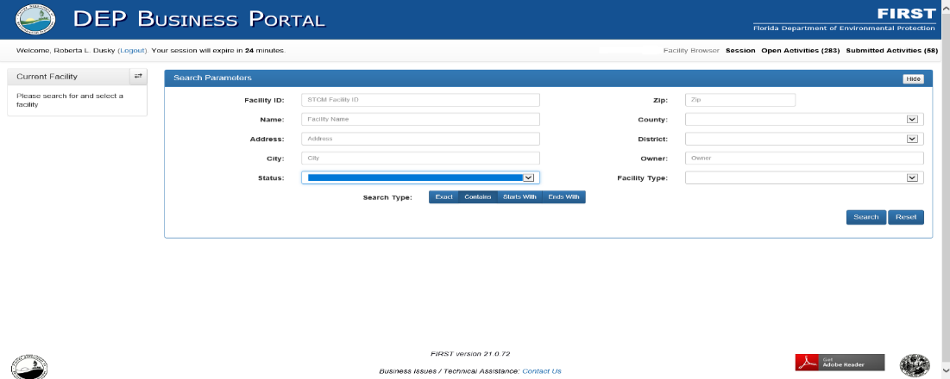
Figure 15: Facility Browser/Search Screen

For example, if the user knows that the facility name contains Cape. They may enter Cape in Name and click Search on the right-hand side.

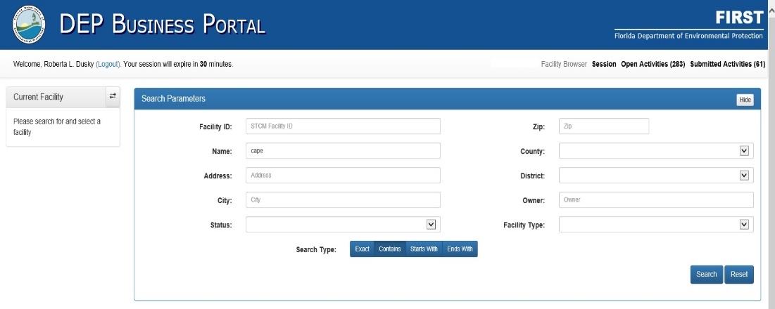
Figure 16: Search Example

FIRST will return and display all facilities that contain Cape.

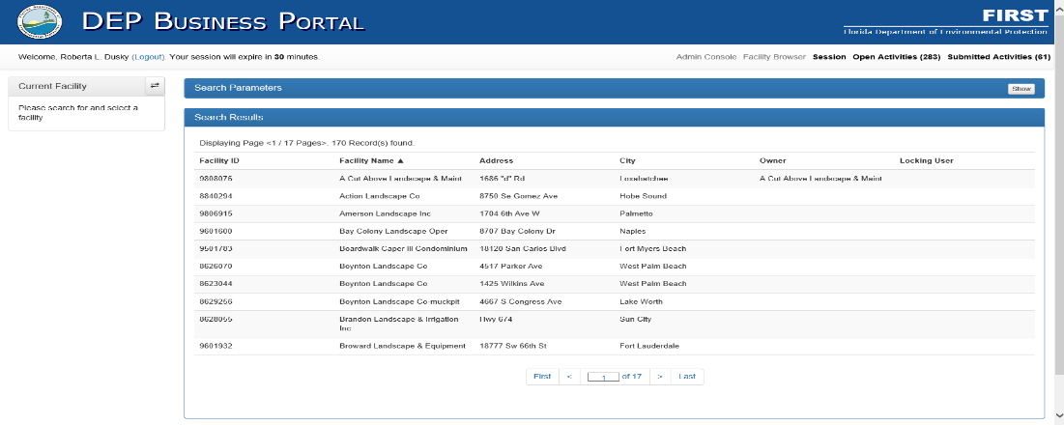
Figure 17: Search Results

Within the display, there will be indications for the number of records found in the search, for this example, (Displaying Page <1/17 Pages>. 170 Record(s) found.) will be shown. The first (10) results are be displayed.

At the bottom of the results screen the user can navigate through the pages of results.

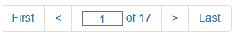
Figure 18: Search Page Navigation

First will automatically take you to the first page, while the 2 arrows will move up or down one page respectively, and Last will take you directly to the last page of results.
Once you have found the facility that you are looking for on a results page, hover over that row and click.

The Facility Information page will display.
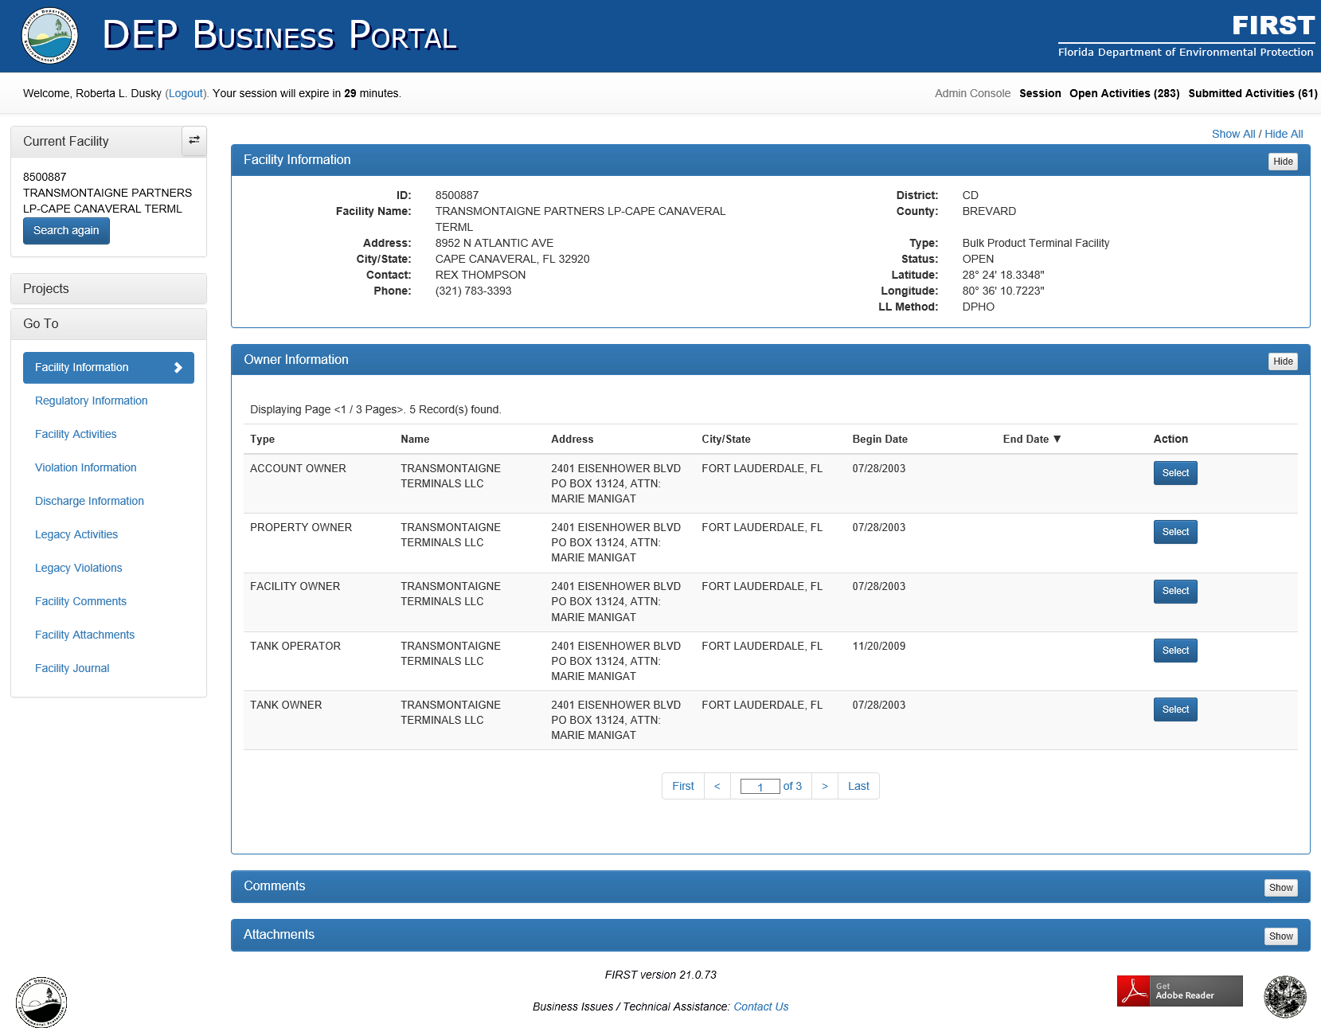
Figure 19: Facility Information Page

Common Navigation Terms of FIRST
There are several ways to navigate through FIRST. Let’s start with the names for the various sections of the user screen, as these will be referred to throughout the document.
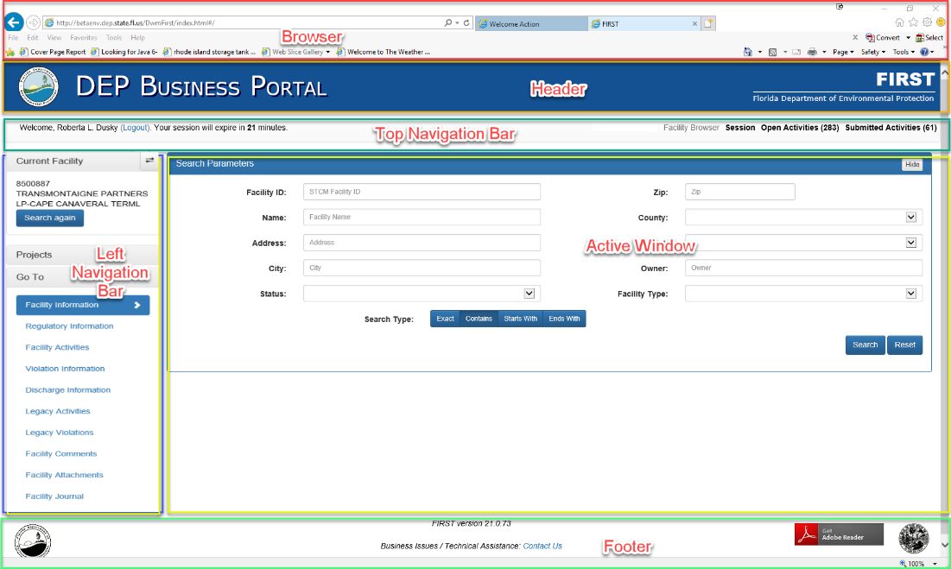
Figure 20: User Screen Sections

Browser
FIRST is a web-based application, available for use on most web browsers. However, Chrome and Firefox are recommended due to compatibility and security.

Header
The Header identifies the DEP Business Portal and the FIRST Application.

Top Navigation Bar
In this location, you will see such information as logged-in user name, Logout link, session timing, Facility Browser, Session, Open Activities and count, and Submitted Activities and count. By clicking any of these links, you will be taken to the home page for that item. For example, Facility Bowser will return you the original Search screen, while Open Activities displays the number of open activities the current logged-on user has and clicking on that will take you directly to the listing of Open Activities. The Logout will take you back to the Portal Application Selection page, where you can access applications such as STCM, WebPoint and Crystal Reports.
Once inside a project, as part of the Top Navigation Bar, you will see a Breadcrumb trail that explains where you are within the application. If you click on the Project within the Breadcrumb trail (Routine Compliance in the example below) you will be returned to the main project screen.

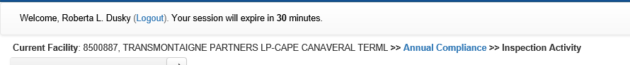
Figure 21: Top Navigation with Breadcrumb

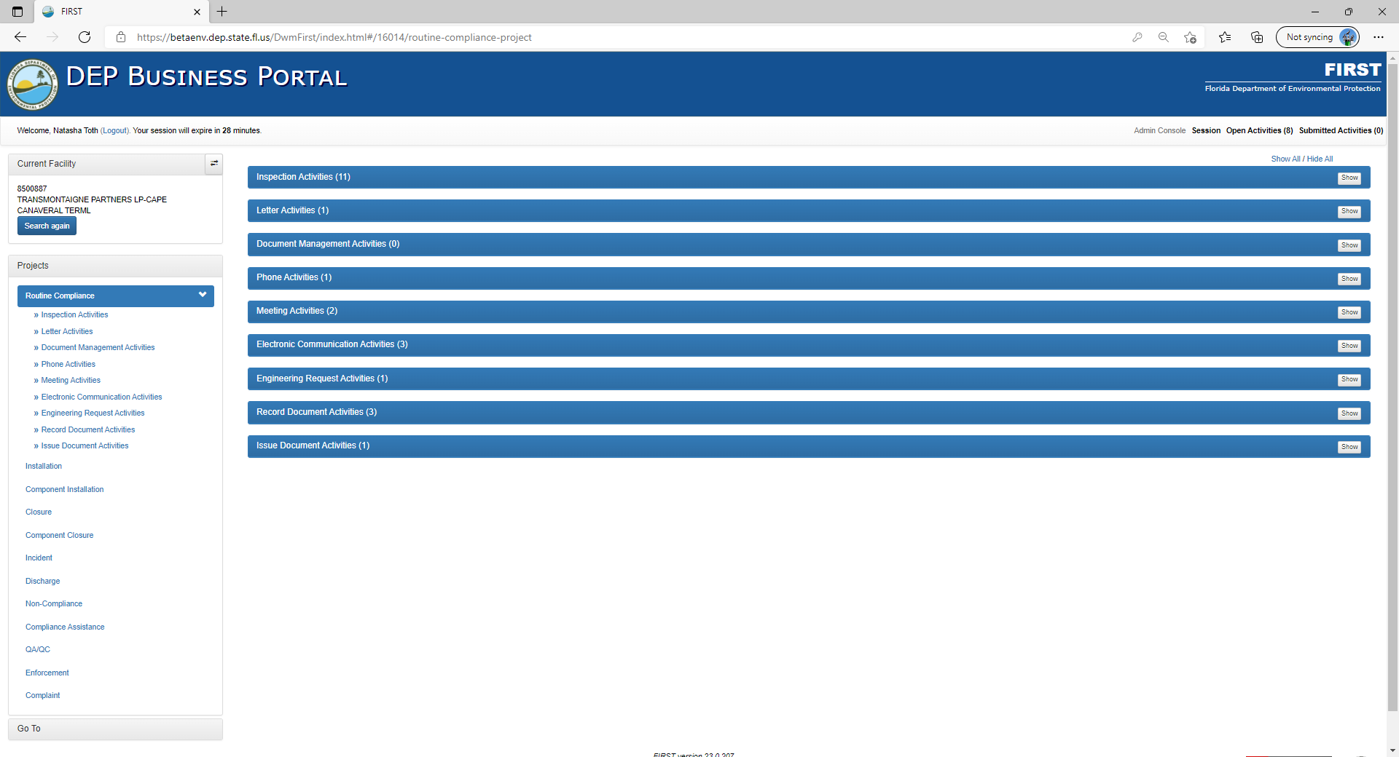
Figure 22: Return to Main from Breadcrumb

Left Navigation Bar
The Current Facility information, Projects and Go To are available in the Left Navigation Bar. Current Facility information will be presented as the Facility ID and Name. By clicking Search again you will be returned to the original search screen and allowed to enter different search parameters.
When clicking on Projects, a listing of all facility projects and the various activities that can be associated to the project will be displayed. The Projects include Routine Compliance, Installation, Component Installation, Closure, Component Closure, Incident, Discharge, Non-Compliance, Compliance Assistance, QA/QC, Enforcement and Complaint. Each of these Projects have activities that include Inspection Activities, Document Management Activities, Phone Activities, and other similar activities. To view the associated activities for a specific project, hover and click on the project.
The Go To provides a way to review all applicable historical information for the chosen facility. After clicking on the Go To, a listing of all pertinent information will be displayed. This information is “Read Only” and includes Regulatory Information, Facility Activities, Violation Information, Discharge Information, Legacy Activities, Legacy Violations, Facility Comments, Facility Attachments and Facility Journal. Later in the document we will discuss each of these in detail.
The Left Navigation Bar is collapsible, which will provide the user with more room on the screen to work, using the Collapse button 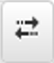 next to Current Facility.

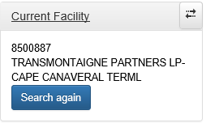
Figure 23: Collapse Button

Active Window
The Active Window is where all information can be reviewed or entered. You may click to enter data, or use the scroll roll on the right-hand side. Within the Active Window the inspection information will continue to scroll throughout the application within the given project and activity. Once you have completed/viewed all information available, the screen will no longer scroll.

Footer
The Footer is the location where the Activity Actions can be completed inside the application. Once the user is within the application, the Footer will change to the Activity Actions bar. Within the Activity Actions bar, the processes of Save, View Report, Submit for Approval, Finish, Refer for Enforcement, Engineering Request, Re-Assign Activity and Exit are available. Each of these will be discussed in detail later in this document.
Other Navigation Aids – Each main header such as Facility Information can be collapsed or expanded individually, by clicking on Show/Hide. You may also do all headers by clicking on the Show All/Hide All.

Figure 24: Show/Hide

Chapter 2
Go To Menu Navigation & Project Description

Go To
When selecting Go To from the Left Navigation Bar, the user will be provided the history of the facility within the links displayed.

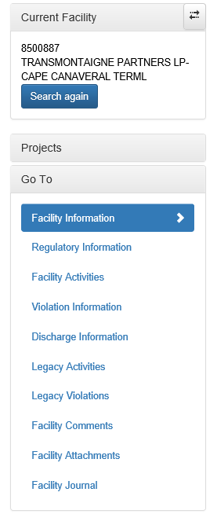
Figure 25: Go To Menu

Remember, this information is displayed as “Read Only” and cannot be changed or modified. However, the user may add Comments and Attachments at this level. These comments and attachments should always pertain to the entire facility and not any one specific piece of equipment.

Facility Information
The Facility Information includes the specifics for the facility such as ID, name, address, city/state, contact, phone, district, county, type, type, status, latitude, longitude and LL Method. Also included in this screen, is Owner Information which provides the information for the current account owner, facility owner, tank owner, property owner and tank operator, and any previous owners and operators. This view also includes the Comments and Attachments at the facility level, such as notification of owner change, or the facility layout.

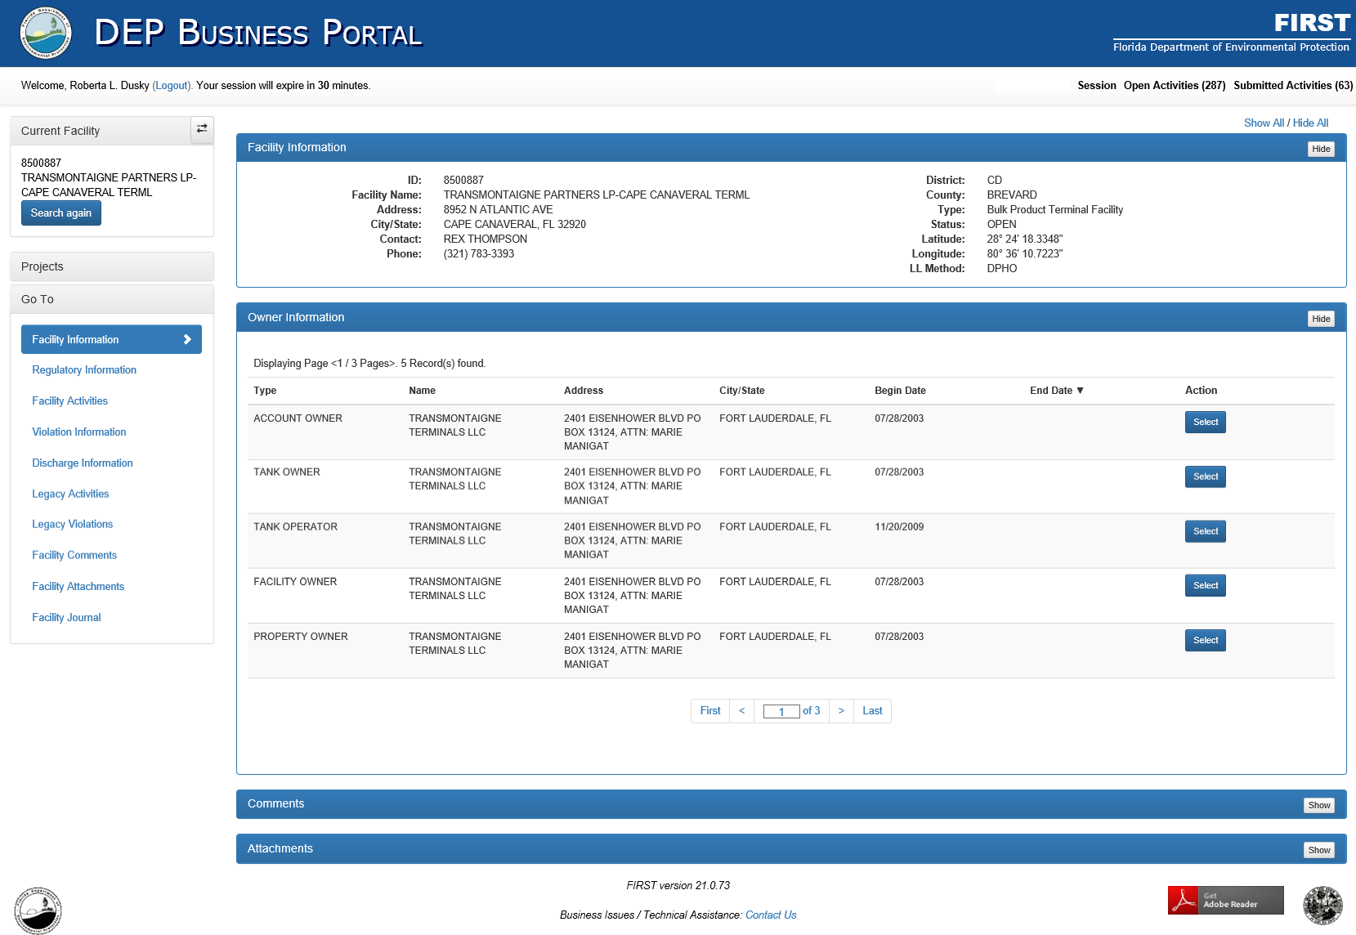
Figure 26: Facility Information

Regulatory Information
The Regulatory Information link includes Placards, Facility Records, System Tests, Financial Responsibility, and Tanks.
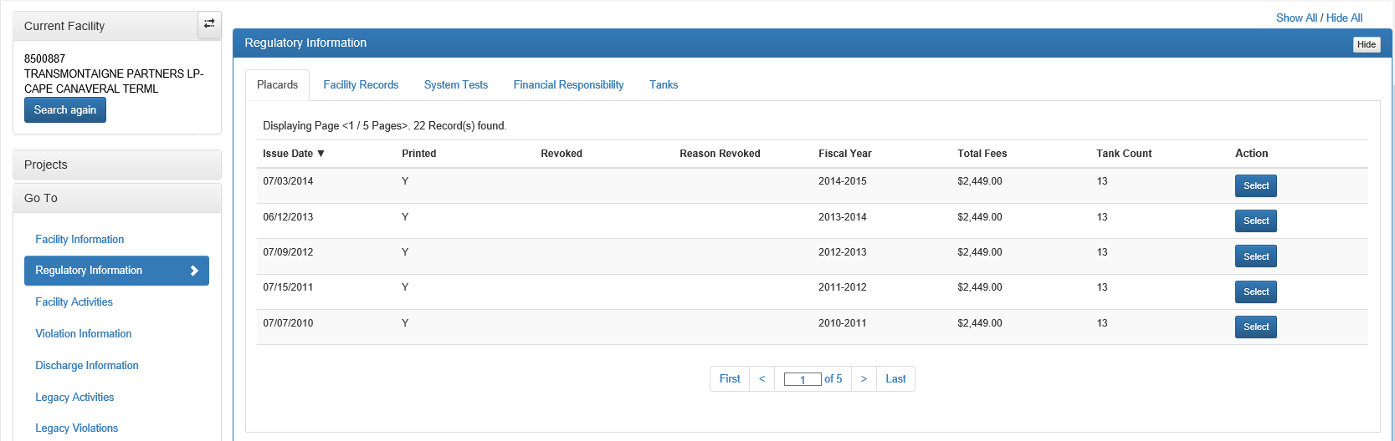
Figure 27: Regulatory Information

Facility Records, System Tests and Financial Responsibility records may be added through the Go To menu. The only time any of these records and tests should be added in this section is, if they are not associated to a specific inspection project. For example, if the owner changes insurance companies between inspections, and supplies the new insurance information, the user may then go into the Go To >> Regulatory Information >> Financial Responsibility and add the new information by clicking on the Add Financial Responsibility and completing the information. Facility Records and System Tests can be completed in the same manner.

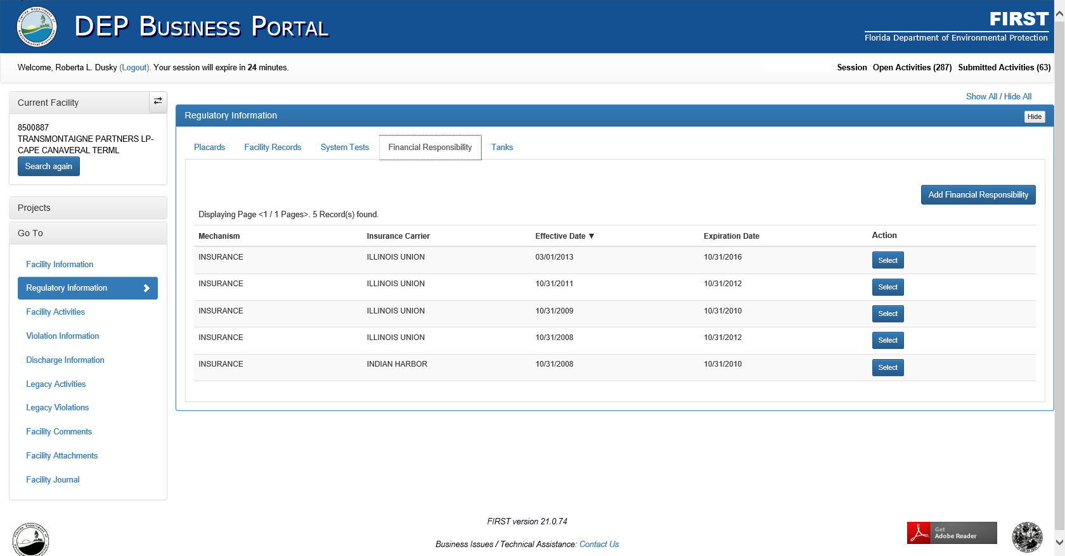
Figure 28: Adding Records from Go To in Regulatory Information

Facility Activities
The Facility Activities in the Go To menu is a historical documentation by activity type for the facility. The data includes any information entered into STCM prior to FIRST or in FIRST since its inception. Information includes Complaints Reported, TCAR Activities, Incident Activities, Inspection Activities, Discharges, Letter Activities, Document Management Activities, Phone Activities, Meeting Activities, Electronic Communication Activities, Engineering Request Activities, Record Document Activities, and Issue Document Activities.

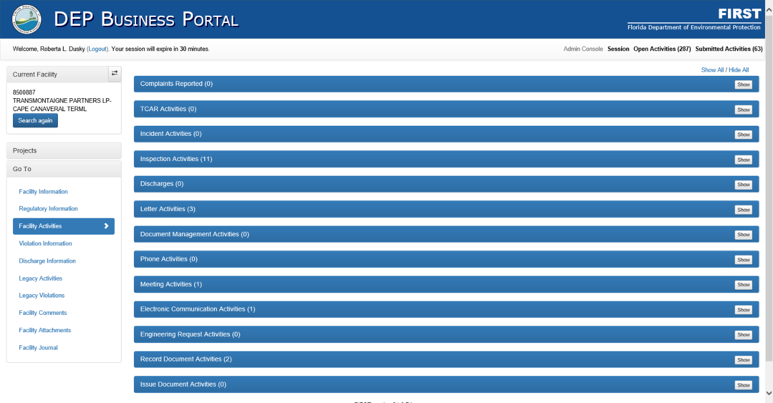
Figure 29: Facility Activities

Violation Information
The Violation Information allows the user to review any open, pending, or closed Violations and Areas of Concern prior to an on-site inspection and can guide the inspector to these areas during the inspection process. This information includes both Legacy violations and FIRST Violations and Areas of Concern.
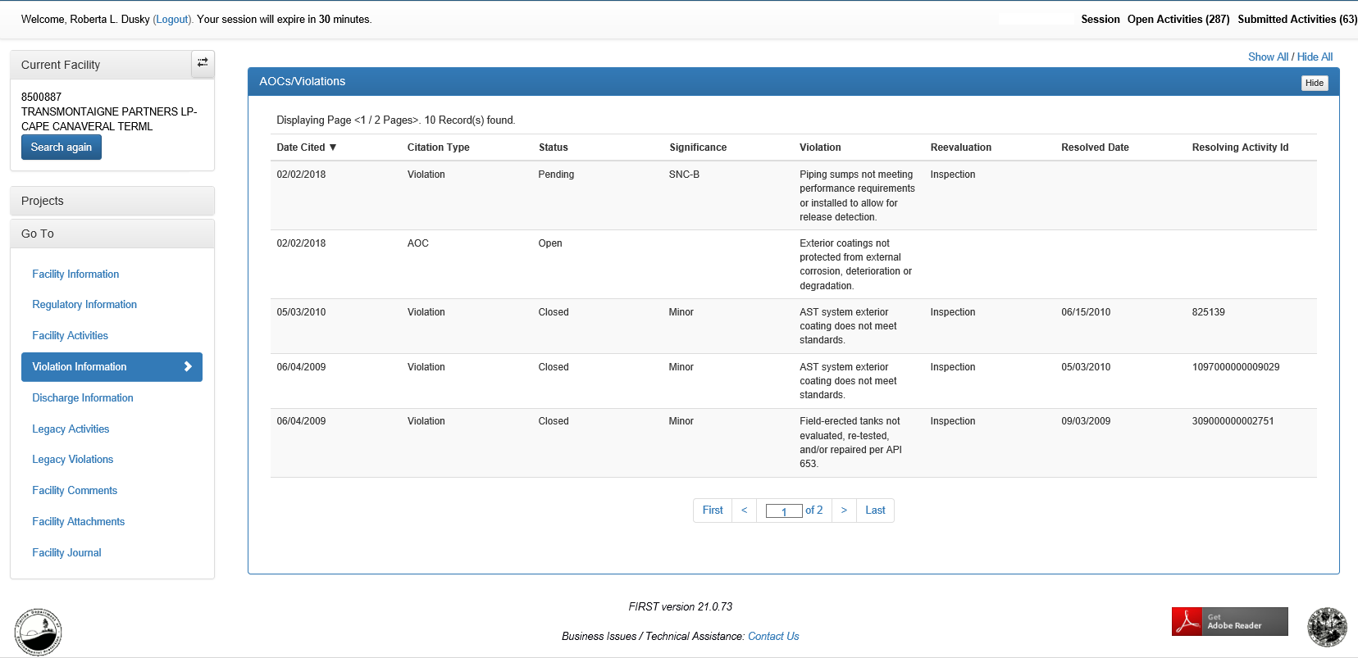
Figure 30: Violation Information

Discharge Information
The Discharge Information provides a summary of all recorded discharges at the facility. By clicking on Select, the user may expand the information and see other information specific to that discharge.
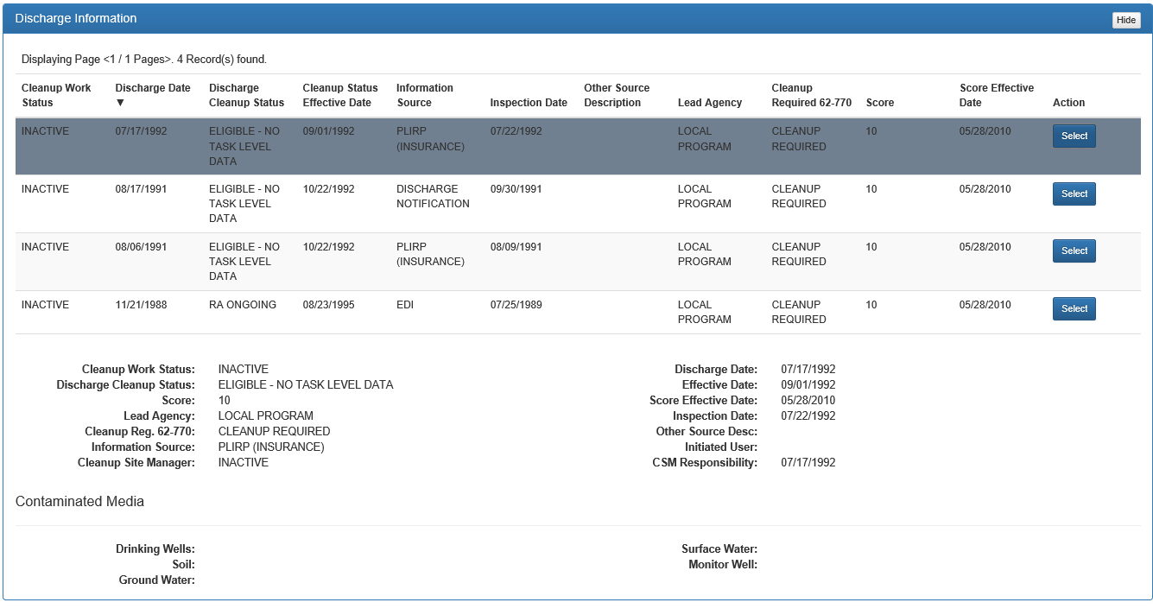
Figure 31: Discharge Information

Legacy Activities
The Legacy Activities provides a summary of those activities that took place prior to the initiation of FIRST and the compliance standing of the activity. These activities were recorded in the Storage Tank Compliance and Monitoring database (STCM). To obtain details for the activity, click on the Select button in the Action column.

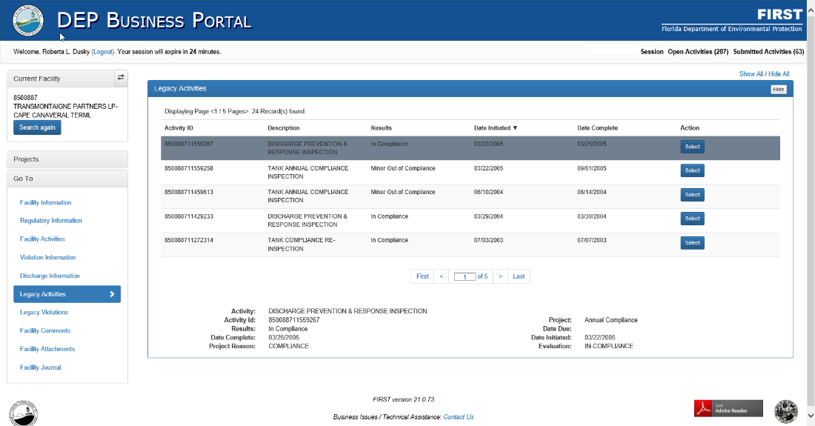
Figure 32: Legacy Activities

Legacy Violations
The Legacy Violations provides a summary of the violations that occurred at the facility prior to the initiation of FIRST.
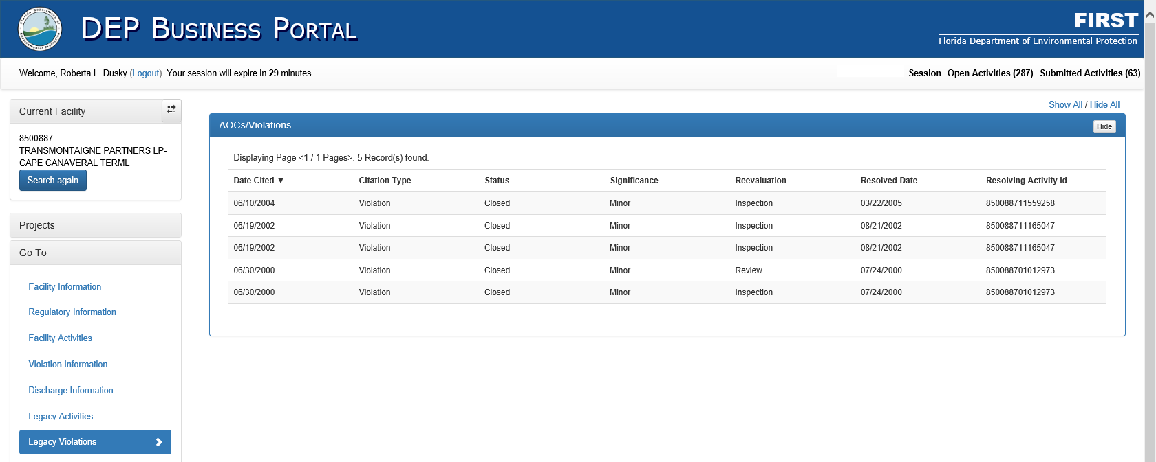
Figure 33: Legacy Violations

Facility Comments
The Facility Comments provides a way to view those comments that have been made at the facility level. Within this section of the Go To, the user may add additional comments at the facility level. These comments could include notification of owner change, placard revocation notes, fuel vendors, and any other comments that apply to the facility, and not a specific component or area of the facility.
To add new facility comments the user should click on Add New Comment in the upper right corner of the Active Window.
To view comments made under this section, select View to the right of the line. Selecting the Dropdown Arrow next to View will allow the user to edit or delete the comment, by selecting either Edit or Delete.

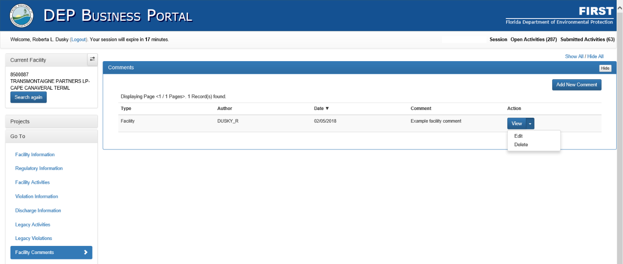
Figure 34: Facility Comments

Facility Attachments
The Facility Attachments provides a way to view those attachments that have been made at the facility level. Within this section of the Go To, the user may add additional attachments at the facility level. These attachments could include facility diagrams, facility pictures, or any other attachments that apply to the facility, and not a specific component or area of the facility.
To add new facility attachments the user should click on Add New Comment in the upper right corner of the Active Window.
To view attachments made under this section, select View to the right of the line. Selecting the Dropdown Arrow next to view will allow the user to edit or delete the attachment, by selecting either Edit or Delete.

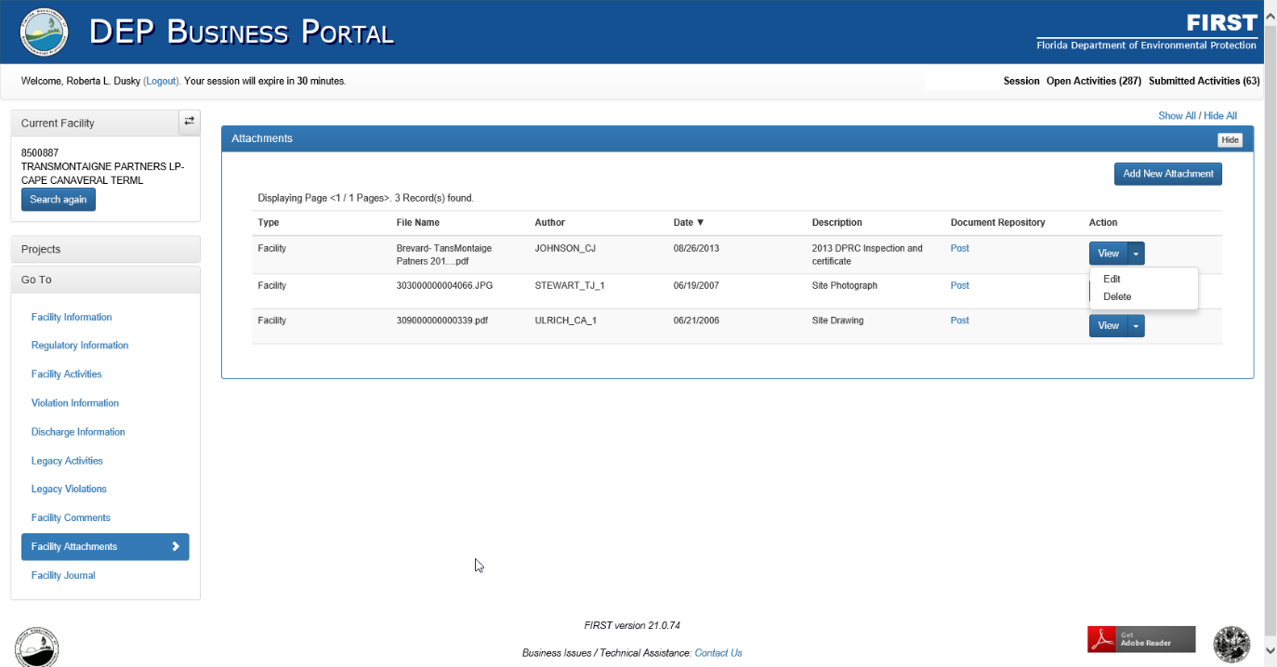
Figure 35: Facility Attachments

Facility Journal
The Facility Journal provides a summary of all activity that has occurred at the facility in chronological order. The parameter page provides the user with the ability to select what criteria is to be displayed on the journal report.
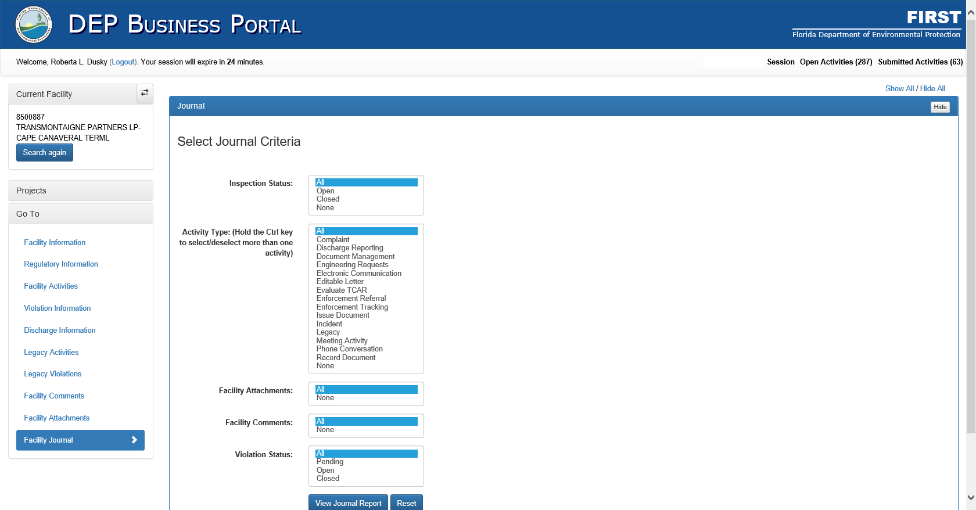
Figure 36: Facility Journal Parameter Page
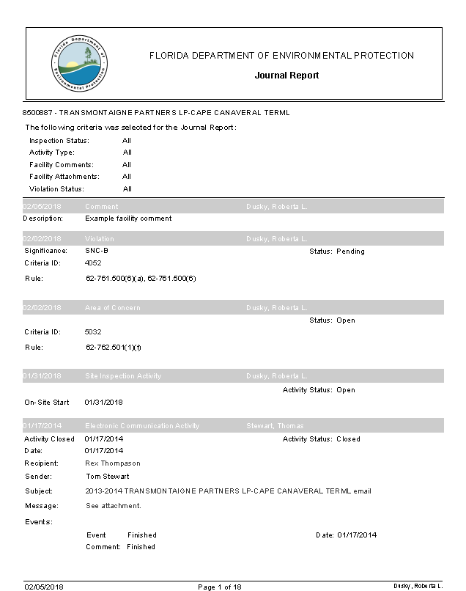
Figure 37: Example Journal Report

Projects (General Description)
Projects within the FIRST Application include Routine Compliance, Installation, Closure, Incident, Discharge, Non-Compliance, Compliance Assistance, QA/QC, Enforcement, and Complaint. Within each project, there are multiple activities. These activities are identified with a double arrow and are indented slightly under each Project.
Project Activities
Figure 38: Projects and Project Activities
The next chapter discusses the process for each Project and associated Project Activity. However, below is a brief description of each project.

Routine Compliance – completed when the facility appears on the Task Assignment for either a County Contract or the Level of Service Task for the District.

Installation – completed when a new AST or UST system is being installed.

Component Installation – completed when a new component is being installed for AST and UST systems.

Closure – completed when an AST or UST system is being removed or replaced.

Component Closure – completed when a component is being removed or replaced for AST and UST systems.

Incident – completed when there is an alarm, release to secondary containment, or any other event that could lead to a potential discharge at a facility. If, after investigation, a discharge did occur, the incident is to be promoted to a discharge.

Discharge – completed when a discharge is known to have occurred, is promoted from an incident, or a DRF is received from the facility. The discharge project is to be completed even if cleanup has already occurred.

Non-Compliance – the previous format for what we now call Compliance Assistance. Therefore, this can be considered a legacy project, but must remain in the application, to not delete the historical data.

Compliance Assistance – the projects for all compliance assistance work to be recorded when a facility is not in compliance for a given inspection. All assistance letters, events, and documentation should be tracked in this project, up until the time it is referred for enforcement if the issues are not resolved.

QA/QC – completed by the District. These projects are conducted by the district while accompanying the county during a scheduled routine inspection (QA), or unaccompanied (QC). These projects can be either accompanied by the District representative, or unaccompanied. The purpose of QA/QC Projects are to review the overall inspection process for a County and be considered when contract review is completed annually.

Enforcement – completed when the facility cannot or will not return to compliance the violations that have been cited. Enforcement Referrals are completed by the County Inspector and then referred to the District for completion and promotion to an Enforcement Tracking Activity. If a county is a self-enforcing county, then the referral is returned to the county for them to promote to an Enforcement Tracking Activity. If the self-enforcing county cannot return the facility to compliance, the case may be referred to the District for further action.

Complaint – completed when an issue has been brought to the attention of the County or Agency from the public. These activities are to be reviewed and approved by Tallahassee before a trip to the facility is done.

Chapter 3
Inspection Activities in FIRST

Initiating an Inspection
This chapter outlines how to initiate, enter information, and complete the general activities found within all projects in FIRST. We will be using the Routine Compliance as an example to walk-through these activities but all activities in this chapter are entered similarly in every project.
To start a Project, from the Left Navigation Bar select Projects, and a list of the various activities that can be associated to Project will be displayed. Select the desired project, for this example we will select Routine Compliance from the Projects tab. Within the Active Window, each activity associated with the selected project will be displayed within a header and the number of activities that have been initiated for that specific activity in that project. For example, in the figure below, there are 9 Routine Inspection Activities for this facility.
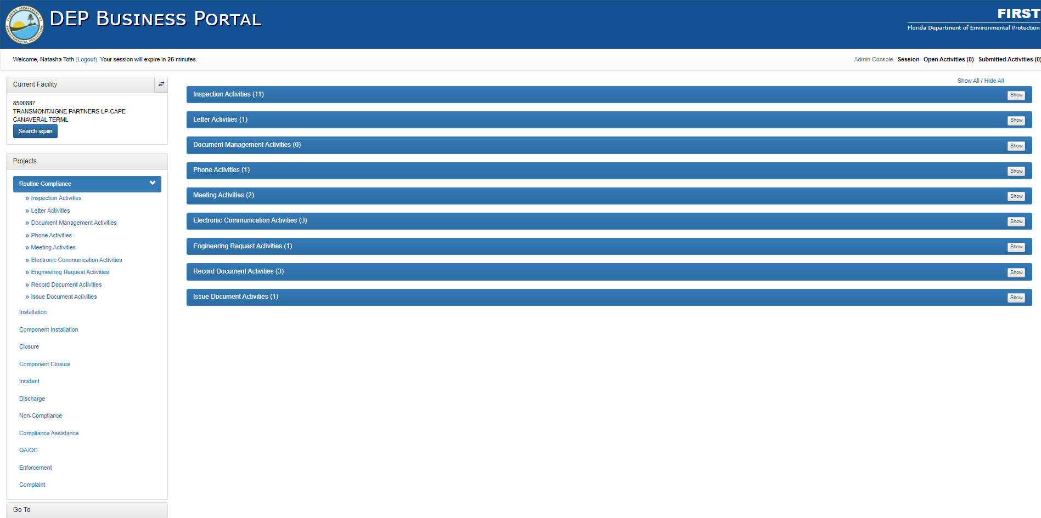
Figure 39: Routine Compliance Project Main

By clicking on the Inspection Activities header bar, or Show button, a list of the Routine inspection activities for this facility will be displayed.
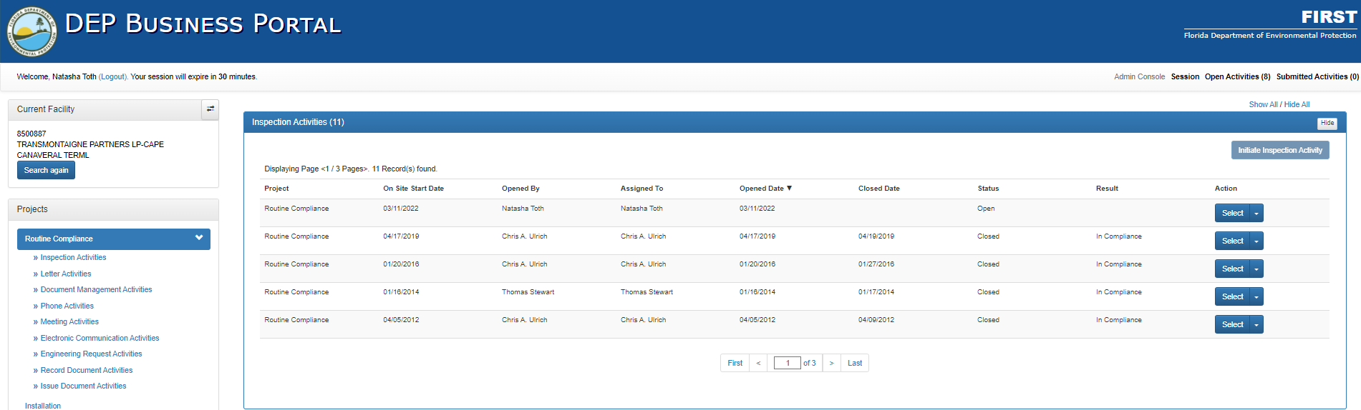
Figure 40: Routine Compliance Activities expanded

If the Initiate Inspection Activity button is grayed out and cannot be selected, an inspection is already open and can be continued by clicking the Select button beside the desired inspection. A new inspection cannot be initiated if a previous inspection is open. (If all inspection activities are closed and the Initiate Inspection Activity button is still grayed out, you may have the Read-Only Role.)
If the Initiate Inspection Activity is blue, the user can click the button, and a new Routine Inspection Activity will start in the Active Window.
After selecting an open inspection activity or initiating a new inspection, the inspection process will populate the Active Window and the Left Navigation Bar will outline the activities for the project. By selecting from the links in the Left Navigation Bar, the application will scroll to the section in the Active Window.
Active Window
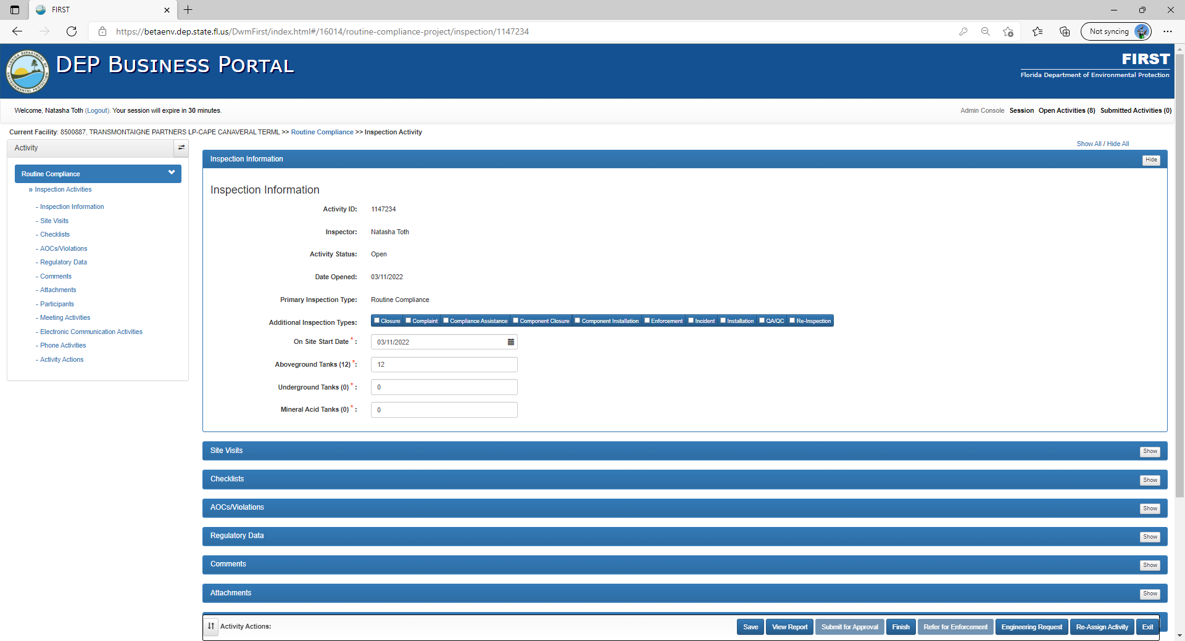
Navigation Bar
Figure 41: Inspection start

Inspection Information
The inspection process starts with the Inspection Information section. This section will display the following auto-populated information:
- Activity ID – Automatically generated number used to identify the activity within FIRST
- Inspector Name – The name of the Inspector for this inspection
- Activity Status – The status of the activity as either “Open” or “Closed”
- Date Opened – The date the activity was created within FIRST
- Primary Inspection Type – The primary inspection type
The following information needs to be entered in the Inspection Information section by the inspector:
- Additional Inspection Types (DO NOT USE!) – Due to changes in business plan, additional inspection types option no longer works as initially intended.

- Operator Training Certification (Only required by UST Facilities) – If applicable, select the required Operator Training Certification. If not applicable, then leave blank.
  - Class A – Person(s) having primary responsibility for on-site operation and maintenance of UST systems (owner or operator of a UST facility)
  - Class B – Persons having daily on-site operation and maintenance of UST systems
  - Class C – Daily on-site employees having primary responsibility for addressing emergencies presented by a spill or release from a UST system

- On Site Start Date – Use the dropdown calendar to select the date the inspector was on-site at the facility and started inspection

- Aboveground Tanks (#) – The number of ASTs inspected during the inspection *

- Underground Tanks (#) – The number of USTs inspected during the inspection *

- Mineral Acid Tanks (#) – The number of Mineral Acid Tanks inspected during the inspection *
* The number in parentheses is the number registered for the facility and the fields are auto populated with this information. This number can be changed if this number does not match what is inspected on site.
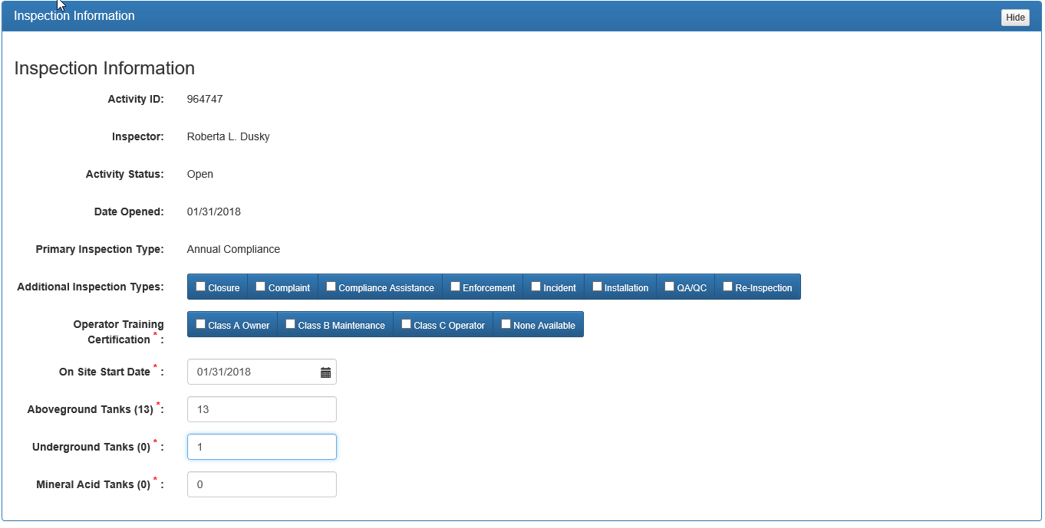
Figure 42: Inspection Information

Site Visit Information
The next section in the flow of a Routine Inspection Project is the addition of Site Visit information. To add Site Visit information, click on the Site Visit header or Show, to expand the Site Visit activity screen. FIRST keeps a record of all site visits in a table within this section.

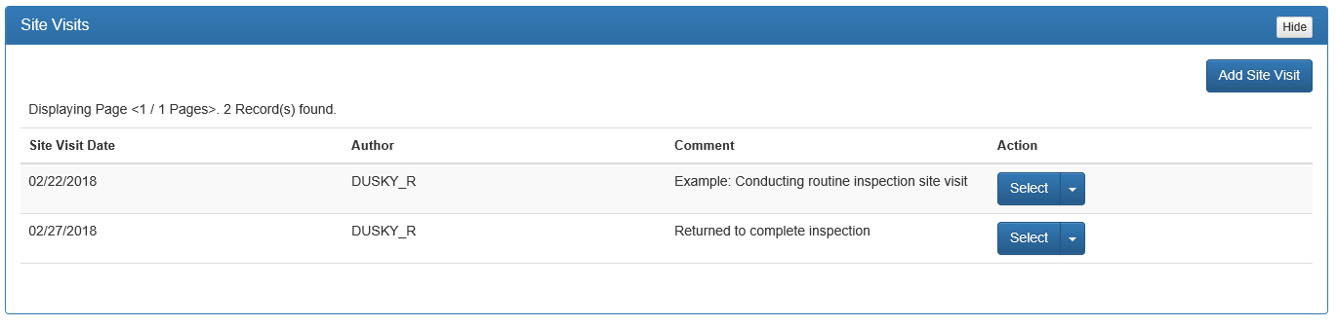
Figure 43: Add Site Visit

Adding a Site Visit Comment
To add a new site visit, click on Add Site Visit and the activity screen will display. The following steps detail how to enter a new Site Visit:
- Click in the date box next to Site Visit Date and use the calendar dropdown to select the date in which the site visit took place.

- Click in the text box next to Site Visit Comment and enter site visit comments. Site visit comments should include:
  - Date of physical inspection.
  - Brief description of the Facility.
  - List of all release detection methods for tanks, piping and sumps. Make sure to describe any unusual operating conditions, such as alarms.
  - List of any forms that were completed during the inspection or provided to the facility for update later
  - A brief description of the physical inspection results for all accessible equipment, such as gauge reading, results (dry, water, product and other conditions as observed) for tank and piping interstices, fill/spill containments, sumps/liners, AST containments
  - Integrity and conditions of all accessible system components (corrosion, containment integrity, flex pipe or sump/liner deterioration or deformation, damaged or worn components
  - Presence of any current leaks or staining indicating past leaks or overfills
  - Identify certain equipment if it was not or could not be inspected and the reason(s) for lack of inspection
  - Any requests for and/or receipt of an INF or DRF based on the records review or physical inspection findings.
  - Describe any Violations.
  - Any violations that were resolved, while on site. Remember you should not resolve the violation until after the inspection is completed and finished. The violation must appear on the inspection report as a violation.
  - Describe any AOCs.

- After all information has been added, Click Add to add the Site Visit.
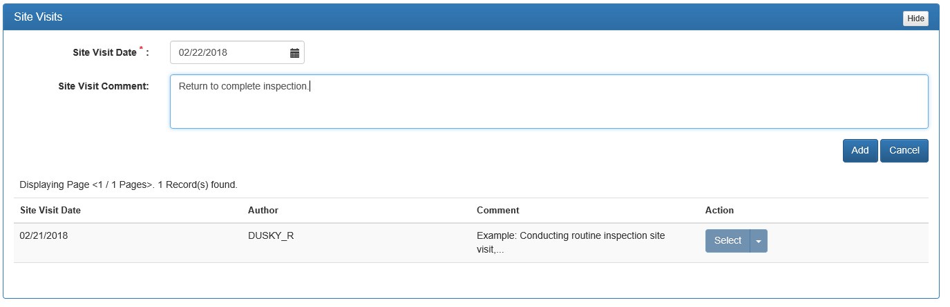
Figure 44: Complete Site Visit Comment

If the inspection has not been finished or submitted for approval, all site visit comments can be edited or deleted. To edit a Site Visit, click on Dropdown Arrow next to Select. A choice of Edit or Delete will appear. Choosing Edit will pop up the Site Visit Date and Comment. Make the appropriate changes and click Save. Choosing Delete will remove the Site Visit and Comment.

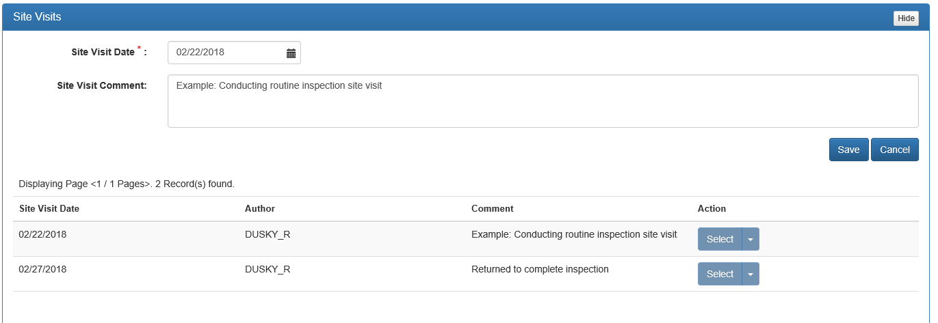
Figure 45: Editing/Deleting Site Visit Information

Checklists
The Checklists are determined in FIRST by the number of tanks entered in the Inspection Information section above. By clicking the Checklists header or Show, the Checklist(s) for this facility will be displayed.
There are two checklists used in FIRST, “Underground” for USTs and “Aboveground” for ASTs. We will be using the “Aboveground” checklist for this example.
The checklists are designed to provide the inspector with reminders of what to be looking for during the inspection process and are used for citing violations and areas of concern.

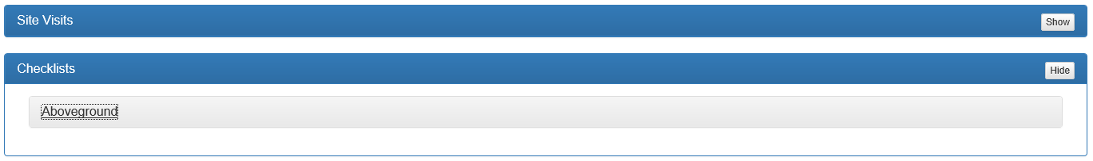
Figure 46: Checklist display

Clicking on the link for Aboveground will bring up the checklist categories. The categories for Aboveground are “Review Records” and “Physical Inspection”. Categories may differ between the Aboveground and Underground checklists but operate the same.

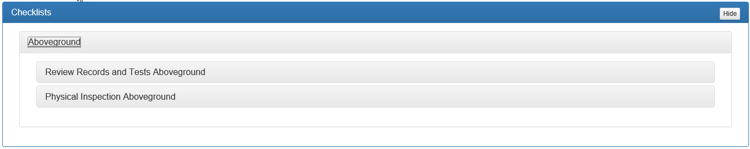
Figure 47: Checklist categories

Click on the desired category to bring up the subcategories of violations.
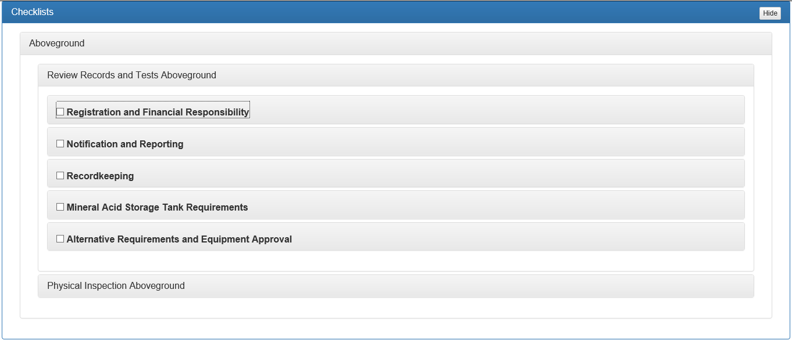
Figure 48: Checklist subcategories

Click on the subcategories to expand the individual violations with the four-digit (4) code assigned to the violation.

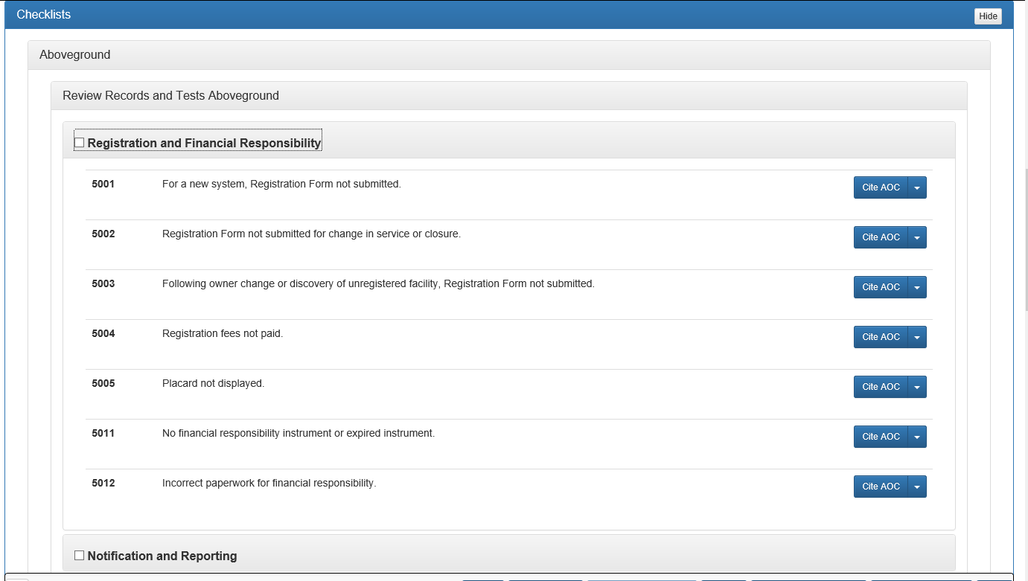
Figure 49: Checklist violations

Please note that all boxes to the left of the Checklist subcategories must be checked in order to finish an inspection.

Citing Violations or Areas of Concern from Checklists Section
To cite an Area of Concern (AOC) from the Checklist, click Cite AOC to the right of the checklist violation. To cite a Violation from the Checklist, click the dropdown arrow to the right of the “Cite AOC” button and click the Cite Violation button that appears in the dropdown. After selecting to cite as an AOC or violation, the inspector can enter the required information in the following fields:
- Citation Type – Automatically generated base on if AOC or Violation was chosen
- Cited Date – Using the dropdown calendar, select the date in which the AOC was cited
- Explanation – Provide an explanation of the AOC and why it was cited. AOC’s require an explanation as to why an AOC was chosen instead of a violation.
- Corrective Action – Provide the corrective actions required for the facility to return to compliance
After all required information has been entered, Click Add.

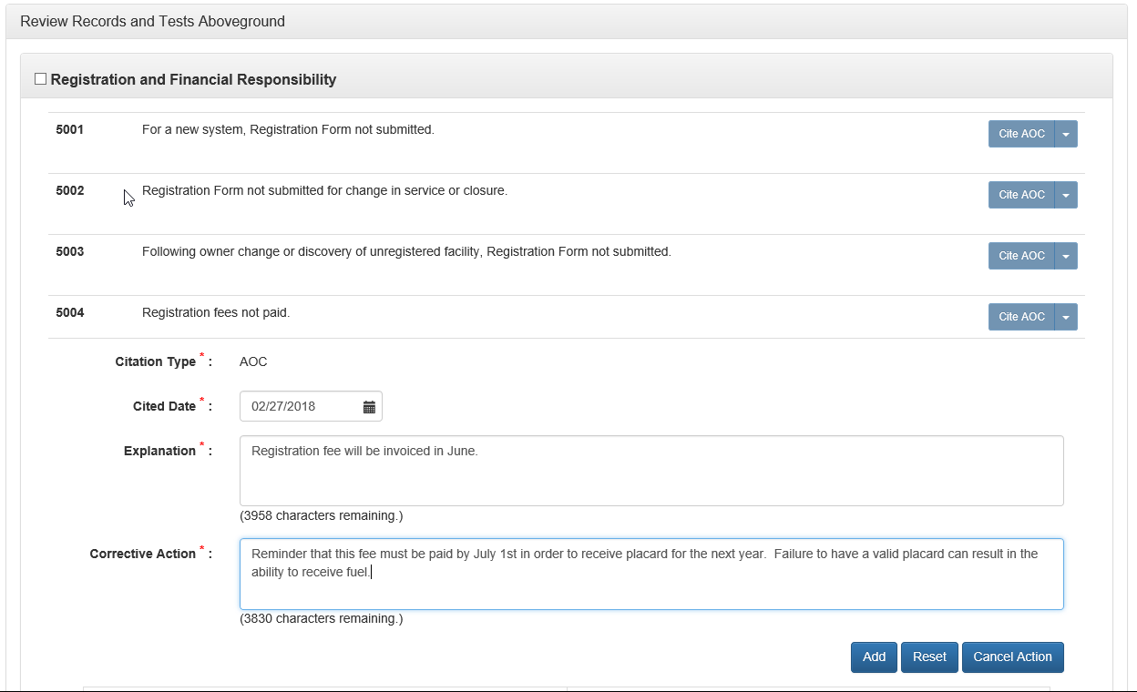
Figure 50: Citing AOC

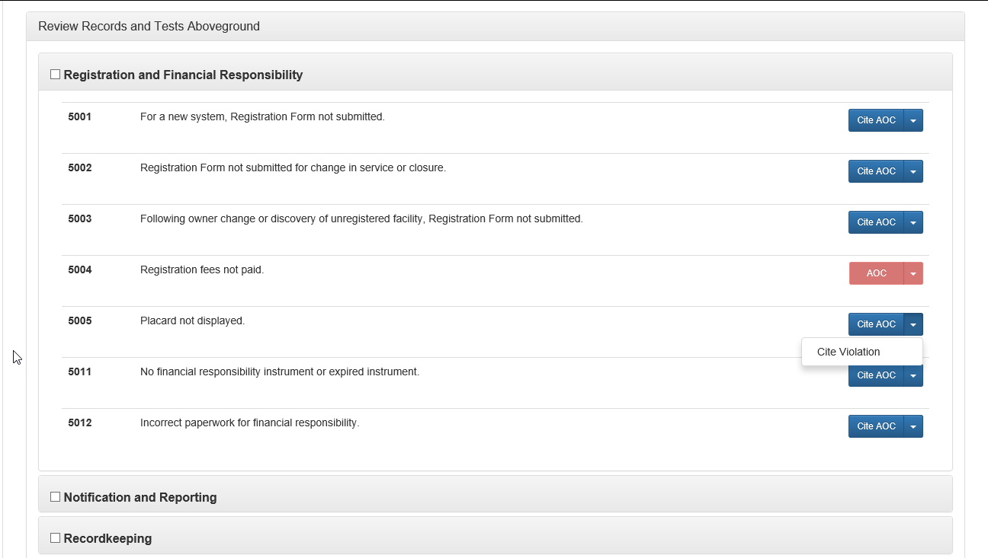
Figure 51: Citing Violation button location

After clicking Add, the AOC or Violation will be added to the AOCs/Violations section of the inspection activity, the Cite AOC button will appear red and indicates whether the item was cited as an AOC or violation and the button will no longer be selectable.

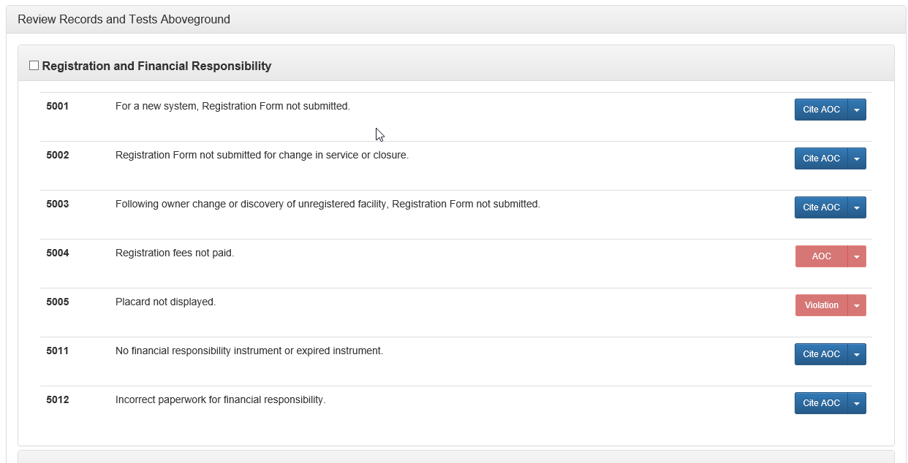
Figure 52: Identification of AOC and Violation cited in Checklists

Example of AOC vs Violation:
An inspector is inspecting the inside of STP sump and notices a very small amount of corrosion but not enough to compromise the component. This would be a situation in which the inspector may want to cite the AOC in order to bring attention to the fact that corrosion is beginning to show when there is not enough corrosion to cite a violation.

AOCs/Violations
Expand this section by either clicking on the header line or by clicking Show.
This section of the activity provides a table of all AOCs and Violations that have ever been cited for the facility within FIRST. The table only displays 5 citations at a time; if more have been cited, a page navigation menu will appear at the bottom of the section window.
For each AOC/Violation within the table, the following information is provided (Figure 53):
- Date Cited - The date the AOC/Violation was cited.
- Citation Type – The type of citation, either AOC or Violation.
- Status – The current state of the AOC/Violation.
  - Open – For an AOC, open indicates the AOC was cited in an activity that is currently open and has not been finished. For a Violation, open indicates the violation was cited in an activity that was finished but has not yet been resolved.
  - Pending – Indicates the activity in which the violation was cited is still open.
  - Closed – Indicates the violation has been resolved.
- Significance – The significance of the Violation (SNC-A, SNC-B, or Minor). AOCs are not assigned a significance.
- Description – A short-detailed statement regarding the AOC or Violation cited.
- Reevaluation – The determination by the Department as to the follow-up to be done for the specific violation.
- Resolved Date – The date that the Violation was resolved as determined by either a follow-up inspection or review (provided documentation).
- Resolving Activity Id – The internal application identification number for the activity in which the violation was resolved.
- Cited by this Activity – A method to identify whether the AOC or Violation was cited by the current activity or another one.
- Action – The action button for each violation.
  - Clicking Select will display related information for the citation and allow for the inspector to add comments or add attachments.
    - Pictures related to violations should be uploaded as an attachment under their respective violation. This will allow for the images to display directly below the cited violation on the inspection report as opposed to displaying with all other photos and documents in the general attachments section.
    - PDFs of documents can also be converted to an image file by following the “How to Convert PDF to Image Files” SOP in Chapter 5.
  - Clicking the Dropdown Arrow with provide the following options (Figure 54):
  - Edit – Allows for the inspector to edit the details for violation cited.
  - Resolve – Allows the user to state if the violation has been corrected by the facility.
  - Un-Resolve – Allows the inspector to return a Violation to Open, if a violation is marked as Resolved. Only those cited in the current inspection activity can be un-resolved.
  - Delete – Allows the removal of a violation, provided the activity is opened, and it is truly not a violation

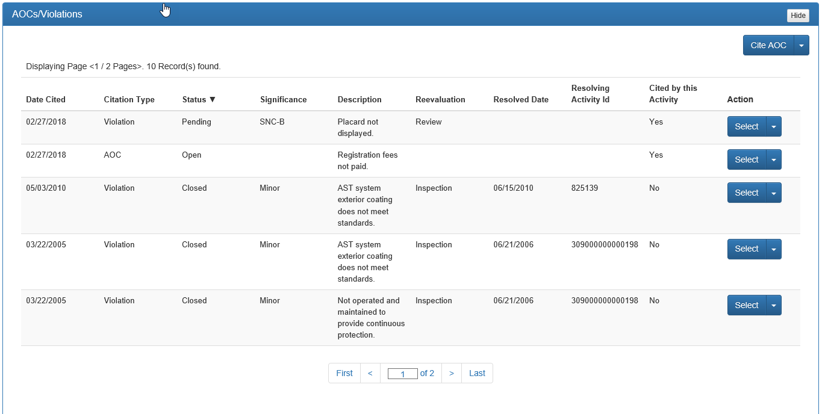
Figure 53: AOC/Violations table

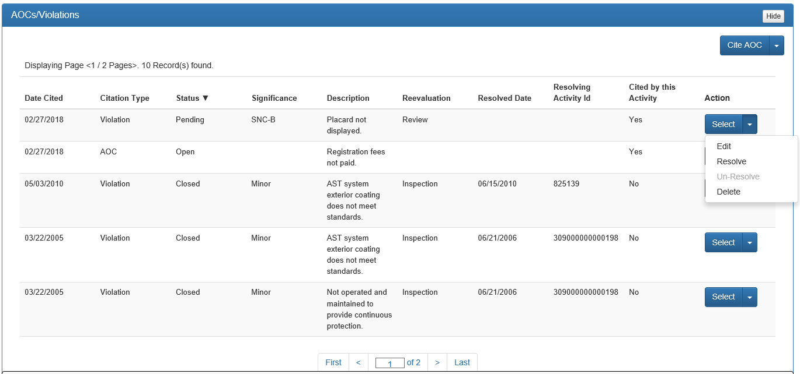
Figure 54: AOC/Violations table description

Adding AOC or Violation from AOC/Violations section
To add a AOC or Violation from the AOCs/Violations section, select either the Cite AOC button or the Dropdown Arrow to the right for a violation. By choosing one of these buttons, the Active Window will change so that search may be completed for the desired AOC/Violation.
There are multiple ways to search for an AOC/violation, including (Figure 55):
- ID is the four-digit (4) violation code that has been assigned by the Division for each violation.
- Description uses common words to search through the rules for the violations, such as financial, or integrity.
- Rule Number is the rule identification such as 62-761.401(1)(b).
- Significance uses a dropdown menu for the significance of the violation SNC-A, SNC-B, and Minor.
- Category is also a dropdown menu for whether aboveground or underground violations are requested.
- Reevaluation is a dropdown menu with the categories of Inspection (re-inspection required), NCLI (closes the violation with the issuance of a Compliance Assistance Offer (CAO), and Review (proof of the resolution is submitted to the inspector.)
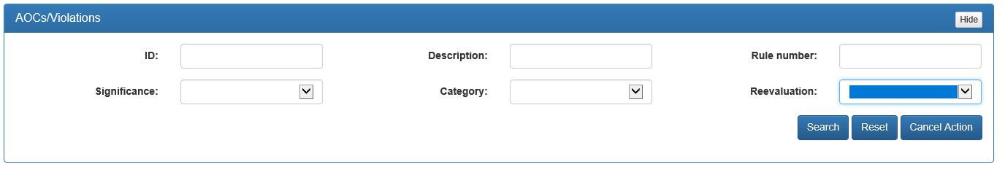
Figure 55: AOC/Violation search parameters

To complete a search, enter one of the parameters, such as financial in the Description box and click on Search. Figure 56 searches for the key word “financial” in the rule description.
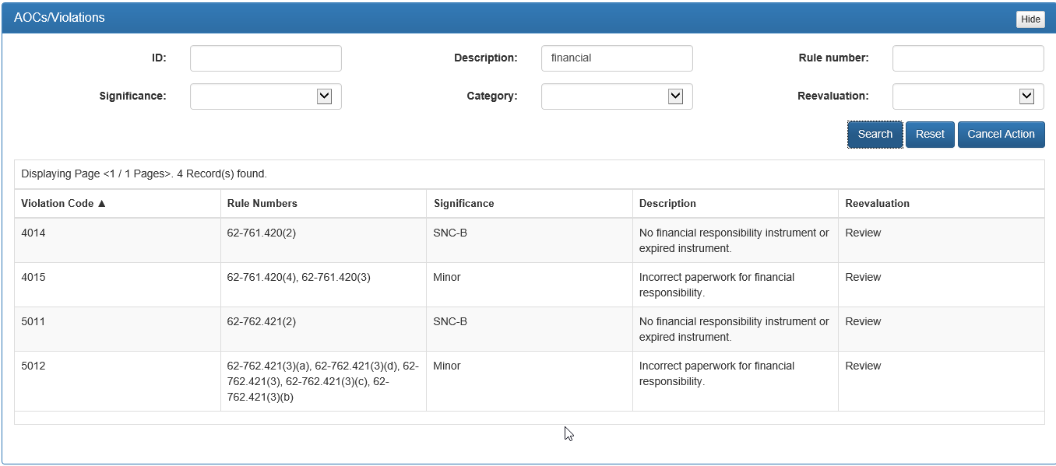
Figure 56: AOC/Violation search and result
To select a violation, click anywhere within the row for the violation. The inspector can then enter the required information in the following fields (Figure 57):
- Citation Type – Automatically generated base on if AOC or Violation was chosen
- Cited Date – Using the dropdown calendar, select the date in which the AOC was cited
- Explanation – Provide an explanation of the AOC and why it was cited
- Corrective Action – Provide the corrective actions required for the facility to return to compliance
After all required information has been entered, Click Add.
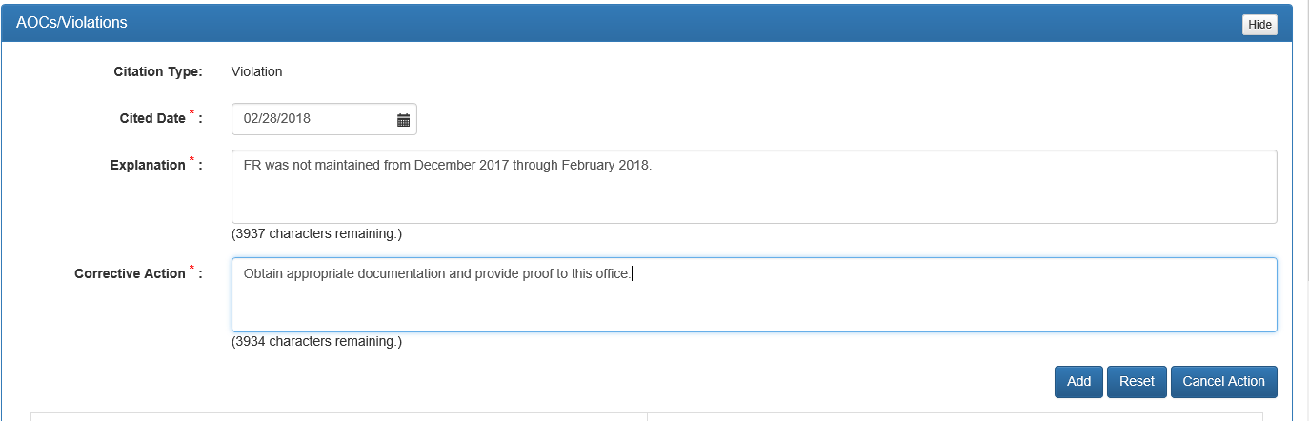
Figure 57: AOC/Violation search citation completed

After selecting Add, the Active Window will default to the AOCs/Violations table, and the recently cited violation will appear in the table.
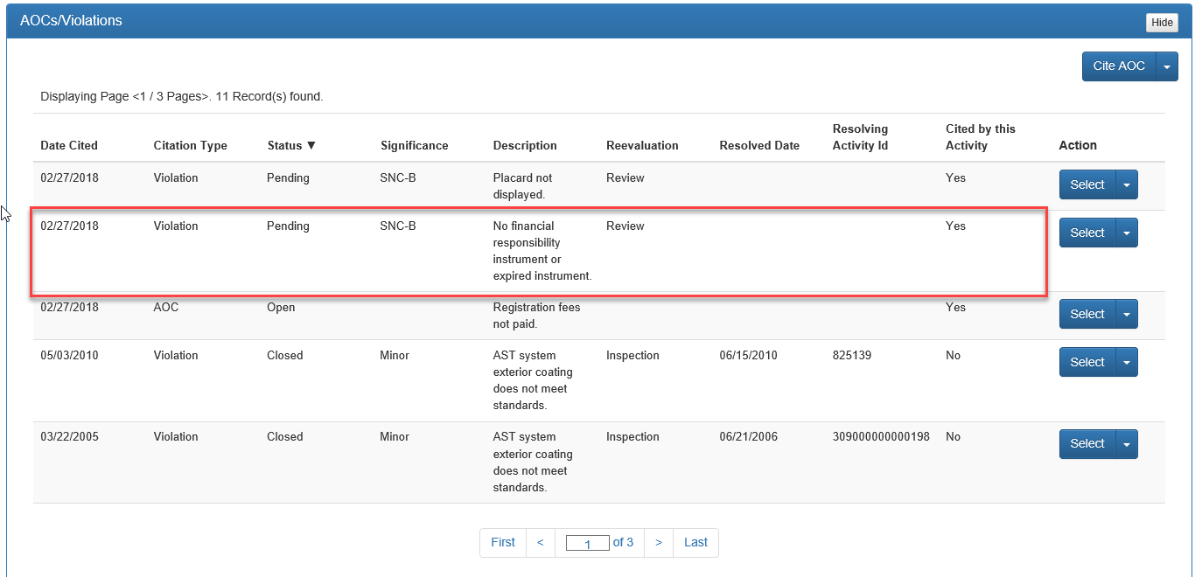
Figure 58: AOC/Violation search result table

Regulatory Data
The Regulatory Data section, displays Placards, Facility Records, System Tests, Financial Responsibility, or Tanks information organized in a tabular format. To review the information related to each individual tab, click the respective tab (Figure 58).

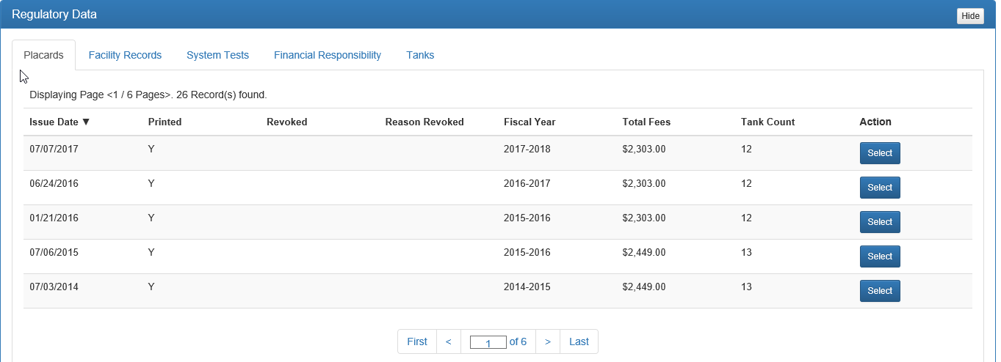
Figure 59: Regulatory Data

Placards
The Placards tab provides the history of the placard status for the facility, including payment of registration fees. To view the information, click Select. The detailed information for the placard will be displayed above the table.
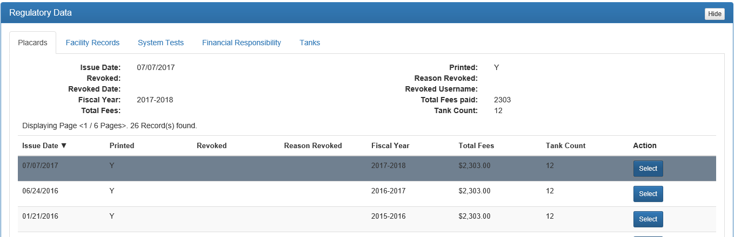
Figure 60: Placard detail
Unpaid registration fees and missing or non-posted placards would require citing a violation using the Registration and Financial Responsibility checklist.

Facility Records
The Facility Records tab are those documents that are used as proof of compliance with aspects to the storage tank regulations including such items as Repair, Operation and Maintenance Records, Test Data, Certificate of Financial Responsibility, and similar documents.
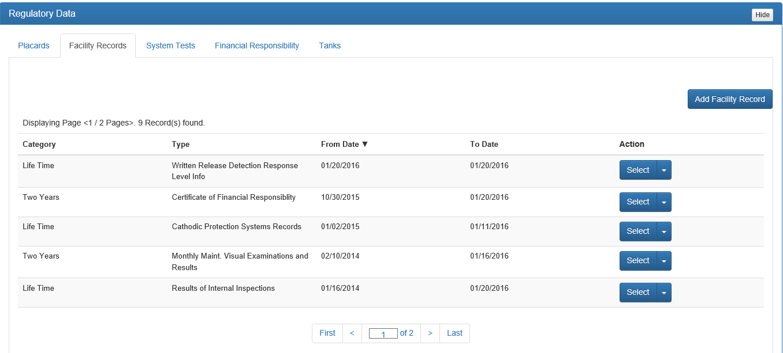
Figure 61: Facility Records table

Adding a new Record Type
New Facility Record types should only be added if the record type being reviewed is not already listed in the display below. Make sure to review all pages of the Facility Records which have already be initiated for the facility, by using the Page Navigation menu in the bottom center of the section so as to not add duplicate record types.
To add a new Facility Record type, that is not already listed in the display:
- Click Add Facility Record on the right side of the Active Window.
- Click on the Dropdown Arrow.
- Click on the new Record Type from the dropdown. The Record Type box will populate with the selected record,
- If correct, click Save and the Active Window will go back to the default display and will show the newly added Facility Record Type in the table below.
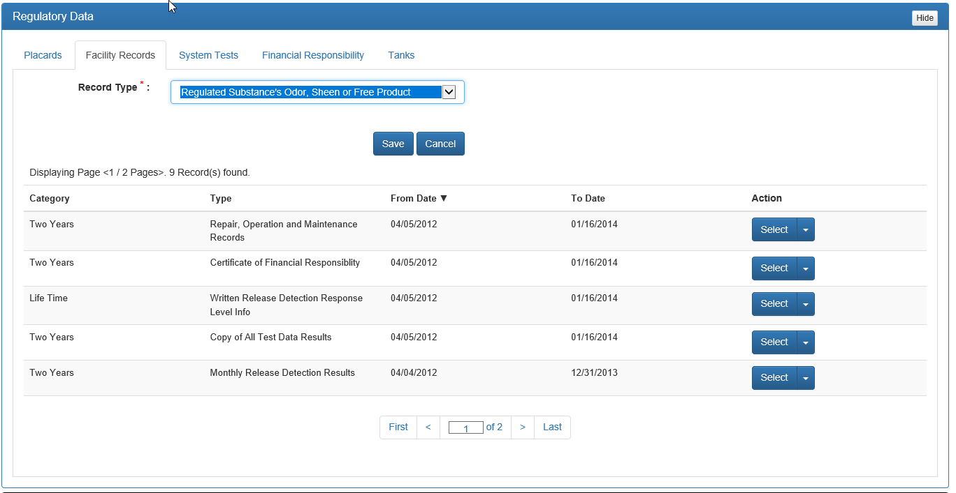
Figure 62: Adding new Facility Record Type

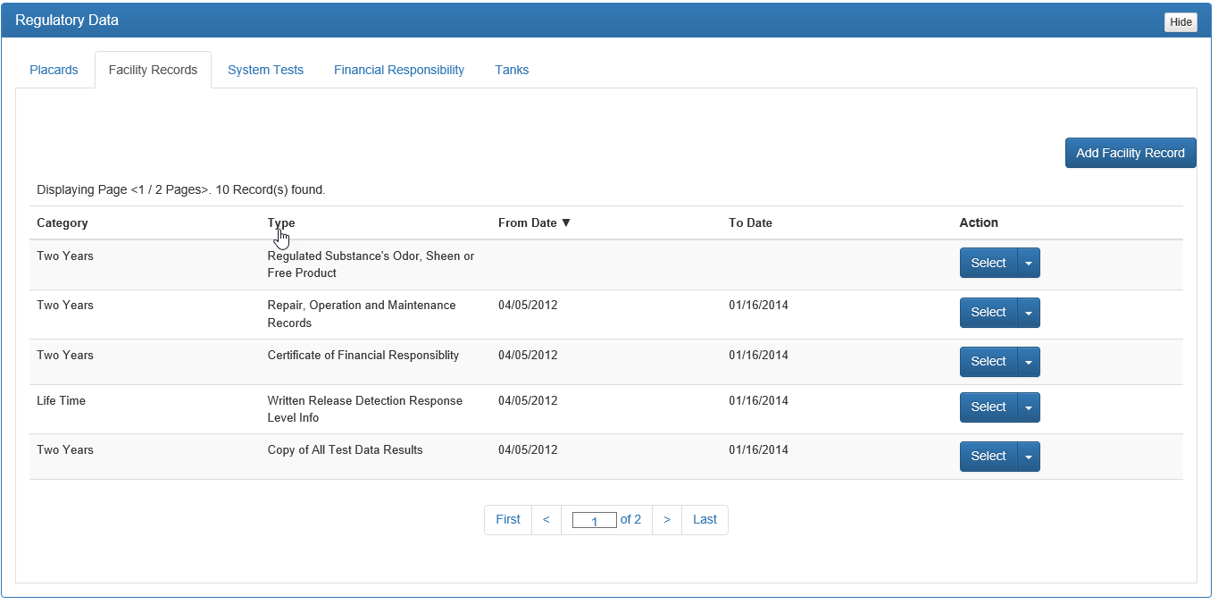
Figure 63: Newly added Facility Record Type

Adding Reviewed Information to a Facility Record Type
To add review information to a Facility Record Type, click Select to the right of the Record Type. (Please note that the process is the same for both new and existing Record Types.) Scroll down slightly, so that the Active Window displays Reviewed Records. Click Add Reviewed Record.
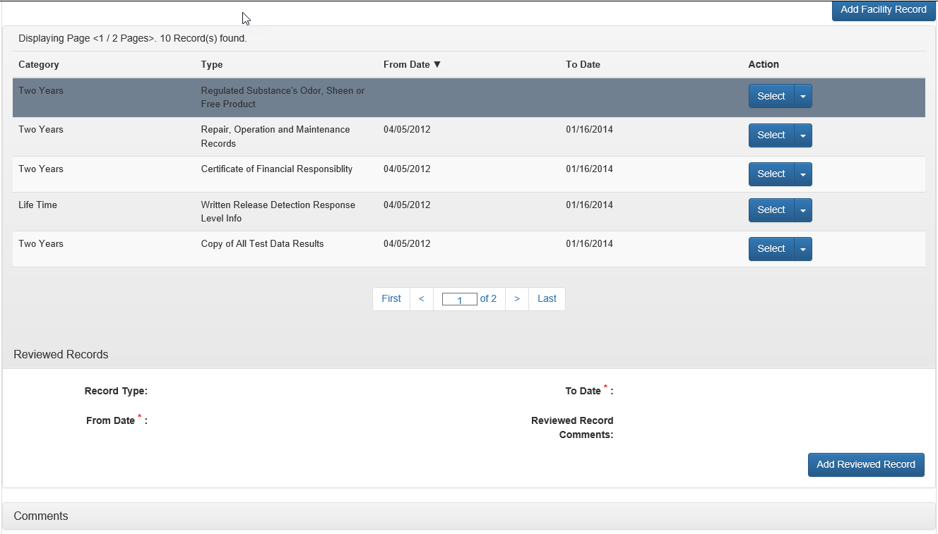
Figure 64: Adding Review Record information

The Reviewed Records section in the Active Window will change to display the specific Record Type selected, From Date, To Date and Reviewed Record Comments. The From Date and To Date must be added using the Calendar Dropdown, and Reviewed Record Comments can be added, if appropriate, using free-form text.
Once the information is verified and correct, click Save. If the entry is incorrect, either correct the information by entering the correct information, or click Cancel.

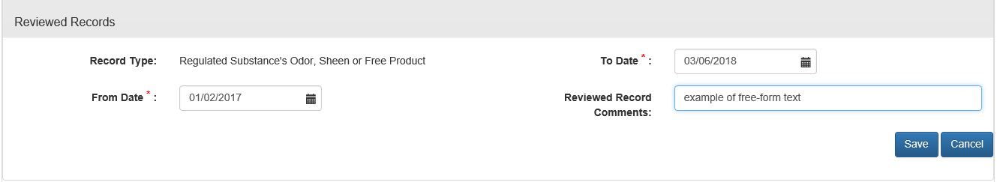
Figure 65: Complete entry of Reviewed Record information

After clicking Save or Cancel, the screen will return to the Records Display and will show the information most recently added in two locations: Displaying Page < >, and under the Reviewed Records.
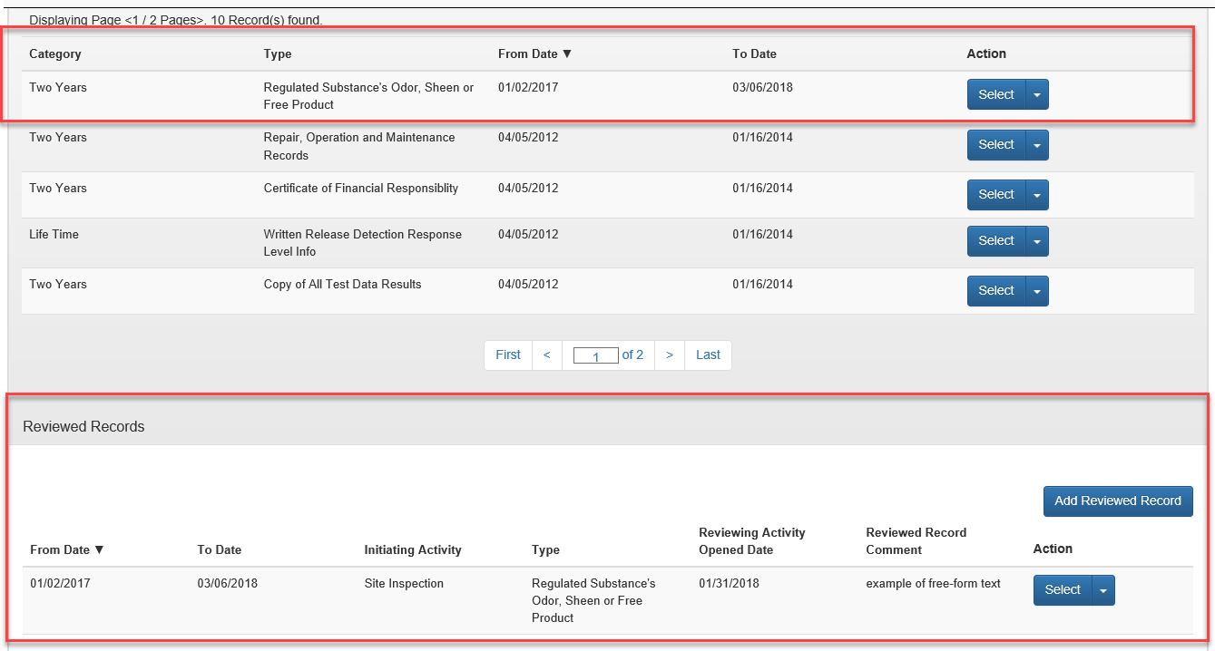
Figure 66: Completed Reviewed Record entry

Editing/Deleting Record Types
Until the Reviewing Activity (inspection) is closed, the information for a Record Type can be edited by clicking the Dropdown Arrow next to Select and clicking Edit in the Reviewed Records section. Deletion is also available until the Reviewing Activity is closed, using the same steps, but choosing Delete.

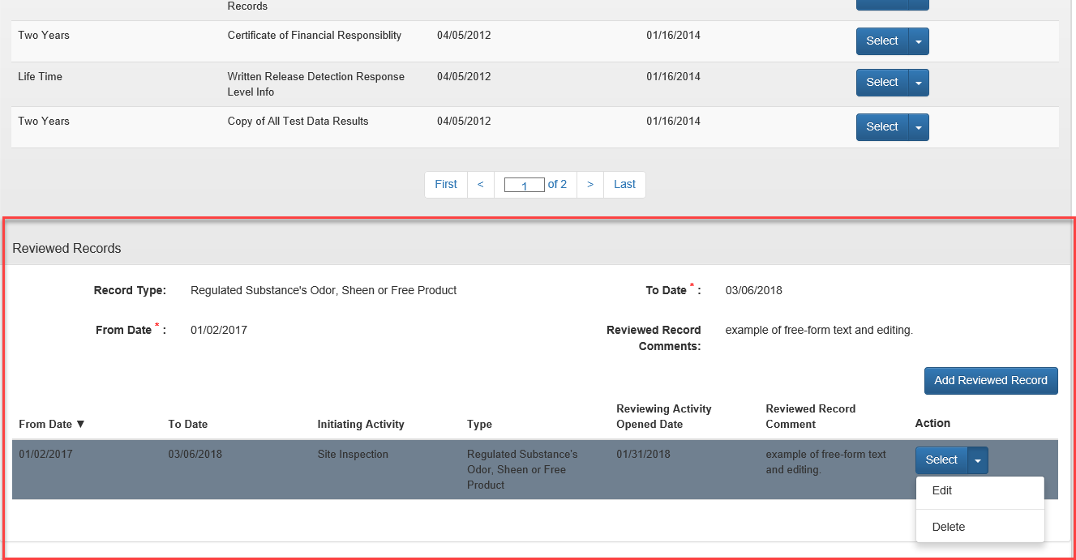
Figure 67: Editing/Deleting a Reviewed Record entry
Once editing or deleting is complete select Save.

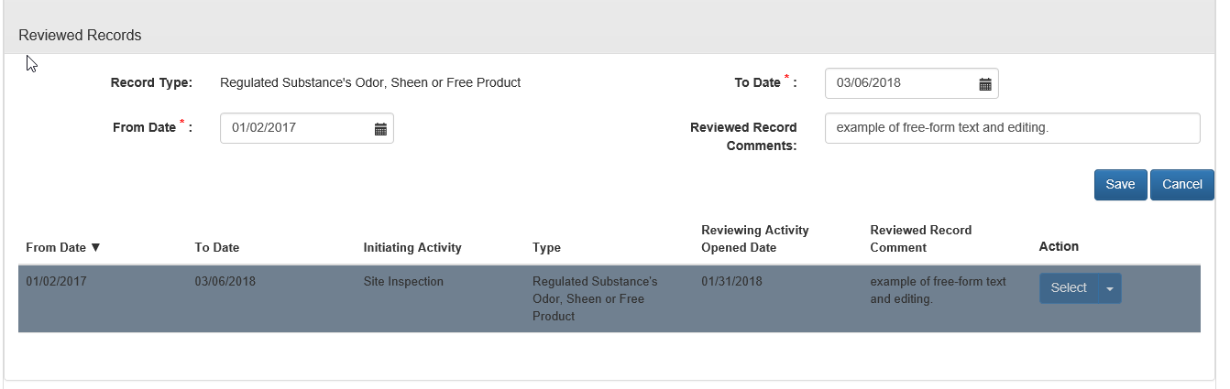
Figure 68: Editing/Deleting Save

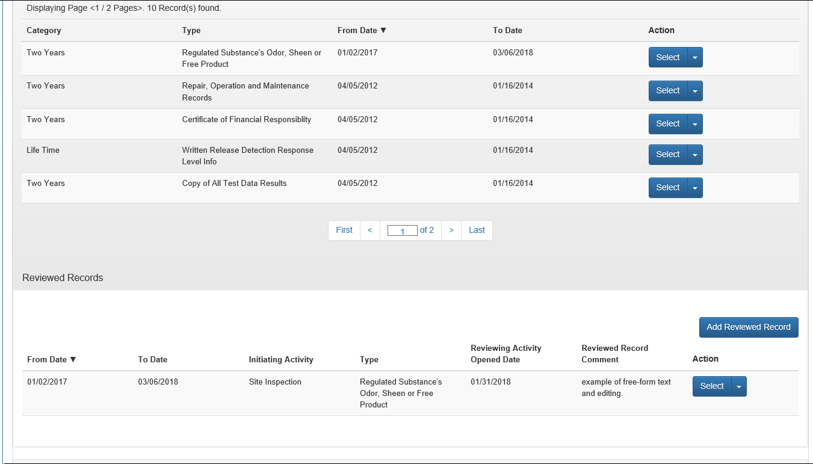
Figure 69: Completed edit of Reviewed Record entry table display

System Tests
The System Tests tab indicates those items that provide proof that the storage tank system is operating properly such as Line Tightness Testing, Operability Testing, and Integrity Testing. Unlike Facility Records, System Tests are to be added each time even though they exist in the Display Table. However, there should never be two records of the same type active at the same time. The previous test records should be deactivated before adding the new test records. After selecting the Systems Test tab, the Active Window will display the listing of Systems Tests previously added for the facility. This information includes Type, Date Completed, Results, Reviewed, Next Due Date, Comments, Deactivated and Action.
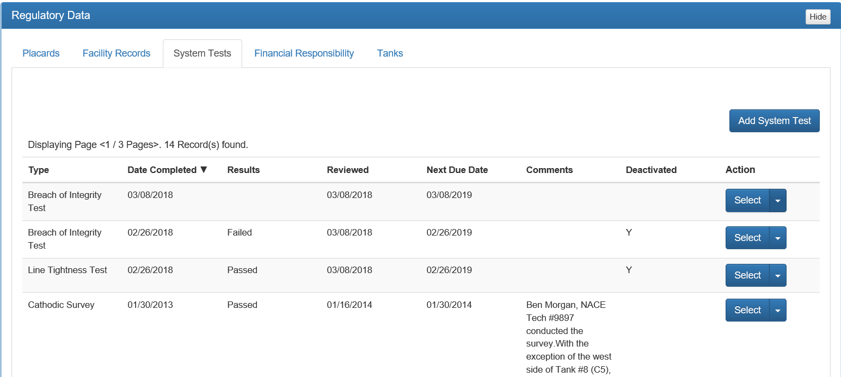
Figure 70: System Test initial screen

- Type is the name of the System Test.
- Date Completed is the most recent system test result date.
- Results is a Dropdown with the choice of Pass or Fail and is a statement of the last test result.
- Next Due Date is the next date for the System Test is required, which may be from one to five years.
- Comments is free-form text for the System Test specific to items such as who conducted the testing.
- Deactivated is an indicator for identifying whether that test is currently active or has expired. If the test has been deactivated, the test is no longer required by the facility, or a more recent test has been completed. All tests necessary for the facility should be listed and active.
- Action is where Edit and Deactivate are available for System Tests.

Deactivating System Tests
To Deactivate a System Test, click Dropdown Arrow next to Select and select Deactivate. The process is complete when a “Y” is in the Deactivated column for that test. When deactivating a System Test a pop-up reminder will appear on the screen confirming the deactivation. Select OK to confirm, or Cancel to unconfirm.

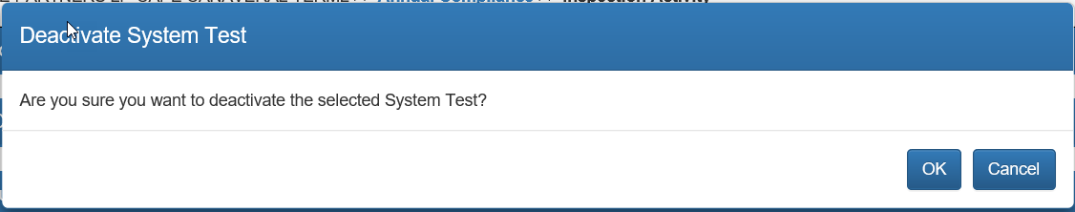
Figure 71: Deactivation Confirmation

Adding System Tests
To add a System Test, click Add System Test. This will change the Active Window to the data screen for System Tests.
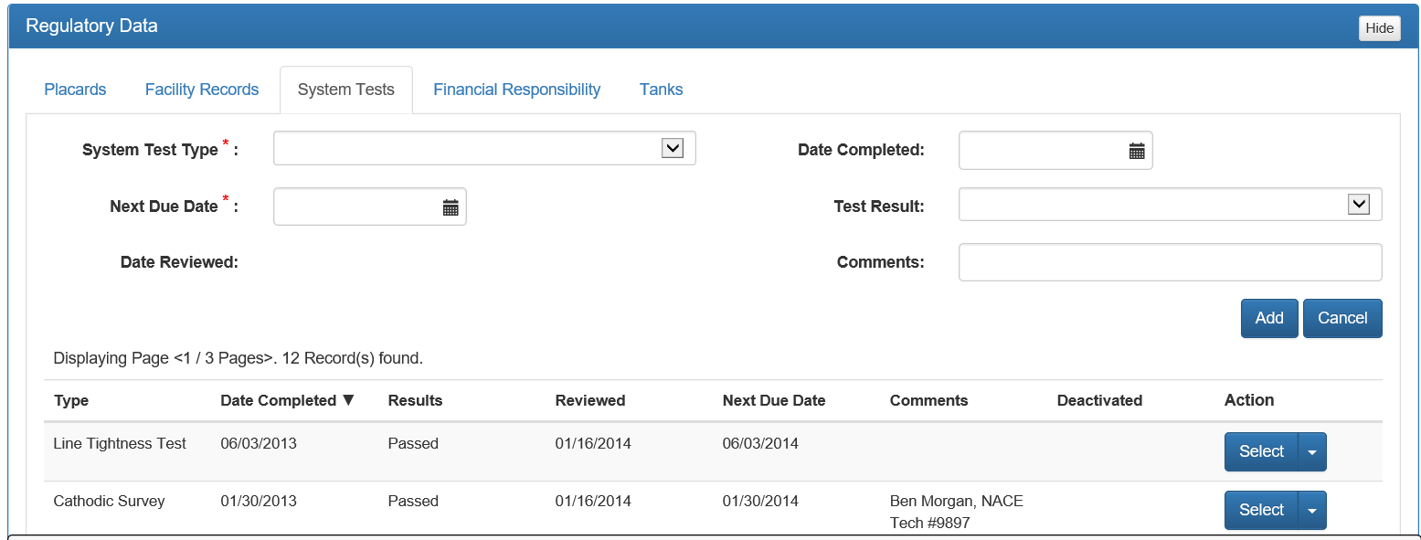
Figure 72: Adding System Test

To complete a System Test entry, select the System Test Type from the dropdown by click the Dropdown Arrow to the right of System Test Type. Select the Date Completed (date of the last test result), and the Next Due Date (date of the next required test), using the Dropdown Calendar. Select the Test Result (Pass, Fail), using the Dropdown Arrow to the right. Date Reviewed will be the date of the inspection activity, and will automatically populate after the record is added. Enter Comments, as appropriate, including tester, or testing company name. Select Add to receive a confirmation question “Is the entered Data correct?” Select OK to confirm, Cancel to unconfirm.

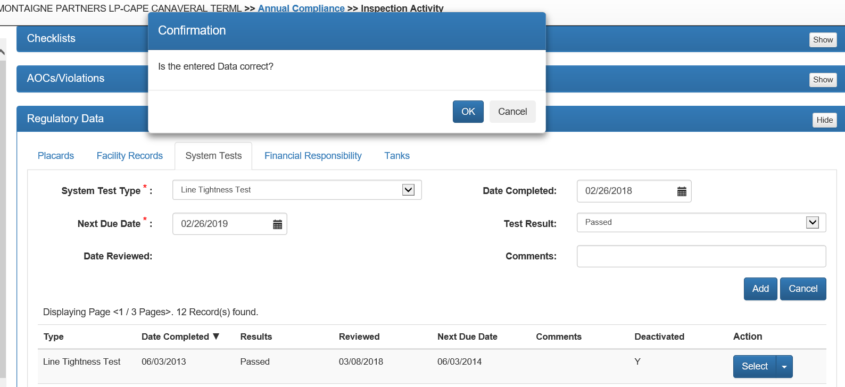
Figure 73: Entered System Test

Editing System Tests
To Edit a System Test, click Dropdown Arrow next to Select and select Edit. Editing of a System Test is available until Date Completed, Result, and Next Due Date are all entered. Once these have been entered, the System Test can no longer be edited. In the example below, Edit is available since the results have not been entered.

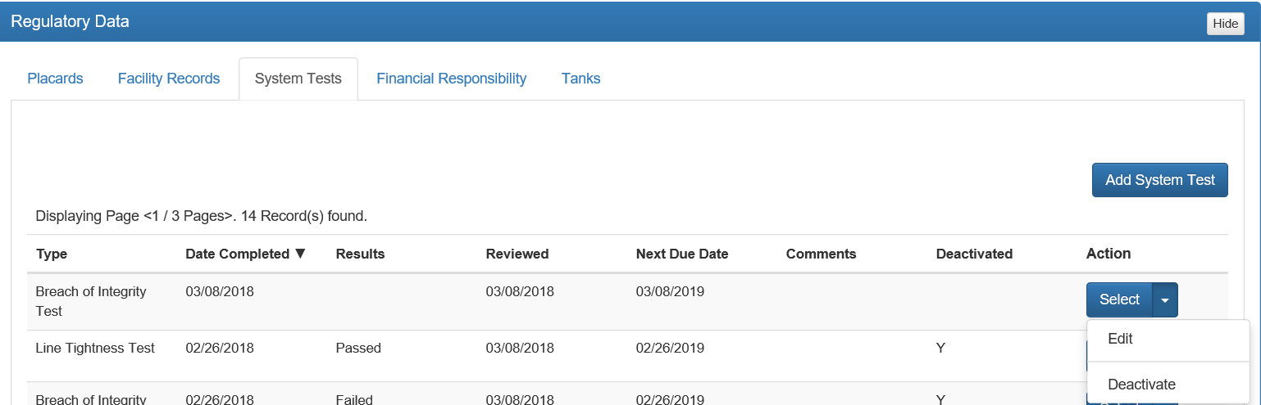
Figure 74: Editing System Tests

Financial Responsibility
Financial Responsibility is the demonstration of the facility’s ability to pay for the cost of corrective action and compensating third parties for bodily injury and property damage that might result from a release from a petroleum storage tank system.
After selecting Financial Responsibility, a display showing the financial mechanism history of the facility will be displayed, including Mechanism, Insurance Carrier, Effective Date, Expiration Date and Action.

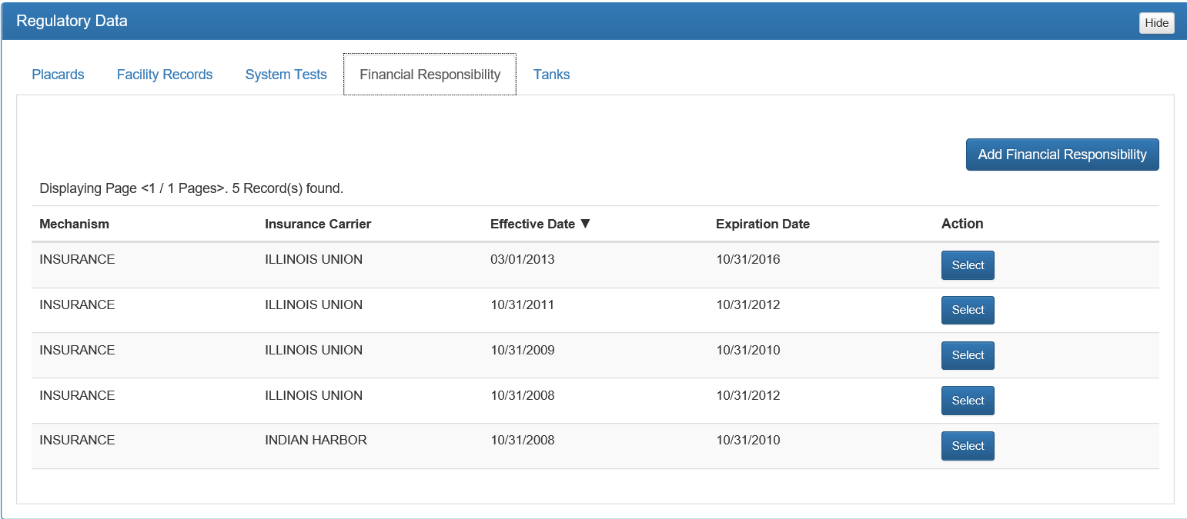
Figure 75: Financial Responsibility display
- Mechanism is the form used to support the ability to pay. These can include insurance, letter of credit, surety bond, self-insurance letter from chief financial officer and others. A complete is of mechanisms can be found by selecting the Dropdown Arrow to the right of Mechanism.
- Insurance Carrier is the name of the company supporting the mechanism. A complete is of mechanisms can be found by selecting the Dropdown Arrow to the right of Insurance Carrier.
- Effective Date and Expiration Date are dates identified on the mechanism and are specific to the mechanism.
- Action is the way to review the history for a specific mechanism identified in the display table by clicking Select.

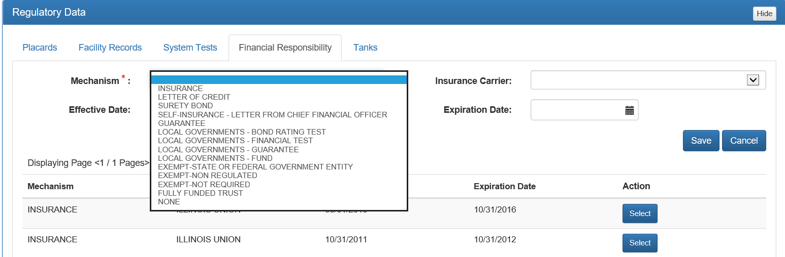
Figure 76: Financial Responsibility Mechanisms

Completing Financial Responsibility
To enter Financial Responsibility, click Add Financial Responsibility.

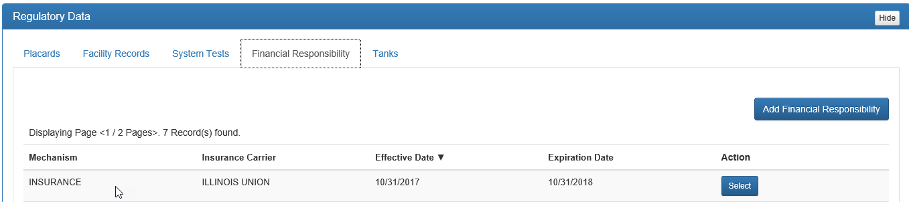
Figure 77: Adding Financial Responsibility

The Active Window will change to the entry page.

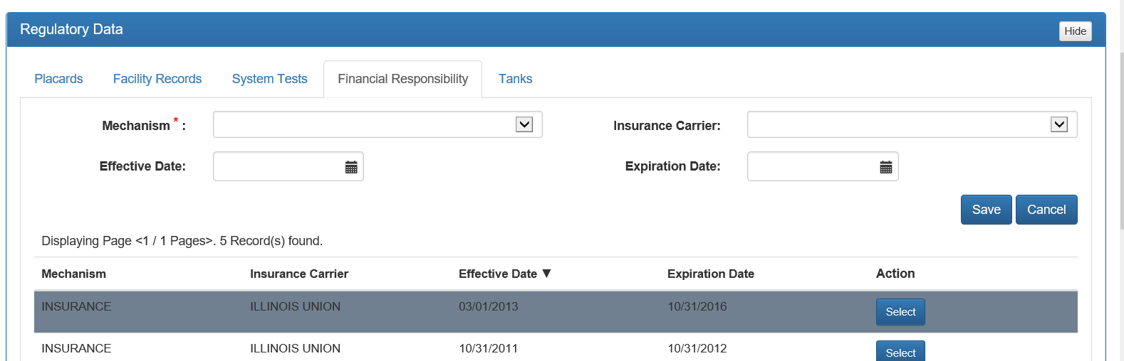
Figure 78: Financial Responsibility entry page

Enter the Mechanism and Insurance Carrier fields by selecting the Dropdown Arrow to the right of Mechanism and Insurance Carrier, respectively. Enter the Effective Date and Expiration Date by selecting the respective Dropdown Arrow and choosing the dates. Click Save. Please note that once a record is entered, it cannot be deleted or edited.
If the mechanism expires on a yearly basis, an entry is required for each year, so that proof of continuous coverage can be demonstrated (as in the figure below).
If the mechanism is continuous and does not need to be renewed every year, such as “Exempt-State or Federal Government Entity,” the expiration date can be left blank until the facility is no longer eligible for the exemption.

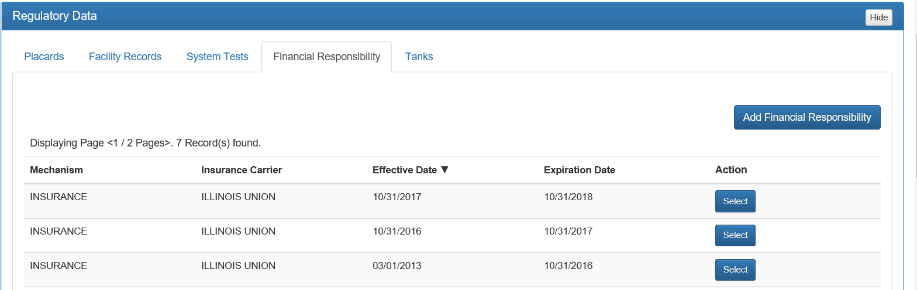
Figure 79: Completed Financial Responsibility

Tanks
The Tanks tab in Regulatory Data is a read only tab. It provides a table displaying the main characteristics of the tanks at the facility, and includes Status, Alias, Placement, Capacity, Compartments, Vessel Indicator, Substance, and Action.

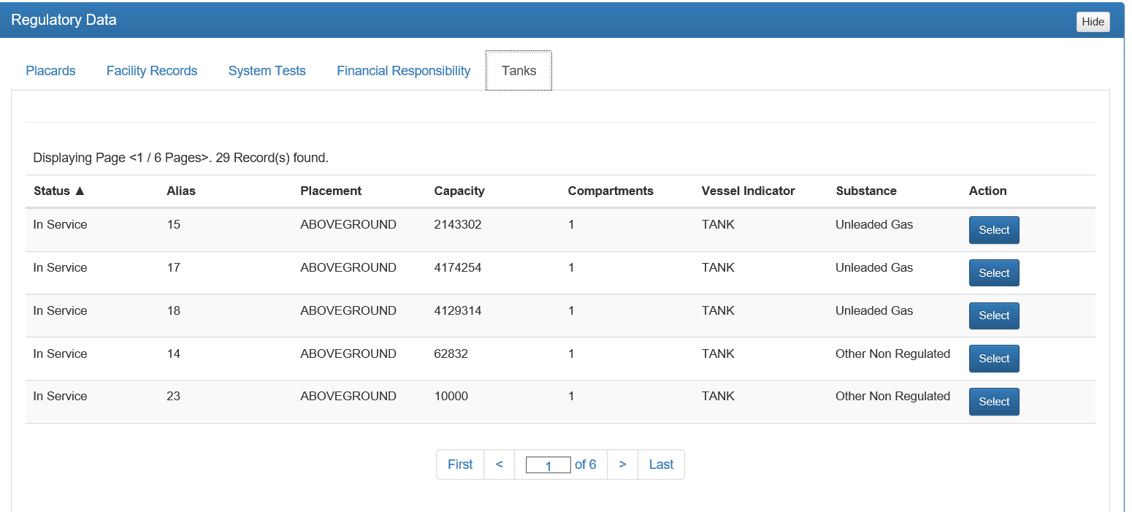
Figure 80: Regulatory Data - Tanks display

- Status indicates the currently registered operating status of the tank, such as In Service, Closed in Place, Out of Service, Temporarily Out of Service, Removed from Site, Deleted-Data Error, NonReg Construction, Unmaintained, Moved to New Site, FieldAST TempOutServ, NonReg Use/Process, and NonReg De-mimimus.
- Alias is the facility’s identification for the tank.
- Placement describes whether the tank is aboveground or underground.
- Capacity is the amount of petroleum based product the tank can hold.
- Vessel Indicator states if the unit is a tank or drum as used when discussing dry-cleaning registration.
- Substance indicates the type of product being stored.
- Action is a way to view these factors, as well as more specific portions of the tank system, such as piping used, monitoring used and construction of the tank. To view these additional details, click Select to the right of the tank line to be viewed. Above the displaying page specific information will be displayed and below the table will be Comments and Attachments. These Comments and Attachments will not be displayed in the final inspection report but will be kept within the FIRST database.
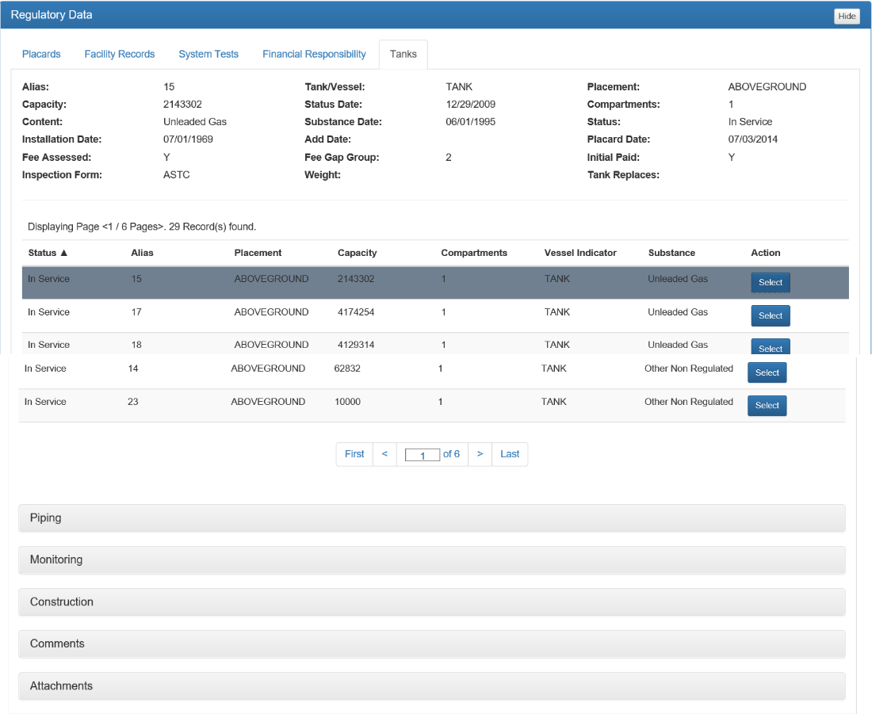
Figure 81: Tanks display - detailed information

Comments within Tanks – Regulatory Data
In Comments, specific information such as EQ numbers can be added for more detail regarding the tank system.

Adding Tanks Related Comments
To add Comments, select the Add Comment, and using free-form text enter the required information.

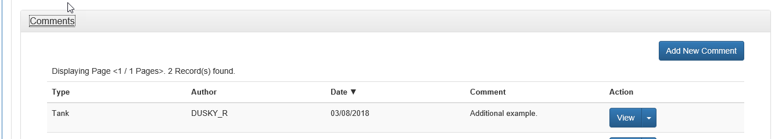
Figure 82: Adding Comments
Click Save Comment to input the comment into FIRST. Previously entered comments will be displayed in a table format below the Comments.
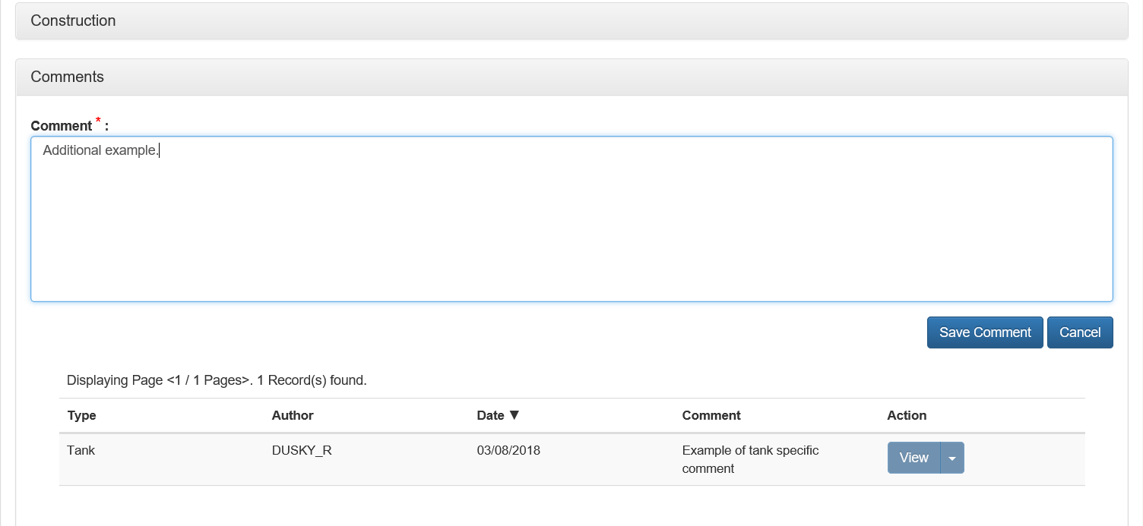
Figure 83: Adding and display for Comments

Editing Tanks Related Comments
Comments can also be edited or deleted. To edit or delete a specific comment, select the Dropdown Arrow next to View. Edit will allow changing the text of the comment, while Delete will remove the comment completely. Upon completing editing, click Save Comment.

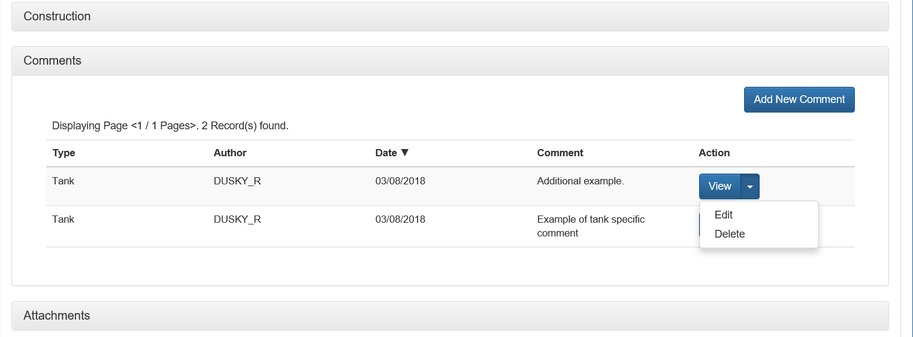
Figure 84: Editing/Deleting Comments

Deleting Tanks Related Comments
To Delete a Comment, click Delete, and a Delete Confirmation box will appear asking “Are you sure you want to delete the selected Comment?”
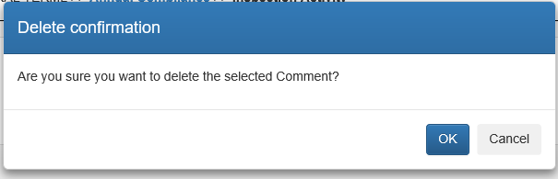
Figure 85: Deleting Comment Confirmation Window

Click OK to delete the comment, or Cancel to leave the comment in FIRST.

Attachments within Tanks – Regulatory Data
To add Attachments, select Add Attachment, after expanding the header Attachments.
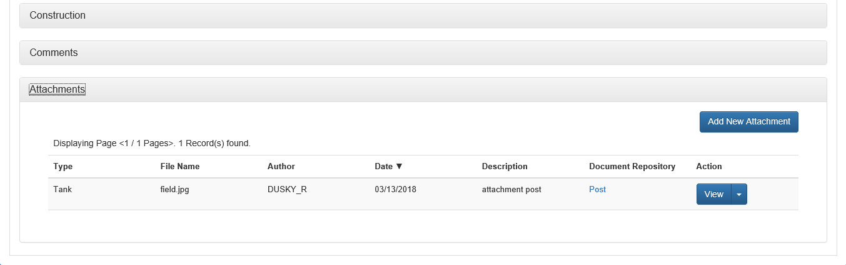
Figure 86: Adding Attachments

The Attachments entry screen will appear in the Active Window.
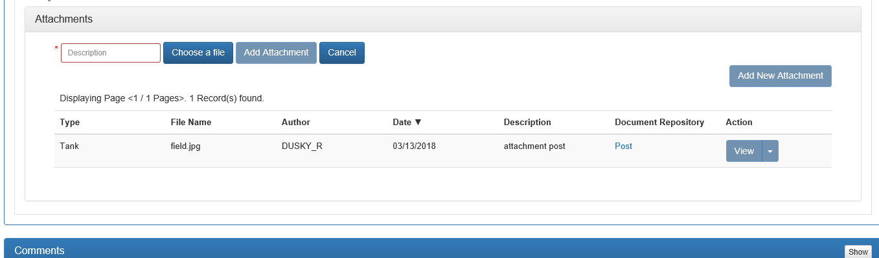
Figure 87: Attachments Active Window

Entering Tanks Related Attachments
Enter a brief description of the attachment using free-form text in the box Description. Choose a file from your directory, by clicking Choose a File. This will pop up your directory, find the described attachment and select Open from the directory popup. The file name you chose will appear in the Choose a file box.
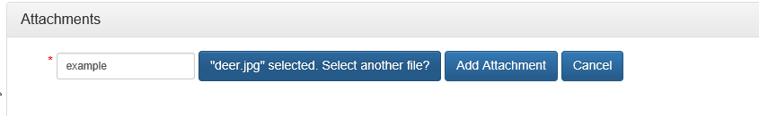
Figure 88: Choosing an attachment
Click Add Attachment to input the attachment into FIRST. A brief progress bar will appear on the screen, and the screen will switch to the Attachments display table. Previously entered attachments will also be displayed in a table format below the Attachments.

Editing/Deleting Tanks Related Attachments
Attachments can also be edited or deleted. To edit or delete a specific attachment, select the Dropdown Arrow next to View. Edit will allow to change the text of the description only. It will not allow you to change the attachment itself.
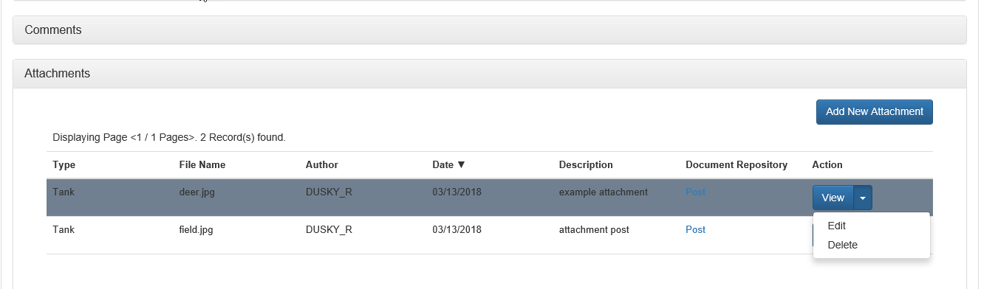
Figure 89: Editing/Deleting Attachments

Upon completing your edits, click Save.
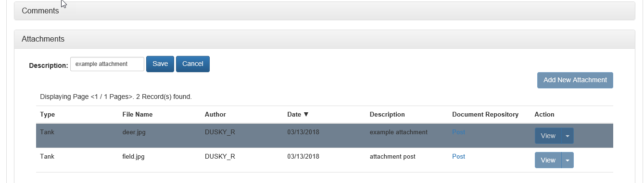
Figure 90: Editing Attachments
To Delete an Attachment, click Delete, from the Dropdown Arrow next to View, and a Delete Confirmation box will appear asking “Are you sure you want to delete the selected Attachment?”
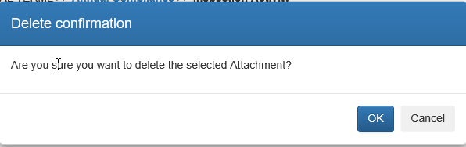
Figure 91: Deleting Attachment Confirmation Window
Click OK to delete the Attachment or Cancel to leave the Attachment in FIRST.

Posting Tanks Related Attachments to Oculus
Attachments can be posted to Oculus by clicking on the Post in the display table.
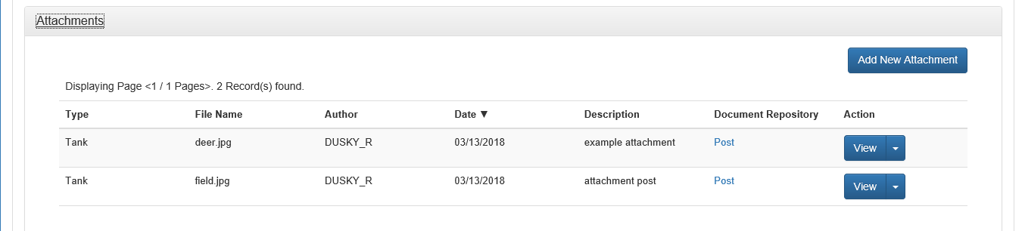
Figure 92: Posting Attachments

Clicking on Post will cause the Document Taxonomy box to appear. If the taxonomy is not already provided (Subject, Catalog, Profile and Repository Document Type will be greyed out), the user will have to select the correct Catalog by clicking on the Dropdown Arrow and selecting Storage Tanks. Users should not choose Storage Tanks Restricted unless confidential is indicated on the Attachment or the Attachment is an Enforcement related document.
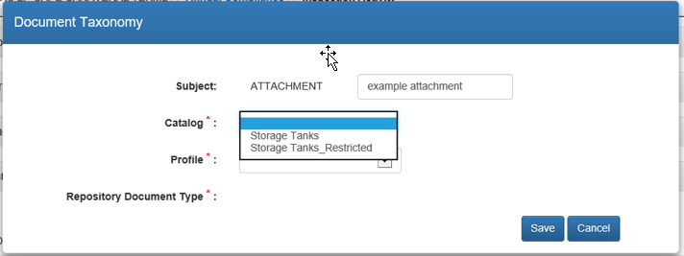
Figure 93: Choosing Document Taxonomy – Catalog
After choosing the Catalog, Profile must be chosen by clicking on the Dropdown Arrow and selecting Discovery_Compliance.
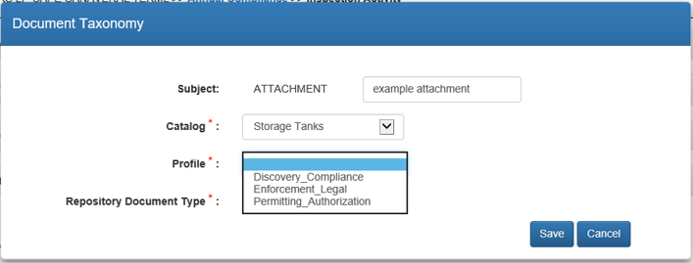
Figure 94: Choosing Document Taxonomy - Profile
A box for Repository Document Type will appear. Click on the Dropdown Arrow and select the appropriate Repository Document Type from the list. Select the most appropriate type.
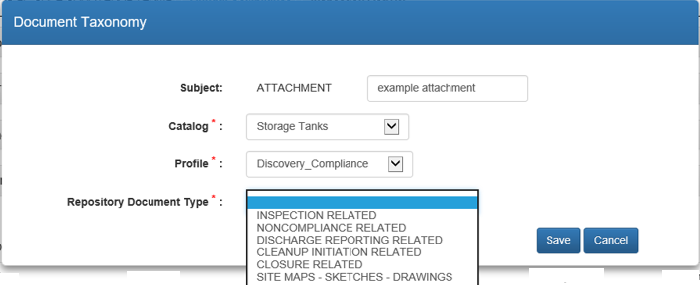
Figure 95: Choosing Document Taxonomy - Repository Document Type
Once all Document Taxonomy information is included, click Save. This will display the Attachments display table. The attachment that the taxonomy was included will be identified by Posted on {date} located under Document Repository column of the table (where the Post was originally).
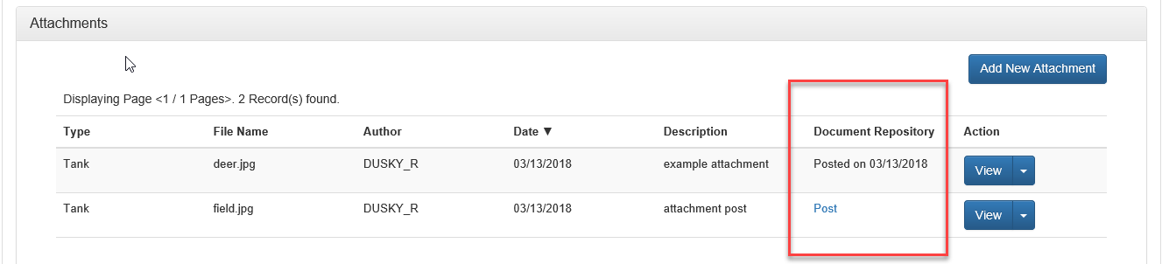
Figure 96: Attachment display after Posting to Oculus
All attachments should be posted to Oculus for future reference.

Comments
The Comments section is the location where inspection specific comments gathered after the initial site visit should be written.

Adding Comments
To add Comments, expand the header by clicking on it or selecting Show. The header will expand and display either the Add New Comment box, or the Add New Comment box plus a table if Comments already exist for this activity.

Figure 97: Adding Comments at Inspection level

Select Add New Comment
Figure 98: Adding New Comments

Comments can be added using free-form in the Comment dialog box. There is an unlimited number of comments that can be added, however each comment cannot exceed 4000 characters. Once comment is completed click Save Comment. If the comment is not to be saved click Cancel and all information entered will be removed.

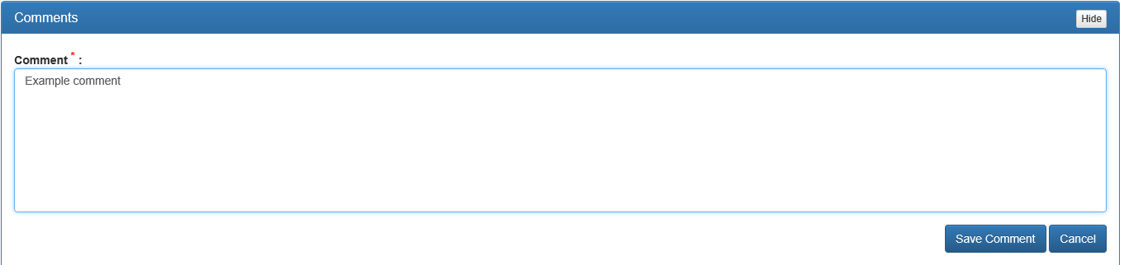
Figure 99: Entering Comment

All comments will be displayed in a tabular format within the Comments activity.
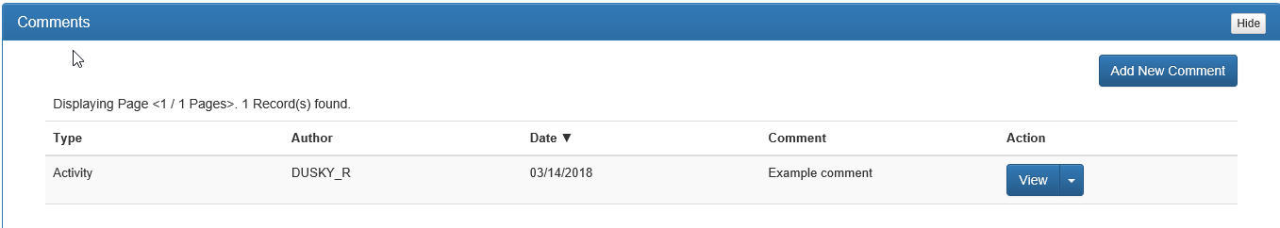
Figure 100: Comment display table
The table will display the Type, Author, Date, Comment, and available Actions for the Comment. Type indicates that whether the comment is at an activity level and will appear on the inspection report. Any comments that do not have the type of Activity will not be on the inspection report (such as, those noted in the Tanks tab of Regulatory Data). Author displays the user name of the person creating the comment. Date is the date of the comment, Comment displays the start of comment. Action indicates the View, Edit and Delete actions available for the comment.
When View is chosen the complete comment will display above the table. To edit or delete the comment, Done must be clicked to return to the table. To Edit or Delete the comment, the Dropdown Arrow to the right of View must be chosen.
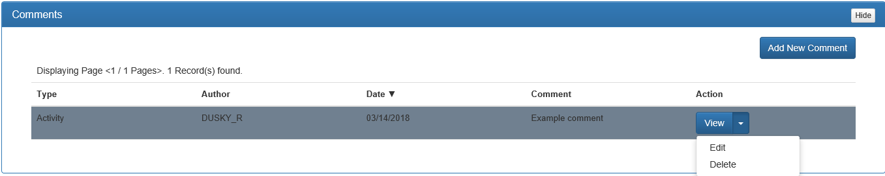
Figure 101: Comment Action button

Editing a Comment
To edit a Comment, select Edit from the dropdown. The Comment dialog box will appear above the table. Click in the box and make any necessary changes. Select Save Comment to keep changes, Cancel to disregard changes and return to original comment. Comments can only be edited within an open activity.
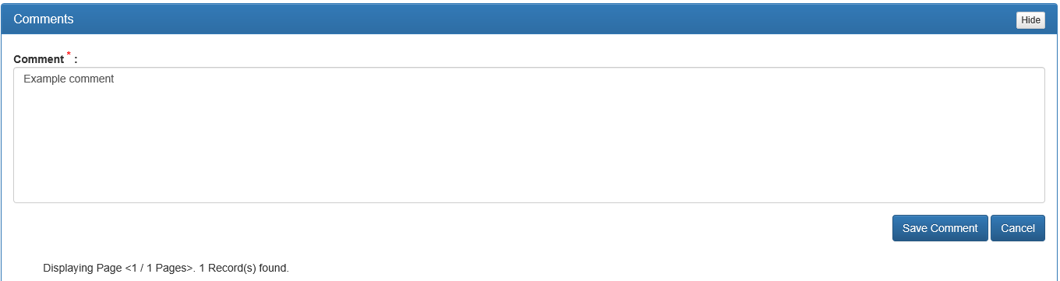
Figure 102: Editing Comment
The edited comment will then be displayed in the display table and the Comment box will disappear.
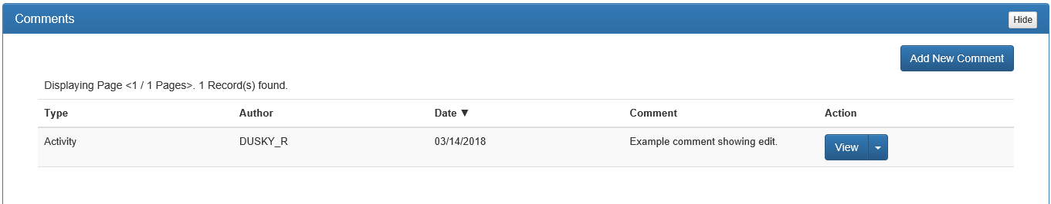
Figure 103: Edited comment display

Deleting a Comment
To delete a Comment, select Delete from the dropdown. A Delete Confirmation popup window will display asking “Are you sure you want to delete the selected Comment?“ Select OK to confirm, or Cancel to disregard and return to the original comment.
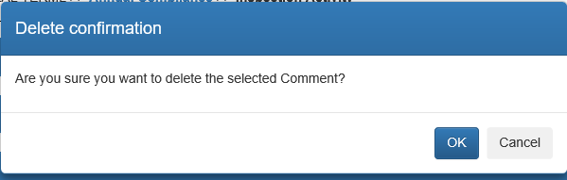
Figure 104: Delete Comment Confirmation Window
If OK is selected, the comment will be removed from the display table.
Figure 105: Deleted Comment table
Please note, if more than one comment is entered, the table will still be shown as in Figure 102.

Attachments
This activity is for Attachment activities at the inspection level. Such attachments include:
- Alarm History
- Copies of Operator Training Certificates
- Copies of Records reviewed
- Copies of System Tests documentation
These attachments will not be attached directly to the inspection report but will appear on the inspection report under Attachment Documents, as a line item to note that there is an attachment.
PDFs of documents can also be converted to an image file by following the “How to Convert PDF to Image Files” SOP in Chapter 5. By converting the PDF to an Image file, the document will show on the inspection report as opposed to only showing as a line item.

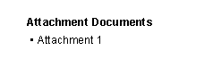
Figure 106: Identifier of Attachments, Inspection Report

Adding Attachments
To add Attachments at the activity level, expand the Attachments header or click Show to the right side of the header. The Attachments will expand, showing the picture below, or if other attachments have already been added to this activity, the picture below plus the display table will be shown.
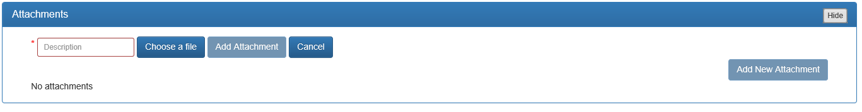
Figure 107: Adding Attachments

Select Add New Attachment. The Active Window will change to display the Attachment dialog.
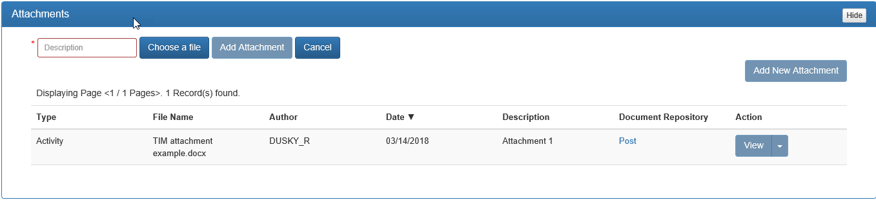
Figure 108: Adding Attachment dialog

Enter a brief description of the attachment using free-form text in the box Description.
Choose a file from your directory, by clicking Choose a File. This will pop up your device directory, find the described attachment and select Open from the directory popup. The file name you chose will appear in the Choose a file box.

Figure 109: Adding Attachment

Click Add Attachment to input the attachment into FIRST. A brief progress bar will appear on the screen, and the screen will switch to the Attachments display table. Previously entered attachments will also be displayed in a table format below the Attachments. Note, if the attachment is a picture, the picture will display in the Attachment Documents section of the inspection report.

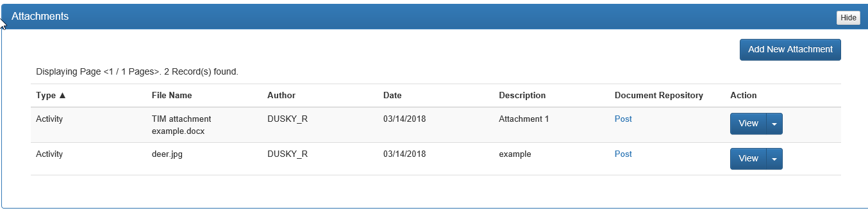
Figure 110: Attachment Table Display

Editing/Deleting Attachments
Attachments can also be edited or deleted. To edit or delete a specific attachment, select the Dropdown Arrow next to View. Edit will allow to change the text of the description only. It will not allow you to change the attachment itself.
Figure 111: Editing/Deleting Attachments

Upon completing your edits, click Save.
Figure 112: Editing Attachments

To Delete an Attachment, click Delete, from the Dropdown Arrow next to View, and a Delete Confirmation box will appear asking “Are you sure you want to delete the selected Attachment?”
Figure 113: Deleting Attachment Confirmation Window
Click OK to delete the Attachment or Cancel to leave the Attachment in FIRST.

Posting Attachments
Attachments can be posted to Oculus by clicking on the Post in the display table.
Figure 114: Posting Attachments
Clicking on Post will cause the Document Taxonomy box to appear. If the taxonomy is already provided the Subject, Catalog, Profile and Repository Document Type will be greyed out. The Subject will automatically populate with the Description entered when adding the attachment. This can be changed by clicking in the box and using free-form text to change. The user will have to select the correct Catalog by clicking on the Dropdown Arrow and selecting Storage Tanks. Users should not choose Storage Tanks Restricted unless confidential information is indicated on the Attachment or the Attachment is an Enforcement related documents.
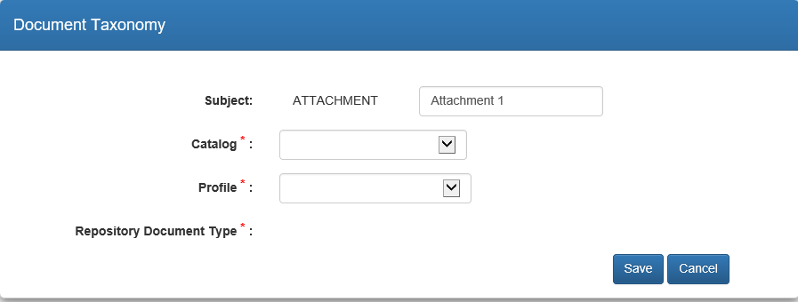
Figure 115: Choosing Document Taxonomy – Catalog
After choosing the Catalog, Profile must be chosen by clicking on the Dropdown Arrow and selecting Discovery_Compliance, or the applicable Profile.
Figure 116: Choosing Document Taxonomy - Profile
A box for Repository Document Type will appear. Click on the Dropdown Arrow and select the appropriate Repository Document Type from the list. Select the most appropriate type.
Figure 117: Choosing Document Taxonomy - Repository Document Type

Once all Document Taxonomy information is included, click Save. This will display the Attachments display table. The attachment that the taxonomy was included will be identified by Posted on {date} located under Document Repository column of the table (where the Post was originally).
Figure 118: Attachment display after Posting to Oculus
All attachments do not need to be posted to Oculus, it is at the inspector’s discretion, as it is stored in FIRST. However, if the information is public knowledge or information or is valuable to all parties, it should be posted to Oculus for future reference.

Participants
The Participants section is where the record of those who were involved in the inspection are documented. All inspections require an Inspector Signature to be captured. Representative signatures are required, unless there is a reason for not obtaining, such as no representative present for the inspection, or they refuse to sign. If a Participant’s signature is not obtained, a notation as to why must be made in the Comments, and the No Signature Required checkbox is to be checked.

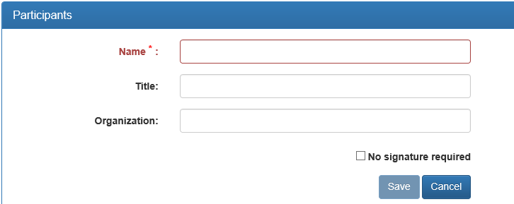
Figure 119: No Signature Required checkbox

Adding Participants and Signatures
To add Participants and signatures, expand the Participants header by clicking on the header or selecting Show.
Figure 120: Participant Section

When expanded the Active Window will change to include the display table, identification of the Inspector and Add Representative.
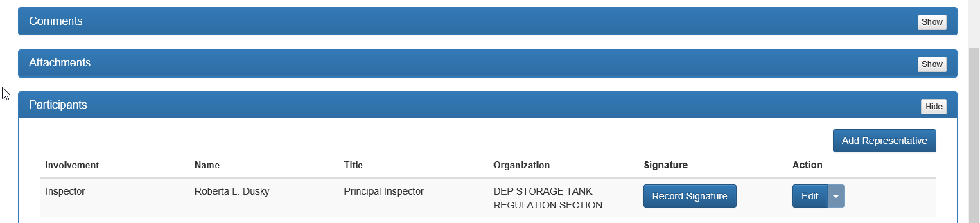
Figure 121: Expanded Participants
To add the signature of the Inspector, select Record Signature, and a pop-up will appear above the table.
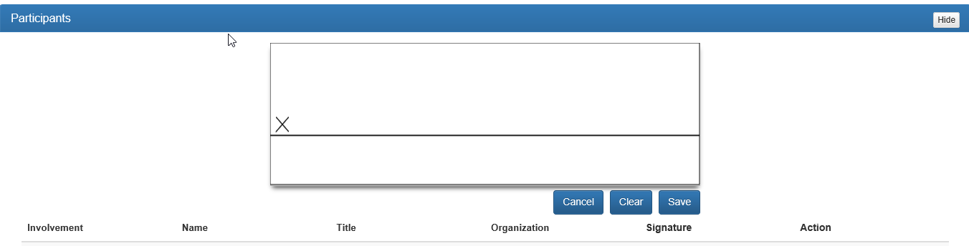
Figure 122: Recording Signature
The Inspector should add their signature (using the stylus, finger or mouse) to the box and select Save. Cancel will remove the box, and return to the table. Clear will leave the signature box, but remove the current signature. Once the signature is saved, it cannot be changed.

Editing Inspector Signature
Please note, the Signature can only be edited by sending an email to FIRSTSupport, asking that the signature be deleted to allow for the inspector to resign. To edit either the Name or Organization of the Inspector, select Edit to the right of the Inspector name.
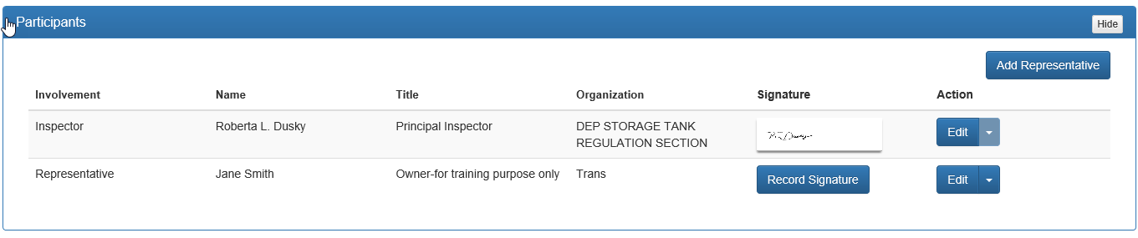
Figure 123: Editing Inspector Signature
Edit the Name or Organization for the Inspector, and click Update. Cancel will delete the changed information and return to the original information that was saved.
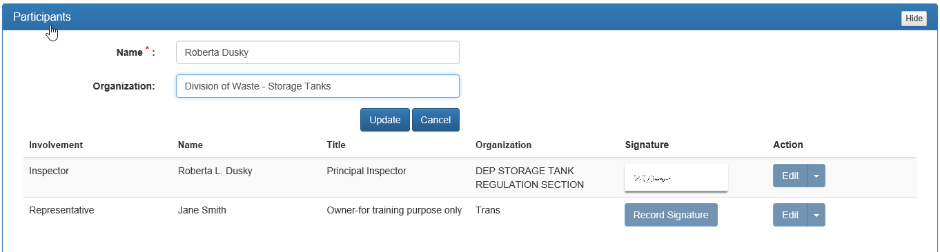
Figure 124: Edited Inspector Signature
Once either Update or Cancel are selected, the display table will appear, with the updated changes or to the original, respectively.
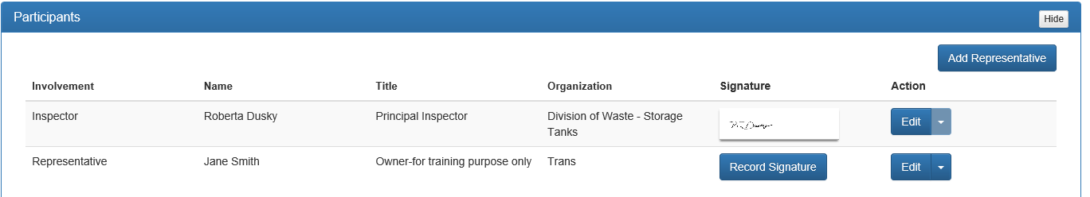
Figure 125: Display Table after editing

Adding Representative
To add a representative for the facility, select Add Representative. An interactive popup will appear above the display table, to input the Name, Title and Organization for the Representative. A No signature required box will also be displayed. This should not be chosen unless there is not a representative present. This must be noted in the inspection report comments.
Figure 126: Adding Representative Information

Once the information has been entered click Save. Cancel will return to the display table without the information being included.
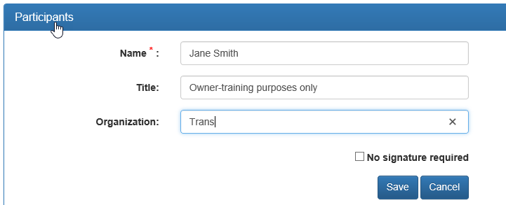
Figure 127: Complete Representative Information

Editing Representative Information
To edit representative information, select Edit to the right of the representative signature. This will bring back the Representative’s Information. All information can be edited. Once editing is complete, select Update or Cancel.
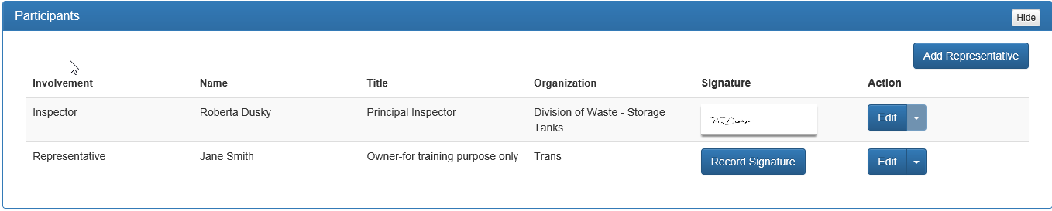
Figure 128: Editing Representative

Capture Representative Signature
To capture the signature of the representative, select Record Signature to the right of the Representative name.
Figure 129: Recording Signature
The Representative should add their signature (using the stylus, finger or mouse) to the box and select Save. Cancel will remove the box and return to the table. Clear will leave the signature box but remove the current signature. Once the signature is saved, it can only be changed by sending an email to FIRSTSupport requesting it to be deleted to allow for the representative to resign.
Once all information and at least the Inspector and Representative signatures are captured the display table will look like:
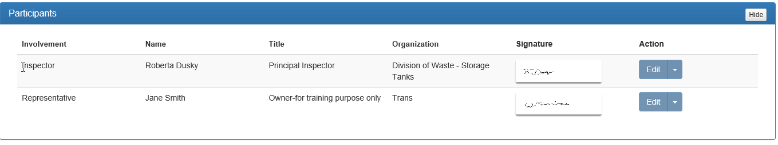
Figure 130: Completed Participants section

Completing an Inspection – Entry Level Inspector
At any time, an inspector can review an Inspection Report. To view a report, click View Report from the Activity Actions header.
Figure 131: Activity Actions header

The inspection report will be displayed in another window, with a watermark of “DRAFT”, until finalized. It is recommended that an inspector review their report prior to finishing.
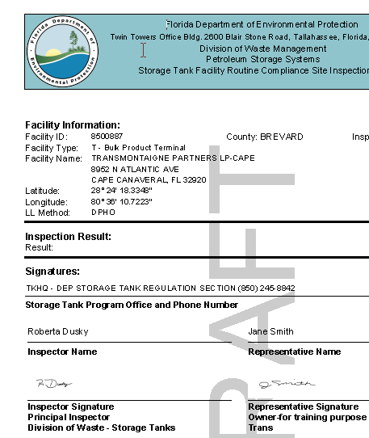
Figure 132: View Report – Draft

Now that the individual activities have been completed, the user is ready to submit the inspection to the supervisor for approval. All Entry Level Inspectors are required to have all inspections, letters, and documents created in FIRST be approved by the supervisor prior to distribution, until such time that the inspector has completed all training and the supervisor believes that the inspector no longer needs supervision for routine activities.
To submit a completed inspection to a supervisor, click Submit for Approval located in the Activity Actions activity header at the bottom of the Active Window.
Figure 133: Activity Actions - Submit for Approval

Possible Warnings upon Submittal
If attachments or documents were included during the inspection, and have not been posted to Oculus, a warning will appear in the Active Window asking if you want to continue with submitting or not. Select Yes to submit, or No to return to the inspection.

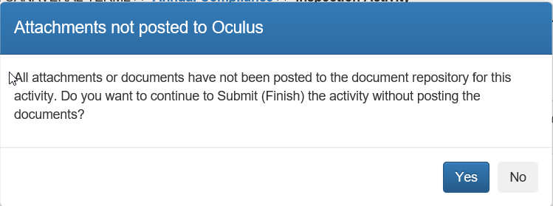
Figure 134: Attachments not posted to Oculus warning

If required information within the Inspection Project is missing, a warning will appear in the Active Window stating what needs attention. Select OK to return to the activity.

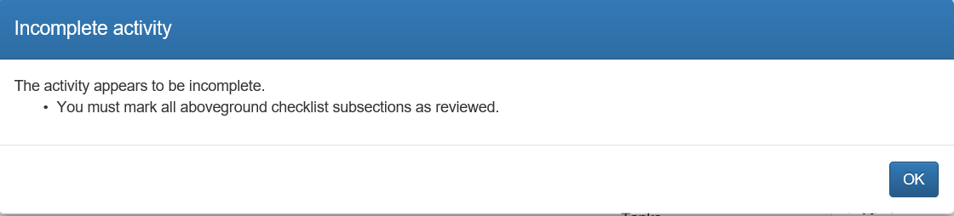
Figure 135: Incomplete Inspection Activity warning example

Other reasons for the Incomplete activity warning include:
- No Representative added
- Checklist not completed
- Operator Training Certificates for Underground Storage Tanks not chosen
- Inspector Signature not captured
Once the activity is complete, click Submit for Approval. The Active Window will return to the main activities screen for the project. Submitted Activities in the upper right corner of the screen will increase by one.
Figure 136: Return to Main after Submittal for Approval

Both the inspector and supervisor will receive an email from FIRST stating that the inspection has been submitted for approval. The email will provide a link for the supervisor, to go directly into FIRST and review the inspection. The supervisor can either approve or reject the inspection. An email will be sent to the inspector indicating what action was taken by the supervisor. The Open Activities number in the upper right will increase by one after the supervisor has taken an action and Submitted Activities will decrease by one. The inspector is to either correct and resubmit a rejected inspection or Finish an approved inspection. Finishing an inspection is required.
To finish an inspection after approval, open the Inspection activity, and click Finish located in the Activity Actions header.

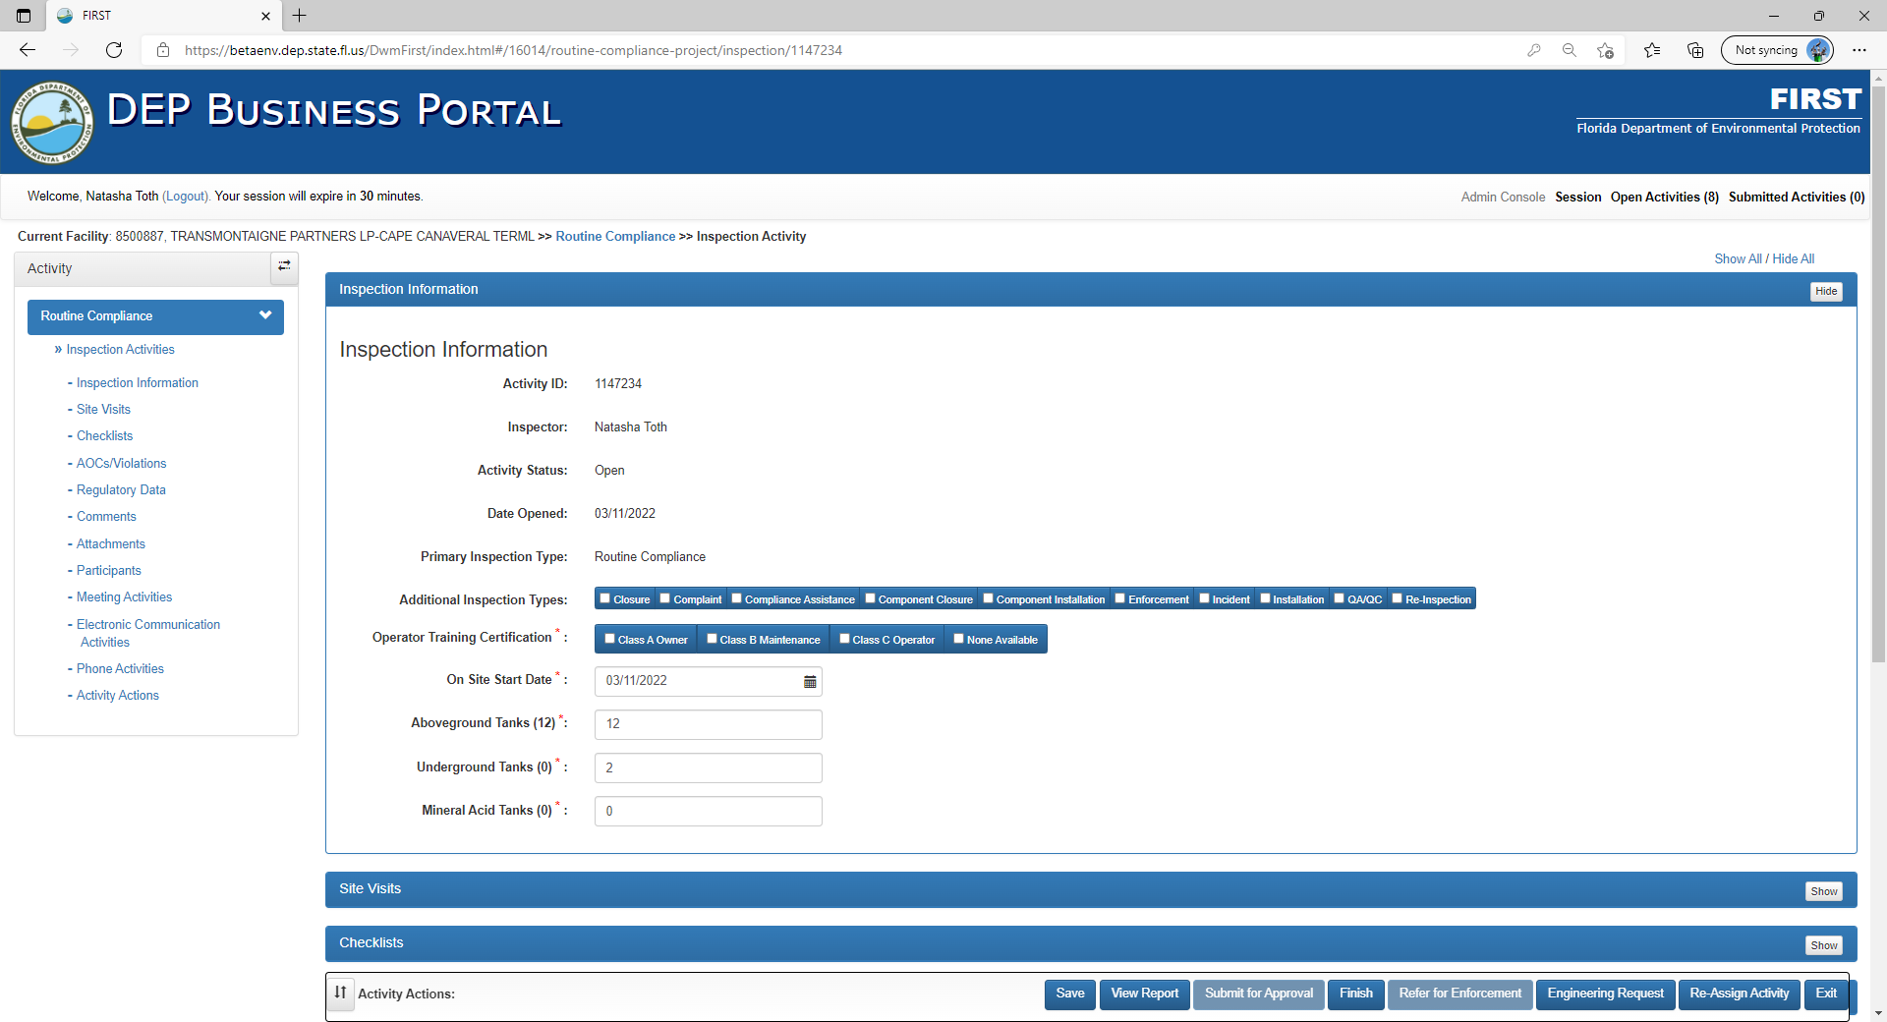
Figure 137: Finishing an inspection

A confirmation warning will appear in the Active Window asking “Are you sure you want to Finish the activity?” Click OK to continue, or Cancel to return to the inspection.
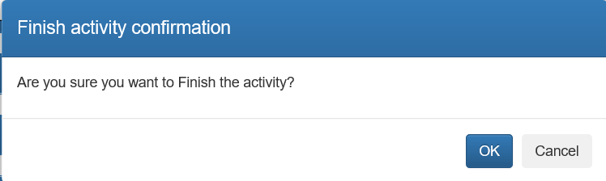
Figure 138: Confirmation warning window

FIRST will open the completed Inspection Report in a different tab of the browser for review.

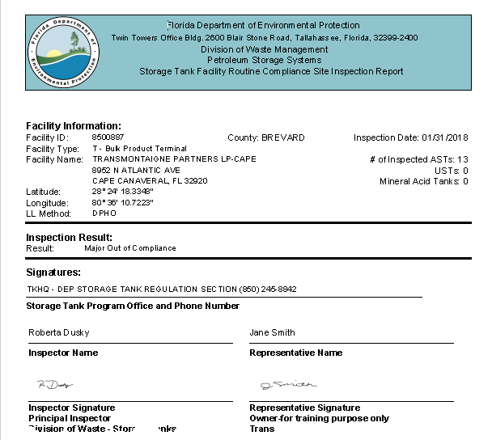
Figure 139: Completed Inspection Report example

Completing an Inspection – Experienced Inspector
At any time, an inspector can review an Inspection Report. To view a report, click View Report from the Activity Actions header.

Figure 140: Activity Actions header

The inspection report will be displayed in another window, with a watermark of “DRAFT”, until finalized. It is recommended that an inspector review their report prior to finishing.
Figure 141: View Report – Draft

Now that the individual activities within the inspection have been completed, it can be finished and a copy of the inspection report can be provided to the facility. To finish the inspection, click Finish from the Activity Actions header.

Possible Warnings upon Finish
If attachments or documents were included during the inspection, and have not been posted to Oculus, a warning will appear in the Active Window asking if you want to continue with submitting or not. Select Yes to submit, or No to return to the inspection.

Figure 142: Attachments not posted to Oculus warning

If for some reason required information within the Inspection Project is missing, a warning will appear in the Active Window stating what needs attention. Select OK to return to the activity.

Figure 143: Incomplete Inspection Activity warning example

Other reasons for the Incomplete activity warning include:
- No Representative added
- Checklist not completed
- Operator Training Certificates for Underground Storage Tanks not chosen
- Inspector Signature not captured
Once the activity is complete, click Finish.

A confirmation warning will appear in the Active Window asking “Are you sure you want to Finish the activity? Click OK to continue, or Cancel to return to the inspection.
Figure 144: Confirmation warning window
The Active Window will return to the main activities screen for the project. Open Activities in the upper right corner of the screen will decrease by one.
FIRST will open the completed Inspection Report in a different tab of the browser for review.
Figure 145: Completed Inspection Report example

The final step for both the Entry Level and Experienced inspector is: if a violation is cited during the inspection, FIRST will automatically create a Compliance Assistance Letter Activity. This can be determined using the Breadcrumb, which will state the current facility identification number, facility name, Compliance Assistance as the project and Letter Activity.
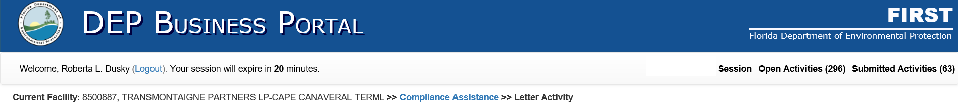
Figure 146: Compliance Assistance Breadcrumb

Letter Activities
Every inspection in FIRST has Letter Activities that are to be completed, whether the inspection is “In Compliance”, “Out of Compliance”, or has “Returned to Compliance” by correcting outstanding violations.
For inspection activities that are “In Compliance” the Letter Activity is generated from the main project screen, not from within the Inspection itself.
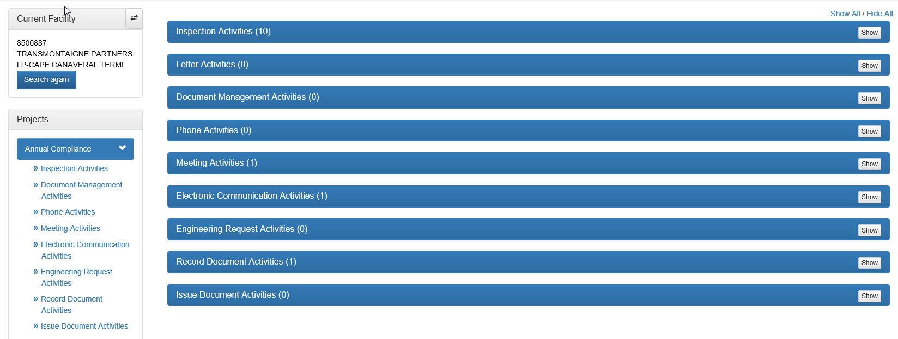
Figure 147: Letter Activities, Main Project

To create an In-Compliance Letter Activity, either click or on the Letter Activities header or Show in the right side of the header.
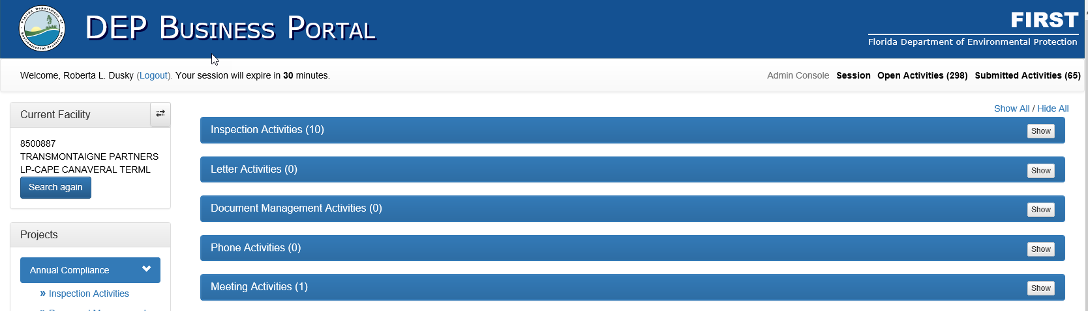
Figure 148: Selection for In Compliance Letter Activity

When expanded, the Initiate Letter Activity will appear in the Active Window.
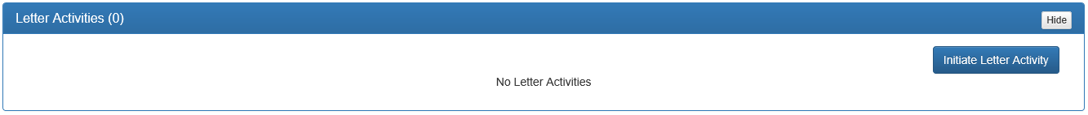
Figure 149: Initiate Letter Activity

After selecting the Initiate Letter Activity, a Letter Type dropdown pop-up box will appear. From the dropdown arrow, select In Compliance Letter and then Save.
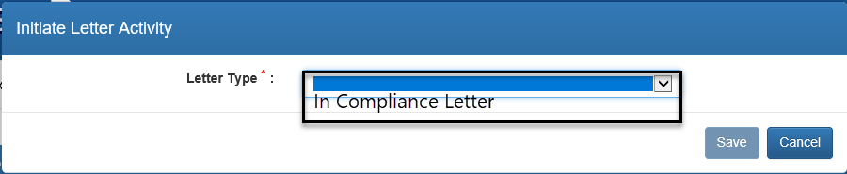
Figure 150: In Compliance Letter selection

The Active Window will switch to the Letter Activity.
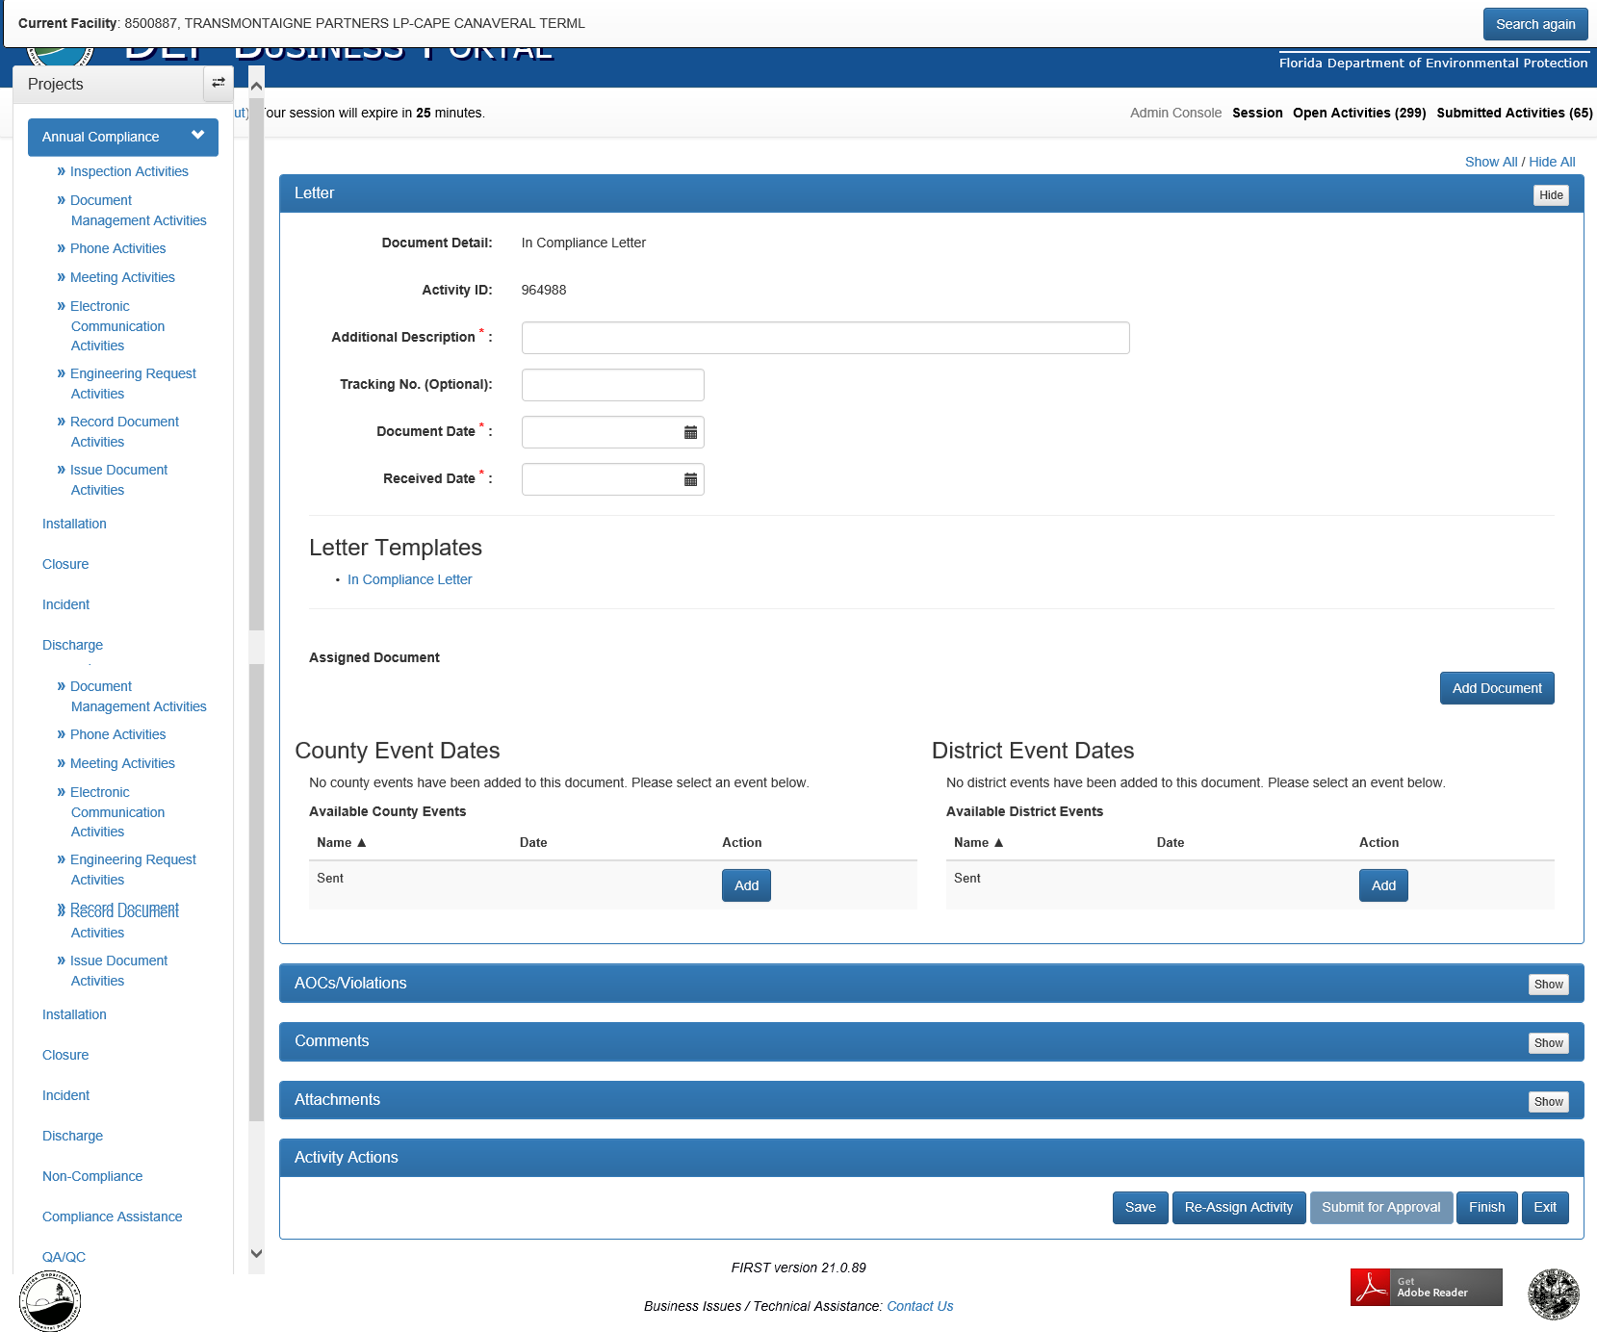
Figure 151: Letter Activity Window

An Additional Description, Document Date and Received Date are required. The Additional Description should be brief and informative as to the purpose of the letter. For example, In Comp Letter, Fac ID 8500887. Using the dropdown calendars, enter the Document Date and Received Date. For all letters issued, these dates will be the same. From the Letter Templates section, select the In Compliance Letter.
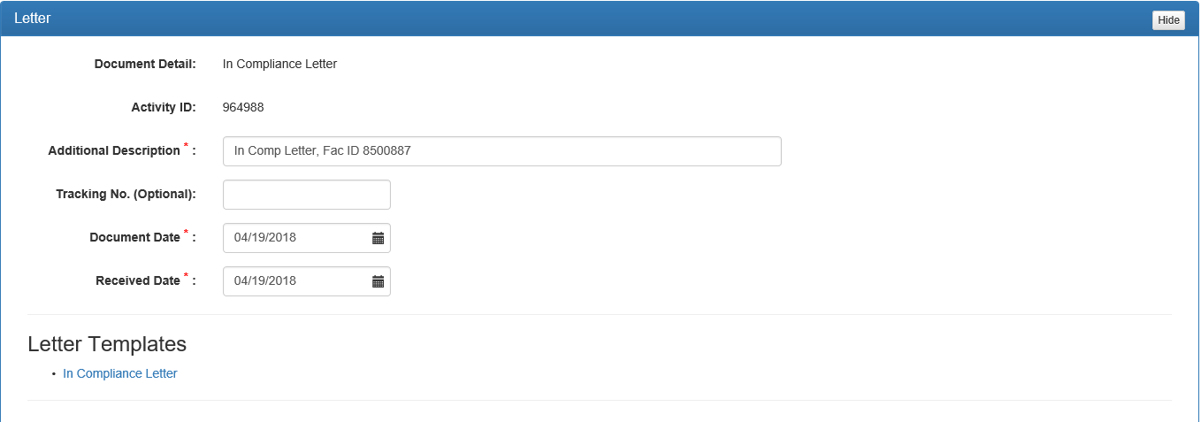
Figure 152: Letter data input

After selecting the In Compliance Letter Template, the Active Window will open a Word document. This document is intended to be a model for the In Compliance Letter. All information that is italicized and in red ink is required to be changed by the inspector and completed appropriately for the facility in question. The letter should be saved to the desktop when completed, so that it can be added in the next step.
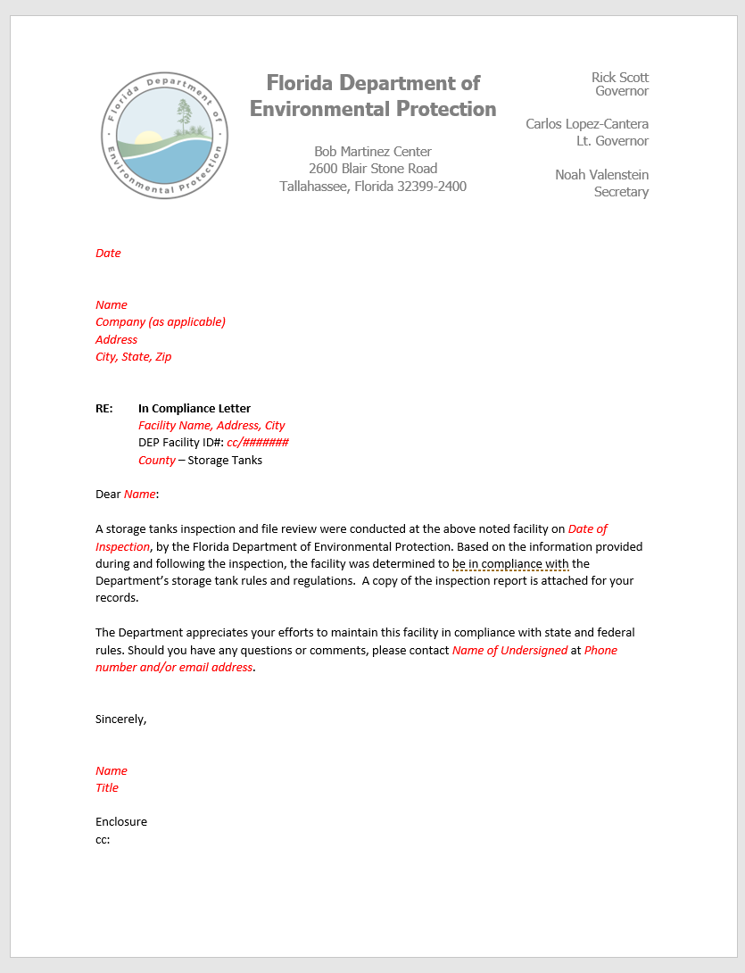
Figure 153: In Compliance Letter Template

In the Assigned Documents section, select Add Document, which will expand the Active Window to:

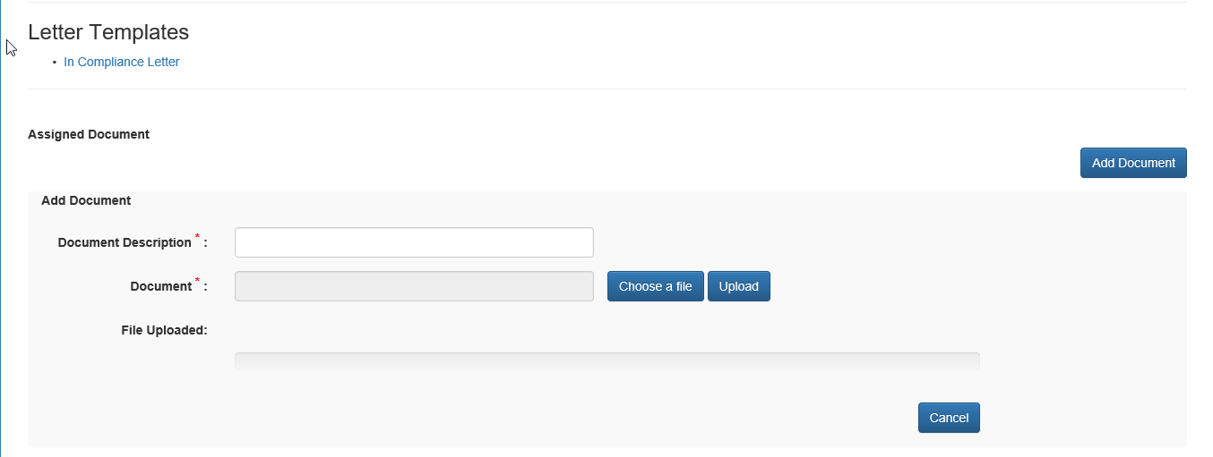
Figure 154: Add Document

In this section, you must add a Document Description, Choose a File and Upload the document. The Document Description will appear in Oculus, so it should be appropriate and informative. For example, In Comp Letter, 8500887, 4/19/2018. When choosing a file, select the document that was previously saved to your desktop. Once you have chosen the file, click Upload. The progress bar will indicate when the letter has completed the upload process. Under Assigned Document, a table will be displayed showing the Author, Date Added, Attachment Description, Post to Document Repository, Date Posted, and Action available. The available actions are View and Delete using the dropdown arrow next to view. The letter may be deleted until it has been posted to Oculus. To post to Oculus, select Post.

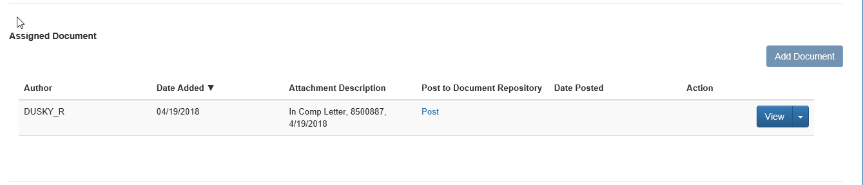
Figure 155: Assigned Document table

After selecting Post, the Document Taxonomy for the document will appear. Verify that the Subject is correct and click Save. The rest of the taxonomy has been established for the letter and cannot be changed.
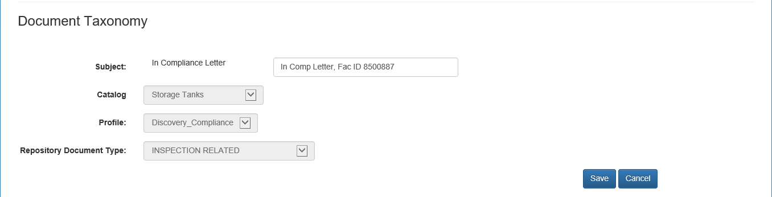
Figure 156: Document Taxonomy

Post will turn to a grey Post in the table, under Assigned Document.
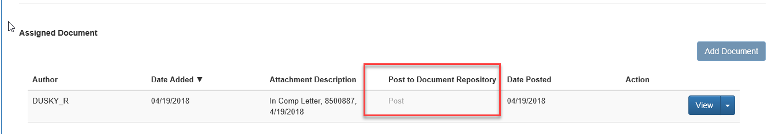
Figure 157: Assigned Document Table after Post

Dependent on whether you are a County or District inspector, select the appropriate Event Date from the tables, using the dropdown calendar and Save.
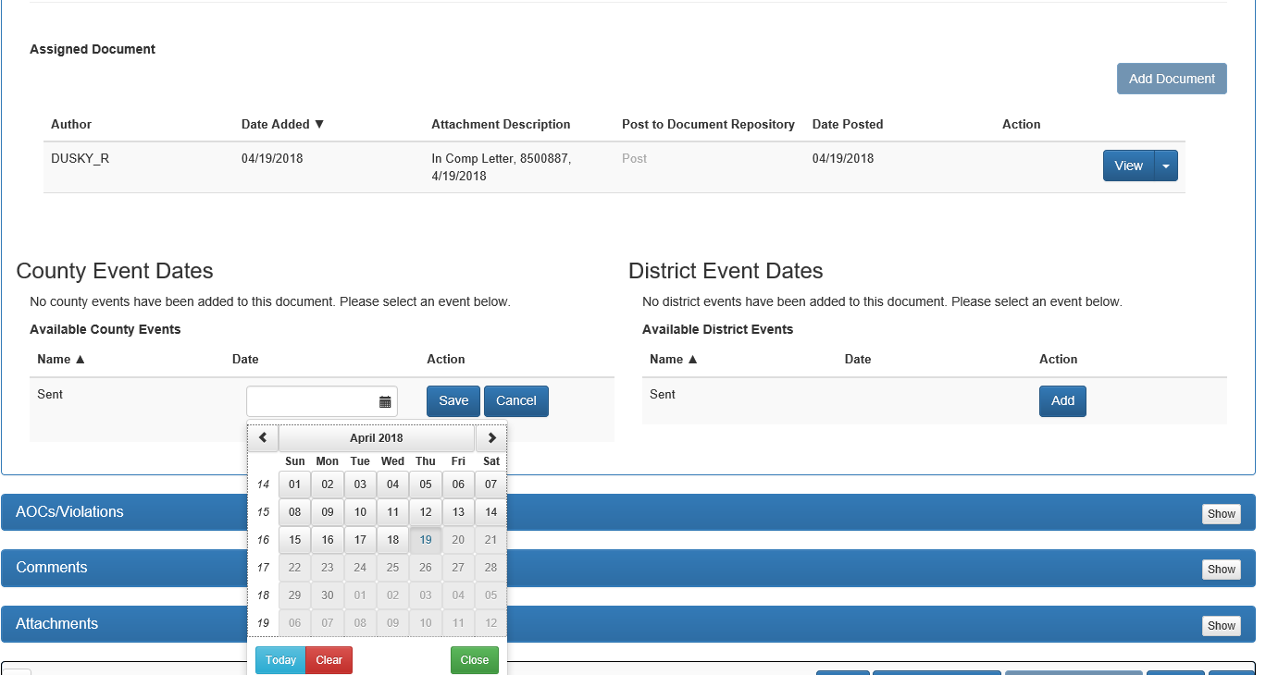
Figure 158: Capturing Event Date Information

The Event table will change to show that the letter was sent on the date selected. The event can be deleted up until the time the Letter Activity is finished.
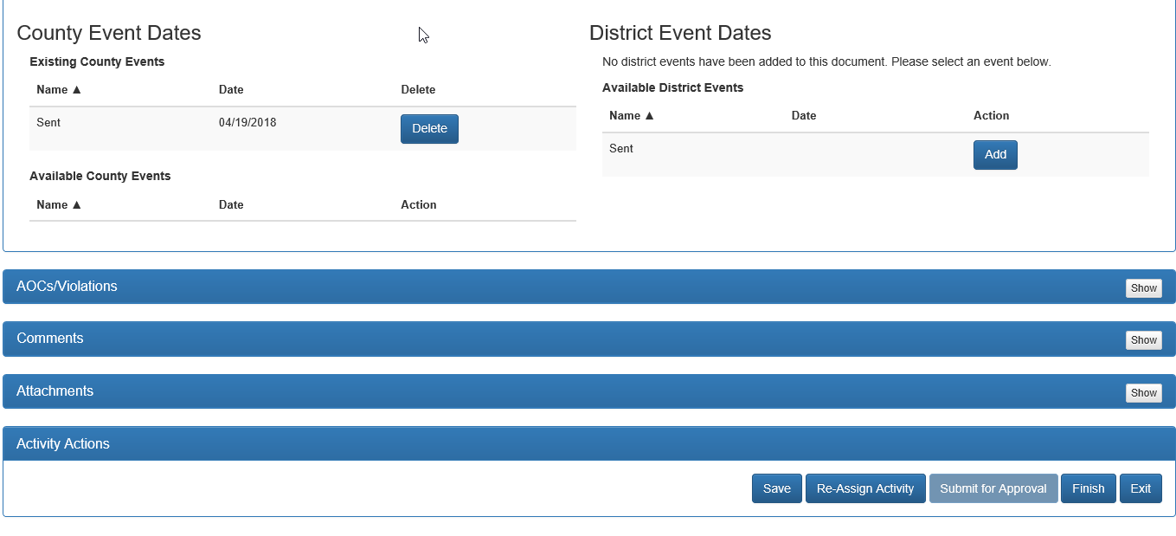
Figure 159: Events table

Once the information is verified as correct, click Finish from the Activity Actions. This will complete the activity.
NOTE: All letters can be completed in the same manner as described above; and choosing the desired template from the Letter Activity under the appropriate project.

Document Management Activities
Document Management Activities at Project Level are for those Documents that need to be completed outside of a specific activity and can include:
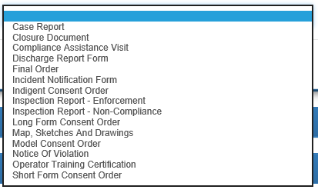
Figure 160: Available Document Management Activities - Project Level

To add a Document Management Activity select the header Document Management Activities or Show, and then Initiate Document Management Activity.
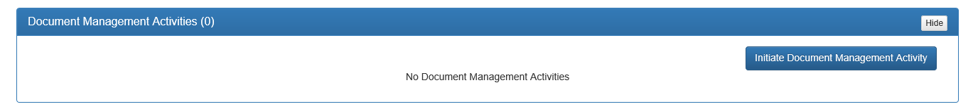
Figure 161: Initiate Document Management Activity

Selecting the Initiate Document Management Activity will display a Document Type popup box.
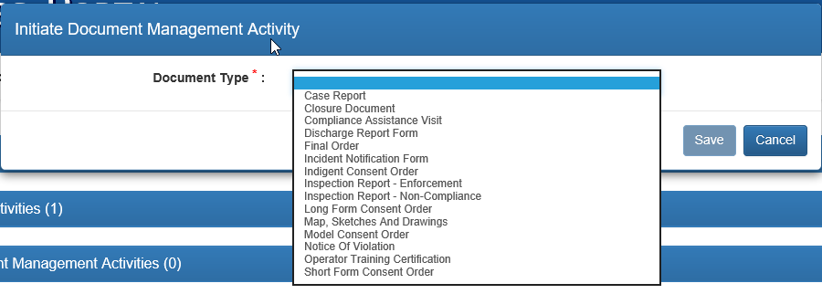
Figure 162: Initiate Document Management Activity dropdown
Choose the desired type of document from the dropdown list and click Save.
The Active Window will display the Document Management Activity. The Additional Description, Document Date and Received Date are required information. The Additional Description should be brief and informative as to the purpose of the document. For example, Copies of Class A, B, C Operator Certifications, Routine Inspection 4/19/2018. The Document Date and Received Date must be added using the dropdown calendars.
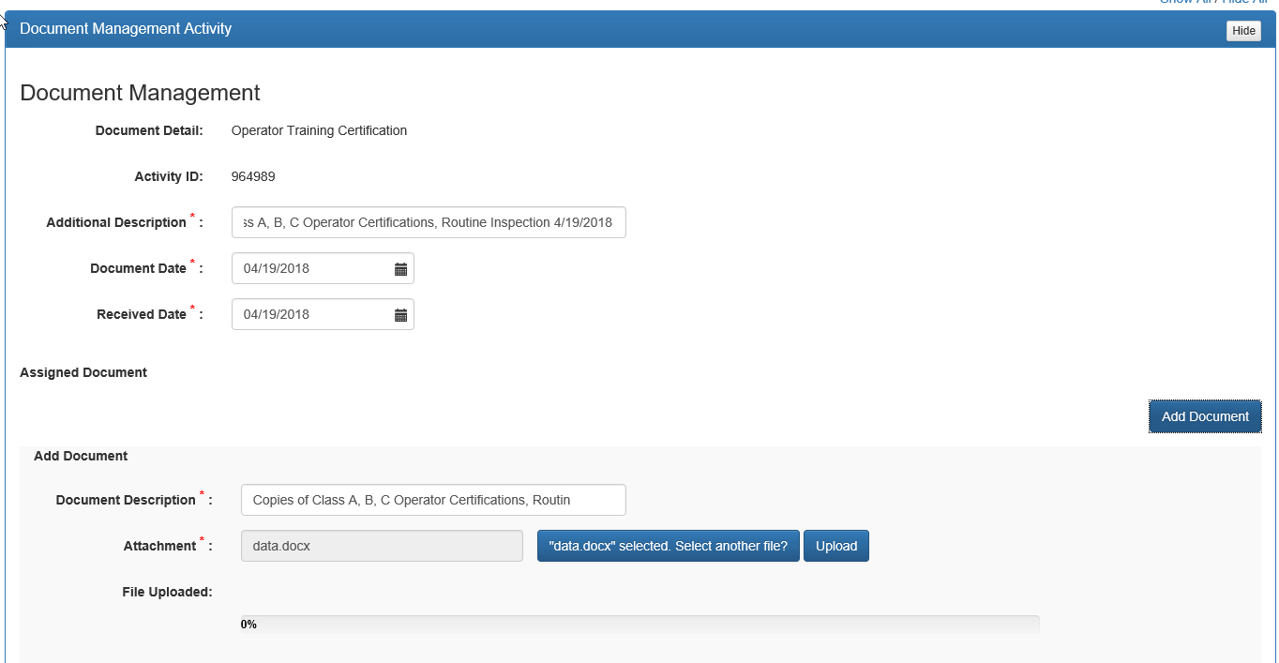
Figure 163: Document Management Activity

Under Assigned Document, you must add a Document Description, Choose a File and Upload the document. The Document Description will appear in Oculus, so it should be appropriate and informative. When choosing a file, select the document that was previously saved to your desktop. Once you have chosen the file, click Upload. The progress bar will indicate when the document has completed the upload process. Under Assigned Document, a table will be displayed showing the Author, Date Added, Attachment Description, Post to Document Repository, Date Posted, and Action available. The available actions are View and Delete using the dropdown arrow next to view. The letter may be deleted until it has been posted to Oculus. To post to Oculus, select Post.
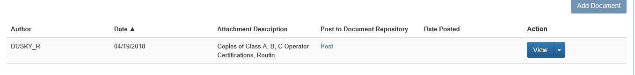
Figure 164: Assigned Document table

After selecting Post, the Document Taxonomy for the document will appear. Verify that the Subject is correct and click Save. The rest of the taxonomy has been established for the document and cannot be changed. Please note, that the addition of documents acts the same throughout the application, including letters.

Phone Activities
A Phone Activity should be recorded anytime there is a phone conversation between representatives for the facility and the department (or representative for the department). Phones Activities can be completed both at the Project Level and within a specific Inspection Activity. A Project Level phone activity should relate to the entire facility and its status, while an Inspection Level phone activity should relate to the specific inspection, such as the 5-day scheduling/notification call. Whether the phone activity is at the Project or Inspection Level, the steps for its completion are the same.
To complete a Phone Activity, select the header Phone Activities or Show. This will expand the Active Window.
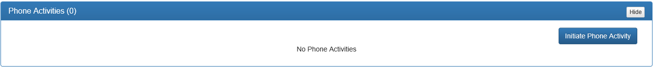
Figure 165: Phone Activities

Click Initiate Phone Activity, and the Phone Conversation window will appear. At Call Type, identify whether the call was Incoming or Outgoing by clicking the appropriate radio button. Also required, are Call Date to be entered using the dropdown calendar, Phone Number and a comment that provides details as to the discussion that took place. There is a maximum character count for comments of 4000. If additional space is needed, add another Phone Conversation and continue to explain, just state that it is a continuation from the other call.
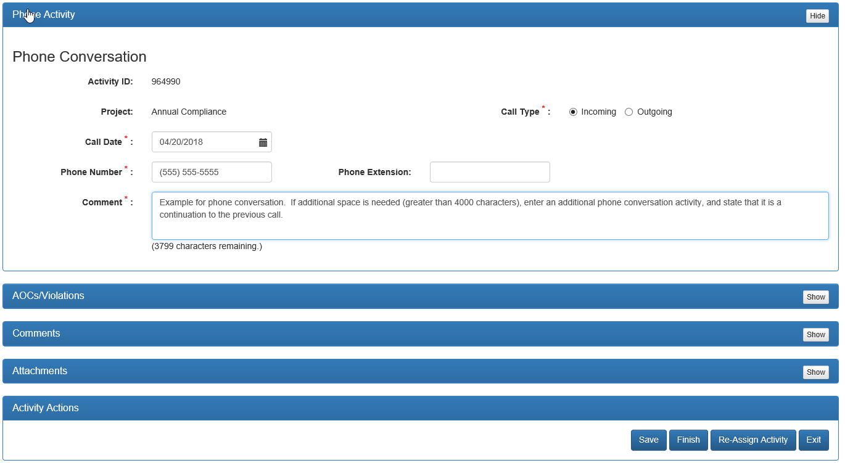
Figure 166: Phone Activity example

Make sure to go to the Activity Actions and select Finish when completed, otherwise your information will not be saved.
A confirmation pop-up will appear asking “Are you sure you want to Finish the activity?” Ok will complete the process, Cancel will revert to the Phone Activity screen. Additional pop-ups may appear, answer appropriately.

Meeting Activities
A Meeting Activity should be recorded anytime there is a meeting between representatives for the facility and the department (or representative for the department). Meeting Activities can be completed both at the Project Level and within a specific Inspection Activity. A Project Level meeting activity should relate to the entire facility and its status, while an Inspection Level meeting activity should relate to the specific inspection. Whether the meeting activity is at the Project or Inspection Level, the steps for its completion are the same.
To complete a Meeting Activity, select the header Meeting Activities or Show. This will expand the Active Window.
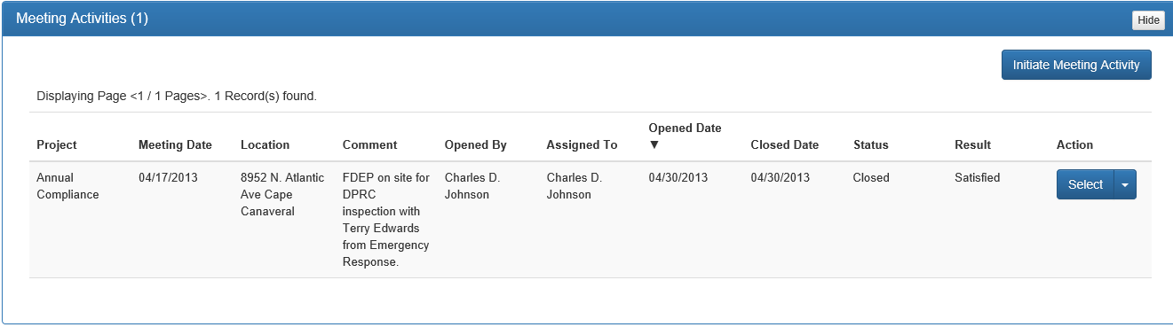
Figure 167: Meeting Activities

Click Initiate Meeting Activity, and the Meeting Activities window will appear. Required information includes Meeting Date (using the dropdown calendar), Location and Comment. There is a maximum character count for comments of 4000. If additional space is needed, add another Meeting and continue to explain, just state that it is a continuation from the other meeting.
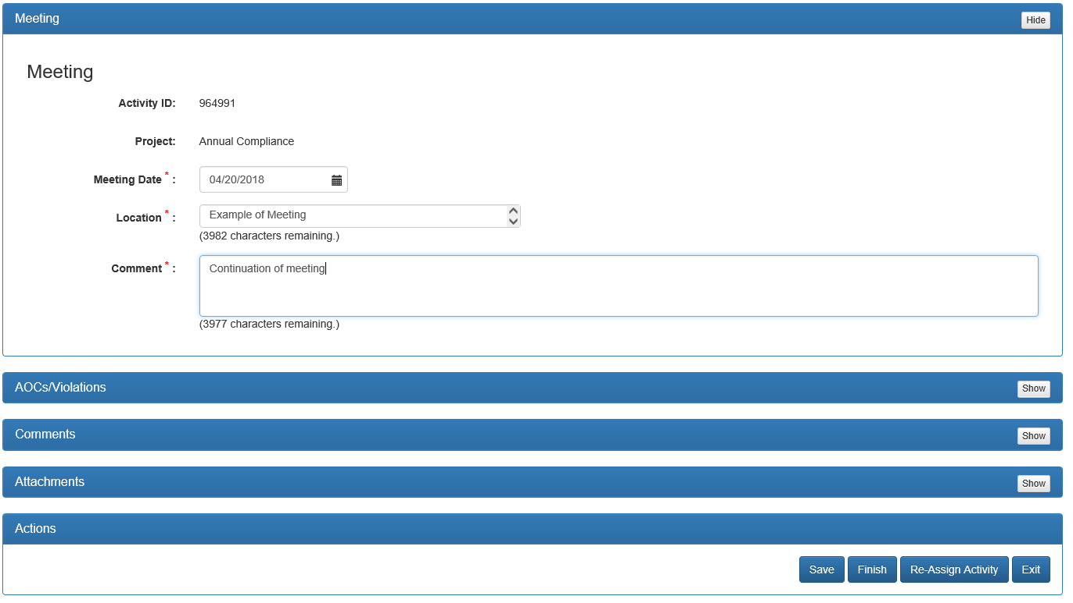
Figure 168: Meeting Activity Example
Make sure to go to the Activity Actions and select Finish when completed, otherwise your information will not be saved.
A confirmation pop-up will appear asking “Are you sure you want to Finish the activity?” Ok will complete the process, Cancel will revert to the Meeting Activity screen. Additional pop-ups may appear, answer appropriately.

Electronic Communication Activity
An Electronic Communication Activity should be recorded anytime there is an exchange between the representatives for the facility and the department (or representative for the department). Electronic Communications can be completed both at the Project Level and within a specific Inspection Activity. A Project Level communication should relate to the entire facility and its status, while an Inspection Level meeting activity should relate to the specific inspection. Whether the communication activity is at the Project or Inspection Level, the steps for its completion are the same. To complete an Electronic Communication Activity, select the header Electronic Communication Activities or Show. This will expand the Active Window.
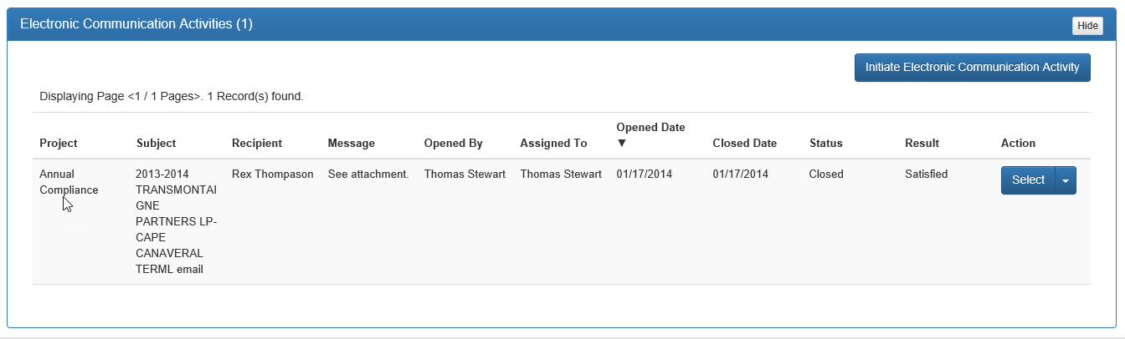
Figure 169: Electronic Communication Initiate example
Click Initiate Electronic Communication Activity, and the Electronic Communication Activities window will appear. Required information includes Date (using the dropdown calendar), Recipient, Sender, Subject and Message. There is a maximum character count for both Subject and Message of 4000. Go to Attachments and attach the email.
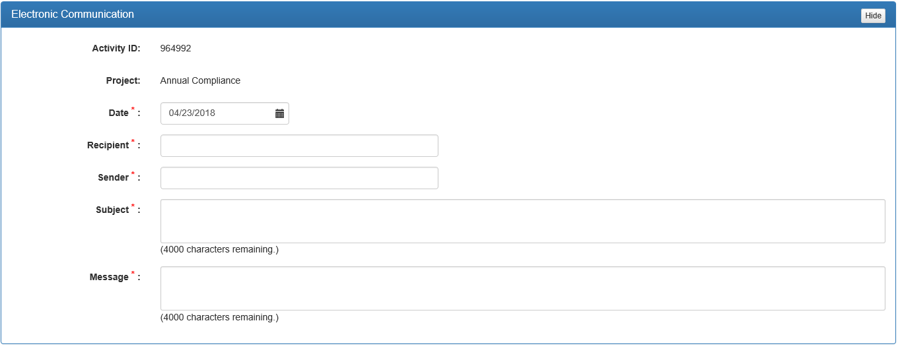
Figure 170: Electronic Communication example
After attaching the email, make sure to go to the Activity Actions and select Finish when completed, otherwise your information will not be saved.
A confirmation pop-up will appear asking “Are you sure you want to Finish the activity?” Ok will complete the process, Cancel will revert to the Electronic Communication Activity screen. Additional pop-ups may appear, answer appropriately.

Engineering Requests
An Engineering Request should be recorded when it is necessary to receive technical evaluation of a system or component inclusion or function from the engineering staff in Tallahassee. It should not be used to ask general questions regarding a system. Before an Engineering Request is submitted, District review is required, and only upon no answer from them should the request be submitted to Tallahassee. Engineering Requests can only be completed at the Project Level. To complete an Engineering Request Activity, select the header Engineering Request Activities or Show. This will expand the Active Window.
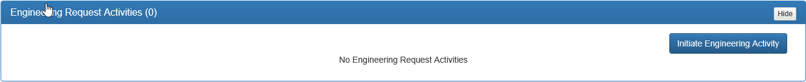
Figure 171: Engineering Request Initiate example
Click Initiate Engineering Activity, and the Electronic Communication Activities window will appear. Required information includes Date (using the dropdown calendar), and Request. Request should detail the question or point being explored. Click Submit, which will send an email to the engineering group in Tallahassee. Once it has been claimed and reviewed you will receive a notification in your email.
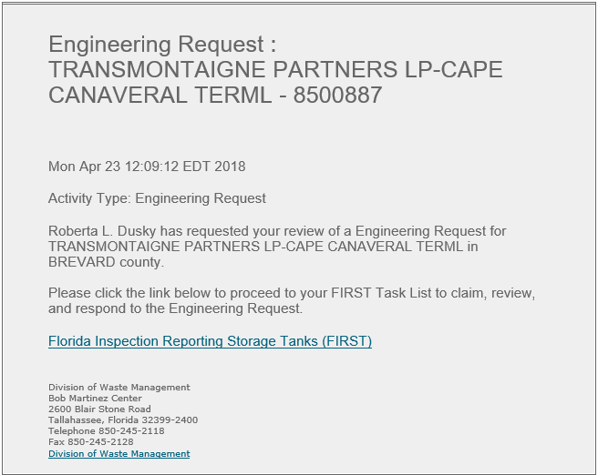
Figure 172: Example email
You will then need to complete the activity, by clicking on the link in the email, and then click Finish in Activity Actions.
Figure 173: Activity Actions for Engineering Requests

A confirmation pop-up will appear asking “Are you sure you want to Finish the activity?” Ok will complete the process, Cancel will revert to the Engineering Activity screen. Additional pop-ups may appear, answer appropriately.

Record Document Activities
A Record Document Activity should be recorded anytime there is a document submitted to the department from representatives for the facility and needs to be noted in FIRST. An example would be, if pictures are sent to the facility indicating that the facility has returned to compliance. This activity can be used to resolve the violation (See resolving violations). Record Document Activities can only be completed at the Project Level. A Project Level record document activity should relate to the entire facility and its status.
To complete a Record Document Activity, select the header Record Document Activities or Show. This will expand the Active Window.
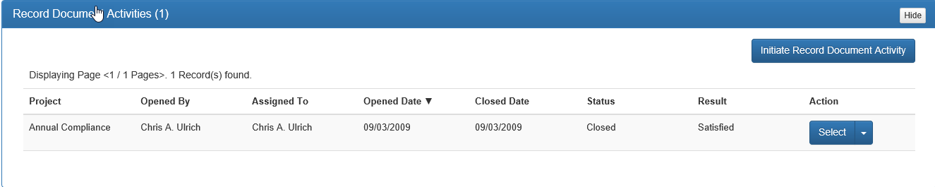
Figure 174: Record Document Initiate example
Click Initiate Record Document Activity, and the Record Document Activities window will appear. Required information includes Date (using the dropdown calendar), Contact and Subject. The Contact should be the person who sent the document. The Subject should be descriptive and include phone and/or email of the contact. Go to Attachments and attach the document.
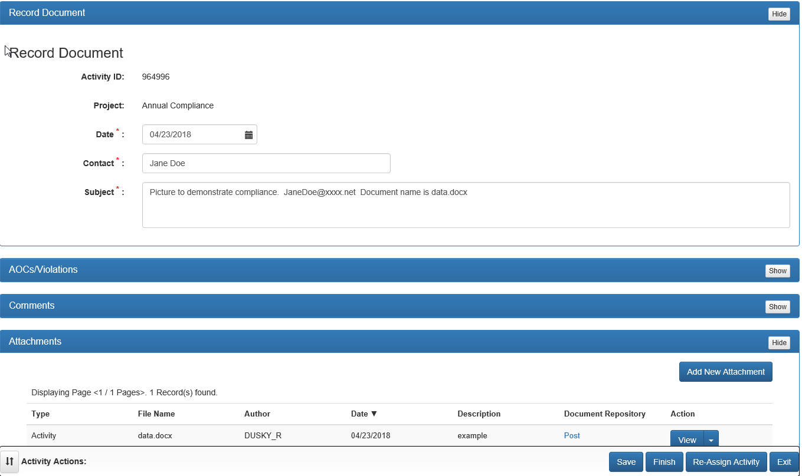
Figure 175: Record Document Activity example
To Finish the Record Document Activity remember to go to Activity Actions and click Finish.
A confirmation pop-up will appear asking “Are you sure you want to Finish the activity?” Ok will complete the process, Cancel will revert to the Record Document Activity screen. Additional pop-ups may appear, answer appropriately.

Issue Document Activities
An Issue Document Activity should be recorded anytime there is a document sent by the department to representatives for the facility that has not been recorded in other activities and needs to be noted in FIRST. This activity can be used to resolve the violation. Issue Document Activities can only be completed at the Project Level. A Project Level record document activity should relate to the entire facility and its status.
To complete an Issue Document Activity, select the header Issue Document Activities or Show. This will expand the Active Window.
Figure 176: Issue Document Initiate example

Click Initiate Issue Document Activity, and the Issue Document Activities window will appear. Required information includes Date (using the dropdown calendar), Contact and Subject. The Contact should be the person who sent the document (Department/Representative for the Department). The Subject should be descriptive and include phone and/or email of the contact. Go to Attachments and attach the document.
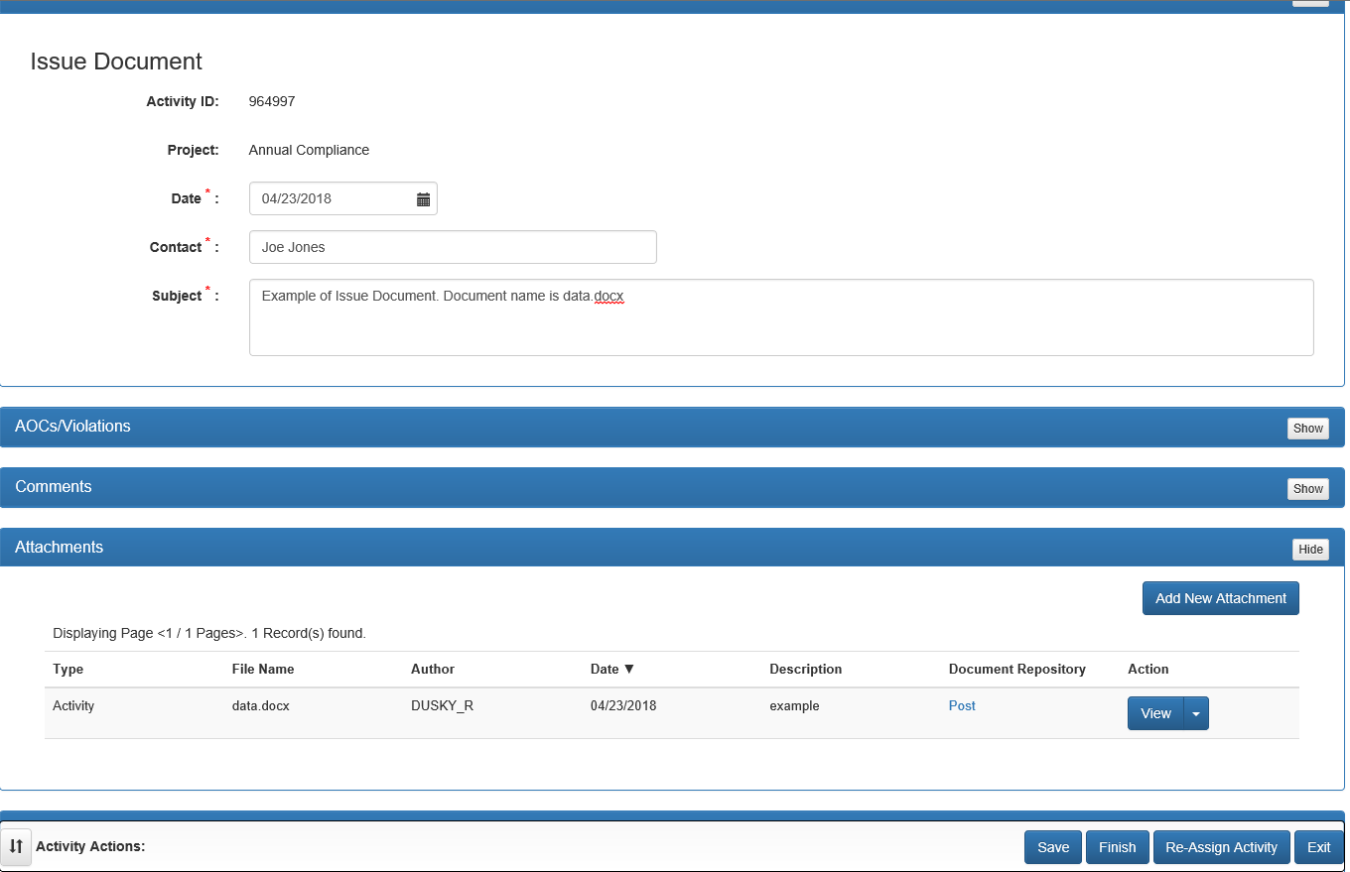
Figure 177: Issue Document example

To Finish the Record Document Activity remember to go to Activity Actions and click Finish.
A confirmation pop-up will appear asking “Are you sure you want to Finish the activity?” Ok will complete the process, Cancel will revert to the Issue Document Activity screen. Additional pop-ups may appear, answer appropriately.

Chapter 4
Project Specific Activities

Routine Compliance, Installation, Non-Compliance (Legacy Project), Compliance Assistance, QA/QC, and Complaint Project Specific Information
For a Routine Compliance Inspection specific information is to be entered during the inspection process. To enter general information, refer to Chapter 3 (Page 33).

Inspection Information
In Inspection Information, it is necessary to enter the On Site Start Date, and number of Aboveground/Underground Tanks being inspected. The number in parentheses next to the tank type indicates the number of regulated tanks that have been registered with the Department. Indicate all tanks being inspected.
If Underground Tanks are being inspected, it is required that Operator Training Certification be identified in Inspection Information.

Site Visits
In Site Visits, specific information to include are the date and who is in attendance.

Checklists and AOCs/Violations
Both project activities deal with the notation of Areas of Concern and citation of Violations, the same specific information is required in both sections.
When citing a violation from either Checklists or AOCs/Violations it is required that the Explanation be specific to the act being cited.
The Corrective Action for a violation should be descriptive in what the facility is required to do to resolve the violation. Any physical violations are required to be documented through a photograph. This photograph is to be attached in Attachments. Be detailed in describing the photograph, as it will be used as comparison for resolution. These photographs will be displayed on the Inspection Report.
When noting an AOC, it is required that again the Explanation be specific for the area being noted.
The Corrective Action for an AOC should be descriptive in what the facility can do to prevent a violation from being cited in the future. For example, if there the facility insurance is current, but will expire in two months, the Corrective Action should be similar to, as a reminder facility insurance will expire in two months. Renewal and revised forms will be required to maintain current compliance status.
In instances where the AOC is physical in nature, photographs should be taken for comparison purposes in future inspections. These photographs should be attached in Attachments and a detailed description provided. These photographs will be displayed on the Inspection Report.
In Checklists, it is required that all check boxes next to the violation subcategories be checked prior to finishing an inspection. By checking these boxes, the inspector is verifying that they have reviewed these categories during the inspection, and that they have either cited violations, noted AOCs or no violations existed at the time of the inspection.
Please note, that if a facility has both USTs and ASTs, and the same violation occurs, (for example, no financial responsibility), both the UST and AST violations are to be cited.

Regulatory Data
In Regulatory Data, Facility Records, it is mandatory that all facility required records be reviewed during the Routine Compliance Inspection. If required records are not available or missing, violations must be cited.
Only one entry for each record type should be entered during the inspection, with appropriate comments made if records are missing. For example, monthly visual records are being reviewed for January 1, 2017, until March 5, 2018, and the facility is missing records for June 2017, August 2017, and February 2018. Only one entry for monthly visual records should be entered with the dates of January 1, 2017 through March 5, 2018, and in the comments box, it should be indicated that the records for June, August and February were missing. Also, cite appropriate recordkeeping violation in the AOCs/Violations section.
You must add a date range (“From Date” and “To Date”) for each record type reviewed during the inspection. Both dates must be dated on or prior to the inspection date and be entered in the table prior to closure of the inspection.
Information such as the name of the person that completed the record can also be entered in the Comments. These comments will appear in the Reviewed Records section of the inspection report.
The inspector should view a draft of the inspection report to make sure that all and only those records reviewed during the inspection are indicated on the inspection report, and that the information is displayed as desired.
For System Tests, only newly preformed system tests should be added (since last inspection). There should be a record for every applicable system test displayed on the inspection report. Any test that is still active does not need to be re-entered, unless a new test has been conducted for some reason. For example, a system test was conducted January 1, 2017 and has a period of 2 years. The facility added another system in January 2018 and was required to conduct the same system test in 2018 for the new system. In order to get all systems on the same testing cycle, the owner/operator conducted testing on all systems, even for the system that was active from January 2017. The January 2017 system test should be deactivated, and the 2018 test should be added for all systems.
It is extremely important to deactivate old system tests and not have duplicate tests. If old system tests are not deactivated, they will appear on the inspection report. Deactivated system tests are not removed from FIRST, as they remain in the history, they just do not appear on the current Inspection Report. If system tests are missing or have not been completed violations must be cited.
A system test may be edited where there is incomplete data for the specific system test, by selecting Edit, entering the additional information, and then click Save. Once all data for a particular system test is entered, editing is no longer available.
Comments can include the name of the person or contractor conducting the system test. These comments will appear in the Systems Tests section of the inspection report.
The inspector should view a draft of the inspection report to make sure that all appropriate system tests are indicated on the inspection report.
For Financial Responsibility, required information includes an entry for each mechanism (possibly each year) to ensure that coverage is continuous and there has not been a break in coverage. An example is, the facility was last inspection in May 2016 and insurance was valid until October 3, 2016, and is now being inspection in March 2018. There should be two entries for Financial Responsibility displaying insurance from October 3, 2016 through October 3, 2017, and another indicating coverage from October 3, 2017 through October 3, 2018.
If there is a gap in insurance, a violation should be cited, even if the facility is currently in compliance with Financial Responsibility. The violation should then be resolved with the issuance of the Compliance Assistance Letter Activity (Return to Compliance or Compliance Assistance Offer). The inspection will indicate that the facility is out of compliance, however a notation can be made in the comments section of the inspection activity stating the facility is currently in compliance and with the issuance of the Return to Compliance Letter, compliance status will be updated. Resolution of violations should not occur during the inspection. Any violation should not be resolved until after the inspection is Finished. Notations can be made in Comments of the inspection that a violation was corrected at the time of inspection.

Comments
For Comments, the specific information that needs to be included during an inspection includes:
All information added in this activity will be displayed on the inspection report.

Attachments
The Attachments, that must be included during a Routine Inspection include:
- Update facility site map (if needed). If the site map already in FIRST is accurate, a new one is not required.
- Alarm History
- Copies of Operator Training Certificates
- Copies of Records reviewed
- Copies of System Tests documentation
These attachments will not be attached directly to the inspection report, but will appear on the inspection report under Attachment Documents, as a line item to note that there is an attachment in the application.

Signatures
The Routine inspection report requires both an inspector and representative signature.
The only time a signature is not required, is if no one is present at the facility, or the representative refuses to sign. In these instances, it is mandatory that this be documented on the inspection report.

Closure Project Specific Information
For a Closure Project all information related to the Closure Inspection, such as inspection report, letters, documentation, phone calls, meetings, electronic communications, engineering requests record documents, and issue documents are entered in FIRST as described in Chapter 3.

TCAR Activities
A Tank Closure Assessment Report (TCAR), summarizes the events conducted by a licensed contractor during the removal of a storage tank system. The report is to be reviewed by a member of the Petroleum Restoration Program or a county contractor for petroleum cleanup. The receipt of a TCAR report is to be documented in FIRST, as well as any revisions, changes in status and requests for additional information. Associated comments and attachments should also be attached to the TCAR Activity. Once it is determined that all information has been received the activity can be closed. Entry of the Closure Received Date.
Follow the steps below to initiation and complete a TCAR Activity:
- Select the header TCAR Activities or the Show button to expand the Active Window.
- Select the Initiate TCAR Activity, and the TCAR Data Window will appear.
- Enter any notes related to the TCAR in the Notes text box. These notes should be short note of where the inspector is in the TCAR process along with the date the note was entered. Examples include: TCAR Requested, Additional Information Requested, TCAR is incomplete, TCAR Received, etc.
- After entering the Notes, if the TCAR has not been received then click Save under Activity Actions and Exit until the TCAR is received.
- Once the TCAR has been received, click TCAR Received under Activity Actions, enter the date the TCAR was received using the calendar dropdown next to Received Date under TCAR Data and update the Notes with any relevant information regarding the TCAR.
- Associated comments and attachments should also be attached to the TCAR Activity under their respective headers (Information on how to enter comments or attachments can be found in Chapter 3).
- Once it is determined that all information has been received and all information has been entered, the activity can be closed by clicking Finish under Activity Actions.
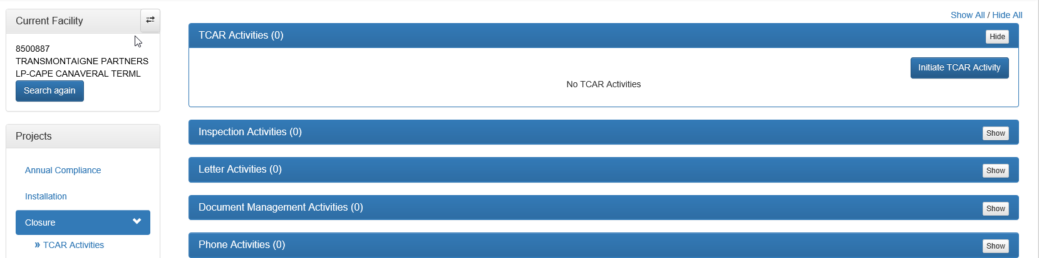
Figure 178: TCAR Initiation
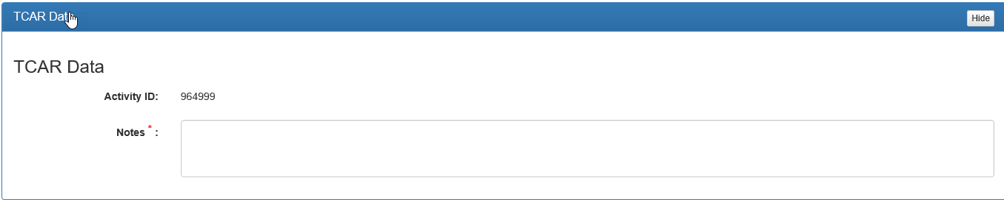
Figure 179: TCAR Notes

Incident Project Specific Information
For an Incident Project all information related to the Incident Inspection, such as inspection report, letters, documentation, phone calls, meetings, electronic communications, engineering requests, record documents, and issue documents are entered in FIRST as described in Chapter 3.

Incident Activities
An Incident Project is used to record an incident (as defined by 62-761.430 or 62-762.431, F. A. C.) that occur at a facility. The facility is required to investigate the incident to determine if a discharge has occurred and submit an Incident Notification Form (INF) to the department, district, or county within 72 hours of the discovery of the incident. Once the INF has been submitted, an investigation must be completed within 14 days from the date of the discovery to determine if a discharge has occurred. Situations in which a DRF submittal is not required can be found in 62-761.440(5) for UST systems or 62-762.441(5) for AST systems.
If an incident is discovered at a facility, follow the steps below to initiate and complete an Incident Project:
- Select the header Incident Activities or the Show button to expand the Active Window.
- Select the Initiate Incident Activity, and the Incident Activity Window will appear.
- Enter the following information into the following fields:
  - Discovery Date – Using the dropdown calendar, select the date the incident was discovered.
  - Discovery Method – Using the dropdown box, select the Discovery Method from the list of methods provided. If “Other” is selected, please explain further in the comment field.
  - Comment – Provide any relevant details related to the incident, such as how the incident was discovered, what actions the facility is taking, etc.
- After all required information has been entered, click Save.
- After clicking Save, the Activity Information Window will appear with the following information:
  - Activity ID – Auto-generated number used for tracking within FIRST
  - Opened Date – The date the incident activity was initiated
  - Discovery Date – The date the incident was discovered
  - Discovery Method – The discovery method selected by the inspector
  - INF Due Date – The date the INF is due from the facility (3 days after discovery date). The INF due date can be extended up to 14 days by clicking the Extend INF Due Date button. This will prompt the inspector to select a new due date within 14 days of the discovery using the calendar dropdown and provide an Extension Comment providing justification for the extension and the date the extension was made.
  - INF Received – A check box that can be checked if the INF has been received, if not then leave unchecked.
  - Incident Comment – The incident comments entered by the inspector.
- After all relevant information has been entered, the incident Inspection Activities, AOCs/Violations, Comments, Attachments can be initiated and completed as described in chapter 3 of this manual. The following are examples of things to be added within these sections of the Incident Activity:
  - The INF should be added under the Document Management Activities section of the Incident Activity.
  - If the investigation determines no discharge occurred, the written confirmation and explanation should be entered into the Comments section and any documentation uploaded under the Attachments section of the Incident Activity.
  - If the investigation comes back that a discharge has occurred, the Discharge Report Form (DRF) should be uploaded under the Document Management Activities section of the Discharge Project.
  - Any AOCs or Violations cited as a result of the incident.
  - The incident inspection, as described in chapter 3 of this manual.
  - Any comments as relevant to the incident
If the investigation of the incident determines a discharge has occurred, the incident can be promoted to a Discharge by clicking Promote from Activity Actions. After clicking Promote, the incident will close the current Incident Activity and initiate a Discharge Activity.
Once all relevant inspections, documentation, comments, and attachments have been entered, the inspector can close the Incident Activity by clicking Finish from Activity Actions. After clicking Finish, the Incident Activity will be closed.

Discharge Project Specific Information
For a Discharge Project all information related to the Discharge Inspection, such as inspection report, letters, documentation, phone calls, meetings, electronic communications, engineering requests, record documents, and issue documents are entered in FIRST as described in Chapter 3.

Discharge Activities
A Discharge Project is used to record a discharge (as defined by 62-761.440 or 62-762.441, F. A. C.) that occurs at a facility. Upon discovery of the discharge, the facility is required to report the discharge to the county or district within 24 hours using a Discharge Report Form (DRF) unless the discharge is thought to have been previously reported, in which case the facility has 30 days to investigate and submit supporting documentation or submit a DRF. The facility shall also submit laboratory analytical results that confirm the discharge to the county or district within 24 hours of their receipt. Situations in which a DRF submittal is not required can be found in 62-761.440(5) for UST systems or 62-762.441(5) for AST systems.
If a discharge is discovered at a facility, follow the steps below to initiate and complete a Discharge Project:
- Select the header Discharges or the Show button to expand the Active Window.
- If an Incident was promoted to a Discharge after the incident investigation, the Discharge Activity will have already been opened and can be found in the table within the Active Window. If this is a new discharge, click the Start Discharge Reporting Activity, and the Discharges Active Window will appear.
- Enter the following information in to the following fields:
  - Project – Auto-generated with the project name.
  - Discovery Method – Using the dropdown box, select the Discovery Method from the list of methods provided. If “Other” is selected, please explain further in the comment field.
  - Discovery Date – Using the dropdown calendar, select the date the incident was discovered.
  - Comment – Provide any relevant details related to the discharge, such as how the incident was discovered, what actions the facility is taking, etc.
- After all required information has been entered, click Save and you will be returned to the Discharges Active Window.
- From the Discharges Active Window, click Select next to the new discharge reporting activity.

After selecting the desired discharge reporting activity, the following sections can be expanded by clicking the header or the Show button to view and enter information related to the discharge:
Activity Information (auto-generated information)
    - Activity ID – Auto-generated number used for tracking within FIRST.
    - Facility – The name of the facility at which the discharge took place.
    - Activity – The name of the activity (Discharge Reporting).
    - Activity ID – Auto-generated number used for tracking within FIRST.
    - Date Opened – The date the incident activity was initiated.
    - Status – The status of the Discharge Reporting Activity (Open or Closed).
    - Assigned To – The inspector to which the activity is currently assigned.

  - Discover of Contamination (auto-generated information)
    - Discovery Method – The discovery method selected by the inspector.
    - Discovery Date – The date entered by the inspector.
    - Comments – The incident comments entered by the inspector.

  - Discharge Report Form (auto- generated information)
    - DRF Due – The date the DRF is due from the facility (24 hours after discovery date). The DRF due date can be extended up to 14 days by clicking the Extend Due Date button. This will prompt the inspector to select the number of days to extend the due date and providing justification for the extension in the Comments field.
    - DRF Received – A check box that can be checked if the DRF has been received, if not then leave unchecked.

- After reviewing the previous three sections, expand the Discharge Information section to enter information from the DRF and the Discharge inspection.

- Within the Discharge Information section, click the Record Discharge button in the top right of the active window and enter the following information on the next screen.
  - Information Source – select the source of the discharge information being recorded from the dropdown list
  - Discharge Date – using the dropdown calendar, select the date in which the discharge took place
  - Inspection Date – using the dropdown calendar, select the date in which the discharge inspection took place
  - Other Source Desc – enter a description of the other sources of information used to record the discharge
  - Contaminated Media – using the dropdown list beside each media type, select whether that media was contaminated by selecting either “Yes” or “No”
  - Pollutants – click the Add Pollutant button on the right of the active window and follow the steps below for adding a pollutant.
    - Gallons Discharged – enter the number of gallons discharged by enter the number in the text box
    - Substance – select the substance that was discharged from the dropdown list
    - Substance Category – provide the category of substance selected for the substance field. (Auto updates depending on the substance selected)
    - Other Description – enter any other related description of the pollutant in the text box.
    - Click the Add button to add that pollutant repeat the step previous steps to add another pollutant.

- After entering all information, click Save to record the data.

- Click the Add DRF Source and Cause button to add the source and cause of the discharge stated on the DRF. Follow the steps below to add the DRF source and cause (The following information needs to be entered and updated accurately. The information entered here and in the Inspected as Source and Cause are reported to the EPA at the end of each fiscal year):
  - Type of Tank – check the box next to the type of tank system involved in the discharge. If the discharge occurred due to a pipe, check the box next to the type of tank the pipe was connected to.
  - Cause – Select the cause of the discharge from the dropdown list. (See Appendix A for explanation of causes and help in identifying the proper cause.)
  - Source – Select the source of the discharge from the dropdown list. (See Appendix A for explanation of sources and help in identifying the proper sources.)
  - Comments – Enter any relevant comments related to the type of tank, cause, or source.
  - Once all information has been entered, click Save to record the data.

- Click the Add Inspected as Source and Cause button to add the source and cause of the discharge stated on the DRF. Follow the steps below to add the DRF source and cause (The following information needs to be entered and updated accurately. The information entered here and in the DRF Source and Cause are reported to the EPA at the end of each fiscal year):
  - Type of Tank – check the box next to the type of tank system involved in the discharge. If the discharge occurred due to a pipe, check the box next to the type of tank the pipe was connected to.
  - Cause – Select the cause of the discharge from the dropdown list. (See Appendix A for explanation of causes and help in identifying the proper cause.)
  - Source – Select the source of the discharge from the dropdown list. (See Appendix A for explanation of causes and help in identifying the proper cause.)
  - Comments – Enter any relevant comments related to the type of tank, cause, or source.
  - Once all information has been entered, click Save to record the data

- If this discharge has been previously reported, the checkbox in the top right of the Discharge Information Active Window needs to be checked, otherwise leave this unchecked. If the box is checked the discharge is not entered into the STCM database as new data.

- After all relevant information has been entered, the incident Inspection Activities, AOCs/Violations, Comments, Attachments can be initiated and completed as described in Chapter 3 of this manual. The following are examples of things to be added within these sections of the activity:

- If the investigation determines no discharge occurred, the written confirmation and explanation that the incident was not a discharge should be uploaded under the Attachments section.
  - The Discharge Report Form (DRF) should be uploaded under the Document Management Activities section.
  - Any AOCs or Violations cited as a result of the discharge.
  - The discharge inspection, as described in Chapter 3 of this manual.
  - Any comments as relevant to the discharge
Once all relevant inspections, documentation, comments, and attachments have been entered, the inspector can close the Discharge Activity by clicking Finish Discharge Activity from Activity Actions. After clicking Finish Discharge Activity, the Discharge Activity will be closed.

Enforcement Project Specific Information
For an Enforcement Project all information, such as inspection report, letters, documentation, phone calls, meetings, electronic communications, engineering requests record documents, and issue documents are entered in FIRST as described in Chapter 3.

Enforcement Referral (Submitting)
If a facility needs to be referred for enforcement, follow the steps below to submit a referral: Go to the Inspection Activity in which the violation leading to the enforcement was cited.
- From the Activity Actions panel, Click Refer for Enforcement, and the Enforcement Referral Activity Active Window will appear.
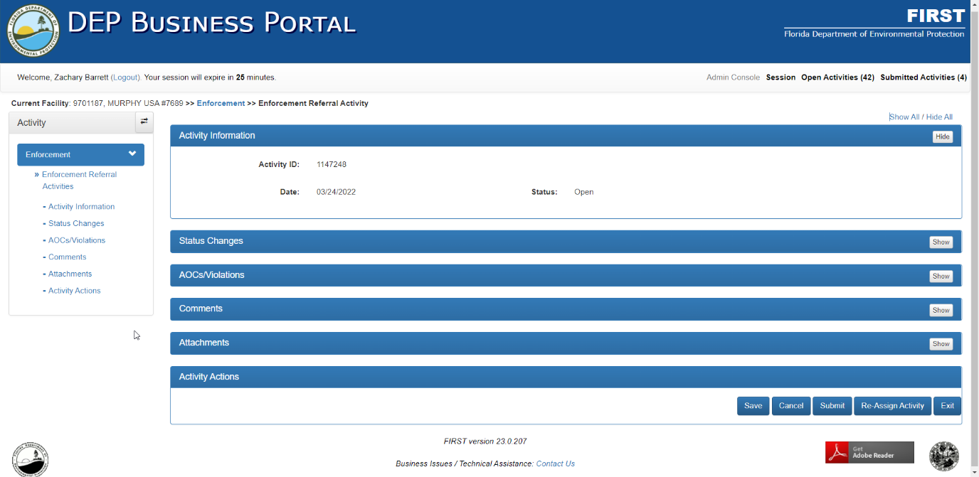
Figure 180: Enforcement Referral Activity
- After initiating the referral, the following sections can be expanded by clicking the header or the Show button to view and enter information related to the discharge:
  - Status Changes (auto-generated information) – this section tracks the actions taken with the referral. It will track when the referral is submitted and assigned and when it is accepted, rejected, or withdrawn.
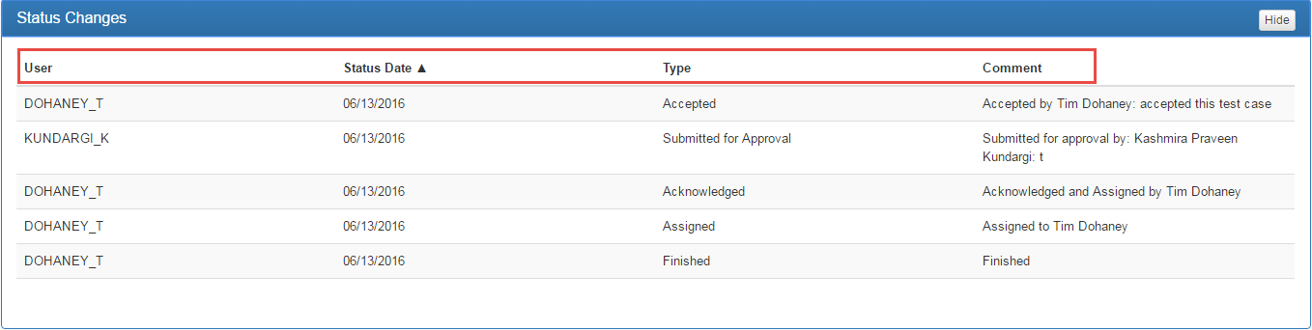
Figure 181: Status Changes
  - AOCS/Violations – all AOCs and Violations cited at the facility will be displayed in this section. It will display the date cited, citation type, status, significance, description, etc. From this section new AOCs/violations can be added or resolved as needed.
  - Comments – within this section, any comments related to the enforcement referral should be added.
  - Attachments – within this section, any attachments related to the enforcement referral should be added.
  - Activity Actions – this section contains all actions for the referral including the buttons Save, Cancel, Submit, Re-Assign Activity, and Exit.
- After all relevant information related to the referral has been added, click the Submit button to submit the referral. An actions comments box will pop up and comments for the referral should be entered to describe the referral to the one that will be accepting. Click Save and the referral will be submitted.

Enforcement Referral (Accepting or Rejecting)
If a facility has been referred for enforcement, follow the steps below to accept or reject the referral:
- Click Enforcement Referral Activities or the Show button to expand the Active Window.
- Click the Select button beside the desired enforcement referral and the Enforcement Referral Activity Active Window will appear.
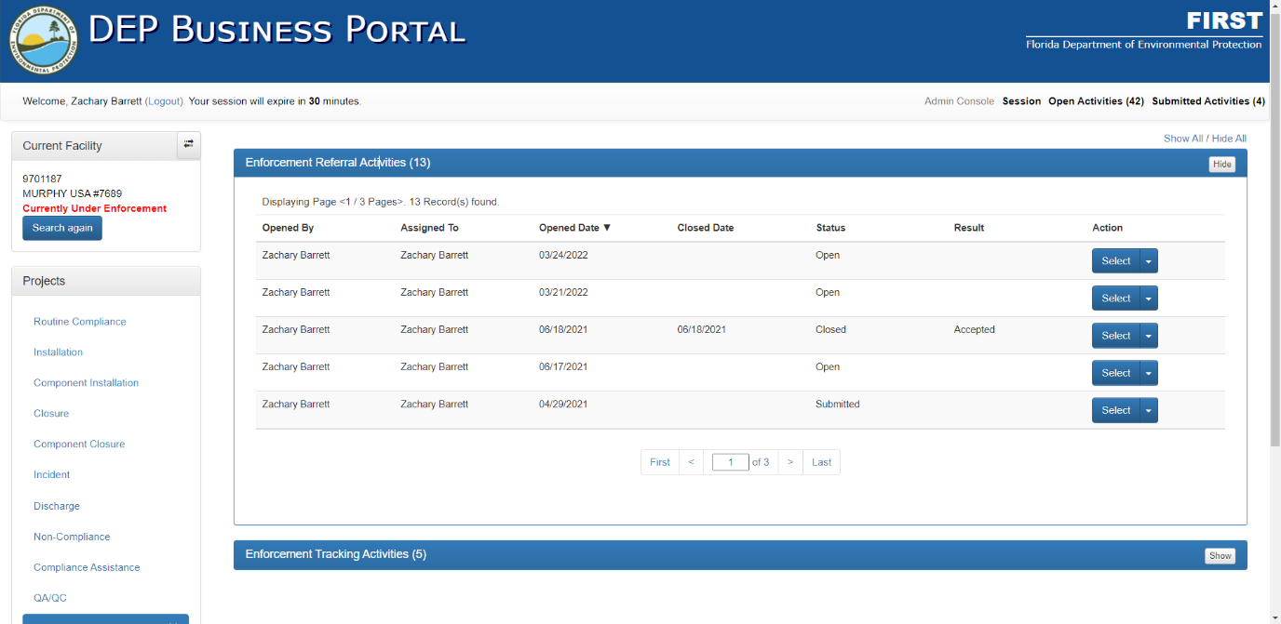
Figure 182: Enforcement Referral Activities

- After selecting the desired enforcement referral activity or initiating a new referral, the following sections can be expanded by clicking the header or the Show button to view and enter information related to the discharge:
  - Status Changes (auto-generated information) – this section tracks the actions taken with the referral. It will track when the referral is submitted and assigned and when it is accepted, rejected, or withdrawn.
  - AOCS/Violations – all AOCs and Violations cited at the facility will be displayed in this section. It will display the date cited, citation type, status, significance, description, etc. From this section new AOCs/violations can be added or resolved as needed.
  - Comments – within this section, any comments related to the enforcement referral should be added.
  - Attachments – within this section, any attachments related to the enforcement referral should be added.
  - Approval – in this section, the approver will be able to accept, return, or reject the enforcement referral by:
    - need to assign themselves as the approver and click Go.
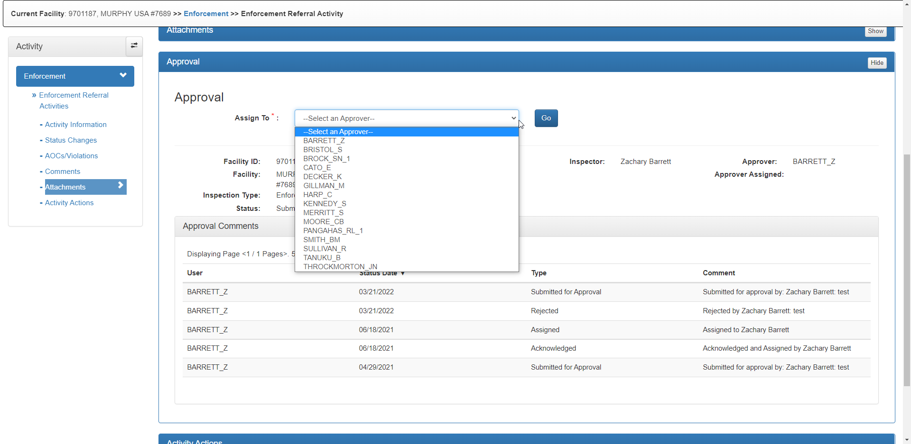
Figure 183: Approver Assign

    - After assigning the referral, the approver can Accept, Reject, or Return the referral using the dropdown box.
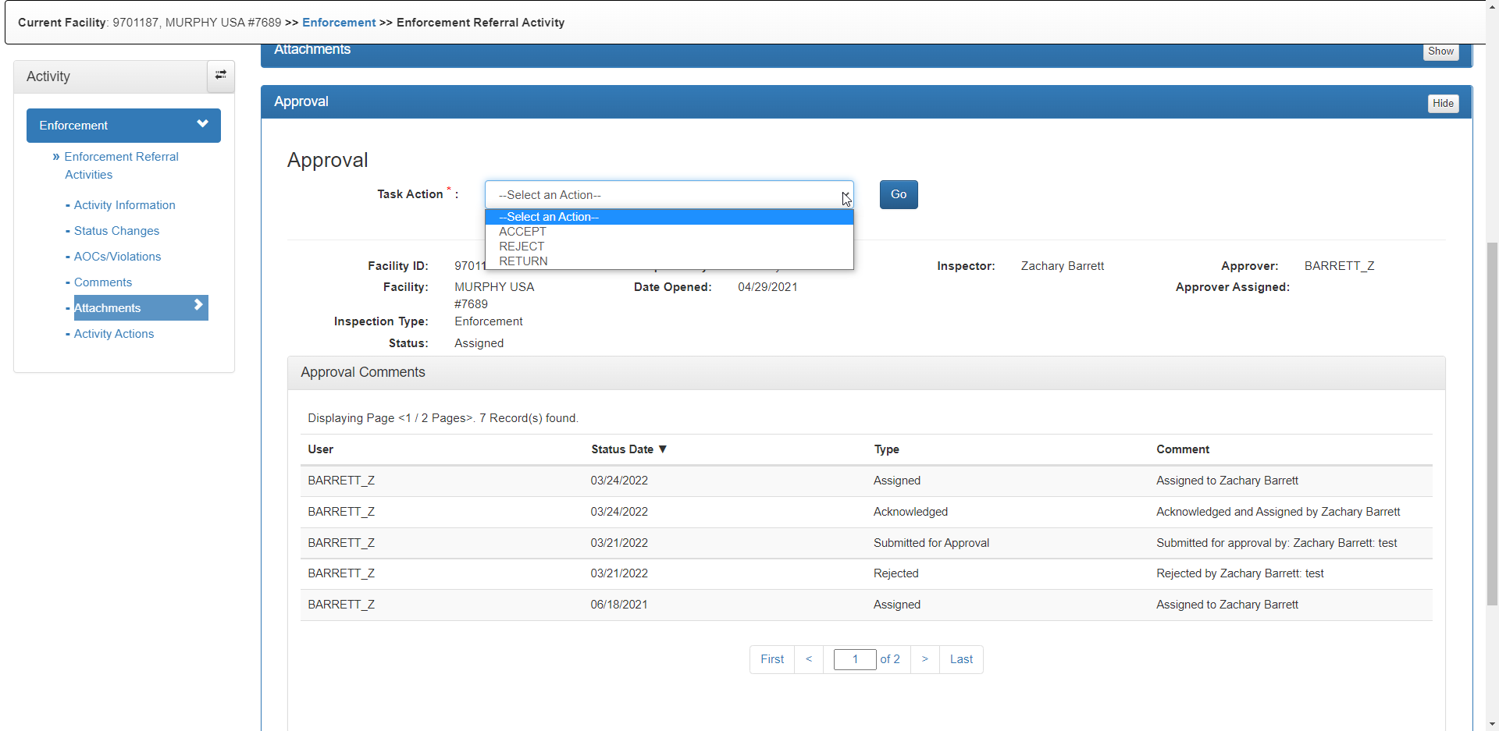
Figure 184: Approval Task Action
    - Once the desired task action is selected, click Go, enter a task comment, and click Save. After accepting the referral, an Enforcement Tracking Activity is automatically initiated with the opened date being the same as the closed date for the referral.
  - Activity Actions – this section contains all actions for the referral including the buttons Save, Cancel, Submit, Re-Assign Activity, and Exit.

- After the referral has either been accepted, rejected, or returned (in this example we are accepting the referral) click Exit in the Activity Actions section to return to the Enforcement Project main page.

Enforcement Tracking
If a facility has been referred for enforcement and has been accepted, follow the steps below for tracking the enforcement activity and recording the relevant information:
- Click Enforcement Tracking Activities or the Show button to expand the Active Window.

- After accepting the referral, an Enforcement Tracking Activity will be automatically initiated. Click the Select button beside the desired enforcement activity and the Enforcement Tracking Activity Active Window will appear.

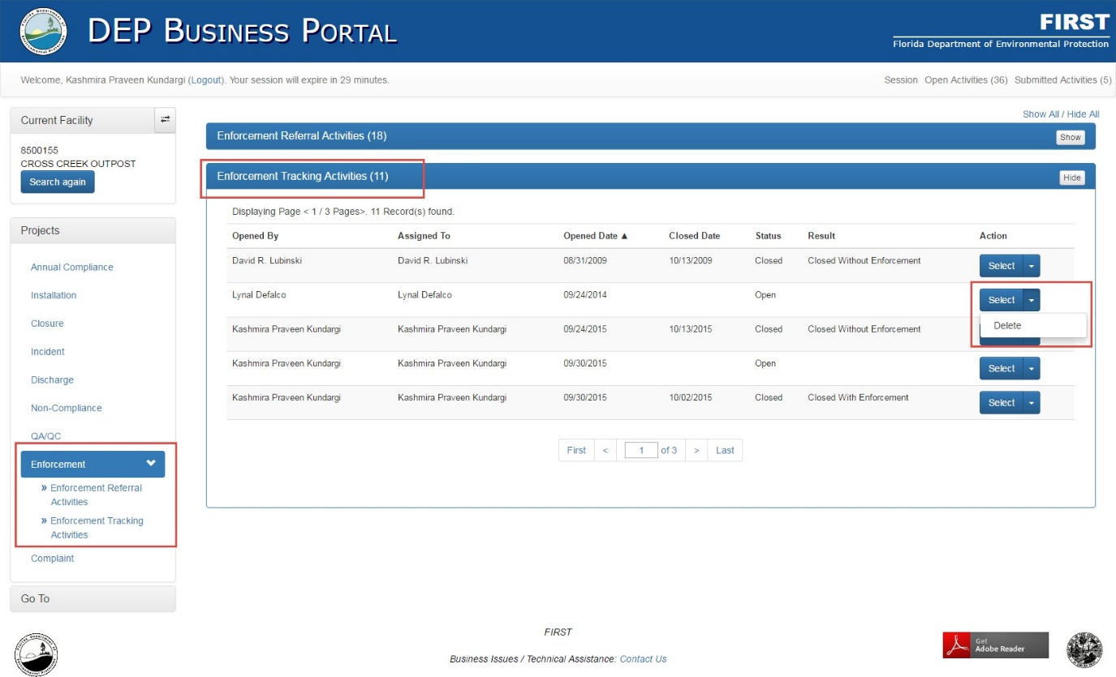
Figure 185: Enforcement Tracking Activities

- After selecting the desired enforcement referral activity or initiating a new referral, the following sections can be expanded by clicking the header or the Show button to view and enter information related to the discharge:
  - Activity Information (auto-generated information) – general information related to the enforcement tracking activity will be presented in this section. The only fields that are editable are Enforcement Closed Date (only to be filled out once the enforcement tracking activity is ready to be closed) and OGC Case Number (only to be filled out if the activity is case reported to OGC and the OGC Case Number has been received).
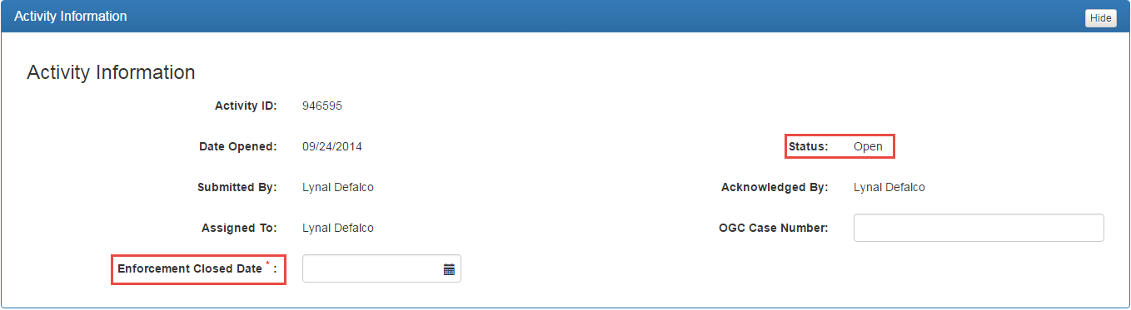
Figure 186: Activity Information
  - Case Actions – this section is used to track any actions taken for the enforcement case, such as Warning Letters, Notice of Violations, Consent Orders, Case Reports, Consent Final Judgements, etc.
    - Case Actions can be added by clicking Add Case Action.
    - Select the desired case action from the dropdown box.
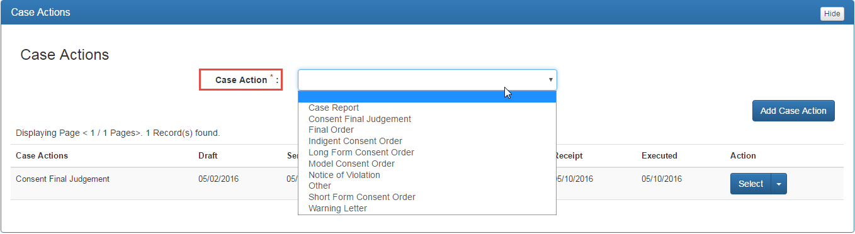
Figure 187: Adding Case Actions

    - Enter the dates required for the selected case action.
    - Click Save to add the case action.
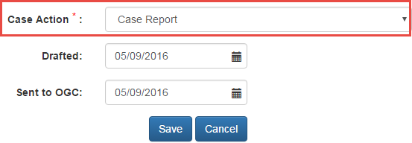
Figure 188: Enter Case Action Data
  - Penalties – this section is used to record information pertaining to the penalties being assessed to the facility. (THIS SECTION IS NOT REQUIRED)
  - Corrective Actions – this section is used to record corrective actions required by the facility to return to compliance. (THIS SECTION IS NOT REQUIRED)
  - Inspection Activities, Meeting Activities, Phone Activities, Letter Activities, Electronic Communication Activities, Document Management Activities, Issue Document Activities, Record Document Activities, AOCs/Violations, Comments, Attachments – these sections are explained in Chapter 3.
  - Activity Actions – this section contains all actions for the referral including the buttons Save, Close with Enforcement, Close without Enforcement, Re-Assign Activity, and Exit.

- After the referral has either been accepted, rejected, or returned (in this example we are accepting the referral) click Exit in the Activity Actions section to return to the Enforcement Project main page.

Chapter 5
Additional Notes & Guidance
TO BE ADDED AS NEEDED

