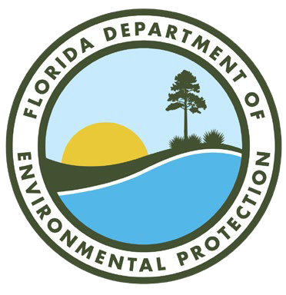
FLORIDA DEPARTMENT OF

Environmental Protection
Bob Martinez Center 2600 Blair Stone Road
Tallahassee, FL 32399-2400
Ron DeSantis
Governor

Jeanette Nuñez
Lt. Governor

Shawn Hamilton
Secretary

HEARING AGENDA
Voluntary Cleanup Tax Credit (VCTC) Rulemaking
DEPARTMENT OF ENVIRONMENTAL PROTECTION
Florida DEP Douglas Building 3900 Commonwealth Boulevard
First Floor Conference Room 137
Tallahassee, Florida

Tuesday, November 9, 2021
9:00 am to no later than 12:00 pm
Remote Attendance – Microsoft Teams
Call In (Audio Only) Phone: 850-629-7330
Phone Conference ID: 632 372 404#

THIS MEETING IS OPEN TO THE PUBLIC

- Call to order and indicate meeting is being recorded, statement of purpose of hearing and indicate the date the meeting was published in the Florida Administrative Register (FAR).
  - Purpose of hearing: The Department is holding a public hearing on Chapter 62-788, Florida Administrative Code, concerning adoption of rules for the VCTC program.
  - Date notice of hearing was published in the FAR: October 13, 2021
- Introduce Department Staff
- Overview of Proposed VCTC Rules
- Receive Public comments on VCTC Rules
- Adjourn

Additional Information:
- Rulemaking documents:
https://floridadep.gov/waste/waste-cleanup/content/VCTC%C2%A02021-rulemaking
- VCTC Contacts:
Scott Sweeney, VCTC Program Manager, Scott.L.Sweeney@FloridaDEP.gov
Jennifer Farrell, Program Administrator, Jennifer.A.Farrell@FloridaDEP.gov

