# ***STANDARD FIELD PROCEDURES FOR WATER QUALITY MONITORING***

# ***WITH YSI Multi-Parameter Instrument***

**for the**

**CHARLOTTE HARBOR ESTUARIES VOLUNTEER**

**WATER QUALITY MONITORING NETWORK (CHEVWQMN)**

**Updated October 5, 2017**

**Prepared by**

**FLORIDA DEPARTMENT OF ENVIRONMENTAL PROTECTION**

**Charlotte Harbor Aquatic Preserves**

**12301 Burnt Store Rd. Punta Gorda, FL 33955**

**phone: (941) 575-5861**

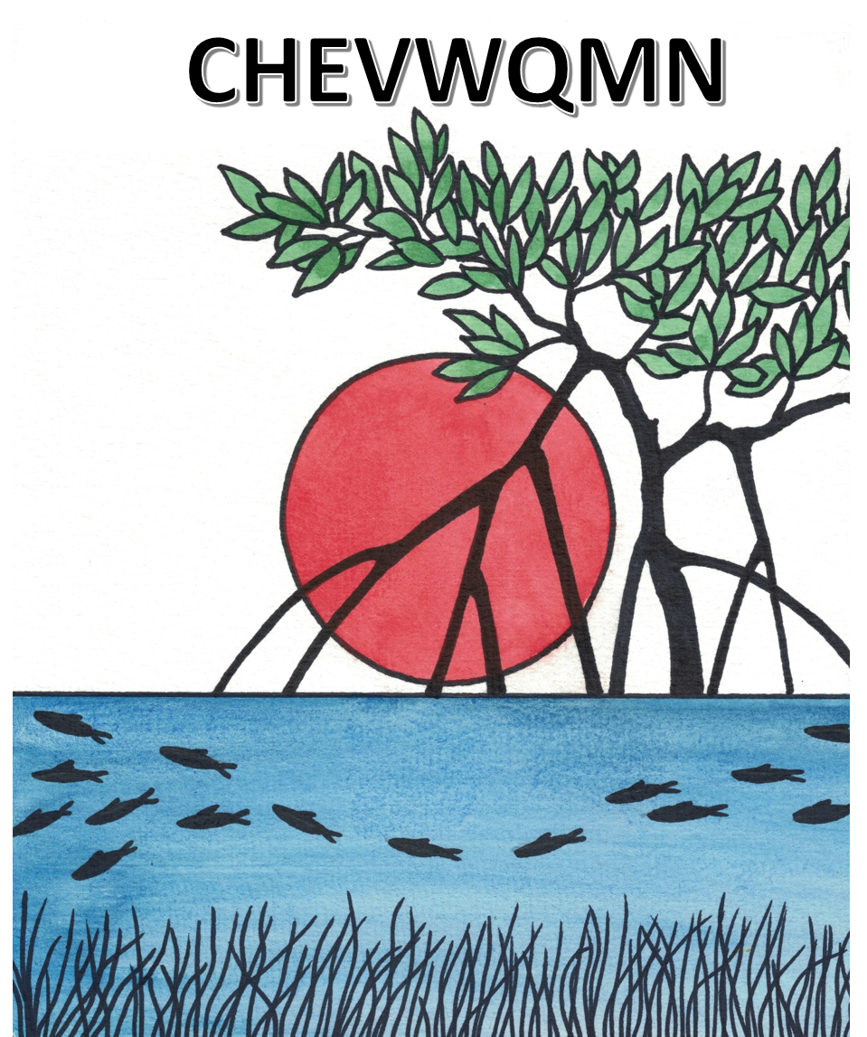





***In cooperation with:***

**ESTERO BAY AQUATIC PRESERVES**

**700-1 Fishermans Wharf**

**Ft. Myers Beach, FL 33931**

**phone: (239) 530-1002**

**and**

**CHARLOTTE HARBOR ENVIRONMENTAL CENTER**

**PO Box 5197**

**Englewood, FL 34224**

**phone: (941) 475-0769**

|  |  |
| --- | --- |
| **F** | **C** |
| 49 | 9.0 |
| 50 | 10.0 |
| 51 | 10.5 |
| 52 | 11.0 |
| 53 | 11.5 |
| 54 | 12.0 |
| 55 | 13.0 |
| 56 | 13.5 |
| 57 | 14.0 |
| 58 | 14.5 |
| 59 | 15.0 |
| 60 | 15.5 |
| 61 | 16.0 |
| 62 | 16.5 |
| 63 | 17.0 |
| 64 | 18.0 |
| 65 | 18.5 |
| 66 | 19.0 |
| 67 | 19.5 |
| 68 | 20.0 |
| 69 | 20.5 |
| 70 | 21.0 |
| 71 | 21.5 |
| 72 | 22.0 |
| 73 | 23.0 |
| 74 | 23.5 |
| 75 | 24.0 |
| 76 | 24.5 |
| 77 | 25.0 |
| 78 | 25.5 |
| 79 | 26.0 |
| 80 | 26.5 |
| 81 | 27.0 |
| 82 | 28.0 |
| 83 | 28.5 |
| 84 | 29.0 |
| 85 | 29.5 |
| 86 | 30.0 |
| 87 | 30.5 |
| 88 | 31.0 |
| 89 | 31.5 |
| 90 | 32.0 |
| 91 | 33.0 |
| 92 | 33.5 |
| 93 | 34.0 |
| 94 | 34.5 |
| 95 | 35.0 |
| 96 | 35.5 |

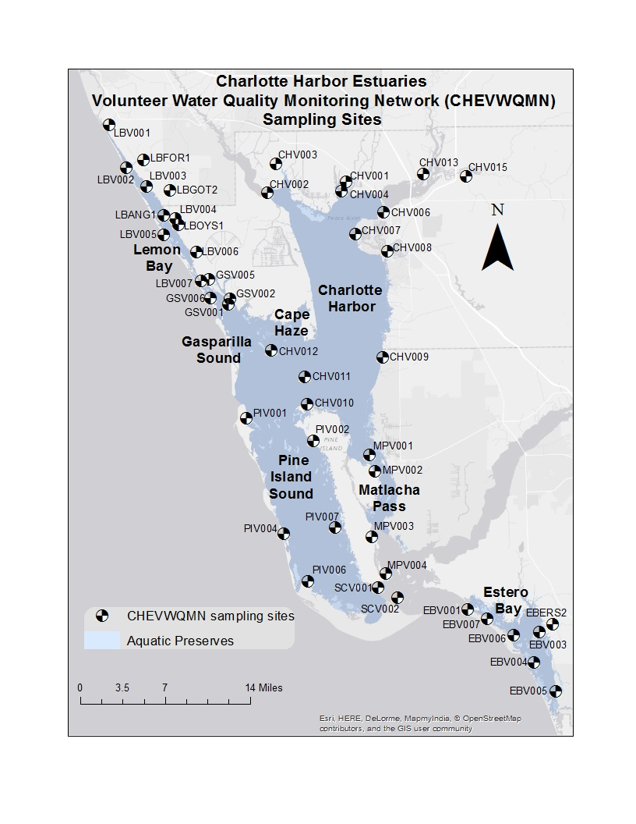

Introduction

**Purpose:** The Charlotte Harbor Estuaries Volunteer Water Quality Monitoring Network (CHEVWQMN) has been following the Standard Field Procedures for Water Quality Monitoring since 1996. These Procedures are an integral part of the approved Quality Assurance/Control (QA/QC) Plan for the CHEVWQMN. Each step of these Procedures is important for collecting accurate, precise and reliable water quality data, as well as assuring consistency between water monitors. Please refer to these Procedures in the field when conducting water monitoring.

**Parameters:** The complete set of parameters included in these Procedures is necessary to fully characterize water quality in the estuaries. The parameters and methods were chosen because of their role in determining estuary health, as well as the ability to collect them reliably. Some analyses are conducted in the field and some are conducted in the laboratory from samples collected in the field. The field parameters include weather conditions, air temperature, precipitation, tide stage, water depth, water temperature, water clarity (Secchi depth), dissolved oxygen and pH. The laboratory parameters include water color, turbidity, nitrogen, phosphorous, chlorophyll and fecal coliform bacteria.

Dissolved oxygen is important for invertebrate and fishery viability. Water color, turbidity and chlorophyll affect light availability for important seagrasses. Nitrogen and phosphorus affect marine plant growth and elevated levels can cause excess algae growth. Fecal coliform bacteria indicate the amount of human and mammal wastes carried into the estuary with stormwater runoff, septic system leaching and other sources. Salinity, color, nutrients and bacteria levels reflect freshwater inflows from the watershed. Sustainability of estuary health depends on identifying and correcting human sources of changes to water quality and quantity from the watershed.

**Guidelines:** Please follow these Procedures carefully for properly conducting field monitoring and collecting and preserving laboratory samples. The laboratory analyses for chlorophyll, nitrogen, phosphorus and bacteria must be collected carefully in the field to avoid contamination. Pre-cleaned, pre-preserved bottles for chlorophyll, nutrients, color, turbidity and bacteria are provided each month in a bag in a small cooler. The bottles are to be filled according to steps U-Z on pages 11 and 12 of these Procedures. The samples are returned to the bag in the cooler and surrounded with ice cubes. **Each water monitor is responsible for transporting their samples to the local collection location within 1 hour of sampling**. CHEVWQMN staff will then transport the samples to a local lab for analysis of fecal coliform within the required sample holding time, while the other samples will be sent to the Department of Environmental Protection Lab in Tallahassee.

In addition, usually once or twice a year, each sampling site will receive an extra cooler of sample bottles to use for collecting a field duplicate or laboratory blank sample for the chlorophyll, color, turbidity, nutrients and bacteria analyses. These Duplicates and Blanks are a critical step in the QA/QC process that validates the samples are technically sound. The instructions for collecting the Blank samples are given in Step G, page 7 and 8, of these Procedures. Instructions for collecting Duplicates are given in Step AA on pages 12.

**Note:**  To validate the data and fulfill the QA/QC plan, monitors are required to attend two bi-annual Quality Assurance sessions. These sessions are important in order to conduct annual audits on the data being collected, review and update sampling procedures, exchange information, and compare QA sampling results for precision and accuracy. Your local coordinators will inform you of the dates, in advance, of the Spring and Fall QA sessions. Choose one of the four local meetings in Englewood, Matlacha, Punta Gorda or Estero, to attend. Please bring all of your sampling equipment to the QA session so that you will be able to complete a full test.

THE DAY BEFORE SAMPLING

**A. Empty rain gauge early in the morning.**

**B. Check newspaper for sunrise time and weather report for the following day.**

**C. Check tide chart for following day.**

**D. Make arrangements to meet your sampling partner the next day.**

**E. Freeze water for ice cubes.**

**F. Prepare sampling gear. Do you have:**

1. safety equipment (gloves, goggles, flashlight, pocket knife needed?)
2. field procedures
3. clip board & pen
4. data sheet
5. compass
6. wind speed chart
7. rinsed and dried plastic bucket provided
8. Secchi disk and attached graduated rope
9. YSI Pro-Plus multi-parameter instrument
10. Conductivity standards (50.0 for calibration and 10.0 for verification)
11. pH standards- pH 7 and pH 10 bottles, and pH 4 bottle if applicable
12. De-ionized (DI) water for rinsing probes
13. cooler with bag containing: acidified nutrient bottle (white), chlorophyll bottle (brown), color/turbidity bottle and small fecal coliform bacteria bottle
    * 1. *check for correct site number on coolers & bottles- make changes if necessary*
14. extra duplicate cooler or blank cooler (with DI water jug) if scheduled

**G. Check YSI Instrument and probes** (night before sampling for preventative maintenance)

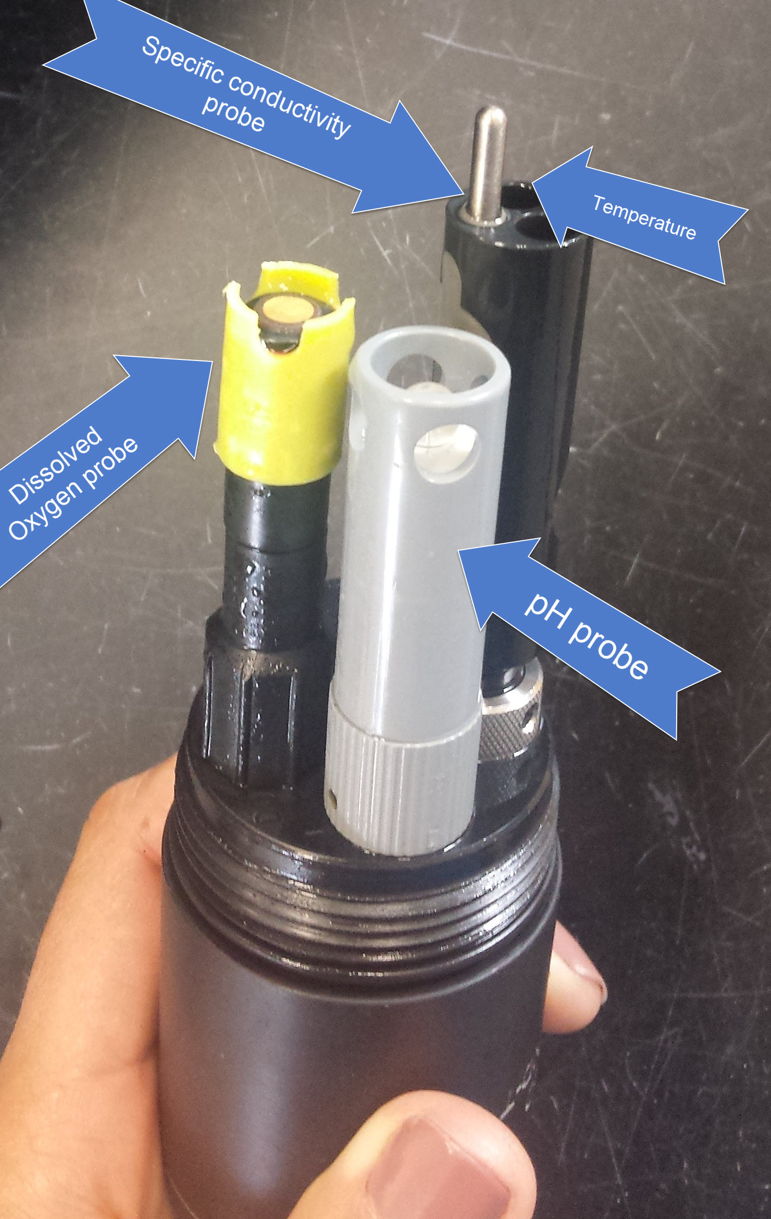

* 1. Check DO probes with yellow cap- If you see white crust/precipitate on the outside of the probe or membrane, then you need to either replace the membrane cap if it’s torn or replace the DO solution inside. Bring the instrument back to your coordinator the morning of sampling and have them look at the meter.
  2. Turn on the meter- Look to see the battery icon on the corner of the screen. If this is less than 50%, it is recommended to replace the batteries. Replace with 2 C batteries. After new batteries are in the meter, you will have to enter the Date and Time before going to the main screen.

**H. Check/Calibrate/ICV Specific Conductance-**

*A 1 point calibration conducted* *at home the night before or the morning of sampling.*

1. Empty the water in sensor storage container and fill 1/4 of the way with the 50-conductivity rinse solution. Rinse the black probe and holes thoroughly, and finally pour the conductivity solution from the container over all of the probes to rinse them as well.
2. Fill the container 2/3 with new conductivity solution and place the probes into the solution. **Make sure the conductivity sensor and hole are submerged in solution, and check to make sure there are no air bubbles in the hole.** Also ensure that the temperature probe is submerged, otherwise the readings will be incorrect.
3. Turn on the YSI meter by pushing the green power button. If additional lighting is needed to see the screen, push the ‘sun/lamp’ button.
4. Allow a few minutes for the Sp. Cond. and temperature values to stabilize (i.e. until the values do not change).
5. When the Sp. Cond. value is stable, record value on the datasheet: In the Specific (Sp.) Conductance box, on the **Check row,** under the50.0 standard column. Record the Date and Time of Check on the same line.
6. **Calibration:** Press the Cal button and select **Conductivity** then press Enter. Next, select **Sp Conductance** by highlighting it using the arrow buttons and then press Enter. Finally, choose **SPC-mS/cm** (second option). Press Enter.
7. Check to make sure the **Calibration Value** at the very top of the screen reads [50.0]. If the calibration value is not [50.0], highlight the reading at the top using the arrow buttons, press Enter and change value to 50.0 using the up/down and left/right arrow buttons.
8. Highlight **Accept Calibration** and press Enter. Once calibration results have been saved, the meter will automatically go back to the main screen.
9. Record the Date and time of Calibration on the **Calibrate** lines. Note- no calibration values need to be recorded.
10. **Initial Calibration Verification (ICV):** From the main screen, record the current Sp. Conductivity value, for the ICV, 50 standard column (it should read within hundredths of 50.0).
11. Record the date and time of the ICV, and the lot number of the 50-conductivity standard in the top of the Sp. Conductance box.

I. **Check/Calibrate/ICV pH-**

*A 2 point calibration conducted the night before or day of sampling*

1. Rinse probes with DI water. Fill sensor storage container 1/4 full with rinse pH 7 standard and rinse the probes thoroughly. Pour the pH 7 standard from the sensor storage container over the probes. Refill sensor storage container 1/2-2/3 full with *fresh* pH 7 and screw back onto the sensor storage container. Make sure the bottom of the pH probe (grey with 4 holes along bottom) and the temperature probe are submerged in the solution.
2. Allow the pH value to stabilize, this may take a couple minutes.
3. Record the Date and Time of the pH check in the **pH** box on the **Check** row.
4. Once the pH value is stable, record the pH value for **Check,** under the **7 buffer** column.
5. Rinse probes with DI water, then with rinse pH 10 standard and Pour the pH 10 standard from the sensor storage container over the probes. Then place probes in container filled with fresh pH 10 standard. Allow value to stabilize and record the value for **Check, under pH 10 buffer column**. If *both* 7 and 10 check values are within 0.2 of the standard (6.8-7.2 and 9.8-10.2) then a calibration is not needed; skip steps 6-15 and write N/A across the Calibrate and ICV rows.
6. Gives the reader and example of the screen to expect when calibrating for pH. **Calibration**: If you need to calibrate, store the pH 10 in a cup for rinse later. Re-rinse the sensor storage container and probes with DI and pH 7 rinse. Then add fresh pH 7 standard to sensor storage container. Ensure the pH probe is covered. Press Cal, **highlight ISE (pH)** using the arrow buttons and press Enter. A message will show towards the bottom on the meter screen stating, “Ready for point 1”.
7. Check the Calibration Value at the top of the screen to confirm it’s [7.01]. If not, highlight Calibration Value, press Enter and input 7.01 using the arrow and enter buttons.
8. Highlight **Accept Calibration** and press enter. The message at the bottom will now say “Ready for point 2”, which means you will calibrate to pH 10 next.
9. Empty the pH 7 standard from sensor storage container (or pour into extra cup to use later for rinsing/verification). Rinse the probes and container with DI and refill a small amount of pH 10 for rinsing. After rinsing container and pH probe, pour the rinse pH 10 standard onto the probes. Refill storage container 1/2 full with *fresh* pH 10 standard. Ensure the bottom of the pH and temperature probes are fully covered.
10. The instrument should automatically recognize the pH 10.
11. Verify that the Calibration value (at the top) reads [10.01]. If incorrect, highlight Calibration value and press enter, then input 10.01 using the arrow and enter buttons.
12. **Highlight Accept Calibration and press enter** to confirm calibration.
13. **Press Cal to complete calibration**. It will then save your calibration values for both pH 7 and 10 and switch back to the main screen.
14. Record Date and Time for pH Calibration on the **Calibrate** line. No calibration values need to be recorded.
15. **Initial Calibration Verification (ICV):** With the meter still in the pH 10 solution, **record** the value it is reading on the **ICV** row under the **10 buffer column**. Record the date and time of ICV.
16. Empty 10 standard (or save in extra cup, if the pH 7 wasn’t saved, for verification), rinse probes with tap water and refill storage container with 1/8 full with tap water for overnight storage.
17. Record the lot numbers of the pH 7 and 10 standards.

ON SAMPLING DAY (i.e. THE FIRST MONDAY OF THE MONTH)

1. **Safety First:** It is up to each individual monitor to determine if weather conditions permit for safe sampling at their site. Sampling will NOT be made up the following day. The consistent sampling time for all sites throughout CHEVWQMN is designed to give a uniform time ‘snapshot’ of water quality conditions throughout the region.
   1. **When using standards:**
      1. Store all standards away from children and animals in a cool dry place.
      2. The use of gloves is suggested while handling standards. If you get any chemicals on your hands or face thoroughly rinse immediately with water.
      3. Dispose of used standards in sink.
2. **Fill your cooler with ice,** completely surrounding the bag of sample bottles**. Recheck your gear before you leave home.**
3. **Complete the top part of the Data Sheet** with site number, date, name of the monitor collecting data with the meter, name of the monitor collecting water samples, estuary region, waterbody name, and YSI ProPlus meter #.
4. **Check the rain gauge** and record the amount of precipitation in the last 24 hours on the data sheet. If unknown put N/A.
5. **Bring your YSI ProPlus instrument with the extra cups of conductivity standard(s) and either the pH 7 or 10 standard, along with your other gear to your sampling site.**
6. **Drive and walk to your site, arriving within 1/2 hour of sunrise.**
   1. As you walk to the site, observe the wind speed effect on trees around you.
   2. When you get to the site, observe the starting tide level & if the pilings are wet or if barnacles are exposed.

**G. Collect the Blank Sample if you have a blank cooler**. If not proceed to step H.

**IMPORTANT**: If you have received a blank cooler, collect the Blank sample **prior** to normal sampling, before the bucket has been used to collect a water sample. The purpose of collecting a blank sample at a site is to assure that our field equipment isn’t contaminating the samples.

**To collect the Blank sample:**

1. Make sure you have a second cooler marked “Blank” with a set of sample bottles, surrounded by ice and a jug of De-ionized Water (DI) from the laboratory. (Use the jug of DI water provided marked with your site number only- not a personal supply.)

2. Prior to sampling, rinse your sample bucket 2 times with a small amount of DI water. Make sure to

rinse all sides of the bucket. Discard the water each time.

3. Fill the sample bucket with all of the remaining DI water from the jug provided. Record the time at the bottom of the datasheet next to ‘Blank Collected?’ and on all bottles. Circle Yes for each parameter/Blank bottle that is filled, below. Circle Y next to ‘Blank Collected?’

1. Rinse the brown chlorophyll bottle 2 times with a small amount of the DI water from the bucket & discard. Fill the bottle at least 2/3 full leaving about an inch of space below neck. You can fill the bottle to the top and then pour water out to reach appropriate level.

5. Repeat step 4 for the color/turbidity bottle.

6. Do not rinse small bacteria bottle, remove cap and fill to 100mL line near the top.

7. Pour the DI water into the white nutrient bottle (with the yellow sulfuric acid sticker) next. Fill the bottle 2/3 full (to the top of white label) leaving about an inch of space. Do **not overfill or rinse this bottle** because the acid preservative will be lost. If this bottle is rinsed or overfilled, please note at the bottom of the datasheet.

8. Place the sample bottles into a bag provided in the “Blank” cooler and ensure samples are

surrounded with ice.

9. Make another copy of the data sheet, by hand or Xerox, to put in the pocket of the “Blank” cooler.

10. Deliver blank cooler and empty DI jug to the local drop off point along with normal sample cooler.

**H. Record the Start Time and Sunrise Time on the Data Sheet.**

**I. Observe the Wind Direction and Speed:**

1. Find the direction the wind is coming from by turning your face back and forth into the wind until

you find the direction the wind is the strongest. Use a compass to determine the direction the

wind is coming from & record on the data sheet.

2. Use the Beaufort Scale handout (page 16) to use visual observations of smoke, leaves and trees to estimate the wind speed and record the speed on the data sheet.

**J. Observe the Weather Conditions** and record them on the data sheet. Remember, any clouds in the sky count as ‘partly cloudy’ category.

**K. Check to make sure you recorded the precipitation amount** from the last 24 hours if you know what it is within 2-3 miles of your sampling location.

**L. Measure the Air Temperature.** Turn on the YSI, unscrew and take the cup off and place in a

shaded spot. Shake off any excess water on the silver temp. probe. Let the reading stabilize and record onto the datasheet under Air Temp.

**M. Calibrate/ICV Dissolved Oxygen (DO)** *–* ***Calibrate/ICV and verify DO *on site\****

* 1. Make sure there are no water droplets on the DO membrane or temperature sensor.
  2. Place the probes back into the storage container and confirm there is a small amount of *tap water* (not DI) in the bottom (about 1/8th of an inch of water).
  3. Do not screw the cup all the way on the probes. Ensure it is resting in the cup, loose enough for proper venting. Check to make sure that none of the probes are touching the water in the bottom of the cup.
  4. Allow 5-15 minutes for DO to stabilize. Note- the colder the temperature, the longer it takes to stabilize.
  5. **Calibration**: Press the Cal button at the top of the meter. Select *DO* then press *Enter*. With the arrow buttons, press down until DO % is highlighted, then press enter.

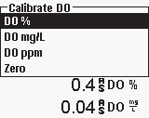

* 1. Record the Barometer reading at the top of the Dissolved Oxygen section on the datasheet. The Barometer reading does not have to be changed.
  2. Gives an example of what the volunteer will expect to see when calibrating for Dissolved Oxygen. Volunteers are expected to select the second option, "Accept Calibration". Record the Air temp (under the Actual Readings), on the Calibrate line, as well as the Date and Time of Calibration. Note that the Air Temp in this step refers to the temperature in the cup and not the ambient air temperature.
  3. Highlight **“Accept Calibration” and press Enter**. This will calibrate DO close to 100% saturation. Allow probe to save configuration and the screen will go back to the main menu and the calibration is complete. No calibration readings need to be recorded.
  4. **Initial Calibration Verification (ICV):** From the main screen, record the current **DO mg/L, DO%** **and Air Temp** values, for the **DO ICV** on the datasheet.
  5. Record the Date and Time of ICV as well.

**N. Observe the Water Surface Conditions** and record on the data sheet.

**O. Observe the Tide Stage at Your Site:**

1. It is important to record the tide stage observed at your site, because it may be different than reported in your local newspaper. Note if the water level has come up or down since you observed it as you were walking to the site. Are more or less barnacles exposed or is the wet area of the pilings greater or smaller?

2. If there is a noticeable change in the tide level, record it appropriately as incoming or outgoing.

3. If there is not a noticeable change in the tide level, wait until later in the sampling session and observe it again. If there is still no noticeable change in the tide level upon departing the site, it may just be a period of slack tide.

**P. Measure the Water Temperature, Dissolved Oxygen, pH and Salinity.** After successfully calibrating for DO, pH and Sp. Conductance, collect water quality readings directly from the estuary.

1. Carefully screw the probe guard (black with holes) onto the sensors.
2. Submerge the probes at 0.5m depth (marked off with zip tie).
3. Values will be displayed on the main display screen. Confirm that the main menu display has all the parameters that you will need: temperature in C°, DO%, DO mg/L, pH, salinity, Sp Cond mS/cm (specific conductance).
4. Allow readings to stabilize (especially temperature and DO) and **record the water temperature,**

**DO mg/L, DO % sat, pH, Salinity ppt *and*****Sp.Conductance** readings under the far right column of the datasheet. Note- if in swift moving waters, DO may fluctuate slightly.

1. After collecting measurements, take off the black probe guard, **rinse all probes,** probe guard and cable (not the meter) with tap water.

**Q. Verifications-** *conducted onsite after estuary measurements*

* 1. **Verify DO first**- Place the probes back into the storage container and confirm there is a small amount of *tap water* (not DI) in the bottom (about 1/8th of an inch of water). Do not screw the cup all the way on the probes, ensure it is resting in the cup, loose enough for proper venting. Check to make sure the DO probe (with yellow cap) and the conductivity probe are not touching the water. Allow 5-15 minutes for DO to stabilize. Note- the colder the temperature, the longer it takes to stabilize.
     1. Allow for temperature and DO to stabilize, then record **DO mg/L and % value and temperature** for DO **Verify**.
     2. Record Date and Time in the Dissolved Oxygen Box next to Verify.
     3. Reference the chart on page 15 to ensure the verification value **is within +/- 0.3 mg/L of the value on the chart** for the air temperature in the cup. If the value for DO is not +/- 0.3 mg/L from the value on the chart (failure), recalibrate for DO and retake DO estuary reading. Then, redo verification as well, crossing off old values to maintain record of actions. Do not obliterate any data by erasing or scribbling out.
  2. **pH verification**- Use pH 7 or 10 to verify. *If the estuary pH measurement was less than 7, use pH 4 to verify for proper bracketing.*
     1. Record the Date and Time in the pH box next to Verify.
     2. Rinse calibration cup with small amount of pH 7 or 10 (or 4) standard, and be sure to rinse the probes as well. Pour pH standard into rinsed storage container- same amount as calibration. Allow temperature and pH to stabilize and make sure the holes on the bottom of the gray pH probe sensor are submerged by the standard. **Record pH value for pH Verify and confirm that value is within +/- 0.2 of the standard** (for pH 4: 3.8-4.2/ pH 7: 6.80-7.20/ pH 10: 9.80-10.20). If the verification does not pass: recalibrate, take new pH estuary measurements and verifications, crossing off old values to maintain record of actions. Do not obliterate any data by erasing or scribbling out.
  3. **Sp. Conductance verification-** Rinse probe and cup with tap water then with Conductivity 10 rinse. Pour fresh 10.0 **standard** into the rinsed storage container.
     1. Allow conductivity to stabilize, making sure the hole in the black conductivity/temperature probe is completely covered by the standard, then **record the value in the Sp. Conductance box on the Verify line.**
     2. **Value must be between 9.5-10.5 mS/cm** (5% of the 10.0 standard). If the verification does not pass, recalibrate and take new salinity estuary measurements and verifications, crossing off old values to maintain record of actions. Do not obliterate any data by erasing or scribbling out.
     3. Record the verification date and time on the Verify line.
     4. Record the lot# for the 10.0 standard on the line next to “10:” at the top of the Sp. Conductance box.
  4. You’re done verifying! Turn off meter and rinse probes with DI or tap water. Pour about a ½ inch of **tap water** into the clear storagecontainer and screw back onto the probes for storage.

**R. Observe & Record Apparent Water Color** by lowering the Secchi disk into the water & noting the water color above the white sections of the Secchi disk. Lower the disk to the sampling depth of 0.5 meters or about 1.5 feet. Use your best judgment about which of the color choices on the data sheet the apparent water color is closest to or circle “other” and write in a more descriptive color.

**S. Observe Tide Stage** based on the tidal changes that occurred during your sampling time. Record the tide as incoming, high slack, outgoing or low slack on the data sheet.

**T. Record Any Additional Comments and Observations**- odor, film, dead fish, any problems while sampling, wildlife observed, etc.

**U. COLLECT WATER SAMPLES FOR LABORATORY ANALYSIS:**

**-**Find the cooler marked with your site number and follow directions below.

* 1. Using the plastic bucket provided, rinse with estuary water 2 times. It is important that you do not contaminate the water for laboratory analysis by putting your hands into it or along the top rim of bucket.
  2. Submerge the bucket 1.5’ down into the estuary, from an undisturbed area of water away from the discarded water from Step 1. Carefully fill and raise bucket.
  3. **Note the time and record on the datasheet under Samp. Collect. Time and on all the bottles.**

**V. Collect Chlorophyll sample:**

1. Find the large brown chlorophyll bottle and pour a small amount of water from the bucket into it.
2. Replace the cap, shake and discard away from bucket. Repeat for a second rinse.
3. Fill the chlorophyll bottle 2/3 full or to the shoulder of the bottle- leaving an air space for the chemist to mix sample thoroughly. This can also be done by overfilling the bottle and pouring off a small amount.
4. Cap tightly and place in bag in cooler surrounded by ice.

**W. Collect Nitrogen/ Phosphorous sample:**

1. Find the white bottle with a yellow sticker indicating it has acid for preservation. Check label for proper site number and date, fill in if blank. Let the bottle sit upright before taking cap off so acid can drain down. If you get acid on hands flush thoroughly with estuary water and don’t touch your eyes afterward.

2. Please **do not rinse this bottle** because it will remove the acid preservative.

Carefully pour water from bucket into bottle, up to the shoulder, leaving about an inch of air space at the top. **Be careful not to overfill** this bottle because it will wash out the acid preservative. If bottle is accidentally rinsed or overfilled please make note at the bottom of the datasheet under **Observations and Comments**.

3. Cap bottle tightly and place in bag in cooler.

**X. Collect Color/Turbidity sample:**

1. Find the small color/turbidity bottle.
2. Pour a small amount of water from the bucket into the bottle. Replace the cap, shake and discard away from bucket. Repeat for a second rinse.
3. Fill the bottle to the shoulder leaving an air space on top.
4. Cap tightly and place in bag in cooler.

**Y. Collect Fecal Coliform Bacteria sample:**

1. Twist the cap off the small bottle to break the seal.

2. Do not rinse, fill the bottle to the 100mL line (near the top) and replace cap.

3. Place bottle in bag, **close bag and ensure ice completely surrounds bottles**.

**Z**. **Circle Yes for all sample bottles collected and ensure all sample bottle times match time recorded on the datasheet. Cover bag of bottles with ice and close cooler.**

**If you received a Duplicate cooler, follow instructions AA. If not move on to Step AB.**

**AA. Collect the field duplicate sample:**

The purpose of collecting the field duplicate sample is to assure consistency in both the field sampling & lab techniques. To collect the duplicate sample, follow steps below:

1. Make sure you have a second cooler marked “Duplicate” with an extra set of sample bottles in a bag and ice.

2. After sampling and filling the regular bottles for lab, empty the water from the bucket. *Rinse the bucket twice with estuary water* and fill it back up again from an undisturbed area of water. Record collection time on the bottom of datasheet next to ‘Duplicate collected?’ and record time on all bottles. Circle Yes for all Duplicate bottles filled below, and circle Y for ‘Duplicate Collected?’

3. Fill the “Duplicate” bottles exactly the same as your site samples bottles. (see steps V-Z above)

4. Place the sample bottles in bag provided into the “Duplicate” cooler, and surround completely with ice.

5. Make another copy of the data sheet, by hand or Xerox copy, and put it in the pocket of the “Duplicate” cooler.

6. Bring both coolers to the drop off point.

**AB. Measure the Secchi Depth:**

1. Remove sunglasses while conducting the Secchi measurement and, if there is sun, conduct the measurement on the shady side of the dock or boat.
2. Lower the black and white disk into the water just until it disappears. Note the water level on the line (rope). Bring the Secchi out of the water to read the depth if necessary (the point at which the line (rope) is wet).
3. Record the depth the Secchi disappeared to the nearest 0.1 meter, as marked on the line.
4. If the Secchi rests on the bottom and is still visible at all, record the Secchi Depth as ">B", meaning "greater than bottom".
5. Lower the Secchi back into the water, past where it disappears and slowly bring it back up just until it reappears. Note the water level on the line.
6. Record the depth the Secchi reappears to the nearest 0.1 meter.
7. Average the depths the Secchi disappears/reappears and **record the average**.

**AC. Measure the Water Depth** by lowering the Secchi all the way to the bottom and noting the water level on the line (rope); the line should feel taut. Record the water depth to the nearest 0.1 meter on the data sheet. If the line is not straight or you are unable to get a Secchi or total depth reading due to strong current, please note on datasheet.

**AD. Review the Data Sheet for Any Missing Data!! (Fill in any empty spaces)**

**AE. Record the End Time of the sampling session on the Data Sheet.**

**AF. Place datasheet into the front pocket of the cooler.**

AFTER SAMPLING

1. **Deliver the sample cooler to local drop off point** (along with any blank or duplicate coolers) **as soon as possible.**
2. **Make a copy of the data sheet to keep for your records and turn in original data sheet with the sample cooler.**
3. **Pick up next month’s cooler** (and duplicate cooler or blank w/DI jug if assigned).
4. **Clean sampling equipment as soon as possible.**

1. Rinse the bucket thoroughly with tap water 2 times, then rinse thoroughly with distilled water from grocery store 2 times. Do not use soap because it will contaminate the nutrient samples even if thoroughly rinsed. Place the bucket in clean, dry place before storing other equipment in it.

2. Rinse the probes and cable with tap water (not the meter-it is not waterproof). Wipe down case with tap water and air dry as well.

3. Rinse the Secchi with tap water. Air dry and store in cool, clean, dry place.

4. Store the YSI in a safe, dry and cool place, keeping the cable nicely coiled (not kinked).

5. If any equipment needs to be replaced, please notify coordinator. The pH and conductivity standards will be replenished at the next QA, but if you should need more please contact your coordinator as soon as possible.

6. If any of the parameters are not reading or calibrating correctly, please notify coordinator so that a backup instrument is available for next sampling day and the instrument can be fixed.

HELPFUL HINTS - Call your local volunteer coordinator with any questions.

**A. Safety is most important. Be careful & work with a partner.**

1. **It is important to perform all calibrations, tests, and verifications each time. (Please check the data sheet for completion.)**

**C. Please conduct the calibration for pH and conductivity at home if possible. Then conduct DO calibration, and all the verifications on site.**

**D. When filling the sample bucket, do not agitate the water to introduce excess air bubbles.**

**E. If you need to replace a Secchi line (rope), soak it in hot water before marking measurements so the line will shrink first.**

**F. Thank you very much for your continuing good work!**

|  |  |  |  |  |
| --- | --- | --- | --- | --- |
| **Table FT 1500-1: Solubility of Oxygen in Water at Atmospheric Pressure (1,2)** | | | | |
| **Temperature** | **Oxygen**  **Solubility** |  | **Temperature** | **Oxygen**  **Solubility** |
| oC | mg/L |  | oC | mg/L |
| 0.0 | 14.621 |  | 26.0 | 8.113 |
| 1.0 | 14.216 |  | 27.0 | 7.968 |
| 2.0 | 13.829 |  | 28.0 | 7.827 |
| 3.0 | 13.460 |  | 29.0 | 7.691 |
| 4.0 | 13.107 |  | 30.0 | 7.559 |
| 5.0 | 12.770 |  | 31.0 | 7.430 |
| 6.0 | 12.447 |  | 32.0 | 7.305 |
| 7.0 | 12.139 |  | 33.0 | 7.183 |
| 8.0 | 11.843 |  | 34.0 | 7.065 |
| 9.0 | 11.559 |  | 35.0 | 6.950 |
| 10.0 | 11.288 |  | 36.0 | 6.837 |
| 11.0 | 11.027 |  | 37.0 | 6.727 |
| 12.0 | 10.777 |  | 38.0 | 6.620 |
| 13.0 | 10.537 |  | 39.0 | 6.515 |
| 14.0 | 10.306 |  | 40.0 | 6.412 |
| 15.0 | 10.084 |  | 41.0 | 6.312 |
| 16.0 | 9.870 |  | 42.0 | 6.213 |
| 17.0 | 9.665 |  | 43.0 | 6.116 |
| 18.0 | 9.467 |  | 44.0 | 6.021 |
| 19.0 | 9.276 |  | 45.0 | 5.927 |
| 20.0 | 9.092 |  | 46.0 | 5.835 |
| 21.0 | 8.915 |  | 47.0 | 5.744 |
| 22.0 | 8.743 |  | 48.0 | 5.654 |
| 23.0 | 8.578 |  | 49.0 | 5.565 |
| 24.0 | 8.418 |  | 50.0 | 5.477 |
| 25.0 | 8.263 |  |  |  |
|  |  |  |  |  |
| 1. The table provides three decimal places to aid in interpolation | | | | |
| 2. Under equilibrium conditions, the partial pressure of oxygen in | | | | |
| air-saturated water is equal to that of oxygen in water-saturated | | | | |

|  |  |  |  |  |  |  |  |
| --- | --- | --- | --- | --- | --- | --- | --- |
|  | | | | **Beaufort Wind Scale** | | | |
|  |
|  | | **Speed** | **Sea** | **Wave** | **Effects on** | **Effects on** |  |
| **Force** | | **mph** | **description** | **height (ft)** | **Sea** | **Land** |  |
| 0 | | <1 | calm |  | Like a mirror | Smoke rises vertically |  |
|  | |  |  |  |  |  |  |
| 1 | | 1-3 | rippled | 0.25 | Ripples with scales forming | Smoke drifts; wind |  |
|  | |  |  |  | but no foam crests | vanes unmoved |  |
| 2 | | 4-7 | smooth | .5-1.0 | Small wavelets, short and | Wind felt on face; |  |
|  | |  |  |  | more pronounced crests | leaves rustle; |  |
|  | |  |  |  | do not break | vane moved by wind |  |
| 3 | | 8-12 |  | 2-3 | Large wavelets; crests begin | Leaves and twigs in motion; wind |  |
|  | |  |  |  | to break; scattered whitecaps | extends light flag |  |
| 4 | | 13-18 | slight | 3.5-5 | Small waves becoming longer; | Raises dust and loose paper |  |
|  | |  |  |  | frequent whitecaps | small branches are moved |  |
| 5 | | 19-24 | moderate | 6-8 | Moderate waves; taking longer form; | Small trees with leaves begin to sway |  |
|  | |  |  |  | many whitecaps; some spray | crested wavelets form on inland water |  |
| 6 | | 25-31 | rough | 9.5-13 | Larger waves forming; | Large branches in motion; |  |
|  | |  |  |  | whitecaps everywhere; more spray | whistling heardin phone wires |  |
| 7 | | 32-38 | very rough | 13.5-18 | Sea heaps up; white foam from | Whole trees in motion; |  |
|  | |  |  |  | breaking waves begins | difficult to walk |  |
|  | |  |  |  | to blow in streaks |  |  |
| 8 | | 39-46 | high | 18-25 | Moderately high waves of greater length; | Breaks twigs off trees; impedes |  |
|  | |  |  |  | edge of crests begin to break into spindrift; | progress |  |
|  | |  |  |  | foam is blown in well marked streaks |  |  |
| 9 | | 47-54 |  | 23-32 | High waves; dense streaks of foam along | Slight structural damage |  |
|  | |  |  |  | direction of wind; sea begins to roll |  |  |
| 10 | | 55-63 | very high | 29-41 | Very high waves with long | Trees uprooted; considerable |  |
|  | |  |  |  | overhanging crests; surface appears white | structural damage |  |
| 11 | | 64-73 |  | 37-52 | Sea completely covered with long white |  |  |
|  | |  |  |  | patches of foam lying along wind direction. |  |  |
|  | |  |  |  | Visibility affected |  |  |
| 12 | | 74-82 | phenomenal | >45 | Air is filled with foam and spray; sea |  |  |
|  | |  |  |  | completely white; visibility seriously affected. |  |  |