Florida Department of Environmental Protection Coral Reef Conservation Program

**Southeast Florida Coral Reef Evaluation and Monitoring Project**

**2019 Project Results**

2015

**The Southeast Coral Reef Evaluation and Monitoring Project (SECREMP) provides local, state, and federal resource managers with an annual coral reef status report for the Southeast Florida Coral Reef Ecosystem Conservation Area.**

The Southeast Florida Coral Reef Evaluation and Monitoring Project (SECREMP) was established as an expansion of the FWC managed Coral Reef Evaluation and Monitoring Project (CREMP) in the Florida Keys. SECREMP provides local, state, and federal resource managers annual reports on the status and condition within the Southeast Florida Coral Reef Ecosystem Conservation Area (ECA) (Miami-Dade, Broward, Palm Beach, and Martin counties) coral reef system as well as information on temporal changes in resource condition. Survey methods include photographic transects to quantify percent cover of major benthic taxa (stony corals, sponges, octocorals, macroalgae, etc.) and demographic surveys to quantify abundance, size distribution, and overall condition of stony corals, octocorals, and the giant barrel sponge. SECREMP is a partnership between FDEP, FWC, and NSU that facilitates collaboration and knowledge sharing benefiting coral reef ecosystems nationwide.

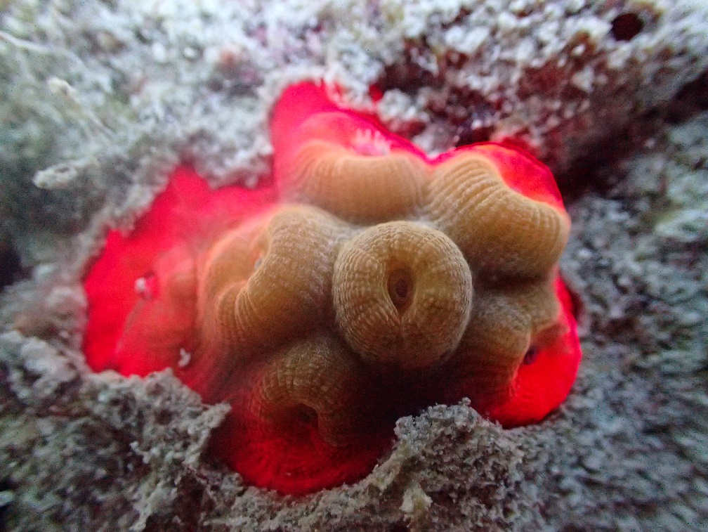Prior to the 2019 sampling year, the ECA experienced an unprecedented stony coral disease event with significant increases in disease prevalence beginning summer of 2014. This outbreak, driven by increases in prevalence of Stony Coral Tissue Loss Disease (SCTLD), increased every year from 2013 to 2016, when disease prevalence peaked. Disease prevalence then decreased every year from 2016 to 2019. Conditions appear to be improving, since in 2019 SCTLD was only observed at two of the 22 sites, and no site had significant increases in SCTLD prevalence. This is a decrease from 2018 where six sites were recorded with SCTLD; both sites with SCTLD infections in 2019 were located in Broward County.

Juvenile *Montastraea cavernosa* colony - a SCTLD susceptible species. Juvenile corals in the sites give hope for future recovery following the disease outbreak.

2019 SECREMP Results

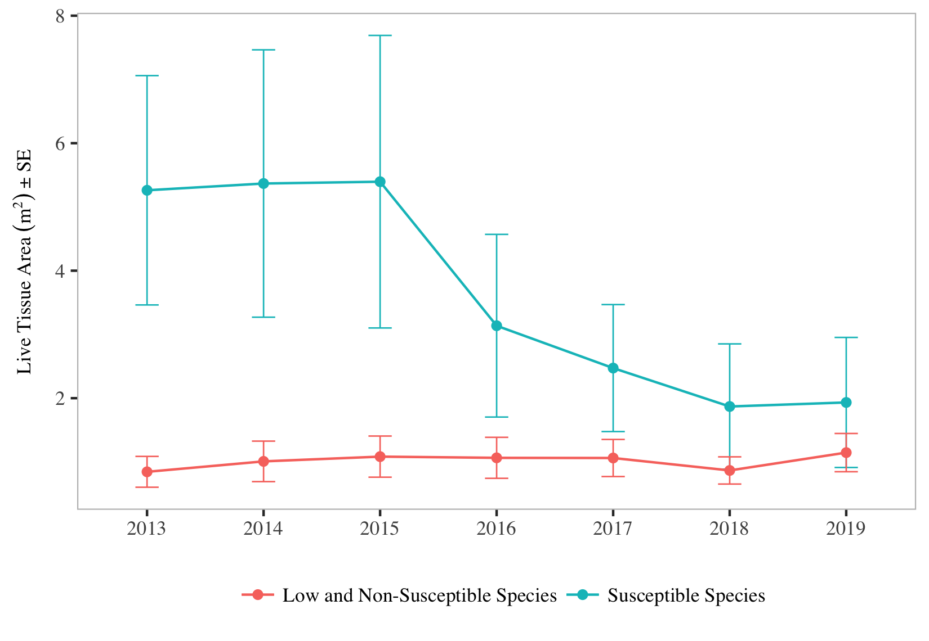To provide an additional metric to evaluate change in the stony coral community, colony size and percent mortality were used to calculate the total stony coral live tissue area (LTA) for each site. A region-wide decline in LTA was initially identified in 2016. LTA continued to decline region-wide such that LTA in 2017, 2018, and 2019 were significantly lower than in 2013-2015. From 2013 to 2019, 21 of the 22 sites had decreases in LTA. However, these declines in LTA were driven exclusively by SCTLD susceptible species. Species that are rarely to never infected with SCTLD had stable regional LTA; where the maximum recorded LTA of these species was found in 2019. Although the susceptible species had severe declines in LTA, no species were completely lost from all the sample sites. Additionally, juvenile data collected in 2018 and 2019 showed that of the 12 susceptible species that had adult colonies within the sample sites, all but *O. annularis* complex had juvenile colonies (colonies <2 cm). The disease event was very likely the greatest contributing factor to the significant loss of stony coral colonies and LTA identified within the SECREMP sites. Once again, the 2019 data collection showed no measurable effect of the disease outbreak on the octocoral or barrel sponge community.

Regional Live Tissue Area for SCTLD Susceptible Species (*C. natans, D. stokesii, D. labyrinthiformis, E. fastigiata, M. meandrites, P. strigosa, P. clivosa, O. annularis* complex, *M. cavernosa, S. bournoni, S. intersepta,* and *S. siderea*) andLow and Non-Susceptible species (all other species).

The chronic nature of disturbances to and the significant economic value of Southeast Florida Coral Reef Ecosystem requires comprehensive, long-term monitoring to define and quantify change and to help identify threats to the ecosystem. Both continual region-wide monitoring (SECREMP) and improved incident-specific monitoring are necessary if resource managers are to develop sound management plans for coral reefs that allow continued use and realization of the economic value of these fragile marine ecosystems. The value for a long-term region-wide monitoring program is highlighted by the information, albeit concerning, presented in this report.