SIGN VERBAGE FOR PROJECTS FUNDED BY THE
Land and Water Conservation Fund

THIS PROJECT WAS PARTIALLY FUNDED BY THE
LAND AND WATER CONSERVATION FUND
THROUGH THE
U.S. DEPARTMENT OF INTERIOR,
THE NATIONAL PARK SERVICE
AND THE
FLORIDA DEPARTMENT OF ENVIRONMENTAL PROTECTION

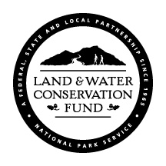

(LWCF LOGO required)
This logo may be downloaded from Office of Information and Recreation Services website:

http://www.dep.state.fl.us/parks/oirs

